Supplementary materials
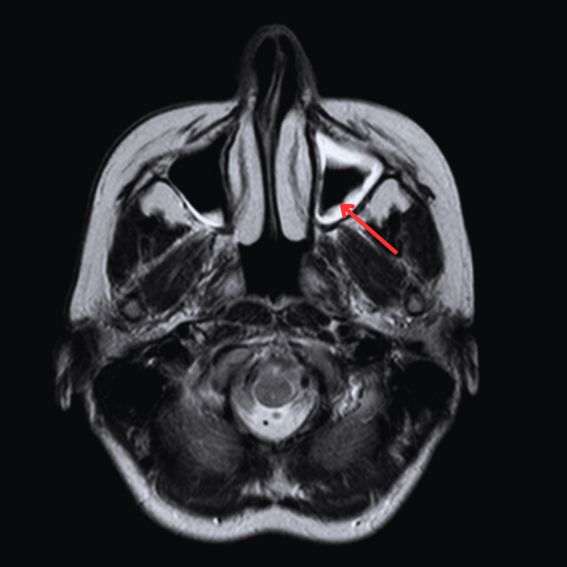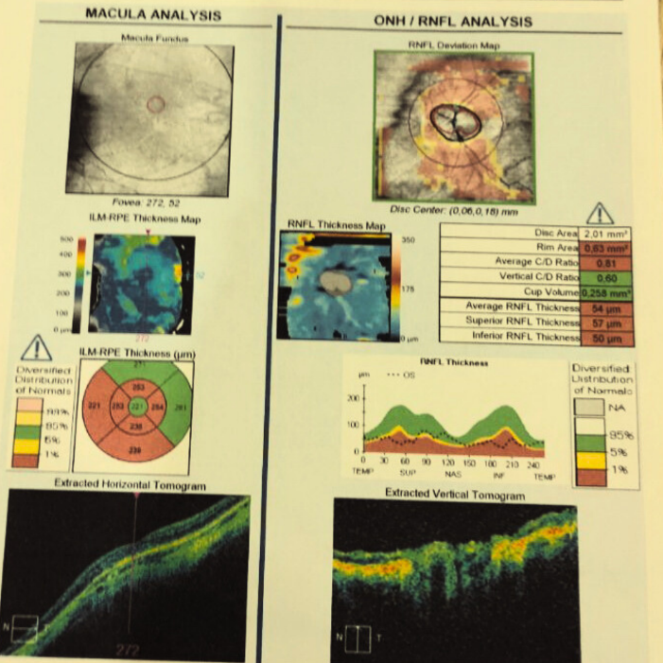
Fig. 5 Patient H. MRI and OCT. The left maxillary sinus involving. The left optic nerve atrophy

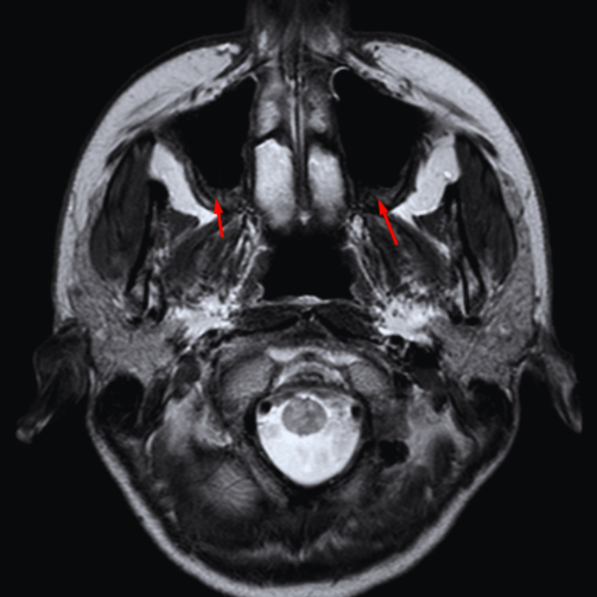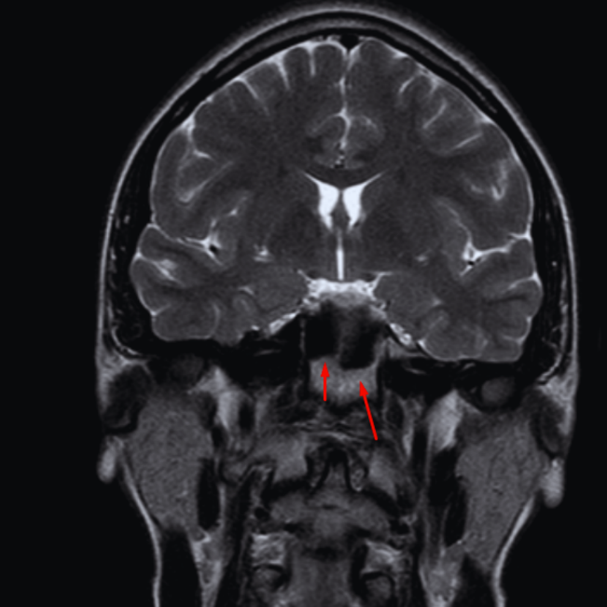
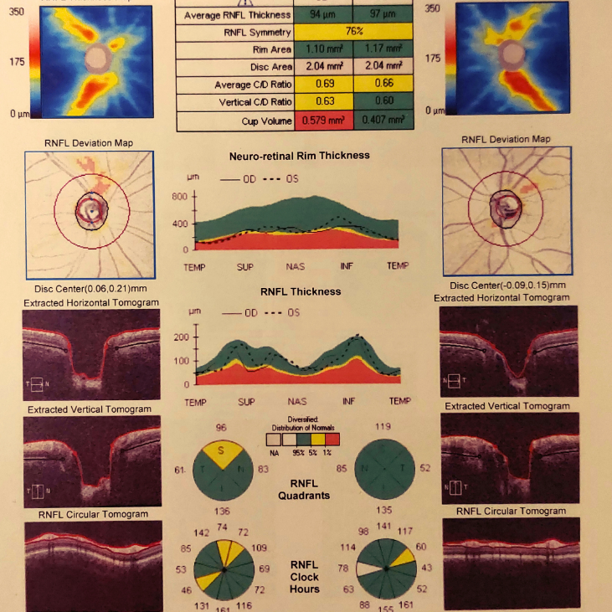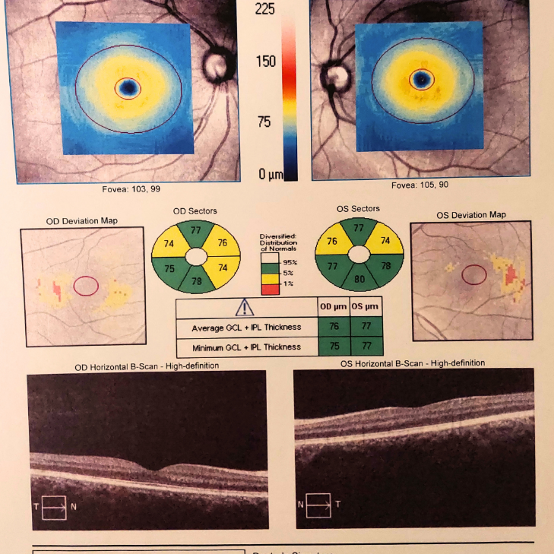
Fig. 6 Patient T. MRI - bilateral maxillary and sphenoid sinus involving. OCT – both eyes RNF and RGC thinning
hnnjhkl;’

