Appendix Figure 1: Sample Flowchart

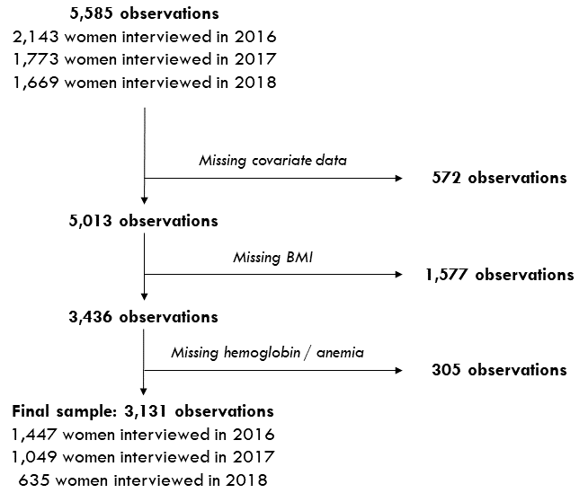
Note: An observation refers to a woman-year (e.g. a woman $i$ interviewed in year $j$).

