SUPPLEMENTAL MATERIAL

Time-dependent S-wave areas can pre-warning sudden cardiac death risk: a prospective, multicenter registered study
Running title: 24-hour electrocardiogram and SCD
Yangxin Chen, MD, PhD^{3,4,5*}, Huiying Zhao, PhD^{3,4,5*},Mengling Qi, PhD^{3,4,5*}, Xinfeng Wang, PhD⁶, Wenhao Liu, MD, PhD^{1,2}, Ziheng Zheng, MD^{1,2}, Wenli Gu, MD^{1,2}, Zhiteng Chen, MD, PhD^{1,2}, Qi Guo, MD, PhD^{1,2}, Liqun Wu, MD⁷, Wei Xu, MD, PhD⁸, Yangang Su, MD, PhD⁹, Keping Chen, MD, PhD¹⁰, MaoXiong Wu, MD, PhD^{1,2}, Qian Chen, MD, PhD^{1,2}, Xiangkun Xie, MD, PhD^{1,2,} Xiaoying Wu, MD, PhD^{1,2}, Xiao Liu, MD, PhD^{1,2}, Hongwei Li, MD^{1,2}, Yuedong Yang, PhD⁶, Yuling Zhang, MD, PhD^{1,2#}, Yangxin Chen, MD, PhD^{1,2#}, Jingfeng Wang, MD, PhD^{1,2#}

Supplemental methods 2
Reducing multicollinearity by excluding the redundant features 2
Comparing LASSO regression model with logistic regression model 2
SCD-HC model 2
SCD-SCDHR model 3
SCDHR-HC model 3
Supplemental results 4
Supplemental tables 4
Supplemental Table 1 4
Supplemental Table 2 5
Supplemental Table 3 10
Supplemental Table 4 11
Supplemental figures 12
Supplemental Figure 1 12
Supplemental Figure 2 13
Supplemental Figure 3 14
Supplemental Figure 4 15
Supplemental Figure 5 16
Supplemental Figure 6 17
Supplemental Figure 7 18
Supplemental Figure 8 19

Supplemental methods

Reducing multicollinearity by excluding the redundant features
To reduce the redundant ECG parameters, we cluster them at each time-fragment. For the ECG parameter, we built a logistic regression model to evaluate the association of it with SCD. The most significant ECG parameter in each cluster was used to represent the cluster. Before clustering, we scaled the ECG parameters by subtracting the mean value and dividing by the standard deviation. Then, K-means was used to cluster the ECG parameters.

Comparing LASSO regression model with logistic regression model
In order to examine if logistic regression is powerful to obtain the ECG parameters associated with SCD risk, we compared it with LASSO regression in discriminating SCD and HC, SCD and SCDHR, and SCDHR and HC.

SCD-HC model
When the LASSO regression model was established in each time-fragment in the training set, we found 795 time-fragments with lower five-fold cross-validation AUC than the logistic regression method (Supplemental Figure 8A). The LASSO regression model was built by combining seven time-fragments, which achieved five-fold cross-validation AUC 0.873 that is slightly higher than the performance of logistic regression model (AUC 0.836). However, in the independent test set, the logistic regression (AUC 0.802) performed better than the LASSO regression (AUC 0.767).

SCD-SCDHR model
When the LASSO regression model was established in each time fragment to discriminate SCD and SCDHR in the training set, 909 time-fragments were found with lower five-fold cross-validation AUC than the logistic regression model (Supplemental Figure 8B). A combined LASSO regression model was established and achieved the best AUC 0.902 after combining models from three time-fragments, which is higher than AUC 0.86 reached by the combined logistic regression model. However, the performance of the LASSO regression model (AUC 0.442) in the independent test set is much worse than the logistic regression (AUC 0.724).

SCDHR-HC model
When the LASSO regression model was built to discriminate SCDHR and HC in the training set, the model of 821 time-fragments performed a worse five-fold cross-validation AUC than the logistic regression model (Supplemental Figure 8C). The LASSO regression integrated three time-fragments and achieved a five-fold cross-validation AUC 0.955 that is comparable to the AUC 0.951 achieved by logistic regression. When the combined LASSO regression model was used in the independent test set, it reached AUC 0.849 that is slightly lower than the AUC (0.894) achieved by logistic regression model.
Taken together, the logistic regression model is more suitable to analyze the associations between ECG parameters and SCD risk than the LASSO regression.

Supplemental results

Supplemental tables
Supplemental Table 1. Number of samples collected from four different hospitals.
Hospital | Group |  |  | Total
Hospital | SCDHR | HF | HC | Total
Sun Yat-sen Memorial hospital | 42 | 86 | 125 | 253
Zhongshan Hospital of Fudan University | 1 | 12 | 0 | 13
Drum Tower Hospital | 1 | 5 | 0 | 6
Ruijin Hospital, Shanghai Jiao Tong University | 5 | 48 | 0 | 53
Total | 49 | 151 | 125 | 325

Supplemental Table 2. Features and their descriptions used in the study.
Symbol | Description | Figure
heart_rate | Beats per minute
maxR | Maximum value of R peak in one minute | 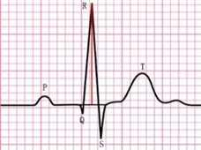
minR | Minimum value of R peak value in one minute
maxS | Maximum value of S peak value in one minute | 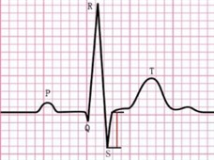
minS | Minimum value of S peak value in one minute
maxT | Maximum value of T peak value in one minute | 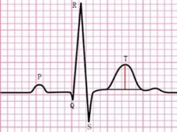
minT | Minimum value of T peak value in one minute
mean_R | Average value of R peak value in one minute
mean_S | Average value of S peak value in one minute
mean_T | Average value of S peak value in one minute
RS | average value of the difference between R peak and S peak | 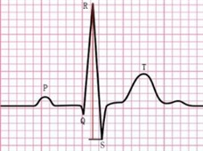
inteRM | The maximum area of the R peak in one minute | 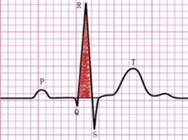
inteRm | The minimum area of the R peak in one minute
inteSM | The maximum area of the S peak in one minute | 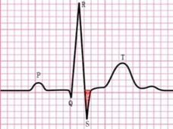
inteSm | The minimum area of the S peak in one minute
inteTM | The maximum area of the T peak in one minute | 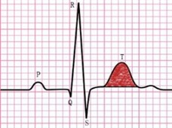
inteTm | The minimum area of the T peak in one minute
inteR_mean | The average area of the R peak in one minute
inteS_mean | The average area of the S peak in one minute
inteT_mean | The average area of the T peak in one minute | 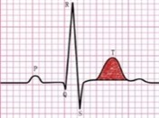
inteRST | average value of R peak area plus S peak area minus T peak area | 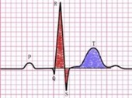
inteRT | average value of R peak area minus T peak area | 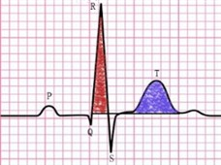
inteST | average value of S peak area plus T peak area | 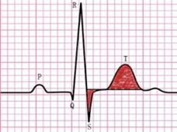
inteRS | average value of R peak area plus S peak area | 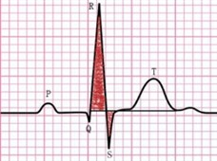
t_ST | S begin-to-T end interval | 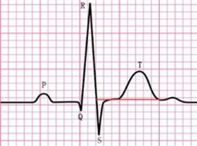
t_RT | R begin-to-T end interval | 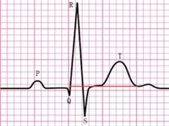
t_RS | R begin-to-S end interval | 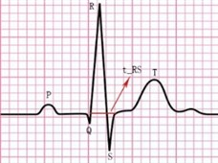
t_T | T begin-to-T end interval | 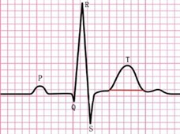
len_ST | the average value of S-T peak difference | 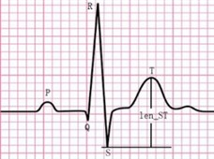
inteR_sum | Total R peak area in one minute | 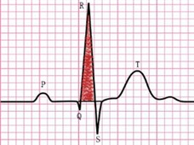
inteS_sum | Total S peak area in one minute | 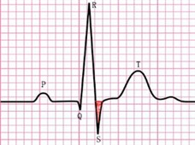
inteT_sum | Total T peak area in one minute | 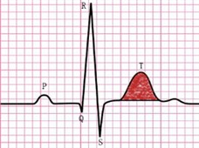
t_R_sum | Total time interval between R begin and R end in one minute | 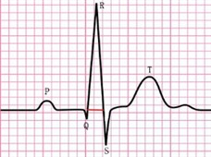
t_S_sum | Total time interval between S begin and S end in one minute | 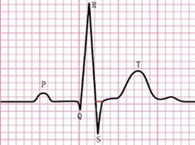
t_T_sum | Total time interval between T begin and T end in one minute
T_sd | standard deviation of T peak value
mean_RS | Average difference between R start and S end in voltage | 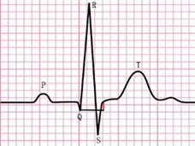
QT | Average time interval between R start and T end | 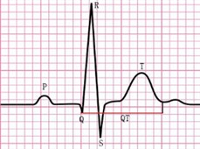
QT_sd | standard deviation of time interval between R start and T end
t_T_sd | standard deviation of time interval between T start and T end
inteT_sd | standard deviation of T peak area

Supplemental Table 3. The logistic regression coefficients, odds ratio (OR), and adjust P-values (P-adjust) of each feature at each time-fragment of SCD-HC classification model.
Feature | Time | Coefficient# | Coefficient* | OR (95% CI)# | OR (95% CI)* | P_adjust# | P_adjust*
mean_T | 10:48 | -1.239 | -4.745 | 0.988(0.959~1.011) | 0.954(0.909~0.986) | 0.382 | 0.143
mean_T | 10:57 | -0.806 | -4.949 | 0.992(0.966~1.013) | 0.952(0.904~0.984) | 0.523 | 0.143
mean_T | 16:31 | -5.607 | -5.001 | 0.945(0.894~0.984) | 0.951(0.898~0.992) | 0.033 | 0.143
mean_T | 16:42 | -1.535 | -4.114 | 0.985(0.961~1.008) | 0.960(0.920~0.991) | 0.222 | 0.143
mean_T | 18:51 | -2.665 | -1.455 | 0.974(0.942~0.996) | 0.986(0.953~1.015) | 0.076 | 0.460
mean_T | 19:27 | -2.992 | -4.306 | 0.971(0.939~0.994) | 0.958(0.912~0.991) | 0.053 | 0.143
mean_T | 19:43 | -3.148 | -1.952 | 0.969(0.938~0.995) | 0.981(0.943~1.006) | 0.051 | 0.374
mean_T | 19:44 | -2.812 | -0.218 | 0.972(0.943~0.997) | 0.998(0.970~1.026) | 0.065 | 0.874
t_RT | 10:48 | 2.218 | -4.297 | 1.022(0.946~1.104) | 0.958(0.872~1.041) | 0.560 | 0.455
t_RT | 10:57 | 6.480 | 2.122 | 1.067(0.983~1.164) | 1.021(0.899~1.178) | 0.150 | 0.855
t_RT | 16:31 | 19.58 | 1.533 | 1.216(1.088~1.403) | 1.015(0.939~1.106) | 0.010 | 0.844
t_RT | 16:42 | 19.756 | -0.715 | 1.218(1.085~1.417) | 0.993(0.914~1.078) | 0.010 | 0.874
t_RT | 18:51 | 10.925 | 0.932 | 1.115(1.034~1.216) | 1.009(0.941~1.085) | 0.017 | 0.859
t_RT | 19:27 | 14.116 | 2.819 | 1.152(1.057~1.276) | 1.029(0.946~1.126) | 0.010 | 0.650
t_RT | 19:43 | 17.712 | 7.180 | 1.194(1.095~1.331) | 1.074(0.982~1.200) | 0.004 | 0.295
t_RT | 19:44 | 16.067 | 5.322 | 1.174(1.084~1.294) | 1.055(0.971~1.160) | 0.004 | 0.367
inteSM | 10:48 | -87.389 | -79.272 | 0.417(0.173~0.853) | 0.453(0.154~0.914) | 0.044 | 0.170
inteSM | 10:57 | -138.697 | -63.498 | 0.250(0.064~0.662) | 0.530(0.22~0.976) | 0.033 | 0.170
inteSM | 16:31 | -113.962 | -81.372 | 0.320(0.112~0.678) | 0.443(0.167~0.947) | 0.022 | 0.154
inteSM | 16:42 | -125.928 | -55.372 | 0.284(0.091~0.625) | 0.575(0.234~1.293) | 0.020 | 0.325
inteSM | 18:51 | -99.565 | -56.992 | 0.369(0.176~0.658) | 0.566(0.232~1.195) | 0.010 | 0.295
inteSM | 19:27 | -93.582 | -124.905 | 0.392(0.192~0.686) | 0.287(0.070~0.765) | 0.012 | 0.143
inteSM | 19:43 | -90.906 | -84.676 | 0.403(0.191~0.697) | 0.429(0.160~0.948) | 0.013 | 0.154
inteSM | 19:44 | -105.287 | -77.549 | 0.349(0.162~0.633) | 0.460(0.214~0.807) | 0.010 | 0.143
#: calculated in the training set
*: calculated in the test set

Supplemental Table 4. The logistic regression coefficients, odds ratio (OR), and adjust P-values (P-adjust) of each feature at each time-fragment of SCDHR-HC classification model.
Feature | Time | Coefficient# | Coefficient* | OR (95% CI)# | OR (95% CI)* | P_adjust# | P_adjust*
minT | 3:41 | -0.979 | -1.033 | 0.990  (0.982~0.997) | 0.990  (0.981~0.997) | 0.020 | 0.020
minT | 13:50 | -0.153 | -0.880 | 0.998  (0.991~1.006) | 0.991  (0.983~0.998) | 0.690 | 0.037
minT | 22:40 | -0.316 | -0.784 | 0.997  (0.992~1.001) | 0.992  (0.985~0.998) | 0.204 | 0.036
inteS_mean | 3:41 | -78.601 | -125.235 | 0.456  (0.296~0.637) | 0.286  (0.111~0.530) | 0.001 | 0.007
inteS_mean | 13:50 | -71.120 | -89.117 | 0.491  (0.317~0.683) | 0.410  (0.207~0.664) | 0.001 | 0.009
inteS_mean | 22:40 | -47.139 | -52.435 | 0.624  (0.482~0.772) | 0.592  (0.384~0.809) | 0.001 | 0.015
RS | 3:41 | 0.566 | 0.616 | 1.006  (1.000~1.011) | 1.006  (1.000~1.013) | 0.055 | 0.072
RS | 13:50 | 0.547 | 0.957 | 1.005  (0.999~1.013) | 1.010  (1.003~1.018) | 0.130 | 0.020
RS | 22:40 | 0.291 | 0.348 | 1.003  (0.998~1.008) | 1.003  (0.998~1.010) | 0.232 | 0.271
inteRS | 3:41 | 28.041 | 60.644 | 1.324  (1.126~1.594) | 1.834  (1.349~2.735) | 0.003 | 0.007
inteRS | 13:50 | 45.700 | 62.662 | 1.579  (1.238~2.158) | 1.871  (1.367~2.929) | 0.002 | 0.007
inteRS | 22:40 | 14.398 | 35.865 | 1.155  (1.040~1.313) | 1.431  (1.161~1.901) | 0.022 | 0.013
inteST | 3:41 | 29.470 | 11.653 | 1.343  (1.157~1.608) | 1.124  (0.992~1.305) | 0.001 | 0.102
inteST | 13:50 | 56.559 | 18.102 | 1.760  (1.342~2.497) | 1.198  (1.008~1.462) | 0.001 | 0.072
inteST | 22:40 | 31.431 | 8.037 | 1.369  (1.174~1.647) | 1.084  (0.959~1.241) | 0.001 | 0.225
#: calculated in the training set
*: calculated in the test set

Supplemental figures
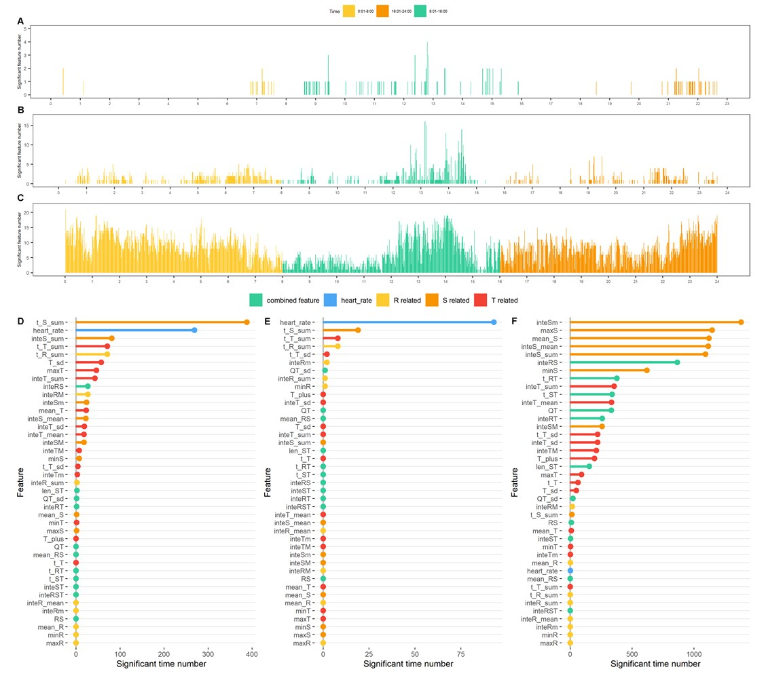
Supplemental Figure 1. Numbers of ECG parameters and time fragments in independent dataset. A. The number of features showing significant difference between SCDHR and HC in time-fragments. B. The number of features showing significant difference between SCDHR and HF in time-fragments. C. The number of features showing significant difference between HF and HC in time-fragments. D. The number of time fragments for features showing significant difference between SCDHR and HC. E. The number of time fragments for features showing significant difference between SCDHR and HF. F. The number of time fragments for features showing significant difference between HF and HC. P-value < 0.0012 (0.05/42) was considered statistically significant.

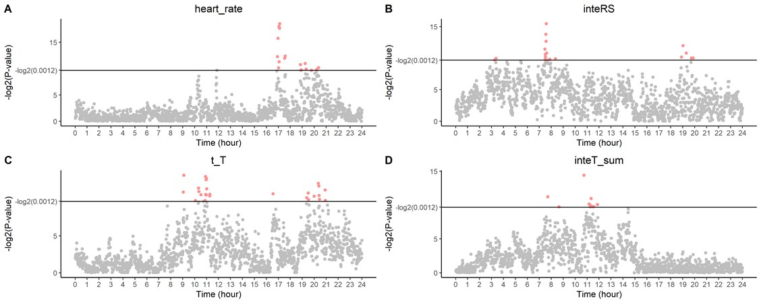
Supplemental Figure 2. P-values for comparing SCDHR and HC in training dataset. The red points represent P-value < 0.0012 at each one-minute time fragment. A-D represent the results for four features heart_rate, inteRS, t_T, and inteT_sum, respectively. The 24 hours ranging from 1:00 to 24:00 are shown in the horizontal axis.

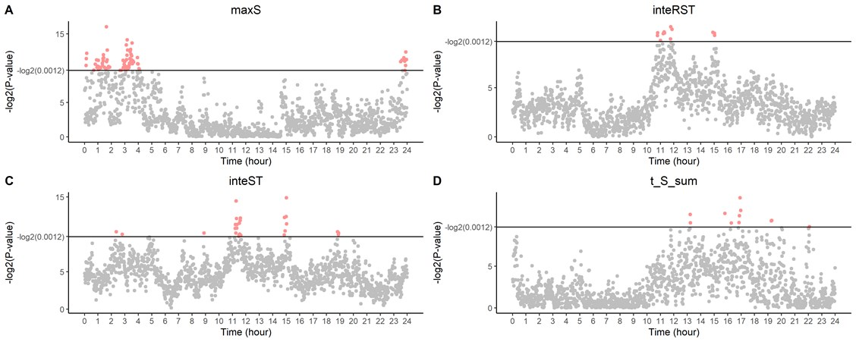
Supplemental Figure 3. P-values for comparing SCDHR and HF in training dataset. The red points represent P-value < 0.0012 at each one-minute time fragment. A-D represent the results for four features maxS, inteRST, inteST, and t_S_sum, respectively. The 24 hours ranging from 1:00 to 24:00 are shown in the horizontal axis.

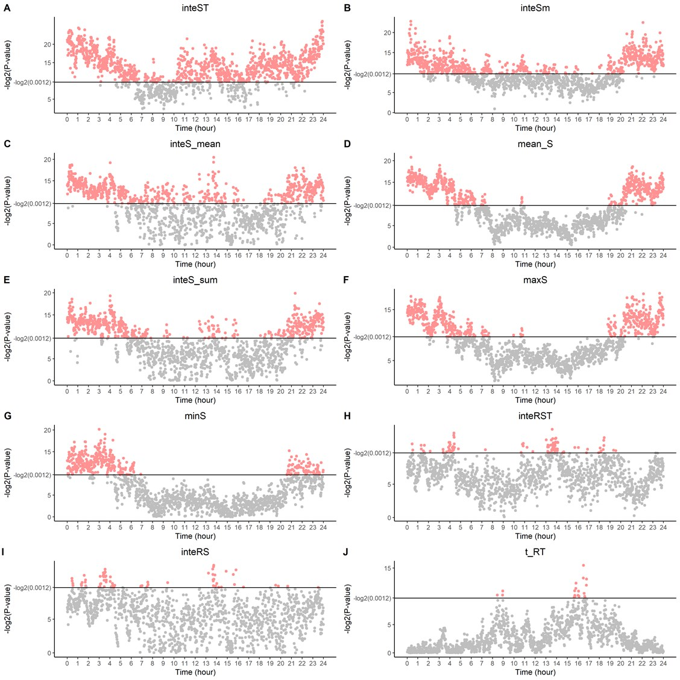
Supplemental Figure 4. P-values for comparing HF and HC in training dataset. The red points represent P-value < 0.0012 at each one-minute time fragment. A-J represent the results for ten features inteST, inteSm, inteS_mean, mean_S, inteS_sum, maxS, minS, inteRST, inteRS, and t_RT, respectively. The 24 hours ranging from 1:00 to 24:00 are shown in the horizontal axis.
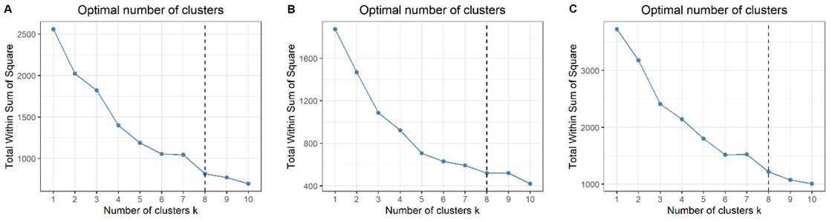 Supplemental Figure 5. The total within the sum of squares (WSS) for clusters. The total WSS is defined as the sum of the squared distance between each member of the cluster and its centroid. A. The total WSS for SCDHR and HC data clustering. B. The total WSS for SCDHR and HF data clustering. C. The total WSS for HF and HC data clustering. From the figure, we can see that when cluster number is bigger than eight, the slope is relatively gentle.

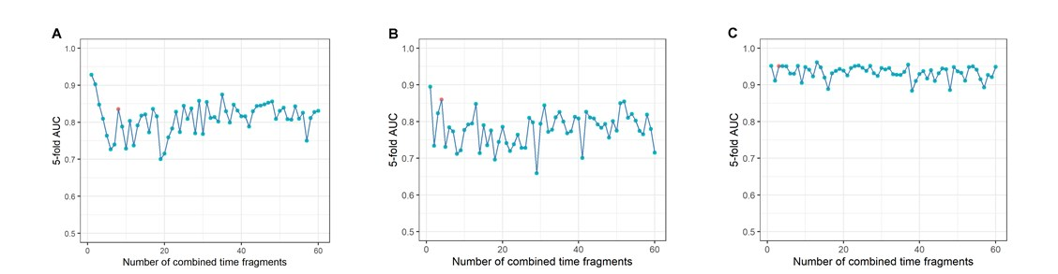
Supplemental Figure 6. The AUCs for each combined model. A. AUC performance of the greedy feature selection in combining increased number of time fragments for SCDHR and HC model. The AUCs were calculated as the average values of five-fold cross validation in training set. The red point gives the highest AUC when the number of time fragments is increased to 8. B. AUC performance of the greedy feature selection in combining increased number of time fragments for SCDHR and HF model. The red point gives the highest AUC when the number of time fragments is increased to 4. C. AUC performance of the greedy feature selection in combining increased number of time fragments for HF and HC model. The red point gives the highest AUC when the number of time fragments is increased to 3.

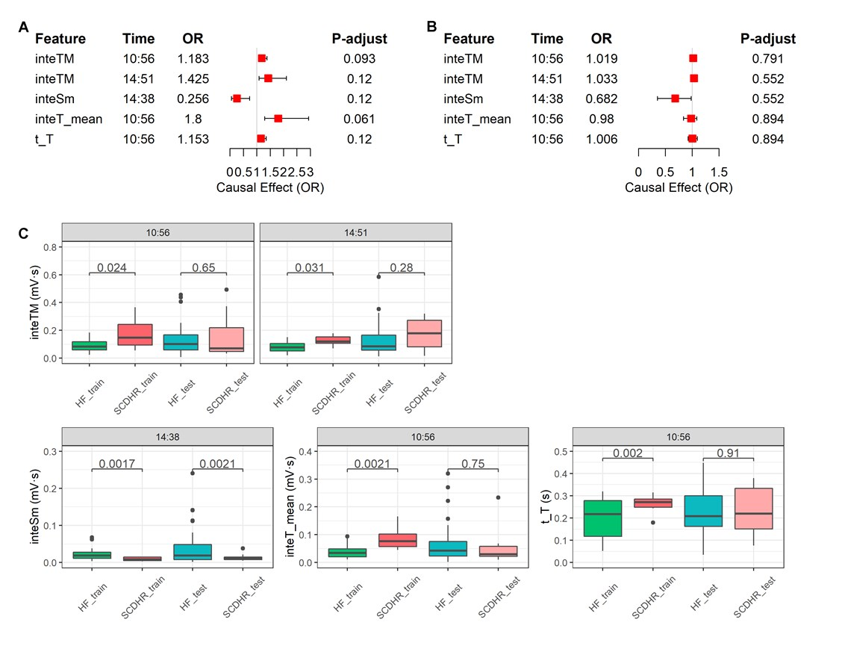
Supplemental Figure 7. The OR values of combined features between SCDHR and HF. A. The OR values of individual features for SCDHR in the training set at significant time-fragments. B. The OR of individual features associated with SCDHR and HF in the independent set at multiple time fragments. If OR<1.0 indicates the ECG parameters are negatively correlated with SCDHR; while OR >1.0 indicates the ECG parameters are positively correlated with SCDHR. The OR values here mean the change of SCDHR risk when the feature changes 1% unit. C. The difference of these feature in SCDHR and HF at these time-fragments was tested by Student’s t-test. The title of each subplot means the time-fragment of this comparison. OR, odds ratio; CI: confidence interval.

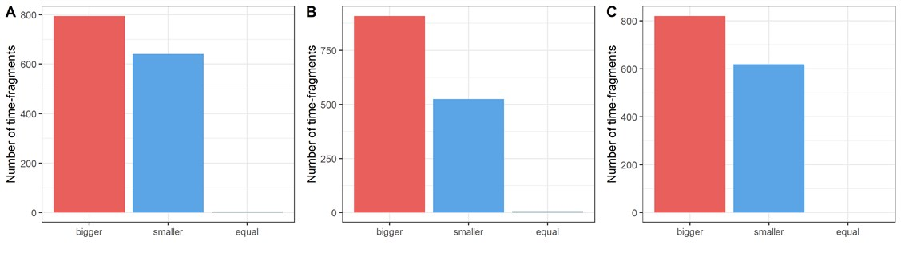
Supplemental Figure 8. Comparing LASSO regression model with logistic regression model. A. Numbers of time-fragments with bigger, smaller and equal AUC between SCD and HC. B. Numbers of time-fragments with bigger, smaller and equal AUC between SCD and SCDHR. C. Numbers of time-fragments with bigger, smaller and equal AUC between SCDHR and HC.

