Supplementary file 3
SEM after imputation of the variables with missed values (quality of life, social support and seizure frequency in the last 6 months)
The fit indices for the full structural model has indicated adequate fit of the data by χ2 = 162.8, (p<0.0001), CFI = 0.97, TLI = 0.97, SRMR=0.10 and RMSEA = 0.07.

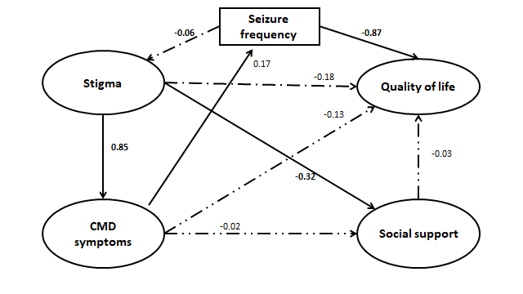
Figure 1. SEM after imputation of the missing values for quality of life (QOL) score and social support (SOS) and seizure frequency in the 6 month follow up

