Supplementary file 2- measurement model
Confirmatory factor analysis for the latent variables
- Common mental disorder (CMD) symptoms
The fit indices for CMD symptoms has indicated adequate fit of the data by χ2 = 480.1, (p<0.0001), CFI = 0.97, TLI = 0.97, SRMR=0.12 and RMSEA = 0.08
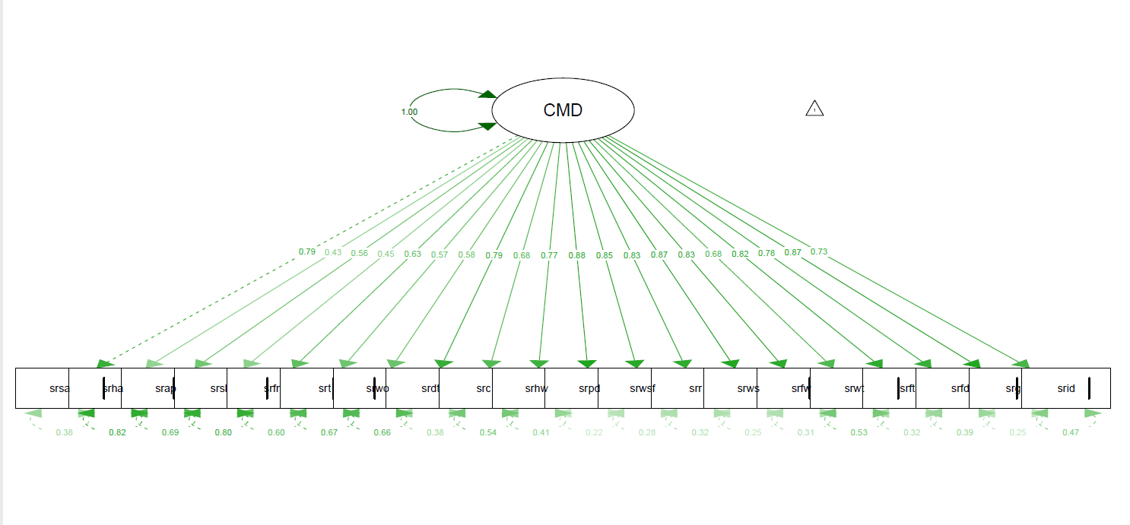

Item |  | Factor loading | 95% Confidence interval
1 | Do you often have headaches? | 0.55 | 0.37, 0.72
2 | Is your appetite poor? | 0.71 | 0.54, 0.88
3 | Do you sleep badly? | 0.57 | 0.38, 0.76
4 | Are you easily frightened? | 0.80 | 0.64, 0.96
5 | Do your hands shake? | 0.73 | 0.56, 0.89
6 | Do you feel nervous, tense or worried? | 0.74 | 0.58, 0.90
7 | Is your digestion poor? | 0.92 | 0.77, 1.08
8 | Do you have trouble thinking clearly? | 1.00 | 0.87, 1.14
9 | Do you feel unhappy? | 1 | 1
10 | Do you cry more than the usual? | 0.86 | 0.69, 1.14
11 | Do you find it difficult to enjoy your daily activities? | 0.97 | 0.83, 1.11
12 | Do you find it difficult to make decisions? | 1.13 | 1.0, 1.25
13 | Is your daily work suffering? | 1.08 | 0.94, 1.21
14 | Are you unable to play useful part in your life? | 1.06 | 0.93, 1.18
15 | Have you lost interest in things? | 1.10 | 0.98, 1.22
16 | Do you feel that you are a worthless person? | 1.06 | 0.93, 1.19
17 | Has the thought of ending your life been on your mind? | 0.87 | 0.70, 1.04
18 | Do you feel tired all the time? | 1.05 | 0.91, 1.18
19 | Do you uncomfortable feeling in your stomach? | 0.99 | 0.85, 1.15
20 | Do you get easily tired? | 1.10 | 0.98, 1.23

- Epilepsy related stigma
The fit indices for CMD symptoms has indicated adequate fit of the data by χ2 = 240.5, (p<0.0001), CFI = 0.98, TLI = 0.99, SRMR=0.08 and RMSEA = 0.07.

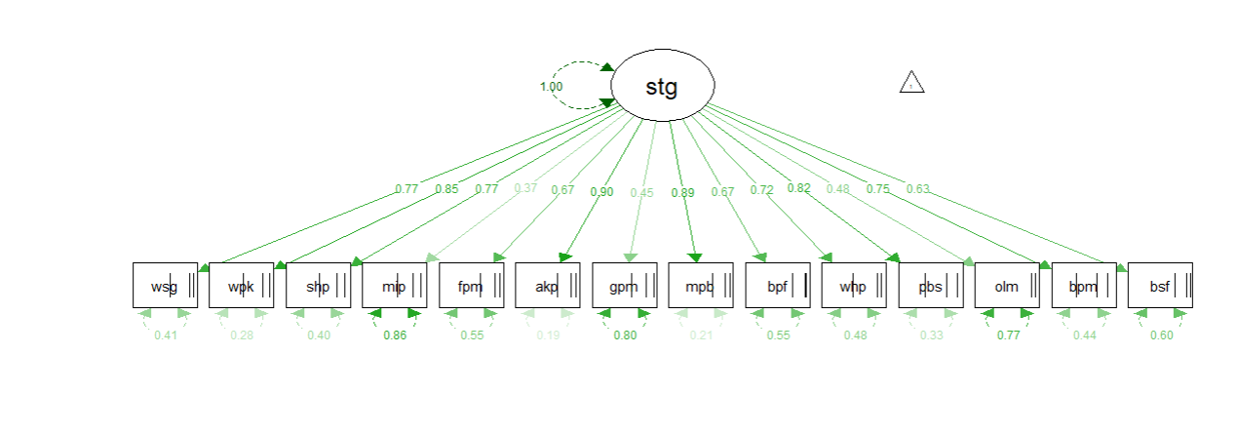

Item |  | Factor loading | 95% Confidence interval
1 | You worried that your neighbors would treat you differently | 0.77 | 0.70, 0.84
2 | You spent time worrying whether people would find out about it | 0.85 | 0.80, 0.90
3 | You sometimes felt the need to hide this fact | 0.77 | 0.71, 0.84
4 | You have helped other people to understand what it is like to have a psychiatric problems | 0.39 | 0.25, 0.49
5 | When you met people for the first time, you made a special effort to keep this fact a secret | 0.67 | 0.58, 0.76
6 | You worried that friends and neighbors would avoid you after they found out about it | 0.90 | 0.85, 0.95
7 | You have found yourself explaining to others that you are not like their picture of “crazy” people | 0.45 | 0.34, 0.57
8 | You worried that people would blame you for your problems | 0.89 | 0.84, 0.94
9 | You worried that a person looking to marry would be reluctant to marry to you | 0.67 | 0.58, 0.77
10 | You worried about getting out | 0.72 | 0.64, 0.80
11 | You felt ashamed or embarrassed about it | 0.82 | 0.76, 0.88
12 | You sought out people who also have a psychiatric problems | 0.48 | 0.32, 0.64
13 | You felt grief or depression because of it | 0.75 | 0.68, 0.82
14 | You felt somehow it might be your fault | 0.64 | 0.54, 0.73

- Quality of life for Epilepsy
The fit indices for quality of life latent construct has indicated adequate fit of the data by χ2 = 103.5, (p<0.0001), CFI = 0.99, TLI = 0.99, SRMR=0.06 and RMSEA = 0.06

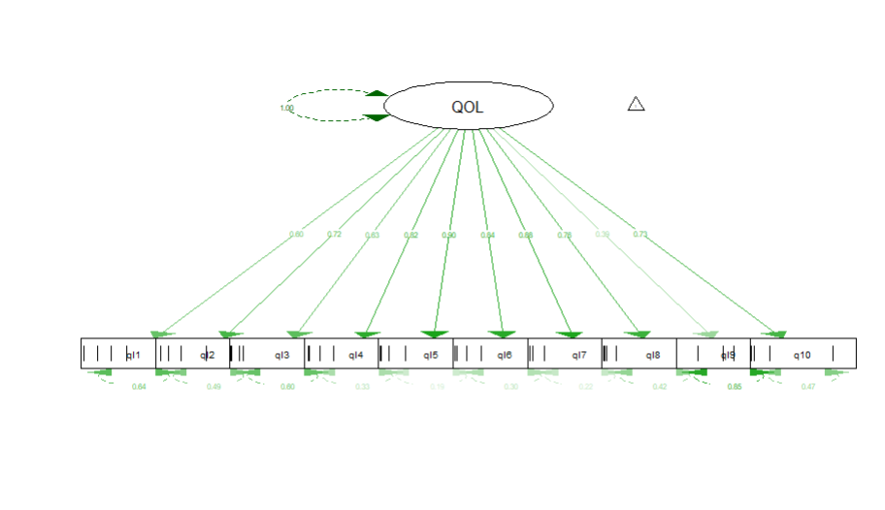
Item |  | Factor loadings | 95% confidence interval
1 | Did you have a lot of energy? | 0.60 | 0.52, 0.68
2 | Have you felt downhearted and low? | 0.72 | 0.63, 0.81
3 | How much of the time during the past 4 weeks your epilepsy or antiepileptic drugs have caused trouble with driving (or other transportation) | 0.63 | 0.49, 0.78
 | During the past 4 weeks…
4 | How much do your work limitations bother you? | 0.82 | 0.75, 0.89
5 | How much do your social limitation bother you? | 0.90 | 0.85, 0.95
6 | How much do your memory difficulties bother you? | 0.84 | 0.77, 0.91
7 | How much do physical effects of antiepileptic drugs bother you? | 0.88 | 0.83, 0.94
8 | How much do psychological effects of antiepileptic drugs bother you? | 0.77 | 0.68, 0.85
9 | How afraid are you of having a seizure during the next 4 weeks? | 0.39 | 0.27, 0.51
10 | How has your QUALITY OF LIFE been during the past 4 weeks (that is, how have things been going for you)? | 0.73 | 0.66, 0.79

- Functional disability
The fit indices for quality of life latent construct has indicated adequate fit of the data by χ2 = 90.71, (p=0.001), CFI = 1.0, TLI = 1.0, SRMR=0.07 and RMSEA = 0.03

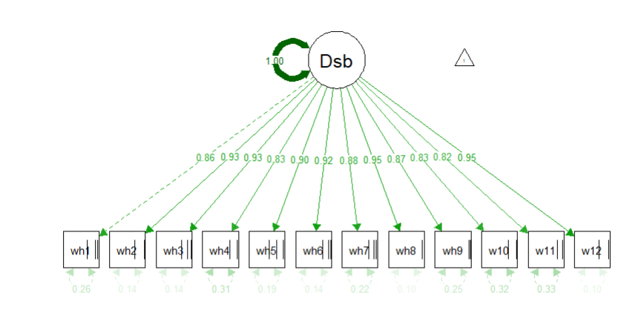

Item |  | Factor loading | 95% Confidence interval
1 | How do you rate your overall health in the past 30 days? | 1 | 1
2 | Standing for long periods such as 30 minutes? | 1.08 | 1.0, 1.16
3 | Taking care of your household responsibilities? | 1.08 | 1.00, 1.16
4 | Learning a new task, for example, learning how to get to a new place? | 0.97 | 0.88, 1.06
5 | How much of a problem did you have in joining community activities (for example, festivities, religious or other activities) in the same way as anyone else can? | 1.05 | 0.97, 1.13
6 | How much have you been emotionally affected by your health problems? | 1.08 | 1.0, 1.16
 | In the last 30 days, how much difficulty did you have in:
7 | Concentrating on doing something for 10 minutes? | 1.03 | 0.95, 1.11
8 | Walking a long distance such as a kilometer? | 1.10 | 1.02, 1.19
9 | Washing your whole body? | 1.01 | 0.92, 1.11
10 | Getting dressed | 0.96 | 0.85, 1.05
11 | Dealing with people you do not know? | 0.95 | 0.85, 1.05
12 | Maintaining a friendship? | 1.10 | 1.03, 1.18

