Supplementary file 1

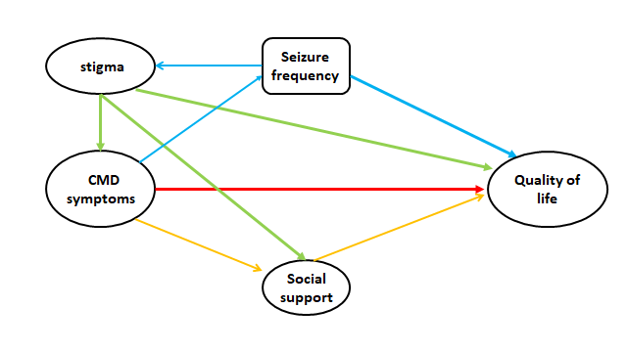

Figure 2. Hypothesised direct and indirect pathways linking co-morbid common mental disorder symptoms with quality of life

