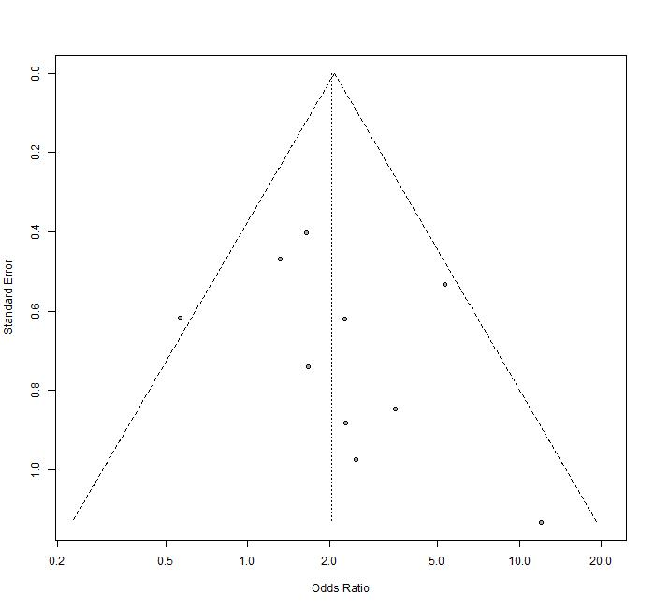
- Funnel plot for the predicton of SPTM and tumor size.
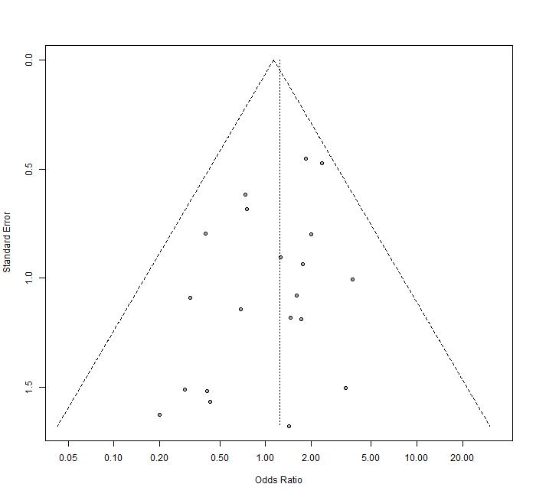
- Funnel plot for the predicton of SPTM and sex.
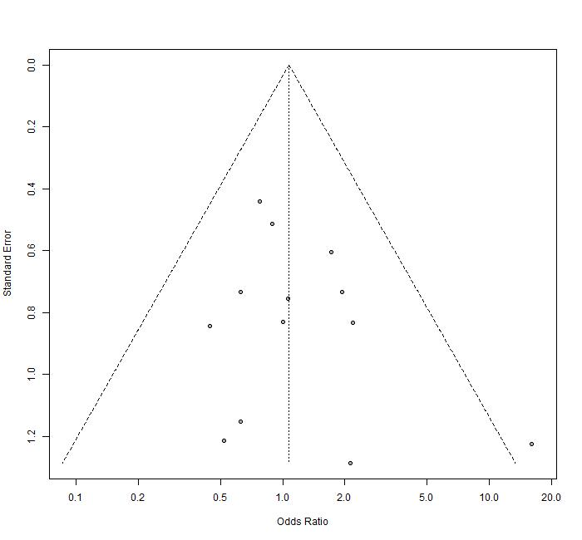
- Funnel plot for the predicton of SPTM and tumor calcification.
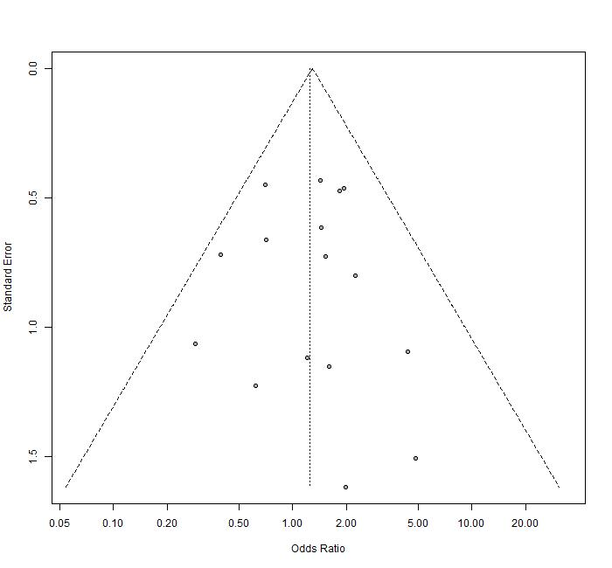
- Funnel plot for the predicton of SPTM and symptoms.
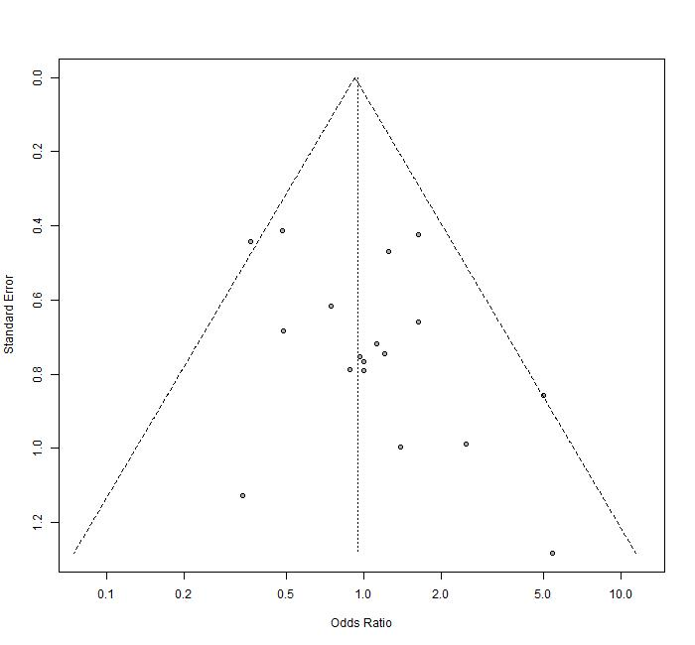
- Funnel plot for the predicton of SPTM and tumor location.
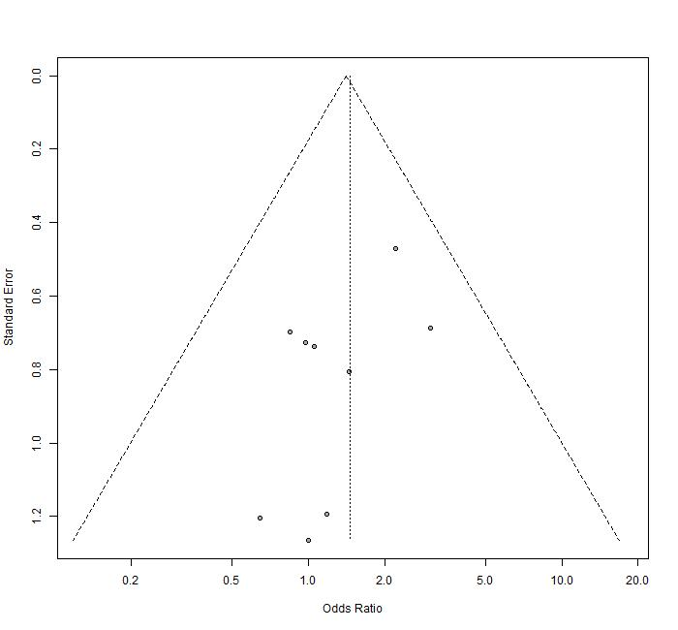

- Funnel plot for the predicton of SPTM and tumor composition.
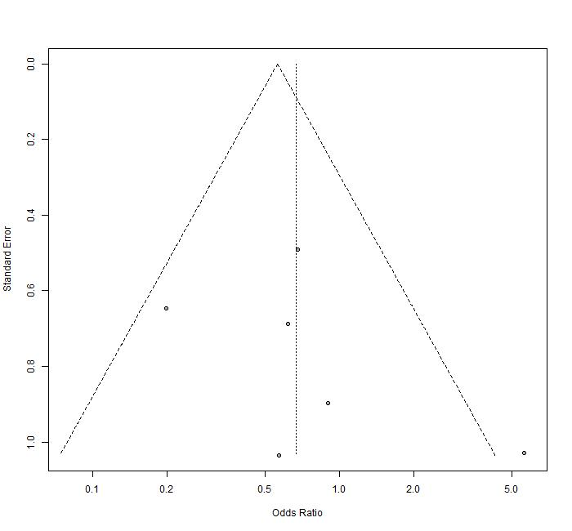
- Funnel plot for the predicton of SPTM and tumor necrosis.

