Table S1 Statistical results of sequencing data
Samples | Clean reads | Clean bases | GC Content | %≥Q30
A0d1 | 33,073,170 | 9,883,172,390 | 43.72% | 94.98%
A0d2 | 37,216,971 | 11,117,525,770 | 43.71% | 95.71%
A0d3 | 32,461,399 | 9,701,942,792 | 43.97% | 94.88%
A1d1 | 29,550,808 | 8,837,006,770 | 42.82% | 94.21%
A1d2 | 28,812,052 | 8,613,206,350 | 42.94% | 94.43%
A1d3 | 32,191,886 | 9,626,441,124 | 42.81% | 94.43%
A2d1 | 33,145,959 | 9,903,233,376 | 42.91% | 93.03%
A2d2 | 28,735,259 | 8,592,807,638 | 43.14% | 95.27%
A2d3 | 32,491,088 | 9,717,487,510 | 42.90% | 94.63%
A4d1 | 26,724,286 | 7,986,258,726 | 43.23% | 94.37%
A4d2 | 25,277,715 | 7,558,136,692 | 43.12% | 93.94%
A4d3 | 35,460,040 | 10,592,260,696 | 42.88% | 95.17%
A7d1 | 34,781,504 | 10,404,034,988 | 42.98% | 94.54%
A7d2 | 33,443,226 | 9,987,645,376 | 43.06% | 94.55%
A7d3 | 36,337,205 | 10,862,515,338 | 42.95% | 94.95%
B0d1 | 32,993,164 | 9,860,213,888 | 43.52% | 94.75%
B0d2 | 30,766,838 | 9,191,178,498 | 43.36% | 95.46%
B0d3 | 31,075,466 | 9,294,896,318 | 43.33% | 94.22%
B1d1 | 35,705,426 | 10,676,871,728 | 42.74% | 94.95%
B1d2 | 29,524,110 | 8,824,117,552 | 42.65% | 94.31%
B1d3 | 33,706,092 | 10,081,290,046 | 42.45% | 94.72%
B2d1 | 35,713,581 | 10,664,075,972 | 42.88% | 94.93%
B2d2 | 36,234,688 | 10,823,355,822 | 42.92% | 95.18%
B2d3 | 34,218,672 | 10,228,298,136 | 42.82% | 94.38%
B4d1 | 32,056,351 | 9,584,478,430 | 42.85% | 94.64%
B4d2 | 32,641,719 | 9,757,621,490 | 42.80% | 93.61%
B4d3 | 34,889,888 | 10,424,533,552 | 42.68% | 95.09%
B7d1 | 31,501,126 | 9,411,638,362 | 43.01% | 94.27%
B7d2 | 32,125,277 | 9,605,748,454 | 42.76% | 94.47%
B7d3 | 34,642,904 | 10,355,561,074 | 42.99% | 94.82%

Table S2 Result statistics of gene function annotation

Annotated databases | New Gene Number
COG | 8,993
GO | 25,135
KEGG | 21,137
KOG | 15,986
Pfam | 23,541
Swiss-Prot | 20,270
eggNOG | 27,095
nr | 32,959
All | 175,116

Figure S1 Heat map of correlation between expression levels of pairwise samples
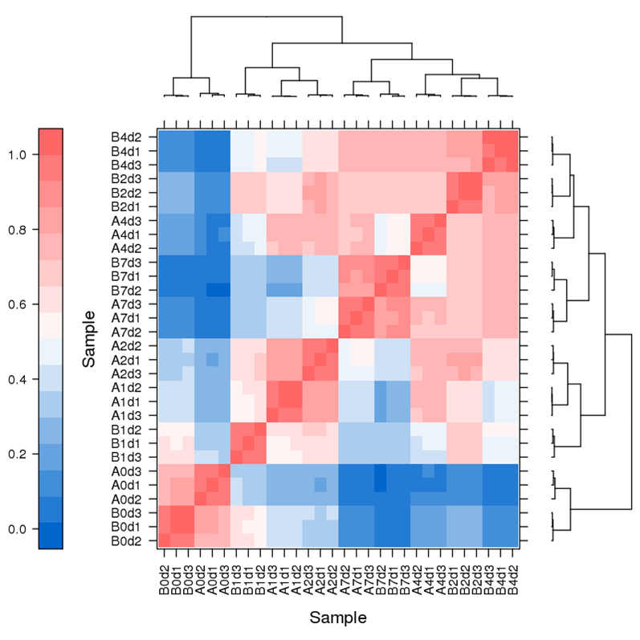

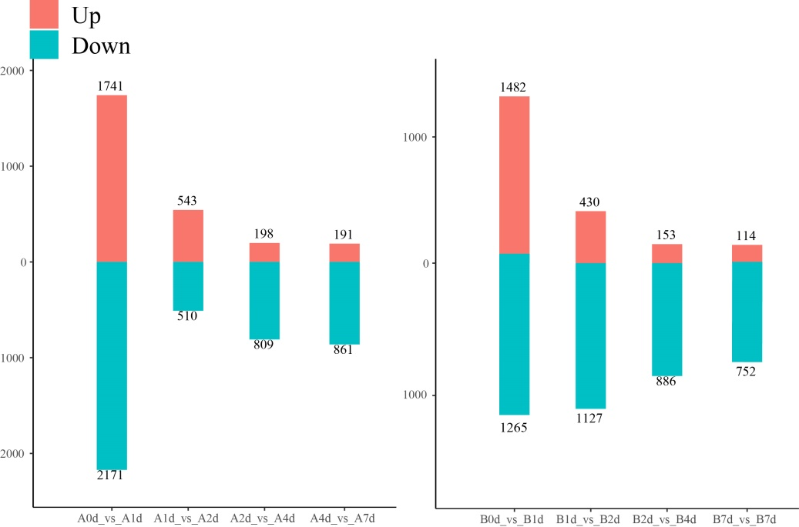
Figure S2
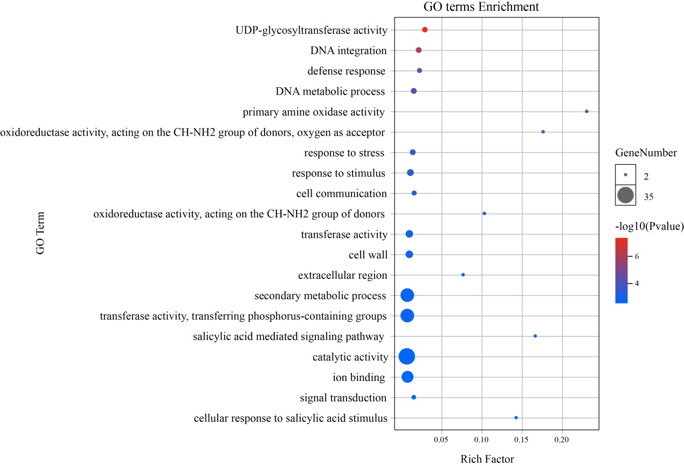
Figure S3 GO enrichment analysis of the top 150 genes in the MEgrey60 co-expression network

Table S3 Primer sequences for qRT-PCR experiments.

Primer name | Primer sequence (5'to3')
EGP18530-SnRK2-F | AGATGGTGTCGCAAGGTG
EGP18530-SnRK2-R | CGAGCGTGAGGGAGTAAAT
EGP11066-PP2C-F | TCAGGGTAGTAGGGATAA
EGP11066-PP2C-R | AACCAAGGCAAGTAACAG
EGP18001-AUX1-F | TCACCCTAACACTACCCT
EGP18001-AUX1-R | TCCCTATAACTTTCTCCC
EGP14445-AUX1/IAA-F | AGGTTTACCAGGGAGGAC
EGP14445-AUX1/IAA-R | CACGCTAACTTTGACATACA
EGP01302-ARF19-F | GCGATTTCGGATGATGTTTGA
EGP01302-ARF19-R | CTGTGAGCCTTTCCATCGTA
EGP14379- CYP90B -F | CTCTCAATGCGTGGTCCTTC
EGP14379- CYP90B -R | ATGTCGAACCCCCTTTATCAC
EGP20989-MYB-F | TAGGTGGTCACTCATAGC
EGP20989-MYB-R | GTTTGTCCGTAGGTTTCT
EGP06499-SQS-F | GCTTCCTCGGAGATTGTGGA
EGP06499-SQS-R | CGAGTGAGATCTCCGAAAGA
EGP09657-C2H2-F | ATCAGCTTAAGCCCGGATCA
EGP09657-C2H2-R | ATGGAGCTCTAACAAGTGCC
EGP25367-LRK10L-2.6-F | TTGGAGGAGTGTCACACAAA
EGP25367-LRK10L-2.6-R | TCTTTCGGCGCTGTAGTTTT
EGP00263-DELLA (RGL1)-F | ACATTAAGTGATAGCCTGGAGC
EGP00263-DELLA (RGL1)-R | AAGCAGTAGACTGTTATGGCG
EGP09992-CYP90B-F | ATCATGGCAAGCGATGCAAG
EGP09992-CYP90B-R | AGCCAAAGAGATTTCCAACCT
EGP06774-GST-F | ACGAGATGTCGGAAGTGA
EGP06774-GST-R | TTAGGCAAGATAGGAGGG
EGP15357-TreY-F | CCAATGGGAGGAGTCTGT
EGP15357-TreY-R | CCAATGGGAGGAGTCTGT
EGP28780-AMY-F | AACGACGGAAGCGACGAA
EGP28780-AMY-R | AGCCCACTCCAAGAAATCAACT
EGP23490-AMY-F | TGGCGAGATTTGATACAG
EGP23490-AMY-R | TGAACGAAAGCTCCCTTA

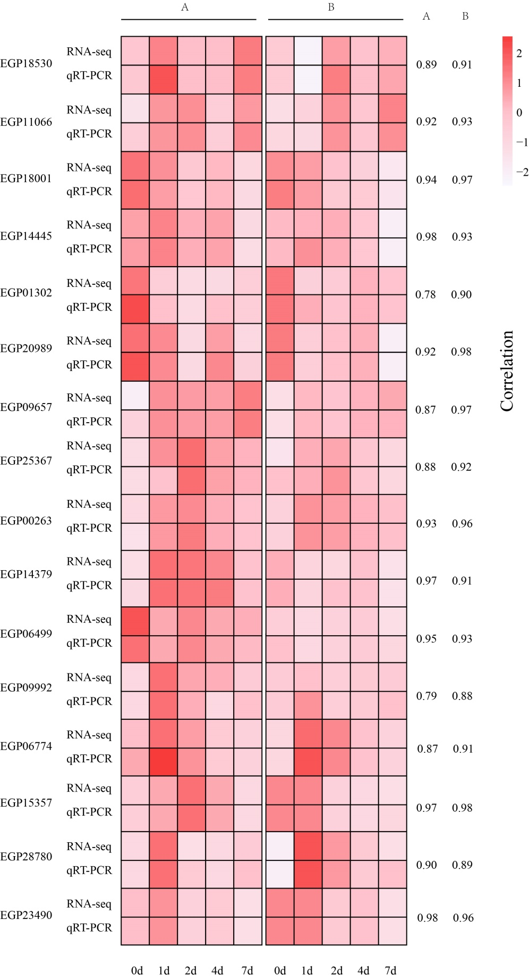
Figure S4 Correlation analysis of the results of qRT PCR validation of RNA Seq data.

