Supplementary Information
Deep-Blue Organic Light-Emitting Diodes for Ultrahigh-Definition Displays
Tao Hua¹†, Xiaosong Cao¹†, Jingsheng Miao¹†, Xiaojun Yin¹, Zhanxiang Chen¹, Zhongyan Huang¹, Chuluo Yang¹*

Corresponding author: clyang@szu.edu.cn

Contents

General Procedure S-3
Synthesis and characterization S-4
Computational data S-45
Crystallographic analysis S-53
Photophysical, electrochemical and thermal properties S-56
OLEDs performance S-62

General Procedure: All of the reactions were conducted under the protection of the dry-argon atmosphere. All new compounds were characterized by ¹H NMR and ¹³C NMR (Supplementary Figs. 1-25). Tetramethylsilane was used as the internal standard and CDCl₃ as the solvent. The target products were further confirmed by high-resolution mass spectrometry (HR-MS, Supplementary Figs. 26-29). High-resolution mass spectra were performed using Thermo Scientific LTQ Orbitrap XL Gas Chromatography Mass spectrometer. The absolute configuration of DPA-B3 and DPA-B4 were confirmed using Bruker D8 Venture diffractometer using MoK radiation source. The single crystals were prepared from a saturated chloromethane and methanol solution by evaporation method. All crystallographic information in CIF format have been deposited at the Cambridge Crystallographic Data Center (CCDC) under deposition number 2299738 for DPA-B3, 2299737 for DPA-B4, through www.ccdc.cam.ac.uk/data_request/cif.

Synthesis and characterization: The synthesis procedures of DPA-B2, DPA-B3, DPA-B4 and Cz-B4 are depicted in Supplementary Scheme 1. The borylated precursors were synthesized from commercially available starting materials using nucleophilic substitution reactions and Buchwald-Hartwig C-N coupling reactions. The final products, DPA-B2, DPA-B3, DPA-B4 and Cz-B4 were achieved in appreciable yields through a one-pot borylation Friedel-Crafts reaction at 200 ℃.
Supplementary Scheme 1. Synthetic procedures of DPA-B2, DPA-B3, DPA-B4 and Cz-B4.

Synthesis of N¹,N³-dimesityl-N¹,N³,N⁵,N⁵-tetraphenylbenzene-1,3,5-triamine (2)
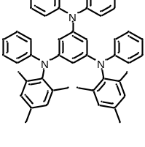
Under argon atmosphere, compound 1 (1.2 g, 3 mmol), 2,4,6-trimethyl-N-phenylaniline (1.4 g, 6.6 mmol), sodium tert-butoxide (1.2 g, 12 mmol), 2-dicyclohexylphosphino-2',6'-dimethoxybiphenyl (246 mg, 0.6 mmol) and tris(dibenzylideneacetone)dipalladium (100 mg, 0.3 mmol) were added into a 100 mL two necked round bottom flask. After 30 mL degassed xylene was added into the flask, the reaction was allowed heating up to 140 ºC and stirred for 6 h. The reaction mixture was allowed to cool to room temperature and extracted with dichloromethane (25 mL) for three times, the organic ingredients were dried over Na₂SO₄ for 15 min and removed by a rotatory evaporation. The crude product was purified by silica gel column chromatography, intermediate 2 was obtained as a white solid (1.8 g, 91%). ¹H NMR (500 MHz, CDCl₃) δ 7.14 (t, J = 8.5 Hz, 4H), 7.09–6.97 (m, 8H), 6.89 (t, J = 7.5 Hz, 2H), 6.82 (d, J = 8.5 Hz, 4H), 6.78 (s, 4H), 6.73 (t, J = 7.3 Hz, 2H), 6.23 (s, 2H), 6.12 (s, 1H), 2.25 (s, 6H), 1.89 (s, 12H). ¹³C NMR (125 MHz, CDCl₃) δ 148.67, 147.46, 146.93, 145.72, 139.79, 137.25, 136.40, 129.60, 128.83, 128.76, 123.58, 122.15, 120.07, 118.77, 109.27, 107.07, 20.97, 18.26.

Synthesis of DPA-B2
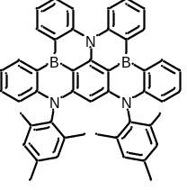
Under argon atmosphere, compound 2 (664 mg, 1 mmol) was dissolved in 15 mL ultradry o-dichlorobenzene. BBr₃ (3.0 mL, 32 mmol) was injected into the mixture at argon atmosphere quickly. The reaction was allowed heating up to 200 ºC and stirred for 48 h. The reaction mixture was allowed to cool to room temperature and excess N,N-dimethyltriethylamine was added into the system slowly in an ice-bath. The mixture was extracted with dichloromethane (25 mL) for three times, the organic ingredients were dried over Na₂SO₄ for 15 min and removed by a rotatory evaporation. The crude product was purified by silica gel column chromatography, DPA-B2 was obtained as a pale-yellow solid (177 mg, 26%). ¹H NMR (500 MHz, CDCl₃) δ 8.94 (dd, J = 7.5, 1.0 Hz, 2H), 8.85 (dd, J = 7.5, 1.5 Hz, 2H), 8.33 (d, J = 8.5 Hz, 2H), 7.59–7.51 (m, 2H), 7.50–7.42 (m, 4H), 7.35 (d, J = 7.0 Hz, 1H), 6.94 (s, 2H), 6.89 (s, 2H), 6.81 (d, J = 8.5 Hz, 2H), 5.27 (s, 1H), 2.41 (s, 6H), 1.69 (s, 6H), 1.64 (s, 6H). ¹³C NMR (125 MHz, CDCl₃) δ 148.47, 147.42, 146.82, 145.87, 137.95, 136.85, 136.54, 136.24, 135.05, 134.57, 131.48, 129.74, 129.44, 128.73, 124.00, 123.36, 120.48, 119.31, 115.54, 89.87, 21.24, 17.10, 17.07. HRMS (MALDI-TOF/MS) m/z [M]⁺ calcd for C₄₈H₄₀N₃B₂ 680.3403, observed 680.3406.

Synthesis of 1,3-dibromo-5-(p-tolyloxy)benzene (4)
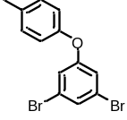
Under argon atmosphere, 1,3-dibromo-5-fluorobenzene (7.6 g, 30 mmol), p-cresol (3.2 g, 30 mmol) and Cs₂CO₃ (14.6 g, 45 mmol) were added into a 200 mL schlenk flask. After addition of 35 mL 1-methyl-2-pyrrolidinone (NMP), the mixture was stirred for 12 h at 150 ºC. The reaction mixture was allowed to cool to room temperature and poured into 100 mL water. The mixture was extracted with dichloromethane (25 mL) for three times, the organic ingredients were dried over Na₂SO₄ for 15 min and removed by a rotatory evaporation. The crude product was purified by silica gel column chromatography, compound 4 was obtained as a colourless liquid (9.4 g, 92%). ¹H NMR (500 MHz, CDCl₃) δ 7.37–7.28 (m, 1H), 7.17 (d, J = 8.0 Hz, 2H), 7.08–6.98 (m, 2H), 6.91 (d, J = 8.0 Hz, 2H), 2.35 (s, 3H). ¹³C NMR (125 MHz, CDCl₃) δ 159.61, 152.99, 134.53, 130.67, 128.13, 123.24, 119.95, 119.71, 20.85.

Synthesis of 3-bromo-N,N-diphenyl-5-(p-tolyloxy)aniline (5)
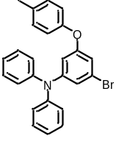
Under argon atmosphere, compound 4 (6.8 g, 20 mmol), diphenylamine (3.3 g, 20 mmol), sodium tert-butoxide (3.8 g, 40 mmol), 1,1'-bis (diphenylphosphino)ferrocene (559 mg, 1 mmol) and tris(dibenzylideneacetone)dipalladium (92 mg, 0.1 mmol) were added into a 100 mL two necked round bottom flask. After 45 ml degassed xylene was added into the flask, the reaction was allowed heating up to 85 ºC and stirred for 16 h. The reaction mixture was allowed to cool to room temperature and extracted with dichloromethane (25 mL) for three times, the organic ingredients were dried over Na₂SO₄ for 15 min and removed by a rotatory evaporation. The crude product was purified by silica gel column chromatography, compound 5 was obtained as a white solid (6.2 g, 72%). ¹H NMR (500 MHz, CDCl₃) δ 7.27 (t, J = 8.0 Hz, 4H), 7.15–7.08 (m, 6H), 7.06 (t, J = 7.3 Hz, 2H), 6.88 (d, J = 8.5 Hz, 2H), 6.84 (d, J = 2.0 Hz, 1H), 6.64 (t, J = 2.0 Hz, 1H), 6.60 (t, J = 2.0 Hz, 1H), 2.31 (s, 3H). ¹³C NMR (125 MHz, CDCl₃) δ 159.19, 153.80, 150.32, 146.86, 133.54, 130.34, 129.51, 125.20, 123.94, 122.96, 119.51, 119.28, 114.12, 111.21, 20.76.

Synthesis of 5-bromo-N¹-mesityl-N³,N³-diphenylbenzene-1,3-diamine (6)
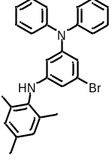
Under argon atmosphere, compound 1 (8.0 g, 20 mmol), 2,4,6-trimethylaniline (2.7 g, 20 mmol), sodium tert-butoxide (7.7 g, 40 mmol), 1,1'-bis(diphenylphosphino)ferrocene (559 mg, 1 mmol) and tris(dibenzylideneacetone)dipalladium (100 mg) were added into a 100 mL two necked round bottom flask. After 45 mL degassed xylene was added into the flask, the reaction was allowed heating up to 90 ºC and stirred for 12 h. The reaction mixture was allowed to cool to room temperature and extracted with dichloromethane (25 mL) for three times, the organic ingredients were dried over Na₂SO₄ for 15 min and removed by a rotatory evaporation. The crude product was purified by silica gel column chromatography, intermediate 6 was obtained as a white solid (4.0 g, 44%). ¹H NMR (500 MHz, CDCl₃) δ 7.23 (t, J = 7.5 Hz, 4H), 7.07 (d, J = 8.0 Hz, 4H), 7.01 (t, J = 7.5 Hz, 2H), 6.86 (s, 2H), 6.52 (t, J = 1.5 Hz, 1H), 6.14 (d, J = 1.5 Hz, 2H), 4.97 (s, 1H), 2.25 (s, 3H), 2.13 (s, 6H). ¹³C NMR (125 MHz, CDCl₃) δ 149.94, 148.69, 147.34, 135.99, 135.93, 134.52, 129.28, 129.25, 124.77, 123.57, 123.19, 116.06, 109.93, 107.21, 20.93, 18.25.

Synthesis of N¹,N³-dimesityl-N¹,N⁵,N⁵-triphenylbenzene-1,3,5-triamine (7)
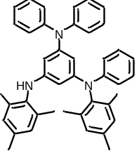
Under argon atmosphere, compound 6 (2.3 g, 5 mmol), 2,4,6-trimethyl-N-phenylaniline (2.1 g, 10 mmol), sodium tert-butoxide (960 g, 10 mmol), 2-dicyclohexylphosphino-2',6'-dimethoxybiphenyl (205 mg, 0.5 mmol) and tris(dibenzylideneacetone)dipalladium (100 mg) were added into a 100 mL two necked round bottom flask. After 25 mL degassed xylene was added into the flask, the reaction was allowed heating up to 120 ºC and stirred for 5 h. The reaction mixture was allowed to cool to room temperature and extracted with dichloromethane (25 mL) for three times, the organic ingredients were dried over Na₂SO₄ for 15 min and removed by a rotatory evaporation. The crude product was purified by silica gel column chromatography, intermediate 7 was obtained as a white solid (2.1 g, 74%). ¹H NMR (500 MHz, CDCl₃) δ 7.16 (t, J = 7.8 Hz, 4H), 7.08–6.99 (m, 6H), 6.90 (t, J = 7.5 Hz, 2H), 6.88–6.82 (m, 4H), 6.78–6.70 (m, 3H), 6.22 (t, J = 2.0 Hz, 1H), 5.77–5.58 (m, 2H), 4.85 (s, 1H), 2.29 (s, 3H), 2.20 (s, 3H), 2.06 (s, 6H), 1.95 (s, 6H). ¹³C NMR (125 MHz, CDCl₃) δ 148.90, 148.28, 147.67, 147.38, 145.91, 140.15, 137.48, 136.36, 135.46, 135.32, 134.89, 129.68, 128.95, 128.79, 128.72, 123.64, 121.99, 120.08, 119.27, 107.36, 103.03, 100.80, 21.00, 20.81, 18.46, 18.16.

Synthesis of N¹-(3-(diphenylamino)-5-(p-tolyloxy)phenyl)-N¹,N³-dimesityl-N³,N⁵,N⁵
-triphenylbenzene-1,3,5-triamine (8)
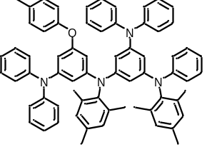
Intermediate 8 was synthesized according to the same procedure described above for the synthesis of compound 2. Compound 8 (yield: 89%) was obtained as a white solid. ¹H NMR (500 MHz, CDCl₃) δ 7.17–7.09 (m, 8H), 7.04–6.93 (m, 12H), 6.93–6.84 (m, 4H), 6.80–6.73 (m, 6H), 6.71 (t, J = 7.5 Hz, 1H), 6.68 (s, 2H), 6.34 (t, J = 2.0 Hz, 1H), 6.27 (t, J = 2.0 Hz, 1H), 6.22 (d, J = 2.0 Hz, 1H), 6.17 (t, J = 2.0 Hz, 1H), 6.09–6.01 (m, 2H), 2.24 (d, J = 6.5 Hz, 6H), 2.19 (s, 3H), 1.87 (s, 6H), 1.83 (s, 6H). ¹³C NMR (125 MHz, CDCl₃) δ 158.06, 155.00, 149.17, 148.61, 147.95, 147.41, 147.33, 146.92, 146.62, 145.56, 139.69, 139.63, 137.22, 136.71, 136.36, 136.27, 131.91, 129.92, 129.56, 129.52, 128.99, 128.85, 128.79, 124.03, 123.59, 122.57, 122.16, 120.19, 118.97, 117.73, 109.86, 109.51, 109.45, 107.28, 106.80, 104.68, 20.97, 20.89, 20.62, 18.20.
Synthesis of DPA-B3
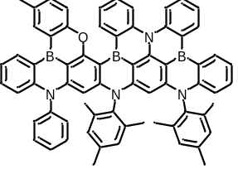
Final product DPA-B3 was synthesized according to the same procedure described above for the synthesis of compound DPA-B2, using 8 (562 mg, 0.6 mmol) instead of compound 2. Final product DPA-B3 (187 mg, 39%) was obtained as a pale yellow solid. ¹H NMR (500 MHz, CDCl₃) δ 8.99 (d, J = 7.5 Hz, 3H), 8.88 (d, J = 7.5 Hz, 1H), 8.69 (s, 1H), 8.49 (d, J = 8.5 Hz, 1H), 8.30 (d, J = 8.5 Hz, 1H), 7.66 (d, J = 8.5 Hz, 1H), 7.64–7.60 (m, 1H), 7.59–7.53 (m, 2H), 7.53–7.42 (m, 5H), 7.42–7.35 (m, 3H), 7.31 (t, J = 7.5 Hz, 1H), 7.15 (d, J = 7.5 Hz, 2H), 6.92 (s, 1H), 6.88–6.83 (m, 2H), 6.80 (d, J = 9.0 Hz, 1H), 6.71 (s, 1H), 6.65 (s, 1H), 5.41 (s, 1H), 5.27 (s, 1H), 2.65 (s, 3H), 2.38 (s, 6H), 1.69 (s, 3H), 1.61 (d, J = 7.0 Hz, 6H), 1.50 (s, 3H). ¹³C NMR (125 MHz, CDCl₃) δ 163.66, 158.42, 154.88, 150.24, 149.26, 148.06, 148.01, 147.85, 146.82, 146.74, 146.63, 145.72, 141.67, 137.91, 137.33, 136.83, 136.51, 136.30, 136.22, 136.13, 136.05, 135.75, 135.17, 135.08, 134.53, 133.90, 133.30, 131.73, 131.71, 131.54, 131.51, 131.37, 130.58, 130.40, 129.82, 129.64, 129.36, 129.16, 128.99, 128.88, 128.85, 127.88, 125.18, 124.11, 123.42, 123.07, 122.28, 120.42, 120.04, 118.47, 117.04, 115.52, 94.79, 90.45, 21.41, 21.11, 17.09, 17.02, 16.84. HRMS (MALDI-TOF/MS) m/z [M]⁺ calcd for C₆₇H₅₂ON₄B₃ 961.4415, observed 961.4417.

Synthesis of N¹,N³-bis(3-(diphenylamino)-5-(p-tolyloxy)phenyl)-N¹,N³-dimesityl-N⁵,N⁵
-diphenylbenzene-1,3,5-triamine (10)
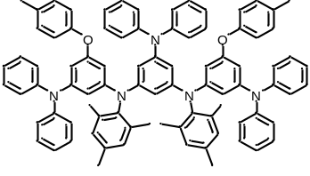
Under argon atmosphere, compound 5 (5.2 g, 12 mmol), intermediate 9 (2.6 g, 5 mmol), sodium tert-butoxide (3.8 g, 40 mmol), 2-dicyclohexylphosphino-2',6'-dimethoxybiphenyl (410 mg, 1 mmol) and tris(dibenzylideneacetone)dipalladium (100 mg) were added into a 100 mL two necked round bottom flask. After 30 mL degassed xylene was added into the flask, the reaction was allowed heating up to 140 ºC and stirred for 6 h. The reaction mixture was allowed to cool to room temperature and extracted with dichloromethane (25 mL) for three times, the organic ingredients were dried over Na₂SO₄ for 15 min and removed by a rotatory evaporation. The crude product was purified by silica gel column chromatography, compound 10 was obtained as a white solid (5.3 g, 88%). ¹H NMR (500 MHz, CDCl₃) δ 7.11 (q, J = 7.5 Hz, 12H), 6.98 (d, J = 8.5 Hz, 4H), 6.96–6.91 (m, 12H), 6.88 (t, J = 7.5 Hz, 4H), 6.84 (t, J = 7.5 Hz, 2H), 6.73 (d, J = 8.5 Hz, 4H), 6.65 (s, 4H), 6.33–6.23 (m, 4H), 6.15 (t, J = 1.5 Hz, 2H), 6.06 (t, J = 1.5 Hz, 2H), 5.78 (d, J = 1.5 Hz, 1H), 2.23 (s, 6H), 2.18 (s, 6H), 1.78 (s, 12H). ¹³C NMR (125 MHz, CDCl₃) δ 158.07, 154.96, 149.11, 148.42, 147.72, 147.36, 147.29, 146.60, 139.60, 136.71, 136.25, 131.93, 129.93, 129.50, 128.99, 128.94, 123.98, 123.53, 122.57, 122.20, 117.76, 110.02, 109.82, 107.43, 106.89, 104.82, 18.15.

Synthesis of DPA-B4
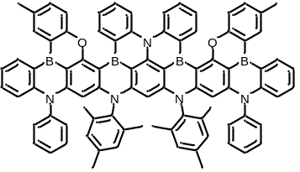
Under argon atmosphere, compound 5 (605 mg, 0.5 mmol) was dissolved in 15 mL ultradry o-dichlorobenzene. BBr₃ (2.2 mL, 24 mmol) was injected into the mixture at argon atmosphere quickly. The reaction was allowed heating up to 200 ºC and stirred for 48 h. The reaction mixture was allowed to cool to room temperature and excess N,N-dimethyltriethylamine was added into the system slowly in an ice-bath. The mixture was extracted with dichloromethane (25 mL) for three times, the organic ingredients were dried over Na₂SO₄ for 15 min and removed by a rotatory evaporation. The crude product was purified by silica gel column chromatography, DPA-B4 was obtained as a yellow powder solid (335 mg, 54%). ¹H NMR (500 MHz, CDCl₃) δ 9.01–8.92 (m, 4H), 8.66 (d, J = 2.0 Hz, 2H), 8.42 (d, J = 8.5 Hz, 2H), 7.66 (d, J = 8.5 Hz, 2H), 7.61–7.51 (m, 4H), 7.44–7.36 (m, 8H), 7.36–7.29 (m, 2H), 7.28–7.23 (m, 2H), 7.08 (d, J = 6.5 Hz, 4H), 6.75 (d, J = 8.5 Hz, 2H), 6.61 (s, 2H), 6.53 (s, 2H), 5.36 (s, 2H), 5.21 (s, 1H), 2.62 (s, 6H), 2.28 (s, 6H), 1.52 (s, 6H), 1.39 (s, 6H). ¹³C NMR (126 MHz, CDCl₃) δ 162.63, 157.37, 149.06, 148.12, 146.78, 146.51, 145.69, 144.81, 140.63, 136.21, 135.40, 134.99, 134.96, 134.63, 134.12, 132.82, 132.24, 130.65, 130.43, 129.49, 128.76, 127.98, 127.94, 127.82, 126.78, 122.66, 122.46, 120.91, 118.94, 117.46, 115.94, 110.56, 109.66, 103.50, 93.68, 89.95, 20.36, 19.91, 15.78, 15.68. HRMS (MALDI-TOF/MS) m/z [M]⁺ calcd for C₈₆H₆₄O₂N₅B₄ 1242.5427, observed 1242.5475.

Synthesis of 5-(9H-carbazol-9-yl)-N1,N3-dimesitylbenzene-1,3-diamine (12)
Under argon atmosphere, compound 11 (2.0 g, 5 mmol), 2,4,6-trimethylaniline (1.6 g, 12 mmol), sodium tert-butoxide (1.9 g, 20 mmol), 1,1-bis(diphenyphosphino)ferrocene (559 mg, 1 mmol) and tris(dibenzylideneacetone)dipalladium (65 mg) were added into a 150 mL two necked round bottom flask. After 60 mL degassed xylene was added into the flask, the reaction was allowed heating up to 90 ºC and stirred for 12 h. The reaction mixture was allowed to cool to room temperature and extracted with dichloromethane (35 mL) for three times, the organic ingredients were dried over Na₂SO₄ for 15 min and removed by a rotatory evaporation. The crude product was purified by silica gel column chromatography, compound 12 was obtained as a gray oily liquid (2.1 g, 83%). ¹H NMR (400 MHz, CDCl₃) δ 8.05 (d, J = 7.6 Hz, 2H), 7.46–7.31 (m, 4H), 7.24–7.15 (m, 2H), 6.87 (s, 4H), 6.00–5.90 (m, 2H), 5.83–5.77 (m, 1H), 5.06 (s, 2H), 2.25 (s, 18H). ¹³C NMR (100 MHz, CDCl₃) δ 149.14, 140.90, 139.47, 136.13, 135.68, 135.33, 129.25, 125.60, 123.03, 120.07, 119.32, 110.33, 102.10, 97.48, 20.90, 18.35.

Synthesis of N¹,N¹'-(5-(9H-carbazol-9-yl)-1,3-phenylene)bis(N¹-mesityl-N³,N³-
diphenyl-5-(p-tolyloxy)benzene-1,3-diamine) (13)
Compound 13 was synthesized according to the same procedure described above for the synthesis of compound 10, using 12 (510 mg, 1 mmol) instead of compound 9. Compound 13 (1.1 g, 89%) was obtained as a yellow solid. ¹H NMR (400 MHz, CDCl₃) δ 8.11 (d, J = 8.0 Hz, 2H), 7.27 (d, J = 7.2 Hz, 2H), 7.21 (t, J = 7.2 Hz, 4H), 7.04 – 6.88 (m, 20H), 6.80 – 6.71 (m, 12H), 6.61 (t, J = 1.8 Hz, 2H), 6.49 – 6.43 (m, 2H), 6.31 – 6.25 (m, 1H), 6.25 – 6.21 (m, 2H), 6.19 – 6.13 (m, 2H), 2.22 (s, 12H), 1.90 (s, 12H). ¹³C NMR (125 MHz, CDCl₃) δ 158.41, 154.90, 149.49, 147.47, 147.26, 140.41, 139.56, 138.53, 136.90, 136.82, 132.20, 130.04, 129.86, 129.06, 125.94, 124.15, 123.35, 122.83, 120.17, 119.76, 117.91, 110.47, 110.19, 110.00, 109.13, 107.29, 105.40, 21.04, 20.68, 18.33.

Synthesis of Compound Cz-B4
Final product Cz-B4 was synthesized according to the same procedure described above for the synthesis of compound DPA-B4, using 13 (605 mg, 0.5 mmol) instead of compound 10. Compound Cz-B4 (291 mg, 47%) was obtained as a yellow solid. ¹H NMR (500 MHz, CDCl₃) δ 9.51 (d, J = 7.5 Hz, 2H), 8.97 (d, J = 7.5 Hz, 2H), 8.69 (s, 2H), 8.58 (d, J = 7.5 Hz, 2H), 7.90 – 7.82 (m, 4H), 7.62 (d, J = 11.0 Hz, 2H), 7.46 – 7.33 (m, 8H), 7.28 (t, J = 7.5 Hz, 2H), 7.12 (d, J = 7.0 Hz, 4H), 6.78 (d, J = 8.5 Hz, 2H), 6.62 (s, 4H), 5.43 (s, 2H), 5.34 (s, 1H), 2.64 (s, 6H), 2.32 (s, 6H), 1.54 (s, 12H). The ¹³C spectrum unable to achieved due to the poor solubility. HRMS (MALDI-TOF/MS) m/z [M+H]⁺ calcd for C₈₆H₆₂O₂N₅B₄ 1239.52702, observed 1240.52940

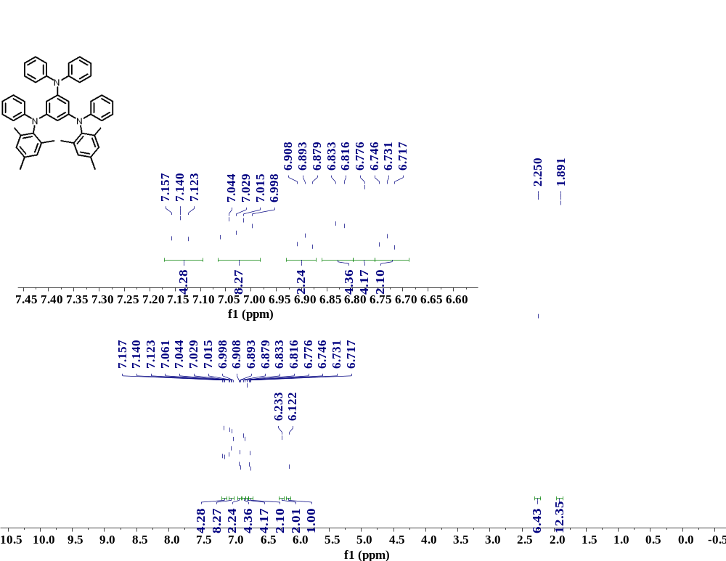 Supplementary Fig. 1. ¹H NMR spectrum of compound 2.

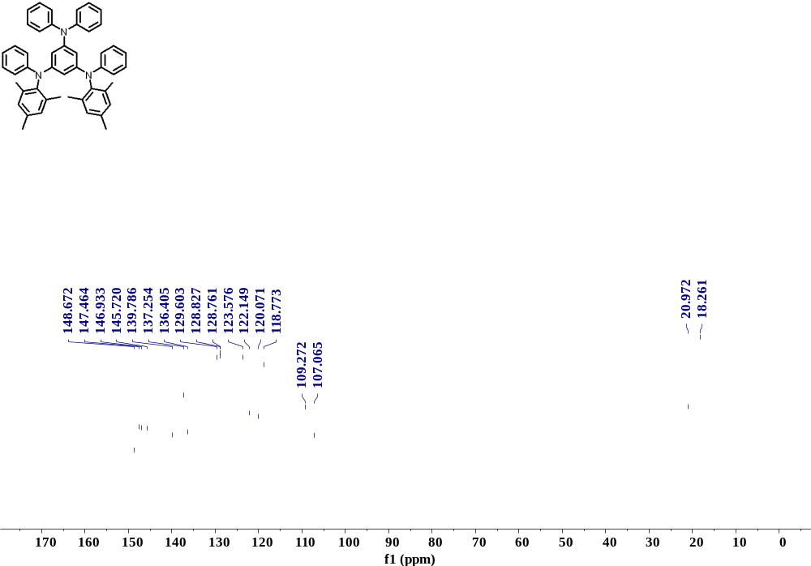

Supplementary Fig. 2. ¹³C NMR spectrum of compound 2.

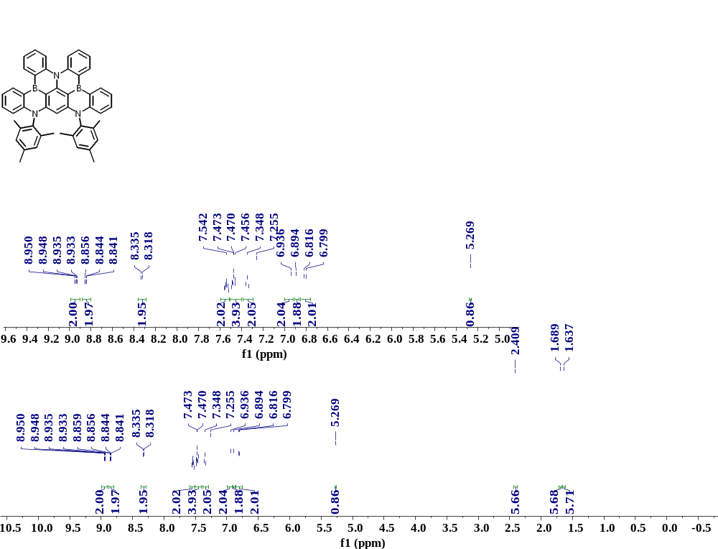

Supplementary Fig. 3. ¹H NMR spectrum of DPA-B2.

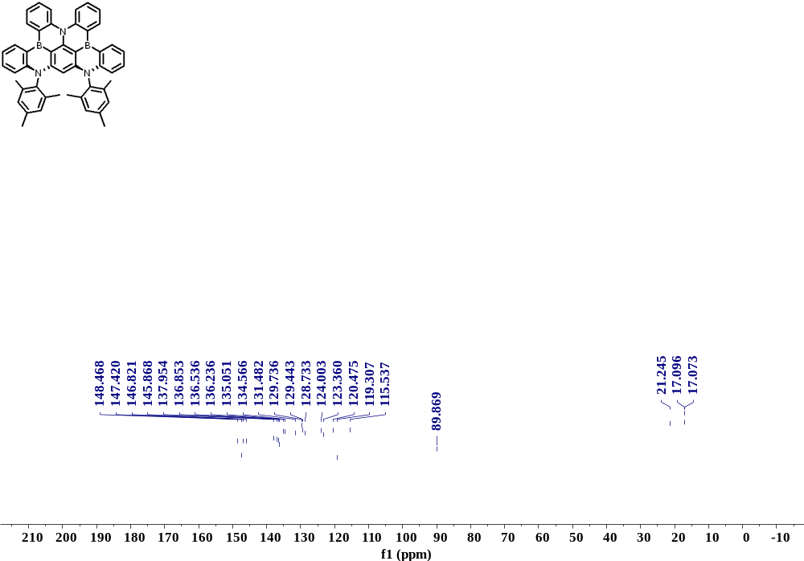

Supplementary Fig. 4. ¹³C NMR spectrum of DPA-B2.

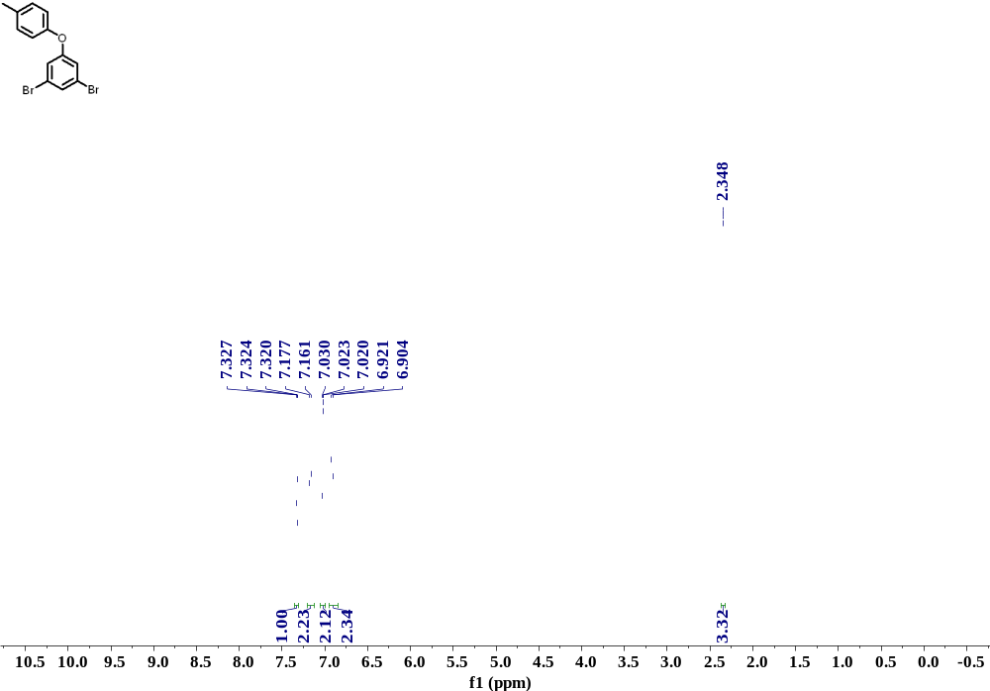

Supplementary Fig. 5. ¹H NMR spectrum of compound 4.

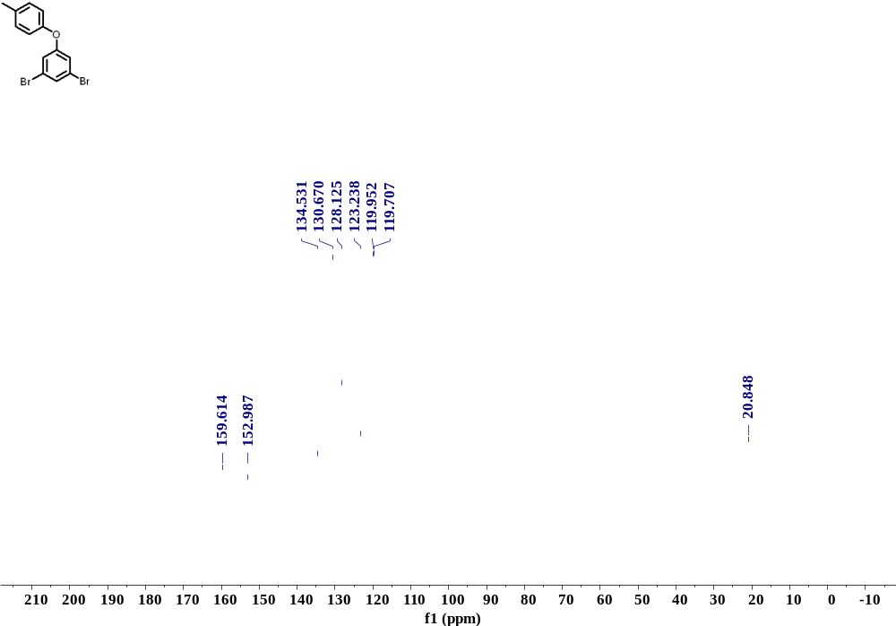

Supplementary Fig. 6. ¹³C NMR spectrum of compound 4.

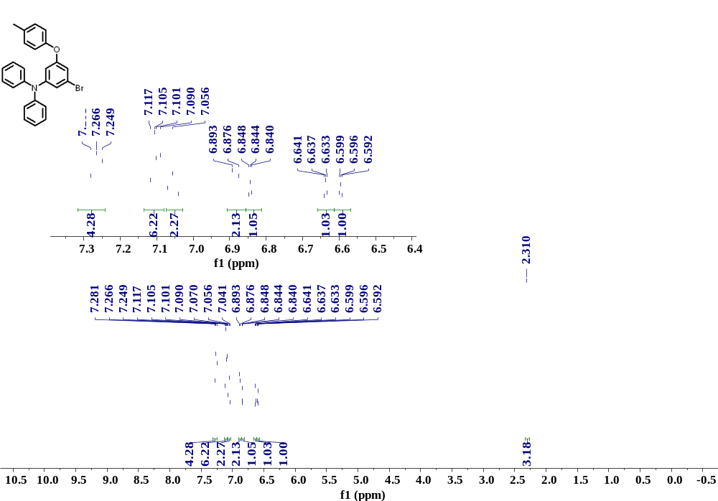

Supplementary Fig. 7. ¹H NMR spectrum of compound 5.

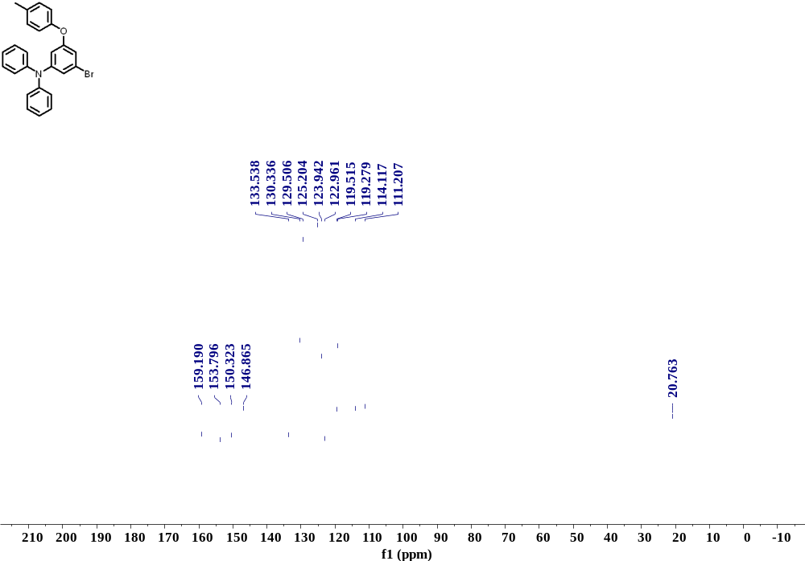

Supplementary Fig. 8. ¹³C NMR spectrum of compound 5.

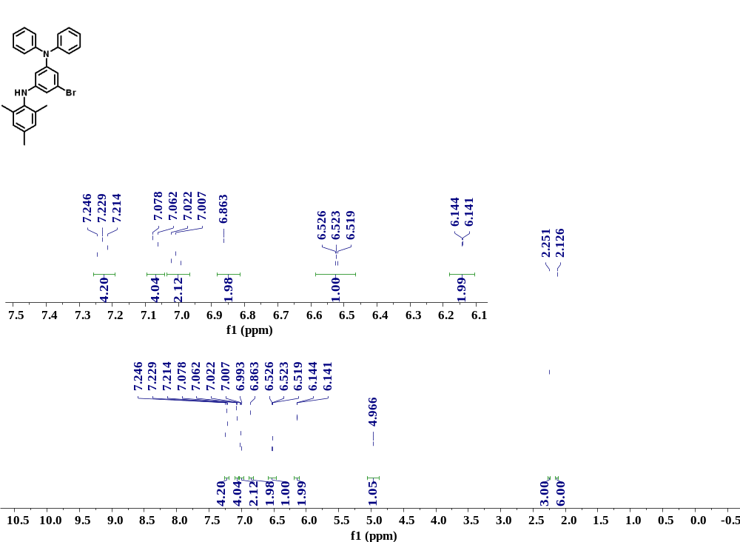

Supplementary Fig. 9. ¹H NMR spectrum of compound 6.

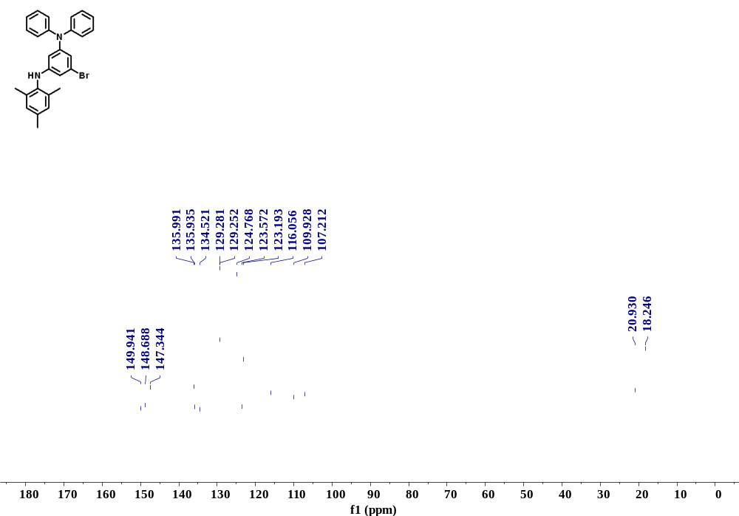

Supplementary Fig. 10. ¹³C NMR spectrum of compound 6.

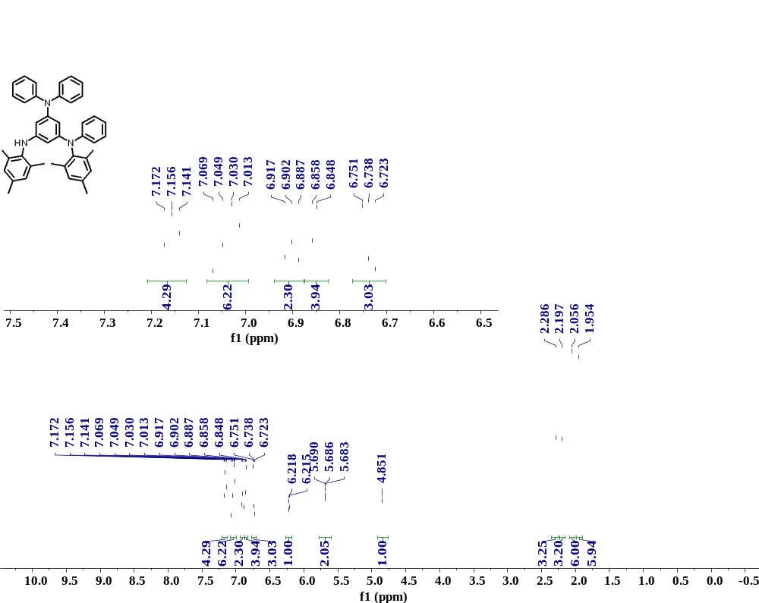

Supplementary Fig. 11. ¹H NMR spectrum of compound 7.

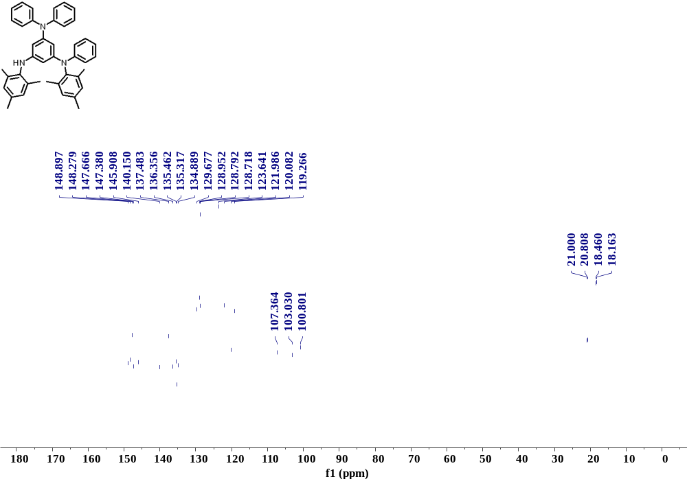

Supplementary Fig. 12. ¹H NMR spectrum of DPA-B2.

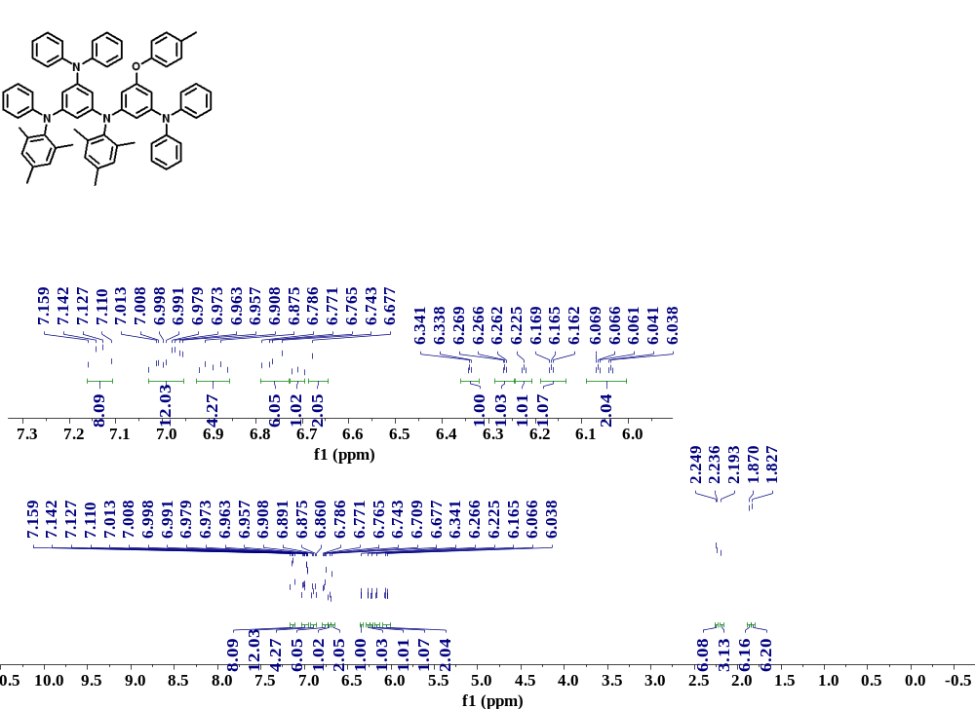

Supplementary Fig. 13. ¹H NMR spectrum of compound 8.

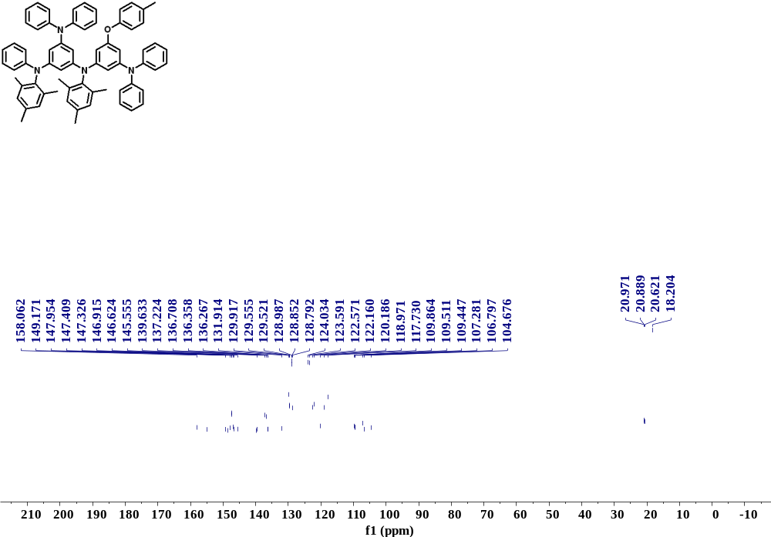

Supplementary Fig. 14. ¹³C NMR spectrum of compound 8.

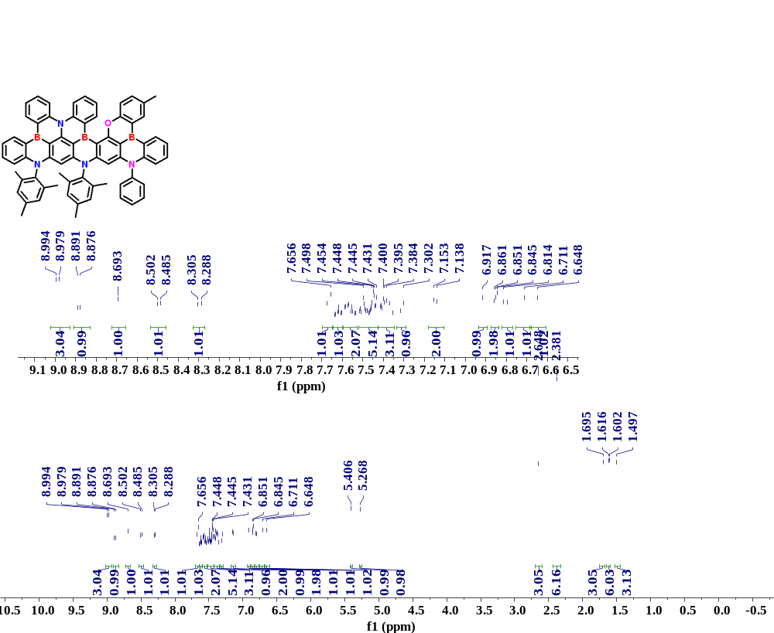

Supplementary Fig. 15. ¹H NMR spectrum of DPA-B3.
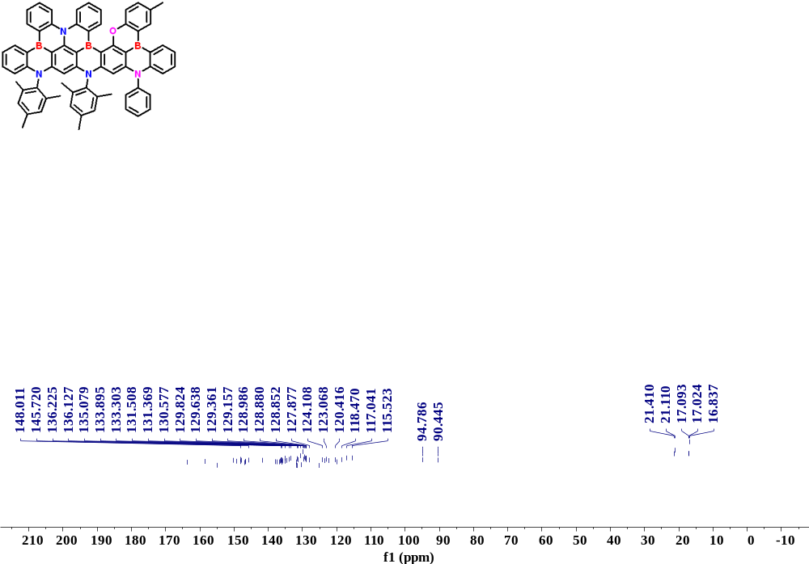

Supplementary Fig. 16. ¹³C NMR spectrum of DPA-B3.
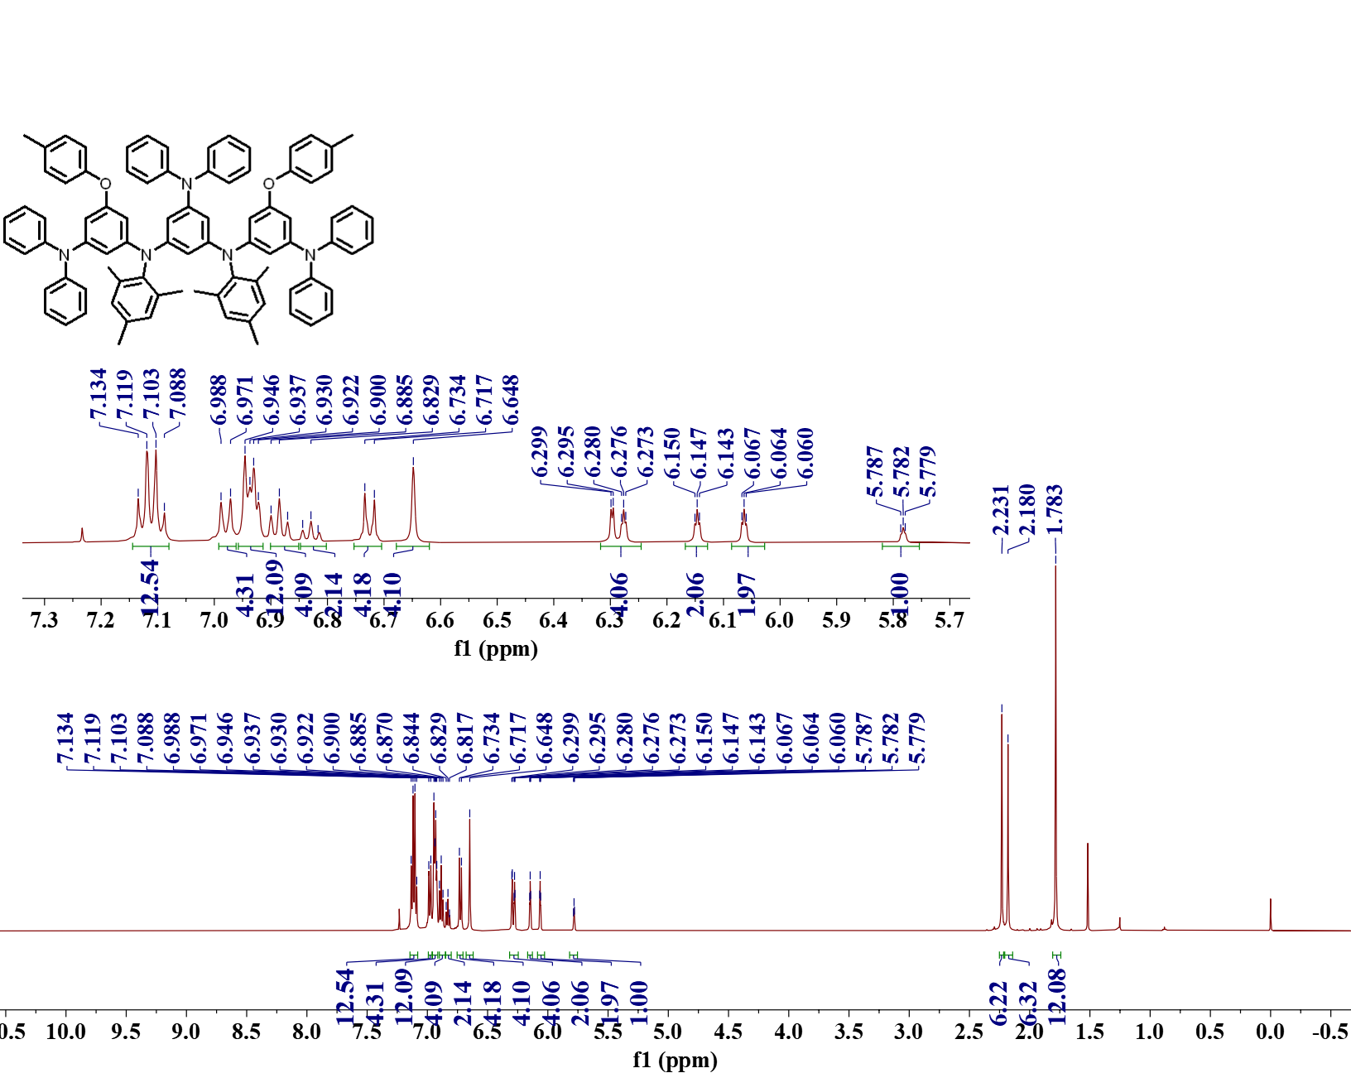

Supplementary Fig. 17. ¹H NMR spectrum of compound 10.

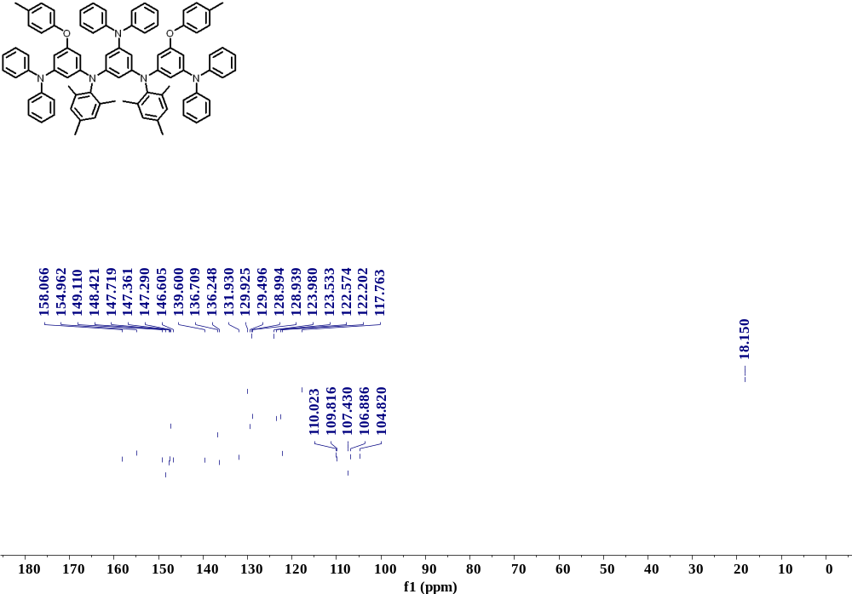

Supplementary Fig. 18. ¹³C NMR spectrum of compound 10.

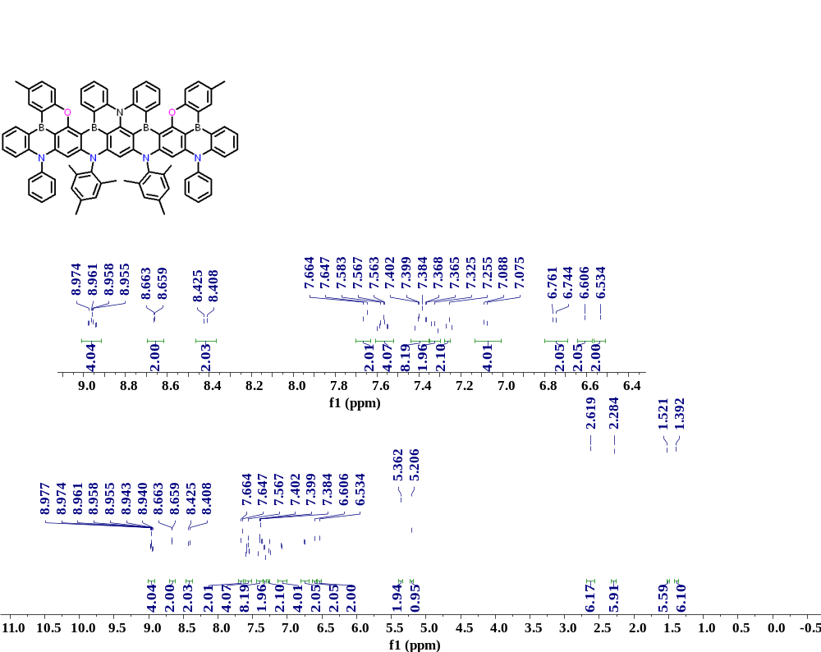

Supplementary Fig. 19. ¹H NMR spectrum of DPA-B4.

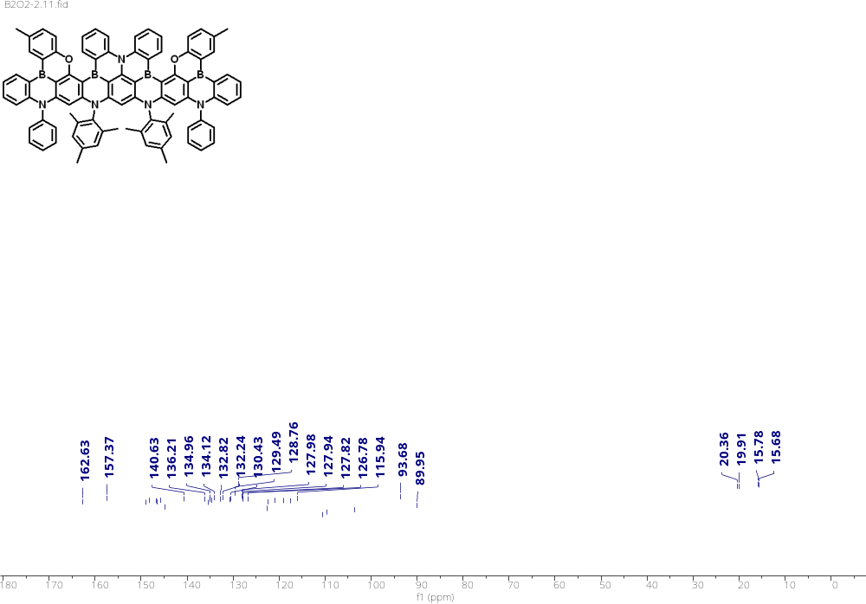

Supplementary Fig. 20. ¹³C NMR spectrum of DPA-B4.

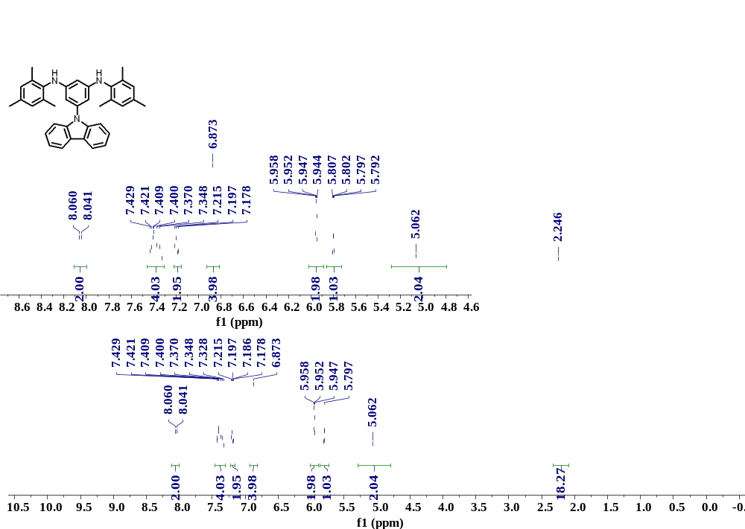

Supplementary Fig. 21. ¹H NMR spectrum of compound 12.

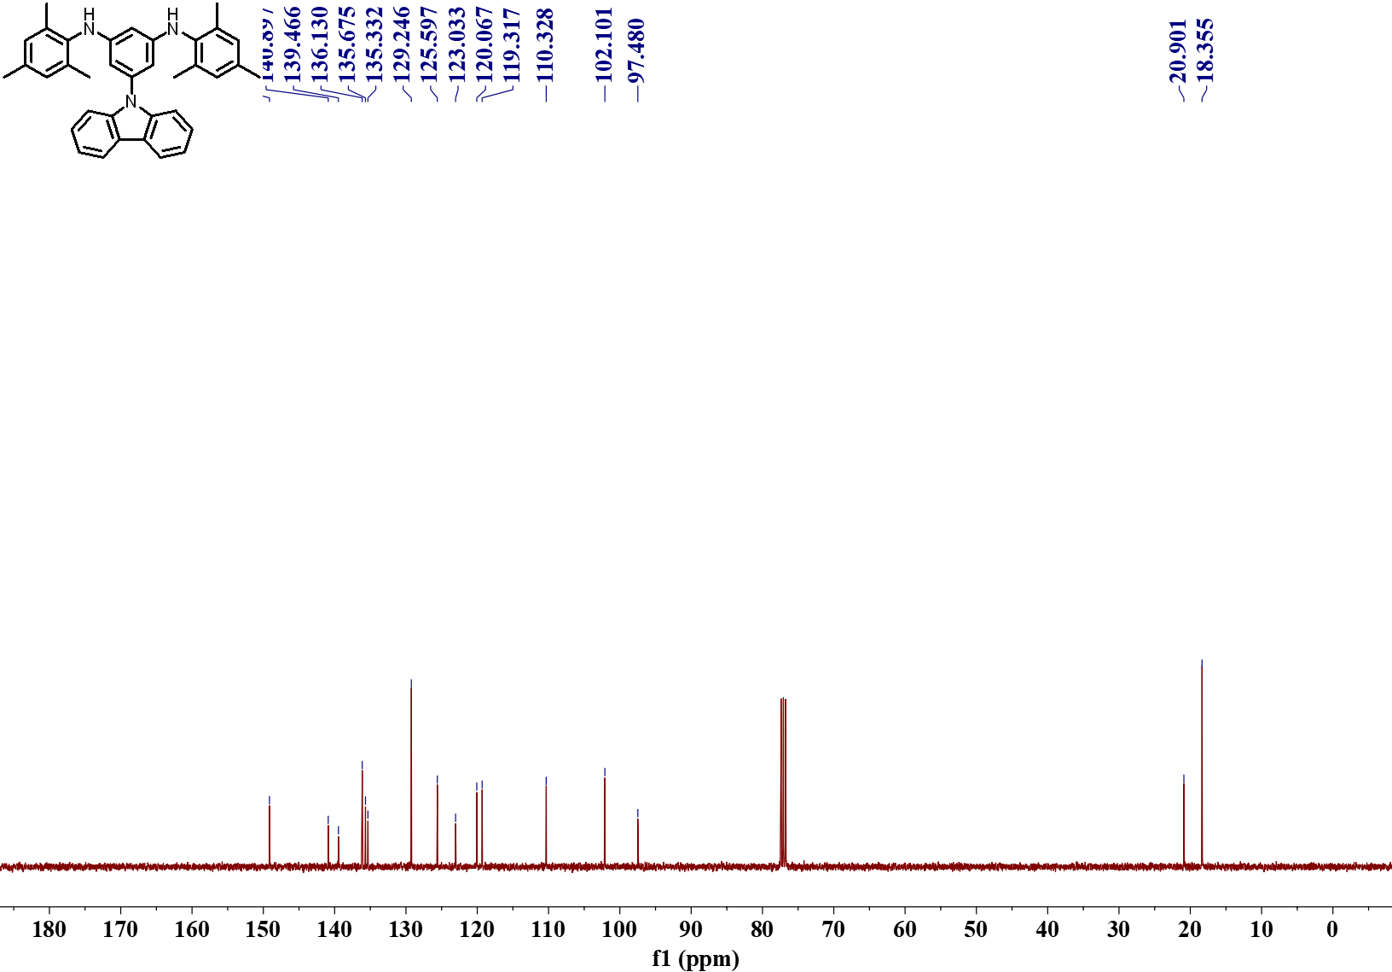

Supplementary Fig. 22. ¹³C NMR spectrum of compound 12.

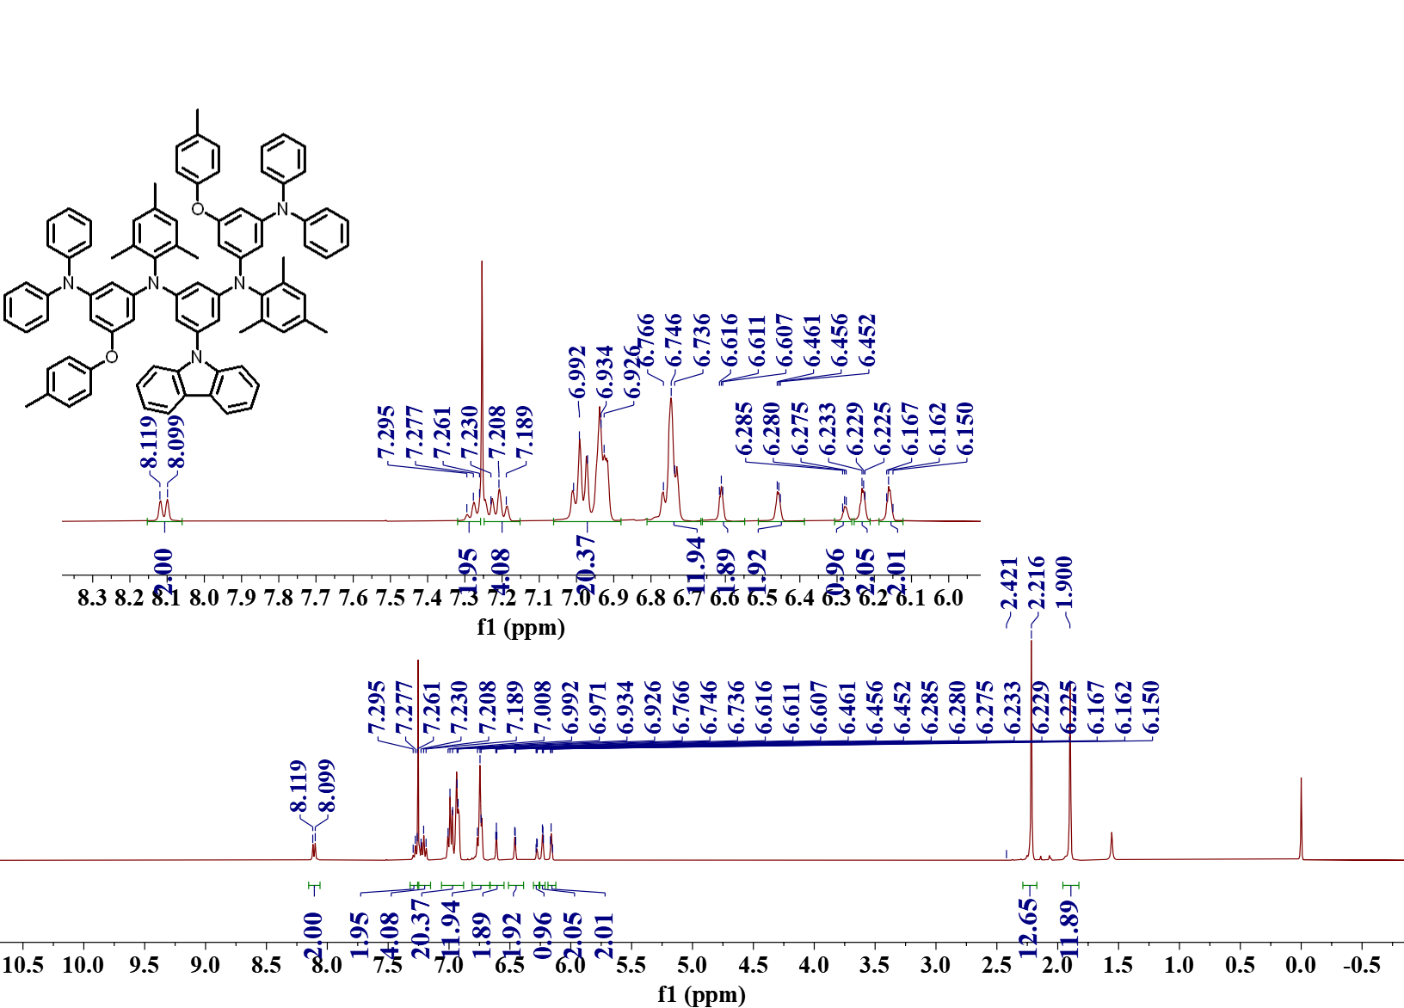

Supplementary Fig. 23. ¹H NMR spectrum of compound 13.

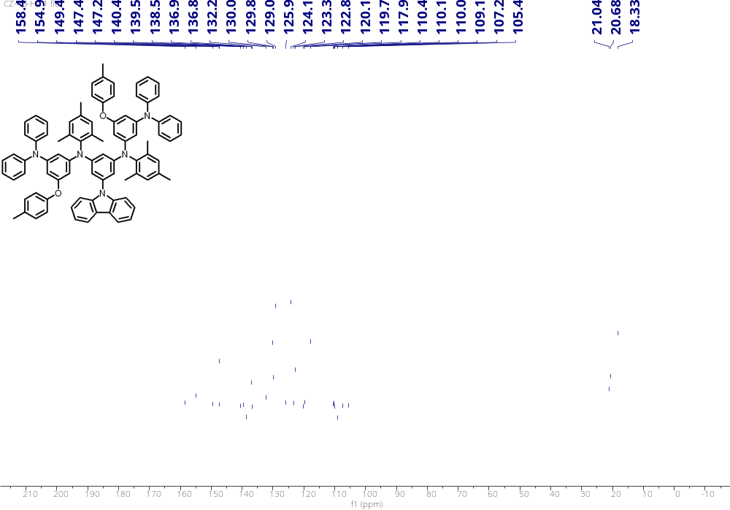

Supplementary Fig. 24. ¹³C NMR spectrum of compound 13.

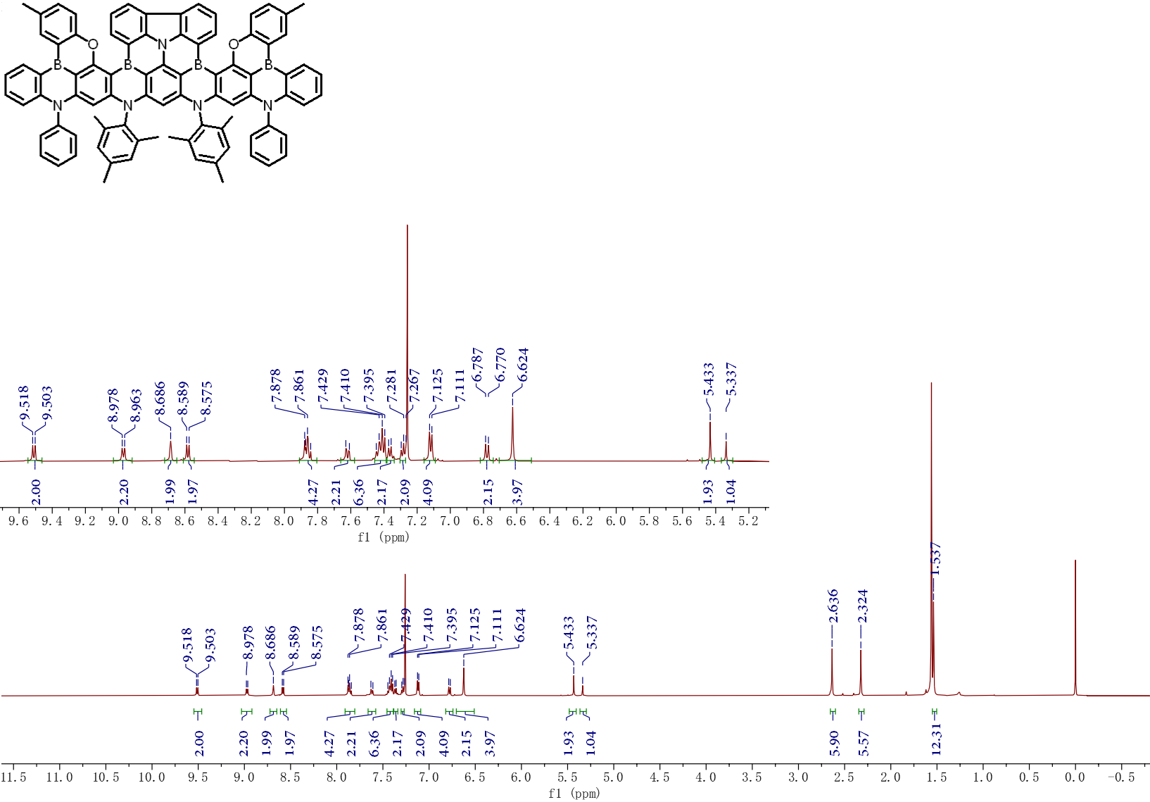

Supplementary Fig. 25. ¹H NMR spectrum of Cz-B4.

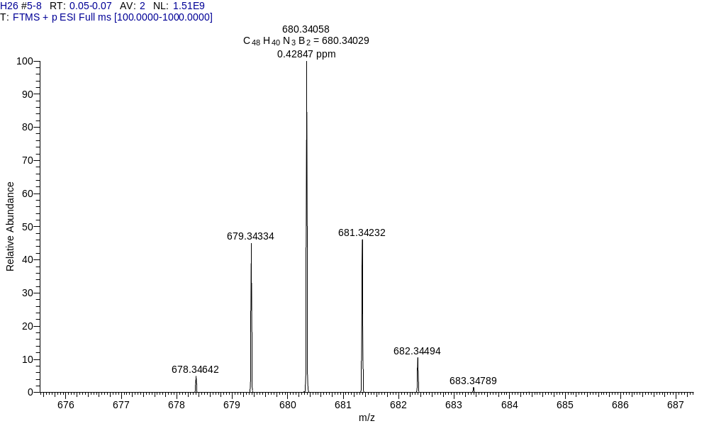

Supplementary Fig. 26. The HR-MS spectrum of DPA-B2.

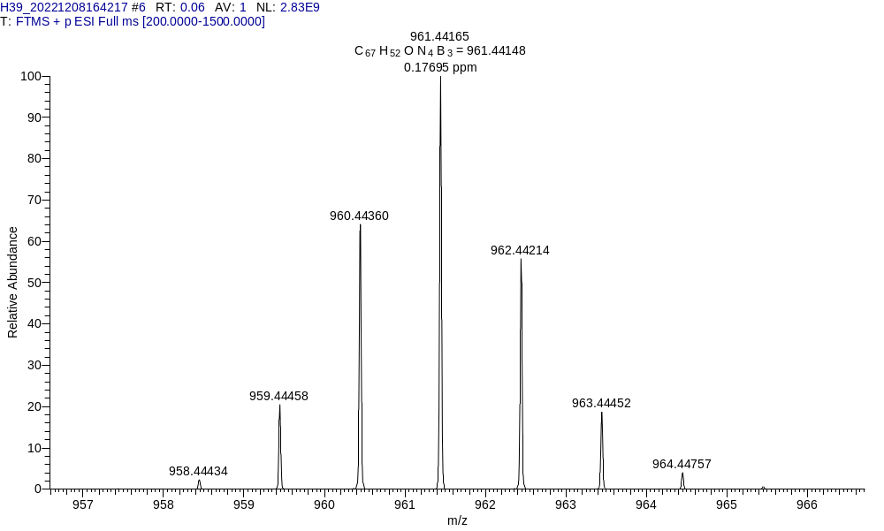

Supplementary Fig. 27. The HR-MS spectrum of DPA-B3.

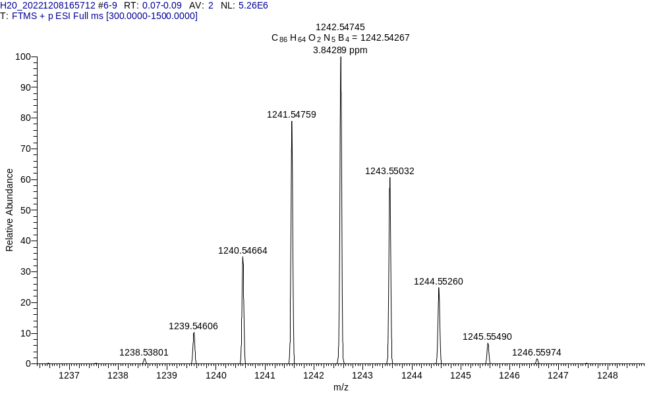

Supplementary Fig. 28. The HR-MS spectrum of DPA-B4.

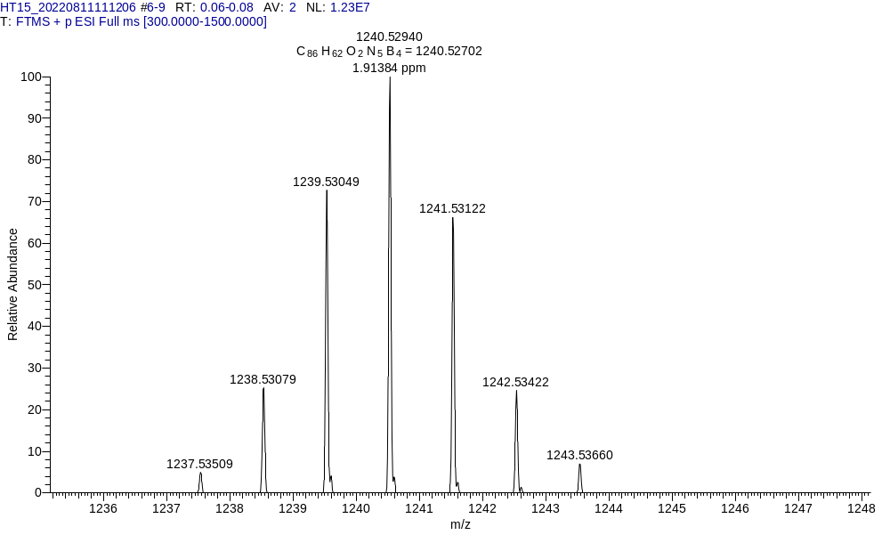

Supplementary Fig. 29. The HR-MS spectrum of Cz-B4.

Quantum Chemical Calculations: Theoretical chemical calculations were performed by the Gaussian 16 program package. Density functional theory (DFT) and Time-dependent DFT (TD-DFT) calculations were performed at the B3LYP-B3(DJ)/6-31G(d,p) level to attain the optimized molecular geometries. The HOMO and LUMO were obtained on the basis of the optimized geometric configurations. The SOC matrix elements was assessed using PySOC. The singlet and triplet energy levels were obtained based on SCS-CC2/cc-pVDZ level using the MRCC program⁵⁸⁻⁵⁹. Huang-Rhys factor and reorganization energy analysis were obtained by the MOMAP (Molecular Materials Property Prediction Package)⁶⁰⁻⁶¹.

Supplementary Fig. 30 The optimized configuration and dihedral angle of DPA-B2, DPA-B3, DPA-B4, and Cz-B4 at ground state.

Supplementary Fig. 31. The reorganization energy and Huang-Rhys factor versus frequency plots for ν-DABNA.

Supplementary Fig. 32. The RMSD values of DPA-B2 (a), DPA-B3 (b), DPA-B4 (c), and Cz-B4 (d).

Supplementary Fig. 33. Vibrational modes with large contribution to reorganization energies of DPA-B2, DPA-B3, DPA-B4, and Cz-B4 in the ground state.

Supplementary Fig. 34. Huang-Rhys factor versus frequency plots of DPA-B2, DPA-B3, DPA-B4, and Cz-B4.

Supplementary Fig. 35. Calculated natural transition orbitals (NTOs) and dominant transition of DPA-B2, DPA-B3, DPA-B4, and Cz-B4 for S₁ states.
Thermal Characterization: A TGA Q50 (TA instrument) thermal analysis system was employed to analyze thermal gravimetric analysis (TGA) ranging from 50 ℃ to 800 ℃ with a heating rate of 10 ℃ min⁻¹ under nitrogen flushing.

Supplementary Fig. 36. TGA curves of a) DPA-B2, b) DPA-B3, c) DPA-B4, and d) Cz-B4.

Electrochemical Characterization: Cyclic voltammograms (CV) were obtained in dichloromethane at room temperature with a CHI600 electrochemical workstation at 25 ℃ and a scan speed of 50 mV s⁻¹. The electrochemical oxidation potentials were collected by cyclic voltammetry measurements via a CHI660 electrochemical workstation (Chenhua, China) and ferroceniumferrocene (Fc/Fc⁺) was used as the internal reference, tetrabutylammonium hexafluorophosphate (0.1 M) was used as the supporting electrolyte. A platinum plate electrode was utilized as the working electrode, a platinum wire was utilized as the counter electrode and Ag/AgCl as reference electrode. The reduction potentials were calculated from E_{ox} and E_{g}, the optical bandgaps (E_{g}) were estimated from the onset of the absorption spectra.

Supplementary Fig. 37. Cyclic voltammetry curves of a) DPA-B2, b) DPA-B3 and c) DPA-B4, and d) Cz-B4 in dichloromethane.

Supplementary Fig. 38. The single crystal structures and packing diagrams of DPA-B3 (a) and DPA-B4 (b).

Supplementary Table 1. Crystal data and structure refinement for DPA-B3 (deposition number: 2299738)
Empirical formula | C₆₇H₅₂B₃N₄O
Formula weight | 961.44
Temperature/K | 170.00
Crystal system | monoclinic
Space group | P2₁/n
a/Å | 9.7546(16)
b/Å | 29.024(5)
c/Å | 22.660(4)
α/° | 90
β/° | 99.062(5)
γ/° | 90
Volume/Å³ | 6335.3(18)
Z | 4
ρ_{calc}g/cm³ | 1.383
μ/mm⁻¹ | 2.665
F(000) | 2712.0
Crystal size/mm³ | 0.16 × 0.08 × 0.03
Radiation | GaKα (λ = 1.34139)
2Θ range for data collection/° | 4.338 to 121.524
Index ranges | -12 ≤ h ≤ 12, -37 ≤ k ≤ 37, -29 ≤ l ≤ 29
Reflections collected | 147068
Independent reflections | 14551 [R_{int} = 0.0960, R_{sigma} = 0.0509]
Data/restraints/parameters | 14551/0/791
Goodness-of-fit on F² | 1.083
Final R indexes [I>=2σ (I)] | R₁ = 0.0759, wR₂ = 0.2286
Final R indexes [all data] | R₁ = 0.1034, wR₂ = 0.2532
Largest diff. peak/hole / e Å⁻³ | 1.21/-1.29

Supplementary Table 2. Crystal data and structure refinement for DPA-B4 (deposition number: 2299737).
Empirical formula | C₈₆H₆₃B₄N₅O₂
Formula weight | 1241.65
Temperature/K | 170.00
Crystal system | monoclinic
Space group | C2/c
a/Å | 23.550(4)
b/Å | 25.550(5)
c/Å | 22.801(4)
α/° | 90
β/° | 98.419(5)
γ/° | 90
Volume/Å³ | 13572(4)
Z | 8
ρ_{calc}g/cm³ | 1.215
μ/mm⁻¹ | 0.353
F(000) | 5200.0
Crystal size/mm³ | 0.09 × 0.06 × 0.04
Radiation | GaKα (λ = 1.34139)
2Θ range for data collection/° | 4.466 to 119.122
Index ranges | -29 ≤ h ≤ 30, -32 ≤ k ≤ 32, -29 ≤ l ≤ 29
Reflections collected | 76411
Independent reflections | 15010 [R_{int} = 0.0821, R_{sigma} = 0.0690]
Data/restraints/parameters | 15010/0/882
Goodness-of-fit on F² | 1.073
Final R indexes [I>=2σ (I)] | R₁ = 0.0614, wR₂ = 0.1645
Final R indexes [all data] | R₁ = 0.0962, wR₂ = 0.1835
Largest diff. peak/hole / e Å⁻³ | 0.35/-0.54

Supplementary Fig. 39. Solvatochromic effect of (a) DPA-B2, (b) DPA-B3 and (c) DPA-B4, and (d) Cz-B4 in different solvents. (Hexane, toluene, dichloromethane and acetonitrile).

Supplementary Fig. 40. The low temperature (77 K) fluorescent spectra (FL) and phosphorescent spectra (Phos) of (a) DPA-B2, (b) DPA-B3 and (c) DPA-B4, and (d) Cz-B4 in toluene solution.

Supplementary Fig. 41. The low temperature (77 K) fluorescent spectra (FL) and phosphorescent spectra (Phos) of (a) DPA-B2, (b) DPA-B3 and (c) DPA-B4, and (d) Cz-B4 in PMMA (1 wt% doped film).

Supplementary Fig. 42. The FL spectra of DPA-B2, DPA-B3, DPA-B4 and Cz-B4 in DOBNA-OAr film (1 wt% doped film)

Supplementary Fig. 43. Transient photoluminescence curves of(a) DPA-B2, (b) DPA-B3 and (c) DPA-B4, and (d) Cz-B4 in PMMA (1 wt% doped film).

Supplementary Fig. 44. The characterizations of horizontal dipole orientation by angle-dependent p-polarized PL spectra. (a) DPA-B2, (b) DPA-B3 and (c) DPA-B4, and (d) Cz-B4 in PMMA (1wt.% doped in DOBNA-OAr host).

Supplementary Fig. 45. Chemical structure of organic materials in each functional layer.

Supplementary Fig. 46. EQE versus FWHM plots of representative deep-blue OLEDs.

Supplementary Fig. 47. The UV-vis absorption spectrum (Abs) of the emitter DPA-B3, DPA-B4, Cz-B4 and the fluorescent (FL) spectrum of the sensitizer mMDBA-DI in toluene.

Supplementary Fig. 48. The EL performance of the DPA-B3-based sensitized OELD using mMDBA-DI as sensitizer. (A) Electroluminescence spectra. (b) External quantum efficiency versus luminance (EQE-L) curves. (c) Current efficiency and power efficiency versus luminance (CE-PE-L) curves. (d) Current density and luminance vs voltage (J-V-L) characteristics.

Supplementary Fig. 49. The EL performance of the Cz-B4-based sensitized OELD using mMDBA-DI as sensitizer. (A) Electroluminescence spectra. (b) External quantum efficiency versus luminance (EQE-L) curves. (c) Current efficiency and power efficiency versus luminance (CE-PE-L) curves. (d) Current density and luminance vs voltage (J-V-L) characteristics.

Analysis of Rate Constants: The rate constants of radiative decay (k_{r,S}) and nonradiative decay (k_{nr,S}) from S₁ to S₀ states, intersystem crossing (k_{ISC}) and reverse intersystem crossing (k_{RISC}) were calculated from the following six equations:
$k_{p}=1/τ$_{p}…………………………………………………………………Eq.(1)
$k_{d}=1/τ$_{d}…………………………………………………………………Eq.(2)
$k_{r,S}= Φ_{p}k_{p}+Φ_{d}k_{d}≈Φ_{p}k_{p}$…………………………… ………………Eq.(3)
$k_{nr,S}=\frac{1-Φ_{PL}}{Φ_{PL}}k_{r,S}$…………………………………………………………Eq.(4)
$k_{ISC}=k_{p}-k_{r,S}-k_{nr,S}$……………………………….…………………Eq.(5)
$k_{RISC}= \left(k_{p}k_{d}Φ_{d}\right)/\left(k_{ISC}Φ_{p}\right)$……………………………………………Eq.(6)
Where τ_{p} and τ_{d} represent the prompt and decay fluorescence lifetime, which determined from transient PL spectra. The k_{p} and k_{d} represent the decay rate constants for prompt and delayed fluorescence, respectively. Φ_{p} and Φ_{d} indicate prompt and delayed fluorescence components and can be distinguished from the total Φ_{PL} by comparing the integrated intensities of prompt and delayed components in the transient PL spectra.

Supplementary Table 3. The key rate constants for the four emitters in DOBNA-OAr doped film with 1 wt% doping concentration.
Emitter | Φ_{PL}ª  (%) | Φ_{p}^{b}  (%) | Φ_{d}^{c}  (%) | k_{r}^{d}  ×10⁷ (s⁻¹) | k_{nr, s}^{e}  ×10⁶ (s⁻¹) | k_{ISC}^{f}  10⁸ (s⁻¹) | k_{RISC}^{g}  10⁶ (s⁻¹)
DPA-B2 | 82 | 18 | 64 | 7.35 | 16.1 | 3.27 | 0.10
DPA-B3 | 93 | 17 | 76 | 6.71 | 4.31 | 4.54 | 0.44
DPA-B4 | 99 | 15 | 84 | 8.47 | 0.86 | 4.70 | 2.60
Cz-B4 | 93 | 47 | 46 | 12.5 | 9.38 | 1.29 | 0.11
ªFluorescence quantum yield. ^{b}Prompt fluorescence components in the Φ_{PL}. ^{c}Delayed fluorescence components in the Φ_{PL}. ^{d}Rate constants of radiative decay. ^{e}Rate constants of nonradiative decay. ^{f}Rate constants of intersystem crossing process. ^{g}Rate constants of reverse intersystem crossing process.

Supplementary Table 4. The EL data of the hyperfluorescent OLEDs based on DPA-B3 and Cz-B4.
Device | λ_{EL}ª  [nm] | L_{max}^{b}  [cd m⁻²] | CE^{c} [cd A⁻¹]  Max (Average) | PE^{d} [lm W⁻¹]  Max (Average) | EQE^{e} [%]  Max (Average) | EQE^{f} [%]  100/1000 | FWHM^{g}  [nm] | CIE^{h}  [x, y]
DPA-3BNO  (HF) | 452 | 52121 | 53.5 (51.0±2.4) | 49.8 (46.9±3.1) | 41.3 (40.6±0.6) | 39.2/34.1 | 23 | (0.150, 0.150)
Cz-4BNO (HF) | 465 | 32733 | 53.0 (52.9±0.1) | 46.2 (46.1±0.3) | 39.1 (39.0±0.2) | 35.9/29.8 | 44 | (0.143, 0.173)
ªElectroluminescence peak wavelength. ^{b}Maximum luminance. ^{c}Maximum current efficiency. ^{d}Maximum power efficiency. ^{e}Maximum external quantum efficiency. ^{f}External quantum efficiency at 100, 1000 cd m⁻². ^{g}Full-width at half-maximum. ^{h}Commission Internationale de l’Eclairage coordinates. HF represents hyperfluorescent device.
Supplementary Table 5. Summary of the representative deep-blue OLEDs performance employing MR-TADF emitters (CIEy ≤0.10).
Emitter | V_{on}  [V] | λ_{EL}  [nm] | FWHM  [nm] | EQE [%]  Max/100/1000 | CIE (x, y) | Ref.
V-DABNA-F | 3.3 | 468 | 15 | 26.6/25.8/23.4 | (0.12, 0.10) | Adv. Sci. 10, e2205070 (2022)
ν-DABNA-OMe | 3.4 | 465 | 23 | 29.5/28.8/26.9 | (0.13, 0.10) | Angew. Chem. Int. Ed. 60, 17910 (2021)
DABNA-1 | - | 459 | 28 | 13.5/6.0/- | (0.13, 0.09) | Adv. Mater. 28, 2777 (2016)
BOBO-Z | 4.5 | 445 | 18 | 13.6/9.8/3.3 | (0.15, 0.04) | Adv. Mater. 34, 2107951 (2022)
BOBS-Z | 4.0 | 456 | 23 | 26.9/24.0/15.0 | (0.14, 0.06) | Adv. Mater. 34, 2107951 (2022)
BSBS-Z | 4.0 | 463 | 22 | 26.8/24.0/15.9 | (0.13, 0.08) | Adv. Mater. 34, 2107951 (2022)
CzBO | 41 | 448 | 30 | 13.4/8.4/3.5 | (0.15, 0.05) | Angew. Chem. Int. Ed. 61, e202205684 (2022)
BN1 | 4.0 | 457 | 28 | 31.2/18.3/9.3 | (0.14, 0.08) | Angew. Chem. Int. Ed. 61, e202201588 (2022)
BN3 | 4.3 | 458 | 23 | 37.6/34.0/26.2 | (0.14, 0.08) | Angew. Chem. Int. Ed. 61, e202201588 (2022)
t-DABNA | 8.2 | 464 | 26 | 28.4/14.8/4.4 | (0.13, 0.10) | Mater. Today Energy 21, 100792 (2021)
t-DAB-DPA | 7.5 | 459 | 26 | 27.6/21.8/9.2 | (0.14, 0.08) | Mater. Today Energy 21, 100792 (2021)
4F-ν-DABNA | 3.7 | 464 | 18 | 35.8/-/- | (0.13, 0.08) | Chem. Eng. J. 432, 134381 (2022)
4F-m-ν-DABNA | 3.7 | 461 | 18 | 33.7/-/- | (0.13, 0.06) | Chem. Eng. J. 432, 134381 (2022)
DPACzBN2 | 3.7 | 469 | 28 | 24.0/23.5/14.3 | (0.13, 0.10) | ACS Appl. Mater. Interfaces 13, 59035 (2021)
BFCz-DABNA | 2.7 | 463 | 26 | 28.0/-/- | (0.13, 0.09) | ACS Appl. Mater. Interfaces 14, 36927 (2022
CzCO | - | 432 | 35 | 15.6/-/- | (0.157, 0.071) | Angew. Chem. Int. Ed. 135, e202215226 (2023)
Cz2CO | - | 445 | 23 | 13.0/-/- | (0.154, 0.051) | Angew. Chem. Int. Ed. 135, e202215226 (2023)
C-BN | 3.5 | 453 | 25 | 20.1/13.8/6.0 | (0.14, 0.07) | Angew. Chem. Int. Ed. 61, e202213585 (2022)
NOBN | 4.2 | 409 | 37 | 8.5/-/- | (0.173, 0.055) | Angew. Chem. Int. Ed. 62, e202215522 (2023)
DBCz-Mes | 3.1 | 452 | 17 | 33.9/-/- | (0.144, 0.058) | Sci. Adv. 9, eadh1434 (2023)
TPD4PA | 3.1 | 455 | 29 | 30.7/30.6/17.8 | (0.14, 0.06) | Chem. Eng. J. 451,138498 (2023
tBu-TPD4PA | 3.1 | 460 | 29 | 32.5/30.9/25 | (0.14, 0.07) | Chem. Eng. J. 451,138498 (2023
DPA-B2 | 3.6 | 442 | 30 | 21.9/15.6/10.0 | (0.150, 0.052) | This  work
DPA-B3 | 3.6 | 448 | 15 | 30.6/25.8/17.2 | (0.150, 0.050) | This  work
DPA-B4 | 3.6 | 456 | 13 | 30.4/28.3/23.3 | (0.140, 0.050) | This  work

