Supporting Information
The Formation of Unsaturated IrO_{x} in SrIrO₃-based Perovskites by Cobalt- Dopping for Efficient Acidic Oxygen Evolution Reaction
Jia-Wei Zhao,^{2,3,†} Kaihang Yue,^{4,†} Hong Zhang,^{5,†} Shu-Yin Wei,² Jiawei Zhu,³ Dongdong Wang,³ Gao-Ren Li^{1,*}
¹College of materials Science and Engineering, Sichuan University, Chengdu 610065, China
²School of Chemistry, Sun Yat-sen University, Guangzhou 510275, China
³Department of Mechanical Engineering, City University of Hong Kong, 83 Tat Chee Avenue, Kowloon, Hong Kong SAR 999077, China
⁴CAS Key Laboratory of Materials for Energy Conversion, Shanghai Institute of Ceramics, Chinese Academy of Sciences (SICCAS), 585 Heshuo Road, Shanghai 200050, China
⁵Electron Microscopy Centre, School of Physical Science and Technology, Lanzhou University, Lanzhou 730099, China
E-mail: ligaoren@scu.edu.cn
†Authors contributed equally to this work.

Experimental Section
Materials synthesis and characterizations.
The chemical reagents utilized in this study were all received from the manufacturer. Potassium hexachloroiridate (IV) [K₂IrCl₆, AR, Macklin], cobalt(III) nitrate hexahydrate [Co(NO₃)₃·6H₂O, AR, Sigma-Aldrich], strontium(II) nitrate [Sr(NO₃)₂, AR, Guangdong chemical reagent)], citric acid monohydrate (AR, LookChem.) were utilized as precursors.
Preparation of SI Catalyst: Solution A was prepared by dissolving Sr(NO₃)₂ (280 mg) and citric acid (840 mg) in 5.0 mL of deionized water. Solution B was prepared by dissolving K₂IrCl₆ (80 mg) in 4.0 mL of ethylene glycol. Solution A was then added dropwise with stirring to solution B. The resulting mixture was dried at 150°C for 12 hours to obtain a brown solid product as a precursor. Subsequently, the precursor was calcined in air at 200°C for 6 hours, 300°C for 6 hours, 500°C for 3 hours, and 700°C for 6 hours with a heating rate of 2°C/min. Afterward, the excess SrCO₃ impurities were removed by reacting with a 1.0 M HCl solution for 12 hours to obtain SrIrO₃ (SI) catalyst.
Preparation of SI₁C₁ Catalyst: Solution A was prepared by dissolving Sr(NO₃)₂ (280 mg) and citric acid (840 mg) in 5.0 mL of deionized water. Solution B was prepared by dissolving K₂IrCl₆ (40 mg) and Co(NO₃)₂ (24 mg) in 4.0 mL of ethylene glycol. The subsequent steps were identical to the preparation of the SI catalyst described above.
Preparation of SI₂C₁ Catalyst: Solution A was prepared by dissolving Sr(NO₃)₂ (280 mg) and citric acid (840 mg) in 5.0 mL of deionized water. Solution B was prepared by dissolving K₂IrCl₆ (53 mg) and Co(NO₃)₂ (16 mg) in 4.0 mL of ethylene glycol. The subsequent steps were identical to the preparation of the SI catalyst described above.
Preparation of SI₄C₁ Catalyst: Solution A was prepared by dissolving Sr(NO₃)₂ (280 mg) and citric acid (840 mg) in 5.0 mL of deionized water. Solution B was prepared by dissolving K₂IrCl₆ (64 mg) and Co(NO₃)₂ (10 mg) in 4.0 mL of ethylene glycol. The subsequent steps were identical to the preparation of the SI catalyst described above.
Preparation of SI₆C₁ Catalyst: Solution A was prepared by dissolving Sr(NO₃)₂ (280 mg) and citric acid (840 mg) in 5.0 mL of deionized water. Solution B was prepared by dissolving K₂IrCl₆ (68 mg) and Co(NO₃)₂ (7 mg) in 4.0 mL of ethylene glycol. The subsequent steps were identical to the preparation of the SI catalyst described above.
Preparation of SI₈C₁ Catalyst: Solution A was prepared by dissolving Sr(NO₃)₂ (280 mg) and citric acid (840 mg) in 5.0 mL of deionized water. Solution B was prepared by dissolving K₂IrCl₆ (71 mg) and Co(NO₃)₂ (5 mg) in 4.0 mL of ethylene glycol. The subsequent steps were identical to the preparation of the SI catalyst described above.
Characterizations: Characterization of the atomic-level crystal structure was performed using an aberration-corrected scanning transmission electron microscope (JEM-ARM200P, JAPAN) operated at 300 kV. Energy-dispersive X-ray (EDX) analysis was used to measure the relative elemental content. X-ray diffraction (XRD) patterns of SrIrO₃ were recorded on an X-ray diffractometer (Smart lab) using Cu-Kα radiation (λ = 1.5418 Å) with a step size of 0.02° and a step time of 0.2 s in the 20°-80° range. X-ray photoelectron spectroscopy (XPS) was performed using a Thermo Scientific K-Alpha X-ray photoelectron spectrometer, and all XPS spectra were calibrated using the C 1s line at 284.8 eV. The surface morphology of SrIrO₃ was characterized using a scanning electron microscope (TESCAN MIRA LMS). Considering the high acid resistance of SrIrO₃, aqua regia was prepared by mixing hydrochloric acid and nitric acid in a 3:1 ratio for the experiment. In this solution, 1.0 mg of SrIrO₃ powder was dissolved in 10 mL of aqua regia and left to stand for one week after thorough ultrasonic treatment. Finally, the proportions of each element in SrIrO₃ were determined by ICP-MS (iCAP RQ) analysis.
In-situ characterizations and LOER confirmation: X-ray absorption find structure spectra of Ir L-edge were collected at BL20U1 beamline of Shanghai Synchrotron Radiation Facility (SSRF). The data were collected in transmission mode or fluorescence mode using a Lytle detector while the corresponding reference sample were collected in transmission mode. The sample were grinded and uniformly daubed on special adhesive tape. In-situ XANES characterizations were performed in fluorescence mode at BL20U1 beamline of Shanghai Synchrotron Radiation Facility (SSRF). The samples were sprayed on carbon paper at a loading of 1.0 mg cm⁻² as the working electrode. Measurements were carried out under the same conditions as for OER measurements in a self-designed cell. All the in-situ Raman spectroscopy characterizations were carried out at an inVia confocal Raman microscope, Renishaw. The laser power was 532 nm with 1% power at grating of 1800 mm/1 and silicon peak was corrected before testing. Measurements were carried out under the same conditions as for OER measurements. During the OER process, differential electrochemical mass spectrometry (DEMS) measurements were carried out using the QAS 100 apparatus from Shanghai Linglu Instruments to determine the ¹⁸O-labeled volatile reaction products of the SI series catalysts and IrO₂ catalyst. Saturated Ag/AgCl and Pt wires were used as the reference electrode (RE) and counter electrode (CE), respectively. The working electrode (WE) was prepared by sputtering Au onto a 50 μm-thick porous PTFE membrane, followed by dropping 10 μL of catalyst ink (1.0 mg/mL) onto the Au surface. The catalyst isotopic labeling was performed by cycling the electrode in H₂¹⁸O for eight times using cyclic voltammetry (CV) with a scan rate of 5 mV/s in the range of 0−0.5 V vs. Ag/AgCl. Subsequently, the ¹⁸O-labeled electrode was rinsed with H₂¹⁶O to remove residual H₂¹⁸O. Finally, the electrode was electrochemically tested against Ag/AgCl in a 1.0 M H₂SO₄ solution at different potentials with a scan rate of 5 mV/s. The DEMS signal was normalized by current density (A/g). Simultaneously, real-time measurements of gas products with different molecular weights generated during the OER process were performed using mass spectrometry. In-situ ICP-MS experiments were conducted using a Thermo Scientific iCAP RQ instrument. The in-situ setup was a standard three-electrode cell with a 3 mm glassy carbon working electrode, consistent with the electrochemical testing. The reference electrode was a saturated calomel electrode (Hg/HgCl₂), and the counter electrode was a platinum foil electrode. To detect the ion distribution, a stirrer was used to avoid leaching and dissolution detection errors, with data sampling every 15 seconds.
Electrochemical characterizations: Catalyst of 0.5 mg was neutralized with 0.05 wt% Nafion solution to obtain catalyst ink. A 10 μl volume of the as prepared ink was dropped onto a glassy carbon electrode (GCE, 5 mm) and dried by infrared lamp. Before use, the GCE was polished using 0.05 μm alumina powder, and washed with high purity water and ethanol mixed solution for three times. Electrochemical measurements were performed in a three-electrode system on an electrochemical workstation (CHI 760E) using an Hg/HgCl₂ (0.5 M H₂SO₄) as the reference electrodes, carbon rod as the counter electrode and a GCE with catalyst as the working electrode. LSV and CV was performed in 0.5 M H₂SO₄ solution at a scan rate of 10 mV/s. A home-made PEM water electrolysis cell with a proton exchange membrane was used to evaluate the performance of SI series catalyst. The preparation step of catalyst inks is the same as above method. The total catalyst loading on the electrode was 1.0 mg and all the catalyst inks were deposited on carbon paper (1 cm×1 cm). The cell temperature (25°C, 60 °C, 80 °C) was maintained by an electric heating plate and measured by a temperature probe in electrolyte.
Density function theory calculations: Spin-polarized density functional theory (DFT) calculations were performed in the plane wave and ultrasoft pseudopotential (USPP) with -Burke-Ernzerhof (PBE) exchange functional correction as implemented in Quantum ESPRESSO^{1,2}. An energy cutoff of 25 Ry was used for the plane-wave expansion of the electronic wavefunction. All the atomic structures for the models were fully relaxed with self-consistency criteria of 10⁻⁶ Ry, and atomic coordinates were converged to within 10-3 Ry/bohr. The vacuum slab of 12 Å was used for surface isolation to prevent interaction between two layers. A 3×3×1 Monkhorst-Pack k-point set-up was used for bulk geometry optimization, and 5×5×1 for electronic structure calculations.

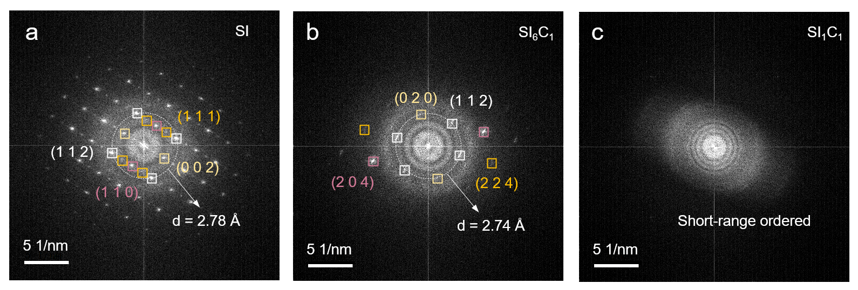
Figure S1. High resolution FFT diagram of (a) SI, (b) SI₆C₁ and (c) SI₁C₁.

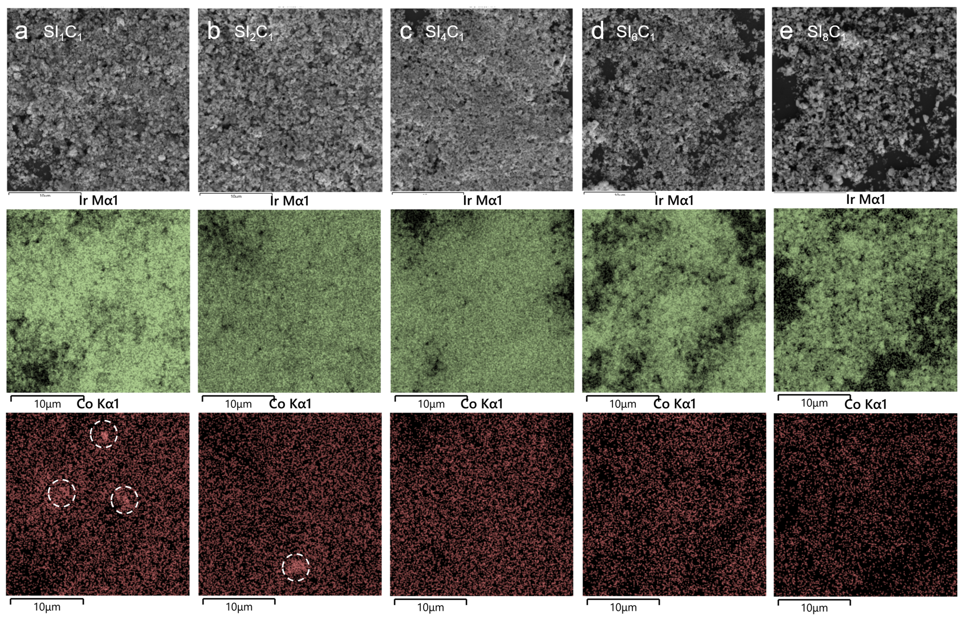
Figure S2. SEM images and EDS mappings of (a) SI₁C₁, (b) SI₂C₁, (c) SI₄C₁. (d) SI₆C₁ and (e) SI₈C₁.

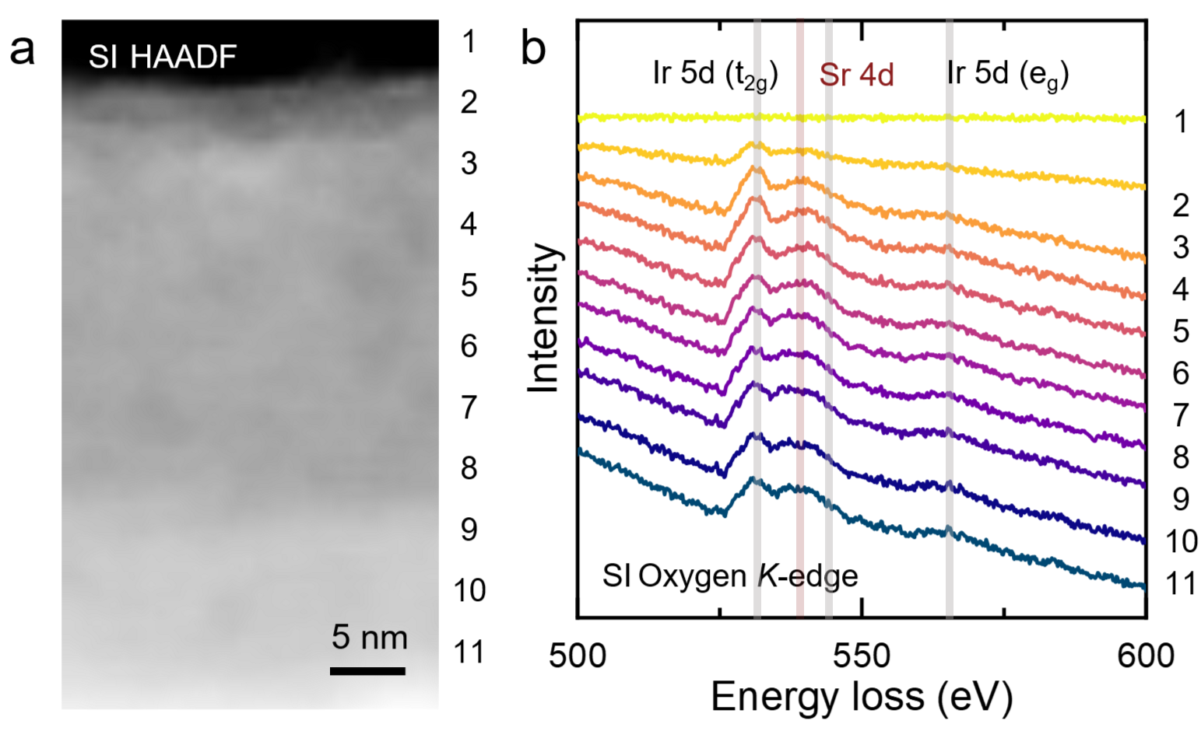
Figure S3. (a) HAADF image of SI, (b) O K-edge EELS spectra of SI.

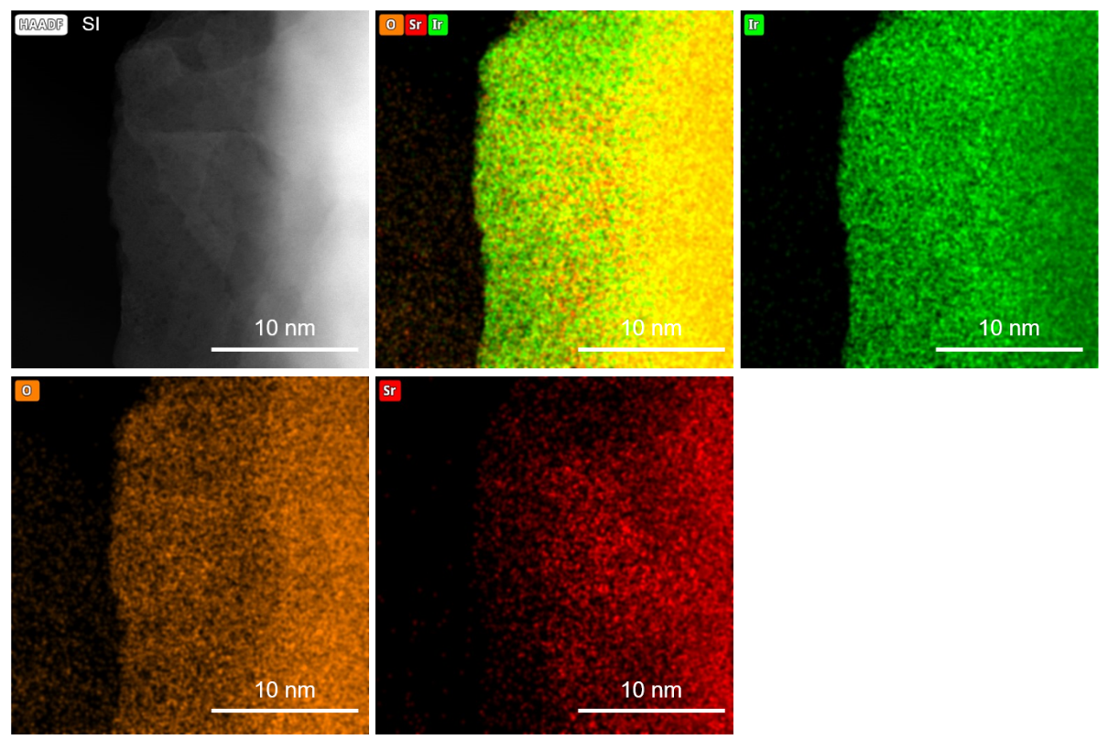
Figure S4. HAADF image of SI and corresponding EDS mapping images.

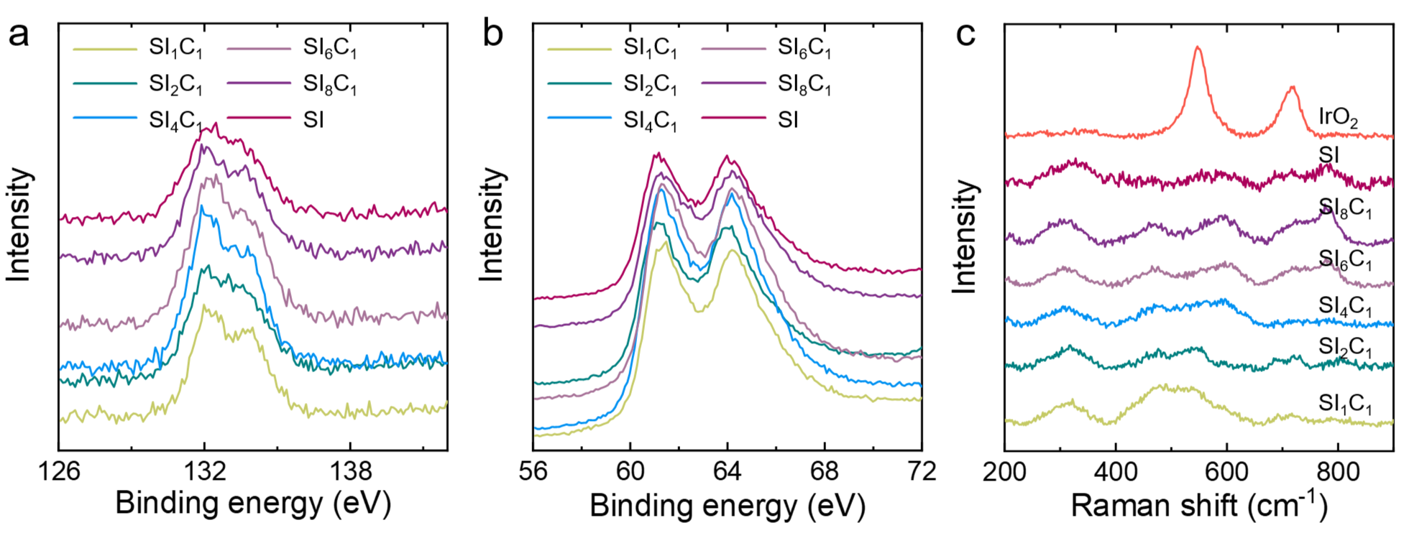
Figure S5. (a−b) XPS diagrams of Sr 3d and Ir 4f for SI series samples; (c) Raman spectra of SI series samples.

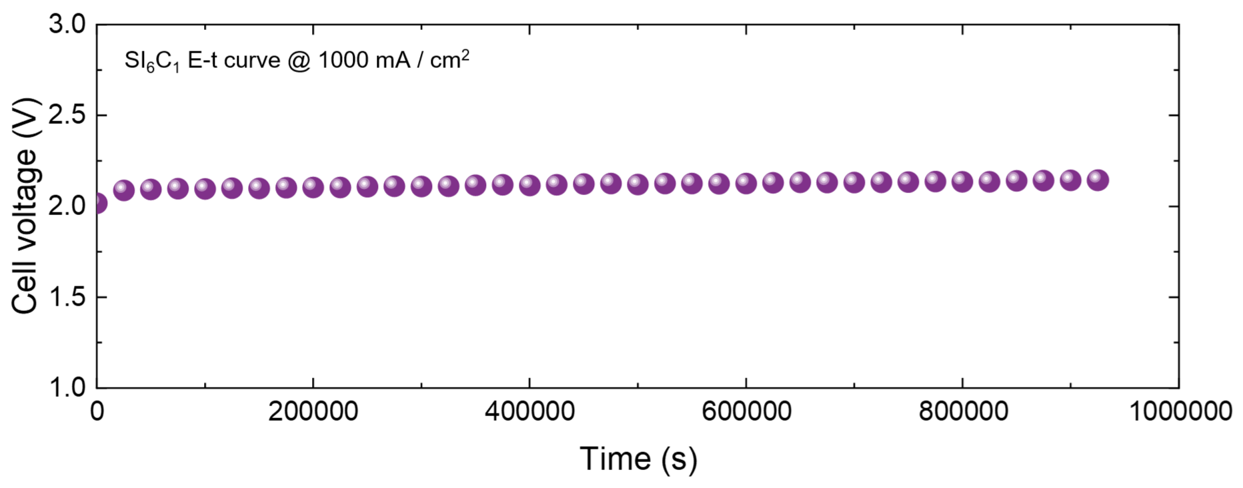
Figure S6. PEM water electrolysis stability of SI₆C₁ (at 1000 mA/cm²).

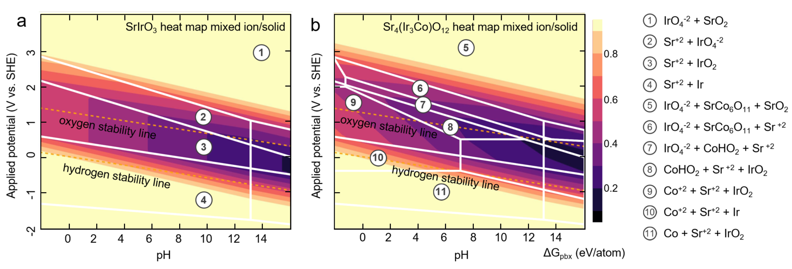
Figure S7. Pourbaix diagram of (a) SrIrO₃ and (b) Sr₄(Ir₃Co)O₁₂.

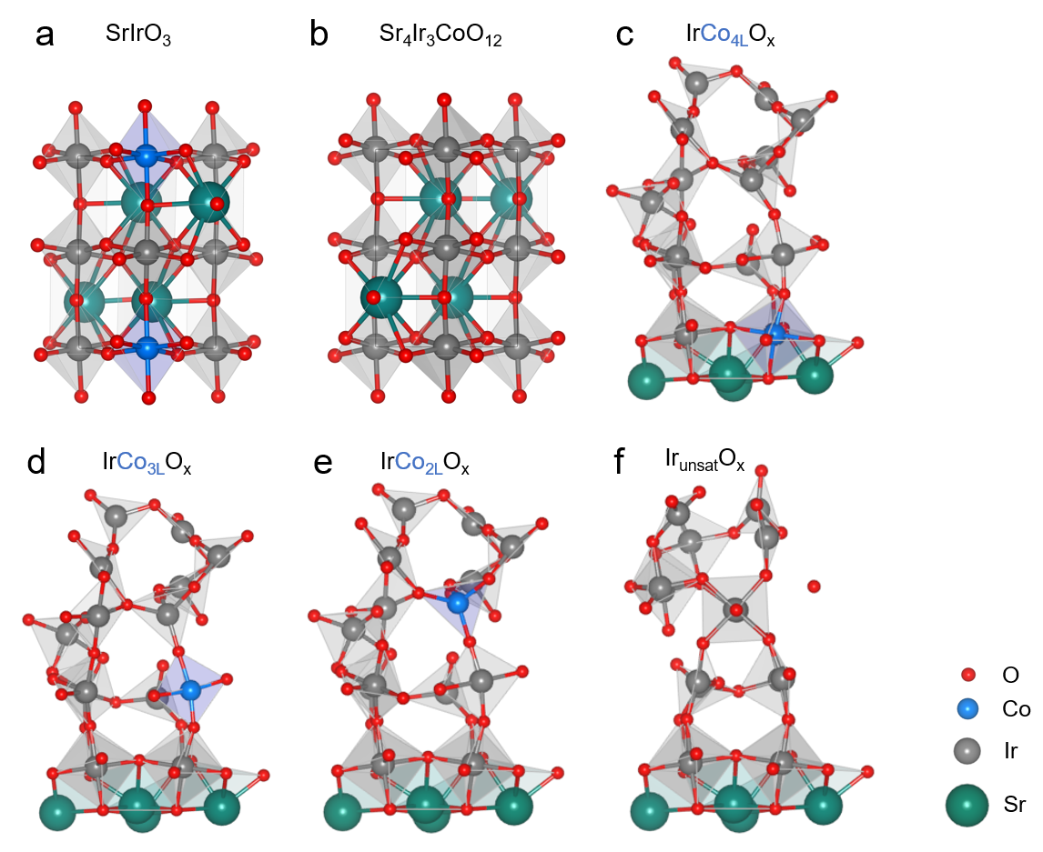
Figure S8. Possible computational models of SrIrO₃, Sr₄Ir₃CoO₁₂, IrCo_{4L}O_{x}, IrCo_{3L}O_{x}, IrCo_{2L}O_{x} and Ir_{unsat}O_{x} for DFT calculations.
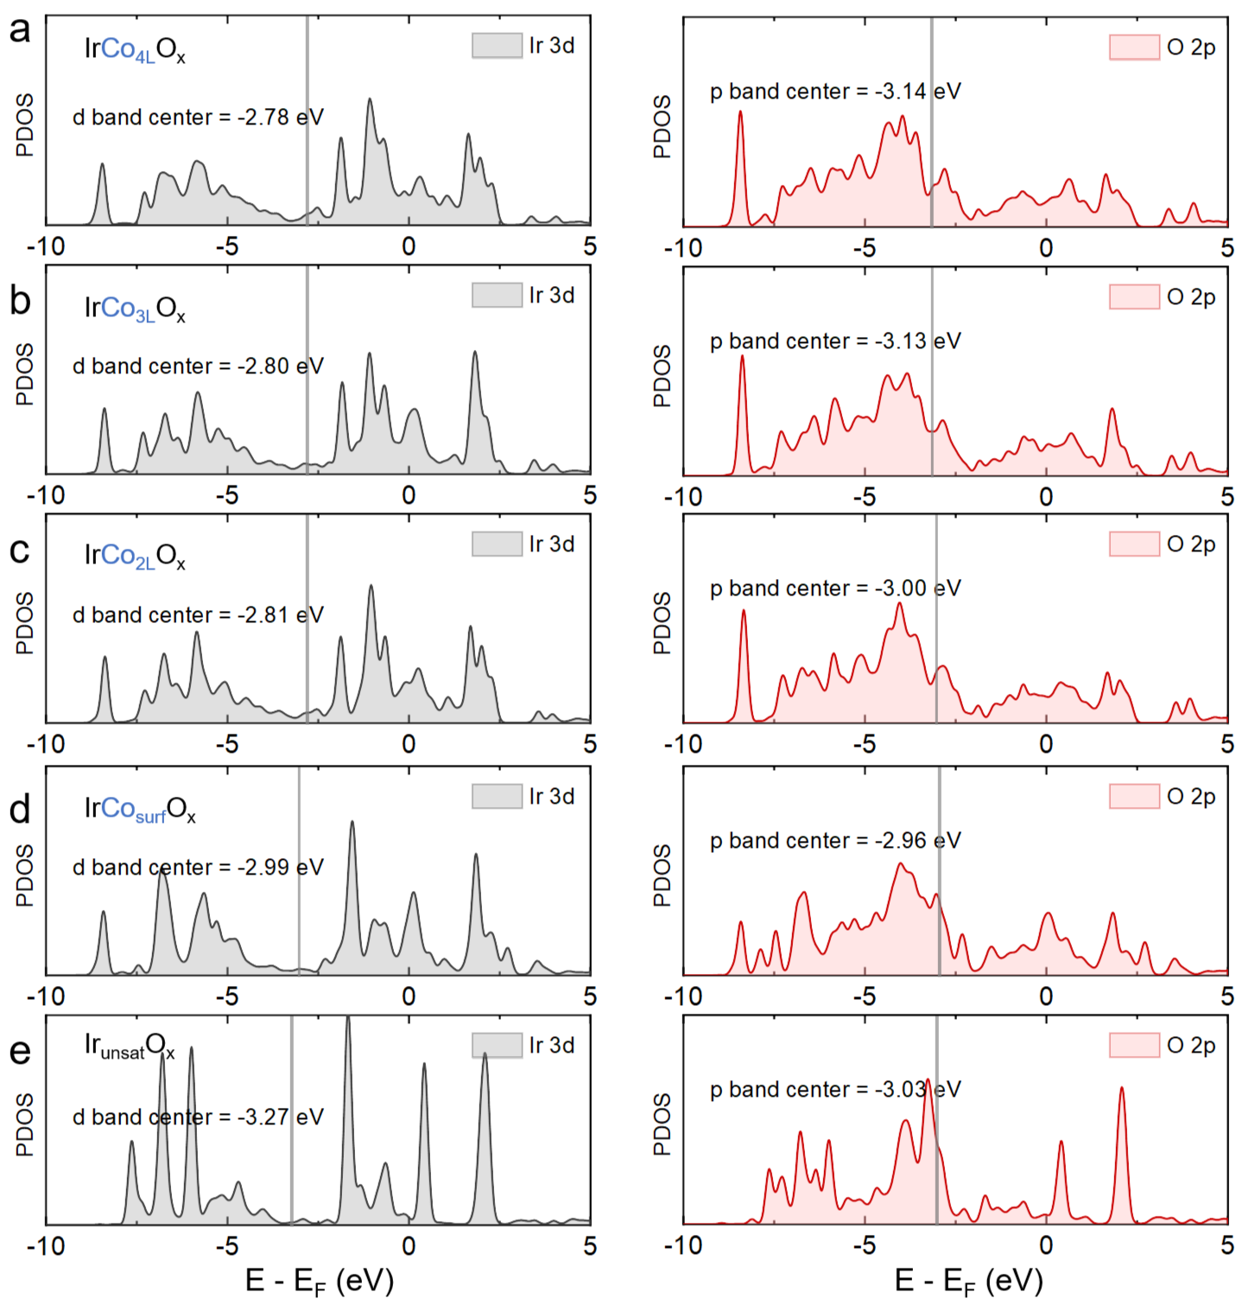
Figure S9. Density of states diagrams (Ir 3d and O 2p) for (a) IrCo_{4L}O_{x}, (b) IrCo_{3L}O_{x}, (c) IrCo_{2L}O_{x}, (d) IrCo_{surf}O_{x} and (e) Ir_{unsat}O_{x}.

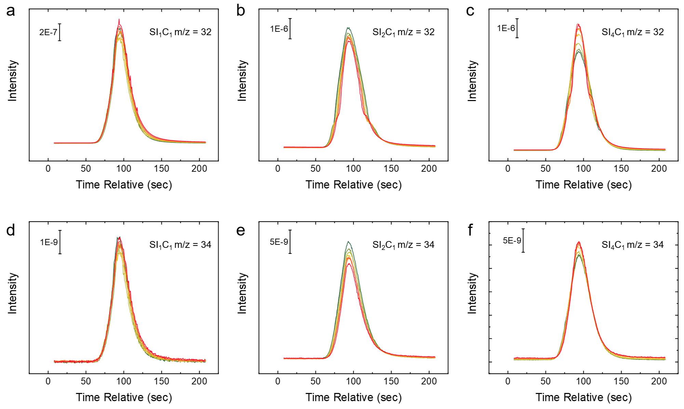
Figure S10. The ¹⁶O¹⁶O and ¹⁸O¹⁶O intensity of (a) SI₁C₁ (b) SI₂C₁ and (c) SI₄C₁ test by DEMS.

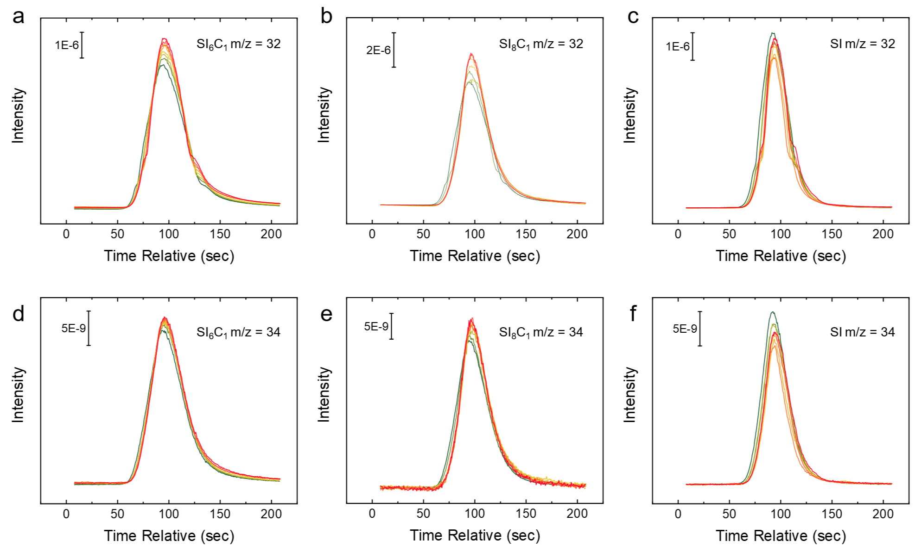
Figure S11. The ¹⁶O¹⁶O and ¹⁸O¹⁶O intensity of (a) SI₆C₁ (b) SI₈C₁ and (c) SI test by DEMS.
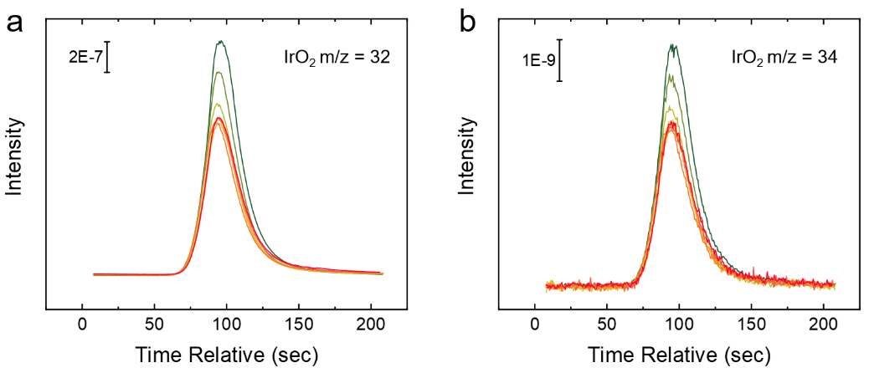
Figure S12. The ¹⁶O¹⁶O and ¹⁸O¹⁶O intensity of IrO₂ test by DEMS.

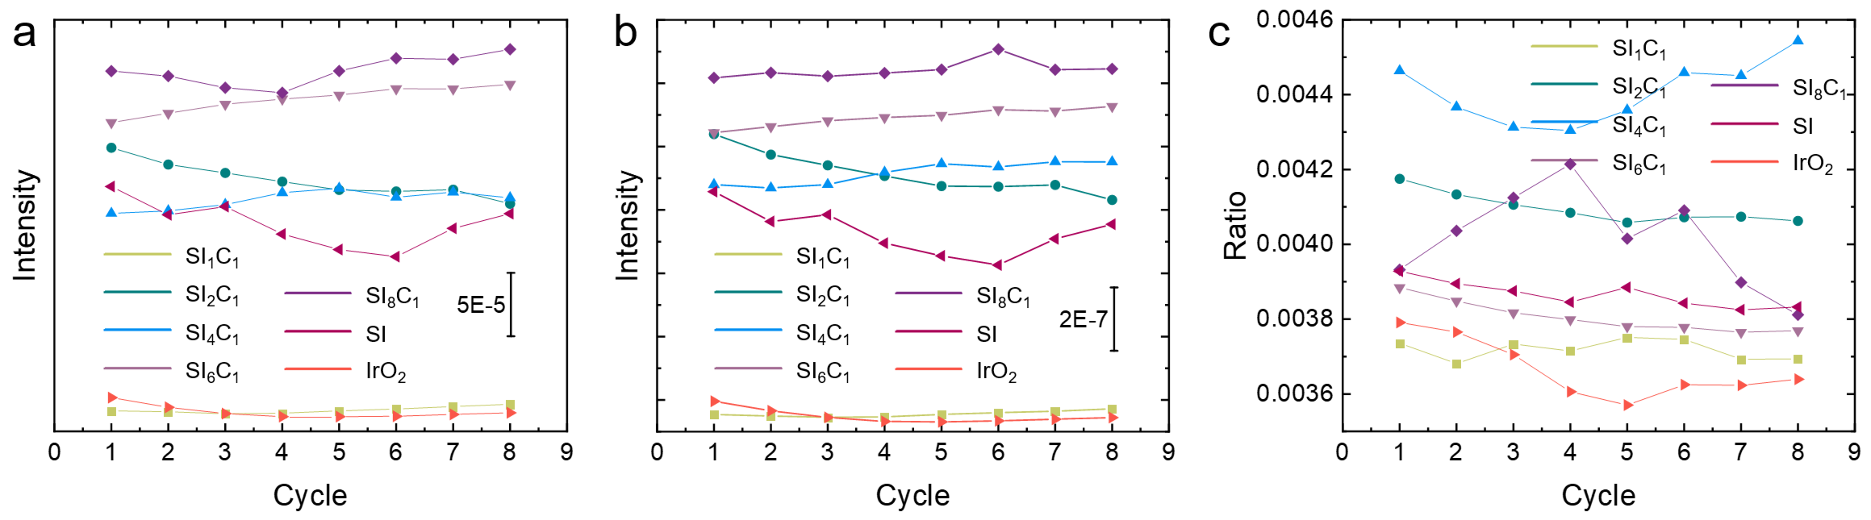
Figure S13. (a) The ³²O₂ intensity under different CV cycles of the samples. (b) The ³⁴O₂ intensity under different CV cycles of the samples. (c) The ratio diagram of ³⁴O₂ under different CV cycles of the samples.

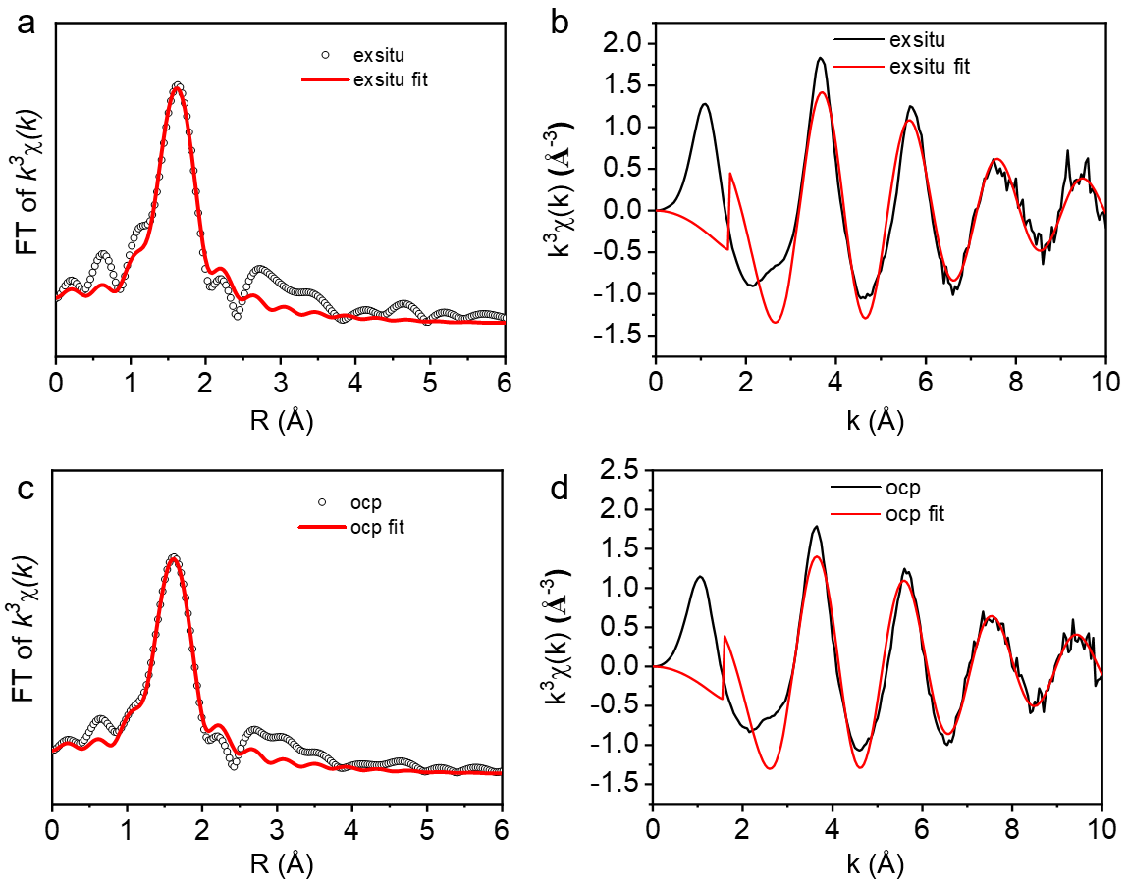
Figure S14. (a) χ(R) space spectra fitting curve of SI (ex-situ and ocp). (b) k³χ(k) space spectra fitting curve of SI (ex-situ and ocp).

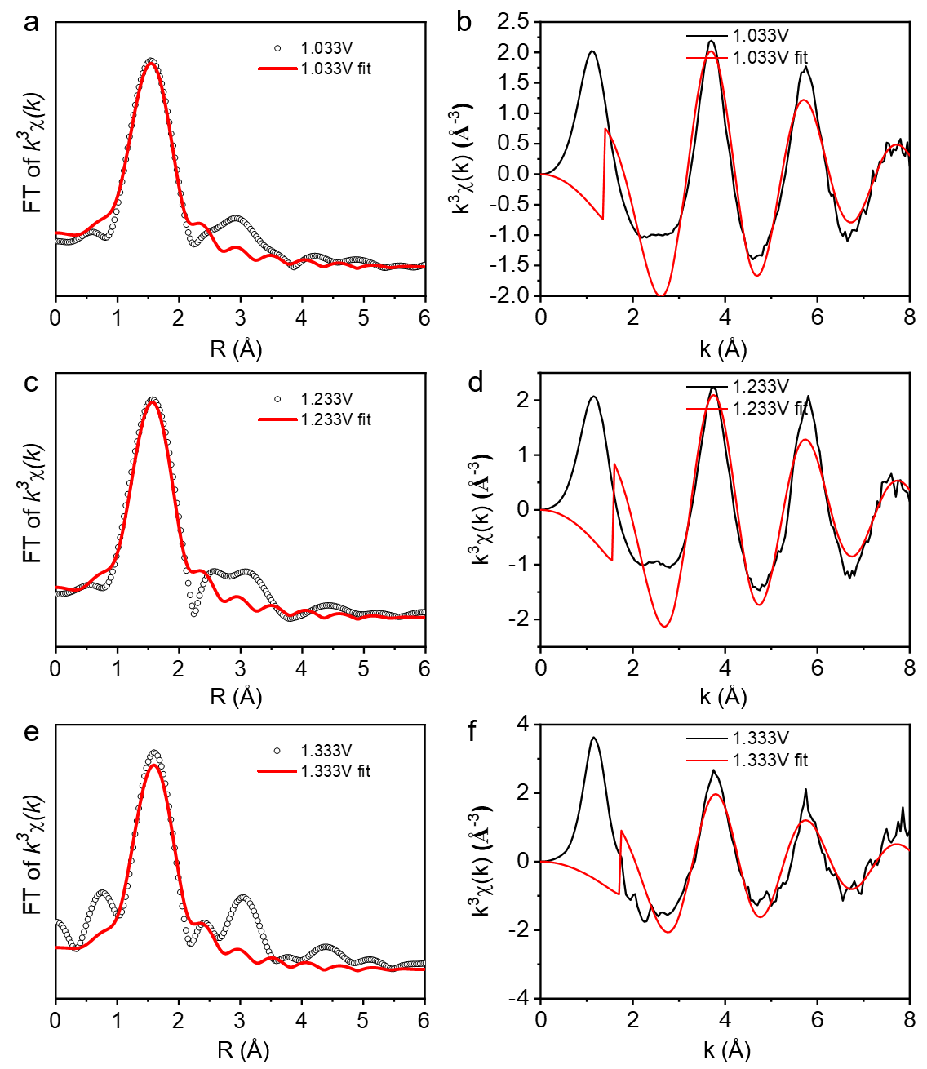
Figure S15. (a) χ(R) space spectra fitting curve of SI (1.033 V, 1.233 V and 1.333 V vs. RHE). (b) k³χ(k) space spectra fitting curve of SI (1.033 V, 1.233 V and 1.333 V vs. RHE).

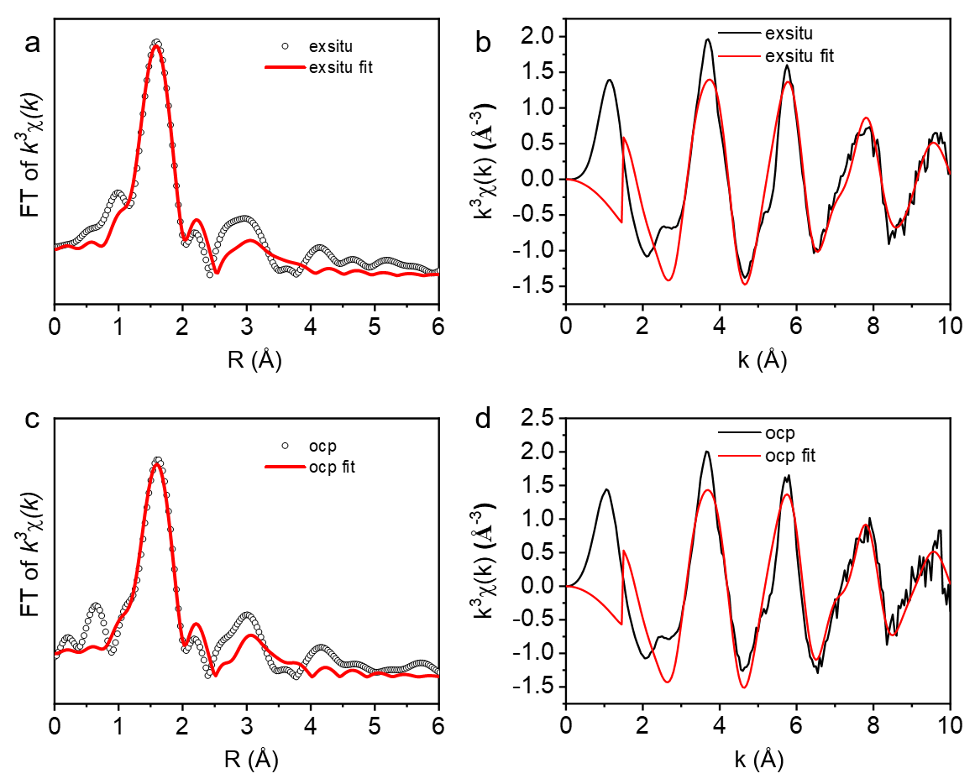
Figure S16. (a) χ(R) space spectra fitting curve of SI₆C₁ (ex-situ and ocp). (b) k³χ(k) space spectra fitting curve of SI₆C₁ (ex-situ and ocp).

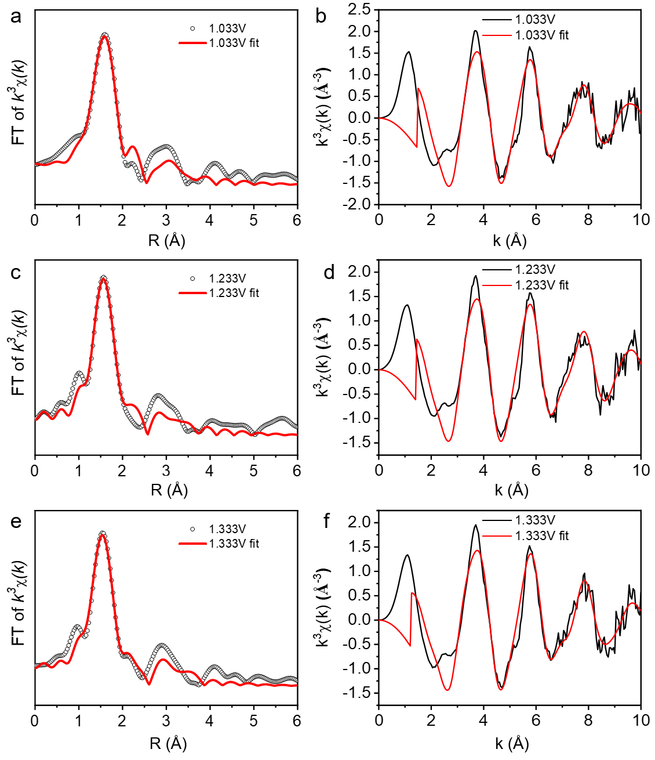
Figure S17. (a) χ(R) space spectra fitting curve of SI₆C₁ (1.033 V, 1.233 V and 1.333 V vs. RHE). (b) k³χ(k) space spectra fitting curve of SI₆C₁ (1.033 V, 1.233 V and 1.333 V vs. RHE).

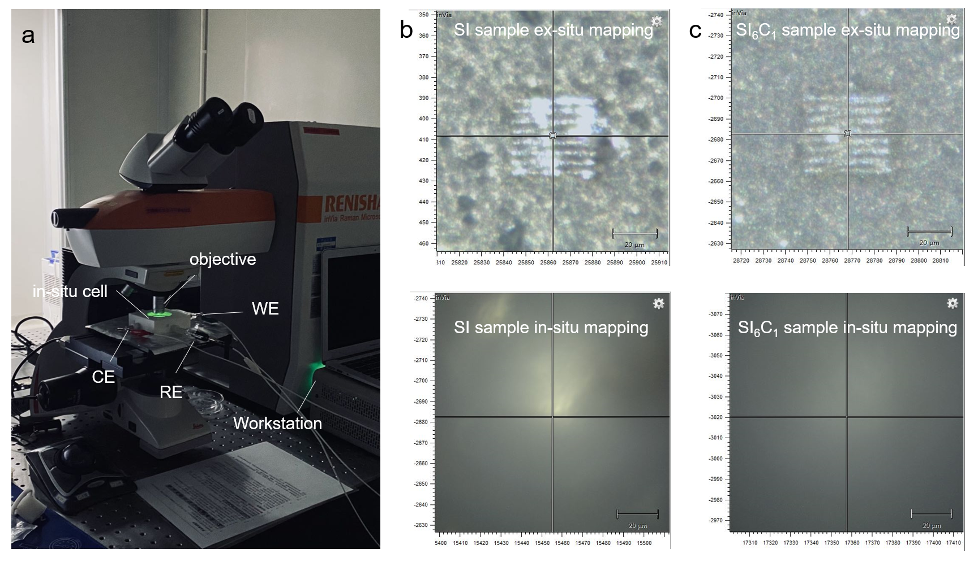
Figure S18. (a) In-situ Raman spectroscopic device photograph and (b-c) operating window.

Table S1. EXAFS fitting parameters of SI at the Ir K-edge (S₀²=0.88)
samples | path | C. N.^{[a]} | R (Å) ^{[b]} | σ² (× 10⁻³ Å²) ^{[c]} | ΔE (eV) ^{[d]} | R factor^{[e]}
ex-situ | Ir-O | 5.6 | 2.01 | 4.4 | 8.2 | 0.01
ocp | Ir-O | 5.6 | 2.02 | 4.1 | 9.6 | 0.01
1.033V | Ir-O | 5.8 | 1.98 | 5.4 | 7.4 | 0.02
1.233V | Ir-O | 5.6 | 1.98 | 6.3 | 9.2 | 0.02
1.333V | Ir-O | 5.5 | 1.99 | 9.8 | 9.4 | 0.02
ªC. N.: coordination numbers; ^{b}R: bond distance; ^{c}σ²: Debye-Waller factors; ^{d}ΔE₀: the inner potential correction. ^{e}R factor: goodness of fit.

Table S2. EXAFS fitting parameters of SI₆C₁ at the Ir K-edge (S₀²=0.88)
samples | path | C. N.^{[a]} | R (Å) ^{[b]} | σ² (× 10⁻³ Å²) ^{[c]} | ΔE (eV) ^{[d]} | R factor^{[e]}
ex-situ | Ir-O | 5.7 | 1.98 | 3.1 | 8.3 | 0.02
ocp | Ir-O | 6.0 | 1.99 | 3.3 | 8.1 | 0.02
1.033V | Ir-O | 5.8 | 1.98 | 5.4 | 8.6 | 0.02
1.233V | Ir-O | 5.6 | 1.97 | 4.1 | 7.9 | 0.02
1.333V | Ir-O | 5.4 | 1.97 | 4.6 | 5.9 | 0.02
ªC. N.: coordination numbers; ^{b}R: bond distance; ^{c}σ²: Debye-Waller factors; ^{d}ΔE₀: the inner potential correction. ^{e}R factor: goodness of fit.
References
1. Perdew, J. P., Burke, K. & Ernzerhof, M. Generalized gradient approximation made simple. Phys. Rev. Lett. 77, 3865 (1996).
2. Giannozzi, P. et al. QUANTUM ESPRESSO: a modular and open-source software project for quantum simulations of materials. J. Phys.: Condens. Matter 21, 395502 (2009).

