The genomic basis of childhood T-lineage acute lymphoblastic leukemia
Supplementary Information

SUPPLEMENTARY METHODS 5
Patient cohort 5
Sequencing 6
HICHIP and ATACseq sample preparation and processing 6
LR RNA Isoseq sample preparation and processing 7
Publicly available data: 7
Data visualization 7
Data analysis 8
WGS and WES Mapping 8
RNAseq Mapping, quantification, and preprocessing 8
SNV/Indel detection 8
Somatic copy number alteration detection 9
Structural variant detection 9
RNA Fusions and SNV/Indel 10
Complex insertions 10
TCR repertoire analysis 10
Healthy normal thymus and bone marrow reference set 10
scRNA library preparation 11
Construction of healthy hematopoietic reference trajectory 12
Gene expression analysis 13
Differential gene expression of T-ALL subtypes 13
Data preprocessing and differential gene expression of MED12 KO vs. WT 14
Gene set enrichment analysis 14
Monoallelic gene expression detection using Cis-X 14
Single cell gene set analysis 15
Statistical analysis 15
GRIN2 15
GISTIC2 16
DNDscv 16
Harmonizing significant coding alterations 17
Harmonizing significant non-coding alterations 18
Association analysis 18
Univariable Screening 18
Competing Risks 19
Multivariable Analysis 19
SUPPLEMENTARY RESULTS 21
Subtype associated co-lesions and altered pathways 21
ETP-like subtype immunophenotype 21
Multivariable model benchmarking 23
SUPPLEMENTARY TABLES 24
Supplementary Table 1. Clinical metadata and all sample identifiers. 24
Supplementary Table 2. Comparison of the eligible and evaluable patients with T-ALL enrolled on AALL0434 and the patients who had complete sequencing in this study. 24
Supplementary Table 3. Sample level genomic annotations, such as subtypes, genetic subtypes, TCR rearrangements, classifying drivers per case, clustering results. 24
Supplementary Table 4. UMAP X/Y coordinates and subtype colors. 24
Supplementary Table 5. 300 genes used for UMAP projection and Leiden clustering. 24
Supplementary Table 6. Flow cytometry panels used for immunophenotype and MRD. 24
Supplementary Table 7. Immunophenotype data from flow cytometry. Contains Mean Fluorescent Intensity (MFI), Median Fluorescent intensity and percent positive cells for each marker. 24
Supplementary Table 8. Alterations per variant, includes significant variants (statistical analysis) or manually reviewed and curated classifying drivers. Also includes RNA SV calls and broad manually curated CNV calls. This table is used for generating the data matrix in Supplementary Tables 9-11. 24
Supplementary Table 9. Case gene matrix of alterations, grouped per gene. 24
Supplementary Table 10. Case lesion matrix of alterations, grouped per variant. 24
Supplementary Table 11. Case pathway matrix of altered pathways. 24
Supplementary Table 12. PMID for pathway curation. 24
Supplementary Table 13. Recurrent SNV/Indel detected by WGS and/or WES. 24
Supplementary Table 14. Pindel mutation calls. 24
Supplementary Table 15. Recurrent structural variants detected from WGS. List of recurrent somatic structural variants identified (genome wide) in T-ALL samples by WGS. 24
Supplementary Table 16. All detected structural variants from WGS. List of all somatic structural variants identified (genome wide) in T-ALL samples by WGS. 24
Supplementary Table 17. List of fusions detected in T-ALL samples by RNA-seq. 24
Supplementary Table 18. Recurrent copy number variants detected from WGS. 24
Supplementary Table 19. Summary of recurrent somatic alterations. These results have been summarized per variant based on Supplementary Table 20-21 results. 24
Supplementary Table 20. GRIN2/DndSCV/GISTIC2 analysis to detect recurrent alterations. 24
Supplementary Table 21. GRIN2 results for regulatory feature analysis to detect recurrent alterations. 24
Supplementary Table 22. Statistical analysis of subtypes vs. genetic lesions. 24
Supplementary Table 23. Statistical analysis of TLX3 genetic subtypes vs. genetic lesions. 24
Supplementary Table 24. Statistical analysis of NKX2-1 genetic subtypes vs. genetic lesions. 24
Supplementary Table 25. Statistical analysis of TAL1 genetic subtypes vs. genetic lesions. 24
Supplementary Table 26. Statistical analysis of ETP-like genetic subtypes vs. genetic lesions. 25
Supplementary Table 27. Statistical analysis of genes upregulated in each subtypes compared to rest of the samples. 25
Supplementary Table 28. Statistical analysis of genes downregulated in each subtypes compared to rest of the samples. 25
Supplementary Table 29. Statistical analysis of differentially expressed genes comparing MED12ko vs. MED12wt in LOUCY cell line. 25
Supplementary Table 30. Statistical univariable outcome analysis of classifying drivers. 25
Supplementary Table 31. Statistical univariable outcome analysis of ETP-status. 25
Supplementary Table 32. Statistical univariable outcome analysis of subtypes. 25
Supplementary Table 33. Statistical univariable outcome analysis of genetic subtypes. 25
Supplementary Table 34. Statistical univariable outcome analysis of altered pathways. 25
Supplementary Table 35. Statistical univariable outcome analysis of alterations. 25
Supplementary Table 36. Statistical univariable outcome (OS) analysis of significant genes from global test, grouped by variants. 25
Supplementary Table 37. Statistical univariable outcome (EFS) analysis of significant genes from global test, grouped by variants. 25
Supplementary Table 38. Statistical univariable outcome (DFS) analysis of significant genes from global test, grouped by variants. 25
Supplementary Table 39. Statistical univariable outcome (MRD) analysis of significant genes from global test, grouped by variants. 25
Supplementary Table 40. Multivariable model benchmark result for different outcome models, from 100 70/30 data splits. 25
Supplementary Table 41. Penalized Cox Regression model and feature explanation. 25
Supplementary Table 42. HICHIP sample metrics and quality. 25
Supplementary Table 43. Primers. Primer design for NOTCH1 validations. 25
SUPPLEMENTARY FIGURES 26
SUPPLEMENTARY REFERENCES 35

SUPPLEMENTARY METHODS

Patient cohort
Matched non-tumor/normal cell selection algorithm
End induction remission samples were used as the source of matched normal control DNA in all cases but 24. Morphologic remission was defined as having less than 5% blasts by morphology (M1 marrow) at the end of induction and no evidence of peripheral blood blasts. 1) For a subject in morphologic remission (bone marrow blasts <5%) and who had bone marrow MRD <5%, an end induction peripheral blood sample was prioritized over a bone marrow sample if both were available as the source of matched normal control DNA. An end induction bone marrow sample was used if peripheral blood sample was unavailable or of insufficient quantity. 2) For a subject in morphologic remission (bone marrow blasts <5%) but who had bone marrow MRD >=5%, an end induction peripheral blood samples was used as the source of matched normal control DNA, if there were no peripheral blood blasts and a peripheral blood sample was available. End induction bone marrow samples were not used. 3) For a subject not in morphologic remission (bone marrow blasts >=5%), an end induction peripheral blood samples was used as the source of matched normal control DNA, if there was no peripheral blood blasts and a peripheral blood sample was available. End induction Bone marrow was not used. 4) For a subject who was not in morphologic remission (bone marrow blasts >=5%) or who had >=5% bone marrow MRD and either (1) had no available peripheral blood sample at end of induction, or (2) had a peripheral blood sample but it had had detectable blasts, or (3) had a peripheral blood sample but it was unknown if the peripheral blood sample had detectable blasts, a diagnostic bone marrow sample was used after flow sorting to isolate non-tumor mononuclear cells. As the T-ALL blasts in all of the cases that required sorting were CD7 positive, a sorting strategy including a negative selection for CD7+ cells and positive selection for CD45+ cells was used. We used our published methods for staining the cells¹. Sorting was performed in the Children’s Hospital of Philadelphia flow cytometry core on a BD Biosciences FACSJazz cell sorter after staining with CD7 FITC (Cat 347483) and CD45 APC (Cat 555485) from BD Biosciences, San Jose CA.

Sequencing

HICHIP and ATACseq sample preparation and processing
For HiChIP and ATACseq, cryopreserved cells were thawed in a 37°C water bath, gradually resuspended in IMDM (#12440061, Gibco, Thermo Fisher Scientific) supplemented with FBS 20% (#SH30910.03HI Thermo Fisher Scientific) and 1× penicillin–streptomycin–glutamine (#15140122, Gibco, ThermoFisher Scientific), and counted using trypan blue. ATACseq was conducted on 5x105 cells following a well-established protocol² with modifications for lysis and transposition steps as previously reported³. Libraries were sequenced on an Illumina Novaseq (100bp, paired end) to obtain 50 million reads.
For H3K27ac HiChIP experiments, 9-10 million cells were directly crosslinked with 2% formaldehyde (10 minutes at room temperature) for samples with cell viability above 70%. For samples with a lower viability, live cells were sorted and crosslinked. The total number of cells collected from sorting ranged from 1 to 6 million (Supplementary Table 42 per sample number of cells and mapped reads, H3K27ac peaks detected). To obtain Double-Positive (DP) thymocytes, CD34-CD1a+ gated cells were sorted based on the expression of both CD8 and CD4. DP mature fraction was subsequently selected based on the CD45+CD3+ markers. Eight million cells were crosslinked for HiChIP. Samples were processed using the Arima-HiC+ kit (Arima Genomics A101020) according to the manufacturer's protocols [Arima-HiC+ document numbers A160168 v00 (HiChIP) and A160169 v00 (library preparation)]. The H3K27ac antibody was from Active Motif (am91194). Uniquely barcoded HiChIP libraries were pooled and sequenced (100bp, paired end) to obtain 300 million reads on an Illumina NovaSeq instrument.
The analysis of HiChIP data was conducted through the utilization of MAPS (v2.0), incorporated within the Arima Genomics bioinformatics pipeline accessible at https://github.com/ijuric/MAPS. The specific program versions employed included BWA⁴(v0.7.12), SAMtools⁵(v1.10), and deepTools⁶(v3.4.0). To facilitate the visualization of 2D heatmaps, .hic files were generated using Juicer⁷ tools and subsequently uploaded to the cloud-based server of St. Jude Protein Paint⁸ for visualization.

LR RNA Isoseq sample preparation and processing
Total RNA was quantified with Quant-iT Ribogreen and NanoDrop and sized with either Agilent BioAnalyzer or TapeStation before being prepared into cDNA libraries following the standard PacBio Iso-Seq protocol. Briefly, 300ng of total RNA was converted to cDNA, and amplified using a combination of NEBNext and PacBio Iso-Seq Express reagents. Following amplification and 0.95x bead size selection, libraries were prepared using the SMARTbell prep kit v3, with standard non-barcoded adapter ligation, and nuclease treated prior to cleanup. The libraries were then quantified and run on BioAnalyzer HS DNA assay for final size verification, which was then entered into SMRT Link v11 sample setup for the Annealing, Binding, and Cleanup (ABC) steps with Sequel Binding kit v3.1. All libraries were run on a Sequel II with a single SMRT cell per sample library. A standard Iso-Seq 24-hour movie per sample was run, with the following settings: 100pM on plate loading and with the Include Low Quality Reads option turned on to save non-HiFi reads.
Reads were aligned to the HG38 reference using Minimap2⁹ to identify isoforms and subsequently visualized in IGV (v2.14).

Publicly available data:
ChIP-Atlas¹⁰ was used for downloading publicly available H3K27ac ChIP-seq data coverage tracks for different T cell populations for dataset GSE151081. CD34 HiChIP was downloaded from GSE165209.

Data visualization
R (v. 4.2.2) packages ComplexHeatmap (v2.14.0)¹¹, ggplot2 (v3.4.0), Cowplot (v1.1.1), EnhancedVolcano (v1.16.0), survminer (v0.4.9). Boxplots shown are defined as in ggplot2: Box is annotated with median and upper/lower hinges correspond to the 25th and 75th percentiles, 1.5 * Inter quartile range for upper/lower whiskers.

Data analysis

WGS and WES Mapping
Paired-end sequencing reads were aligned to the human Hg38-GDC reference using BWA-MEM⁴.

RNAseq Mapping, quantification, and preprocessing
Sequencing read adapters were removed using Trim Galore (v0.4.4, -q 20 –phred 33 --paired). The processed reads were then aligned to the human genome GRCh38 using STAR v(2.7.11)¹². The resulting gene counts for each sample, estimated by RSEM v(1.3.0)¹³, were combined to create a unified gene count matrix. RSEM expected counts were filtered and processed as follows: Samples were required to exhibit expression of over 1 Counts per million (CPM)≥ 5 samples. (2) sva R package (v3.46) function ComBat_seq was used for batch correction. Batch effects were defined based on library type; stranded and unstranded and based on cohort; TARGET or ‘X01’ newly sequenced samples. (3) DESeq2 R package (v1.38.3) vst function was used for data normalization.

SNV/Indel detection
An ensemble strategy was employed to identify somatic mutations (SNVs/indels) using multiple established tools, including Mutect2¹⁴(v4.1.2.0), SomaticSniper¹⁵ (v1.0.5.0), VarScan2¹⁶ (v2.4.3), MuSE¹⁷ (v1.0rc), and Strelka2¹⁸ (v2.9.10). Variant annotation was performed using Annovar¹⁹. These consensus calls underwent manual assessment and filtering, considering factors such as read depth, mapping quality, and strand bias, to eliminate additional artifacts. (1) Somatic mutations called by at least two platforms were considered reliable. (2) Somatic mutations called by at least two tools were considered reliable. (3) Variants initially called by a single tool were retained following thorough quality evaluation with emphasis for genes frequently mutated in T-ALL.

Somatic copy number alteration detection
Somatic copy number alterations (SCNAs) were determined through CONSERTING²⁰. The call sets were filtered: (1) CNV alterations on centromeres and telomeres were excluded (2) TCR, IGH, IGL, IGK CNVs were excluded, if both breakpoints were within the locus. Conserting Log ratio>0.3 and >0.7 was used as cutoffs for CNV gain and amplification and -0.4 and -1.4 for CNV loss and deletion. Variants with Conserting DMean>1.3 for gains or DMean<0.7 for losses and diploid germline CNV were considered high confidence. Other variants underwent manual review and additional filtering steps.

Structural variant detection
For somatic structural variants (SVs), four distinct SV callers were utilized to generate a comprehensive set of SV events: Delly²¹ (v0.8.2), Manta²² (v1.5.0), GRIDSS²³ (v2.5.0), LUMPY ²⁴(v0.3.0). SV calls that met the default quality filters of each caller were merged into a combined set of SVs using SURVIVOR²⁵ (v1.0.7) and then genotyped using SVtyper²⁶ (v0.7.1). The intersected call sets underwent filtering and manual evaluation process. This involved considering the support from soft-clipped and discordant read counts (with a count threshold of ≥10) at both ends of potential SV sites. Additionally, low germline sample soft-clipped and discordant read counts (<3) were considered. These thresholds were relaxed under specific conditions, such as cases with tumor in normal contamination, where germline read counts were not filtered, and in instances with low blast percentages, where only ≥3 soft-clipped and discordant read counts were required. Furthermore, the detection of SV was performed in a tumor-only mode to ensure the inclusion of variants, particularly in situations involving tumor in normal contamination. TCR, IGH, IGL, IGK SVs were excluded, if both breakpoints were within these loci.

RNA Fusions and SNV/Indel
Arriba (v2.4.0)²⁷, Fusioncather (v1.0)²⁸, Pizzly (v1.0)²⁹, SQUID³⁰, STAR-fusion (v1.2)³¹ were used for detecting fusion genes. Fusions were used for validating WGS fusion calls and other fusions were manually reviewed. GATK4 was used for detecting SNV/Indel for RNAseq and ANNOVAR was used for annotation. RNAseq SNV/Indel calls were used for WGS/WES variant validation.

Complex insertions
After a thorough manual review of the variants, a list of genes/regions suspected to contain complex insertions was generated. Subsequently, these genes/regions were subjected to analysis by running Pindel on WGS, WES, and RNA data.

TCR repertoire analysis
The RNAseq and WGS data's fastq files were aligned to reference V, D, J, and C genes of TCR, subsequently resulting in the assembly of clonotypes via MiXCR³² (v3.0.13). The TCR reference employed in this study was the default setting within the MiXCR software, utilizing the following identifiers: TRA/TRD, NG_001332.2; TRB, NG_001333.2; TRG, NG_001336.2. Notably, TCR rearrangement calls were filtered, excluding cases where (i) cloneCount was less than 5, and (ii) cloneFraction was less than 0.1 following the computation of TCR-specific frequencies.

Healthy normal thymus and bone marrow reference set
Pediatric thymus samples were acquired from children who were undergoing cardiac surgery. The collection and utilization of these samples were conducted in strict adherence to the guidelines and with the official approval of the Institutional Review Board at the Children’s Hospital of Philadelphia. To create a single-cell suspension, the thymus tissue was mechanically disrupted. Subsequently, the tissue was treated with liberase (0.2 mg/mL Roche) for a duration of 30 minutes at 37°C, with intermittent agitation. The resultant thymocytes were then suspended in a flow buffer and subsequently sorted into distinct fractions based on the CD45+, DN, and CD34+CD1A- markers. These fractions were subsequently subjected to single-cell RNA sequencing (scRNA-seq) analysis.

scRNA library preparation
To analyze live cells, the procedure involved initial centrifugation and suspension of cells in 45 μL of Cell Staining Buffer (BioLegend, Cat #: 420201) per million cells. Blocking with 5 μL of Human TruStain FcX (BioLegend, Cat #: 422301) per million cells at 4°C for 15 minutes reduced non-specific binding. After blocking, TotalSeq-A antibodies were added and incubated for 30 minutes at 4°C. Cells were washed thrice with Cell Staining Buffer, resuspended in PBS with 0.04% BSA, and counted using the Countess II cell counter (Invitrogen), with 17,000 cells per sample. Subsequently, the isolated cells (17,000 per sample) were loaded onto a 10x Genomics Chromium controller along with Chromium NEXT GEM Single Cell 3’ reagent kits V3.1. GEX libraries were generated using the 10x Genomics library preparation kit. For ADT libraries, the KAPA HiFi HotStart ReadyMix kit (Kapa Biosystems, catalog no. KK2601) was employed. The ADT library PCR involved an initial denaturation step at 98°C for 2 minutes, followed by 14-15 cycles of denaturation, annealing, and extension, with a final extension at 72°C for 5 minutes and a concluding step at 4°C. Library quality was assessed using the Agilent High Sensitivity DNA kit on the Bioanalyzer 2100 platform. Library quantification was performed with the dsDNA High-Sensitivity (HS) assay kit on the Qubit fluorometer, using the qPCR-based KAPA quantification kit. Finally, the libraries were sequenced on an Illumina Nova-Seq 6000 platform using a 28:8:0:87 paired-end format.
scRNA data processing
The demultiplexing and alignment of RNA and antibody-derived tag sequences were carried out employing cellranger v3.1.0. Following this, a filtering process was implemented to eliminate low-quality cells and red blood cells (RBC). Specifically, cells were retained if they exhibited a gene count between 300 and 2500 in the scRNA-Seq data, had over 1500 RNA counts, demonstrated less than 10% mitochondrial RNA content, and featured fewer than 3 unique molecular identifiers (UMI) mapped to Hemoglobin B. To address the presence of cell doublets observed in the scRNA data, DoubletFinder2 v2.0.3 was applied, utilizing an expected doublet rate of 5%. Subsequently, the patient-specific cell-gene and cell-antibody-derived tag (ADT) count matrices were individually preserved. These matrices were subsequently integrated and combined using Seurat (v4.0.53), facilitating downstream analyses.

Construction of healthy hematopoietic reference trajectory
Construction of the healthy reference trajectory of T, B, and myeloid development began with sample-by-sample cell annotation followed by consensus clustering and annotation. Annotations from previously published bone marrow samples were kept³³. Cell x gene matrices from each thymus sample were log-normalized and subject to dimensionality reduction. Cells were clustered at multiple resolutions (k=1, k=2, k=3), and clusters given preliminary labels based on marker gene expression. Cell x gene matrices from all thymus donors (n=3) were then concatenated, log-normalized, and subject to dimensionality reduction. Cells were re-clustered at high resolutions (k=3), and clusters relabeled based on marker gene expression and prior labels.
Cell x gene matrices from healthy thymus donors were then concatenated with cell x gene matrices from healthy bone marrow donors (n=5), log-normalized, and subject to dimensionality reduction. Dimensionality reduction was performed using UMAP of the top 25 principal components of the concatenated scRNA-Seq data with 30 neighbors and 2 principal components. The features used for construction of a final working reference trajectory were identified in several iterations. First, the FindVariableFeatures function in Seurat was used to identify top 2,000 variable genes. These 2,000 genes were then filtered in two iterations based on Gini coefficient, a previously described method which retains genes of maximal inequality between cell clusters. Briefly, a shared nearest neighbor graph was constructed using 50 and 20 PCs; cells were clustered at k=0.1 resolution and the Gini coefficient was calculated for each variable gene. Genes with low Gini coefficient (bottom 10% percentile) and cluster level expression < 10% were removed in each iteration, retaining 1,065 features which captured the biology of T-cell maturation. Early T-cells undergo massive proliferation which can skew identification of underlying cell state when projecting patient derived cancer blasts (ie, proliferating cancer blasts will map to proliferating thymocytes based on expression of cell-cycle related genes, rather than developmental stage related genes). To address this, 134 cell cycle related genes previously described in other single cell analyses of thymic tissue9 (total gene set size, n=559) were removed. The remaining 931 variable features were used as input to PCA and UMAP dimension reductions (25 PCs), yielding the final scRNA reference trajectory used for projection of patient data. Trajectory analysis was performed using Slingshot 1.8.010 with HSPC as start cluster and EffectorT, Mature-B, and Monocyte as end clusters for T, B, and Myeloid trajectories, respectively. Principal curves were selected for T-cell trajectory and Myeloid-cell trajectories, and values were scaled based on a maximum of 1 in each curve. To visualize the arrest state of ETP-ALL in context of both Myeloid and T-cell development, values corresponding with states in myeloid development were multiplied by -1. Pseudotime values of shared cell states that occurred in both myeloid and T-cell development (multipotent progenitors: HSPC, LMPP) were then averaged. These transformations yielded a trajectory where multipotent progenitors were centered near 0, myeloid development corresponded with psuedotime values from 0 to -1, and T-cell development corresponded with pseudotime values from 0 to 1.

Gene expression analysis

Differential gene expression of T-ALL subtypes
Batch corrected filtered counts were normalized by library size using edgeR (v3.4) calcNormFactors TMM method and further transformed by ‘limma’³⁴ (v3.54.1) voom. Differential gene expression analysis was performed contrasting two groups of interest and standard limma workflow. P-values were adjusted using the Benjamini Hochberg False Discovery Rate (FDR) method, using cutoffs 0.01 for FDR, log fold change >1 and average expression in group 1 > 2 for upregulated or log fold change < (-1) average expression in group 2 > 2 for downregulated genes.

Data preprocessing and differential gene expression of MED12 KO vs. WT
RSEM expected counts were filtered, with samples required to exhibit expression of over 1 CPM and over 0.5 TPM≥ 3 samples. Deseq2 estimateSizeFactors, estimateDispersions with fitType "local" and nbinomWaldTest were used for differential gene expression analysis.

Gene set enrichment analysis
GSEA v4.1.0 (Java-GSEA) was used for gene set analysis using sample permutation for T-ALL cohort binary group comparisons and gene for MED12 KO vs. WT analysis. R package msigdbr c7.5.1 was used for downloading human genesets; CP:BIOCARTA, CP:KEGG, CP:PID, CP:REACTOME, CP:WIKIPATHWAYS, HALLMARKS, HAY_BONE_MARROW and transcription factor target gene sets from C2 CGP set.

Monoallelic gene expression detection using Cis-X
Cis-X³⁵ was applied to discover regulatory noncoding variants in each single T-ALL tumor sample by integrating the single sample’s corresponding whole-genome and transcriptome sequencing data (WGS and RNAseq). All required data were prepared by following the instruction from Cis-X manual (see Data and software availability). Due to Cis-X needs to have all data aligned to hg19 reference, Crossmap was used to liftover all data, including SNP genotyping data, SNV, CNV, and SV data, as well as RNAseq BAMs from hg38 to hg19 format. The T-ALL reference expression database provided by Cis-X was used in the current study to determine outlier genes based on RNAseq FPKM values.

Single cell gene set analysis
Enrichment scores were computed for significantly differentially expressed genes (for T-ALL, ETP-like genetic subtypes, MED12 Knockout) in normal healthy BM/thymus scRNA data. Gene set enrichment was computed using custom function: (1) sum of ‘scale.data’ values from Seurat workflow was computed for each cell separately for both up- and downregulated genes deriving two scores per cell (2) these scores were subtracted from each other and subsequently normalized by the total number of up- and downregulated genes. Mean of these scores per normal healthy cell type were computed and summarized as dotplots.

Statistical analysis

GRIN2
Tools and libraries were sourced from: https://raw.githubusercontent.com/stjude/TALL-example/main/GRIN2.0.ALEX.library.09.29.2022.R. For gene and regulatory region annotations, as well as chromosome sizes, downloads were made according to instructions using the get.ensembl.annotation functions for the Human_GRCh38 reference. Annotation data of 60,568 protein coding genes and non-protein coding processed transcripts were retrieved from Ensembl BioMart database (release 104) using ‘biomaRt’ R package. Ensembl regulatory build (release 104) included around 620k features, such as promoters, enhancer, TF and CTCF binding sites.
For Genomic Random Interval³⁶ 2 (GRIN2) analysis, somatic mutations were categorized into 6 types: “GAIN” (copy number gain), “AMP” (high level copy number gain), “LOSS” (copy deletion), “DEL” (two copy deletion), “SNV_Indel” (all nonsynonymous SNV, small insertions/deletions), “BRK” (chromosomal rearrangements, inversion). Overlapping variant calls were harmonized as follows: (1) if SV breakpoint was detected within 1000bp window of translocation breakpoint or CNV breakpoint it was excluded (2) remaining segments were combined as one segment using bedtools merge, to remove redundancies and to combine CONSERTING segments that were split into smaller fragments.
Thereafter, GRIN2 package was used to map each genomic lesion to the list of annotated genes based on their genomic coordinates (start and end positions) to identify genomic loci affected by each type of genomic lesions facilitated by the grin.stats function. In preparation for regulatory feature analysis, the data was adjusted as follows: (1) SNV/Indel cases with VAF < 0.25 were excluded to focus only on clonal mutations. (2) Coordinates of SNV/Indel and Gain/Amp events were expanded ± 2500 bp to enhance alignment with neighboring regulatory regions. (3)both ends of CNV losses and deletion were annotated as BRK_LOSS to search for putative regulatory regions outside the CNV breakpoints (3) Breakpoints stemming from SV or CNV losses/deletions were expanded ±50kb, considering that hijacked regulatory elements might reside further from the breakpoint. GRIN2 tool ALEX was also run to find association between lesions and coding gene expression, using parameters min.pts.expr=5, min.pts.lsn=5 for alex.prep.lsn.expr function and min.grp.size=5 for KW.hit.express function, with q-value 0.05 as cutoff for significance.

GISTIC2
Gistic2 was run for the whole cohort and larger individual subtypes; ETP-like, TLX3, TAL1 groups, in matlab 2019a version, using parameters; -ta 0.1 -td 0.1 -qvt 0.25 -cap 1.5 -rx 0 -js 4 -maxseq 2000 -genegistic 1 -smallmem 0 -broad 1 -brlen 0.7 -conf 0.99 -armpeel 1 -savegene 1 -gcm extreme. Results from del_genes.conf_99.txt and amp_genes.conf_99.txt were filtered using q-value<0.05.

DNDscv
The DNDscv algorithm was downloaded from github: im3sanger/dndscv. Algorithm was computed for exonic SNV and Indels, using RefCDS_human_GRCh38_GencodeV18_recommended.rda as reference database and covariates_hg19_hg38_epigenome_pcawg.rda as covariate data with parameters max_muts_per_gene_per_sample set to 3 and max_coding_muts_per_sample set to 500. Significant genes were defined as q-value <0.05.

Harmonizing significant coding alterations
GRIN2 coding gene analysis, Gistic2 from the whole cohort, ETP-like, TAL1 groups and TLX3 and DndScv results were combined and integrated with expression and allelic expression data. GRIN2 provides q-value for each lesion type; we assigned q-value cutoffs as (1) 0.01 for AMP, BRK, DEL (2) 0.001 for GAIN, LOSS, and constellation (3) 0.05 for SNV/Indels. Furthermore, both DndScv and GRIN2 SNV/Indels significant genes were required to have at least 5 patients with >0.25 VAF. Similarly, we required that there should be a minimum of 5 patients exhibiting a particular type of alteration for each significant gene, or, in the case of constellation, a minimum of 5 patients with any combination of SNV/Indel VAF>0.25, SV breakpoints, or focal <500kb CNV events. Additional filtering and exploratory analysis were conducted to ensure genes displayed driver gene characteristics: (1) Lollipop plots were utilized to identify mutation hotspots or enrichment for putative loss-of-function mutations, such as stop/frameshift/splicing alterations. (2) Mutations targeting amino acid hotspots or the same PFAM domain in at least 5 patients, or (3) stop/frameshift/splicing mutations in at least 25% of patients were considered high confidence hits (4) CNV gene targets that showed significance in Gistic2, GRIN2, and ALEX were included. (5) Intragenic GAIN, LOSS, and BRK events were retained if observed in a minimum of 5 patients, even if gene expression remained unaltered. (6) For a given significant gene, if the median size of CNV lesions exceeded 500kb, the lesion was annotated as a broad CNV feature by chromosome, chromosome arm, and cytoband, based on median lesion size. To further prioritize genes within each broad CNV, the top 5 targeted candidates were reported based on the maximum q-value between GRIN2 and ALEX. Hits from this analysis were divided into coding and putative non-coding and non-coding hits were annotated based on domain knowledge and exploratory analysis jointly with regulatory region hits described below.

Harmonizing significant non-coding alterations
Analogous to coding gene analysis, GRIN2 detects recurrence of lesions targeting around 620k regulatory features for each data type. We assigned q-value cutoffs as (1) 0.01 for AMP, BRK, BRK_LOSS (2) 0.001 for GAIN and constellation (3) 0.05 for SNV/Indels. GAIN, AMP was required to have at least 5 patients with lesions <250kb to exclude broad lesions that are unlikely to target specific regulatory regions. We performed integrative analysis combining gene and allelic expression to identify putative regulatory mutations: Fisher’s exact test was used for assigning allelic expression for each lesion type. Similarly, we performed limma differential gene expression analysis comparing genes within 2000 kb of the mutated vs. wt. regulatory feature. Estimating the consequences of the variants and confirming significant hits required extensive exploratory analysis, integration with coding analysis results and annotation based on domain knowledge.

Association analysis
The examination of associations between gene and pathway level alterations as binary features and subtype indicator features was conducted using Fisher’s exact test. Additionally, Fisher’s exact test was employed to calculate both mutual exclusivity and co-occurrence of altered genes. The P-values from Fisher’s exact test were adjusted using the Benjamini Hochberg FDR method.

Univariable Screening
For subtypes, genetic drivers, co-lesions, broad CNV changes, altered pathways, and gene expression, we fit Firth-penalized Cox models³⁷ for OS, EFS, and DFS outcomes and Firth-penalized logistic regression models for binary MRD outcome³⁸, using the ‘coxphf’ (v1.13.1) and ‘logistf’ (v1.24.1) R packages, respectively. Each molecular feature was considered separately, while adjusting for ordinal MRD in the survival model. Because we have both variant-level and gene-level data for genomic alterations, we used the ‘globaltest’ (v5.50.0) R package to assess gene-level significance while considering the variants for each gene^{39,40}. For genes with significant global test, we then fit the Firth-penalized Cox model to the subsequent variants for OS, EFS, and DFS endpoints while adjusting for ordinal MRD, and the Firth-penalized logistic regression model for binary MRD endpoint. In these univariable screening analyses, P<0.1 was considered statistically significant. For the gene expression univariable screening analyses, we computed the q-value to adjust for multiple comparisons and considered q<0.1 statistically significant⁴¹.

Competing Risks
EFS is defined by a combination of event types, but we were particularly interested in relapse, toxic death, and secondary cancer. To assess the univariable associations of drivers, subtypes, and genomic alterations with time to each event of interest, we fit Fine-Gray models to each molecular feature type ⁴². We also conducted Gray’s test ⁴³ to compare all variants with a gene or pathway. All competing risks analyses were conducted in the ‘cmprsk’ (v2.2-11) and ‘tidycmprsk’ (v0.2.0) R packages.

Multivariable Analysis
Penalized Cox Models: R package glmnet⁴⁴ (v.4.1.6) was used to construct penalized Cox regression models. To determine the optimal alpha parameter, which specifies the proportion of L1 and L2 norm penalties, we utilized the cv.glmnet function with the family="cox" option, performing 10-fold cross-validation. This process involved running the model across a range of alpha values from 0 to 1 in increments of 0.1 and recording the mean cross-validated error at the lambda.min value, the minimum tuning parameter for the L1 penalty. Subsequently, the alpha value associated with the minimum mean cross-validated error was selected for model fitting, and the lambda.min value was used to choose the model with the lowest error. Through bootstrap analysis as defined above, we identified that the most effective predictors were subtype and variants when alpha was set to 0.9 and therefore, we proceeded to fit the model on the entire dataset using these features and alpha set to 0.9. Lambda was set to 0.00397 (lambda.min 0.00329) resulting in model with 26 coefficients. Subsequently, we calculated a risk score for each patient using the model coefficients and divided the scores into four quartiles for Kaplan-Meier curves. In addition, to assess the model's performance, we used the coxph function to compute the concordance index and log-rank test p-value for the model.
Random Survival Forests: The ‘ranger’ ⁴⁵ (v0.14.1) R package was used to fit random survival forests with log-rank splitting criteria with num.trees=1000. We also set case.weights=1 if the sample is in the training set and case.weights=0 if the sample is in the test set. We used the holdout=TRUE argument to calculate model concordance in the test set. Permutation importance was used to evaluate the variable importance of each feature by setting importance=”permutation”⁴⁶. The remaining arguments were left as default values. The random survival forest fit to clinical variables and the select (refined) subtypes had the highest mean concordance from the 100 replicates compared to all random forest, survival tree, and elastic net models. Since random forests are “black box”, we decided to fit a survival tree with the select subtypes to the entire dataset to produce an interpretable and clinically useful model. We fit this model using the ‘rpart’ package and forced the tree to have four terminal nodes by setting cp=0, xval=20, minsplit=2, and maxdepth=2. We compared the four groups defined by the subtypes in each terminal node using Kaplan-Meier curves and the log-rank test in the ‘survival’ (v3.5-5) R package. We also further stratified these to eight risk groups by incorporating binary MRD. To validate the subtype assignment to the four risk groups, we repeated the four-node survival tree procedure in 1000 bootstraps replicates, sampled from the entire dataset, and calculated the proportion of bootstraps that each subtype was classified into each risk group.
Survival Trees: We used the ‘rpart’ package (v4.1.16) in R to fit survival trees with the logrank splitting criteria to the training datasets. We set cp=1e-10, xval=100, maxdepth=30, minbucket=7, and the remaining parameters we set to default values. We used the best complexity (cp) value for pruning per the automated rpart method. We used the ‘intsurv’ (v0.2.2) R package to calculate concordance in the test datasets. Feature importance was calculated as the proportion of the 100 replicates that a feature was included in the tree.

SUPPLEMENTARY RESULTS

Subtype associated co-lesions and altered pathways
We sought to discern co-lesions within subtypes and subsequently unveil significantly mutated genes and broader genomic regions linked to these subtypes. Notably, FLT3 mutations were predominantly characterized by internal tandem duplications (ITDs), exclusively manifesting within the BCL11B and TLX3 subtypes. These subtypes also displayed heightened frequencies of WT1 alterations. The TLX3 subtype emerged further, exhibiting a notable prevalence of Cohesin pathway aberrations, encompassing CTCF alterations, CNV losses at 16q22.1, and PHF6 mutations.
The ETP-like subtype exhibited a distinctive profile, characterized by an elevated number of copy number alterations and higher frequency of RAS pathway mutations, accompanied by occurrences of JAK3, ASXL1, EZH2, SUZ12, and SH2B3 mutations. Interestingly, 6q losses were exclusively found in the TAL1 αβ-like subtype. Notably, PI3K pathway mutations exhibited the most pronounced enrichment in the TAL1 αβ-like subtype, while FBXW7 alterations showcased prevalence within the TAL1 DP-like subtype.
Distinct genetic imprints were observed in other subtypes as well. LEF1, XPO1, and ZNF219 alterations found their highest enrichment in the NKX2-1 subtype, while RB1 alterations were most prevalent in both the NKX2-1 and NKX2-5 subtypes. RAS alterations showcased a distinctive enrichment within the SPI1 subtype, while MYCN alterations were predominantly enriched within the LMO2 γδ-like subtype, but also in TAL1 αβ-like. This intricate interplay of genetic alterations underpins the heterogeneous landscape of T-ALL subtypes.

ETP-like subtype immunophenotype
We aimed to elucidate the underlying factors contributing to the heightened prevalence of cases with the ETP and Near-ETP immunophenotype (ETP-IP and near-ETP IP) within the ETP-like subtype, while we also found a significant frequency of Non-ETP immunophenotype (non-ETP-IP) cases in the ETP-like subtype. The absence of TCR rearrangements or rearranged γδ loci suggested a shared differentiation stage among ETP-like subtype cases. Clinical characteristics, including frequency of relapse, minimal residual disease (MRD) and morphological response, as well as the composition of driver and co-lesions, showed no significant distinctions between ETP-like subgroup cases stratified by immunophenotype (ETP-IP vs near-ETP-IP vs not ETP-IP) (Extended Data Fig. 7h). These data establish that immunophenotype may not provide clinically informative or accurate insights into the underlying biology within this subtype.
Further validation was sought through genetic subtype signatures analysis. ETP-like subtype cases were divided based on immunophenotype and TCR rearrangement status, and their signatures were compared with KMT2A, HOXA9, and MLTT10 subtypes (Fig. 4e). The gene expression signatures for each genetic subtype unequivocally indicated a similarity in differentiation stage, resembling bone marrow derived progenitor cells. To strengthen these findings, an immunophenotypic analysis was conducted across the different ETP-like subtypes and ETP immunotype categories and compared with other genetic subtypes (Fig. 4f-i, Extended Data Fig. 7i,j, Supplementary Fig. 9). ETP-like subtype cases did share some similarities including lower expression of differentiation markers, such as CD1a, CD4, CD8, and CD3, and higher expression of stem, progenitor, and myeloid cell markers like CD33, CD34, and CD7, similar to what is expected with the ETP immunophenotype. However, non-ETP-IP cases in the ETP-like group do not fulfill the immunophenotypic requirements to be classified as ETP-IP or near-ETP-IP. A comparison between non-ETP-IP cases in the ETP-like subtype with ETP-IP and Near-ETP-IP cases revealed higher CD5 expression and lower CD33 and CD34 expression. Comparing non-ETP-IP cases in the ETP-like subtype vs Non-ETP-IP cases in other genetic subtypes, the ETP-like subtype demonstrated lower expression of CD1a, CD4, CD8, CD3, CD5, and higher expression of CD33 and CD7, indicative of progenitor differentiation level.

Multivariable model benchmarking
We compared the power of three different algorithms and variety of feature types within each algorithm by iteratively dividing the data into training and validation sets and reporting the mean concordance indices for each approach (Supplementary Methods). Incorporating numeric MRD and clinical variables (Sex, WBC count at diagnosis >2e5 cells/μl, Central nervous system (CNS) status) yielded higher concordance than when MRD was considered alone as a binary/continuous variable (Extended Data Fig.10a). Random Survival Forest (RSF) achieved the highest mean concordance (0.711) when subtype and genetic subtype were included. Including ETP-IP status decreased model fit (Extended Data Fig.10a). Penalized Cox Regression (pCox) with subtype and variant level features performed well concordance (0.703) with a lasso-type penalty (Extended Data Fig.10a). A previously published 4-gene classifier^{47,48} had relatively high concordance (0.664) when applied to our dataset but was outperformed by other models.

Multivariable model precision and potential clinical utility
Even though genetic subtypes based RSF model had the highest accuracy, it is difficult to implement clinically, and it is also difficult to understand how the model predicts outcome. Therefore, we implemented the four node Survival Tree (ST) to divide patients into risk groups solely based on genetic subtypes and MRD. While the ST performance was not as high as the pCox or RSF model, it is more straightforward to interpret and implement for clinical use. On the contrary, pCox model was accurate and can be divided into equal sized risk categories as this model yields a continuous risk. This can be helpful for clinical trials to for example de-escalate therapy in patients in favorable risk group and maintaining large group sizes. However, the model requires expertise in genomic interpretation of the data, which could pose a challenge to its implementation in clinical setting.

SUPPLEMENTARY TABLES

Supplementary Table 1. Clinical metadata and all sample identifiers.

Supplementary Table 2. Comparison of the eligible and evaluable patients with T-ALL enrolled on AALL0434 and the patients who had complete sequencing in this study.

Supplementary Table 3. Sample level genomic annotations, such as subtypes, genetic subtypes, TCR rearrangements, classifying drivers per case, clustering results.

Supplementary Table 4. UMAP X/Y coordinates and subtype colors.

Supplementary Table 5. 300 genes used for UMAP projection and Leiden clustering.

Supplementary Table 6. Flow cytometry panels used for immunophenotype and MRD.

Supplementary Table 7. Immunophenotype data from flow cytometry. Contains Mean Fluorescent Intensity (MFI), Median Fluorescent intensity and percent positive cells for each marker.

Supplementary Table 8. Alterations per variant, includes significant variants (statistical analysis) or manually reviewed and curated classifying drivers. Also includes RNA SV calls and broad manually curated CNV calls. This table is used for generating the data matrix in Supplementary Tables 9-11.

Supplementary Table 9. Case gene matrix of alterations, grouped per gene.

Supplementary Table 10. Case lesion matrix of alterations, grouped per variant.

Supplementary Table 11. Case pathway matrix of altered pathways.

Supplementary Table 12. PMID for pathway curation.

Supplementary Table 13. Recurrent SNV/Indel detected by WGS and/or WES.

Supplementary Table 14. Pindel mutation calls.

Supplementary Table 15. Recurrent structural variants detected from WGS. List of recurrent somatic structural variants identified (genome wide) in T-ALL samples by WGS.

Supplementary Table 16. All detected structural variants from WGS. List of all somatic structural variants identified (genome wide) in T-ALL samples by WGS.

Supplementary Table 17. List of fusions detected in T-ALL samples by RNA-seq.

Supplementary Table 18. Recurrent copy number variants detected from WGS.

Supplementary Table 19. Summary of recurrent somatic alterations. These results have been summarized per variant based on Supplementary Table 20-21 results.

Supplementary Table 20. GRIN2/DndSCV/GISTIC2 analysis to detect recurrent alterations.

Supplementary Table 21. GRIN2 results for regulatory feature analysis to detect recurrent alterations.

Supplementary Table 22. Statistical analysis of subtypes vs. genetic lesions.

Supplementary Table 23. Statistical analysis of TLX3 genetic subtypes vs. genetic lesions.

Supplementary Table 24. Statistical analysis of NKX2-1 genetic subtypes vs. genetic lesions.

Supplementary Table 25. Statistical analysis of TAL1 genetic subtypes vs. genetic lesions.

Supplementary Table 26. Statistical analysis of ETP-like genetic subtypes vs. genetic lesions.

Supplementary Table 27. Statistical analysis of genes upregulated in each subtypes compared to rest of the samples.

Supplementary Table 28. Statistical analysis of genes downregulated in each subtypes compared to rest of the samples.

Supplementary Table 29. Statistical analysis of differentially expressed genes comparing MED12ko vs. MED12wt in LOUCY cell line.

Supplementary Table 30. Statistical univariable outcome analysis of classifying drivers.

Supplementary Table 31. Statistical univariable outcome analysis of ETP-status.

Supplementary Table 32. Statistical univariable outcome analysis of subtypes.

Supplementary Table 33. Statistical univariable outcome analysis of genetic subtypes.

Supplementary Table 34. Statistical univariable outcome analysis of altered pathways.

Supplementary Table 35. Statistical univariable outcome analysis of alterations.

Supplementary Table 36. Statistical univariable outcome (OS) analysis of significant genes from global test, grouped by variants.

Supplementary Table 37. Statistical univariable outcome (EFS) analysis of significant genes from global test, grouped by variants.

Supplementary Table 38. Statistical univariable outcome (DFS) analysis of significant genes from global test, grouped by variants.

Supplementary Table 39. Statistical univariable outcome (MRD) analysis of significant genes from global test, grouped by variants.

Supplementary Table 40. Multivariable model benchmark result for different outcome models, from 100 70/30 data splits.

Supplementary Table 41. Penalized Cox Regression model and feature explanation.

Supplementary Table 42. HICHIP sample metrics and quality.

Supplementary Table 43. Primers. Primer design for NOTCH1 validations.

SUPPLEMENTARY FIGURES

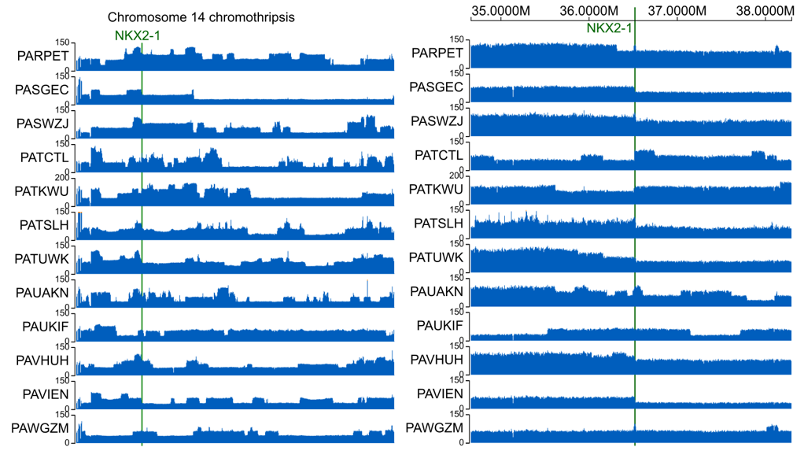

Supplementary Figure 1. T-ALL patient WGS coverage tracks in Chromosome 14 and on the right zoomed in to NKX2-1 loci.

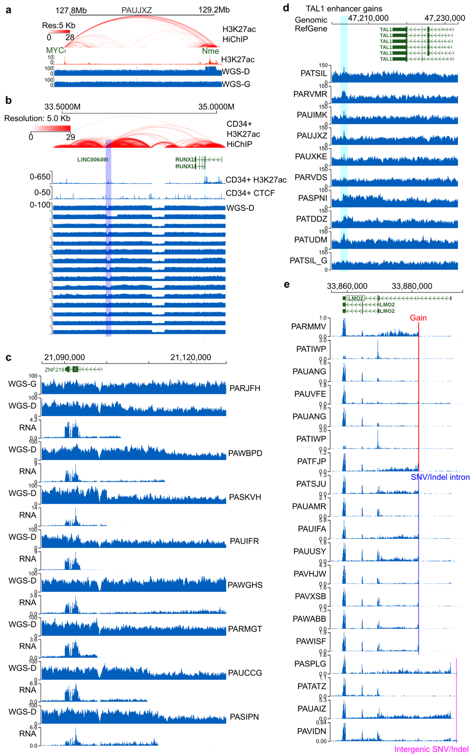
Supplementary Figure 2. Genomic analysis of recurrent mechanisms of oncogene activation. a, Positive control of HiChIP in N-Me enhancer gain case. Depiction of H3K27ac HiChIP, H3K27ac Coverage, Diagnostic Sample, and Germline WGS Coverage in a T-ALL patient, showcasing interactions between MYC and amplified Nme enhancer loci. Arcs represent interactions between genomic loci, with color coding denoting interaction strength; b, WGS coverage tracks showing recurrent LINC00649 losses in T-ALL patients. H3K27ac HiChIP, H3K27ac and CTCF Coverage shown as in a. LINC00649 is putative regulatory region for RUNX1 in CD34+ cells; c, WGS and RNA coverage showing recurrent losses at ZNF219 loci, also revealing RNA coverage match with breakpoint location; d, WGS coverage tracks for TAL1 enhancer gains (Cyan line) are shown in 9 patient samples and one germline sample; e, RNA coverage tracks for LMO2 intronic gains, intronic SNV/Indel and intergenic SNV/Indels are shown, revealing generation of alternative transcript start site for intronic gains and intronic SNV/Indel, but not intergenic SNV/Indels.

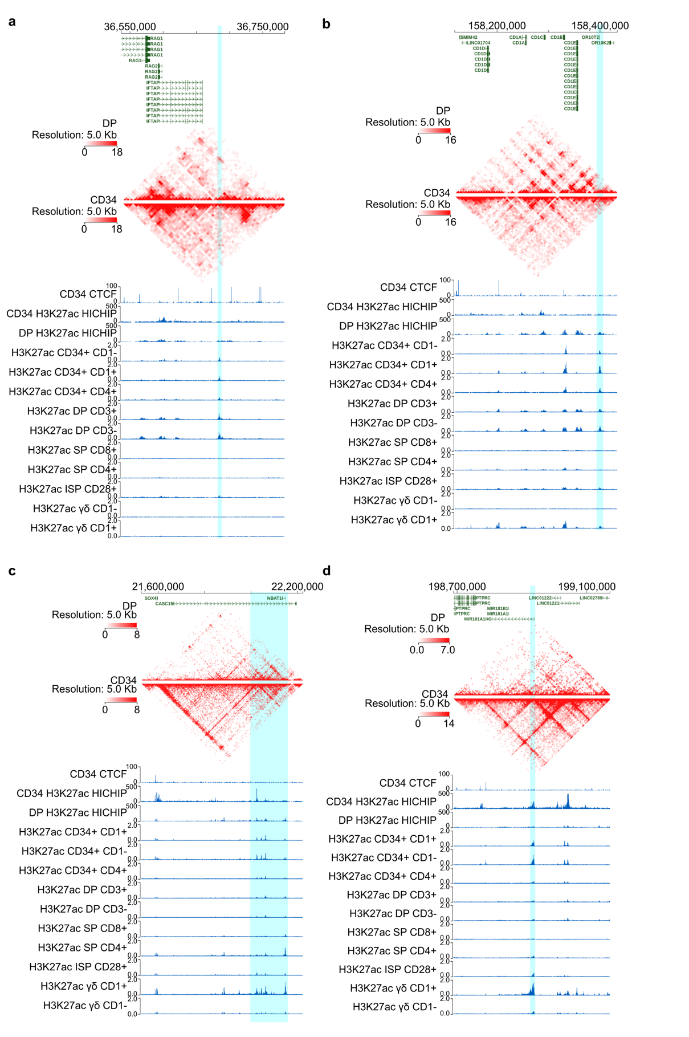
Supplementary Figure 3. Normal cell types and hijacked enhancers. a, H3K27ac coverage tracks of RAG::LMO2 hijacked enhancer (marked by cyan line) is shown in different healthy thymic T-cells and in CD34+ cells. On top: Heatmap depicting healthy normal double positive and CD34+ HSPCs H3K27ac HiChIP raw interactions as heatmaps; b, same as a for CD1E::TAL1 hijacked enhancer; c, same as a for SOX4/CASC15::HOXA13 hijacked enhancer; d, same as a for MIR181A1HG::HOXA13/LMO2 hijacked enhancers.

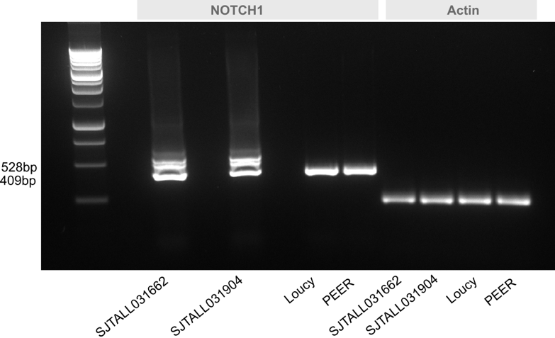
Supplementary Figure 4. NOTCH1 Intergenic SNV RT-PCR validation. Two patient samples, SJTALL031662, SJTALL031904 have extended transcript (528bp vs. 409bp) due to the intronic SNV, compared to PEER and LOUCY cell lines not harboring the intronic SNV.

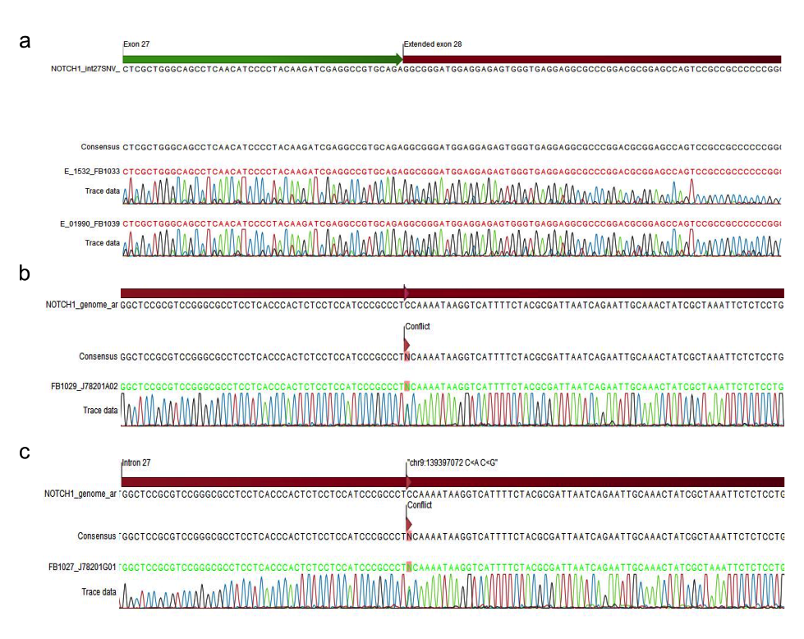
Supplementary Figure 5. Sanger sequencing result of NOTCH1 intronic SNV in control (a) and two patient sample genomic DNA (b-c).
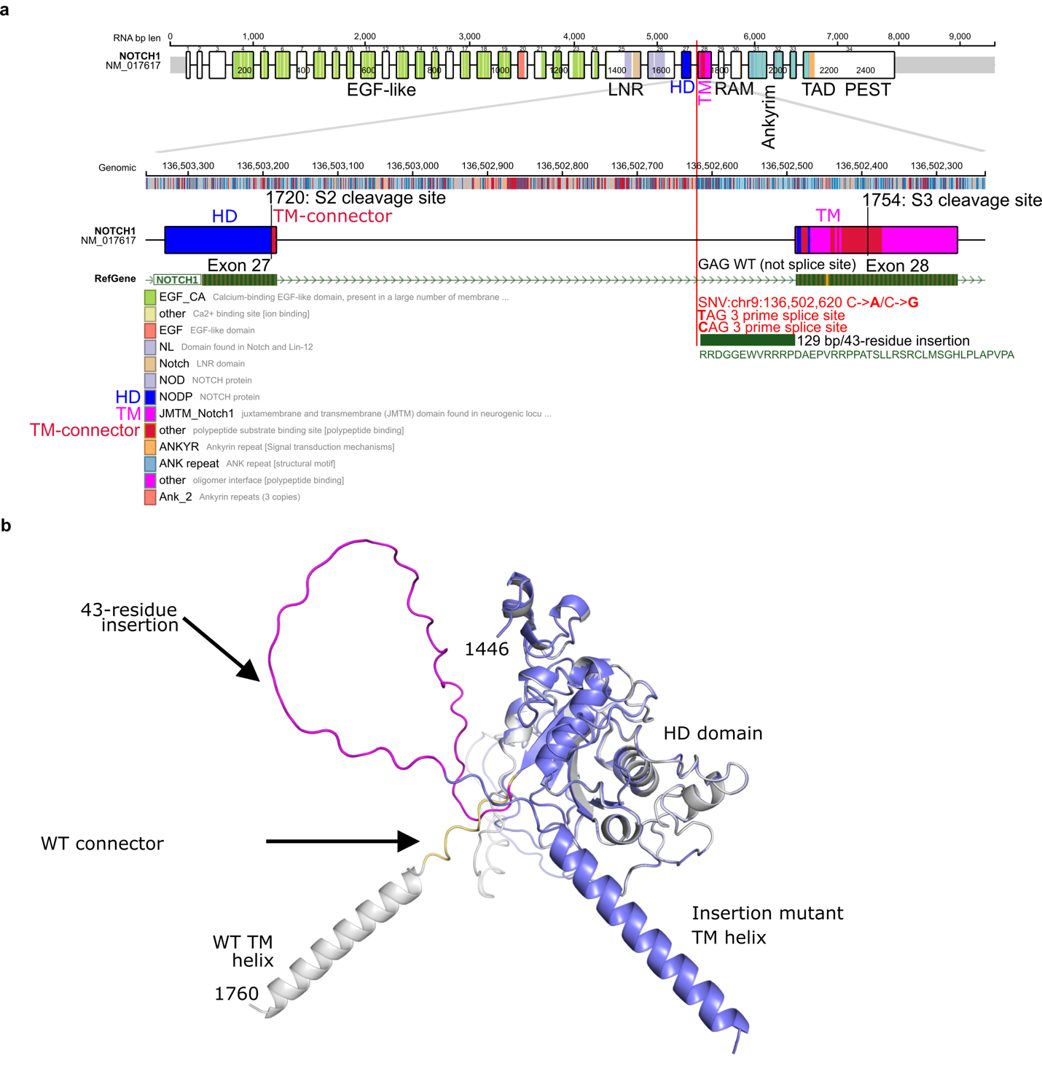
Supplementary Figure 6. NOTCH1 intronic SNV. a, NOTCH1 exons, amino acid residue position and CDD/PFAM and previously⁴⁹ described protein domains are shown. Heterodimerization domain (HD) and transmembrane (TM), TM-connector domains are color coded and S2-S3 cleavage site and residue positions are shown as black lines. Below, Exon 27-28 are shown, with NOTCH1 intronic SNV location marked by red line, with mutation types, generated 3 prime splice site and 43-residue insert sequence is shown; b, The observed mutant displays a 43-residue insertion, depicted in magenta, following the C-terminus of the final domain of the extracellular portion of Notch, the HD domain. AlphaFold2 models of the wild-type (WT) and mutant proteins, including only the HD domain and TM helix, suggest that the fold of the HD domain is unperturbed by the insertion. Notably, the insertion would dramatically increase the distance between the extracellular domain of Notch and the cellular membrane, which could both increase the accessibility for proteolytic cleavage and potentially affect receptor signaling. Models of WT and the insertion mutant are depicted in gray and blue, respectively. The loop connecting the WT domain to the TM helix is shown in yellow and the residue numbers with regards to full-length Notch are depicted.

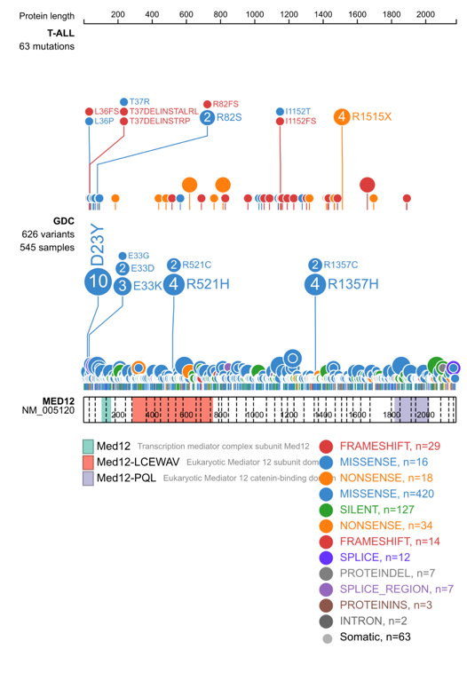
Supplementary Figure 7. Lollipop plots denoting MED12 SNV/Indel amino acid locations in T-ALL and GDC cohorts, revealing loss-of-function characteristics.

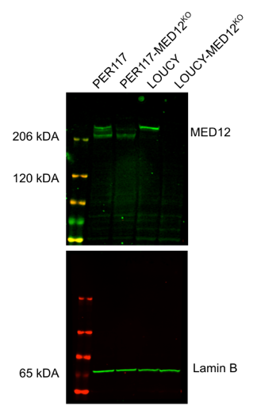
Supplementary Figure 8. Western blot of MED12 protein levels in knockout model in PER117 and LOUCY cell line. PER117 knockout was not complete, but LOUCY showed clearly diminished MED12 levels.

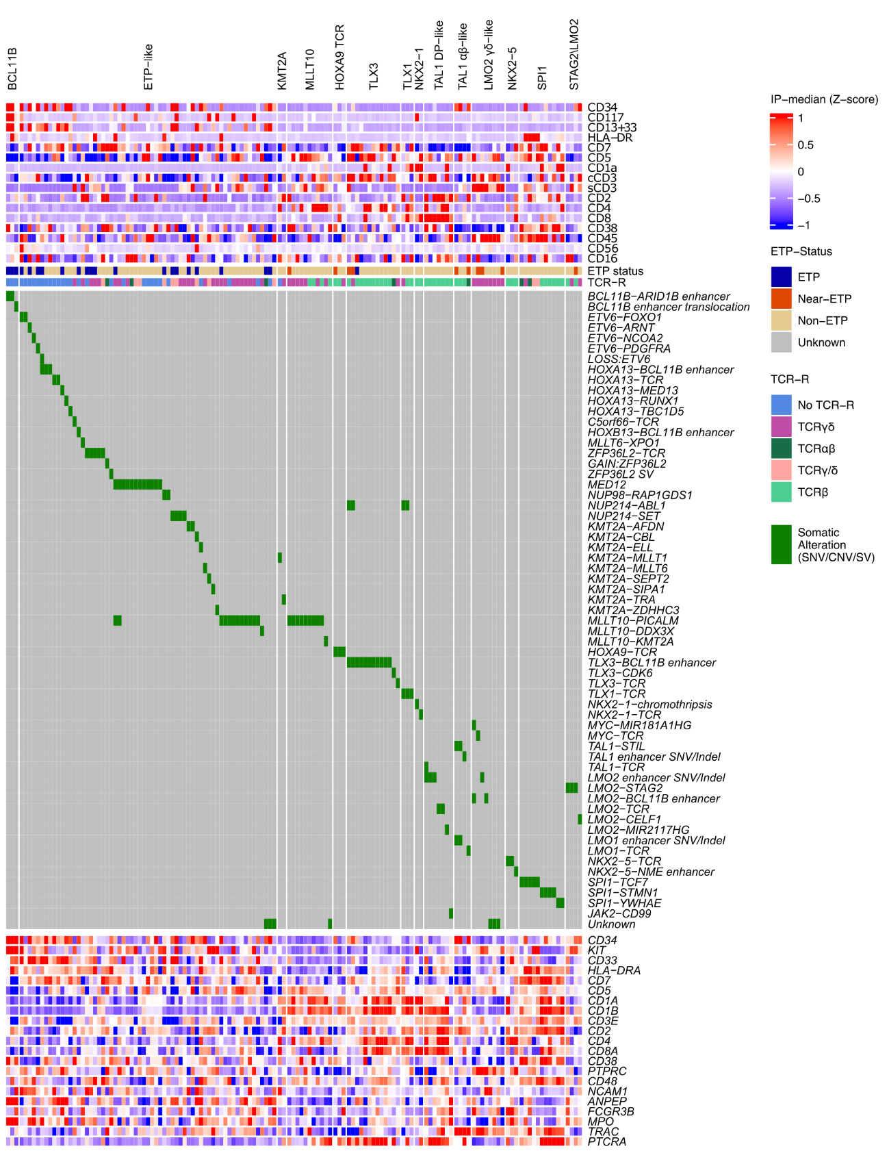
Supplementary Figure 9. Oncoprint of surface markers IP-median Z-scores, ETP-status, T-cell TCR rearrangement status, genomic driver of each case and gene expression profiles of the marker genes.

SUPPLEMENTARY REFERENCES

1 Sugiyama, S. et al. Adverse effects of anti-tumor drug, cisplatin, on rat kidney mitochondria: disturbances in glutathione peroxidase activity. Biochem Biophys Res Commun 159, 1121-1127 (1989). https://doi.org:10.1016/0006-291x(89)92225-0
2 Buenrostro, J. D., Giresi, P. G., Zaba, L. C., Chang, H. Y. & Greenleaf, W. J. Transposition of native chromatin for fast and sensitive epigenomic profiling of open chromatin, DNA-binding proteins and nucleosome position. Nat Methods 10, 1213-1218 (2013). https://doi.org:10.1038/nmeth.2688
3 Corces, M. R. et al. An improved ATAC-seq protocol reduces background and enables interrogation of frozen tissues. Nat Methods 14, 959-962 (2017). https://doi.org:10.1038/nmeth.4396
4 Li, H. & Durbin, R. Fast and accurate short read alignment with Burrows–Wheeler transform. Bioinformatics 25, 1754-1760 (2009). https://doi.org:10.1093/bioinformatics/btp324
5 Danecek, P. et al. Twelve years of SAMtools and BCFtools. GigaScience 10 (2021). https://doi.org:10.1093/gigascience/giab008
6 Ramírez, F. et al. deepTools2: a next generation web server for deep-sequencing data analysis. Nucleic Acids Research 44, W160-W165 (2016). https://doi.org:10.1093/nar/gkw257
7 Durand, N. C. et al. Juicer Provides a One-Click System for Analyzing Loop-Resolution Hi-C Experiments. Cell Systems 3, 95-98 (2016). https://doi.org:https://doi.org/10.1016/j.cels.2016.07.002
8 Zhou, X. et al. Exploring genomic alteration in pediatric cancer using ProteinPaint. Nat Genet 48, 4-6 (2016). https://doi.org:10.1038/ng.3466
9 Li, H. New strategies to improve minimap2 alignment accuracy. Bioinformatics 37, 4572-4574 (2021). https://doi.org:10.1093/bioinformatics/btab705
10 Zou, Z., Ohta, T., Miura, F. & Oki, S. ChIP-Atlas 2021 update: a data-mining suite for exploring epigenomic landscapes by fully integrating ChIP-seq, ATAC-seq and Bisulfite-seq data. Nucleic Acids Research 50, W175-W182 (2022). https://doi.org:10.1093/nar/gkac199
11 Gu, Z., Eils, R. & Schlesner, M. Complex heatmaps reveal patterns and correlations in multidimensional genomic data. Bioinformatics 32, 2847-2849 (2016). https://doi.org:10.1093/bioinformatics/btw313
12 Dobin, A. et al. STAR: ultrafast universal RNA-seq aligner. Bioinformatics 29, 15-21 (2012). https://doi.org:10.1093/bioinformatics/bts635
13 Li, B. & Dewey, C. N. RSEM: accurate transcript quantification from RNA-Seq data with or without a reference genome. BMC Bioinformatics 12, 323 (2011). https://doi.org:10.1186/1471-2105-12-323
14 Cibulskis, K. et al. Sensitive detection of somatic point mutations in impure and heterogeneous cancer samples. Nat Biotechnol 31, 213-219 (2013). https://doi.org:10.1038/nbt.2514
15 Larson, D. E. et al. SomaticSniper: identification of somatic point mutations in whole genome sequencing data. Bioinformatics 28, 311-317 (2012). https://doi.org:10.1093/bioinformatics/btr665
16 Koboldt, D. C. et al. VarScan 2: somatic mutation and copy number alteration discovery in cancer by exome sequencing. Genome Res 22, 568-576 (2012). https://doi.org:10.1101/gr.129684.111
17 Fan, Y. et al. MuSE: accounting for tumor heterogeneity using a sample-specific error model improves sensitivity and specificity in mutation calling from sequencing data. Genome Biol 17, 178 (2016). https://doi.org:10.1186/s13059-016-1029-6
18 Kim, S. et al. Strelka2: fast and accurate calling of germline and somatic variants. Nat Methods 15, 591-594 (2018). https://doi.org:10.1038/s41592-018-0051-x
19 Wang, K., Li, M. & Hakonarson, H. ANNOVAR: functional annotation of genetic variants from high-throughput sequencing data. Nucleic Acids Res 38, e164 (2010). https://doi.org:10.1093/nar/gkq603
20 Chen, X. et al. CONSERTING: integrating copy-number analysis with structural-variation detection. Nat Methods 12, 527-530 (2015). https://doi.org:10.1038/nmeth.3394
21 Rausch, T. et al. DELLY: structural variant discovery by integrated paired-end and split-read analysis. Bioinformatics 28, i333-i339 (2012). https://doi.org:10.1093/bioinformatics/bts378
22 Chen, X. et al. Manta: rapid detection of structural variants and indels for germline and cancer sequencing applications. Bioinformatics 32, 1220-1222 (2016). https://doi.org:10.1093/bioinformatics/btv710
23 Cameron, D. L. et al. GRIDSS: sensitive and specific genomic rearrangement detection using positional de Bruijn graph assembly. Genome Res 27, 2050-2060 (2017). https://doi.org:10.1101/gr.222109.117
24 Layer, R. M., Chiang, C., Quinlan, A. R. & Hall, I. M. LUMPY: a probabilistic framework for structural variant discovery. Genome Biol 15, R84 (2014). https://doi.org:10.1186/gb-2014-15-6-r84
25 Jeffares, D. C. et al. Transient structural variations have strong effects on quantitative traits and reproductive isolation in fission yeast. Nat Commun 8, 14061 (2017). https://doi.org:10.1038/ncomms14061
26 Chiang, C. et al. SpeedSeq: ultra-fast personal genome analysis and interpretation. Nat Methods 12, 966-968 (2015). https://doi.org:10.1038/nmeth.3505
27 Uhrig, S. et al. Accurate and efficient detection of gene fusions from RNA sequencing data. Genome Res 31, 448-460 (2021). https://doi.org:10.1101/gr.257246.119
28 Nicorici, D. et al. <strong>FusionCatcher</strong> – a tool for finding somatic fusion genes in paired-end RNA-sequencing data. bioRxiv, 011650 (2014). https://doi.org:10.1101/011650
29 Bray, N. L., Pimentel, H., Melsted, P. & Pachter, L. Near-optimal probabilistic RNA-seq quantification. Nat Biotechnol 34, 525-527 (2016). https://doi.org:10.1038/nbt.3519
30 Ma, C., Shao, M. & Kingsford, C. SQUID: transcriptomic structural variation detection from RNA-seq. Genome Biol 19, 52 (2018). https://doi.org:10.1186/s13059-018-1421-5
31 Haas, B. J. et al. STAR-Fusion: Fast and Accurate Fusion Transcript Detection from RNA-Seq. bioRxiv, 120295 (2017). https://doi.org:10.1101/120295
32 Bolotin, D. A. et al. MiXCR: software for comprehensive adaptive immunity profiling. Nat Methods 12, 380-381 (2015). https://doi.org:10.1038/nmeth.3364
33 Chen, C. et al. Single-cell multiomics reveals increased plasticity, resistant populations, and stem-cell-like blasts in KMT2A-rearranged leukemia. Blood 139, 2198-2211 (2022). https://doi.org:10.1182/blood.2021013442
34 Ritchie, M. E. et al. limma powers differential expression analyses for RNA-sequencing and microarray studies. Nucleic Acids Research 43, e47-e47 (2015). https://doi.org:10.1093/nar/gkv007
35 Liu, Y. et al. Discovery of regulatory noncoding variants in individual cancer genomes by using cis-X. Nat Genet 52, 811-818 (2020). https://doi.org:10.1038/s41588-020-0659-5
36 Pounds, S. et al. A genomic random interval model for statistical analysis of genomic lesion data. Bioinformatics 29, 2088-2095 (2013). https://doi.org:10.1093/bioinformatics/btt372
37 Heinze, G. & Schemper, M. A solution to the problem of monotone likelihood in Cox regression. Biometrics 57, 114-119 (2001). https://doi.org:10.1111/j.0006-341x.2001.00114.x
38 Heinze, G. & Schemper, M. A solution to the problem of separation in logistic regression. Stat Med 21, 2409-2419 (2002). https://doi.org:10.1002/sim.1047
39 Goeman, J. J., Oosting, J., Cleton-Jansen, A. M., Anninga, J. K. & van Houwelingen, H. C. Testing association of a pathway with survival using gene expression data. Bioinformatics 21, 1950-1957 (2005). https://doi.org:10.1093/bioinformatics/bti267
40 Goeman, J. J., van de Geer, S. A., de Kort, F. & van Houwelingen, H. C. A global test for groups of genes: testing association with a clinical outcome. Bioinformatics 20, 93-99 (2004). https://doi.org:10.1093/bioinformatics/btg382
41 Pounds, S. & Cheng, C. Robust estimation of the false discovery rate. Bioinformatics 22, 1979-1987 (2006). https://doi.org:10.1093/bioinformatics/btl328
42 Fine, J. P. & Gray, R. J. A Proportional Hazards Model for the Subdistribution of a Competing Risk. Journal of the American Statistical Association 94, 496-509 (1999). https://doi.org:10.1080/01621459.1999.10474144
43 Gray, R. J. A Class of $K$-Sample Tests for Comparing the Cumulative Incidence of a Competing Risk. The Annals of Statistics 16, 1141-1154, 1114 (1988).
44 Friedman, J., Hastie, T. & Tibshirani, R. Regularization Paths for Generalized Linear Models via Coordinate Descent. J Stat Softw 33, 1-22 (2010).
45 Wright, M. N. & Ziegler, A. ranger: A Fast Implementation of Random Forests for High Dimensional Data in C++ and R. Journal of Statistical Software 77, 1 - 17 (2017). https://doi.org:10.18637/jss.v077.i01
46 Taylor, J. M. Random Survival Forests. J Thorac Oncol 6, 1974-1975 (2011). https://doi.org:10.1097/JTO.0b013e318233d835
47 Trinquand, A. et al. Toward a <i>NOTCH1/FBXW7/RAS/PTEN</i>–Based Oncogenetic Risk Classification of Adult T-Cell Acute Lymphoblastic Leukemia: A Group for Research in Adult Acute Lymphoblastic Leukemia Study. Journal of Clinical Oncology 31, 4333-4342 (2013). https://doi.org:10.1200/jco.2012.48.5292
48 Petit, A. et al. Oncogenetic mutations combined with MRD improve outcome prediction in pediatric T-cell acute lymphoblastic leukemia. Blood 131, 289-300 (2018). https://doi.org:10.1182/blood-2017-04-778829
49 Gordon, W. R., Arnett, K. L. & Blacklow, S. C. The molecular logic of Notch signaling--a structural and biochemical perspective. J Cell Sci 121, 3109-3119 (2008). https://doi.org:10.1242/jcs.035683

