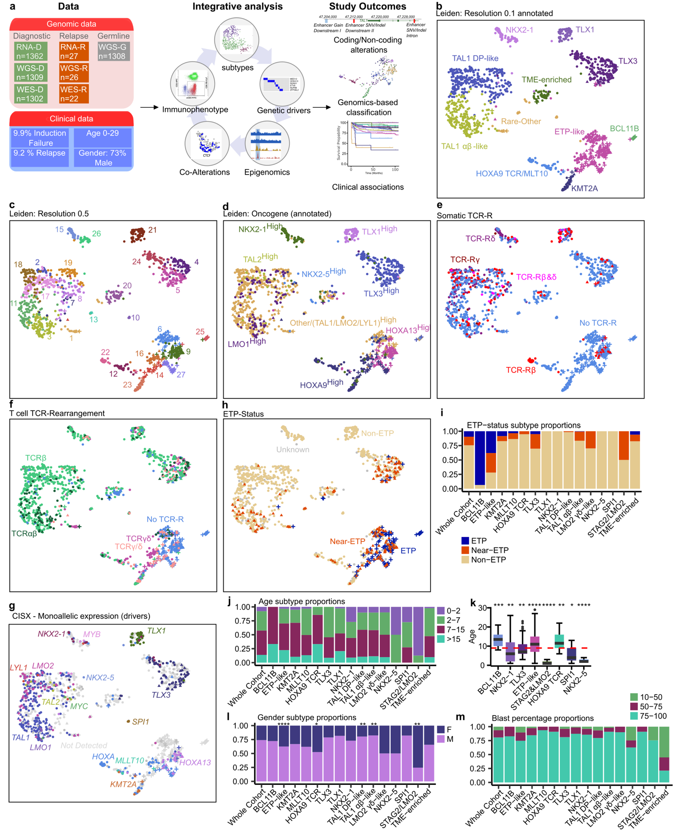
Extended Data Figure 1. T-ALL cohort composition and subtyping. a, Schematic depiction of the cohort structure, analysis framework, and study outcomes; b, UMAP scatter plots illustrating Leiden algorithm clusters at 0.1 resolution, annotated by subtype; c, Leiden algorithm clusters at 0.5 resolution, further delineating distinct groups; d, Leiden algorithm clusters showcasing oncogene expression patterns; e. UMAP plot visualizing TCR types hijacked by oncogenes; f, UMAP plot displaying types of T cell TCR-rearrangements; g, UMAP plot showing samples with monoallelic expression of driver gene; h, UMAP plot of the ETP-status; i, Barplot illustrating ETP-status proportions, categorized by subtypes; j, Barplot showcasing age distribution proportions, categorized by subtypes; k, Boxplot presenting age distributions per subtypes. Only significant subtypes shown, with stars on top describing significance. Median age is shown as red dotted line; l, Barplot depicting gender distribution proportions, categorized by subtypes, with stars on top describing significance; m, Barplot presenting blast percentage distribution proportions, categorized by subtypes.

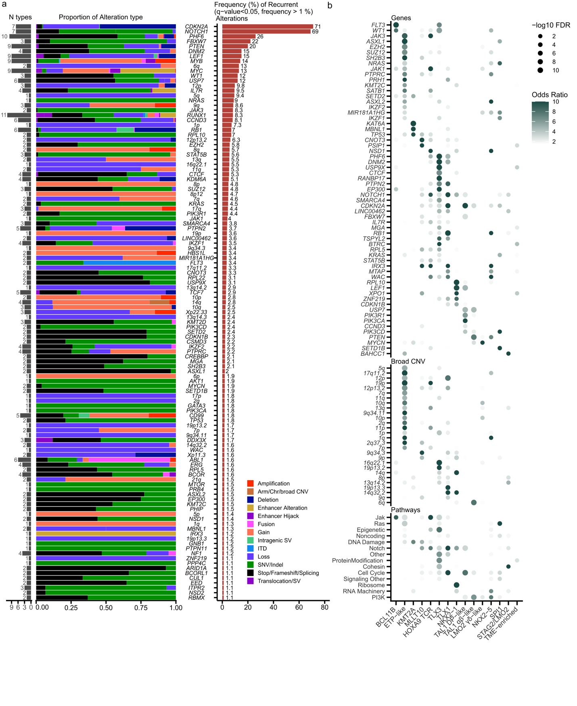
Extended Data Figure 2. Alterations in T-ALL and subtype-associated genetic changes. a, Stacked barplot depicting frequencies of significantly altered genes (q<0.05) with alterations >1% in cases, segregated by alteration types. Frequency of alteration types are shown on the left, alteration relative frequencies on the right; b, Dotplot illustrating altered genes, broad CNVs, and pathways significantly associated with subtypes, displaying odds ratio as dot color and -log10 FDR as dot size. Odds ratio was capped at 10. Genes/lesions are ordered by significance within each subtype.

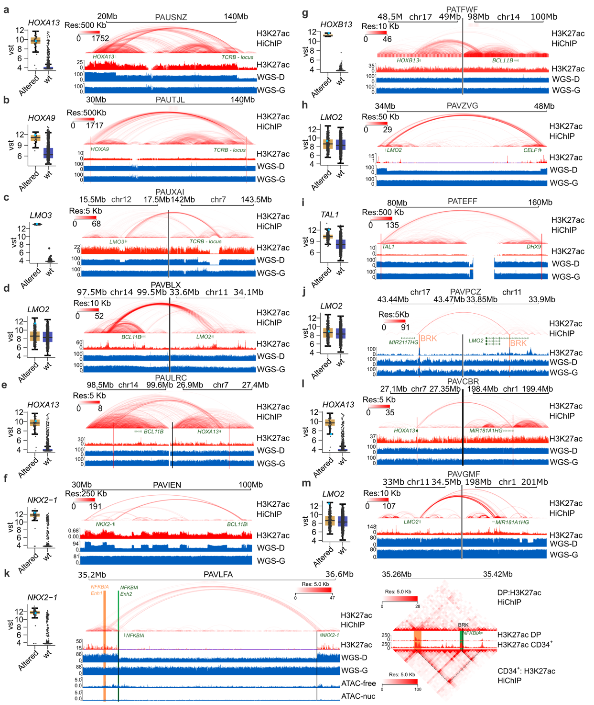
Extended Data Figure 3. Validation of non-coding alterations. a, Complex chr7 rearrangements: Depiction of H3K27ac HiChIP, H3K27ac coverage, diagnostic Sample, and germline WGS coverage in a T-ALL patient, showcasing interactions between HOXA13 and TCRβ loci after chr7 rearrangements. Arcs represent interactions between genomic loci, with color coding denoting interaction strength. On the left: Boxplot of HOXA13 gene expression for altered and wt samples, with PAVHBC sample labeled in cyan; b, HOXA9 TCR Inversion: Similar representation as a; c, LMO3 TCR translocation: similar representation as a; d, LMO2 BCL11B loci translocation: Similar representation as a; e, HOXA13 BCL11B translocation: similar representation as a; f, NKX2-1 Chromosome 14 chromothripsis and BCL11B locus rearrangement: similar representation as a; g, HOXB13 BCL11B translocation: similar representation as a; h, LMO2 CELF1 intergenic loss: Similar representation as a; i, TAL1 DHX9 inversion: Similar representation as a; j, LMO2 MIR2117HG translocation: Similar representation as a; k, NKX2-1 NFKBIA enhancer hijacking: similar representation as Fig. 2b; l, HOXA13 MIR181A1HG Translocation: similar representation as a; m, LMO2 MIR181A1HG translocation: similar representation as a; Abbreviations: diagnostic/germline sample WGS (WGS-D, WGS-G). Nucleosome-free and nucleosome cut fragments (ATAC-free, ATAC-nuc)
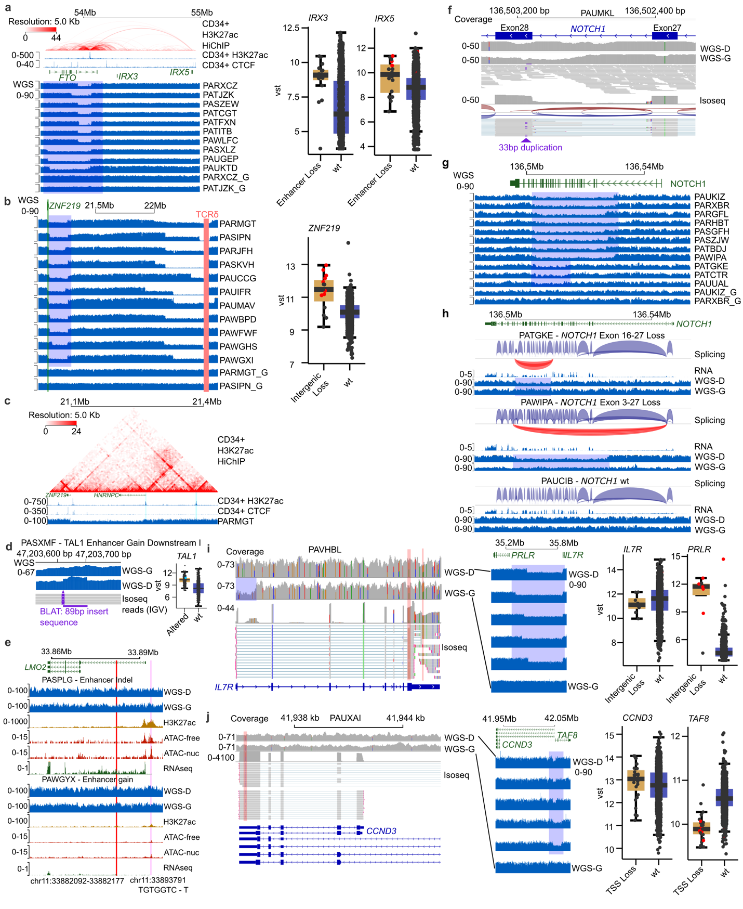
Extended Data Figure 4. Intragenic and intergenic alterations and long read (LR) isoform sequencing validations. a, Illustration of representative cases featuring WGS coverage tracks in FTO/IRX loci, along with two WGS germline control samples. Boxplots display IRX3 and IRX5 gene expressions, with allelic expression denoted by red dots. On top is depiction of H3K27ac HiChIP, H3K27ac and CTCF Coverage in CD34+ cells, showcasing interactions between FTO enhancers and IRX3 and IRX5. Arcs represent interactions between genomic loci, with color coding denoting interaction strength; b, Similar representation as a for ZNF219 loci with annotation of TCRδ loci; c, H3K27ac HiChIP, H3K27ac and CTCF Coverage in CD34+ cells, showcasing interactions between HNRNPC promoter and enhancers and ZNF219 loci; d, WGS coverages for T-ALL patient diagnostic and germline samples are shown with four RNA isoform sequencing reads visualized in IGV, capturing the 89bp gain of the TAL1 enhancer. BLAT match of the insert sequence is shown below, matching with the increased coverage of the WGS in that region. On the right, boxplot of TAL1 gene expression with PASXMF sample labeled in cyan; e, WGS, H3K27ac HiChIP, ATAC seq coverage tracks are shown for T-ALL patient with Enhancer Indel (pink line) and Enhancer gain (red line), revealing high levels of H3K27ac marking neoenhancer formation and neomorphic promoter generation; f, NOTCH1 exon28 33bp duplication sites are shown using WGS and LR isoform sequencing; g, Similar representation as a for NOTCH1 loci showing intragenic deletions in representative cases; h, NOTCH1 splicing plots for T-ALL patients with exon 16-27 and 3-27 losses, compared to wt control, are visualized. Atypical splicing reads are highlighted in red; i, Coverage tracks for IL7R diagnostic and germline WGS, along with SNPs, are displayed at the top. Isoform sequencing reads are presented below, indicating the loss of one allele due to TSS loss. On the right, IL7R and PRLR loci CNV loss is exhibited in representative cases, accompanied by IL7R and PRLR gene expression, where allelic expression is marked as red dots; j, Similar Representation as i for CCND3: showcasing the loss of the long isoform of CCND3 and TAF8 allele, while both alleles of short isoforms are expressed; Abbreviations: Diagnostic/germline sample WGS (WGS-D, WGS-G). Nucleosome-free and nucleosome cut fragments (ATAC-free, ATAC-nuc).
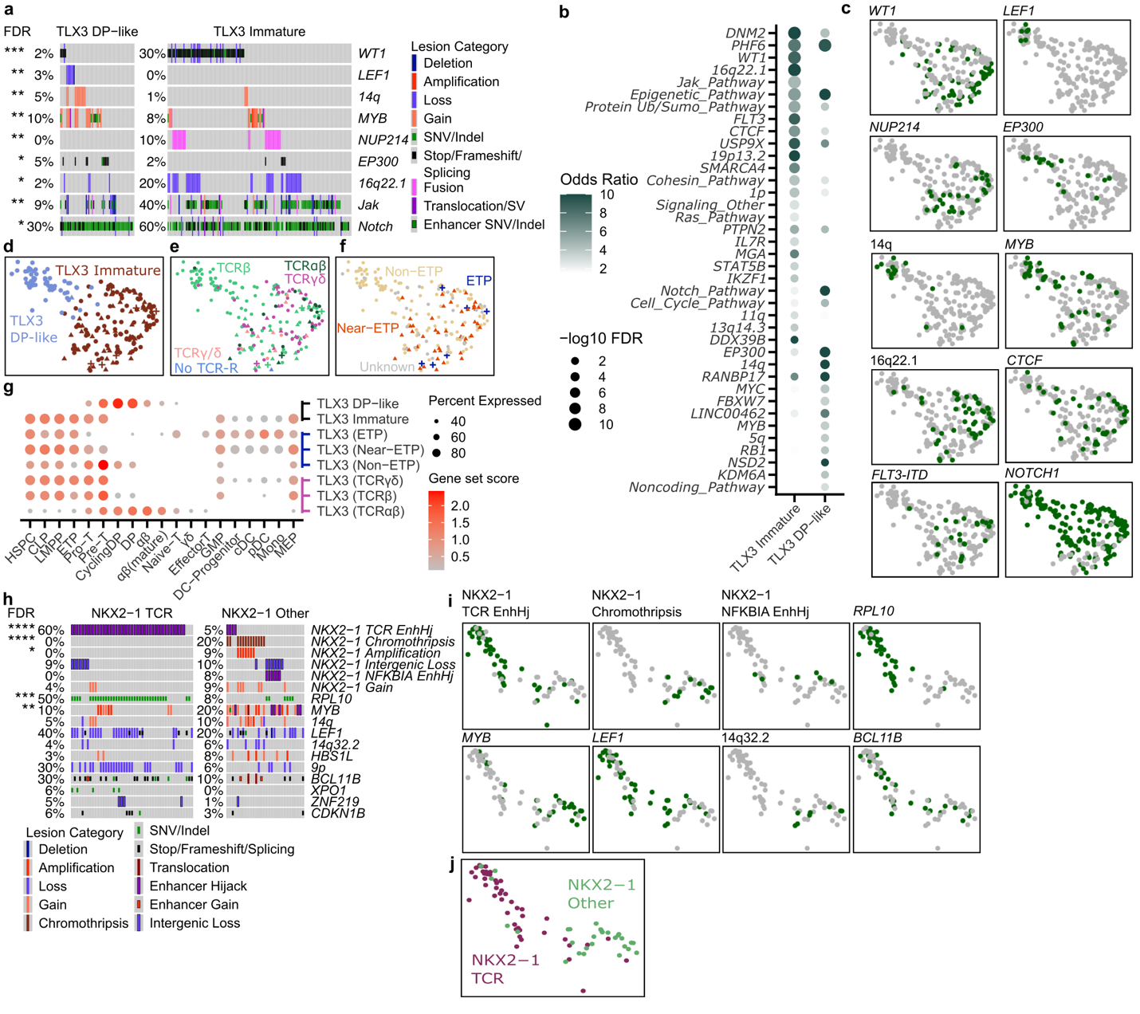

Extended Data Figure 5. Subtyping and genomic analysis of TLX3 and NKX2-1 subgroups. a, Oncoprint illustrating lesions that exhibit significant differences between TLX3 DP-like and Immature subgroups. Significance levels (Fisher’s exact test) are indicated as stars on the left side (**** = FDR<0.0001, *** = FDR<0.001, ** = FDR<0.01, * = FDR<0.05); b, Dotplot depicting significantly altered genes, broad CNVs, and pathways associated with TLX3 DP-like and Immature subgroups. Dot color represents odds ratio, and dot size reflects -log10 FDR values. Odds ratio values are capped at 10. Genes are ordered by significance within each subtype; c, UMAP scatter plots showcasing selected gene and lesion alterations (green) for TLX3 samples; d, UMAP plots representing TLX3 DP-like and Immature subgroups; e, UMAP plot displaying TCR rearrangement status for TLX3 cases; f, UMAP plot illustrating ETP-status for TLX3 cases; g, Dotplot visualizing expression of TLX3 DP-like and Immature gene expression signatures in healthy normal BM/Thymic single-cell RNA data. Detection percentage is represented by dot size, while mean signature enrichment by normal cell type is indicated by color. TLX3 subgroup is further divided based on ETP-status and TCR rearrangement status; h, Similar to a, this section presents the oncoprint showcasing significantly differing lesions between NKX2-1 TCR and Other subgroups; i, UMAP scatter plots displaying selected gene and lesion alterations (green) for NKX2-1 samples; j, UMAP scatter plot illustrating labels for NKX2-1 TCR and Other subgroups.

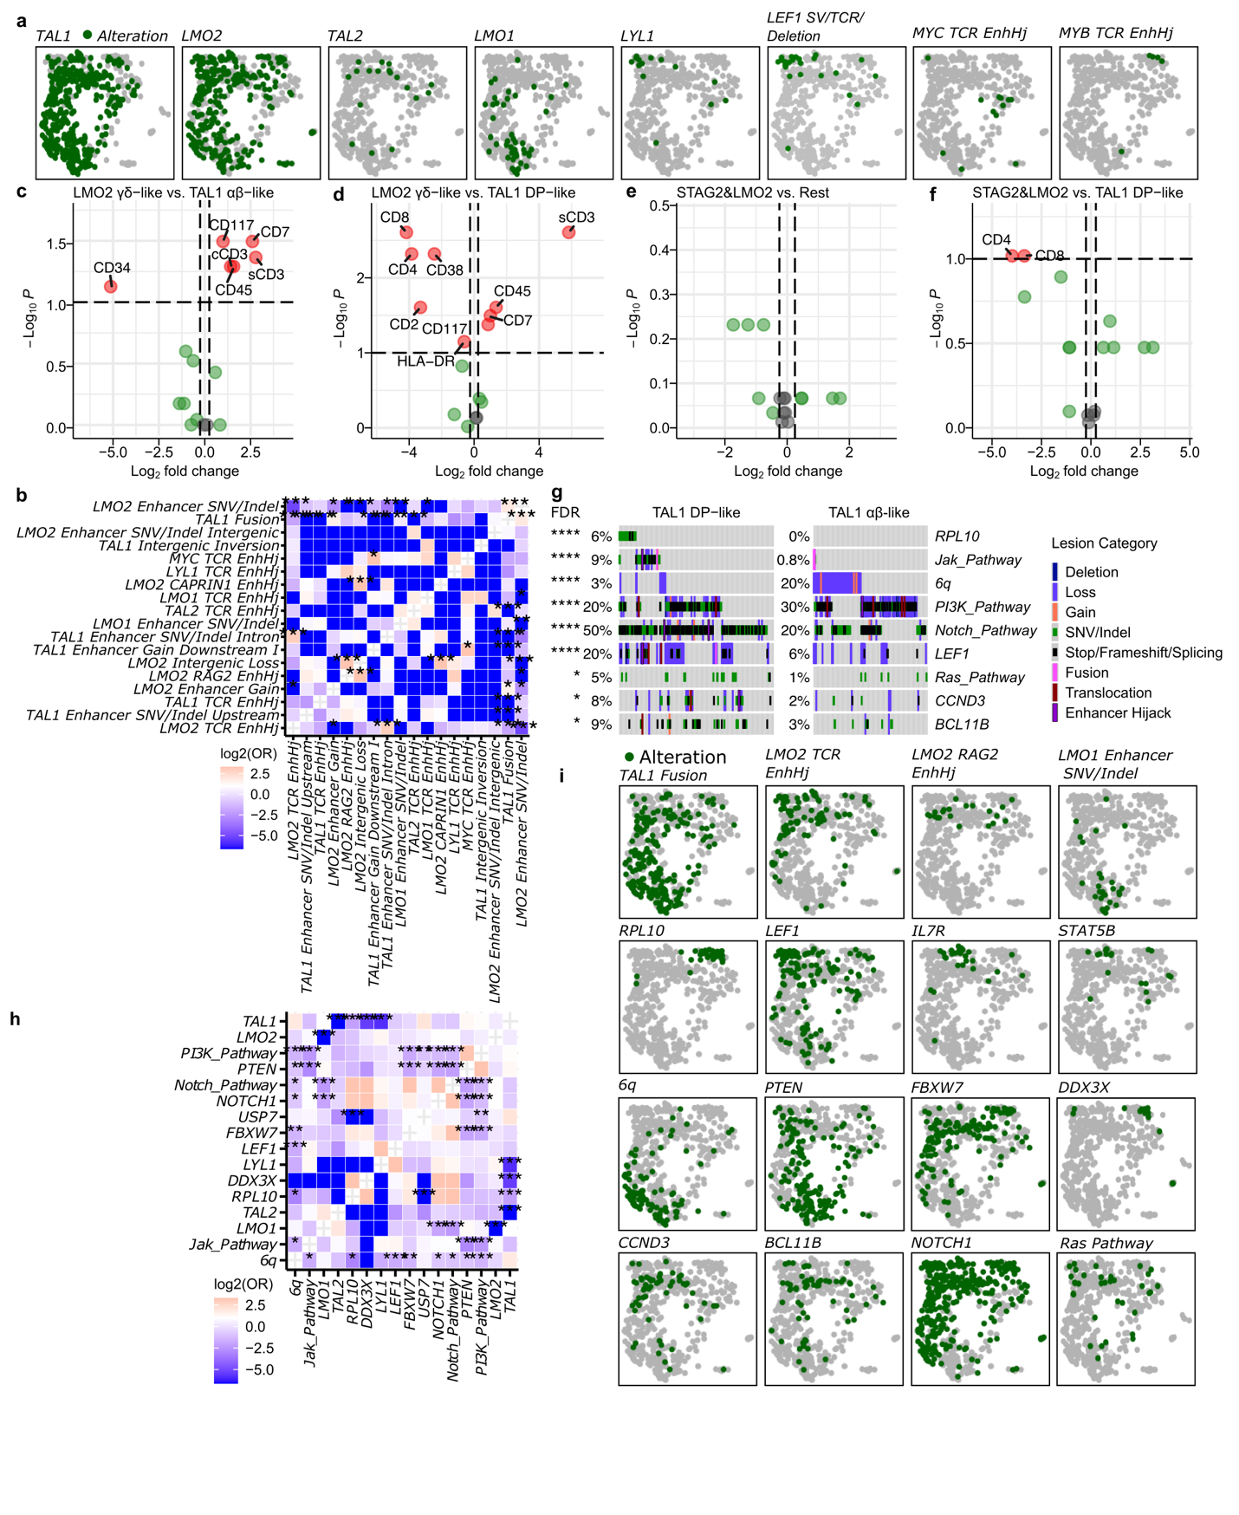
Extended Data Figure 6: TAL1 Group genetic subtypes; a, UMAP plot displaying the distribution of oncogene alterations within the TAL1 group; b, Heatmap showcasing mutually exclusive and co-occurring patterns of TAL1 group driver alterations. Color represents log2 odds ratio. Significant pairs are indicated by stars: (*** = FDR<0.001, ** = FDR<0.01, * = FDR<0.05); c, Volcano plot visualizing differential flow cytometry markers between LMO2 γδ-like and TAL1 αβ-like subtypes. Significantly altered markers are labeled with their respective protein names; d, Similar to c, this section presents a volcano plot comparing flow cytometry markers between LMO2 γδ-like and TAL1 DP-like subtypes; e, Similar to c, this plot displays differential flow cytometry markers in STAG2/LMO2 group; f, Similar to c, this plot displays differential flow cytometry markers between STAG2/LMO2 and TAL1 DP-like subtypes; g, Oncoprint highlighting lesions that exhibit significant differences between TAL1 DP-like and αβ-like subgroups. Significance levels are marked by stars on the left side; h, Comparable illustration as b, but showcasing genes and lesions associated with the TAL1 group or differing between TAL1 DP-like and αβ-like subgroups; i, UMAP plot representing the alterations associated with the TAL1 group.

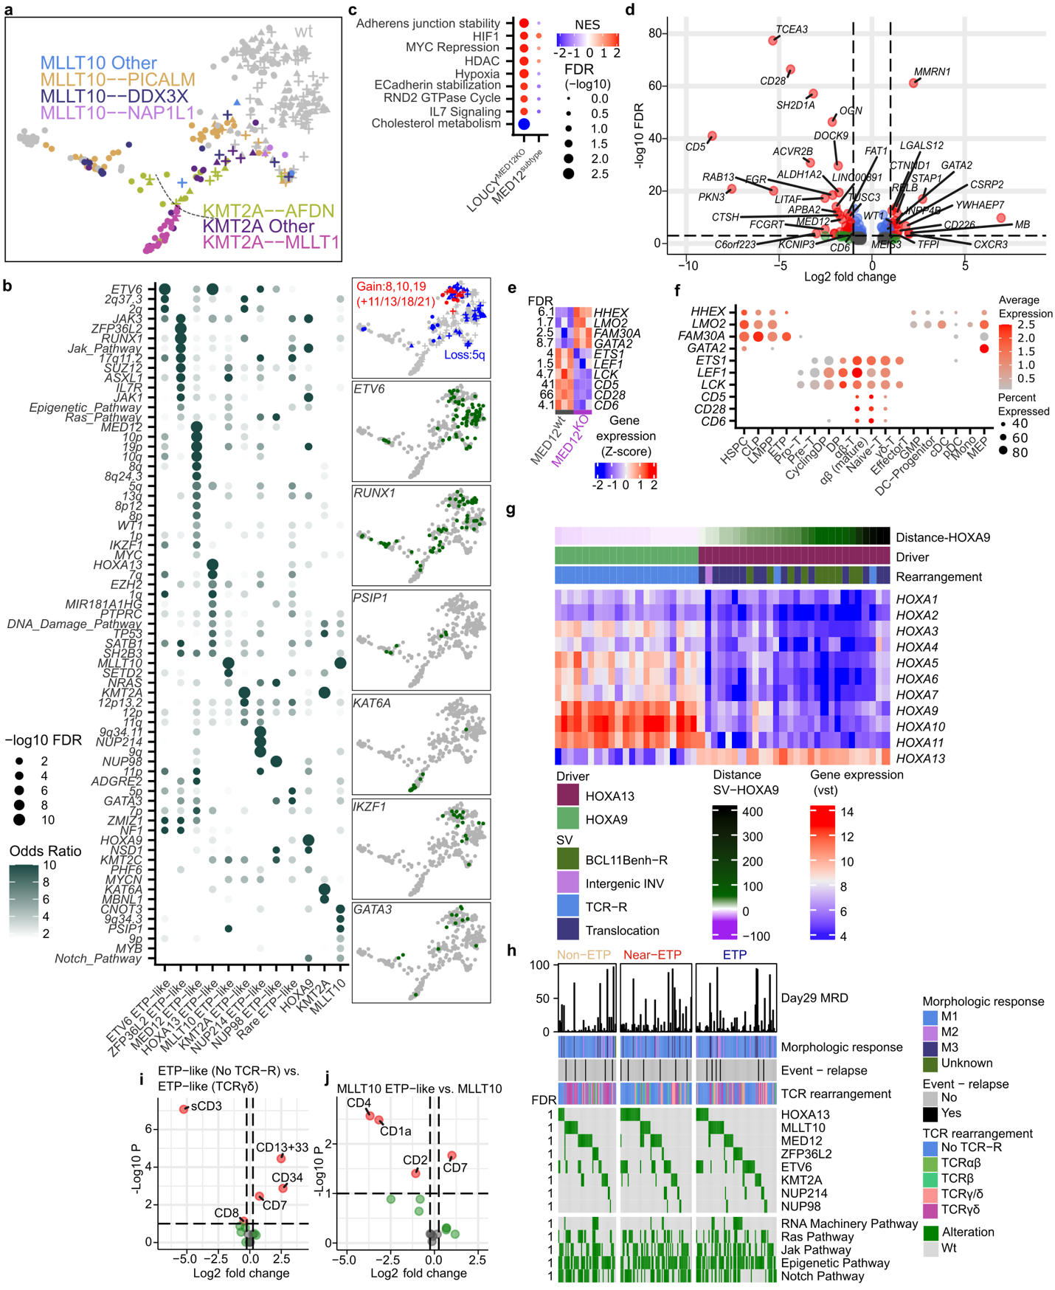

Extended Data Figure 7: ETP/ETP-like genomics, immunophenotype and clinical associations. a, UMAP plot revealing distinct MLLT10 and KMT2A fusion partners; b, Dotplot showcasing significant gene, CNV, and pathway alterations linked with ETP-like genetic subtypes, with dot color indicating odds ratio and dot size reflecting -log10 FDR. Odds ratio capped at 10, with genes/lesions ordered by significance within each subtype; c, Dotplot displaying GSEA enrichment result for significant pathways in MED12^{KO} vs. wt and MED12 subtype, where dot size is -log10 FDR and dot color is Normalized Enrichment Score (NES); d, Volcano plot illustrating significantly differentially expressed genes between LOUCY MED12 knockout (KO) and wild-type (WT) samples. The analysis is restricted to genes that exhibited differential expression in MED12 subtype; e, Heatmap of select differentially expressed cell type markers. FDR is shown on the left, comparing MED12wt and MED12KO in LOUCY cell line; f, Dotplot of panel e genes in normal healthy scRNA, depicting average expression (dot color) and detection percentage (dot size); g, Heatmap of HOXA gene expression, samples ordered by distance to HOXA9 TSS, and driver/alteration type annotations on top; h, Oncoprint of ETP-like group altered drivers and pathways, divided by ETP-status, with Day29 MRD barplot, clinical characteristics, morphological response, relapses, and TCR rearrangement status annotations. FDR between ETP categories and genomics indicated on the plot's left; i, Volcano plot depicting differential flow cytometry markers between ETP-like cases without TCR rearrangement versus those with TCRγδ rearrangement, with significantly altered markers labeled by protein names; j, Similar to i, this plot compares flow cytometry markers between ETP-like MLLT10 cases and other MLLT10 cases.

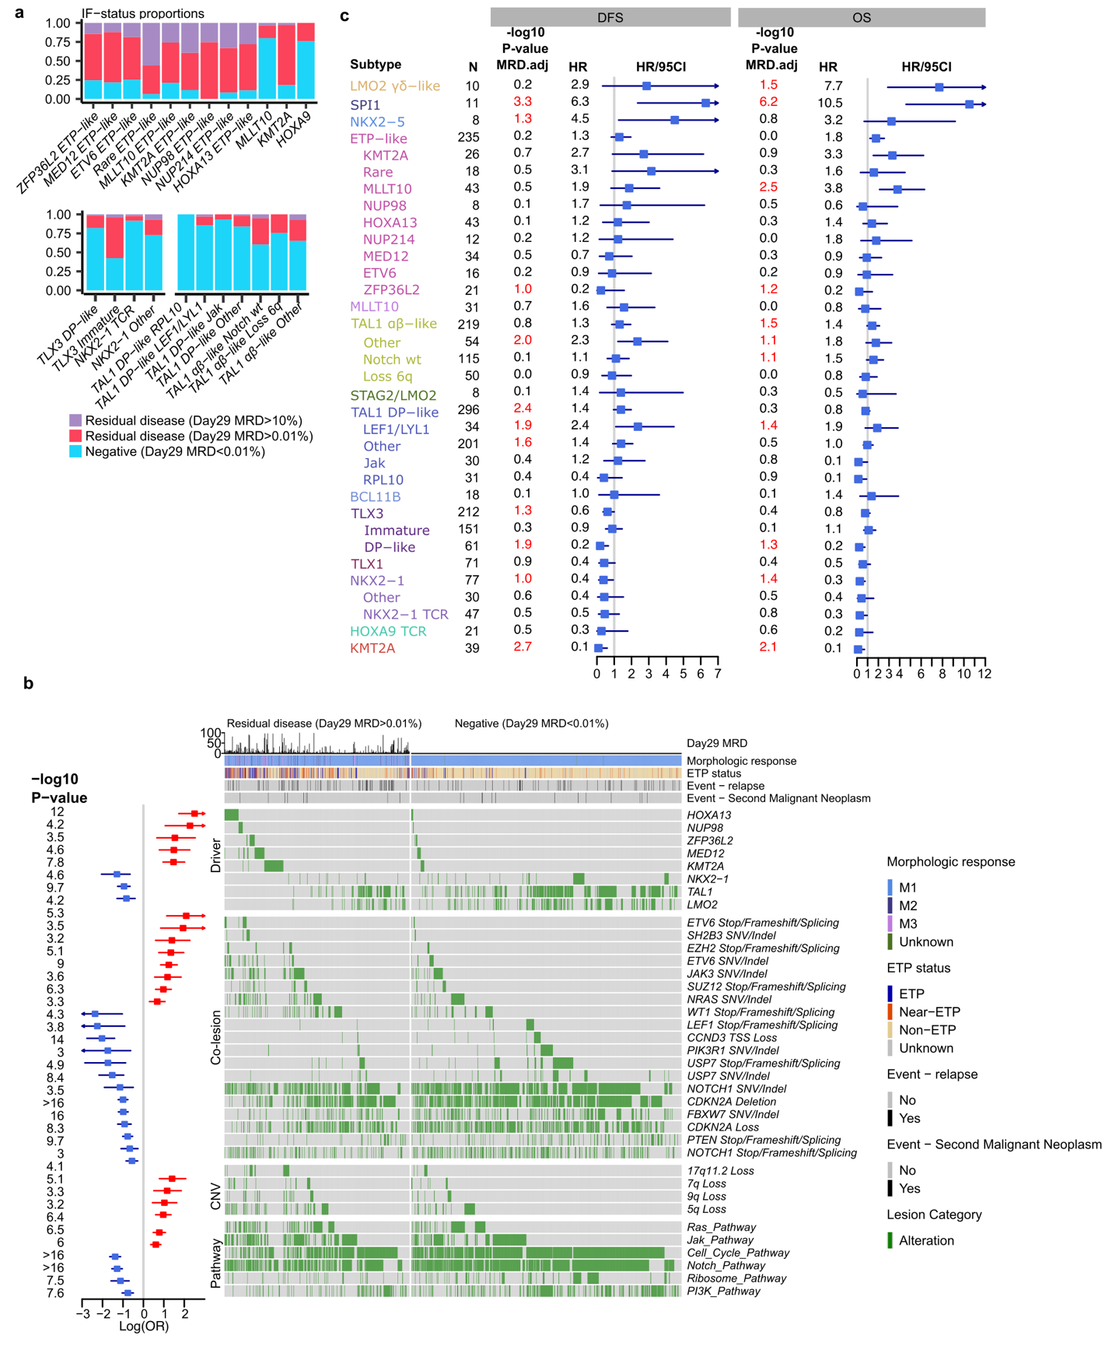
Extended Data Figure 8. T-ALL Genomic risk factors and clinical outcomes considering MRD, DFS, OS. a, Proportions of induction failure and residual disease per genetic subtype; b, Oncoprint of alterations significantly associated with MRD. Log odds ratios and confidence intervals presented on the left from Firth penalized logistic regression. Day29 MRD displayed as a barplot on top alongside other clinical annotations. Genomic data was divided to Residual disease, and Negative groups; c, Forest plot illustrating hazard ratios and 95th percentile confidence intervals for subtypes and genetic subtypes, considering DFS and OS as outcomes. Significant associations highlighted in red.

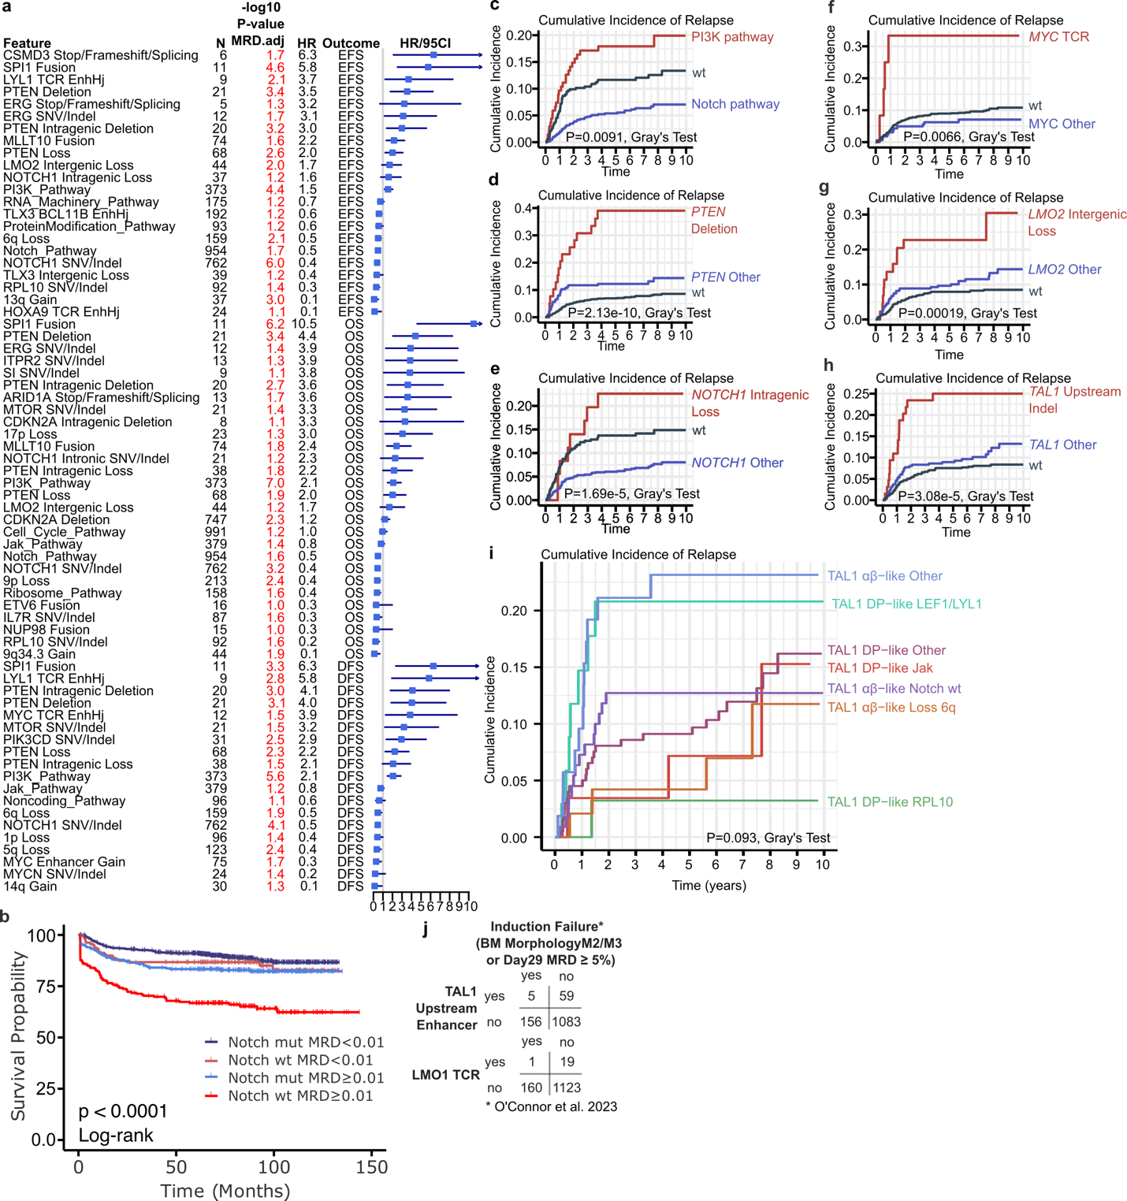 Extended Data Figure 9. Genomic risk factors and cumulative incidence of relapse in T-ALL. a, Forest plot depicting hazard ratios and 95th percentile confidence intervals for variants, utilizing EFS, DFS, and OS as outcomes. Significant associations are highlighted in red; b, The Kaplan-Meier curve of NOTCH pathway mutated vs. not mutated cases, divided by MRD percentage (%); c, Cumulative incidence of relapse plot, revealing distinct risk disparities between PI3K and Notch pathway alterations;
d, Comparison of PTEN deletions to other PTEN alterations in terms of cumulative relapse incidence; e, Comparison of NOTCH1 intragenic loss to other NOTCH1 alterations regarding cumulative relapse incidence; f, Comparison of MYC TCR alterations to other MYC alterations in relation to cumulative relapse incidence; g, Comparison of LMO2 intergenic loss to other LMO2 alterations with respect to cumulative relapse incidence; h, Comparison of TAL1 upstream enhancer Indel to other TAL1 alterations in terms of cumulative relapse incidence; i. Comparison of TAL1 genetic subtypes in relation to cumulative relapse incidence; j, Contingency table comparing TAL1 upstream enhancer Indel and LMO1 TCR to induction failure, demonstrating no association.

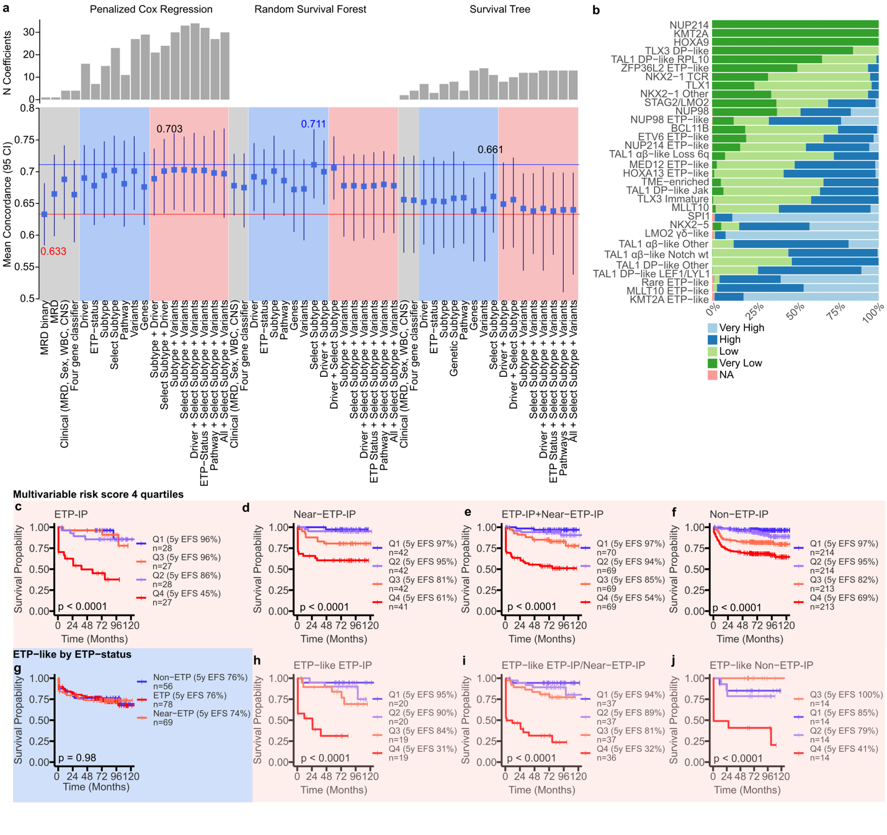 Extended Data Figure 10. Multivariable outcome model evaluation. a, The mean validation concordance and associated 95% confidence intervals are shown, derived from 100 random splits (70% training, 30% validation) of the data for three distinct survival models. These models were fitted using different data types, with binary Day29 MRD (≥0.01%) employed as the baseline, shown as red line. The baseline condordance results are denoted by grey rectangles, where binary MRD, numeric MRD, and a combination of clinical features (MRD, Sex, WBC, CNS) and previously reported four gene classifier are shown. The blue rectangle represents models fitted using single data types, including numeric MRD, Sex, WBC, and CNS as predictors. The pink rectangles denote combinations of genomic and clinical features. Model coefficient numbers are shown on top of the figure as barplots for penalized Cox regression and Survival Trees. Model concordance is shown on top of the best performing model for each algorithm and highest concordance annotated as blue line. Select subtype denotes data where the main subtype is further divided into genetic subtypes when available; b, This stacked barplot portrays a four-node survival tree that was generated from 1000 bootstrap resamples. The proportion of bootstrap samples in which each subtype was classified into various risk groups is shown; c, The Kaplan-Meier curve illustrates the risk score (divided into four quartiles) derived from a penalized Cox regression multivariable model, limited to ETP-IP cases. Log-rank test p-value is shown; d, Same as c, for Near-ETP-IP cases; e, Same as c, for ETP-IP and Near-ETP-IP cases; f, Same as c, for Non-ETP-IP cases; g, The Kaplan-Meier curve splitting ETP-like group by ETP-status; h, Same as c, for ETP-like subtype ETP-IP cases; i, Same as c, for ETP-like subtype ETP-IP and Near-ETP-IP cases; j, Same as c, for ETP-like subtype Non-ETP-IP cases.

