Supplementary Material

Gene-Based Therapy for the Treatment of Spinal Muscular Atrophy Types 1 and 2:
A Systematic Review and Meta-Analysis

Table of Contents: Supplementary Material
Meta-analysis results of gene-based therapy effects for SMA type 1:
Figure S1. Forest plot displaying the number of patients showing improvement in the HINE-2 score
Figure S2. Forest plot illustrating the number of SMA type 1 patients achieving independent sitting after treatment
Figure S3. Forest plot depicting the change in HINE-2 score (limited to studies with nusinersen)
Figure S4. Forest plot presenting the change in HFMSE score (limited to studies with nusinersen)
Figure S5. Forest plot showing the change in MFM-20 score (limited to studies with nusinersen)
Figure S6. Forest plot demonstrating the change in RULM score (limited to studies with nusinersen)
Figure S7. Forest plot analyzing the need for ventilatory support
Figure S8. Forest plot summarizing the number of patients with an improvement in their CHOP-INTEND score ≥ 4
Figure S9. Forest plot presenting the number of patients responding to HINE-2
Figure S10. Forest plot illustrating the change in CHOP-INTEND score
Table S1. Search terms and corresponding results in the literature databases
Table S2. The important characteristics of the patients in the included studies

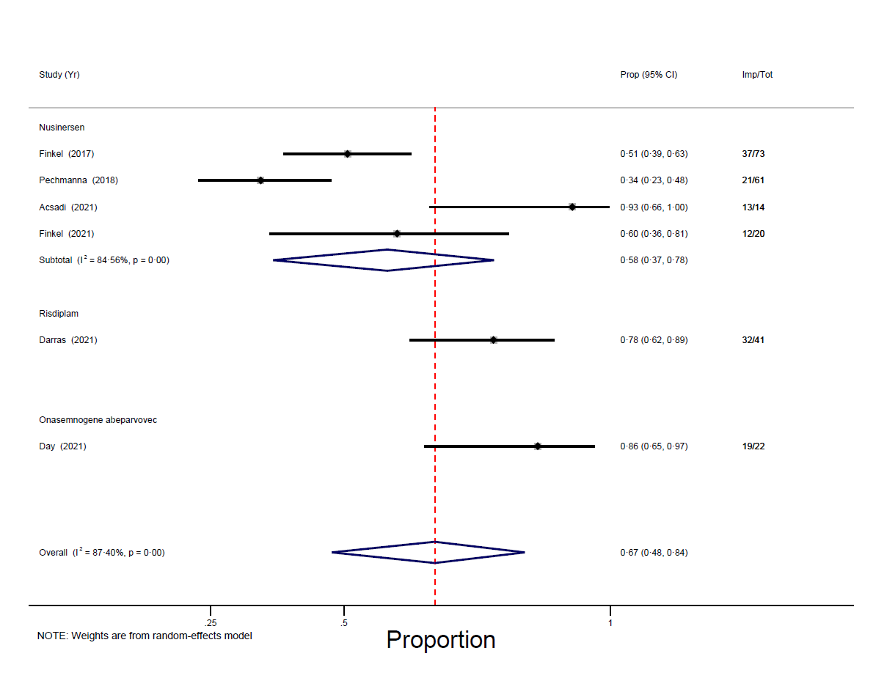
Figure S1. Forest plot displaying the number of patients showing improvement in the HINE-2 score

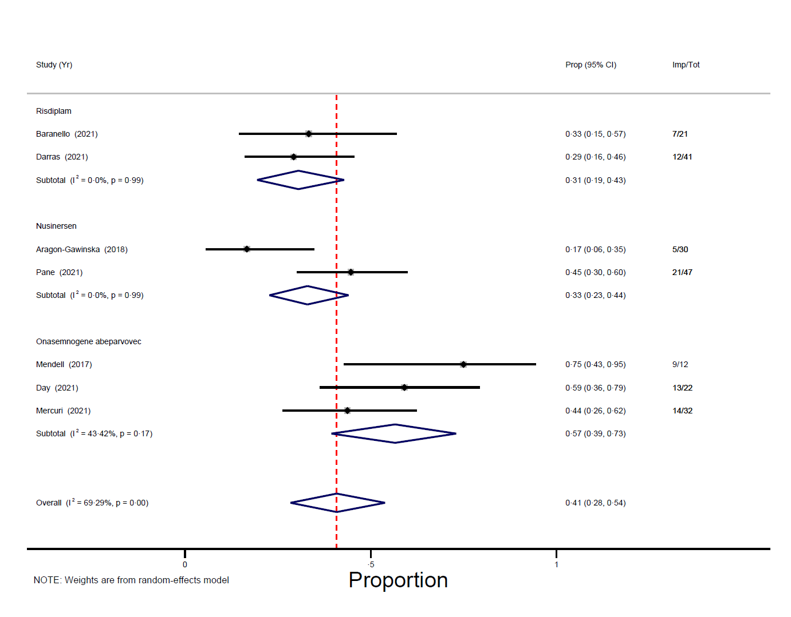
Figure S2. Forest plot illustrating the number of SMA type 1 patients achieving independent sitting after treatment

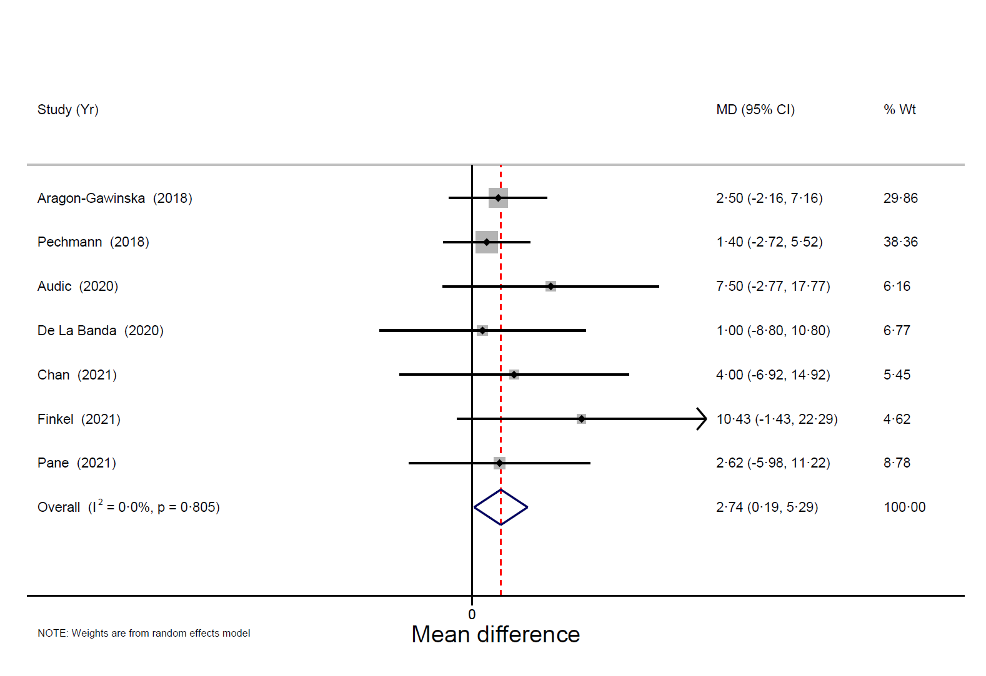
Figure S3. Forest plot depicting the change in HINE-2 score (limited to studies with nusinersen)

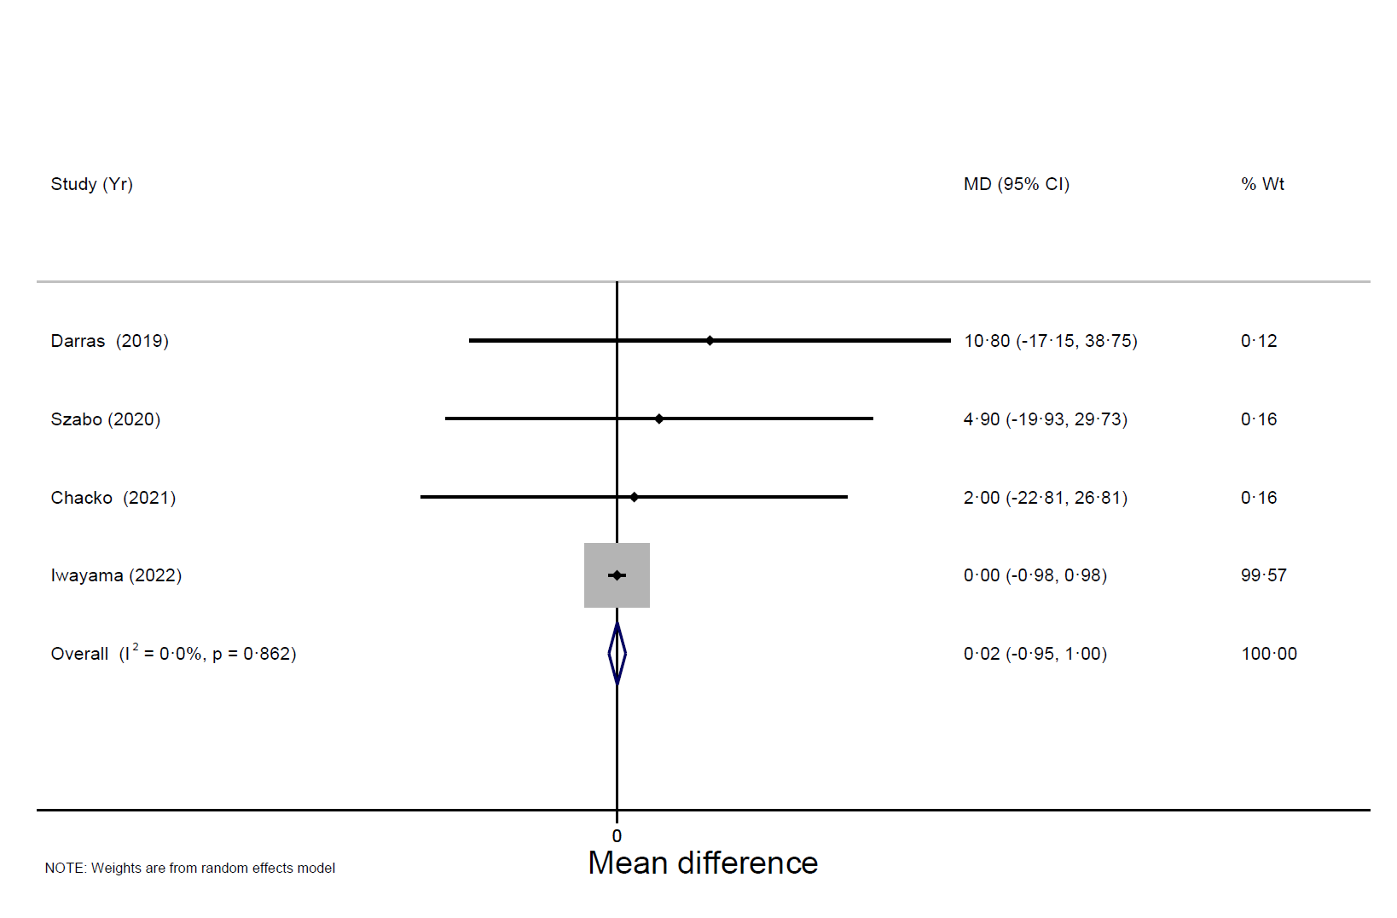
Figure S4. Forest plot presenting the change in HFMSE score (limited to studies with nusinersen)

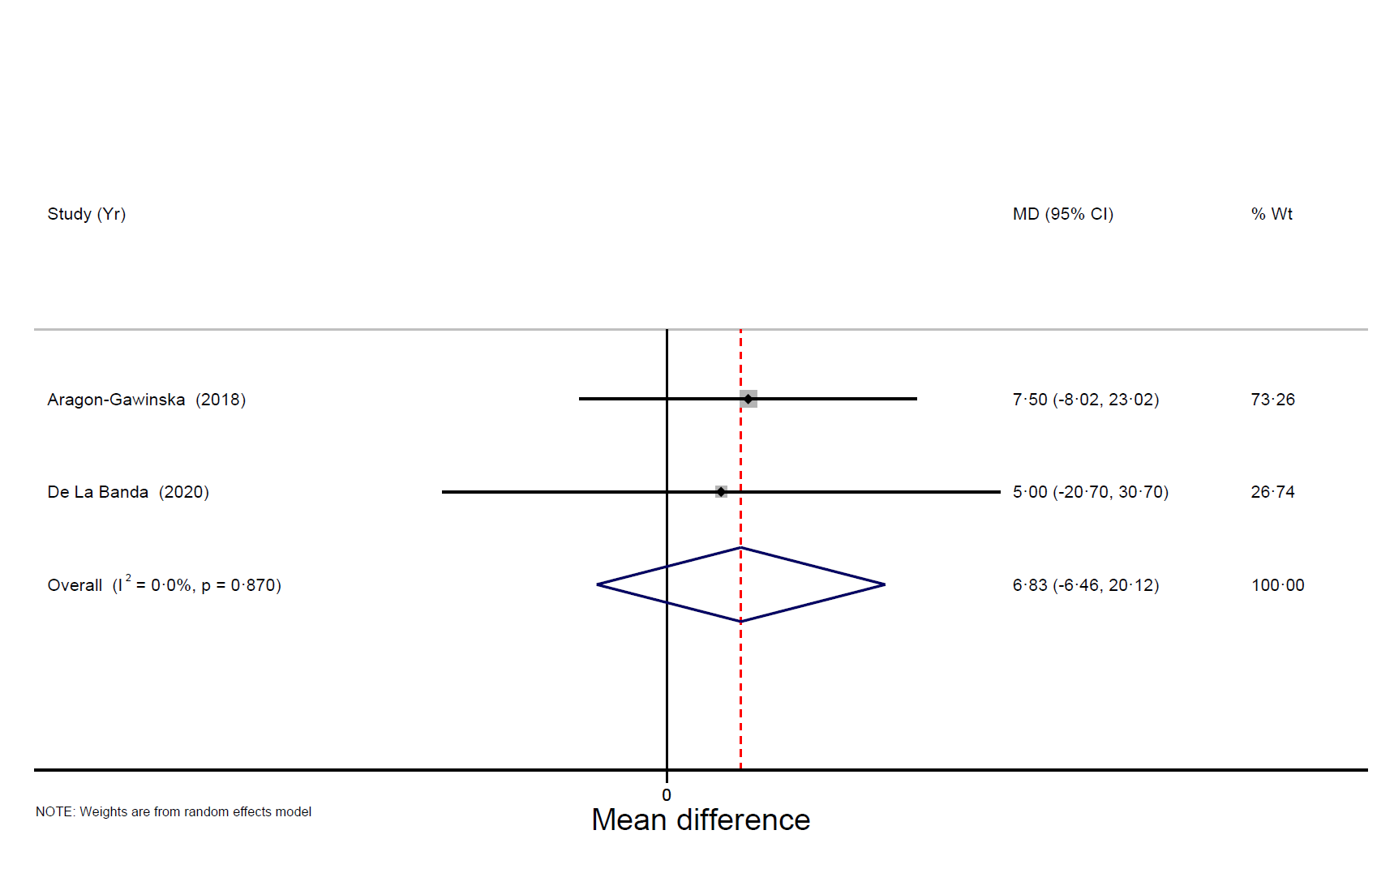
Figure S5. Forest plot showing the change in MFM-20 score (limited to studies with nusinersen)

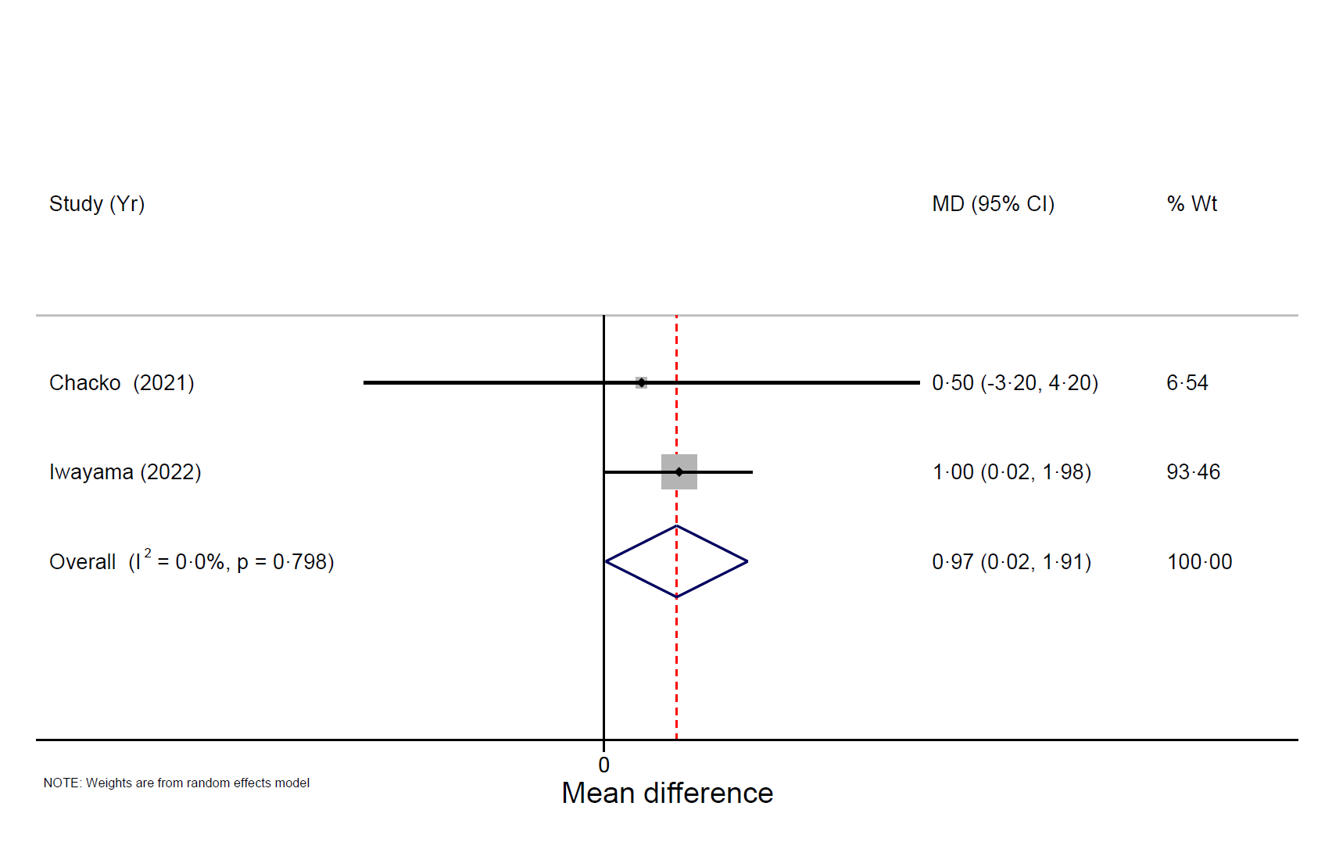
Figure S6. Forest plot demonstrating the change in RULM score (limited to studies with nusinersen)

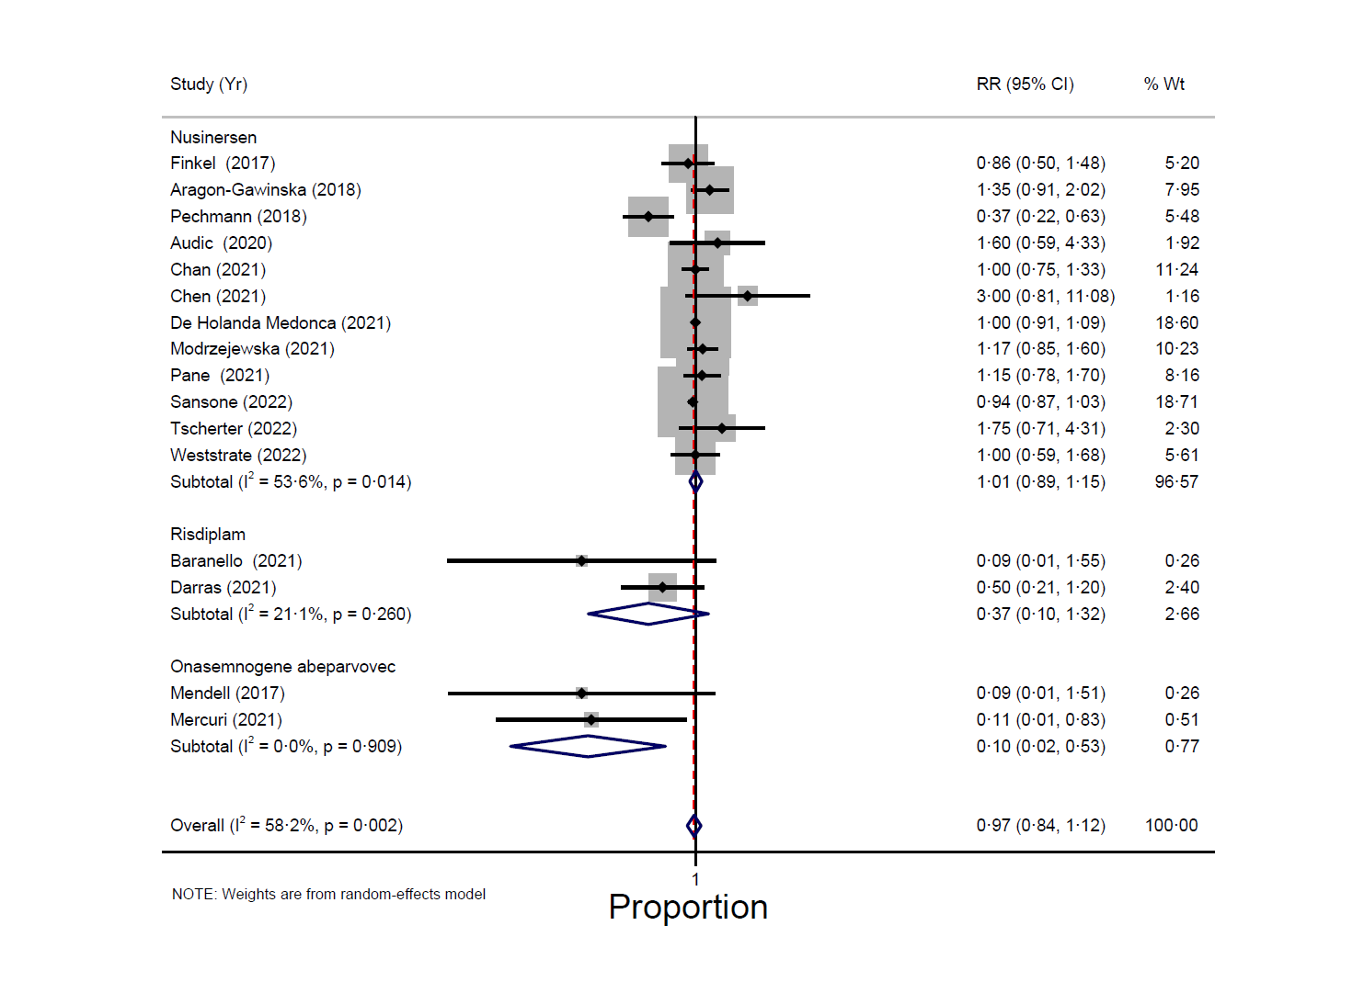
Figure S7. Forest plot analyzing the need for ventilatory support

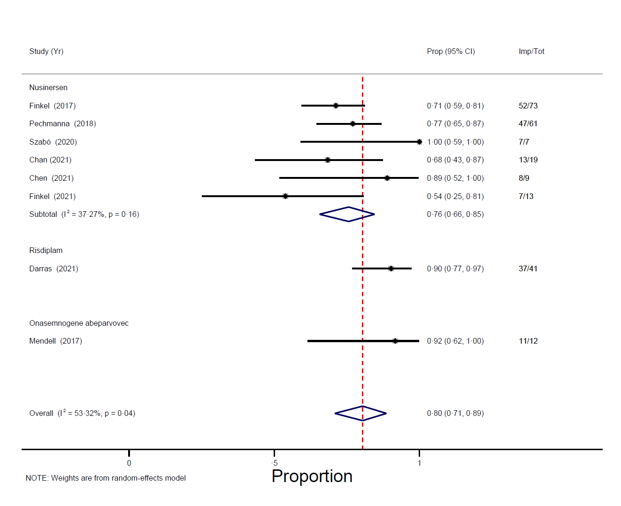
Figure S8. Forest plot summarizing the number of patients with an improvement in their CHOP-INTEND score ≥ 4

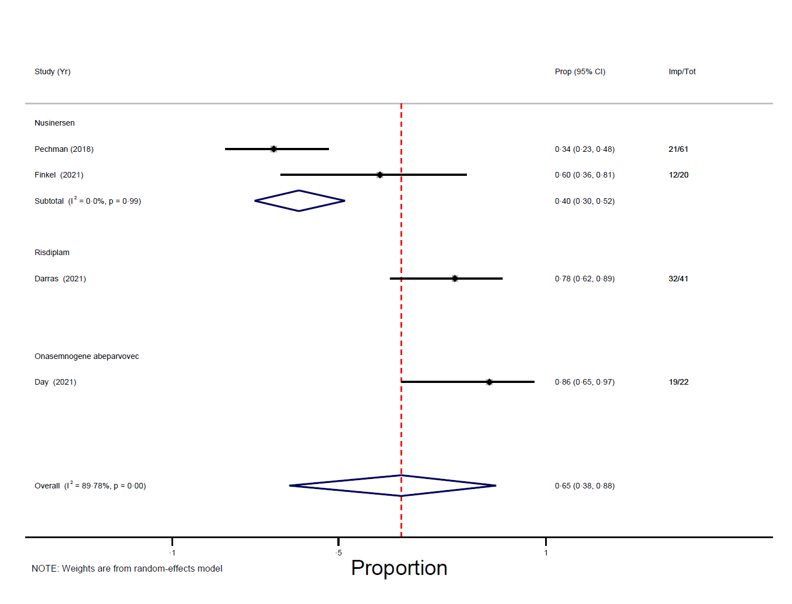
Figure S9. Forest plot presenting the number of patients responding to HINE-2

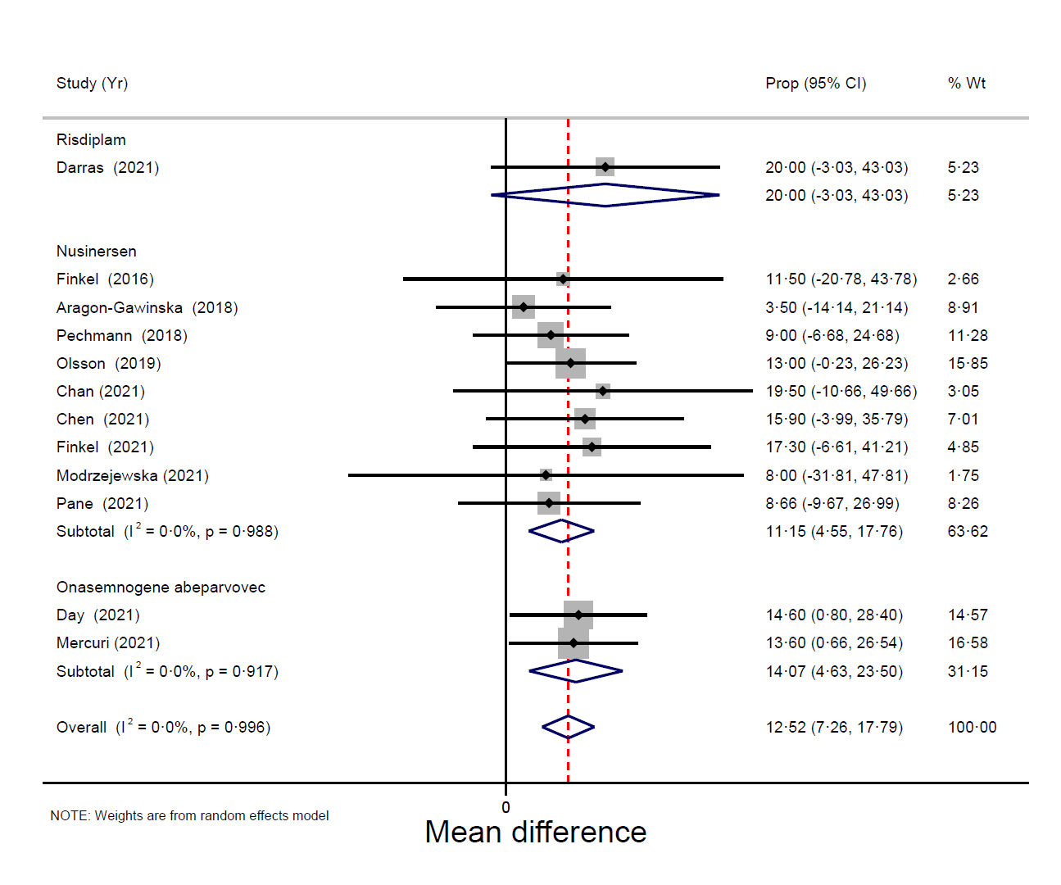
Figure S10. Forest plot illustrating the change in CHOP-INTEND score

Table S1. Search terms and corresponding results in the literature databases

PubMed
No | Keywords | Results
1 | ("spinal muscular atrophy") OR (SMA) | 33,628
2 | ("genetic based therapy") OR ("splicing modifi*") OR ("gene replacement") OR (gene) OR ("gene therapy") OR ("SMN 2") OR (IONIS-SMNRx) OR (ISIS-SMNRx) OR (nusinersen) OR (spinraza) OR (avxs-101) OR ("onasemnogene abeparvovec") OR (zolgensma) OR (RG7916) OR (RO7034067) OR (risdiplam) OR (evrysdi) | 3,296,971
3 | 1 AND 2 | 8,888
4 | 1 AND 2 (Filters applied: Clinical Study, Clinical Trial, Controlled Clinical Trial, Observational Study, Randomized Controlled Trial) | 123

Cochrane CENTRAL
No | Keywords | Results
1 | ("spinal muscular atrophy") OR (SMA) | 1,566
2 | ("genetic based therapy") OR ("splicing modifi*") OR ("gene replacement") OR (gene) OR ("gene therapy") OR ("SMN 2") OR (IONIS-SMNRx) OR (ISIS-SMNRx) OR (nusinersen) OR (spinraza) OR (avxs-101) OR ("onasemnogene abeparvovec") OR (zolgensma) OR (RG7916) OR (RO7034067) OR (risdiplam) OR (evrysdi) | 88,891
3 | 1 AND 2 | 354
4 | 1 AND 2 (Filters applied: Trials) | 226

EMBASE
No | Keywords | Results
1 | ("spinal muscular atrophy") OR (SMA) | 63,889
2 | ("genetic based therapy") OR ("splicing modifi*") OR ("gene replacement") OR (gene) OR ("gene therapy") OR ("SMN 2") OR (IONIS-SMNRx) OR (ISIS-SMNRx) OR (nusinersen) OR (spinraza) OR (avxs-101) OR ("onasemnogene abeparvovec") OR (zolgensma) OR (RG7916) OR (RO7034067) OR (risdiplam) OR (evrysdi) | 4,466,992
3 | 1 AND 2 | 20,028
4 | 1 AND 2 (Filters applied: Clinical study, clinical trial, cohort analysis, controlled clinical trial, cross sectional study, intervention study, observational study, phase 1 clinical trial, phase 2 clinical trial, phase 3 clinical trial, phase 4 clinical trial, postmarketing surveillance, prospective study, randomized controlled trial, retrospective study) | 1,958

ClinicalTrials.gov
No | Keywords | Results
1 | "Spinal Muscular Atrophy" | 221
2 | "Spinal Muscular Atrophy" (Filters applied: Completed Studies, Studies With Results) | 21

Scopus
No | Keywords | Results
1 | TITLE-ABS-KEY ("spinal muscular atrophy" OR SMA) | 208,236
2 | TITLE-ABS-KEY ("genetic based therapy" OR "splicing modifi*" OR "gene replacement" OR gene OR "gene therapy" OR "SMN 2" OR ionis-smnrx OR isis-smnrx OR nusinersen OR spinraza OR avxs-101 OR "onasemnogene abeparvovec" OR zolgensma OR rg7916 OR ro7034067 OR risdiplam OR evrysdi) | 12,219,445
3 | 1 AND 2 | 54,361
4 | 1 AND 2 (Filters applied: Article, Human, Humans, Eng | 7,539

Table S2. The important characteristics of the patients in the included studies
First author  (y) | Types  of SMA | Status of  patient symptom | No. of pts. w ventilatory support | No. of pts. w  feeding support | No. of pts. w  SMN2 copies | Ages at  starting treatment  [Med (range) mo.] | Age at  the first symptom  [Med (range) mo.] | Ages at  last follow-up  (mo.) | Durations  of follow up (mo.)
Acsadi  (2021) | 1, 2 | Symptomatic | - Nusinersen  = 3/14 (21%)  - Sham  = 4/7 (57%) | NR | Nusinersen  - 2 SMN2 = 3/14 (21%)  - 3 SMN2 = 11/14 (79%)  Sham  - 2 SMN2 = 4/7 (57%)  - 3 SMN2 = 3/7 (43%) | - Nusinersen  = 16·7 (7·3, 48·6)  - Sham  = 18·5 (15·3, 53·3) | - Nusinersen  = 5·5 (2·0, 11·0)  - Sham  = 5·1 (1·8, 11·0) | NR | 14
Ali  (2021) | 1, 2 | Symptomatic | All = 2/9 (22%)  - SIMV = 1/9 (11%)  - BiPAP = 1/9 (11%) | NR | - 2 SMN2 = 7/9 (78%)  - 3 SMN2 = 2/9  (22%) | 18 (4, 23) | 4 days to 21 mo. | NR | 10
Aragon-Gawinska (2018) | 1 | NR | NIV = 17/33 (52%)  - 2 SMN2 = 9/15 (60%)  - 3 SMN2 = 7/17 (41%) | All = 9/33 (27%)  - NGT = 3/33  - PEG = 6/33  2 SMN2 = 4/15 (27%)  - NGT = 2/15  - PEG = 2/15  3 SMN2 = 5/17 (29%)  - NGT = 1/17  - PEG = 4/17 | - 2 SMN2 = 15/33 (45%)  - 3 SMN2 = 17/33 (52%) | All = 21·3 (8·3, 113·1)  - 2 SMN2 = 19·8 (8·3, 42·0)  - 3 SMN2 = 27·7 (8·8, 113·1) | All = 4 (1·5, 6)  - 2 SMN2 = 3 (1·5, 5)  - 3 SMN2 = 4 (2, 6) | NR | 6
Audic  (2020) | 1, 2 | NR | All = 45/123 (37%)  - <2 yr. = 5/30  - 2-5 yr. = 17/47  - 6-17 yr. = 23/46 | All = 14/123 (11%)  - <2 yr. = 3/30  - 2-5 yr. = 6/47  - 6-17 yr. = 5/46 | - 2 SMN2 = 18/123 (15%)  - 3 SMN2 = 96/123 (78%)  - 4 SMN2 = 3/123 (2%) | 3 mo. to 16 yr. | NR | NR | 12
Axente  (2022) | 1, 2, 3 | NR | NR | NR | SMA 1  - 2 SMN2 = 11/11 (100%)  SMA 2  - 2 SMN2 = 3/16 (19%)  - 3 SMN2 = 13/16 (81%) | SMA 1 = (2, 76)  SMA 2 = (13, 196) | NR | NR | 26
Baranello  (2021) | 1 | Symptomatic | All = 5/21 (24%) | All = 1/21 (5%) | 2 SMN2 = 21/21 (100%) | 6·7 (3·3, 6·9) | 2·0 (0·9, 3·0) | 17·7 | 12
Bitetti  (2022) | 1 | Symptomatic | NIV < 16 h = 9/9 (100%) | PEG = 2/9 (22%) | 2 SMN2 = 9/9 (100%) | 25 (1·7, 48) | 2·7 (0, 5) | NR | 3
Chacko  (2022) | 1, 2, 3 | NR | NIV = 10/19 (53%)  - SMA 1 = 2/7 (29%)  - SMA 2 = 8/12 (67%) | NR | - 2 SMN2 = 4/19 (21%)  - 3 SMN2 = 15/19 (79%) | - SMA 1 = 0·42 (0·17, 5·00) yr.  - SMA 2 = 9·70 (3·60, 18·80) yr. | NR | NR | 12
Chan  (2021) | 1 | Symptomatic | Nocturnal NIV, NIV, IV = 29/40 (72·5%) | NR | - 1 SMN2 = 1/40 (2·5%)  - 2 SMN2 = 25/40 (62·5%)  - 3 SMN2 = 14/40 (35%) | All = 20·0 (0·35, 294·0)  - 1 SMN2 = 2·0  - 2 SMN2 = 19·0 (0·35, 140·0)  - 3 SMN2 = 25·3 (4·0, 294·0) | All = 3·0 (0·0, 6·0)  - 1 SMN2 = 0.0  - 2 SMN2 = 2·0 (0·0, 6·0)  - 3 SMN2 = 4·5 (1·0, 6·0) | NR | 10
Chen  (2021) | 1 | NR | NIV = 2/9 (22%)  - 2 SMN2 = 0  - 3 SMN2 = 2 | All = 2/9 (22%)  - 2 SMN2 = 0  - 3 SMN2 = 2 | - 2 SMN2 = 4/9 (44%)  - 3 SMN2 = 5/9 (56%) | 10·6 (2·7, 178·6) | 3·0 (1·0, 5·0) | NR | 2 yr.
Darras  (2019) | 2, 3 | NR | NR | NR | 3 SMN2 = 11/11 (100%) | NR | 11·0 (3, 15)  *Mean (range) | NR | 3 yr.
Darras  (2021) | 1 | NR | All = 12/41 (29%) | All = 2/41 (5%) | 2 SMN2 = 41/41 (100%) | 5·3 (2·2, 6·9) | 1·5 (1·0, 3·0) | NR | 12
Day  (2021) | 1 | Symptomatic | All = 0/22 (0%) | All = 0/22 (0%) | ≤ 2 SMN2 = 22/22 (100%) | 3·5 (2·7, 5·3) | 1·8 (1·0, 3·0)  *Mean (range) | NR | 18
De Holanda Mendonca  (2021) | 1 | Symptomatic | All = 21/21 (100%)  - IMV = 14/21 (67%)  - NIV = 7/21 (33%) | All = 20/21 (95·2%) | All  - 2 SMN2 = 18/21 (86%)  - 3 SMN2 = 3/21 (14%)  IMV  - 2 SMN2 = 13/14 (93%)  - 3 SMN2 = 1/14 (7%)  NIV  - 2 SMN2 = 5/7 (71%)  - 3 SMN2 = 2/7 (29%) | NR | Mean (SD)  2·7 (1·5) | NR | 24
De la Banda (2021) | 1, 2 | NR | All = 10/16 (62%)  - NIV = 9/16 (56%)  - IV = 1/16 (6%) | All = 2/16 (13%) | 3 SMN2 = 16/16 (100%) | 9·4 (2·3) yr.  *Mean (SD) | NR | NR | 14
De Vivo  (2019) | 1 | Asymptomatic | NA | NA | - 2 SMN2 = 15/25 (60%)  - 3 SMN2 = 10/25 (40%) | 0·7 (0·1, 1·4) d. | NA | 34·8 (25·7, 45·4)  *Mean (range) | 34
D’Silva  (2022) | 1, 2 | - Asymptomatic = 11/21 (52%)  - Symptomatic = 10/21 (48%) | NIV = 7/21 (33%) | 7/21 (33%) | - 2 SMN2 = 16/21 (76%)  - 3 SMN2 = 5/21 (14%) | 11 (0·65, 24) d. | 27 (9, 329) | 2 (0·17, 3·3) yr. | 15
Finkel  (2016) | 1 | Symptomatic | 0/20 (0%) | All = 2/20 (10%)  - Low dose = 1/4  (5%)  - High dose = 1/16 (5%) | All  - 2 SMN2 = 17/19 (89%)  - 3 SMN2 = 2/19 (11%)  Low dose  - 2 SMN2 = 4/4 (100%)  High dose  - 2 SMN2 = 13/15 (87%)  - 3 SMN2 = 2/15  (13%) | All = 4·7 (1·2, 7)  - Low dose = 4·8 (2·2, 6·9)  - High dose = 4·7 (1·2, 7)  *Mean (range) | All = 2 (0·7, 5·1)  - Low dose = 1·6 (0·9, 2·3)  - High dose = 2·1 (0·7, 5·1)  *Mean (range) | NR | 32
Finkel  (2017) | 1 | Symptomatic | - Nusinersen  = 21/80 (26%)  - Sham  = 6/41 (15%) | - Nusinersen  = 7/80 (9%)  - Sham  = 5/41 (12%) | 2 SMN2 = 121/121 (100%) | - Nusinersen  = 5·4 (1·7, 8·1)  - Sham  = 6·0 (1·0, 8·7)  *Mean (range) | - Nusinersen  = 2 (0·5, 4·5)  - Sham  = 2·4 (0·3, 5)  *Mean (range) | NR | 13
Finkel  (2021) | 1 | Symptomatic | NR | NR | - 2 SMN2 = 17/19 (89%)  - 3 SMN2 = 2/19 (11%) | 4·7 (1·2, 7)  *Mean (range) | 2 (0·7, 5·1)  *Mean (range) | NR | 3 yr.
Hache  (2016) | 2, 3 | NR | NR | NR | NR | 73·2 (24, 168)  *Mean (range) | NR | NR | 6
Hahn  (2022) | 1, 2 | NR | NR | NR | NR | - SMA 1 = 13·5 (11·1) yr.  - SMA 2 = 29·0 (14·0) yr.  *Mean (SD) | - 2·65 (2·18) yr.  - 11·1 (4·4) yr.  *Mean (SD) | NR | 12
Hepkaya  (2022) | 1, 2, 3 | NR | - SMA 1 = 5  - SMA 2 = 0 | - SMA 1 = 5  - SMA 2 = 0 | < 3 SMN2  - SMA 1 = 16  - SMA 2 = 2  ≥ 3 SMN2  - SMA 1 = 2  - SMA 2 = 10 | - SMA 1 = 8·81 (7·67)  - SMA 2 = 51·42 (44·55) | NR | NR | 12
Hully  (2020) | 1, 2 | NR | NIV = 4/37 (11%) | All = 35/37 (95%)  - Enteral feeding  = 34/37 (92%)  - Gastrostomy  = 1/37 (3%) | NR | NR | 1 (0, 4)  *Mean (range) | NR | 4 yr.
Iwayama  (2022) | 1, 2 | Symptomatic | NIV = 4/7 (57%) | NGT = 3/7 (43%) | - 2 SMN2 = 2/7 (29%)  - 3 SMN2 = 5/7 (71%) | 23 (12, 40) yr. | NR | NR | 3·55 yr.
Kim  (2020) | 1, 2 | NR | All = 4/7 (57%)  - SMA 1 = 4/4 (100%)  - 24 hr IMV  = 2/4  - NIV < 8 h/d  = 2/4  - SMA 2 = 0/3 (0%) | All = 2/7 (29%)  - SMA 1 = 2/4 (50%)  - SMA 2 = 0/3 (0%) | SMA 1  - 2 SMN2 = 4/4 (100%)  SMA 2  - 3 SMN2 = 3/3 (100%) | 44·7 (1·1, 265) | NR | 6·1 (2·1, 22·1)  * Med (range) | 2 yr.
Kotulska  (2022) | 1, 2, 3 | - Presymptomatic patients = 4 (1·4%)  - SMA 1 = 127 (43·5%)  - SMA 2 = 68 (23·3%)  - SMA 3 = 93 (31·8%) | NR | NR | NR | 6·9 (5·0) | NR | NR | 12
Kwon  (2022) | 1, 2 | Symptomatic | NR | NR | - 2 SMN2 = 67 (43%)  - 3 SMN2 = 75 (48%)  - 4 SMN2 = 3 (2%) | 11 (0, 50) yr. | NR | NR | 4·8
Mendell  (2017) | 1 | Symptomatic | All = 5/15 (33%)  - Low dose = 3/3 (100%)  - High dose = 2/12 (17%) | All = 8/15 (53%)  - Low dose = 3/3 (100%)  - High dose = 5/12 (42%) | 2 SMN2 = 15/15 (100%) | - Low dose  = 6·3 (5·9, 7·2)  - High dose  = 3·4 (0·9, 7·9)  *Mean (range) | - Low dose  = 1·7 (1, 3)  - High dose  = 1·4 (0, 3)  *Mean (range) | NR | 36
Mercuri  (2021) | 1 | Symptomatic | 9/33 (27%) | 9/33 (27%) | ≤ 2 SMN2 = 33/33 (100%) | 4·1 (1·8, 6·0) | 1·5 (0·0, 4·0) | NR | 18
Mirea  (2022) | 1, 2, 3 | Symptomatic | NR | NR | 2 SMN2 = 46/46  (100%) | NR | NR | NR | 12
Modrzejewska (2021) | 1 | NR | - NIV = 5/26 (19%)  - Tracheostomy and Ventilation > 16 h per day = 13/26 (50%) | NGT or PEG = 15/26 (58%) | - 2 SMN2 = 16 (61%)  - 3 SMN2 = 9 (35%)  - 4 SMN2 = 1 (4%) | 23·00 (12·25, 41·25) | 2·00 (1·00, 3·00) | NR | 26
Olsson  (2019) | 1 | NR | NR | NR | 2 SMN2 = 12/12 (100%) | 14·4 (1·2, 92·4)  *Mean (range) | 2·2 (0·3, 4)  *Mean (range) | NR | Varied by patient
Osredkar  (2021) | 1, 2, 3 | NR | All = 16/48 (33%)  - IV = 4  - NIV at night = 8  - NIV day & night = 4  SMA 1 = 10/16 (63%)  - IV = 4  - NIV at night = 4  - NIV day & night = 2  SMA 2 = 6/32 (19%)  - NIV at night = 4  - NIV day & night = 2 | All = 8/48 (17%)  - SMA 1 = 5/16 (31%)  - SMA 2 = 3/32 (9%) | All  - 2 SMN2 = 11/48 (23%)  - 3 SMN2 = 30/48 (63%)  - 4 SMN2 = 7/48 (14%)  SMA 1  - 2 SMN2 = 10/16 (63%)  - 3 SMN2 = 5/16 (31%)  - 4 SMN2 = 1/16 (6%)  SMA 2  - 2 SMN2 = 1/32 (3%)  - 3 SMN2 = 25/32 (78%)  - 4 SMN2 = 6/32 (19%) | - SMA 1 = 62·4 (2·4, 176·4)  - SMA 2 = 106·8 (9·6, 225·6) | NR | NR | 14
Pane  (2021) | 1 | NR | All = 27/68 (40%)  - NIV >16 h/day = 7/68 (10%)  - Tracheostomy = 20/68 (30%) | 36/68 (53%) | NR | 47·52 (2·4, 191·04)  *Mean (range) | NR | NR | 24
Pechmann  (2018) | 1 | NR | All = 35/61 (57·4%)  - NIV <16 h/day = 17/61 (27·9%)  - NIV >16 h/day = 6/61 (9·8%)  - Tracheostomy = 12/61 (19·7%) | 34/61 (55·7%) | - < 2 SMN2 = 38/58 (66%)  - > 3 SMN2 = 20/58 (35%) | All = 21·08 (1, 93)  - < 2 SMN2 = 22·08 (2, 93)  - > 3 SMN2 = 21·85 (2, 50)  *Mean (range) | All = 2·78 (0, 6)  - < 2 SMN2 = 2·53 (0, 6)  - > 3 SMN2 = 3·5 (0, 6)  *Mean (range) | NR | 6
Sansone  (2022) | 1 | NR | - Spontaneous breathing = 22  - NIV ≤ 10 h/day = 26  - NIV > 10 h/day = 24  - Invasive ventilation = 46 | NR | - - 1 SMN2 = 3  - - 2 SMN2 = 82  - - 3 SMN2 = 27  - - 4 SMN2 = 2  - *NR = 4 | 42·8 (11·0, 102·8) | NR | NR | 10
Strauss  (2022) | 1 | Asymptomatic | 0/14 (0%) | 0/14 (0%) | 2 SMN2 = 14/14 (100%) | 21·0 (8, 34) d. | NR | 18 | 18
Szabo  (2020) | 1, 2 | NR | 18/31 (58%) | 1/31 (3%) | All  - 2 SMN2 = 10/31 (32%)  - 3 SMN2 = 21/31 (68%)  SMA 1  - 2 SMN2 = 7/10 (70%)  - 3 SMN2 = 3/10 (30%)  SMA 2  - 2 SMN2 = 3/21 (14%)  - 3 SMN2 = 18/21 (86%) | Med (range)  - SMA 1 = 9·6 (4·8, 18·0)  - SMA 2 = 34.8 (15·6, 144) | NR | NR | 21
Tscherter  (2022) | 1, 2 | NR | All = 4/33 (12%)  - SMA 1 = 4/11 (36%)  - SMA 2 = NR | SMA 1 = 4/11  (36%) | SMA 1  - 2 SMN2 = 5/11 (45%)  - 3 SMN2 = 4/11 (36%)  SMA 2  - 2 SMN2 = 1/21 (5%)  - 3 SMN2 = 16/21 (76%)  - ≥4 SMN2 = 3/21 (14%) | - SMA 1 = 1·4 (0·1, 16·1) yr.  - SMA 2 = 7·8 (1·2, 31·4) yr. | NR | - SMA 1 (0 −18 mo. at treatment start) = 2·5 (1·0, 3·6)  - SMA 1 (>18 mo. at treatment start) = 15·9 (7·4, 17·9)  - SMA 2 = 9·7 (1·7, 33·3) | 1·9 yr.
Weiß  (2022) | 1, 2 | - Presymptomatic patients = 6/76 (8%)  - SMA 1 = 51/76 (67%)  - SMA 2 = 19/76 (25%) | 24/76 (32%) | 19/76 (25%) | - 2 SMN2 = 50/76 (66%)  -3 SMN2 = 26/76 (34%) | 16·8 (0·8, 59·0) | NR | NR | 6
Weststrate  (2022) | 1 | Symptomatic | 13/24 (54%) | 14/24 (58%) | - 2 SMN2 = 17/24 (71%)  - 3 SMN2 = 6/24 (25%) | 11 (1, 90) | NR | NR | 24
BiPAP, bilevel positive airway pressure; IV, invasive ventilation; IMV, invasive mechanical ventilation; NA, not applicable; NGT, nasogastric tube; NIV, non-invasive ventilation; NR, no report; PEG, percutaneous endoscopic gastrostomy; SIMV, synchronized intermittent mandatory ventilation

