Online Supplement
Figure OSM.1. Intercorrelations among the alternative age markers at follow-up assessment, if available.
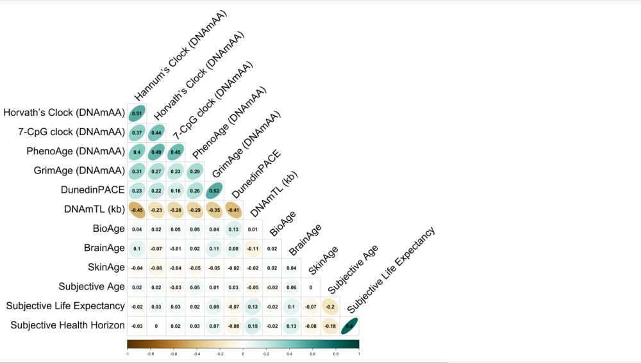
Note. Data for BioAge, BrainAge, and SkinAge taken from baseline assessment.
Figure OSM.2. Intercorrelations among the alternative age markers at follow-up assessment (using Horvath’s Clock (DNAmAA, buccal swap DNA).
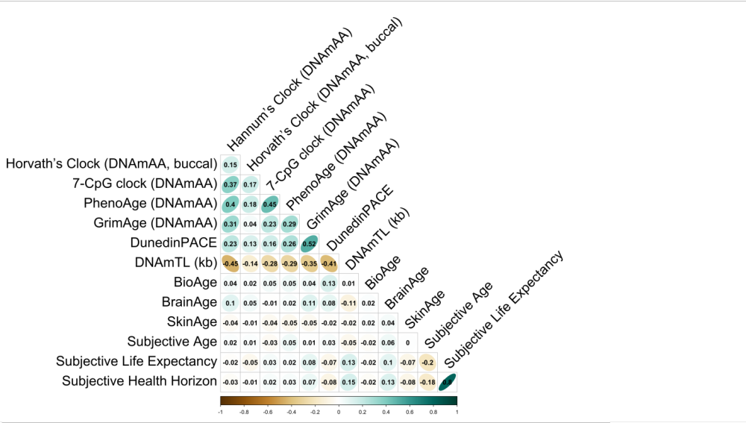
Note. Data for BioAge, BrainAge, and SkinAge taken from baseline assessment.
Figure OSM.3. Intercorrelations between the alternative age markers at baseline assessment and long-term longitudinal changes.
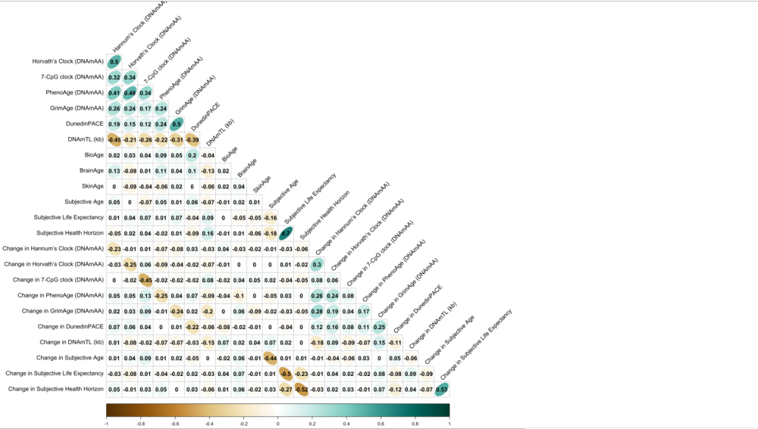
Note. Intercorrelations that were not statistically significant at p < .05 were omitted for clarity.
Figure OSM.4. Intercorrelations among the alternative age markers at follow-up assessment using complete cases.
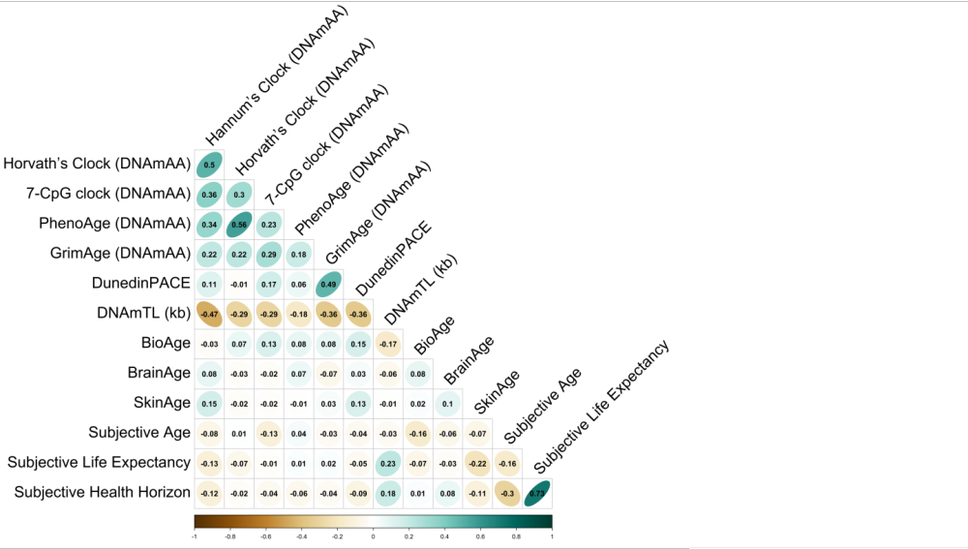
Note. We want to point out that the correlation between epigenetic clocks with the exception of the DunedinPACE methylation age was already published as part of ²⁵.
Figure OSM.5. Intercorrelations among the alternative age markers at follow-up assessment using complete cases.
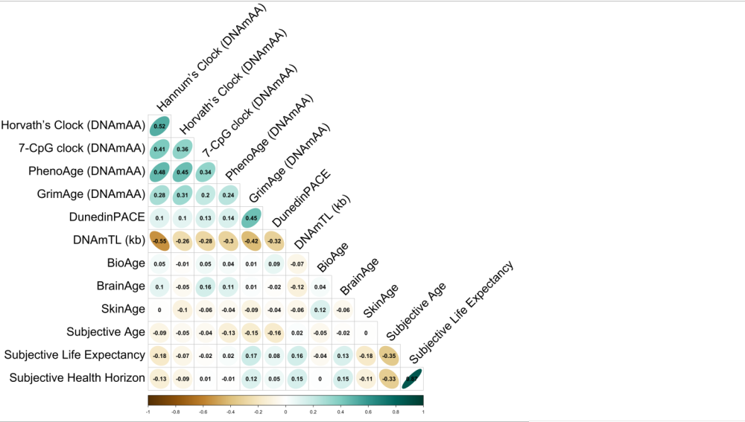
Data for BioAge, BrainAge, and SkinAge taken from baseline assessment.
Figure OSM.6. Intercorrelations among the alternative age markers at baseline assessment for women.
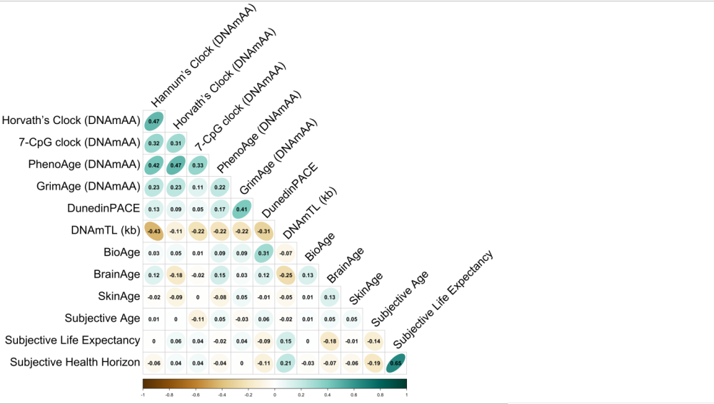

Figure OSM.7. Intercorrelations among the alternative age markers at baseline assessment for men.
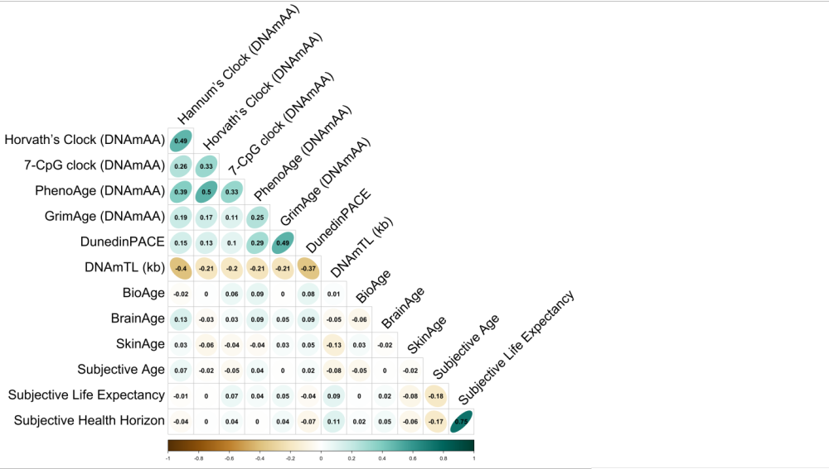

Figure OSM.8. Intercorrelations among the alternative age markers at follow-up assessment for those who suffered from two and more chronic physical diseases at follow-up (n = 376).
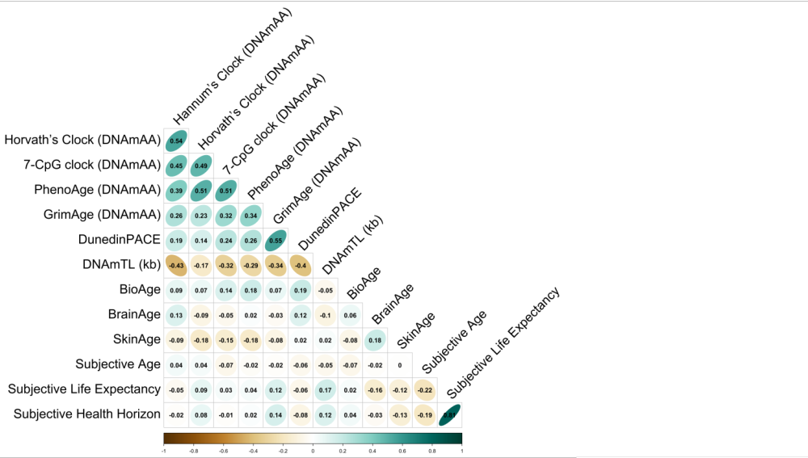
Note. Data for BioAge, BrainAge, and SkinAge taken from baseline assessment.
Figure OSM.9. Intercorrelations among long-term longitudinal changes in the alternative age markers between baseline and follow-up assessments for those who were re-assessed within six years (n = 223).

