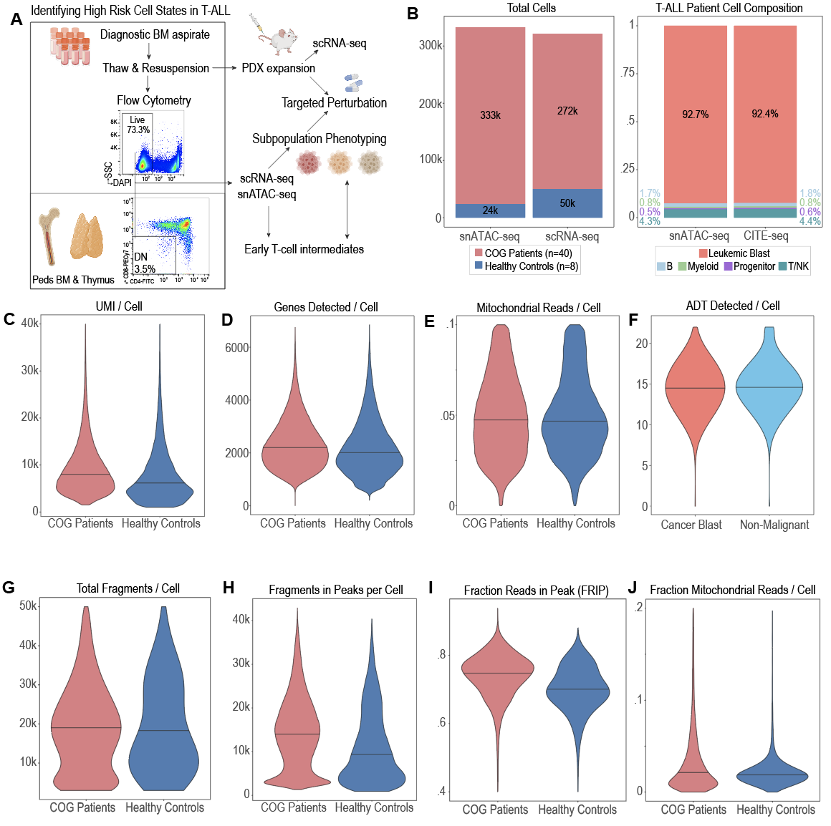
Supplementary Data Fig 1 | Generation of high-quality single cell multiomic data to identify high-risk cell states in T-ALL. (a) experimental overview for single cell data from 40 T-ALL cases and 8 healthy thymus/BM controls. (b) overall scRNA and scATAC dataset size (left) and cell type composition (right). (c-e) quality of scRNA-seq dataset after filtering. (f) quality of ADT (CITE-seq) after filtering. (g-j) scATAC-seq quality metrics after filtering.

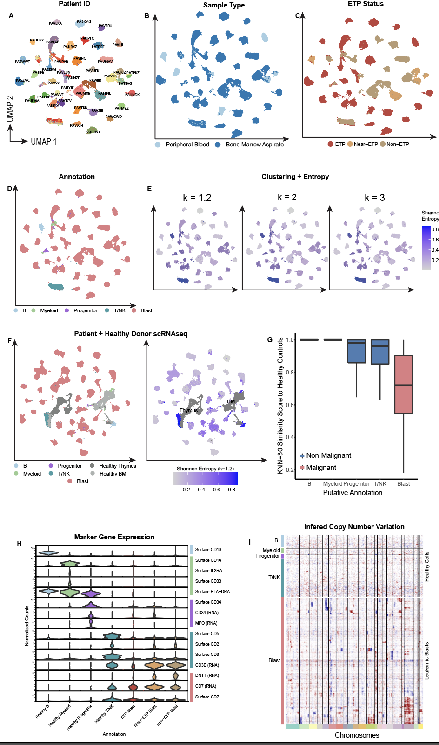
Supplementary Data Fig 2 | Marker Gene, clustering, and Shannon entropy based annotation of single-cell data. (a-d) UMAP representation of scRNA dataset (n=328,820 cells) colored by patient ID (a), sample type (b) and ETP status (c), and annotation (d). (e) Shannon Entropy (1 = equal contribution from each sample; 0 = contribution from only 1 sample) of cell clusters at k=1.2, k=2, and k=3 clustering resolutions. (f) clustering of T-ALL patient derived data with n=8 healthy bone marrow/thymus controls. Left: colored by annotation; right: colored by Shannon entropy. (g) k=30 nearest neighbor similarity score to known healthy controls. Patient derived cells were mapped to known healthy controls using the RPCA method within Seurat 4.0. The average similarity score to 30 nearest healthy control neighbors in principal-component space are shown for each cell. (h) marker gene expression of annotated cell types. (i) inferCNV results for annotated patient derived cells within scRNA data. Due to computational constraints, cells were downsampled 1:10 prior to running inferCNV.

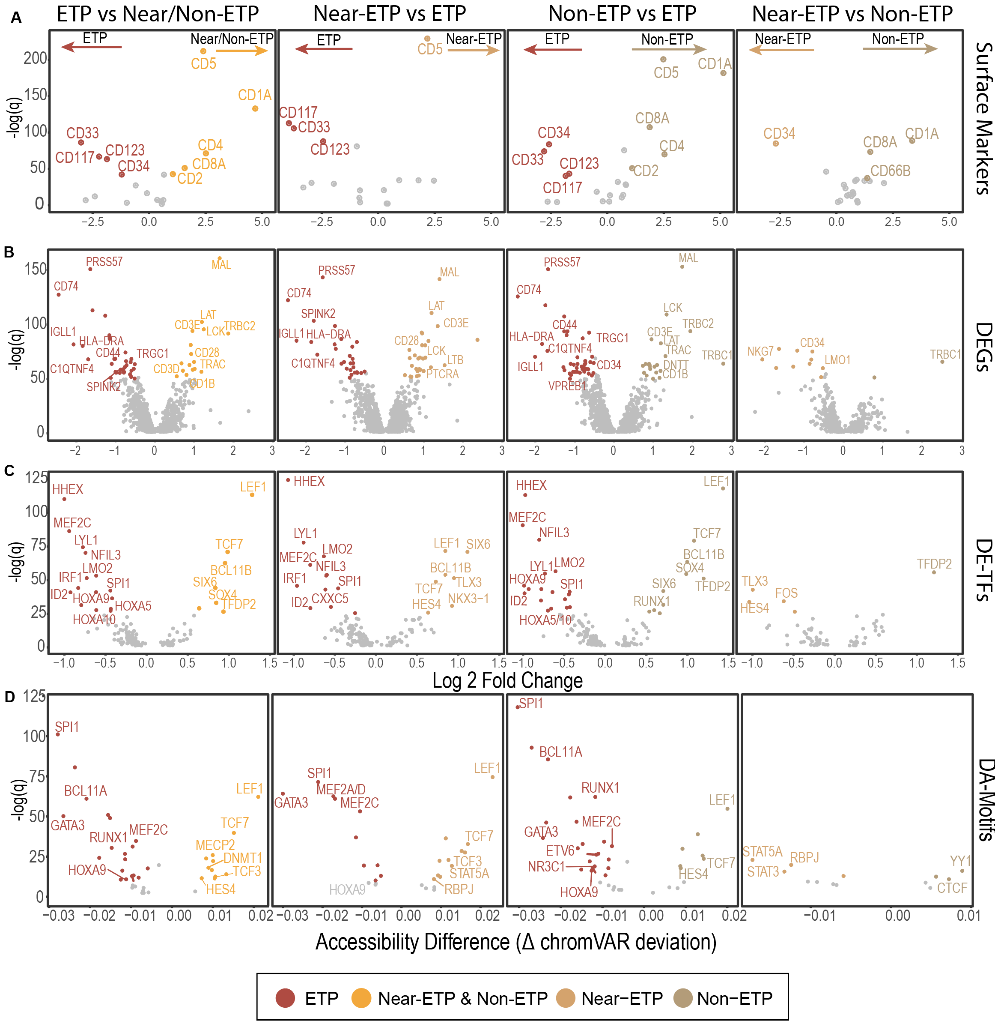
Supplementary Data Fig 3 | Molecular differences between immunophenotypically defined subtypes of T-ALL. (a-c) Differential Expression of surface proteins, genes, and transcription factors between 3 subtypes of T-ALL. DE was performed with 1000 randomly downsampled cells from each group using Mann-Whitney test on log-normalized data. (d) differential accessibility of TF motifs between 3 subtypes of T-ALL. DA was performed with 1000 randomly downsampled cells from each group using MW test on chromVAR deviation Z-scores.

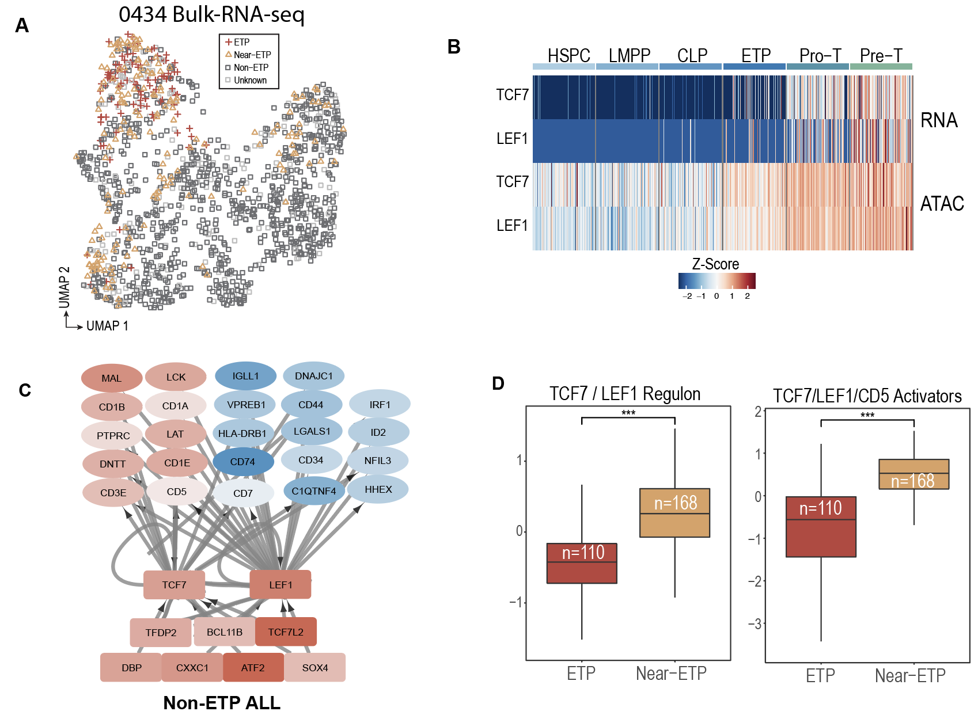
Supplementary Data Fig 4 | TCF7/LEF1 activation in healthy T-cell development and Non-ETP-ALL. (a) UMAP of AALL0434 bulk RNA-seq data from primary T-ALL samples (n=1335), colored by subtype. (b) Expression of TCF7 and LEF1 and accessibility of TCF7 and LEF1 motifs in healthy T-cell development. (c) Subset of transcriptional regulatory network constructed using integrated scRNA and scATAC data from Non-ETP-ALL patients. Transcription factors are represented as squares, gene targets as ovals. Color is proportional to expression fold change in comparison to ETP blasts: blue is downregulated, red upregulated. Edges contacting TCF7 and LEF1 with regression coefficient > 0.3 are shown. (d) Signature score of top 28 target genes of the TCF7/LEF1 regulon and top 11 predicted TF regulators of TCF7/LEF1/CD5 in bulk-sequenced ETP and Near-ETP T-ALL patients from COG AALL0434 trial.

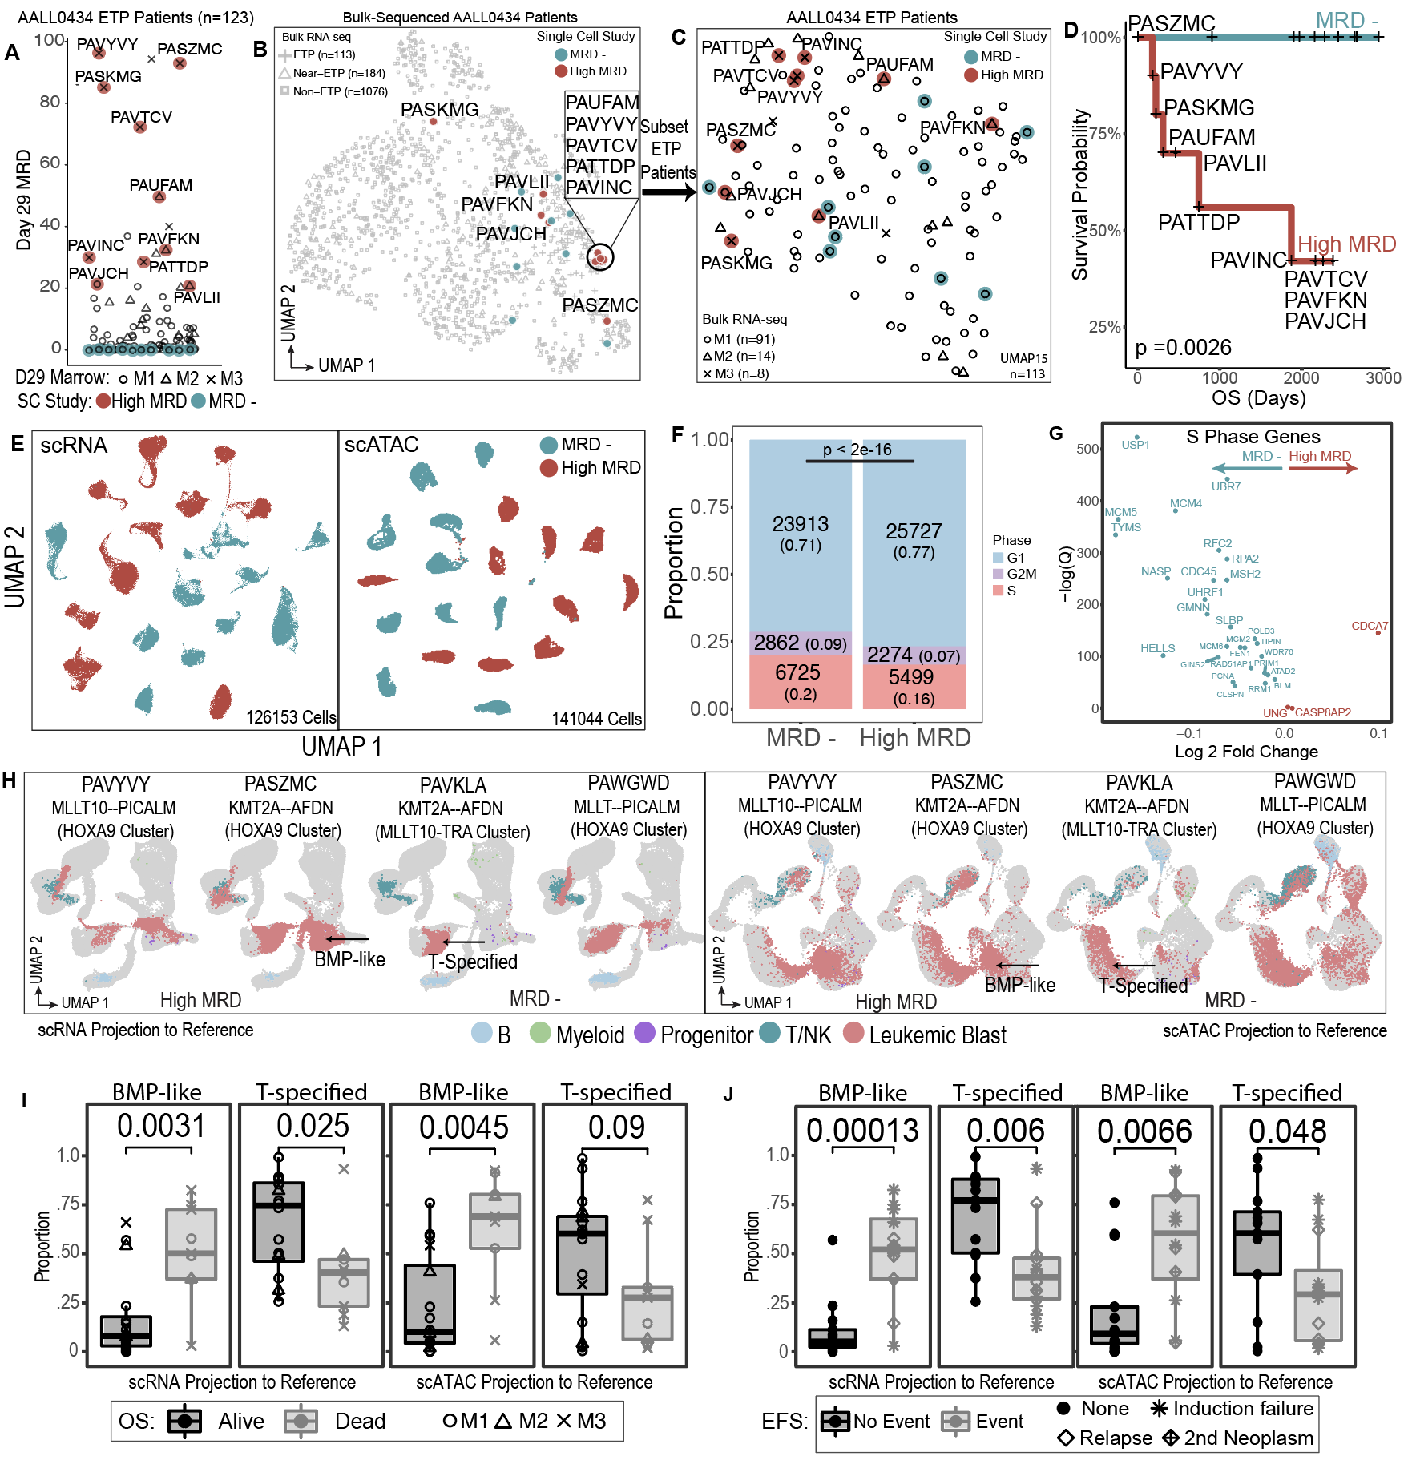
Supplementary Data Fig 5 | Analysis of treatment resistant ETP-ALL cases reveals enrichment progenitor-like populations and increased proportion of non-cycling cells. (a) Selection of 10 High MRD and 10 MRD Negative (control) patients from ETP-ALL patients diagnosed within COG AALL0434. Patients with EOI MRD > 20 (high MRD) are labeled. (b) UMAP representation of 1335 primary patient samples from COG AALL0434 bulk RNA sequencing. High MRD patients are labeled. (c) UMAP representation of 110 bulk-sequenced ETP patient samples from AALL0434. (d) Overall survival of high MRD vs MRD negative patients profiled using single cell genomics. High MRD patients are labeled. The p-value for Log-likelihood statistic of Cox-proportion hazard test run with Day 29 MRD as a co-variate is shown. (e) UMAP representation of leukemic blasts from 10 High MRD and 10 MRD negative patients in scRNA (n=126,153 cells, 126,153 plotted) and scATAC (n=141,044 cells, 27,652 plotted) space. (f) number and proportion of non-cycling (G1), cycling (S), and dividing (G2M) cells high MRD vs MRD negative patients. Patient cells were downsampled to 3,350 leukemic blasts per patient (33,500 per group) and cell-cycle scoring was performed. The Chi-squared test statistic and p-value was computed by comparing the number of cells in G1 vs non-G1 phases in clinical category. (g) Differential expression of S-phase genes in MRD negative vs High MRD patients. P-value for each gene was calculated using Mann-Whitney test and adjusted for multiple testing. (h) Projection of patient scRNA (left) and scATAC (right) data using 981 VEGs (scRNA) and 7,171 peaks (scATAC) learned from healthy reference trajectories. Two representative patients from each group are shown. Key stages of T-cell development are labeled in both scRNA and scATAC space. (i-j) Proportion of ETP blasts in BMP-like and T-specified developmental stages. BMP-like stage encapsulates all cells that possess multipotent potential: HSPC/LMPP/CLP/ETP. T-specified stage encapsulates T-cells that have become specified to the T-lineage: Pro-T, Pre-T, DP, alpha-beta, Naïve_T. P-values from two-sided t-test are shown above brackets. Alive indicates patients (n=16/25) who were alive at last known follow-up (mean = 2091 days). No event indicates patients (n=13/25) who had no event at last known follow-up (mean = 2108 days).

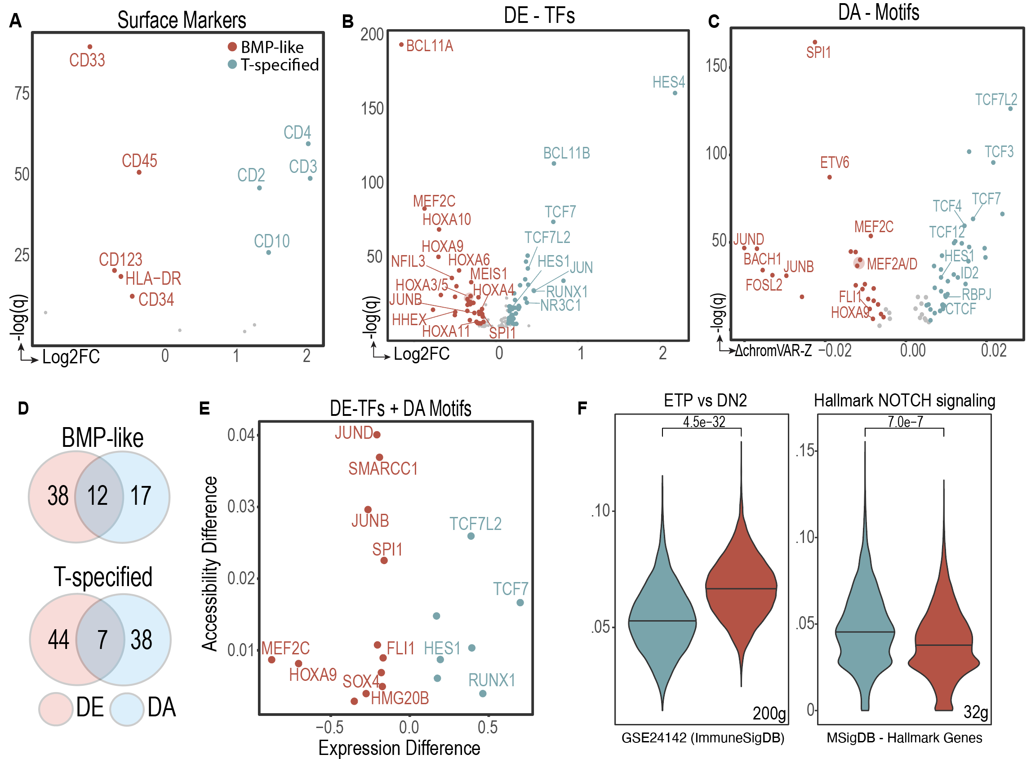
Supplementary Data Fig 6 | Transcriptional and epigenetic characteristics of BMP-like and T-specified cell states. (a-b) differential expressed of surface markers and transcription factors between BMP-like blasts from non-responding patients and T-specified blasts from responding patients. DE was performed with 1500 randomly downsampled cells from each group using Mann-Whitney test on log-normalized data. (c) differentially accessible transcription factors motifs between BMP-like blasts from non-responding patients and T-specified blasts from responding patients. DA was performed with 1000 randomly downsampled cells from each group. Two-sided Mann-Whitney test was used to compare chromVAR deviation Z-scores. (d-e) intersection of differentially expressed transcription factors and differentially accessible motifs. Differentially expressed transcription factors were defined by Log2FC > 0.15, adjusted pvalue < 0.01; differentially accessible motifs were defined by Δmedian chromVAR deviation > 0.005, adjusted p-value < 0.01. Differential expression was performed using 5000 randomly downsampled cells per cluster. Differential accessibility was performed using 5000 randomly downsampled cells per cluster. (f) signature scores for T-specified and BMP-like blasts were calculated using AUCell. Representative top pathways from ImmuneSigDB and MSigDB Hallmark database are shown.

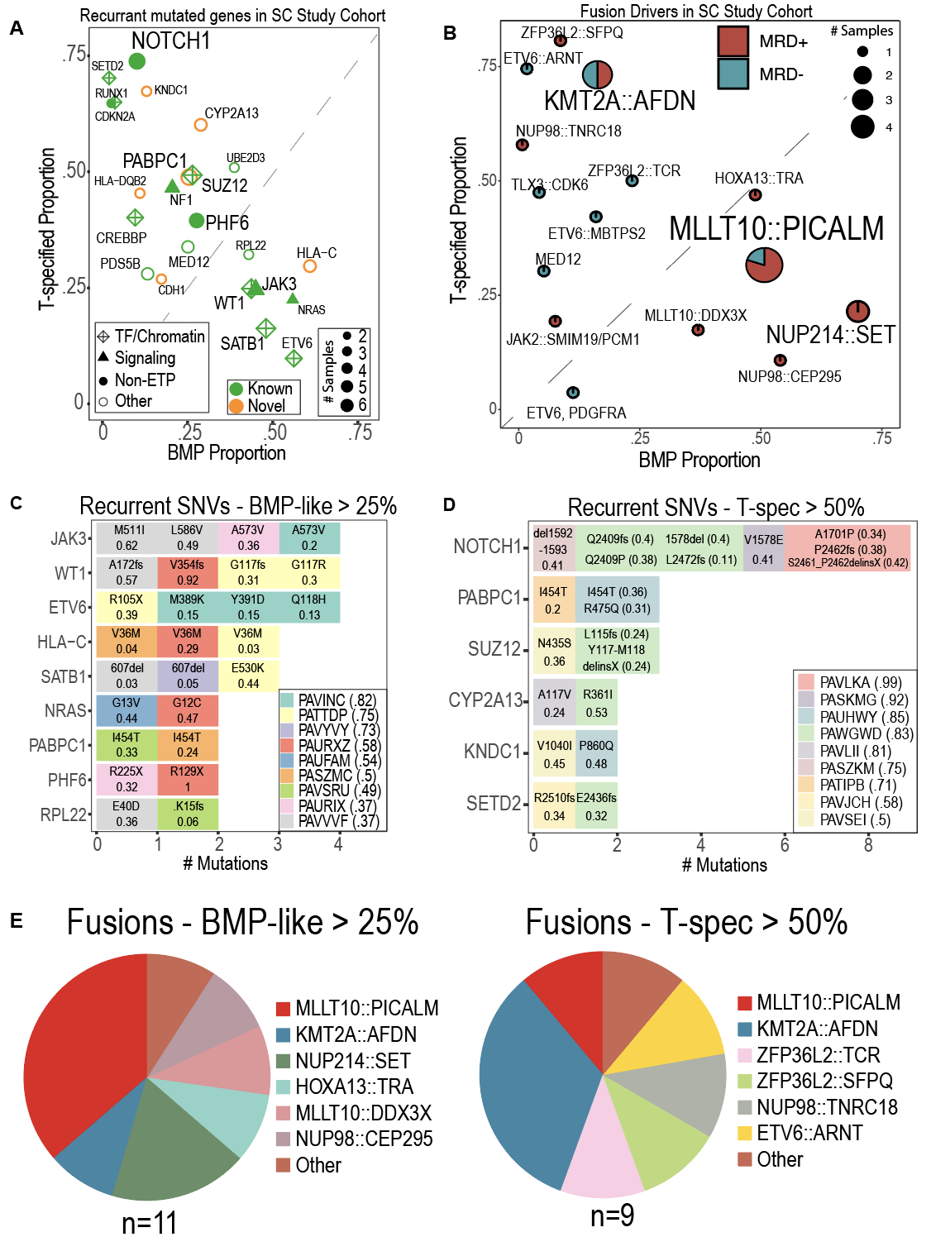
Supplementary Data Fig 7. | Integration of bulk-derived mutation calls with single-cell-derived tumor phenotype. (a) recurrently mutated genes among 25 ETP-ALL patients and associated tumor BMP-like and T-specified proportion. SNV were called using WES data (Polonen et al) and integrated with tumor phenotype derived from scRNA data. (b) driver fusions among 25 ETP-ALL patients and associated tumor BMP-like and T-specified proportion. Fusions were called from WGS data and bulk RNA-sequencing data (Polonen et al) and integrated with tumor phenotype derived from scRNA data. (c) recurrently mutated genes seen in high BMP-like patients (high risk). (d) recurrently mutated genes seen in high T-specified patients (low risk). (e) driver fusion profile of high BMP-like patients (high risk, left) and high T-specified patients (low risk, right).

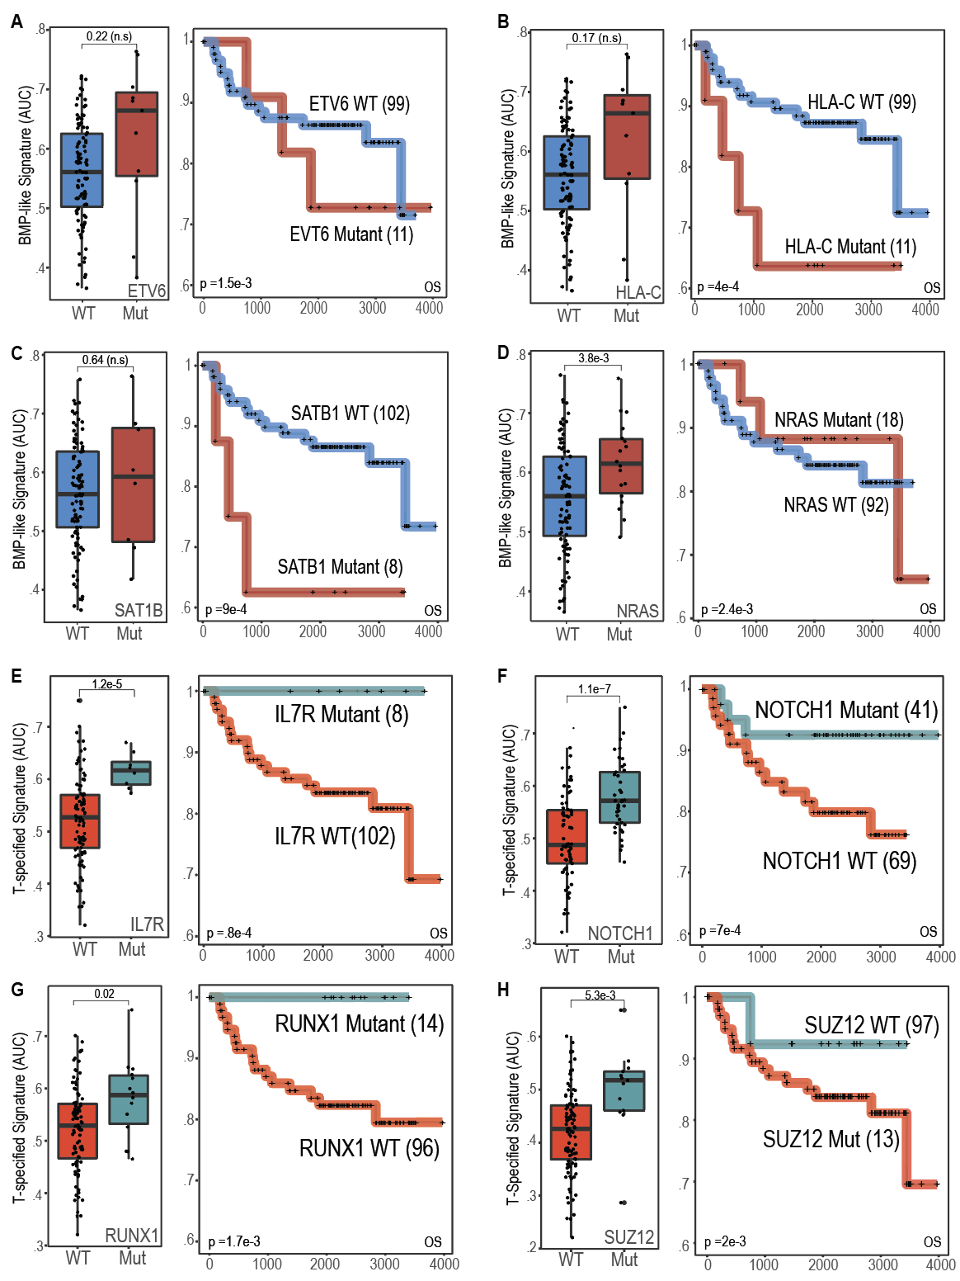
Supplementary Data Fig. 8 | Prognostic value of individual mutated genes associated with BMP-like and T-specified states. (a-d) recurrently mutated genes associated with BMP-like cell state. Overall survival and single cell-signature scores among 110 bulk-sequenced ETP-ALL patients grouped by mutation status within BMP-like (ETV6, NRAS, HLA-C, SAT1B) genes. The p-value for Log-likelihood statistic of Cox-proportional hazard test run with Day 29 MRD as a co-variate is shown in the bottom left of Kaplan-Meier curves. (e-h) identical analysis performed with recurrently mutated genes associated with T-specified cell state.

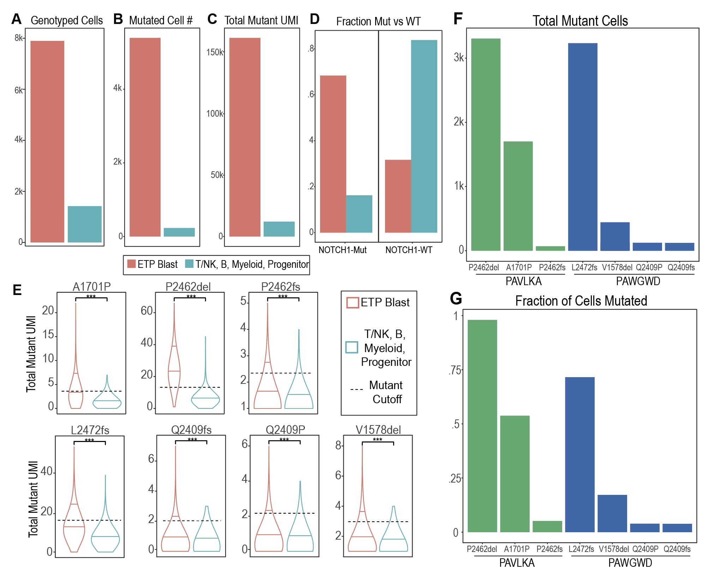
Supplemental Data Figure 9 | Detection of NOTCH1 mutant single-cells via genotyping of transcriptomes. (a-d) summary statistics from n=9314 genotyped cells from 7 independent GoT experiments. P-values from correlation test are shown (* < 0.05; ** < 0.01, ***< 0.001). (e) Expression of mutant NOTCH1 UMI amongst ETP-blast and non-ETP-blast populations in scRNA-seq data. P-values from two-sided Mann-Whitney test are shown (* < 0.05; ** < 0.01, ***< 0.001). In each sample, cutoffs for NOTCH1 mutant cells are indicated by the dotted line, which is representative of the 90th percentile of UMI reads detected in non-ETP-blast populations. The median of both populations and 90th percentile of UMI reads in ETP-blast populations are indicated within each violin plot. (f-g) summary statistics for 7 NOTCH1 variants amongst 2 single-cell sequenced patients selected for GoT.

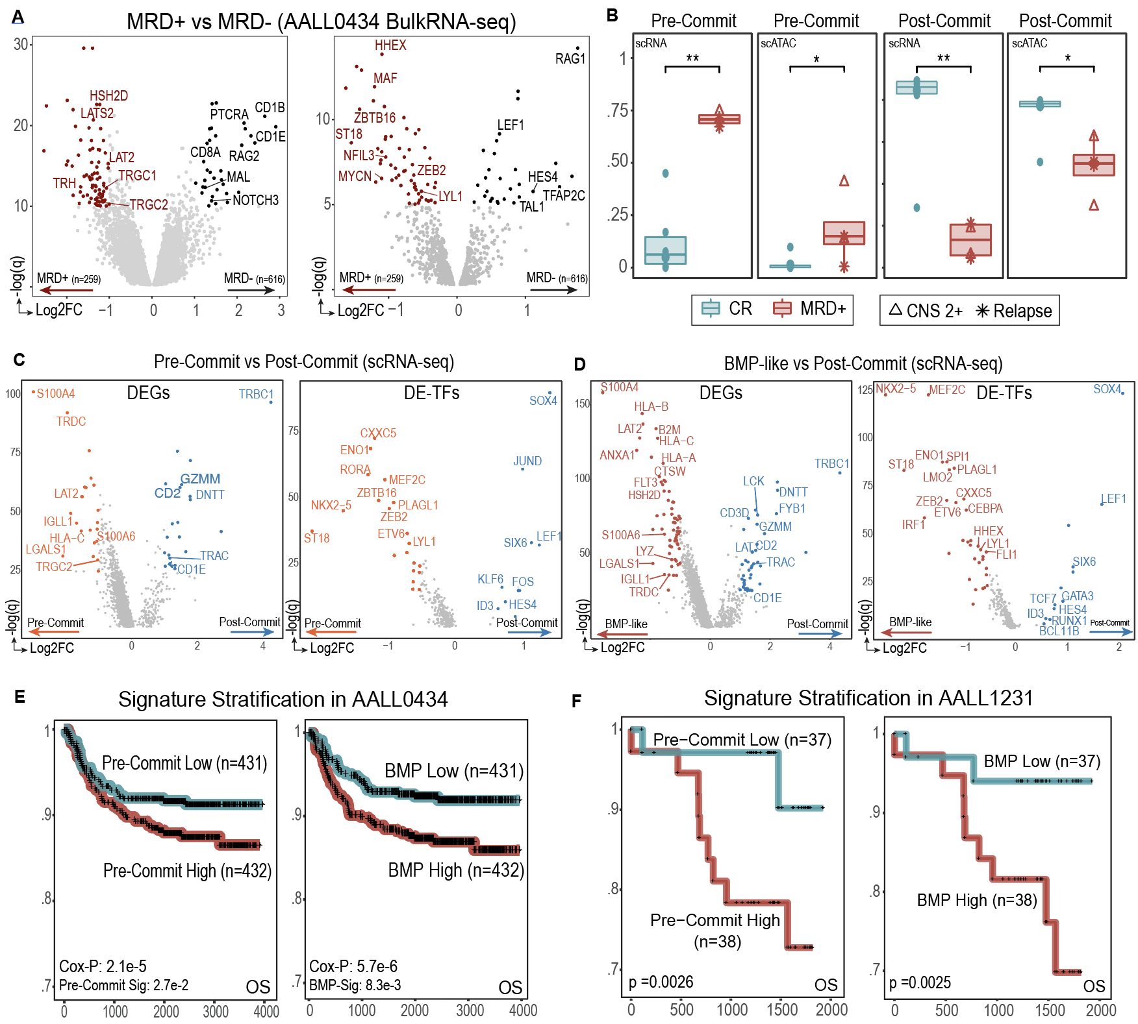
Supplementary Data Fig 10 | Pre-Committed and BMP-like populations in Non-ETP T-ALL are associated with poor outcome. (a) differentially expressed genes and TFs between MRD+ and MRD- non-ETP patients treated in AALL0434. Genes related to T-cell maturation state are labeled. (b) proportion of Non-ETP blasts in pre-commit (all cells before the Pre-T stage) and post-commit (after the Pre-T stage) developmental arrest state. P-values from two-sided Mann-Whitney test are indicated (* < 0.05; **< 0.01). (c) differential expression between pre-committment vs post-committment projected Non-ETP blasts from our single cell cohort. Left to right: DE surface protein markers, DEGs, and DE TFs. Genes related to T-cell maturation state are labeled. (d) differential expression between BMP-like and post-committed projected Non-ETP blasts from our single cell cohort. Left to right: DEGs and DE TFs. Genes related to T-cell maturation state are labeled. (e-f) Kaplan-Meier plot showing overall survival of Non-ETP T-ALL patients in AALL0434 (left) and AALL1231 (right) when binarized using signatures derived from pre-committed Non-ETP blasts and BMP-like Non-ETP blasts. P-value for Log-likelihood statistic of Cox-proportional hazard test run with Day 29 MRD as a co-variate is shown in the bottom left.

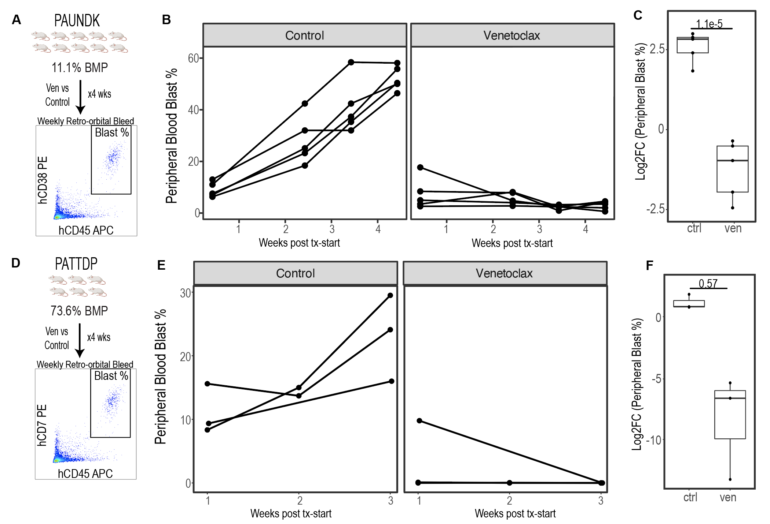
Supplemental Data Fig 11 | Peripheral blood leukemic burden in BMP-low and BMP-high PDX models during venetoclax treatment. (a) experimental workflow for quantification of peripheral blast percentage during venetoclax or control treatment for PAUNDK (BMP-low) PDX. (b) peripheral blast percentage during control (left) and venetoclax (right) treatment for PAUNDK PDX models. Timepoints of retro-orbital bleeds are indicated with black points. (c) log2 fold change of peripheral blast % over study period for PAUNDK PDX models. P-value from two-sided t-test is shown. (d-f) experimental workflow, peripheral blast percentage, and log2 fold change of peripheral blast % over study period for PATTDP (BMP-high) PDX model.

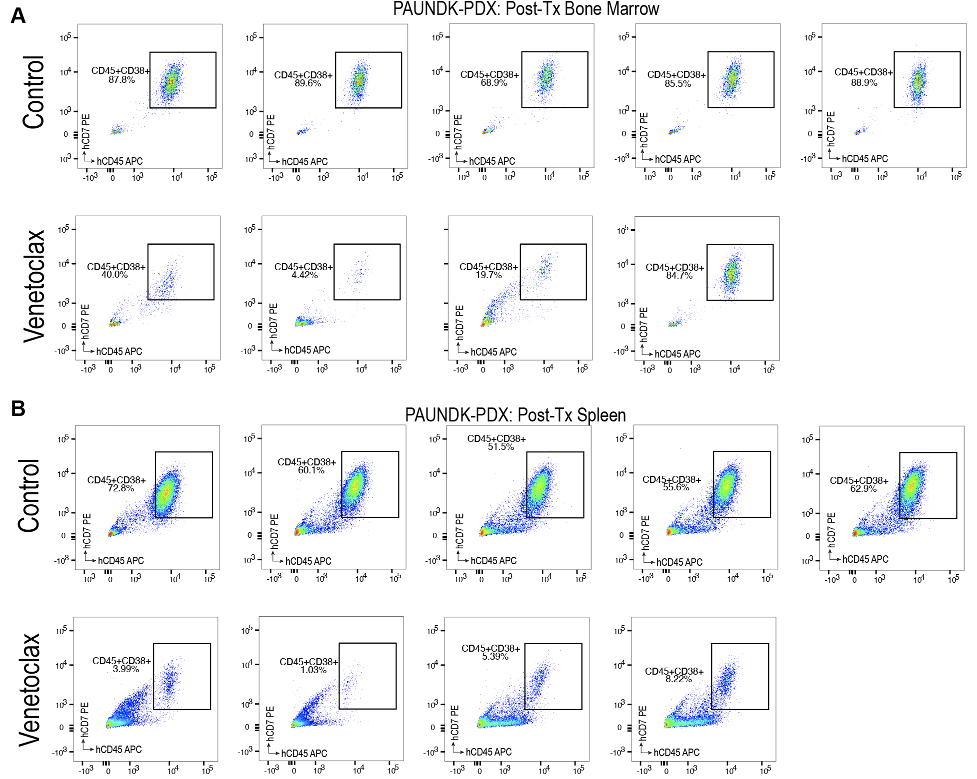Supplemental Data Fig 12 | Response to venetoclax vs. control in BMP-low PDX via two-marker flow cytometry. (a) bone marrow leukemic blast % post control (top, n=5) and venetoclax (bottom, n=4) treatment. Gates were set using CD38-FITC/CD45-APC FMO controls. The percentage of hCD38+CD45+ blasts amongst all live singlets is plotted. (b) Splenic leukemic blast % post control (top, n=5) and venetoclax (bottom, n=4) treatment. Gates were set using CD38-FITC/CD45-APC FMO controls. The percentage of hCD38+CD45+ blasts amongst all live singlets is plotted.

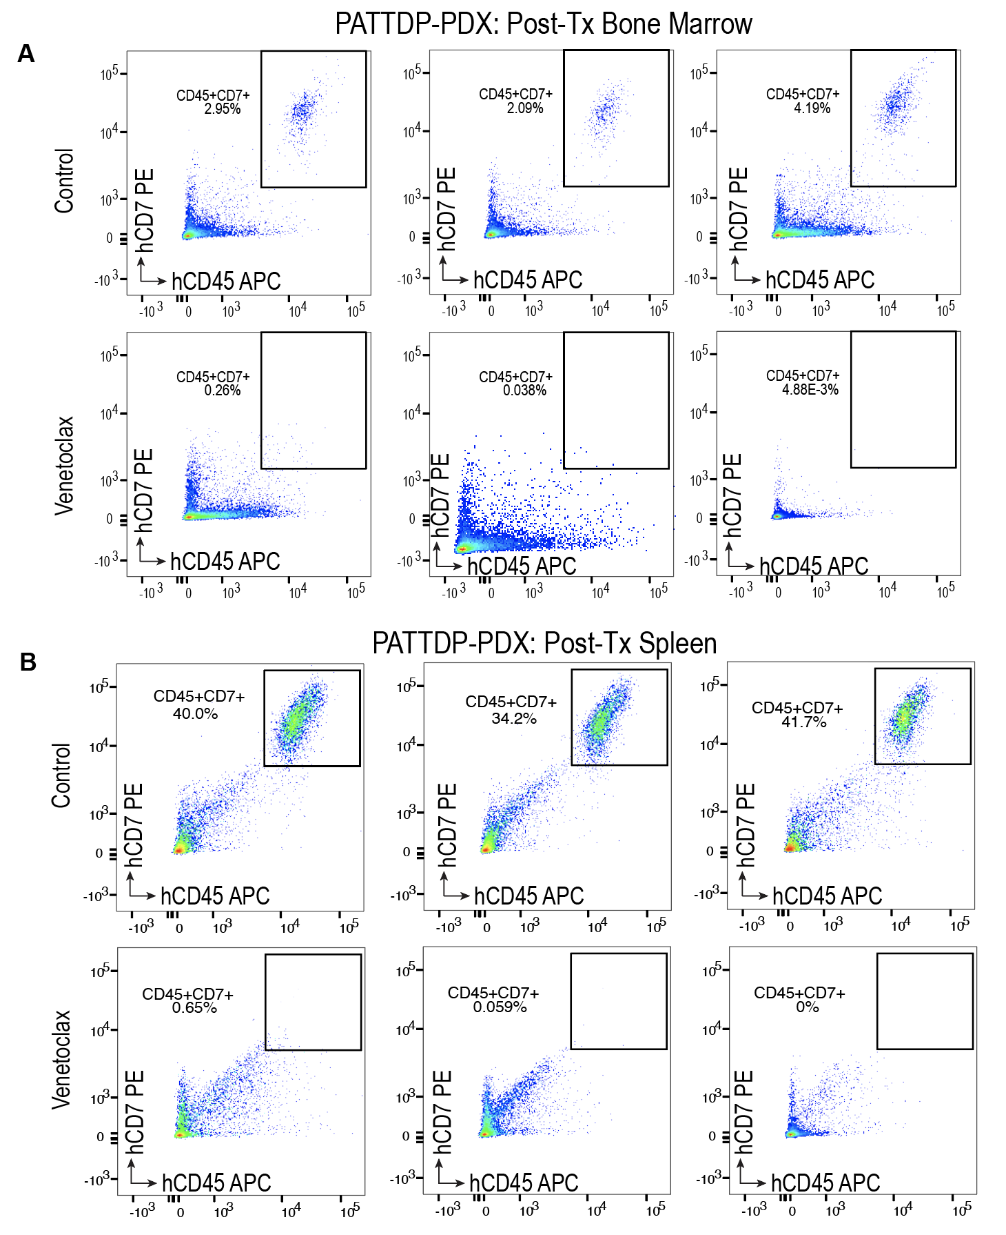
Supplemental Data Fig 13 | Robust blast clearance in BMP-high models detected via two-marker flow cytometry. (a) bone marrow leukemic blast % post control (top, n=3) and venetoclax (bottom, n=3) treatment. Gates were set using CD7-PE/CD45-APC FMO controls. The percentage of hCD45+CD7+ blasts amongst all live singlets is plotted. (b) Splenic leukemic blast % post control (top, n=3) and venetoclax (bottom, n=3) treatment. Gates were set using CD7-PE/CD45-APC FMO controls. The percentage of hCD45+CD7+ blasts amongst all live singlets is plotted.

