Extended Data Figures and Tables
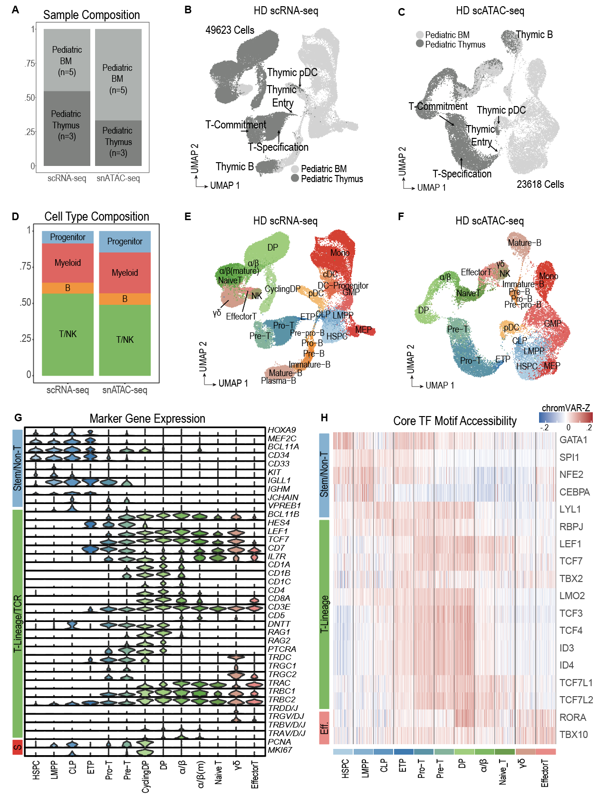
Extended Data Fig. 1 | Healthy reference maps of pediatric hematopoiesis. a, sample composition of scRNA-seq and snATAC-seq reference maps. b-c, UMAP representation of developmental reference trajectories, based on scRNA (b) and scATAC (c) data. Key stages of T-cell development implicated in T-ALL and low-frequency thymic populations are labeled. d, cell-type composition of scRNA-seq and snATAC-seq reference maps. e-f, UMAP representation of developmental reference trajectories. 26 distinct cell populations defined by clustering and marker gene expression are labeled. g, Stem, T, and S-Phase marker gene expression (scRNA, log-normalized counts) within developing T-cell populations. h, Stem, T-lineage, and effector transcription factor motif accessibility (scATAC, chromVAR-Z) within developing T-cell populations.

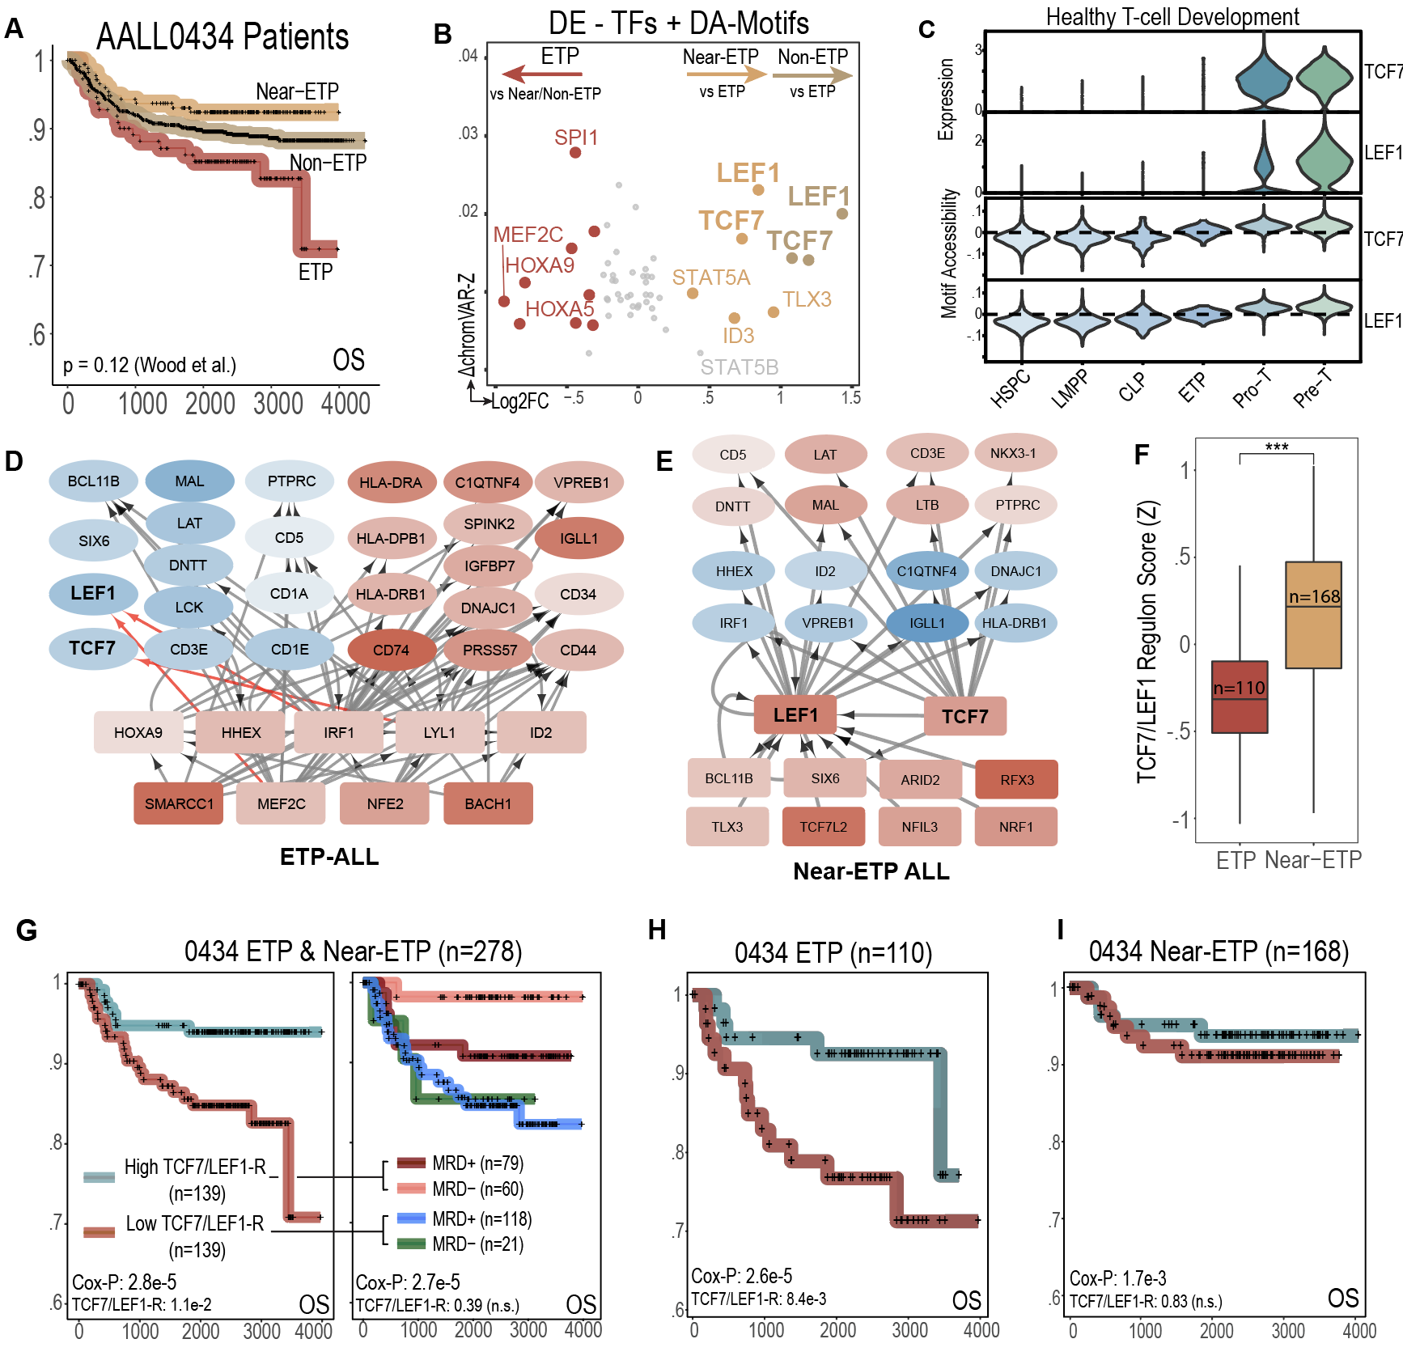
Extended Data Fig. 2 | TCF7/LEF1 activation underlies CD5 expression in Near-ETP T-ALL and contributes to positive outcome in ETP-ALL Patients. a, Overall survival of ETP, Near-ETP and Non-ETP patients from Children’s Oncology Group AALL0434 cohort (n=1411). b, Intersection of differentially expressed transcription factors and differentially accessible motifs. c, Expression of TCF7 and LEF1 and accessibility of TCF7 and LEF1 motifs in healthy T-cell development. d, Subset of transcriptional regulatory network constructed using integrated scRNA and scATAC data from ETP-ALL patients. Transcription factors are represented as squares, gene targets as ovals. Color is proportional to expression fold change in comparison to Near-ETP and Non-ETP blasts: blue is downregulated, red upregulated. Edges with > 100 edge score are shown, with edge score representing the sum of -log(p-value) of all predicted EP interactions. Predicted regulators of TCF7 and LEF1 are highlighted. e, Subset of transcriptional regulatory network constructed using integrated scRNA and scATAC data from Near-ETP-ALL patients. Transcription factors are represented as squares, gene targets as ovals. Color is proportional to expression fold change in comparison to ETP blasts: blue is downregulated, red upregulated. Edges contacting TCF7 and LEF1 with regression coefficient > 0.3 are shown e, Signature score of top 28 target genes of the TCF7/LEF1 regulon and top 11 predicted TF regulators of TCF7/LEF1/CD5 in bulk-sequenced ETP and Near-ETP T-ALL patients from COG AALL0434 trial. g-i, Kaplan-Meier plot showing overall survival of bulk-RNA-sequenced ETP-ALL and Near-ETP patients in AALL0434 binarized using the TCF7-LEF1 targets and activator signature. Prognostic value of the TCF7/LEF1 signature in multivariate analysis (w/ Day 29 MRD and CNS status) is shown below the Cox-proportional hazard log-likelihood p-value.

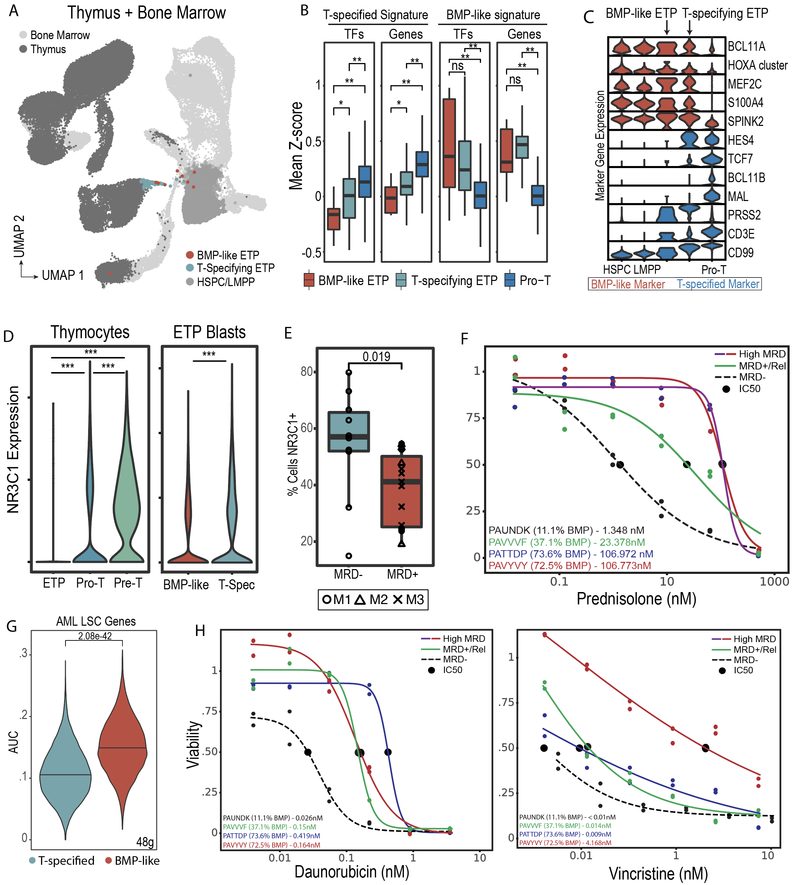
Extended Data Fig. 3 | Non-Malignant counterparts to BMP-like blasts and associated resistance to frontline ALL therapy. a, Healthy reference trajectory with BMP-like ETP and T-specifying ETP highlighted. Thymus, bone marrow, and subset of BM progenitors (HSPC/LMPP) are colored in different shades of gray. b, average Z score of BMP-like and T-specified-like gene signatures derived from non-responding and responding ETP-ALL patients were computed for BMP-like ETP, T-specifying ETP, and Pro-T cells. c, Expression of BMP-like and T-specified TFs and marker genes across multipotent BM progenitors, BMP-like ETP, T-specifying ETP, and Pro-T cells. HOXA cluster denotes sum of expression across HOXA cluster genes and MEIS1, the HOX co-factor. d, expression of NR3C1 during thymic entry, T-specification, and T-commitment. P-value was calculated based on Mann Whitney test on log normalized data. *** < .001. e, Expression of NR3C1 in BMP-like ETP blasts from non-responding patients and T-specified ETP blasts from responding patients. P-value was calculated based on Mann Whitney test on log normalized data. f, Response of Three High BMP, and One MRD Negative ETP patient to prednisolone. Three high MRD patients both had > 30% BMP-like blast; MRD Negative patient and Non-ETP Patients had > 50% T-specified blast. g, AUCell signature score for 48 LSC-related genes (Ng et.al. Nature 2016) in T-specified and BMP-like ETP blasts. h, response of Three High BMP-like and One MRD Negative ETP patient. Three high MRD patients all had > 30% BMP-like blasts; MRD Negative patient had > 50% T-specified blasts.
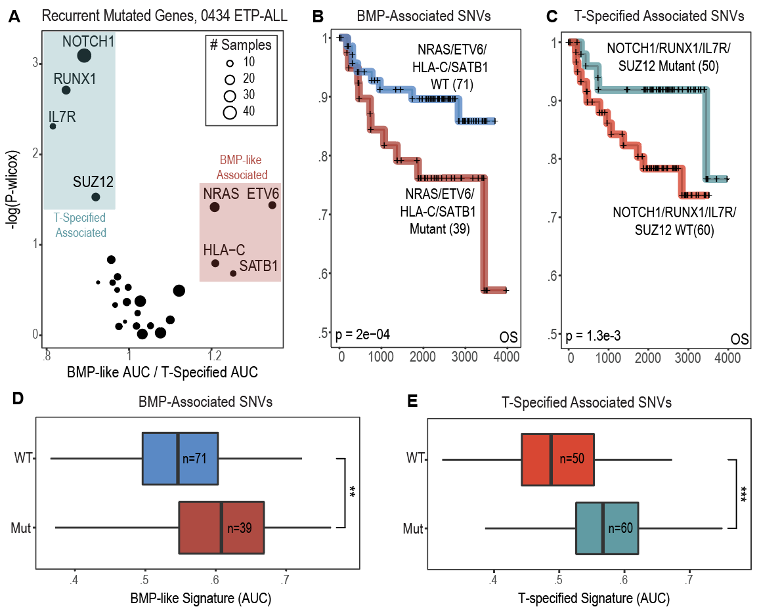
Extended Data Fig. 4 | Prognostic value of mutations associated with T-specified and BMP-like states. a, recurrently mutated genes associated with BMP-like and T-specified cell states. Top recurrently mutated genes are highlighted. b-e, Overall survival and single cell-signature scores among 110 bulk-sequenced ETP-ALL patients grouped by mutation status within BMP-like (ETV6, NRAS, HLA-C, SAT1B) and T-specified (NOTCH1, IL7R, RUNX1, SUZ12) associated genes (**, p<0.01, *** p<1e-5). The p-value for Log-likelihood statistic of Cox-proportional hazard test run with Day 29 MRD as a co-variate is shown in the bottom left of Kaplan-Meier curves.
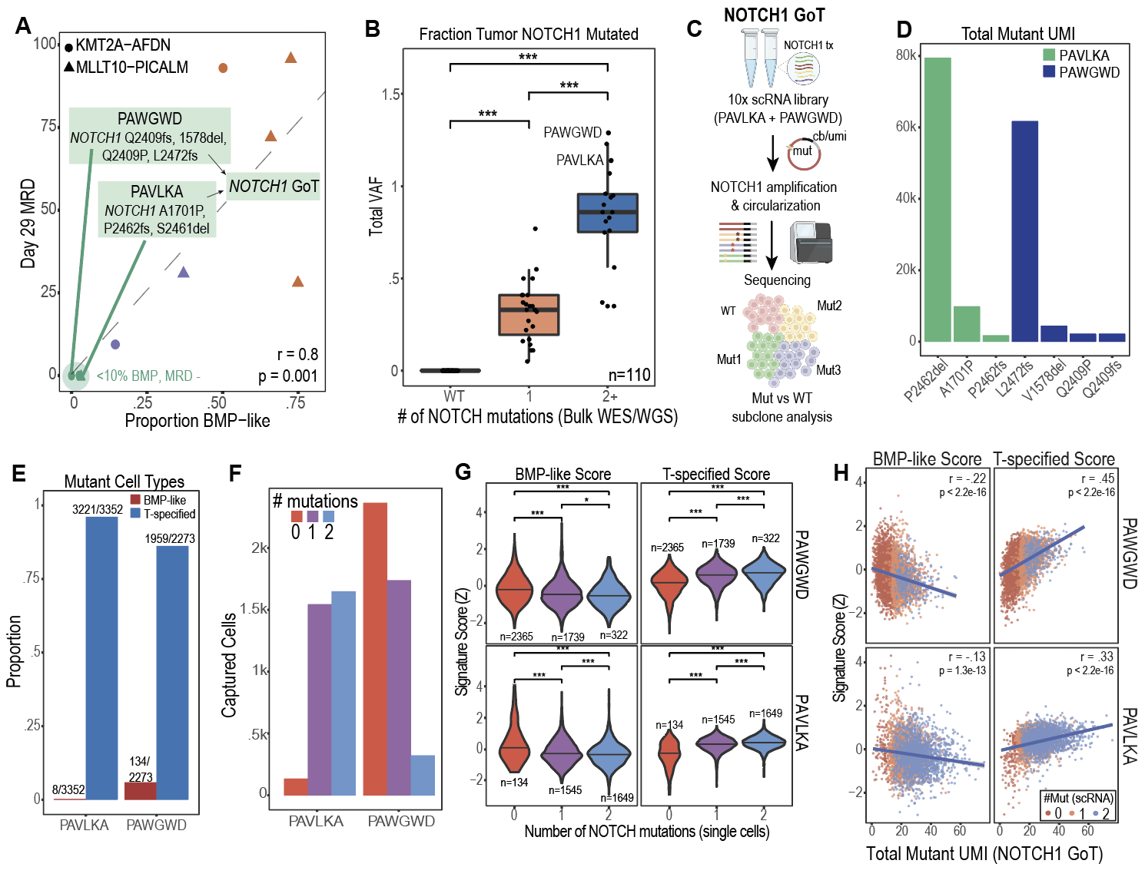
Extended Data Fig. 5 | Sub-clonal NOTCH1 mutations additively contribute to differentiation towards the T-specified state. a, identification of subclonal NOTCH1 mutations in MRD negative patients with BMP-like associated fusion drivers. b, Summed VAF of NOTCH1 mutations in AALL0434 ETP patients with 0 (WT), 1, and 2+ NOTCH1 mutations. P-values from two-sided Mann-Whitney test are indicated (***, p<1e-5). Single-cell profiled samples with multiple NOTCH1 mutations are highlighted. c, experimental workflow for detection of NOTCH1-mut leukemic blasts in scRNA libraries via genotyping of transcriptomes (GoT). d, GoT detection of 7/7 mutant transcripts determined from bulk WES/WGS. e, fraction of BMP-like and T-specified cells within NOTCH-mut cells f, detection of n= 1971 cells harboring 2 unique NOTCH1 mutations within leukemic blasts from PAVLKA and PAWGWD.42 g, association of BMP-like and T-specified signature scores with NOTCH1 mutation dosage in single-cells. Cells are binarized into 0 (WT), 1, and 2 mutations. P-values from two-sided Mann-Whitney test are shown (* < 0.05; ** < 0.01, ***< 0.001). h, association of mutant-NOTCH1 transcript expression and BMP-like and T-specified signatures. 7754 genotyped single cells from PAWGWD and PAVLKA are plotted; Pearson correlation coefficient and p-value for Pearson’s product-moment are indicated in the top right.
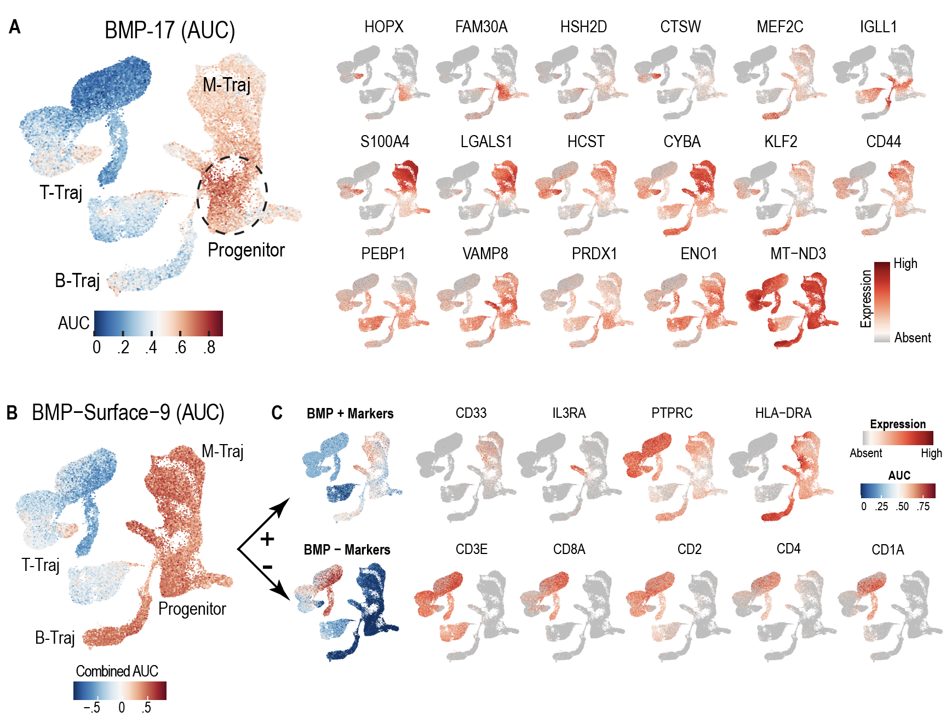

Extended Data Fig. 6 | Non-T-lineage expression of BMP-17 and BMP-Surface-9 marker genes within healthy hematopoietic development. a, signature score of BMP-17 signature calculated via AUCell (left) and expression of BMP-17 marker genes (right) within scRNA-seq reference of normal hematopoesis. b, Aggregate signature score of BMP-Surface-9 signature (AUC of positive markers – AUC of negative markers) calculated via AUCell. c, RNA expression of BMP-Surface-9 marker genes within scRNA-seq reference of normal hematopoiesis. Positive marker genes are shown on top row; negative marker genes are shown on the bottom row. AUC of positive and negative surface marker genes within healthy hematopoiesis is shown on the left-most panel.

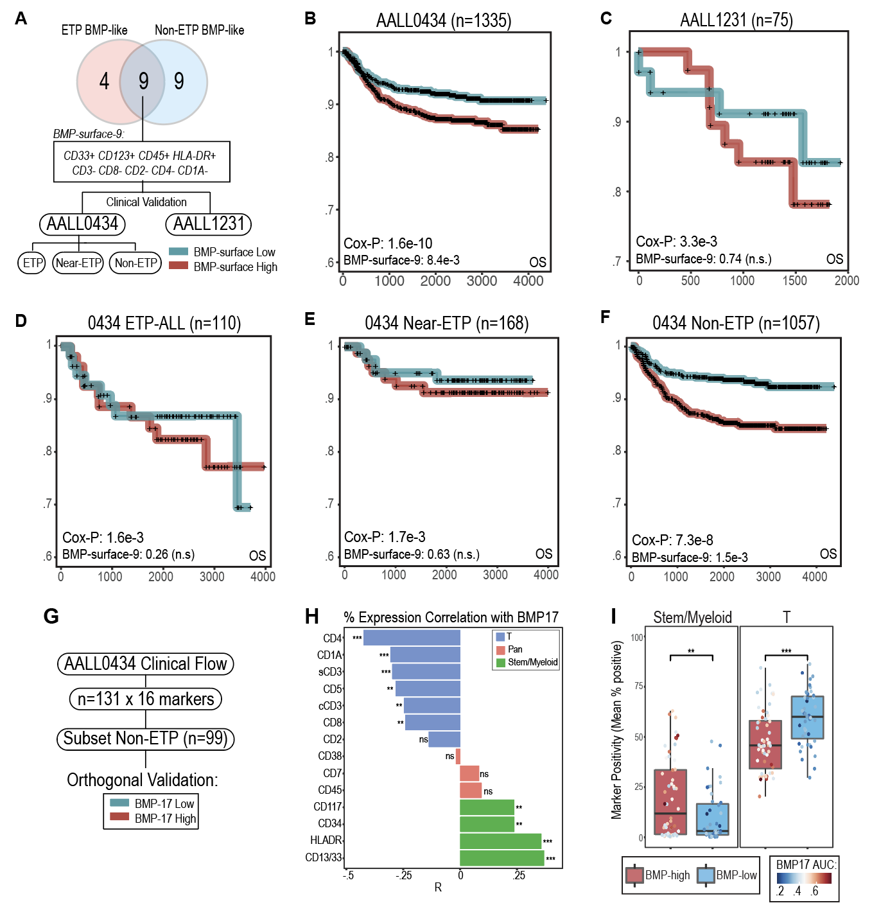
Extended Data Fig. 7 | Clinical utility of the BMP-like surface immunophenotype in risk stratifying T-ALL patients. a, Overlap of ETP BMP-like and Non-ETP BMP-like DE surface markers to create consensus surface marker signature for risk stratification in AALL0434 (fully sequenced) and AALL1231 (partially sequenced). Positive surface markers were filtered for Log2FC > 0.5, adjusted p-value < 0.001. Negative surface markers were filtered for Log2FC < -0.5, adjusted p-value < 0.001. b-f, Kaplan-Meier plot showing overall survival of bulk-RNA-sequenced T-ALL patients in AALL0434 and AALL1231. Patients in each analysis were binarized using RNA-seq derived expression of BMP-surface-8 signature genes. Patients are grouped by subtype, with non-subtyped patients (n=194) grouped with Non-ETP Patients. Prognostic value of the BMP-surface-9 signature in multivariate analysis (with Day 29 MRD and CNS status) is shown below the Cox-proportional hazard log-likelihood p-value. g, gating of clinical flow cytometry from 131 AALL0434 patients and analytical plan to test BMP-like detection in Non-ETP cases. h, Pearson correlation of % expression of T, Pan, Stem, and Myeloid flow cytometric markers amongst n=99 Non-ETP patients. P-values from correlation test are shown (* < 0.05; ** < 0.01, ***< 0.001). i, Average percent expression of Stem/Myeloid (CD117/34/HLA-DR/13/33) and T (CD4/1A/s3/5/8/2) in BMP-high vs BMP-low Non-ETP cases. BMP-high and BMP-low were defined using bulk-RNA-seq and matched with flow cytometric values by USI. P-values from two sided Mann Whitney test are shown (* < 0.05; ** < 0.01, ***< 0.001)

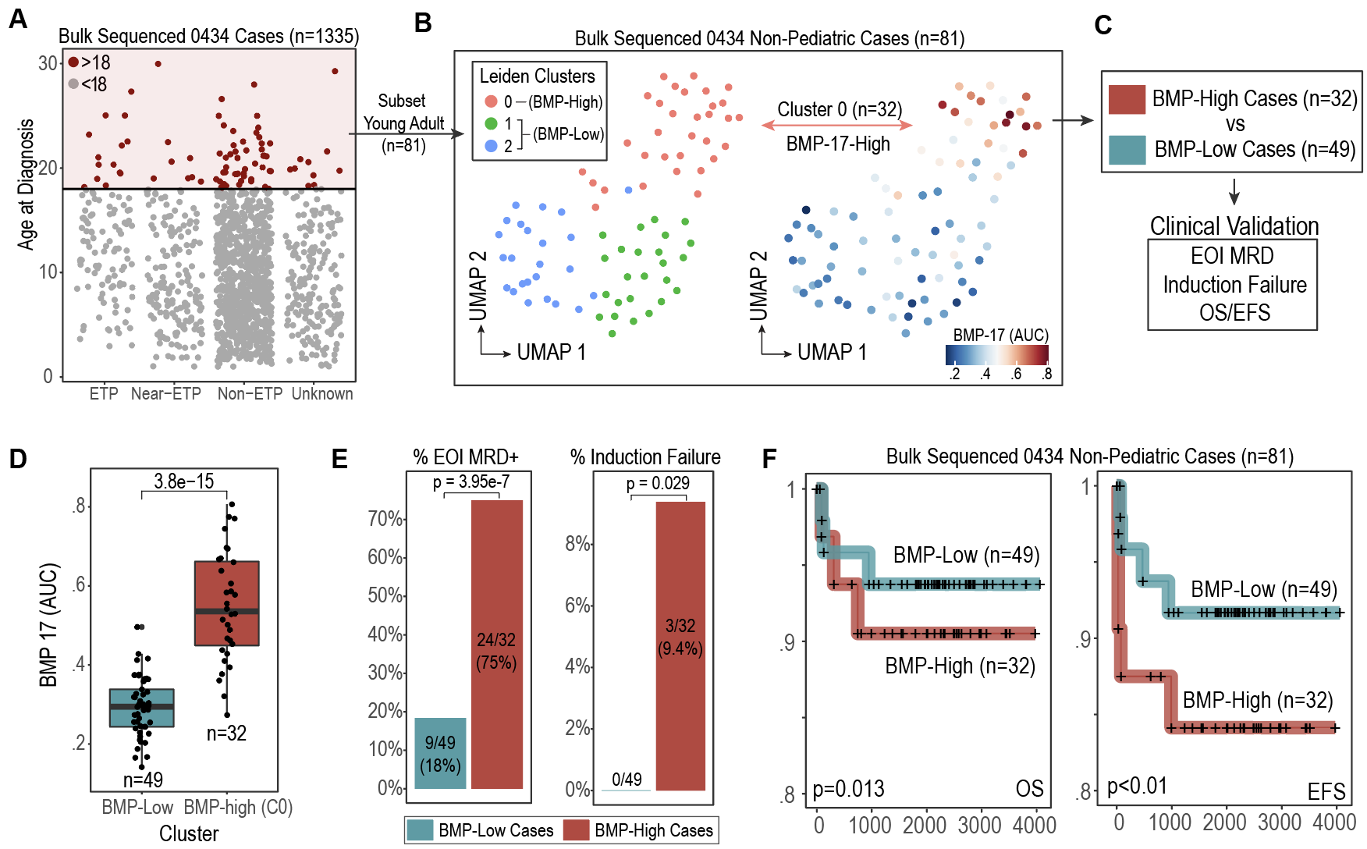
Extended Data Fig. 8 | Clinical utility of the BMP-like-17 in risk stratifying non-pediatric T-ALL patients. a,
Selection of 81 young adult (age at diagnosis >= 18 years) T-ALL cases from bulk-sequenced AALL0434 cohort. b, identification of BMP-17-high cluster within AALL0434 young adult cases via Leiden clustering. c, Clinical outcome comparison strategy between BMP-17-High and BMP-17-Low cases. d, BMP-17 signature score in cluster 0 (BMP-high) vs cluster 1/2 (BMP-low) cases. e, enrichment of EOI MRD positive and induction failure cases within BMP-High cases. f, overall (left) and event free (right) survival outcomes in BMP-High and BMP-Low cases. Cox-proportional hazard log-likelihood p-value is shown in the bottom left.

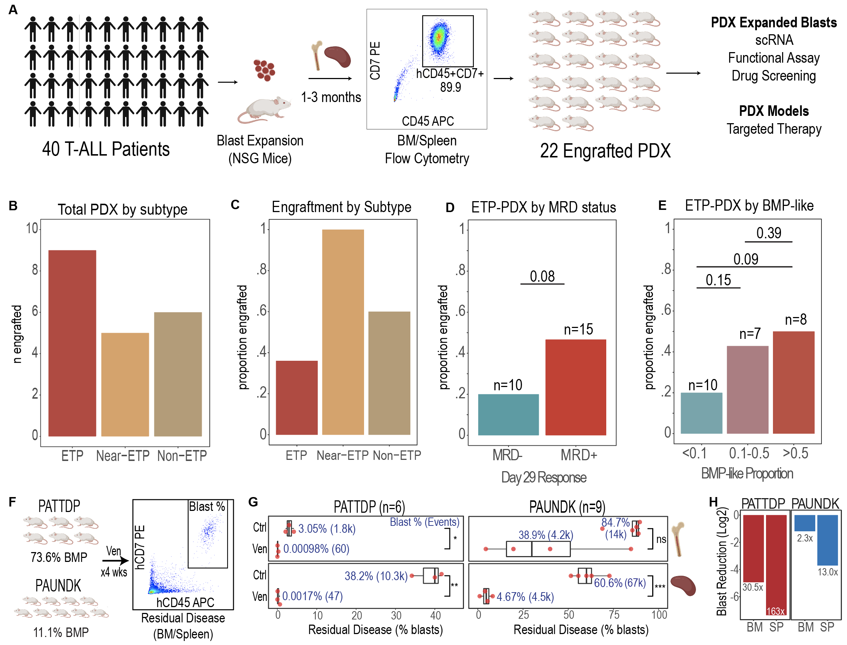
Extended Data Fig. 9 | In-vivo drug-response validation within BMP-high and BMP-low PDX models established by expansion of primary T-ALL blasts in NSG mice. a, Experimental workflow for expansion of primary T-ALL samples in NSG mice and confirmation of leukemic engraftment. b, total engrafted PDX by subtype. c, engraftment potential by T-ALL subtype. d-e, Engraftment potential of ETP-ALL PDX by MRD status (d) and BMP-like proportion (e). To test whether BMP-mid and BMP-high groups have higher engraftment potential, one-sided proportion test was used to compare BMP-mid (0.1-0.5) and BMP-high (>0.5) groups to BMP-low (<0.1) group. f, Experimental workflow for in-vivo study of venetoclax efficacy in BMP-high (PATTDP) and BMP-low (PAUNDK) PDX models. g, Bone Marrow (BM, top) and spleen (bottom) leukemic burden in High-BMP (left) and low-BMP (right) PDX models after 1 month of venetoclax or vehicle (ctrl) treatment. P-value from two-sided t-test is shown (*<0.05, **<0.01, ***<0.001). h, aggregate fold-reduction of leukemic burden in BM and spleen with venetoclax treatment in BMP-high and BMP-low PDX models.
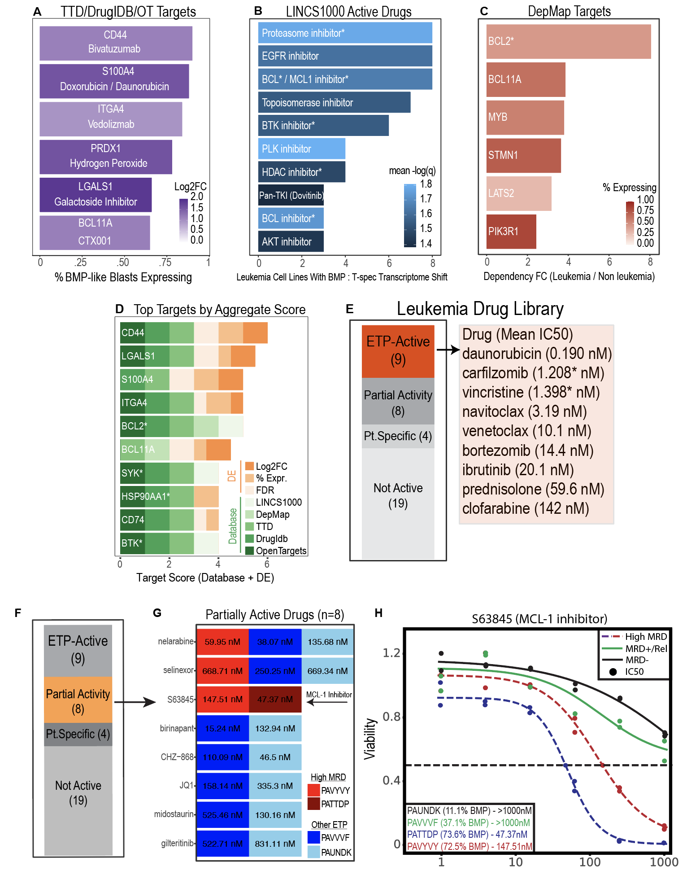
Extended Data Fig. 10 | Computational and in vitro drug screening results against BMP-like blasts. a, Top predicted drugs from LINCS1000. BMP-like DEGs (High Risk) and T-specified DEGs (Low Risk) were inputted into LINCS1000. Drug treated leukemia cell lines were filtered for statistical significance (FDR < 0.1) and connectivity score (NCS > 0.8). Drugs are ranked by number of leukemia cell lines with favorable transcriptomic shift after treatment (downregulation of BMP-like DEG, upregulation of T-specified DEG). Each drug is colored by the mean -log(FDR). b, Top leukemia specific targets predicted from DepMap screening. Dependency scores in leukemic and non-leukemic cell lines were calculated for all BMP-like DEGs and ranked by fold change in dependency (mean dependency in leukemia / mean dependency in non-leukemia cell lines). The top druggable (with score 1+ from other drug databases) targets are shown. c, Top druggable targets from TTD/DrugIDB drug database screening. Targets are ranked by percentage expression & selected based on Log2FC > 1. An example of drug is listed below the target. d, Top 10 targets by aggregate database (1-5) and DE (1-3) score. e, 9 Drugs active in some 4/4 ETP patients tested with mean IC50. Drugs with marked asterisk had IC50 below lowest tested dose in 1 sample. f-g, 8 Drugs active in some, but not all ETP patients. S63845, the only drug to have specificity to High MRD patients is indicated with an arrow. h, Response of BMP-high and BMP-low ETP PDX to MC1-inhibitor, S63845. High MRD patients are indicated with the dashed lines.

