Supplementary Materials

Supplementary Methods - Full Task Instructions

Pre-Scan Task Instructions
This is a practice of the task that you will be doing in the scanner. You’re going to see three short video clips of people telling stories – these are each around 30 seconds, but in the scanner they will be closer to two minutes.
As you watch each one, please use the 2 and 3 key to rate how positive or negative you think the person was feeling while they were telling their story. You’ll rate their emotion by moving to the left or right of a sliding scale. When you press the 2 key, the slider will move to the left, making your rating more negative. When you press the 3 key, the slider will move to the right, making your rating more positive.
We’d like you to make these ratings continuously, whenever you see a change in the person’s emotional state. For instance, imagine someone is discussing a family vacation. You might imagine that this person feels positively overall, so you might think to move the rating scale all the way to the right and leave it there. However, even while talking about a positive event, someone’s emotions can change. For instance, this person might remember an argument that occurred on the vacation, and momentarily feel more negative. Does that make sense?
We’d like you to focus on, and rate, these momentary shifts in emotion, not just how someone feels overall.
Importantly, sometimes you will only hear the audio of someone’s stories without seeing them. Other times, you will only see a silent video of the person talking without hearing what they say. In these cases, please do your best to rate how that person feels based on the information you have available to you. Does that make sense? Questions? Great, press the 9 key to start, and let me know when you’ve finished.

Post-Scan Task Instructions
We’d now like you to complete one more task. You will see or hear a clip of the first 10 seconds of each video you watched in the scanner.
After each clip, you’ll be answering a few questions about each story. There will be two questions about the content of the story, (if there was audio for that story). Other questions will include how you think the person in the story felt while talking, how you felt while viewing or listening to the story, and whether or not you might know that person. Does that make sense so far?

fMRI Scan Room Set-up Instructions
o 32-channel coil, sheets down, pillowcase over head cushion, red pads for sides of head, knee cushion, blankets, earphones, monitor on, PYKA box plugged in (align pink nail polish)
o Tape squeeze ball, button box, headphones to Ps.
o Squeeze ball to be used if you need to get out of the scanner ASAP for an emergency.
o Have the participant use the restroom. Wash their hands in the sink outside the bathroom.
o Arms/legs uncrossed
o Button Press Instructions: Index and Middle finger to make ratings (we’ll give further instructions in the scanner) and pinkie/thumb for volume. Pinkie =volume up. Thumb = volume down.
o Same task as you practiced outside. You might see the same person tell a story twice, but it will be a different story. Also targets were having their heart rate recorded, just giving a heads up in case you see any sensors on them.
o Please be still the entire time. Even a millimeter of movement can make the scan image very blurry.
o The scanner makes very loud and strange noises. Some sound like a machine gun, some like a robot.

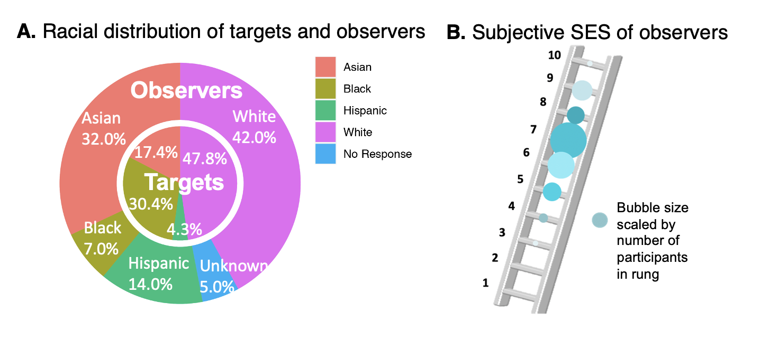Supplementary Figure 1. Participant Demographics.
A. Racial distribution of targets and observers. The outer pie graph contains the distribution of observers (N = 100), and the inner pie graph contains the distribution of targets (N = 24). The demographics of our participants are representative of the city of Palo Alto where the study was conducted. B. Subjective SES of observers. Observers completed the MacArthur Scale of Subjective Social Status (Adler et al., 2000) where they place themselves on a rung of a ladder. The top of the ladder represents the people who are the best off, and the bottom represents the people who are the worst off, socioeconomically (SES = socioeconomic status). The size of the bubble reflects the frequency (counts) of participants on each rung. Observers in this study skew towards upper and upper middle classes.

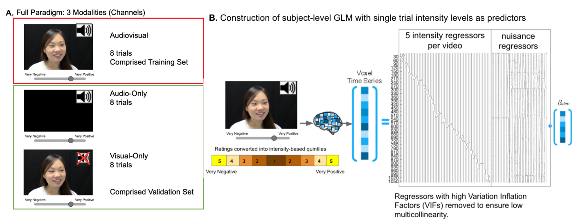Supplementary Figure 2. Full paradigm schematic
A. Full Paradigm. There were three sensory conditions in the full experiment: a visual-only condition, where participants could see but not hear the videos (8 trials); an auditory-only condition where they could hear but not see the videos (8 trials); and an audiovisual condition where they could both see and hear the videos (8 trials). The audiovisual condition was the focus of the current paper and comprised the model training set. The audio-only and visual-only conditions were used as an independent held-out validation set. Due to counterbalancing, participants did not see all the same videos in the audiovisual condition. There were 23 unique videos in the audiovisual condition. These trials were divided into two runs of 12 trials each. Videos were separated by an ITI (fixation cross) that ranged from 4 - 12 s. The woman in this image is not an actual participant. B. Construction of subject-level general linear model (GLM) with single trial intensity levels as predictors. Regressors were constructed for each rating level for each video stimulus and input into the participant’s design matrix. The number of regressors for each participant varied based on their ratings. The nuisance regressors and intercept were added to each design matrix and an ordinary least squares (OLS) regression was run for each participant. This entire procedure was repeated three times, for the three unique rating types (1) observer inference ratings, (2) “ground truth” target self-ratings, and (3) empathic accuracy. Variance Inflation Factors (VIF) were calculated for all regressors of interest for quality control. Event trials with a VIF greater than three standard deviations from the mean (within individuals) were removed as outliers. We tested for intercorrelation across the design matrix and found no issues of multicollinearity within regressors of interest.

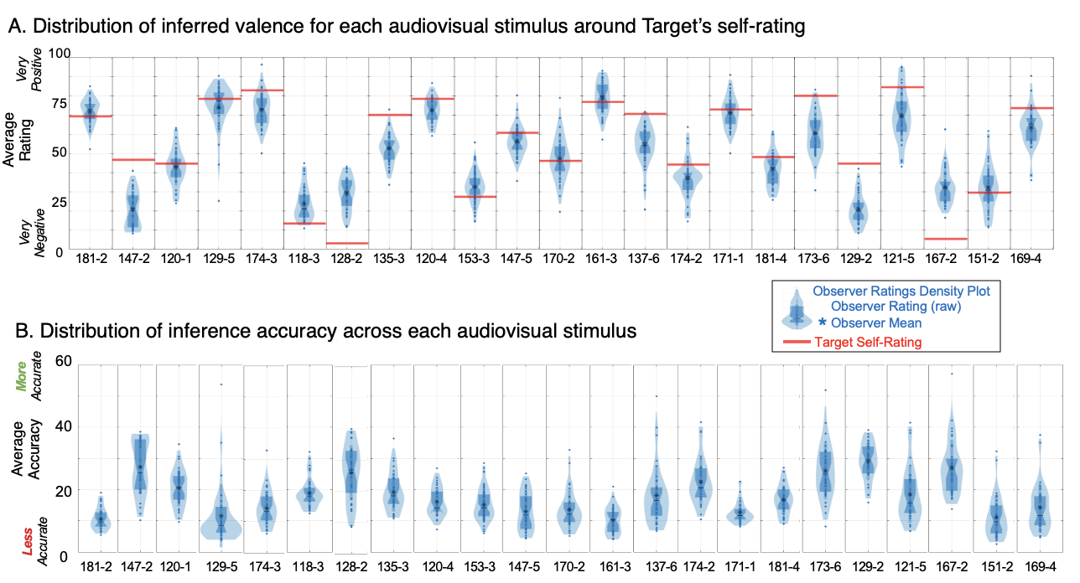Supplementary Figure 3. The distribution of “ground truth” and inference ratings around each audiovisual stimulus in the training set.
A. Distribution of inferred valence for each audiovisual stimulus around each target’s self-rating. Observer ratings across the whole video are averaged, per observer. All observer average ratings are plotted in blue. The mean of all observer means is a blue asterisk in the density plot. Target self-ratings are also averaged across the whole video and plotted as one red line. Red lines represent the “ground truth.” Each plot is one audiovisual stimulus (a target’s story). These plots demonstrate the variability of our study stimuli and of the observer’s inferences. B. Distribution of inference accuracy across each audiovisual stimulus. Inference accuracy was calculated by subtracting each observer’s rating trace from the target’s self-ratings, per video. Then the absolute value of the difference scores was calculated and averaged within observers. Observer accuracy is plotted in blue density plots where the mean of all observers is a blue asterisk in the density plot. Each plot is one audiovisual stimulus (target story).

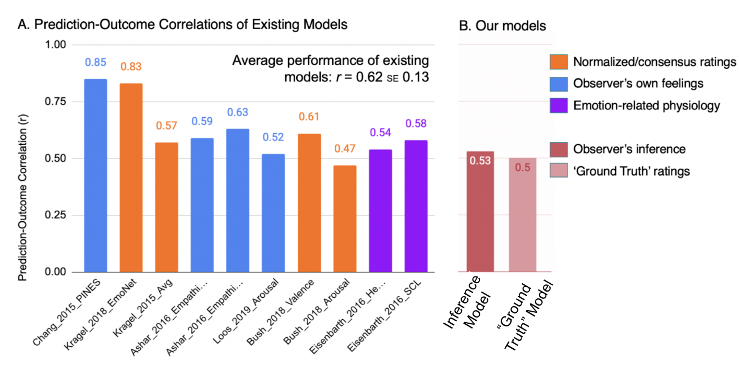Supplementary Figure 4. Comparison of our “ground truth” and inference models with other brain-based models of emotion
A. Prediction-Outcome Correlations of Existing Models. We searched the literature for BOLD fMRI models of emotion that reported prediction-outcome metrics for their model’s cross-validated training performance and plotted the r values below (Featured models come from: Ashar et al., 2017; Bush et al., 2018; Chang et al., 2015; Eisenbarth et al., 2016; Kragel et al., 2019; Kragel & LaBar, 2015; Loos et al., 2019). Models that predict feelings of the participant are colored blue. Models that predict the normalized rating of the emotional stimulus from the participant’s brain activity are colored orange. Models that predict socioemotional physiological responses from brain activity are in purple. Only our experiment contains “ground truth” ratings derived from the target themself. Note that only the Ashar et al., (2016) models are derived from naturalistic socioemotional stimuli. B. Our Models. The r values from our models training performance are replotted here for comparison.

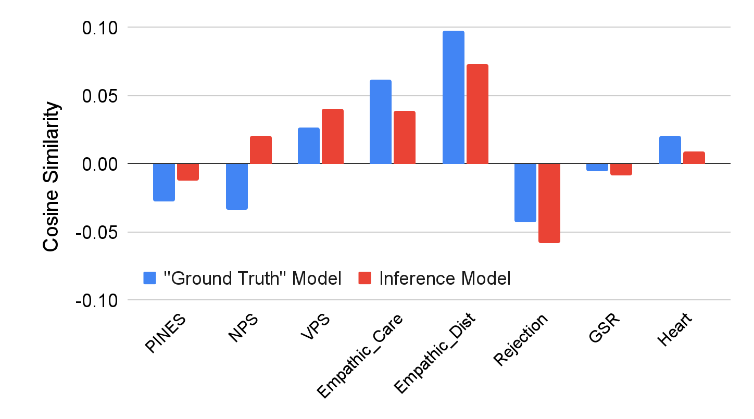Supplementary Figure 5. Similarity of “ground truth” and inference models to other neural patterns predictive of emotion
Cosine similarity was calculated between our models’ pattern weights and eight published models of various components of emotion (the Picture Induced Negative Emotion Signature (PINES; Chang et al., 2015), the Neurologic Pain Signature (NPS; Wager et al., 2013), the Vicarious Pain Signature (VPS; Krishnan et al., 2016), Empathic Care & Empathic Distress (Ashar et al., 2016), Social Rejection (Woo et al., 2014), Galvanic Skin Response (GSR; Eisenbarth, Chang, & Wager, 2016), and Heart Rate (Heart; Eisenbarth, Chang, & Wager, 2016). Cosine similarity is plotted on the y-axis. Cosine similarity ranges from -1 to 1, where values closer to 0 mean the two vectors are orthogonal or perpendicular to each other. When the value is closer to 1, it means the angle is smaller and images more similar. When the value is closer to -1, it means the images are more opposite. Our models are dissimilar to social rejection (viewing an ex-romantic partner); emotion-related physiology (GSR and Heart Rate); and PINES. Our models are most similar to models of vicarious pain as well as empathic care and distress. The empathic care and distress models are the only other ones in this plot that use naturalistic stimuli, but its stimuli are auditory-only.

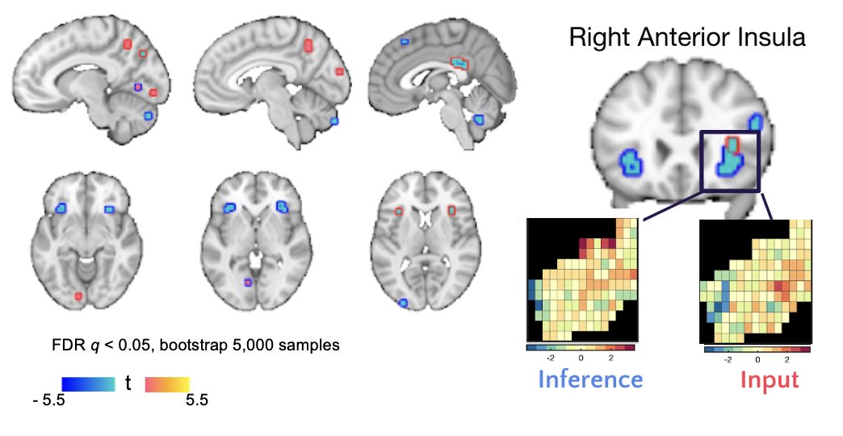

Supplementary Figure 6. “Ground truth” and inference brain patterns overlap in the anterior insula
After thresholding, the only brain region with shared predictive significance in the two models was the right anterior insula, but voxel-wise patterns in the bilateral insular cortex (Harvard Oxford Atlas) were unique (cosine similarity = 0.22).

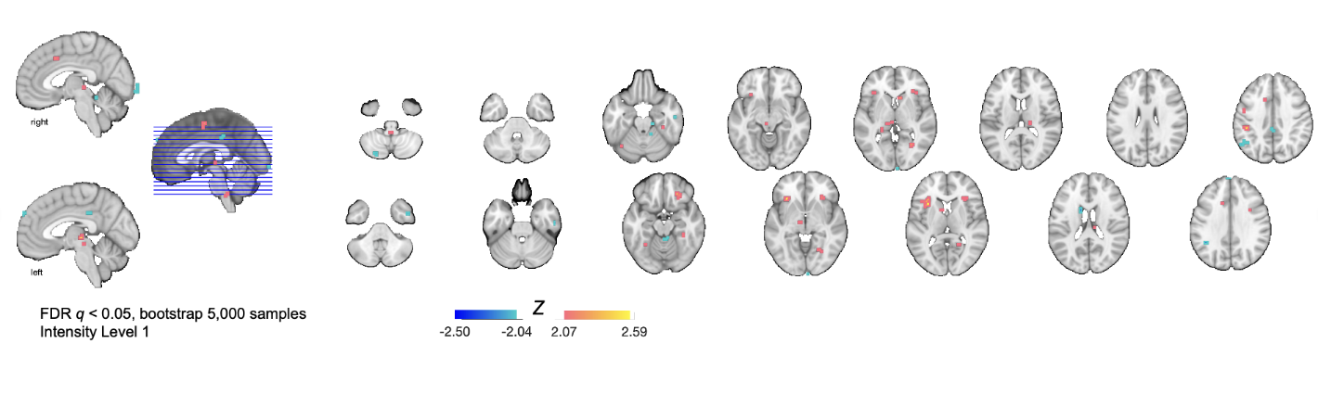Supplementary Figure 7. Beta map of the separability of “ground truth” and inference at the lowest level of intensity
We trained a binary linear SVM to separate subject-level “ground truth” and inference beta maps at each of the five levels of rating intensity (see Figure 4). To better understand the brain regions that distinguish between “ground truth” and inference, the predictive voxel weights for the classifications at Level 1 (Low Intensity) were bootstrapped (5,000 samples) and thresholded (FDR q < 0.05). These regions include the precuneus, bilateral anterior insula, and thalamus. See Figure 5B for the voxel weights at Level 5 (High Intensity).

 |  | MNI Coordinates
 | Region | X | Y | Z | # voxels |  | mm3 | max stat
 | Limbic Lobe
L | Posterior Cingulate Cortex | 0 | -33 | 26 | 17 |  | 415 | -6
L | Midcingulate Cortex | -3 | -22 | 29 | 1 |  | 24 | -4.34
 | Occipital Lobe
L | Calcarine Sulcus | -9 | -86 | -5 | 1 |  | 24 | 4.68
L | Cuneus | -6 | -91 | 18 | 1 |  | 24 | 4.23
R | Cuneus | 11 | -68 | 35 | 1 |  | 24 | -4.71
R | Cuneus | -74 | 44 | 1 | 1 |  | 24 | -4.31
 | Frontal Lobe
L | Inferior Frontal Gyrus | -38 | 45 | 12 | 1 |  | 24 | -4.22
R | Inferior Frontal Gyrus | 35 | 25 | 9 | 3 |  | 73 | -4.54
R | Superior Frontal Gyrus | 23 | 7 | 55 | 1 |  | 24 | 4.29
R | Superior Frontal Gyrus | 26 | 33 | 50 | 1 |  | 24 | 4.22
R | Middle Frontal Gyrus | 49 | 33 | 24 | 2 |  | 49 | -4.70
 | Parietal Lobe
L | Precuneus | -15 | -65 | 32 | 1 |  | 24 | -4.26
 |  | -9 | -74 | 38 | 1 |  | 24 | -4.98
 |  | -6 | -57 | 47 | 7 |  | 171 | 4.84
 |  | -12 | -62 | 58 | 1 |  | 24 | 4.48
R | Precuneus | 6 | -62 | 41 | 1 |  | 24 | 4.22
R | Angular Gyrus | 43 | -59 | 29 | 1 |  | 24 | 4.82
 |  | 35 | -57 | 47 | 3 |  | 73 | -4.88
R | Superior Parietal Lobule | 14 | -59 | 64 | 1 |  | 24 | 4.22
 | Insular Cortex
L | Anterior Insula | -32 | 22 | 9 | 1 |  | 24 | -4.20
R | Anterior Insula | 40 | 22 | 3 | 1 |  | 24 | -4.47
FDR corrected q < 0.05; k > 1
Supplementary Table 1. Brian regions that predict the target’s “ground truth” ratings

 |  | MNI Coordinates
 | Region | X | Y | Z | # voxels |  | mm3 | max stat
 | Cerebellum
L | Crus II | -9 | -80 | -32 | 2 |  | 49 | -4.73
R | Vermis V. IX | 0 | -57 | -34 | 10 |  | 244 | -5.13
R | Crus I | 37 | -51 | -32 | 1 |  | 24 | -4.56
 | Occipital Lobe
L | Lingual Gyrus | -9 | -68 | 0 | 1 |  | 24 | 4.66
R | Lingual Gyrus | 8 | -74 | 3 | 2 |  | 49 | 4.33
 |  | 6 | -42 | 6 | 1 |  | 24 | -4.13
L | Middle Occipital Gyrus | -26 | -94 | 9 | 1 |  | 24 | -4.29
R | Middle Occipital Gyrus | 29 | -91 | 12 | 1 |  | 24 | -4.32
R | Superior Occipital Gyrus | 8 | -100 | 18 | 2 |  | 49 | -4.76
 | Frontal Lobe
L | Superior Medial Frontal Gyrus | -3 | 54 | 38 | 1 |  | 24 | 4.14
R | Inferior Frontal Gyrus | 52 | 25 | 26 | 2 |  | 49 | -4.34
R | Superior Medial Frontal Gyrus | 3 | 28 | 53 | 1 |  | 24 | -4.13
 | Temporal Lobe
L | Inferior Temporal Gyrus/ Temporal Pole | -44 | -4 | -43 | 2 |  | 49 | 4.84
R | Inferior Temporal Gyrus/ Temporal Pole | 46 | 1 | -37 | 1 |  | 24 | 4.38
 | Parietal Lobe
L | Precuneus | 0 | -54 | 18 | 1 |  | 24 | -4.14
R | Postcentral Gyrus/S1 | 46 | -16 | 53 | 1 |  | 24 | 4.41
 | Insular Cortex
L | Anterior Insula | -32 | 28 | 0 | 13 |  | 317 | -5.56
 |  | -32 | 22 | 9 | 1 |  | 24 | -4.22
R | Anterior Insula | 32 | 28 | 3 | 19 |  | 463 | -6.66
FDR corrected q < 0.05; k > 1
Supplementary Table 2. Brian regions from that predict an observer’s socioemotional inference ratings

