Evidence for small-scale segmented fault rupture along the East Anatolian Fault during the Mw 7.8 2023 Kahramanmaras earthquake

Supplementary Material

Mauro Palo^{1,*} and Aldo Zollo¹

¹ Physics Department, University of Naples Federico II, Italy

*Corresponding author (mauro.palo@unina.it)

Figure S1. On the top, the three ground motion components at one station are shown (blue, red, green show respectively Z, NS, EW). Signals are filtered in 0.1-10 Hz. Polarization time window was fixed at 10 s with overlap of 1 s at each step. On the bottom, the time history of the polarization azimuths is shown. Dotted line displays the theoretical azimuth given the positions of stations and epicenter. Zero on the time scale marks the origin time. Blue and red stars correspond respectively to the manually picked P arrival and the expected S arrival, respectively.

Figure S2. Mean azimuth error (in degrees) averaged over the stations at the P onset using as potential radiating sources the points of a grid with spacing of 0.1° (i.e. sources are not constrained on the fault). Polarization azimuths were calculated on seismograms filtered in the frequency band 0.1-10 Hz in a time window of 10 seconds centered on the P onset. The star marks the epicenter, the diamond shows the minimum of the error function. The minimum of the error function is correctly identified for a source located at the epicenter.

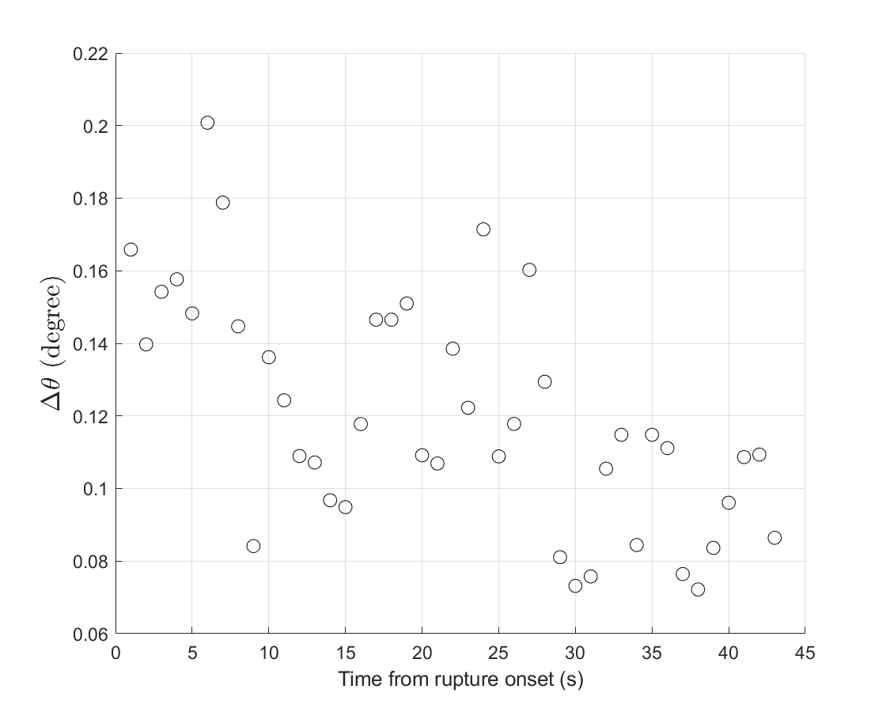
Figure S3. Each point in this graph has been calculated as follows: at each time and for each station a fault point has been selected as the point of the fault that minimizes the difference between observed polarization azimuth and the azimuth between the fault point and the station. For each time then, this difference has been averaged over the stations, and these mean values are here plotted.
Figure S4. Mean error of the inferred position of the radiating point at each time inferred from azimuth polarization. As described in the Methods of the main text, error increases over time as stations closer to the epicenter are discarded once they are reached by the S waves.

