Additional File 1

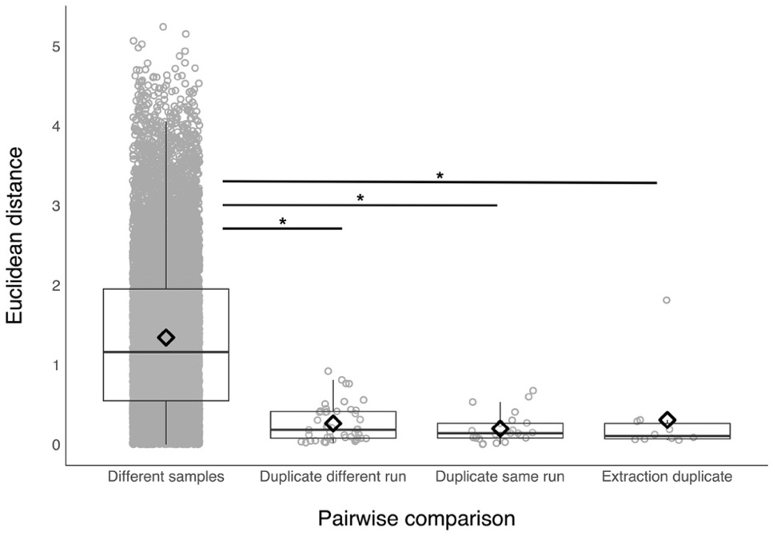
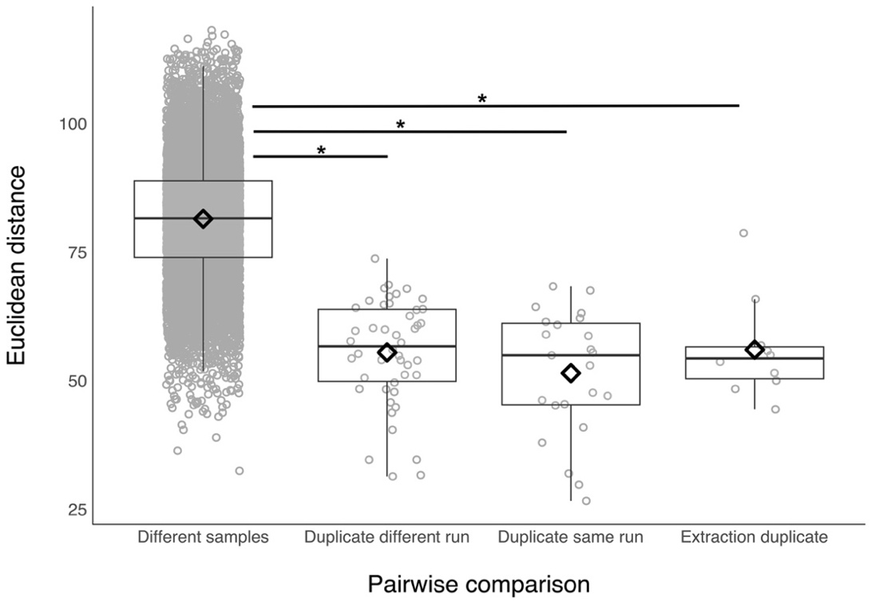
A
B

Figure S1. The similarity of A) Shannon diversity, and B) beta diversity across repeat samples in adult Seychelles warblers (i.e. those >1 year of age). Pairwise Euclidean distances were calculated between replicates of the same DNA sample that was sequenced twice across different sequencing runs (“Duplicate different run”, N=46 samples) or within the same run (“Duplicate same run”, N=23). There were also 10 samples for which DNA was extracted twice (“Extraction duplicate”). These were compared to all pairwise combinations of the duplicated samples (“Different samples”). Boxes span the interquartile (25%-75%) range. The median is marked by a horizontal line and the mean is marked by a diamond. Whiskers extend to 1.5 times the interquartile range. * indicates significant differences P_{adj}<0.05 in a Dunn’s multiple comparison test.

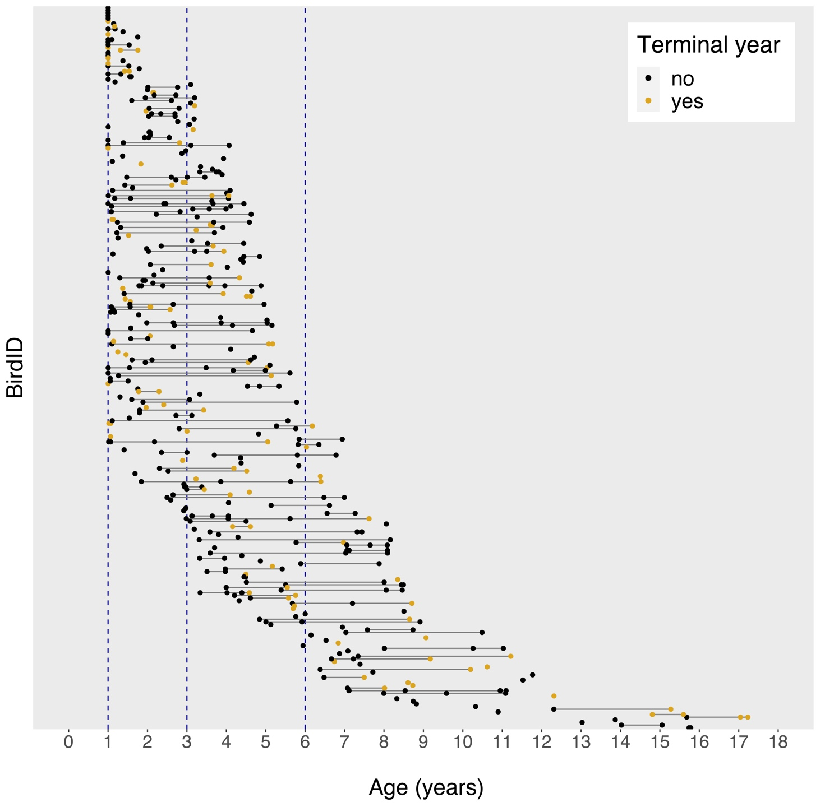

Figure S2. Study sampling distribution; 462 samples were collected from 273 unique adult Seychelles warblers (those >1 year of age) between 2017 and 2022. Solid black lines connect longitudinal samples collected from the same individual at different ages. Points are coloured according to whether samples were taken in the terminal year of life (yellow) or not (black). Vertical dashed lines represent different age categories used in certain analyses: young adults (1-3 years), N=192 samples; middle aged adults (3-6 years), N=172 samples; old, senescent adults (>6 years), N=98 samples.

Table S1. A Generalised Additive Mixed Model (GAMM) investigating variation in gut microbiome Shannon diversity according to age and terminal year in adult Seychelles warblers (N=462 samples, 273 individuals). Significant (P<0.05) predictors are shown in bold. Reference categories for categorical variables were as follows: female (sex), major (season), yes (terminal year). The adjusted R²=0.06.

Predictor | Estimate | SE | t | P
Intercept | 3.083 | 0.077 | 40.049 | <0.001
Sex (male) | -0.128 | 0.081 | -1.576 | 0.116
Season (minor) | -0.145 | 0.123 | -1.179 | 0.239
Mean territory quality | -0.201 | 0.112 | -1.788 | 0.074
Mean-centred territory quality | -0.054 | 0.113 | -0.475 | 0.635
Terminal year (no) | -0.042 | 0.095 | -0.446 | 0.656
Smoothed terms | edf | F | P
Age | 1.000 | 1.163 | 0.281
Time of day | 1.000 | 1.649 | 0.200
Time at 4°C | 1.000 | 13.226 | <0.001
Random | 462 observations |  | variance
Bird ID | 273 individuals |  | 0.189

Table S2. A Generalised Additive Mixed Model (GAMM) investigating the relationship between age, terminal year and observed ASV richness in the gut microbiome of adult Seychelles warblers (N=462 sample, 273 individuals). This model includes all interaction terms; where not significant, these were removed sequentially (in order of least significance) to enable interpretation of the main effects (see Table 1 for results). Significant (P<0.05) predictors are shown in bold. Reference categories for categorical variables were as follows: female (sex), major (season), and yes (terminal year). Adjusted R²=0.04.

Predictor | Estimate | SE | z | P
Intercept | 5.195 | 0.044 | 117.985 | <0.001
Sex (male) | -0.110 | 0.047 | -2.366 | 0.018
Season (minor) | -0.045 | 0.070 | -1.645 | 0.519
Mean territory quality | -0.120 | 0.064 | -1.860 | 0.063
Mean-centred territory quality | -0.075 | 0.065 | -1.157 | 0.247
Terminal year (no) | 0.027 | 0.054 | 0.491 | 0.623
Smoothed terms | edf | χ² | P
Age | 1.001 | 1.934 | 0.165
Age*Terminal year | 1.000 | 0.884 | 0.347
Age*Sex | 1.003 | 0.032 | 0.865
Time of day | 1.657 | 2.189 | 0.345
Time at 4°C | 1.001 | 2.130 | 0.145
Random | 462 observations |  | variance
Bird ID | 273 individuals |  | 0.119

Table S3. A Generalised Additive Mixed Model (GAMM) investigating the relationship between age, terminal year, and Shannon diversity in the gut microbiome of adult Seychelles warblers (N=462 sample, 273 individuals). This model includes all interaction terms; where not significant, these were removed sequentially (in order of least significance) to enable interpretation of the main effects (see Table S1 for results). Significant (P<0.05) predictors are shown in bold. Reference categories for categorical variables were as follows: female (sex), major (season), and yes (terminal year). Adjusted R²=0.06.

Predictor | Estimate | SE | t | P
Intercept | 3.090 | 0.077 | 39.997 | <0.001
Sex (male) | -0.136 | 0.082 | -1.661 | 0.097
Season (minor) | -0.136 | 0.123 | -1.104 | 0.270
Mean territory quality | -0.192 | 0.112 | -1.710 | 0.088
Mean-centred territory quality | -0.050 | 0.113 | -0.446 | 0.656
Terminal year (no) | 0.031 | 0.095 | 0.326 | 0.744
Smoothed terms | edf | F | P
Age | 1.000 | 2.355 | 0.126
Age*Terminal year | 1.000 | 2.440 | 0.119
Age*Sex | 1.000 | 0.045 | 0.832
Time of day | 1.000 | 1.451 | 0.229
Time at 4°C | 1.000 | 12.757 | <0.001
Random | 462 observations |  | variance
Bird ID | 273 individuals |  | 0.220

Table S4. Results of a PERMANOVA analysis investigating the association between age, terminal year, and gut microbiome composition in adult Seychelles warblers. The analysis was performed using Aitchison distances calculated using centred log ratio (CLR)‑transformed amplicon sequencing variant (ASV) abundances. Significant predictors (P<0.05) are shown in bold. The analysis included 462 samples from 273 individuals. Bird ID was included as blocking factor to control for repeated measures. This model includes all interaction terms; where not significant, these were removed sequentially (in order of least significance) to enable interpretation of the main effects (see Table 2 for results).

Predictor | Df | R² | F | P
Age*Terminal year | 1 | 0.002 | 1.112 | 0.288
Sex*Terminal year | 1 | 0.002 | 0.905 | 0.873
Mean centred territory quality | 1 | 0.003 | 1.395 | 0.593
Mean territory quality | 1 | 0.006 | 2.646 | <0.001
Season | 1 | 0.008 | 3.968 | <0.001
Time of day | 1 | 0.008 | 3.670 | <0.001
Time at 4°C | 1 | 0.007 | 3.101 | 0.005

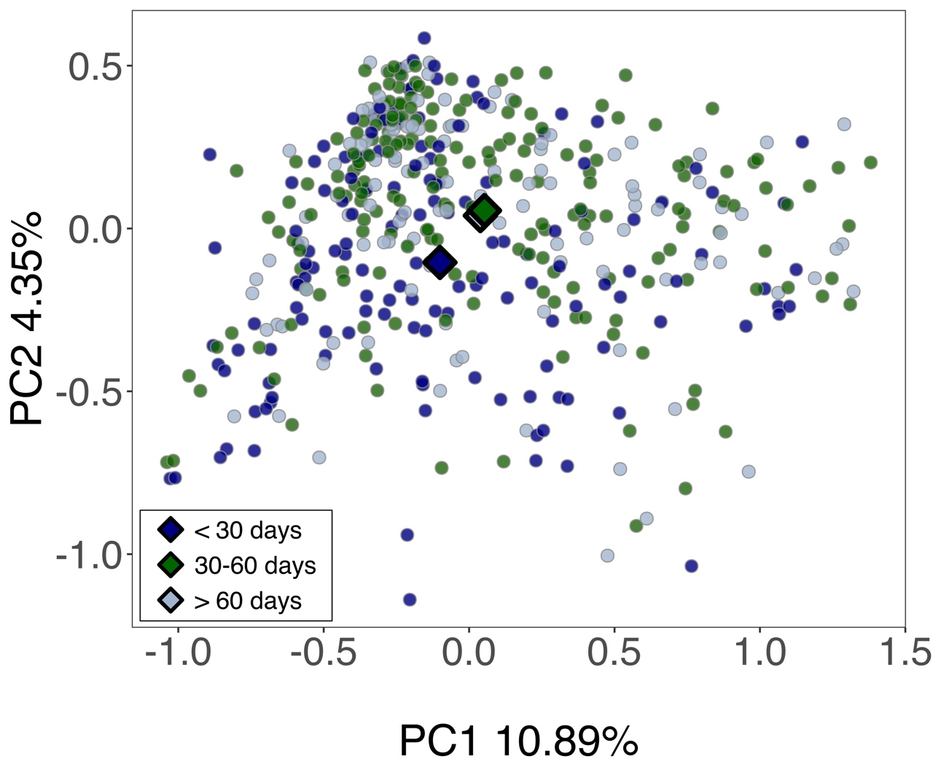

Figure S3. Shifts in gut microbiome composition according to the number of days samples were stored at 4°C in the field. PCA ordination was carried out using Aitchison distances calculated on Centred Log Ratio (CLR)‑transformed amplicon sequencing variant (ASV) abundances. Each point represents a unique gut microbiome sample (N = 462 samples from 273 individuals). Large diamonds represent the group centroids. For clarity, samples were grouped into discrete categories (<30 days, 30-60 days, or >60 days) for plotting. Principal components 1 and 2 explained 10.9% and 4.4% of variation in gut microbiome structure, respectively.

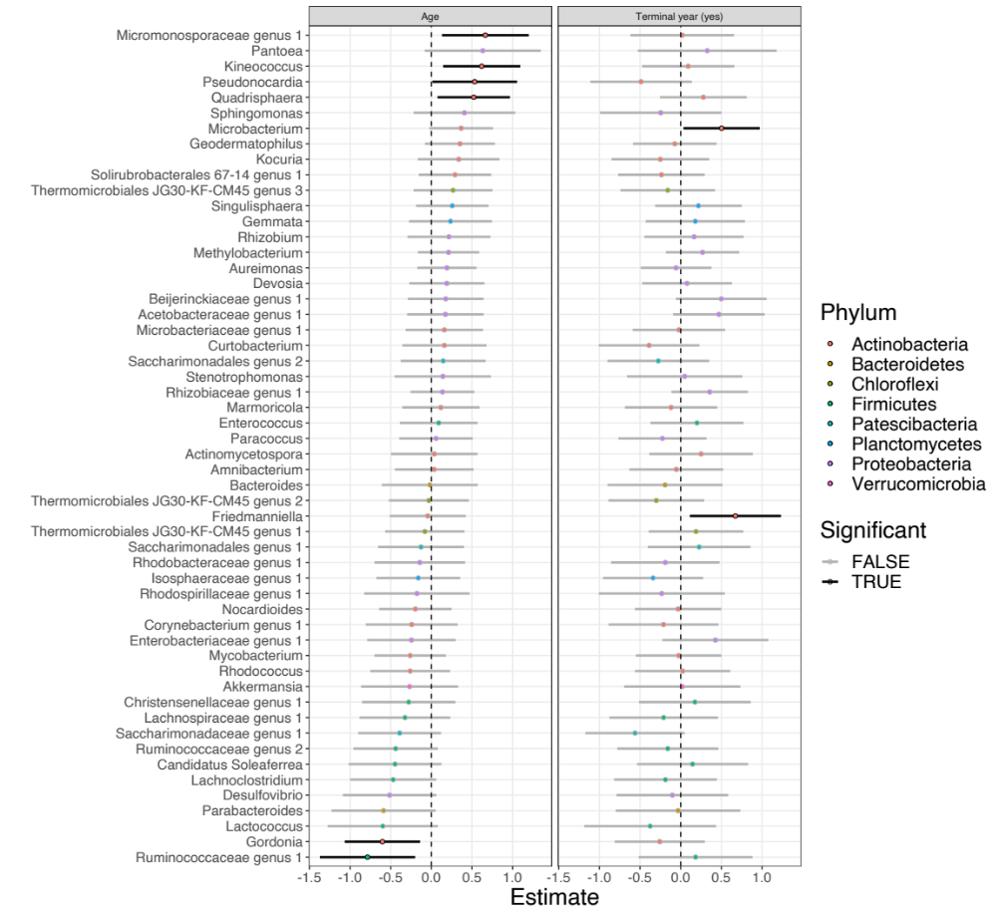

Figure S4. Changes in the abundance of core genera in association with age and terminal year in adult Seychelles warblers. Core genera were defined as those found in at least 50% of adults. Points and bars represent estimates and 95% confidence intervals generated from a Generalised Linear Latent Variable Model (GLLVM). Points are ordered according to genus and coloured according to phylum. Bars are coloured according to significance (True: P<0.05 in GLLVM model). N=462 samples from 273 adult warblers were included in this analysis. Other environmental and host variables (Figure S5) were also controlled for in the GLLVM analysis.

Table S5. Changes in the abundance of six core genera (A-F) with host age, controlling for other host and environmental factors. These genera were significantly associated with host age in GLLVM models (Figure S4). The abundance of each genus was modelled using a Generalised Additive Mixed Model (GAMM). Abundances were Centred Log Ratio (CLR) transformed to control for the compositionality of the dataset. The analysis included 462 samples from 273 adult individuals. Significant (P<0.05) predictors are shown in bold. Reference categories for categorical variables were as follows: female (sex), major (season), yes (terminal year).

A) Kineococcus
Predictor | Estimate | SE | t | P
Intercept | -1.091 | 0.214 | -5.092 | <0.001
Sex (male) | 0.092 | 0.258 | 0.356 | 0.722
Season (minor) | -0.194 | 0.266 | -0.729 | 0.467
Mean-centred territory quality | 0.059 | 0.246 | 0.241 | 0.810
Mean territory quality | 0.314 | 0.245 | 1.277 | 0.202
Terminal year (no) | 0.149 | 0.293 | 0.509 | 0.611
Smoothed terms | edf | F | P
Age | 1.000 | 5.361 | 0.021
Time of day | 2.297 | 4.929 | 0.003
Time at 4°C | 1.000 | 1.222 | 0.270
B) Pseudonocardia
Predictor | Estimate | SE | t | P
Intercept | 0.911 | 0.228 | 3.977 | <0.001
Sex (male) | 0.262 | 0.273 | 0.960 | 0.338
Season (minor) | -0.814 | 0.296 | -2.747 | 0.006
Mean-centred territory quality | -0.422 | 0.270 | -1.560 | 0.119
Mean territory quality | -0.363 | 0.269 | -1.350 | 0.178
Terminal year (no) | -0.489 | 0.322 | -1.521 | 0.129
Smoothed terms | edf | F | P
Age | 1.000 | 3.879 | 0.050
Time of day | 1.000 | 3.063 | 0.081
Time at 4°C | 1.000 | 1.835 | 0.176
C) Quadrisphaera
Predictor | Estimate | SE | t | P
Intercept | 0.115 | 0.194 | 0.593 | 0.554
Sex (male) | -0.074 | 0.232 | -0.321 | 0.748
Season (minor) | -0.571 | 0.253 | -2.259 | 0.024
Mean-centred territory quality | 0.421 | 0.230 | 1.830 | 0.068
Mean territory quality | 0.149 | 0.231 | 0.647 | 0.518
Terminal year (no) | 0.282 | 0.273 | 1.035 | 0.301
Smoothed terms | edf | F | P
Age | 1.000 | 4.678 | 0.031
Time of day | 2.269 | 5.172 | 0.002
Time at 4°C | 1.000 | 3.162 | 0.076
D) Micromonosporaceae genus
Predictor | Estimate | SE | t | P
Intercept | -1.142 | 0.232 | -4.923 | <0.001
Sex (male) | -0.080 | 0.277 | -0.288 | 0.773
Season (minor) | -0.392 | 0.303 | -1.295 | 0.196
Δ territory quality | -0.347 | 0.275 | -1.263 | 0.207
Mean territory quality | 0.162 | 0.277 | 0.586 | 0.558
Terminal year (no) | -0.030 | 0.327 | -0.091 | 0.928
Smoothed terms | Edf | F | P
Age | 1.000 | 6.035 | 0.014
Time of day | 3.218 | 1.665 | 0.158
Time at 4°C | 1.000 | 0.031 | 0.860
E) Ruminococcaceae genus
Predictor | Estimate | SE | t | P
Intercept | 0.133 | 0.262 | 0.508 | 0.612
Sex (male) | -0.230 | 0.315 | -0.729 | 0.466
Season (minor) | 1.004 | 0.330 | 3.044 | 0.002
Δ territory quality | 0.165 | 0.303 | 0.544 | 0.587
Mean territory quality | 0.027 | 0.303 | 0.091 | 0.928
Terminal year (no) | 0.210 | 0.360 | 0.584 | 0.560
Smoothed terms
Age | 1.317 | 3.402 | 0.031
Time of day | 3.258 | 2.004 | 0.092
Time at 4°C | 1.392 | 5.080 | 0.024
F) Gordonia
Predictor | Estimate | SE | t | P
Intercept | 0.648 | 0.202 | 3.213 | 0.001
Sex (male) | -0.075 | 0.241 | -0.311 | 0.756
Season (minor) | -0.399 | 0.263 | -1.518 | 0.130
Δ territory quality | -0.253 | 0.239 | -1.058 | 0.291
Mean territory quality | -1.177 | 0.240 | -4.903 | <0.001
Terminal year (no) | -0.251 | 0.284 | -0.884 | 0.377
Smoothed terms | edf | F | P
Age | 1.000 | 6.999 | 0.008
Time of day | 2.217 | 2.355 | 0.062
Time at 4°C | 1.000 | 4.309 | 0.038

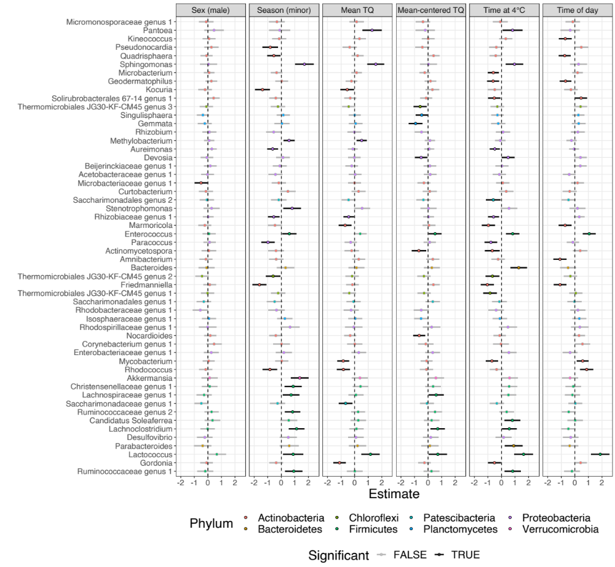

Figure S5. Changes in the abundance of core genera in association with host and environmental variables in adult Seychelles warblers. Core genera were defined as those found in at least 50% of adults. Points and bars represent estimates and 95% confidence intervals generated from a Generalised Linear Latent Variable Model (GLLVM). Points are ordered according to genus and coloured according to phylum. Bars are coloured according to significance (True: P < 0.05). N=462 samples from 273 adult warblers were included in this analysis. Age and terminal year were also included in the same GLLVM (results show in Figure S4).

Table S6. Results of a Bayesian dyadic model testing for the effect of age group and terminal year on gut microbiome similarity between individuals. Pairwise comparisons were made between samples taken from different individuals within the same age group, whereby YY = young adult sample comparisons (individuals 1-3 yrs) and MM = middle aged adult comparisons (3-6 years). Old adult sample comparisons (OO, individuals >6 years) were used as a reference. The terminal comparison term indicates whether pairwise comparisons were made between a non-terminal sample and a sample taken in a bird’s terminal year (NT), or between two terminal year samples (TT). NN (two non-terminal year samples) was used a reference. Sex similarity (same sex or different sex) and temporal distance were also included as fixed effects in the model. A multi-membership random effect (mm(IDAIDB)) indicating the sample IDs in each pairwise comparison was also included in the model. N=4867 pairwise comparisons involving 273 samples were included in the model. Estimate error is the standard deviation of the posterior distribution. Significant terms (where the lower and upper 95% credible intervals don’t span zero) are indicated in bold.

Predictor | Estimate | Estimate error | Lower 95% CI | Upper 95% CI
Intercept | -0.536 | 0.085 | -0.706 | -0.371
Age group
MM | -0.041 | 0.102 | -0.237 | 0.166
YY | -0.109 | 0.096 | -0.290 | 0.083
Sex similarity | -0.002 | 0.006 | -0.014 | 0.008
Terminal comparison
NT | 0.002 | 0.042 | -0.086 | 0.080
TT | 0.022 | 0.084 | -0.143 | 0.184
Temporal distance | -0.045 | 0.009 | -0.063 | -0.026
Random term
mm(IDAIDB) | 0.600 | 0.027 | 0.550 | 0.656

Table S7. Results of a Bayesian dyadic model testing for the effect of age group on microbiome similarity within individuals. Each sample was compared to other samples taken from the same individual within the same age group. The categories “YY” and “MM” represent comparisons between samples taken when individuals were young (1-3 years) or middle aged (3-6 years) adults, respectively. The old adult category (OO- comparisons of samples from when individuals were >6 years) was used a reference. N=155 pairwise comparisons involving 227 samples were included in the model (56 comparisons=YY; 58=MM; 41=OO). Estimate error is the standard deviation of the posterior distribution. Significant terms (where the lower and upper 95% credible intervals don’t span zero) are indicated in bold. A multi-membership random effect (mm(IDAIDB)) indicating the sample IDs in each pairwise comparison was also included in the model.

Predictor | Estimate | Estimate error | Lower 95% CI | Upper 95% CI
Intercept | -0.394 | 0.097 | -0.583 | -0.204
Age group
MM | -0.022 | 0.102 | -0.219 | 0.176
YY | -0.078 | 0.103 | -0.277 | 0.122
Temporal distance | -0.423 | 0.173 | -0.764 | -0.087
Random term
mm(IDAIDB) | 0.457 | 0.057 | 0.340 | 0.565

