Standards | Catalog number
2­Arachidonoyl Glycerol­d5 | 362162
2­Arachidonoyl Glycerol­d8 | 362160
Oleoyl Ethanolamide | 90265
Palmitoyl Ethanolamide­d4 | 10007824
Arachidonoyl Ethanolamide­d8 | 390050
Oleoyl Ethanolamide­d4 | 9000552
Arachidonoyl Ethanolamide | 90050
Palmitoleoyl Ethanolamide | 10965
Arachidonoyl Ethanolamide­d4 | 10011178
2­Arachidonoyl Glycerol | 62160

Supplementary Table 1: Deuterated and non-deuterated standards used for mass spectrometry analysis of the ECS ligands in plasma and tissues.

Instrumentation | LC-MS : QQQ Agilent 6495 coupled with an Infinity 1260 HPLC system
LC Method | Column: CSH C18 2.1x100mm 3.5μm de Waters  Mobile Phase A: 50/50 H2O/ACN +0.4 %FA  Mobile Phase B: 90/10 IPA/ACN +0.4% FA  Gradient: 30% to 45% B in 10min.  Total run time: 20 min  Volume of injection: 10µL
MS Method | ESI positive ionization  MRM Transitions:  AEA à 348.3 -> 62.1  AEA-d4 à 352.0 -> 66.0  OEA à 326.3 -> 62.0  OEA-d4 à 330.3 -> 66.0  PEA à 300.3 -> 62.0  PEA-d4 à 304.3 -> 62.0  2-AG à 379.3 -> 91.0  2-AG d5 à 384.3 -> 91.0

Supplementary Table 2: Experimental conditions for ECS ligand identification through LC-MS.

 | Mass Channel | Antibody Target | Clone | Provider | Dilution
1 | 141Pr | aSMA | polyclone | Abcam | 1:100
2 | 142Nd | CD45R (B220) | RA3-6B2 | Abcam | 1:100
3 | 143Nd | Vimentin | D21H3 | Cell Signaling Technology | 1:200
4 | 144Nd
5 | 145Nd | NK1.1 | E6Y9G | Cell Signaling Technology | 1:50
6 | 146Nd | CD31 | SZ31 | Cedarlane labs | 1:100
7 | 147Sm | CD45 | D3F8Q | Cell Signaling Technology | 1:50
8 | 148Nd | Pan-CK | AE1/AE3 | Standard BioTools | 1:100
9 | 149Sm | CD11b | EPR1344 | Standard BioTools | 1:100
10 | 150Nd | CD19-Biotin | 6OMP31 | ThermoFisher | 1:100
11 | 151Eu | CD44 | E7K2Y | Cell Signaling Technology | 1:100
12 | 152Sm
13 | 153Eu | CD8a | D4W2Z | Cell Signaling Technology | 1:100
14 | 154Sm | CD11c | D1V9Y | Cell Signaling Technology | 1:50
15 | 155Gd
16 | 156Gd | PD-L1 | D5V3B | Cell Signaling Technology | 1:50
17 | 158Gd | FoxP3 | D6O8R | Cell Signaling Technology | 1:50
18 | 159Tb | F4/80 | D2S9R | Cell Signaling Technology | 1:50
19 | 160Gd
20 | 161Dy
21 | 162Dy | CD3e | D4V8L | Cell Signaling Technology | 1:100
22 | 163Dy
23 | 164Dy | CD4 | 4SM95 | ThermoFisher | 1:50
24 | 165Ho | CD68 | EPR23917-164 | Abcam | 1:100
25 | 166Er | Ly6G | 1A8 | Standard BioTools | 1:50
26 | 167Er | PD-1 | polyclonal | Bio-Techne | 1:50
27 | 168Er | Ki67 | B56 | Standard BioTools | 1:100
28 | 169Tm | CD206 | polyclonal | Cell Signaling Technology | 1:100
29 | 170Er | CD3 | CD3-12 | Abcam | 1:50
30 | 171Yb | GranzymB | D6E9W | Cell Signaling Technology | 1:100
31 | 172Yb | cleaved Casp3 | Asp175 | Cell Signaling Technology | 1:100
32 | 173Yb
33 | 174Yb | MHC-II | M5/114.15.2 | Bio-Techne | 1:100
34 | 175Lu | pS6 | N7-548 | Standard BioTools | 1:100
35 | 176Yb | HH3 | D1H2 | Standard BioTools | 1:300

Supplementary Table 3: IMC antibodies used for the current study with their respective dilutions

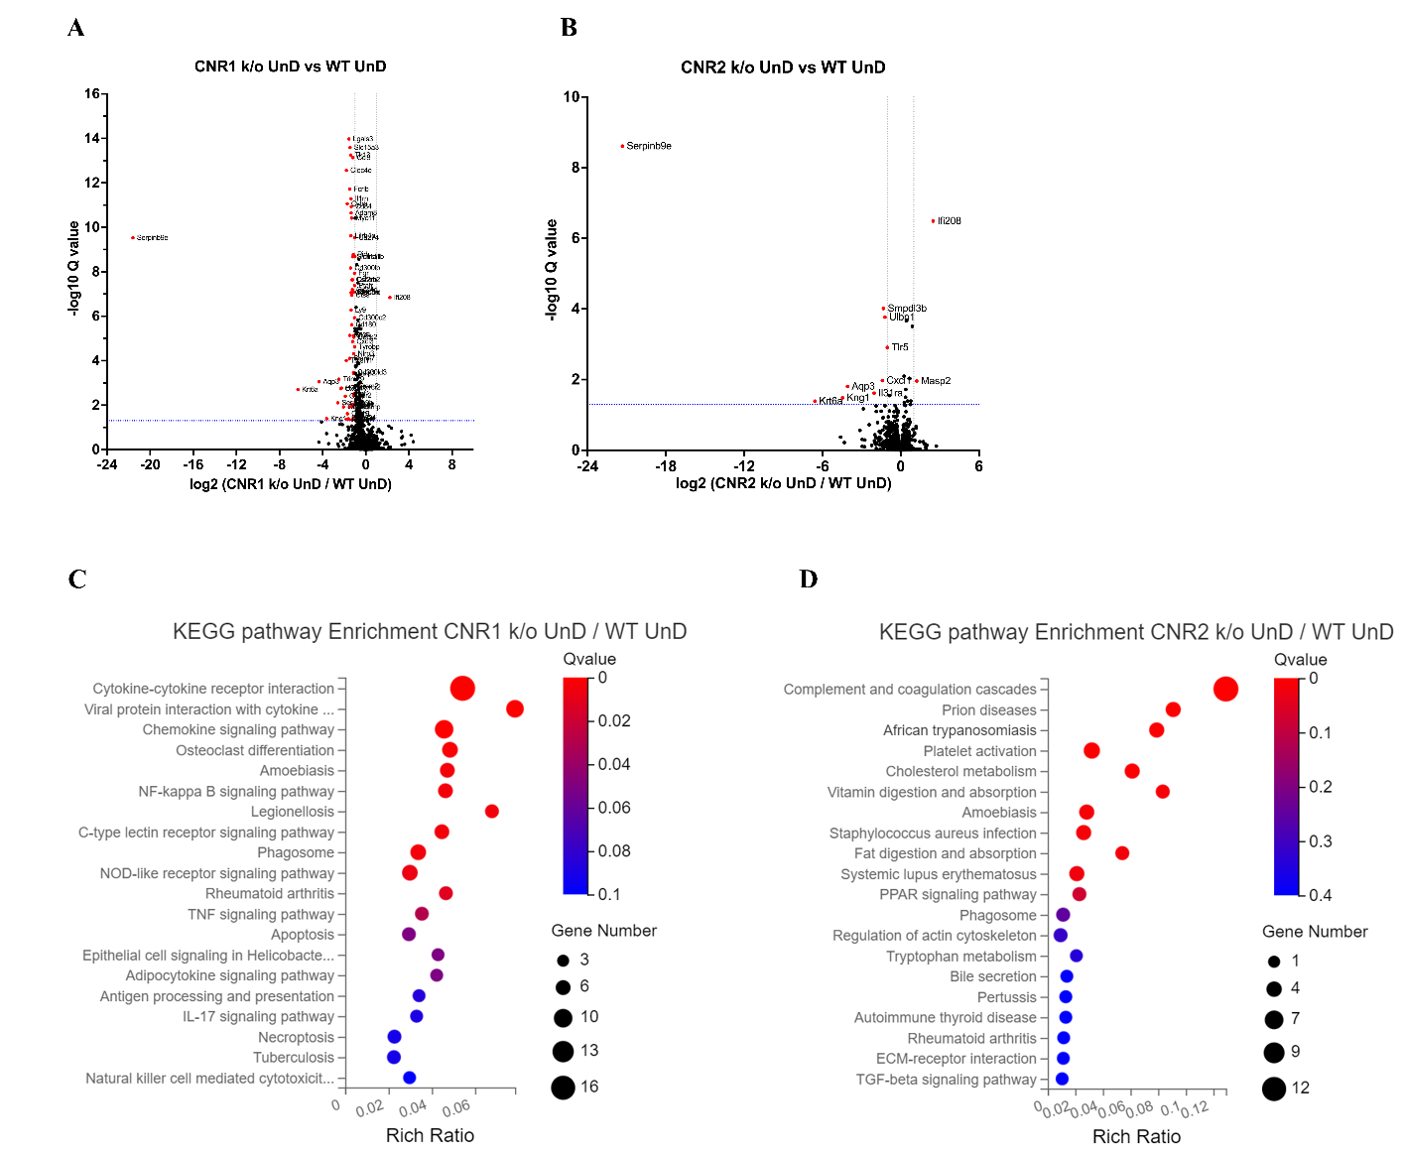
Supplementary Figure 1: DEGs of bulk RNA sequencing between the UnD lesions from CNR1 k/o and CNR2 k/o compared to WT controls.
A, B The volcano plots for DD lesions of CNR1 k/o and CNR2 k/o compared to WT, respectively. Log2 fold change is represented on the x-axis and log10 Q-value (FDR adjusted) as the y-axis. Vertical dotted lines on the x-axis indicate ± 1-fold change and vertical dotted line on the y-axis indicate Q-value of 0.05. C, D KEGG pathway analysis of DEGs of CNR1 k/o UnD lesions and CNR2 k/o UnD lesions compared to WT controls, respectively. Gene Number represents the number of DEGs enriched in the pathway. Rich Ratio shows the ratio of enriched DEGs to background genes and Q-value indicates significance, with a value closer to zero being more significant and is corrected by Benjamini-Hochberg method.

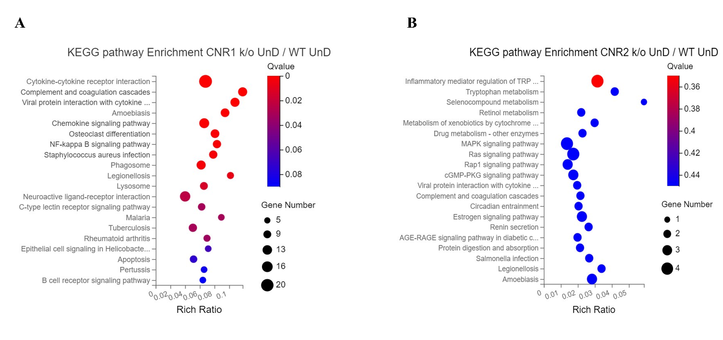
Supplementary Figure 2: KEGG pathway analysis of immune specific DEGs.
A, B Immune specific genes that were differentially expressed were subjected to KEGG pathway analysis between CNR1 k/o UnD lesions and CNR2 k/o UnD lesions compared to WT UnD controls, respectively.

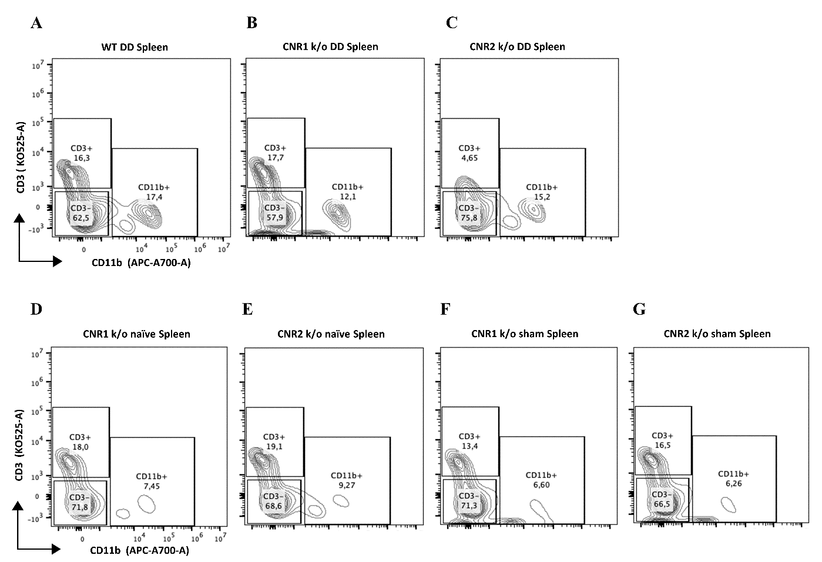
Supplementary Figure 3: Gating panel representing T cells from splenocytes.
A-G, Splenocytes stained for CD3 on the y-axis and CD11b on the x-axis among WT, CNR1 k/o, and CNR2 k/o mice with EM like condition, as well as CNR1 k/o and CNR2 k/o naive and sham-operated controls.
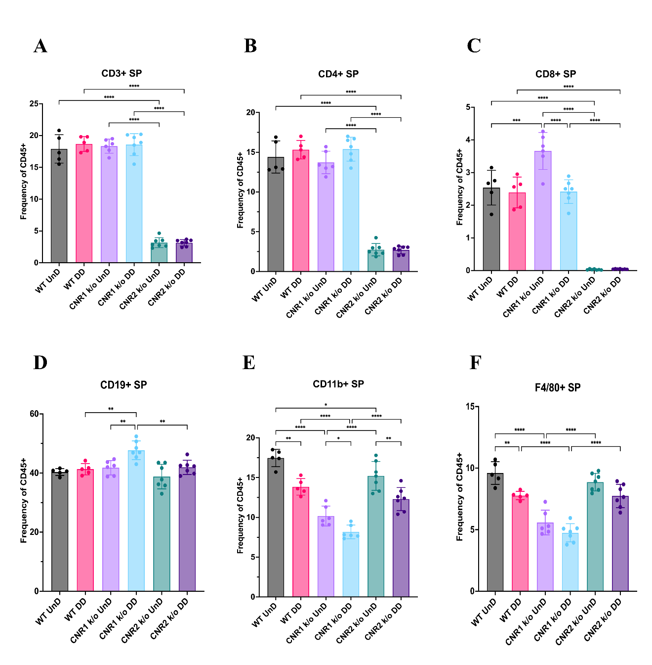
Supplementary Figure 4: Flow cytometry analysis of immune cell phenotypes in the splenocytes of WT, CNR1 k/o and CNR2 k/o mice with EMS.
A-F Bar plot (mean ± SD) representation of splenocytes (SP) stained for CD3+ total T cells, CD4+ helper T cells, CD8+ cytotoxic T cells, CD19+ B cells, CD11b+ monocytes and F4/80 monocytes/macrophages of all the genotypes with EM lesions, respectively. n = 5-7 individual biological samples per genotype. Statistical analyses were performed using the ordinary one-way ANOVA with Holm-Sidak post hoc test. * p < 0.05, ** p < 0.01, *** p < 0.001 and **** p < 0.0001

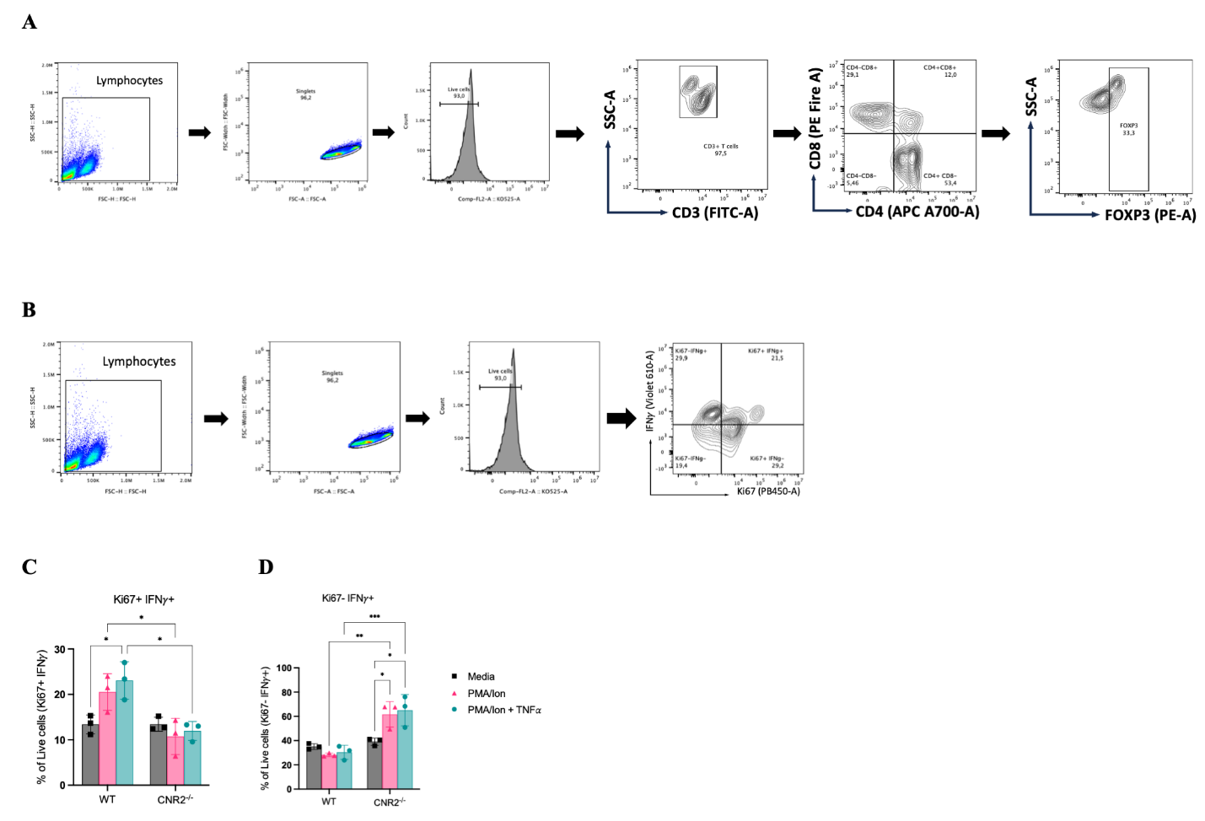
Supplementary Figure 5: In vitro functional assay and flow cytometry evaluation of activated CD3 T cells from naïve WT and CNR2 k/o mice.
A, B Flow cytometry gating strategies for CD3+ T cells to identifiy the different phenotypes and functional state, respectively. C, Bar plots representing the percentage positive live cells that are double positive for proliferation (Ki67) and IFNγ markers. D, Bar plots showing the percentage positive live cells that are negative for Ki67 and positive for IFNγ. Statistical analyses were performed using the ordinary one-way ANOVA with Holm-Sidak post hoc test. * p < 0.05, ** p < 0.01, *** p < 0.001 and **** p < 0.0001. Data presented as mean ± SD.

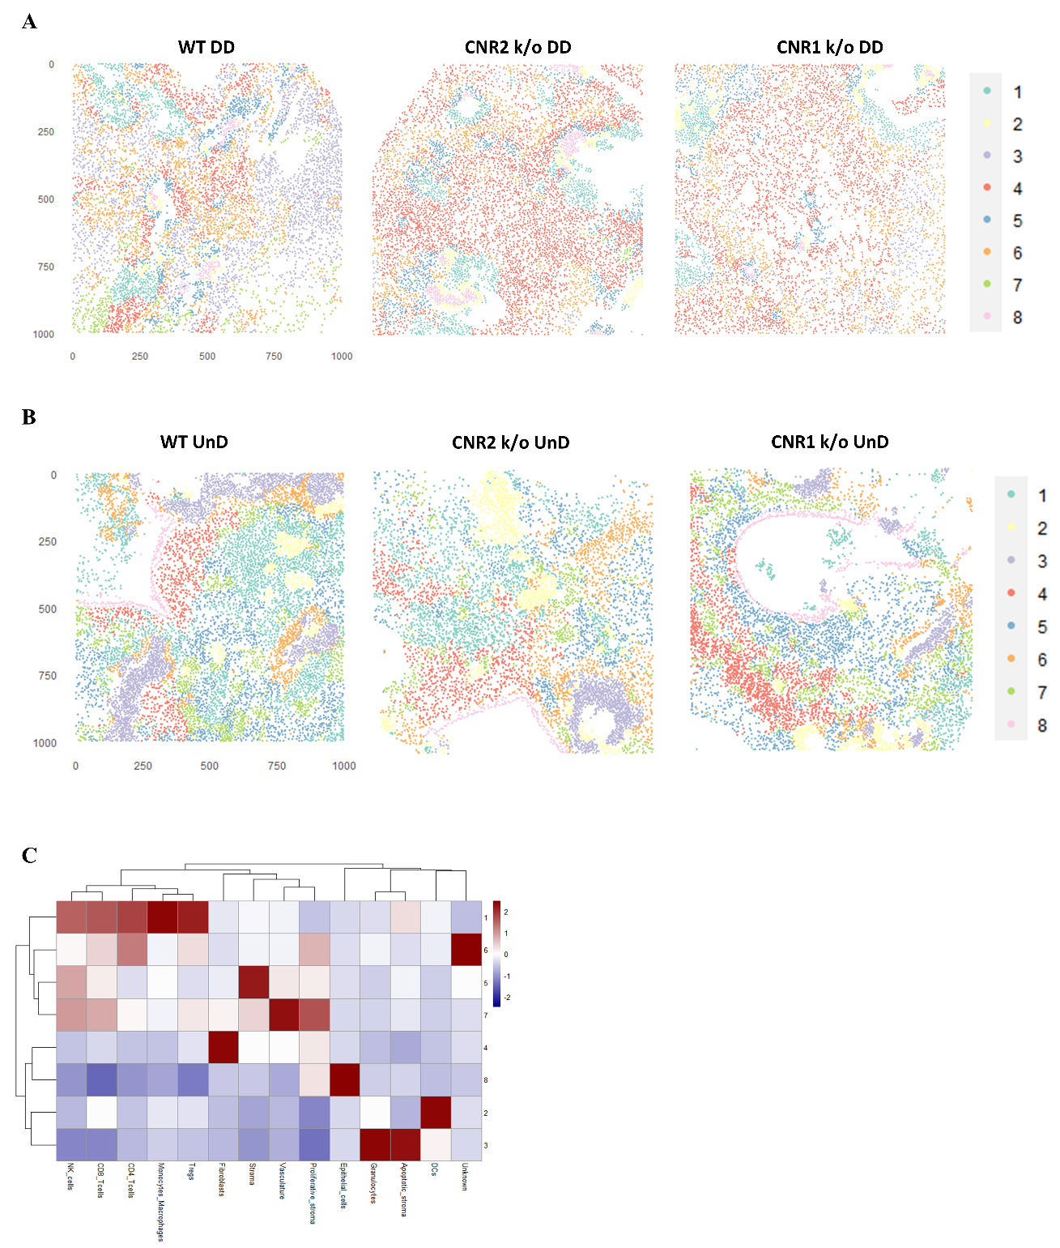
Supplementary Figure 6: IMC and cellular neighbourhoods (CN) in UnD, EMS lesions from CNR1 k/o, CNR2 k/o and WT mice.
A, B Representative image of 8 distinct cell types from CN analysis of DD and UnD lesions from WT, CNR1 k/o, and CNR2 k/o mice, respectively. C Heatmap representation of CN analysis shows distinct clustering patterns observed in the UnD lesions among the different genotypes.

