Selective agents, microbial ecology, and horizontal gene transfer underly microdiversity-level heterogeneity in the fate of resistance genes during biological wastewater treatment

Connor L. Brown¹, Ayella Maile-Moskowitz², Delaney Snead³, Allison J. Lopatkin⁴, Kang Xia⁵, Latania Logan⁶, Benjamin Davis², Liqing Zhang⁷, Peter Vikesland², Amy Pruden²

Dept. of Genetics, Bioinformatics, and Computational Biology, Virginia Tech¹
Dept. of Civil and Environmental Engineering, Virginia Tech²
Dept. of Civil and Environmental, University of Michigan³
Dept. of Chemical Engineering, University of Rochester⁴
Dept. of Plant and Environmental Sciences, Virginia Tech⁵
Dept. of Pediatrics, Emory University⁶
Dept. of Computer Science, Virginia Tech⁷

Contents
Fig S1. Pairwise Bray-Curtis distances between influent and activated sludge (AS) samples using abundances of taxa at different levels of classification. Distances between AS samples only. (B) Distances between influent samples with comparisons in the form of 10% vs. 0%. 2
Fig S2. Pairwise Bray-Curtis distances between influent and AS samples using abundances of taxa at different levels of classification. Distances between influent samples with comparisons in the form of 10% vs. 0%. 2
Fig. S3. Genera of bacteria with significant differences between the 0% AS and 10% AS condition. Wilcox-rank sum test used to compare abundance across 0% (white) and 10% (black) conditions partitioned by whether the samples were taken directly after addition of hospital sewage (Days 1-3) vs. the end of the experiment (Days 5-15). 3
Fig. S4. Phylum-level counts of high- and medium-quality metagenome assembled genomes (MAGs) before dereplication. 4
Fig. S5. Association of antibiotic resistance genes (ARGs) with putative composite mobile genetic elements (MGEs). Counts of resistance genes in terms of their co-occurring mobileOGs with different element classifications. For example, the most frequent association predicted through co-occurrence analysis was with plasmid hallmarks. 4
Fig. S6. Sampling scheme used for Fig. 2. Samples of feed or influent (brown bottles) and AS from reactor 10%-1 (yellow box) were deeply sequenced for use in situ HGT and microdiversity analyses. The 10%-specific contigs are those detected in A (day 6 0% influent/feed) but not B (day 6 10% influent/feed). 5
Fig. S7. Example contexts of sul1 in the 10% or 0% influent samples. Clinker plots generated from a balanced, random sample of contigs bearing sul1 predicted to be either native- or hospital-sewage specific. Interactive html of this plot is available in the online supplementary materials. 5
Fig. S8. Example contexts of genes encoding macrolide phosphotransferase A (mphA) in the 10% or 0% influent samples. Clinker plots generated from a balanced, random sample of contigs bearing mphA predicted to be either native- or hospital-sewage specific. Interactive html of this plot is available in the online supplementary materials. 6
Fig S9. Relative abundance of contigs through read mapping is concordant with the Kairos assess workflow predictions. (A) Summed relative abundances of contigs predicted by Kairos assess (as in Fig. 3) to be innate to the AS microbiome. (B) Summed relative abundances of contigs predicted to be innate to hospital sewage. (C) Summed relative abundances of contigs predicted to be associated with municipal sewage. 7
Fig. S10. Overall structure and properties of hospital- and background municipal-sewage mobile resistance gene networks were similar. (A) Drug classes showed similar rankings in terms of neighborhood connectivity. (B) Individual resistance genes showed similar rankings in hospital sewage vs. native sewage. (C) Hospital sewage lacked many of the phyla associated with background municipal sewage. 7
Fig. S11. Experimental and logic flow diagram for distinguishing fate of hospital and native-sewage resistance genes as in Fig. 4G. “Attenuated” genes are those present in A (day 6 influent/feed) but not B (day 9 influent/feed) or C (AS on the last day of sampling). “Persistent” genes are those present in A and C but not B. 8
Fig. S12. Microdiversity-level disparity in the fate of hospital and native-sewage associated resistance genes. Determined using the Kairos assess workflow and logic described in Fig. S11. Persistent contigs were considered those still detectable after several days of operation. Attenuated contigs were those that were not detected in AS following several days of operation. Native contigs are described as those only detected in AS. 8
Fig. S13. Hosts of the genomes associated with attenuated resistance genes. (A) is partitioned by fraction. (B) is partitioned by date category associated with sampling. ML: mixed liquor or activated sludge. FE: final effluent. FEED: feed or influent sewage. 9
Fig. S14. Hosts of the genomes associated with persistent resistance genes. (A) is partitioned by fraction. (B) is partitioned by date category associated with sampling. ML: mixed liquor or activated sludge. FE: final effluent. FEED: feed or influent sewage. 10
Fig. S15. Putative gene-sharing or HGT network of resistance genes. Nodes are taxa and edges are identical proteins found in contigs found predicted to be derived from those taxa. 11
Fig. S16. Contigs associated with the putative in situ transfer of mphA. Star indicates position of mphA. Interactive html of this plot is available in the online supplementary materials. 12
Fig. S17. Contigs were detected that predicted multiple potential pathways of in situ transfers of sul2. Start indicates position of sul2. Interactive html of this plot is available in the online supplementary materials. 13
Fig. S18. Putative in situ HGT of sul1 contigs. Contigs align against edges meaning that the taxonomic assignment underlying its status as an HGT may be inaccurate and/or uncertain. Interactive html of this plot is available in the online supplementary materials. 13
Fig. S19. Example nanopore read alignment to both Myxococcota and Enterobacterales genomes. The nanopore read here (6de60e4c-c959-472c-93f4-1fe535ef4dd0)encodes mphA as well as phage genes. Alignment details are provided in Extended Data 1. 14
Table S9. Hits to myxophage derived from CP064980.1. 14

Supplementary Information
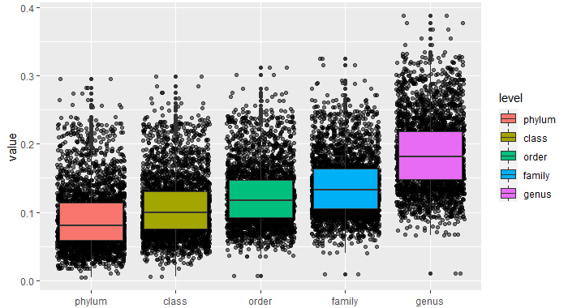

Fig S1. Pairwise Bray-Curtis distances between influent and activated sludge (AS) samples using abundances of taxa at different levels of classification. Distances between AS samples only. (B) Distances between influent samples with comparisons in the form of 10% vs. 0%.

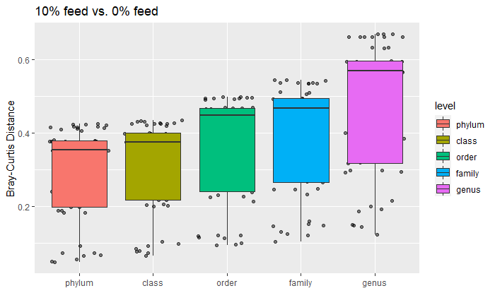

Fig S2. Pairwise Bray-Curtis distances between influent and AS samples using abundances of taxa at different levels of classification. Distances between influent samples with comparisons in the form of 10% vs. 0%.

Fig. S3. Genera of bacteria with significant differences between the 0% AS and 10% AS condition. Wilcox-rank sum test used to compare abundance across 0% (white) and 10% (black) conditions partitioned by whether the samples were taken directly after addition of hospital sewage (Days 1-3) vs. the end of the experiment (Days 5-15).

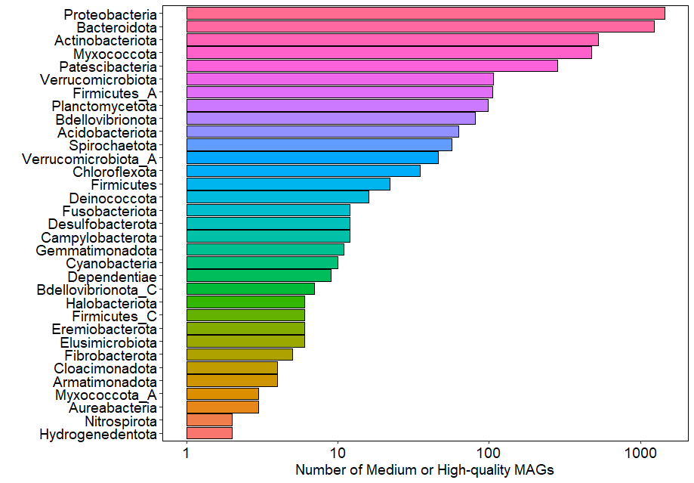

Fig. S4. Phylum-level counts of high- and medium-quality metagenome assembled genomes (MAGs) before dereplication.

Fig. S5. Association of antibiotic resistance genes (ARGs) with putative composite mobile genetic elements (MGEs). Counts of resistance genes in terms of their co-occurring mobileOGs with different element classifications. For example, the most frequent association predicted through co-occurrence analysis was with plasmid hallmarks.

Fig. S6. Sampling scheme used for Fig. 2. Samples of feed or influent (brown bottles) and AS from reactor 10%-1 (yellow box) were deeply sequenced for use in situ HGT and microdiversity analyses. The 10%-specific contigs are those detected in A (day 6 0% influent/feed) but not B (day 6 10% influent/feed).

Fig. S7. Example contexts of sul1 in the 10% or 0% influent samples. Clinker plots generated from a balanced, random sample of contigs bearing sul1 predicted to be either native- or hospital-sewage specific. Interactive html of this plot is available in the online supplementary materials.

Fig. S8. Example contexts of genes encoding macrolide phosphotransferase A (mphA) in the 10% or 0% influent samples. Clinker plots generated from a balanced, random sample of contigs bearing mphA predicted to be either native- or hospital-sewage specific. Interactive html of this plot is available in the online supplementary materials.
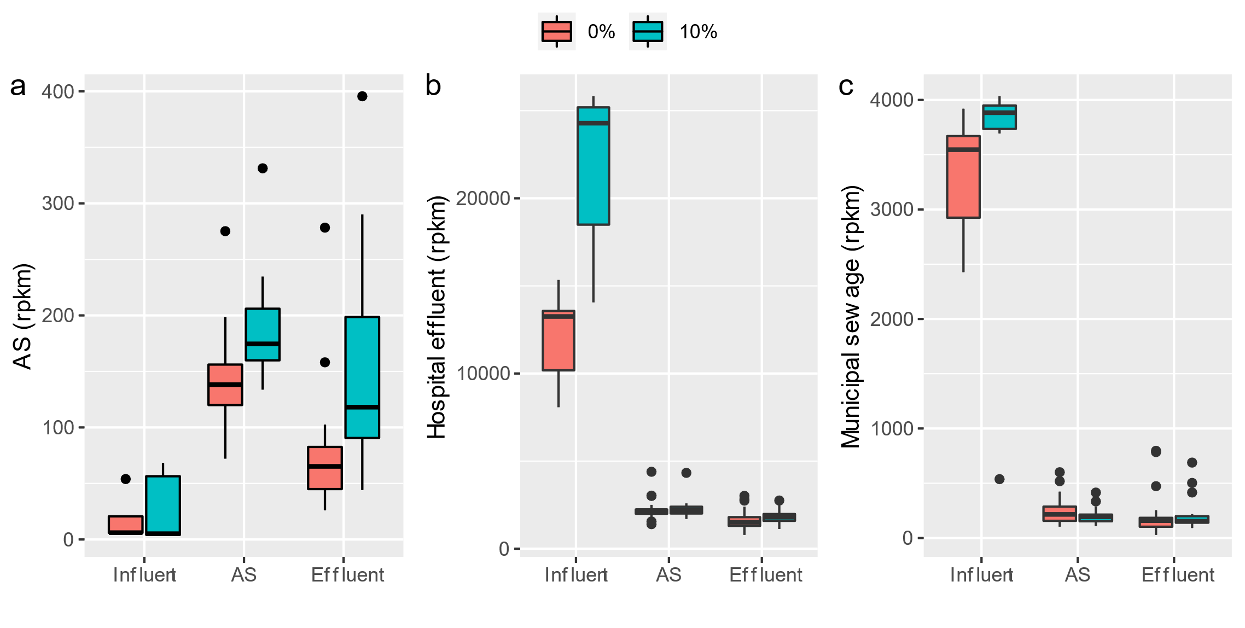

Fig S9. Relative abundance of contigs through read mapping is concordant with the Kairos assess workflow predictions. (A) Summed relative abundances of contigs predicted by Kairos assess (as in Fig. 3) to be innate to the AS microbiome. (B) Summed relative abundances of contigs predicted to be innate to hospital sewage. (C) Summed relative abundances of contigs predicted to be associated with municipal sewage.

Fig. S10. Overall structure and properties of hospital- and background municipal-sewage mobile resistance gene networks were similar. (A) Drug classes showed similar rankings in terms of neighborhood connectivity. (B) Individual resistance genes showed similar rankings in hospital sewage vs. native sewage. (C) Hospital sewage lacked many of the phyla associated with background municipal sewage.

Fig. S11. Experimental and logic flow diagram for distinguishing fate of hospital and native-sewage resistance genes as in Fig. 4G. “Attenuated” genes are those present in A (day 6 influent/feed) but not B (day 9 influent/feed) or C (AS on the last day of sampling). “Persistent” genes are those present in A and C but not B.

Fig. S12. Microdiversity-level disparity in the fate of hospital and native-sewage associated resistance genes. Determined using the Kairos assess workflow and logic described in Fig. S11. Persistent contigs were considered those still detectable after several days of operation. Attenuated contigs were those that were not detected in AS following several days of operation. Native contigs are described as those only detected in AS.
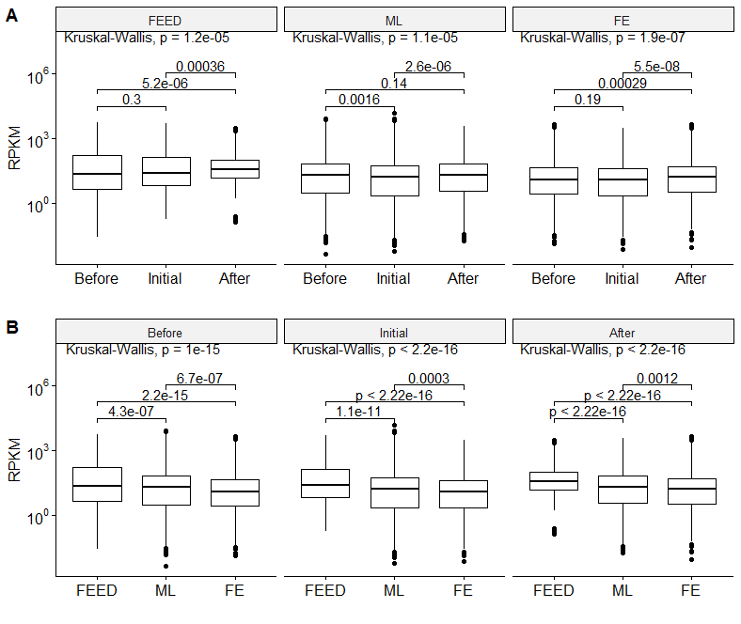

Fig. S13. Hosts of the genomes associated with attenuated resistance genes. (A) is partitioned by fraction. (B) is partitioned by date category associated with sampling. ML: mixed liquor or activated sludge. FE: final effluent. FEED: feed or influent sewage.
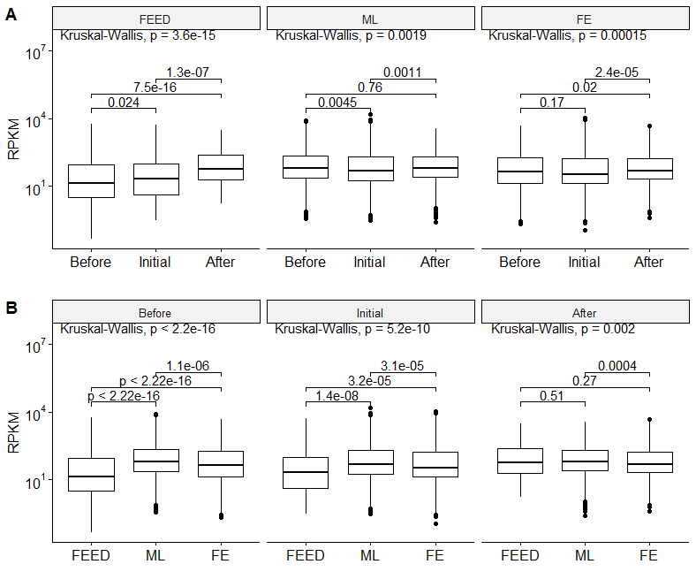

Fig. S14. Hosts of the genomes associated with persistent resistance genes. (A) is partitioned by fraction. (B) is partitioned by date category associated with sampling. ML: mixed liquor or activated sludge. FE: final effluent. FEED: feed or influent sewage.

Fig. S15. Putative gene-sharing or HGT network of resistance genes. Nodes are taxa and edges are identical proteins found in contigs found predicted to be derived from those taxa.

Fig. S16. Contigs associated with the putative in situ transfer of mphA. Star indicates position of mphA. Interactive html of this plot is available in the online supplementary materials.

Fig. S17. Contigs were detected that predicted multiple potential pathways of in situ transfers of sul2. Start indicates position of sul2. Interactive html of this plot is available in the online supplementary materials.
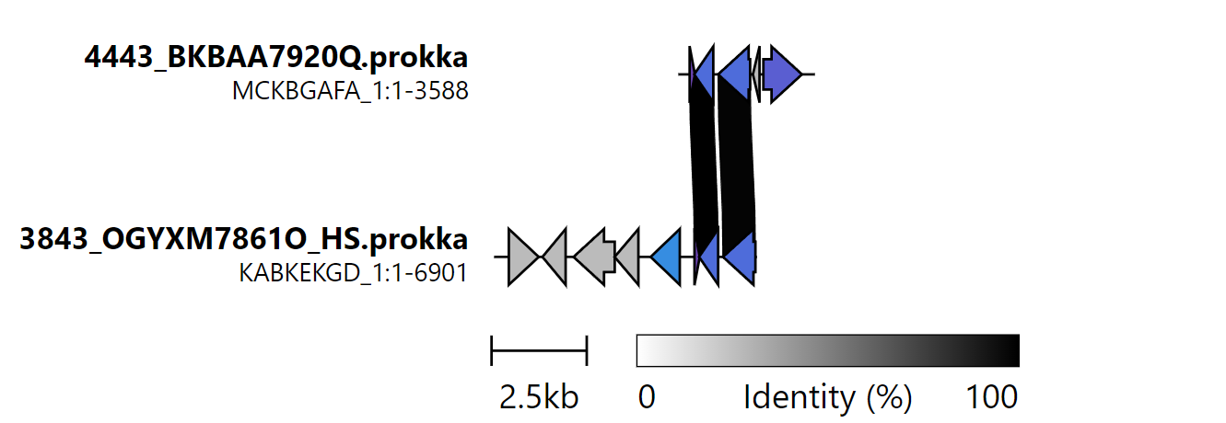

Fig. S18. Putative in situ HGT of sul1 contigs. Contigs align against edges meaning that the taxonomic assignment underlying its status as an HGT may be inaccurate and/or uncertain. Interactive html of this plot is available in the online supplementary materials.
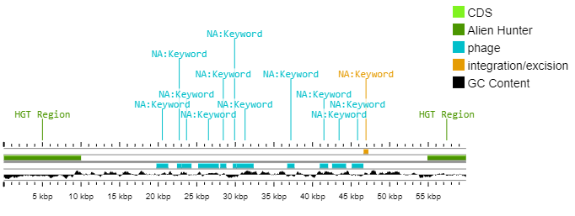
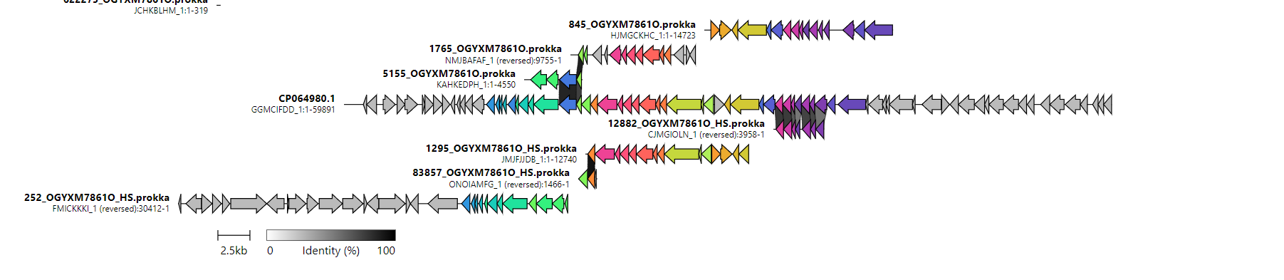

Fig. S19. Scaffolding draft phage genomes based on alignment to reference sequenced. (TOP): First 60,000 basepairs of NCBI entry CP064980.1 visualized using proksee with mobileOG-db (cyan and orange), Alien Hunter (forest green) and GC%. Alien Hunter was used to infer the prophage region as 10,000 – 55,000 bp. In this case, Alien Hunter is suggesting the region surrounding the integration site rather than the prophage is the HGT region as the prophage inhabits the majority of the 60,000 basepair fragment. (BOTTOM): Example clinker plot used to orient fragments for merging.

Fig. S20. One putative prophage in NCBI genome CP064980.1 was integrated near genes encoding MacA and MacB putatively associated with macrolide export.

Fig. S21. Example nanopore read alignment to both Myxococcota and Enterobacterales genomes. The nanopore read here (6de60e4c-c959-472c-93f4-1fe535ef4dd0)encodes mphA as well as phage genes. Alignment details are provided in Extended Data 1.

Table S9. Hits to myxophage derived from CP064980.1.
Table S9. Hits to myxophage derived from CP064980.1.
Description | Scientific Name | Max Score | Total Score | Query Cover | E value | Per. ident | Acc. Len | Accession
Myxococcales bacterium isolate Fred_18-Q3-R57-64_BAT3C.417 chromosome | Myxococcales bacterium | 1.07E+05 | 1.07E+05 | 100% | 0 | 100 | 4018971 | CP064980.1
Corallococcus sp. EGB chromosome, complete genome | Corallococcus sp. EGB | 5012 | 38100 | 68% | 0 | 86.62 | 9431171 | CP079946.1
Archangium violaceum strain SDU34 chromosome, complete genome | Archangium violaceum | 2870 | 17434 | 41% | 0 | 77.94 | 12677854 | CP069338.1
Myxococcus xanthus strain GH3.5.6c2 chromosome, complete genome | Myxococcus xanthus | 2686 | 10077 | 34% | 0 | 74.25 | 9321034 | CP017169.1
Myxococcus xanthus strain DK101 chromosome | Myxococcus xanthus | 2676 | 36430 | 51% | 0 | 74.3 | 9346413 | CP104803.1
Myxococcus xanthus DZ2 chromosome, complete genome | Myxococcus xanthus DZ2 | 2676 | 36430 | 51% | 0 | 74.3 | 9365783 | CP080538.1
Myxococcus xanthus strain ATCC 27925 chromosome, complete genome | Myxococcus xanthus | 2676 | 36425 | 51% | 0 | 74.3 | 9346321 | CP080534.1
Myxococcus xanthus DZ2 chromosome, complete genome | Myxococcus xanthus DZ2 | 2676 | 36406 | 51% | 0 | 74.3 | 9359382 | CP070500.1
Myxococcus xanthus strain DK1622:pDPO-Mxn116-Pvan-Tpase chromosome, complete genome | Myxococcus xanthus | 2676 | 12994 | 44% | 0 | 74.3 | 9201039 | CP065375.1
Myxococcus xanthus DK 1622, complete genome | Myxococcus xanthus DK 1622 | 2676 | 12994 | 44% | 0 | 74.3 | 9139763 | CP000113.1
Myxococcus xanthus strain DK1050 chromosome | Myxococcus xanthus | 2673 | 23741 | 50% | 0 | 74.35 | 9253193 | CP104804.1
Myxococcus fulvus 124B02, complete genome | Myxococcus fulvus 124B02 | 2671 | 12002 | 43% | 0 | 74.3 | 11048835 | CP006003.1
Myxococcus sp. MH1 DNA, complete genome | Myxococcus sp. MH1 | 2625 | 13929 | 48% | 0 | 74.19 | 10778154 | AP026947.1
Corallococcus macrosporus DSM 14697 chromosome, complete genome | Corallococcus macrosporus DSM 14697 | 2580 | 24668 | 50% | 0 | 74.05 | 8973512 | CP022203.1
Myxococcus xanthus strain R31 chromosome, complete genome | Myxococcus xanthus | 2074 | 12564 | 41% | 0 | 75.41 | 9251369 | CP068048.1
Stigmatella aurantiaca DW4/3-1, complete genome | Stigmatella aurantiaca DW4/3-1 | 1855 | 18108 | 36% | 0 | 75.88 | 10260756 | CP002271.1

