Supporting Information

Crown ether decorated silicon photonics for safeguarding against lead poisoning

Luigi Ranno^{1,✝}, Yong Zen Tan^{2,✝}, Chi Siang Ong², Xin Guo³, Khong Nee Koo⁴, Xiang Li³, Wanjun Wang³, Samuel Serna¹, Chongyang Liu⁵, Rusli³, Callum G. Littlejohns⁶, Graham T. Reed⁶, Juejun Hu¹, Hong Wang³ and Jia Xu Brian Sia^{1,3,}*

¹Department of Materials Science & Engineering, Massachusetts Institute of Technology, Cambridge, M.A., USA
²Fingate Technologies, Singapore
³School of Electrical and Electronic Engineering, Nanyang Technological University, 50 Nanyang Avenue, 639798, Singapore
⁴Vulcan Photonics, Kuala Lumpur, Malaysia
⁵Temasek Laboratories, Nanyang Technological University, 50 Nanyang Avenue, 637553, Singapore
⁶Optoelectronics Research Centre, University of Southampton, Southampton SO17 1BJ, UK
✝These authors contributed equally
*Corresponding author: jxbsia@mit.edu, jiaxubrian.sia@ntu.edu.sg

Supplementary Note 1: Exploded-view schematic representation of the Pb²⁺ ion sensor assembly

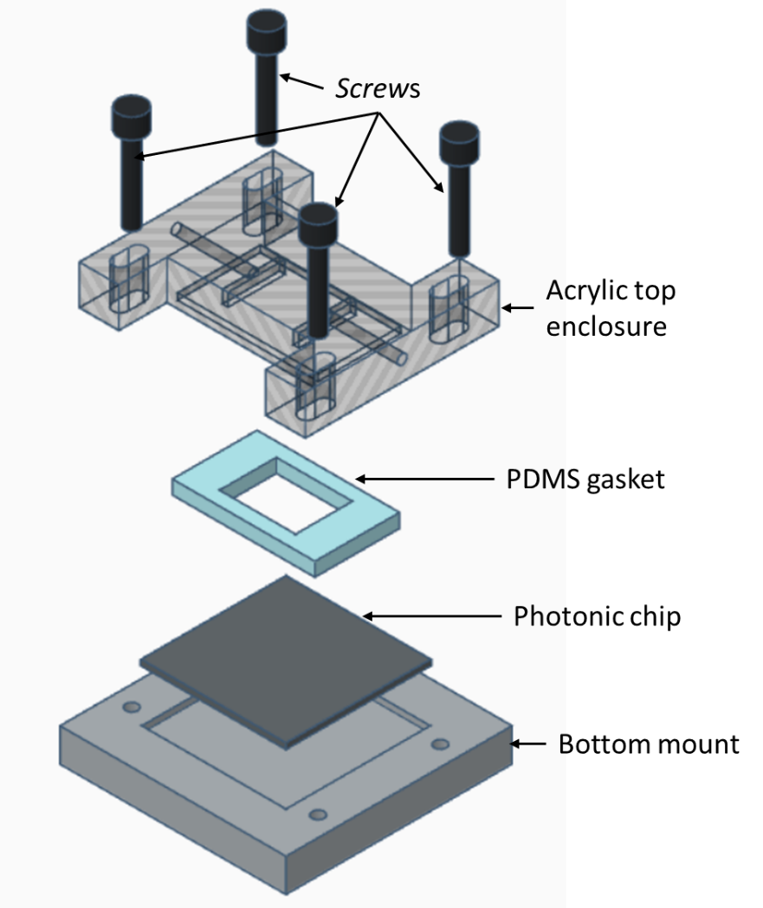
Supplementary Fig. 1. Exploded view representation of the Pb²⁺ ion sensor assembly, consisting of the bottom mount, photonic chip, PDMS gasket, acrylic top enclosure, and the screws, which are used to secure the assembly, and prevent microfluidic chamber leakage. The assembly is mounted on top of a TEC controller for thermal stabilization.

Supplementary Note 2: Definition of FoM for the Optimization of Surface Sensitivity
The cross section of a slot waveguide is illustrated in Supplementary Fig. 2a, with strip and slot width indicated; 20 nm of SiO₂ is deposited on the strip via ALD prior functionalization (Fig. 3a of the main text). For instance, the electric field distribution of the implemented slot waveguide with strip and slot width of 240 nm is shown in Supplementary Fig. 2b. Higher surface sensitivity implies that power of the optical mode about the surface of the strip width will be higher. To that effect, the FoM which considers the confinement factor 10 nm from the waveguide surface, with 20 nm of SiO₂ cladding, is derived from the following:
$$FoM=\frac{∂n_{eff.}}{∂n_{confine}}=\frac{n_{g}}{n_{confine}}\frac{\int_{confine}^{ }{ε|\vec{E}|^{2}dA}}{\int{ε|\vec{E}|^{2}dA}} (2.1)$$
n_{eff.} and n_{g} are the effective index and group index of the optical mode respectively,$\vec{E}$ is the electric field of the waveguide mode, n_{confine} and 𝛆 are the material index and the dieletric permittivity of the medium. In the computation, the medium surrounding the waveguide is taken to be water. The 2D integral in the numerator is to be taken about the 10 nm region which surrounds the waveguide and its cladding, while the integral at the denominator is considered about the entire space. The computed FoM of the slot waveguide is indicated in Fig. 2b of the main text. It is known that when the slot width is comparable to the exponential decay length of the fundamental eigenmode, optical power perpendicular to the high-index contrast interfaces is amplified ^{1–6}. As a comparison, the optical power 10 nm about the surface of strip TE and TM waveguides with 20 nm of SiO₂ cladding was also computed. The cross section of the strip waveguide is illustrated in Supplementary Fig. 2c. The FoM of the strip waveguides at the fundamental TE and TM polarization are computed as a function of strip widths in Supplementary Fig. 2d. On the 220 nm SOI platform, at λ = 1.55 μm, the optimal waveguide width for surface sensing at the TE polarization is found to be 270 nm. The FoM for TM strip waveguides is found to be lower than that of TE. This is because for TM polarization, the optical field is intensified at the top and bottom interfaces of the waveguide (Supplementary Fig. 2f)⁷, unlike TE (Supplementary Fig. 2e), which is lateral ⁷. The field at the bottom interface of the TM waveguide does not contribute to surface sensitivity. Furthermore, as the BOX has higher material refractive index than DI water, the field intensity at the bottom interface of the TM strip waveguide will be higher than that at the top (Supplementary Fig. 2f). From Supplementary Fig. 2d it can be seen that the FoM of the TM strip waveguide plateaus when strip width is larger 400 nm; the cross sectional electric field distribution of a TM strip waveguide with width of 425 nm is indicated in Supplementary Fig. 2f.Comparing the FoM of the slot waveguides (Fig. 2b of the main text) against that of the TE and TM slot waveguides, it can be seen that significantly higher surface sensitivity can be realized for slot waveguides. To that effect, slot waveguides are implemented for the Pb²⁺ photonic sensor presented in this work.
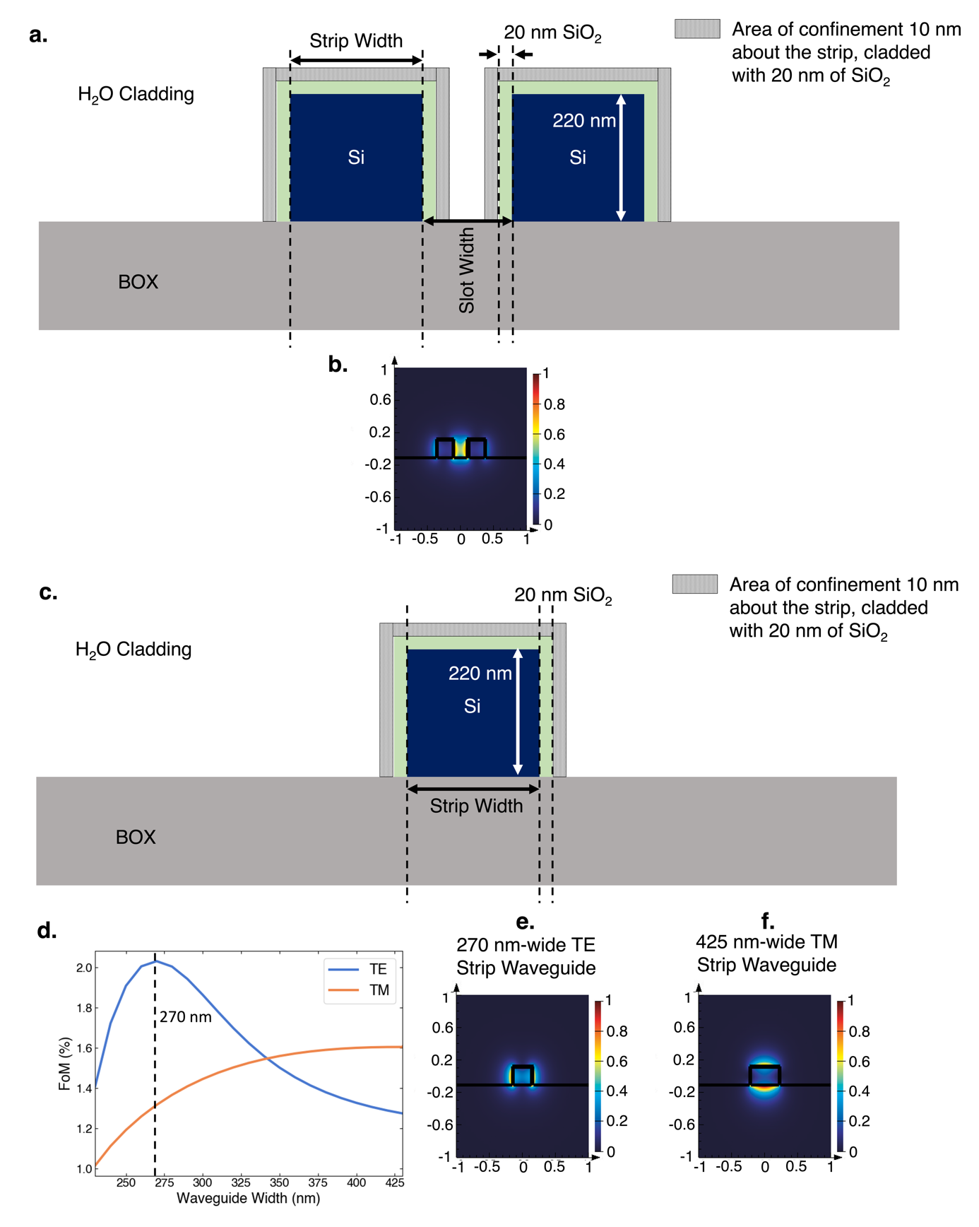
Supplementary Fig. 2. Definition of FoM for the optimization of waveguide surface sensitivity. The height of the waveguide layer is 220 nm with a 20 nm SiO₂ layer surrounding the waveguide, deposited via ALD. a, Cross-sectional schematic of the slot waveguide with definition of slot and strip width illustrated; the area of confinement is illustrated. b, An instance of electric field distribution pertaining to a slot waveguide with slot and strip width of 240 nm. c, Cross-sectional schematic of the strip waveguide(TE/TM) with definition of strip width illustrated; the area of confinement is illustrated. d, Sensor surface sensing FoM for strip waveguides (TE and TM) as a function of strip width. Instances of electric field distribution pertaining to e, TE strip waveguide with width of 270 nm, and f, TM strip waveguide with width of 425 nm.

Supplementary Note 3: Derivation of Equation 3 in the main text, relating designed loss (water absorption) with splitter power ratios
Condition 1 is illustrated in Supplementary Fig. 3a. A lightwave ($I=|E^{2}|$) is injected into an asymmetrical splitters, with two power splitting ratios; $S_{1}, S_{1}^{'}$ (input splitter) and $S_{2}, S_{2}^{'}$ (output splitter) where, $S_{1}=S_{2}$ and $S_{1}^{'}=S_{2}^{'}$, $S_{1/2}^{'}≠0.5$. Assuming the splitters are lossless, energy conservation dictates that $S_{1/2}=1-S_{1/2}^{'}$. After the input splitter, the field is separated into the sensing and reference arm, yielding $E_{1}$and $E_{2}$ respectively. These two terms are related to the electric field at the input of the splitter ($E$) through the splitting ratio such that $E_{1}=E\sqrt{S_{1}}$ and $E_{2}=E\sqrt{S_{1}'}$. As the light propagates through the sensing arm, it will accumulate attenuation from water absorption which we define as $e^{-αL}$, with L being the sensing arm length and ⍺ is the attenuation constant, as compared to the reference arm. We can express the phase difference between the two MZI arms as $e^{-jΔϕ}$.

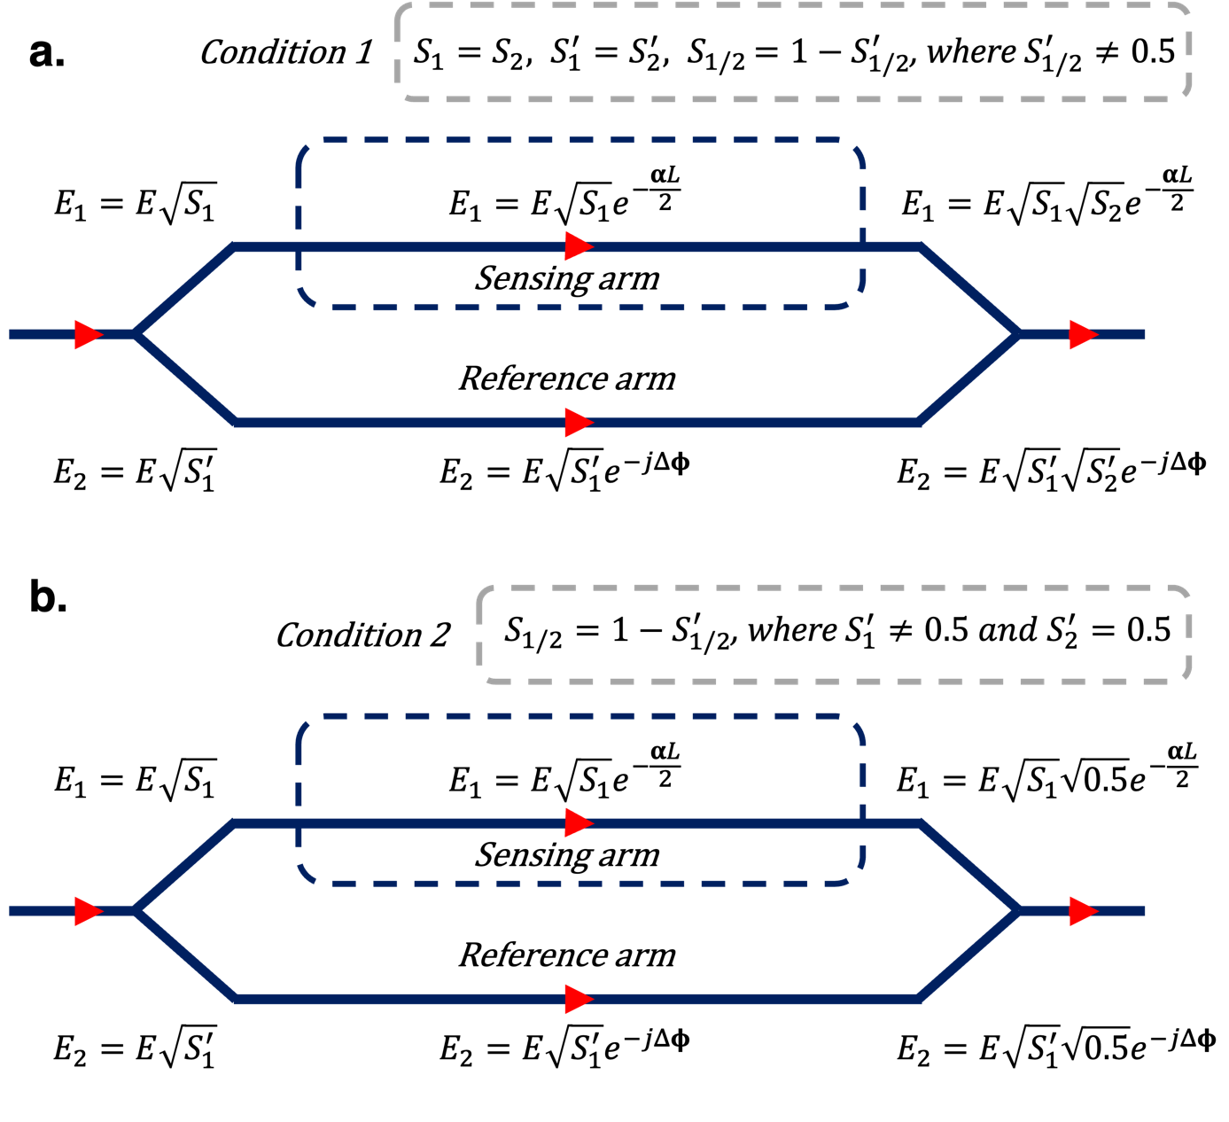
Supplementary Fig 3. Architectures of two MZI-based sensor designs with a, Condition 1, ${S_{1}=S_{2}, S_{1}^{'}=S_{2}^{'}, S}_{1/2}=1- S_{1/2}^{'}, where S_{1/2}^{'}≠0.5$, and b, Condition 2, $S_{1/2}=1- S_{1/2}^{'}, where S_{1}^{'}≠0.5, and S_{2}^{'}=0.5$ . According to Fig. 2c of the main text, it can be seen that the architecture in Supplementary Fig. 2a, condition 1 imposes lower requirements on splitter asymmetry as compared to Supplementary Fig. 2b, condition 2.
Lastly, as the two fields recombine at the output splitter, the total output intensity will be of the form:
$$I_{out}= E^{2}|\sqrt{S_{1}}\sqrt{S_{2}}e^{-\frac{αL}{2}}+\sqrt{S_{1}'}\sqrt{S_{2}'}e^{-jΔɸ}|^{2} (3.1)$$
In order to maximize sensor visibility, $I_{out}=0$ during destructive interference condition. As a result, (S2.1) can be reduced to the following form,
$$\sqrt{S_{1}}\sqrt{S_{2}}e^{-\frac{αL}{2}}=\sqrt{S_{1}'}\sqrt{S_{2}^{'}} (3.2)$$
An alternative MZI architecture (condition 2) is also illustrated in Supplementary Fig. 3b. In this design, an arbitrary and 3-dB splitter are used at the input and output respectively; $S_{1}^{'}≠0.5, S_{2}^{'}=0.5$. The output of the MZI can be defined as the following.
$$I_{out}= E^{2}|\sqrt{S_{1}}\sqrt{0.5}e^{-\frac{αL}{2}}+\sqrt{S_{1}'}\sqrt{0.5}e^{-jΔɸ}|^{2} (3.3)$$
Similarly, to maximize sensor visibility, we set $I_{out}=0$. As such, Equation 3.3 can be reduced to.
$$\sqrt{S_{1}}e^{-\frac{αL}{2}}=\sqrt{S_{1}^{'}} (3.4)$$
Via Equation 3.2 and 3.4, we determine the splitting ratio of the arbitrary splitters as a function of designed losses for the MZI architectures in Supplementary Fig. 3a-b; designed loss from water absorption is assumed to be the only source of optical loss. It can be seen that the MZI structure illustrated in Supplementary Fig. 3a reduces the asymmetrical requirement in power splitting which significantly alleviates requirement on fabrication ratios; accurate fabrication of highly asymmetrical power splitters is challenging; small variations in splitter dimensions will result in significant changes from the intended design.

Supplementary Note 4: Detection of Sn²⁺ through EDX analysis after functionalization
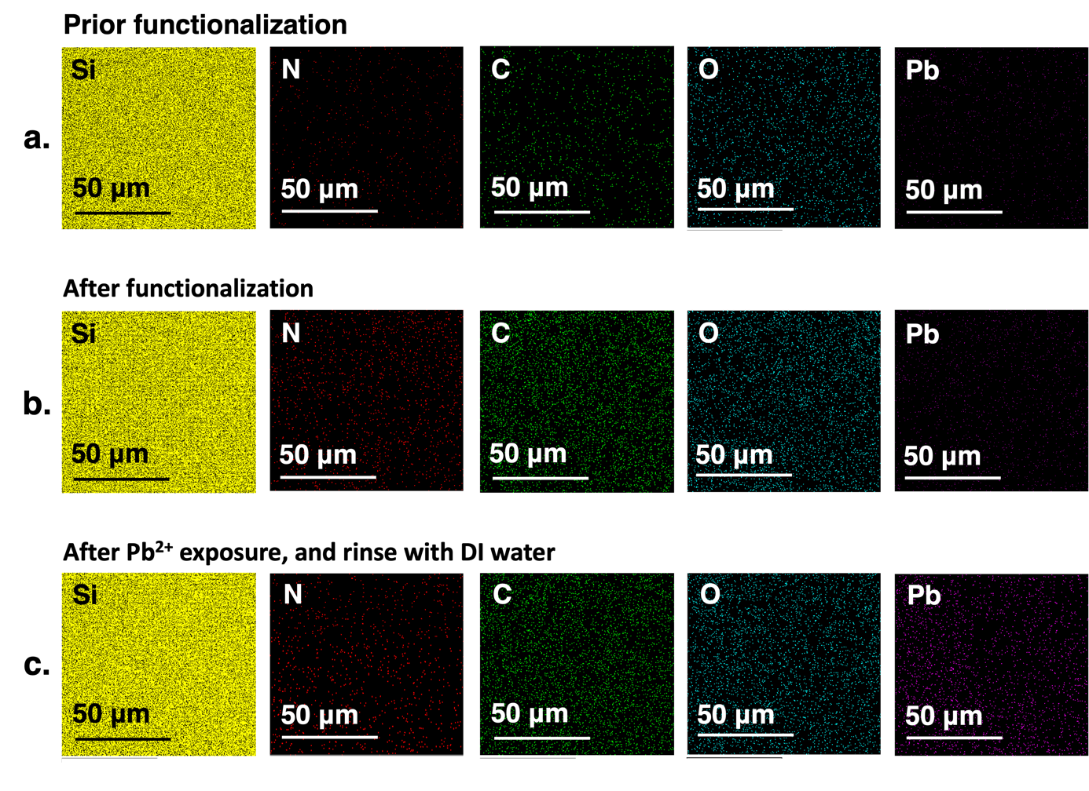
Supplementary Fig. 4 EDX analysis of the photonic chips pertaining to Si, N, C, O, and Pb elemental composition a, prior functionalization, b, after functionalization, and c, after Pb²⁺ exposure and rinse with DI water and dry (N₂).
In addition to the XPS results shown in the Fig. 3b-d, and Fig. 4I of the main text, an EDX analysis (Supplementary Fig. 4) was carried out to evaluate the elemental composition of Si, N, C, O and Pb. The analysis of N, C, and O indicates the viability of the Fischer esterification protocol that was developed in this work⁸. By comparing Supplementary Fig. 4a with Supplementary Fig. 4b or Supplementary Fig. 4c, an increase in N and C elemental composition can be observed. This is in line with the conclusion derived from the N 1S and C 1S regions of the XPS spectrums shown in Fig. 3b-c of the main text. We were not able to observe a change in O elemental composition in the EDX analysis. This is due to the fact that the O signal is attributed from the functional layer, as well as the 20 nm SiO₂ that was deposited on the slot waveguides prior functionalization. As the 20 nm SiO₂ layer is the primary contributor to the O signal in Supplementary Fig. 4⁹, a clear change in signal intensity cannot be seen. To further validate the capacity of the functional layer to bind with Pb²⁺ ions, the functional layer is exposed to Pb²⁺ for 120 s, followed by flushing with DI water and drying (N₂). By comparing the rightmost column of Supplementary Fig. 4b and c, the appearance of Pb via the binding capabilities of the functional layer can be clearly observed.

Supplementary Note 5: Detection of Sn²⁺ through XPS analysis after functionalization
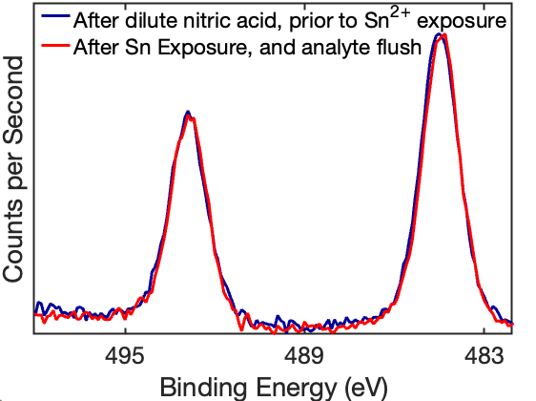
Supplementary Fig. 5 XPS spectrum measured after dilute nitric acid purification and prior to Sn²⁺ exposure, and after Sn exposure with DI water rinse and dry (N₂).
Due to the application of H₂O as a green solvent for the developed reaction, Brønsted acid catalyst such as H₂SO₄ is incompatible, in view of its drastic decrease in catalytic activity, in the presence of H₂O¹⁰. To that effect, the Lewis acid catalyst, SnCl₂ is utilized, which has a catalytic activity that is more resilient to the presence of H₂O^{11,12}. While Fischer esterification is favored when H₂O is removed as the reaction proceeds (dehydrative esterification), for the reaction disclosed in this work, Sn is embedded within the SiO₂ substrate, forming a heterogeneous catalyst. Thereby, improved catalytic activity¹³ that favors esterification in the presence of H₂O is achieved¹⁴. Evidence of successful Fischer esterification is indicated by the XPS N 1S, C 1S, and O 1S data in Fig. 3b-d of the main text respectively, and the EDX analysis in Fig S4 (See Section S4 in Supporting Information). Furthermore, Supplementary Fig. 5 shows the XPS results of the functional layer after dilute nitric acid purification (process in Fig. 3a of the main text), prior to Sn²⁺ exposure. It can be seen that presence of Sn cannot be eliminated via the purification step. We note that heterogeneous catalyst displays improved catalytic activity that favors esterification, even in the presence of H₂O. Supplementary Fig. 5 also shows the XPS measurement of the functional layer after Sn²⁺ exposure, followed by DI water flush and drying. As the DBTA crown ethers that undergoes amine conjugation subsequently do not bind to Sn²⁺ ions, it can be seen that the XPS spectrum is similar to that prior Sn²⁺ exposure. The subtraction of the narrow scan XPS spectrum before ion interaction was subtracted to that after ion interaction, referring to the normalized XPS spectrum as shown in Fig. 5 of the main text.

Supplementary Note 6: Measured optical spectrum of the photonic sensor when the sensing region is exposed to air

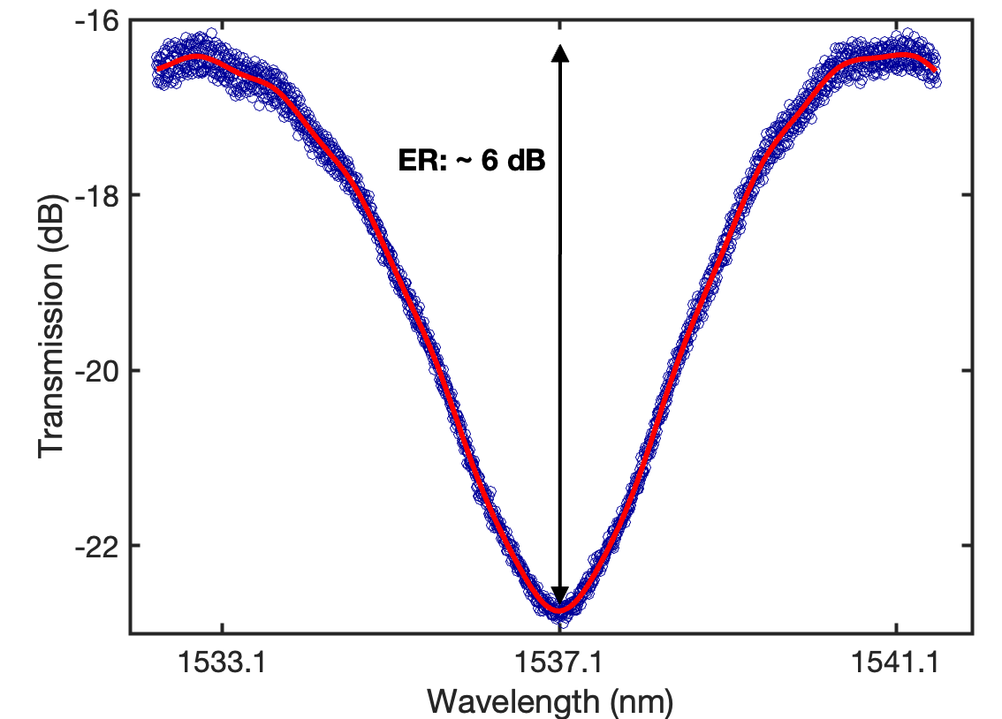
Supplementary Fig. 6. Measured optical spectrum of the photonic sensor when the sensing region of the photonic sensor is exposed to air. Poor visibility, as implied from the interferometric spectrum ER is observed, which is resultant when the designed losses are non-optimal to the asymmetrical splitting ratios.

Supplementary Note 7: Details on chip fabrication
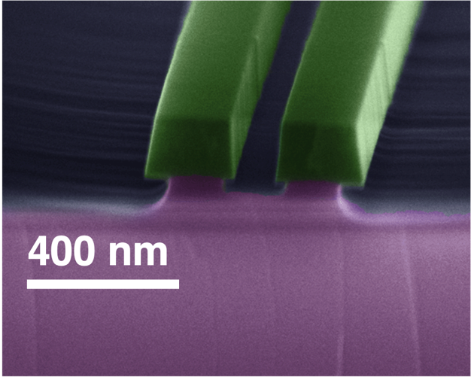
Supplementary Fig. 7 The SEM image (false colour) of fabricated slot waveguide, with strip and slot widths of 240 nm.
The fabrication of the sensor chips starts from commercially available 200 mm silicon on insulator wafers with 3 µm thick buried oxide and 220 nm thick device layer. First, the wafers are cleaned using a heated acetone bath kept at 55°C and rinsed in methanol, isopropanol and DI water. Then, an adhesion promoter (Surpass 4000) and electron-sensitive resist (ma-N 2403) are spin-coated onto the wafer and baked for 2 minutes at 90°C. The thickness of the E-beam resist after spin coating is ~300 nm (achieved at spin speeds of 3000 rounds per minute). A discharging layer (Espacer-300Z from Showa Denko Inc.) is applied to minimize charging effects. The wafer is patterned using E-beam lithography (ELS-HS50 from STS-Elionix) with a 50 kV accelerating voltage and a beam current of 5 nA. After development in RD6 (Futurexx Inc.) for 80s and rinsing in DI water, the waveguides are etched using ICP-RIE (RIE-230iP from Samco Inc.) with a gas chemisty of CF₄ and Ar at a pressure of 1 Pa, ICP Power of 300 W and 100 W of bias Power. The wafer is then ashed in O₂ plasma to strip away any remaining E-beam resist and to remove residual fluoropolymer formed during the etching process and thoroughly cleaned in Piranha solution, followed by a DI water rinse. Subsequently, the wafer was cladded with 2 µm of SiO₂ deposited at 350°C vie PECVD (Samco PD-220NL from Samco Inc). The wafer was then baked at 115 °C and silanized in an oven (TA Series from Yield Engineering Systems Inc.) to increase adhesion promotion of photoresist. Then, a thin (~1 µm) AZ 3312 photoresist layer is spin-coated and softbaked at 110°C for 60s. The sensing trench pattern is exposed into the resist using a maskless aligner (MLA-150 from Heidelberg Instruments Mikrotechnik GmbH) with a laser source centered at 405 nm. The resist was then post-exposure baked at 110 °C for 60 s and developed using AZ 726 MIF developer (Microchemicals GmbH) for 60 s. A diluted buffered oxide etchant solution was then used to open the sensing trenches, exposing the waveguides in the sensing arm. To avoid overetching, which could suspend the waveguides and generally change the structural cross-section from the intended design, the etching depth was monitored during the etching process using both profilometry (Dektak-XT from Bruker Corporation) and reflectometry (F50-UVX from Filmetrics Inc.). Once a total etch depth of 2 µm is reached, the resist was stripped in oxygen plasma (e3511 wafer asher from ESI Inc.), followed by thorough cleaning in acetone, isopropanol and DI water to prepare the wafer for the crown ether functionalization step.

Supplementary Note 8 Pb²⁺ ion photonic sensor selectivity test against Na⁺, Mg⁺, Cu⁺, Sn⁺², Ca⁺², Fe²⁺
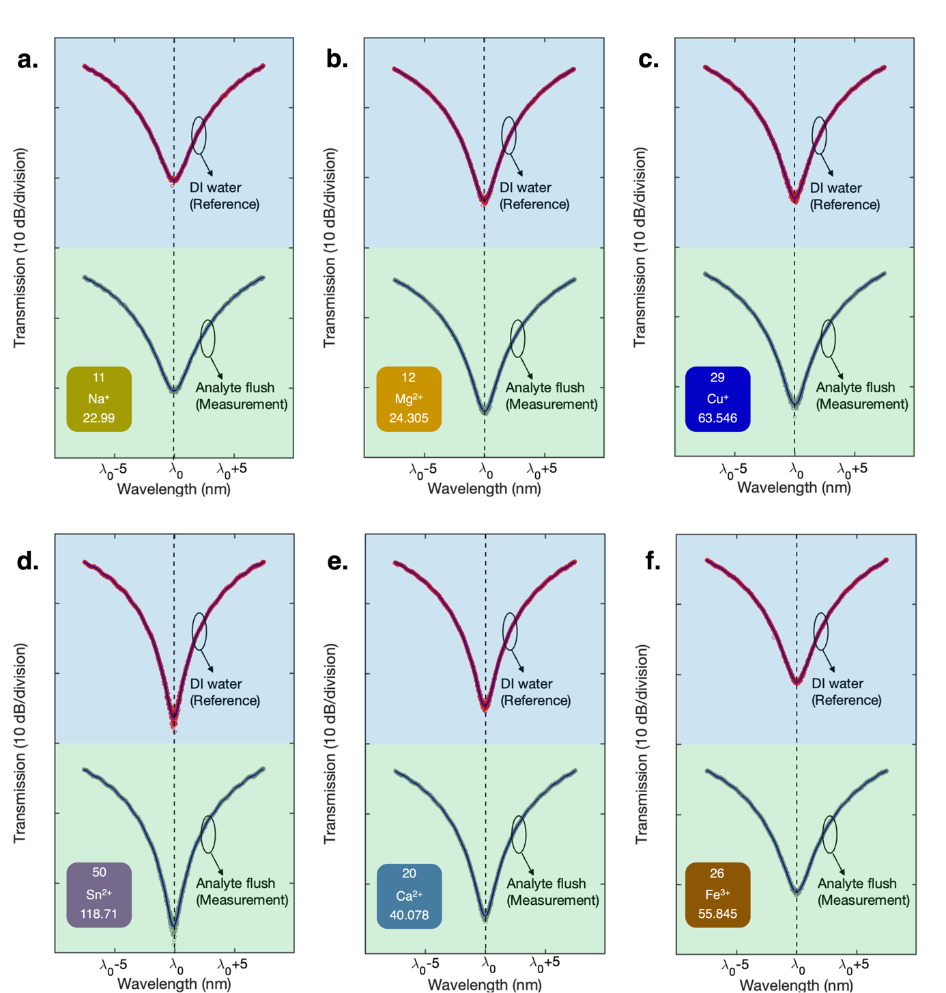
Supplementary Fig. 8 Selectivity performance of the Pb⁺² ion sensor against a, Na⁺, b, Mg⁺, c, Cu⁺, d, Sn⁺², e, Ca⁺², f, Fe⁺² at 15 ppb where no shifts in the interferometric spectra indicative of ion binding is observed across all the tested ions.
References
1. Almeida, V. R., Xu, Q., Barrios, C. A. & Lipson, M. Guiding and confining light in void nanostructure. Opt. Lett. 29, 1209–1211 (2004).
2. Kita, D. M., Michon, J., Johnson, S. G. & Hu, J. Are slot and sub-wavelength grating waveguides better than strip waveguides for sensing? Optica 5, 1046–1054 (2018).
3. Claes, T. et al. Label-Free Biosensing With a Slot-Waveguide-Based Ring Resonator in Silicon on Insulator. IEEE Photonics J. 1, 197–204 (2009).
4. Palmer, R. et al. Low-Loss Silicon Strip-to-Slot Mode Converters. IEEE Photonics J. 5, 2200409 (2013).
5. Liu, Q. et al. Highly sensitive Mach–Zehnder interferometer biosensor based on silicon nitride slot waveguide. Sens. Actuators B Chem. 188, 681–688 (2013).
6. Tu, X. et al. Thermal independent Silicon-Nitride slot waveguide biosensor with high sensitivity. Opt. Express 20, 2640–2648 (2012).
7. Ranno, L., Sia, J. X. B., Dao, K. P. & Hu, J. Multi-material heterogeneous integration on a 3-D photonic-CMOS platform. Opt. Mater. Express 13, 2711–2725 (2023).
8. Khan, Z. et al. Current developments in esterification reaction: A review on process and parameters. J. Ind. Eng. Chem. 103, 80–101 (2021).
9. Stefan Hüfner. Photoelectron Spectroscopy Principles and Applications. vol. 82 (Springer-Verlag Berlin Heidelberg New York, 2003).
10. Liu, Y., Lotero, E. & Goodwin, J. G. Effect of water on sulfuric acid catalyzed esterification. J. Mol. Catal. A Chem. 245, 132–140 (2006).
11. da Silva, M. J., Julio, A. A. & dos Santos, K. T. Sn(ii)-catalyzed β-citronellol esterification: a Brønsted acid-free process for synthesis of fragrances at room temperature. Catal. Sci. Technol. 5, 1261–1266 (2015).
12. Casas, A., Ramos, M. J., Rodríguez, J. F. & Pérez, Á. Tin compounds as Lewis acid catalysts for esterification and transesterification of acid vegetable oils. Fuel Process. Technol. 106, 321–325 (2013).
13. Xie, W., Wang, H. & Li, H. Silica-Supported Tin Oxides as Heterogeneous Acid Catalysts for Transesterification of Soybean Oil with Methanol. Ind. Eng. Chem. Res. 51, 225–231 (2012).
14. Baek, H., Minakawa, M., Yamada, Y. M. A., Han, J. W. & Uozumi, Y. In-Water and Neat Batch and Continuous-Flow Direct Esterification and Transesterification by a Porous Polymeric Acid Catalyst. Sci. Rep. 6, 25925 (2016).

