Supplementary material
Plant species supplementary information
Table S1. Summary of traits of exotic (bold type) and native seed species. Mean and standard deviation of traits measured in 50 seeds per species. In the case of seed number per fruit, we counted seeds in 50 fruits per species.
Species | Width (mm) | Length (mm) | Area (mm2) | Seeds per fruit | Seed mass (g) | Coat hardness* | Shape
A.microphylla | 1.74±0.31 | 1.84±0.25 | 2.57±067 | 1.62±0.89 | 0.002±0.001 | 1 | Spherical
R. idaeus | 1.96±0.56 | 2.36±0.53 | 3.49±0.78 | 27.6±5.93 | 0.003±0.001 | 2 | Oval
A. chilensis | 3.25 ± 0.26 | 2.59±0.38 | 6.75±1.17 | 3.64±1 | 0.012±0.002 | 1 | Spherical
M. boaria | 3.99±0.56 | 2.02±0.49 | 6.82±1.12 | 2±0 | 0.012±0.004 | 3 | Oval
B. darwinii | 4.11±0.43 | 2.09±0.27 | 6.76±1.2 | 4.68±1.25 | 0.005±0.001 | 2 | Oval
S. patagonicus | 4.57±0.41 | 4.41±0.50 | 15.95±2.36 | 1±0 | 0.033±0.005 | 2 | Spherical
P. cerasus | 10.11±0.55 | 8.37±0.47 | 66.61±6.47 | 1±0 | 0.457±0.051 | 3 | Spherical
*Seeds coat hardness categories: 1: could be penetrated easy by a fingernail; 2: could not be penetrated by a fingernail; 3: difficult to penetrate with a knife (Gong et al. 2015).

Estimates of relative abundance of seeds at landscape scale
To estimate the relative abundance of seeds we combined data of the relative abundance of fruiting plants of each species and their canopy size (data from transects), their fruit production and phenology (data from focal individuals) and the number of seeds becoming available for granivores (data from tagged branches in focal individuals). All this information was combined into a model that simulated the number of individuals present at the landscape scale and their fruit production (according to allometric functions). Then, for each week we simulated the number of sound fruits (according to each species’ phenology) and the number of seeds available on the ground (considering fruit consumption by dispersers and fallen due to fruit ripening).
In December 2019, when all the focal species were in bloom, we established 5 transects 100 m long x 2 m width (1000 m²) randomly located throughout the landscape (mean distance across transects 200 m). In each one, we registered adult individuals of fleshy-fruited species, and their canopy projection (diameter, m). In dioecious species (S. patagonicus, A. chilensis, and A. microphylla) we identified the sex of flowers to consider sex-ratios when estimating the number of trees producing fruits. Moreover, we selected 10-15 focal tree individuals from each species and measured the canopy diameter. For each focal tree, at the beginning of the fruit bearing season, we counted the number of fruits present in the canopy, randomly marked 10 branches and counted the number of fruits. . On a weekly basis and for each tagged individual of each species, we monitored the number of fruits present (in branches and in the canopy) and the proportion of fruits missing in the branches (with respect to previous week). Missing fruits were mostly due to fall of ripe fruits or dispersal by birds (clean vs pulp remaining in the pedicel). To estimate the number of seeds per fruit, for each focal species, we collected a total of 50 fruits across 5 to 10 individuals and counted the number of seeds.
Following Carlo and Morales (2016) we estimated the number of fruits per species by means of bootstrapping techniques. In each iteration, we first sampled a number of individuals equal to those present in 10 ha (according to the relative abundances observed in transects) and assigned them a canopy size (sampled from the density distribution fitted to field data). When necessary, we corrected this number by the sex ratio of species. Then, for each sampled individual we simulated fruit production as a function of their canopy size (based on allometric functions fitted to observed data in focal trees). Allometric functions were obtained by regressing the number of fruits produced by focal individuals against their canopy size. We used four candidate functions of fruit production-canopy relationships: (i) intercept, no relationship; (ii) lineal, (iii) saturating and (iv) exponential. For each species, we selected the more suited allometric function based on AIC values. On a weekly basis, we simulated fruit ripening according to species phenology ($F_{jkw}={Crop}_{j}×P_{kw}$). The number of sound fruits of the j-th individual, corresponding to species k, during the w-th week ($F_{jkw}$) was obtained by multiplying its total fruit production (${Crop}_{j}$by $P_{kw})$, which represents species-specific fruiting phenology. In particular, it is the ratio between the average number of ripe fruits produced by individuals of the k-th species in the w-th week and the average maximum fruits they produce. From week to week, we simulated the number of seeds becoming available for granivores due to frugivory (and subsequent defecation) or natural fall. The number of fruits becoming available in the j-th focal tree during the w-th week ($f_{jkw}$) was equal to the number of ripe fruits in the previous week ($F_{jw-1}$) multiplied by the average proportion of fruits missing from the previous week in branches of tagged individuals of the k-th species $\overline{\left(M_{kw}\right)}$ $f_{jkw}=$ $F_{jw-1}×\overline{M_{kw}}$. The number of fruits was converted into seeds by multiplying these values by the average number of seeds per fruit of each species. Finally, for each species, we summed seeds of all individuals and divided this value by the sum across species to calculate the relative abundance. Simulations were repeated 2000 times and averaged per species and week.
Table S2. Estimated relative seed abundance of exotic (bold type) and native species at landscape scale throughout the weeks in which the cafeteria experiment was carried out.
Week / Species | A. chilensis | S.patagonicus | P.cerasus | B.darwinni | R.idaeus | A.microphylla | M.boaria
1 | 0.921 | 0.005 | 0.022 | 0.001
2 | 0.973 | 0.003 | 0.004 |  | 0.012
3 | 0.987 | 0.002 |  |  | 0.006 | 0.004
4 | 0.984 |  |  |  | 0.007 | 0.007 | 0.0003

Models and priors
3.1. Effect of shrub cover on plot encounter probability
$$Y_{is}\sim Bernoulli\left(p_{i}\right)$$
$$logit\left(p_{is}\right)=β_{0_{s}}+β_{1}*O_{i}$$
$$β_{0_{s}}˷Normal \left(µ_{0},σ_{0}\right)$$

$$µ_{0} \sim Uniform \left(-∞,∞\right)$$
$$σ_{0} \sim Student t \left(0, 2.5, 3\right)$$

The probability that at least one seed from the i-th plot and s-th site, was removed during the first 24 h of seeds offering, was modeled as a Bernoulli process that depended on the probability of encountering the plot $p_{is}$. $p_{is}$was a function of the microhabitat where the plot was located (0 = covered; 1 = open). The s-th site in which the plot was situated was introduced as a random effect on the intercept ($β_{0_{s}}$). We used weakly informative priors for the intercept and sigma (random effect)—student-t distribution with mean = 0, df = 3 and sd = 2.5. For the mean of the random effect ($µ_{0}$) we used a uniform distribution (- ∞, +∞). We ran 4 chains over 10000 iterations, leaving 1000 for warm-up, and a thining of 10. After checking for convergence (Rhat <1.01) and effective sample sizes (n.eff >3500), we evaluated model fit by means of posterior predictive checks (Fig. S2). We fitted the model using the brms 2.17.0 R package (Bürkner 2017).

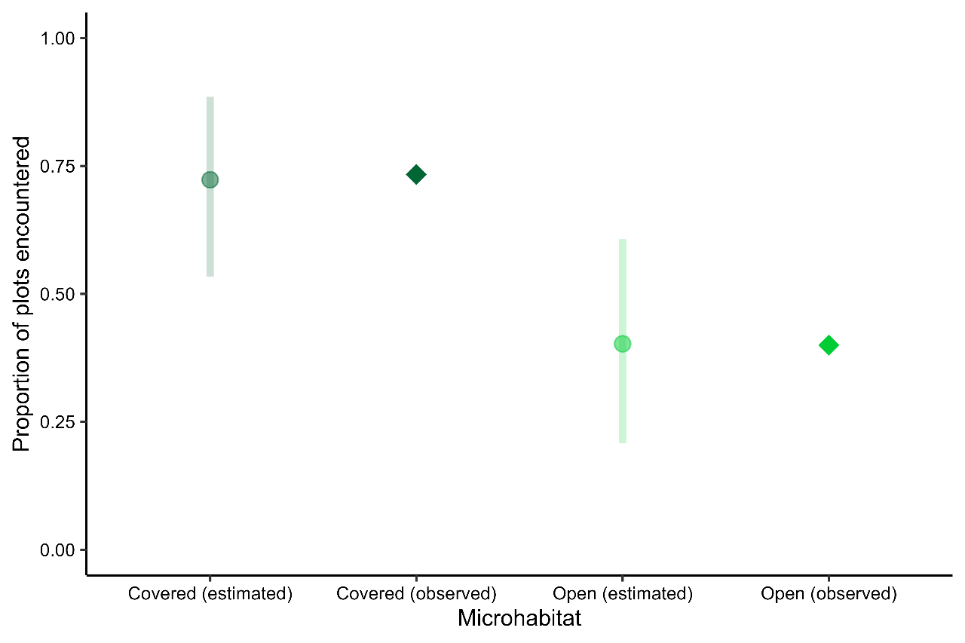
Figure S1. Posterior predictive check of the model for plot encounter probability (Table 1, main text). Rhombus depict observed values and dots mean predictions and 90% credible intervals across 1,000 posterior samples.

3.2. Effects of shrub cover on seeds removal rates
$$Y_{isw}\sim Binomial\left(p_{isw},N\right)$$
$$logit\left(p_{isw}\right)=β_{0_{s}}+β_{1}*O_{i}$$
$$β_{0_{s}} \sim Normal \left(µ_{0},σ_{0}\right)$$

$$µ_{0} \sim Uniform \left(-∞,∞\right)$$
$$σ_{0} \sim Student t \left(0, 2.5, 3\right)$$

The number of seeds removed in the i-th plot, s-th site, during the w-th week was modeled as a binomial process with probability of seed removal$p_{isw}$ and number of seeds offered ($N$ = 40). The probability of seed removal depended on the microhabitat where the plot was located (0/1, covered by shrubs or open areas). The s-th site in which the plot was situated was introduced as a random effect on the intercept ($β_{0_{s}}$). We used weakly informative priors for the intercept and sigma (random effect)—t student distribution with mean = 0, df = 3, sd = 2.5. For the effect term and the mean of the random effect ($µ_{0}$ we used a flat prior, a uniform distribution (- ∞, +∞). We ran 3 chains over 10000 iterations with 1000 of warm-up and a thining of 10. After checking for convergence (Rhat <1.01) and effective sample sizes (n.eff >2500), we evaluated model fit by means of posterior predictive checks (Fig. S2). Model was fitted using Brms 2.17.0 program (Bürkner 2017).

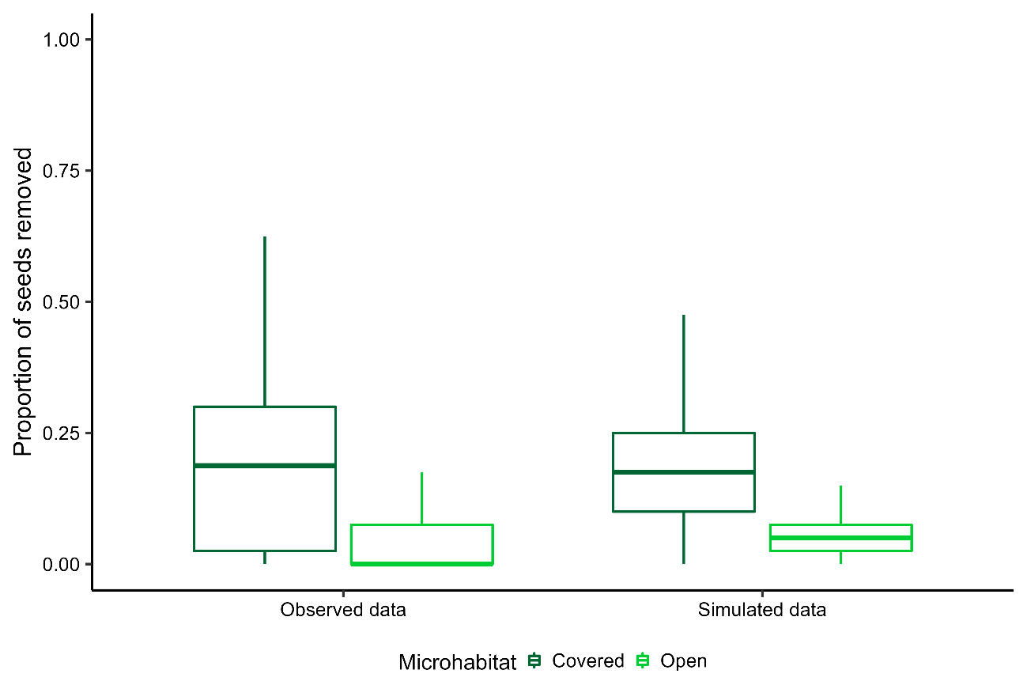
Figure S2. Posterior predictive check of the seed removal model (Table 1, main text). Box plots represent observed and simulated values (across 1000 repetitions) of the proportion of seed removed after 72 h of seed offering. Dark green boxplots represent plots located under shrub cover microhabitats, and light green ones, open microhabitats.

3.3. Factors driving foraging choices by granivores

$$y_{kiw \sim } WalleniusHipergeometric\left(p_{kiw},T_{iw},N_{kiw}\right)$$
$$p_{kiw}=\frac{exp\left(η_{kiw}\right)*I_{kw}}{\sum_{j=1}^{7}{exp\left(η_{jiw}\right)*I_{jw}}}$$
$I_{jw}\left\{\begin{aligned}0 if the I-th species is absent \\ 1 if the I-th species is present\end{aligned}\right.$ $I_{kw}\left\{\begin{aligned}0 if the I-th species is absent \\ 1 if the I-th species is present\end{aligned}\right.$
$$η_{kiw}=β_{1}S_{k}+β_{2}S_{k}^{2}+β_{3}A_{kw}+β_{4}S_{k}*O_{i}+β_{5}S_{k}^{2}*O_{i}+β_{6}A_{kw}*O_{i}$$
$β_{n} \sim Normal \left(0,1\right)$ for n \ in {1, 2, …, 6}

The number of seeds removed of the k-th species in the i-th plot during the w-th week followed a multivariate Wallenius’ Hipergeometric distribution with a species-specific probability of removal $p_{kiw}$, a total number of removed seeds $T_{iw}$ and number of seeds offered by species $N_{kiw}$. Species-specific probability of seed selection depended on their size, following a quadratic response ($β_{1}S_{k}+β_{2}S_{k}^{2}$), their estimated species-specific relative abundance per week ($β_{3}A_{kw}$, log-transformed) and the interaction of both terms with shrub cover. Covariates were standardized (mean=0, sd = 1) before model fit. We used weakly informative priors for all parameters – normal distribution with mean = 0, sd = 1. We run 3 chains over 200000 iterations with a thining of 20. After checking for convergence (Rhat <1.01) and effective sample sizes (n.eff >9000), we evaluated model fit by means of posterior predictive checks (Fig. S3). Model was fitted using the R package BiasedUrn (Fog, 2022) for computing the likelihood function, and sampling the posterior distribution with random walk Metropolis algorithm, as implemented in the MCMC R package (Geyer, 2022).

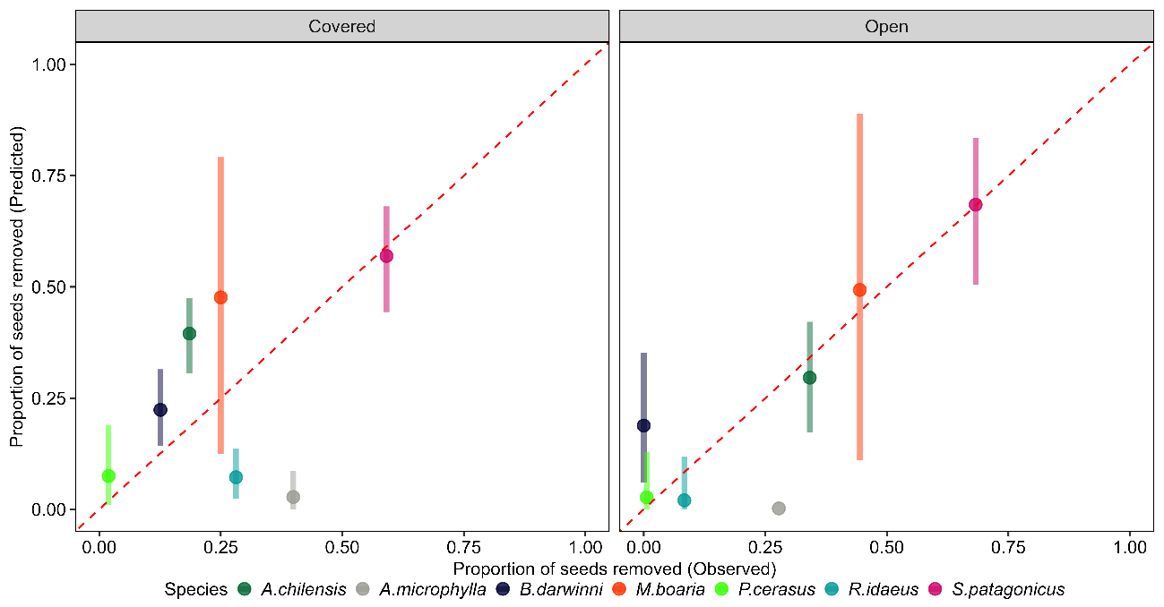
Figure S3: Posterior predictive check of the seed selection model (Table 2, main text). Dots represent the mean predicted value of the seed removal rates after 72 h of offering (across 10000 posterior samples), and lines, the 90 % credible interval. The red line shows the 1:1 relationship.

