Supplementary figures

Supplementary figure 1

Histopathological lung studies from infected (panels A-D) or vaccinated then challenged (panels E-H) mice.
40-fold magnified histopathological images of lung tissues 5 days post-infection: (A) Normal lung parenchyma in a mock-infected animal. (B) Intranasal (IN) infection with rHMPV virus resulted in mild to moderate peri-bronchial and perivascular inflammation. (C) IN infection with monovalent Metavac® LAV candidate resulted in mild interstitial, peri-bronchial, and perivascular inflammation. (D) IN infection with bivalent Metavac®-RSV LAV candidate resulted in mild interstitial, peri-bronchial, and perivascular inflammation. Scale bar = 500µm.
200-fold magnified histopathological images of lung tissues 5 days post-challenge with HMPV: (A) Normal lung parenchyma in a mock-infected animal. (E) Interstitial inflammation with alveolar wall thickening and intra-alveolar inflammatory cells (neutrophils, macrophages) in infected non-vaccinated mice. (F-G) Dual IN immunization with monovalent Metavac® (F) or bivalent Metavac®-RSV (G) vaccine candidates and HMPV challenge resulted in mild (interstitial inflammation. (H) Dual IM immunization with split inactivated HMPV preparation and HMPV challenge resulted in moderate to marked peri-bronchial inflammation, moderate interstitial inflammation, focal pleural inflammation, and marked peri-vascular inflammation. Scale bar = 100µm.

Supplementary figure 2
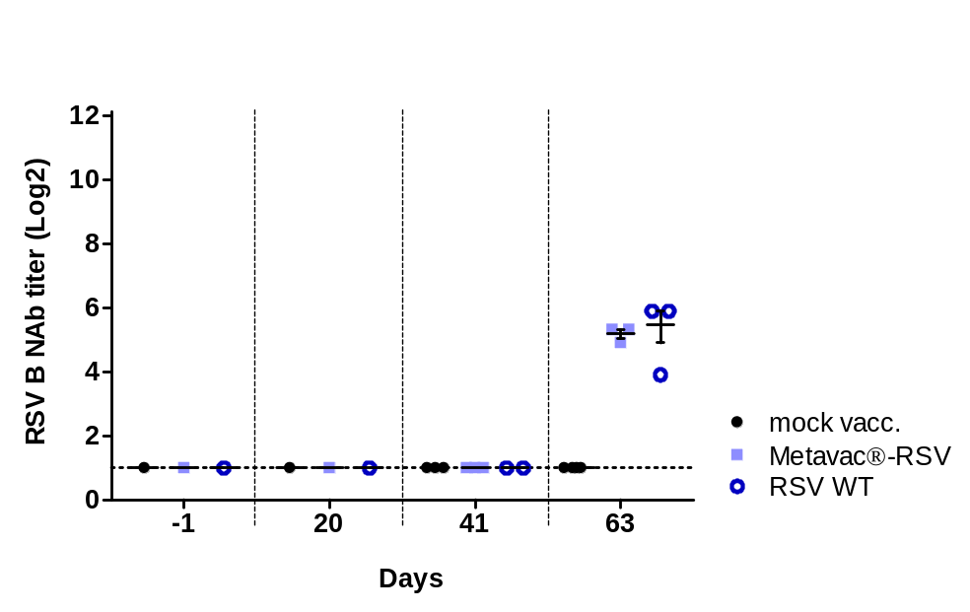

Neutralization studies for heterologous RSV B strain. To evaluate the production of specific neutralizing antibody response against heterologous virus strains, sera were recovered from blood samples, pooled, and heat-inactivated at 56°C until testing. Serial twofold dilutions of sera in infection medium were then tested for neutralization of RSV B strain WV/14617/85 (VR-1400™, ATCC) on Vero cells. Reciprocal neutralizing antibody (NAb) titers were determined by an endpoint dilution assay based on CPEs observation.

