Video still

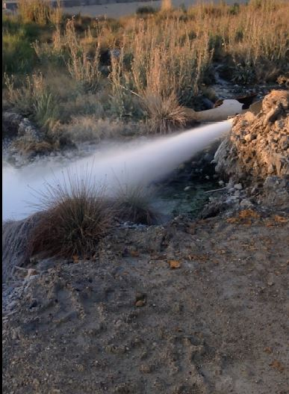

Supplemantal movie 1. Hot spring in Kopru (Agri)

