Supplementary Information for

Ohmic memristors with new type switching for continual learning

Shaochuan Chen¹*†, Zhen Yang²†, Heinrich Hartmann³, Astrid Besmehn³, Yuchao Yang^{2,4,5,6}*, Ilia Valov^{1,7}*

¹Institute of Materials in Electrical Engineering 2 (IWE2), RWTH Aachen University, Aachen, Germany.
²Beijing Advanced Innovation Center for Integrated Circuits, School of Integrated Circuits, Peking University, Beijing, China.
³Central Institute for Engineering, Electronics and Analytics (ZEA-3), Forschungszentrum Jülich, Jülich, Germany.
⁴School of Electronic and Computer Engineering, Peking University, Shenzhen 518055, China.
⁵Center for Brain Inspired Chips, Institute for Artificial Intelligence, Peking University, Beijing, China.
⁶Center for Brain Inspired Intelligence, Chinese Institute for Brain Research (CIBR), Beijing, China.
⁷Peter Grünberg Institute 7 and JARA-FIT, Forschungszentrum Jülich, Jülich, Germany.

*e-mail: i.valov@fz-juelich.de; yuchaoyang@pku.edu.cn; s.chen@iwe.rwth-aachen.de
†These authors contributed equally to this work.

Supplementary Note

Charge transport at the electrode/switching layer interface
To analyze the charge transport and electrical characteristics at the metal/oxide interface (Fig. 2, a,b), the overall current density flow in the system is considered as the sum of thermionic-emission current density and the ionic current density

$$\begin{aligned}j= j_{TE}+ j_{ION} \#\text{(S}\text{1)}\end{aligned}$$

The Schottky-emission current density is expressed as

$$\begin{aligned}j_{TE}=j_{S}\left[exp\left(\frac{e∆φ}{kT}\right)-1\right]\#\#(S2)\end{aligned}$$

where $j_{S}={A^{*}Τ}^{2}exp\left(-\frac{eϕ_{Β}}{kT}\right)$ is the saturation current density, $A^{*}$ is the effective Richardson constant, $Τ$ is the absolute temperature, $e$ is the elementary charge, $ϕ_{Β}$ is the barrier height, $k$ is the Boltzmann constant, $∆φ$ is the applied voltage.

The ionic-redox current density is expressed using the Butler-Volmer equation

$$\begin{aligned}j_{ION}=j_{0}\left[exp\left(\frac{α_{a}ze∆φ}{kT}\right)-exp\left(-\frac{α_{c}ze∆φ}{kT}\right)\right]\#\left(S3\right)\end{aligned}$$

where $j_{0}=zek_{0}c_{0} exp\left(-\frac{∆G_{a}}{kT}\right)$ is the exchange current density, $z$ is the charge number, $k_{0}$ is the rate constant, $c_{0}$is the concentration of ions at equilibrium, $∆G_{a}$ is the free energy of activation, $α_{a}$ is the anodic transfer coefficient, $α_{c}$ = 1 − $α_{a}$ is the cathodic transfer coefficient, $∆φ$ is the electron−transfer overpotential.

Assume the charge number$z$= 2, anodic and cathodic transfer coefficient is identical, i.e., $α_{a}$= $α_{c}$ = 0.5, then the overall current density

$$\begin{aligned}j=j_{S}\left[exp\left(\frac{e∆φ}{kT}\right)-1\right]+j_{0}\left[exp\left(\frac{e∆φ}{kT}\right)-exp\left(-\frac{e∆φ}{kT}\right)\right]\end{aligned}$$

$$\begin{aligned}=j_{S}\left[exp\left(\frac{e∆φ}{kT}\right)\right]-j_{S}+j_{0}\left[2\sinh\left(\frac{e∆φ}{kT}\right)\right]\#(S4)\end{aligned}$$

Now we consider if the Schottky barrier height $eϕ_{Β}$ in the system is sufficiently high, $\left[exp\left(-\frac{eϕ_{Β}}{kT}\right)\right] ≈0$, saturation current $j_{S}={A^{*}Τ}^{2}exp\left(-\frac{eϕ_{Β}}{kT}\right)≈0$, Equation (S4) is modified as

$$\begin{aligned} j=j_{S}\left[exp\left(\frac{e∆φ}{kT}\right)\right]+j_{0}\left[2\sinh\left(\frac{e∆φ}{kT}\right)\right]\#(S5)\end{aligned}$$

(i) When the system is positively biased, $∆φ>0$, consider the applied voltage is much higher than the thermal voltage: $∆φ≫\frac{kT}{e}$ , we have $\frac{e∆φ}{kT}≫1$, thus $\left[2sinh⁡\left(\frac{e∆φ}{kT}\right)\right]≈exp\left(\frac{e∆φ}{kT}\right)$, Equation S5 can be modified as

$$\begin{aligned}j=j_{S}\left[exp\left(\frac{e∆φ}{kT}\right)\right]+j_{0}\left[exp\left(\frac{e∆φ}{kT}\right)\right]\#\left(S6\right)\end{aligned}$$

$j$ can be further written as

$$\begin{aligned}{j= A}^{*}Τ^{2}\left[exp\left(\frac{e\left(∆φ-ϕ_{Β}\right)}{kT}\right)\right]+2ekc\left[exp\left(\frac{e∆φ-∆G_{a}}{kT}\right)\right]\#\left(S7\right)\end{aligned}$$

We attribute this condition to the region I in Fig. 2a. The energy diagram is presented in Fig. 2c. The current density is the sum of Schottky-emission current density (forward-biased) and ionic current density.

(ii) When the system is under reversed biased, $∆φ<0$, consider the absolute value of applied voltage is high and much higher than the thermal energy, then $-\frac{e∆φ}{kT}≫1$, thus $\left[2sinh⁡\left(\frac{e∆φ}{kT}\right)\right]≈-exp\left(-\frac{e∆φ}{kT}\right)$, Equation S5 is modified as

$$\begin{aligned} j=-j_{0}exp\left(-\frac{e∆φ}{kT}\right)\#(S8)\end{aligned}$$

$j$ can be further written as

$$\begin{aligned} j=-2ekc exp\left(\frac{-e∆φ-∆G_{a}}{kT}\right)\#(S8)\end{aligned}$$

We attribute this condition to region II in Fig. 2a. The energy diagram is presented in Fig. 2d. The current density is dominated by ionic current density.

Now we consider if the Schottky barrier height $eϕ_{Β}$ in the system is very low: ${eϕ}_{Β }≈0$, the term $\left[exp\left(-\frac{eϕ_{Β}}{kT}\right)\right]≈1$, $j_{S}={A^{*}Τ}^{2}\left[exp\left(-\frac{eϕ_{Β}}{kT}\right)\right]≈{A^{*}Τ}^{2}$, Equation S4 is modified as

$$\begin{aligned}j=A^{*}Τ^{2}\left[exp\left(\frac{e∆φ}{kT}\right)-1\right]+j_{0}\left[2\sinh\left(\frac{e∆φ}{kT}\right)\right]\#\left(S9\right)\end{aligned}$$

(iii) When the system is positively biased, $∆φ>0$, consider the applied voltage is much higher than the thermal voltage: $∆φ≫\frac{kT}{e}$ , similar to (i), we have $\frac{e∆φ}{kT}≫1$, $\left[2sinh⁡\left(\frac{e∆φ}{kT}\right)\right]≈exp\left(\frac{e∆φ}{kT}\right)$,

Equation S9 is modified as

$$\begin{aligned}j= A^{*}Τ^{2}\left[exp\left(\frac{e∆φ}{kT}\right)\right]+j_{0}\left[exp\left(\frac{e∆φ}{kT}\right)\right]\#\left(S10\right)\end{aligned}$$

$j$ can be further written as

$$\begin{aligned}j= A^{*}Τ^{2}\left[exp\left(\frac{e∆φ}{kT}\right)\right]+2ekc\left[exp\left(\frac{e∆φ-∆G_{a}}{kT}\right)\right]\#\left(S11\right)\end{aligned}$$

We attribute this condition to region III in Fig. 2b. The energy diagram is presented in Fig. 2e. The current density is the sum of Schottky-emission current density (forward-biased) and ionic current density. In addition, owing to the low energy barrier, the overall current density in this condition is higher than that in condition (i).

(iv) When the system is under reversed biased, $∆φ<0$, consider the absolute value of applied voltage is high and much higher than the thermal energy, similar to (ii), we have$\left[exp\left(\frac{e∆φ}{kT}\right)\right]≈0$ and $-\frac{e∆φ}{kT}≫1$, $\left[2sinh⁡\left(\frac{e∆φ}{kT}\right)\right]≈-exp\left(-\frac{e∆φ}{kT}\right)$, Equation S9 is modified as

$$\begin{aligned}j={-A}^{*}Τ^{2}-j_{0}\left[-exp\left(-\frac{e∆φ}{kT}\right)\right]\#\left(S12\right)\end{aligned}$$

$j$ can be further written as

$$\begin{aligned}j=-ΑΤ^{2}-2ekc \left[exp\left(\frac{-e∆φ-∆G_{a}}{kT}\right)\right]\#\left(S12\right)\end{aligned}$$

We attribute this condition to region IV in Fig. 2b. The energy diagram is presented in Fig. 2f. The current density is the sum of Schottky-emission current density (reversely biased) and ionic current density. Owing to the low energy barrier, the saturation currents are high in this case, making the overall current density much higher than that in condition (ii).

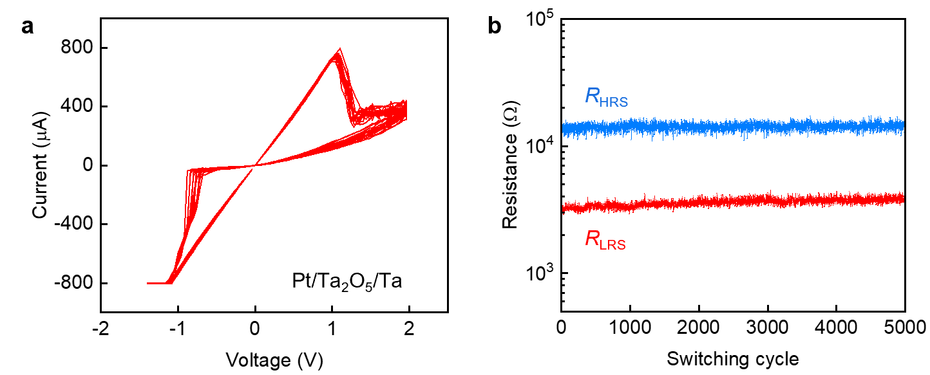

Supplementary Fig. 1. Electrical properties of a conventional VCM device. a, Exemplary I-V characteristic of a conventional VCM: Pt/Ta₂O₅/Ta/Pt device. b, Endurance test showing the high resistive state resistance (R_{HRS}) and low resistive state resistance (R_{LRS}) values as a function of switching cycles. No distinct degradation was observed after five thousand cycles. The resistances at HRS and LRS were read at −200 mV.

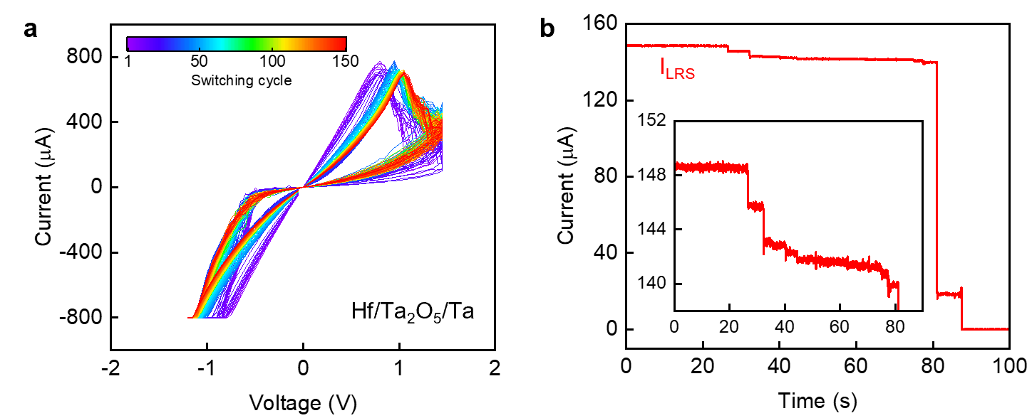

Supplementary Fig. 2. Electrical stability of ohmic memristive device without capping layers. a, One hundred and fifty consecutive I-V curves from a Hf/Ta₂O₅/Ta device. A clear degradation in cycle-to-cycle uniformity was observed with increasing switching cycles. b, Constant voltage stress measurement shows the instability of low resistive state current (I_{LRS}). The I_{LRS} was recorded by applying a constant −200 mV voltage after the SET process. With increasing resistive switching cycles a, or longer read voltage stress time b, the current at LRS is decreasing, indicating the increasing series resistance resulting from the metal electrodes passivation. These reliability problems^{1,2} were also found in all other ohmic memristive devices without or using thin capping layers.

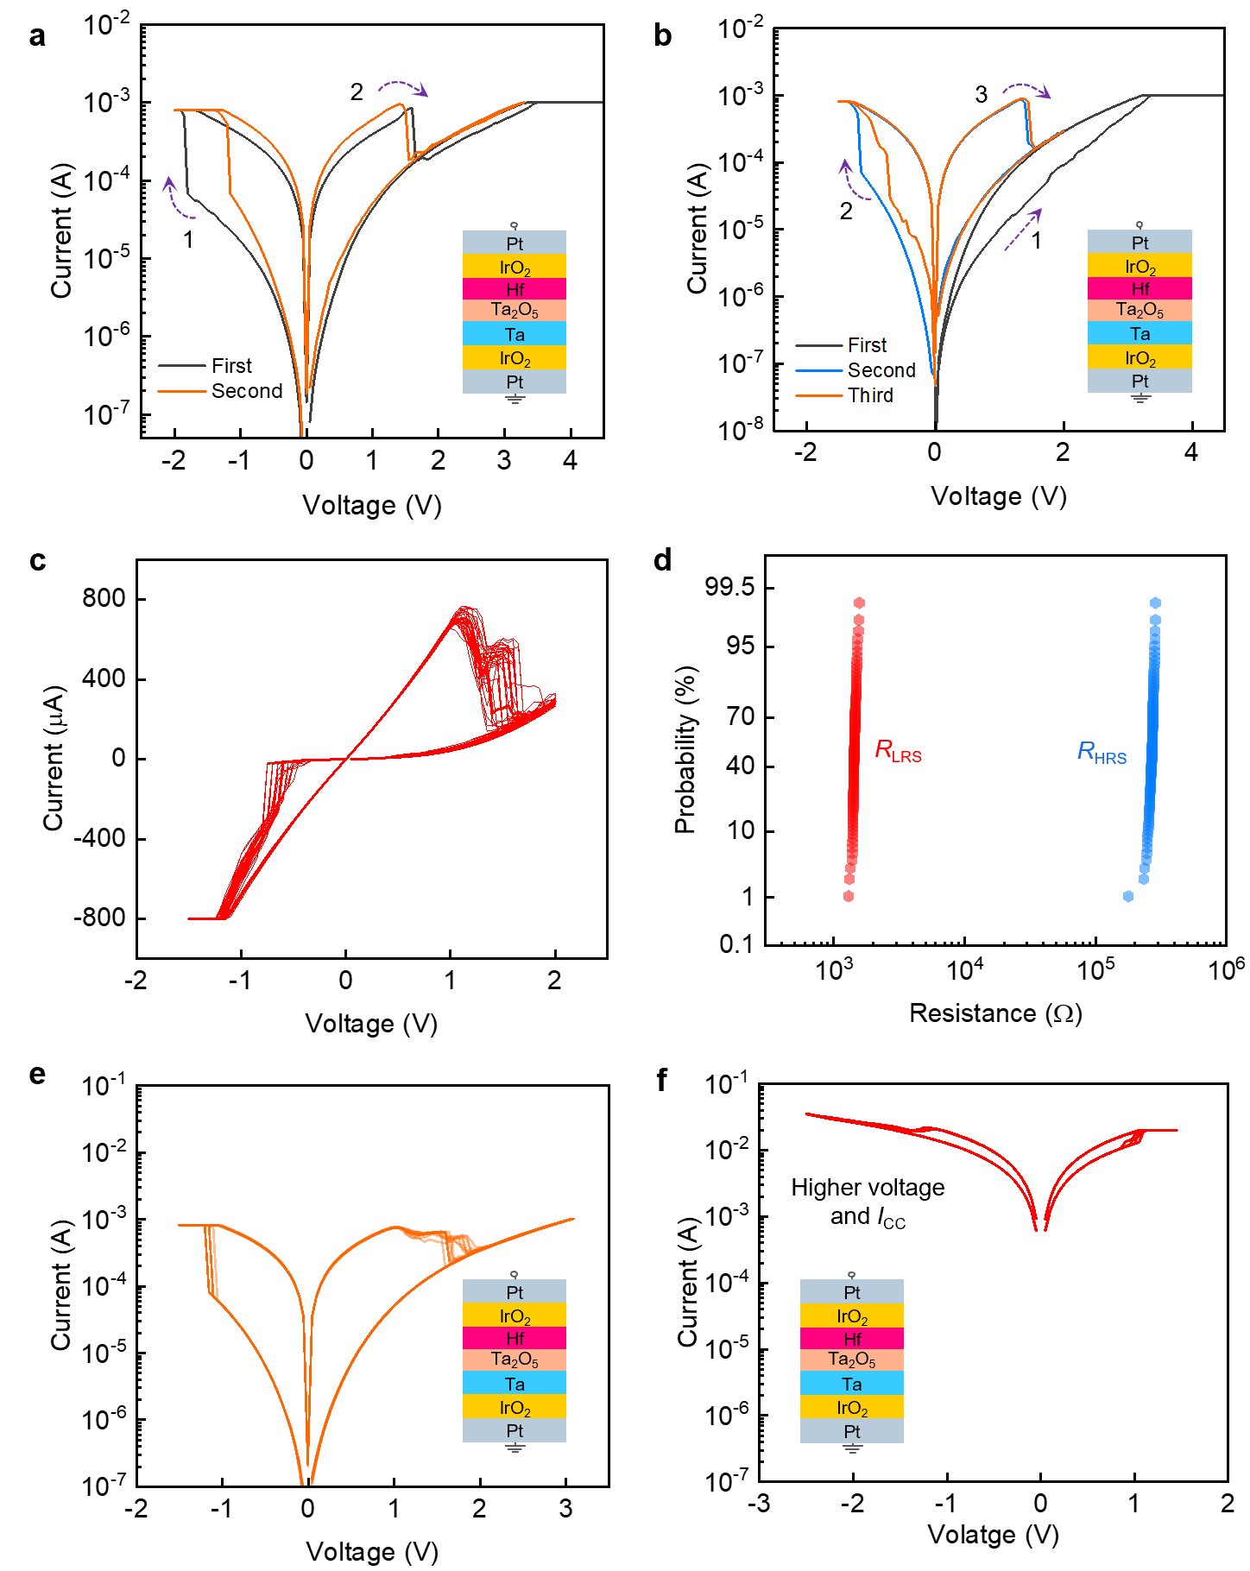

Supplementary Fig. 3. Resistive switching in ohmic memristive device with IrO₂/Pt capping layers. a, Forming process and the subsequent I-V curves. The device was formed (SET) into LRS by applying negative voltage to top electrode (Hf). b, Device operation started with applying positive voltage to Hf electrode (First sweep). The current decreased in the backward sweep, showing no reliable forming was achieved. A successful forming was reached in the second negative voltage sweep. The results show that forming of the devices was successful only for the negative polarization (towards top Hf electrode). In this way the cells were SET into LRS and the RESET process occurs at positive voltages. c, Exemplary I-V curves of the memristive devices after forming process. The I-V curves are comparable to those in conventional: Pt/Ta₂O₅/Ta/Pt VCM device (Supplementary Fig. 1a). d, Cumulative probability of resistances at high resistive state and low resistance state (read at 0.2 V) from one hundred I-V curves (shown in Fig. 1d). The use of capping layers prevents the passivation of the ohmic electrodes and leads to improved cycling uniformity and electrical stability. e, Typical c8w resistive switching (shown in semilogarithmic scale) observed in ohmic memristive device (see also Fig. 1d). f, 8w switching polarity observed at high voltage and current ranges. The transition from c8w to 8w switching mode was reached if highly voltage was applied to already formed system. The transition can occur after the first RESET, but can be reached at any cycle of c8w switching after applying high sweep voltages. The c8w to 8w transition is irreversible, and it means device failure. Note that using high voltage or high currents (>10 mA) should be avoided in practical applications, since high voltage/current operation can cause increasing defects in the metal oxide. Here, we show the 8w switching to study the possible failure mechanism.

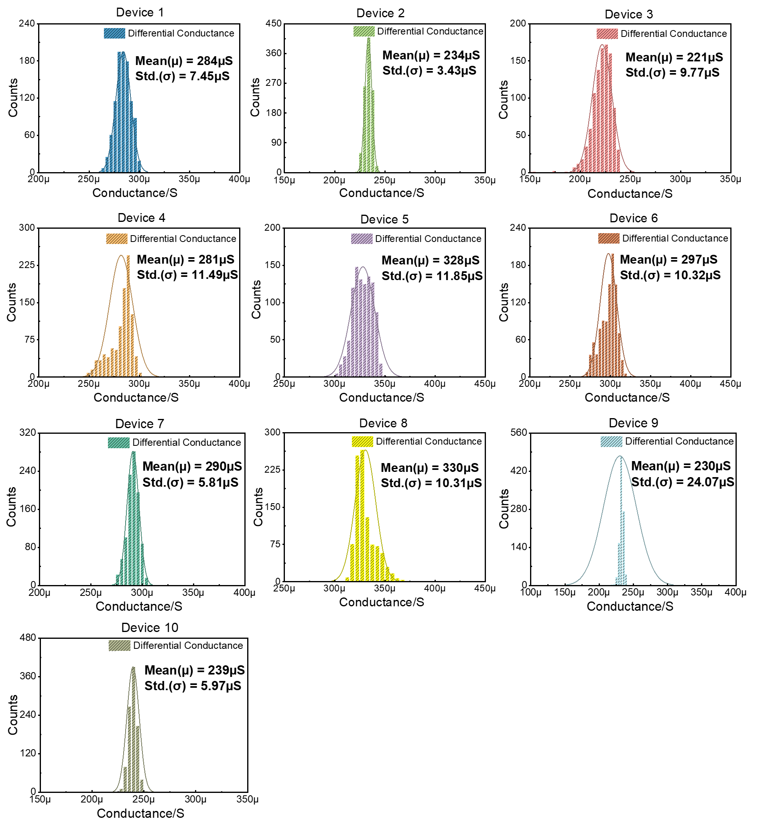

Supplementary Fig. 4. The differential conductance distribution for different devices with 1000 endurance cycles.

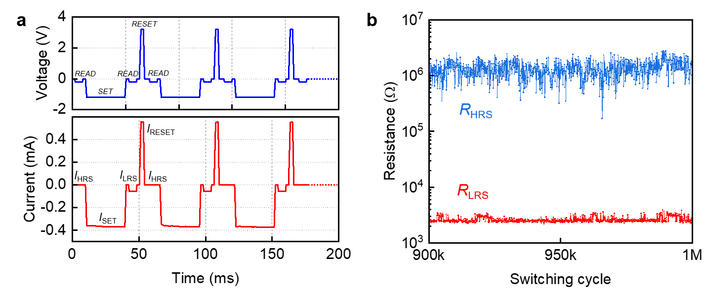

Supplementary Fig. 5. Endurance test. a, The upper panel shows the applied pulse waveform. Each switching cycle contains sequenced READ (HRS)→SET→READ (LRS)→RESET→READ (HRS) operation. The lower panel shows the recorded current signals under the applied pulse voltage stress (V_{READ}: –0.2 V/6 ms, V_{SET}: –1.2 V/30 ms, V_{RESET}: 3.2 V/2 ms). b, A zoomed-in view of the endurance plot (Fig. 1e) from switching cycle 9×10⁵ to 10⁶.

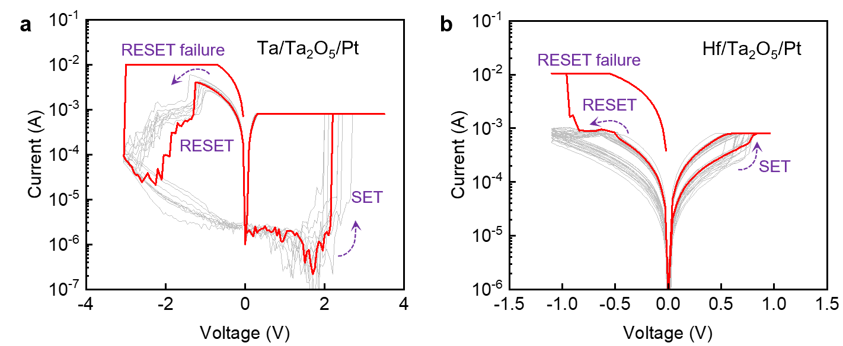

Supplementary Fig. 6. Comparison of electrical characteristics. a, I-V characteristics of a Ta/Ta₂O₅/Pt and b, Hf/Ta₂O₅/Pt valence change memory. The red curve shows a typical device failure at the RESET voltage sweep. The sudden increase of the current implies the massive generation of oxygen defects at the Ta₂O₅ layer, making the device stuck at LRS. The high voltage drop across the Schottky-like interface can lead to RESET failure due to the excessive generation of oxygen vacancies. This is also ascribed in part by the low (negative) oxygen vacancy formation energy in Ta₂O₅ layer. For the ohmic memristive devices, no reset failure was observed during the I−V sweeps (under the same operation parameters) and pulse measurements (Fig. 1d,e), indicating an improvement in device reliability in the ohmic memristive system.

Supplementary Fig. 7. Flowchart of the write-verify programming algorithm. It mainly includes two modules as SET and RESET, both work in negative feedback principle.

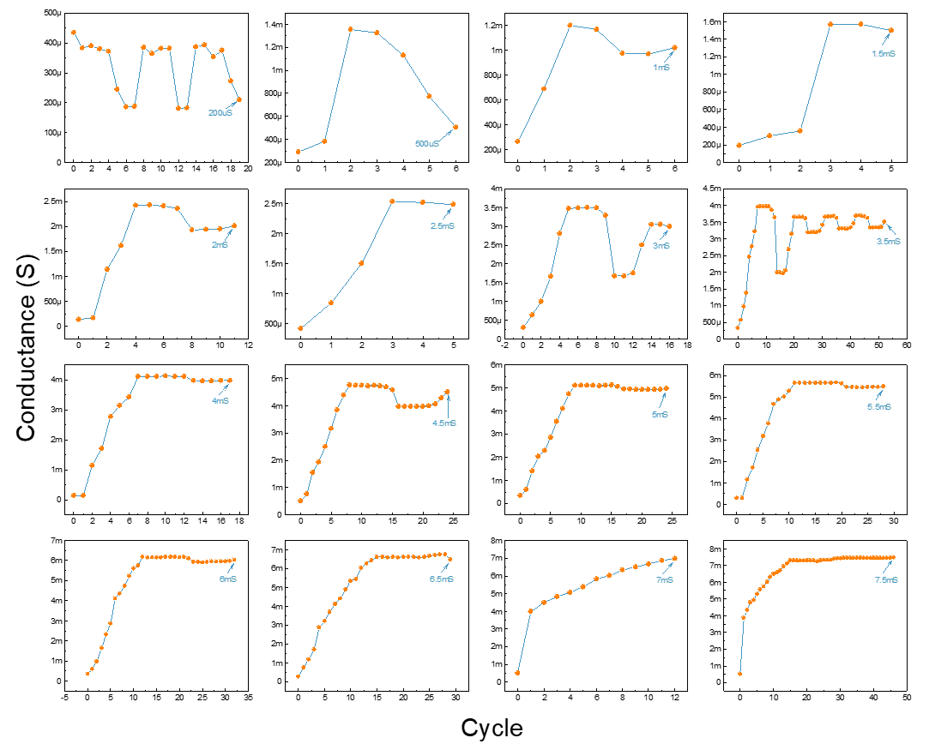

Supplementary Fig. 8. Examples of the device conductance variation under the write-verify scheme.

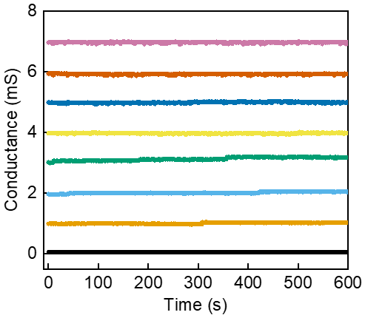

Supplementary Fig. 9. Stability of analogue switching. Retention of multiple LRS levels with 0.1 V read bias, all conductance states show no distinguishable degradation for more than 600 s.

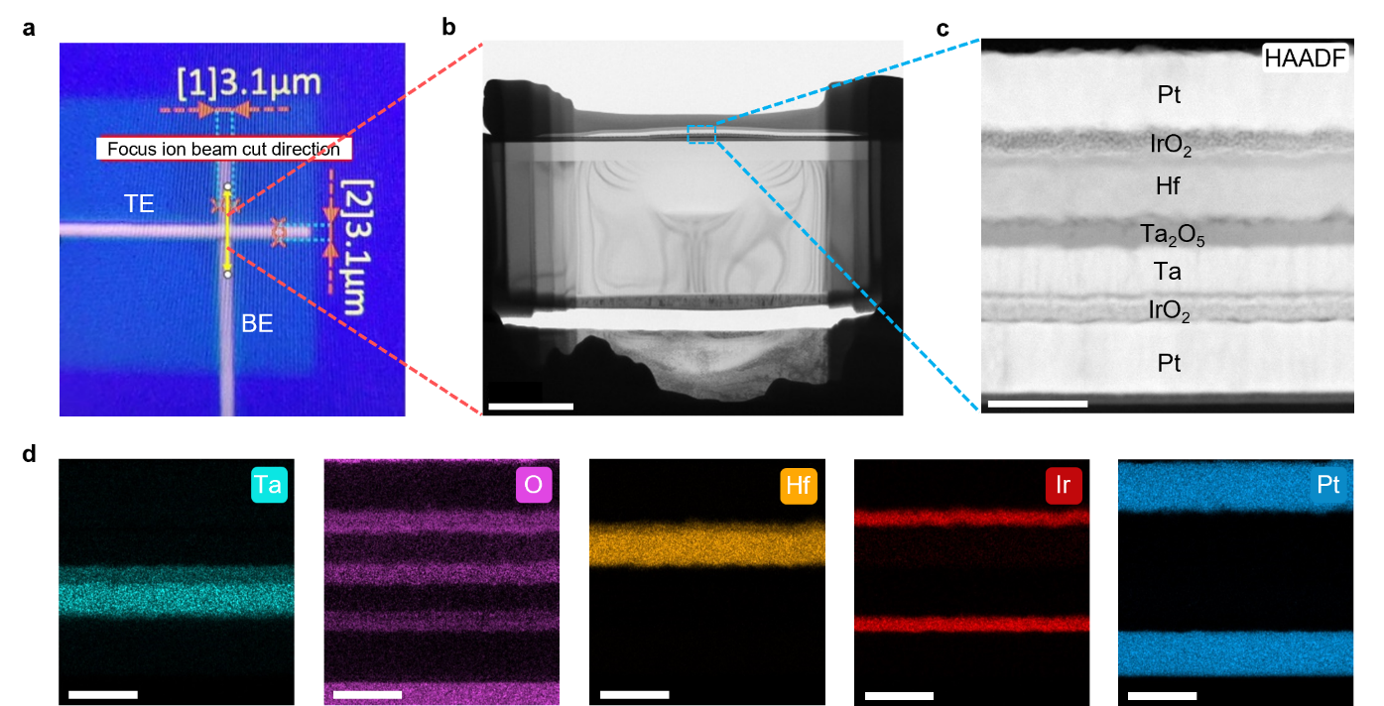

Supplementary Fig. 10. Cross-sectional TEM and energy-dispersive X-ray spectroscopy characterization. a, Schematic of the crossbar intersection and the direction for focus ion beam treatment. b, TEM lamella prepared by focus ion beam. Scale bar, 2 μm. c, High-angle annular dark-field TEM image showing the stack information. Scale bar, 50 nm. d, EDS spectra of each layer. The element species are indicated in the upper right of each panel. Scale bar, 50 nm.

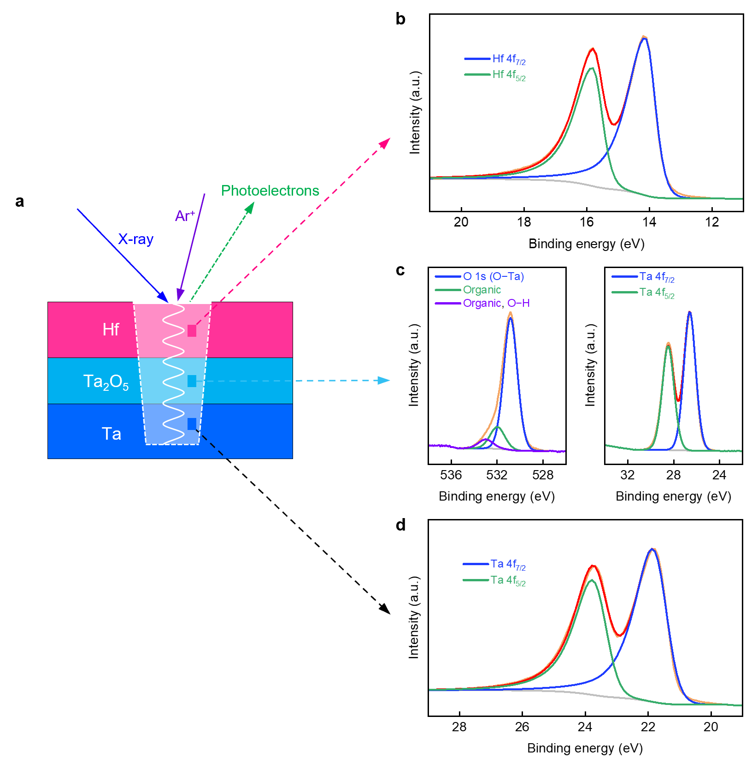

Supplementary Fig. 11. X-ray photoelectron spectroscopy (XPS) depth profiling. a, Schematic illustration of XPS depth profiling performed on the Hf/Ta₂O₅/Ta device. By using monatomic Ar⁺ as a sputtering source it allows to obtain vertical chemical profiles of the memristive device. The results reveal the presence of metallic Hf component (b), stoichiometric Ta₂O₅ (c), and metallic Ta component (d). We also performed XPS depth profiling on Ta/Ta₂O₅/Ta, Zr/Ta₂O₅/Ta samples, all results reveal the metallic phase of the top electrode and bottom electrode.

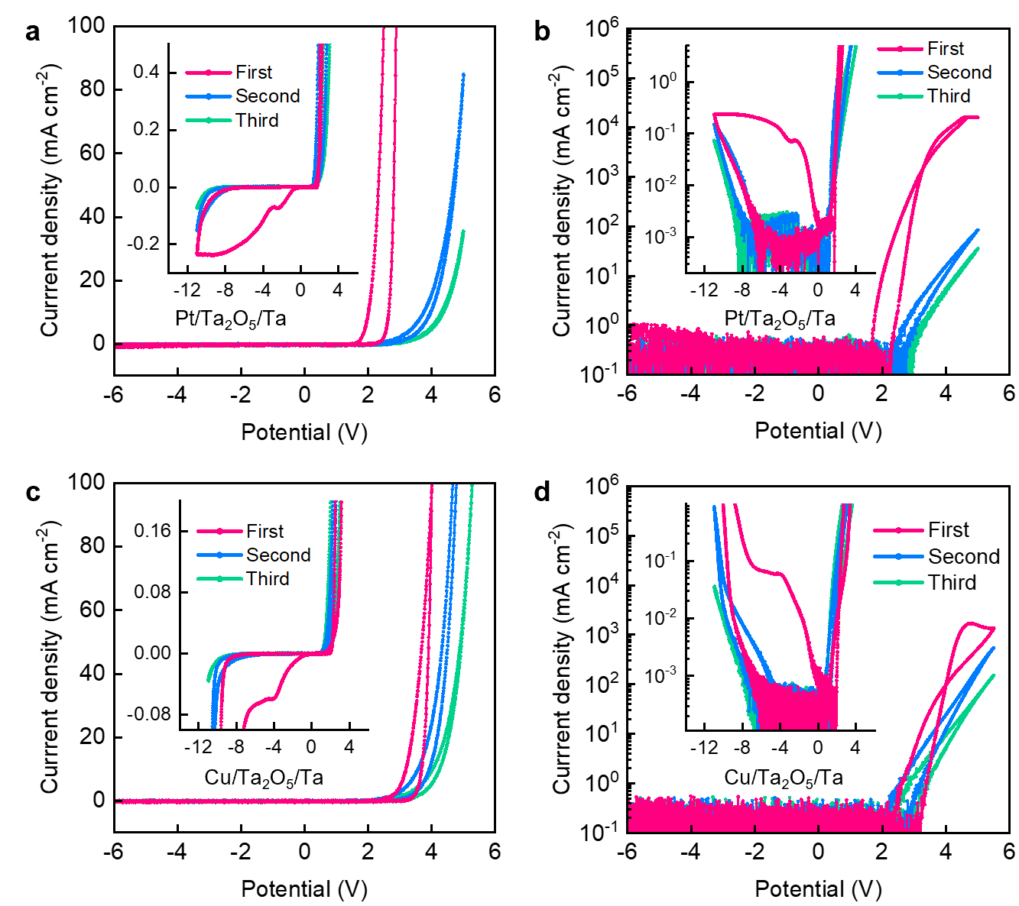

Supplementary Fig. 12. Diode-like electrical properties. a, Cyclic voltammograms Pt/Ta₂O₅/Ta and c, Cu/Ta₂O₅/Ta devices. b and d show the CVs on a logarithmic scale. The insets show zoom-in CVs.

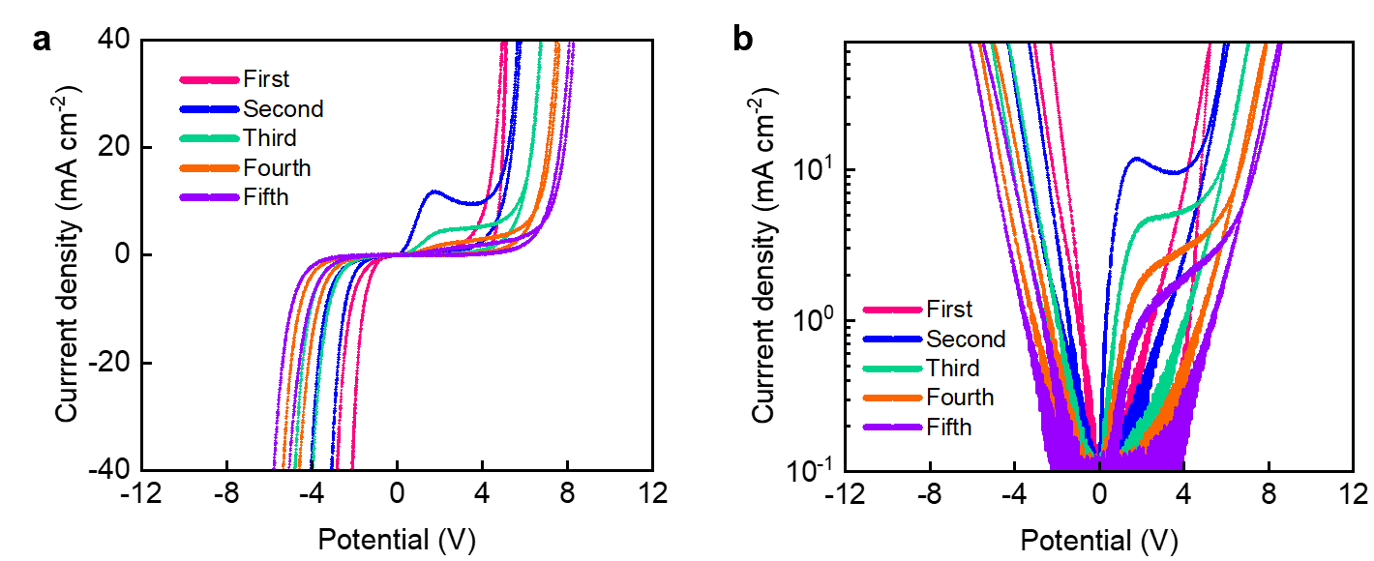

Supplementary Fig. 13. Cyclic voltammograms in Ta vs. Hf ohmic memristive systems. a, CVs when the electrical potentials were applied to Ta electrodes. b, CV presented in semilogarithmic scale. Here, the oxidation current density peaks are more pronounced, compared to Hf vs. Ta, Ta vs, Ta and Zr vs. Ta (see Fig. 2b and Supplementary Fig. 14).

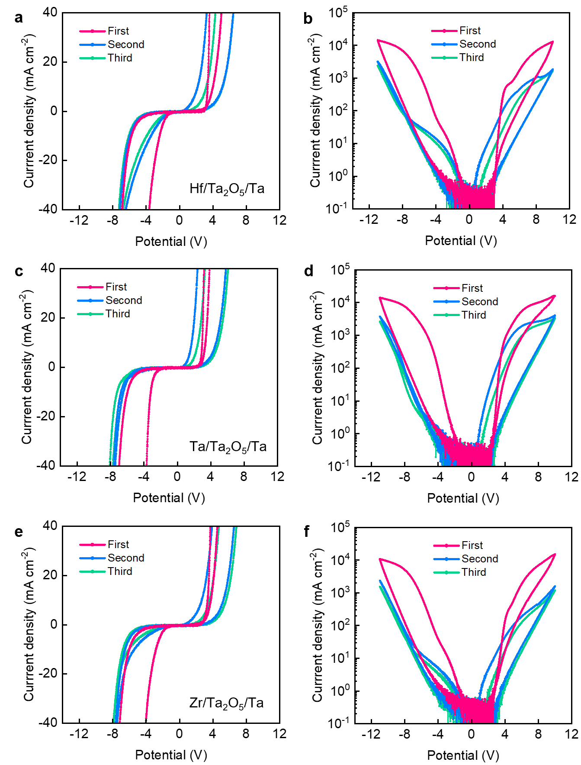

Supplementary Fig. 14. Cyclic voltammograms in ohmic memristive systems. a,b, Hf/Ta₂O₅/Ta. c,d,: Ta/Ta₂O₅/Ta. e,f,: Zr/Ta₂O₅/Ta. The CVs are presented in linear scale in a, b and c. In panels b, d and f the CVs are presented in semilogarithmic scale.

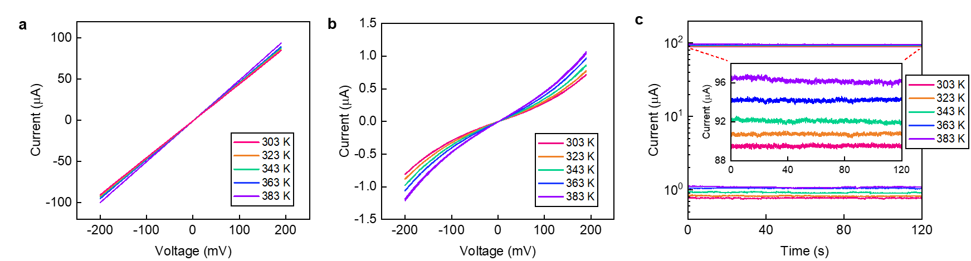

Supplementary Fig. 15. Temperature-dependent electrical characteristics in ohmic memristive devices. a, Temperature-dependent I-V characteristics at LRS. The LRS current has a linear dependence on the voltage under various temperatures. b, Temperature-dependent I-V characteristics at HRS. c, Retention of HRS and LRS currents at various temperature conditions. Both HRS and LRS currents increase with increasing temperature.

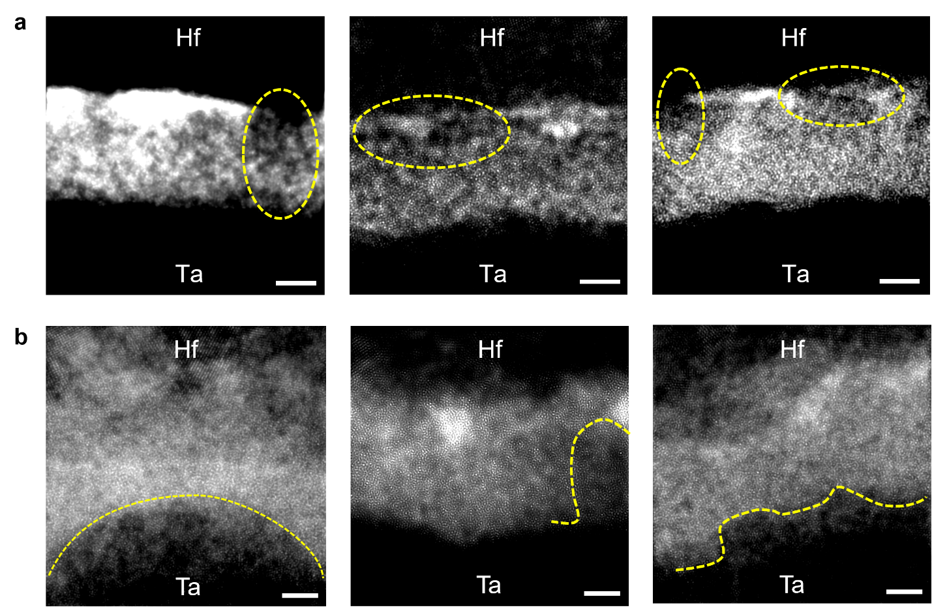

Supplementary Fig. 16. Additional TEM image showing the filament formation. a, Formation of the Ta conduction channel at the cathode (Hf) interface. The conduction channel grows toward the anode (Ta) under the applied electrical potential. Scale bar, 4 nm. b, Formation of the O-deficient (Ta-rich) clusters when the top Hf electrode was positively biased. The ohmic electrode Hf scavenges oxygen (O²⁻) from the oxide and the IrO₂ layer (see Fig. 4k and Supplementary Fig. 19), generating oxygen vacancies at the cathode (Ta) interface. Scale bar, 2 nm.

Supplementary Fig. 17. SET kinetics measurement. This figure shows temporal current response under applied pulse voltage. The t_{SET} (width of the black arrow) is defined as the time difference between the half of the SET pulse rising edge and the half of the SET current rising edge.

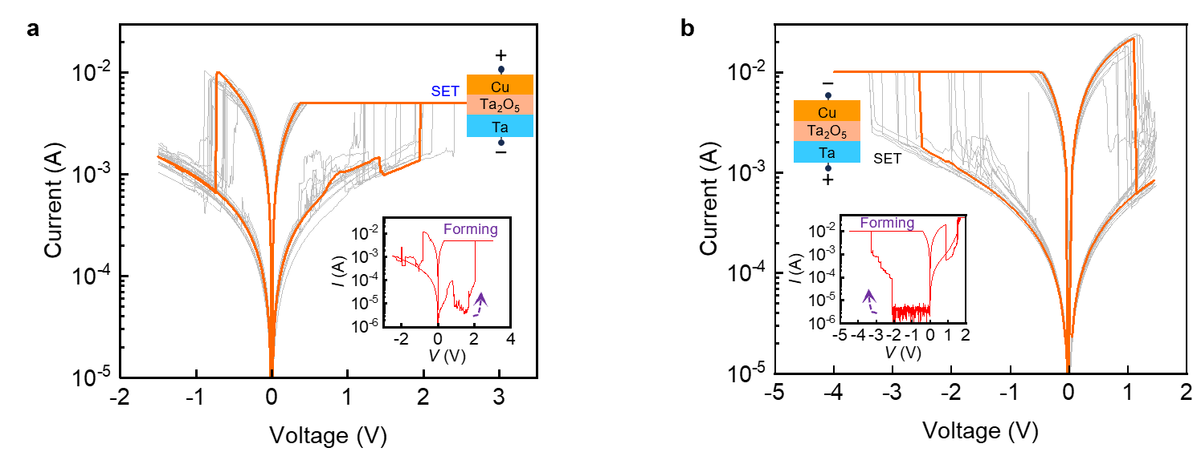

Supplementary Fig. 18. Resistive switching in Cu/Ta₂O₅/Ta based memristive device. a, Typical ECM-type resistive switching when using Cu as active electrode. The forming and SET operations were realized by applying positive voltages to Cu electrode. Inset: forming I-V curve b, ECM-type resistive switching observed when a negative voltage was applied to Cu (positive to Ta) in forming and SET operations. Inset: forming I-V curve.

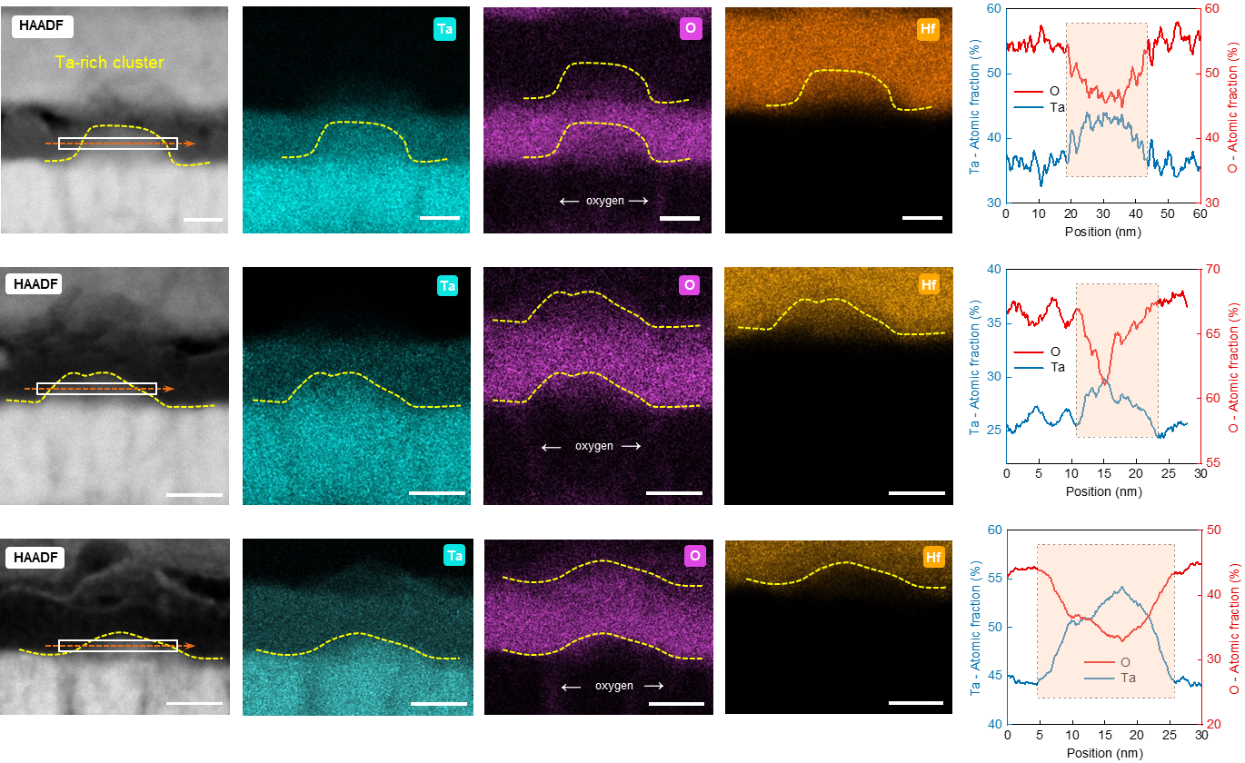

Supplementary Fig. 19. Additional cross-sectional TEM images and EDS profiling. The presented TEM images show the formation of O-deficient clusters at the Ta/Ta₂O₅ interface. The EDS line scan results shown on the right depict the concentration of the Ta and O elements. It can be seen that the cluster regions exhibit a substantial decrease of the O concentration. Scale bars, 10 nm.

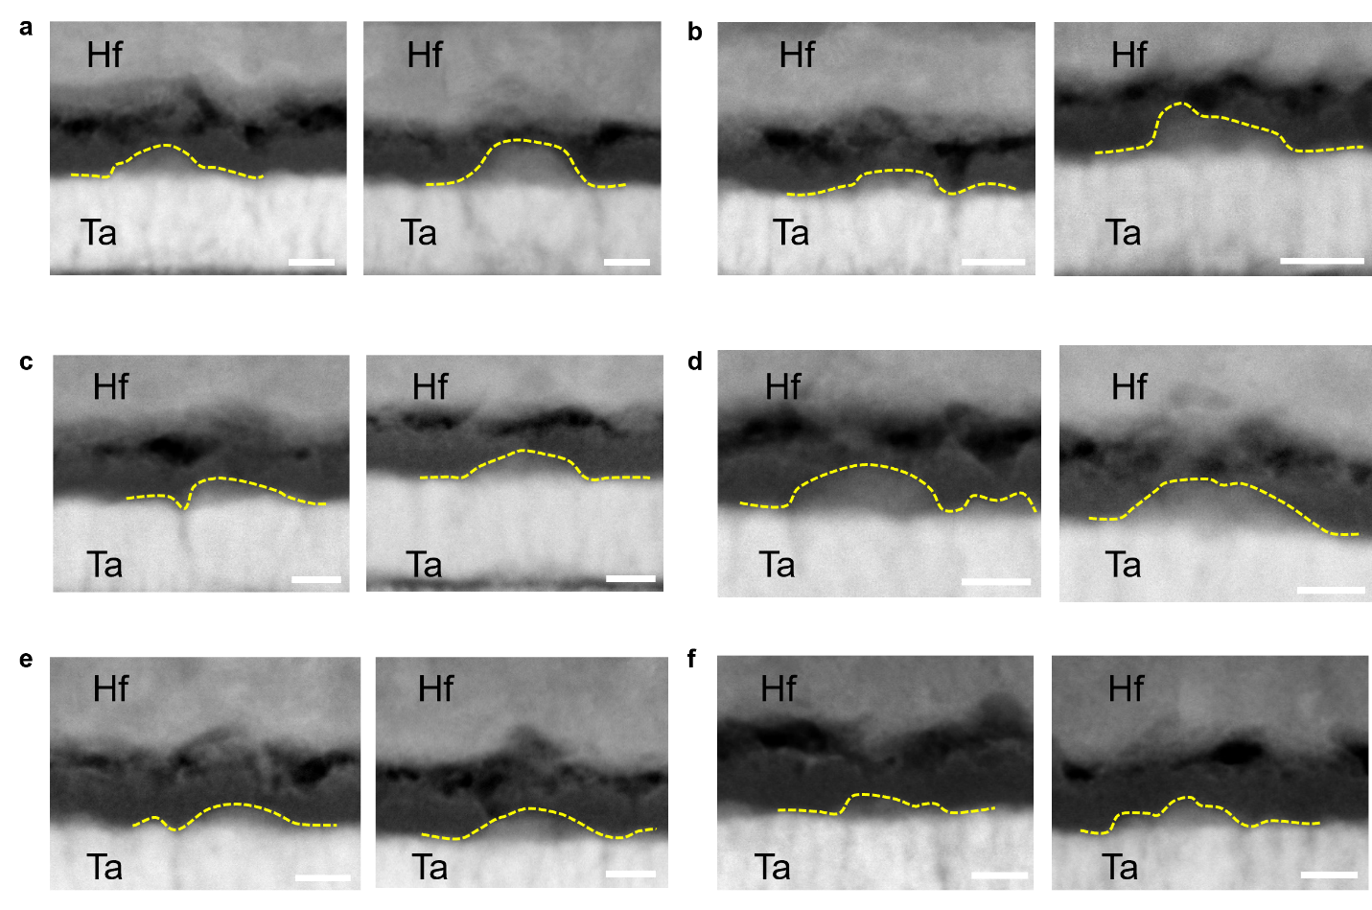

Supplementary Fig. 20. Multiple oxygen-deficient filaments within the oxide layer. Scale bar, 10 nm.

Supplementary Fig. 21. Three different tasks for testing the neural-networks continual learning capacity.

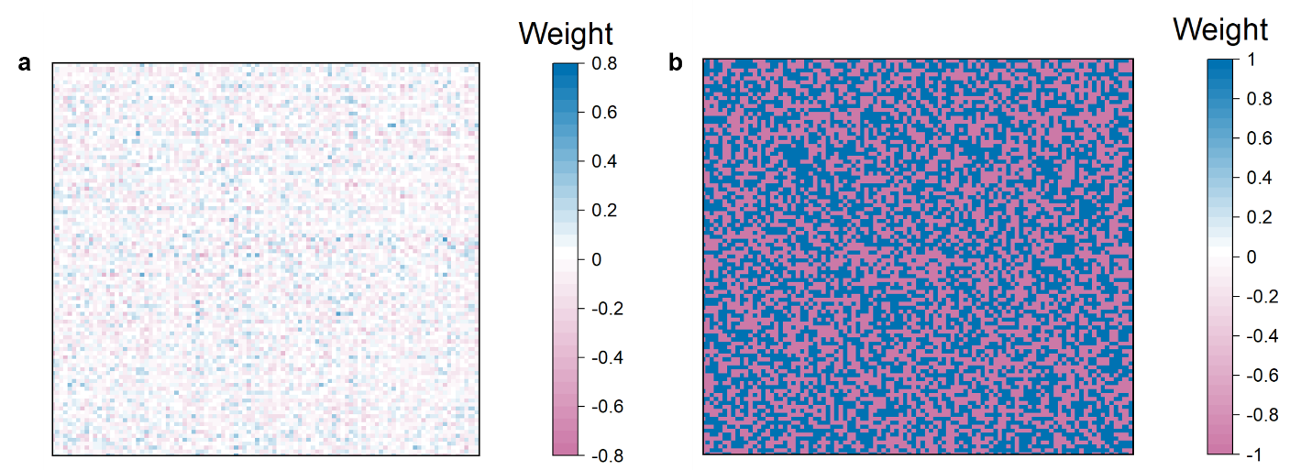

Supplementary Fig. 22. Weights mapping for part of the hidden layer, including the float-point and binary-value format.

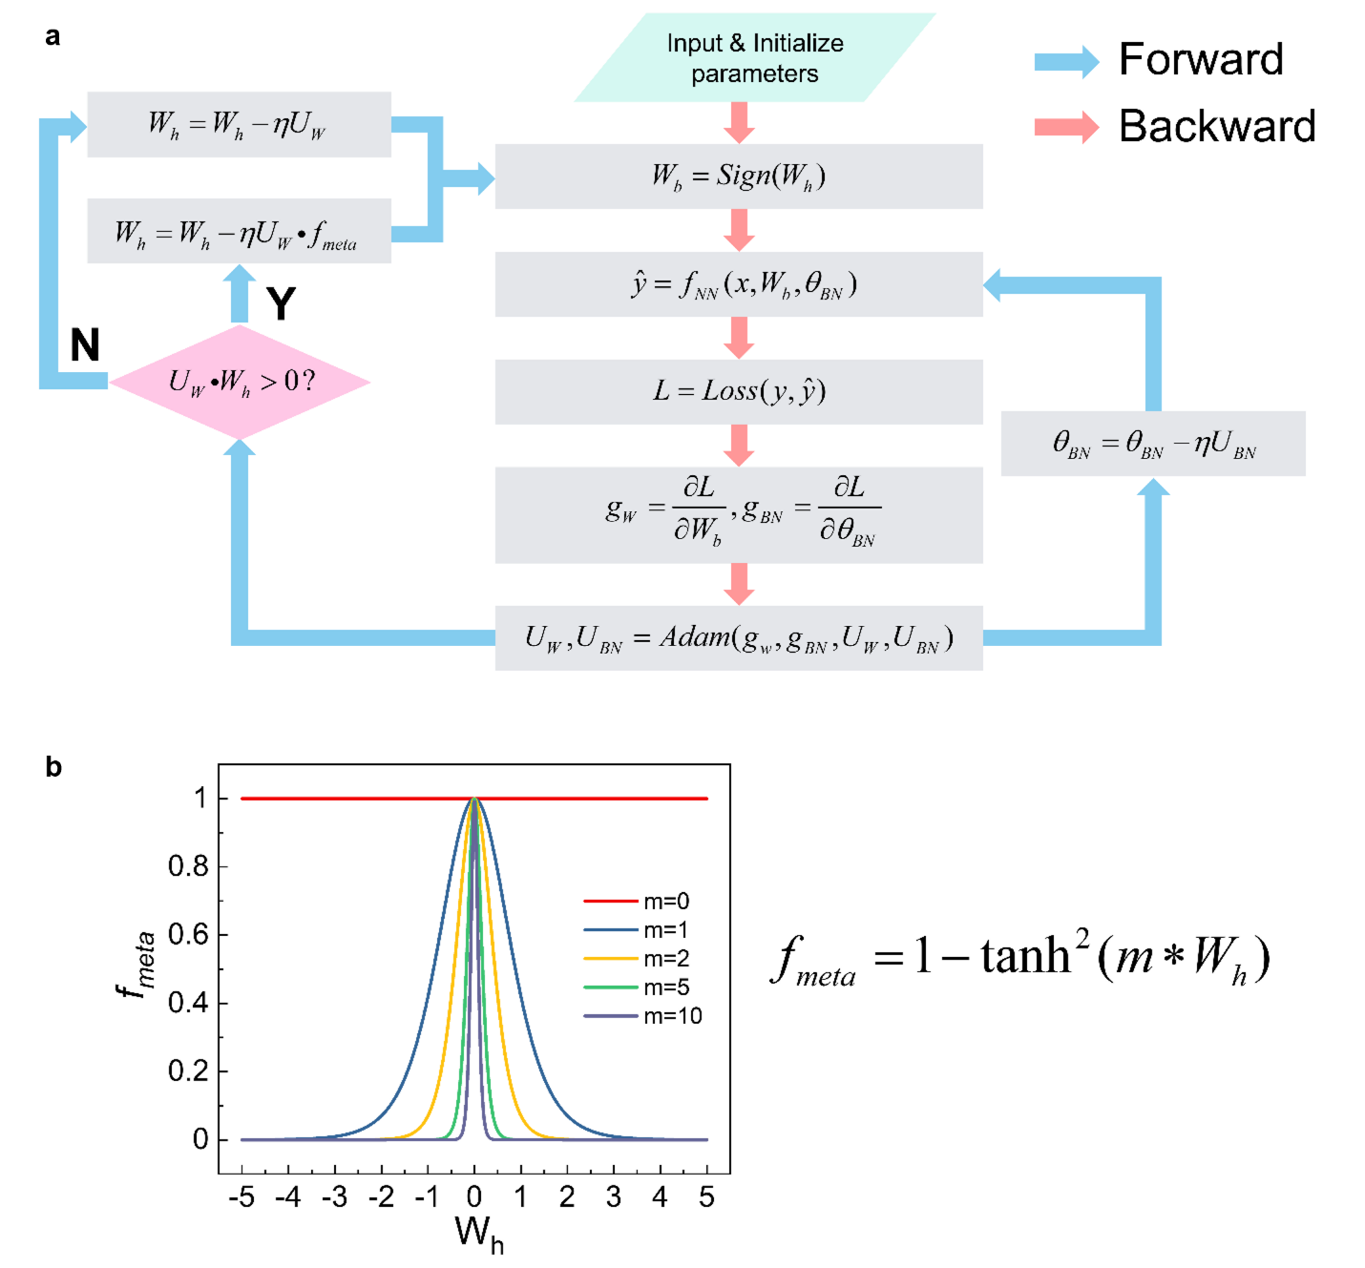

Supplementary Fig. 23. Calculation process for the metaplasticity-inspired neural network. a, Schematic of the forward and backward procedure in the neural network computation process, where the binary-value weights are adopted for inference and the analog-value hidden weights are updated

with a nonlinear function and gradients. b, The nonlinear function f_{meta} whose variables include hyperparameters m and analog-value weights W_{h}.

Supplementary Fig. 24. The hardware architecture for implementing metaplasticity-inspired continual learning. There are two kinds of memristor arrays, which are both based on the novel ohmic memristors. To represent the positive and negative weight values, the differential structure is employed, in which two devices correspond to one weight in the neural network. Considering the time-consuming programming procedures of analog weights, the hidden buffer module is set for storing the value of the hidden weights temporarily, once the training processes for the new tasks are finished, the analog weight module will get programmed from the hidden weight buffer.

Supplementary Fig. 25. The quantized details between the devices’ conductances and neural network’s weight values. For taking the measured devices’ weights into the neural network model, the real weights samples from N(273.8µS,(39.88µS)²), which is the statistics in Supplementary Fig. 4. The hidden weights samples from U(W_{min}, W_{max}), the uniform distribution is controlled by the feedback programming method. Both for the real weights and hidden weights, the linear scale factor λ is adopted to better map the real device conductance into model weights, and the linear mapping of hardware parameters can ensure no difference in the final neural network results.

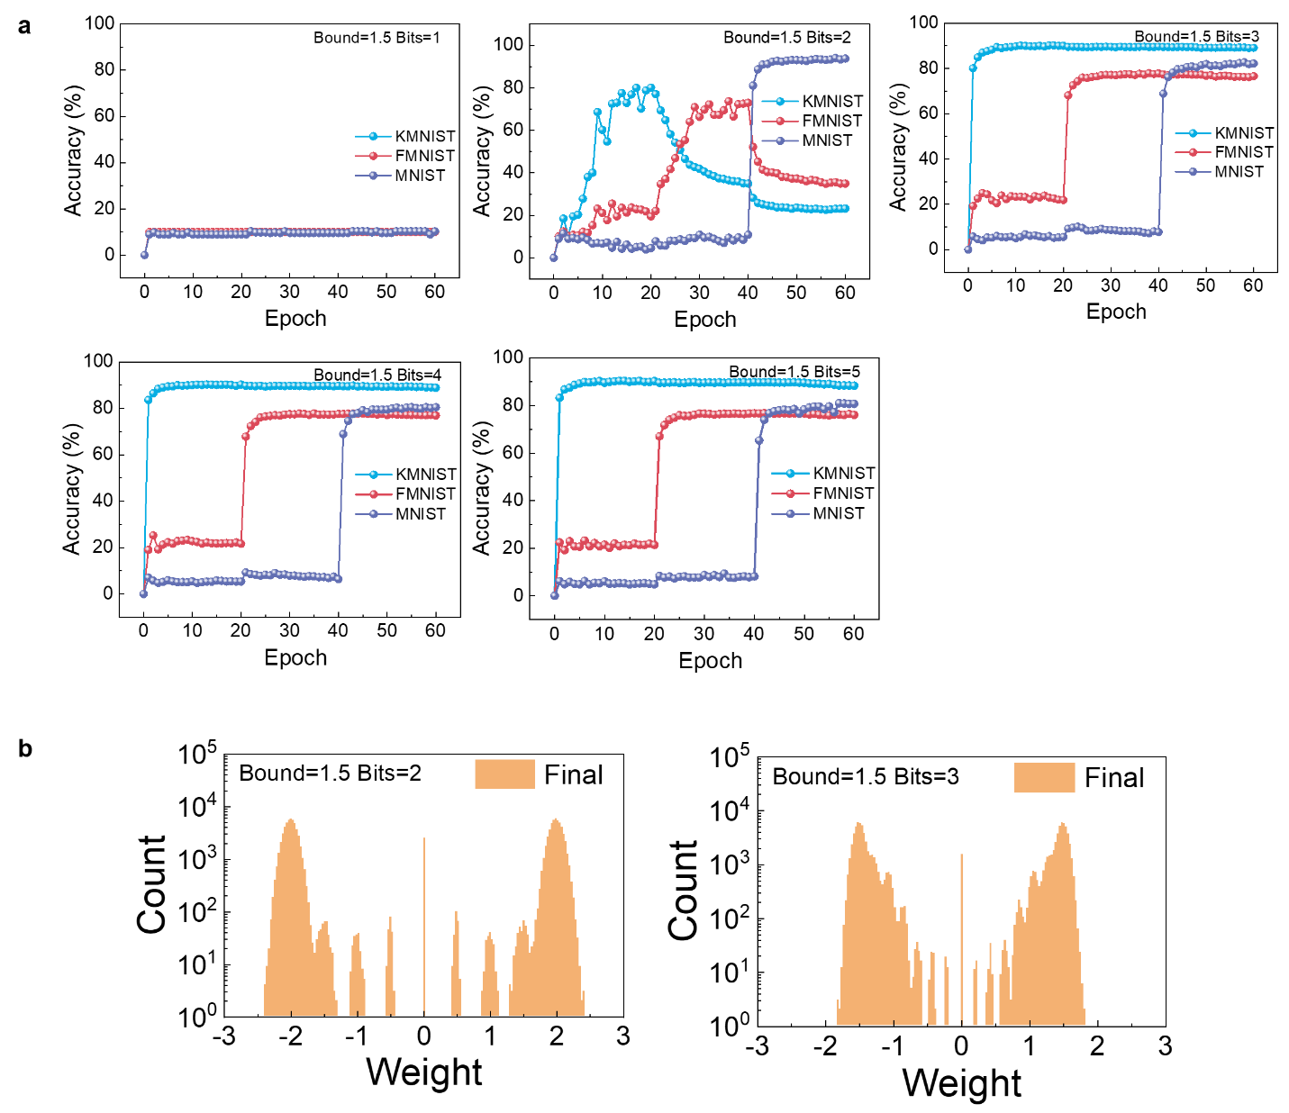

Supplementary Fig. 26. Network performance for different quantized bits precision within the same quantized bounds. a, The quantized bound was chosen at 1.5. b, The final weights distribution of the output layer (500 × 200) for the 2-bit and 3-bit precision.

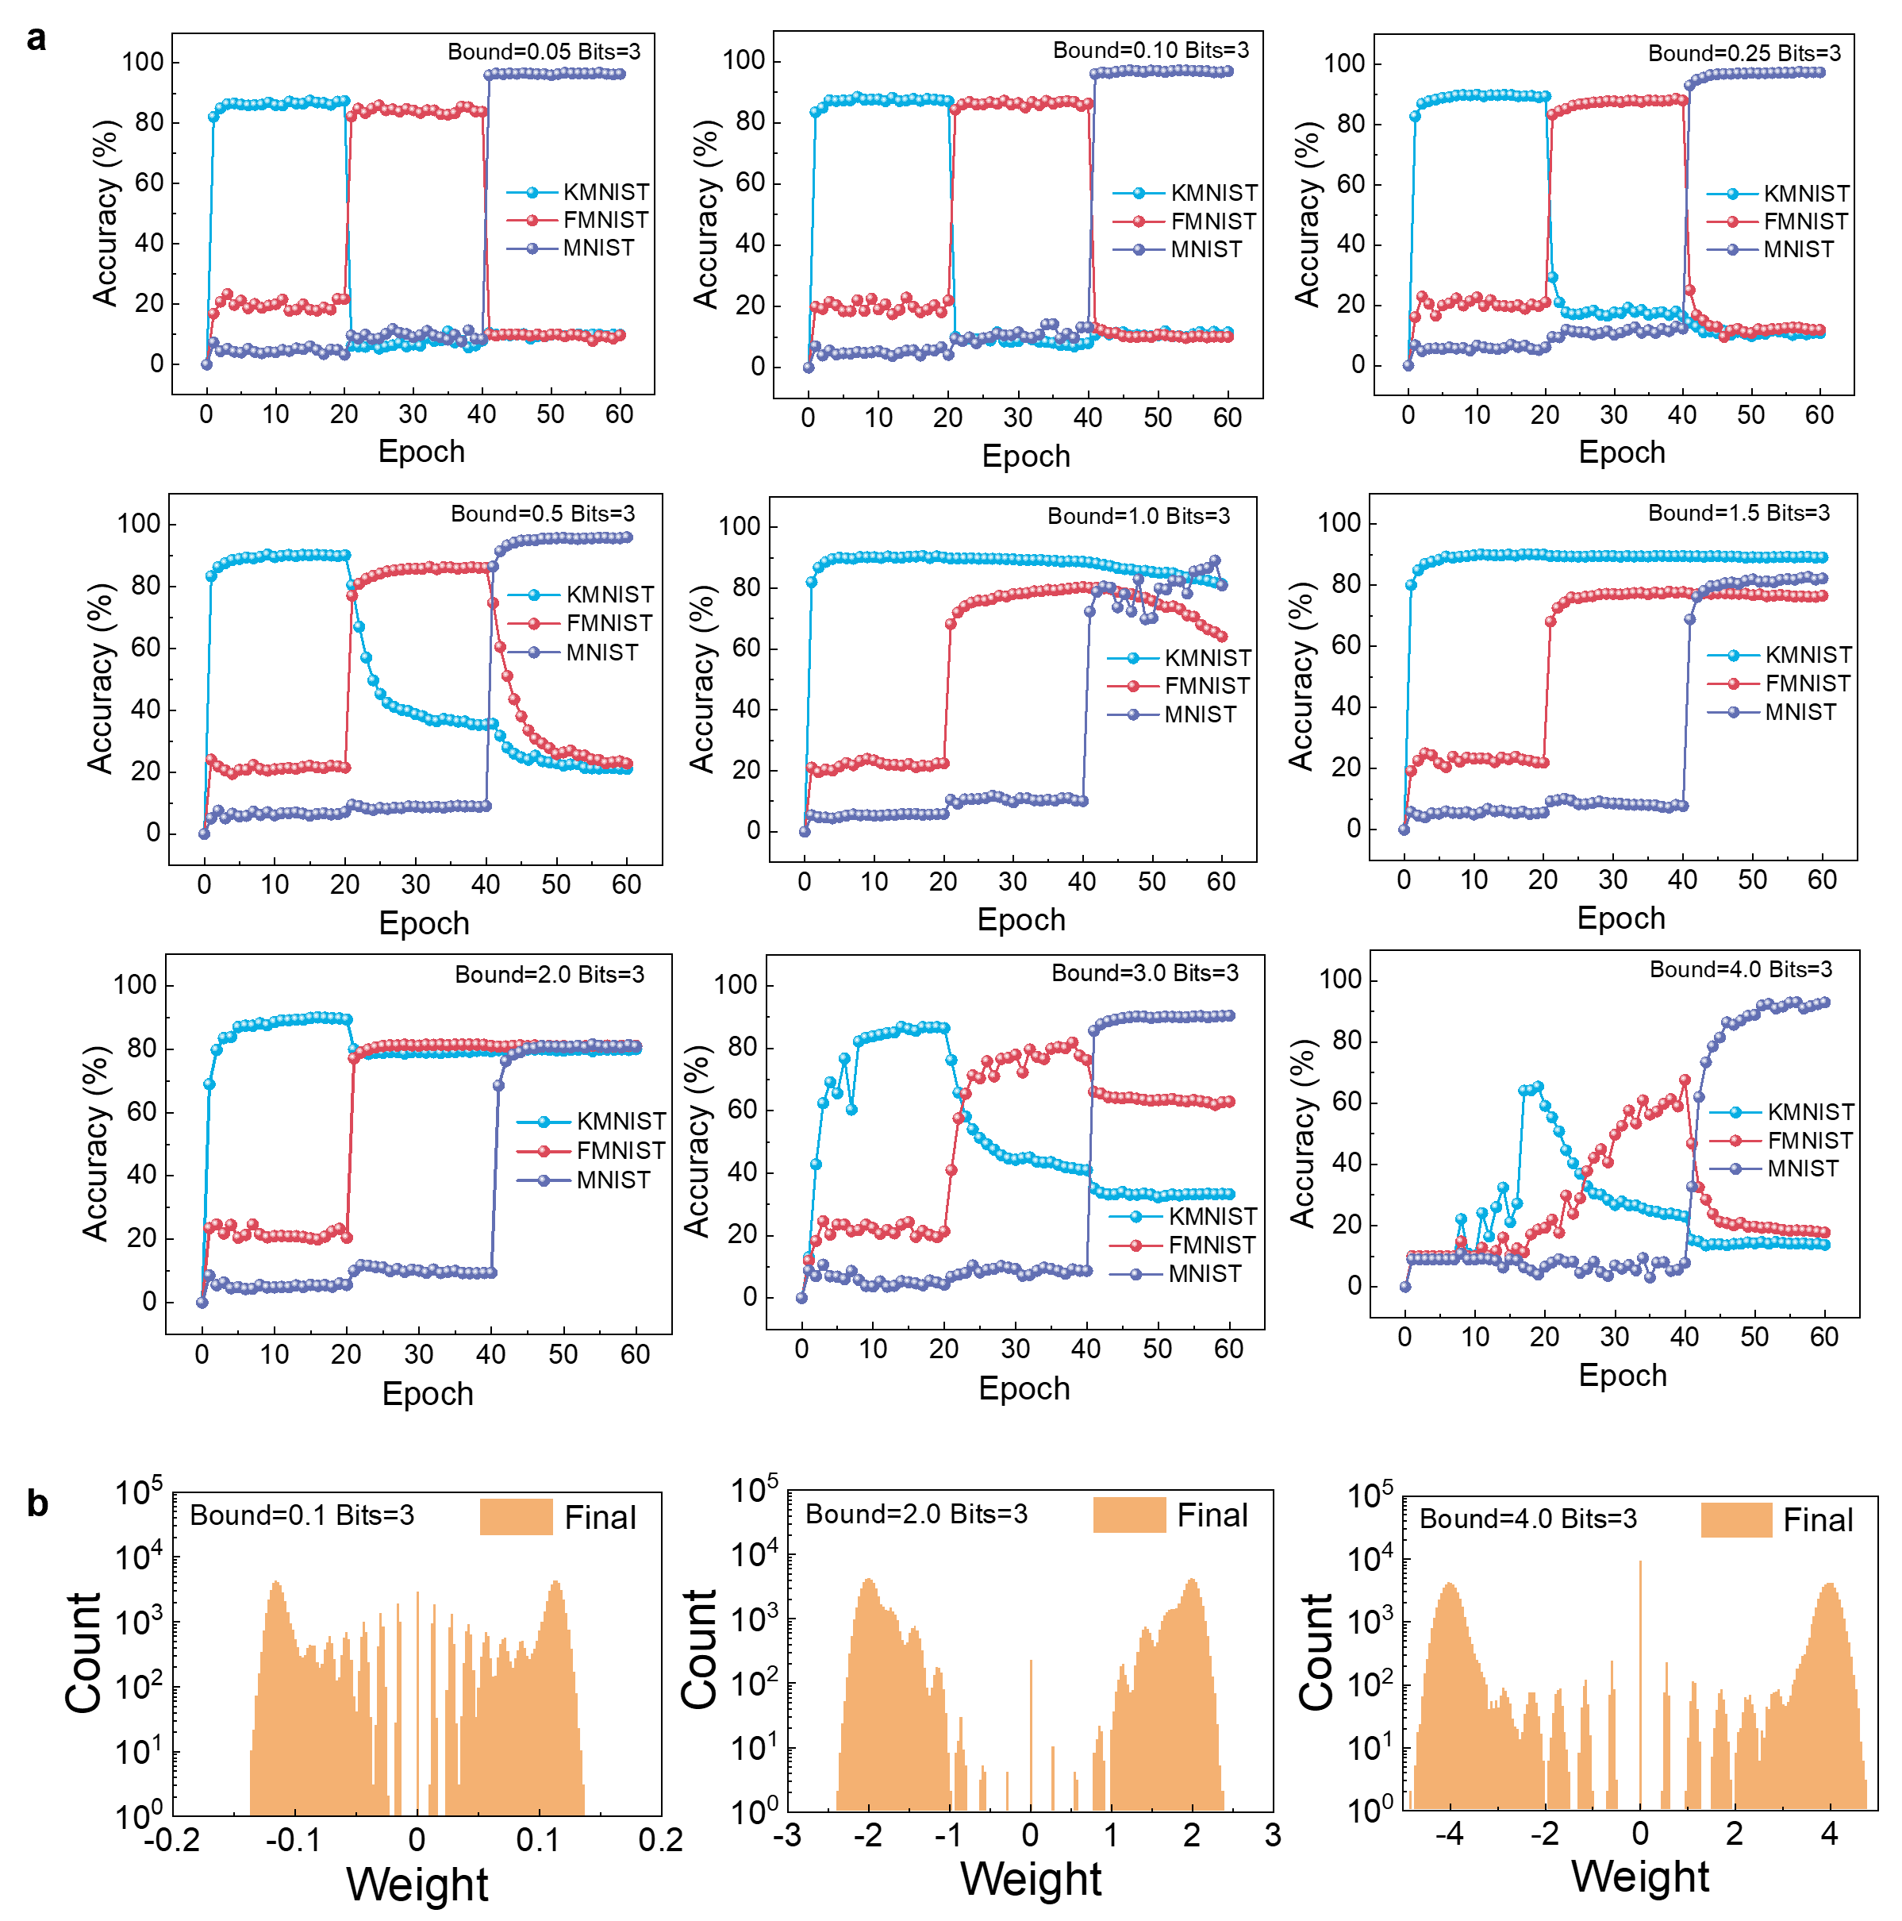

Supplementary Fig. 27. Network performances for different quantized bounds at the same quantized bits. a, The quantized bits were chosen at 3. b, The final weights distribution of the hidden layer (500200) for the quantized bound of 0.1, 2.0 and 4.0, respectively.

Supplementary Fig. 28. The schematic of impact on cell updating when device is stuck at LRS. In the conventional VCMs, such as Ta/Ta₂O₅/Pt and Hf/Ta₂O₅/Pt, the device would be stuck at LRS after frequent programming operations, then the cell weight will be fixed at ±1 or 0. With the interface engineering, the ohmic memristor can better overcome this issue and is suitable for the continual learning application which requires more frequent network training and weights updating.

Supplementary Fig. 29. The schematic of the parallel programming method for devices’ binary switching. To accelerate the binary programming, we employ the parallel programming method, in which a train of designed pulses are input from SL while the corresponding BL is set at a certain level and WL is set at V_{DD}, the different polarity of voltage drop on each memristor cell will enable the device to set or reset. The parallel programming method ensures that device states only depend on the current waveforms and have no relation with previous states.

Supplementary Fig. 30. The effect of different line resistances and cell ratios on neural network performances. a, The schematic for programming binary weights and analog weights, in which the feedback write-verify method is implemented in analog programming, the final analog weight values include the line resistance, while the binary weight switching without feedback needs to be considered the effect of line resistances. b, The final accuracies of three tasks under different line resistances and cell ratios.

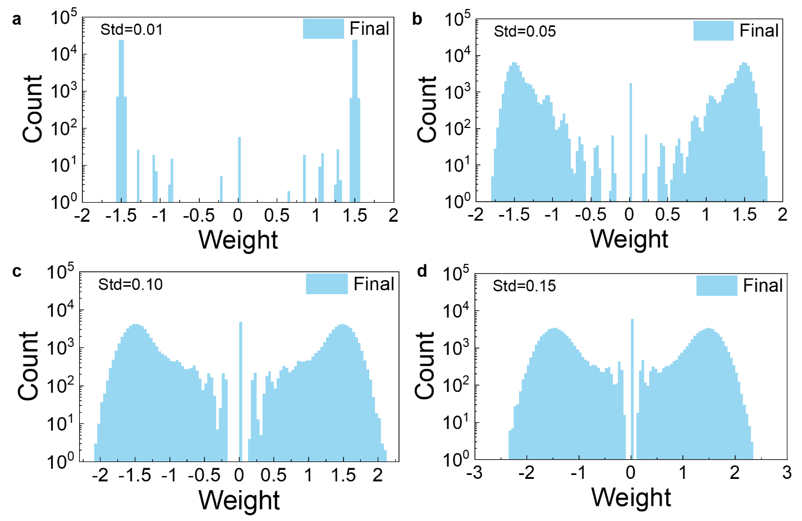

Supplementary Fig. 31. The final weight distributions of the hidden layer (500200) for the different programming errors at the standard variation of 0.01(a), 0.05(b), 0.10(c) and 0.15(d), respectively.

Supplementary Table 1: Intrinsic energy barrier height at metal/Ta₂O₅ interface

Metal | Work function (eV) | Metal-Ta₂O₅ barrier height $eϕ_{Β}$ (eV)
Pt | 5.65 | 2.45 eV
Cu | 4.65 | 1.45 eV
Hf | 3.90 | 0.70 eV
Ta | 4.25 | 1.05 eV
Zr | 4.05 | 0.85 eV

Supplementary Table 2: Standard electrode potentials. This table summarizes the standard electrode potentials ${\text{E}}^{\text{°}}$ (with respect to standard hydrogen electrode) of redox systems. The standard electrode potentials are taken from Ref.³.

Half-cell reaction | ${\text{E}}^{\text{°}}$/V
Pt²⁺/Pt [Pt(OH)₂ + 2e– $\text{⇌}$ Pt + 2OH–] | 0.14
Pt⁴⁺/Pt [PtO₂ + 4H⁺ + 4e– $\text{⇌}$ Pt+ 2H₂O] | 1.00
Pt⁴⁺/Pt²⁺ [PtO₂ + 2H⁺ + 2e– $\text{⇌}$ PtO+ H₂O] | 1.01
Pt²⁺/Pt [Pt²⁺ + 2e– $\text{⇌}$ Pt] | 1.18
Pt²⁺/Pt [PtOH⁺ + H⁺ + 2e– $\text{⇌}$ Pt + H₂O] | 1.2
Pt⁶⁺/Pt⁴⁺ [PtO₃ + 4H⁺ + 2e– $\text{⇌}$ Pt(OH)₂²⁺ + H₂O] | 1.5
Pt⁶⁺/Pt⁴⁺ [PtO₃ + 2H⁺ + 2e– $\text{⇌}$ PtO₂+ H₂O] | 1.7
Cu⁺/Cu [Cu₂O + H₂O + 2e– $\text{⇌}$ 2Cu + 2OH–] | –0.360
Cu²⁺/Cu [Cu(OH)₂ + 2e– $\text{⇌}$ Cu + 2OH–] | –0.222
Cu²⁺/Cu⁺ [2Cu(OH)₂ + 2e– $\text{⇌}$ Cu₂O+ 2OH– + H₂O] | –0.080
Cu²⁺/Cu⁺ [Cu²⁺ + e– $\text{⇌}$ Cu⁺] | 0.153
Cu²⁺/Cu [Cu²⁺ + 2e– $\text{⇌}$ Cu] | 0.3419
Cu⁺/Cu [Cu⁺ + e– $\text{⇌}$ Cu] | 0.521
Cu³⁺/Cu²⁺ [Cu₂O₃ + 6H⁺ + 2e– $\text{⇌}$ 2Cu²⁺ + 3H₂O] | 2.0
Cu³⁺/Cu²⁺ [Cu³⁺ + e– $\text{⇌}$ Cu²⁺] | 2.4
Hf⁴⁺/Hf [Hf⁴⁺ + 4e– $\text{⇌}$ Hf] | –1.55
Hf⁴⁺/Hf [HfO₂ + 4H⁺ + 4e– $\text{⇌}$ Hf + 2H₂O] | –1.505
Hf⁴⁺/Hf [HfO²⁺ + 2H⁺ + 4e– $\text{⇌}$ Hf + H₂O] | –1.724
Hf⁴⁺/Hf [HfO(OH)₂ + H₂O + 4e– $\text{⇌}$ Hf + 4OH–] | –2.50
Ta³⁺/Ta [Ta³⁺ + 3e– $\text{⇌}$ Ta] | –0.6
Ta⁵⁺/Ta [Ta₂O₅ + 10H⁺ + 10e– $\text{⇌}$ 2Ta + 5H₂O] | – 0.75
Zr⁴⁺/Zr [Zr⁴⁺ + 4e– $\text{⇌}$ Zr] | –1.45
Zr⁴⁺/Zr [ZrO₂ + 4H⁺ + 4e– $\text{⇌}$ Zr + 2H₂O] | –1.553
Zr⁴⁺/Zr [ZrO(OH)₂ + H₂O + 4e– $\text{⇌}$ Zr + 4OH–] | –2.36

References

1. Kindsmüller, A. et al. Valence change detection in memristive oxide based heterostructure cells by hard X-ray photoelectron emission spectroscopy. APL Mater. 6, 046106 (2018).
2. Lübben, M. & Valov, I. Active Electrode Redox Reactions and Device Behavior in ECM Type Resistive Switching Memories. Adv. Electron. Mater. 5, 1800933 (2019).
3. CRC Handbook of Chemistry and Physics. (CRC Press, 2016). doi:10.1201/9781315380476.

