Supplementary Information
Contents
Supporting Data 2
Figure S1. Ex vivo supression of eicosanoid production 2
Figure S2. Higher selectivity of AVX420 in the cancer cell lines screen. 3
Figure S3. Comparative profiling of cPLA2α inhibitors 4
Table S1. Compounds in the comparative profiling study 5
Table S2. List of the compounds that reliably clustered with cPLA₂α inhibitors 6
Table S3. Genetic modifications associated with AVX420 sensitivity 7
Table S4: Cancer-related genes that correlated with sensitivity to AVX420 8
Table S5: Cancer-related genes that correlated with sensitivity to cPLA₂α inhibition 9
Figure S4. PLA2G4A expression and sensitivity to cPLA₂α inhibitors. 10
Table S6. Genes associated with resistance to cPLA2α inhibition 11
Figure S5. Sensitivity of cell lines derived from hematological malignancies. 12
Figure S6. AVX420 does not affect the viability of peripheral blood mononuclear cells. 13
Figure S7. AVX420 increases intracellular ROS accumulation and cell death. 14
Table S7. Differentially expressed genes. 15
Table S8. Differential ribosomal occupancy. 16
Table S9. Gene set enrichment analysis performed on ribosomoal occupancy data 17
Table S10. Gene set enrichment analysis performed on differential expression data 18
Supplemental Methods 19
Synthesis of Inhibitors 19
Cancer cell line screening 45
Cell proliferation assays 45
Compound activity profiling 46
Identification of genetic modifications associated with inhibitor sensitivity. 46
Correlation of gene expression with drug response. 47
Gene set enrichment and overlap analyses. 47
HPLC chromatograms of inhibitors 49
Figure S8. HPLC chromatogram of inhibitor 17a 49
Figure S9. HPLC chromatogram of inhibitor 17b 49
Figure S10. HPLC chromatogram of inhibitor 17c 50
Figure S11. HPLC chromatogram of inhibitor 17d 50
Figure S12. HPLC chromatogram of inhibitor 17g 51
Figure S13. HPLC chromatogram of inhibitor 17h 51
Figure S14. HPLC chromatogram of inhibitor 17i 52
¹H and ¹³C NMR Traces 53
References 114

Supporting Data

a.
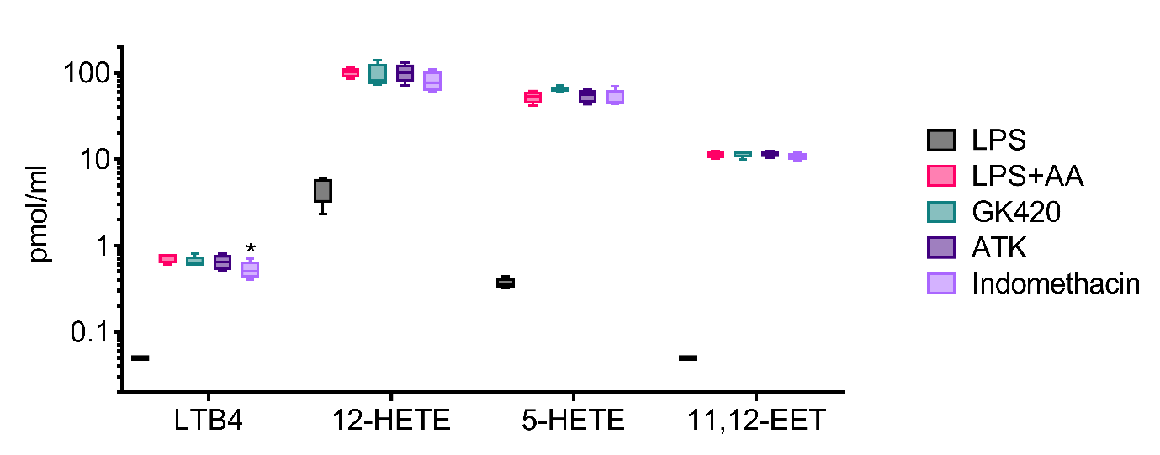
b.
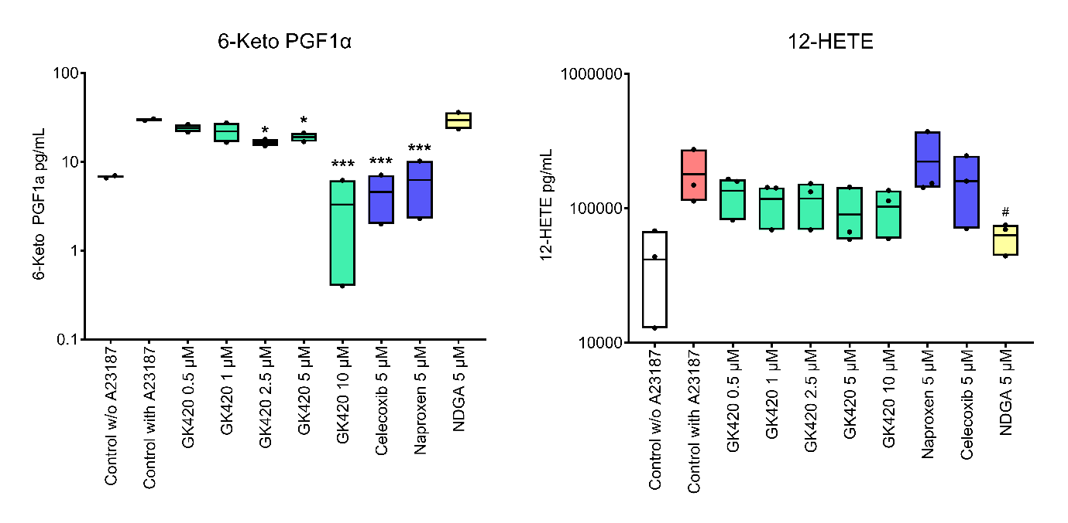
Figure S1. Ex vivo supression of eicosanoid production a. Eicosanoid levels in the plasma of whole blood pretreated with vehicle or inhibitors (AVX420 (3, 10 or 30 µM), ATK (10 µM), indomethacin (1 µM)) before stimulation with LPS (1 µg/ml, 24 h) + 5 µM AA. Data are the mean and stdev, with min and max (whiskers) of the eicosanoid levelsin pmol/mL from 4 healthy blood donors. b. Eicosanoid levels in the supernatants of isolated human PBMCs pretreated with vehicle (DMSO), GK420, naproxen, celecoxib, or NDGA for 90 min before the addition of A23187 (30 µM, 15 min). Data are the mean and stdev, with min and max (whiskers) of the eicosanoid levels in pmol/mL from 2 or 3 blood donors. Repeated measures one-way ANOVA was performed, followed by Dunnets multiple comparison tests between inhibitors and appropriate stimulated control, * indicates p<0.1, ** p<0.05, and *** p<0.01.
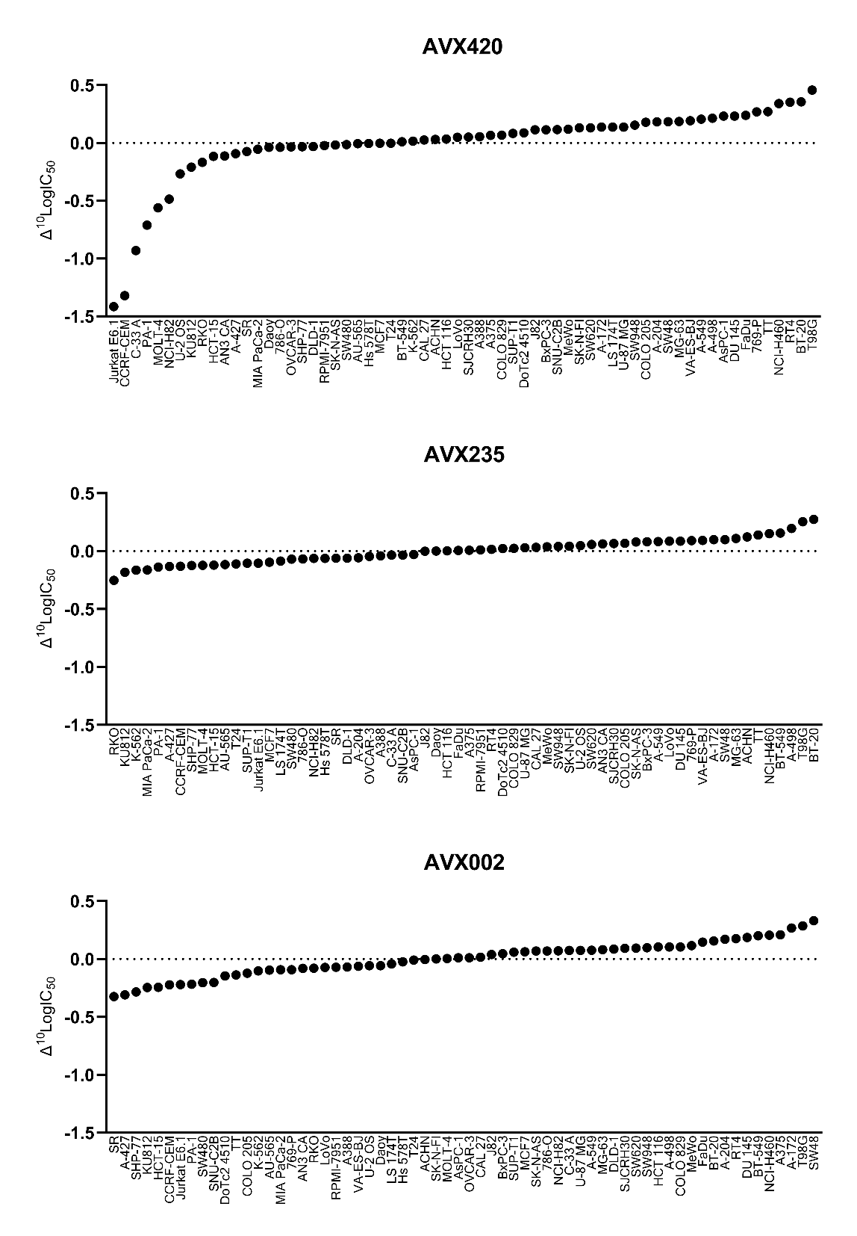

Figure S2. Higher selectivity of AVX420 in the cancer cell lines screen. The charts depict ¹⁰logIC₅₀ values for each cell line relative to the average ¹⁰logIC₅₀ measured in the panel. A number of -1 on the y axis reflects a 10x lower IC₅₀ compared to the panel average for that compound. The average panel ¹⁰logIC₅₀ (IC₅₀ in nM) in this study was 4.17, 4.20 and 3.98, corresponding to IC₅₀ values of 18.4, 16.3 and 10.2 µM for AVX420, AVX235, and AVX002 respectively.

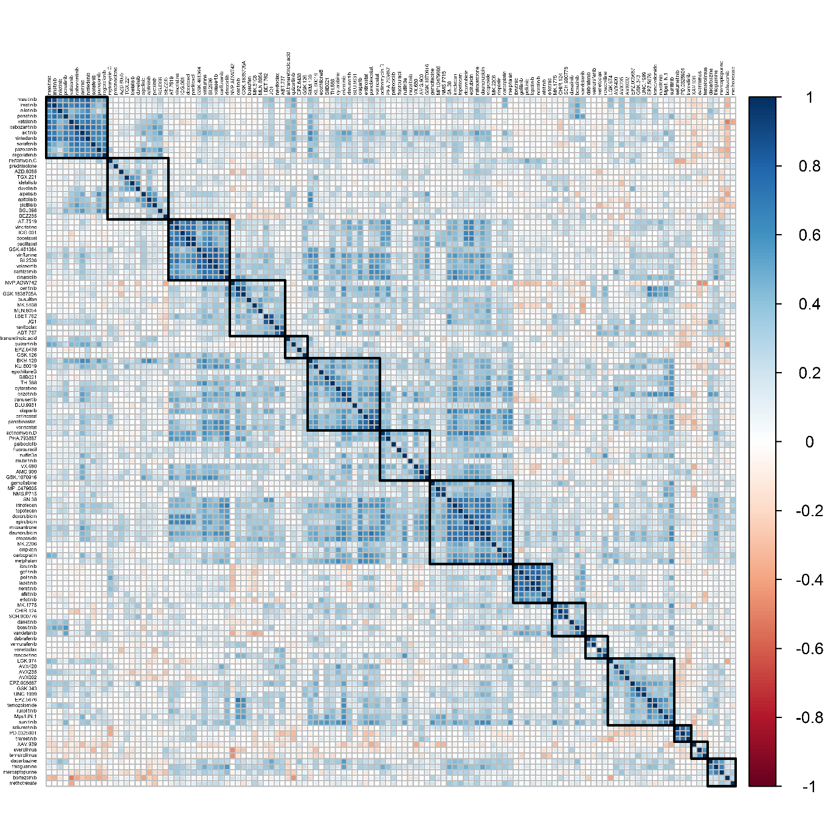
Figure S3. Comparative profiling of cPLA2α inhibitors. Correlation matrix shows the the pearson correlations corr (a,b) between all compound pairs. Rows and columns were ordered according to the results of the unsupervised hierarchical clustering to highlight similarities. The color legend on the right indicates matching values for the Pearson correlation coefficients. Reliable clusters, defined by bootstrapping, are outlined in bold.

Table S1. Compounds in the comparative profiling study

Table S2. List of the compounds that reliably clustered with cPLA₂α inhibitors
Drug | Target
LGK.974 | PORCN
AVX420 | cPLA2
AVX235 | cPLA2
AVX002 | cPLA2
EPZ.005687 | EZH2
GSK.343 | EZH2
UNC.1999 | EZH1/EZH2
EPZ.5676 | DOTL1
Temozolomide | DNA alkylating
Ruxolitinib | JAK2/JAK3
Mps1.IN.1 | TTK
sunitinib | VEGFR/PDGFR

Cancer Gene | IC50 shift | p-value | adj. P-value
ARHGAP35 | -0.75 | 3.55E-06 | 3.77E-04
MLL | -0.65 | 1.15E-05 | 6.09E-04
NRAS | -0.55 | 2.96E-04 | 0.01
PTEN | -0.39 | 3.03E-04 | 0.01
DNMT1 | -0.69 | 3.41E-04 | 0.01
POLE | -0.69 | 3.63E-04 | 0.01
CDK12 | -0.64 | 1.00E-03 | 0.01
MLL2 | -0.33 | 1.01E-03 | 0.01
FLT3 | -0.63 | 1.10E-03 | 0.01
FBXW7 | -0.37 | 1.84E-03 | 0.02
EGFR | -0.4 | 2.39E-03 | 0.02
ING1 | -0.49 | 3.77E-03 | 0.03
ERBB3 | -0.44 | 4.41E-03 | 0.04
ARID1B | -0.43 | 1.00E-02 | 0.09
SMC3 | -0.43 | 1.00E-02 | 0.09
SMARCA4 | -0.33 | 1.00E-02 | 0.09
ARID1A | -0.31 | 2.00E-02 | 0.12
CREBBP | -0.46 | 2.00E-02 | 0.12
ASXL1 | -0.33 | 2.00E-02 | 0.12
TSC1 | -0.35 | 3.00E-02 | 0.13
MET | -0.35 | 3.00E-02 | 0.15
Table S3. Genetic modifications associated with AVX420 sensitivity. A negative IC₅₀ shift indicates that the compound is more potent in cell lines that carry the mutated gene. Bold text indicates gene modifications that were also associated with sensitivity to AVX235.

Table S4: Cancer-related genes that correlated with sensitivity to AVX420
at an FDR of 5%, (adjusted p value < 0.05).
Gene | cor.pearson | p.value.pearson | adjusted.p
TSHR | -0.78082 | 2.06E-12 | 7.42E-10
IKZF1 | -0.61768 | 5.07E-07 | 7.82E-05
RUNX1 | -0.61308 | 6.50E-07 | 7.82E-05
CD1D | -0.60461 | 1.02E-06 | 9.17E-05
ACVR2B | -0.58134 | 3.25E-06 | 0.000235
PBRM1 | -0.48649 | 0.000166 | 0.006005
CHD1 | -0.48125 | 0.0002 | 0.006005
RAD21 | -0.47126 | 0.000282 | 0.007823
MDM4 | -0.46864 | 0.000308 | 0.007938
WHSC1L1 | -0.46031 | 0.000406 | 0.008903
BAP1 | -0.45934 | 0.000419 | 0.008903
SPEN | -0.45502 | 0.000483 | 0.009678
EZH2 | -0.45028 | 0.000562 | 0.010672
PHF6 | -0.44432 | 0.000678 | 0.012239
DNMT3A | -0.4373 | 0.000843 | 0.014131
TDRD9 | -0.43658 | 0.000861 | 0.014131
KAT6A | -0.42641 | 0.001169 | 0.018355
DIAPH1 | -0.42469 | 0.00123 | 0.018466
UHRF2 | -0.42278 | 0.001302 | 0.018466
E2F3 | -0.42075 | 0.001381 | 0.018466
BCOR | -0.40943 | 0.001909 | 0.024617
IKZF2 | -0.40581 | 0.002113 | 0.02608
MGA | -0.4049 | 0.002167 | 0.02608
MED23 | -0.39764 | 0.002645 | 0.02884
ARID1A | -0.39749 | 0.002656 | 0.02884
RBM10 | -0.39632 | 0.002741 | 0.02884
FAM123B | -0.39495 | 0.002844 | 0.02884
CTCF | -0.39454 | 0.002876 | 0.02884
BRCA2 | -0.38315 | 0.003886 | 0.037912

Table S5: Cancer-related genes that correlated with sensitivity to cPLA₂α inhibition
at an FDR of 20% (adjusted p-value<0.2). Pearson’s correlations and associated p values are shown for AVX420.
Gene |  | cor.pearson | p.value.pearson | adjusted.p
IKZF1 |  | -6.18E-01 | 5.07E-07 | 7.82E-05
ACVR2B |  | -5.81E-01 | 3.25E-06 | 2.35E-04
CHD1 |  | -4.81E-01 | 2.00E-04 | 6.00E-03
RAD21 |  | -4.71E-01 | 2.82E-04 | 7.82E-03
MDM4 |  | -4.69E-01 | 3.08E-04 | 7.94E-03
SPEN |  | -4.55E-01 | 4.83E-04 | 9.68E-03
EZH2 |  | -4.50E-01 | 5.62E-04 | 1.07E-02
KAT6A |  | -4.26E-01 | 1.17E-03 | 1.84E-02
DIAPH1 |  | -4.25E-01 | 1.23E-03 | 1.85E-02
E2F3 |  | -4.21E-01 | 1.38E-03 | 1.85E-02
MGA |  | -4.05E-01 | 2.17E-03 | 2.61E-02
MED23 |  | -3.98E-01 | 2.65E-03 | 2.88E-02
KLHL8 |  | -3.61E-01 | 6.84E-03 | 6.20E-02
PHF3 |  | -3.21E-01 | 1.69E-02 | 9.38E-02
MLL4 |  | -2.86E-01 | 3.45E-02 | 1.50E-01
MEN1 |  | -2.67E-01 | 4.89E-02 | 1.88E-01
OMA1 |  | -2.63E-01 | 5.23E-02 | 1.99E-01

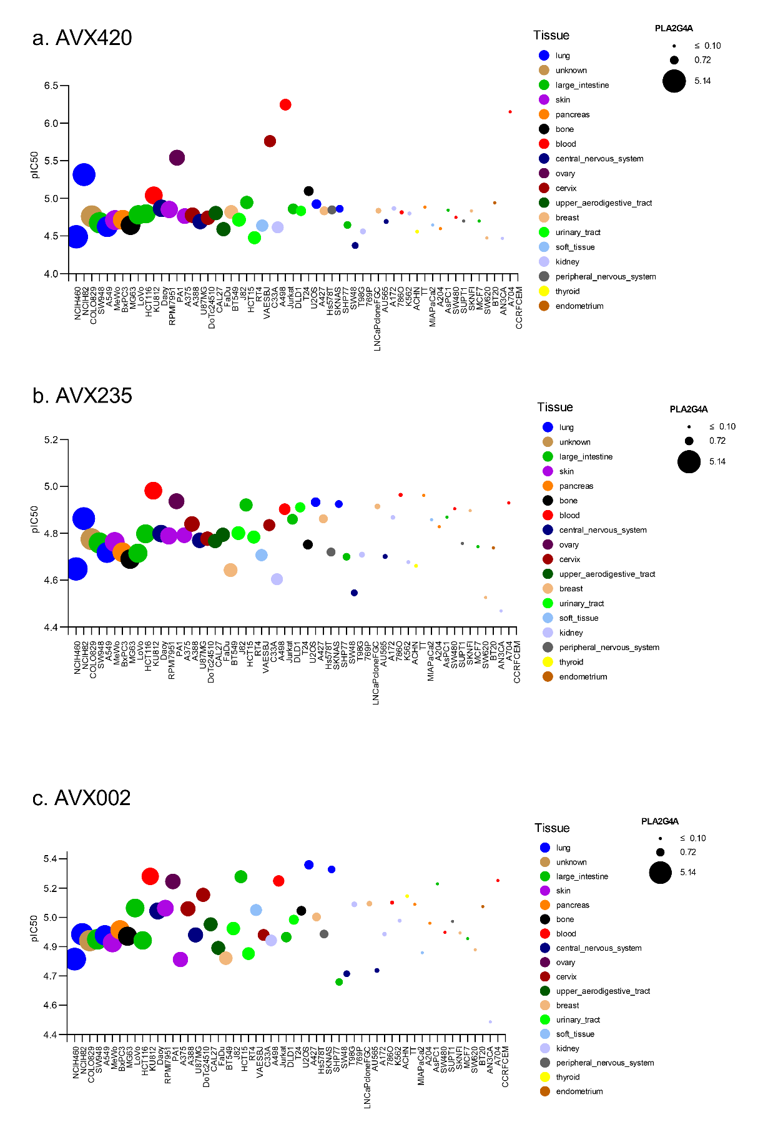
Figure S4. PLA2G4A expression and sensitivity to cPLA₂α inhibitors. The pIC₅₀ is plotted on the y-axis for each cell line ordered by expression of PLA2G4A (highest on the left) and where the size of the bubble is relative to the gene expression.

gene |  | sigma.score | p.value.sigma |  | gene | sigma.score | p.value.sigma
PIR | 4.01 |  | 6.05E-05 |  | AKR1B10 | 2.25 | 2.44E-02
CES2 | 3.57 |  | 3.55E-04 |  | GTF2I | 2.23 | 2.56E-02
UBC | 3.37 |  | 7.51E-04 |  | IFI35 | 2.19 | 2.86E-02
NFE2L2 | 3.30 |  | 9.56E-04 |  | UGDH | 2.18 | 2.96E-02
ALDH3A1 | 2.86 |  | 4.26E-03 |  | MSH6 | 2.17 | 3.02E-02
EPHX1 | 2.83 |  | 4.65E-03 |  | TBXAS1 | 2.17 | 3.03E-02
C9orf3 | 2.80 |  | 5.07E-03 |  | HSD17B2 | 2.17 | 3.03E-02
AKR1C2 | 2.69 |  | 7.20E-03 |  | TNFRSF1A | 2.16 | 3.08E-02
SLC16A3 | 2.68 |  | 7.30E-03 |  | HARS2 | 2.13 | 3.34E-02
LOC344887 | 2.63 |  | 8.43E-03 |  | C2orf18 | 2.13 | 3.35E-02
ITPRIPL2 | 2.51 |  | 1.19E-02 |  | RETSAT | 2.11 | 3.52E-02
MYO1E | 2.43 |  | 1.50E-02 |  | G6PC3 | 2.08 | 3.74E-02
GPC1 | 2.42 |  | 1.54E-02 |  | C1RL | 2.08 | 3.76E-02
AVPI1 | 2.41 |  | 1.60E-02 |  | NCSTN | 2.08 | 3.78E-02
HLA-G | 2.40 |  | 1.62E-02 |  | SRC | 2.06 | 3.94E-02
ABCC3 | 2.39 |  | 1.67E-02 |  | PCBP1 | 2.04 | 4.12E-02
ACVRL1 | 2.39 |  | 1.68E-02 |  | CD44 | 2.04 | 4.16E-02
LYNX1 | 2.37 |  | 1.76E-02 |  | ARF1 | 2.02 | 4.31E-02
MTMR11 | 2.37 |  | 1.77E-02 |  | SLC30A5 | 2.02 | 4.33E-02
ADSS | 2.36 |  | 1.83E-02 |  | CRYBA1 | 2.02 | 4.35E-02
DEFB1 | 2.35 |  | 1.86E-02 |  | ATOH1 | 2.01 | 4.48E-02
SNTB2 | 2.35 |  | 1.87E-02 |  | LOC400550 | 2.00 | 4.57E-02
BCL3 | 2.35 |  | 1.88E-02 |  | AMIGO2 | 1.99 | 4.63E-02
SHC1 | 2.35 |  | 1.90E-02 |  | RAB11B | 1.99 | 4.67E-02
HAS3 | 2.33 |  | 1.98E-02 |  | SULF2 | 1.98 | 4.80E-02
RARG | 2.32 |  | 2.03E-02 |  | LOC100134713 | 1.98 | 4.81E-02
LURAP1L | 2.31 |  | 2.12E-02 |  | GPR64 | 1.97 | 4.83E-02
AKR1C3 | 2.28 |  | 2.26E-02 |  | CYP4F11 | 1.97 | 4.84E-02
SAMD5 | 2.26 |  | 2.38E-02 |  | ADM | 1.96 | 4.98E-02
AKR1B10 | 2.25 |  | 2.44E-02
Table S6. Genes associated with resistance to cPLA2α inhibition. The sigma score (sigma.score) corresponds to the number of standard deviations a particular gene-compound correlation stands out above or below the mean for the compound library. Positive sigma scores with a p<0.05 were considered significant and genes associated with resistance to AVX420 and at least one other cPLA₂α inhibitor are listed. Sigma scores are shown for AVX420.

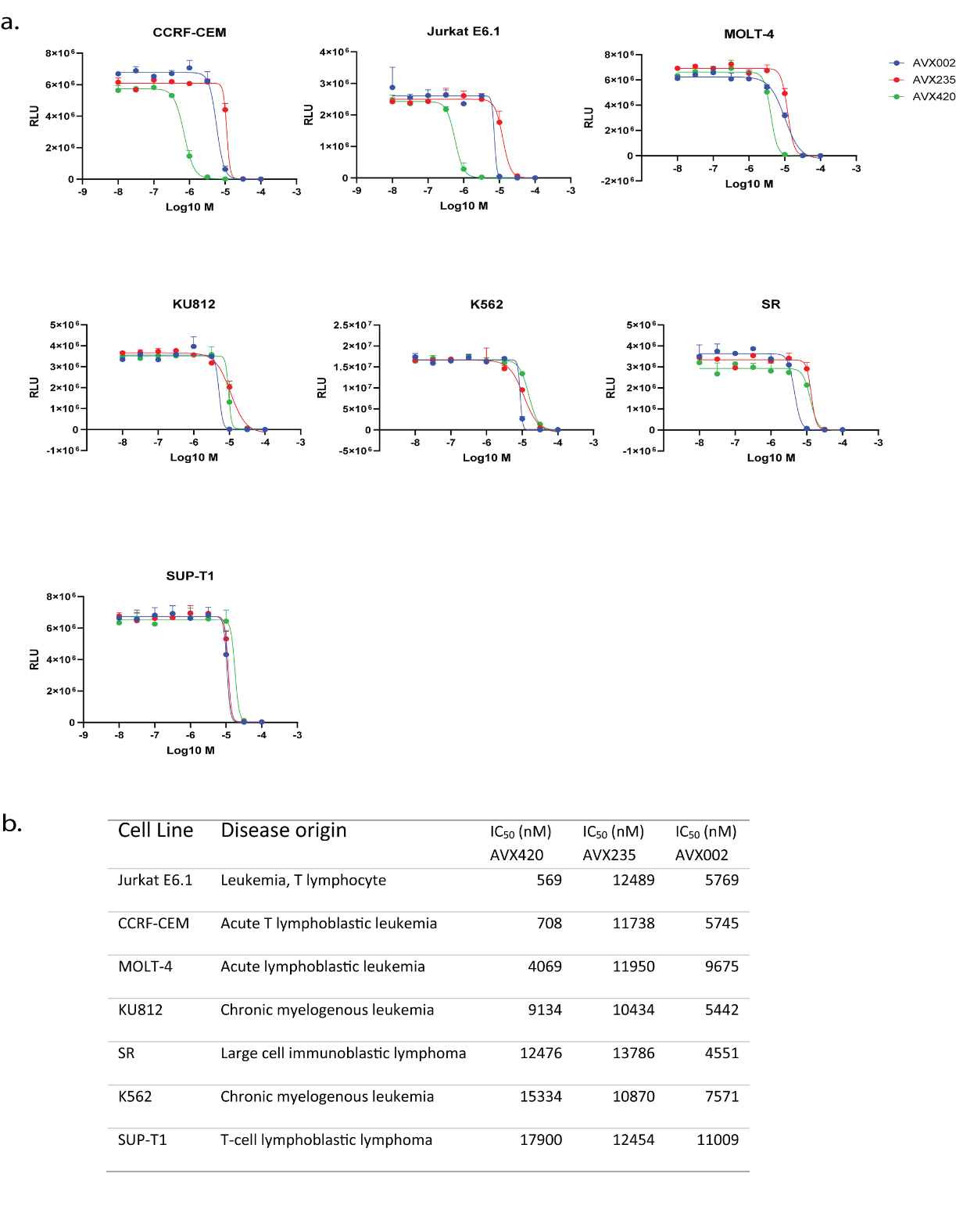
Figure S5. Sensitivity of cell lines derived from hematological malignancies. a. cell viability in RLU is plotted for all cell lines in the screen that were derived from hematological malignancies. b. corresponding IC₅₀ values calculated by non-linear regression analysis.

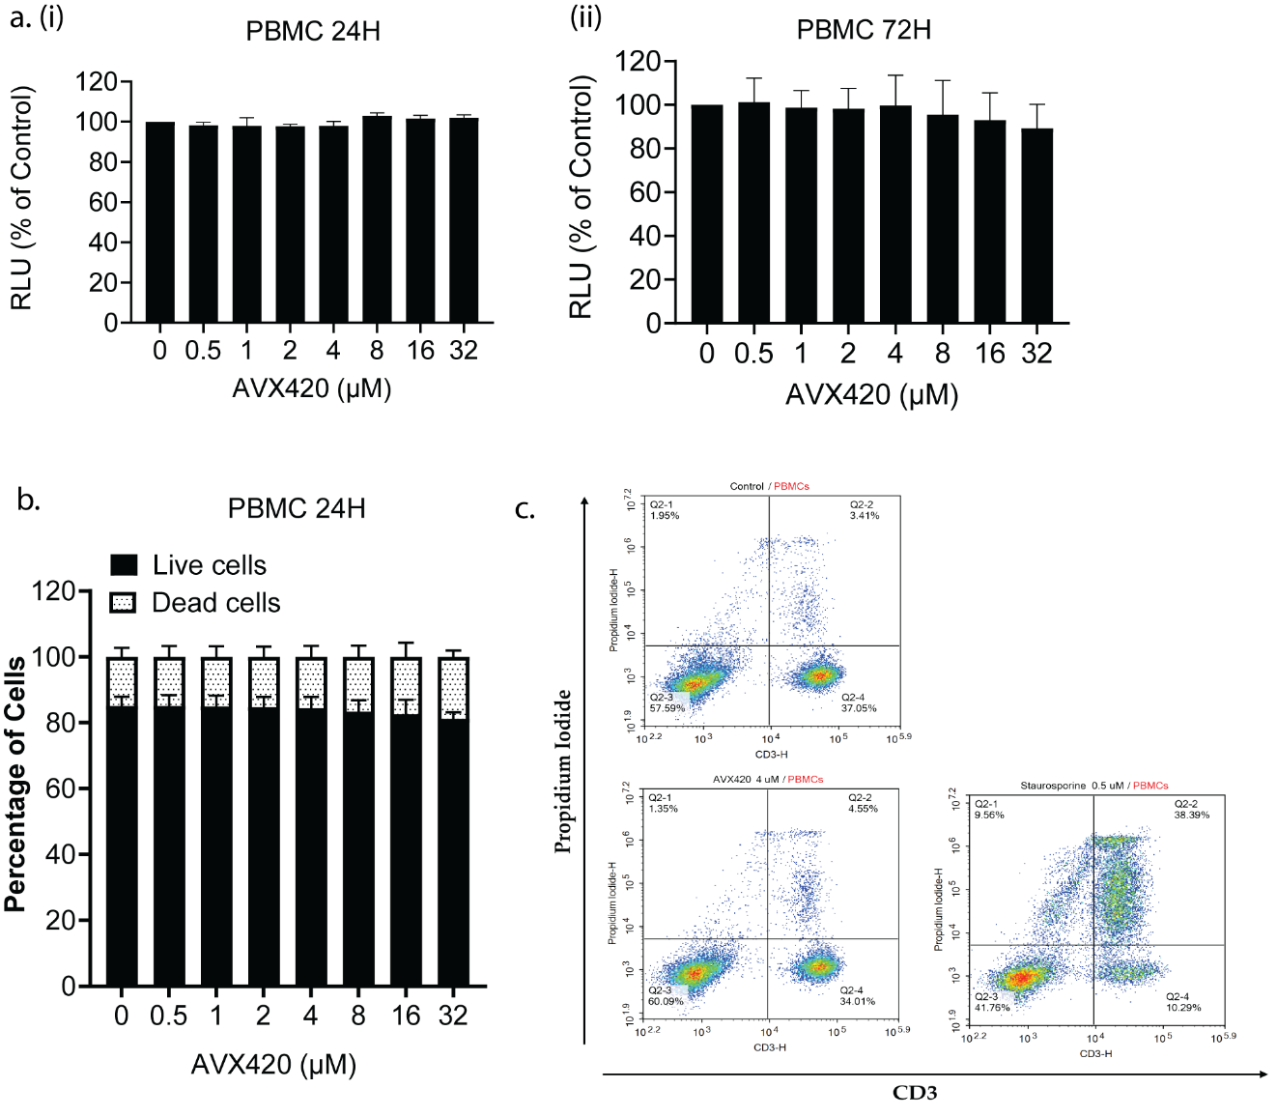
Figure S6. AVX420 does not affect the viability of peripheral blood mononuclear cells. a. CTG viability assays using PBMCs from healthy persons after (i) 24 hours and (ii) 72 hours treatment with AVX420 at the doses indicated. b. Propidium iodide exclusion assay using isolated PBMCs treated with AVX420 at the indicated doses for 24 hours. c. Representative data showing propidium iodide exclusion assay measured by flow cytometry in CD3+ PBMCs. The bottom right quadrant shows PI-negative (live) CD3+ T-cells while the top right quadrant shows PI-positive (dead) cells.

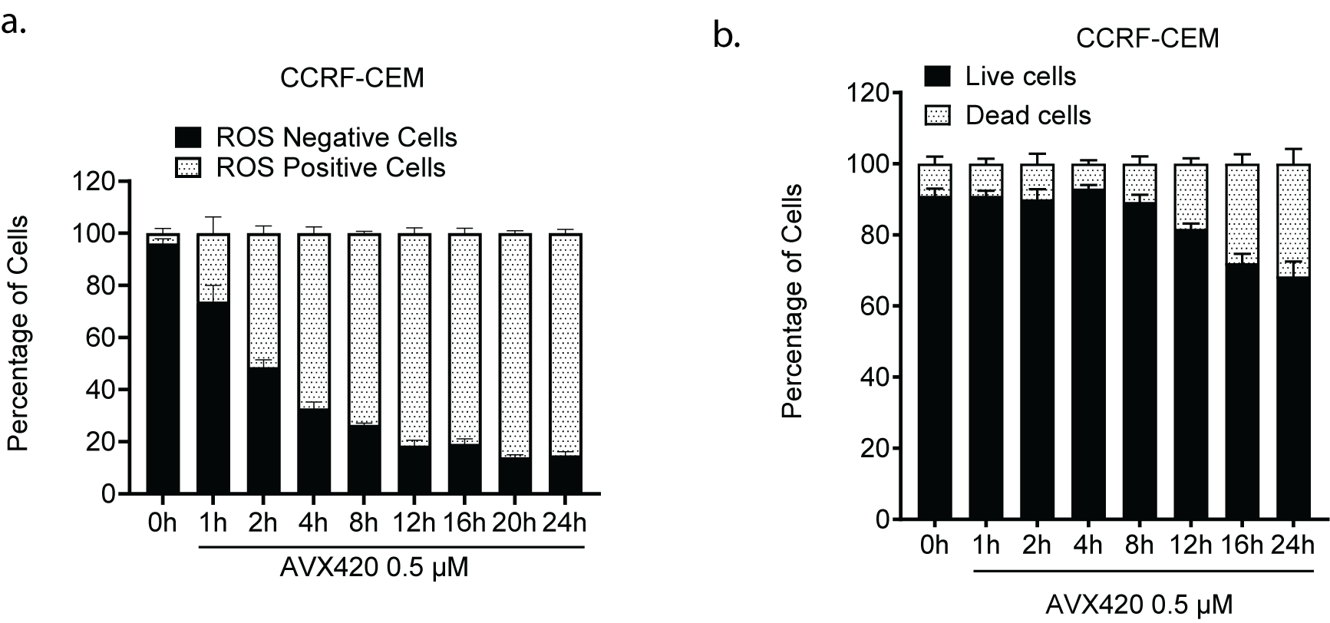

Figure S7. AVX420 increases intracellular ROS accumulation and cell death. a. Time dependency of the increase in iROS following treatment with AVX420 in CCRF-CEM cells as measured by ROS-red staining. b. Time-dependency of cell death induced by AVX420 in CCRF-CEM cells as measured by PI exclusion and flow cytometry.

Table S7. Differentially expressed genes. The top 20 up-regulated and all down-regulated genes after 16 hours of treatment with 0.5 μM AVX420. p-value cut off of 0.01 after multiple testing adjustment and a log2 fold change >1 or <-1.
Gene | log2FoldChange | padj
CHAC1 | 3.51 | 1.63E-43
LINC02970 | 3.49 | 7.91E-04
GPT2 | 3.48 | 2.51E-14
SLC7A11 | 3.42 | 2.17E-105
OSGIN1 | 3.08 | 1.67E-10
L3MBTL2-AS1 | 3.01 | 5.22E-07
SLC6A9 | 2.93 | 3.47E-16
HRG | 2.92 | 9.16E-04
NMRAL2P | 2.89 | 1.56E-06
RFPL1S | 2.61 | 4.30E-03
MIR22HG | 2.58 | 6.78E-03
SESN2 | 2.53 | 4.17E-41
TM6SF1 | 2.49 | 4.76E-18
VLDLR-AS1 | 2.44 | 4.42E-15
B4GALNT1 | 2.37 | 1.06E-06
ADM2 | 2.31 | 3.43E-22
NOL3 | 2.29 | 2.34E-05
ENSG00000260498 | 2.28 | 6.66E-04
NDUFA4L2 | 2.19 | 2.47E-04
IFRD1 | 2.08 | 1.01E-03

RPL23AP42 | -2.03 | 8.39E-03
THOC3 | -1.74 | 7.46E-03
CAMKK1 | -1.18 | 8.94E-03
MYT1 | -1.13 | 1.82E-05
RAG1 | -1.12 | 8.71E-13
LRRTM1 | -1.11 | 3.01E-03
AQP3 | -1.1 | 6.96E-04
CAMKV | -1.07 | 2.92E-05
DUSP2 | -1.04 | 7.53E-07
PNMA1 | -1.02 | 6.74E-03

Table S8. Differential ribosomal occupancy. Genes with differential ribosomal occupancy after 1 hour treatment with 100 nM Torin1. Log2 fold change of differentially expressed gene from the IP library (log2fc.Ribo), RNA-seq library (log2fc.RNA) and the ribosomal occupancy (log2fc.RO) are shown. Differential occupancy was considered relevant when log2(FC) is >1 or <-1, and the adjusted p-value (padj) < 0.01.
gene_name | log2fc.Ribo | log2fc.RNA | log2fc.RO | padj
ENSG00000226484 | -2.12 | 0.00 | -2.12 | 3.32E-03
ENSG00000260983 | -1.00 | 0.36 | -1.36 | 4.33E-04
RPS3 | -1.24 | 0.11 | -1.35 | 3.83E-08
EEF1G | -1.37 | -0.03 | -1.34 | 3.04E-14
RPS15A | -1.15 | 0.15 | -1.29 | 2.31E-07
RPL34 | -1.31 | -0.04 | -1.27 | 1.12E-09
RPS13 | -1.25 | 0.01 | -1.26 | 3.71E-07
KIZ-AS1 | -1.19 | 0.05 | -1.24 | 1.51E-05
RPL26 | -1.15 | 0.07 | -1.23 | 5.36E-09
RPS29 | -1.16 | 0.07 | -1.23 | 7.12E-05
RPS4X | -1.03 | 0.10 | -1.13 | 2.66E-07
GAPDH | -0.94 | 0.19 | -1.13 | 1.01E-06
RPL10A | -1.05 | 0.07 | -1.12 | 8.31E-07
AMBRA1 | -1.05 | 0.06 | -1.11 | 7.94E-07
RPL27 | -0.91 | 0.18 | -1.10 | 8.07E-04
RPS9 | -1.07 | 0.01 | -1.09 | 6.12E-08
UBA52 | -1.02 | 0.06 | -1.07 | 8.31E-06
RPL27A | -1.08 | -0.04 | -1.04 | 9.50E-07
EEF1D | -1.00 | 0.03 | -1.03 | 3.16E-08
RPS21 | -0.98 | 0.03 | -1.00 | 9.77E-04

Table S9. Gene set enrichment analysis performed on ribosomoal occupancy data from CCRF-CEM cells treated with Torin1 for 1 hour. The adjusted p-value (padj) for the gene set enrichment analysis (GSEA) and the average fold change of all genes included in the analysis (Log2 fold change (FC)) are shown.
Ribosomal Occupancy gene enrichment | Log2FC |  | padj
GO-cellular component
cytosolic ribosome | -1.17 |  | 7.80E-23
ribosomal subunit | -1.17 |  | 2.00E-19
ribosome | -1.17 |  | 8.20E-19
cytosolic small ribosomal subunit | -1.18 |  | 4.30E-15
small ribosomal subunit | -1.18 |  | 5.10E-13
GO- molecular function
structural constituent of ribosome | -1.17 |  | 6.70E-20
structural molecule activity | -1.17 |  | 2.20E-14
translation regulator activity | -1.15 |  | 6.90E-03
rRNA binding | -1.21 |  | 4.10E-05
translation elongation factor activity | -1.19 |  | 4.40E-03
GO - biological processes
cytoplasmic translation | -1.17 |  | 4.70E-19
regulation of cellular amide metabolic processes | -1.18 |  | 2.60E-02
regulation of translation | -1.18 |  | 2.60E-02
regulation of cellular macromolecule biosynthetic process | -1.18 |  | 2.60E-02
rRNA processing | -1.11 |  | 2.60E-02
KEGG
coronavirus disease | -1.17 |  | 7.50E-17
ribosome | -1.17 |  | 9.80E-18

Table S10. Gene set enrichment analysis performed on differential expression data from CCRF-CEM cells treated with AVX420 (0.5 μM) for 16 hours. The adjusted p-value for the enrichment analysis and the average fold change of all genes included in the analysis Log2 (fold change) are shown.
RNA-seq gene enrichment | Log2 (fold change) | Adjusted p-value
GO-Biological Process
response to ER stress | 1.64 | 2.80E-03
intrinsic apoptotic signaling in response to endoplasmic reticulum stress | 1.82 | 5.70E-03
response to unfolded protein | 1.63 | 1.10E-02
endoplasmic reticulum unfolded protein response | 1.25 | 1.10E-02
negative regulation of protein processing | 2.51 | 1.80E-02
GO- molecular function
organic acid binding | 1.64 | 4.20E-02
amino acid binding | 1.81 | 4.20E-02
cysteine-type endopeptidase inhibitor activity | 2.31 | 4.20E-02

Supplemental Methods

Synthesis of Inhibitors
Chromatographic purification of products was accomplished using Merck Silica Gel 60 (70-230 or 230-400 mesh). Thin-layer chromatography (TLC) was performed on Silica Gel 60 F254 aluminum plates. Visualization of the developed TLC was carried out by UV light and/or phosphomolybdic acid in EtOH. Melting points were determined using a Büchi 530 apparatus and were uncorrected. ¹H, ¹³C and ¹⁹F NMR spectra were recorded on a Varian Mercury (200 MHz, 50 MHz and 188 MHz, respectively) and on a Bruker AVANCE III (400 MHz, 100 MHz and 377 MHz, respectively) in CDCl₃. ¹H and ¹³C NMR spectra of inhibitors 17d, h-j were recorded on a Bruker AVANCE III (600 MHz and 150 MHz, respectively) in CDCl₃. Chemical shifts are given in ppm, and coupling constants (J) in Hz. Peak multiplicities are described as follows: s, singlet, d, doublet, t, triplet and m, multiplet. Electron spray ionization (ESI) mass spectra were recorded on a Finnigan, Surveyor MSQ Plus spectrometer. Dichloromethane, diethylether and toluene were dried by standard procedures and stored over molecular sieves. All other solvents and chemicals were reagent grade and used without further purification. The purity of all compounds subjected to biological tests was determined by analytical HPLC, and was found to be ≥95%. HRMS spectra were recorded on a Bruker Maxis Impact QTOF Spectrometer.
Compounds 10k,¹ 11a,² 12a,² 12d,² and 13a² were prepared as previously described.
Ethyl 2-(4-(heptyloxy)phenoxy)acetate (11b)
Yield 96%; White oil; ¹H-NMR (400 MHz, CDCl₃): δ 6.85 (d, J = 9.2 Hz, 2H, ArH), 6.81 (d, J = 9.2 Hz, 2H, ArH), 4.56 (s, 2H, OCH₂), 4.26 (q, J = 7.1 Hz, 2H, OCH₂), 3.89 (t, J = 6.6 Hz, 2H, OCH₂), 1.82-1.62 (m, 2H, CH₂), 1.52-1.11 (m, 11H, 4 x CH₂ and CH₃), 0.88 (t, J = 6.6 Hz, 3H, CH₃); ¹³C-NMR (100 MHz, CDCl₃): δ 169.0, 153.9, 151.7, 115.6, 115.1, 68.3, 66.1, 61.0, 31.6, 29.2, 28.9, 25.9, 22.5, 14.0, 13.9; HRMS (ESI⁺) m/z calcd for C₁₇H₂₇O₄⁺: 295.1904; [M + H]⁺ found: 295.1904.

Ethyl 2-(4-phenoxyphenoxy)acetate (11c)
Commercially Available.
Ethyl 2-(4-(4-fluorophenoxy)phenoxy)acetate (11d)
Yield 94%; White oil; ¹H-NMR (400 MHz, CDCl₃): δ 6.97-6.91 (m, 2H, ArH), 6.90-6.82 (m, 6H, ArH), 4.55 (s, 2H, OCH₂), 4.21 (q, J = 7.1 Hz, 2H, OCH₂), 1.25 (t, J = 7.1 Hz, 3H, CH₃); ¹³C-NMR (100 MHz, CDCl₃): δ 168.6, 158.2 (d, J = 240.7 Hz), 153.8, 153.6, 153.6, 151.3, 119.7, 119.2 (d, J = 8.1 Hz), 115.9 (d, J = 23.3 Hz), 115.7, 65.6, 61.0, 13.8; ¹⁹F-NMR (377 MHz, CDCl₃): δ -120.80; HRMS (ESI⁺) m/z calcd for C₁₆H₁₆FO₄⁺: 291.1027; [M + H]⁺ found: 291.1020.
Ethyl 2-(4-(hexylthio)phenoxy)acetate (11e)
Yield 92%; White oil; ¹H-NMR (200 MHz, CDCl₃): δ 7.29 (d, J = 8.9 Hz, 2H, ArH), 6.81 (d, J = 8.9 Hz, 2H, ArH), 4.57 (s, 2H, OCH₂), 4.24 (q, J = 7.1 Hz, 2H, OCH₂), 2.79 (t, J = 7.0 Hz, 2H, PhSCH₂), 1.64-1.46 (m, 2H, CH₂), 1.45-1.14 (m, 9H, 3 x CH₂ and CH₃), 0.84 (t, J = 7.1 Hz, 3H, CH₃); ¹³C-NMR (50 MHz, CDCl₃): δ 168.7, 156.5, 132.2, 128.2, 115.0, 65.3, 61.3, 35.2, 31.3, 29.1, 28.3, 22.4, 14.0, 14.0; HRMS (ESI⁺) m/z calcd for C₁₆H₂₄NaO₃S⁺: 319.1338; [M + Na]⁺ found: 319.1340.
Ethyl 2-(4-(hexyloxy)phenylthio)acetate (11f)
Yield 95%; White oil; ¹H-NMR (400 MHz, CDCl₃): δ 7.39 (d, J = 9.0 Hz, 2H, ArH), 6.81 (d, J = 9.0 Hz, 2H, ArH), 4.11 (q, J = 7.2 Hz, 2H, OCH₂), 3.90 (t, J = 6.4 Hz, 2H, OCH₂), 3.48 (s, 2H, PhSCH₂), 1.89-1.63 (m, 2H, CH₂), 1.52-1.20 (m, 9H, 3 x CH₂ and CH₃), 0.88 (t, J = 7.2 Hz, 3H, CH₃); ¹³C-NMR (100 MHz, CDCl₃): δ 169.9, 159.3, 134.2, 124.6, 115.2, 68.1, 61.3, 38.7, 31.5, 29.1, 25.7, 22.6, 14.1, 14.0; HRMS (ESI⁺) m/z calcd for C₁₆H₂₄NaO₃S⁺: 319.1338; [M + Na]⁺ found: 319.1339.
Ethyl 2-(4-octylphenoxy)propanoate (11g)
Yield 98%; White oil; ¹H-NMR (400 MHz, CDCl₃): δ 7.07 (d, J = 8.4 Hz, 2H, ArH), 6.80 (d, J = 8.4 Hz, 2H,ArH), 4.71 (q, J = 6.8 Hz, 1H, OCH), 4.22 (q, J = 7.1 Hz, 2H, OCH₂), 2.54 (t, J = 8.0 Hz, 2H, OCH₂), 1.70-1.43 (m, 5H, CH₂ and CH₃), 1.41-1.09 (m, 13H, 5 x CH₂ and CH₃), 0.88 (t, J = 7.1 Hz, 3H, CH₃); ¹³C-NMR (100 MHz, CDCl₃): δ 172.4, 155.6, 136.0, 129.2, 114.9, 72.8, 61.1, 35.0, 31.8, 31.6, 29.4, 29.2, 22.6, 18.5, 14.1, 14.0; HRMS (ESI⁺) m/z calcd for C₁₉H₃₁O₃⁺: 307.2268; [M + H]⁺ found: 307.2268.
Ethyl 2-(4-(heptyloxy)phenoxy)propanoate (11h)
Yield 97%; White oil; ¹H-NMR (200 MHz, CDCl₃): δ 6.86-6.69 (m, 4H, ArH), 4.63 (q, J = 6.8 Hz, 1H, OCH), 4.18 (q, J = 7.1 Hz, 2H, OCH₂), 3.86 (t, J = 6.5 Hz, 2H, OCH₂), 1.84-1.64 (m, 2H, CH₂), 1.57 (d, J = 6.6 Hz, 3H, CH₃), 1.46-1.13 (m, 11H, 4 x CH₂ and CH₃), 0.87 (t, J = 6.3 Hz, 3H, CH₃); ¹³C-NMR (50 MHz, CDCl₃): δ 172.3, 153.8, 151.4, 116.2, 115.1, 73.4, 68.2, 61.0, 31.7, 29.2, 28.9, 25.9, 22.5, 18.4, 13.9; HRMS (ESI⁺) m/z calcd for C₁₈H₂₉O₄⁺: 309.2060; [M + H]⁺ found: 309.2064.
Ethyl 2-(4-phenoxyphenoxy)propanoate³ (11i)
Yield 96%; White oil; ¹H-NMR (400 MHz, CDCl₃): δ 7.29 (t, J = 7.4 Hz, 2H, ArH), 7.05 (t, J = 7.4 Hz, 1H, ArH), 7.00-6.93 (m, 4H, ArH), 6.91-6.86 (m, 2H, ArH), 4.71 (q, J = 6.8 Hz, 1H, OCH), 4.24 (q, J = 7.1 Hz, 2H, OCH₂), 1.63 (d, J = 6.8 Hz, 3H, CH₃), 1.27 (t, J = 7.1 Hz, 3H, CH₃); ¹³C-NMR (100 MHz, CDCl₃): δ 172.0, 158.0, 153.6, 150.8, 129.5, 122.5, 120.4, 117.7, 116.3, 73.1, 61.0, 18.4, 14.0; HRMS (ESI⁺) m/z calcd for C₁₇H₁₉O₄⁺: 287.1278; [M + H]⁺ found: 287.1280.
Ethyl 2-(4-(hexylthio)phenoxy)propanoate (11j)
Yield 95%; White oil; ¹H-NMR (200 MHz, CDCl₃): δ 7.22 (d, J = 9.0 Hz, 2H, ArH), 6.74 (d, J = 9.0 Hz, 2H, ArH), 4.64 (q, J = 6.8 Hz, 1H, OCH), 4.14 (q, J = 7.1 Hz, 2H, OCH₂), 2.75 (t, J = 7.0 Hz, 2H, PhSCH₂), 1.59-1.42 (m, 5H, CH₂ and CH₃), 1.39-1.10 (m, 9H, 3 x CH₂ and CH₃), 0.80 (t, J = 7.1 Hz, 3H, CH₃); ¹³C-NMR (50 MHz, CDCl₃): δ 171.7, 156.3, 132.1, 127.9, 115.4, 72.4, 61.0, 35.1, 31.1, 29.0, 28.1, 22.3, 18.3, 13.9, 13.8; HRMS (ESI⁺) m/z calcd for C₁₇H₂₇O₃S⁺: 311.1675; [M + H]⁺ found: 311.1679.
2-(4-(Heptyloxy)phenoxy)ethanol (12b)
Yield 88%; White solid m.p.: 77-78 ^{ο}C; ¹H-NMR (400 MHz, CDCl₃): δ 6.93-6.76 (m, 4H, ArH), 4.06-3.99 (m, 2H, OCH₂), 3.96-3.86 (m, 4H, 2 x OCH₂), 2.25 (br s, 1H, OH), 1.81-1.70 (m, 2H, CH₂), 1.51-1.23 (m, 8H, 4 x CH₂), 0.89 (t, J = 6.1 Hz, 3H, CH₃); ¹³C-NMR (100 MHz, CDCl₃): δ 153.6, 152.6, 115.5, 115.4, 69.9, 68.6, 61.5, 31.7, 29.3, 29.0, 26.0, 22.6, 14.0; HRMS (ESI⁺) m/z calcd for C₁₅H₂₄NaO₃⁺: 275.1618; [M + Na]⁺ found: 275.1618.
2-(4-Phenoxyphenoxy)ethanol (12c)
Commercially available.
2-(4-(Hexylthio)phenoxy)ethanol (12e)
Yield 80%; White solid m.p.: 48-49 ºC; ¹H-NMR (200 MHz, CDCl₃): δ 7.30 (d, J = 7.8 Hz, 2H, ArH), 6.82 (d, J = 7.8 Hz, 2H, ArH), 4.16-3.80 (m, 4H, 2 x OCH₂), 2.79 (t, J = 7.2 Hz, 2H, SCH₂), 2.58 (br s, 1H, OH), 1.67-1.47 (m, 2H, CH₂), 1.46-1.16 (m, 6H, 3 x CH₂), 0.86 (t, J = 6.3 Hz, 3H, CH₃); ¹³C-NMR (50 MHz, CDCl₃): δ 157.5, 132.6, 127.4, 115.0, 69.2, 61.2, 35.5, 31.3, 29.1, 28.3, 22.4, 13.9; HRMS (ESI⁺) m/z calcd for C₁₄H₂₂NaO₂S⁺: 277.1233; [M + Na]⁺ found: 277.1233.
2-(4-(Hexyloxy)phenylthio)ethanol (12f)
Yield 81%; White solid low m.p.; ¹H-NMR (200 MHz, CDCl₃): δ 7.37 (d, J = 8.8 Hz, 2H, ArH), 6.84 (d, J = 8.8 Hz, 2H, ArH), 3.93 (t, J = 6.6 Hz, 2H, OCH₂), 3.73-3.57 (m, 2H, OCH₂), 2.98 (t, J = 6.0 Hz, 2H, PhSCH₂), 2.39 (br s, 1H, OH), 1.86-1.66 (m, 2H, CH₂), 1.55-1.15 (m, 6H, 3 x CH₂), 0.91 (t, J = 6.4 Hz, 3H, CH₃); ¹³C-NMR (50 MHz, CDCl₃): δ 158.8, 133.9, 124.2, 115.1, 68.0, 59.9, 39.1, 31.5, 29.0, 25.6, 22.5, 13.9; HRMS (ESI⁺) m/z calcd for C₁₄H₂₂NaO₂S⁺: 277.1233; [M + Na]⁺found: 277.1233.
2-(4-Octylphenoxy)propan-1-ol (12g)
Yield 87%; White oil; ¹H-NMR (400 MHz, CDCl₃): δ 7.10 (d, J = 8.2 Hz, 2H, ArH), 6.86 (d, J = 8.2 Hz, 2H, ArH), 4.52-4.39 (m, 1H, OCH), 3.78-3.65 (m, 2H, OCH₂), 2.56 (t, J = 7.7 Hz, 2H, PhCH₂), 2.47 (br s, 1H, OH), 1.66-1.54 (m, 2H, CH₂), 1.40-1.22 (m, 13H, 5 x CH₂ and CH₃), 0.91 (t, J = 6.7 Hz, 3H, CH₃); ¹³C-NMR (100 MHz, CDCl₃): δ 155.6, 135.6, 129.3, 116.0, 74.9, 66.1, 35.0, 31.8, 31.6, 29.4, 29.2, 29.2, 22.6, 15.8, 14.0; HRMS (ESI⁺) m/z calcd for C₁₇H₂₈NaO₂⁺: 287.1982; [M + Na]⁺ found: 287.1982.

2-(4-(Heptyloxy)phenoxy)propan-1-ol (12h)
Yield 92%; White solid m.p.: 81-83 ºC; ¹H-NMR (200 MHz, CDCl₃): δ 6.85 (d, J = 9.4 Hz, 2H, ArH), 6.79 (d, J = 9.4 Hz, 2H, ArH), 4.40-4.21 (m, 1H, OCH), 3.88 (t, J = 6.5 Hz, 2H, 2 x OCH₂), 3.71-3.59 (m, 2H, OCH₂), 2.74 (s, 1H, OH), 1.82-1.55 (m, 2H, CH₂), 1.49-1.24 (m, 8H, 4 x CH₂), 1.20 (d, J = 6.2 Hz, 3H, CH₃), 0.89 (t, J = 6.4 Hz, 3H, CH₃); ¹³C-NMR (50 MHz, CDCl₃): δ 153.7, 151.3, 117.6, 115.2, 75.9, 68.4, 66.0, 31.7, 29.2, 29.0, 25.9, 22.5, 15.8, 14.0; HRMS (ESI⁺) m/z calcd for C₁₆H₂₆NaO₃⁺: 289.1774; [M + Na]⁺ found: 289.1777.

2-(4-Phenoxyphenoxy)propan-1-ol (12i)
Yield 83%; White solid m.p.:79-81 ºC; ¹H-NMR (400 MHz, CDCl₃): δ 7.31 (t, J = 7.5 Hz, 2H, ArH), 7.05 (t, J = 7.5 Hz, 1H, ArH), 7.01-6.89 (m, 6H, ArH), 4.49-4.38 (m, 1H, OCH), 3.80-3.66 (m, 2H, OCH₂), 2.06 (br s, 1H, OH), 1.28 (d, J = 6.1 Hz, 3H, CH₃); ¹³C-NMR (100 MHz, CDCl₃): δ 158.2, 153.8, 150.8, 129.6, 122.6, 120.7, 117.8, 117.5, 75.6, 66.3, 15.8; HRMS (ESI⁺) m/z calcd for C₁₅H₁₆NaO₃⁺: 267.0992; [M + Na]⁺ found: 267.0993.
2-(4-(Hexylthio)phenoxy)propan-1-ol (12j)
Yield 85%; White oil; ¹H-NMR (200 MHz, CDCl₃): δ 7.27 (d, J = 8.8 Hz, 2H, ArH), 6.82 (d, J = 8.8 Hz, 2H, ArH), 4.51-4.32 (m, 1H, OCH), 3.72-3.60 (m, 2H, OCH₂), 2.79 (t, J = 7.0 Hz, 2H, SCH₂), 2.67 (s, 1H, OH), 1.65-1.47 (m, 2H, CH₂), 1.45-1.14 (m, 9H, 3 x CH₂ and CH₃), 0.85 (t, J = 6.5 Hz, 3H, CH₃); ¹³C-NMR (50 MHz, CDCl₃): δ 156.5, 132.5, 127.4, 116.4, 74.8, 65.9, 35.4, 31.2, 29.1, 28.3, 22.4, 15.6, 13.9; HRMS (ESI⁺) m/z calcd for C₁₅H₂₄NaO₂S⁺: 291.1389; [M + Na]⁺ found: 291.1391.
2-(tert-Butyldimethylsilyloxy)-3-(4-(heptyloxy)phenoxy)propanenitrile (13b)
Yield 73%; White oil; ¹H-NMR (200 MHz, CDCl₃): δ 6.90-6.73 (m, 4H, ArH), 4.76 (t, J = 6.2 Hz, 1H, CHCN), 4.20-4.02 (m, 2H, OCH₂), 3.90 (t, J = 6.5 Hz, 2H, OCH₂), 1.84-1.66 (m, 2H, CH₂), 1.49-1.23 (m, 8H, 4 x CH₂), 0.97-0.80 (m, 12H, C(CH₃)₃ and CH₃), 0.19 (d, J = 8.7 Hz, 6H, 2 x SiCH₃); ¹³C-NMR (50 MHz, CDCl₃): δ 154.1, 151.7, 118.2, 115.8, 115.4, 70.4, 68.5, 61.5, 31.8, 29.3, 29.1, 26.0, 25.7, 25.4, 22.6, 18.1, 14.1, -5.3; HRMS (ESI⁺) m/z calcd for C₂₂H₃₇NNaO₃Si⁺: 414.2435; [M + Na]⁺ found: 414.2438.

2-(tert-Butyldimethylsilyloxy)-3-(4-phenoxyphenoxy)propanenitrile (13c)
Yield 28%; White oil; ¹H-NMR (200 MHz, CDCl₃): δ 7.38-7.24 (m, 2H, ArH), 7.12-6.85 (m, 7H, ArH), 4.84-4.75 (m, 1H, CHCN), 4.21-4.10 (m, 2H, OCH₂), 0.94 (s, 9H, C(CH₃)₃), 0.24 (s, 3H, SiCH₃), 0.19 (s, 3H, SiCH₃); ¹³C-NMR (50 MHz, CDCl₃): δ 158.1, 153.9, 151.1, 129.6, 122.6, 120.7, 118.0, 117.7, 115.8, 70.1, 61.5, 25.4, 18.1, -5.2, -5.3; HRMS (ESI⁺) m/z calcd for C₂₁H₂₇NNaO₃Si⁺: 392.1652; [M + Na]⁺ found: 392.1652.
2-((tert-Butyldimethylsilyl)oxy)-3-(4-(4-fluorophenoxy)phenoxy)propanenitrile (13d)
Yield 82%; Pale yellow syrup; ¹H-NMR (400 MHz, CDCl₃): δ 7.04-6.85 (m, 8H, ArH), 4.80 (t, J = 6.0 Hz, 1H, CHCN), 4.21-4.10 (m, 2H, OCH₂), 0.96 (s, 9H, C(CH₃)₃), 0.25 (s, 3H, SiCH₃), 0.21 (s, 3H, SiCH₃); ¹³C-NMR (100 MHz, CDCl₃): δ 158.3 (d, J = 240.1 Hz), 153.8, 153.7, 151.5, 120.0, 119.5 (d, J = 7.8 Hz), 117.8, 116.1, 115.8 (d, J = 22.6 Hz), 70.1, 61.4, 25.3, 17.9, -4.8, -5.4; HRMS (ESI⁺) m/z calcd for C₂₁H₂₆FNNaO₃Si⁺: 410.1558; [M + Na]⁺ found: 410.1562.
2-(tert-Butyldimethylsilyloxy)-3-(4-(hexylthio)phenoxy)propanenitrile (13e)
Yield 36%; White oil; ¹H-NMR (200 MHz, CDCl₃): δ 7.28 (d, J = 7.0 Hz, 2H, ArH), 6.79 (d, J = 7.0 Hz, 2H, ArH), 4.90-4.61 (m, 1H, CHCN), 4.28-3.87 (m, 2H, OCH₂), 3.02-2.57 (m, 2H, SCH₂), 1.67-1.06 (m, 8H, 4 x CH₂), 1.03-0.63 (m, 12H, C(CH₃)₃ and CH₃), 0.29-(-0.04) (m, 6H, Si(CH₃)₂); ¹³C-NMR (50 MHz, CDCl₃): δ 156.6, 132.4, 128.4, 117.9, 115.1, 69.5, 61.3, 35.3, 31.3, 29.6, 29.1, 28.3, 25.4, 22.5, 14.0, -5.3; HRMS (ESI⁺) m/z calcd for C₂₁H₃₅NNaO₂SSi⁺: 416.2050; [M + Na]⁺ found: 416.2053.

2-(tert-Butyldimethylsilyloxy)-3-(4-(hexyloxy)phenylthio)propanenitrile (13f)
Yield 30%; White oil; ¹H-NMR (200 MHz, CDCl₃): δ 7.41 (d, J = 8.7 Hz, 2H, ArH), 6.87 (d, J = 8.7 Hz, 2H, ArH), 4.44-4.35 (m, 1H, CHCN), 4.02-3.87 (m, 2H, OCH₂), 3.20-3.03 (t, m, 2H, PhSCH₂), 1.86-170 (m, 2H, CH₂), 1.55-1.18 (m, 6H, 3 x CH₂), 0.96-0.79 (m, 12H, C(CH₃)₃ and CH₃), 0.18-(-0.05) (m, 6H, Si(CH₃)₂); ¹³C-NMR (50 MHz, CDCl₃): δ 159.4, 134.3, 124.0, 116.3, 115.4, 68.2, 62.0, 41.9, 31.5, 29.1, 25.6, 25.4, 22.6, 18.0, 14.0, -5.3, -5.4; HRMS (ESI⁺) m/z calcd for C₂₁H₃₅NNaO₂SSi⁺ ⁺: 416.2050; [M + Na]⁺ found: 416.2047.
2-(tert-Butyldimethylsilyloxy)-3-(4-octylphenoxy)butanenitrile (mixture of diastereomers) (13g)
Yield 51%; Pale yellow oil; ¹H-NMR (200 MHz, CDCl₃): δ 7.19-7.01 (m, 2H, ArH), 6.93-6.70 (m, 2H, ArH), 4.81-4.35 (m, 2H, CHCN and OCH), 2.66-2.44 (m, 2H, PhCH₂), 1.72-1.15 (m, 15H, 6 x CH₂ and CH₃), 1.05-0.76 (m, 12H, C(CH₃)₃ and CH₃), 0.25-0.15 (m, 6H, Si(CH₃)₂); ¹³C-NMR (50 MHz, CDCl₃): δ 155.6, 154.9, 136.3, 135.6, 129.4, 129.2, 118.4, 114.6, 75.5, 74.6, 65.4, 65.1, 35.0, 31.9, 31.6, 29.5, 29.3, 29.1, 25.6, 25.4, 25.3, 22.6, 18.1, 18.0, 15.4, 15.1, 14.1, -5.3, -5.4; HRMS (ESI⁺) m/z calcd for C₂₄H₄₁NNaO₂Si⁺: 426.2799; [M + Na]⁺ found: 426.2802.
2-((tert-butyldimethylsilyl)oxy)-3-(4-(heptyloxy)phenoxy)butanenitrile (mixture of diastereomers) (13h)
Yield 78%; White oil; ¹H-NMR (200 MHz, CDCl₃): δ 6.94-6.78 (m, 4H, ArH), 4.65-4.48 (m, 1H, CHCN), 4.47-4.24 (m, 1H, OCH), 3.92 (t, J = 6.5 Hz, 2H, OCH₂), 1.89-1.64 (m, 2H, CH₂), 1.54-1.25 (m, 11H, 4 x CH₂ and CH₃), 1.01-0.84 (m, 12H, C(CH₃)₃ and CH₃), 0.29-0.09 (m, 6H, Si(CH₃)₂); ¹³C-NMR (50 MHz, CDCl₃): δ 154.2, 150.8, 117.7, 115.3, 76.7, 75.7, 68.4, 65.3, 65.1, 31.7, 29.3, 29.0, 25.9, 25.4, 22.5, 15.5, 15.1, 14.0, -5.3, -5.4; HRMS (ESI⁺) m/z calcd for C₂₃H₃₉NNaO₃Si⁺: 428.2591; [M + Na]⁺ found: 428.2594.
2-(tert-Butyldimethylsilyloxy)-3-(4-phenoxyphenoxy)butanenitrile (mixture of diastereomers) (13i)
Yield 19%; Pale yellow oil; ¹H-NMR (200 MHz, CDCl₃): δ 7.46-7.22 (m, 2H, ArH), 7.20-6.85 (m, 7H, ArH), 4.66-4.32 (m, 2H, CHCN and OCH), 1.55-1.36 (m, 3H, CH₃), 0.96-0.89 (m, 9H, C(CH₃)₃), 0.29-0.11 (m, 6H, Si(CH₃)₂); ¹³C-NMR (50 MHz, CDCl₃): δ 157.3, 153.0, 151.1, 132.6, 131.5, 129.6, 127.8, 122.6, 120.6, 117.8, 117.7, 117.6, 117.3, 76.1, 75.2, 65.4, 65.2, 25.7, 25.4, 18.0, 17.8, 15.6, 15.1, -5.3, -5.4; HRMS (ESI⁺) m/z calcd for C₂₂H₂₉NNaO₃Si⁺: 406.1809; [M + Na]⁺ found: 406.1812.

2-((tert-Butyldimethylsilyl)oxy)-3-(4-(hexylthio)phenoxy)butanenitrile (mixture of diastereomers) (13j)
Yield 34%; White oil; ¹H-NMR (200 MHz, CDCl₃): δ 7.31 (d, J = 8.8 Hz, 2H, ArH), 6.85 (d, J = 8.8 Hz, 2H, ArH), 5.32-5.28 (m, 1H, CHCN), 4.63-4.38 (m, 1H, OCH), 2.82 (t, J = 7.2 Hz, 2H, SCH₂), 1.71-1.19 (m, 11H, 4 x CH₂ and CH₃), 1.00-0.82 (m, 12H, C(CH₃)₃ and CH₃), 0.28-0.09 (m, 6H, Si(CH₃)₂); ¹³C-NMR (50 MHz, CDCl₃): δ 156.9, 132.4, 132.3, 128.6, 116.7, 116.5, 75.5, 74.7, 65.5, 65.2, 35.4, 33.2, 31.3, 29.2, 28.4, 25.4, 22.5, 18.0, 15.4, 15.1, 14.0, -5.3, -5.3; HRMS (ESI⁺) m/z calcd for C₂₂H₃₇NNaO₂SSi⁺: 430.2206; [M + Na]⁺ found: 430.2209.

Ethyl 2-(1-(tert-butyldimethylsilyloxy)-2-(4-octylphenoxy)ethyl)-4,5-dihydrothiazole-4-carboxylate (mixture of diastereomers) (14a)
Yield 92%; White oil; ¹H-NMR (200 MHz, CDCl₃): δ 7.06 (d, J = 8.4 Hz, 2H, ArH), 6.81 (d, J = 8.4 Hz, 2H, ArH), 5.14 (t, J = 9.3 Hz, 1H, OCH), 5.05-4.91 (m, 1H, NCH), 4.37-4.16 (m, 3H, 3 x OCHH), 4.15-3.99 (m, 1H, OCHH), 3.61-3.33 (m, 2H, SCH₂), 2.53 (t, J = 7.8 Hz, 2H, PhCH₂), 1.67-1.47 (m, 2H, CH₂), 1.38-1.19 (m, 13H, 5 x CH₂ and CH₃), 0.99-0.81 (m, 12H, C(CH₃)₃ and CH₃), 0.26-0.05 (m, 6H, Si(CH₃)₂); ¹³C-NMR (50 MHz, CDCl₃): δ 178.4, 178.0, 170.6, 156.4, 135.2, 129.1, 114.3, 78.4, 72.5, 72.4, 71.6, 71.5, 61.7, 35.0, 33.8, 33.8, 31.8, 31.7, 29.4, 29.2, 25.7, 25.7, 22.6, 18.2, 14.1, 14.1, -4.7, -5.2, -5.2; HRMS (ESI⁺) m/z calcd for C₂₈H₄₈NO₄SSi⁺: 522.3068; [M + H]⁺ found: 522.3060.

Methyl 2-(1-(tert-butyldimethylsilyloxy)-2-(4-(heptyloxy)phenoxy)ethyl)-4,5-dihydrothiazole-4-carboxylate (mixture of diastereomers) (14b)
Yield 63%; Pale yellow oil; ¹H-NMR (200 MHz, CDCl₃): δ 6.89-6.67 (m, 4H, ArH), 5.23-5.07 (m, 1H, OCH), 5.02-4.89 (m, 1H, NCH), 4.28-3.94 (m, 2H, OCH₂), 3.88 (t, J = 6.6 Hz, 2H, OCH₂), 3.80 (s, 3H, OCH₃), 3.57-3.39 (m, 2H, SCH₂), 1.83-1.64 (m, 2H, CH₂), 1.52-1.18 (m, 8H, 4 x CH₂), 1.00-0.72 (m, 12H, C(CH₃)₃ and CH₃), 0.24-0.03 (m, 6H, Si(CH₃)₂); ¹³C-NMR (50 MHz, CDCl₃): δ 178.8, 178.3, 171.1, 153.4, 152.5, 115.4, 115.2, 78.3, 78.2, 72.5, 72.5, 72.1, 68.5, 52.8, 33.7, 31.7, 29.3, 29.0, 26.0, 25.6, 22.6, 18.2, 14.1, -4.7, -5.2; HRMS (ESI⁺) m/z calcd for C₂₆H₄₃NNaO₅SSi⁺: 532.2523; [M + Na]⁺found: 532.2523.
Methyl 2-(1-(tert-butyldimethylsilyloxy)-2-(4-phenoxyphenoxy)ethyl)-4,5-dihydrothiazole-4-carboxylate (mixture of diastereomers) (14c)
Yield 80%; White oil; ¹H-NMR (200 MHz, CDCl₃): δ 7.32-7.19 (m, 2H, ArH), 7.07-6.78 (m, 7H, ArH), 5.22-5.05 (m, 1H, OCH), 5.01-4.89 (m, 1H, NCH), 4.30-4.14 (m, 1H, OCHH), 4.11-3.92 (m, 1H, OCHH), 3.77 (s, 3H, OCH₃), 3.54-3.38 (m, 2H, SCH₂), 0.90 (s, 9H, C(CH₃)₃), 0.29-(-0.02) (m, 6H, Si(CH₃)₂); ¹³C-NMR (50 MHz, CDCl₃): δ 178.6, 178.0, 171.0, 158.3, 154.7, 150.2, 129.5, 122.3, 120.7, 117.5, 115.6, 78.3, 78.2, 72.4, 72.0, 53.2, 52.6, 33.7, 25.6, 18.2, -4.7, -5.2; HRMS (ESI⁺) m/z calcd for C₂₅H₃₄NO₅SSi⁺: 488.1921; [M + H]⁺ found: 488.1922.
Methyl 2-(1-((tert-butyldimethylsilyl)oxy)-2-(4-(4-fluorophenoxy)phenoxy)ethyl)-4,5-dihydrothiazole-4-carboxylate (mixture of diastereomers) (14d)
Yield 35%; White oil; ¹H-NMR (400 MHz, CDCl₃): δ 7.14-6.82 (m, 8H, ArH), 5.24-5.09 (m, 1H, OCH), 5.04-4.90 (m, 1H, NCH), 4.35-4.17 (m, 1H, OCHH), 4.14-4.01 (m, 1H, OCHH), 3.81 (s, 3H, OCH₃), 3.60-3.41 (m, 2H, PhSCH₂), 0.93 (s, 9H, C(CH₃)₃), 0.33-(-0.00) (m, 6H, Si(CH₃)₂); ¹³C-NMR (100 MHz, CDCl₃) δ 178.6, 178.0, 171.1, 158.3 (d, J = 240.6 Hz), 154.8, 154.1, 150.9, 146.4, 120.1, 119.2 (d, J = 8.2 Hz), 116.1 (d, J = 23.3 Hz), 115.8, 115.7, 78.4, 78.3, 72.5, 72.5, 72.2, 52.7, 33.8, 25.7, 18.3, -4.7, -5.1; ¹⁹F-NMR (377 MHz, CDCl₃): δ -121.31; HRMS (ESI⁺) m/z calcd for C₂₅H₃₃FNO₅SSi⁺: 506.1827; [M + Na]⁺ found: 506.1825.
Methyl 2-(1-(tert-butyldimethylsilyloxy)-2-(4-(hexylthio)phenoxy)ethyl)-4,5-dihydrothiazole-4-carboxylate (mixture of diastereomers) (14e)
Yield 37%; Pale yellow oil; ¹H-NMR (200 MHz, CDCl₃): δ 7.25 (d, J = 8.3 Hz, 2H, ArH), 6.78 (d, J = 8.3 Hz, 2H, ArH), 5.26-5.03 (m, 1H, OCH), 5.01-4.84 (m, 1H, NCH), 4.29-4.10 (m, 1H, OCHH), 4.09-3.89 (m, 1H, OCHH), 3.75 (s, 3H, OCH₃), 3.59-3.29 (m, 2H, SCH₂), 2.75 (t, J = 7.0 Hz, 2H, SCH₂), 1.63-1.13 (m, 8H, 4 x CH₂), 1.01-0.68 (m, 12H, C(CH₃)₃ and CH₃), 0.23-(-0.06) (m, 6H, Si(CH₃)₂); ¹³C-NMR (50 MHz, CDCl₃): δ 178.6, 178.1, 171.0, 157.4, 132.6, 127.1, 115.0, 78.3, 78.2, 72.3, 71.5, 52.8, 35.6, 33.7, 31.3, 29.2, 28.3, 25.6, 22.5, 18.2, 14.0, -4.7, -5.2; HRMS (ESI⁺) m/z calcd for C₂₅H₄₂NO₄S₂Si⁺: 512.2319; [M + H]⁺ found: 512.2321.
Methyl 2-(1-(tert-butyldimethylsilyloxy)-2-(4-(hexyloxy)phenylthio)ethyl)-4,5-dihydrothiazole-4-carboxylate (mixture of diastereomers) (14f)
Yield 42%; White oil; ¹H-NMR (400 MHz, CDCl₃): δ 7.36 (d, J = 8.1 Hz, 2H, ArH), 6.82 (d, J = 8.1 Hz, 2H, ArH), 5.07 (t, J = 9.2 Hz, 1H, OCH), 4.80-4.68 (m, 1H, NCH), 3.97-3.90 (m, 2H, OCH₂), 3.84-3.74 (m, 3H, OCH₃), 3.55-3.29 (m, 2H, SCH₂), 3.23-3.13 (m, 2H, PhSCH₂), 1.82-1.73 (m, 2H, CH₂), 1.51-1.31 (m, 6H, 3 x CH₂), 0.92 (s, 12H, C(CH₃)₃ and CH₃), 0.17-0.05 (m, 6H, Si(CH₃)₂); ¹³C-NMR (100 MHz, CDCl₃): δ 179.8, 179.1, 171.0, 158.5, 133.1, 126.2, 115.1, 77.9, 77.8, 72.9, 72.5, 68.1, 52.7, 43.0, 42.9, 33.9, 31.6, 29.2, 25.7, 22.6, 18.2, 14.0, -3.6, -4.6; HRMS (ESI⁺) m/z calcd for C₂₅H₄₂NO₄S₂Si⁺: 512.2319; [M + H]⁺ found: 512.2320.
Methyl 2-(1-(tert-butyldimethylsilyloxy)-2-(4-octylphenoxy)propyl)-4,5-dihydrothiazole-4-carboxylate (mixture of diastereomers) (14g)
Yield 31%; White oil; ¹H-NMR (200 MHz, CDCl₃): δ 7.04 (d, J = 8.6 Hz, 2H, ArH), 6.82 (d, J = 8.6 Hz, 2H, ArH), 5.24-5.03 (m, 1H, OCH), 4.87-4.78 (m, 1H, NCH), 4.72-4.57 (m, 1H, CH), 3.85-3.70 (m, 3H, OCH₃), 3.55-3.28 (m, 2H, SCH₂), 2.51 (t, J = 7.8 Hz, 2H, PhCH₂), 1.62-1.46 (m, 2H, CH₂), 1.38-1.17 (m, 13H, 5 x CH₂ and CH₃), 1.01-0.78 (m, 12H, C(CH₃)₃ and CH₃), 0.21-(-0.06) (m, 6H, Si(CH₃)₂); HRMS (ESI⁺) m/z calcd for C₂₈H₄₇NNaO₄SSi⁺: 544.2887; [M + Na]⁺ found: 544.2887.
Methyl 2-(1-((tert-butyldimethylsilyl)oxy)-2-(4-(heptyloxy)phenoxy)propyl)-4,5-dihydrothiazole-4-carboxylate (mixture of diastereomers)³ (14h)
Yield 26%; Pale yellow oil; ¹H-NMR (400 MHz, CDCl₃): δ 6.92-6.71 (m, 4H, ArH), 5.23-5.05 (m, 1H, OCH), 4.87-4.77 (m, 1H, NCH), 4.64-4.50 (m, 1H, OCH), 3.89 (t, J = 6.6 Hz, 2H, OCH₂), 3.83-3.75 (m, 3H, OCH₃), 3.54-3.31 (m, 2H, SCH₂), 1.82-1.68 (m, 2H, CH₂), 1.50-1.21 (m, 11H, 4 x CH₂ and CH₃), 1.02-0.84 (m, 12H, C(CH₃)₃ and CH₃), 0.23-(-0.03) (m, 6H, Si(CH₃)₂). ¹³C-NMR (100 MHz, CDCl₃): δ 179.5, 171.2, 153.5, 153.3, 151.4, 151.4, 149.4, 117.6, 116.9, 116.8, 116.0, 115.6, 115.4, 115.2, 78.4, 78.2, 75.1, 74.9, 68.7, 68.6, 52.6, 52.6, 33.8, 33.7, 31.9, 31.8, 29.7, 29.4, 29.1, 26.0, 25.9, 25.7, 25.7, 22.6, 18.3, 14.2, 14.1, 14.1, -4.6, -4.7, -5.2, -5.2; HRMS (ESI⁺) m/z calcd for C₂₇H₄₅NNaO₅SSi⁺: 546.2680; [M + Na]⁺ found: 546.2683.
Methyl 2-(1-(tert-butyldimethylsilyloxy)-2-(4-phenoxyphenoxy)propyl)-4,5-dihydrothiazole-4-carboxylate (mixture of diastereomers) (14i)
Yield 23%; Pale yellow oil; ¹H-NMR (200 MHz, CDCl₃): δ 7.37-7.22 (m, 2H, ArH), 7.09-6.75 (m, 7H, ArH), 5.25-5.05 (m, 1H, OCH), 4.91-4.80 (m, 1H, NCH), 4.72-4.56 (m, 1H, OCH), 3.87-3.73 (m, 3H, OCH₃), 3.52-3.29 (m, 2H, SCH₂), 1.35-1.20 (m, 3H, CH₃), 0.95 (s, 9H, C(CH₃)₃), 0.15-0.04 (m, 6H, Si(CH₃)₂); ¹³C-NMR (50 MHz, CDCl₃): δ 178.5, 170.4, 156.7, 153.6, 150.2, 129.6, 122.4, 120.8, 117.6, 116.9, 78.3, 78.0, 75.0, 74.7, 74.4, 52.7, 33.8, 25.7, 18.3, 14.1, -4.6, -5.2; HRMS (ESI⁺) m/z calcd for C₂₆H₃₅NNaO₅SSi⁺: 524.1897; [M + Na]⁺ found: 524.1899.
Methyl 2-(1-((tert-butyldimethylsilyl)oxy)-2-(4-(hexylthio)phenoxy)propyl)-4,5-dihydrothiazole-4-carboxylate (mixture of diastereomers)³ (14j)
Yield 19%; White oil; ¹H-NMR (200 MHz, CDCl₃): δ 7.41-7.14 (m, 2H, ArH), 6.96-6.61 (m, 2H, ArH), 5.31-5.02 (m, 1H, OCH), 4.89-4.77 (m, 1H, NCH), 4.76-4.57 (m, 1H, OCH), 3.79 (s, 3H, OCH₃), 3.56-3.29 (m, 2H, SCH₂), 2.79 (t, J = 7.0 Hz, 2H, SCH₂), 1.73-1.15 (m, 11H, 4 x CH₂ and CH₃), 1.06-0.68 (m, 12H, C(CH₃)₃ and CH₃), 0.24-(-0.10) (m, 6H, Si(CH₃)₂); ¹³C-NMR (50 MHz, CDCl₃): δ 179.8, 171.2, 156.4, 133.1, 132.7, 116.1, 116.1, 116.0, 78.3, 78.0, 76.4, 74.8, 74.6, 52.7, 35.9, 35.6, 33.8, 33.6, 31.4, 29.3, 28.4, 25.7, 22.5, 18.2, 14.0, 13.9, -4.7, -5.3; HRMS (ESI⁺) m/z calcd for C₂₆H₄₃NNaO₄S₂Si⁺: 548.2295; [M + Na]⁺ found: 548.2299.
Ethyl 2-(1-(tert-butyldimethylsilyloxy)-2-(4-octylphenoxy)ethyl)thiazole-4-carboxylate (15a)
Yield 92%; White oil; ¹H-NMR (200 MHz, CDCl₃): δ 8.15 (s, 1H, ArH), 7.06 (d, J = 8.4 Hz, 2H, ArH), 6.80 (d, J = 8.4 Hz, 2H, ArH), 5.45 (dd, J = 7.9, 2.2 Hz, 1H, OCH), 4.55-4.30 (m, 3H, 3 x OCHH), 4.08-3.94 (m, 1H, OCHH), 2.52 (t, J = 7.8 Hz, 2H, PhCH₂), 1.66-1.46 (m, 2H, CH₂), 1.40 (t, J = 7.1 Hz, 3H, CH₃), 1.35-1.17 (m, 10H, 5 x CH₂), 1.00-0.79 (m, 12H, CH₃ and C(CH₃)₃), 0.24-(-0.04) (m, 6H, Si(CH₃)₂); ¹³C-NMR (50 MHz, CDCl₃): δ 174.3, 161.4, 156.4, 147.2, 135.3, 129.1, 127.6, 114.2, 72.7, 72.5, 61.4, 35.0, 31.8, 31.7, 29.4, 29.2, 25.7, 22.6, 18.2, 14.3, 14.0, -4.5, -5.2; HRMS (ESI⁺) m/z calcd for C₂₈H₄₅NNaO₄SSi⁺: 542.2731; [M + Na]⁺ found: 542.2733.
Methyl 2-(1-(tert-butyldimethylsilyloxy)-2-(4-(heptyloxy)phenoxy)ethyl)thiazole-4-carboxylate (15b)
Yield 43%; White oil; ¹H-NMR (200 MHz, CDCl₃): δ 8.15 (s, 1H, ArH), 6.99-6.53 (m, 4H, ArH), 5.56-5.13 (m, 1H, OCH), 4.53-4.22 (m, 1H, OCHH), 4.12-3.60 (m, 6H, 3 x OCHH and OCH₃), 1.88-1.58 (m, 2H, CH₂), 1.51-1.10 (m, 8H, 4 x CH₂), 1.05-0.68 (m, 12H, C(CH₃)₃ and CH₃), 0.36-(-0.14) (m, 6H, Si(CH₃)₂); ¹³C-NMR (50 MHz, CDCl₃): δ 174.5, 161.9, 153.4, 152.4, 146.7, 128.0, 115.3, 115.2, 73.3, 72.5, 68.4, 52.4, 31.7, 29.3, 29.0, 25.9, 25.6, 22.5, 18.2, 14.0, -4.6, -5.3; HRMS (ESI⁺) m/z calcd for C₂₆H₄₁NNaO₅SSi⁺: 530.2367; [M + Na]⁺ found: 530.2367.
Methyl 2-(1-(tert-butyldimethylsilyloxy)-2-(4-phenoxyphenoxy)ethyl)thiazole-4-carboxylate (15c)
Yield 91%; White oil; ¹H-NMR (200 MHz, CDCl₃): δ 8.18 (s, 1H, ArH), 7.36-7.21 (m, 2H, ArH), 7.10-6.79 (m, 7H, ArH), 5.45 (dd, J = 7.8, 2.5 Hz, 1H, OCH), 4.43 (dd, J = 9.8, 2.5 Hz, 1H, OCHH), 4.14-4.01 (m, 1H, OCHH), 3.94 (s, 3H, OCH₃), 0.95 (s, 9H, C(CH₃)₃), 0.17 (s, 3H, SiCH₃), 0.15 (s, 3H, SiCH₃); ¹³C-NMR (50 MHz, CDCl₃): δ 174.3, 161.8, 158.3, 154.6, 150.3, 146.8, 129.5, 128.0, 122.4, 120.7, 117.5, 115.6, 73.1, 72.5, 52.4, 25.6, 18.2, -4.5, -5.2; HRMS (ESI⁺) m/z calcd for C₂₅H₃₁NNaO₅SSi⁺: 508.1584; [M + Na]⁺ found: 508.1583.
Methyl 2-(1-((tert-butyldimethylsilyl)oxy)-2-(4-(4-fluorophenoxy)phenoxy)ethyl)thiazole-4-carboxylate (15d)
Yield 86%; White oil; ¹H-NMR (400 MHz, CDCl₃): δ 8.18 (s, 1H, ArH), 7.04-6.82 (m, 8H, ArH), 5.45 (dd, J = 7.8, 2.5 Hz, 1H, OCH), 4.42 (dd, J = 9.8, 2.5 Hz, 1H, OCHH), 4.08-4.01 (m, 1H, OCHH), 3.96 (s, 3H, OCH₃), 0.95, (s, 9H, C(CH₃)₃), 0.17 (s, 3H, SiCH₃), 0.15 (s, 3H, SiCH₃); ¹³C-NMR (100 MHz, CDCl₃): δ 174.4, 162.9 (d, J = 238.5 Hz), 154.7, 151.0, 150.4, 146.9, 128.0, 120.1, 119.2 (d, J = 8.0 Hz), 116.1 (d, J = 23.3 Hz), 73.3, 72.6, 52.5, 25.7, 18.3, -4.5, -5.1; ¹⁹F-NMR (377 MHz, CDCl₃): δ -121.26; HRMS (ESI⁺) m/z calcd for C₂₅H₃₀FNNaO₅SSi⁺: 526.1490; [M + Na]⁺ found: 526.1494.
Methyl 2-(1-(tert-butyldimethylsilyloxy)-2-(4-(hexylthio)phenoxy)ethyl)thiazole-4-carboxylate (15e)
Yield 90%; White oil; ¹H-NMR (200 MHz, CDCl₃): δ 8.17 (s, 1H, ArH), 7.28 (d, J = 8.7 Hz, 2H, ArH), 6.81 (d, J = 8.7 Hz, 2H, ArH), 5.42 (dd, J = 7.7, 2.1 Hz, 1H, OCH), 4.41 (dd, J = 9.7, 2.2 Hz, 1H, OCHH), 4.11-3.98 (m, 1H, OCHH), 3.93 (s, 3H, OCH₃), 2.79 (t, J = 7.0 Hz, 2H, SCH₂), 1.64-1.44 (m, 2H, CH₂), 1.31-1.12 (m, 6H, 3 x CH₂), 0.97-0.72 (m, 12H, C(CH₃)₃ and CH₃), 0.21-(-0.02) (m, 6H, Si(CH₃)₂); ¹³C-NMR (50 MHz, CDCl₃): δ 174.2, 161.8, 157.4, 146.8, 132.6, 128.0, 127.4, 115.0, 72.7, 72.4, 52.5, 35.6, 31.3, 29.2, 28.3, 25.6, 22.7, 22.5, 18.2, 14.0, -4.5, -5.2; HRMS (ESI⁺) m/z calcd for C₂₅H₃₉NNaO₄S₂Si⁺: 532.1982; [M + Na]⁺ found: 532.1982.
Methyl 2-(1-(tert-butyldimethylsilyloxy)-2-(4-(hexyloxy)phenylthio)ethyl)thiazole-4-carboxylate (15f)
Yield 83%; White oil; ¹H-NMR (200 MHz, CDCl₃): δ 8.13 (s, 1H, ArH), 7.29 (d, J = 8.8 Hz, 2H, ArH), 6.77 (d, J = 8.8 Hz, 2H, ArH), 5.28 (dd, J = 6.4, 4.0 Hz, 1H, OCH), 3.99-3.82 (m, 5H, OCH₂ and OCH₃), 3.42-3.22 (m, 2H, 2 x SCHH), 1.87-1.68 (m, 2H, CH₂), 1.40-1.19 (m, 6H, 3 x CH₂), 0.99-0.76 (m, 12H, C(CH₃)₃ and CH₃), 0.14 (s, 3H, SiCH₃), 0.01 (s, 3H, SiCH₃); ¹³C-NMR (50 MHz, CDCl₃): δ 176.2, 161.8, 158.4, 146.4, 133.1, 127.8, 126.1, 115.0, 72.2, 68.0, 52.4, 45.2, 31.5, 29.6, 29.1, 25.7, 22.6, 18.1, 14.0, -4.7, -4.9; HRMS (ESI⁺) m/z calcd for C₂₂₆H₄₁NNaO₄S₂Si⁺: 546.2138; [M + Na]⁺ found: 546.2138.
Methyl 2-(1-(tert-butyldimethylsilyloxy)-2-(4-octylphenoxy)propyl)thiazole-4-carboxylate (15g)
Yield 67%; White oil; ¹H-NMR (200 MHz, CDCl₃): δ 8.16 (s, 1H, ArH), 7.07 (d, J = 8.6 Hz, 2H, ArH), 6.87 (d, J = 8.6 Hz, 2H, ArH), 5.38 (d, J = 2.5 Hz, 1H, OCH), 4.90-4.75 (m, 1H, OCH), 3.96 (s, 3H, OCH₃), 2.53 (t, J = 7.8 Hz, 2H, PhCH₂), 1.63-1.49 (m, 2H, CH₂), 1.38-1.22 (m, 10H, 5 x CH₂), 1.14 (d, J = 6.2 Hz, 3H, CH₃), 0.96 (s, 9H, C(CH₃)₃), 0.87 (t, J = 6.4 Hz, 3H, CH₃), 0.18 (s, 3H, SiCH₃), 0.04 (s, 3H, SiCH₃); HRMS (ESI⁺) m/z calcd for C₂₈H₄₅NNaO₄SSi⁺: 542.2731; [M + Na]⁺ found: 542.2735.
Methyl 2-(1-((tert-butyldimethylsilyl)oxy)-2-(4-(heptyloxy)phenoxy)propyl)thiazole-4-carboxylate (mixture of diastereomers) (15h)
Yield 65%; White oil; ¹H-NMR (400 MHz, CDCl₃): δ 8.15 (s, 1H, ArH), 6.89 (d, J = 8.9 Hz, 2H, ArH), 6.81 (d, J = 8.9 Hz, 2H, ArH), 5.40-5.33 (m, 1H, OCH), 4.80-4.70 (m, 1H, OCH), 3.96 (s, 3Η, OCH₃), 3.90 (t, J = 6.5 Hz, 2H, OCH₂), 1.81-1.70 (m, 2H, CH₂), 1.38-1.23 (m, 8H, 4 x CH₂), 1.14 (d, J = 6.2 Hz, 3H, CH₃), 0.97 (s, 9H, C(CH₃)₃), 0.89-0.86 (m, 3H, CH₃), 0.18 (s, 3H, SiCH₃), 0.04z (s, 3H, SiCH₃); ¹³C-NMR (100 MHz, CDCl₃): δ 175.3, 171.5, 161.2, 153.6, 151.3, 146.9, 127.8, 117.0, 115.5, 77.2, 75.0, 68.6, 52.4, 31.8, 29.4, 29.1, 26.0, 25.8, 22.6, 18.3, 14.1, 13.0, -4.5, -5.3; HRMS (ESI⁺) m/z calcd for C₂₇H₄₃NNaO₅SSi⁺: 544.2523; [M + Na]⁺ found: 544.2526.
Methyl 2-(1-(tert-butyldimethylsilyloxy)-2-(4-phenoxyphenoxy)propyl)thiazole-4-carboxylate (15i)
Yield 54%; White oil; ¹H-NMR (200 MHz, CDCl₃): δ 8.16 (s, 1H, ArH), 7.38-7.22 (m, 2H, ArH), 7.14-6.80 (m, 7H, ArH), 5.39 (d, J = 2.4 Hz, 1H, OCH), 4.88-4.78 (m, 1H, OCH), 3.95 (s, 3H, OCH₃), 1.18 (d, J = 6.2 Hz, 3H, CH₃), 0.97 (s, 9H, C(CH₃)₃), 0.19 (s, 3H, SiCH₃), 0.05 (s, 3H, SiCH₃); ¹³C-NMR (50 MHz, CDCl₃): δ 175.0, 161.9, 158.2, 153.6, 150.3, 146.8, 129.6, 127.9, 122.4, 120.8, 117.6, 116.9, 77.3, 74.9, 52.4, 25.7, 18.3, 14.1, -4.5, -5.3; HRMS (ESI⁺) m/z calcd for C₂₆H₃₄NO₅SSi⁺: 500.1921; [M + H]⁺ found: 500.1922.
Methyl 2-(1-(tert-butyldimethylsilyloxy)-2-(4-(hexylthio)phenoxy)propyl)thiazole-4-carboxylate (mixture of diastereomers) (15j)
Yield 92%; White oil; ¹H-NMR (200 MHz, CDCl₃): δ 8.16 (s, 1H, ArH), 7.31 (d, J = 7.3 Hz, 2H, ArH), 6.89 (d, J = 7.3 Hz, 2H, ArH), 5.48-5.27 (m, 1H, OCH), 5.02-4.73 (m, 1H, OCH), 3.94 (s, 3H, OCH₃), 2.94-2.71 (m, 2H, SCH₂), 1.72-1.21 (m, 11H, 4 x CH₂ and CH₃), 1.11-0.74 (m, 12H, C(CH₃)₃ and CH₃), 0.09 (d, J = 26.5 Hz, 6H, Si(CH₃)₂); ¹³C-NMR (50 MHz, CDCl₃): δ 174.9, 160.2, 156.4, 146.9, 133.1, 132.8, 127.8, 116.2, 76.7, 74.7, 52.4, 35.6, 31.3, 29.3, 28.4, 25.7, 22.5, 18.2, 14.0, 12.8, -4.5, -5.3; HRMS (ESI⁺) m/z calcd for C₂₆H₄₁NNaO₄S₂Si⁺: 546.2138; [M + Na]⁺ found: 546.2140.
Ethyl 2-(1-hydroxy-2-(4-octylphenoxy)ethyl)thiazole-4-carboxylate (16a)
Yield 91%; White solid m.p.: 55-57 ºC; ¹H-NMR (200 MHz, CDCl₃): δ 8.15 (s, 1H, ArH), 7.06 (d, J = 8.2 Hz, 2H, ArH), 6.81 (d, J = 8.2 Hz, 2H, ArH), 5.44 (dd, J = 6.0, 3.5 Hz, 1H, OCH), 4.54-4.31 (m, 3H, 3 x OCHH), 4.26-4.14 (m, 1H, OCHH), 4.09 (br s, 1H, OH), 2.52 (t, J = 7.6 Hz, 1H, PhCH₂), 1.66-1.45 (m, 2H, CH₂), 1.38 (t, J = 7.1, CH₃), 1.33-1.17 (m, 10H, 5 x CH₂), 0.87 (t, J = 6.0 Hz, 3H, CH₃); ¹³C-NMR (50 MHz, CDCl₃): δ 172.3, 161.3, 155.9, 146.9, 136.0, 129.2, 127.9, 114.4, 71.2, 70.6, 61.4, 35.0, 31.8, 31.6, 29.4, 29.2, 22.6, 14.3, 14.0; HRMS (ESI⁺) m/z calcd for C₂₂H₃₁NNaO₄S⁺: 428.1866; [M + Na]⁺ found: 428.1870.
Methyl 2-(2-(4-(heptyloxy)phenoxy)-1-hydroxyethyl)thiazole-4-carboxylate (16b)
Yield 93%; White solid m.p.: 111-113 ºC; ¹H-NMR (200 MHz, CDCl₃): δ 8.20 (s, 1H, ArH), 6.99-6.63 (m, 4H, ArH), 5.40 (dd, J = 6.3, 4.0 Hz, 1H, OCH), 4.44 (dd, J = 9.4, 3.7 Hz, 1H, OCHH), 4.24-4.10 (m, 1H, OCHH), 4.00-3.82 (m, 4H, OCH₃ and OCHH), 3.54-3.41 (m, 1H, OCHH), 2.71 (br s, 1H, OH), 1.87-1.60 (m, 2H, CH₂), 1.51-1.11 (m, 8H, 4 x CH₂), 0.88 (t, J = 6.3 Hz, 3H, CH₃); ¹³C-NMR (50 MHz, CDCl₃): δ 172.3, 171.8, 161.7, 157.2, 153.9, 151.8, 128.2, 115.8, 115.3, 72.0, 70.8, 68.5, 52.5, 31.7, 29.3, 29.0, 25.9, 22.6, 14.1; HRMS (ESI⁺) m/z calcd for C₂₀H₂₇NNaO₅S⁺: 416.1502; [M + Na]⁺ found: 416.1500.
Methyl 2-(1-hydroxy-2-(4-phenoxyphenoxy)ethyl)thiazole-4-carboxylate (16c)
Yield 75%; White solid m.p.: 130-132 ºC; ¹H-NMR (400 MHz, CDCl₃): δ 8.21 (s, 1H, ArH), 7.34-7.28 (m, 2H, ArH), 7.12-6.80 (m, 7H, ArH), 5.50-5.38 (m, 1H, OCH), 4.48 (dd, J = 9.6, 3.7 Hz, 1H, OCHH), 4.24 (dd, J = 9.6, 6.8 Hz, 1H, OCHH), 3.96 (s, 3H, OCH₃), 3.39 (br s, 1H, OH); ¹³C-NMR (100 MHz, CDCl₃): δ 171.9, 161.8, 158.2, 154.1, 151.2, 146.8, 129.7, 128.2, 122.7, 120.7, 117.9, 116.0, 71.8, 70.8, 52.5; HRMS (ESI⁺) m/z calcd for C₁₉H₁₇NNaO₅S⁺: 394.0720; [M + Na]⁺ found: 394.0720.
Methyl 2-(2-(4-(4-fluorophenoxy)phenoxy)-1-hydroxyethyl)thiazole-4-carboxylate³ (16d)
Yield 95%; White solid m.p.: 110-112 ºC; ¹H-NMR (200 MHz, CDCl₃): δ 8.19 (s, 1H, ArH), 7.09-6.79 (m, 8H, ArH), 5.43 (dd, J = 6.3, 3.0 Hz, 1H, OCH), 4.46 (dd, J = 9.6, 2.7 Hz, 1H, OCHH), 4.28-4.14 (m, 1H, OCHH), 3.92 (s, 3H OCH₃), 3.62 (br s, 1H, OH); ¹³C-NMR (50 MHz, CDCl₃): δ 172.3, 161.8, 154.0, 153.7 (d, J = 233.8 Hz), 146.0, 136.2, 128.2, 120.0, 119.3 (d, J = 8.2 Hz), 116.1 (d, J = 23.1 Hz), 115.9, 71.8, 70.7, 52.5; ¹⁹F-NMR (377 MHz, CDCl₃): δ -120.92; HRMS (ESI⁺) m/z calcd for C₁₉H₁₆FNNaO₅S⁺: 412.0625; [M + Na]⁺ found: 412.0628.
Methyl 2-(2-(4-(hexylthio)phenoxy)-1-hydroxyethyl)thiazole-4-carboxylate (16e)
Yield 75%; White solid m.p.: 75-77 ºC; ¹H-NMR (200 MHz, CDCl₃): δ 8.18 (s, 1H, ArH), 7.28 (d, J = 8.6 Hz, 2H, ArH), 6.82 (d, J = 8.6 Hz, 2H, ArH), 5.51-5.32 (m, 1H, OCH), 4.46 (d, J = 9.0 Hz, 1H, OCHH), 4.31-4.11 (m, 1H, OCHH), 3.92 (s, 3H, OCH₃), 3.60 (br s, 1H, OH), 2.79 (t, J = 7.3 Hz, 2H, SCH₂), 1.66-1.12 (m, 8H, 4 x CH₂), 0.85 (t, J = 6.6 Hz, 3H, CH₃), ¹³C-NMR (50 MHz, CDCl₃): δ 172.2, 161.7, 156.8, 146.5, 132.3, 128.2, 115.2, 71.3, 70.6, 52.5, 35.3, 31.3, 29.1, 28.3, 22.4, 13.9; HRMS (ESI⁺) m/z calcd for C₁₉H₂₅NNaO₄S₂⁺: 418.1117; [M + Na]⁺ found: 418.1122.
Methyl 2-(2-(4-(hexyloxy)phenylthio)-1-hydroxyethyl)thiazole-4-carboxylate (16f)
Yield 90%; White solid m.p.: 66-68 ºC; ¹H-NMR (200 MHz, CDCl₃): δ 8.05 (s, 1H, ArH), 7.32 (d, J = 8.2 Hz, 2H, ArH), 6.74 (d, J = 8.2 Hz, 2H, ArH), 4.90 (dd, J = 9.0, 3.6 Hz, 1H, OCH), 3.93-3.72 (m, 5H, OCH₂ and OCH₃), 3.46 (dd, J = 14.0, 3.6 Hz, 1H, SCHH), 2.97 (dd, J = 14.0, 9.0 Hz, 1H, SCHH), 1.80-1.60 (m, 2H, CH₂), 1.48-1.20 (m, 6H, 3 x CH₂), 0.83 (t, J = 6.2 Hz, 3H, CH₃); ¹³C-NMR (50 MHz, CDCl₃): δ 175.5, 174.0, 161.7, 159.4, 156.7, 146.6, 134.8, 127.8, 122.6, 115.4, 69.2, 68.1, 52.4, 44.4, 31.5, 29.1, 25.6, 22.6, 14.0; HRMS (ESI⁺) m/z calcd for C₁₉H₂₆NO₄S₂⁺ [M + H]⁺: 396.1298. Found: 396.1298.
Methyl 2-(1-hydroxy-2-(4-octylphenoxy)propyl)thiazole-4-carboxylate (16g)
Yield 73%; White solid m.p.: 87-89 ºC; ¹H-NMR (400 MHz, CDCl₃): δ 8.18 (s, 1H, ArH), 7.09 (d, J = 8.5 Hz, 2H, ArH), 6.89 (d, J = 8.5 Hz, 2H, ArH), 5.39-5.25 (m, 1H, OCH), 4.94-4.76 (m, 1H, OCH), 3.95 (s, 3H, OCH₃), 2.54 (t, J = 8.0 Hz, 2H, PhCH₂), 1.69-1.47 (m, 2H, CH₂), 1.41-1.09 (m, 13H, 5 x CH₂ and CH₃), 0.88 (t, J = 6.0 Hz, 3H, CH₃); ¹³C-NMR (100 MHz, CDCl₃): δ 171.7, 161.8, 154.6, 146.5, 136.5, 129.5, 129.4, 128.2, 116.3, 115.0, 76.3, 73.5, 52.5, 35.1, 31.9, 31.6, 29.5, 29.3, 22.7, 14.1, 13.7; HRMS (ESI⁺) m/z calcd for C₂₂H₃₁NNaO₄S⁺: 428.1866; [M + Na]⁺ found: 428.1866.
Methyl 2-(2-(4-(heptyloxy)phenoxy)-1-hydroxypropyl)thiazole-4-carboxylate (mixture of diastereomers) (16h)
Yield 76%; White solid m.p.: 91-93 ºC; ¹H-NMR (200 MHz, CDCl₃): δ 8.17 (s, 1H, ArH), 6.92 (d, J = 8.9 Hz, 2H, ArH), 6.83 (d, J = 8.9 Hz, 2H, ArH), 5.35-5.29 (m, 1H, OCH), 5.11-5.06 (m, 1H, OCH), 3.97 (s, 3Η, OCH₃), 3.91 (t, J = 6.4 Hz, 2H, OCH₂), 1.81-1.72 (m, 2H, CH₂), 1.50-1.25 (m, 11H, 4 x CH₂ and CH₃), 0.91 (t, J = 6.2 Hz, 3H, CH₃); ¹³C-NMR (50 MHz, CDCl₃): δ 174.5, 161.8, 153.4, 152.4, 146.7, 127.8, 116.0, 115.6, 76.2, 73.8, 68.7, 60.4, 51.0, 31.8, 29.1, 26.0, 25.8, 22.6, 14.1; HRMS (ESI⁺) m/z calcd for C₂₁H₂₉NNaO₅S⁺: 4³0.1659; [M + Na]⁺ found: 430.1657.
Methyl 2-(1-hydroxy-2-(4-phenoxyphenoxy)propyl)thiazole-4-carboxylate (16i)
Yield 69%; Low m.p. white solid; ¹H-NMR (400 MHz, CDCl₃): δ 8.19 (s, 1H, ArH), 7.37-7.25 (m, 2H, ArH), 7.12-6.90 (m, 7H, ArH), 5.33 (d, J = 4.0 Hz, 1H, OCH), 4.90-4.77 (m, 1H, OCH), 3.95 (s, 3H, OCH₃), 1.27-1.24 (m, 3H, CH₃), 1.22 (br s, 1H, OH); ¹³C-NMR (100 MHz, CDCl₃): δ 174.8, 170.7, 161.8, 158.0, 151.4, 146.5, 129.7, 129.6, 128.1, 122.8, 122.5, 121.0, 120.6, 118.0, 117.6, 117.0, 116.3, 74.9, 52.6, 23.0; HRMS (ESI⁺) m/z calcd for C₂₀H₁₉NNaO₅S⁺: 408.0876; [M + Na]⁺ found: 408.0874.
Methyl 2-(2-(4-(hexylthio)phenoxy)-1-hydroxypropyl)thiazole-4-carboxylate (mixture of diastereomers) (16j)
Yield 87%; White oil; ¹H-NMR (200 MHz, CDCl₃): δ 8.18 (s, 1H, ArH), 7.31 (d, J = 8.8 Hz, 2H, ArH), 6.90 (d, J = 8.8 Hz, 2H, ArH), 5.31 (d, J = 4.0 Hz, 1H, OCH), 4.95-4.79 (m, 1H, OCH), 3.94 (s, 3H, OCH₃), 2.82 (t, J = 7.2 Hz, 2H, SCH₂), 1.68-1.49 (m, 2H, CH₂), 1.49-1.17 (m, 9H, 3 x CH₂ and CH₃), 0.87 (t, J = 6.6 Hz, 3H, CH₃). ¹³C-NMR (50 ΜΗz CDCl₃): δ 171.6, 161.9, 154.2, 146.7, 127.8, 115.8, 76.6, 72.8, 51.9, 35.4, 31.5, 29.1, 25.6, 22.6, 14.0; HRMS (ESI⁺) m/z calcd for C₂₀H₂₇NNaO₄S₂⁺: 432.1274; [M + Na]⁺ found: 432.1277.
Ethyl 2-(2-(4-octylphenoxy)acetyl)thiazole-4-carboxylate (17a, GK401)
Yield 78%; White waxy solid m.p.: 63-65 ºC; ¹H-NMR (200 MHz, CDCl₃): δ 8.49 (s, 1H, ArH), 7.10 (d, J = 7.2 Hz, 2H, ArH), 6.91 (d, J = 7.2 Hz, 2H, ArH), 5.57 (s, 2H, OCH₂), 4.46 (q, J = 7.1 Hz, 2H, OCH₂), 2.53 (t, J = 7.5 Hz, 2H, PhCH₂), 1.66-1.51 (m, 2H, CH₂), 1.43 (t, J = 7.1 Hz, 3H, CH₃), 1.36-1.20 (m, 10H, 5 x CH₂), 0.87 (t, J = 7.0 Hz, 3H, CH₃); ¹³C-NMR (50 MHz, CDCl₃): δ 187.7, 164.4, 160.5, 155.7, 149.0, 136.3, 133.4, 129.3, 114.7, 70.3, 62.0, 35.0, 31.8, 31.6, 29.4, 29.2, 22.6, 14.3, 14.1; HRMS (ESI⁺) m/z calcd for C₂₂H₂₉NNaO₄S⁺: 426.1710; [M + Na]⁺ found: 426.1709.
Methyl 2-(2-(4-(heptyloxy)phenoxy)acetyl)thiazole-4-carboxylate (17b, GK420)
Yield 79%; Pale yellow solid m.p.: 120-122 ºC; ¹H-NMR (200 MHz, CDCl₃): δ 8.50 (s, 1H, ArH), 6.93 (d, J = 9.0 Hz, 2H, ArH), 6.81 (d, J = 9.0 Hz, 2H, ArH), 5.53 (s, 2H, OCH₂), 3.98 (s, 3H, OCH₃), 3.88 (t, J = 6.5 Hz, 2H, OCH₂), 1.84-1.64 (m, 2H, CH₂), 1.50-1.20 (m, 8H, 4 x CH₂), 0.87 (t, J = 6.1 Hz, 3H, CH₃); ¹³C-NMR (50 MHz, CDCl₃): δ 187.8, 164.4, 161.0, 154.1, 151.7, 148.5, 133.6, 116.2, 115.3, 71.1, 68.4, 52.8, 31.7, 29.3, 29.0, 26.0, 22.6, 14.1; HRMS (ESI⁺) m/z calcd for C₂₀H₂₅NNaO₅S⁺: 414.1346; [M + Na]⁺ found: 414.1357.
Methyl 2-(2-(4-phenoxyphenoxy)acetyl)thiazole-4-carboxylate (17c, GK403)
Yield 71%; White solid m.p.: 148-150 ºC; ¹H-NMR (200 MHz, CDCl₃): δ 8.51 (s, 1H, ArH), 7.38-7.23 (m, 2H, ArH), 7.13-6.85 (m, 7H, ArH), 5.58 (s, 2H, OCH₂), 3.99 (s, 3H OCH₃); ¹³C-NMR (50 MHz, CDCl₃): δ 187.5, 164.3, 160.9, 158.0, 153.9, 151.2, 148.6, 133.7, 129.6, 122.6, 120.6, 117.8, 116.2, 70.8, 52.8; HRMS (ESI⁺) m/z calcd for C₁₉H₁₅NNaO₅S⁺: 392.0563; [M + Na]⁺ found: 392.0562.
Methyl 2-(2-(4-(4-fluorophenoxy)phenoxy)acetyl)thiazole-4-carboxylate (17d, GK440)
Yield 85%; White solid m.p.: 139-141 ºC; ¹H-NMR (600 MHz, CDCl₃): δ 8.51 (s, 1H, ArH), 7.02-6.95 (m, 4H, ArH), 6.95-6.89 (m, 4H, ArH), 5.58 (s, 2H, OCH₂), 4.00 (s, 3H, OCH₃); ¹³C-NMR (150 MHz, CDCl₃): δ 187.5, 164.4, 161.0, 158.5 (d, J = 241.0 Hz), 153.9, 153.8, 151.8, 148.7, 133.6, 120.0, 119.5 (d, J = 8.2 Hz), 116.4, 116.1 (d, J = 23.3 Hz), 70.9, 52.8; HRMS (ESI⁺) m/z calcd for C₁₉H₁₄FNNaO₅S⁺: 410.0469; [M + Na]⁺ found: 410.0477.
Methyl 2-(2-(4-(hexylthio)phenoxy)acetyl)thiazole-4-carboxylate (17e, GK427)
Yield 69%; Pale yellow solid m.p.: 89-90 ºC; ¹H-NMR (200 MHz, CDCl₃): δ 8.52 (s, 1H, ArH), 7.32 (d, J = 8.6 Hz, 2H, ArH), 6.93 (d, J = 8.6 Hz, 2H, ArH), 5.58 (s, 2H, OCH₂), 4.01 (s, 3H, OCH₃), 2.82 (t, J = 7.2 Hz, 2H, SCH₂), 1.65-1.48 (m, 2H, CH₂), 1.32-1.18 (m, 6H, 3 x CH₂), 0.87 (t, J = 6.6 Hz, 3H, CH₃); ¹³C-NMR (50 MHz, CDCl₃): δ 187.3, 164.3, 161.0, 156.6, 148.6, 133.7, 132.4, 128.6, 115.5, 70.2, 52.9, 35.4, 31.3, 29.2, 28.4, 22.5, 14.0; HRMS (ESI⁺) m/z calcd for C₁₉H₂₃NNaO₄S₂⁺: 416.0961; [M + Na]⁺ found: 416.0961.
Methyl 2-(2-(4-(hexyloxy)phenylthio)acetyl)thiazole-4-carboxylate (17f, GK419)
Yield 77%; Pale yellow solid m.p.: 74-76 ºC; ¹H-NMR (200 MHz, CDCl₃): δ 8.46 (s, 1H, ArH), 7.39 (d, J = 8.8 Hz, 2H, ArH), 6.81 (d, J = 8.8 Hz, 2H, ArH), 4.32 (s, 2H, OCH₂), 3.98 (s, 3H, OCH₃), 3.92 (t, J = 6.6 Hz, 2H, SCH₂), 1.86-1.68 (m, 2H, CH₂), 1.52-1.27 (m, 6H, 3 x CH₂), 0.90 (t, J = 6.6 Hz, 3H, CH₃); ¹³C-NMR (50 MHz, CDCl₃): δ 187.0, 166.2, 161.2, 159.5, 148.3, 135.0, 133.7, 123.6, 115.2, 68.0, 52.7, 42.0, 31.5, 29.1, 25.7, 22.6, 14.0; HRMS (ESI⁺) m/z calcd for C₁₉H₂₃NNaO₄S₂⁺: 416.0961; [M + Na]⁺ found: 416.0961.
Methyl 2-(2-(4-octylphenoxy)propanoyl)thiazole-4-carboxylate (17g, GK402)
Yield 84%; White solid m.p.: 97-99 ºC; ¹H-NMR (200 MHz, CDCl₃): δ 8.51 (s, 1H, ArH), 7.04 (d, J = 8.6 Hz, 2H, ArH), 6.83 (d, J = 8.6 Hz, 2H, ArH), 6.03 (q, J = 6.8 Hz, 1H, OCH), 4.01 (s, 3H, OCH₃), 2.50 (t, J = 7.8 Hz, 2H, PhCH₂), 1.75 (d, J = 6.8 Hz, 3H, CH₃), 1.60-1.44 (m, 2H, CH₂), 1.36-1.20 (m, 10H, 5 x CH₂), 0.87 (t, J = 6.8 Hz, 3H, CH₃); ¹³C-NMR (50 MHz, CDCl₃): δ 191.8, 164.7, 161.1, 155.1, 148.7, 136.1, 133.9, 129.3, 115.2, 74.9, 52.8, 35.0, 31.9, 31.6, 29.4, 29.2, 22.6, 18.7, 14.1; HRMS (ESI⁺) m/z calcd for C₂₂H₂₉NNaO₄S⁺: 426.1710; [M + Na]⁺ found: 426.1716.
Methyl 2-(2-(4-(heptyloxy)phenoxy)propanoyl)thiazole-4-carboxylate (17h, GK439)
Yield 87%; Pale yellow solid m.p.: 119-121 ºC; ¹H-NMR (600 MHz, CDCl₃): δ 8.48 (s, 1H, ArH), 6.87 (d, J = 9.0 Hz, 2H, ArH), 6.77 (d, J = 9.0 Hz, 2H, ArH), 5.96 (q, J = 6.6 Hz, 1H, OCH), 4.00 (s, 3H, OCH₃), 3.86 (t, J = 6.6 Hz, 2H, OCH₂), 1.76-1.69 (m, 5H, CH₂ and CH₃), 1.64-1.53 (m, 2H, CH₂), 1.45-1.38 (m, 2H, CH₂), 1.35-1.27 (m, 4H, 2 x CH₂), 0.88 (t, J = 6.6 Hz, 3H, CH₃); ¹³C-NMR (150 MHz, CDCl₃): δ 191.9, 164.9, 161.1, 154.2, 151.2, 148.7, 133.7, 117.0, 115.4, 76.0, 68.5, 52.7, 31.8, 29.3, 29.0, 26.0, 22.6, 18.6, 14.1; HRMS (ESI⁺) m/z calcd for C₂₁H₂₇NNaO₅S⁺: 428.1502; [M + Na]⁺ found: 428.1514.
Methyl 2-(2-(4-phenoxyphenoxy)propanoyl)thiazole-4-carboxylate (17i, GK428)
Yield 87%; Off-white solid m.p.: 55-57 ºC ; ¹H-NMR (600 MHz, CDCl₃): δ 8.50 (s, 1H, ArH), 7.28 (t, J = 9.0 Hz, 2H, ArH), 7.04 (t, J = 9.0 Hz, 1H, ArH), 6.96-6.86 (m, 6H, ArH), 6.02 (q, J = 6.8 Hz, 1H, OCH), 4.00 (s, 3H, OCH₃), 1.76 (d, J = 6.8 Hz, 3H, CH₃); ¹³C-NMR (150 MHz, CDCl₃): δ 191.6, 164.8, 161.1, 158.1, 153.4, 151.2, 148.8, 133.8, 129.6, 122.7, 120.5, 117.9, 116.9, 75.6, 52.7, 18.6; HRMS (ESI⁺) m/z calcd for C₂₀H₁₇NNaO₅S⁺: 406.0720; [M + Na]⁺ found: 406.0720.
Methyl 2-(2-(4-(hexylthio)phenoxy)propanoyl)thiazole-4-carboxylate (17j, GK449)
Yield 89%; Yellow solid m.p.: 64-66 ºC; ¹H-NMR (600 MHz, CDCl₃): δ 8.44 (s, 1H, ArH), 7.19 (d, J = 9.0 Hz, 2H, ArH), 6.77 (d, J = 9.0 Hz, 2H, ArH), 5.97 (q, J = 7.2 Hz, 1H, OCH), 3.93 (s, 3H, OCH₃), 2.72 (t, J = 7.2 Hz, 2H, SCH₂), 1.68 (d, J = 7.2 Hz, 3H, CH₃), 1.53-1.45 (m, 2H, CH₂), 1.35-1.26 (m, 2H, CH₂), 1.25-1.13 (m, 4H, 2 x CH₂), 0.80 (t, J = 6.6 Hz, 3H, CH₃); ¹³C-NMR (150 MHz, CDCl₃): δ 191.4, 164.7, 161.1, 156.2, 148.8, 133.9, 132.4, 128.5, 116.1, 75.0, 52.7, 35.4, 31.3, 29.3, 28.4, 22.5, 18.6, 14.0; HRMS (ESI⁺) m/z calcd for C₂₀H₂₆NO₄S₂⁺: 408.1298; [M + H]⁺ found: 408.1291.
3-(4-(Heptyloxy)phenoxy)-2-hydroxypropanenitrile (18a)
Yield 67%; White solid; m.p.: 78-80 ºC; ¹H-NMR (400 MHz, CDCl₃): δ 6.98-6.70 (m, 4H, ArH), 4.83-4.68 (m, 1H, CHCN), 4.21-4.08 (m, 2H, OCH₂), 3.90 (t, J = 6.6 Hz, 2H, OCH₂), 3.75 (br s, 1H, OH), 1.82-1.70 (m, 2H, CH₂), 1.51-1.25 (m, 8H, 4 x CH₂), 0.90 (t, J = 6.5 Hz, 3H, CH₃); ¹³C-NMR (100 MHz, CDCl₃): δ 154.3, 151.5, 117.9, 116.0, 115.5, 69.6, 68.6, 60.5, 31.7, 29.2, 29.0, 25.9, 22.5, 14.0; HRMS (ESI⁺) m/z calcd for C₁₆H₂₃NNaO₃⁺: 300.1570; [M + Na]⁺ found: 300.1569.
2-Hydroxy-3-(4-octylphenoxy)butanenitrile (18b)
Yield 66%; Colorless oil; ¹H-NMR (400 MHz, CDCl₃): δ 7.11 (d, J = 8.2 Hz, 2H, ArH), 6.87 (d, J = 8.2 Hz, 2H, ArH), 4.61-4.47 (m, 2H, CHCN and OCH), 2.55 (t, J = 7.7 Hz, 2H, PhCH₂), 1.63 (br s, 1H, OH), 1.61-1.53 (m, 2H, CH₂), 1.44 (t, J = 6.9 Hz, 3H, CH₃), 1.35-1.24 (m, 10H, 5 x CH₂), 0.88 (t, J = 6.6 Hz, 3H, CH₃); ¹³C-NMR (100 MHz, CDCl₃): δ 154.5, 154.4, 137.2, 129.6, 117.3, 116.6, 116.5, 75.1, 74.8, 65.3, 65.0, 35.1, 31.9, 31.6, 29.4, 29.2, 22.7, 15.5, 15.3, 14.1; HRMS (ESI⁺) m/z calcd for C₁₈H₂₇NNaO₂⁺: 312.1934; [M + Na]⁺ found: 312.1934.
3-(4-(Heptyloxy)phenoxy)-2-hydroxybutanenitrile (18c)
Yield 62%; Colorless oil; ¹H-NMR (400 MHz, CDCl₃): δ 6.89 (d, J = 9.1 Hz, 2H, ArH), 6.83 (d, J = 9.1 Hz, 2H, ArH), 4.58-4.51 (m, 1H, OCH), 4.46-4.36 (m, 1H, OCH), 3.91 (t, J = 6.6 Hz, 2H, OCH₂), 1.81-1.71 (m, 2H, CH₂), 1.50-1.26 (m, 12H, 4 x CH₂, CH₃ and OH), 0.90 (t, J = 6.6 Hz, 3H, CH₃); ¹³C-NMR (100 MHz, CDCl₃): δ 154.8, 150.3, 150.2, 118.4, 118.4, 115.5, 115.5, 76.1, 76.0, 68.6, 65.2, 64.8, 31.7, 29.3, 29.0, 26.0, 22.6, 15.3, 14.0; HRMS (ESI⁺) m/z calcd for C₁₇H₂₅NNaO₃⁺: 314.1727; [M + Na]⁺ found: 314.1728.
2-Hydroxy-3-(4-phenoxyphenoxy)butanenitrile (18d)
Yield 50%; Colorless oil; ¹H-NMR (400 MHz, CDCl₃): δ 7.30 (t, J = 6.9 Hz, 2H, ArH), 7.11 (t, J = 6.9 Hz, 1H, ArH), 7.01-6.80 (m, 6H, ArH), 4.68-4.39 (m, 2H, CHCN and OH), 4.25 (t, J = 6.1 Hz, 1H, OCH), 1.55-1.23 (m, 3H, CH₃); ¹³C-NMR (100 MHz, CDCl₃): δ 157.6, 152.5, 151.4, 129.5, 122.7, 120.4, 117.9, 117.8, 75.5, 75.0, 64.9, 64.3, 15.3, 15.0; HRMS (ESI⁺) m/z calcd for C₁₆H₁₅NNaO₃⁺: 292.0944; [M + Na]⁺ found: 292.0948.

Cancer cell line screening

Cell proliferation assays
All cell lines were from the American Type Culture Collection (ATCC) Manassas, Virginia (US) and maintained under ATCC-recommended protocols and within 9 passages of the ATCC vial.
AVX420/GK420, AVX235 and AVX002 were stored as 31.6 µM solutions in 100% DMSO at -80°C until one hour before use. Cells exposed within one hour after thawing of the compound stocks. Final compound concentration range in the assay was 10 µM to 10 nM Reference compounds (list provided in Table S1) were stored as indicated by supplier. Compounds were dissolved in 100 % DMSO and stored at room temperature. Final concentration of the reference compounds in the assay was 3.16x10⁻⁵ M to 3.16x10⁻⁹ M. The final DMSO concentration during incubation was 0.4 % in all wells.
Cell lines were plated in Advanced RPMI 1640 (Gibco, ref 12633-012) cell culture medium, containing 1% Glutamax solution (Gibco, ref 35050-038), 0.4% Pen Strep solution (Gibco, ref 15140-122) and bovine serum. The cPLA₂α inhibitors were tested in 0.5% bovine serum (HyClone, ref SH30072.03) with the exception of769-P, A-204, BT-549, SR, T98G, which were tested in the presence of 1.0% serum and A-704 and LNCaP FGS, which were tested in the in the presence of 10% serum. Reference compounds were all tested in the presence of 10% bovine serum.
Cells were dispensed in a 384-well plate, at a concentration of 200 - 3200 cells per well, depending on the cell line, in 45 μl medium. Plated cells were incubated in a humidified atmosphere of 5 % CO₂ at 37 ºC. After 24 hours, 5 μl of compound dilution was added and plates were further incubated for another 72 hours. After 72 hours, 25 μl of ATPlite 1Step™ (PerkinElmer) solution was added to each well, and subsequently shaken for 2 minutes. After 10 minutes of incubation in the dark, the luminescence was recorded on an Envision multimode reader (PerkinElmer).
Cell growth control. The cellular doubling times of all cell lines are calculated from the t = 0 hours and t = 72 hours growth signals of the untreated cells. If the doubling time is out of specification (0.5 – 2.0 times deviating from historic average) the assay is invalidated.
IC₅₀s were calculated by non-linear regression using IDBS XLfit 5. The percentage growth after 72h (%-growth) was calculated as follows: 100% x (luminescence _{t = 72h} / luminescence _{untreated,t=72h}). This was fitted to the ¹⁰log compound concentration (conc) by a 4-parameter logistics curve: %-growth = bottom + (top – bottom) / (1+ 10^{(logIC50 –conc)*hill)}), where hill is the Hill-coefficient, and bottom and top the asymptotic minimum and maximum cell growth that the compound allows in that assay.
All analysis were performed in the statistical software package R and visualized using GraphPad Prism version 10.0.0

Compound activity profiling
Correlations were calculated by the Pearson methods where the ¹⁰logIC₅₀ (nM) data of the cPLA₂α inhibitors were used to calculate correlations with all reference compounds. The significance of correlation coefficients was estimated by a p-value based on converting the Pearson correlation to a t-statistic according to equation (1) where n indicates the number of cell lines. Values for t were subsequently translated into p-values using the Student t distribution function.
$t=\frac{r . \sqrt{n-2}}{\sqrt{1-r^{2}}}$ (1)
Hierarchical clustering. Compounds were clustered using unsupervised hierarchical clustering. The Ward-method was used, distances were set to 1 - corr(a,b), where corr(a,b) is the Pearson correlation between the ¹⁰logIC₅₀ (nM) profiles of compounds a and b, defined by the covariance of datasets a and b, and the standard deviations (σ) of datasets a and b (equation 2).
$corr\left(a,b\right)=\frac{cov\left(a,b\right)}{σ_{a}σ_{b}}$ (2)
The resulting clustering tree was validated using bootstrapping, as implemented in the R-package pvclust. This analysis provides data on reliability of clustering by re-clustering subsamples of the data. It reports the values AU (approximate unbiased) and BP (bootstrapping probability). The quantity 1 - AU gives an approximate p-value for cluster reliability. Clusters associated with AU > 95 (p < 0.05) were considered validated clusters.
The correlation matrix shows all correlations between all compounds analyzed. Pearson correlations corr(a,b) were calculated for all compound pairs, and displayed using the R-package corrplot. Compounds in rows and columns were ordered according to the results of the hierarchical clustering.
The network tree connects compounds with correlations exceeding 0.5, thus providing a visual interpretation of compound similarities. In contrast to the clustering tree, compounds can have multiple neighbors. Data were analyzed and plotted in R, using the igraph package.

Identification of genetic modifications associated with inhibitor sensitivity.
The mutation status of cell lines was established from a combination of public and proprietary data. Based on public data (COSMIC Cancer Genome Project), genetic changes were required to be observed at least once in one patient tumor sample in COSMIC. Cell lines were classified as having a ‘wild type’ or a ’mutated’ genotype, where ‘mutated’ means: at least one allele changed by point mutation, insertion, deletion, amplification or copy number variation. Analysis was performed on genes that were mutated in at least three different cell lines (114 in total).
The ¹⁰log IC₅₀ differences between the ‘mutated’ and ‘wild type’ groups were analyzed by a two-sided homoscedastic t-test in R. To compute significance, p-values were subjected to a Benjamin-Hochberg multiple testing correction, and genetic associations with a <20% false discovery rate (FDR) were considered significant. (adj. p. <0.2).

Correlation of gene expression with drug response.
Gene expression data as reported by CCLE2 (CCLE_Expression_ Entrez_2012-10-18.res) were found for 55 of the 66 cell lines. Data from cell lines A-704 and LNCaP FGS were not used because they did not proliferate in low serum. Data for 18900 genes were used to investigate whether high expression of a certain gene is correlated to either sensitivity or resistance to inhibitor.
The Pearson correlations between the ¹⁰logIC₅₀ (nM) values of the inhibitors in the cell lines, and gene expression values in the corresponding cell lines were calculated and filtered based on specific gene subsets to avoid false-positive correlations. The first was 361 genes experimentally determined to be frequently mutated, amplified or deleted in cancer (Cancer genes) ⁴⁻⁶ the second was 87 phospholipase genes from the drug gene interaction database (DGIdb)⁷ and the third was 405 genes that are involved in drug resistance based on expert- and non-expert curated databases⁷ (drug resistance genes). Pearson p-values were subjected to multiple testing correction using the Benjamini-Hochberg correction. Pearson correlations with a false discovery rate <20% were considered significant.
Genes which are often correlated to response, irrespective of which compound is used (‘frequent hitters’) were filtered out in a second approach, using the reference library of 120 compounds. First, Pearson correlations were calculated between each of these compounds and expression of the 18,900 genes. After including the correlations of the inhibitor, all correlations were subjected to a Fisher’s z-transformation. This way, the correlation data assume a normal distribution, which is necessary for further analysis. Subsequently, the average Fisher’s z (μ) and standard deviation (σ) were calculated for every gene across all compounds. A sigma score was then assigned to every Fisher’s z value (X), according to equation (1).
𝑆𝑖𝑔𝑚𝑎 𝑠𝑐𝑜𝑟𝑒= 𝑋−μ𝜎 (1)
The sigma score indicates the number of standard deviations a particular gene-compound correlation stands out above or below the mean of the compound library, that is, how unique its association is compared to other compounds. The significance of the sigma score was estimated by a p-value as determined in R and a p-value < 0.001. was considered significant.

Gene set enrichment and overlap analyses.
Gene set enrichment analysis was performed in R using the Piano package10 using the pre-ranked list of 18,900 correlations as input.. Gene sets mainly enriched in sensitivity markers get a highly positive ES assigned. Lists were queried against the Oncogenic Signatures collection (c6) in the Molecular Signatures Database (MSigDB) which had 189 gene sets representing signatures of cellular pathways which are often deregulated in cancer, and which are directly derived from microarray experiments. Only gene sets containing a minimum number of 10, and a maximum number of 1000 genes were used in the analysis. The significance of enrichment of a specific gene set was determined by performing a permutation test with a total of 10000 permutations. This significance indicates the probability that a random list of genes shows a higher enrichment than the provided list of genes. P-values were subjected to multiple testing correction using the Benjamini-Hochberg correction to control the rate of false-positives. Gene sets with false discovery rate <20% were considered significant.
Gene set overlaps with the MSigDB human collections were calculated using the online toolset (https://www.gsea-msigdb.org/) available via the Broad institute, UC San Diego. Gene sets with and FDR q value < 0.05 were considered significant and the top ten overlapping gene sets are shown for each analysis.

HPLC chromatograms of inhibitors

GK401 (17a)
Peak# | Ret. Time | Area | Peak Start | Peak End | Area%
1 | 1.406 | 73061 | 1.325 | 1.500 | 2.2
2 | 3.045 | 3213349 | 2.825 | 3.308 | 97.8
Figure S8. HPLC chromatogram of inhibitor 17a [ACN/water 80:20, 1 mL/min, column: Phenomenex, Luna 5u C18(2) 100 Å 150 x 2 mm, 254 nm].

GK420 (17b)
Peak# | Ret. Time | Area | Peak Start | Peak End | Area%
1 | 6.201 | 2388555 | 5.775 | 6.592 | 100.0
Figure S9. HPLC chromatogram of inhibitor 17b [ACN/water 60:40, 1 mL/min, column: Phenomenex, Luna 5u C18(2) 100 Å 150 x 2 mm, 254 nm].

GK403 (17c)
Peak# | Ret. Time | Area | Peak Start | Peak End | Area%
1 | 1.517 | 123769 | 1.433 | 1.650 | 1.4
2 | 2.746 | 8613241 | 2.492 | 3.042 | 98.6
Figure S10. HPLC chromatogram of inhibitor 17c [ACN/water 55:45, 1 mL/min, column: Phenomenex, Luna 5u C18(2) 100 Å 150 x 2 mm, 254 nm].

GK440 (17d)
Peak# | Ret. Time | Area | Peak Start | Peak End | Area%
1 | 2.847 | 4121723 | 2.625 | 3.108 | 100.0
Figure S11. HPLC chromatogram of inhibitor 17d [ACN/water 55:45, 1 mL/min, column: Phenomenex, Luna 5u C18(2) 100 Å 150 x 2 mm, 254 nm].

GK402 (17g)
Peak# | Ret. Time | Area | Peak Start | Peak End | Area%
1 | 2.081 | 80024 | 1.942 | 2.208 | 3.6
2 | 3.170 | 50875 | 3.067 | 3.283 | 2.3
3 | 3.997 | 2094418 | 3.742 | 4.525 | 94.1
Figure S12. HPLC chromatogram of inhibitor 17g [ACN/water 75:25, 1 mL/min, column: Phenomenex, Luna 5u C18(2) 100 Å 150 x 2 mm, 254 nm].

GK439 (17h)
Peak# | Ret. Time | Area | Peak Start | Peak End | Area%
1 | 4.057 | 11113 | 3.958 | 4.167 | 0.4
2 | 5.676 | 50978 | 5.450 | 5.900 | 2.0
3 | 8.775 | 2466346 | 8.233 | 9.383 | 97.6
Figure S13. HPLC chromatogram of inhibitor 17h [ACN/water 60:40, 1 mL/min, column: Phenomenex, Luna 5u C18(2) 100 Å 150 x 2 mm, 254 nm].

GK428 (17i)
Peak# | Ret. Time | Area | Peak Start | Peak End | Area%
1 | 2.320 | 204649 | 2.200 | 2.450 | 3.5
2 | 3.737 | 5726156 | 3.425 | 4.050 | 96.5
Figure S14. HPLC chromatogram of inhibitor 17i [ACN/water 55:45, 1 mL/min, column: Phenomenex, Luna 5u C18(2) 100 Å 150 x 2 mm, 254 nm].

¹H and ¹³C NMR Traces

¹H-NMR (400 MHz) of 11b in CDCl₃
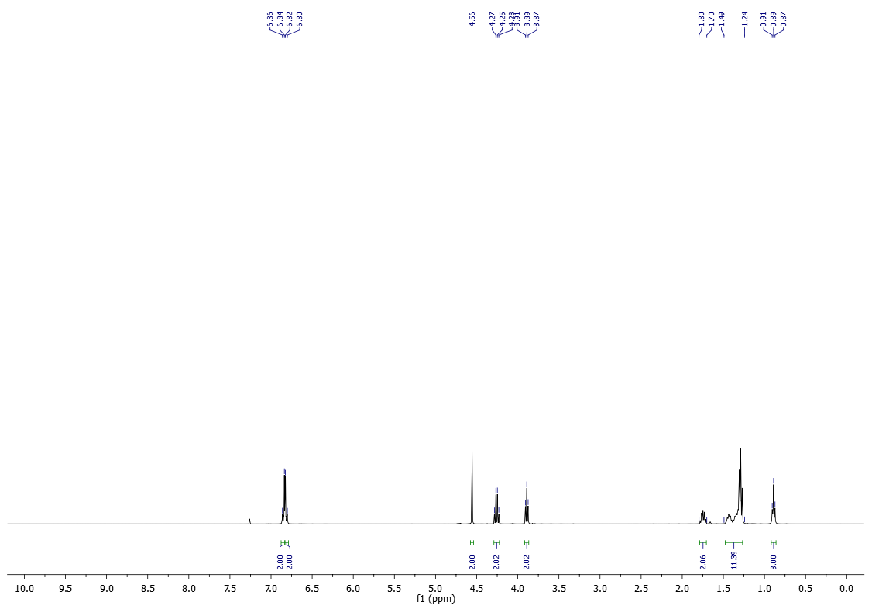¹³C-NMR (100 MHz) of 11b in CDCl₃
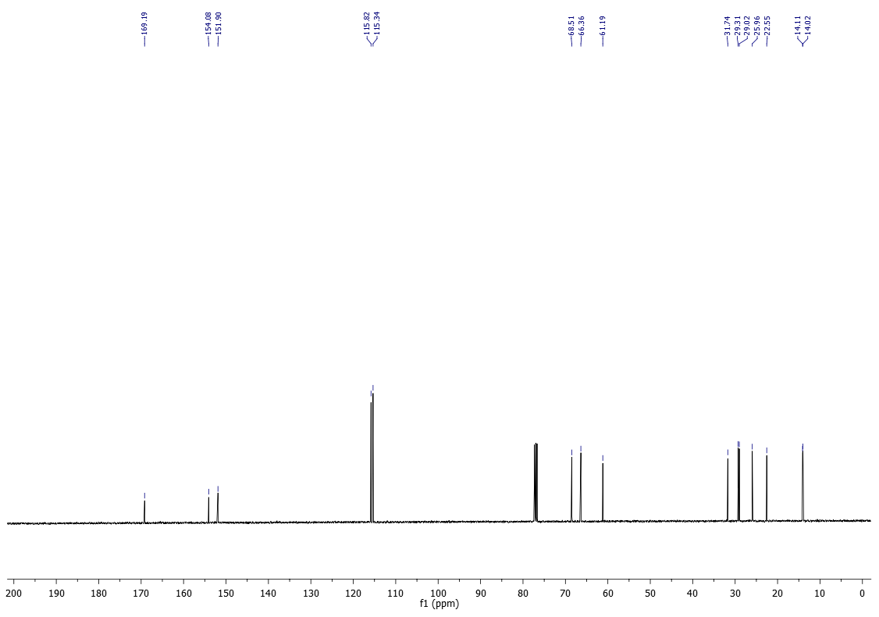

¹H-NMR (400 MHz) of 11d in CDCl₃
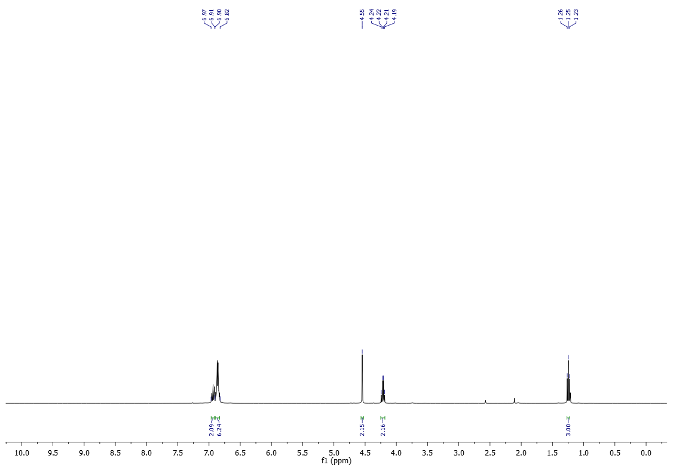
¹³C-NMR (100 MHz) of 11d in CDCl₃
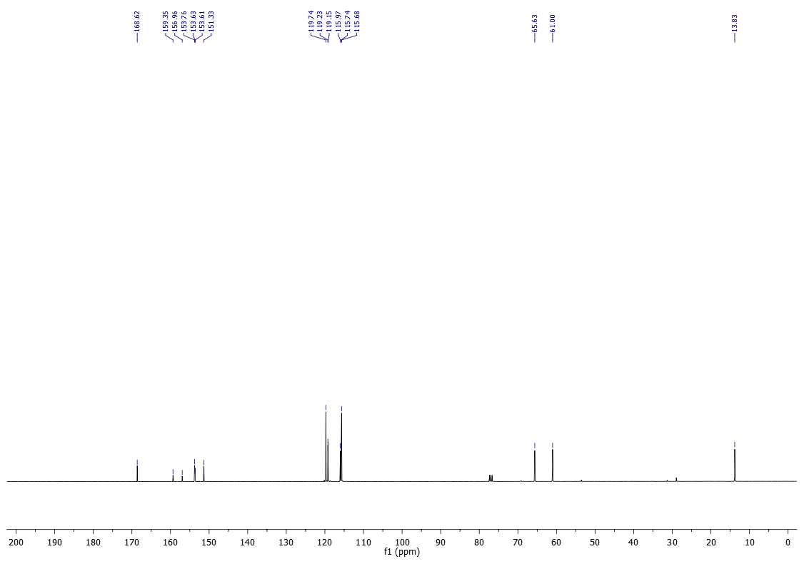

¹⁹F-NMR (377 MHz) of 11d in CDCl₃
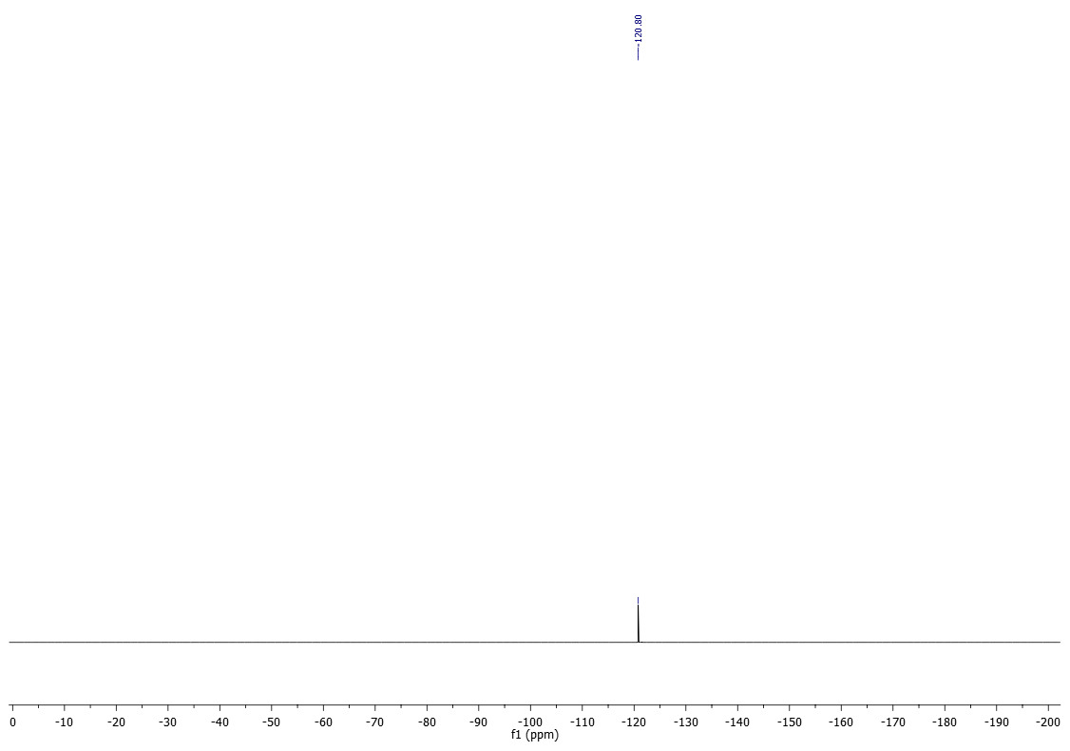

¹H-NMR (200 MHz) of 11e in CDCl₃
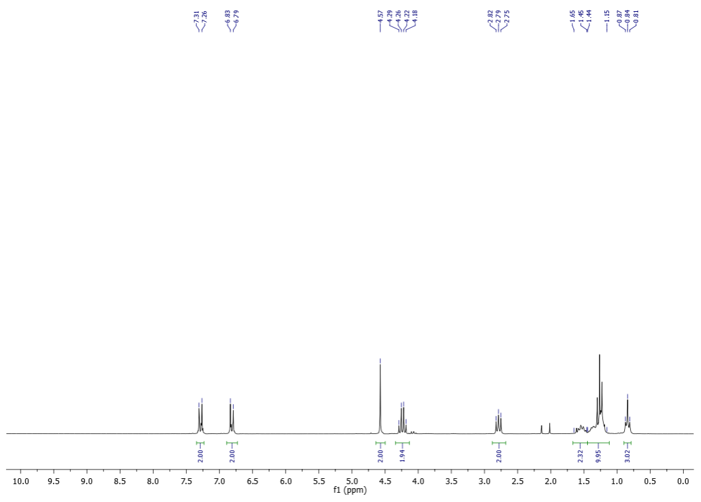
¹³C-NMR (50 MHz) of 11e in CDCl₃
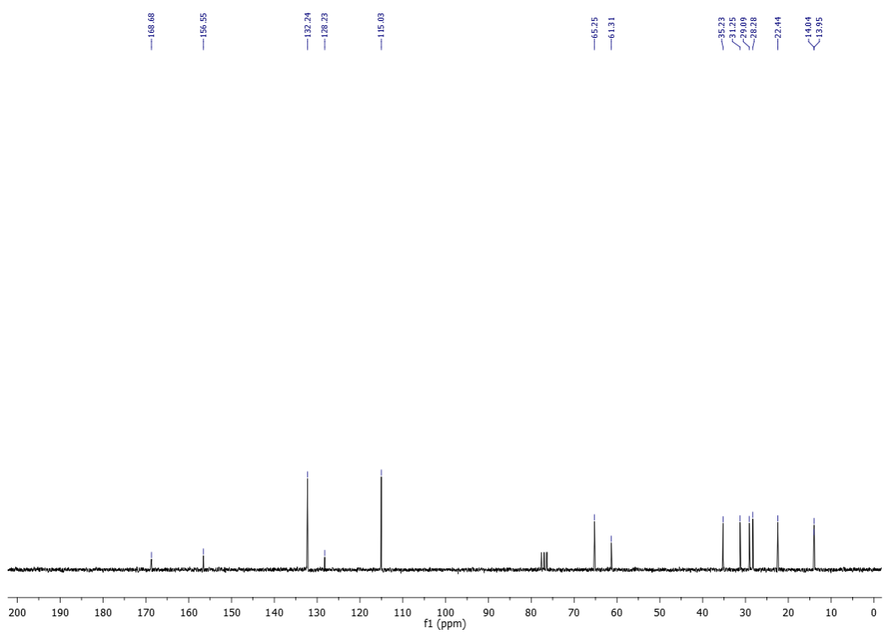

¹H-NMR (400 MHz) of 11f in CDCl₃
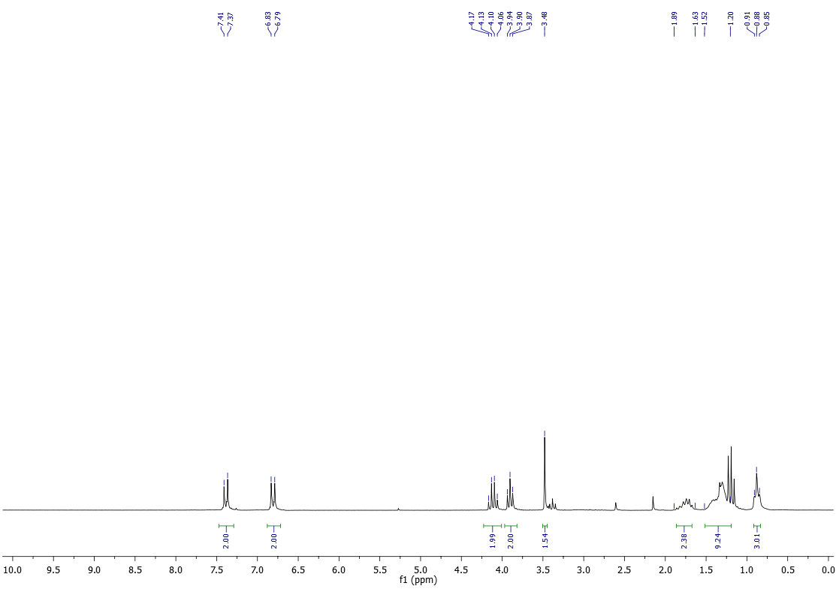

¹³C-NMR (100 MHz) of 11f in CDCl₃
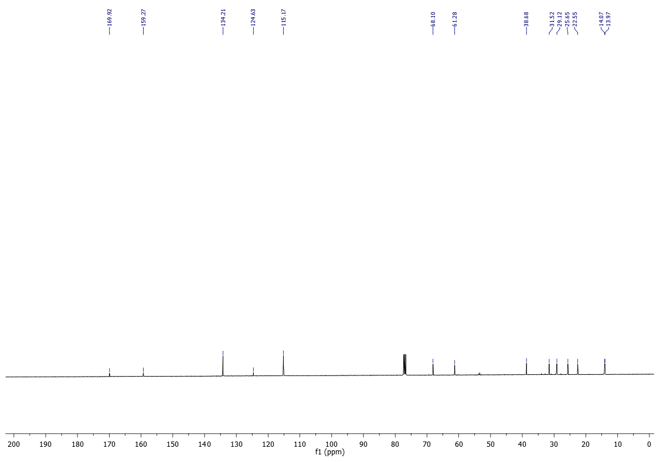
¹H-NMR (400 MHz) of 11g in CDCl₃
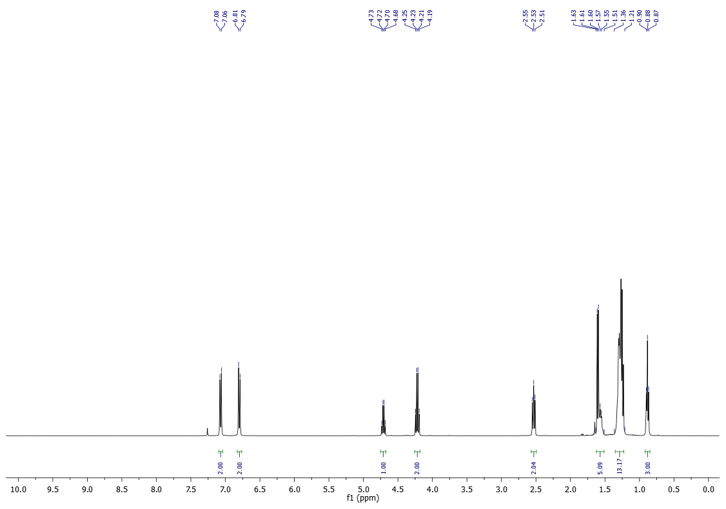

¹³C-NMR (100 MHz) of 11g in CDCl₃
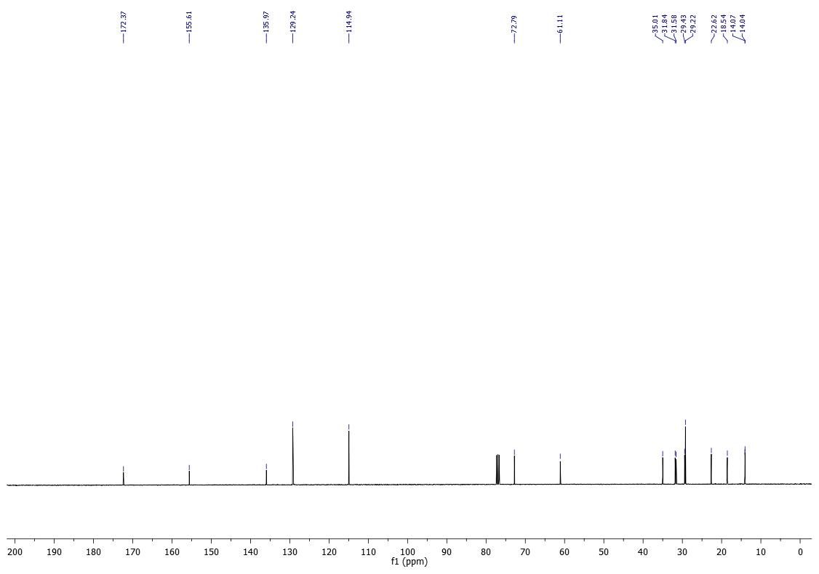
¹H-NMR (200 MHz) of 11h in CDCl₃
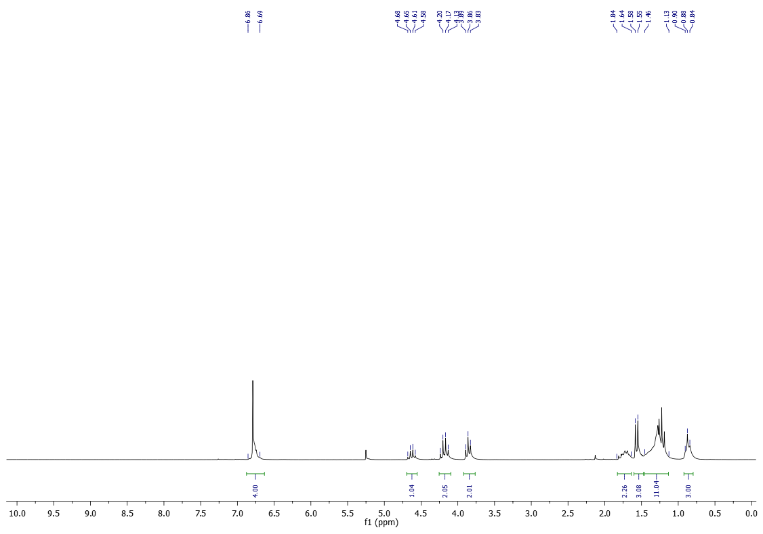

¹³C-NMR (50 MHz) of 11h in CDCl₃
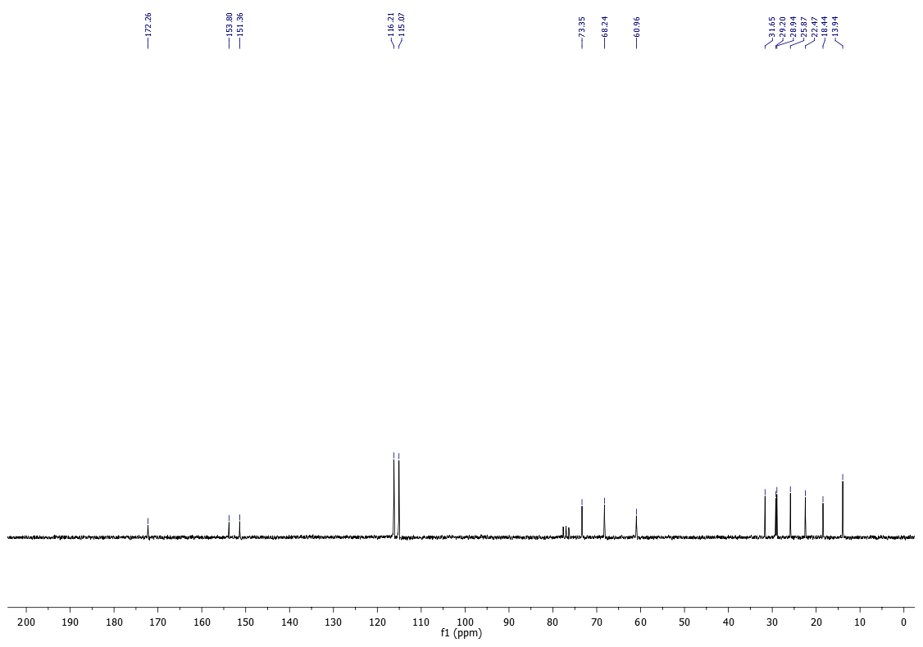
¹H-NMR (400 MHz) of 11i in CDCl₃
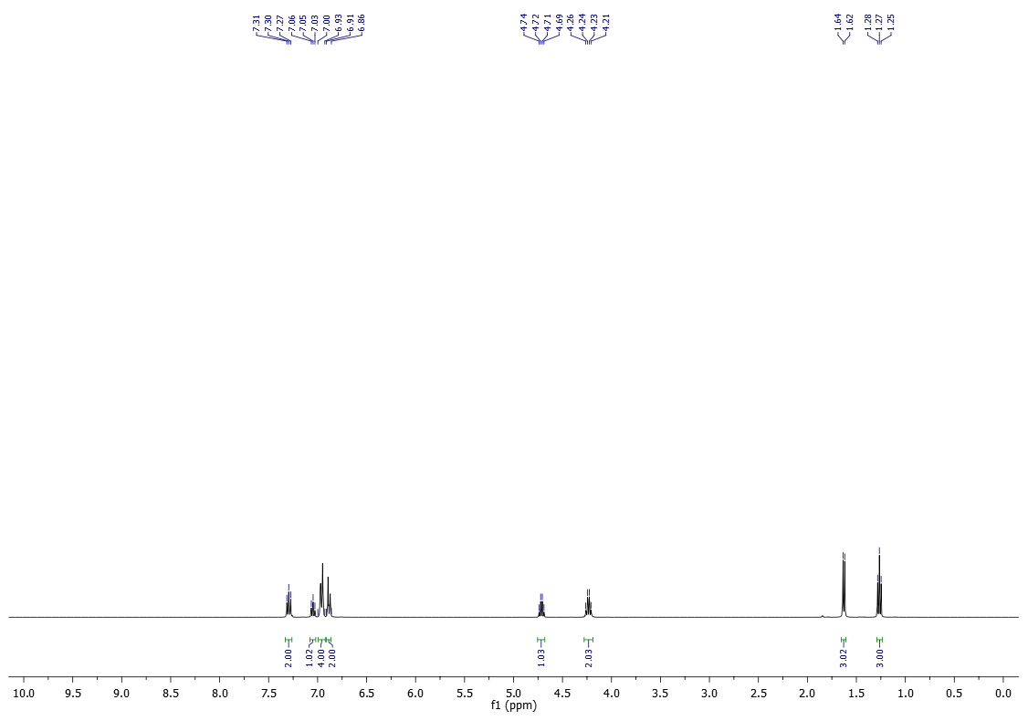

¹³C-NMR (100 MHz) of 11i in CDCl₃
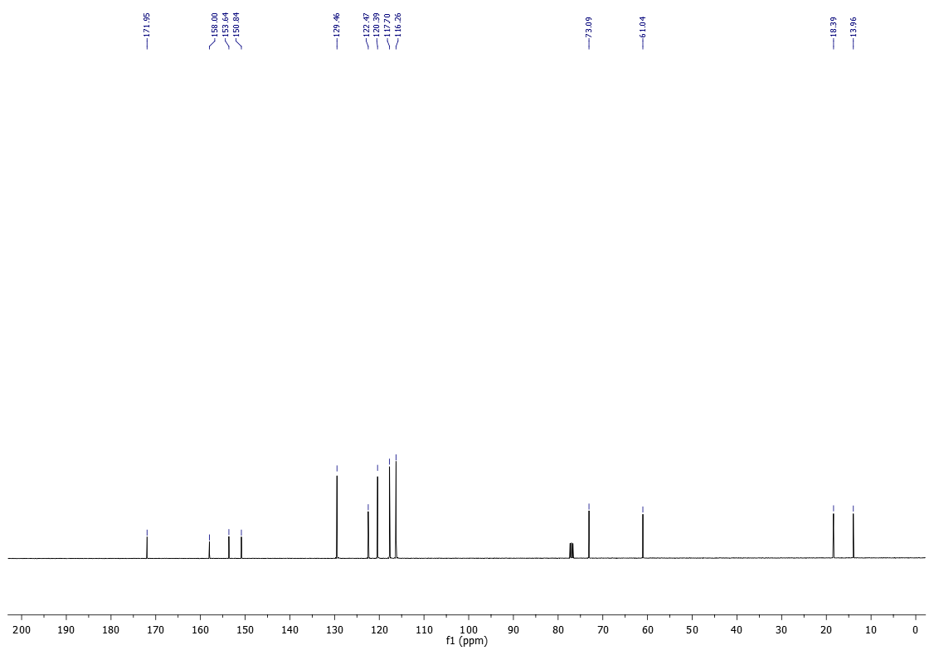
¹H-NMR (200 MHz) of 11j in CDCl₃
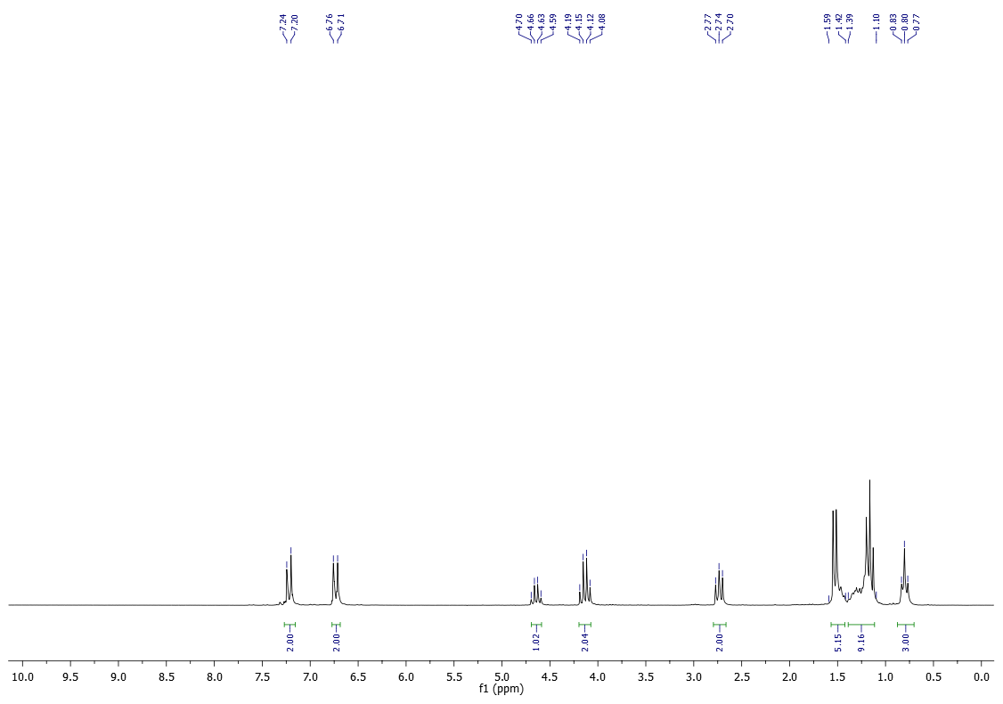

¹³C-NMR (50 MHz) of 11j in CDCl₃
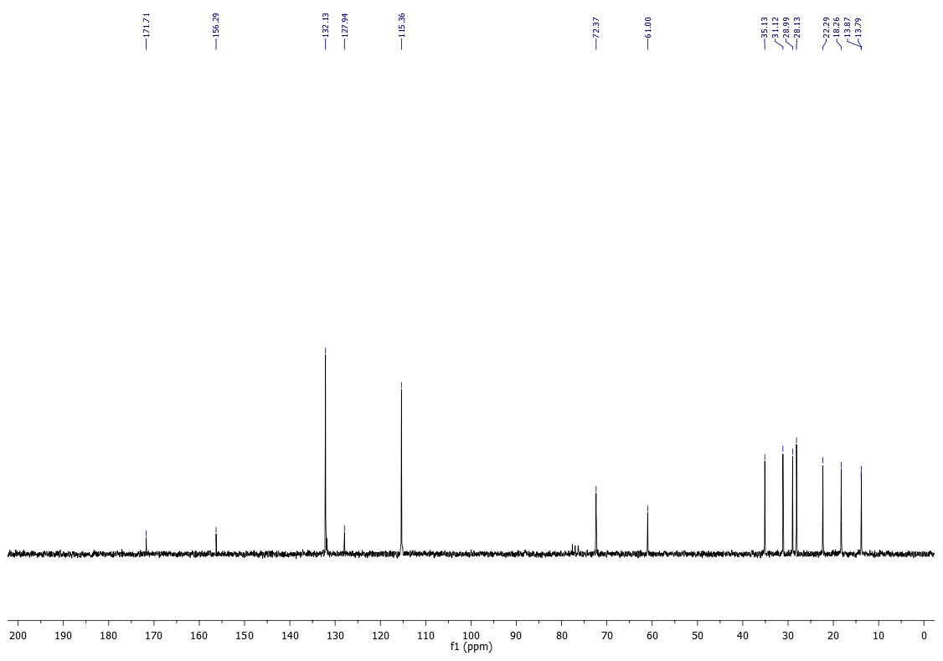
¹H-NMR (400 MHz) of 12b in CDCl₃
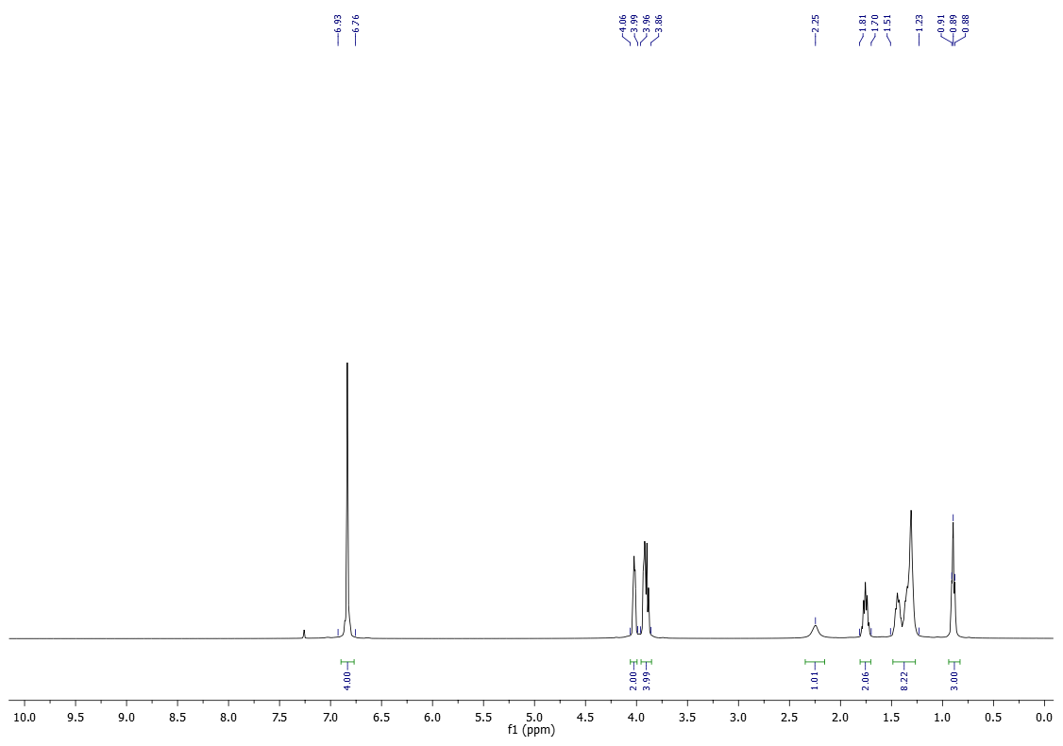

¹³C-NMR (100 MHz) of 12b in CDCl₃
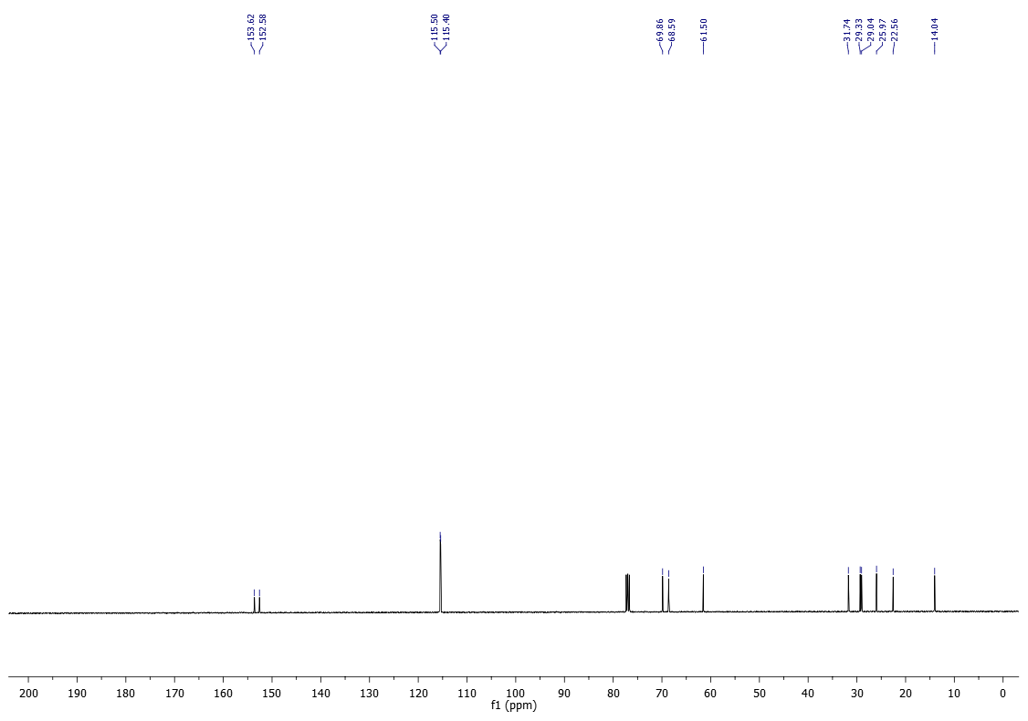
¹H-NMR (200 MHz) of 12d in CDCl₃
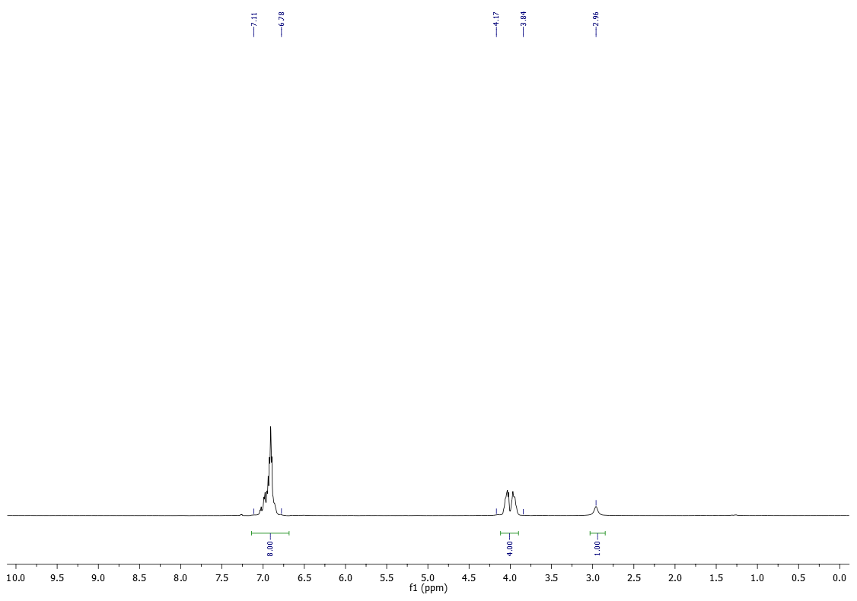

¹³C-NMR (50 MHz) of 12d in CDCl₃
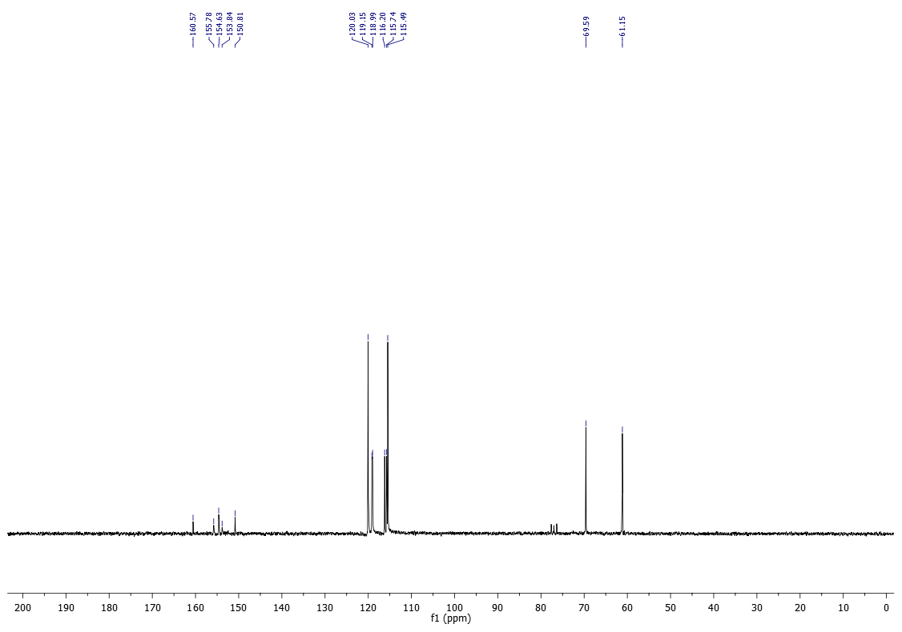

¹⁹F-NMR (177 MHz) of 12d in CDCl₃
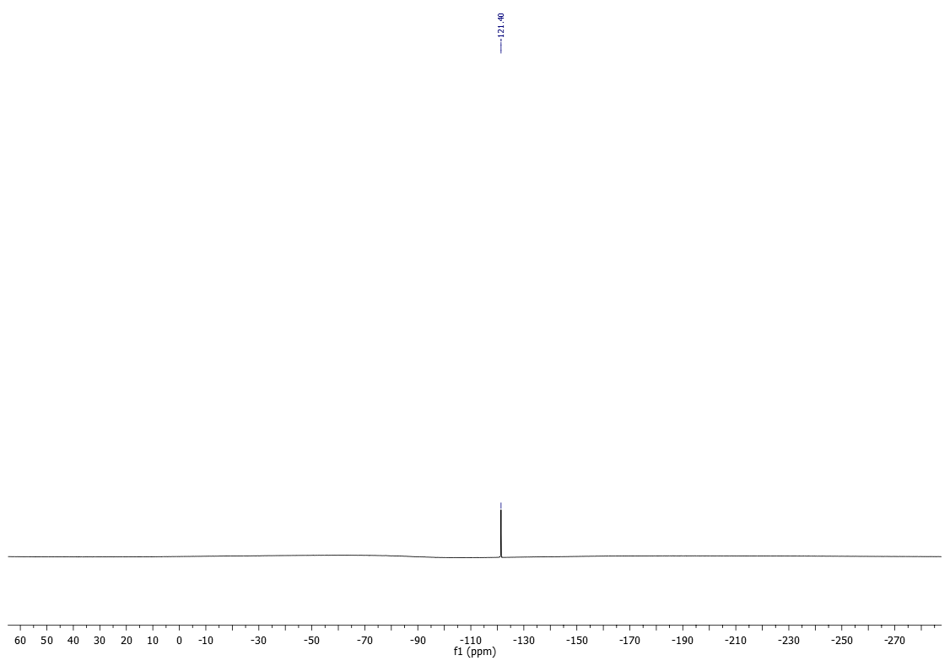

¹H-NMR (200 MHz) of 12e in CDCl₃
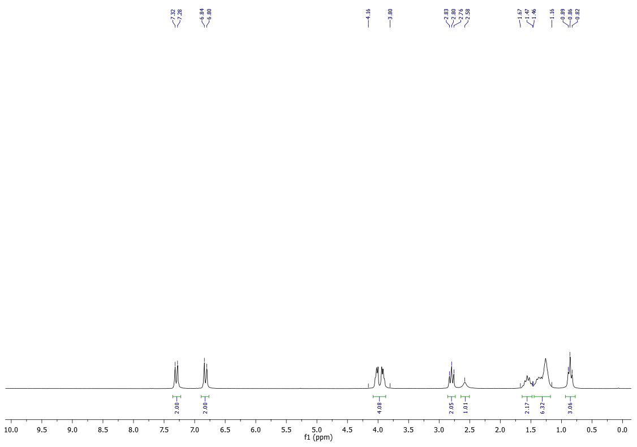
¹³C-NMR (50 MHz) of 12e in CDCl₃
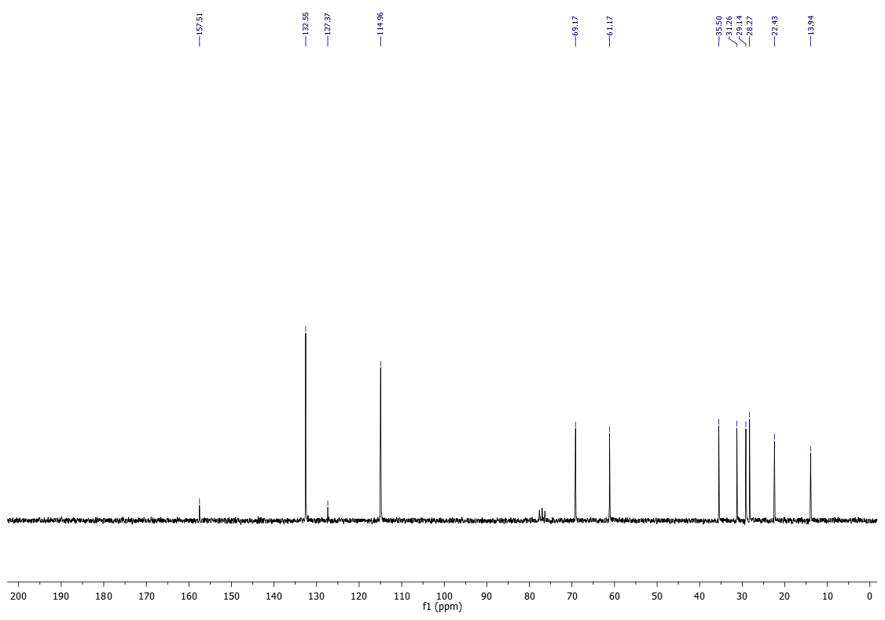

¹H-NMR (400 MHz) of 12g in CDCl₃
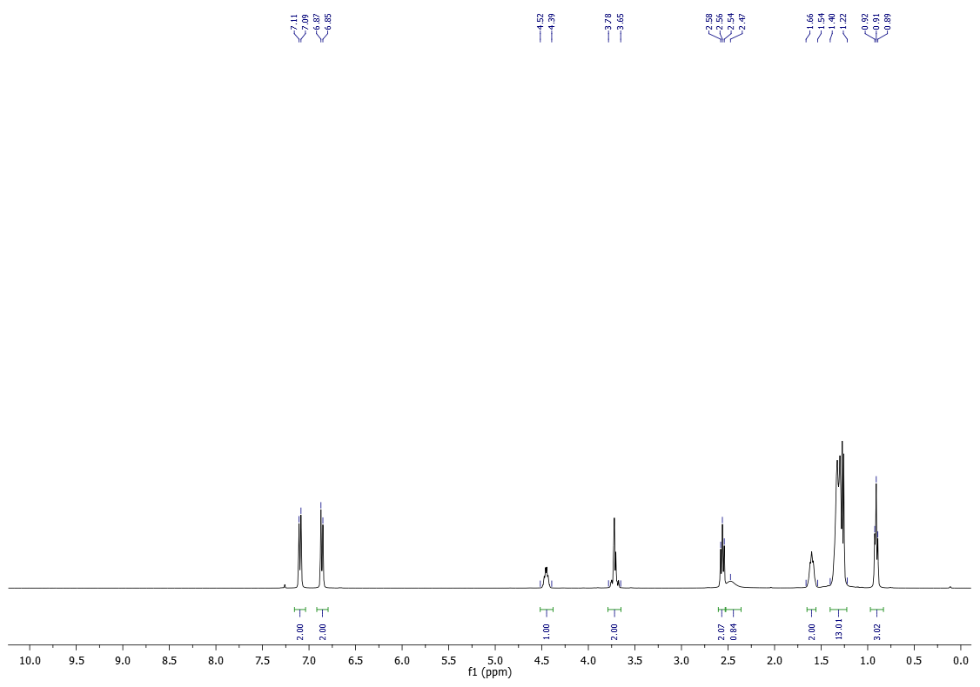
¹³C-NMR (100 MHz) of 12g in CDCl₃
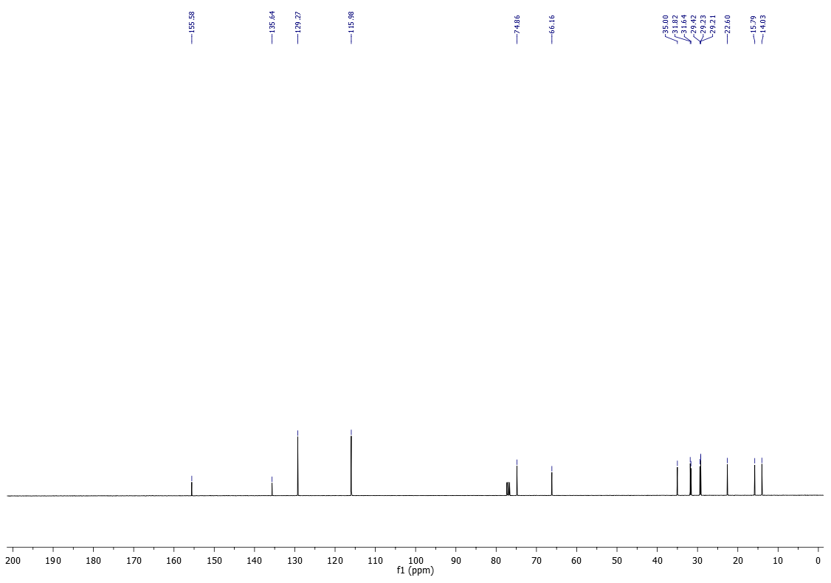

¹H-NMR (200 MHz) of 12h in CDCl₃
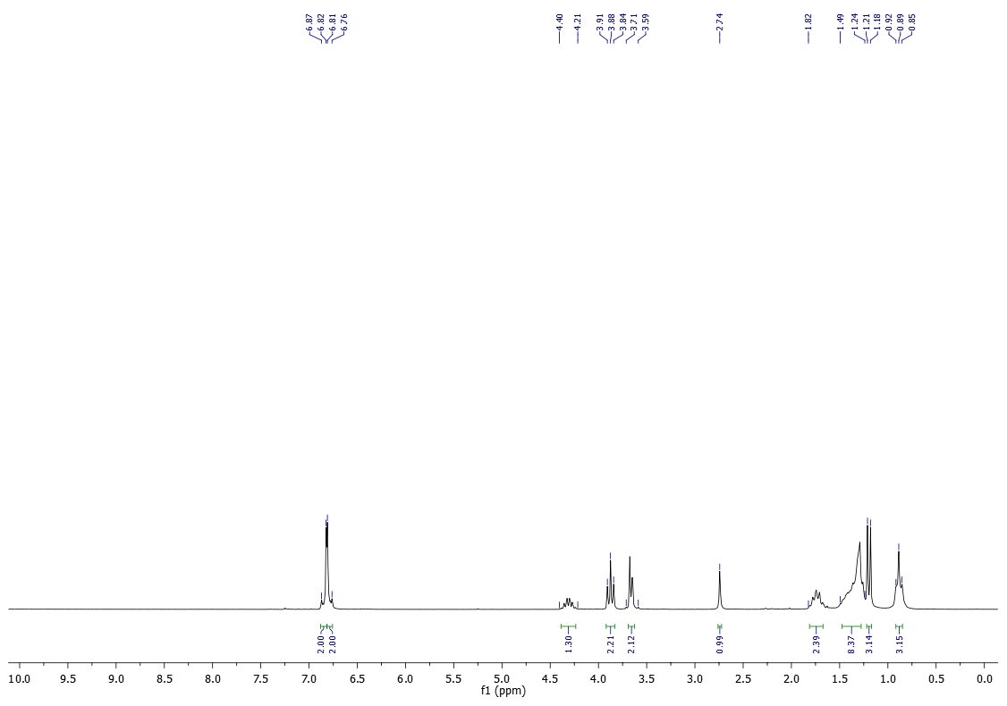
¹³C-NMR (50 MHz) of 12h in CDCl₃
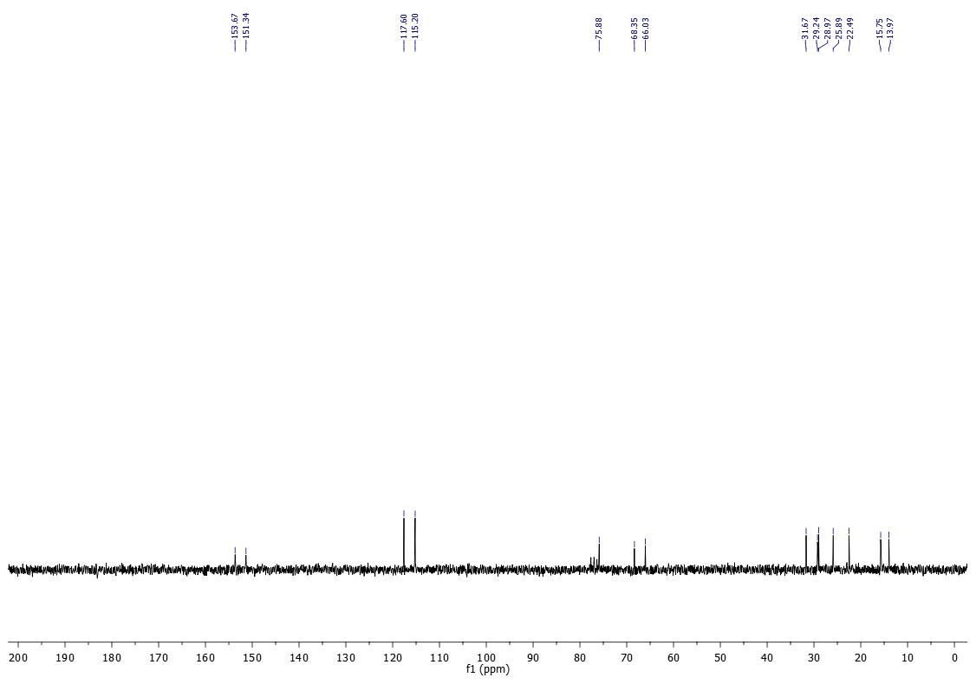

¹H-NMR (400 MHz) of 12i in CDCl₃
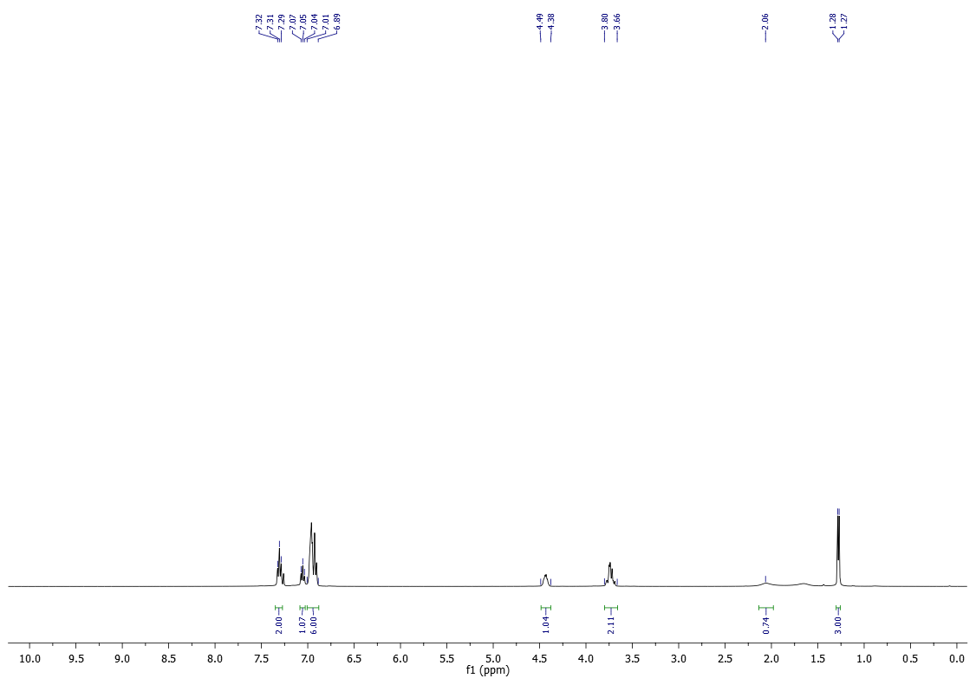
¹³C-NMR (100 MHz) of 12i in CDCl₃
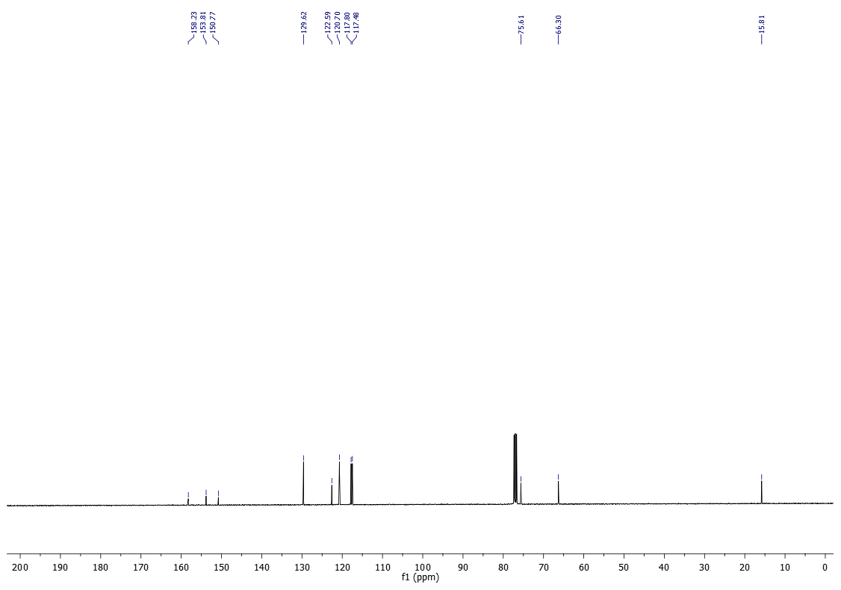

¹H-NMR (200 MHz) of 12j in CDCl₃
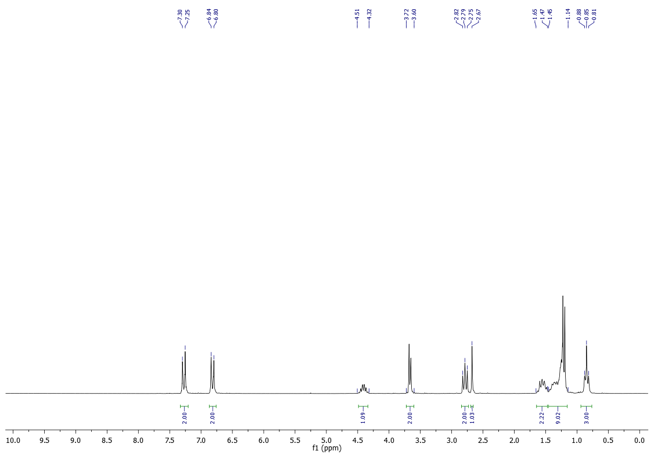
¹³C-NMR (50 MHz) of 12j in CDCl₃
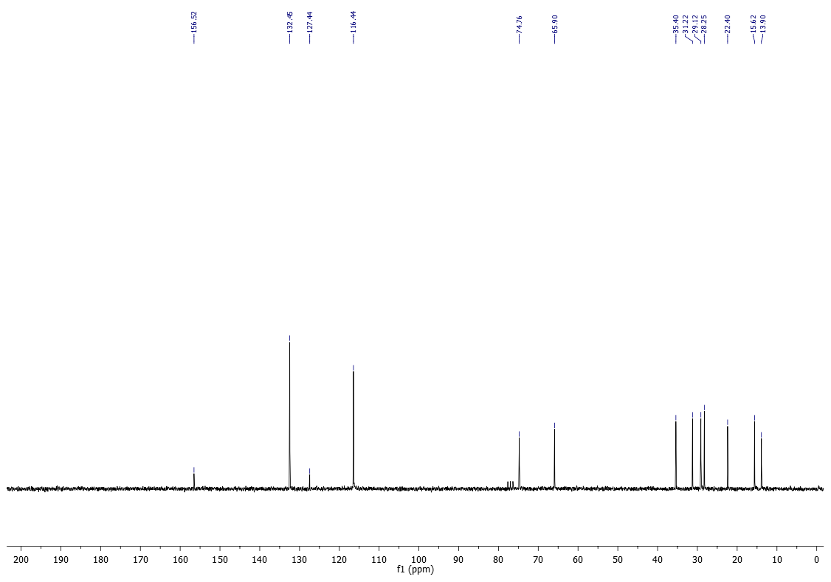

¹H-NMR (200 MHz) of 13b in CDCl₃
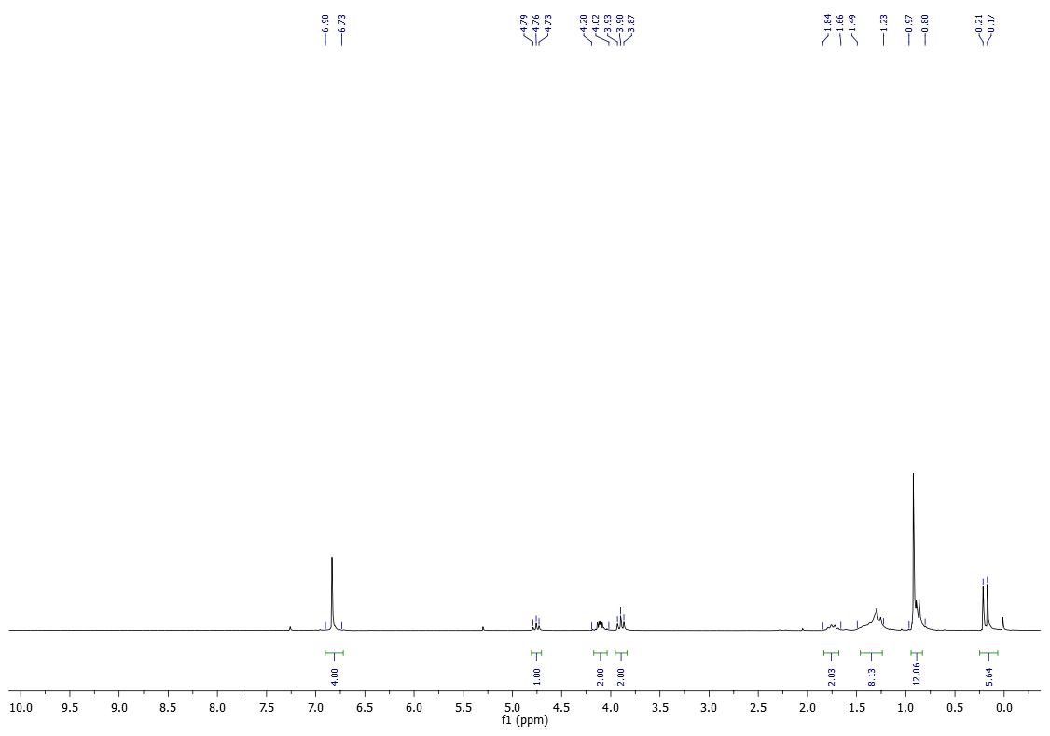
¹³C-NMR (50 MHz) of 13b in CDCl₃
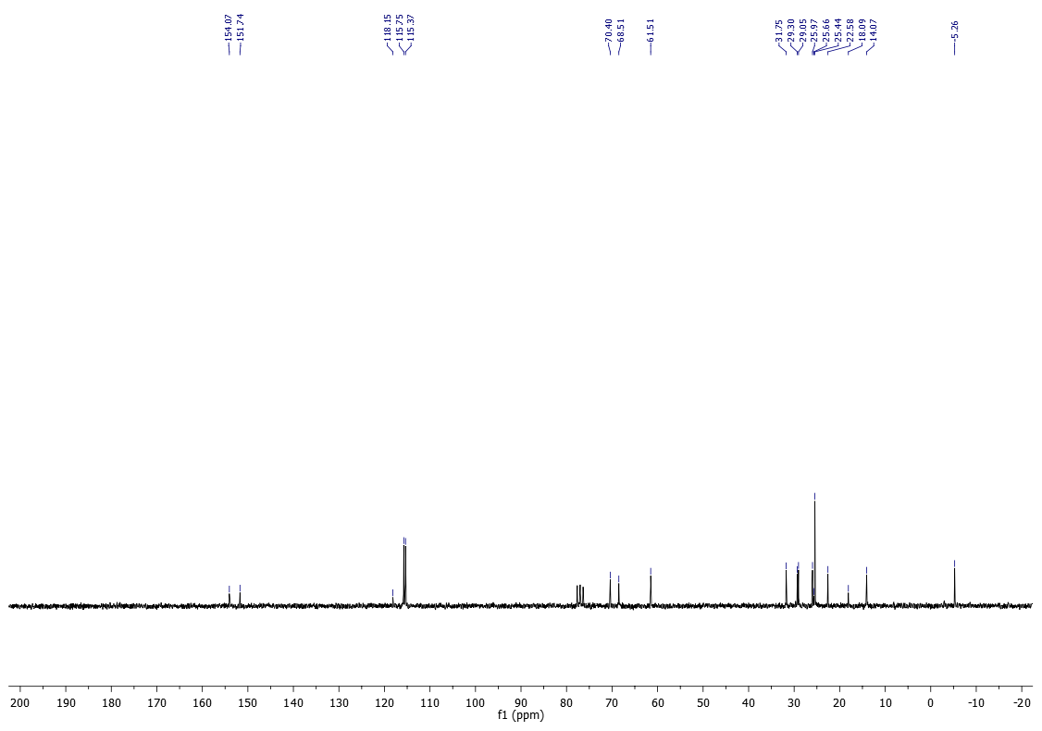

¹H-NMR (200 MHz) of 13h in CDCl₃
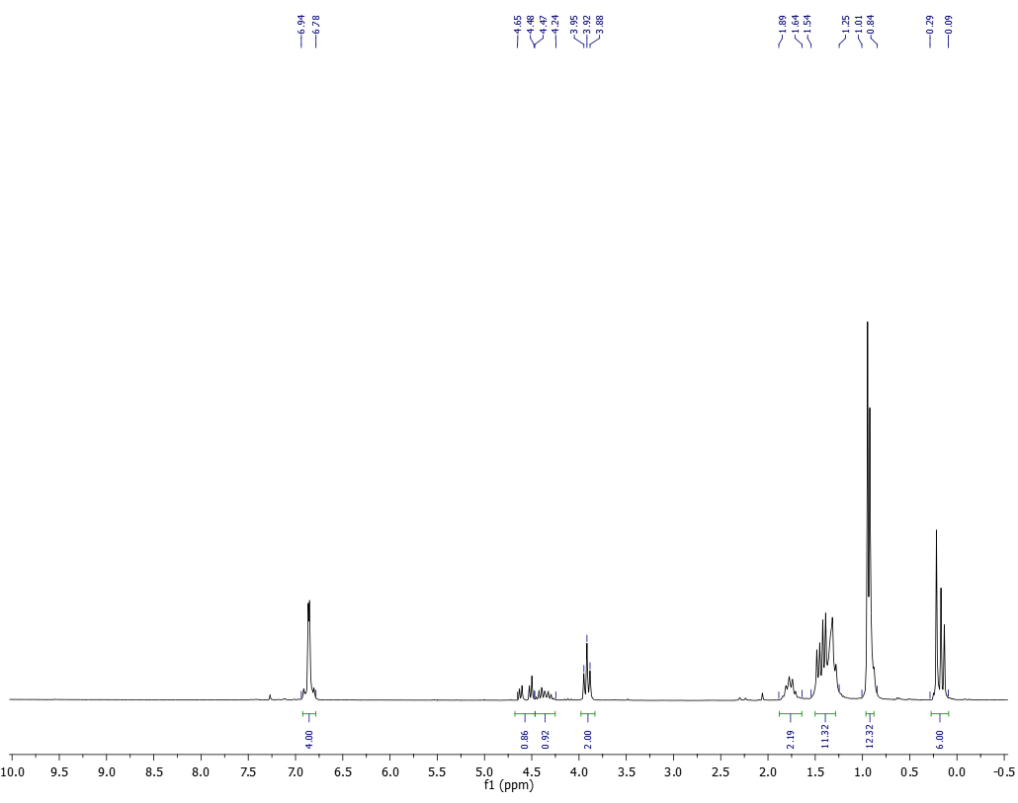
¹³C-NMR (50 MHz) of 13h in CDCl₃
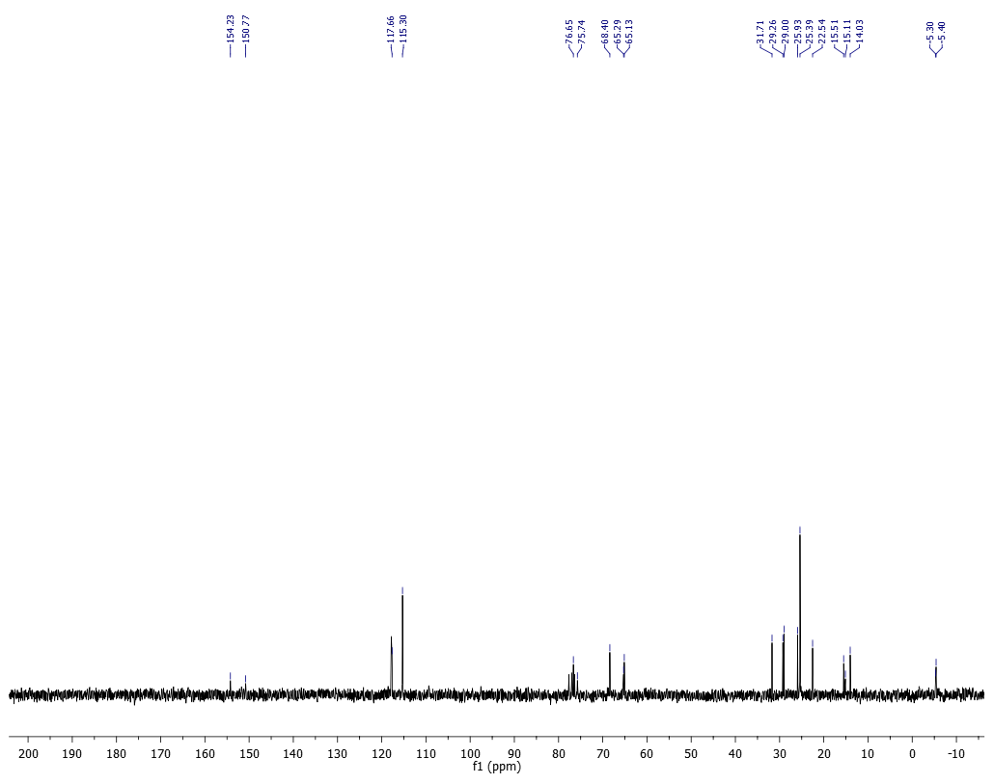

¹H-NMR (200 MHz) of 13j in CDCl₃
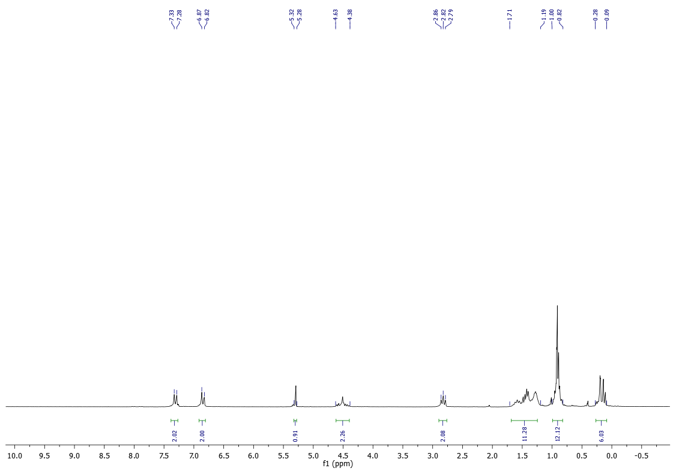
¹³C-NMR (50 MHz) of 13j in CDCl₃
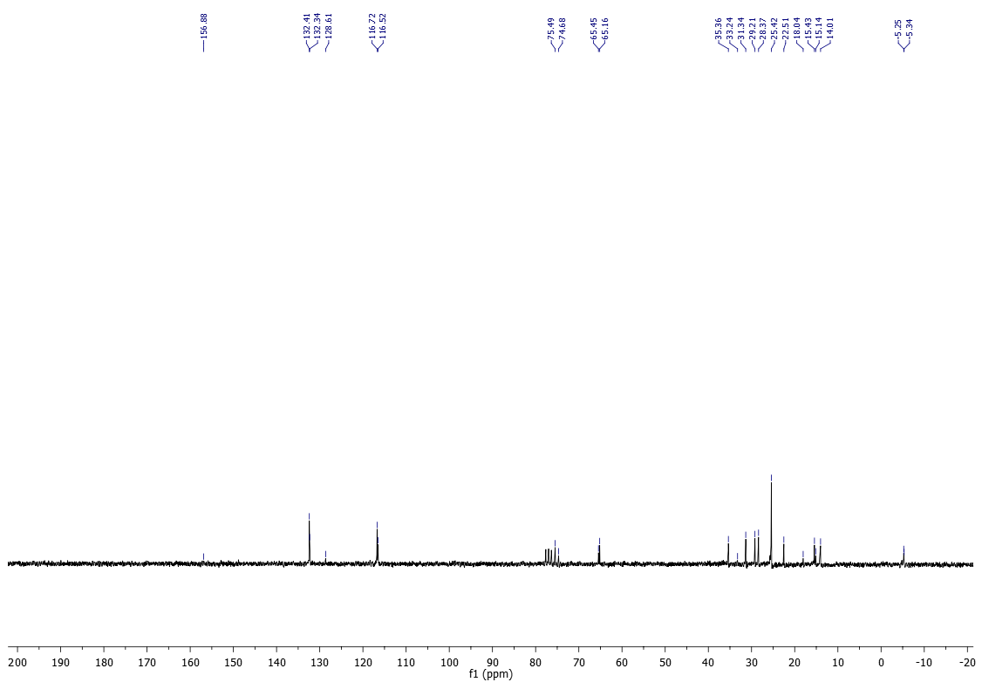

¹H-NMR (200 MHz) of 14a in CDCl₃
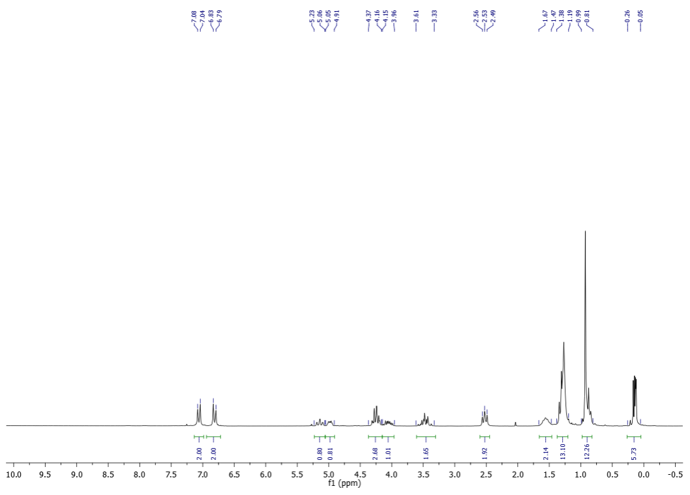
¹³C-NMR (50 MHz) of 14a in CDCl₃
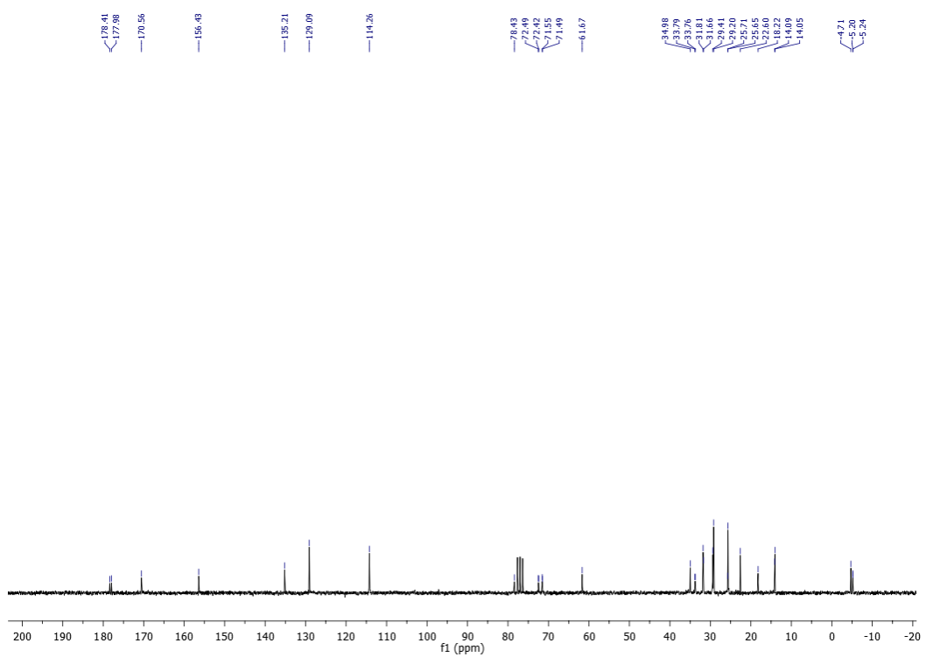

¹H-NMR (200 MHz) of 14b in CDCl₃
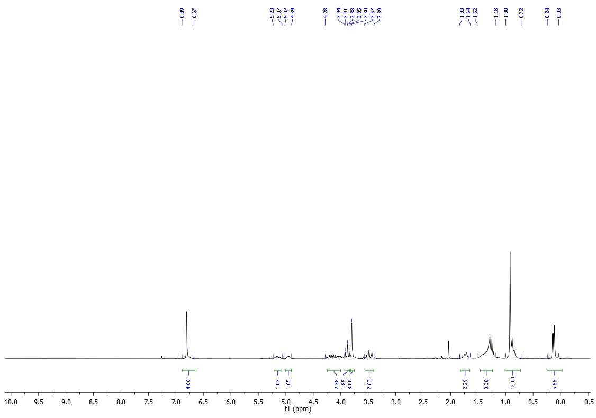
¹³C-NMR (50 MHz) of 14b in CDCl₃
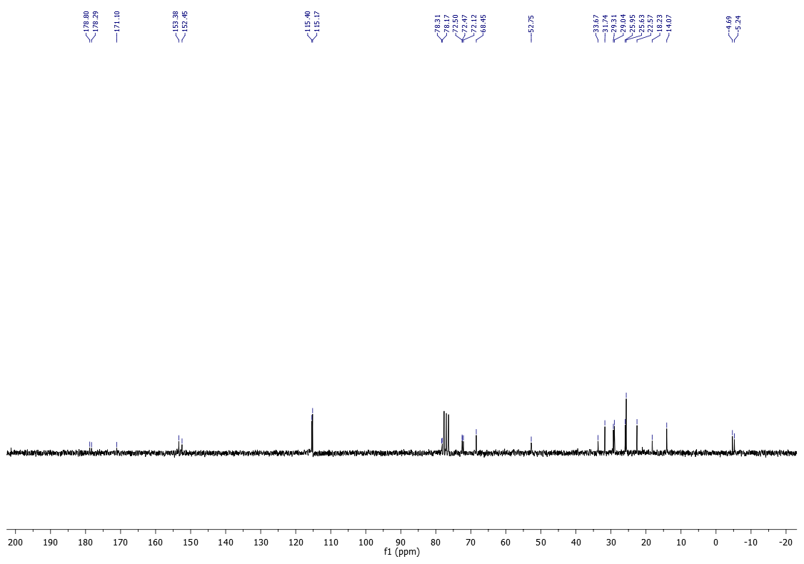

¹H-NMR (400 MHz) of 14d in CDCl₃
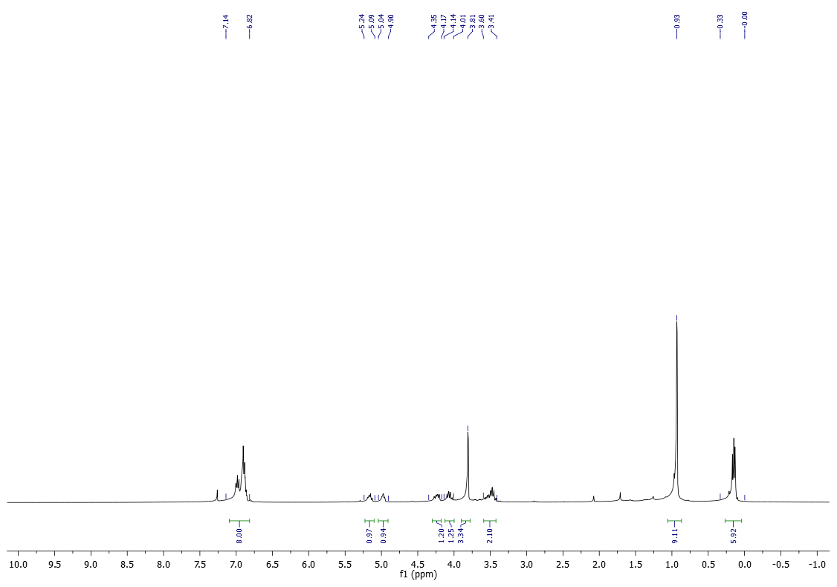
¹³C-NMR (100 MHz) of 14d in CDCl₃
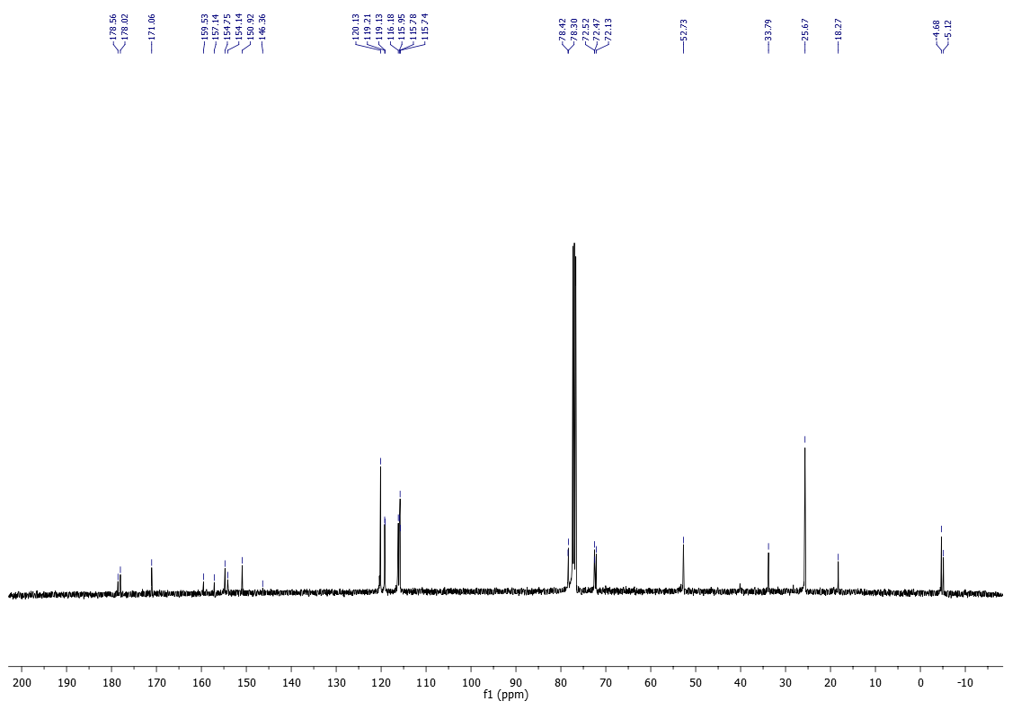

¹⁹F-NMR (377 MHz) of 14d in CDCl₃
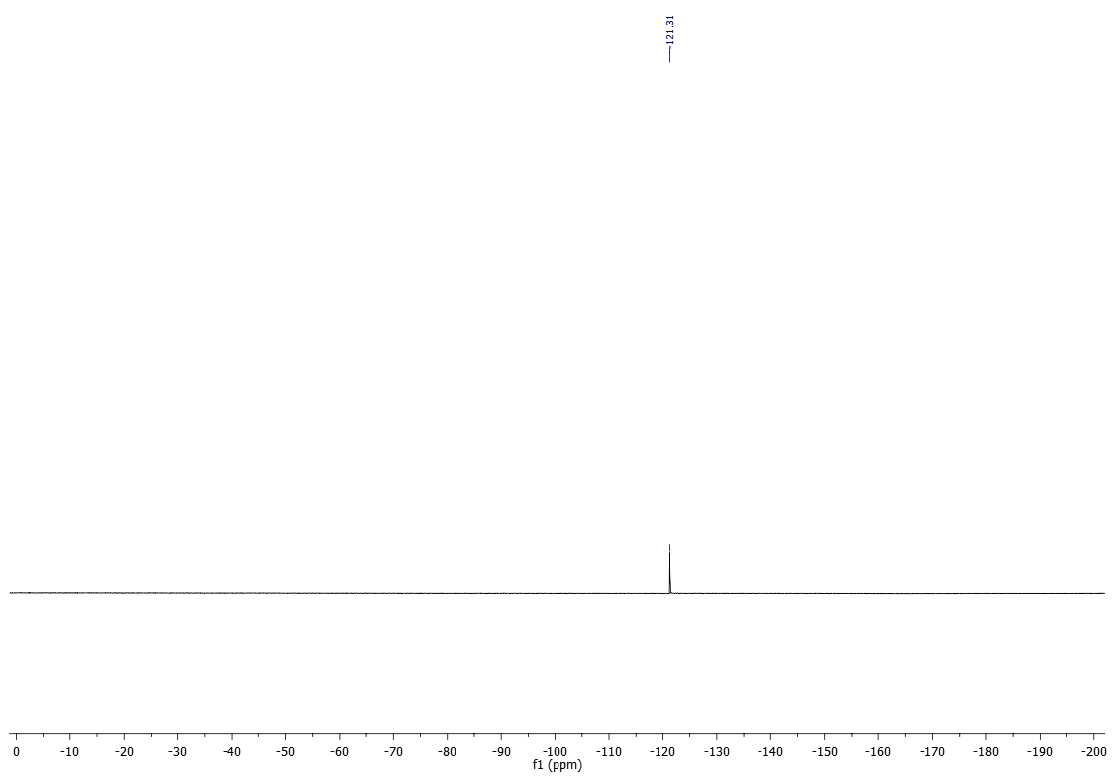

¹H-NMR (200 MHz) of 14e in CDCl₃
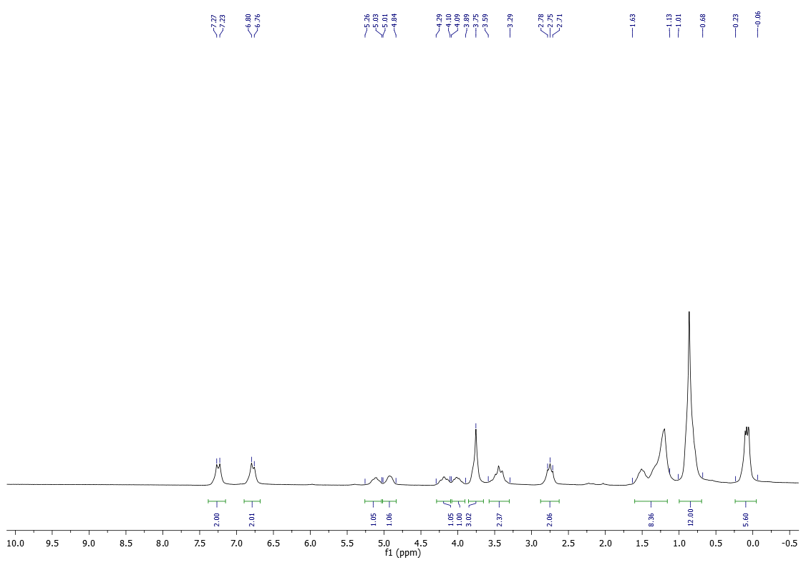
¹³C-NMR (50 MHz) of 14e in CDCl₃
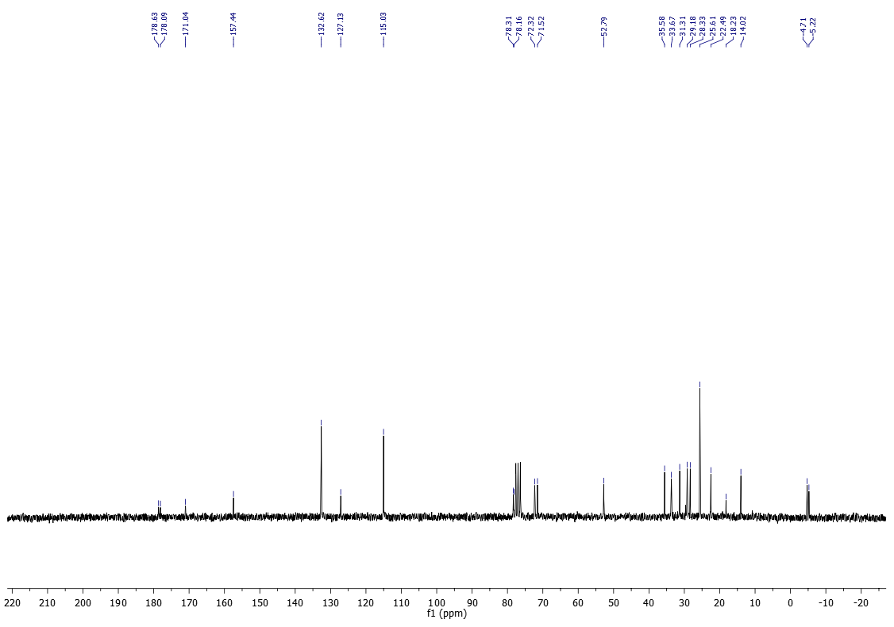

¹H-NMR (400 MHz) of 14h in CDCl₃
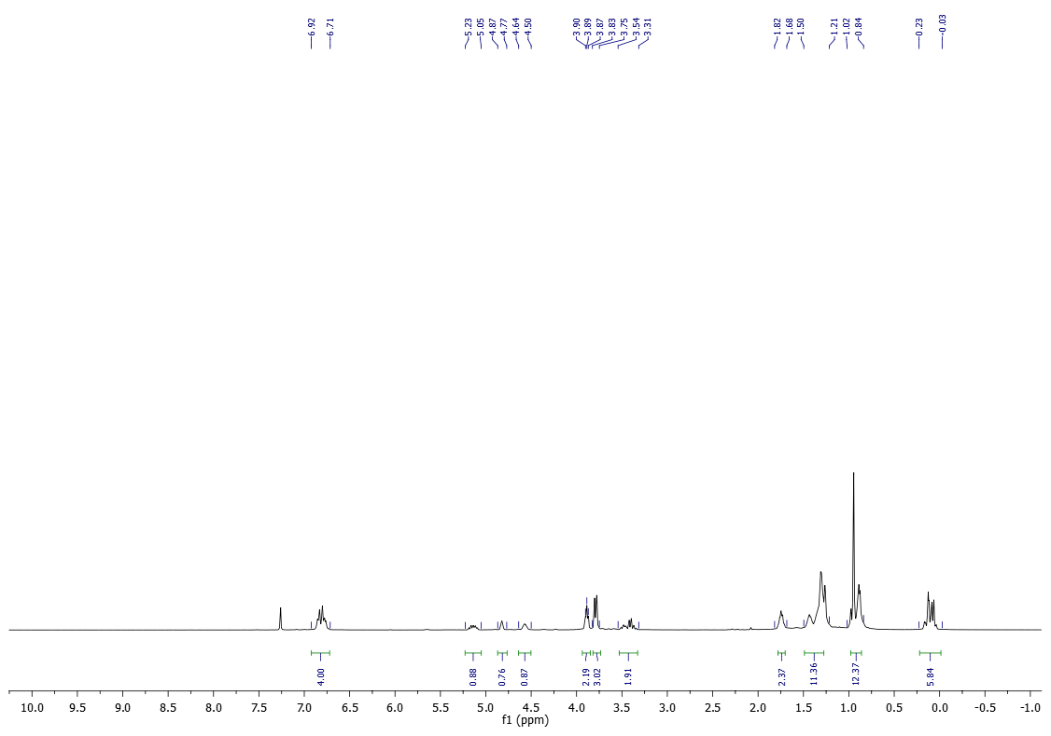
¹³C-NMR (100 MHz) of 14h in CDCl₃
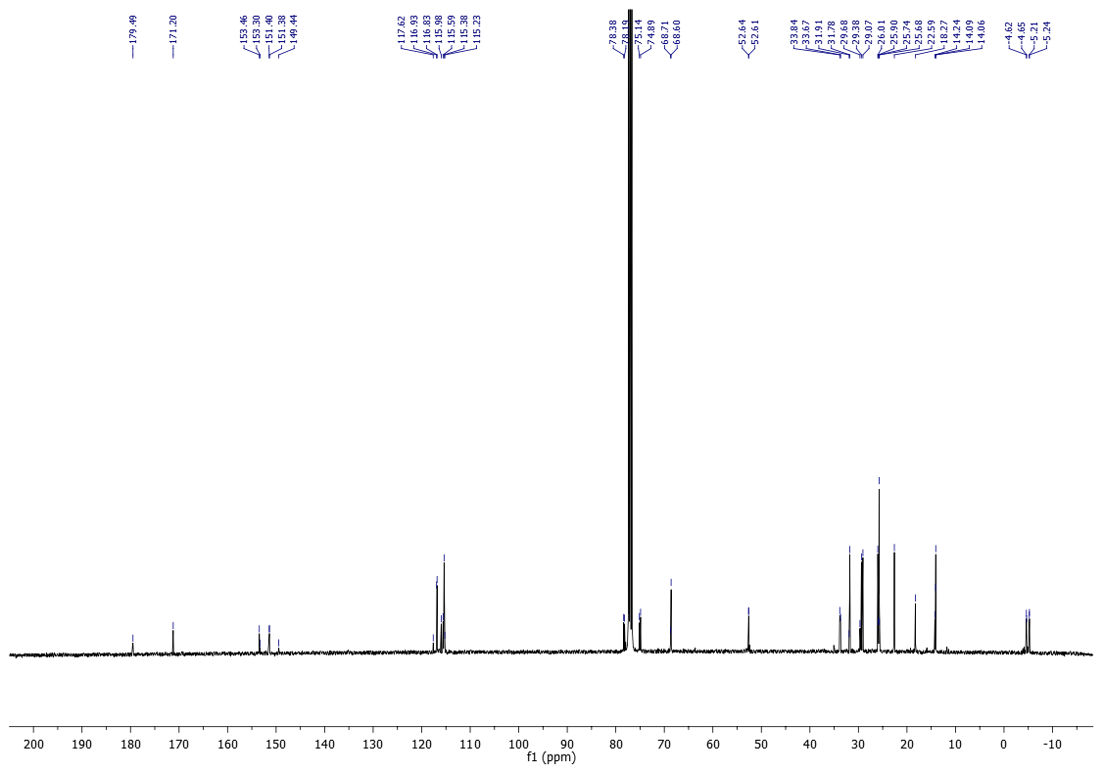

¹H-NMR (200 MHz) of 14j in CDCl₃
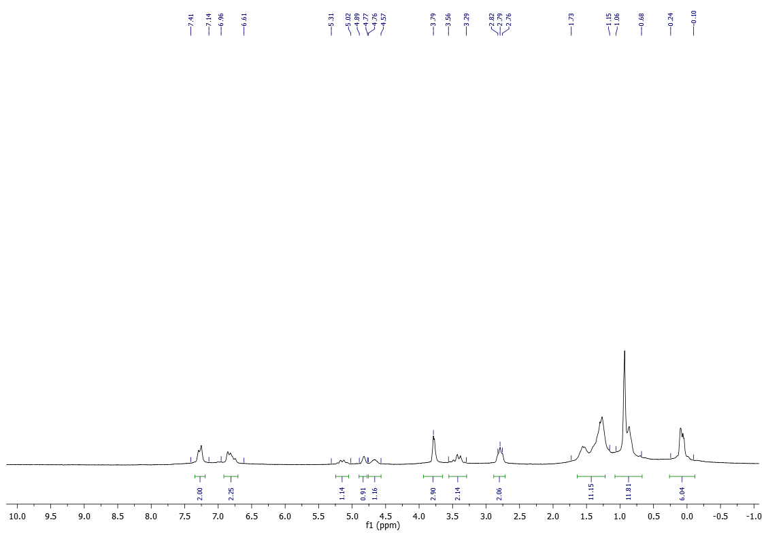
¹³C-NMR (50 MHz) of 14j in CDCl₃
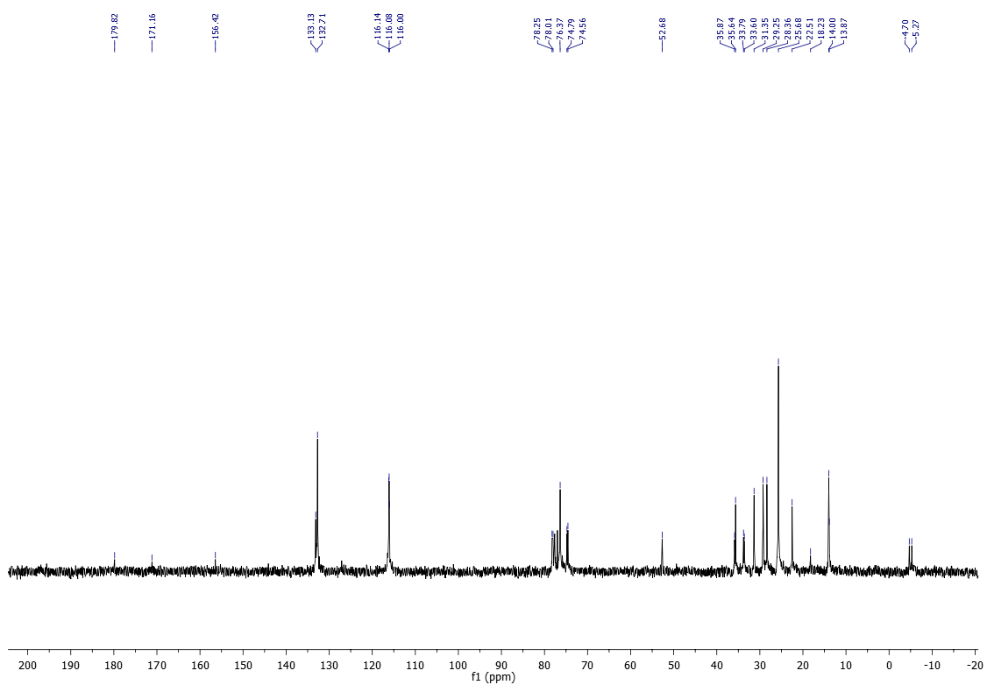

¹H-NMR (200 MHz) of 15a in CDCl₃
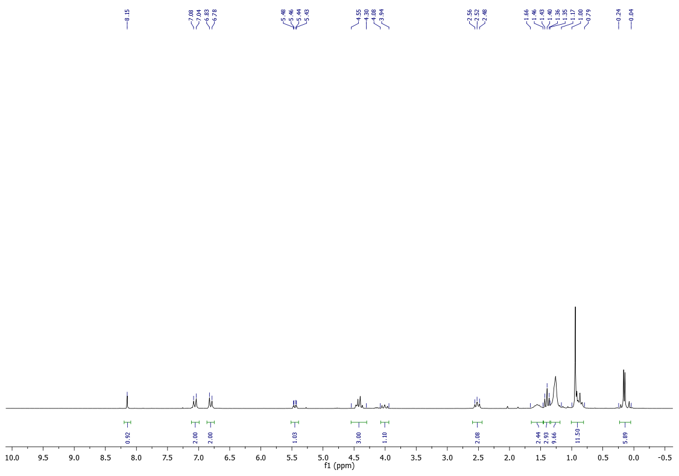
¹³C-NMR (50 MHz) of 15a in CDCl₃
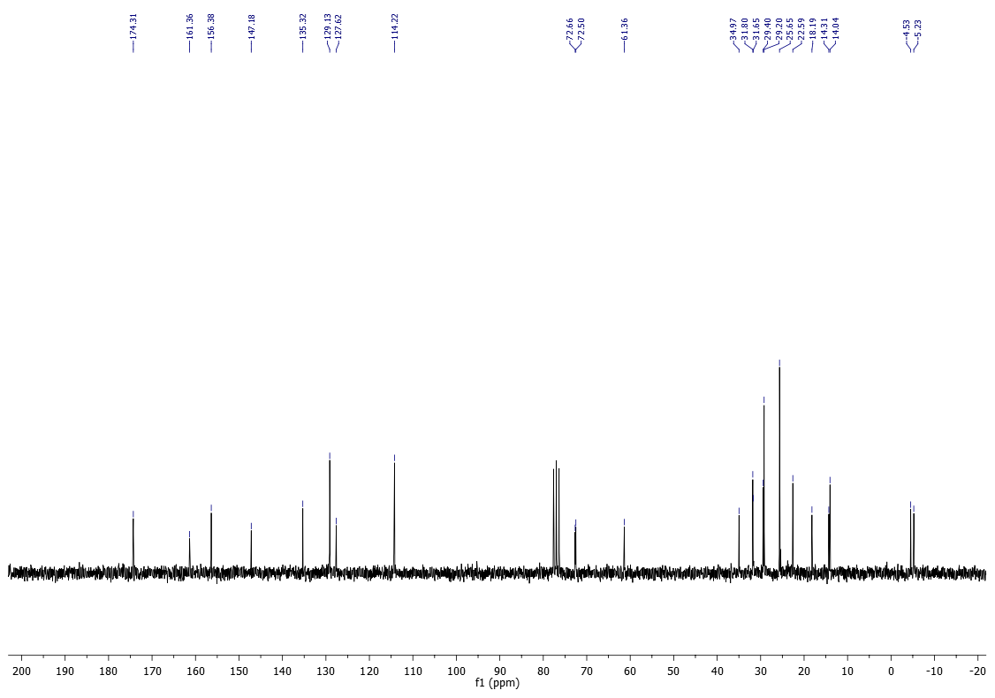

¹H-NMR (200 MHz) of 15b in CDCl₃
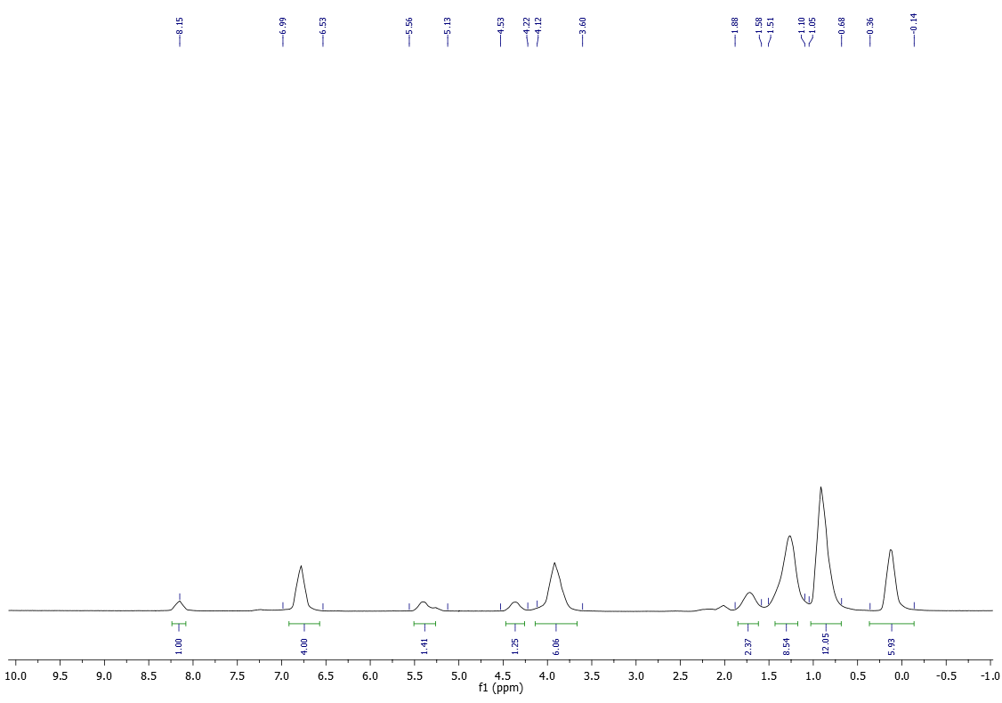
¹³C-NMR (50 MHz) of 15b in CDCl₃
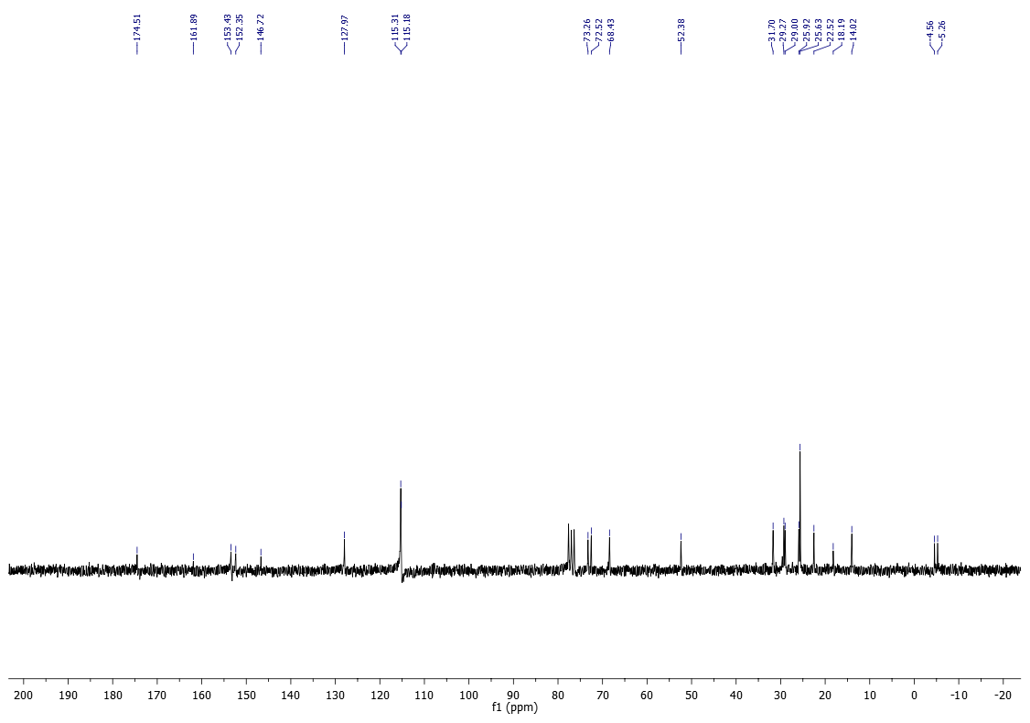

¹H-NMR (200 MHz) of 15c in CDCl₃
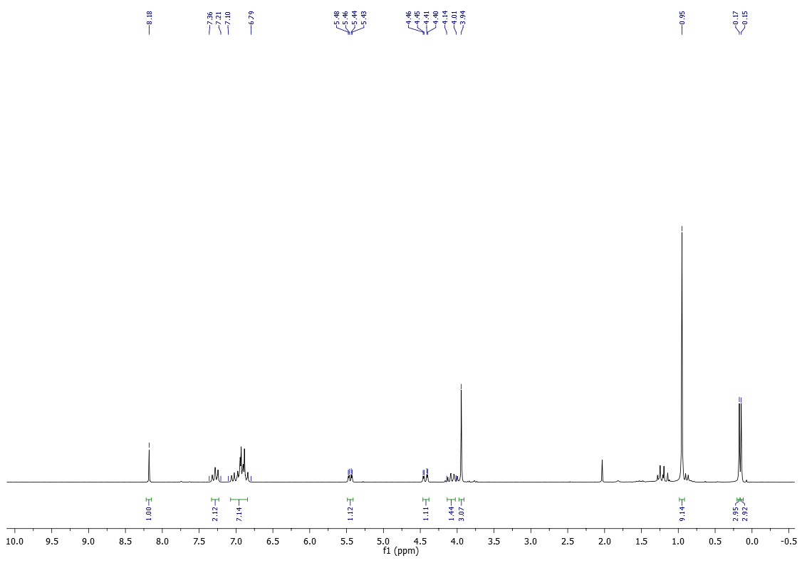
¹³C-NMR (50 MHz) of 15c in CDCl₃
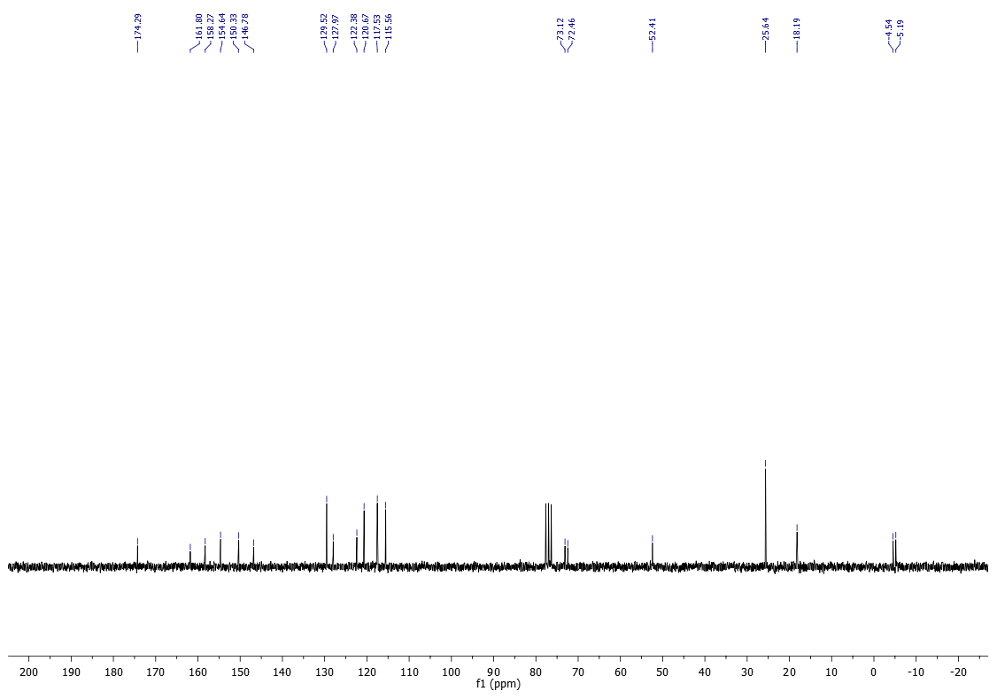

¹H-NMR (400 MHz) of 15d in CDCl₃
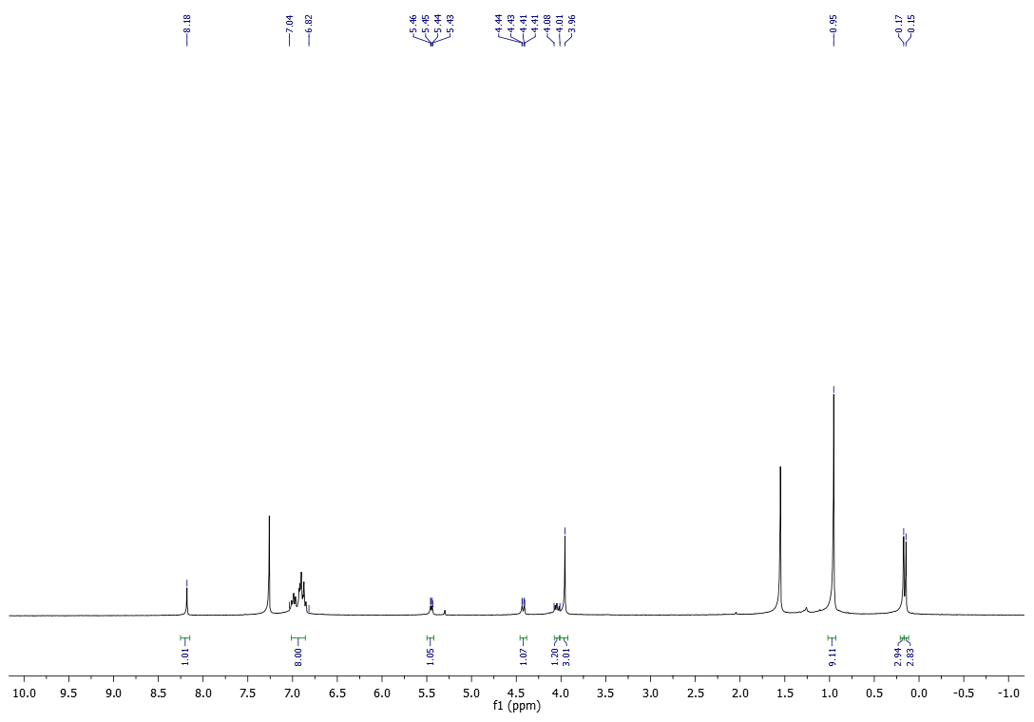
¹³C-NMR (100 MHz) of 15d in CDCl₃
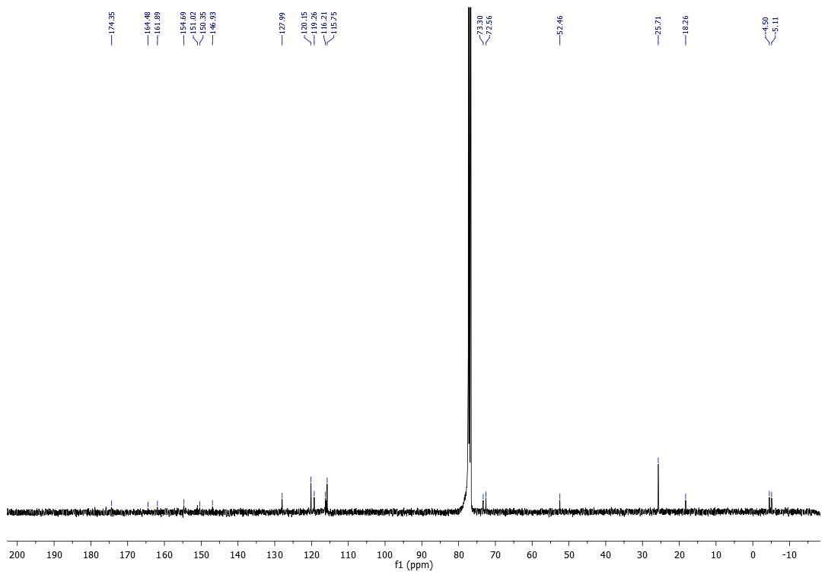

¹⁹F-NMR (377 MHz) of 15d in CDCl₃
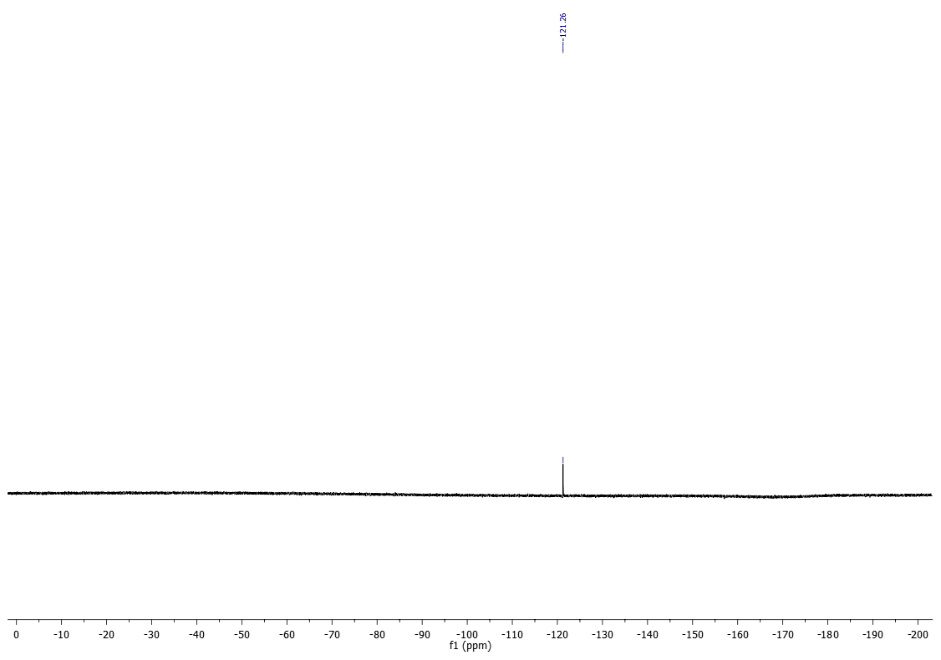

¹H-NMR (200 MHz) of 15e in CDCl₃
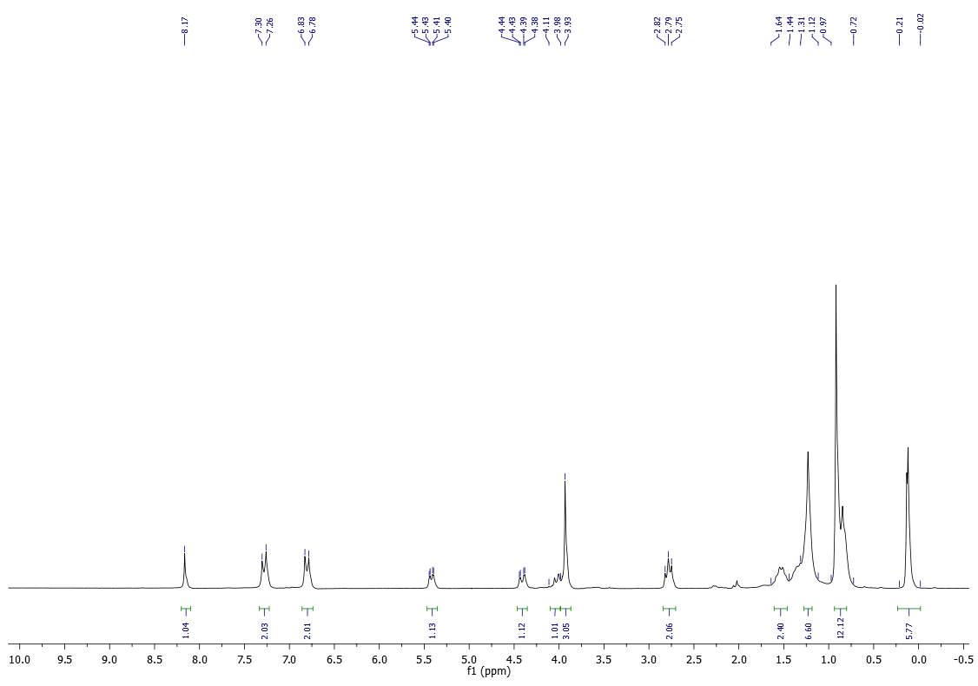
¹³C-NMR (50 MHz) of 15e in CDCl₃
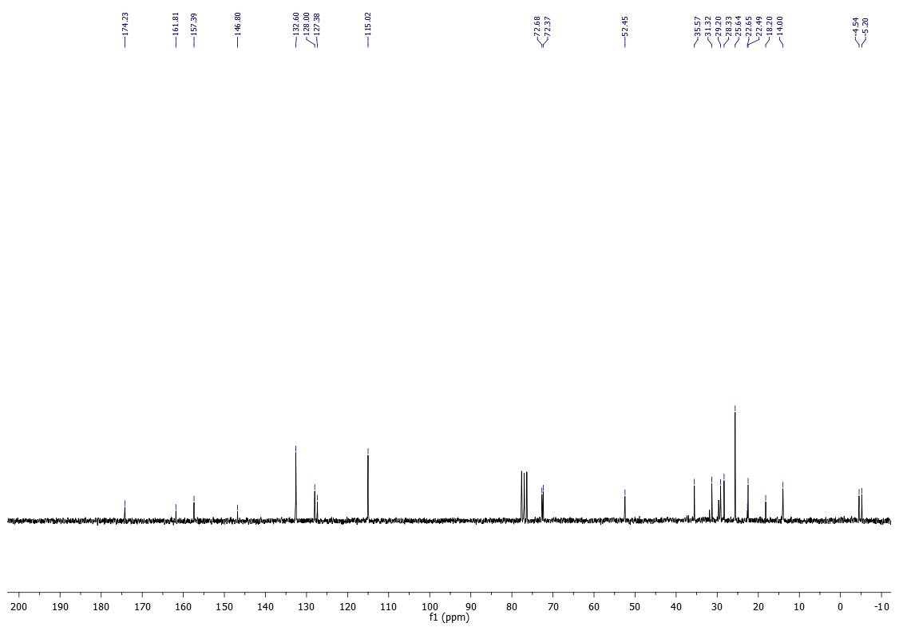
¹H-NMR (200 MHz) of 15f in CDCl₃
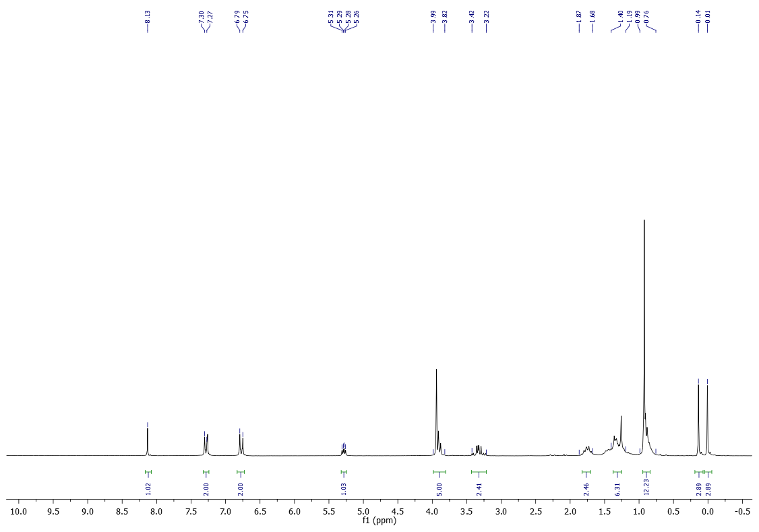
¹³C-NMR (50 MHz) of 15f in CDCl₃
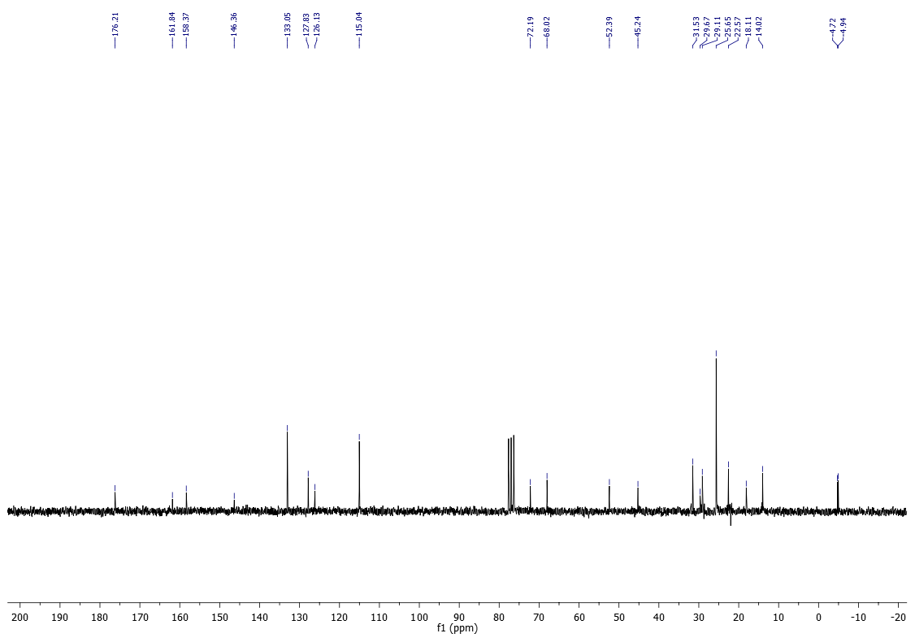

¹H-NMR (200 MHz) of 15g in CDCl₃
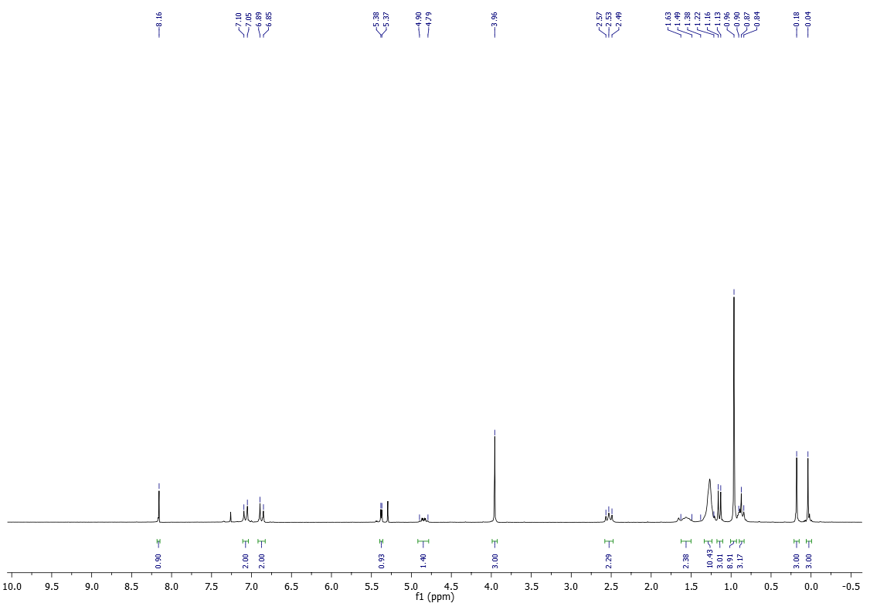

¹H-NMR (400 MHz) of 15h in CDCl₃
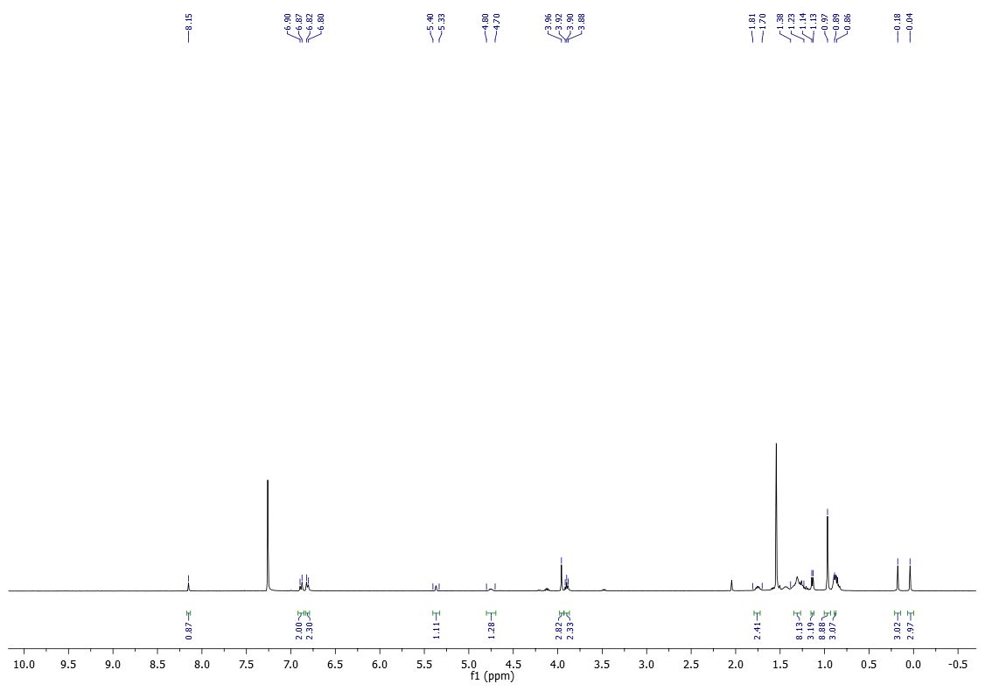
¹³C-NMR (100 MHz) of 15h in CDCl₃
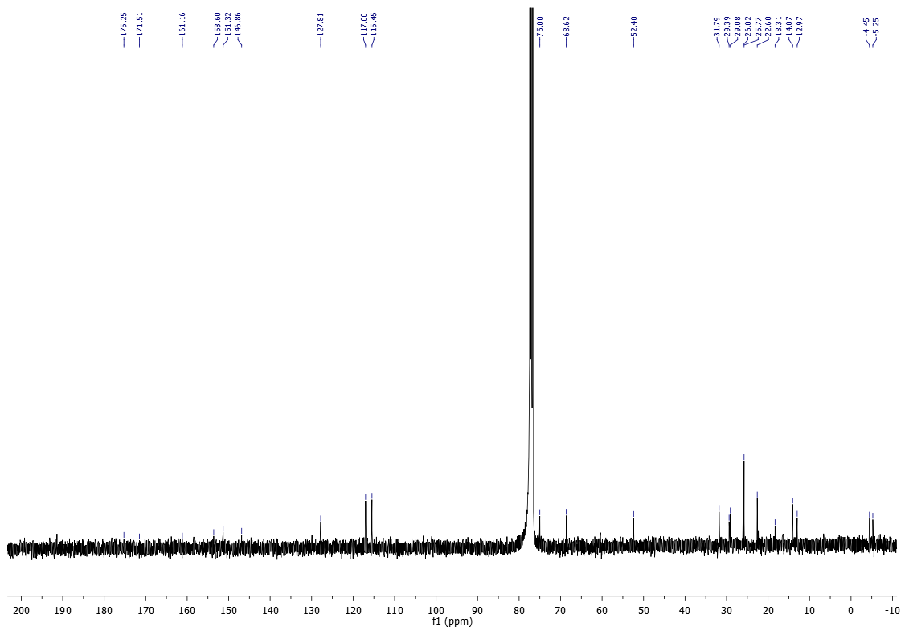

¹H-NMR (200 MHz) of 15j in CDCl₃
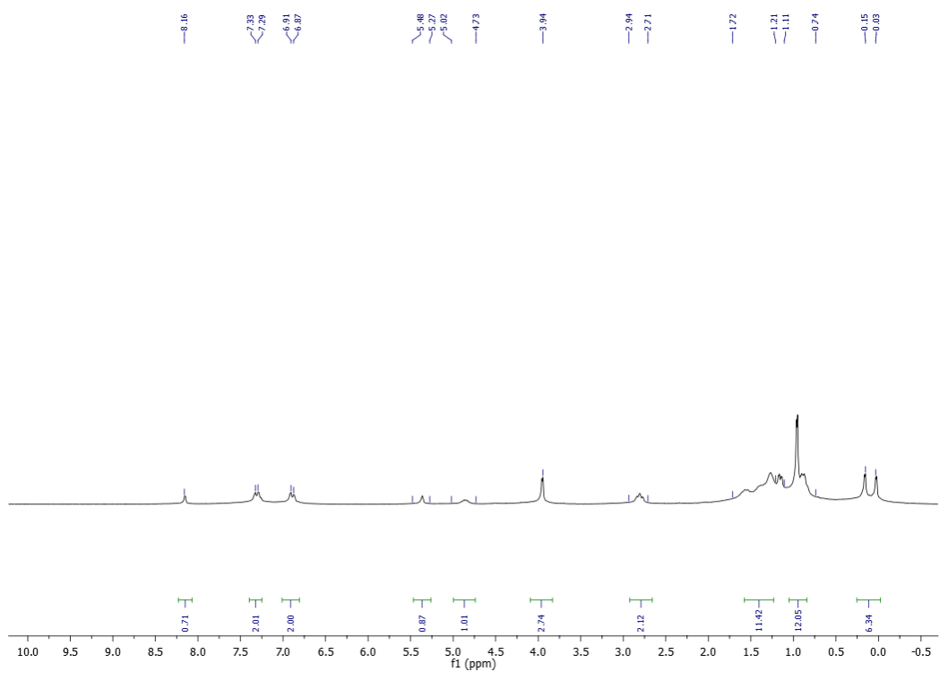
¹³C-NMR (50 MHz) of 15j in CDCl₃
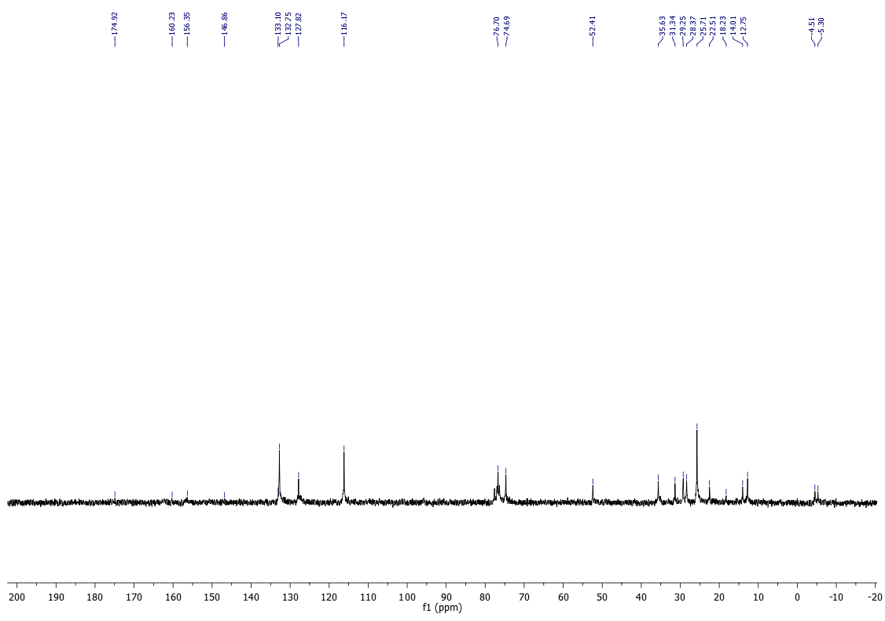

¹H-NMR (200 MHz) of 16a in CDCl₃
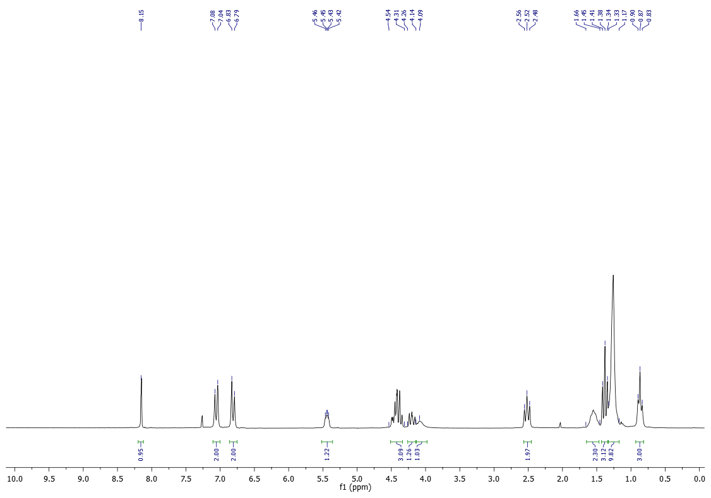
¹³C-NMR (50 MHz) of 16a in CDCl₃
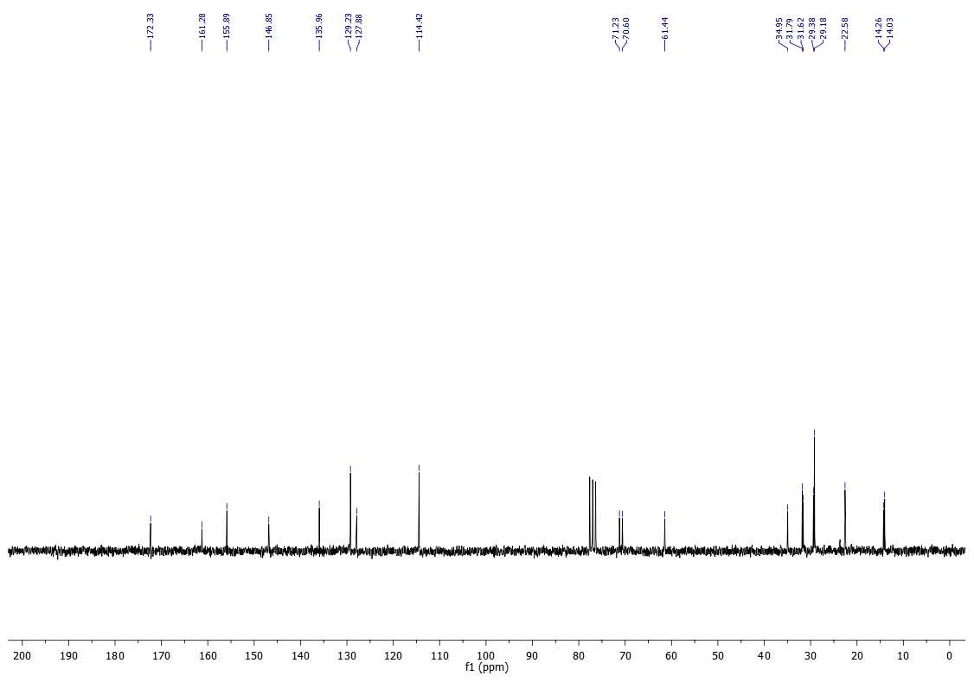

¹H-NMR (400 MHz) of 16c in CDCl₃
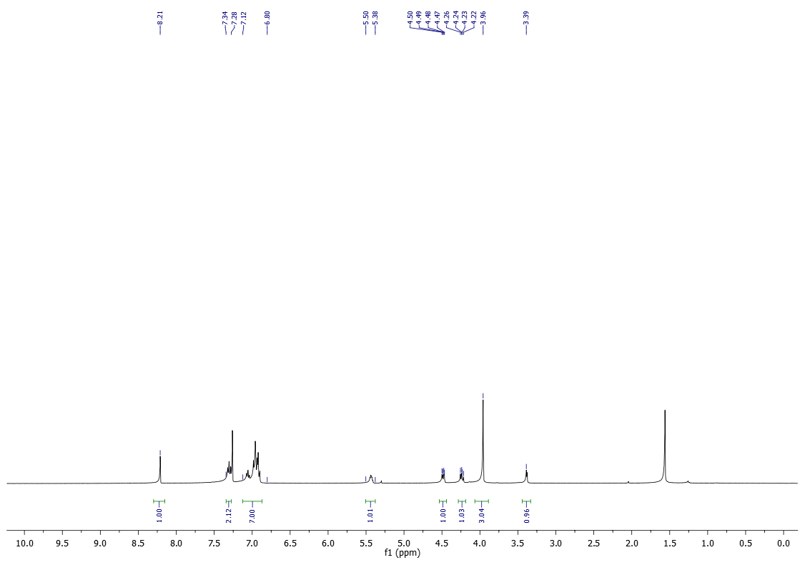
¹³C-NMR (100 MHz) of 16c in CDCl₃
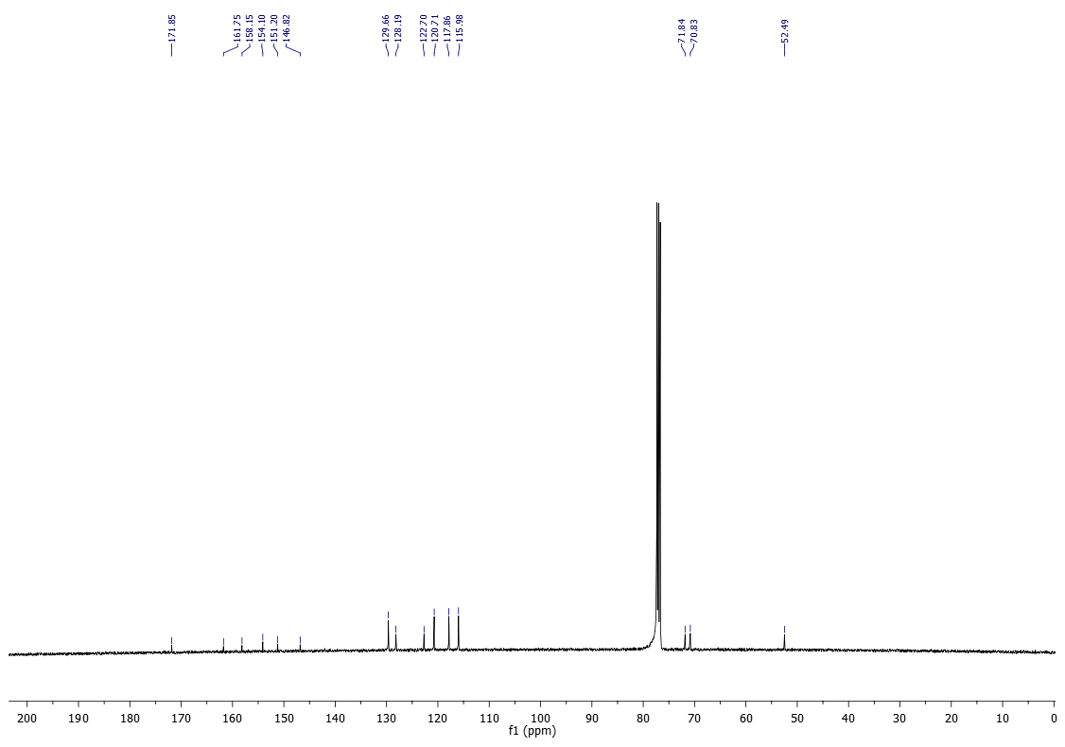

¹H-NMR (200 MHz) of 16d in CDCl₃
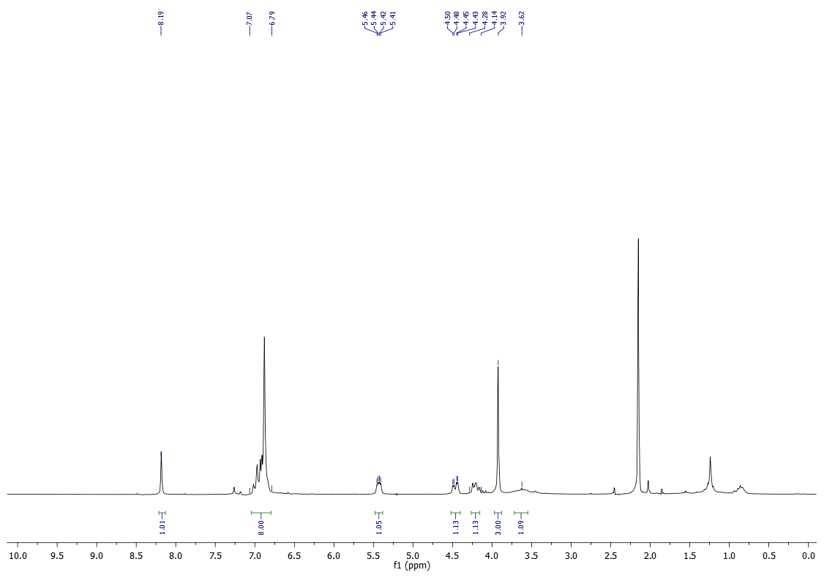
¹³C-NMR (50 MHz) of 16d in CDCl₃
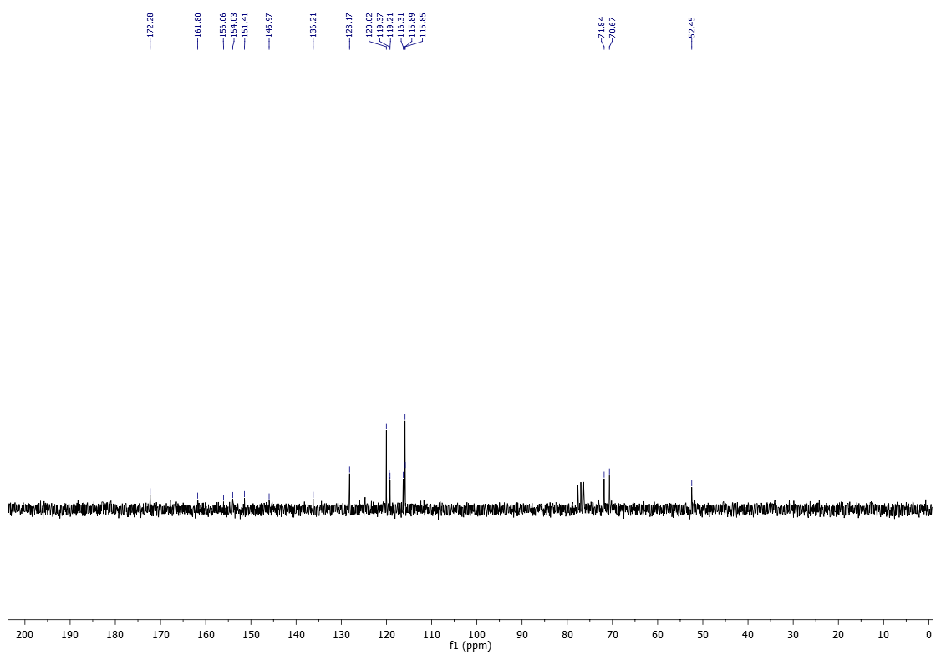

¹⁹F-NMR (377 MHz) of 16d in CDCl₃
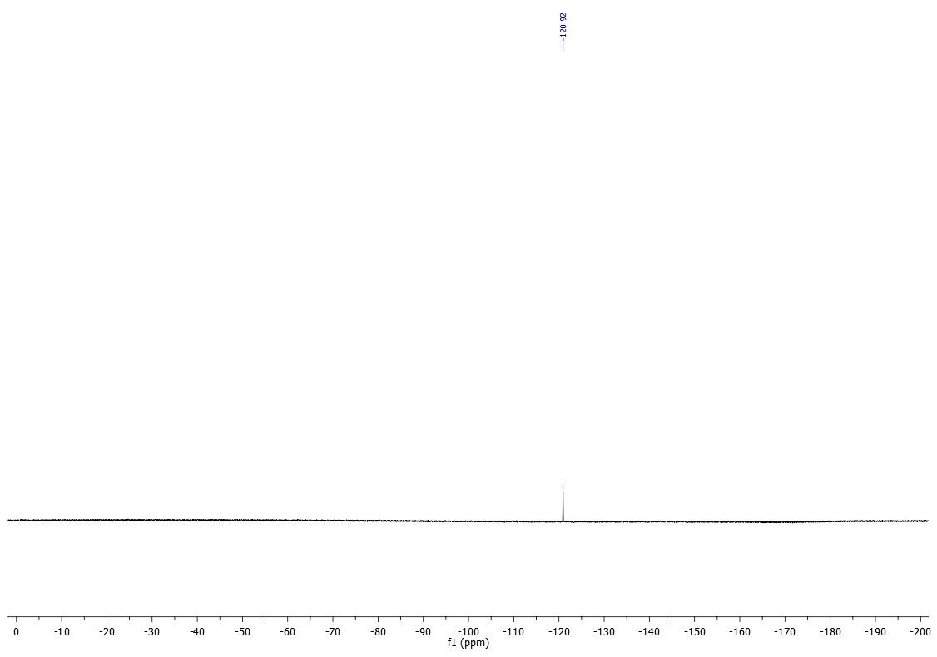

¹H-NMR (200 MHz) of 16e in CDCl₃
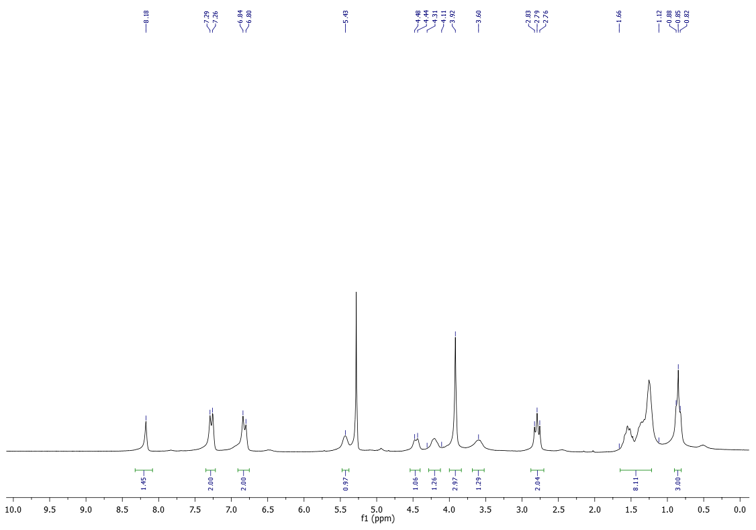
¹³C-NMR (50 MHz) of 16e in CDCl₃
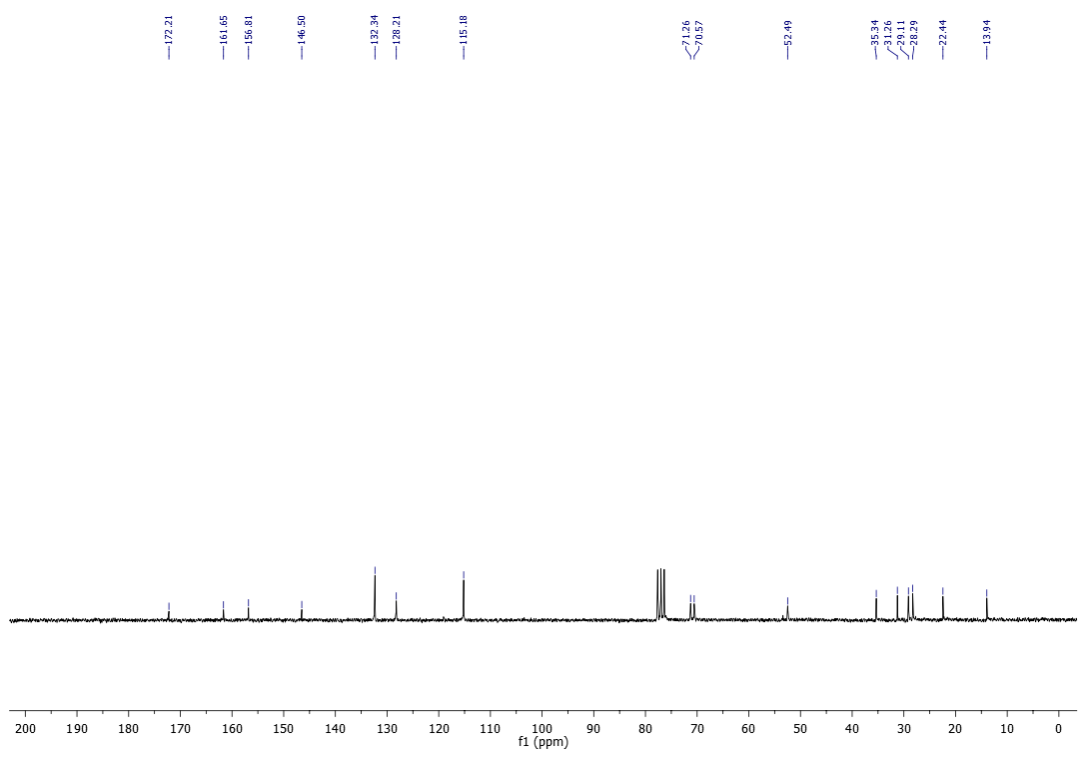

¹H-NMR (200 MHz) of 16f in CDCl₃
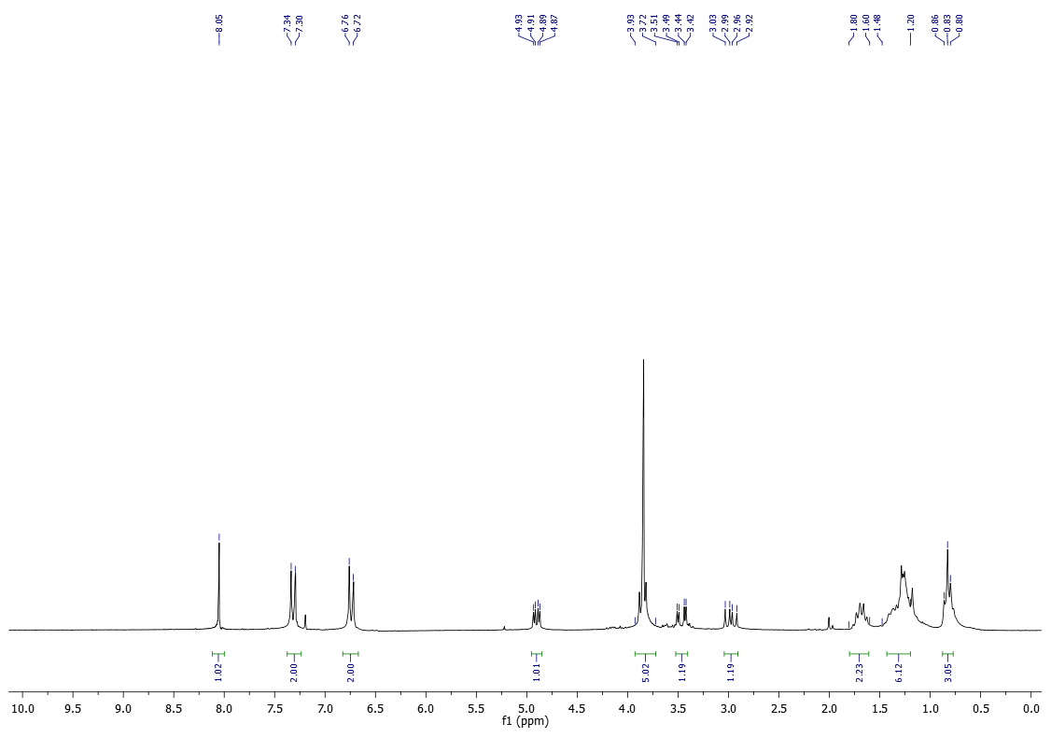
¹³C-NMR (100 MHz) of 16f in CDCl₃
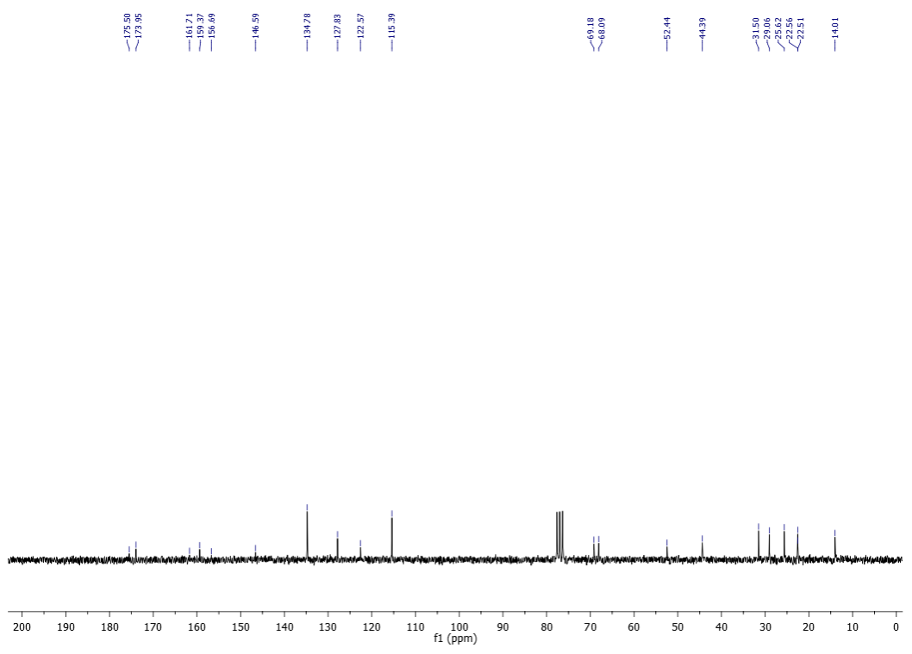

¹H-NMR (400 MHz) of 16g in CDCl₃
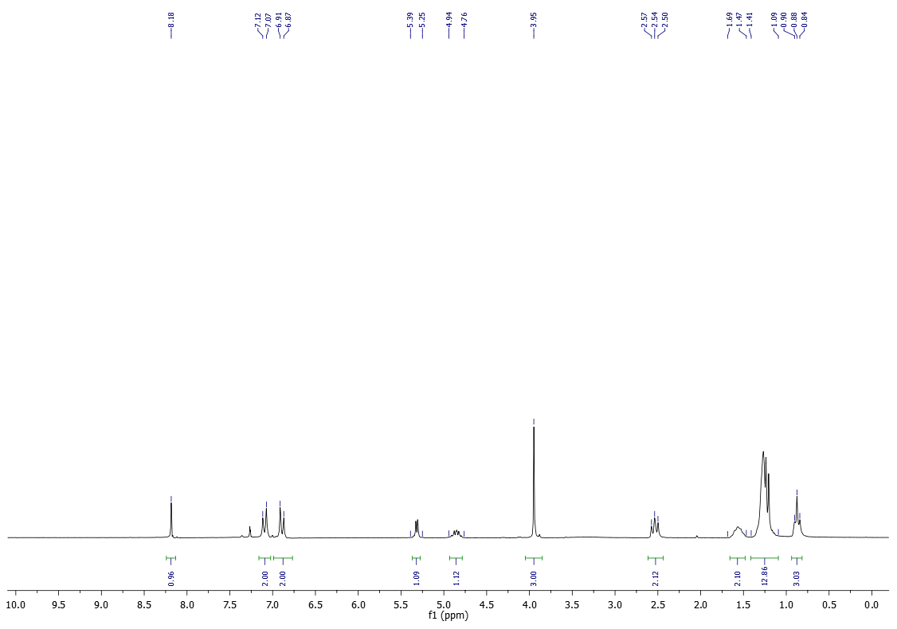
¹³C-NMR (100 MHz) of 16g in CDCl₃
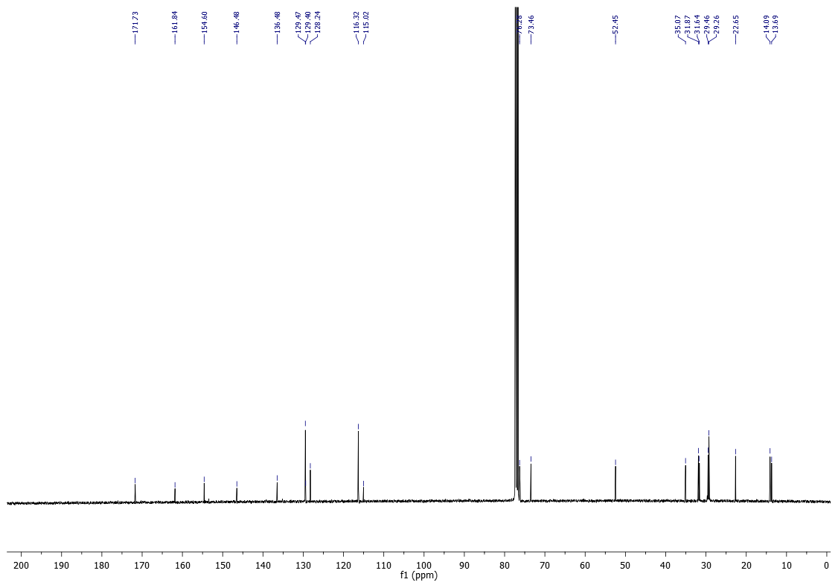

¹H-NMR (400 MHz) of 16i in CDCl₃
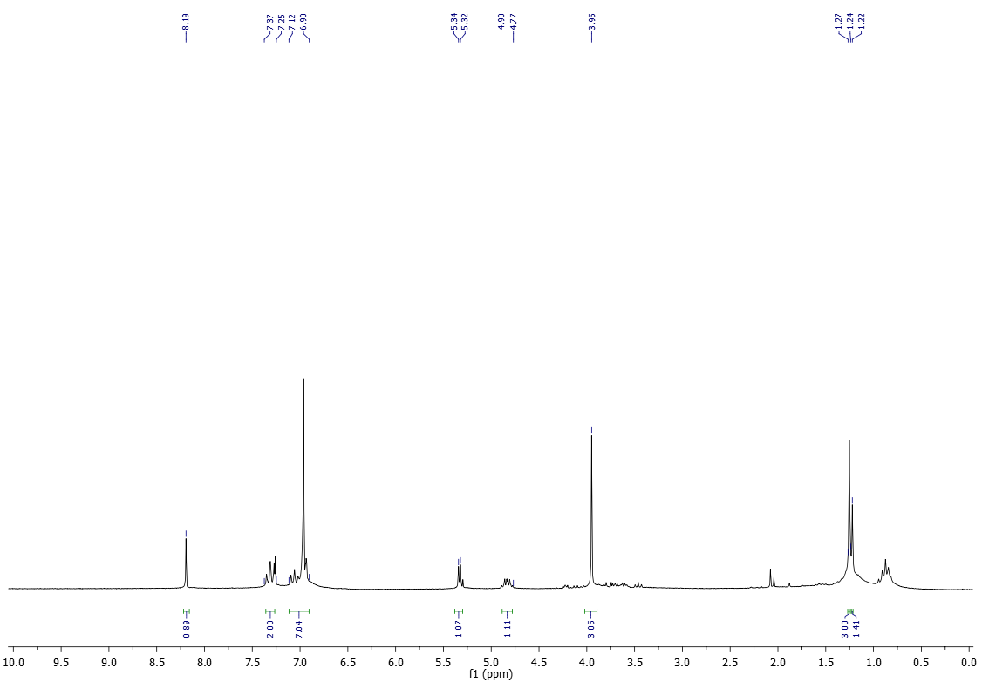
¹³C-NMR (100 MHz) of 16i in CDCl₃
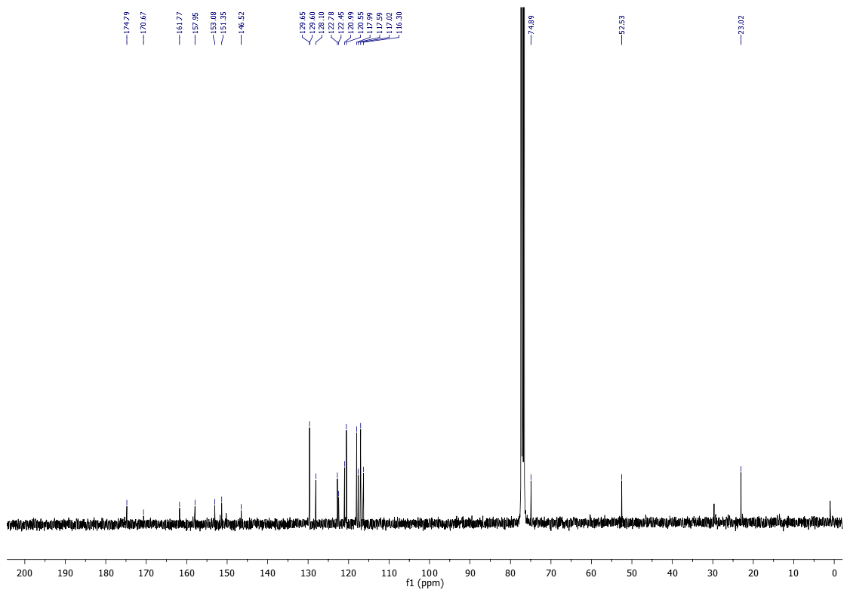

¹H-NMR (200 MHz) of 16j in CDCl₃
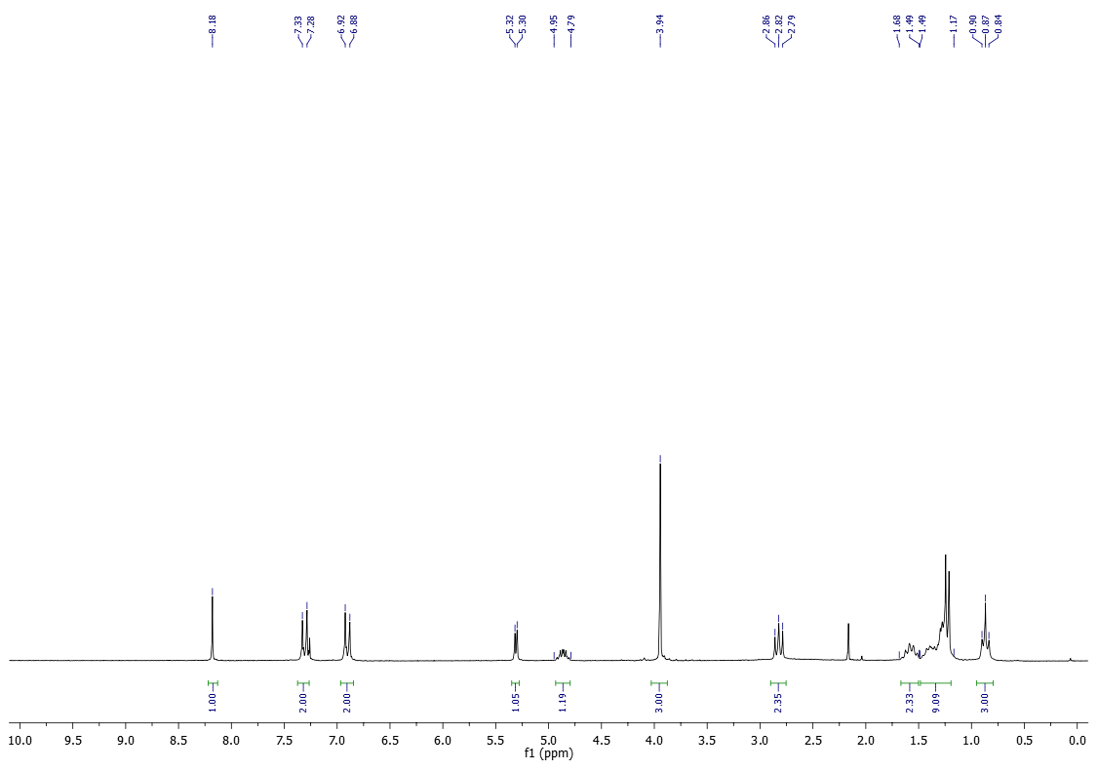

¹H-NMR (200 MHz) of 17a in CDCl₃
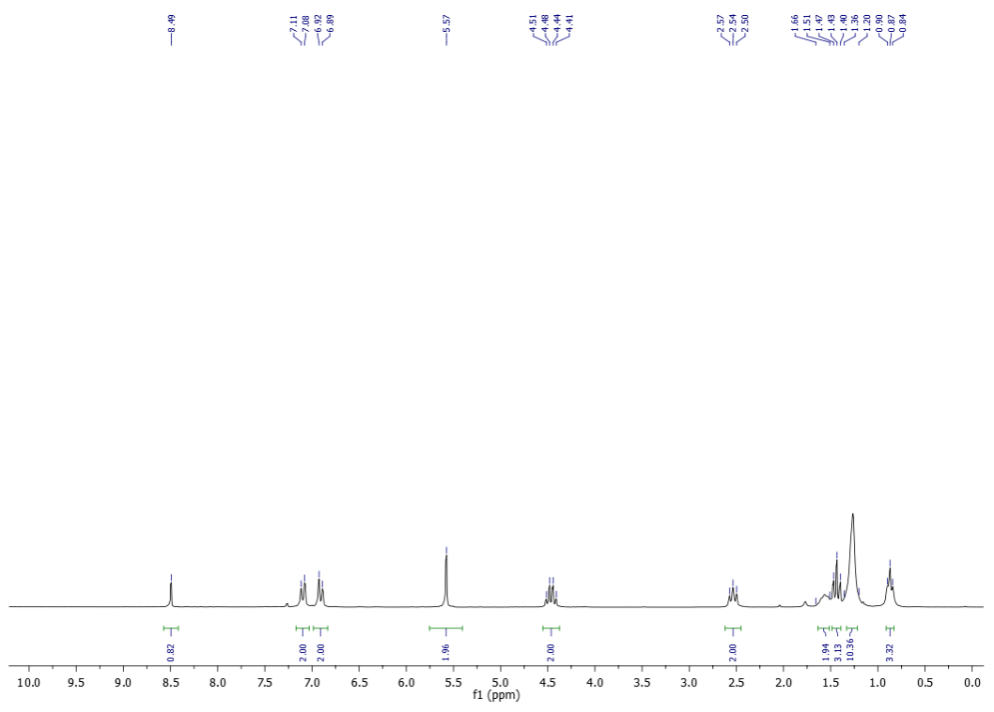
¹³C-NMR (50 MHz) of 17a in CDCl₃
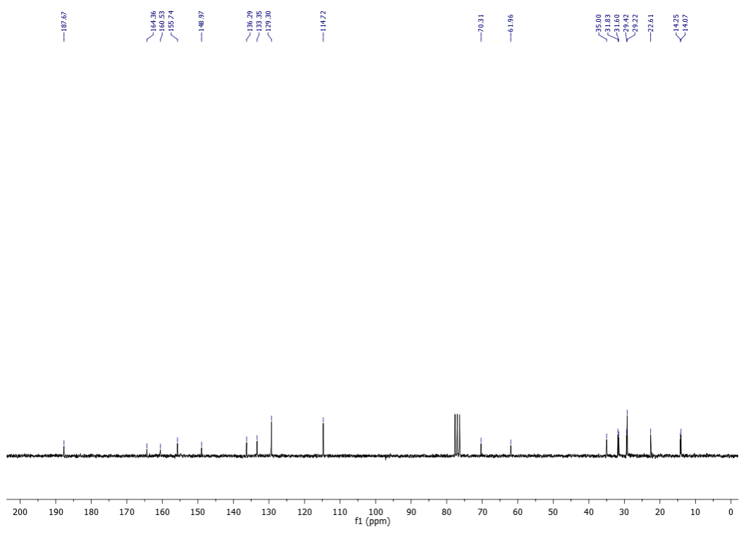

¹H-NMR (200 MHz) of 17b in CDCl₃
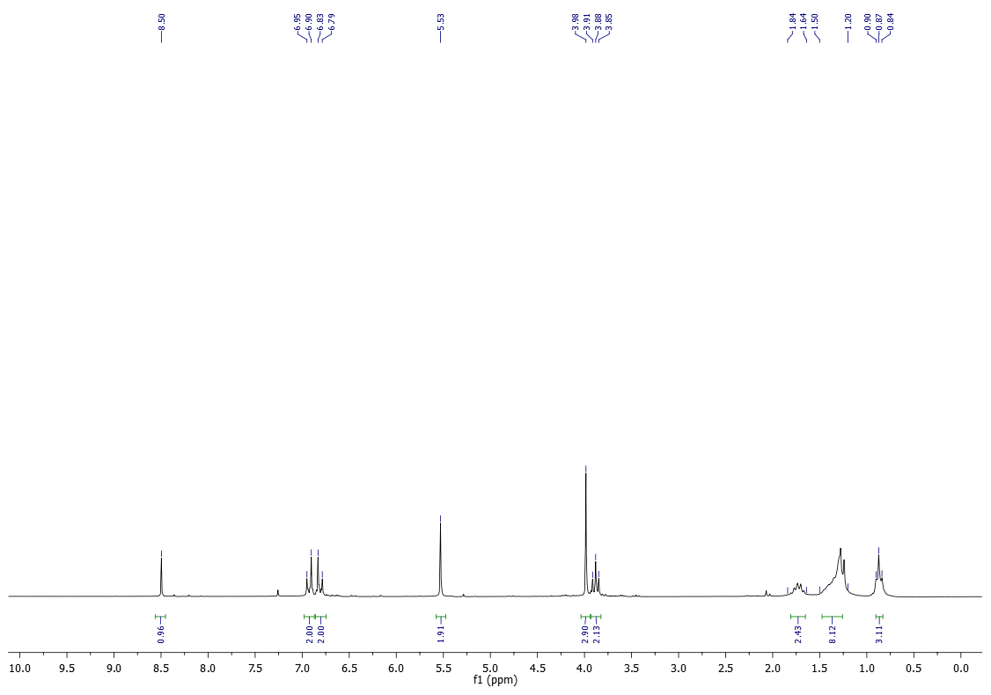
¹³C-NMR (50 MHz) of 17b in CDCl₃
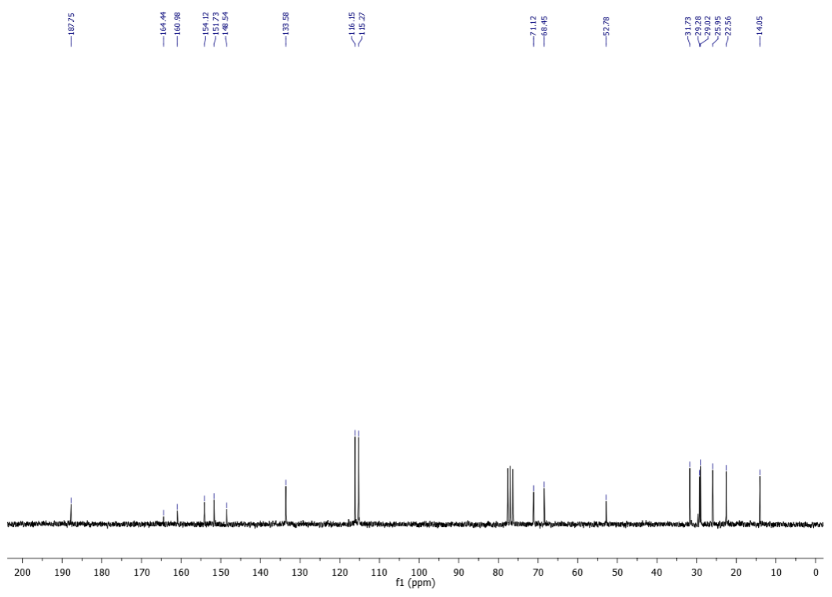

¹H-NMR (200 MHz) of 17c in CDCl₃
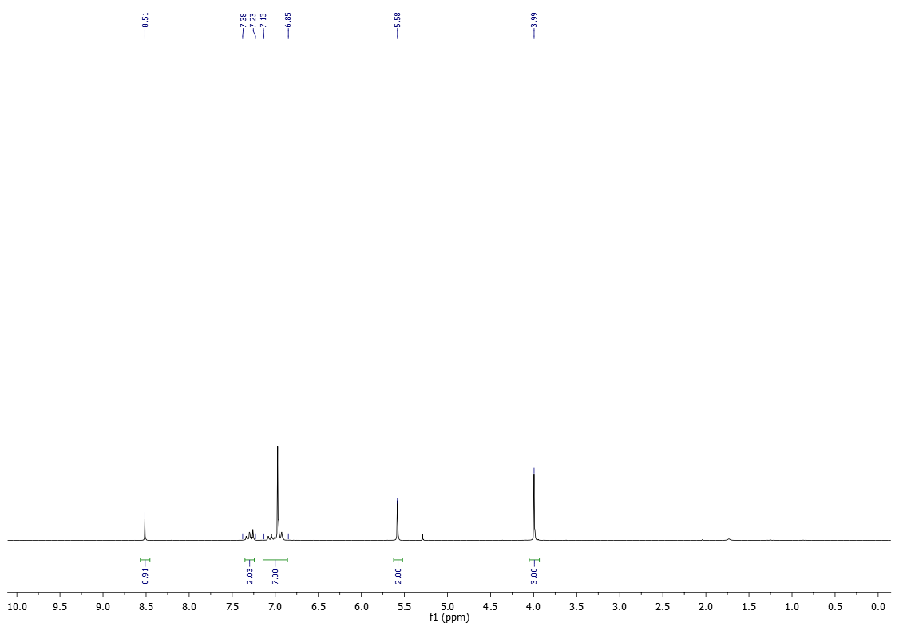
¹³C-NMR (100 MHz) of 17c in CDCl₃
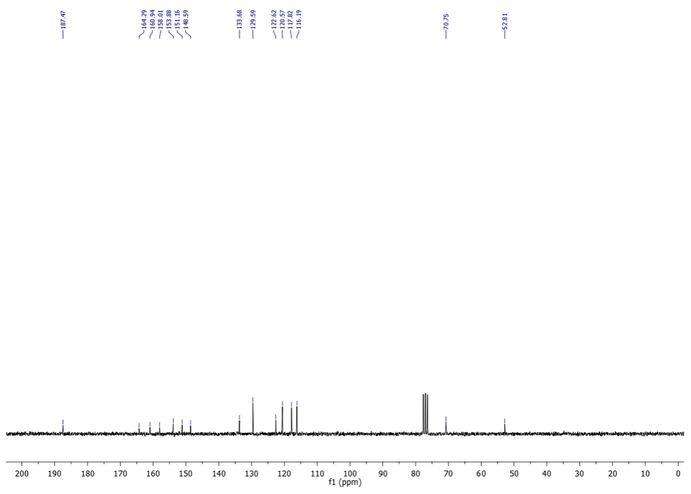

¹H-NMR (600 MHz) of 17d in CDCl₃
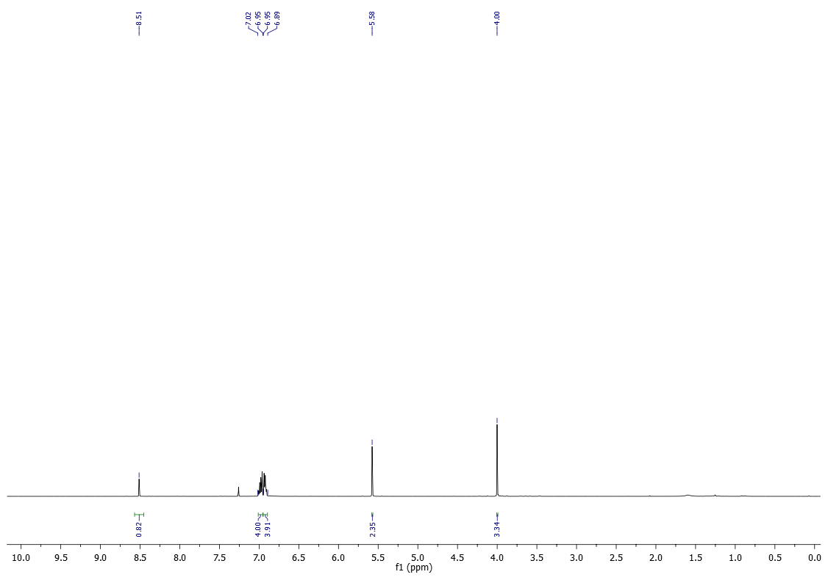
¹³C-NMR (150 MHz) of 17d in CDCl₃
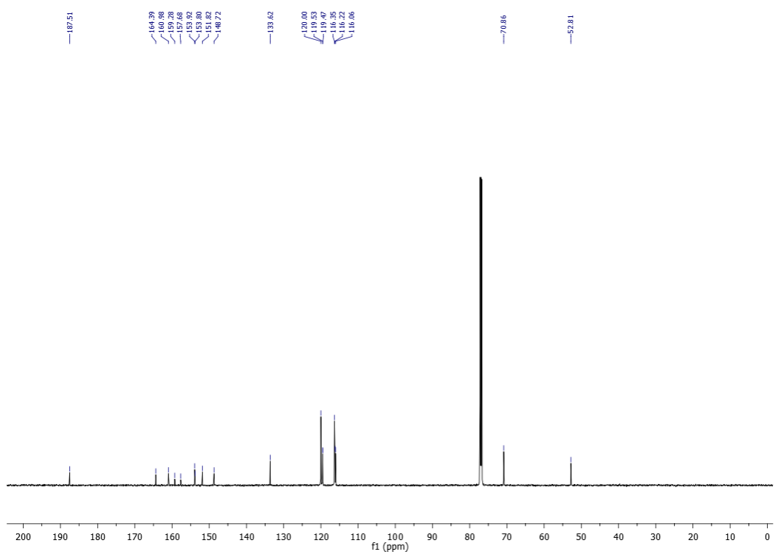

¹H-NMR (200 MHz) of 17e in CDCl₃
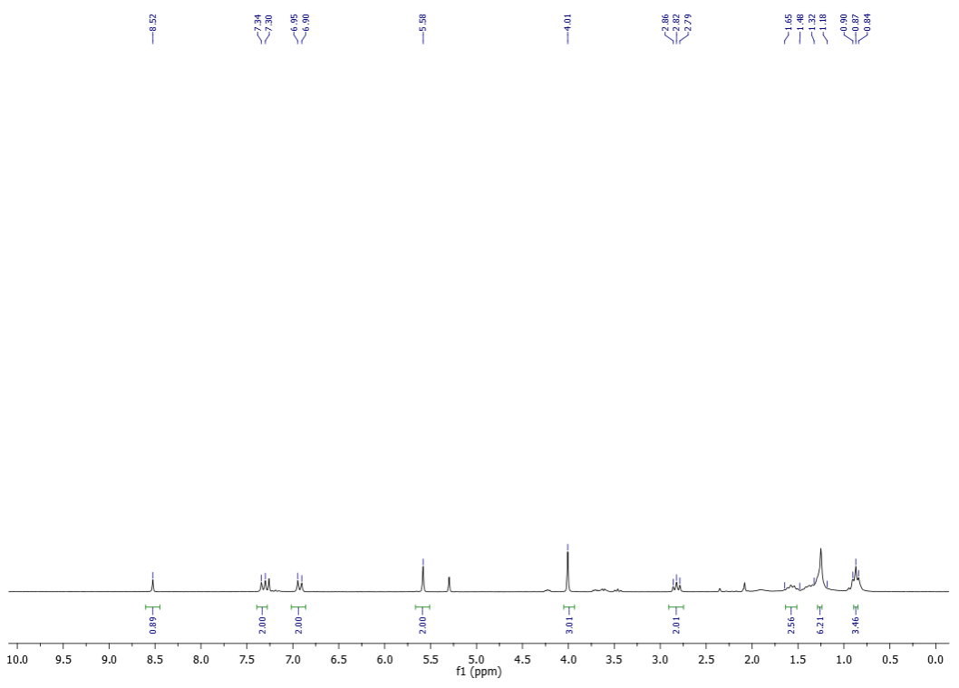
¹³C-NMR (50 MHz) of 17e in CDCl₃
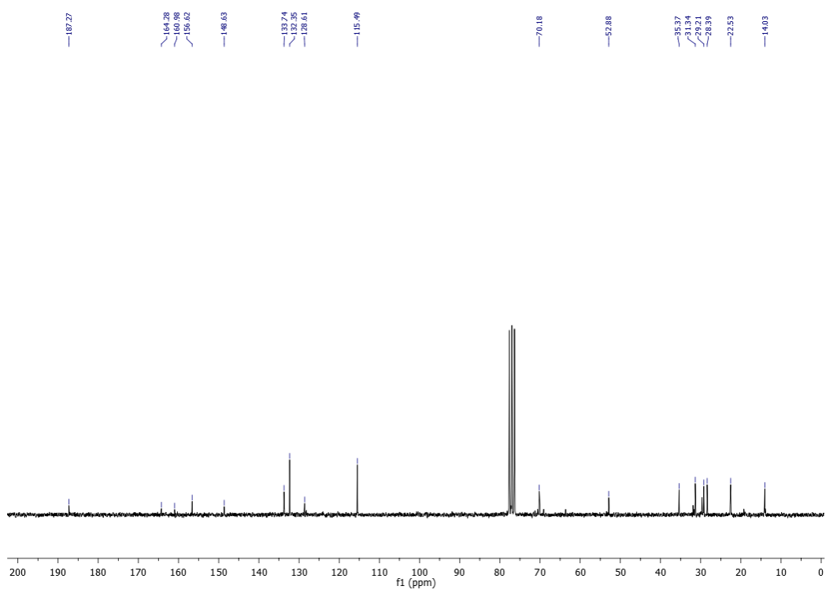
¹H-NMR (200 MHz) of 17f in CDCl₃
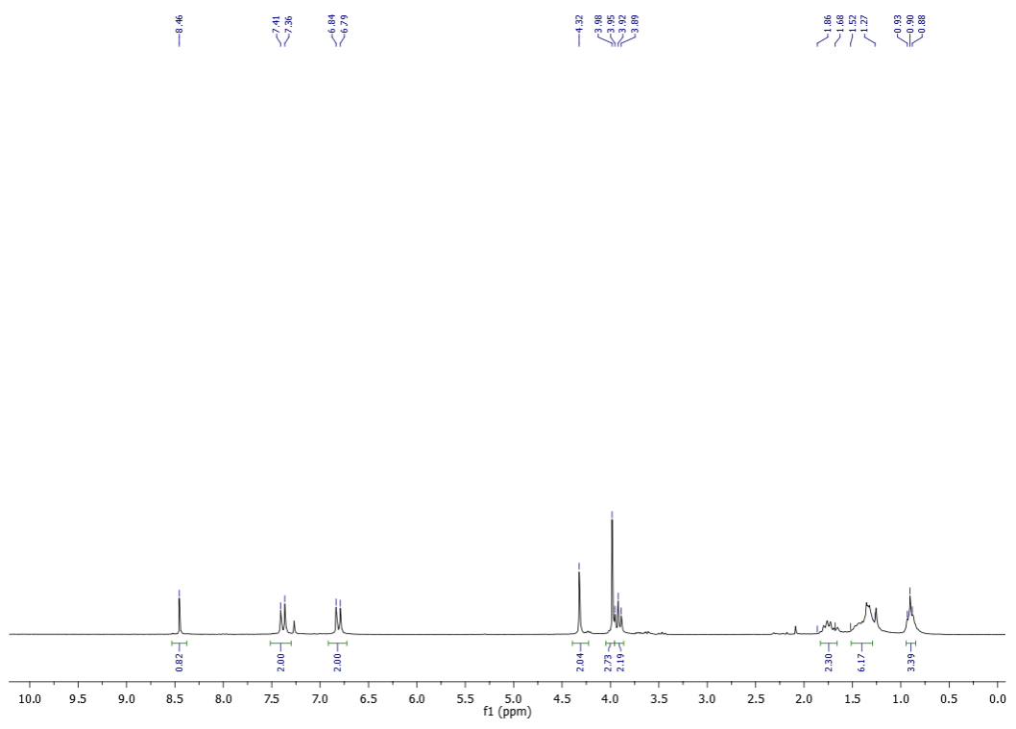
¹³C-NMR (50 MHz) of 17f in CDCl₃
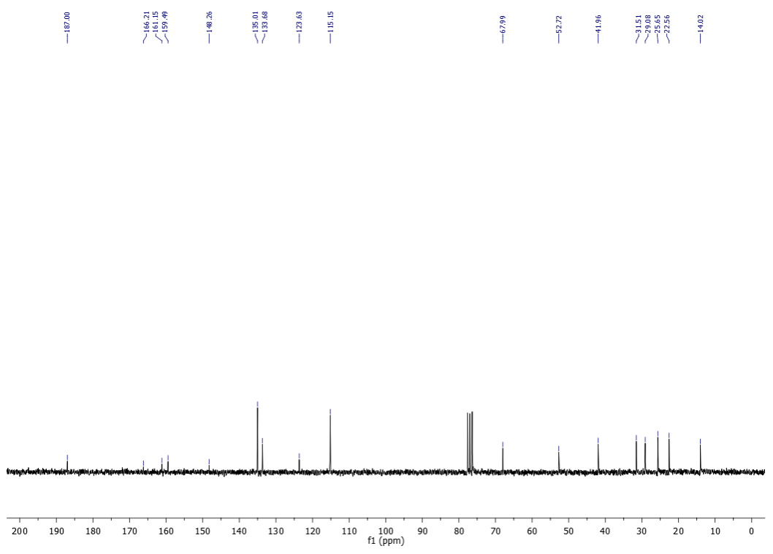

¹H-NMR (200 MHz) of 17g in CDCl₃
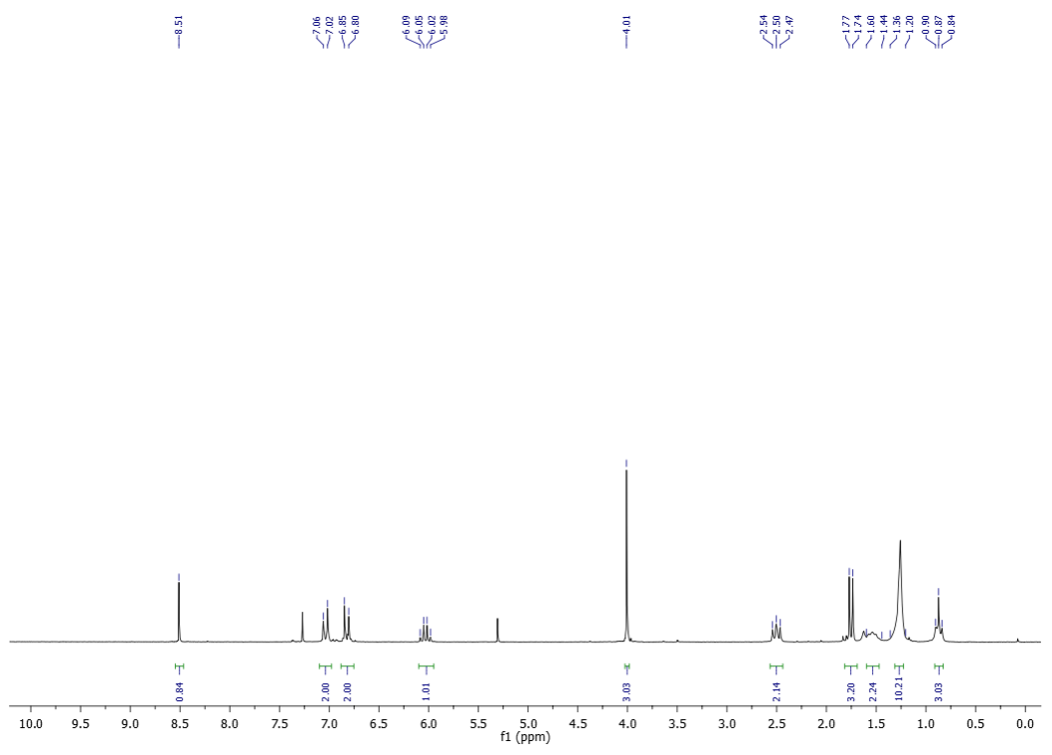
¹³C-NMR (50 MHz) of 17g in CDCl₃
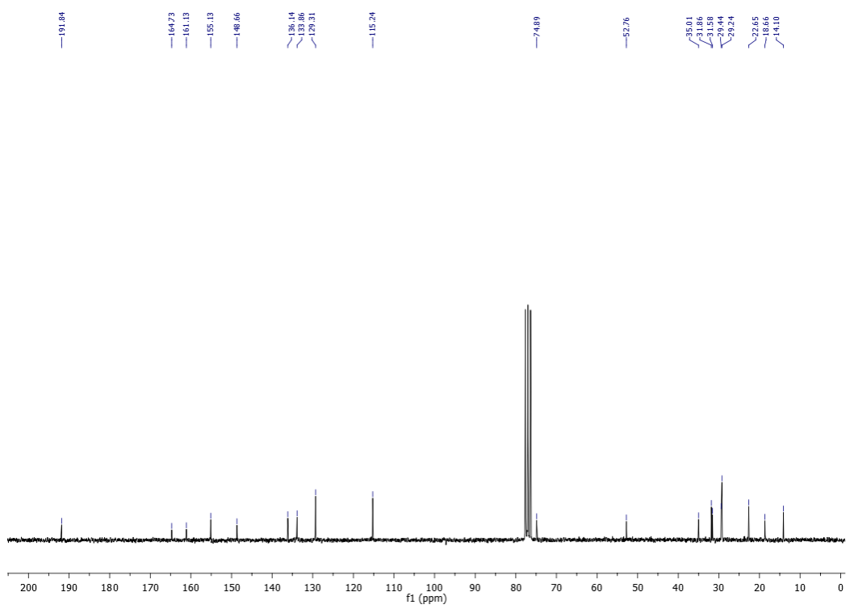

¹H-NMR (600 MHz) of 17h in CDCl₃
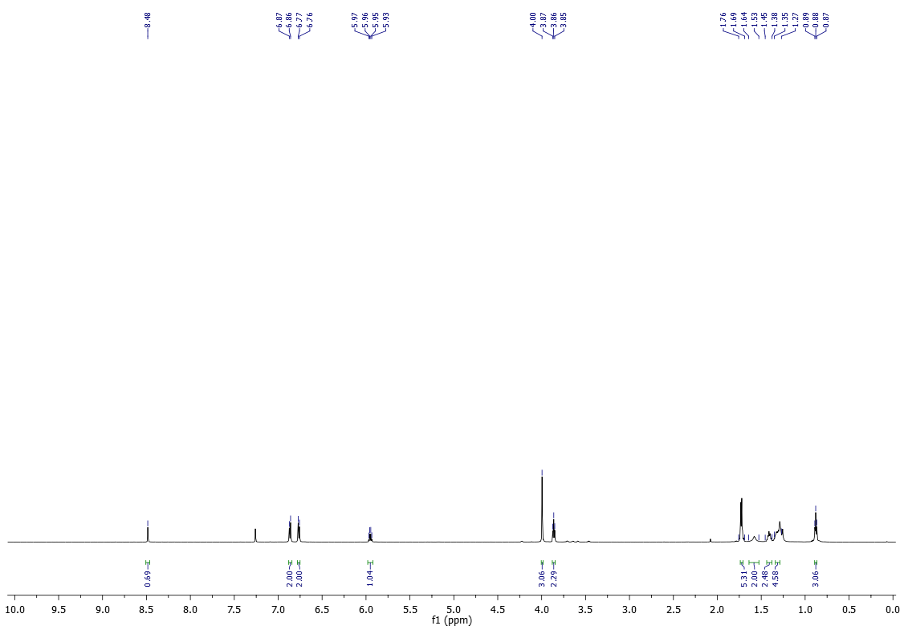
¹³C-NMR (150 MHz) of 17h in CDCl₃
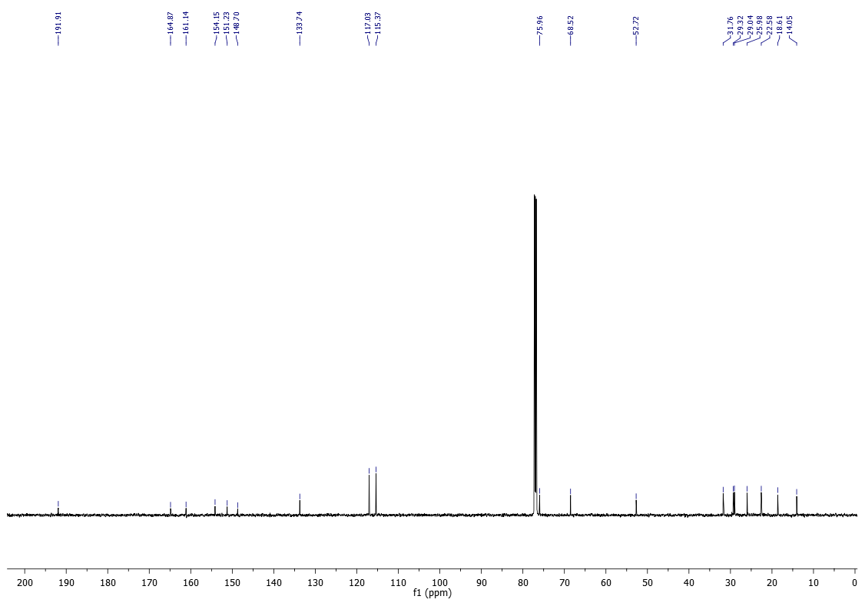

¹H-NMR (600 MHz) of 17i in CDCl₃
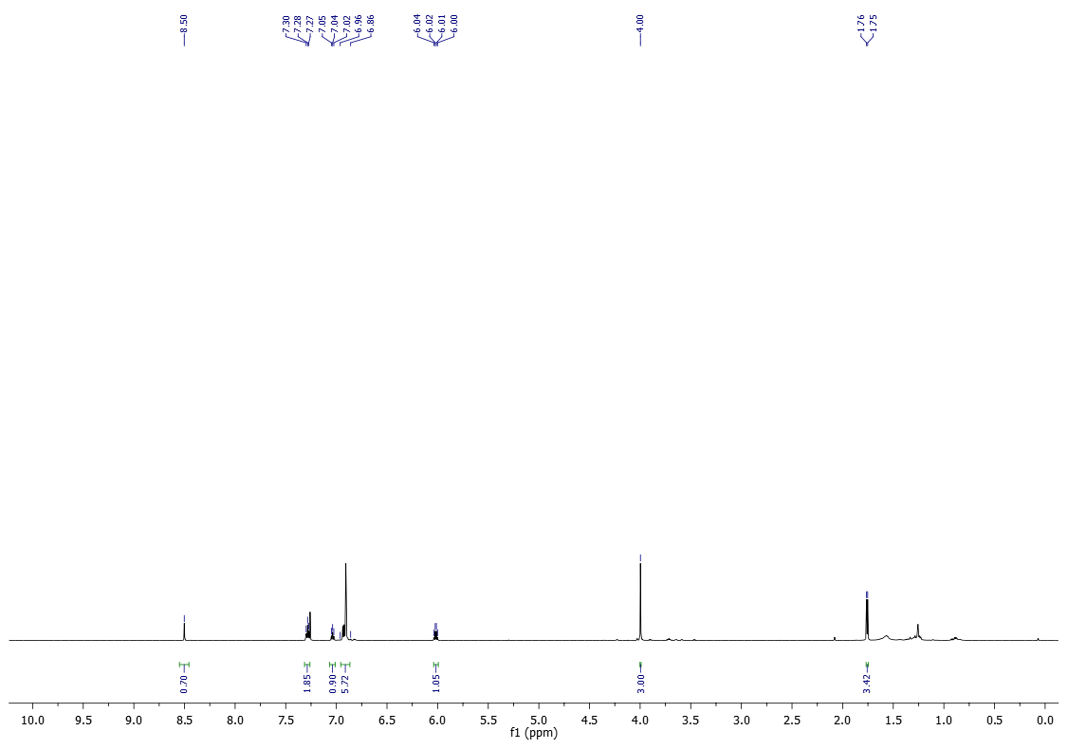
¹³C-NMR (150 MHz) of 17i in CDCl₃
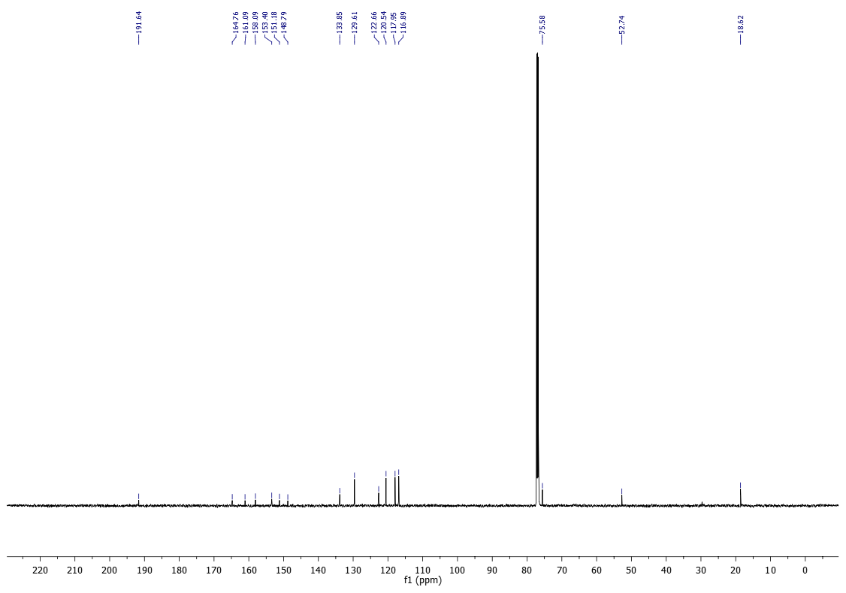

¹H-NMR (600 MHz) of 17j in CDCl₃
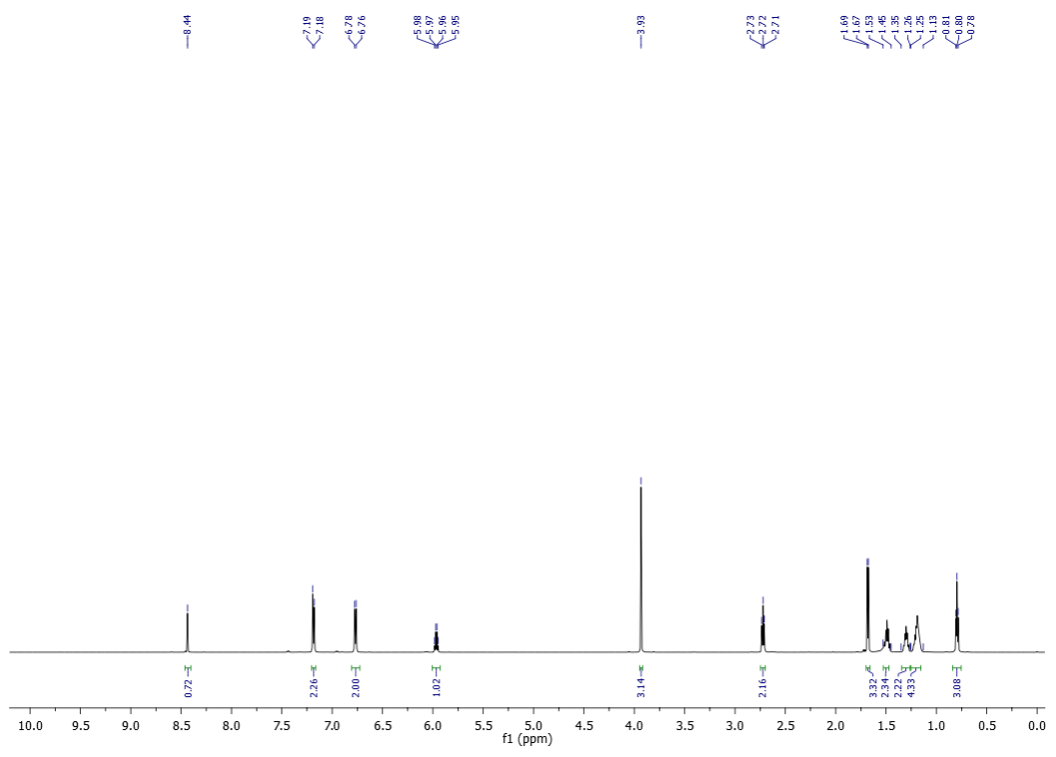
¹³C-NMR (150 MHz) of 17j in CDCl₃
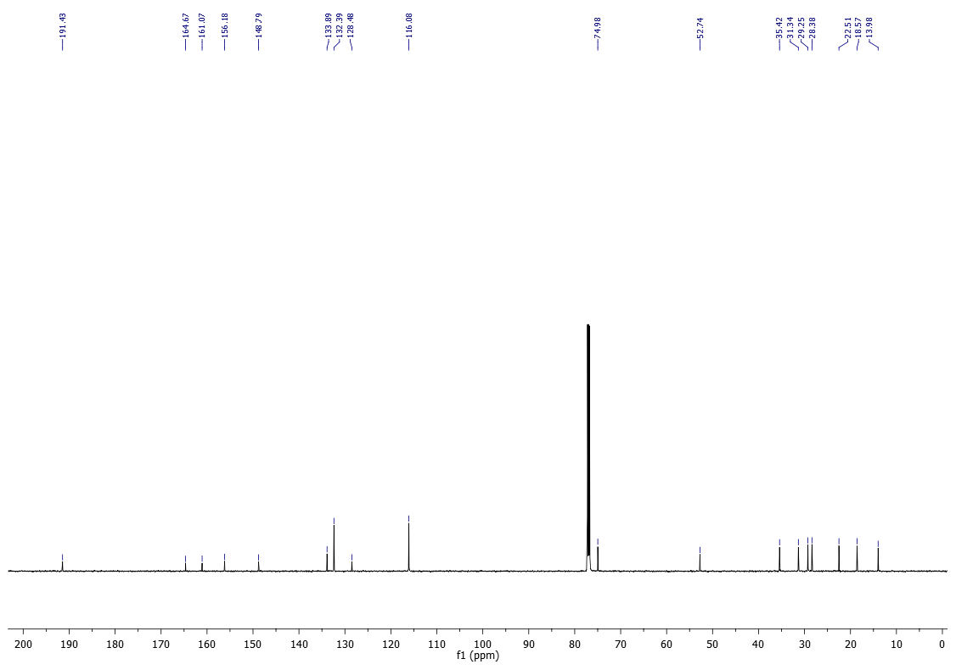

¹H-NMR (400 MHz) of 18a in CDCl₃
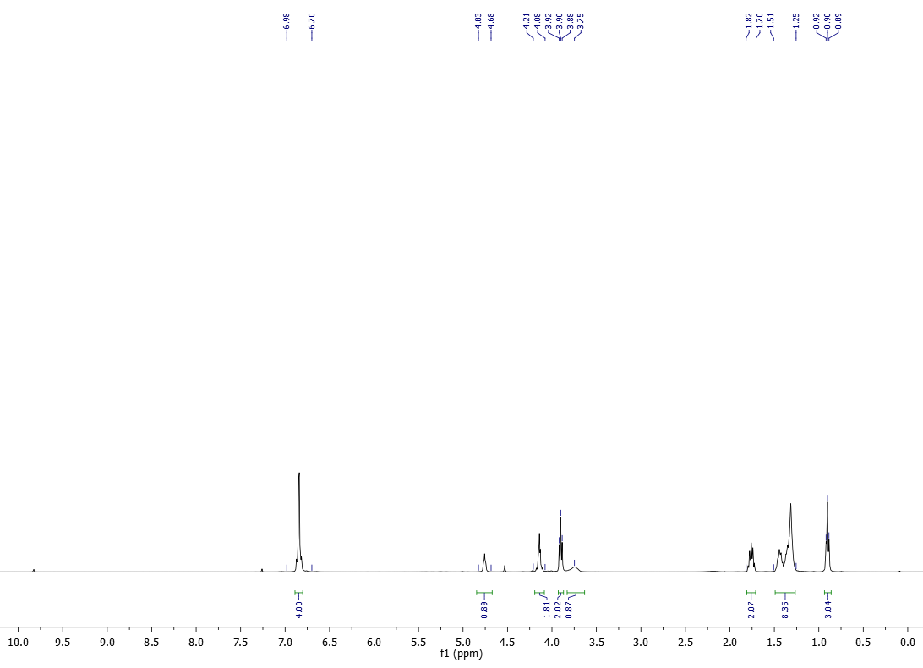
¹³C-NMR (100 MHz) of 18a in CDCl₃
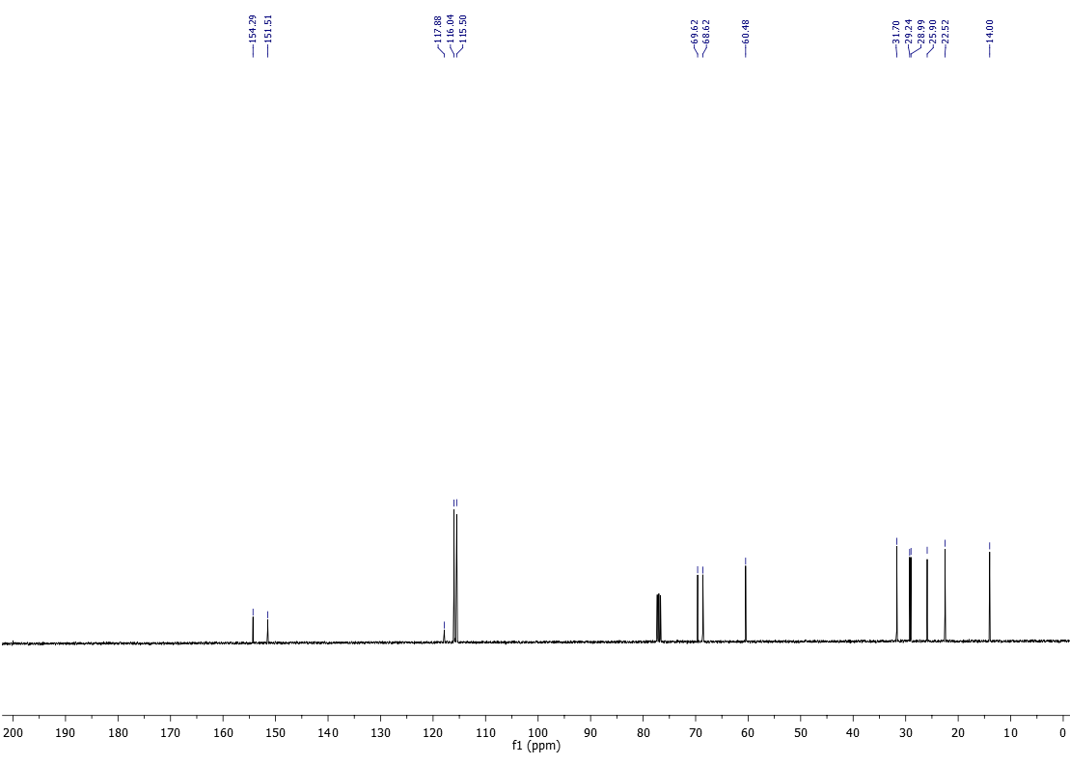

¹H-NMR (400 MHz) of 18b in CDCl₃
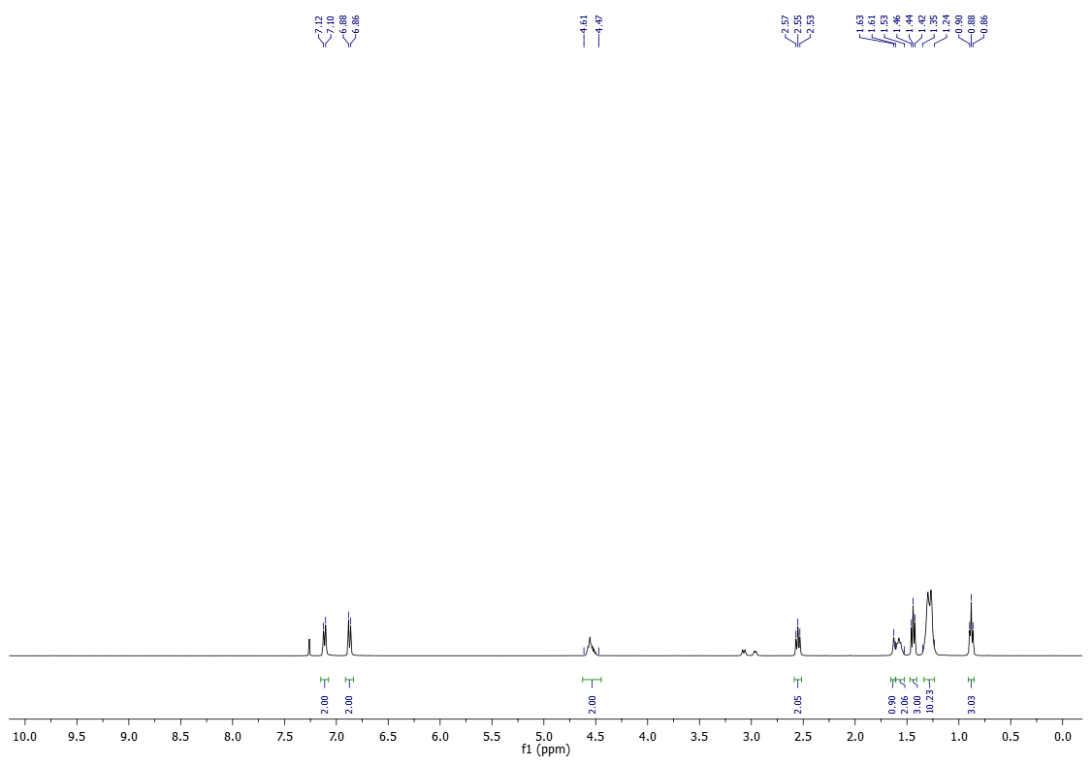
¹³C-NMR (100 MHz) of 18b in CDCl₃
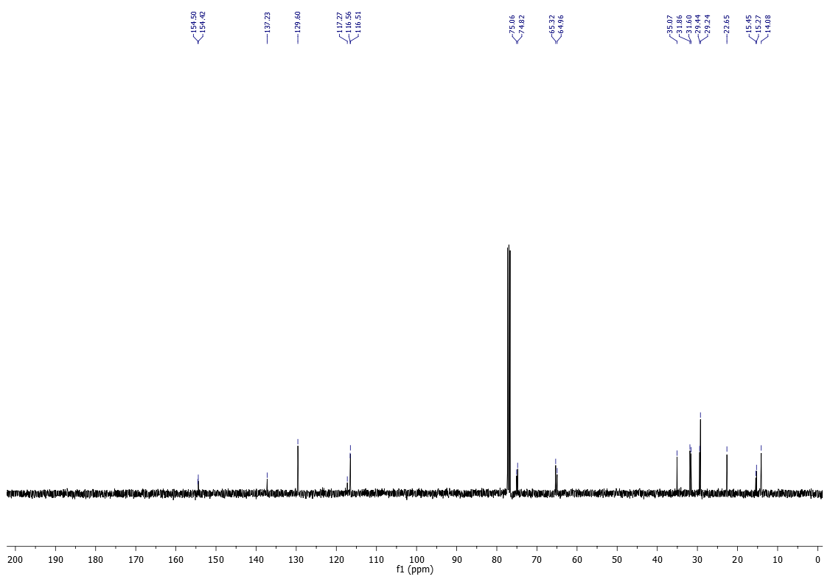

¹H-NMR (400 MHz) of 18c in CDCl₃
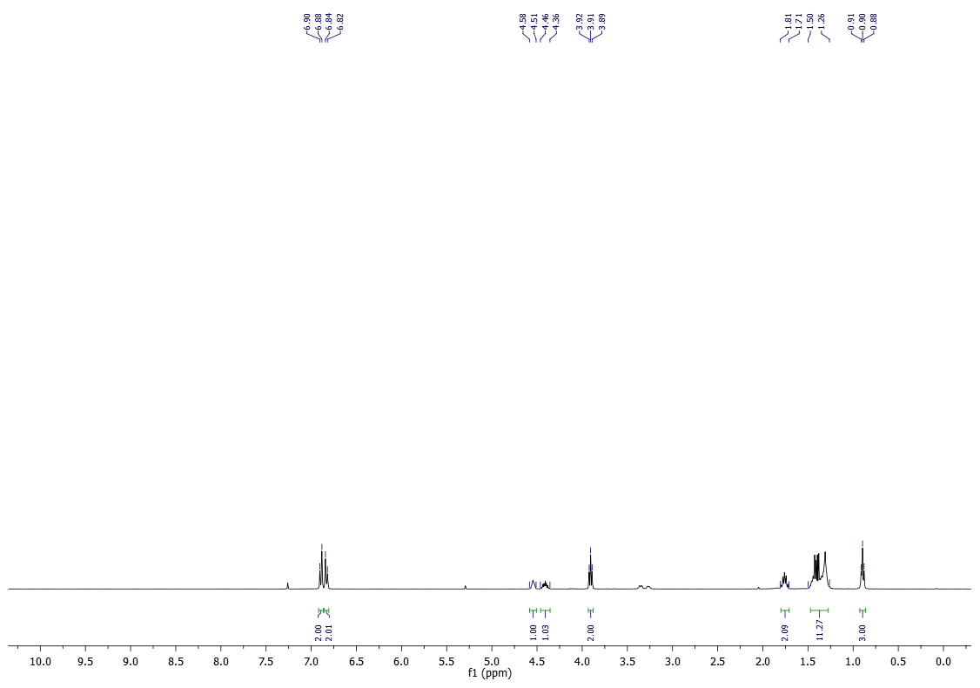
¹³C-NMR (100 MHz) of 18c in CDCl₃
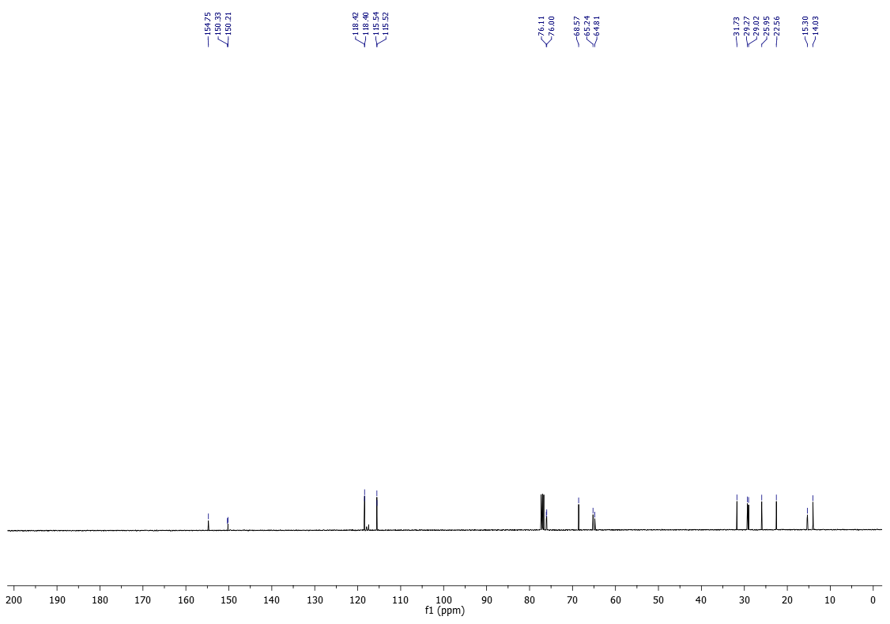

¹H-NMR (200 MHz) of 18d in CDCl₃
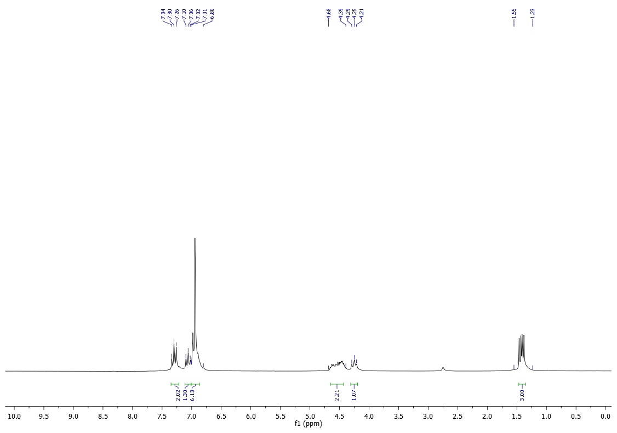
¹³C-NMR (50 MHz) of 18d in CDCl₃
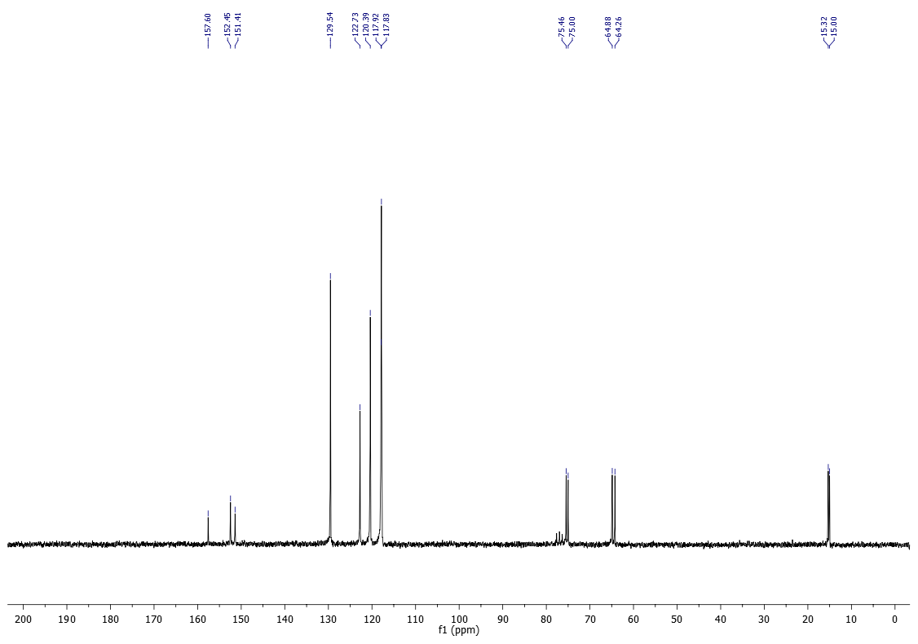

References
1 Liu, Z. et al. Blood-Brain Barrier Permeable and NO-Releasing Multifunctional Nanoparticles for Alzheimer's Disease Treatment: Targeting NO/cGMP/CREB Signaling Pathways. J Med Chem 64, 13853-13872 (2021). https://doi.org:10.1021/acs.jmedchem.1c01240
2 Kokotos, G. et al. Inhibition of group IVA cytosolic phospholipase A2 by thiazolyl ketones in vitro, ex vivo, and in vivo. J Med Chem 57, 7523-7535 (2014). https://doi.org:10.1021/jm500192s
3 Sarges, R. et al. Glucose transport-enhancing and hypoglycemic activity of 2-methyl-2-phenoxy-3-phenylpropanoic acids. J Med Chem 39, 4783-4803 (1996). https://doi.org:10.1021/jm950364f
4 Lawrence, M. S. et al. Discovery and saturation analysis of cancer genes across 21 tumour types. Nature 505, 495-501 (2014). https://doi.org:10.1038/nature12912
5 Vogelstein, B. et al. Cancer genome landscapes. Science 339, 1546-1558 (2013). https://doi.org:10.1126/science.1235122
6 Zack, T. I. et al. Pan-cancer patterns of somatic copy number alteration. Nature Genetics 45, 1134-1140 (2013). https://doi.org:10.1038/ng.2760
7 Wagner, A. H. et al. DGIdb 2.0: mining clinically relevant drug-gene interactions. Nucleic Acids Res 44, D1036-1044 (2016). https://doi.org:10.1093/nar/gkv1165

