Supplement

Simvastatin impairs myoblast proliferation and myotube formation of C2C12 myoblasts and in mouse skeletal muscle

Gerda M. Sanvee^{1,2}, Jamal Bouitbir^{1,2,3}, and Stephan Krähenbühl^{1,2,3}

¹ Division of Clinical Pharmacology & Toxicology, University Hospital, Basel, Switzerland
² Department of Biomedicine, University of Basel, Switzerland
³ Swiss Centre for Applied Human Research (SCAHT), Switzerland

Corresponding author
Stephan Krähenbühl, MD, PhD
Clinical Pharmacology & Toxicology
University Hospital
4031 Basel
Switzerland
Phone: +41 61 265 4715
Fax: +41 61 265 4560
E-mail: stephan.kraehenbuehl@usb.ch

Supplementary Figure S1
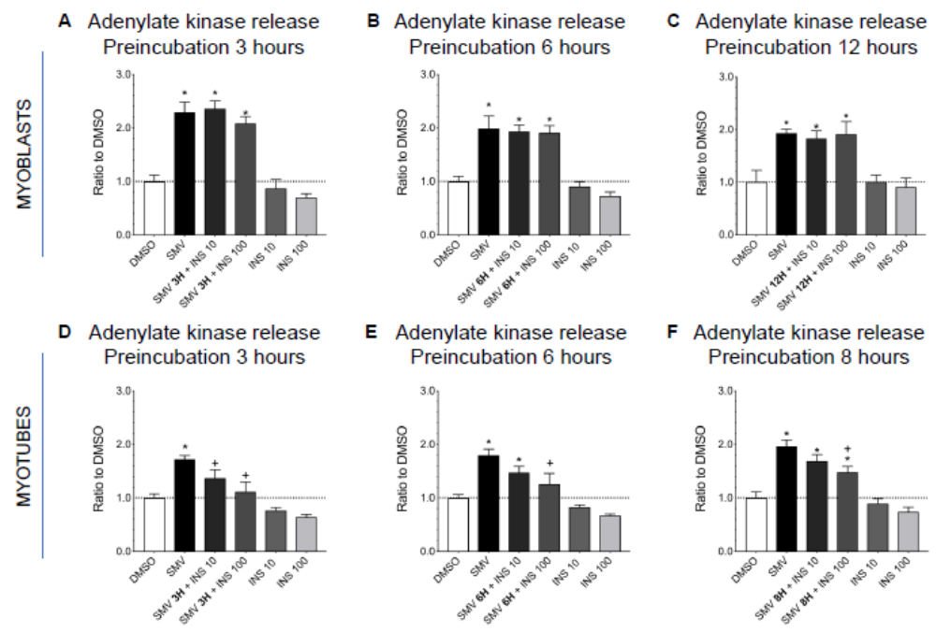
Rescue from simvastatin-induced membrane toxicity in myoblasts and myotubes by insulin. Membrane toxicity was assessed by release of adenylate kinase (AK) in the medium. A-C. Myoblasts were treated with 10 μM simvastatin for 3 (A), 6 (B) and 12 (C) hours before addition of 10 or 100 ng/mL insulin. Membrane toxicity was determined after 24 hours incubation. D-F. Myotubes were treated with 10 μM simvastatin for 3 (D), 6 (E) and 8 (F) hours before addition of 10 or 100 ng/mL insulin. Membrane toxicity was determined after 24 hours incubation. Data represent the mean ± SEM of three independent experiments. *P<0.05 versus 0.1 % DMSO; ⁺P<0.05 versus 10 μM simvastatin. SMV: simvastatin, INS: insulin.

Supplementary Figure S2
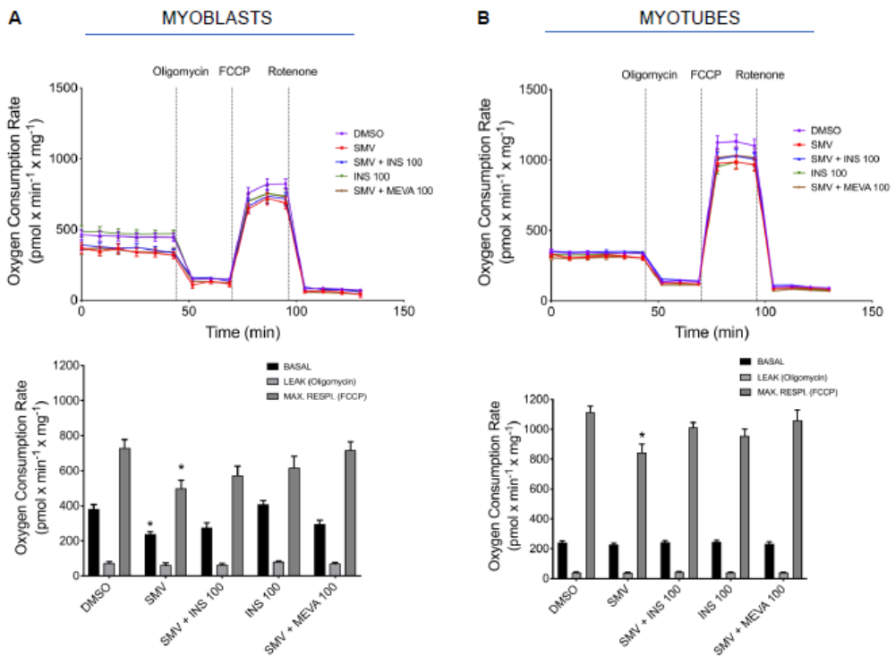
Function of the respiratory chain in C2C12 myoblasts and myotubes. A. Oxygen consumption rate (OCR) and corresponding quantifications in C2C12 myoblasts and in B. C2C12 myotubes following 24 hours exposure to 10 μM simvastatin, 100 ng/mL insulin and/or 100 μM mevalonolactone. Values are expressed per mg protein. Data represent the mean ± SEM of four independent experiments. *P<0.05 versus 0.1 % DMSO; ⁺P<0.05 versus 10 μM simvastatin. SMV: simvastatin, INS: insulin, MEVA: mevalonolactone.

