Supplemental Figure 1. Genetic differentiation in different edible maize subgroups. The number on each dashed line represents the F_{ST} value between the subgroups it connects.
Supplemental Figure 2. PCA plots of all metabolites for inbred lines and landraces. (A) and (B) PCA plots of all metabolites for landraces. (C) and (D) PCA plots of all metabolites for improved lines.
Supplemental Figure 3. Coefficient of metabolite variation for FIN, FLA, WIN, WLA, SIN, SLA and whole population, respectively
Supplemental Figure 4. VIP value distribution associated with two divergence process.
Supplemental Figure 5. The classification of all divergence metabolites (blue: both divergence in Field-Waxy and Field-Sweet; green: divergence in Field-Sweet; yellow: divergence in Field-Waxy).
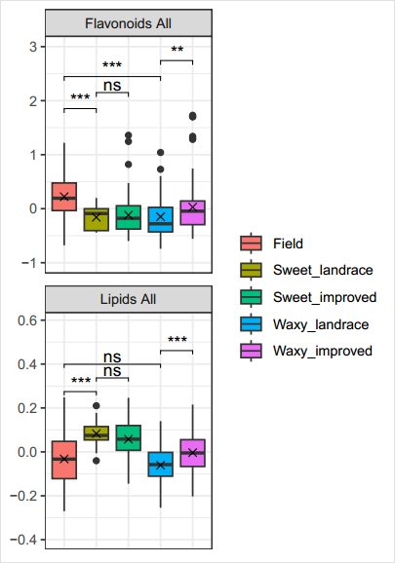
Supplemental Figure 6. Comprehensively evaluated the overall trend of flavonoids and lipids in each edible maize subgroup.
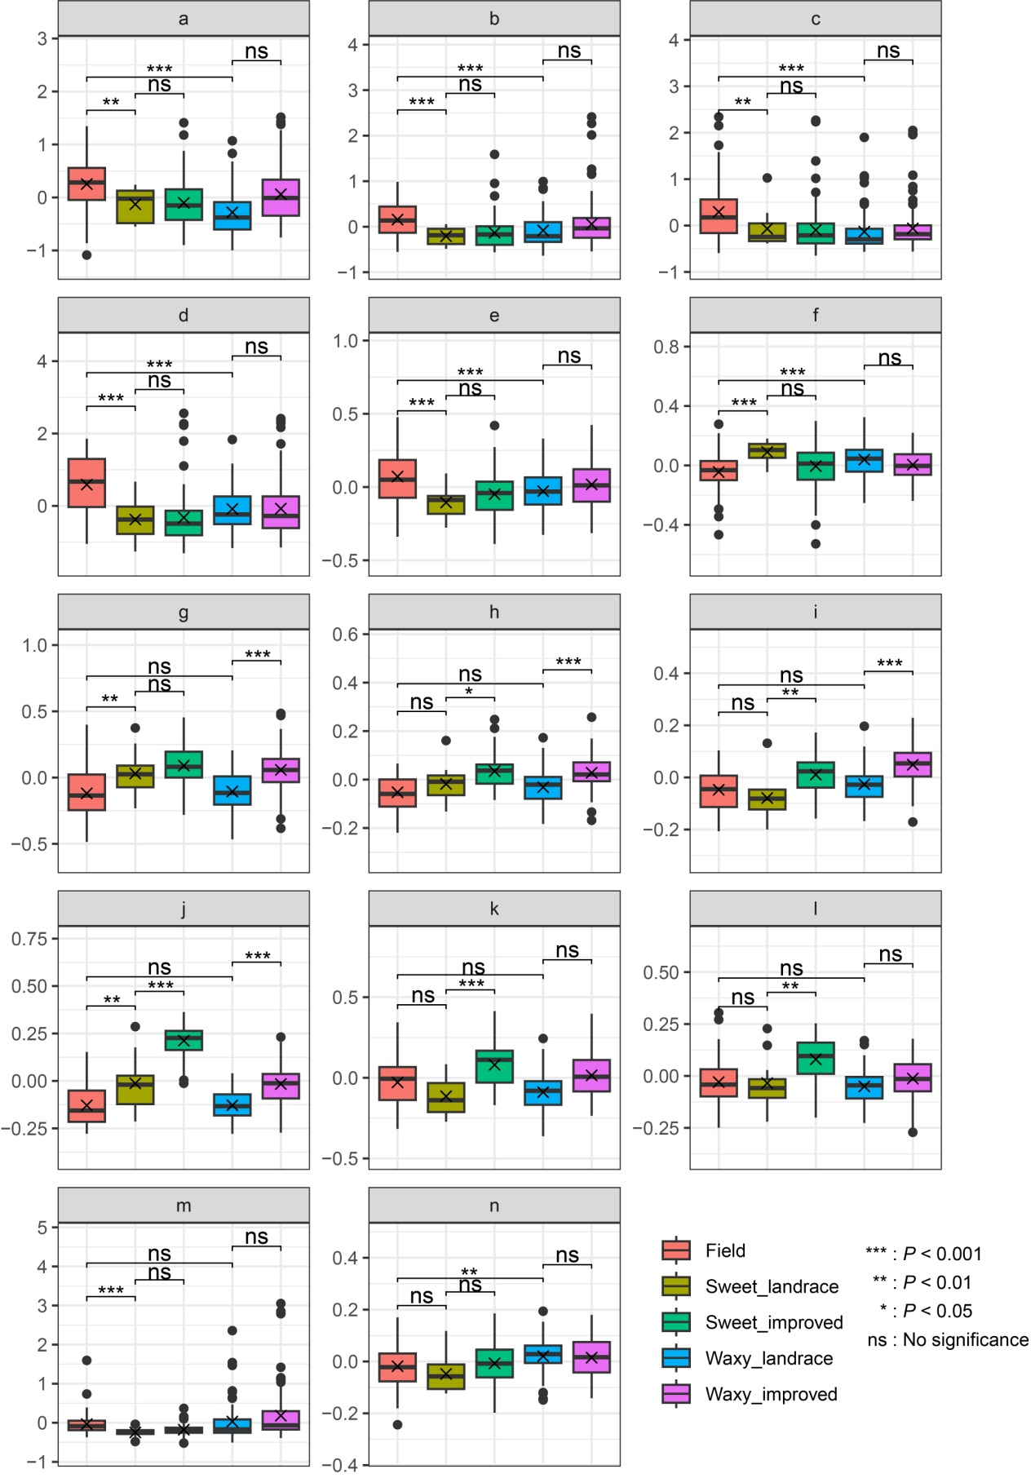
Supplemental Figure 7. Comprehensively evaluated the overall trend of divergence metabolic classes. a. flavone, b. flavonol, c. flavone C-gly, d. dihydroflavone, e. coumarin, f. LPE, g. free fatty acid, h. nucleotide and derivative, i. organic acid, j. saccharide and alcohol, k. phenolic acid, l. plumeranem, m. anthocyanin, n. vitamin.

Supplemental Figure 8. The expected and empirical probability distributions of mGWAS signals in 2M intervals were estimated assuming a Poisson distribution.
Supplemental Figure 9. qRT-PCR analysis of two genes in the flavonoids pathway. (A) MYB5 (Zm00001d047671) expression in two haplotypes. (B) OGT1 (Zm00001d052492) expression in two haplotypes.
Supplemental Figure 10. qRT-PCR analysis of two genes in the lipids pathway. (A) GPAT1 (Zm00001d049616) expression in two haplotypes. (B) PLA1 (Zm00001d021131) expression in two haplotypes.
Supplemental Figure 11. mGWAS identification of candidate genes for variation of folate. (A) Structure of folate (folic acid). (B) Manhattan plot displaying the mGWAS result of the content of folate. (C) Regional association plot for locus THY2. (D) Gene model of THY2. (E) qRT-PCR analysis of THY2 expression in the kernels. (F) The pathway of folate biosynthesis.
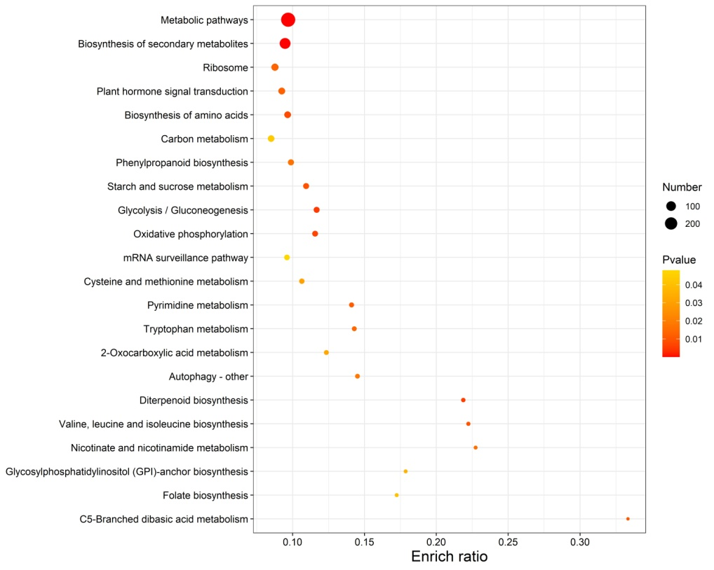
Supplemental Figure 12. KEGG enrichment analysis of the genes encompassed in selective sweeps.
Supplemental Figure 13. The gene allele frequency differences across different groups and the selective pattern of the promising associations. (A) The allele frequency of genes in flavonoids biosynthesis pathway across different groups. (B) and (C) The allele frequency changes of flavonoid-related genes in Field-Sweet and Field-Waxy divergence. (D) and (E) The allele frequency changes of lipid-related genes in Field-Sweet and Field-Waxy divergence.
Supplemental Figure 14. The key divergence hub genes for lipids. (A) The divergence hub genes in Field-Sweet and Field-Waxy for lipids. (B) and (C) Manhattan plot (upper) and LD heat map (lower) for association signals of UGT1 and C1 for all flavonoids. (D) and (E) XP-CLR (above) and F_{ST} (below) of these two gene regions. (F) and (G) Gene structure and gene-based association mapping for all flavonoids. (H) and (I) Frequency changes and flavonoids content of UGT1 and C1 haplotypes in different population. (J) and (K) qRT-PCR analysis of UGT1 and C1 expression in different haplotypes.
Supplemental Figure 15. The accuracy of observed and predicted value for Anthocyanin, Dihydroflavone, Flavanol, Flavone, Flavone C-gly and Flavonol.
Supplemental Figure 16. The chromosome recombination information for five elite lines breeding from two parents.

