Supporting information for
Shifts in structure and dynamics of the soil microbiome in fuel/biofuel blends-affected areas triggered by different bioremediation treatments

Kelly Hidalgo-Martinez^{a,b}, Admir José Giachini^{c} , Marcio Schneider^{c}, Adriana Soriano^{d}, Marcus Paulus Baessa^{d}, Luiz Fernando Martins^{d}, and Valéria Maia de Oliveiraª
ª Divisão de Recursos Microbianos, Centro Pluridisciplinar de Pesquisas Químicas, Biológicas e Agrícolas (CPQBA), Microbial Resources Division, Research Center for Chemistry, Biology and Agriculture (CPQBA), Universidade Estadual de Campinas (UNICAMP), CEP 13148-218, Paulínia, SP, Brasil,
^{b} Programa de pós-graduação de Genética e Biologia Molecular, Instituto de Biologia. Universidade Estadual de Campinas (UNICAMP), CEP 13083-970, Campinas, SP, Brasil.
^{c} Núcleo Ressacada de Pesquisas Em Meio Ambiente (REMA) - Department of Microbiology, Federal University of Santa Catarina (UFSC), Campus Universitário Sul da Ilha - Rua José Olímpio da Silva, 1326 - Bairro Tapera, 88049-500 Florianópolis, SC, Brazil.
^{d} PETROBRAS/ R&D Center (CENPES), Av. Horácio Macedo, 950. ZIP 21941-915 Cidade Universitária, Ilha do Fundão, Rio de Janeiro, Brazil.

Supplementary information

Table S1. Permutational multivariate analysis of variance (Adonis) test to evaluate the influence of the fuel blend on the microbial community composition based on the Bray-Curtis distance.
 | df | SumOfSqs | R² | F | p-value
Fuel Blend | 1 | 1.0275 | 0.27222 | 3.7404 | 0.002997**
Residual | 10 | 2.7471 | 0.72778
Total | 11 | 3.7746 | 1.00
* Values in bold denote statistical significance (*p < 0.05; **p < 0.01; ***p < 0.001)

Table S2. Alpha diversity indexes.
Area | Time | Observed Speciesª | Chao1^{b} | Shannon Index^{c} | Simpson Index^{d}
4.E25-BAN | 0 | 277±51.3 | 333±74.7 | 2.59±0.775 | 0.714±0.161
4.E25-BAN | 12 | 367±70.1 | 386±86.7 | 4.94±0.131 | 0.980±0.0014
4.E25-BAN | 24 | 290±40.7 | 299±40.8 | 4.99±0.0634 | 0.989±0.00036
5.B20-ANM | 0 | 347±49.9 | 356±54.5 | 4.22±0.277 | 0.957±0.00249
5.B20-ANM | 12 | 284±90 | 290±93 | 4.14±0.600 | 0.94±0.04585
5.B20-ANM | 24 | 329±13.8 | 331±15 | 4.8±0.132 | 0.979±0.00466
7.E10-BAN | 0 | 171±31.5 | 171±31.5 | 1.49±0.229 | 0.551±0.134
7.E10-BAN | 12 | 520±142 | 528±149 | 5.47±0.188 | 0.992±0.00088
7.E10-BAN | 24 | 294±89.7 | 299±89.1 | 4.54±0.173 | 0.961±0.00283
8.B20-BAA | 0 | 251±64.3 | 268±56.7 | 3.30±0.760 | 0.876±0.0786
8.B20-BAA | 12 | 342±5.86 | 352±15.1 | 4.44±0.188 | 0.965±0.00811
8.B20-BAA | 24 | 345±22.2 | 349±23.6 | 4.73±0.141 | 0.979±0.00406
ª Number of ASVs observed (Richness)
^{b} Species richness estimator
^{c} >0; higher more diverse
^{d} 0-1; 0 = most simple

Table S3. Shapiro-Wilk test for normal distribution of alpha diversity index
Diversity Index | Statistics | Df | Sig.
Shannon | 0.92513 | 12 | 0.3992
Simpson | 0.8714 | 12 | 0.753

Table S4. T-test analysis of the effect of the biofuel in the alpha diversity indexes.
Alpha Diversity Index | Statistic | df | p-value
Shannon | 5.6392 | 5 | 0.0024**
Simpson | 5.5855 | 5 | 0.0025**
* Values in bold denote statistical significance (*p < 0.05; **p < 0.01; ***p < 0.001)

Table S5. Permutational multivariate analysis of variance (Adonis) test to evaluate the influence of the bioremediation treatment on the microbial community composition based on the Bray-Curtis distance
 | 4.E10-BAN |  |  |  |  | 5.B20-ANM |  |  |  |  | 7.E10-BAS |  |  |  |  | 8.B20-BAA
 | df | SumOfSqs | R² | F | p-value | df | SumOfSqs | R² | F | p-value | df | SumOfSqs | R² | F | p-value | df | SumOfSqs | R² | F | p-value
Time | 2 | 1.99 | 0.83 | 15.17 | 0.004** | 2 | 1.43 | 0.64 | 5.45 | 0.002** | 2 | 2.18 | 0.86 | 17.80 | 0.004** | 2 | 1.06 | 0.68 | 6.52 | 0.003**
Residual | 6 | 0.39 | 0.17 |  |  | 6 | 0.79 | 0.35 |  |  | 6 | 0.37 | 0.14 |  |  | 6 | 0.49 | 0.32
Total | 8 | 2.38 | 1.00 |  |  | 8 | 2.22 | 1.00 |  |  | 8 | 2.55 | 1.00 |  |  | 8 | 1.54 | 1.00
* Values in bold denote statistical significance (*p < 0.05; **p < 0.01; ***p < 0.001)

Table S6. Shapiro-Wilk test for normal distribution of alpha diversity index
 | Shapiro-Wilk normality test |  | Levene’s homogeneity of Variance test
Areas | Statistics | Sig. | Statistics | Sig.
4.E25-BAN | 0.83635 | 0.05259 | 2.8844 | 0.1325
5.B20-ANM | 0.93575 | 0.5379 | 0.6162 | 0.571
7.E10-BAN | 0.91381 | 0.3435 | 0.0491 | 0.9525
8.B20-BAA | 0.9005 | 0.2549 | 0.9154 | 0.4498

Table S7. ANOVA and Tukey post-hoc test of the effects of bioremediation treatments on Shannon index
Areas | Anova |  |  | Tukey Post-Hoc Test
Areas | df | F | p-values | p-values
 |  |  |  | 0 vs 12 | 12 vs 24
4.E25-BAN | 2 | 27.201 | 0.00098*** | 0.00169** | 0.99237
5.B20-ANM | 2 | 5.798 | 0.0396* | 0.3431 | 0.0334*
7.E10-BAN | 2 | 330.7 | 7.27e-07*** | <0.001 *** | 0.00323**
8.B20-BAA | 2 | 8.052 | 0.02* | 0.0530 | 0.7295
* Values in bold denote statistical significance (*p < 0.05; **p < 0.01; ***p < 0.001)

Table S8. Correlations and topological properties of microbial networks from the biodiesel and bioethanol polluted areas before and after the bioremediation treatment applied.
Topological property | 4.E25-BAN |  |  | 7.E10-BAS |  |  | 5.B20-ANM |  |  | 8.B20-BAA
Topological property | 0 | 12 | 24 | 0 | 12 | 24 | 0 | 12 | 24 | 0 | 12 | 24
# Nodes | 414 | 367 | 236 | 235 | 535 | 335 | 510 | 276 | 313 | 293 | 373 | 362
# Edges | 2641 | 1750 | 962 | 678 | 6082 | 2395 | 4437 | 807 | 1349 | 1739 | 2014 | 1971
Positive edges | 2576 (97.5%) | 1640 (93.7%) | 933 (96.7%) | 664 (97.9 %) | 5499 (90.4%) | 2230 (93.1%) | 4401 (99.2%) | 521 (64.5%) | 1253 (92.9%) | 1660 (95.4%) | 1873 (92.9%) | 1759 (89.2%)
Negative edges | 65 (2.5%) | 110 (6.3%) | 29 (3.3%) | 14 (2.1%) | 633 (9.6%) | 165 (6.9%) | 36 (0.8%) | 286 (35.5%) | 96 (7.1%) | 79 (4.6%) | 141 (7.1%) | 212 (10.8%)
Modularity | 0.496 | 0.604 | 0.558 | 0.507 | 0.572 | 0.538 | 0.587 | 0.532 | 0.642 | 0.445 | 0.618 | 0.643
Number of communities | 3 | 4 | 6 | 6 | 6 | 6 | 4 | 5 | 4 | 3 | 3 | 4
Network diameter | 7 | 8 | 6 | 6 | 9 | 7 | 8 | 8 | 7 | 8 | 7 | 7
Average path length | 2.229 | 2.516 | 2.076 | 2.099 | 2.920 | 2.385 | 2.253 | 2.683 | 2.298 | 2.180 | 2.339 | 2.241
Average degree | 6.379 | 4.768 | 4.076 | 2.885 | 11.368 | 7.149 | 8.7 | 2.924 | 4.31 | 5.935 | 5.299 | 5.445
Average clustering coefficient | 0.078 | 0.082 | 0.089 | 0.058 | 0.166 | 0.116 | 0.097 | 0.075 | 0.083 | 0.093 | 0.084 | 0.094
Edge/node ratio | 6.37 | 4.76 | 4.07 | 2.9 | 11.37 | 7.14 | 8.7 | 2.9 | 4.3 | 5.9 | 5.4 | 5.4

2-column size
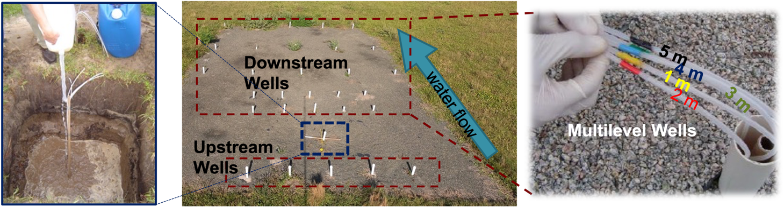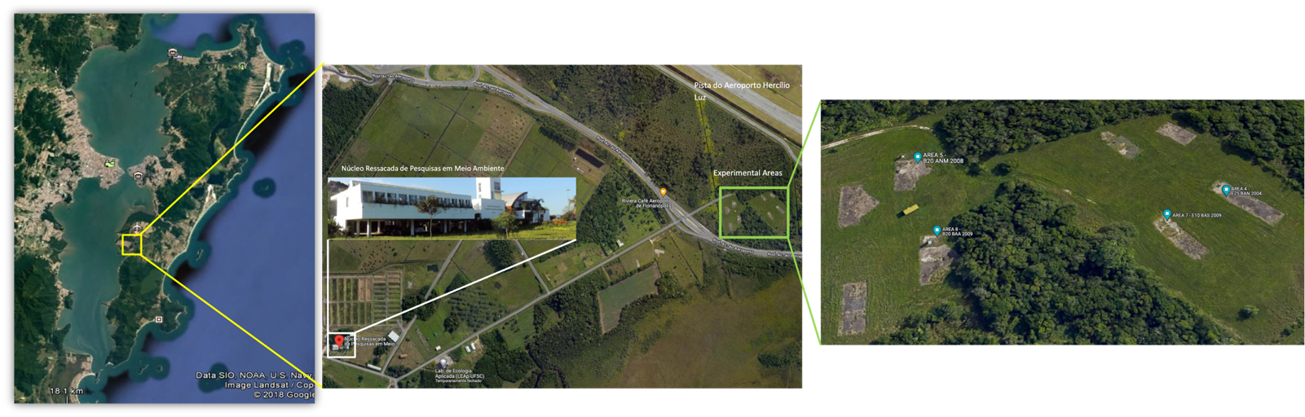
C
A
B
Figure S1. (A) Satellite view of the Florianopólis Island and the Ressacada Experimental Farm. (B) Satellite view of the experimental areas configuration. (C) From the left to the right: Fuels release, spatial monitoring wells distribution along water flow direction and identification of monitoring levels. Square dashed in blue indicates the source well

2-column size
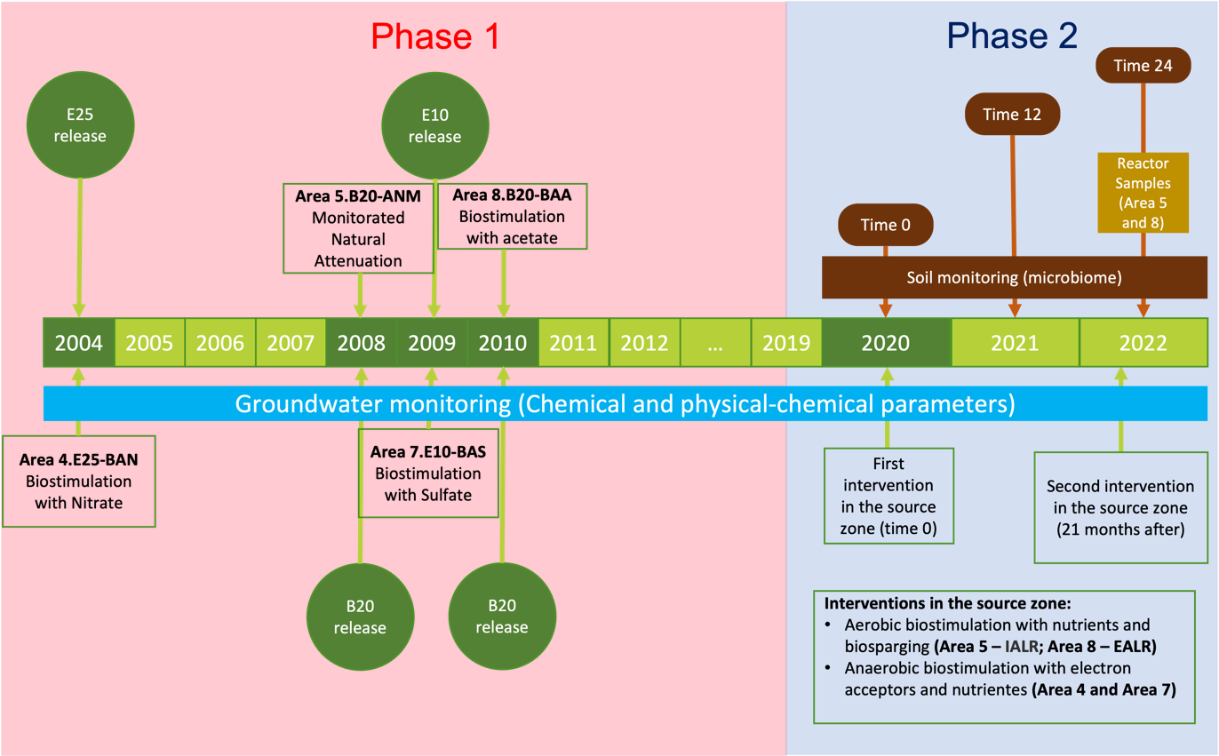
Figure S2. Timeline of the fuel releases and bioremediation treatments and details of the experimental areas.

Single-column size
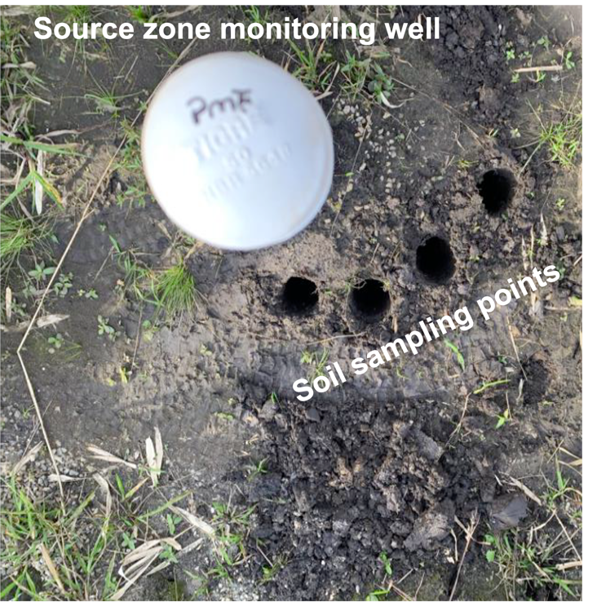
Figure S3. Example of source zone monitoring well and soil sampling points.

Single-column size
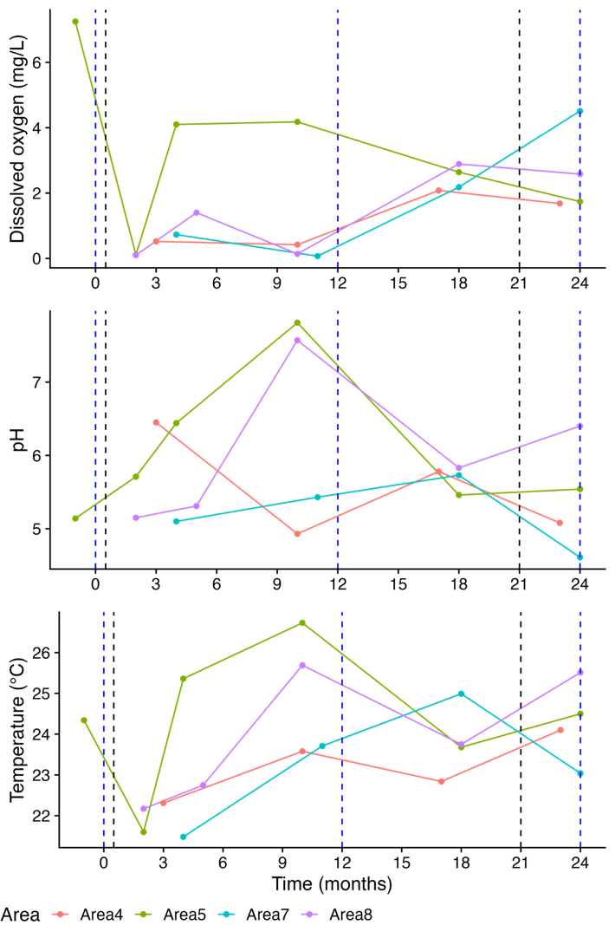
A
B
C
Figure S4. Dissolved oxygen (A); pH (B); and temperature (C) at 2 m below ground surface. Blue dashed lines represent soil microbiome sampling. Black dashed line represents bioremediation application.

1.5-column size
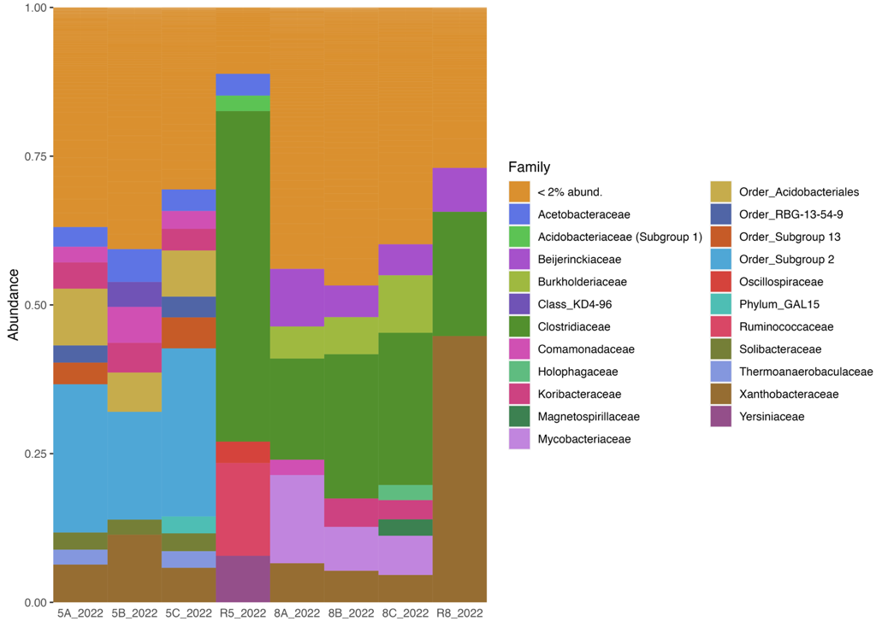
Figure S5. Relative abundances of microbial families in areas 5 and 8 and in the respective reactors, based on 16S rRNA gene sequencing. Families with <2% de abundance were grouped in one category (<2% abund). Samples named as R5 and R8 are from reactors in areas 5 and 8, respectively.

Single-column size
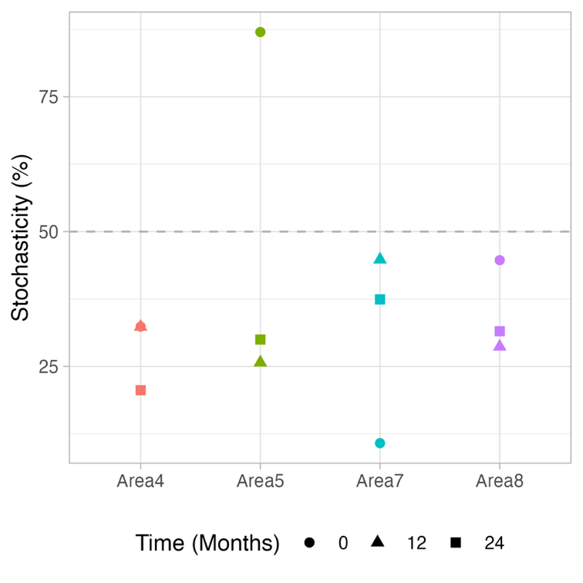
Figure S6. The magnitude of stochasticity quantified as the normalized stochasticity ratio in the different impacted areas and sampling times. The values were calculated based on the Jaccard dissimilarity.

1.5-column size
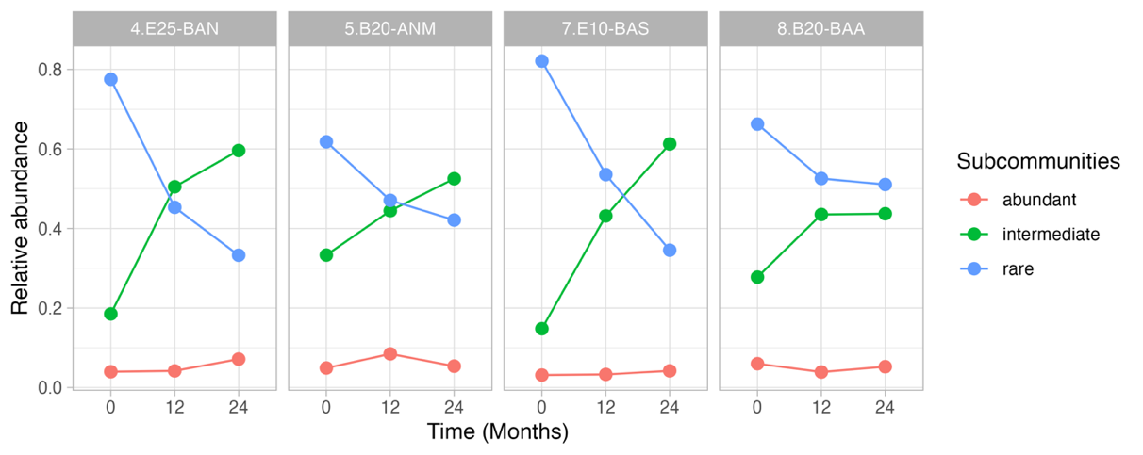
Figure S7. Relative abundance of rare (≤ 0.01%), intermediate (>0.01% & < 0.5%) and abundant (≥ 0.5%) sub-communities in each area over the time.

2-Column size
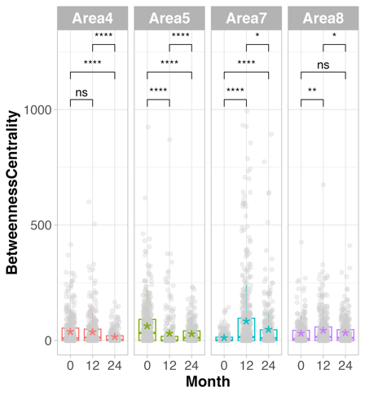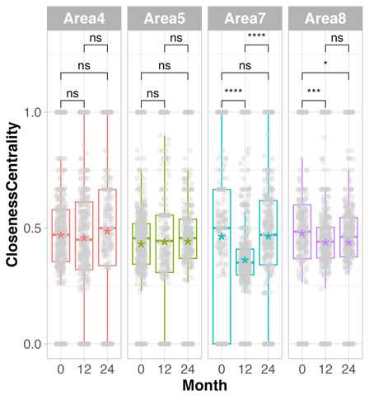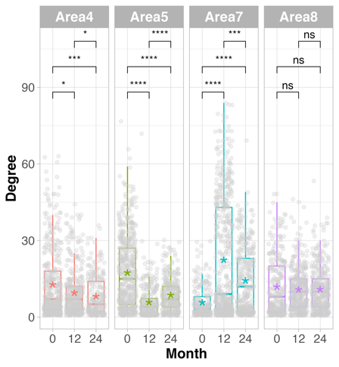
Figure S8. Unique node topological features, specifically, betweenness and closeness centrality and degree. Means comparison by Student t-test (p-value < 0.05)

Single-column size
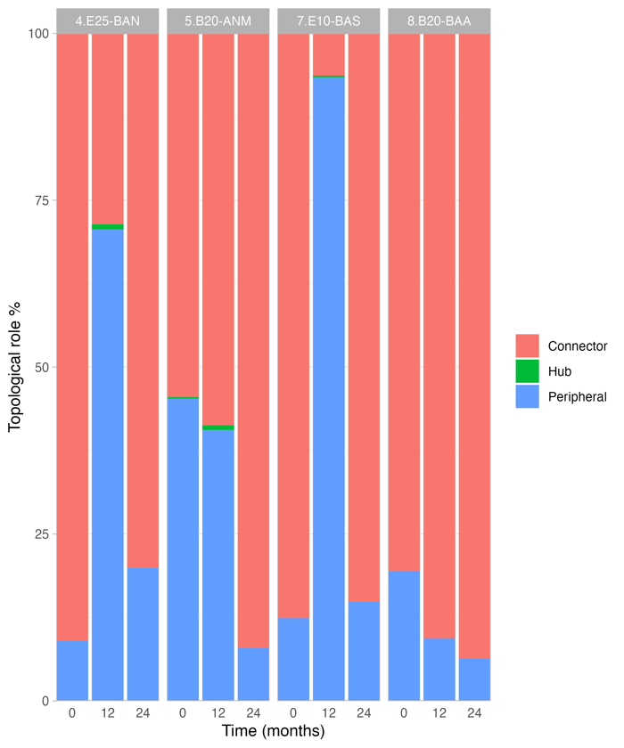
Figure S9. Percentage of nodes according with the ecological roles, connector, hub or peripherals in all the areas over the time

2-column size
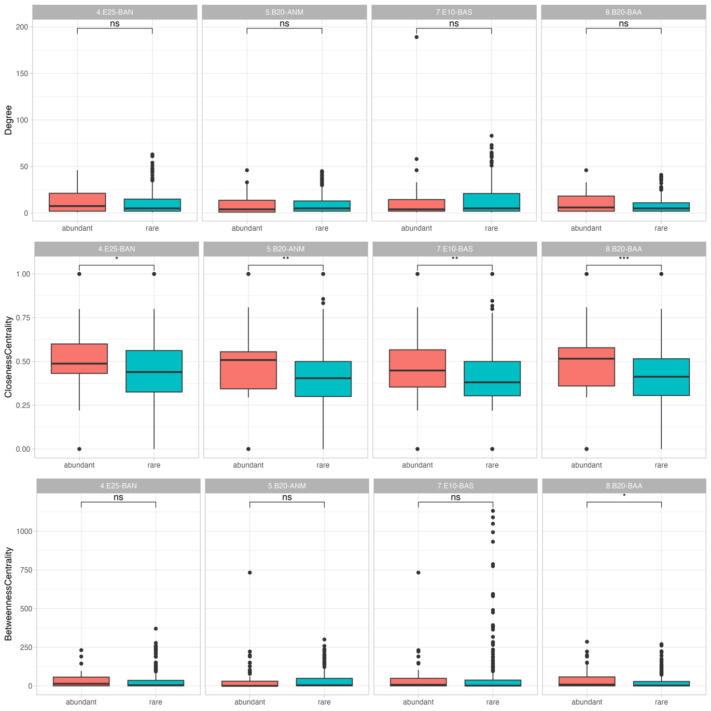
Figure S10. Unique node topological features of rare and abundant taxa in all the areas over the time, specifically the degree, betweenness and closeness centrality. Means comparison by Wilcoxon rank sum test (p-value < 0.05)

1.5-column size
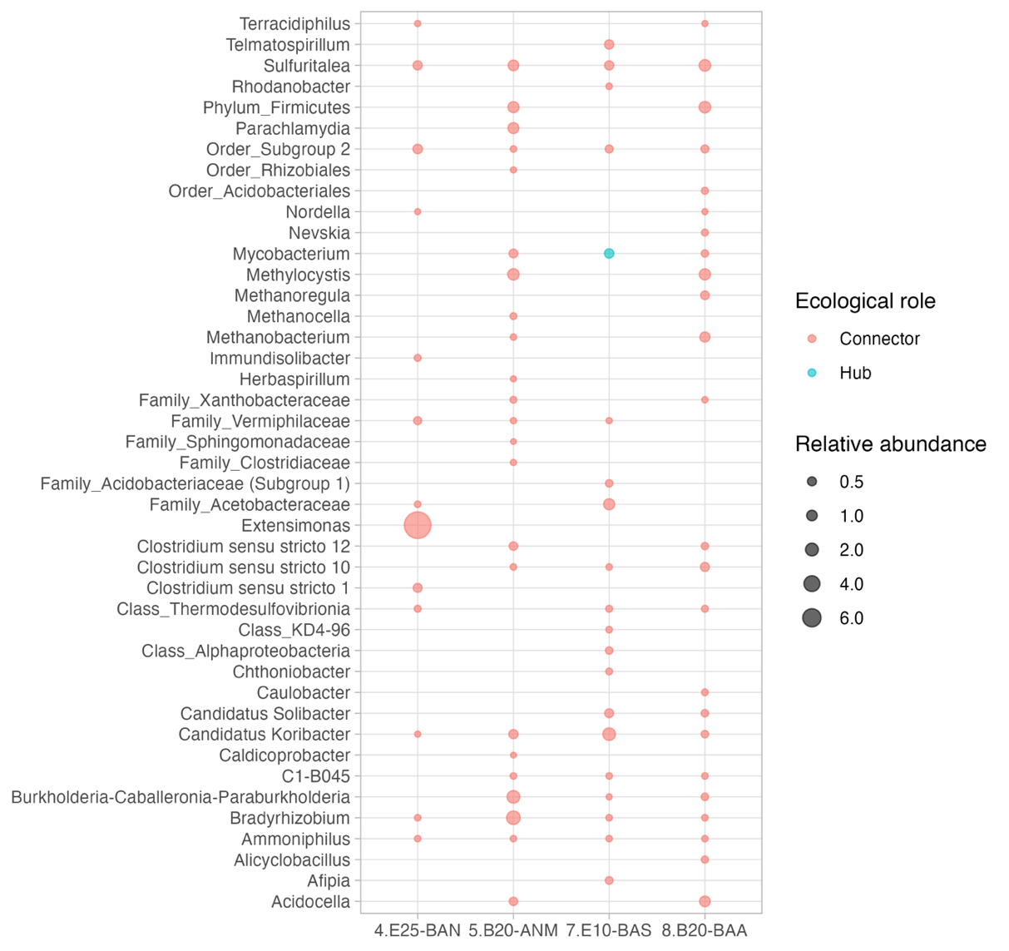
Figure S11. Relative abundance and taxonomic classification at genus level of taxa categorized as connectors and module hubs keystone.

Corresponding author: K.J. Hidalgo E-mail: khidalgo@javeriana.edu.co Telephone: +55 19 98172 1510

