Supplementary Information for

Hydroamination of alkenes with dinitrogen in a trititanium polyhydride framework

Takanori Shima,*^{,1,2,4} Qingde Zhuo,^{2,4} Xiaoxi Zhou,² Ping Wu,³ Ryota Owada,² Gen Luo,*^{,3} and Zhaomin Hou*^{,1,2}
¹Advanced Catalysis Research Group, RIKEN Center for Sustainable Resource Science, Wako 351-0198, Japan
²Organometallic Chemistry Laboratory, RIKEN Cluster for Pioneering Research, Wako, 351-0198, Japan
³Institutes of Physical Science and Information Technology, Anhui University, Hefei 230601, China
⁴These authors contributed equally: Takanori Shima, Qingde Zhuo

This file includes the following materials:

General procedure
Supplementary Text
Figures S1 to S85
Tables S1 to S4

General Procedures
All reactions were carried out under a dry and oxygen free argon atmosphere by using Schlenk techniques or under a nitrogen or argon atmosphere in an Mbraun glovebox. The argon was purified by being passed through a Dryclean column (4A molecular sieves, Nikka Seiko Co.) and a Gasclean GC-XR column (Nikka Seiko Co.). The nitrogen and the argon in the glovebox were constantly circulated through a copper/molecular sieves catalyst unit. The oxygen and moisture concentrations in the glovebox atmosphere were monitored by an O₂/H₂O Combi-Analyzer (Mbraun) to ensure both were always below 1 ppm. Samples for NMR spectroscopic measurements were prepared by using Schlenk techniques or in the glovebox by use of J. Young valve NMR tubes. ¹H, ¹³C, and ¹⁵N NMR spectra were recorded on a JEOL JNM-ECS400 or Bruker-AVANCE500HD spectrometer. Elemental analyses were performed by a MICRO CORDER JM10. High-resolution MS were recorded on a JEOL JMS-700V (EI). Field desorption (FD) mass spectra were acquired on a JEOL JMS-T100GCV time of flight mass spectrometer equipped with an EI/FI(FD) combination ion source. Anhydrous THF, hexane, benzene, Et₂O, and toluene were purified by use of a SPS-800 solvent purification system (Mbraun), and dried over fresh Na chips or activated molecular sieves in the glovebox. NMR solvents were dried with activated 3 Å molecular sieves. [(C₅Me₄SiMe₃)₃Ti₃(μ₃-H)(μ₂-H)₆] (1), [(C₅Me₄SiMe₃)₃Ti₃(μ₃-N)(μ-NH)(μ-H)₂] (2) TiCl₃(THF)₃, and [C₅Me₄SiMe₂^{t}Bu]Li (Cp”Li) were prepared according to literature procedures. ¹⁵N₂ (99.9%), D₂ (99.96%) were purchased from SHOKO science. Hydrogen (>99.99999%) was purchased from TAIYO NIPPON SANSO and used as received. Other chemicals were purchased from common commercial sources and used as received.

[{(C₅Me₄SiMe₃)Ti}₃(μ-η²,η¹,η¹-CH=CH-CH₂-)(μ₃-N)(μ-NH)] (3). a) Propylene (1 atm) was introduced to a hexane solution (4 mL) of 2 (61.2 mg, 0.081 mmol) at room temperature. The mixture was heated at 70 ºC and stirred for 2 days. After removal of the solvent under vacuum, the residual solid was recrystallized from DME at –33 ºC to afford 3 (38 mg, 0.048 mmol, 59%) as dark brown block crystals. b) A benzene solution (0.5 mL) of 5 (14 mg, 0.018 mmol) in J-Young NMR tube was kept at 70 °C for 1 day. The color of the solution changed from dark purple to brown purple. After the reaction, the solution was evaporated and the residue was crystallized in DME at –30 °C to give 3 (12 mg, 0.015 mmol, 83%) as dark brown solid. The ¹⁵N-enriched compound [{(C₅Me₄SiMe₃)Ti}₃(μ-η³,η³,η¹-CH=CH-CH₂-)(μ₃-¹⁵N)(μ-¹⁵NH)] (3-¹⁵N) was obtained from the reaction of [{(C₅Me₄SiMe₃)Ti}₃(μ₃-¹⁵N)(μ-¹⁵NH)(μ-H)₂] (2-¹⁵N) (6 mg, 0.008 mmol) with propylene (1 atm) in C₆D₆ (0.4 mL) at 70 °C for 16 h.
3: ¹H NMR (C₆D₆, rt): δ 15.00 (s, 1H, NH), 7.72 (d, J = 9.8 Hz, 1H, -CH=CH-CH₂-), 5.21 (t, J = 5.8 Hz, 1H, -CH=CH-CH₂-), 4.01 (ddd, J = 9.8, 5.8, 2.4 Hz, 1H, -CH=CH-CH₂-), 2.48 (s, 3H, C₅Me₄SiMe₃), 2.48 (-CH=CH-CH₂-, obscured by Cp’), 2.44 (s, 3H, C₅Me₄SiMe₃), 2.34 (s, 3H, C₅Me₄SiMe₃), 2.25 (s, 3H, C₅Me₄SiMe₃), 2.21 (s, 3H, C₅Me₄SiMe₃), 2.16 (s, 3H, C₅Me₄SiMe₃), 2.00 (s, 3H, C₅Me₄SiMe₃), 1.96 (s, 3H, C₅Me₄SiMe₃), 1.91 (s, 3H, C₅Me₄SiMe₃), 1.84 (s, 3H, C₅Me₄SiMe₃), 1.53 (s, 3H, C₅Me₄SiMe₃), 1.26 (s, 3H, C₅Me₄SiMe₃), 0.36 (s, 9H, C₅Me₄SiMe₃), 0.32 (s, 9H, C₅Me₄SiMe₃), 0.23 (s, 9H, C₅Me₄SiMe₃). ¹³C{¹H} NMR (C₆D₆, rt): δ 223.6 (s, -CH=CH-CH₂-), 140.1 (s, -CH=CH-CH₂-), 136.3 (s, -CH=CH-CH₂-),128.6 (s, C₅Me₄SiMe₃), 128.5 (s, C₅Me₄SiMe₃), 127.7 (s, C₅Me₄SiMe₃), 126.0 (s, C₅Me₄SiMe₃), 124.8 (s, C₅Me₄SiMe₃), 124.1₇ (s, C₅Me₄SiMe₃), 124.1₅ (s, C₅Me₄SiMe₃), 123.8 (s, C₅Me₄SiMe₃), 123.4 (s, C₅Me₄SiMe₃), 123.3 (s, C₅Me₄SiMe₃), 122.1 (s, C₅Me₄SiMe₃), 120.9 (s, C₅Me₄SiMe₃), 116.3 (s, C₅Me₄SiMe₃), 115.5 (s, C₅Me₄SiMe₃), 112.9 (s, C₅Me₄SiMe₃), 16.0 (s, C₅Me₄SiMe₃), 15.4₉ (s, C₅Me₄SiMe₃), 15.4₆ (s, C₅Me₄SiMe₃), 15.0 (s, C₅Me₄SiMe₃), 12.5 (s, C₅Me₄SiMe₃), 12.3 (s, C₅Me₄SiMe₃), 12.1 (s, C₅Me₄SiMe₃), 12.0 (s, C₅Me₄SiMe₃), 11.8 (s, C₅Me₄SiMe₃), 11.2 (s, C₅Me₄SiMe₃), 2.6₂ (s, C₅Me₄SiMe₃), 2.5₆ (s, C₅Me₄SiMe₃). ¹³C NMR (C₆D₆, non-decoupling, rt): δ 223.6 (d, J_{CH} = 134.7 Hz, -CH=CH-CH₂-), 140.1 (d, J_{CH} = 154.0 Hz, -CH=CH-CH₂-), 136.3 (dd, J_{CH} = 123.0, 70.0 Hz, -CH=CH-CH₂-). ¹H-¹H COSY (C₆D₆, rt): δ_{H} 7.72-4.01; δ_{H} 5.21-4.01, 2.48; δ_{H} 4.01-7.72, 5.21. ¹H-¹³C HMQC (C₆D₆, rt): δ_{H} 7.72-δ_{C} 223.6; δ_{H} 4.01-δ_{C} 140.1; δ_{H} 5.21, 2.48-δ_{C} 136.3. Anal. calcd. for C₄₁H₇₀N₂Si₃Ti₃: C, 60.14; H, 8.62; N, 3.42. Found: C, 61.18; H, 8.63; N, 3.16.
3-¹⁵N: ¹H NMR (C₆D₆, rt): δ 14.98 (d, J_{NH} = 66.0 Hz, ¹⁵N-H). ¹⁵N NMR (C₆D₆, rt): δ 499.4 (s, μ₃-¹⁵N), 97.6 (s, μ-¹⁵NH).

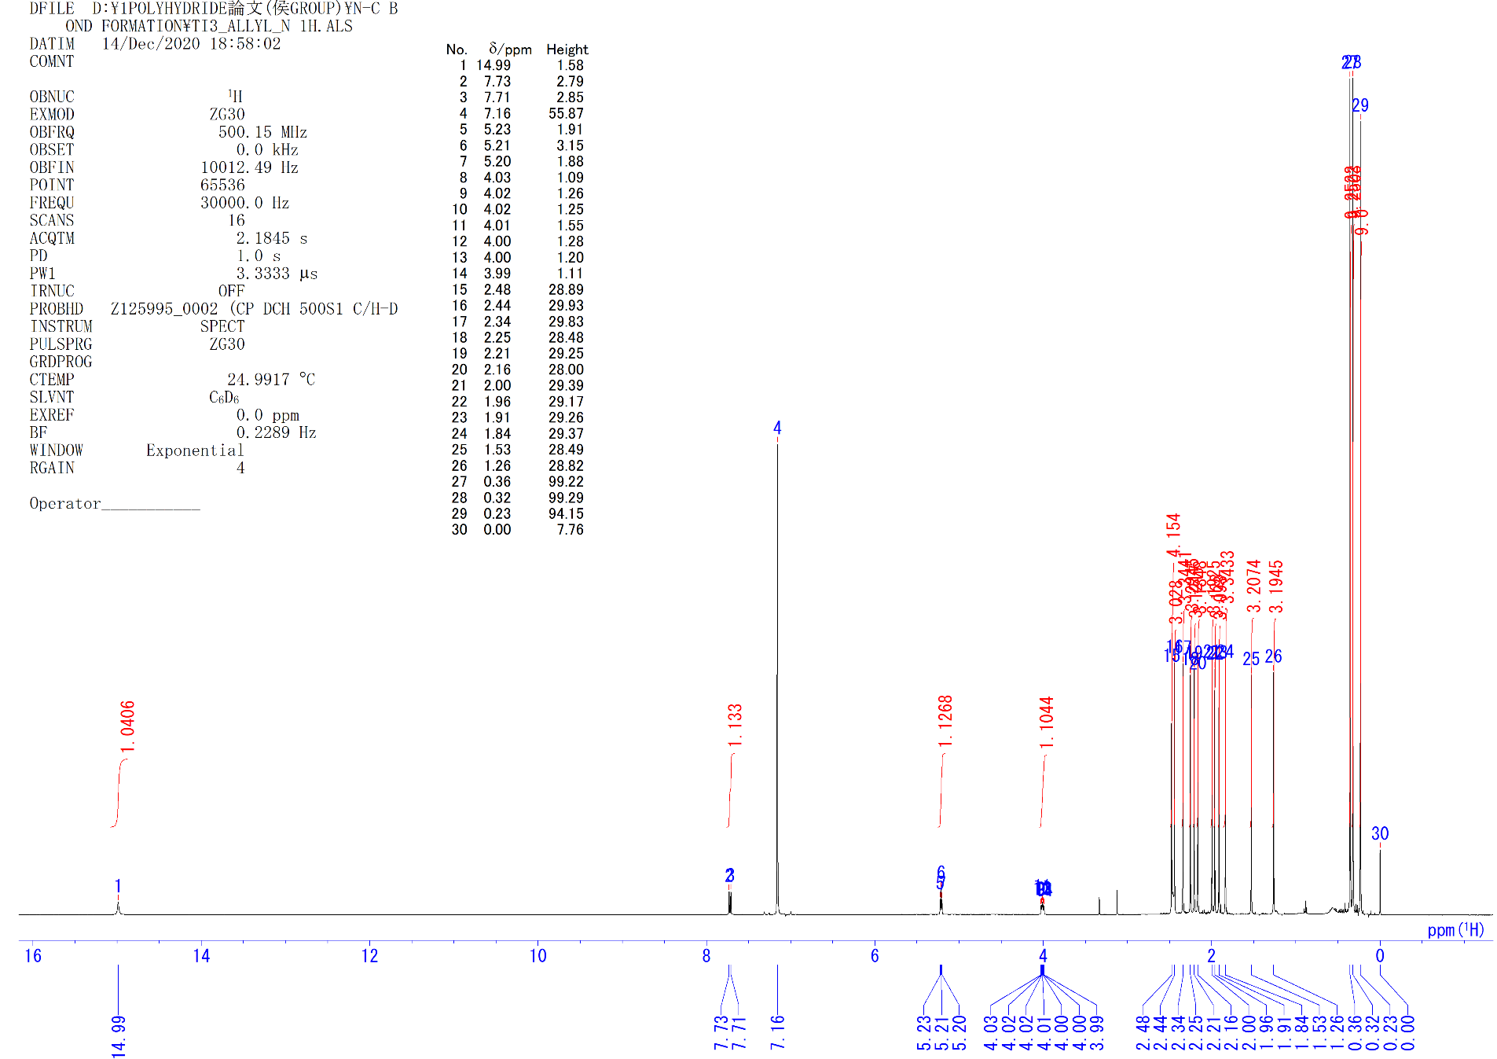
Figure S1. ¹H NMR spectrum of 3 (C₆D₆, rt)

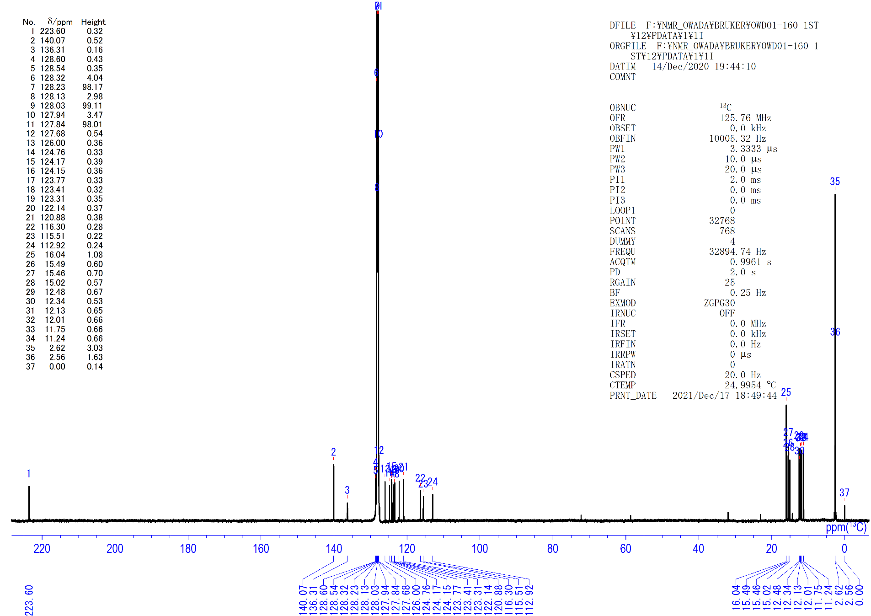
Figure S2. ¹³C{¹H} NMR spectrum of 3 (C₆D₆, rt).

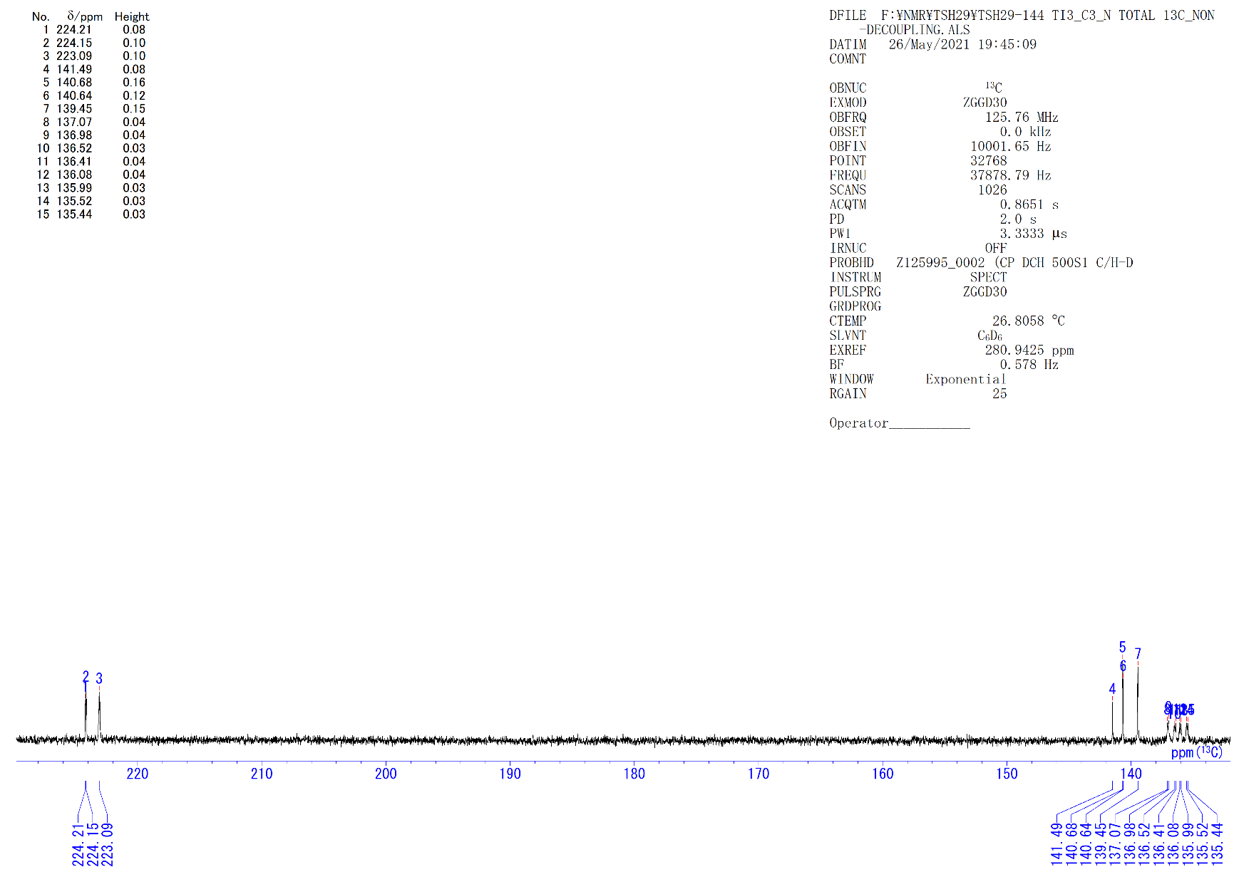
Figure S3. ¹³C{¹H non decoupling} NMR spectrum of 3 (C₆D₆, rt).

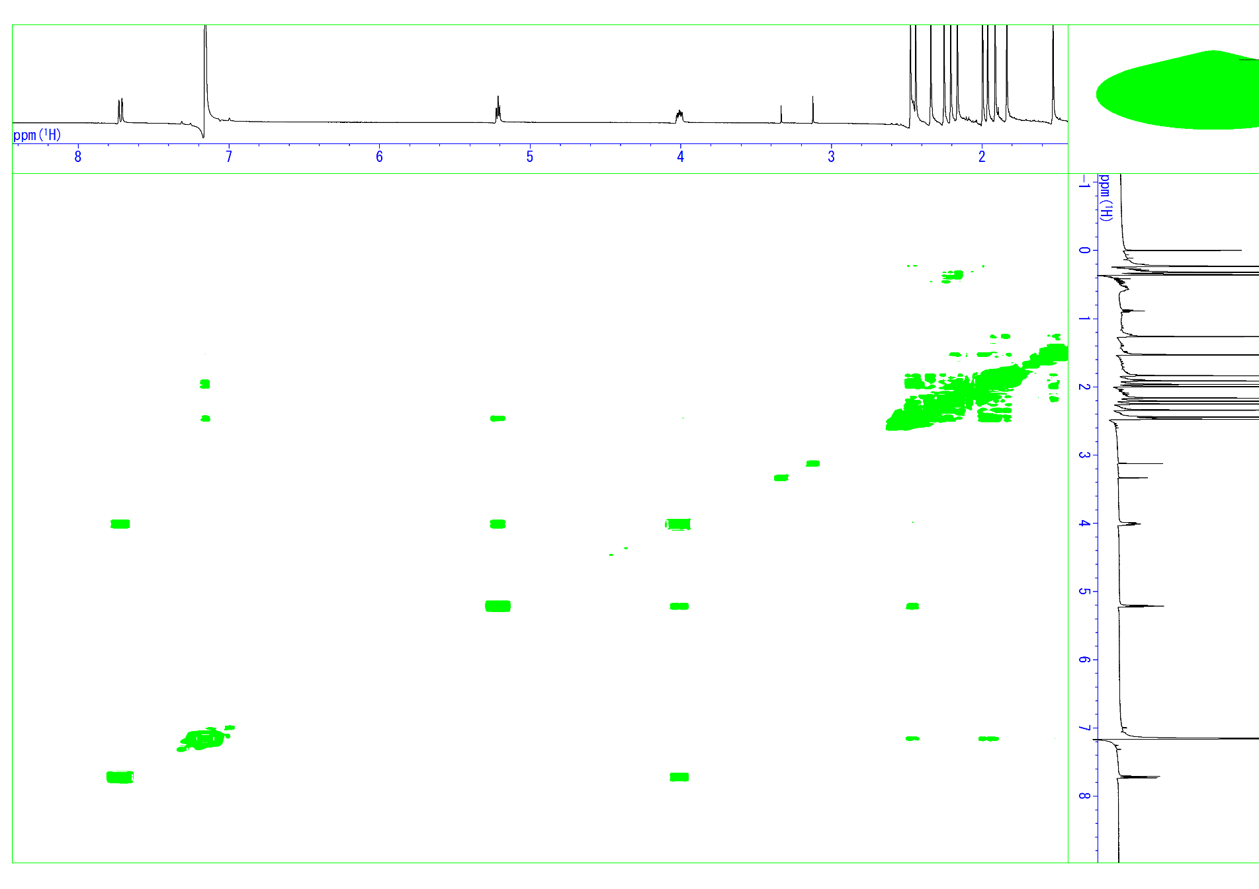
Figure S4. ¹H-¹H COSY spectrum of 3 (C₆D₆, rt).
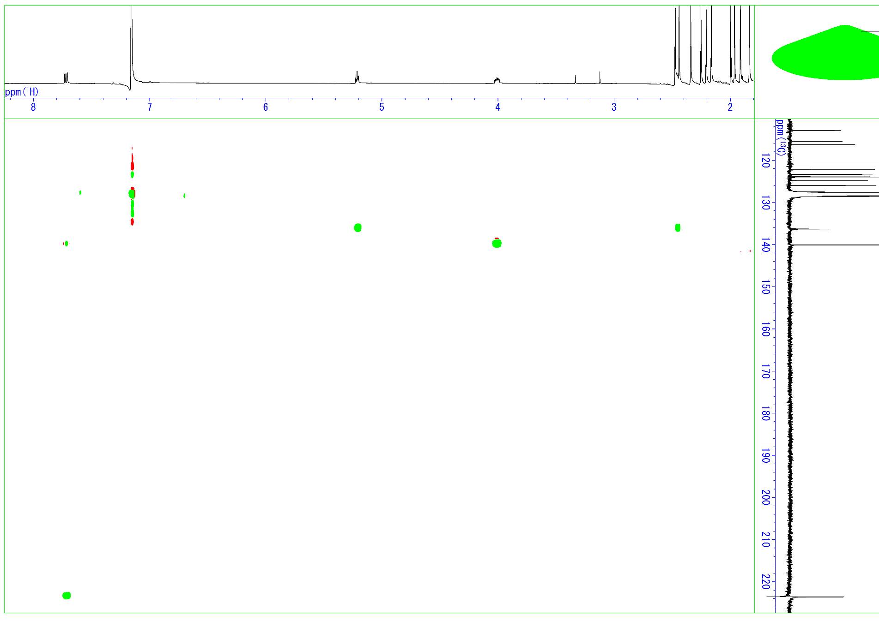
Figure S5. ¹³C-¹H HMQC spectrum of 3 (C₆D₆, rt).

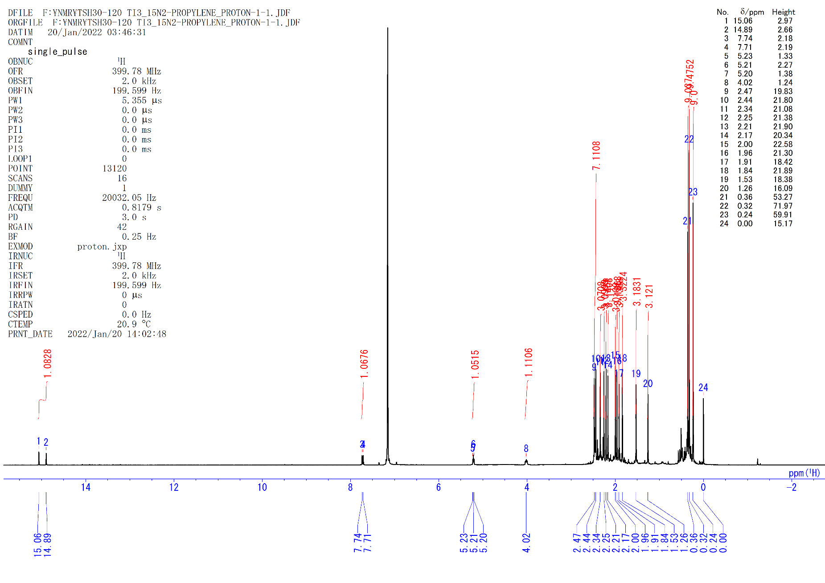
Figure S6. ¹H NMR spectrum of 3-¹⁵N (C₆D₆, rt).

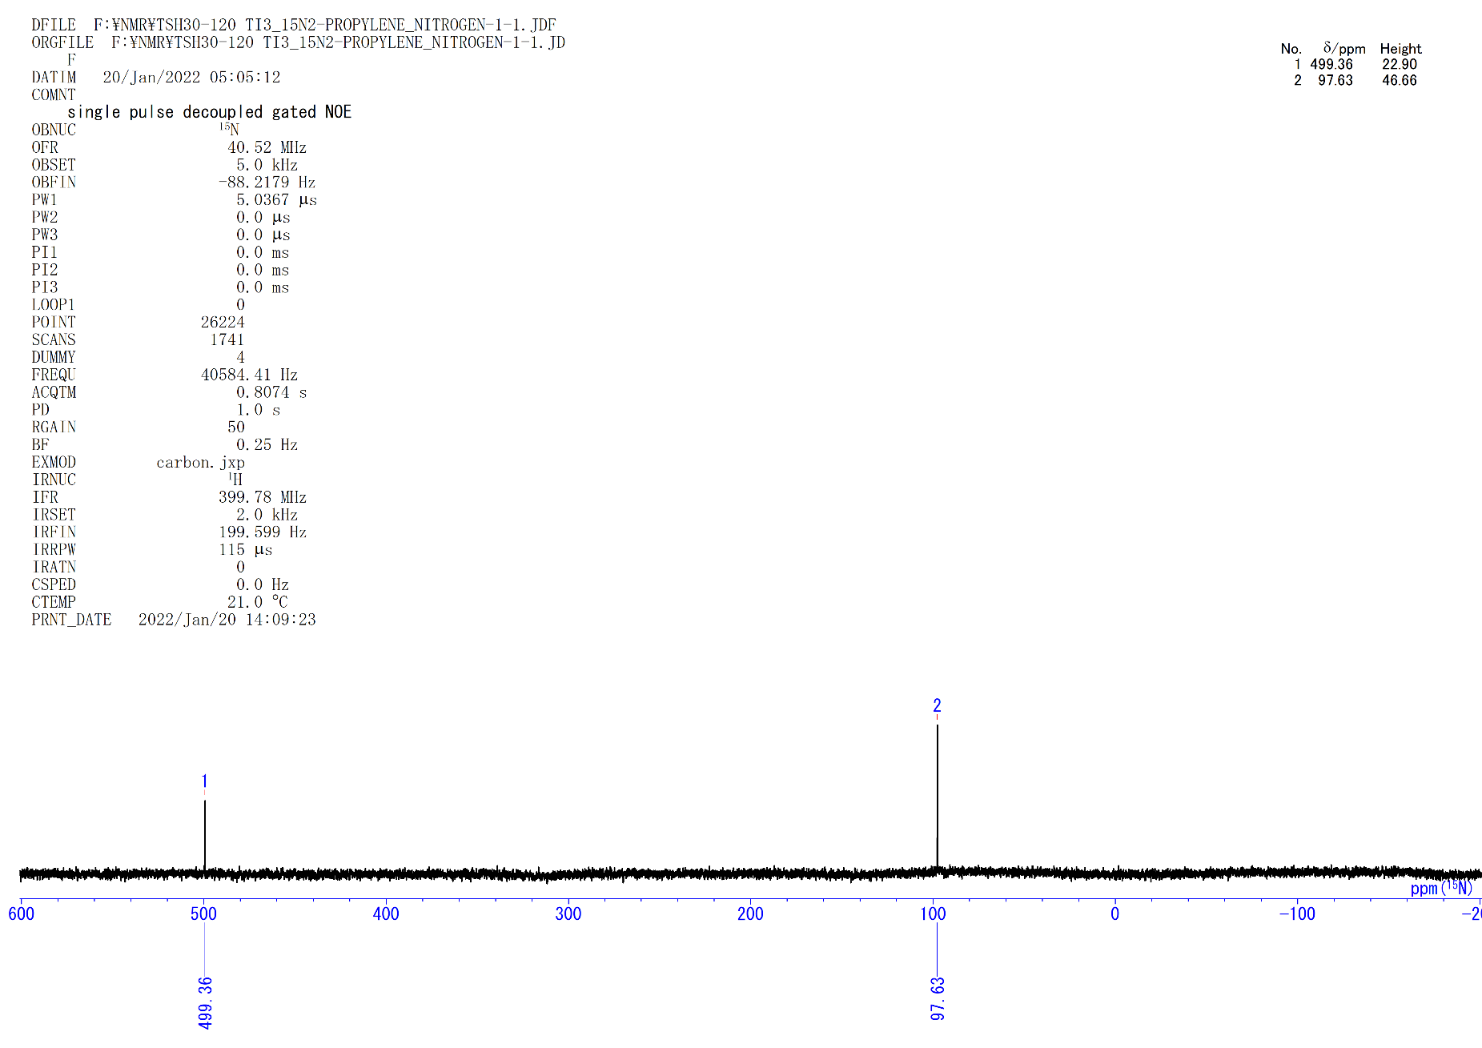
Figure S7. ¹⁵N NMR spectrum of 3-¹⁵N (C₆D₆, rt).

[{(C₅Me₄SiMe₃)Ti}₃(μ₃-η²,η²,η¹-C=CCH₃)(μ-H)₃(μ₃-H)] (4a). A hexane solution (3.0 mL) of 1 (75 mg, 0.10 mmol) in 50 mL Schlenk tube equipped with a J. Young valve was frozen in liquid nitrogen, pumped, and backfilled with atmospheric pressure of propylene. The solution was stirred at room temperature for 1 h. The solution turned from brown to dark red-brown. After removal of the solvent under vacuum, the resulting solid was dissolved in dimethoxyethane (DME), concentrated and crystallized at –30 °C to give dark brown crystals of 4a (65 mg, 0.085 mmol, 85%). Single crystals of 4a suitable for X-ray diffraction studies were obtained by recrystallization from a hexane solution at –30 °C.
4a: ¹H NMR (C₆D₆, rt): δ 6.43 (q, J_{HH} = 14.5 Hz, 1H, μ₃-H), 2.29 (s, 18H, C₅Me₄SiMe₃), 1.91 (s, 18H, C₅Me₄SiMe₃), 1.74 (s, 3H, μ₃-C=CCH₃), 0.39 (s, 27H, C₅Me₄SiMe₃), –2.30 (d, J_{HH} = 14.5 Hz, 3H, μ-H). ¹³C{¹H} NMR (C₆D₆, rt): δ 338.3 (s, μ₃-C=CCH₃), 247.0 (s, μ₃-C=CCH₃), 128.7 (s, C₅Me₄SiMe₃), 124.5 (s, C₅Me₄SiMe₃), 116.2 (s, C₅Me₄SiMe₃), 23.3 (s, μ₃-C=CCH₃), 16.5 (s, C₅Me₄SiMe₃), 12.4 (s, C₅Me₄SiMe₃), 2.9 (s, C₅Me₄SiMe₃). Anal. calcd. for C₃₉H₇₀Si₃Ti₃: C, 61.08; H, 9.20. Found: C, 62.03; H, 9.18.
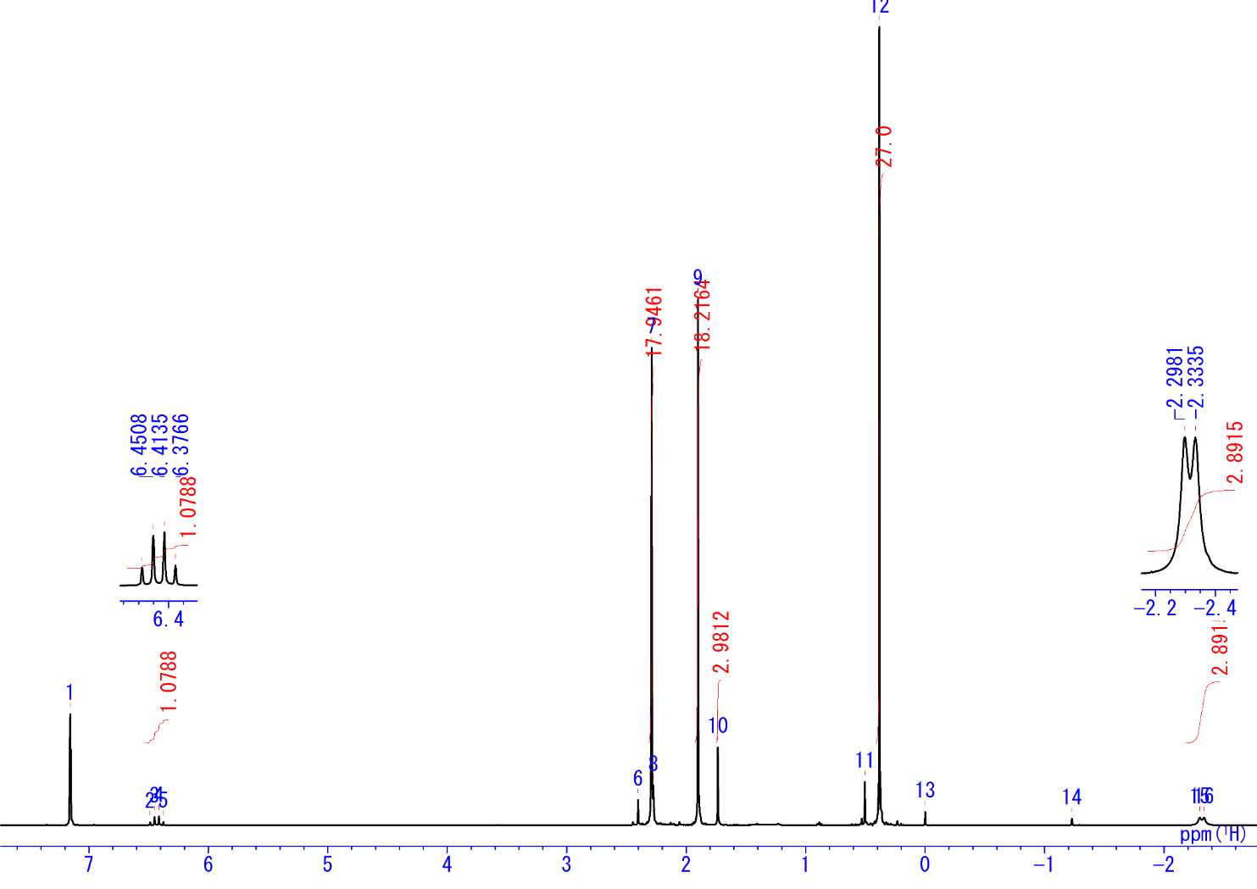
Figure S8. ¹H NMR spectrum of 4a (C₆D₆, rt)

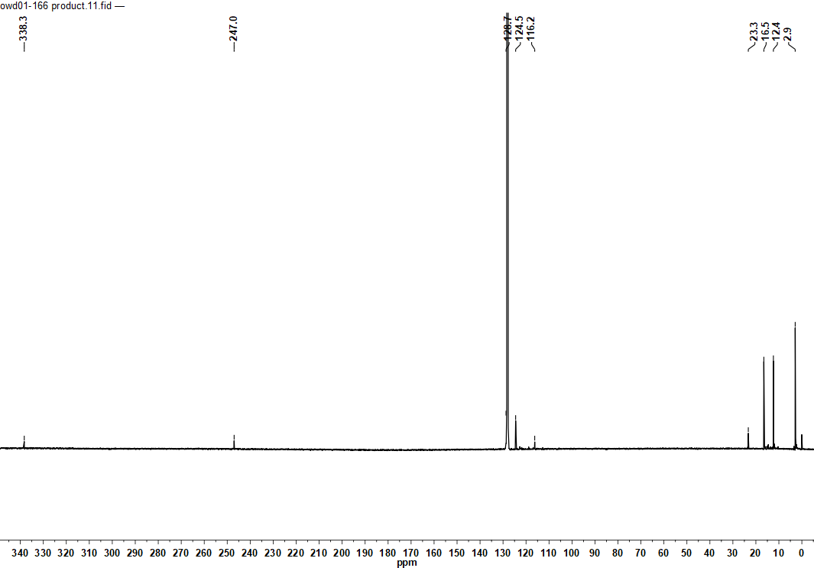
Figure S9. ¹³C{¹H} NMR spectrum of 4a (C₆D₆, rt)

¹H NMR monitoring the reaction of 1 with propylene in THF-d₈. A J. Young valve NMR sample tube was charged with 0.4 mL of THF-d₈ and complex 1 (4 mg). The solution was frozen in liquid nitrogen, degassed and 1 atm of propylene gas was added. The reaction was monitored by ¹H NMR at –20 °C to room temperature. An intermediate species was observed during the reaction. After 1h at room temperature, the intermediate species was disappeared and complex 4a was formed quantitatively.
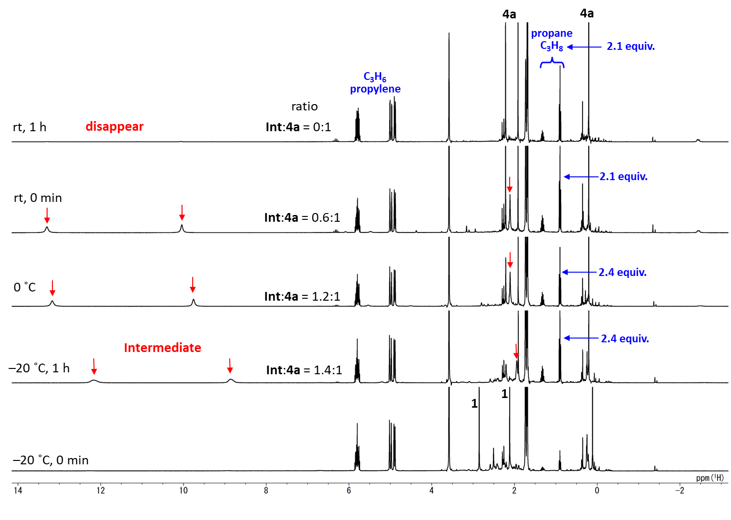
Figure S10. ¹H NMR monitoring the reaction of 1 with propylene (1 atm) (THF-d₈, –20 °C~rt).

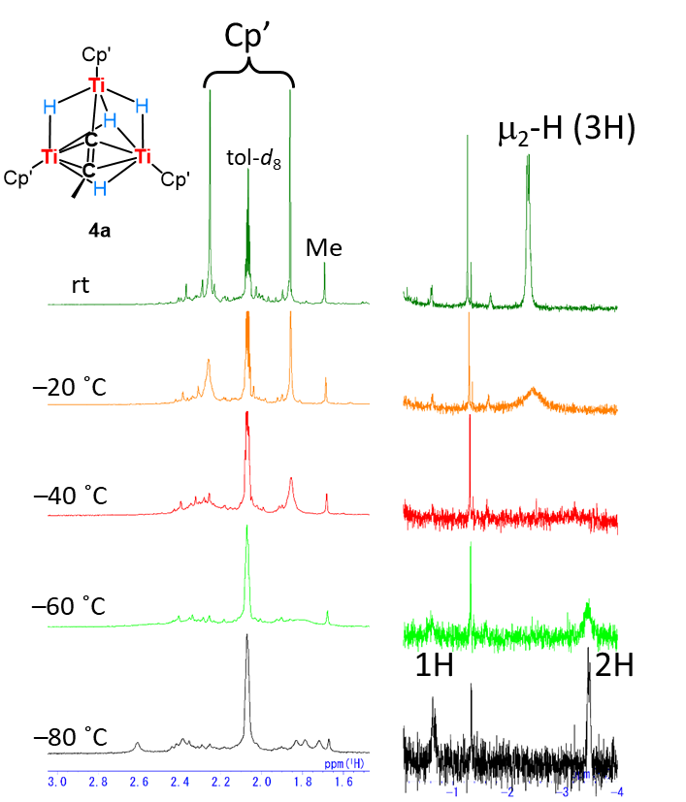
Figure S11. VT-¹H NMR spectra of 4a (toluene-d₈), and plausible dynamic behavior (right).

[{(C₅Me₄SiMe₃)Ti}₃(μ₃-η²,η²,η¹-C=CCH₂CH₃)(μ-H)₃(μ₃-H)] (4b). A hexane solution (4.0 mL) of 1 (115 mg, 0.157 mmol) in 50 mL Schlenk tube equipped with a J. Young valve was frozen in liquid nitrogen, pumped, and backfilled with atmospheric pressure of 1-butene. The solution was stirred at room temperature for 1 h. The solution turned from brown to dark red-brown. After removal of the solvent under vacuum, the resulting solid was dissolved in pentane (1st batch) / DME (2nd batch), concentrated and crystallized at –30 °C to give dark brown crystals of 4b (81 mg, 0.104 mmol, 66%).
4b: ¹H NMR (C₆D₆, rt): δ 5.91 (q, J = 14.7 Hz, 1H, μ-H), 2.31 (s, 18H, C₅Me₄SiMe₃), 2.25 (m, 2H, μ₃-C=CC₂H₅), 1.93 (s, 18H, C₅Me₄SiMe₃), 0.64 (t, J = 7.3 Hz, 3H, μ₃-C=CC₂H₅), 0.38 (s, 27H, C₅Me₄SiMe₃), –2.33 (d, J = 14.7 Hz, 3H, μ-H). ¹³C{¹H} NMR (C₆D₆, rt): δ 338.8 (s, μ₃-C=CC₂H₅), 255.9 (s, μ₃-C=CC₂H₅), 128.9 (s, C₅Me₄SiMe₃), 124.5 (s, C₅Me₄SiMe₃), 116.4 (s, C₅Me₄SiMe₃), 32.0 (s, μ₃-C=CC₂H₅), 16.6 (s, C₅Me₄SiMe₃), 16.4 (s, μ₃-C=CC₂H₅), 12.4 (s, C₅Me₄SiMe₃), 2.9 (s, C₅Me₄SiMe₃). Anal. calcd. for C₄₀H₇₂Si₃Ti₃: C, 61.53; H, 9.29. Found: C, 61.60; H, 9.22.
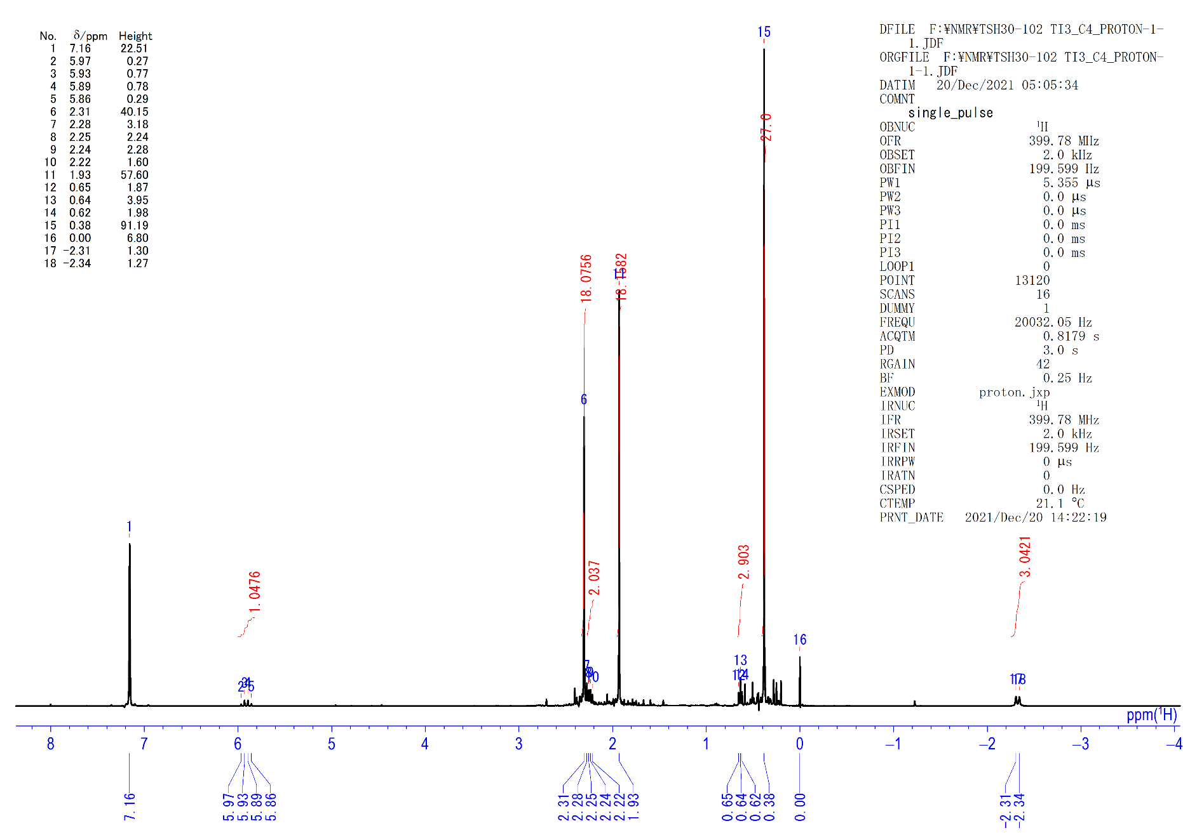
Figure S12. ¹H NMR spectrum of 4b (C₆D₆, rt)

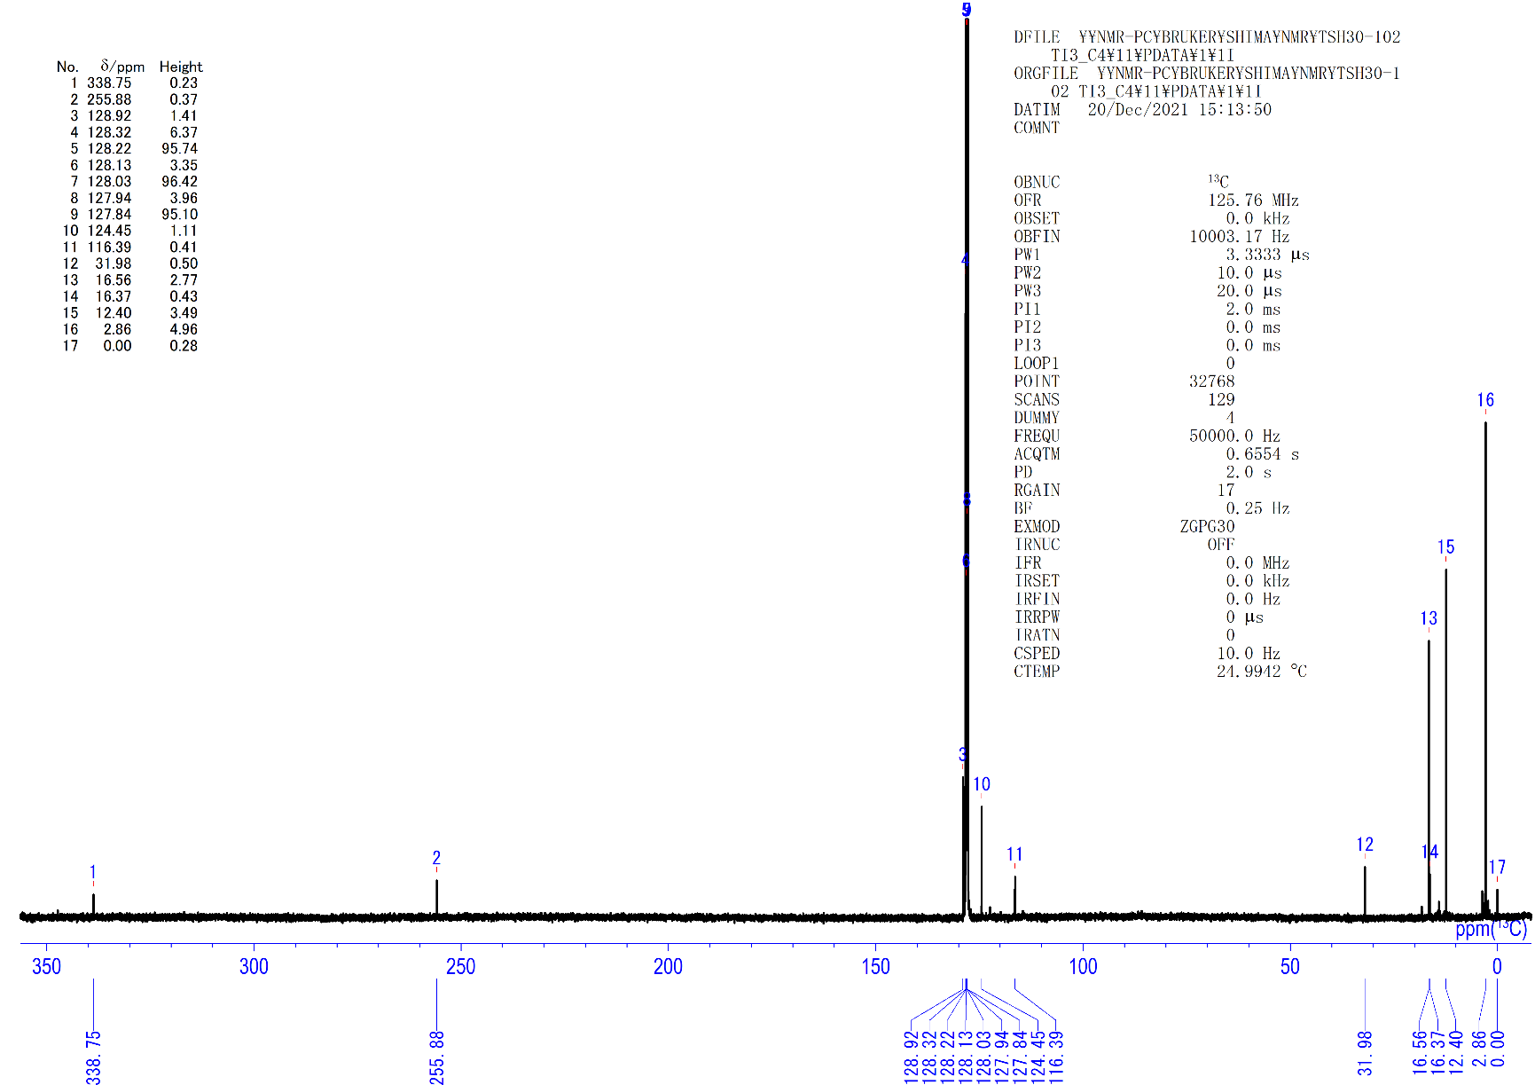
Figure S13. ¹³C{¹H} NMR spectrum of 4b (C₆D₆, rt)

[{(C₅Me₄SiMe₃)Ti}₃(μ₃-η²,η²,η¹-C=CCH₂CH₂CH₃)(μ-H)₃(μ₃-H)] (4c). To a 2.0 mL hexane solution of 1 (90 mg, 0.12 mmol) was added 1-pentene (80 μl, 0.73 mmol) in a 50-mL round-bottomed flask in an Ar glovebox. The solution was kept at room temperature for 1 h. The solution turned from brown to dark red-brown. After removal of the solvent under vacuum, the resulting solid was dissolved in pentane and crystallized at –30 °C to give dark brown crystals of 4c (72 mg, 0.091 mmol, 74%).
4c: ¹H NMR (C₆D₆, rt): δ 5.93 (q, J = 14.5 Hz, 1H, μ-H), 2.31 (s, 18H, C₅Me₄SiMe₃), 2.25 (t, J = 7.5 Hz, 2H, μ-C=CC₃H₇), 1.94 (s, 18H, C₅Me₄SiMe₃), 1.02 (sext, J = 7.5 Hz, 2H, μ-C=CC₃H₇), 0.82 (t, J = 7.5 Hz, 3H, μ-C=CC₃H₇), 0.38 (s, 27H, C₅Me₄SiMe₃), –2.32 (d, J = 14.5 Hz, 3H, μ-H). ¹³C{¹H} NMR (C₆D₆, rt): δ 338.2 (s, μ-C=CC₃H₇), 253.8 (s, μ-C=CC₃H₇), 129.0 (s, C₅Me₄SiMe₃), 124.5 (s, C₅Me₄SiMe₃), 116.5 (s, C₅Me₄SiMe₃), 41.4 (s, μ-C=CC₃H₇), 25.1 (s, μ-C=CC₃H₇), 16.6 (s, C₅Me₄SiMe₃), 14.3 (s, μ-C=CC₃H₇), 12.5 (s, C₅Me₄SiMe₃), 2.9 (s, C₅Me₄SiMe₃). Anal. calcd. for C₄₁H₇₄Si₃Ti₃∙(C₅H₁₁)_{0.5}: C, 62.88; H, 9.70. Found: C, 63.29; H, 9.39.
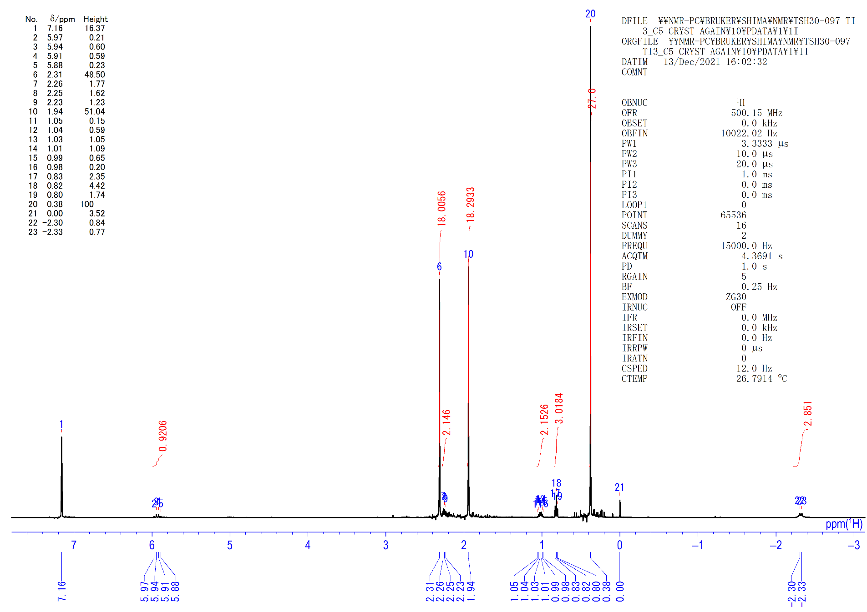
Figure S14. ¹H NMR spectrum of 4c (C₆D₆, rt).
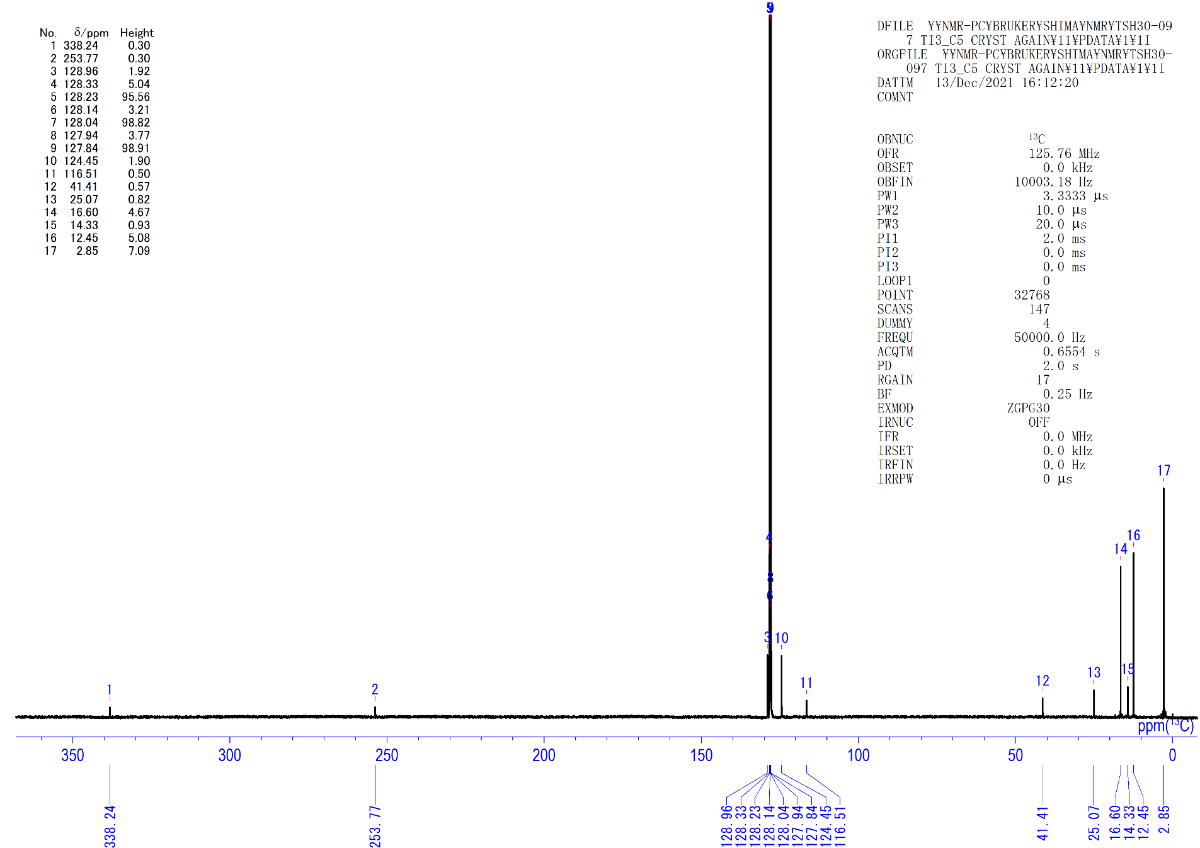Figure S15. ¹³C{¹H} NMR spectrum of 4c (C₆D₆, rt).

[{(C₅Me₄SiMe₃)Ti}₃(μ₃-η²,η²,η¹-C=CCH₂CH₂CH₂CH₃)(μ-H)₃(μ₃-H)] (4d). To a 2.0 mL hexane solution of 1 (100 mg, 0.137 mmol) was added 1-hexene (100 μl, 0.8 mmol) in a 50-mL round-bottomed flask in an Ar glovebox. The solution was kept at room temperature for 2 h. The solution turned from brown to dark red-brown. After removal of the solvent under vacuum, the resulting solid was dissolved in pentane (1st batch), DME (2nd batch) and crystallized at –30 °C to give dark brown crystals of 4d (81 mg, 0.10 mmol, 73%).
4d: ¹H NMR (C₆D₆, rt): δ 5.92 (q, J = 14.5 Hz, 1H, μ-H), 2.31 (s, 18H, C₅Me₄SiMe₃), 2.28 (m, 2H, μ-C=CC₄H₉), 1.95 (s, 18H, C₅Me₄SiMe₃), 1.21 (sext, J = 7.4 Hz, 2H, μ-C=CC₄H₉), 1.00 (quint, J = 7.5 Hz, 2H, μ-C=CC₄H₉), 0.89 (t, J = 7.5 Hz, 3H, μ-C=CC₄H₉), 0.38 (s, 27H, C₅Me₄SiMe₃), –2.33 (d, J = 14.5 Hz, 3H, μ-H). ¹³C{¹H} NMR (C₆D₆, rt): δ 338.2 (s, μ-C=CC₄H₉), 254.0 (s, μ-C=CC₄H₉), 128.9 (s, C₅Me₄SiMe₃), 124.4 (s, C₅Me₄SiMe₃), 116.5 (s, C₅Me₄SiMe₃), 38.9 (s, μ-C=CC₄H₉), 34.1 (s, μ-C=CC₄H₉), 23.0 (s, μ-C=CC₄H₉), 16.6 (s, C₅Me₄SiMe₃), 14.4 (s, μ-C=CC₄H₉), 12.4 (s, C₅Me₄SiMe₃), 2.9 (s, C₅Me₄SiMe₃). Anal. calcd. for C₄₂H₇₆Si₃Ti₃: C, 62.36; H, 9.47. Found: C, 62.02; H, 9.38.
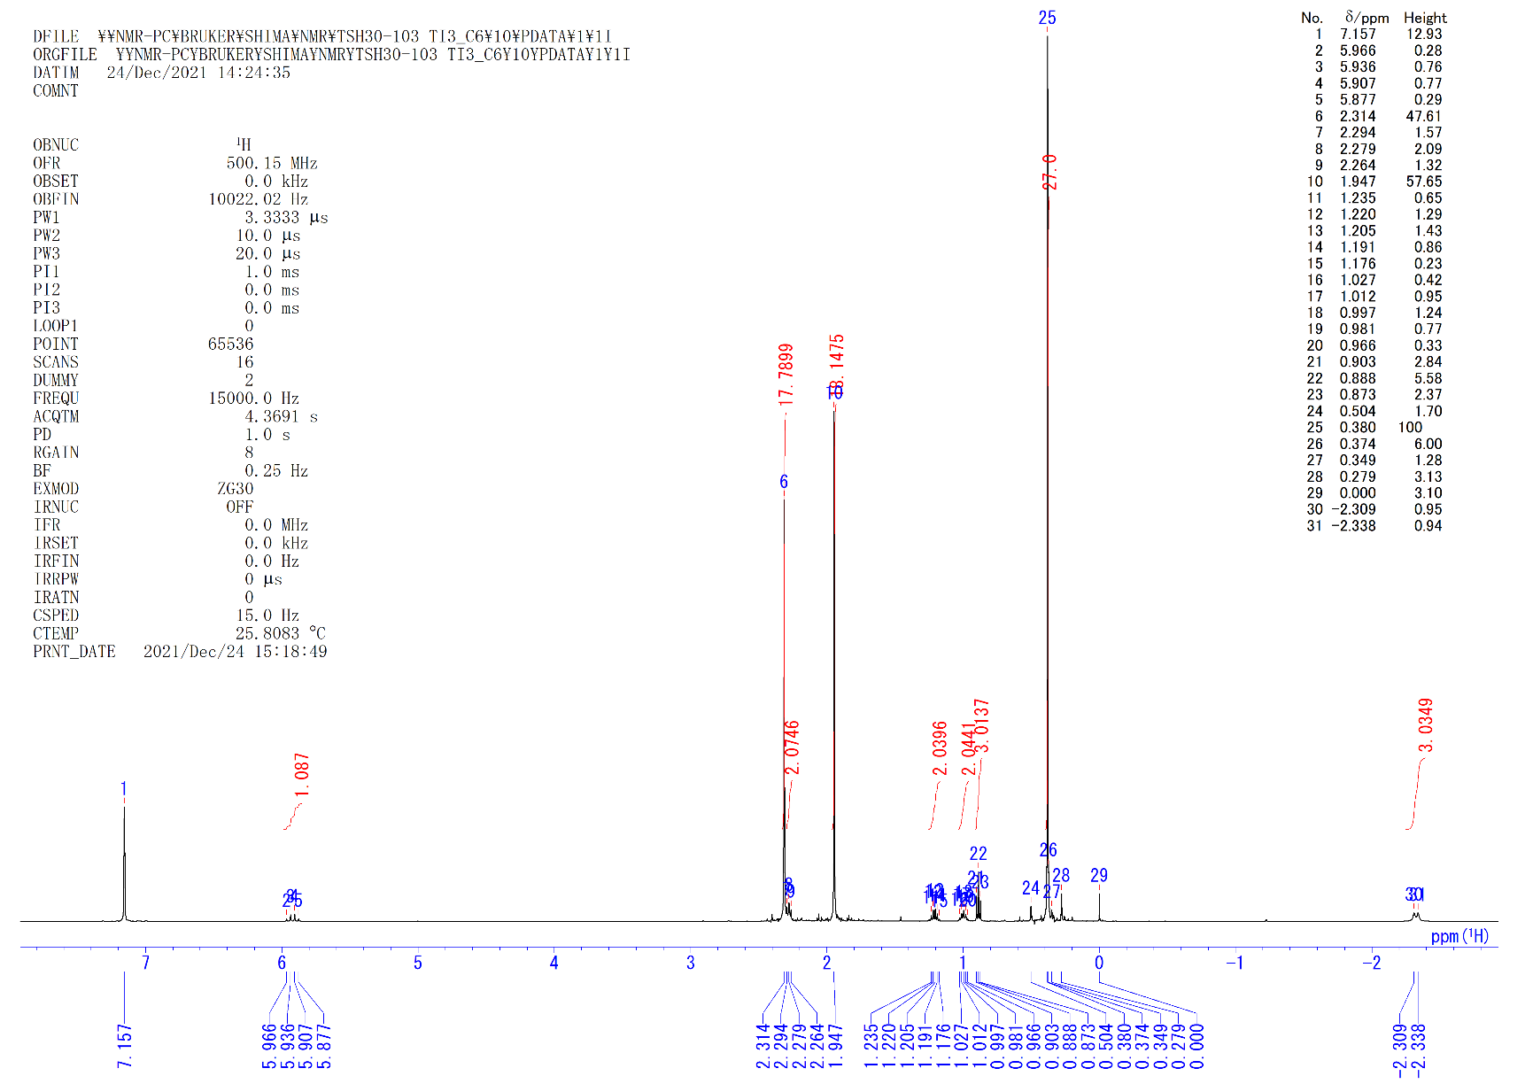
Figure S16. ¹H NMR spectrum of 4d (C₆D₆, rt).

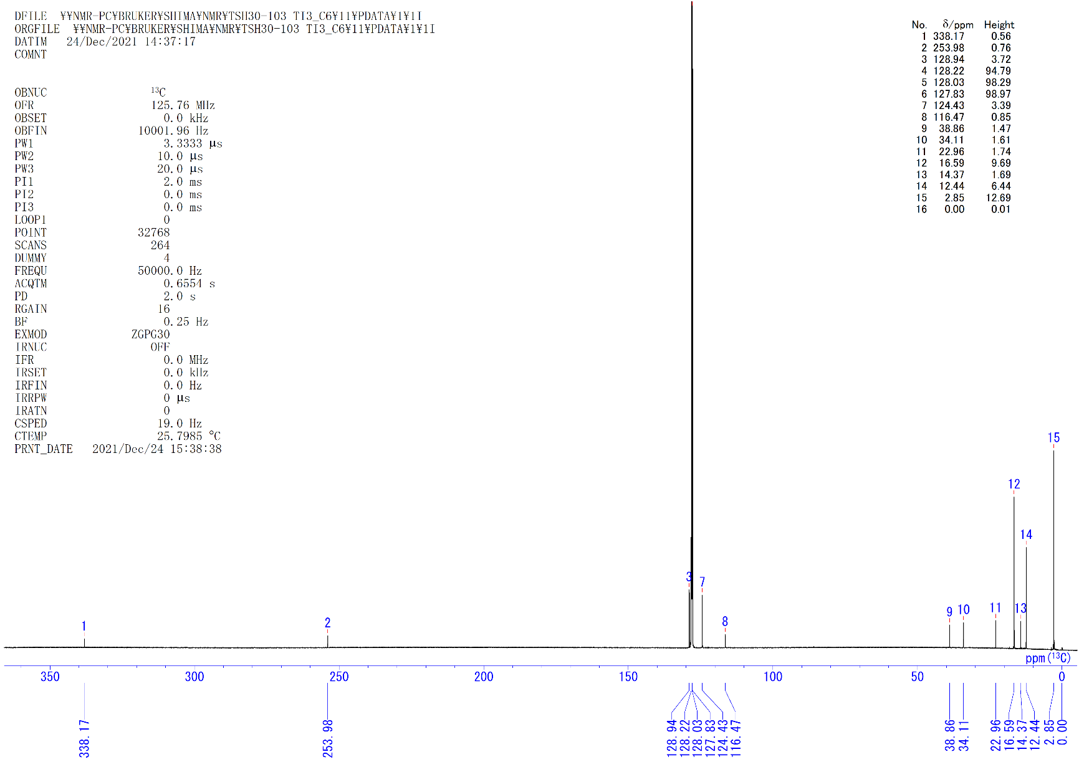
Figure S17. ¹³C{¹H} NMR spectrum of 4d (C₆D₆, rt).

[{(C₅Me₄SiMe₃)Ti}₃(μ₃-η²,η²,η¹-C=CPh)(μ-H)₃(μ₃-H)] (4e). To a 1.0 mL hexane solution of 1 (47 mg, 0.064 mmol) was added styrene (25 μl, 0.22 mmol) in a sample tube in an Ar glovebox. The solution was kept at room temperature for 2 h. The solution turned from brown to dark red-brown. After removal of the solvent under vacuum, the oily crude product was crystallized in DME at –30 °C to give dark brown solids of 4e (28 mg, 0.034 mmol, 53%).
4e: ¹H NMR (C₆D₆, rt): δ 7.08 (t, J = 7.6 Hz, 2H, Ph), 6.82 (t, J = 7.6 Hz, 1H, Ph), 6.69 (d, J = 7.6 Hz, 2H, Ph), 5.38 (q, J = 15.0 Hz, 1H, μ-H), 2.37 (brs, 18H, C₅Me₄SiMe₃), 1.88 (brs, 18H, C₅Me₄SiMe₃), 0.35 (s, 27H, C₅Me₄SiMe₃), –2.75 (brs, 2~3H, μ-H). ¹H NMR (C₆D₆, 50 °C): δ 7.06 (t, J = 7.6 Hz, 2H, Ph), 6.81 (t, J = 7.6 Hz, 1H, Ph), 6.68 (d, J = 7.6 Hz, 2H, Ph), 5.39 (brs, 1H, μ-H), 2.37 (s, 18H, C₅Me₄SiMe₃), 1.89 (brs, 18H, C₅Me₄SiMe₃), 0.34 (s, 27H, C₅Me₄SiMe₃), –1.61 (brs, 2~3H, μ-H). ¹³C{¹H} NMR (C₆D₆, rt): δ 340.8 (s, μ-C=CPh), 245.6 (s, μ-C=CPh), 145.6 (s, μ-C=CPh), 127.1 (s, μ-C=CPh), 126.1 (s, μ-C=CPh), 124.8 (s, μ-C=CPh), ring carbons were not observed, 16.7 (s, C₅Me₄SiMe₃), 12.7 (s, C₅Me₄SiMe₃), 2.6 (s, C₅Me₄SiMe₃). Anal. calcd. for C₄₄H₇₂Si₃Ti₃: C, 63.76; H, 8.76. Found: C, 63.15; H, 8.76.
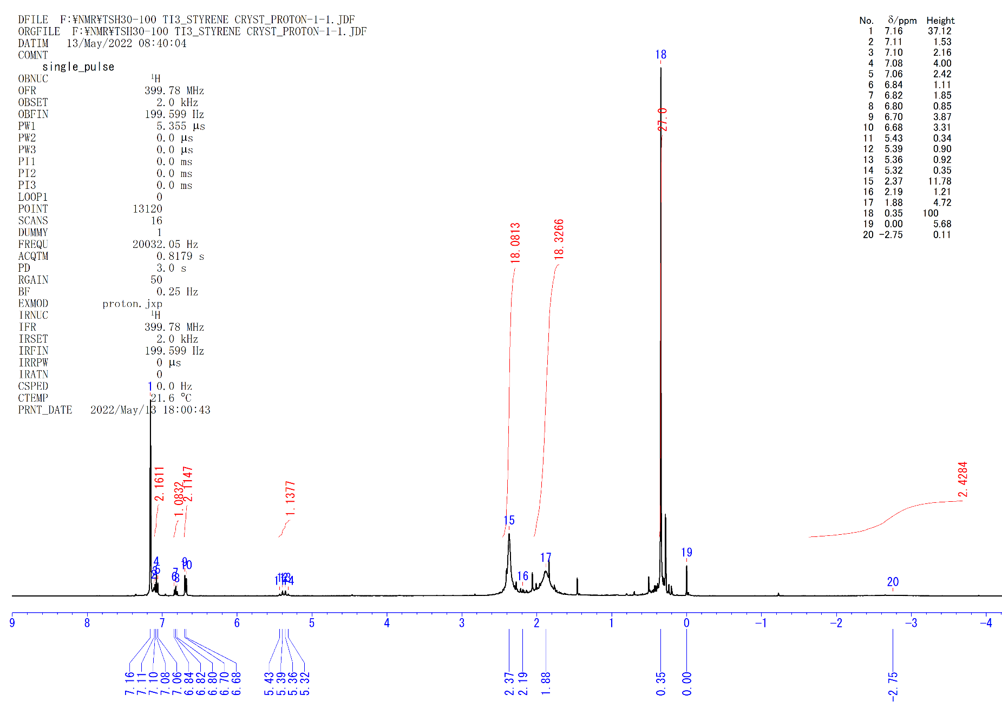
Figure S18. ¹H NMR spectrum of 4e (C₆D₆, rt).
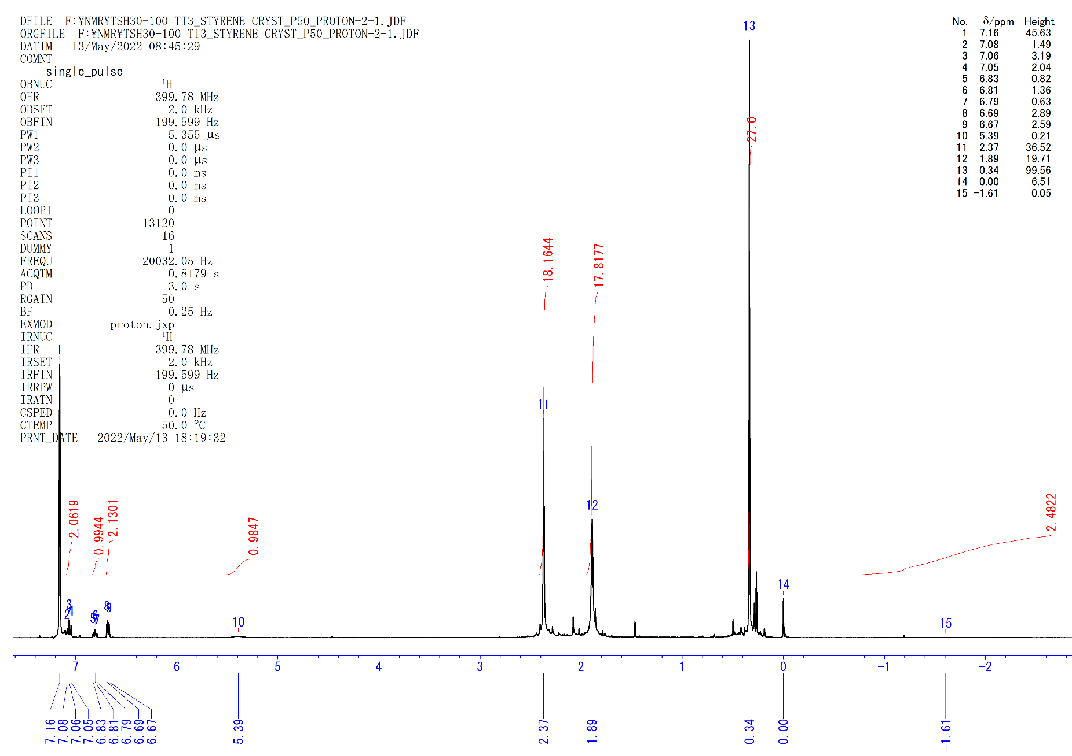
Figure S19. ¹H NMR spectrum of 4e (C₆D₆, 50 °C).

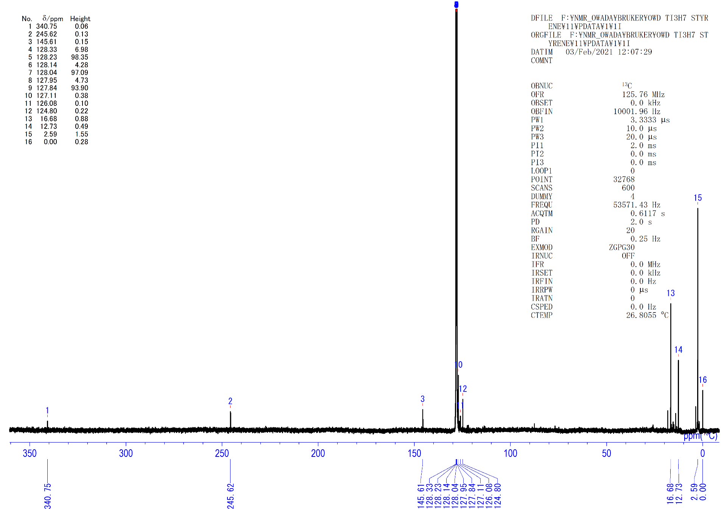
Figure S20. ¹³C{¹H} NMR spectrum of 4e (C₆D₆, rt).

[(C₅Me₄SiMe₂^{t}Bu)TiCl₃]. THF solution (35 mL) of [C₅Me₄SiMe₂^{t}Bu]Li (Cp”Li) (1.68 g, 6.94 mmol) was slowly added to a suspension of TiCl₃(THF)₃ (2.57 g, 6.94 mmol) in THF(35 mL) at room temperature. The mixture was refluxed for 1 day. The color of the solution changed from pale blue to deep green. After the reaction, the solution was cooled to 0 ºC and treated dropwise 2 mL of conc. HCl. After removal of the solvent under vacuum, the residual solid was extracted with toluene and filtered. Then the solution was evaporated. The residue was recrystallized from toluene at –33 ºC to afford Cp”TiCl₃ (1.52 g, 3.91 mmol, 56%) as red needle crystals.
Cp”TiCl₃: ¹H NMR (C₆D₆, rt): δ 2.29 (s, 6H, C₅Me₄Si^{t}BuMe₂), 1.92 (s, 6H, C₅Me₄Si^{t}BuMe₂), 0.69 (s, 9H, C₅Me₄Si^{t}BuMe₂), 0.53 (s, 6H, C₅Me₄Si^{t}BuMe₂). ¹³C{¹H} NMR (C₆D₆, rt): δ 144.4 (s, C₅Me₄Si^{t}BuMe₂), 142.3 (s, C₅Me₄Si^{t}BuMe₂), 138.4 (s, C₅Me₄Si^{t}BuMe₂), 27.2 (s, C₅Me₄Si^{t}BuMe₂), 20.3 (s, C₅Me₄Si^{t}BuMe₂), 18.0 (s, C₅Me₄Si^{t}BuMe₂), 14.0 (s, C₅Me₄Si^{t}BuMe₂), –2.1 (s, C₅Me₄Si^{t}BuMe₂). Anal. calcd. for C₁₅H₂₇Cl₃SiTi: C, 46.23; H, 6.98. Found: C, 47.95; H, 7.02.

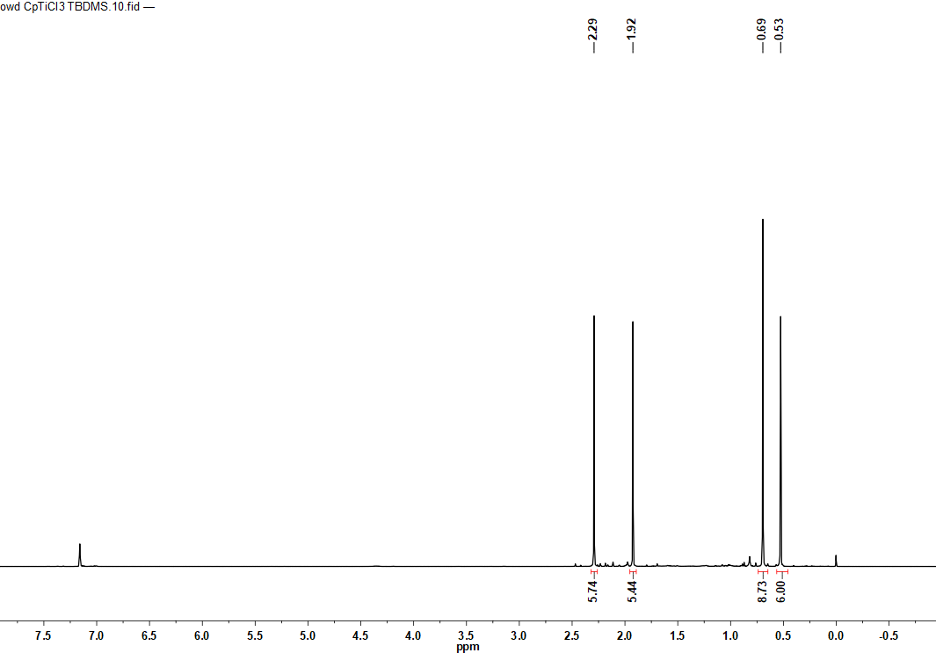Figure S21. ¹H NMR spectrum of Cp”TiCl₃ (C₆D₆, rt, *…residual internal C₆D₅H)
*
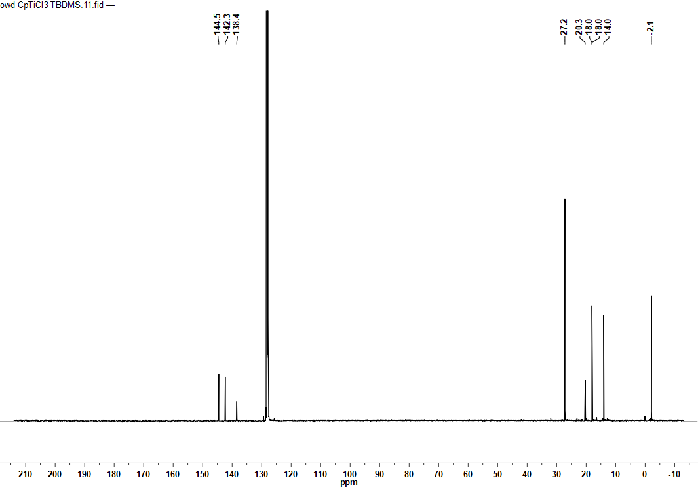Figure S22. ¹³C{¹H} NMR spectrum of Cp”TiCl₃ (C₆D₆, rt, *…C₆D₆)
*

[Cp”Ti(CH₂SiMe₃)₃]. Toluene suspension (14 mL) of LiCH₂SiMe₃ (249 mg, 2.64 mmol, 3 equiv.) was slowly added to a solution of Cp”TiCl₃ (343 mg, 0.879 mmol) in toluene (10 mL) at room temperature. The mixture was stirred for 1h. After removal of the solvent under vacuum, the residue was extracted with hexane and filtered. The hexane solution was concentrated and recrystallized at –33 ºC to give [Cp”Ti(CH₂SiMe₃)₃] (465 mg, 0.853 mmol, 97%) as yellowish-brown block crystals.
[Cp”Ti(CH₂SiMe₃)₃]: ¹H NMR (C₆D₆, rt): δ 2.11 (s, 6H, Ti(CH₂SiMe₃)₃), 1.88 (s, 6H, C₅Me₄Si^{t}BuMe₂), 1.55 (s, 6H, C₅Me₄Si^{t}BuMe₂), 0.91 (s, 9H, C₅Me₄Si^{t}BuMe₂), 0.35 (s, 6H, C₅Me₄Si^{t}BuMe₂), 0.28 (s, 27H, Ti(CH₂SiMe₃)₃). ¹³C{¹H} NMR (C₆D₆, rt): δ 129.6 (s, C₅Me₄Si^{t}BuMe₂), 127.8 (s, C₅Me₄Si^{t}BuMe₂), 119.7 (s, C₅Me₄Si^{t}BuMe₂), 86.1 (s, Ti(CH₂SiMe₃)₃), 27.5 (s, C₅Me₄Si^{t}BuMe₂), 20.7 (s, C₅Me₄Si^{t}BuMe₂), 16.6 (s, C₅Me₄Si^{t}BuMe₂), 13.3 (s, C₅Me₄Si^{t}BuMe₂), 3.0 (s, Ti(CH₂SiMe₃)₃), –1.7 (s, C₅Me₄Si^{t}BuMe₂). Anal. calcd. for C₂₇H₆₀Si₄Ti: C, 59.51; H, 11.10. Found: C, 59.99; H, 10.71.

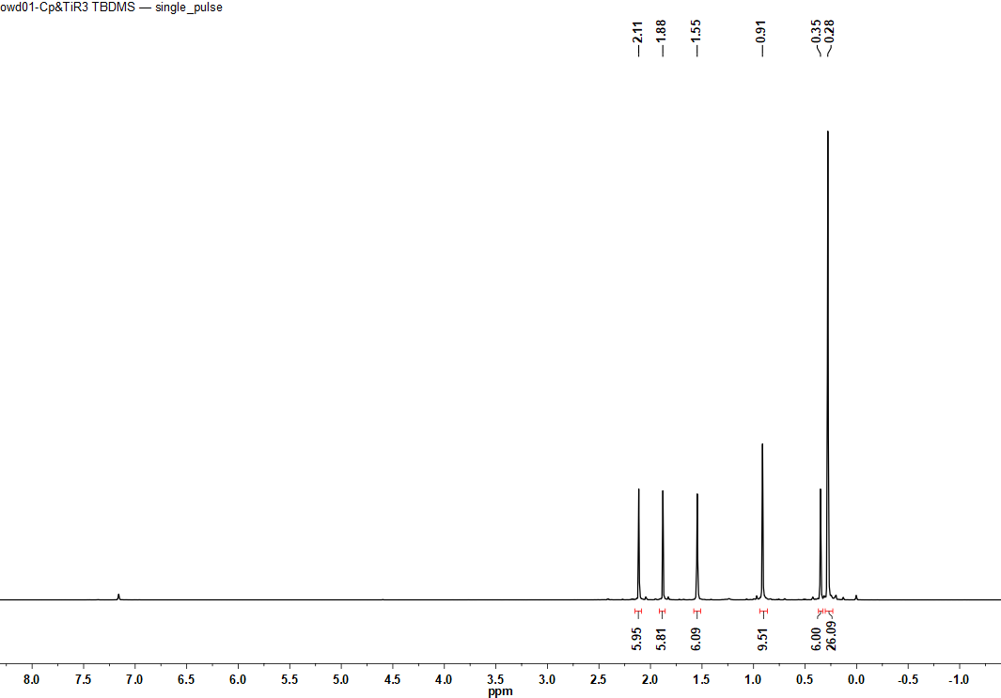
Figure S23. ¹H NMR spectrum of [Cp”Ti(CH₂SiMe₃)₃] (C₆D₆, rt).
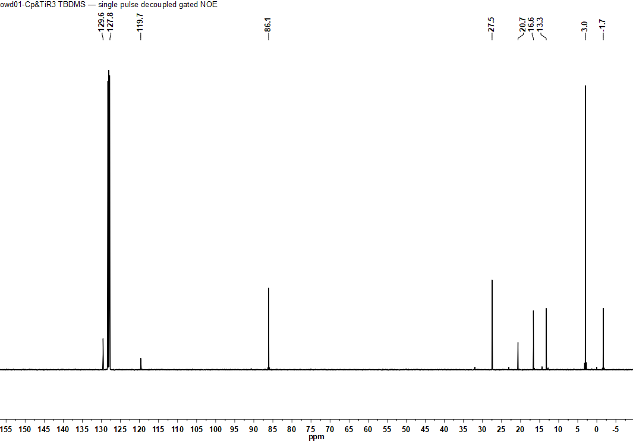
Figure S24. ¹³C{¹H} NMR spectrum of [Cp”Ti(CH₂SiMe₃)₃] (C₆D₆, rt)

[(Cp”Ti)₃(μ₃-H)(μ-H)₆] (1’). A hexane solution (6 mL) of [Cp”Ti(CH₂SiMe₃)₃] (626 mg, 1.15 mmol) in 10 mL Hiper Glass Cylinder (TAIATSU TECHNO®) was filled with H₂ (4 atm). The solution was stirred at 60 ºC for 19h. After the reaction, the solution was evaporated and recrystallized in hexane solution at –33 ºC to give 1’ (278 mg, 0.295 mmol, 77 %) as dark-brown block crystals. Single crystals of 1’ suitable for X-ray diffraction studies were obtained by recrystallization from a hexane solution at –30 °C.
1’: ¹H NMR (C₆D₁₂, rt): δ 2.90 (s, 18H, C₅Me₄Si^{t}BuMe₂), 2.57 (s, 7H, μ-H), 2.13 (s, 18H, C₅Me₄Si^{t}BuMe₂), 0.88 (s, 27H, C₅Me₄Si^{t}BuMe₂), 0.20 (s, 18H, C₅Me₄Si^{t}BuMe₂). ¹³C{¹H} NMR (C₆D₁₂, rt): δ 131.1 (s, C₅Me₄Si^{t}BuMe₂), 124.7 (s, C₅Me₄Si^{t}BuMe₂), 113.1 (s, C₅Me₄Si^{t}BuMe₂), 28.5 (s, C₅Me₄Si^{t}BuMe₂), 21.0 (s, C₅Me₄Si^{t}BuMe₂), 18.6 (s, C₅Me₄Si^{t}BuMe₂), 14.0 (s, C₅Me₄Si^{t}BuMe₂), 0.2 (s, C₅Me₄Si^{t}BuMe₂). Anal. calcd. for C₅₁H₁₀₂Si₃Ti₃ (1’•Hex): C, 64.94; H, 10.90. Found: C, 64.38; H, 10.40.

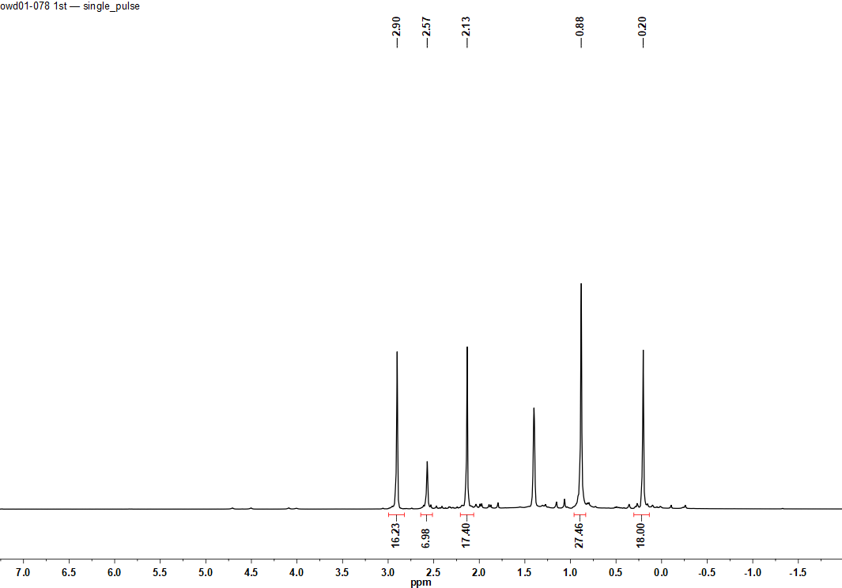
*
Figure S25. ¹H NMR spectrum of 1’ (C₆D₁₂, rt, *…residual internal C₆D₁₁H)
*
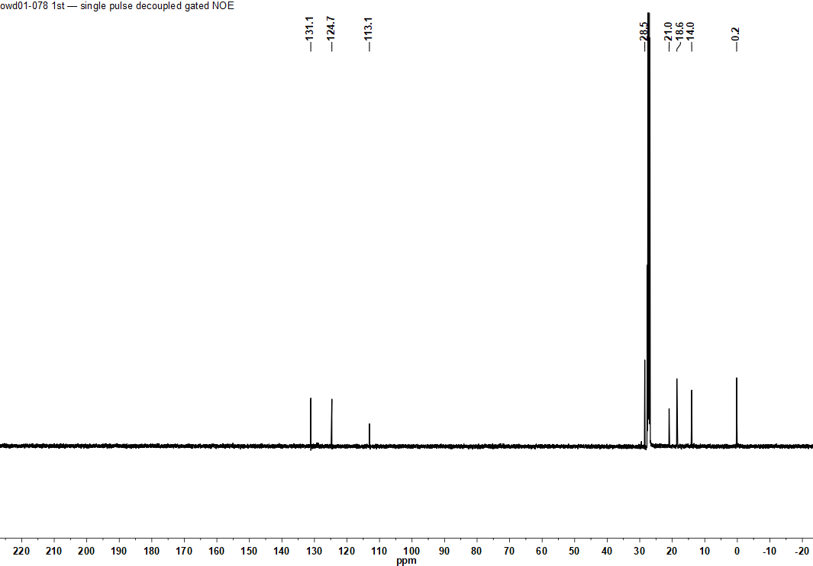
Figure S26. ¹³C{¹H} NMR spectrum of 1’ (C₆D₁₂, rt, *…C₆D₁₂)
[{(C₅Me₄SiMe₃)Ti}₃(μ₃-η²,η²,η¹-C=CC₅H₉)(μ-H)₃(μ₃-H)] (4f). To a 3.0 mL hexane solution of 1 (110 mg, 0.15 mmol) was added norbornene (42 mg, 0.45 mmol) in a sample tube in an Ar glovebox. The solution was kept at room temperature for 2 hours. After removal of the solvent under vacuum, the crude product was crystallized in DME at –30 °C to give dark brown-purple solids of 4f (80 mg, 0.097 mmol, 65%). The analogous C₅Me₄SiMe₂^{t}Bu-ligated complex [{(C₅Me₄SiMe₂^{t}Bu)Ti}₃(μ₃-η²,η²,η¹-C=CC₅H₉)(μ-H)₃(μ₃-H)] (4f’) was obtained from the reaction of [{(C₅Me₄SiMe₂^{t}Bu)Ti}₃(μ₃-H)(μ-H)₆] (1’) with norbornene. Single crystals of 4f’ suitable for X-ray diffraction studies were obtained by recrystallization from a DME/benzene solution at –30 °C.
4f: ¹H NMR (C₆D₆, rt): δ 4.02 (q, J = 14.3 Hz, 1H, μ-H), 2.63 (qt, J = 7.6 Hz, 1H, -C₅H₉), 2.32 (s, 18H, C₅Me₄SiMe₃), 1.99 (s, 18H, C₅Me₄SiMe₃), 1.66 (m, 2H, -C₅H₉), 1.59 (m, 2H, -C₅H₉), 1.41 (m, 2H, -C₅H₉), 0.94 (m, 2H, -C₅H₉), 0.36 (s, 27H, C₅Me₄SiMe₃), –2.44 (d, J = 14.3 Hz, 3H, μ-H). ¹³C{¹H} NMR (C₆D₆, rt): δ 341.0 (s, μ-C=CC₅H₉), 255.6 (s, μ-C=CC₅H₉), 129.4 (s, C₅Me₄SiMe₃), 124.6 (s, C₅Me₄SiMe₃), 116.6 (s, C₅Me₄SiMe₃), 49.5 (s, μ-C=CC₅H₉), 37.6 (s, μ-C=CC₅H₉), 25.7 (s, μ-C=CC₅H₉), 16.8 (s, C₅Me₄SiMe₃), 12.9 (s, C₅Me₄SiMe₃), 3.0 (s, C₅Me₄SiMe₃). Anal. calcd. for C₄₃H₇₆Si₃Ti₃: C, 62.91; H, 9.33. Found: C, 61.88; H, 9.15.
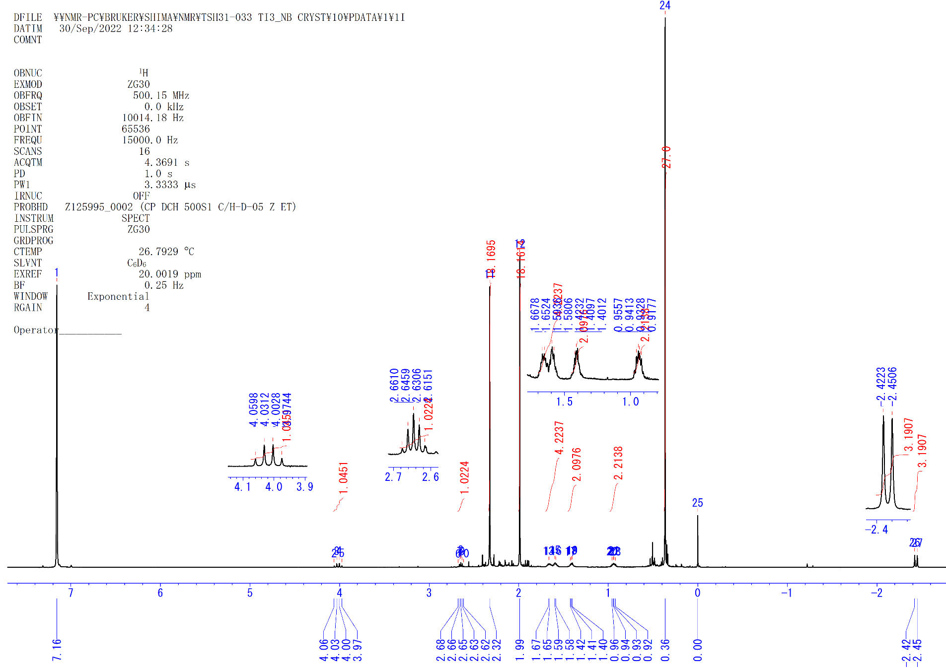
Figure S27. ¹H NMR spectrum of 4f (C₆D₆, rt).

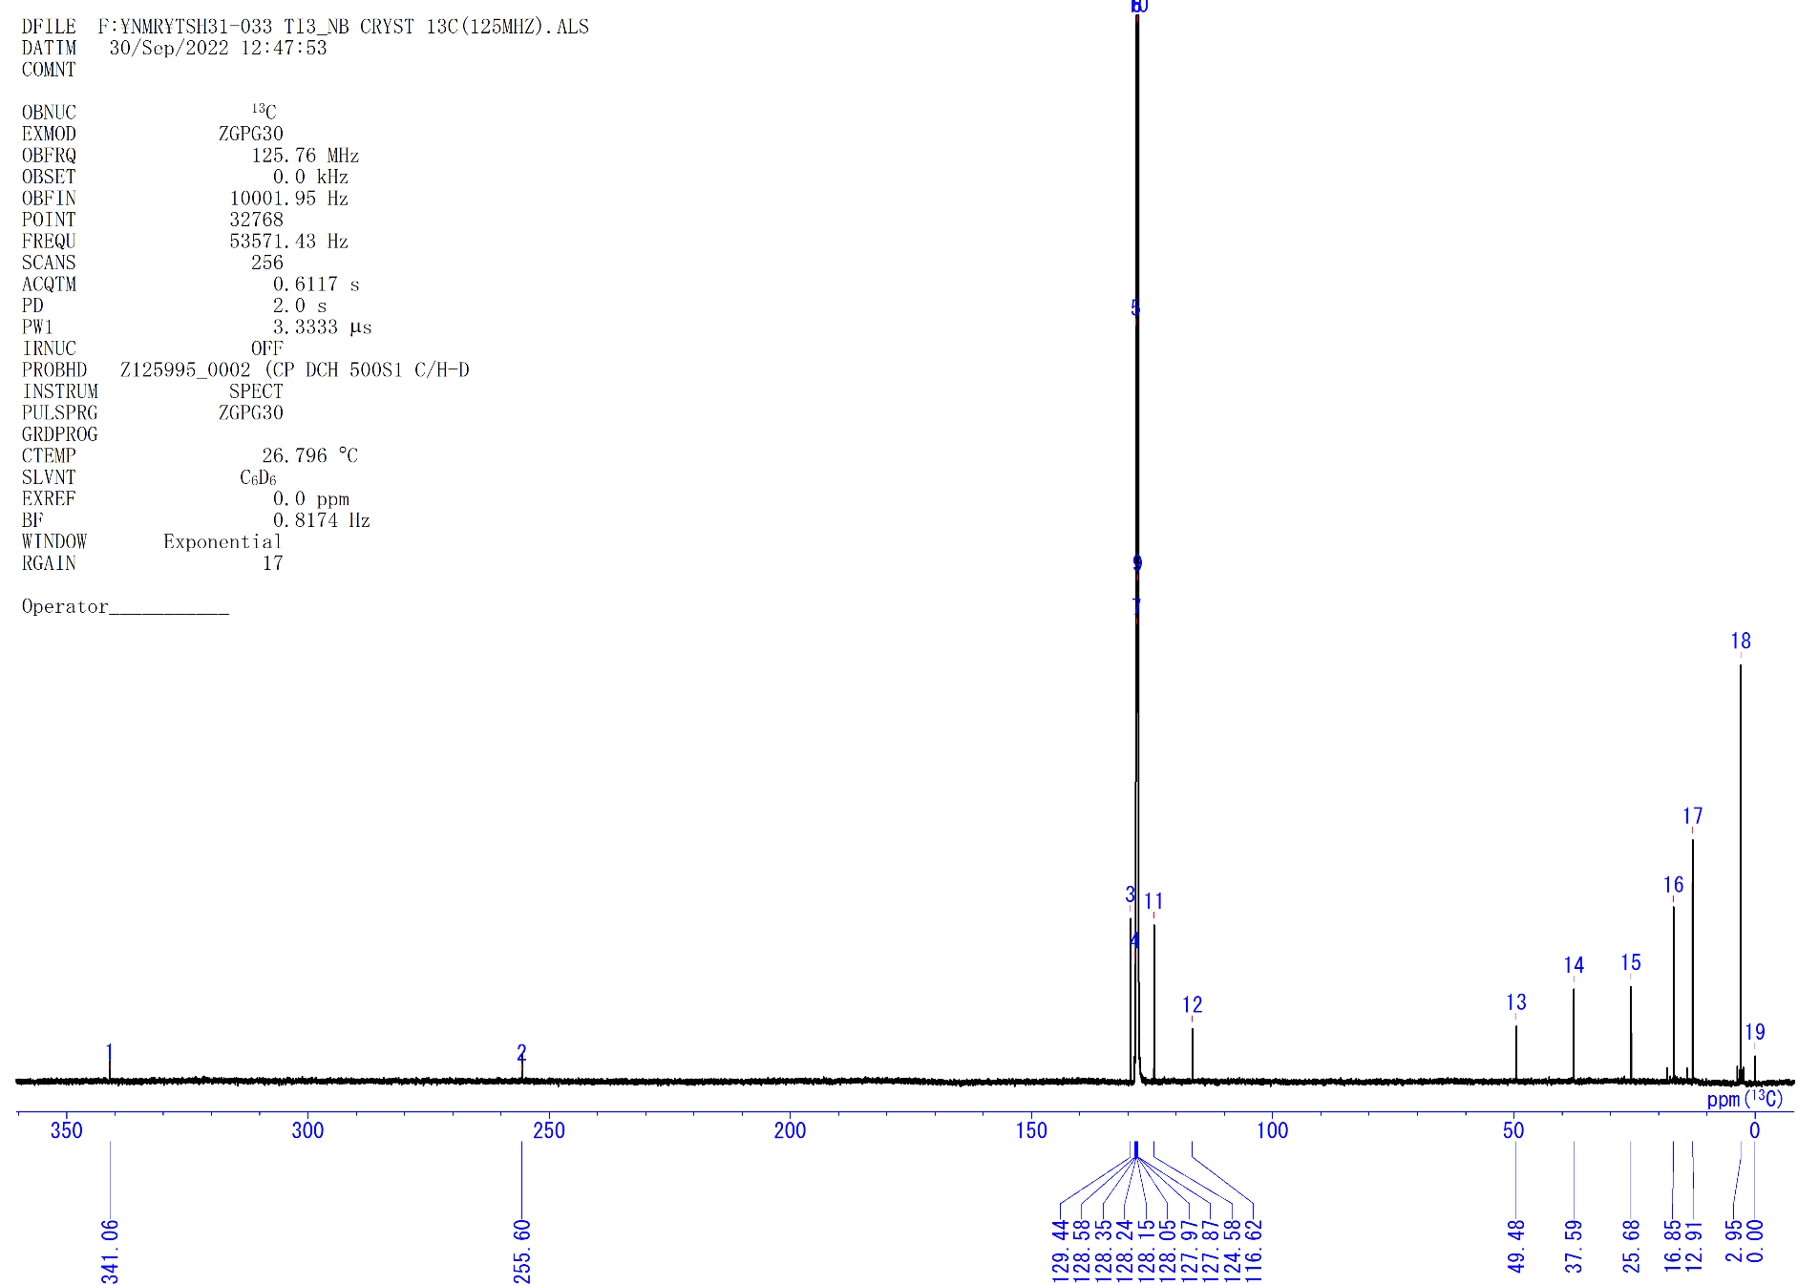
Figure S28. ¹³C{¹H} NMR spectrum of 4f (C₆D₆, rt).

[{(C₅Me₄SiMe₃)Ti}₃(μ₃-η²,η³,η¹-C₆H₇)(μ-H)₃(μ₃-H)] (4g). a) To a 2.0 mL hexane solution of 1 (66 mg, 0.090 mmol) was added cyclohexene (100 μl, 1 mmol) in a sample tube in an Ar glovebox. The solution was kept at 60 °C for 2 days. The solution turned from brown to dark red-brown. After removal of the solvent under vacuum, the oily crude product was crystallized in DME at –30 °C to give dark brown solids of 4g (44 mg, 0.055 mmol, 61%). Single crystals of 4g suitable for X-ray diffraction studies were obtained by recrystallization from a DME/benzene solution at –30 °C. b) To a 3.0 mL hexane solution of 1 (72 mg, 0.099 mmol) was added 1,3-cyclohexadiene (40 μl, 0.42 mmol) in a sample tube in an Ar glovebox. The solution was kept at room temperature for 2 days. After removal of the solvent under vacuum, the oily crude product was crystallized in DME at –30 °C to give dark brown solids of 4g (48 mg, 0.059 mmol, 60%). The analogous C₅Me₄SiMe₂^{t}Bu-ligated complex [{(C₅Me₄SiMe₂^{t}Bu)Ti}₃(μ₃-N)(μ₃-η²,η³,η¹-C₆H₇)(μ-H)₃(μ₃-H)] (4g’) was obtained from the reaction of [{(C₅Me₄SiMe₂^{t}Bu)Ti}₃(μ₃-H)(μ-H)₆] (1’) with 1,3-cyclohexadiene.
4g: ¹H NMR (tol-d₈, rt): δ 3.23 (brs, 2H, -CH₂-), 2.54 (q, J = 13.4 Hz, 1H, μ₃-H), 2.19 (brs, 18H, C₅Me₄SiMe₃), 2.01 (brs, 18H, C₅Me₄SiMe₃), 1.08 (brs, 4H, -CH₂-), 0.33 (s, 27H, C₅Me₄SiMe₃). ¹³C{¹H} NMR (C₆D₆, rt): δ 245.7 (s, μ₃-C), 216.2 (s, μ₂-C), 127.6 (brs, C₅Me₄SiMe₃), 123.6 (brs, C₅Me₄SiMe₃), 114.4 (brs, C₅Me₄SiMe₃), 97.9 (s, -CH-), 38.3 (s, -CH₂-), 32.2 (s, -CH₂-), 25.4 (s, -CH₂-), 16.5 (s, C₅Me₄SiMe₃), 12.6 (s, C₅Me₄SiMe₃), 2.7 (s, C₅Me₄SiMe₃). Anal. calcd. for C₄₂H₇₄Si₃Ti₃: C, 62.52; H, 9.24. Found: C, 61.83; H, 9.01.
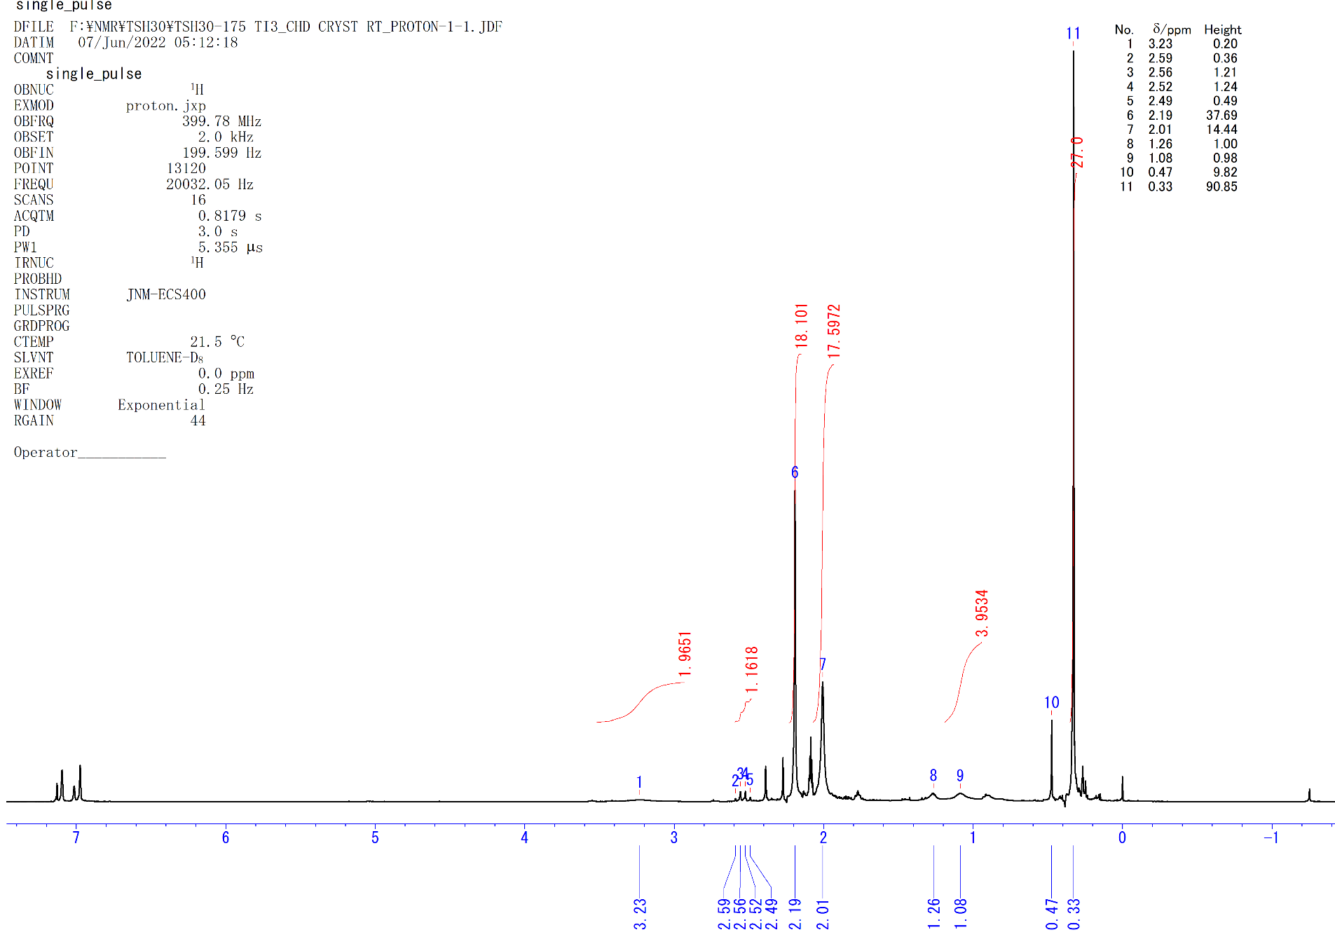
Figure S29. ¹H NMR spectrum of 4g (toluene-d₈, rt).
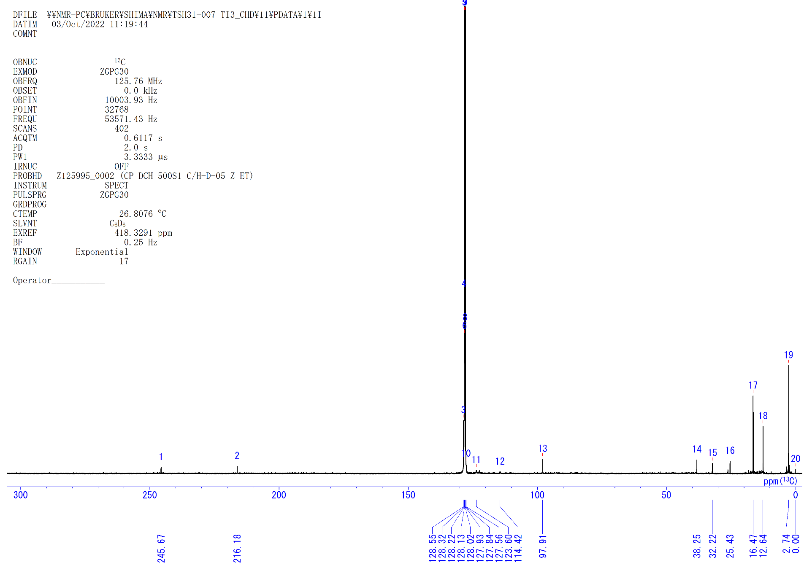
Figure S30. ¹³C{¹H} NMR spectrum of 4g (C₆D₆, rt).

[{(C₅Me₄SiMe₃)Ti}₃(μ-η³,η³,η¹-CH=C(CH₃)N-)(μ₃-N)(μ-H)] (5). A hexane solution (2.0 mL) of 4a (41 mg, 0.053 mmol) in 10 mL Hiper Glass Cylinder (TAIATSU TECHNO®) was filled with 10 atm of N₂. The solution was stirred at room temperature for 2 days. The color of the solution changed from dark brown to dark purple. After the reaction, the solution was evaporated and the residue was crystallized in DME at –30 °C to give 5 (37 mg, 0.047 mmol, 89%) as dark-purple solid. Single crystals suitable for X-ray diffraction study were obtained from the concentrated DME/C₆H₆ solution of 5 at –30 °C. The ¹⁵N-enriched compound [{(C₅Me₄SiMe₃)Ti}₃(μ-η³,η³,η¹-CH=C(CH₃)¹⁵N-)(μ₃-¹⁵N)(μ-H)] (5-¹⁵N) was obtained from the reaction of 4a (11 mg, 0.014 mmol) with ¹⁵N₂ (1 atm) in C₆D₆ (0.4 mL) at room temperature for 4 days, which afforded 5-¹⁵N in 87% NMR yield.
5: ¹H NMR (C₆D₆, rt): δ 7.53 (s, 1H, =CH-), 2.90 (s, 3H, C₅Me₄SiMe₃ or Me), 2.58 (s, 3H, C₅Me₄SiMe₃ or Me), 2.54 (s, 3H, C₅Me₄SiMe₃ or Me), 2.44 (s, 3H, C₅Me₄SiMe₃ or Me), *2.44 (s, 1H, μ-H), 2.29 (s, 3H, C₅Me₄SiMe₃ or Me), 2.26 (s, 3H, C₅Me₄SiMe₃ or Me), 2.173 (s, 3H, C₅Me₄SiMe₃ or Me), 2.169 (s, 3H, C₅Me₄SiMe₃ or Me), 2.06 (s, 3H, C₅Me₄SiMe₃ or Me), 1.80 (s, 3H, C₅Me₄SiMe₃ or Me), 1.63 (s, 3H, C₅Me₄SiMe₃ or Me), 1.53 (s, 6H, C₅Me₄SiMe₃), 0.28 (s, 9H, C₅Me₄SiMe₃), 0.16 (s, 18H, C₅Me₄SiMe₃). ¹³C{¹H} NMR (C₆D₆, rt): δ 191.8 (s, C_{α}), 130.8, 130.4, 130.0, 126.5, 126.4, 126.29, 126.25, 126.0, 125.5 (s, C₅Me₄SiMe₃), 124.5 (s, C_{β}), 122.7, 122.3, 122.2, 117.5, 116.6, 115.7 (s, C₅Me₄SiMe₃), 27.1 (s, Me), 17.3, 17.0, 16.2, 16.0, 15.4, 13.2, 12.8, 12.4, 11.9, 11.7, 11.5 (s, C₅Me₄SiMe₃), 2.4, 2.3 (s, C₅Me₄SiMe₃). Anal. calcd. for C₃₉H₆₈N₂Si₃Ti₃: C, 59.08; H, 8.64; N, 3.53. Found: C, 59.45; H, 8.66; N, 2.42.
5-¹⁵N: ¹³C{¹H} NMR (C₆D₆, rt): δ 191.7 (s, C_{α}), 124.5 (d, J_{15NC} = 15.0 Hz, C_{β}), 27.1 (d, J_{15NC} = 5.3 Hz, Me). ¹⁵N NMR (C₆D₆, rt): δ 431.3 (s, μ₃-¹⁵N), 177.2 (s, μ₂-¹⁵N-C).

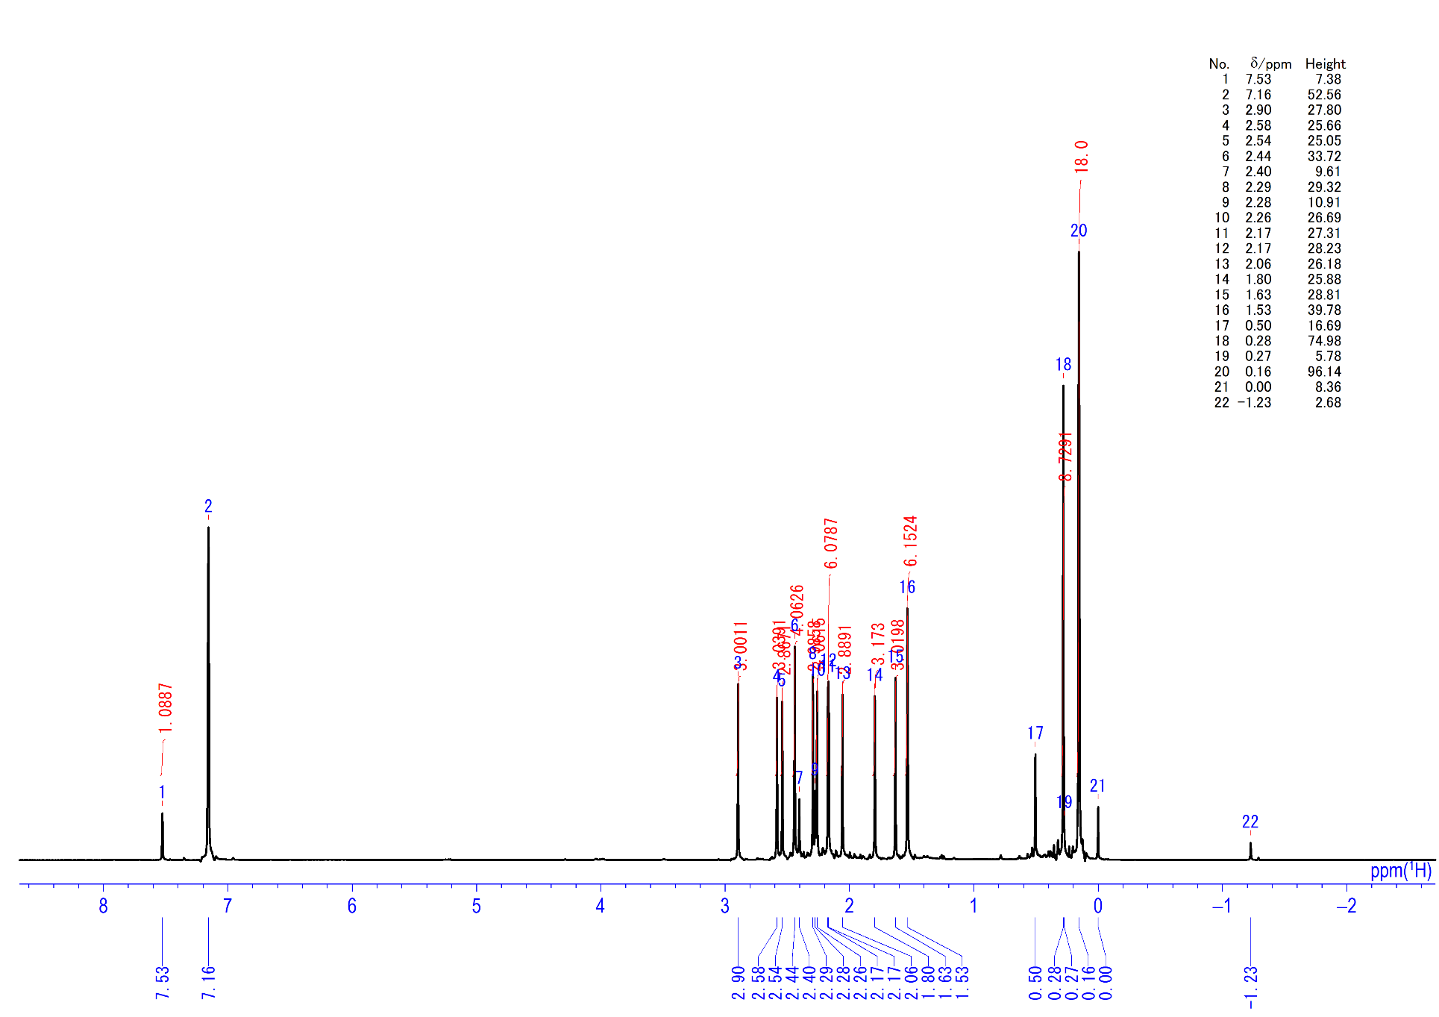
Figure S31. ¹H NMR spectrum of 5 (C₆D₆, rt)

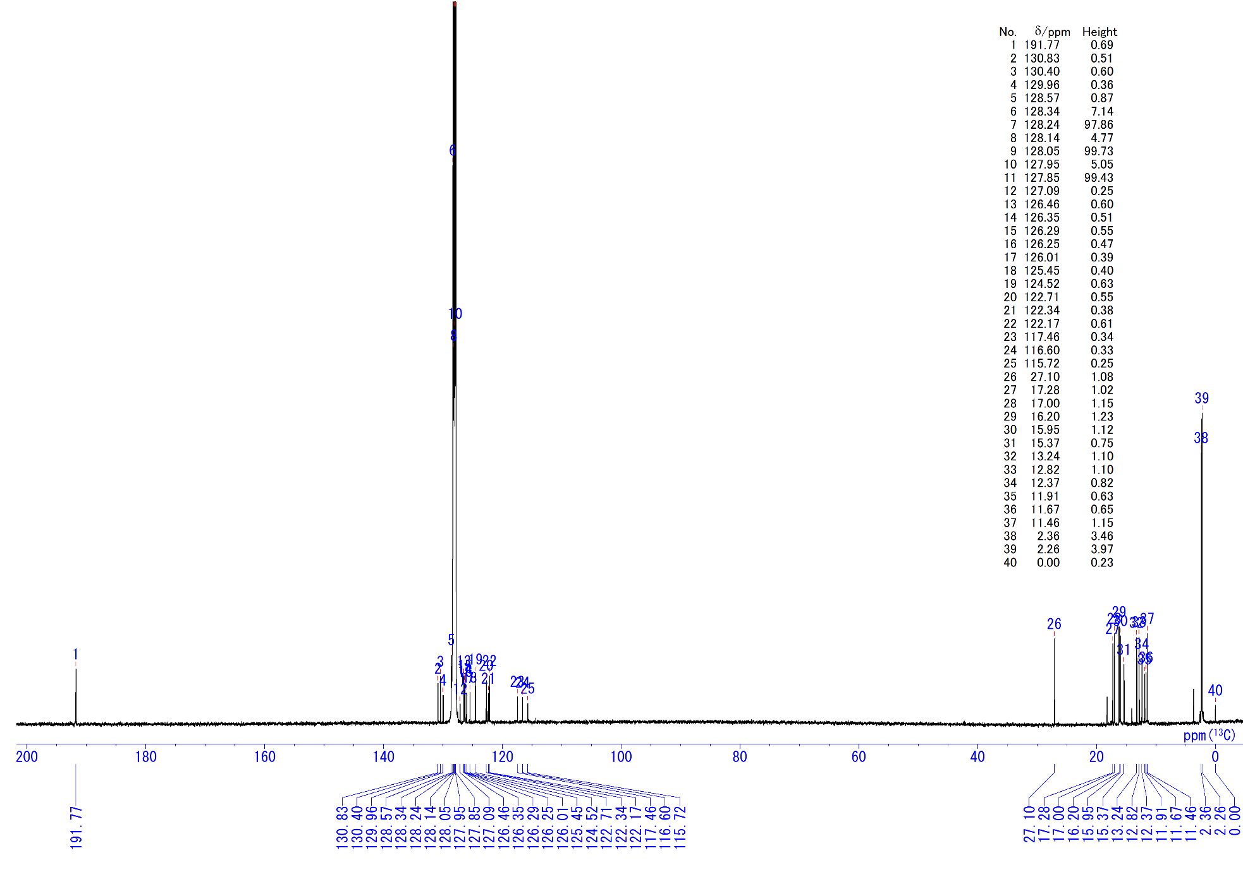
Figure S32. ¹³C{¹H} NMR spectrum of 5 (C₆D₆, rt).
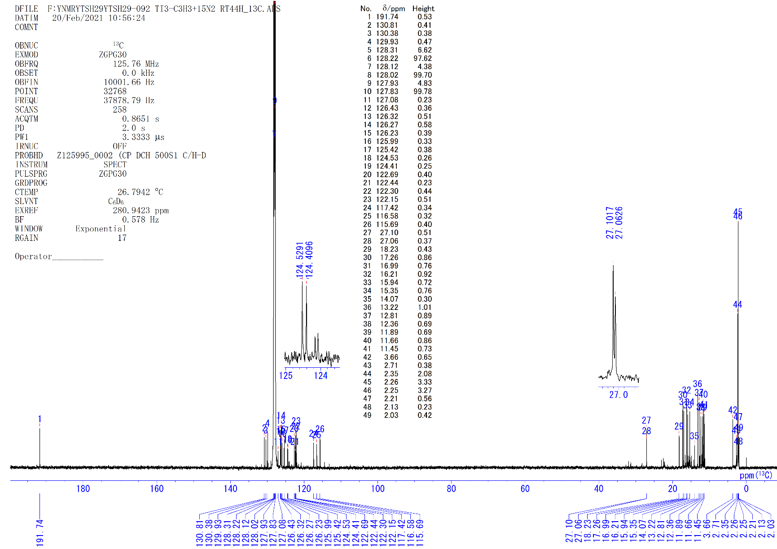
Figure S33. ¹³C{¹H} NMR spectrum of 5-¹⁵N (C₆D₆, rt).

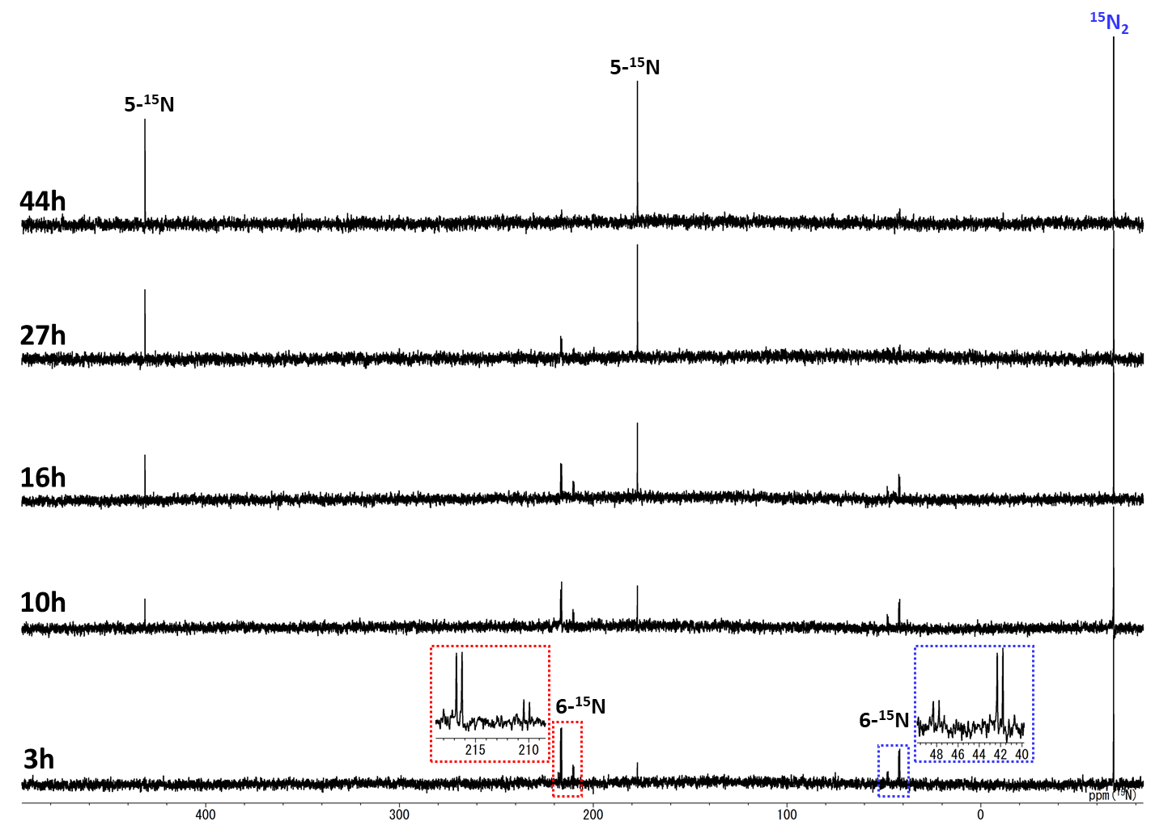
Figure S34. ¹⁵N NMR monitoring of the reaction of 4a with ¹⁵N₂ in C₆D₆ (rt).

Reaction of 4a-d₄ with N₂.
A J. Young valve NMR sample tube was charged with 0.4 mL of C₆D₆ and complex 4a (6 mg). The solution was frozen in liquid nitrogen, degassed and 1 atm of D₂ gas was added. The solution was kept at room temperature for 30 min and the ¹H NMR monitoring showed quantitative formation of the deuterated complex [{(C₅Me₄SiMe₃)Ti}₃(μ₃-η²:η²:η¹-C=CCH₃)(μ-D)₃(μ₃-D)] (4a-d₄). After the confirmation of the deuteration, the solution was frozen in liquid nitrogen, degassed and 1 atm of N₂ gas was added. The reaction was monitored at room temperature by ¹H NMR. After 4 days, the partially deuterated complex [{(C₅Me₄SiMe₃)Ti}₃(μ-η³,η³,η¹-CD=C(CH₃)N-)(μ₃-N)(μ-D)] (5-d₂) was obtained.
5-d₂: ²H NMR (C₆H₆, rt): δ 7.6 (s, C_{α}-D), 2.4 (s, μ-D).
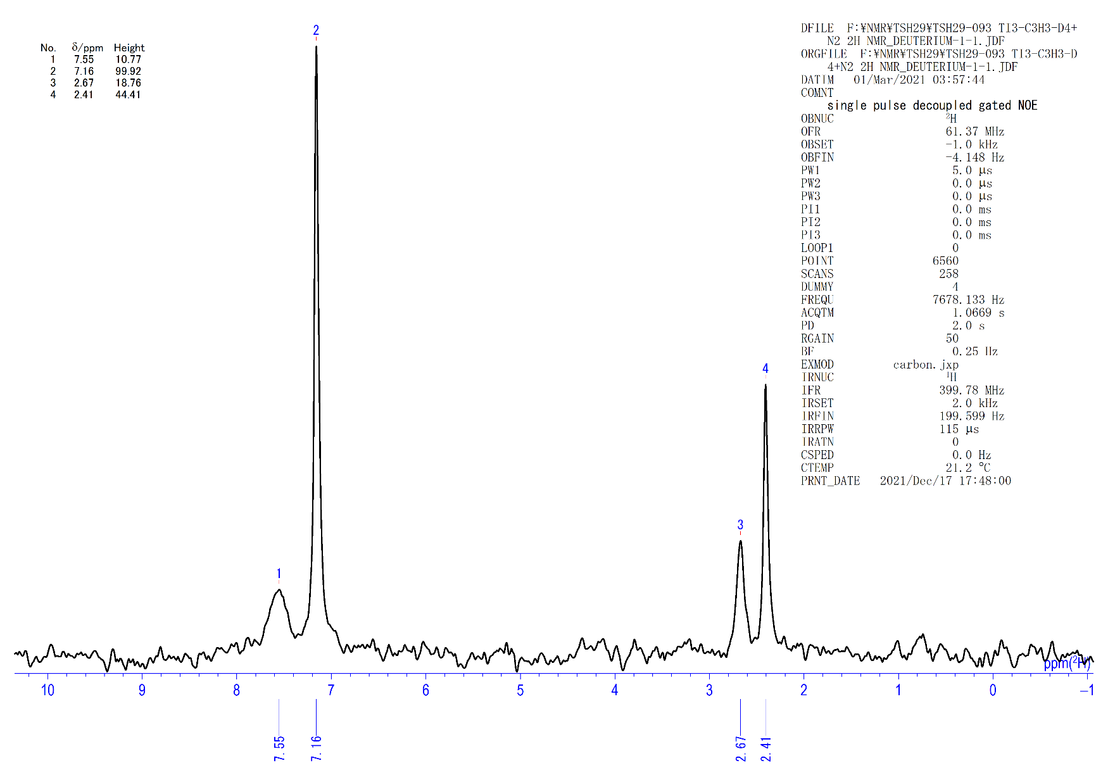
Figure S35. ²H NMR spectrum of 5-d (C₆H₆, rt, δ_{H} 2.7…8a-d).

[{(C₅Me₄SiMe₃)Ti}₃(μ-η²,η²,η¹-CH=CCH₃)(μ-η²,η²,η¹-N₂)(μ-H)] (6). a) In the N₂ glovebox, 4a (19 mg, 0.025 mmol) was dissolved in THF (1.0 mL) at –30 °C under N₂ (1 atm). After 1 day at –30 °C, the solution was evaporated and dissolved in small amount of DME and crystalized at –30 °C. After a few days, microcrystalline precipitates of 6 (11 mg, 0.014 mmol, 56%) were formed as dark brown solid. Single crystals of 6 suitable for X-ray study were obtained from DME solution at –30 °C. b) A 5-mm pressure NMR tube (Wilmad Lab Glass) was charged with 4a (5.0 mg, 0.0065 mmol) and C₆D₆ (0.40 ml, 9.8 mM) in a glovebox. The solution was degassed under vacuum. High pressure N₂ gas (5 atm) was then introduced to the NMR tube. The sample was monitored at room temperature by ¹H NMR spectroscopy. After 20 minutes, complex 4a was disappeared and complex 6 was quantitatively formed. Complex 6 was slowly converted to 5 at room temperature for 2 days. The ¹⁵N-labeled complex [{(C₅Me₄SiMe₃)Ti}₃(μ-η²,η²,η¹-CH=CCH₃)(μ-η²,η²,η¹-¹⁵N₂)(μ-H)] (6-¹⁵N) was observed when the reaction of 4a with ¹⁵N₂ (1 atm) in C₆D₆ was monitored by ¹⁵N NMR.
6: ¹H NMR (C₆D₆, rt): δ 9.14 (s, 1H, =CH-), 2.62, 2.41, 2.39, 2.35, 2.18, 2.17, 2.11, 2.02, 1.95, 1.81, 1.48, 1.40, 1.27 (s, 3H×13, C₅Me₄SiMe₃ or Me), 0.57 (s, 9H, C₅Me₄SiMe₃), 0.38 (s, 9H, C₅Me₄SiMe₃), 0.20 (s, 9H, C₅Me₄SiMe₃), –4.07 (s, 1H, μ-H). ¹³C{¹H} NMR (C₆D₆, rt): δ 269.6 (s, -MeC=CH-), 217.9 (s, -MeC=CH-), 131.6, 129.8, 129.0, 127.2, 126.4, 124.2, 124.1, 123.5, 122.7, 122.4, 122.0, 121.5, 120.8, 113.2 (s, C₅Me₄SiMe₃), 22.5 (s, Me), 16.6, 15.6, 15.4, 15.3, 15.1, 14.9, 12.7, 12.6, 12.1, 12.0, 11.3, 11.2 (s, C₅Me₄SiMe₃), 2.7, 2.2, 2.0 (s, C₅Me₄SiMe₃). 6-¹⁵N: ¹⁵N NMR (C₆D₆, rt): major δ 216.5 (d, J_{NN} = 21.8 Hz, ¹⁵N-¹⁵N), 42.1 (d, J_{NN} = 21.8 Hz, ¹⁵N-¹⁵N); minor δ 210.2 (d, J_{NN} = 21.7 Hz, ¹⁵N-¹⁵N), 48.0 (d, J_{NN} = 21.7 Hz, ¹⁵N-¹⁵N).

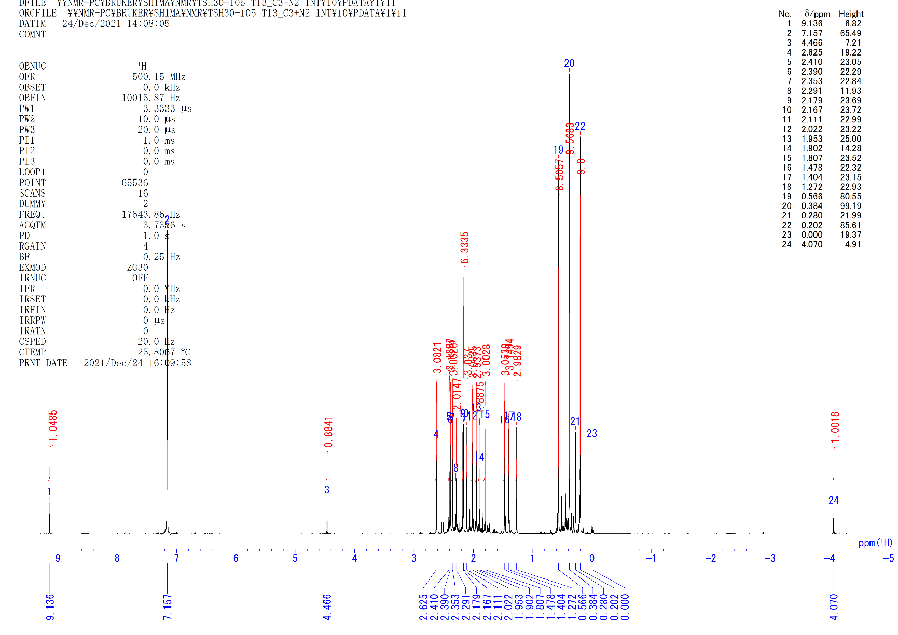
Figure S36. ¹H NMR spectrum of 6 (C₆D₆, rt).

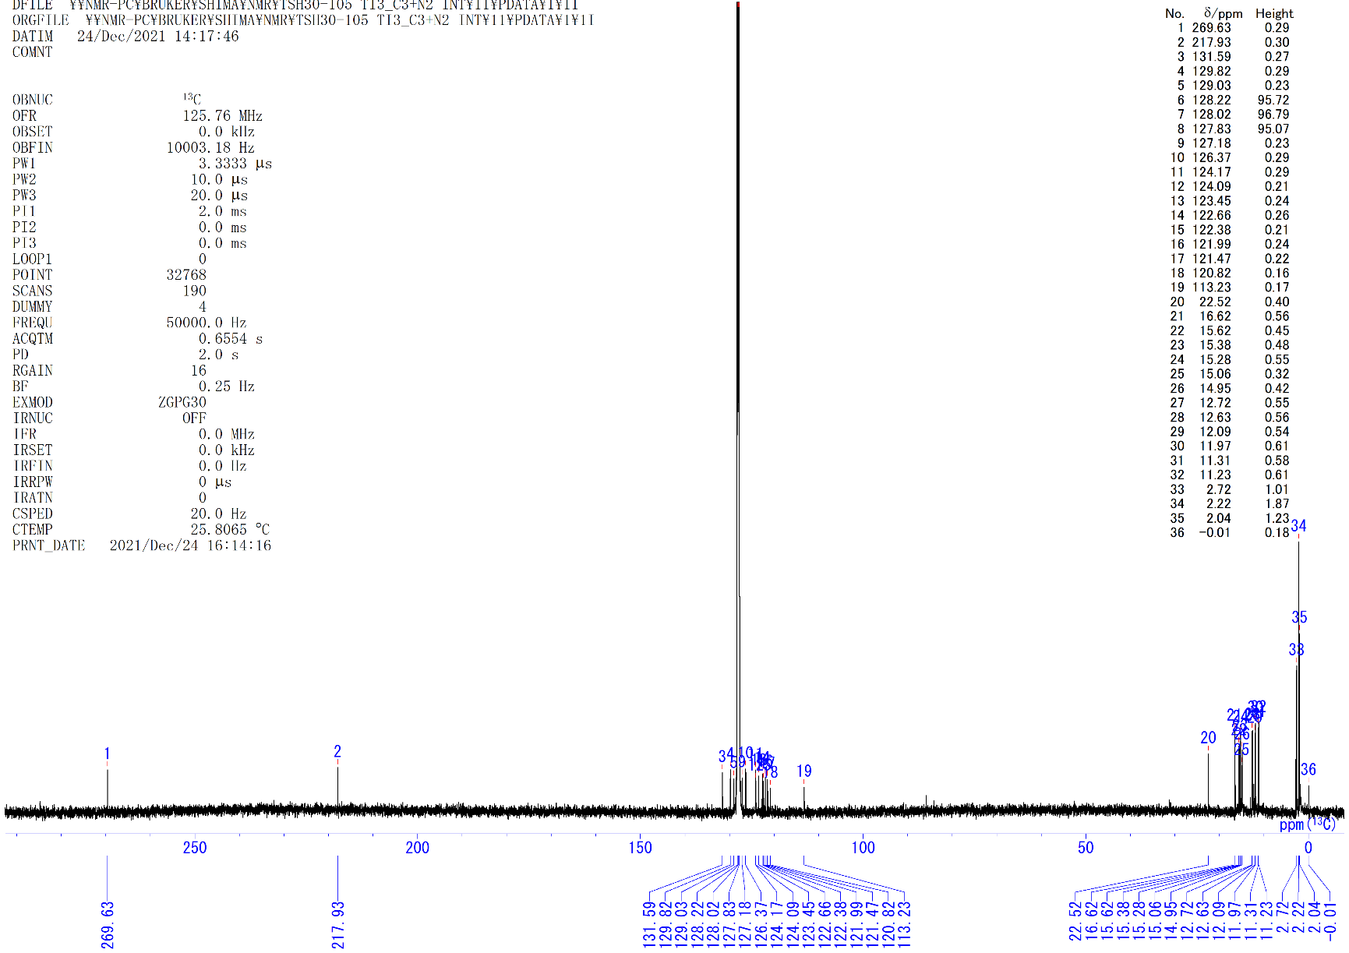
Figure S37. ¹³C{¹H} NMR spectrum of 6 (C₆D₆, rt).

Thermal reaction of 5-d. A J. Young valve NMR sample tube was charged with 0.4 mL of C₆D₆ and complex 5 (5 mg). The solution was frozen in liquid nitrogen, degassed and 1 atm of D₂ gas was added. The solution was kept at room temperature for 15 min and the ¹H NMR monitoring showed quantitative formation of the deuterated complex [{(C₅Me₄SiMe₃)Ti}₃(μ-η³,η³,η¹-CH=C(CH₃)N-)(μ₃-N)(μ-D)] (5-d). After the confirmation of the deuteration, the solution was frozen in liquid nitrogen, degassed and 1 atm of N₂ gas was added. The reaction was kept at 70 °C. After 1 day, the partially deuterated complex [{(C₅Me₄SiMe₃)Ti}₃(μ-η³,η¹,η¹-CH=CH_{0.5}D_{0.5}-CH₂-)(μ₃-N)(μ-NH)] (3-d) was obtained quantitatively by the ¹H NMR.
3-d: ¹H NMR (C₆D₆, rt): δ 14.97 (s, 1H, NH), 7.72 (d, J = 6.1 Hz, 1H, -CH=CH_{0.5}D_{0.5}-CH₂-), 5.21 (d, J = 4.8 Hz, 1H, -CH=CH_{0.5}D_{0.5}-CH₂-), 4.01 (m, 0.5H, -CH=CH_{0.5}D_{0.5}-CH₂-).
3-d: ²H NMR (C₆H₆, rt): δ 4.1 (s, μ-CH=CH_{0.5}D_{0.5}-CH₂-).
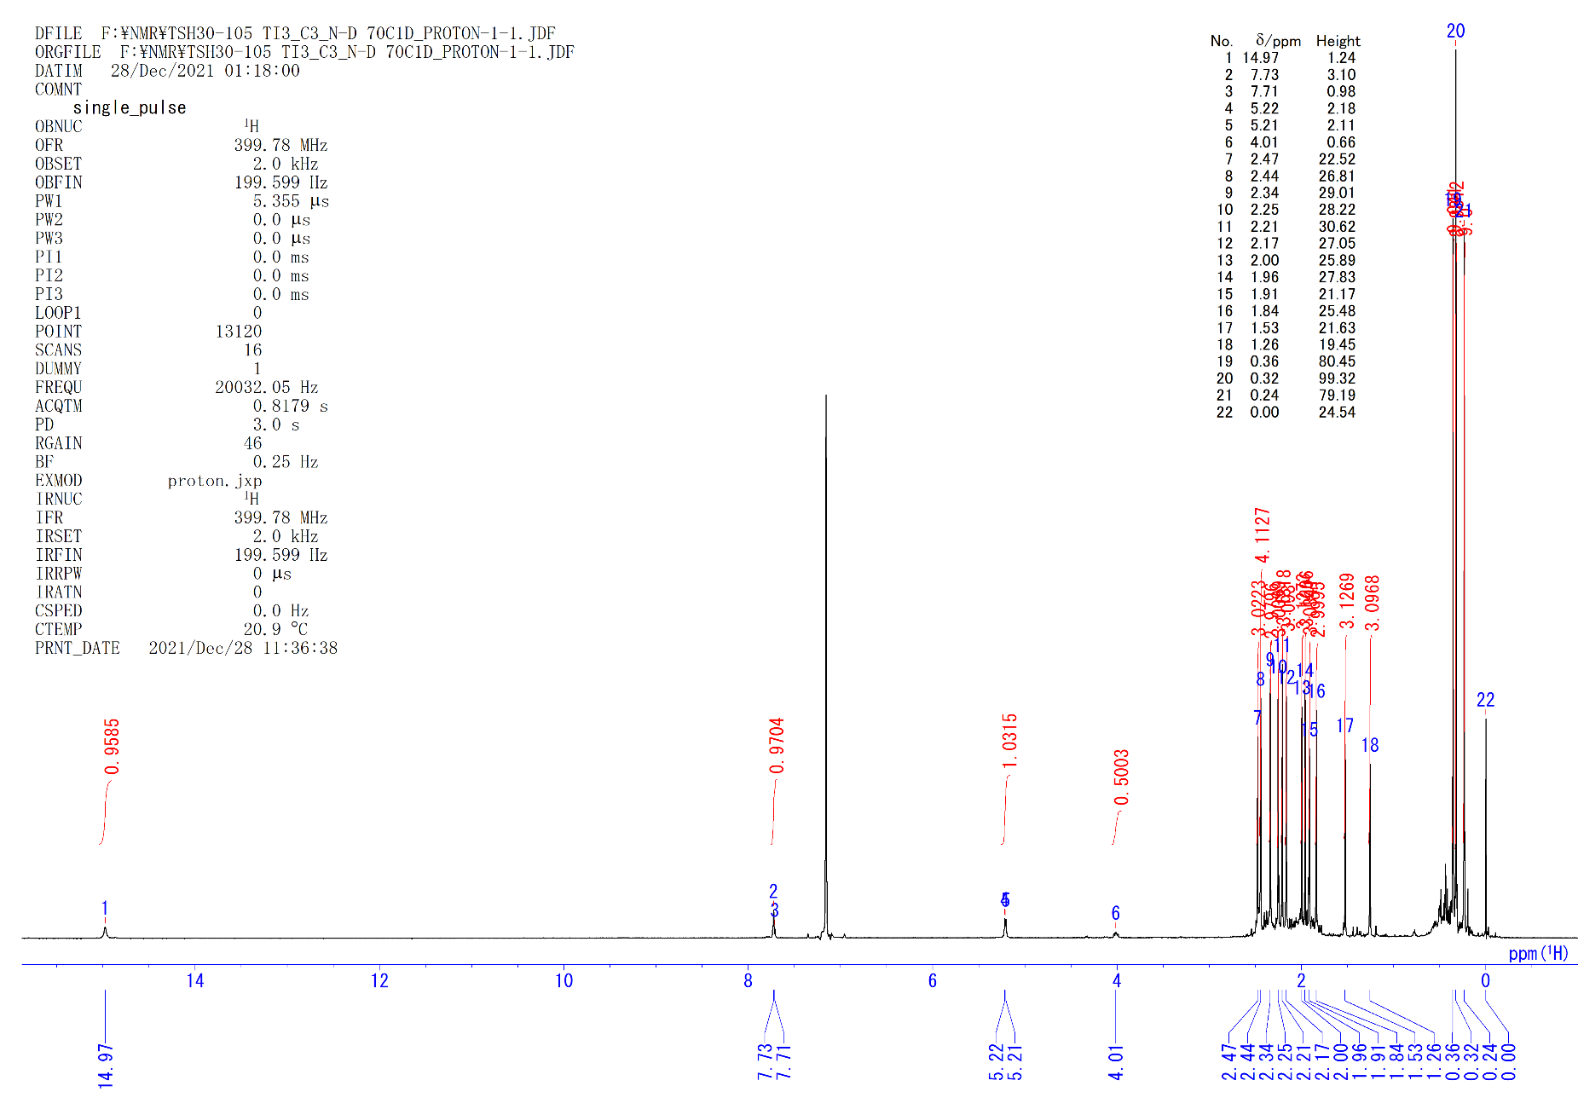
Figure S38. ¹H NMR spectrum of 3-d (C₆D₆, rt).

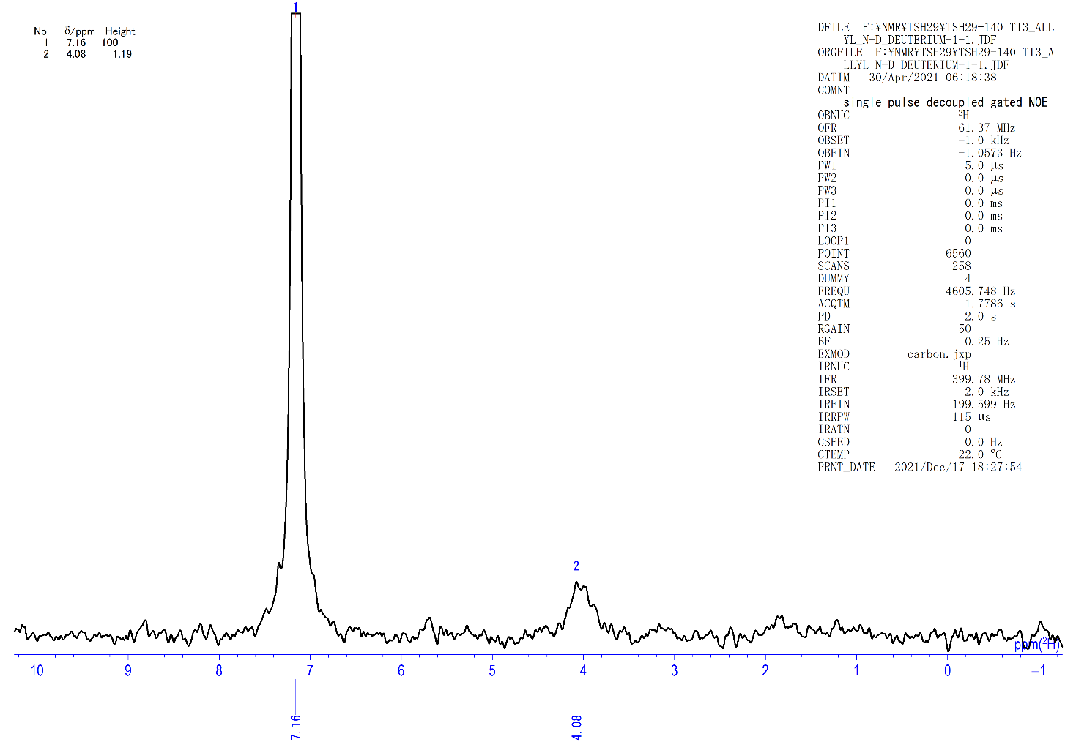
Figure S39. ²H NMR spectrum of 3-d (C₆H₆, rt).

[{(C₅Me₄SiMe₃)Ti}₃(μ₃-N)(μ-NCH(CH₃)₂)(μ-H)₂] (8a). A hexane solution (3.0 mL) of 5 (100 mg, 0.126 mmol) in 10 mL Hiper Glass Cylinder (TAIATSU TECHNO®) was filled with 4 atm of H₂. The solution was kept at room temperature for 1 day with stirring. After the reaction, the solution was evaporated and the residual dark brown powder was crystallized in DME at –30 °C to precipitate 8a (83 mg, 0.104 mmol, 83%) as a black crystalline solid. Single crystals of 8a suitable for X-ray study were obtained from DME/benzene solution at –30 °C.
8a: ¹H NMR (C₆D₆, rt): δ 16.63 (s, 6H, C₅Me₄SiMe₃), 9.25 (s, 6H, C₅Me₄SiMe₃), 7.91 (s, 6H, C₅Me₄SiMe₃), 5.25 (s, 6H, C₅Me₄SiMe₃), 3.98 (s, 6H, C₅Me₄SiMe₃), 3.49 (s, 6H, C₅Me₄SiMe₃), 2.72 (s, 6H, -CHMe₂), 1.16 (s, 9H, C₅Me₄SiMe₃), 0.79 (s, 18H, C₅Me₄SiMe₃), –2.57 (s, 1H, -CHMe₂). Anal. calcd. for C₃₉H₇₂N₂Si₃Ti₃: C, 58.78; H, 9.11; N, 3.51. Found: C, 60.22; H, 9.12; N, 3.53. FD-MS: m/z = 796.4 ([8a]⁺).
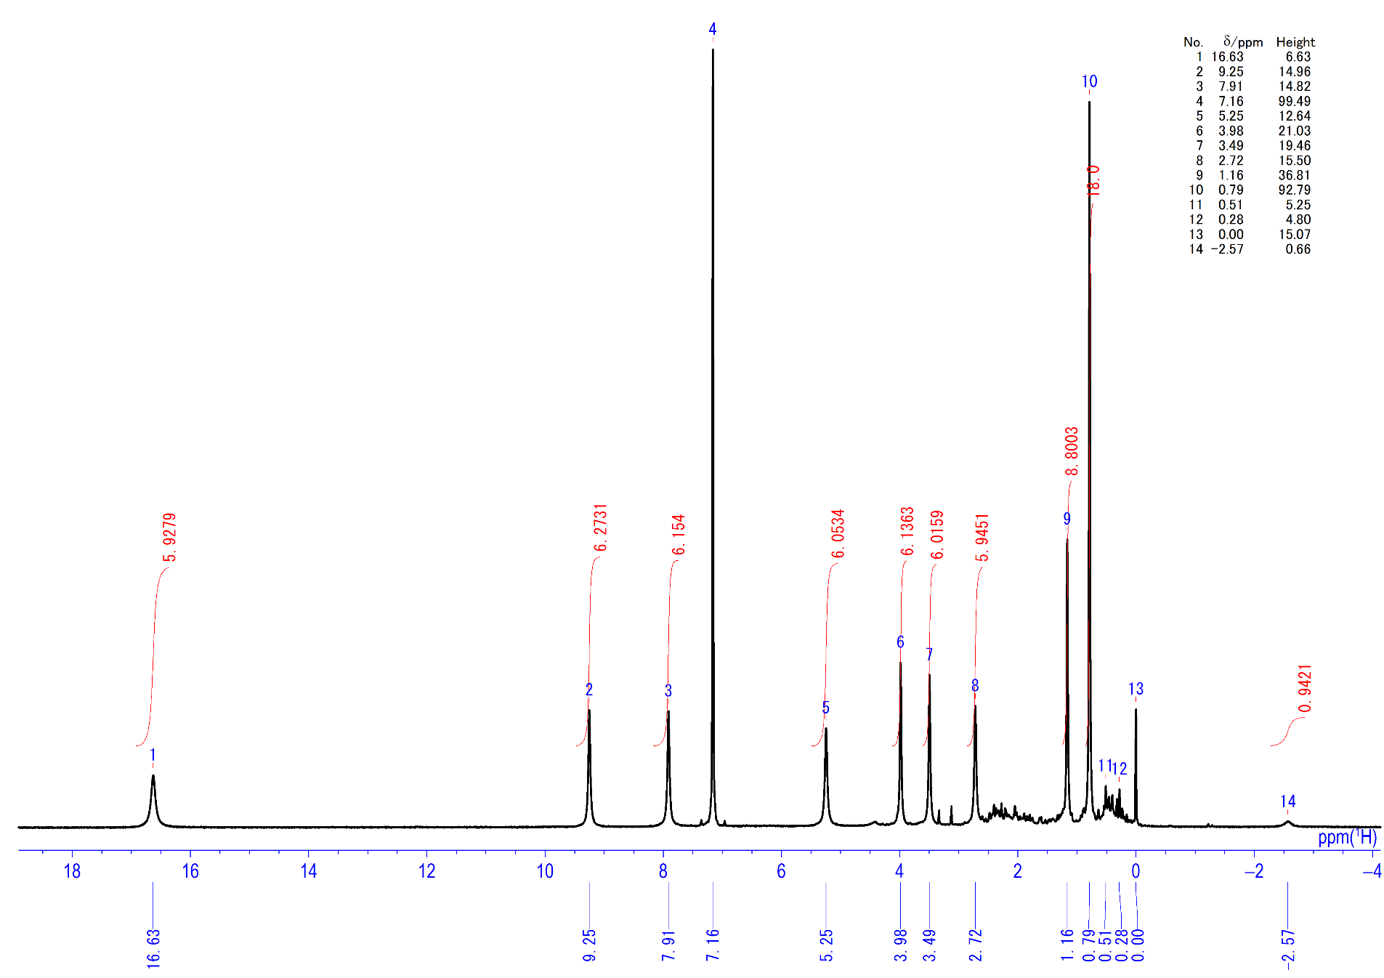
Figure S40. ¹H NMR spectrum of 8a (C₆D₆, rt).

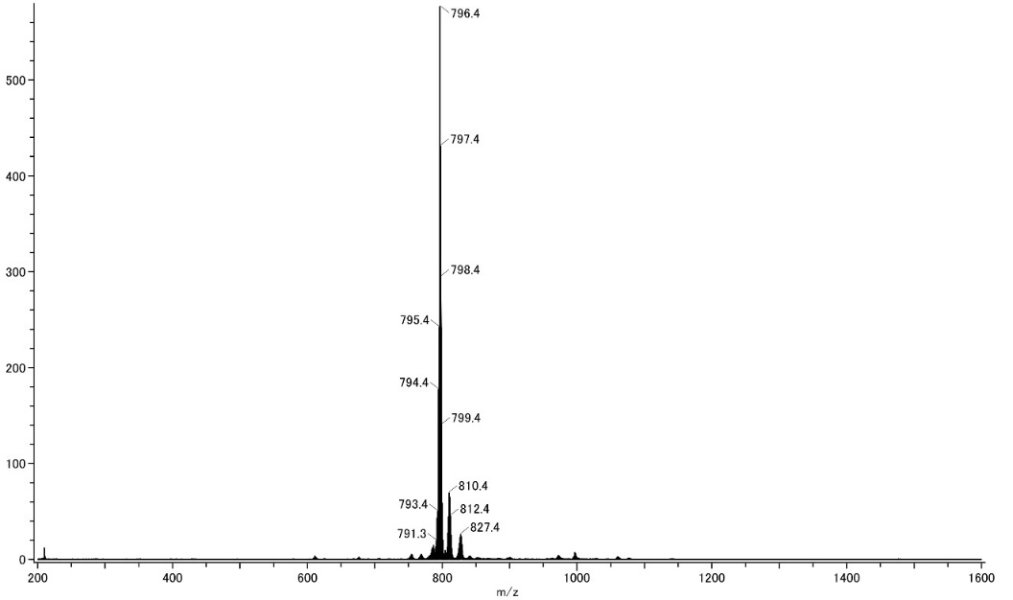
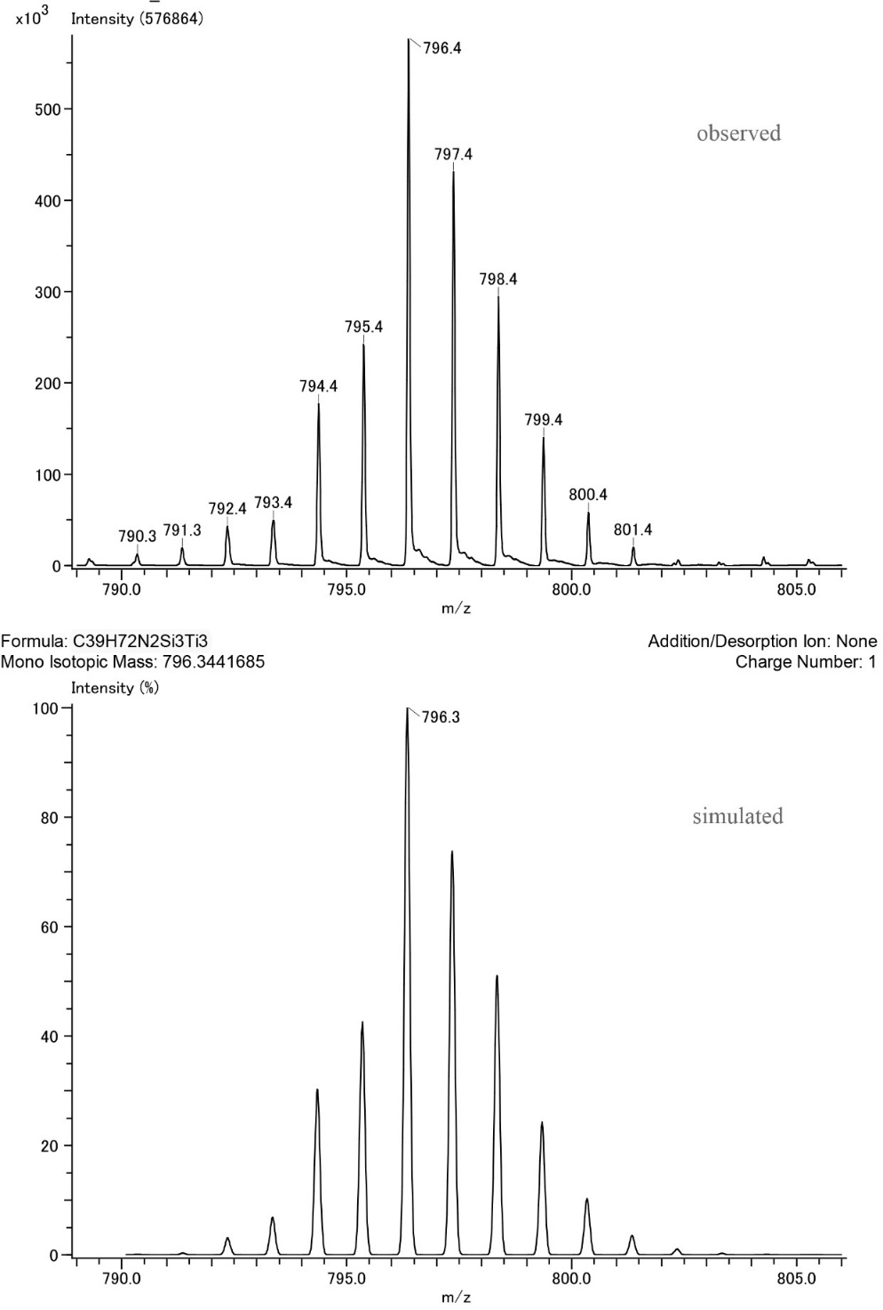
Figure S41. FD-MS spectra of 8a.

Reaction of 5 with D₂. A J. Young valve NMR sample tube was charged with 0.4 mL of C₆D₆ and complex 5 (4 mg). The solution was degassed and 2 atm of D₂ gas was added. The solution was kept at room temperature for 16 h and the ¹H NMR monitoring showed the formation of the deuterated complex [{(C₅Me₄SiMe₃)Ti}₃(μ₃-N)(μ-NCD(CH₃)(CHD₂))(μ-D)₂] (8a-d).
8a-d: ¹H NMR (C₆D₆, rt): δ 2.69 (s, 4H, (CH₃)(CHD₂)). ²H NMR (C₆H₆, rt): δ 2.7 (brs, CD(CH₃)(CHD₂)), –1.4 (brs, CD(CH₃)(CHD₂)).
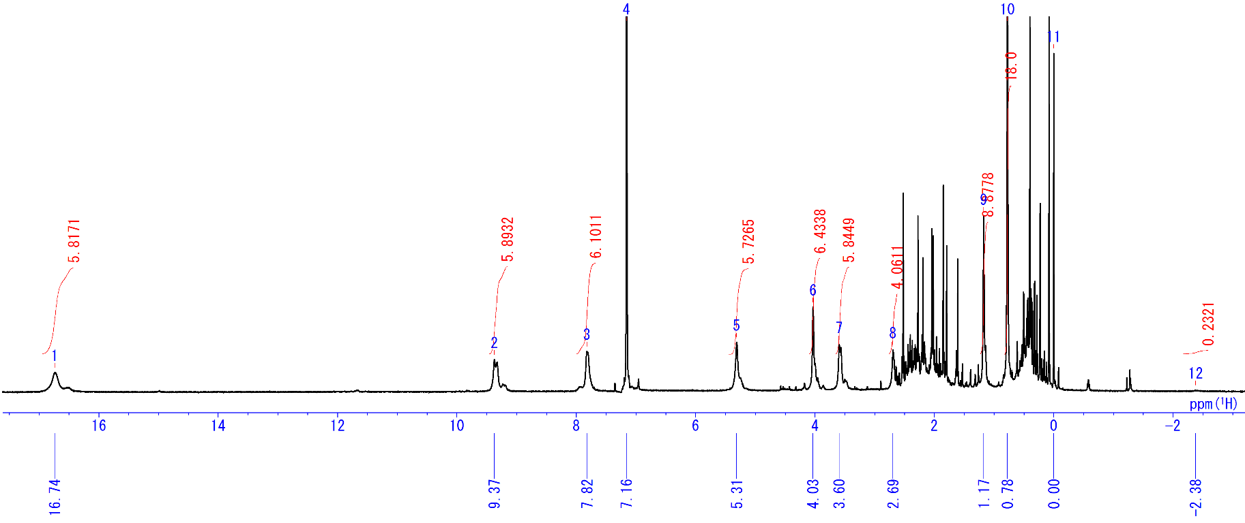
Figure S42. ¹H NMR spectrum of 8a-d (C₆D₆, rt).

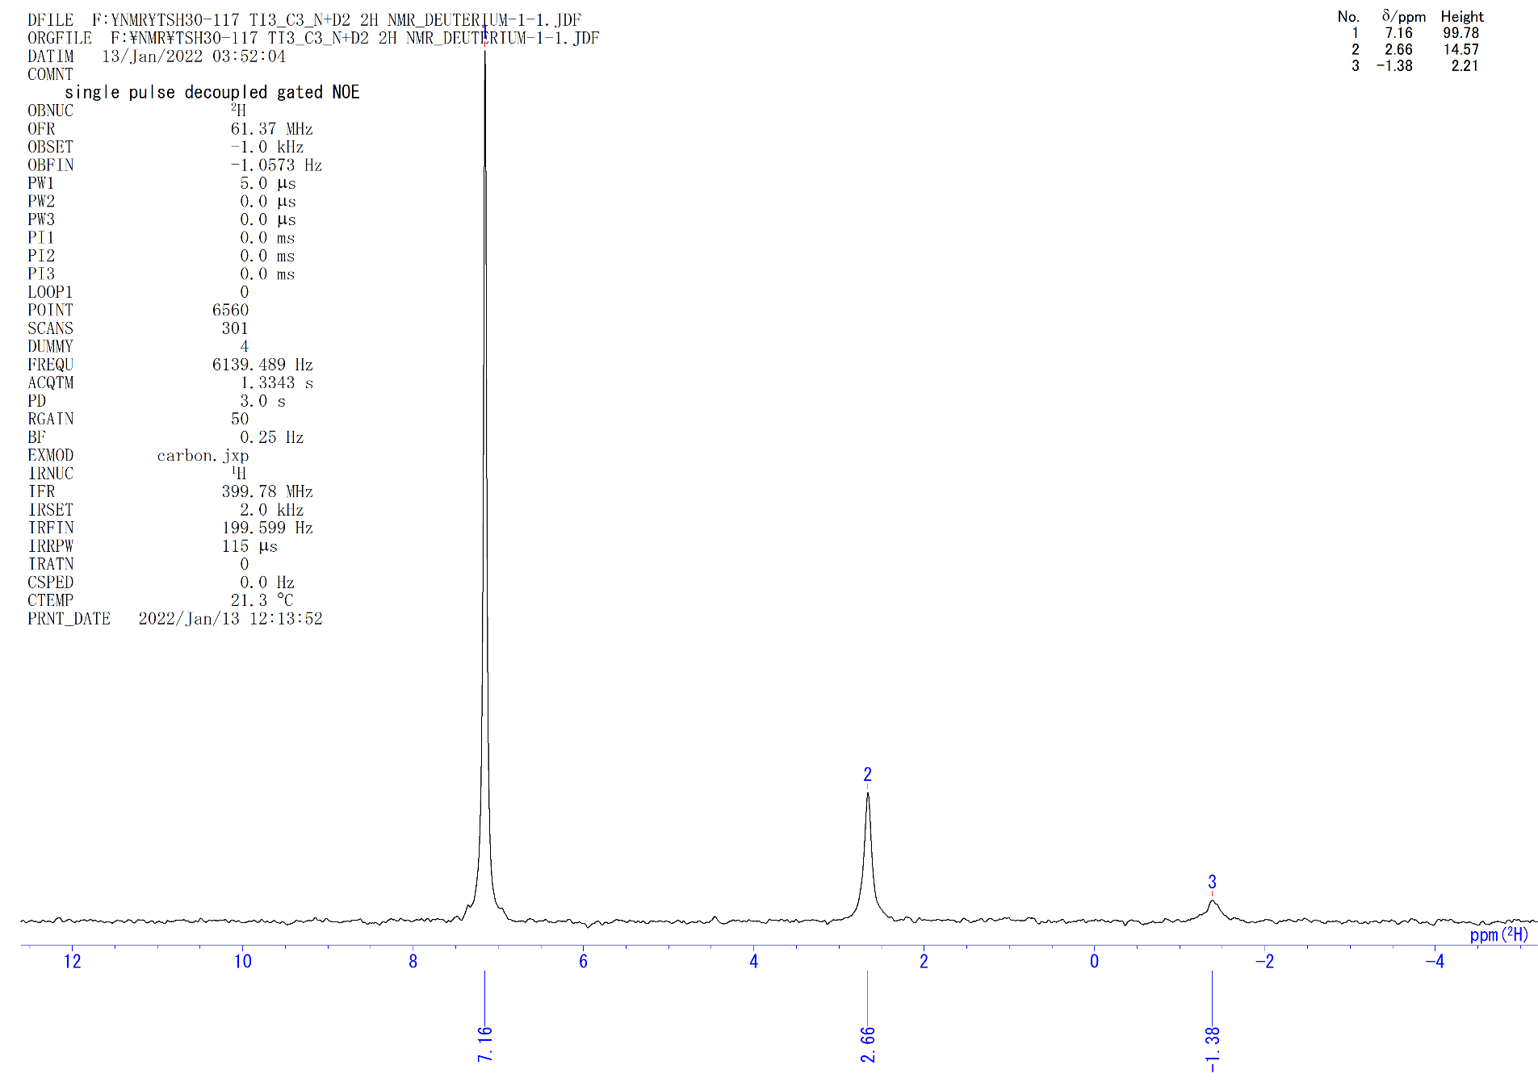
Figure S43. ²H NMR spectrum of 8a-d (C₆H₆, rt).

[{(C₅Me₄SiMe₃)Ti}₃(μ₃-N)(μ-NCH(CH₃)₂)(μ-H)₂] (8a) from 4a. A hexane solution (2.0 mL) of 4a (51 mg, 0.067 mmol) in 10 mL Hiper Glass Cylinder (TAIATSU TECHNO®) was filled with 5 atm of N₂. The solution was stirred at room temperature for 2 days. After the reaction, N₂ was released and H₂ (4 atm) was filled instead. The solution was kept at room temperature for 1 day with stirring. After the reaction, the solution was evaporated under reduced pressure and the residual dark brown powder was crystallized in hexane/benzene (10/1) at –30 °C to precipitate the crystalline solid 8a (30 mg, 0.038 mmol). The solution part was evaporated under reduced pressure and the residual dark brown powder was crystallized in DME at –30 °C to precipitate the microcrystalline solid 8a (13 mg, 0.013 mmol). Overall yield of 8a is 72%.

[{(C₅Me₄SiMe₃)Ti}₃(μ₃-N)(μ-NCH(CH₃)(CH₂CH₃))(μ-H)₂] (8b). A hexane solution (2.0 mL) of 4b (81 mg, 0.10 mmol) in 10 mL Hiper Glass Cylinder (TAIATSU TECHNO®) was filled with 5 atm of N₂. The solution was stirred at room temperature for 2 days. After the reaction, N₂ was released and H₂ (4 atm) was filled instead. The solution was kept at room temperature for 1 day with stirring. After the reaction, the solution was evaporated and the residual dark brown powder was crystallized in DME (~0.5 mL) at –30 °C to precipitate the crystalline solid [(Cp’Ti)₃(μ₃-N)(μ-NH)(μ-H)₂]. The solution part was concentrated and recrystallized at –30 °C to give the complex 8b (50 mg, 0.062 mmol, 62%) as a dark green solid.
8b: ¹H NMR (C₆D₆, rt): δ 16.17 (s, 3H, C₅Me₄SiMe₃), 15.82 (s, 3H, C₅Me₄SiMe₃), 9.10 (s, 3H, C₅Me₄SiMe₃), 8.91 (s, 3H, C₅Me₄SiMe₃), 8.30 (s, 3H, C₅Me₄SiMe₃), 6.90 (s, 3H, C₅Me₄SiMe₃), 5.01 (s, 3H, C₅Me₄SiMe₃), 4.88 (s, 3H, C₅Me₄SiMe₃), 3.92 (s, 1H, -CHCH₂CH₃), 3.69 (s, 3H, C₅Me₄SiMe₃), 3.66 (s, 3H, C₅Me₄SiMe₃), 3.61 (s, 3H, C₅Me₄SiMe₃), 3.07 (s, 3H, C₅Me₄SiMe₃), 2.75 (s, 3H, -CHCH₂CH₃), 1.34 (s, 3H, -CHMe), 0.94 (s, 9H, C₅Me₄SiMe₃), 0.73 (s, 9H, C₅Me₄SiMe₃), 0.66 (s, 9H, C₅Me₄SiMe₃), –1.29 (s, 1H, -CHMe). Anal. calcd. for C₄₀H₇₄N₂Si₃Ti₃: C, 59.25; H, 9.20; N, 3.45. Found: C, 59.23; H, 8.99; N, 3.55.

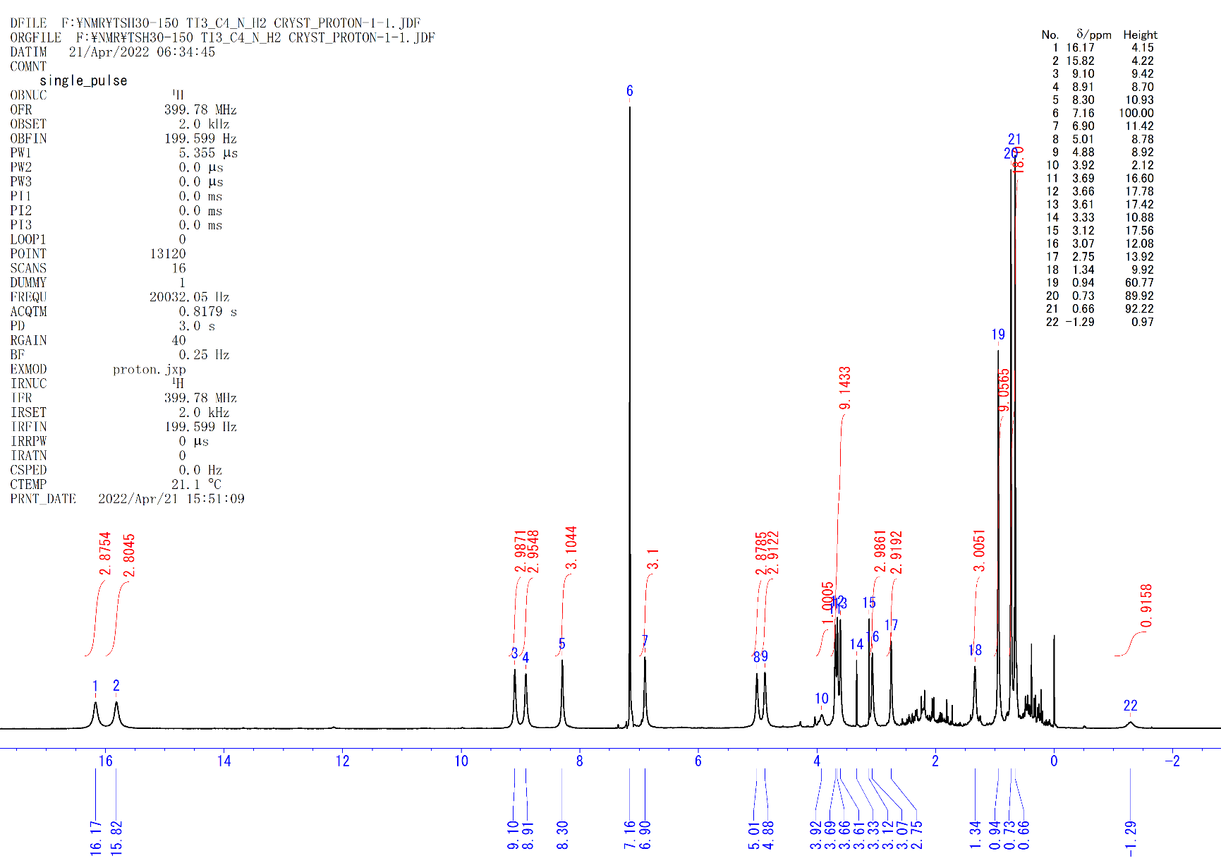
Figure S44. ¹H NMR spectrum of 8b (C₆D₆, rt).

[{(C₅Me₄SiMe₃)Ti}₃(μ₃-N)(μ-NCH(CH₃)(CH₂CH₂CH₃))(μ-H)₂] (8c). A hexane solution (2.0 mL) of 4c (62 mg, 0.078 mmol) in 10 mL Hiper Glass Cylinder (TAIATSU TECHNO®) was filled with 5 atm of N₂. The solution was stirred at room temperature for 2 days. After the reaction, N₂ was released and H₂ (4 atm) was filled instead. The solution was kept at room temperature for 1 day with stirring. After the reaction, the solution was evaporated and the residual dark brown powder was crystallized in DME (~0.3 mL) at –30 °C to precipitate the crystalline solid [(Cp’Ti)₃(μ₃-N)(μ-NH)(μ-H)₂]. The solution part was evaporated under reduced pressure to give the complex 8c (54 mg, 0.065 mmol, 83%) as a dark green solid (no crystals were obtained).
8c: ¹H NMR (C₆D₆, rt): δ 16.41 (s, 3H, C₅Me₄SiMe₃), 15.74 (s, 3H, C₅Me₄SiMe₃), 9.14 (s, 3H, C₅Me₄SiMe₃), 9.10 (s, 3H, C₅Me₄SiMe₃), 8.34 (s, 3H, C₅Me₄SiMe₃), 6.81 (s, 3H, C₅Me₄SiMe₃), 5.11 (s, 3H, C₅Me₄SiMe₃), 4.73 (s, 3H, C₅Me₄SiMe₃), 3.79 (s, 3H, C₅Me₄SiMe₃), 3.60 (s, 6H, C₅Me₄SiMe₃), 3.16 (s, 3H, C₅Me₄SiMe₃), 2.62 (s, 3H, C₅Me₄SiMe₃), 1.13 (s, 3H, C₅Me₄SiMe₃), 0.92 (s, 9H, C₅Me₄SiMe₃), 0.71 (s, 9H, C₅Me₄SiMe₃), 0.64 (s, 9H, C₅Me₄SiMe₃), –0.69 (s, 1H, -CHMe). Anal. calcd. for C₄₁H₇₆N₂Si₃Ti₃: C, 59.70; H, 9.29; N, 3.40. Found: C, 59.13; H, 8.98; N, 3.71.

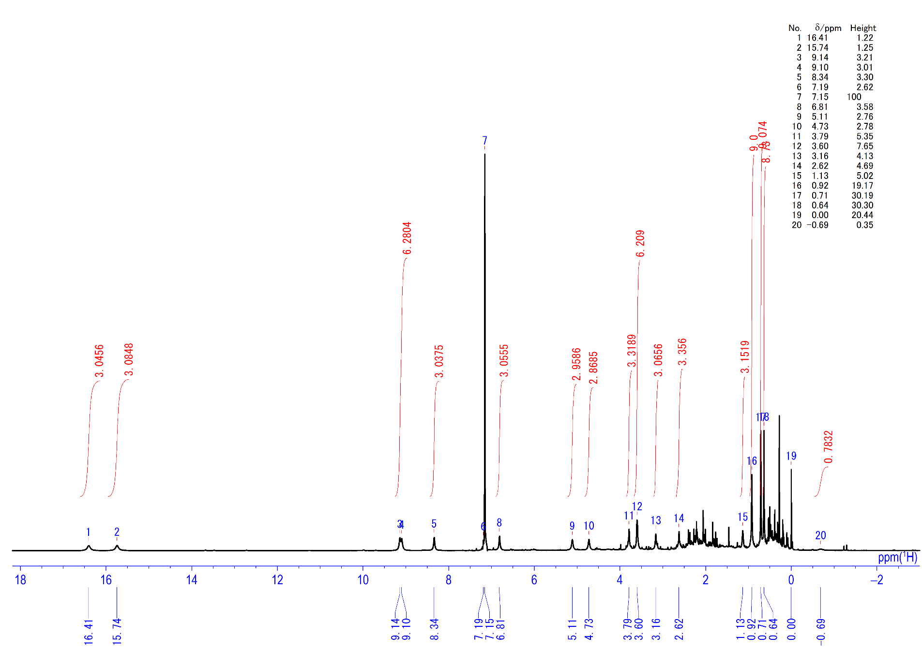
Figure S45. ¹H NMR spectrum of 8c (C₆D₆, rt).

[{(C₅Me₄SiMe₃)Ti}₃(μ₃-N)(μ-NCH(CH₃)(CH₂CH₂CH₂CH₃))(μ-H)₂] (8d). A hexane solution (2.0 mL) of 4d (40 mg, 0.049 mmol) in 10 mL Hiper Glass Cylinder (TAIATSU TECHNO®) was filled with 5 atm of N₂. The solution was stirred at room temperature for 2 days. After the reaction, N₂ was released and H₂ (4 atm) was filled instead. The solution was kept at room temperature for 1 day with stirring. After the reaction, the solution was evaporated and the residual dark brown powder was crystallized in DME at –30 °C to precipitate the crystalline solid [(Cp’Ti)₃(μ₃-N)(μ-NH)(μ-H)₂]. The solution part was evaporated under reduced pressure to give the complex 8d (34 mg, 0.041 mmol, 84%) as a dark green solid (no crystals were obtained).
8d: ¹H NMR (C₆D₆, rt): δ 16.22 (s, 3H, C₅Me₄SiMe₃), 15.79 (s, 3H, C₅Me₄SiMe₃), 9.13 (s, 3H, C₅Me₄SiMe₃), 8.89 (s, 3H, C₅Me₄SiMe₃), 8.39 (s, 3H, C₅Me₄SiMe₃), 6.88 (s, 3H, C₅Me₄SiMe₃), 5.06 (s, 3H, C₅Me₄SiMe₃), 4.87 (s, 3H, C₅Me₄SiMe₃), 3.74 (s, 3H, C₅Me₄SiMe₃), 3.62 (s, 6H, C₅Me₄SiMe₃), 3.07 (s, 3H, C₅Me₄SiMe₃), 2.74 (s, 3H, C₅Me₄SiMe₃), 0.97 (s, 9H, C₅Me₄SiMe₃), 0.89 (s, 3H, -CHMe), 0.74 (s, 9H, C₅Me₄SiMe₃), 0.66 (s, 9H, C₅Me₄SiMe₃), –0.69 (s, 1H, -CHMe). Anal. calcd. for C₄₂H₇₈N₂Si₃Ti₃: C, 60.13; H, 9.37; N, 3.34. Found: C, 59.92; H, 8.89; N, 3.67.

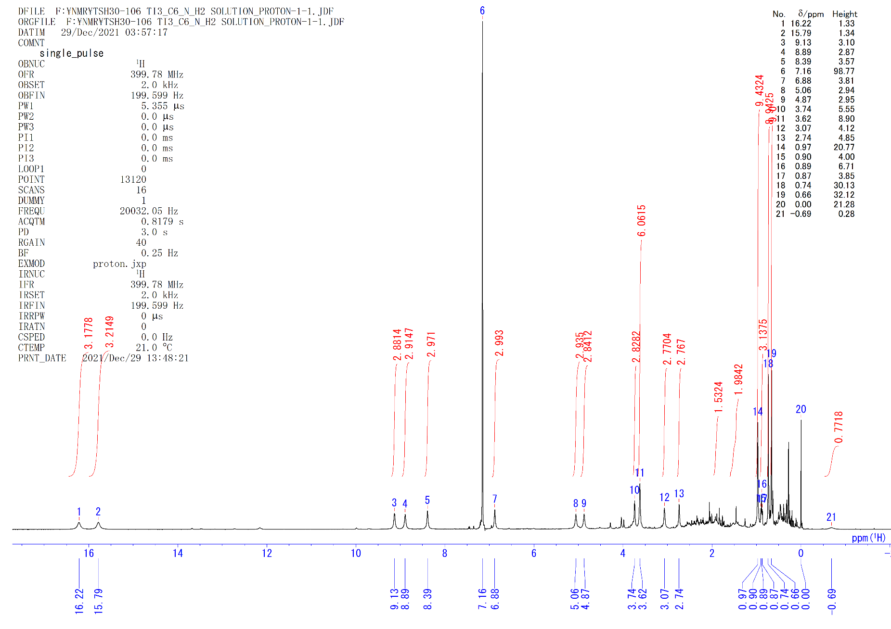
Figure S46. ¹H NMR spectrum of 8d (C₆D₆, rt).

[{(C₅Me₄SiMe₃)Ti}₃(μ₃-N)(μ-NCH(CH₃)Ph)(μ-H)₂] (8e). A hexane solution (2.0 mL) of 4e (60 mg, 0.072 mmol) in 10 mL Hiper Glass Cylinder (TAIATSU TECHNO®) was filled with 5 atm of N₂. The solution was stirred at 40 °C for 2 days. After the reaction, N₂ was released and H₂ (4 atm) was filled instead. The solution was kept at room temperature for 1 day with stirring. After the reaction, the solution was evaporated and the residual dark brown powder was crystallized in hexane at –30 °C to precipitate the crystalline solid [(Cp’Ti)₃(μ₃-N)(μ-NH)(μ-H)₂]. The solution part was evaporated under reduced pressure to give the complex 8e (45 mg, 0.052 mmol, 72%) as a dark brown solid (no crystals were obtained).
8e: ¹H NMR (C₆D₆, rt): δ 14.51 (s, 3H, C₅Me₄SiMe₃), 13.00 (s, 3H, C₅Me₄SiMe₃), 10.61 (s, 3H, C₅Me₄SiMe₃), 7.61 (s, 3H, C₅Me₄SiMe₃), 7.54 (t, J_{HH} =7.2 Hz, 1H, Ph), 6.85 (s, 2H, Ph), 6.65 (s, 3H, C₅Me₄SiMe₃), 6.24 (s, 2H, Ph), 5.55 (s, 3H, C₅Me₄SiMe₃), 4.38 (s, 6H, C₅Me₄SiMe₃), 3.85 (s, 3H, C₅Me₄SiMe₃), 3.37 (s, 3H, C₅Me₄SiMe₃), 3.30 (s, 3H, C₅Me₄SiMe₃), 3.16 (s, 3H, C₅Me₄SiMe₃), 0.75 (s, 9H, C₅Me₄SiMe₃), 0.60 (s, 9H, C₅Me₄SiMe₃), 0.41 (s, 9H, C₅Me₄SiMe₃). Anal. calcd. for C₄₄H₇₄N₂Si₃Ti₃: C, 61.53; H, 8.68; N, 3.26. Found: C, 61.25; H, 8.56; N, 3.57.

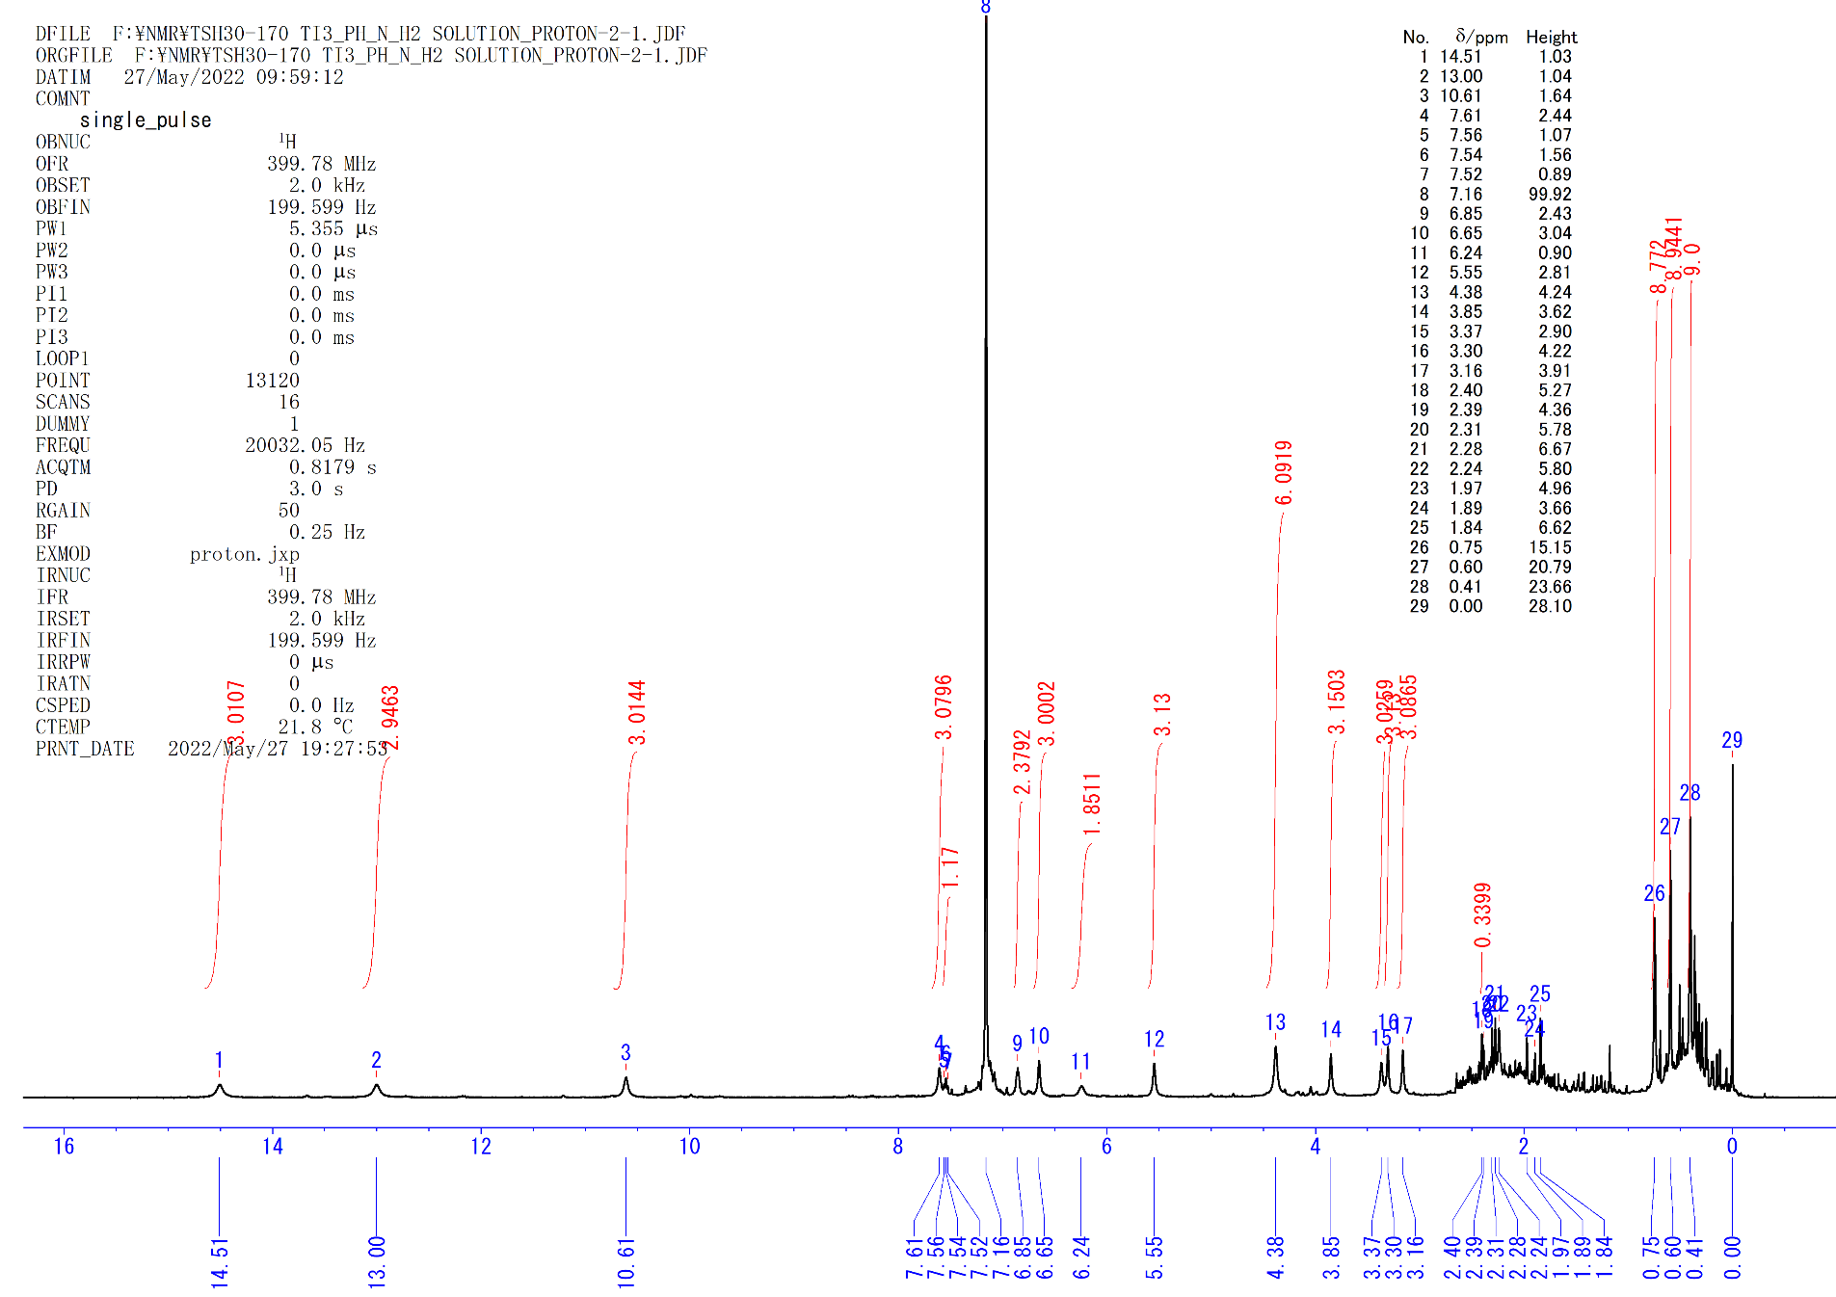
Figure S47. ¹H NMR spectrum of 8e (C₆D₆, rt).

[{(C₅Me₄SiMe₃)Ti}₃(μ₃-N)(μ-NCH(CH₃)C₅H₉)(μ-H)₂] (8f). A hexane solution (2.0 mL) of 4f (63 mg, 0.077 mmol) in 10 mL Hiper Glass Cylinder (TAIATSU TECHNO®) was filled with 5 atm of N₂. The solution was stirred at room temperature for 1 day. After the reaction, N₂ was released and H₂ (10 atm) was filled at –20 °C. The solution was kept at –20 °C for 19 h with stirring. After the reaction, the solution was evaporated and the residual dark brown powder was crystallized in hexane at –30 °C to precipitate the crystalline solid [(Cp’Ti)₃(μ₃-N)(μ-NH)(μ-H)₂]. The solution part was evaporated under reduced pressure to give the complex 8f (55 mg, 0.065 mmol, 84%) as a dark brown solid (no crystals were obtained).
8f: ¹H NMR (C₆D₆, rt): δ 15.42 (s, 3H, C₅Me₄SiMe₃), 14.25 (s, 3H, C₅Me₄SiMe₃), 9.45 (s, 3H, C₅Me₄SiMe₃), 8.31 (s, 3H, C₅Me₄SiMe₃), 6.96 (s, 3H, C₅Me₄SiMe₃), 5.87 (s, 3H, C₅Me₄SiMe₃), 4.77 (s, 3H, C₅Me₄SiMe₃), 4.00 (s, 3H, C₅Me₄SiMe₃), 3.88 (s, 3H, C₅Me₄SiMe₃), 3.30 (s, 6H, C₅Me₄SiMe₃), 2.88 (s, 3H, C₅Me₄SiMe₃), 1.96 (m, 7H, C₅Me₄SiMe₃+-CH₃), 1.53 (m, 2H, -C₅H₉), 0.97 (m, 2H, -C₅H₉), 0.61 (s, 9H, C₅Me₄SiMe₃), 0.59 (s, 9H, C₅Me₄SiMe₃), 0.52 (s, 9H, C₅Me₄SiMe₃). Anal. calcd. for C₄₃H₇₈N₂Si₃Ti₃: C, 60.69; H, 9.24; N, 3.29. Found: C, 59.88; H, 8.91; N, 2.86.

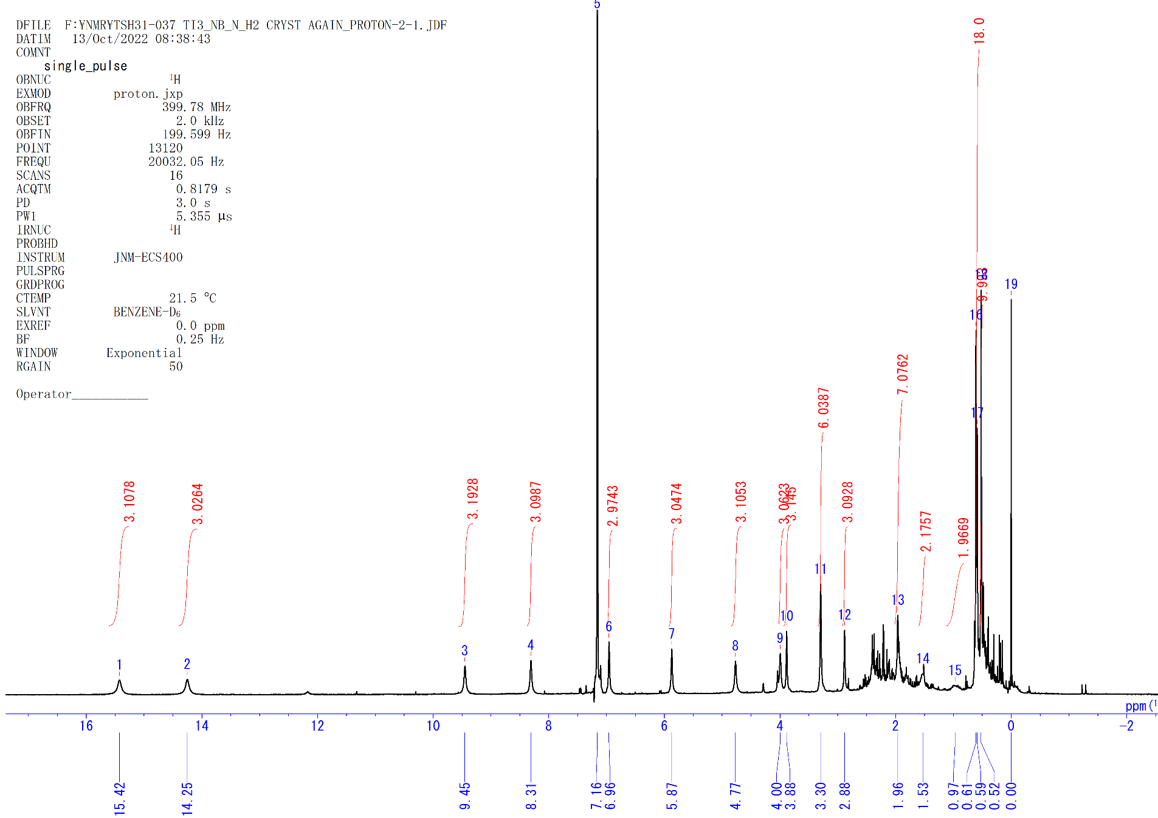
Figure S48. ¹H NMR spectrum of 8f (C₆D₆, rt).

[{(C₅Me₄SiMe₃)Ti}₃(μ₃-N)(μ-NC₆H₁₁)(μ-H)₂] (8g). A C₆D₆ solution (0.5 mL) of 4g (38 mg, 0.047 mmol) in J-Young NMR tube was filled with 1 atm of N₂. The solution was stirred at 40 °C for 2 days. After the reaction, N₂ was removed and H₂ (1 atm) was filled instead. The solution was kept at 40 °C for 1 day. After the reaction, the ¹H NMR showed that the complex 8g was quantitatively formed. The solution part was evaporated under reduced pressure to give the complex 8g (40 mg, 0.047 mmol, 100%) as a dark brown solid. Many trials for crystallization of 8g were failed. Alternatively, the analogous C₅Me₄SiMe₂^{t}Bu-ligated complex [{(C₅Me₄SiMe₂^{t}Bu)Ti}₃(μ₃-N)(μ-NC₆H₁₁)(μ-H)₂] (8g’) obtained from the reaction of [{(C₅Me₄SiMe₂^{t}Bu)Ti}₃(μ₃-η²,η³,η¹-C₆H₇)(μ-H)₃(μ₃-H)] (4g’) with N₂, followed by H₂ provided crystals suitable for an X-ray diffraction study (toluene, –30 °C).
8g: ¹H NMR (C₆D₆, rt): δ 17.03 (s, 6H, C₅Me₄SiMe₃), 9.19 (s, 6H, C₅Me₄SiMe₃), 8.13 (s, 6H, C₅Me₄SiMe₃), 5.48 (s, 6H, C₅Me₄SiMe₃), 4.04 (s, 6H+2H, C₅Me₄SiMe₃+-C₆H₁₁), 3.44 (s, 6H+2H, C₅Me₄SiMe₃+-C₆H₁₁), 2.80 (brs, 2H, -C₆H₁₁), 1.19 (s, 9H, C₅Me₄SiMe₃), 0.82 (s, 18H, C₅Me₄SiMe₃), –1.05 (brs, 1H, -C₆H₁₁). Anal. calcd. for C₄₂H₇₆N₂Si₃Ti₃: C, 60.27; H, 9.15; N, 3.35. Found: C, 60.58; H, 9.29; N, 2.81.
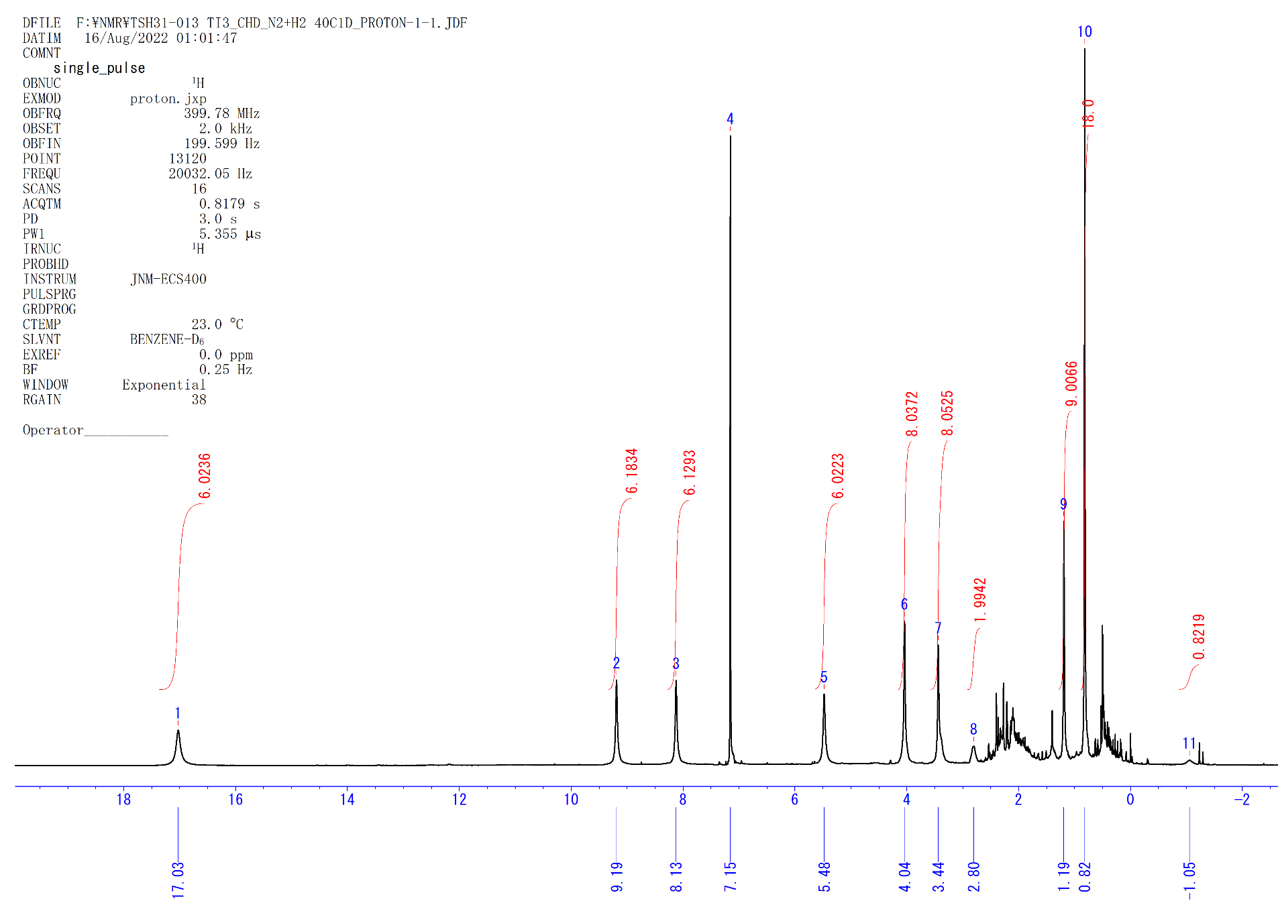
Figure S49. ¹H NMR spectrum of 8g (C₆D₆, rt).

Hydrolysis of 3 with H₂O
Degassed H₂O (5.0 M in THF, 100 µl, 0.50 mmol) was added to a 3 ml toluene solution of complex 3 (22 mg, 0.028 mmol) under vigorously stirring at −78 ºC. After 1 h, the resulting dark-red suspension was separated by a “trap-to-trap” technique. The solid residue was treated with an excess amount of ether solution of HCl (1.0 M, 300 µl). The resulting orange–red solution was evaporated to give (C₅Me₄SiMe₃)TiCl₃ (28 mg, 0.081 mmol, 96%). The volatile part obtained in the above “trap-to-trap” separation was treated with HCl (1.0 M in ether, 0.3 ml), which led to immediate formation of NH₄Cl (2.5 mg, 0.047 mmol, 168%) as white solid. Hydrolysis of C₆D₆ solution of 3 with H₂O in a J. Young valve NMR tube showed the formation of propylene (37% NMR yield) and propane (9% NMR yield) as hydrocarbon units.

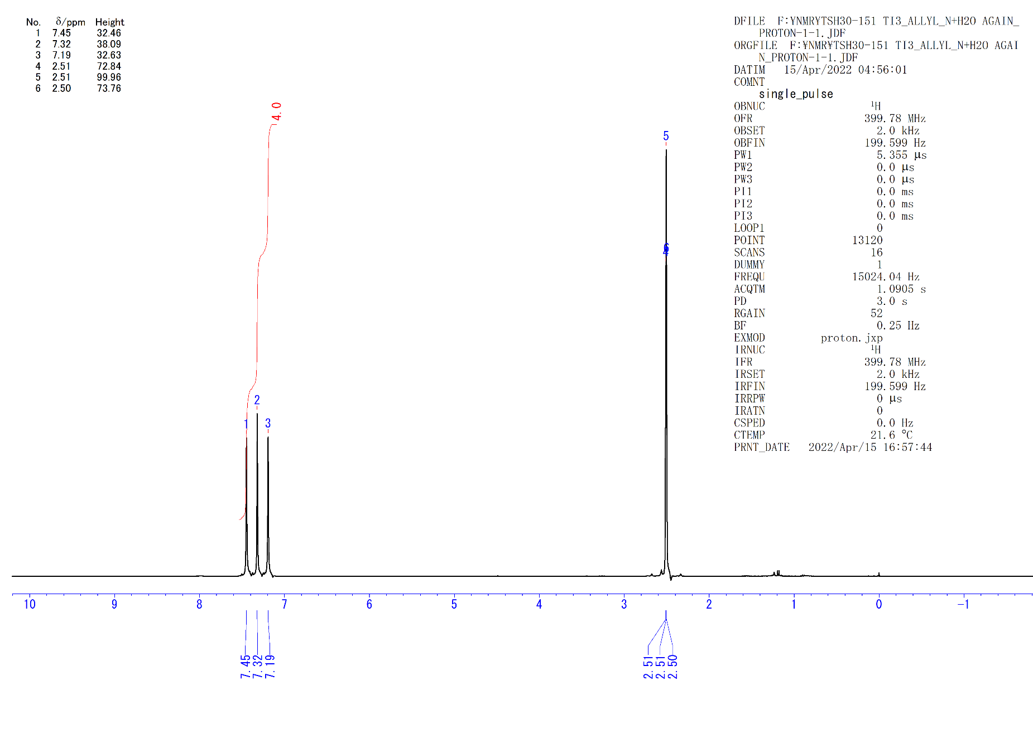
Figure S50. ¹H NMR spectrum of NH₄Cl (dmso-d₆, rt).

Hydrolysis of 5 with H₂O
Degassed H₂O (5.0 M in THF, 200 µl, 1 mmol) was added to a 5 ml toluene solution of complex 5 (41 mg, 0.052 mmol) under vigorously stirring at −78 ºC. After 1 h, the resulting dark-red suspension was separated by a “trap-to-trap” technique. The solid residue was treated with an excess amount of ether solution of HCl (1.0 M, 500 µl). The resulting orange–red solution was evaporated to give (C₅Me₄SiMe₃)TiCl₃ (46 mg, 0.13 mmol, 83%). The volatile part obtained in the above “trap-to-trap” separation was treated with HCl (1.0 M in ether, 0.5 ml), which led to immediate formation of mixture of ^{i}PrNH₃Cl (7a, 20% NMR) and NH₄Cl (144% NMR) as white solid (5.0 mg). As the same manner, ¹⁵N-labeled compounds ^{i}Pr¹⁵NH₃Cl (7a-¹⁵N, 31% NMR) and ¹⁵NH₄Cl (69% NMR) were obtained from 5-¹⁵N and H₂O.
^{i}PrNH₃Cl (7a): ¹H NMR (dmso-d₆, rt): δ 7.98 (brs, 3H, (CH₃)₂CHNH₃Cl), 3.26 (m, 1H, (CH₃)₂CHNH₃Cl), 1.19 (d, J_{HH} = 6.8 Hz, 6H, (CH₃)₂CHNH₃Cl). ¹³C{¹H} NMR (dmso-d₆, rt): δ 42.9 (s, (CH₃)₂CHNH₃Cl), 20.4 (s, (CH₃)₂CHNH₃Cl). EI-MS (m/z): Calculated for C₃H₈N ([M-H]⁺): 58.06567; Found. m/z = 58.06569 ([CH₃-CH(CH₃)-NH]⁺), 44.04991 ([CH₃-CH-NH₂]⁺).
NH₄Cl: ¹H NMR (dmso-d₆, rt): δ 7.39 (1:1:1 t, J_{NH} = 51 Hz, NH₄Cl).
^{i}Pr¹⁵NH₃Cl (7a-¹⁵N): ¹H NMR (dmso-d₆, rt): δ 7.98 (dd, J_{15NH} = 72.0 Hz, J_{HH} = 5.6 Hz, 3H, (CH₃)₂CH¹⁵NH₃Cl), 3.25 (m, 1H, (CH₃)₂CH¹⁵NH₃Cl), 1.18 (dd, J_{HH} = 6.8 Hz, J_{15NH} = 2.5 Hz, 6H, (CH₃)₂CH¹⁵NH₃Cl). ¹³C{¹H} NMR (dmso-d₆, rt): δ 42.9 (d, J_{15NH} = 4.5 Hz, (CH₃)₂CH¹⁵NH₃Cl), 20.4 (s, (CH₃)₂CH¹⁵NH₃Cl). EI-MS: m/z = 59.06278 ([CH₃-CH(CH₃)-¹⁵NH]⁺), 45.04715 ([CH₃-CH-¹⁵NH₂]⁺).
¹⁵NH₄Cl: ¹H NMR (dmso-d₆, rt): δ 7.30 (d, J_{15NH} = 71 Hz, ¹⁵NH₄Cl).

¹H NMR monitoring of the hydrolysis of 5 with H₂O
Degassed H₂O (5.0 M in THF, 4.5 µl, 0.045 mmol) was added to a benzene-d₆ solution of 5 (4.0 mg, 0.005 mmol) at room temperature. After 3 h, the formation of isopropylamine (7a, 47% NMR), propane (29% NMR), and propylene (10% NMR) was confirmed by the ¹H NMR analysis.

Hydrolysis of 8a with H₂O
Degassed H₂O (5.0 M in THF, 150 µl, 0.75 mmol) was added to a 5 ml toluene solution of complex 8a (41 mg, 0.051 mmol) under vigorously stirring at −78 ºC. After 1 h at room temperature, the resulting dark-red suspension was separated by a “trap-to-trap” technique. The solid residue was treated with an excess amount of ether solution of HCl (1.0 M, 500 µl). The resulting orange–red solution was evaporated to give (C₅Me₄SiMe₃)TiCl₃ (50 mg, 0.15 mmol, 95%). The volatile part obtained in the above “trap-to-trap” separation was treated with HCl (1.0 M in ether, 0.3 ml), which led to immediate formation of mixture of ^{i}PrNH₃Cl (7a, 98% NMR) and NH₄Cl (71% NMR) as white solid (6.7 mg). 7a (4 mg, 0.042 mmol, 82%) was isolated by extraction with chloroform.

¹H NMR monitoring of the hydrolysis of 8a with H₂O
Degassed H₂O (5.0 M in THF, 6.0 µl, 0.03 mmol) was added to a benzene-d₆ solution of 8a (4.0 mg, 0.005 mmol) at room temperature. After 3 h, the quantitative formation of ^{i}PrNH₂ (7a) was confirmed by the ¹H NMR analysis. No free hydrocarbon units were observed in the reaction mixture.
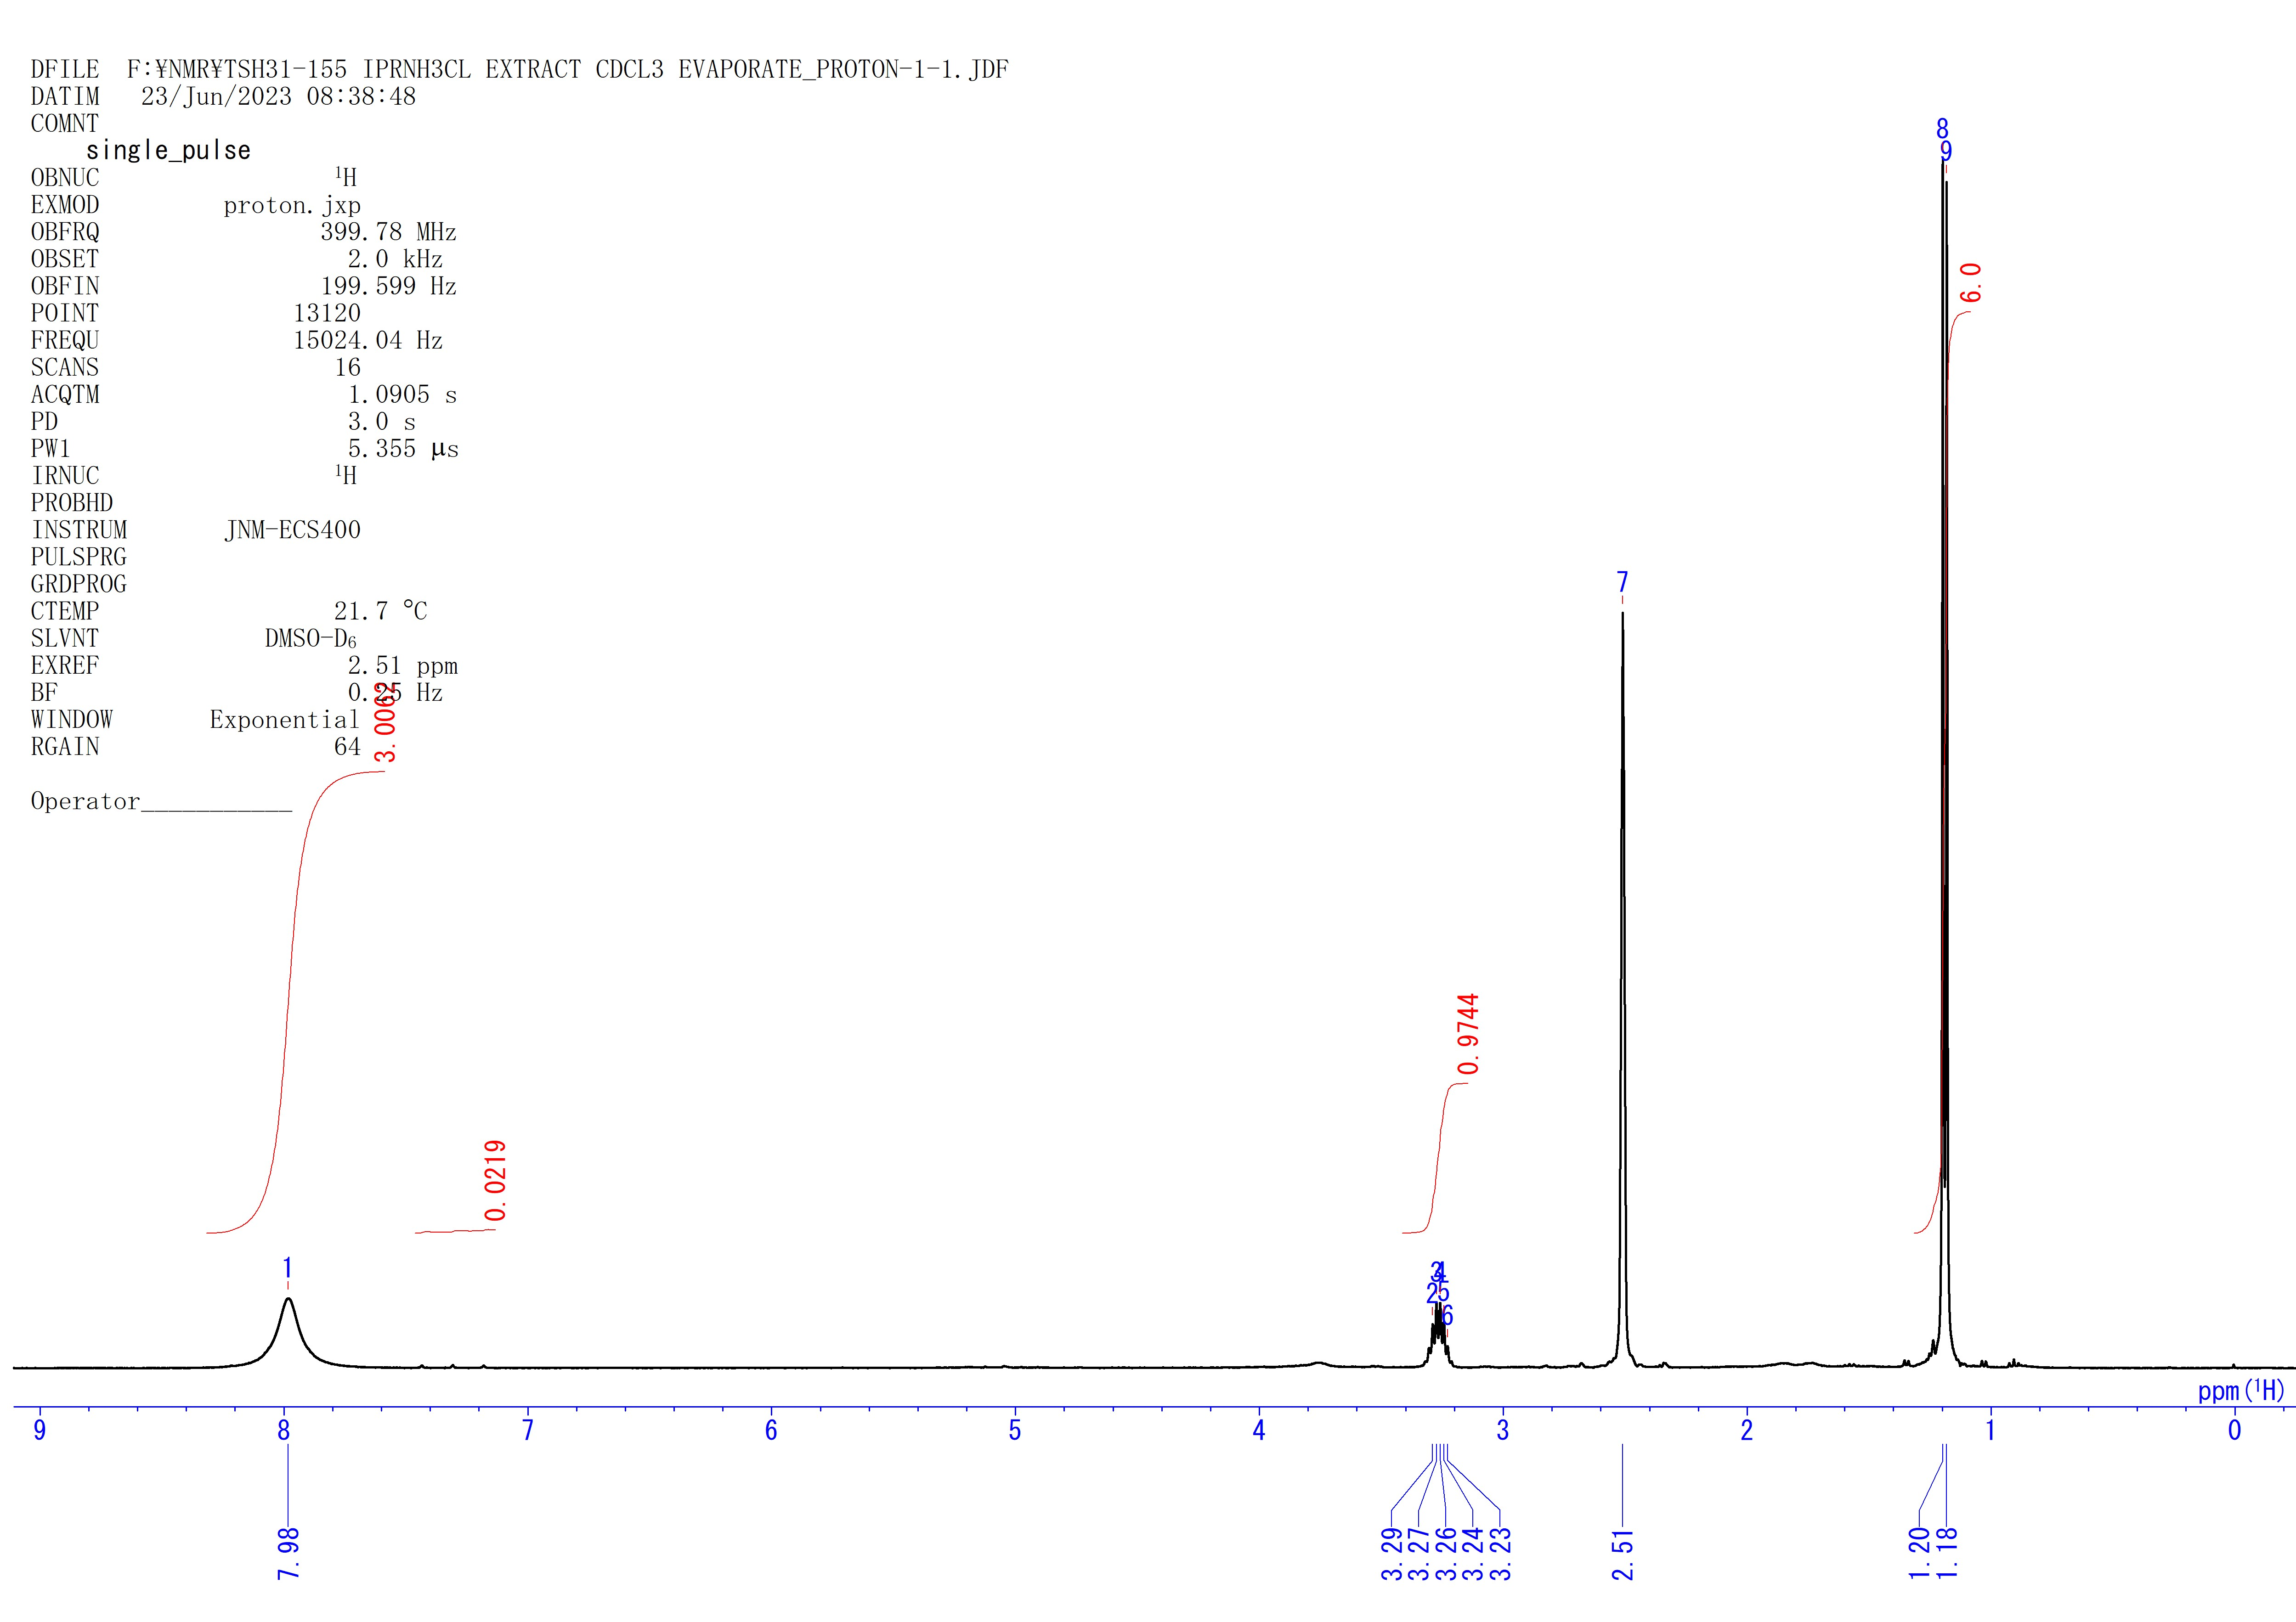
Figure S51. ¹H NMR spectrum of 7a (dmso-d₆, rt).

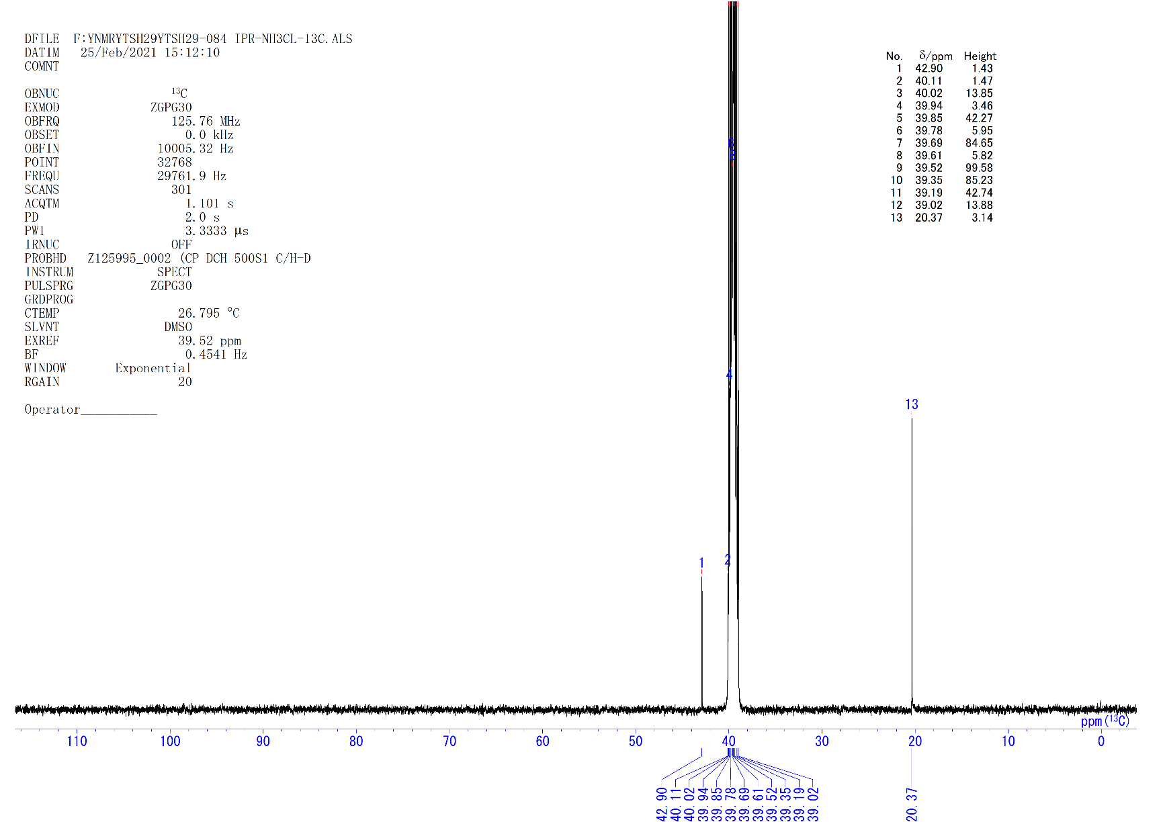
Figure S52. ¹³C{¹H} NMR spectrum of 7a (dmso-d₆, rt).

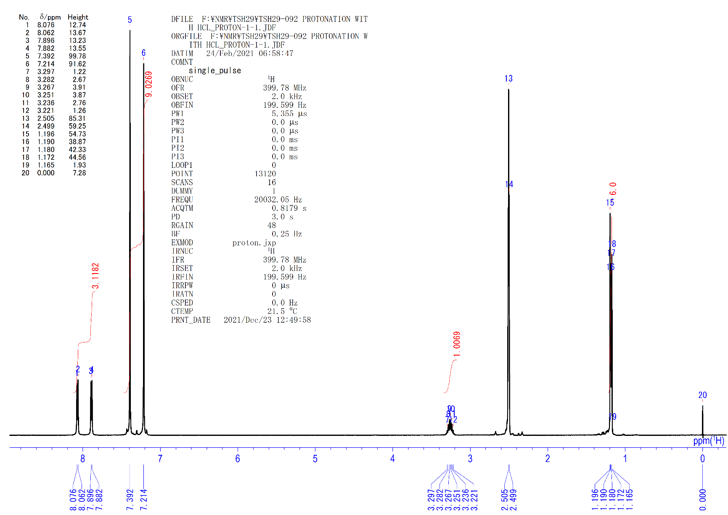
Figure S53. ¹H NMR spectrum of 7a-¹⁵N and ¹⁵NH₄Cl (dmso-d₆, rt).

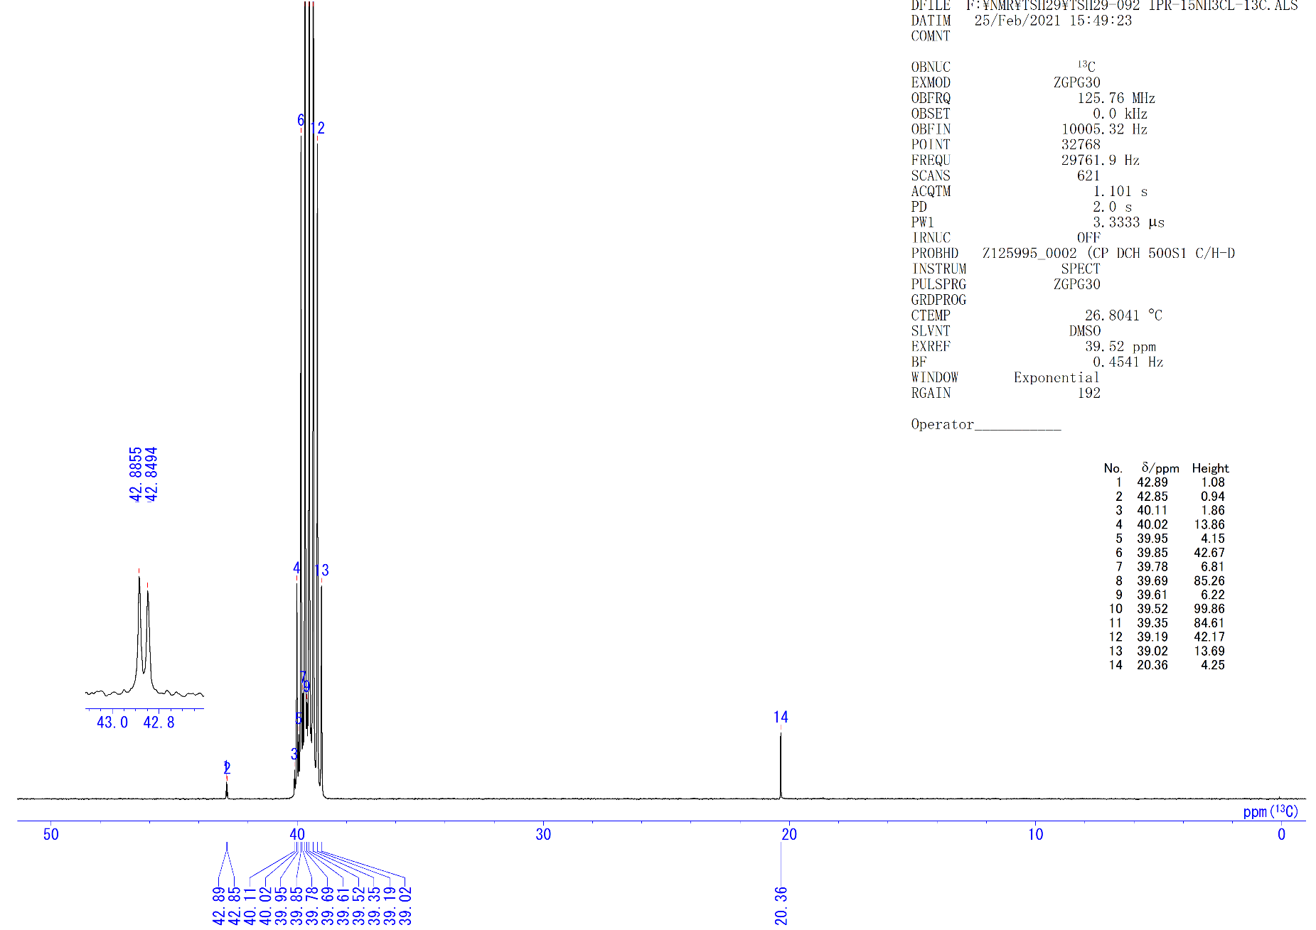
Figure S54. ¹³C{¹H} NMR spectrum of 7a-¹⁵N (dmso-d₆, rt).

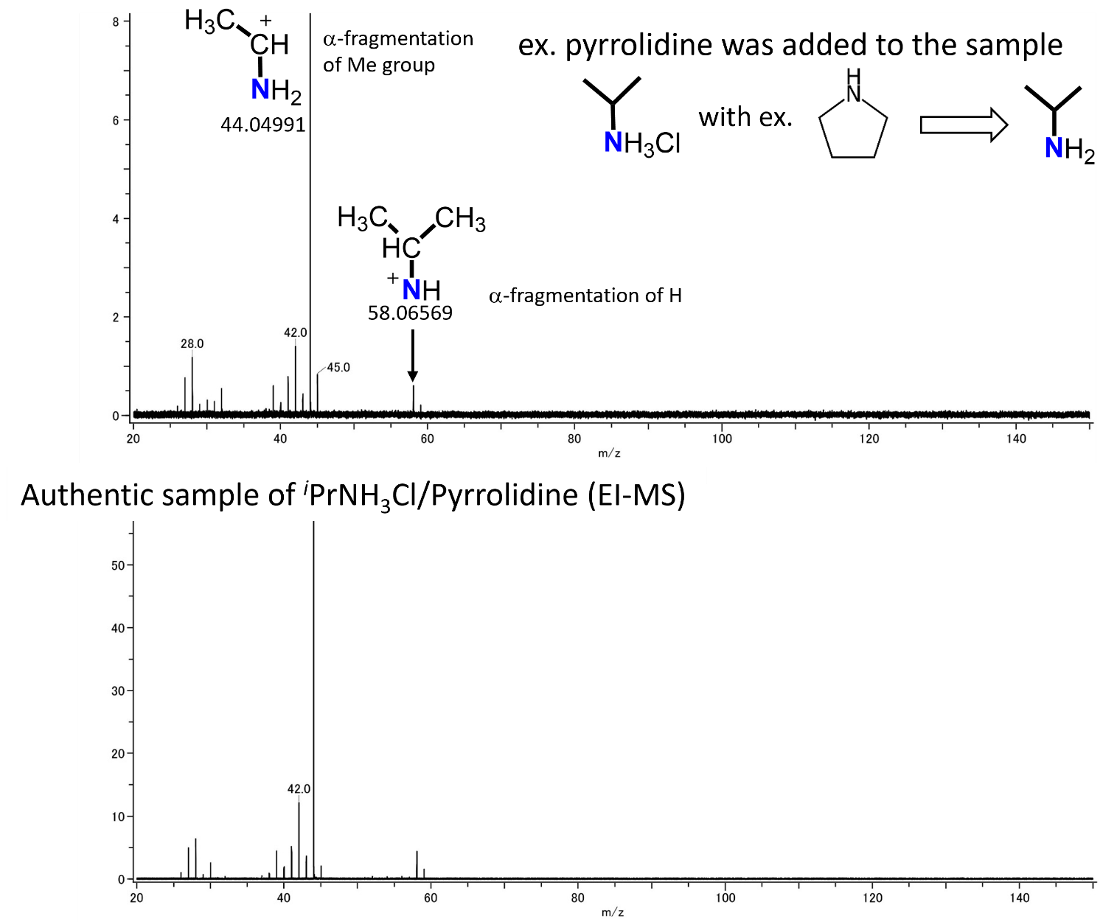
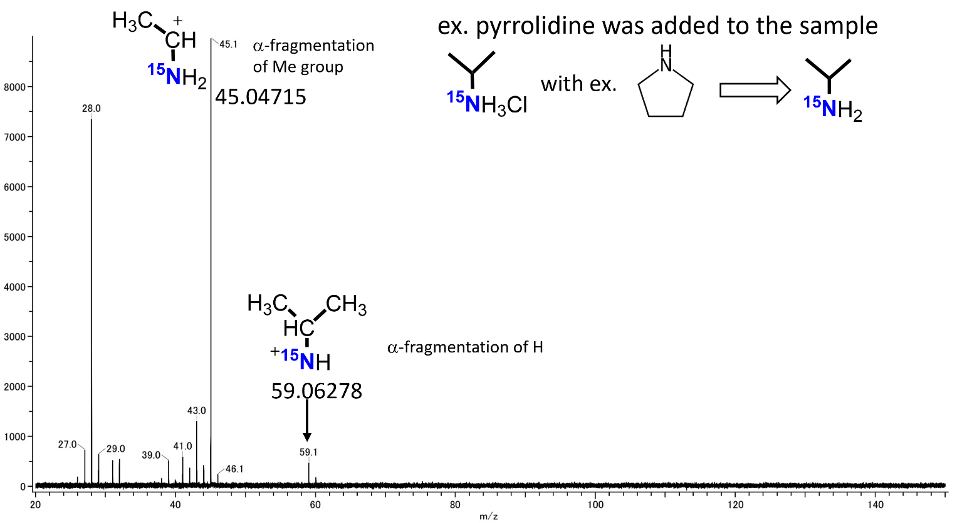
Figure S55. EI-MS spectra of 7a, authentic sample, and 7a-¹⁵N.

Hydrolysis of 8b with H₂O
Degassed H₂O (5.0 M in THF, 200 µl, 1 mmol) was added to a 3 ml toluene solution of complex 8b (43 mg, 0.053 mmol) under vigorously stirring at −78 ºC. After 2 h at room temperature, the resulting dark-red suspension was separated by a “trap-to-trap” technique. The solid residue was treated with an excess amount of ether solution of HCl (1.0 M in ether, 500 µl). The resulting orange–red solution was evaporated to give (C₅Me₄SiMe₃)TiCl₃ (50 mg, 0.15 mmol, 91%). The volatile part obtained in the above “trap-to-trap” separation was treated with HCl (1.0 M in ether, 0.3 ml), which led to immediate formation of mixture of MeCH(CH₂CH₃)NH₃Cl (7b, 87% NMR) and NH₄Cl (70% NMR) as white solid (7 mg).
7b: ¹H NMR (dmso-d₆, rt): δ 8.09 (brs, 3H, CH₃CH(CH₂CH₃)NH₃Cl), 3.04 (m, 1H, CH₃CH(CH₂CH₃)NH₃Cl), 1.64 (m, 1H, CH₃CH(CH₂CH₃)NH₃Cl), 1.47 (m, 1H, CH₃CH(CH₂CH₃)NH₃Cl), 1.17 (d, J_{HH} = 6.4 Hz, 3H, CH₃CH(CH₂CH₃)NH₃Cl), 0.89 (t, J_{HH} = 7.5 Hz, 3H, CH₃CH(CH₂CH₃)NH₃Cl). ¹³C{¹H} NMR (dmso-d₆, rt): δ 48.0 (s, CH₃CH(CH₂CH₃)NH₃Cl), 27.1 (s, CH₃CH(CH₂CH₃)NH₃Cl), 17.6 (s, CH₃CH(CH₂CH₃)NH₃Cl), 9.7 (s, CH₃CH(CH₂CH₃)NH₃Cl). EI-MS (m/z): Calculated for C₄H₁₀N ([M-H]⁺): 72.0813; Found. m/z = 72.08123 ([CH₃-CH₂-CH(CH₃)-NH]⁺), 58.06557([CH₃-CH₂-CH-NH₂]⁺), 44.04986 ([CH₃-CH-NH₂]⁺).

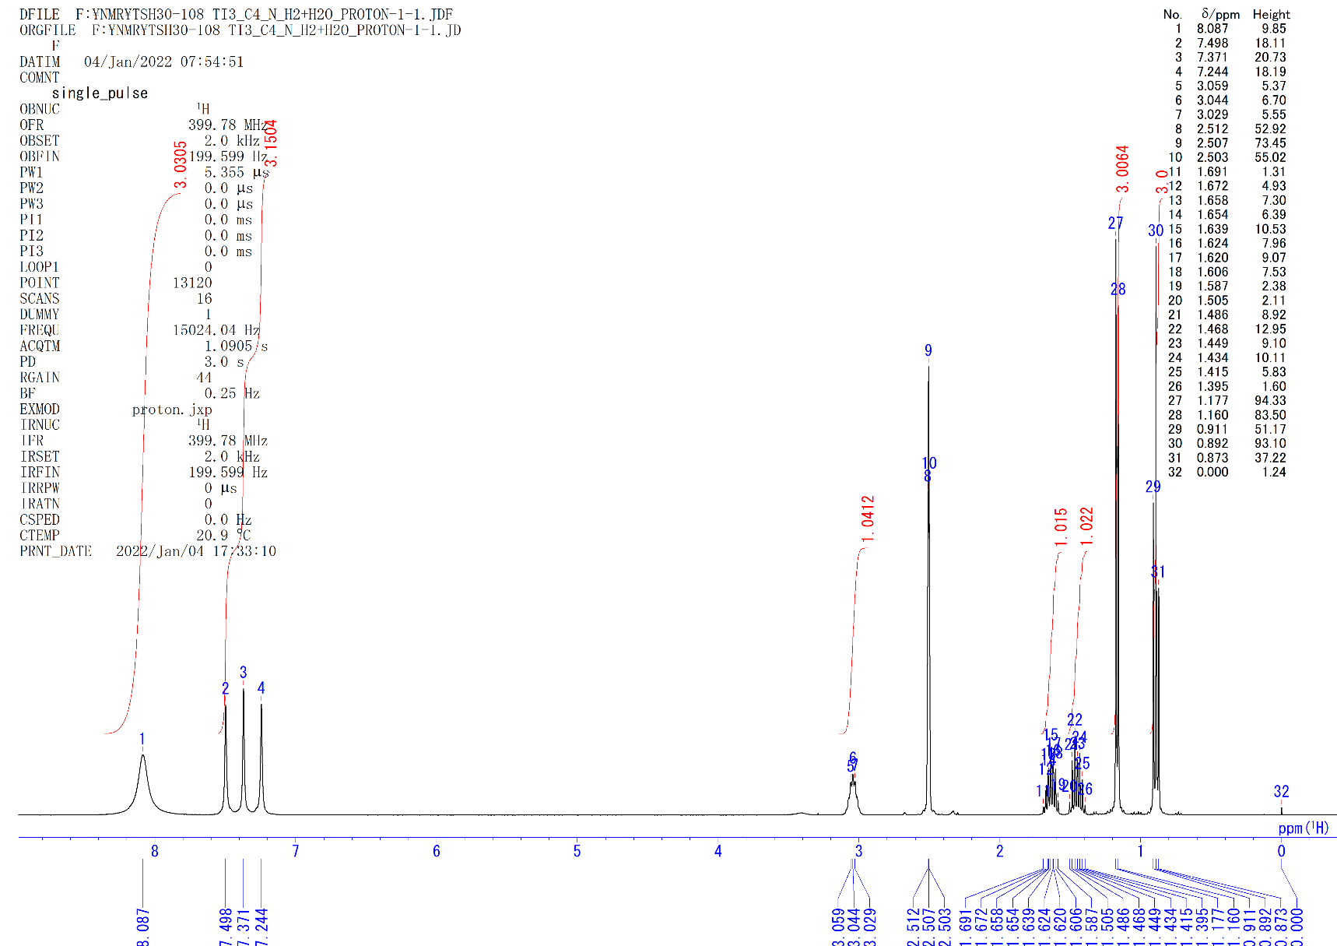
Figure S56. ¹H NMR spectrum of 7b and NH₄Cl (dmso-d₆, rt).

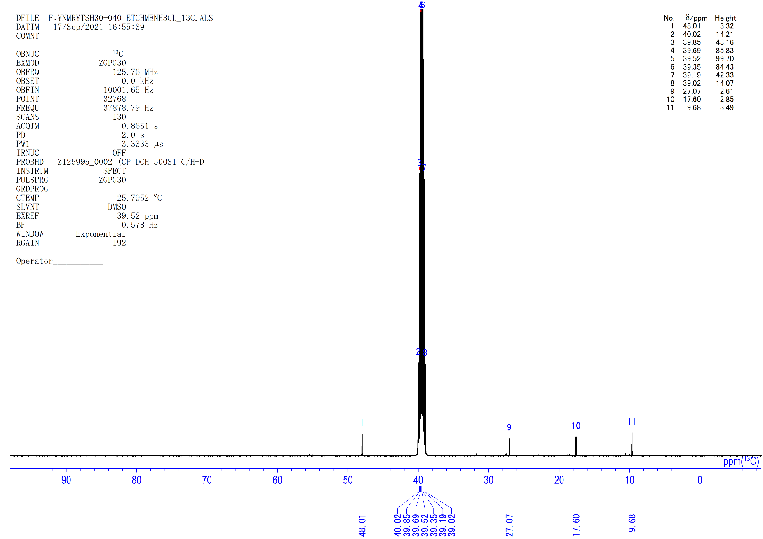
Figure S57. ¹³C NMR spectrum of 7b (dmso-d₆, rt).

Hydrolysis of 8c with H₂O
Degassed H₂O (5.0 M in THF, 200 µl, 1 mmol) was added to a 3 ml toluene solution of complex 8c (51 mg, 0.061 mmol) under vigorously stirring at −78 ºC. After 1 h at room temperature, the resulting dark-red suspension was separated by a “trap-to-trap” technique. The solid residue was treated with an excess amount of ether solution of HCl (1.0 M in ether, 500 µl). The resulting orange–red solution was evaporated to give (C₅Me₄SiMe₃)TiCl₃ (60 mg, 0.17 mmol, 93%). The volatile part obtained in the above “trap-to-trap” separation was treated with HCl (1.0 M in ether, 0.3 ml), which led to immediate formation of mixture of MeCH(CH₂CH₂CH₃)NH₃Cl (7c, 87% NMR) and NH₄Cl (77% NMR) as white solid (9 mg).
7c: ¹H NMR (dmso-d₆, rt): δ 8.13 (brs, 3H, CH₃CH(CH₂CH₂CH₃)NH₃Cl), 3.11 (m, 1H, CH₃CH(CH₂CH₂CH₃)NH₃Cl), 1.58 (m, 1H, CH₃CH(CH₂CH₂CH₃)NH₃Cl), 1.33 (m, 3H, CH₃CH(CH₂CH₂CH₃)NH₃Cl), 1.18 (d, J_{HH} = 6.5 Hz, 3H, CH₃CH(CH₂CH₂CH₃)NH₃Cl), 0.88 (t, J_{HH} = 7.1 Hz, 3H, CH₃CH(CH₂CH₂CH₃)NH₃Cl). ¹³C{¹H} NMR (dmso-d₆, rt): δ 46.5 (s, CH₃CH(CH₂CH₂CH₃)NH₃Cl), 36.2 (s, CH₃CH(CH₂CH₂CH₃)NH₃Cl), 18.1₂ (s, CH₃CH(CH₂CH₂CH₃)NH₃Cl), 18.0₇ (s, CH₃CH(CH₂CH₂CH₃)NH₃Cl), 13.7 (s, CH₃CH(CH₂CH₂CH₃)NH₃Cl). EI-MS (m/z): Calculated for C₅H₁₂N ([M-H]⁺): 86.09697; Found. m/z = 86.09692 ([CH₃-(CH₂)₂-CH(CH₃)-NH]⁺), 72.08113 ([CH₃-(CH₂)₂-CH-NH₂]⁺), 44.04980 ([CH₃-CH-NH₂]⁺).

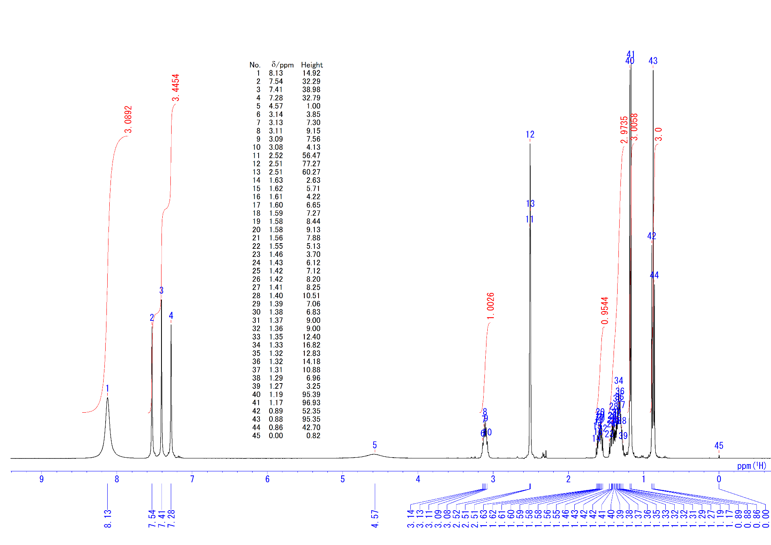
Figure S58. ¹H NMR spectrum of 7c and NH₄Cl (dmso-d₆, rt).

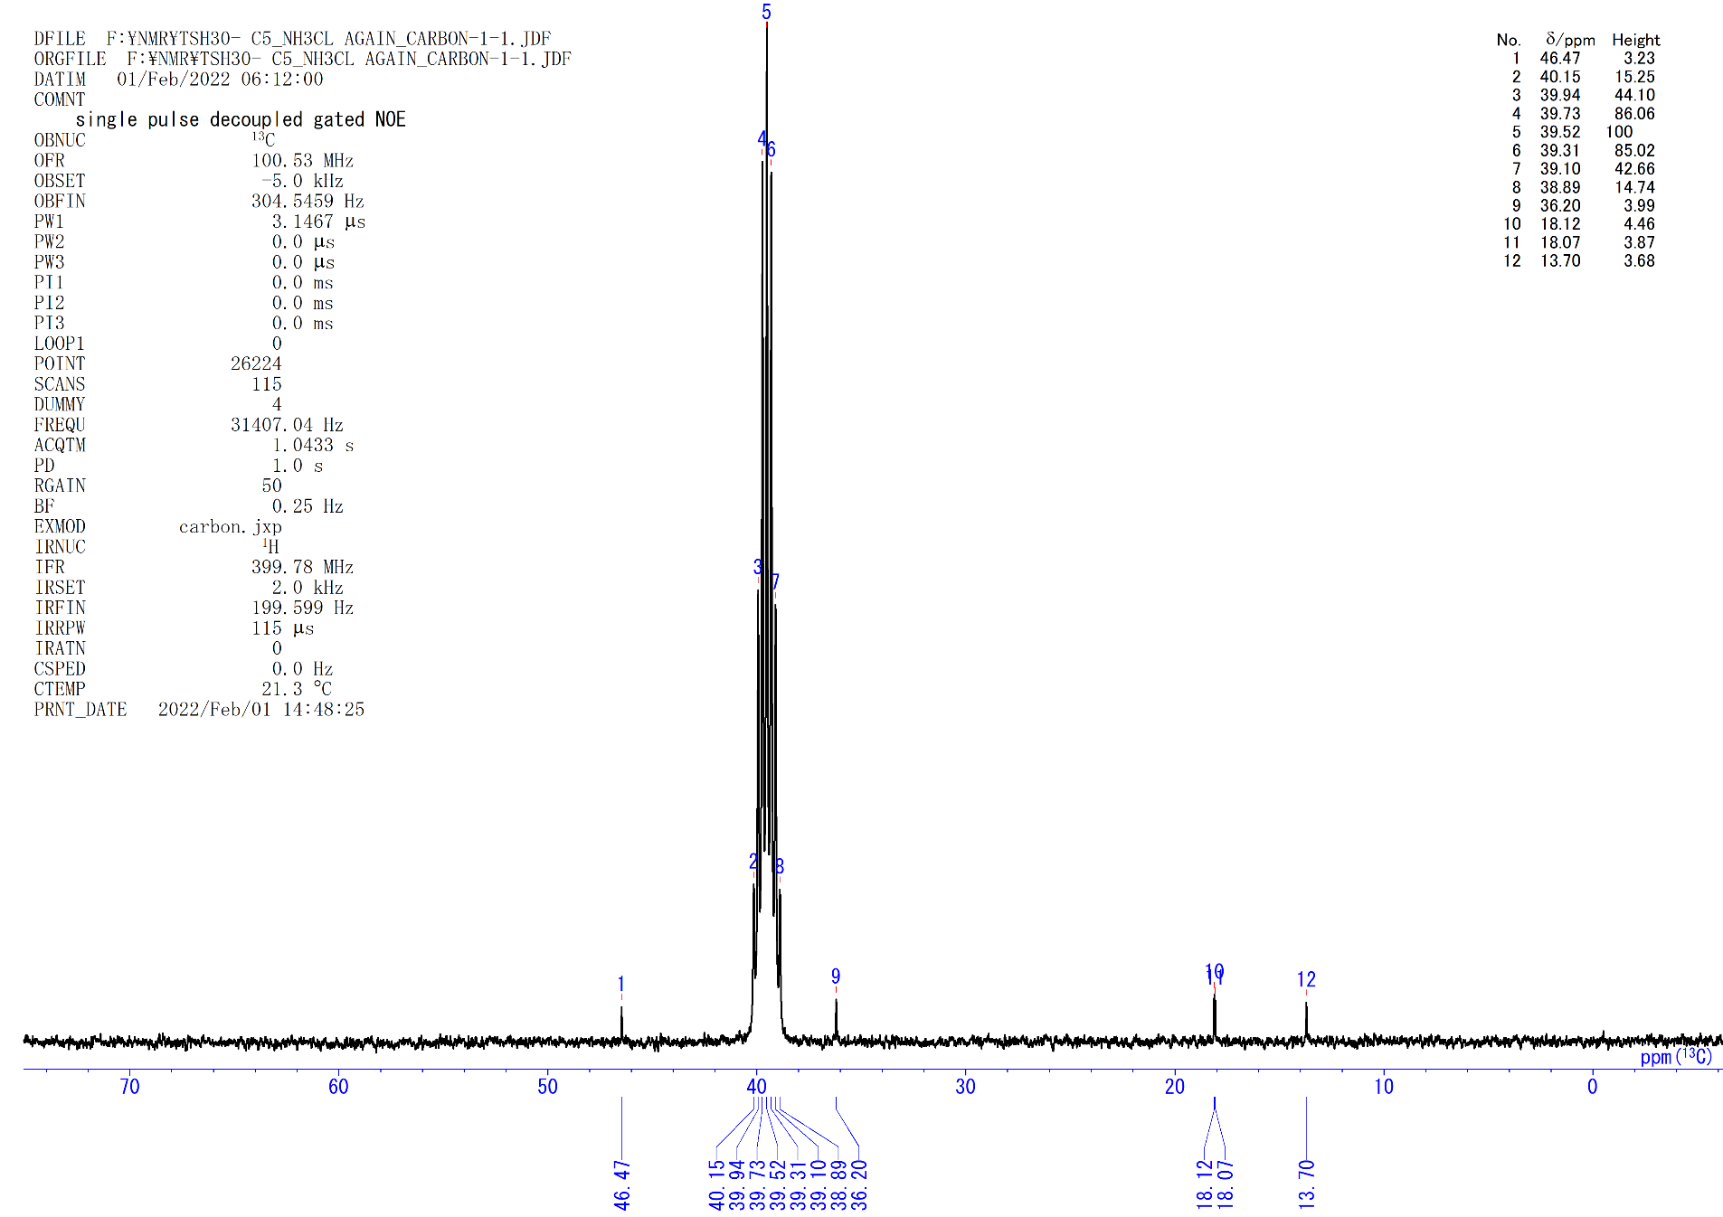
Figure S59. ¹³C{¹H} NMR spectrum of 7c (dmso-d₆, rt).

Hydrolysis of 8d with H₂O
Degassed H₂O (5.0 M in THF, 200 µl, 1 mmol) was added to a 3 ml toluene solution of complex 8d (53 mg, 0.063 mmol) under vigorously stirring at −78 ºC. After 2 h at room temperature, the resulting dark-red suspension was separated by a “trap-to-trap” technique. The solid residue was treated with an excess amount of ether solution of HCl (1.0 M in ether, 600 µl). The resulting orange–red solution was evaporated to give (C₅Me₄SiMe₃)TiCl₃ (60 mg, 0.17 mmol, 90%). The volatile part obtained in the above “trap-to-trap” separation was treated with HCl (1.0 M in ether, 0.3 ml), which led to immediate formation of mixture of MeCH(CH₂CH₂CH₂CH₃)NH₃Cl (7d, 81% NMR) and NH₄Cl (59% NMR) as white solid (9.0 mg).
7d: ¹H NMR (dmso-d₆, rt): δ 8.13 (brs, 3H, CH₃CH(CH₂CH₂CH₂CH₃)NH₃Cl), 3.09 (m, 1H, CH₃CH(CH₂CH₂CH₂CH₃)NH₃Cl), 1.61 (m, 1H, CH₃CH(CH₂CH₂CH₂CH₃)NH₃Cl), 1.43 (m, 1H, CH₃CH(CH₂CH₂CH₂CH₃)NH₃Cl), 1.28 (m, 4H, CH₃CH(CH₂CH₂CH₂CH₃)NH₃Cl), 1.18 (d, J_{HH} = 6.4 Hz, 3H, CH₃CH(CH₂CH₂CH₂CH₃)NH₃Cl), 0.88 (t, J_{HH} = 7.2 Hz, 3H, CH₃CH(CH₂CH₂CH₂CH₃)NH₃Cl). ¹³C{¹H} NMR (dmso-d₆, rt): δ 46.7 (s, CH₃CH(CH₂CH₂CH₂CH₃)NH₃Cl), 33.8 (s, CH₃CH(CH₂CH₂CH₂CH₃)NH₃Cl), 26.9 (s, CH₃CH(CH₂CH₂CH₂CH₃)NH₃Cl), 21.9 (s, CH₃CH(CH₂CH₂CH₂CH₃)NH₃Cl), 18.1 (s, CH₃CH(CH₂CH₂CH₂CH₃)NH₃Cl), 13.8 (s, CH₃CH(CH₂CH₂CH₂CH₃)NH₃Cl). EI-MS (m/z): Calculated for C₆H₁₄N ([M-H]⁺): 100.1126; Found. m/z = 100.1125 ([CH₃-(CH₂)₃-CH(CH₃)-NH]⁺), 86.09685 ([CH₃-(CH₂)₃-CH-NH₂]⁺), 44.04979 ([CH₃-CH-NH₂]⁺).

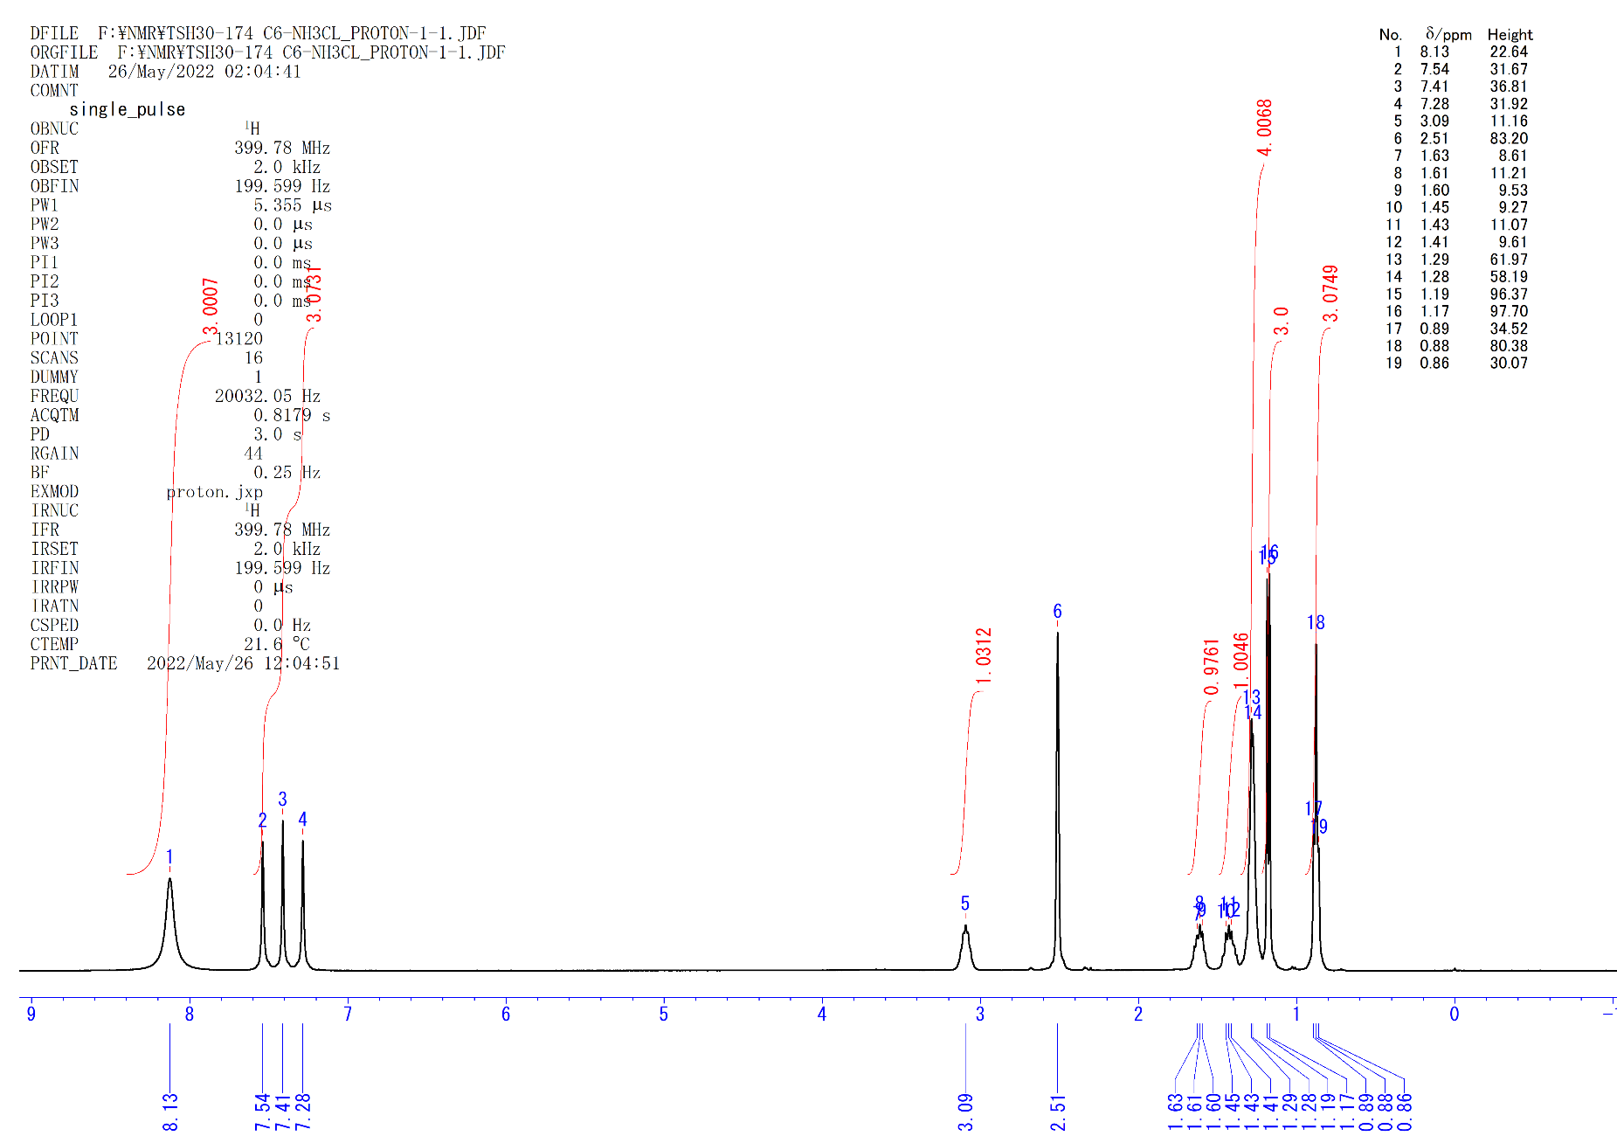
Figure S60. ¹H NMR spectrum of 7d and NH₄Cl (dmso-d₆, rt).

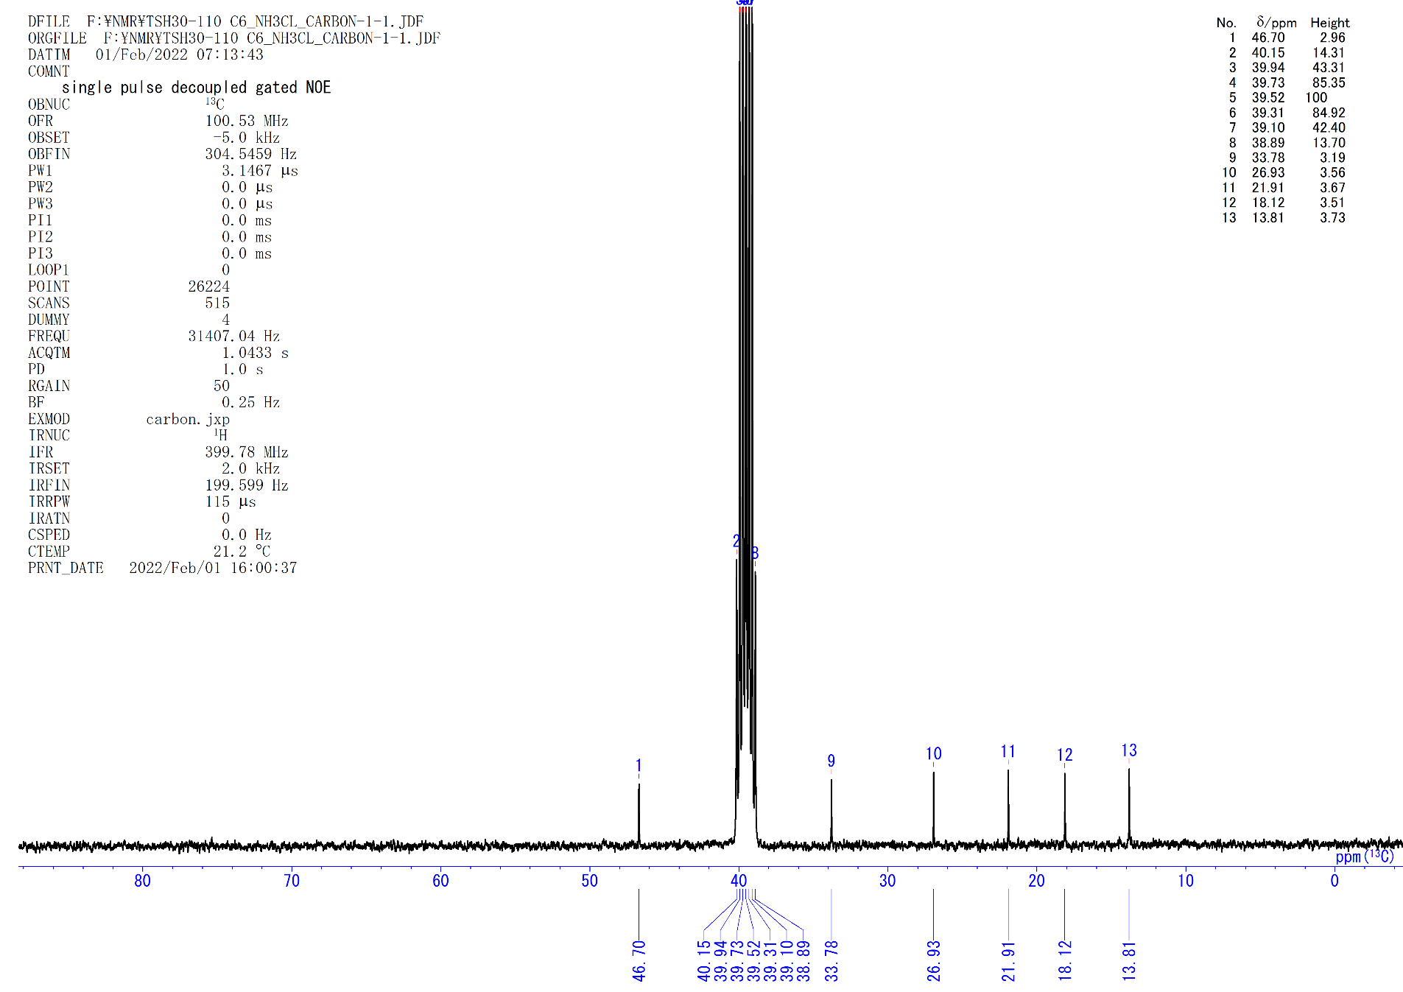
Figure S61. ¹³C{¹H} NMR spectrum of 7d (dmso-d₆, rt).

Hydrolysis of 8e with H₂O
Degassed H₂O (5.0 M in THF, 200 µl, 1.0 mmol) was added to a 3 ml toluene solution of complex 8e (38 mg, 0.044 mmol) under vigorously stirring at −78 ºC. After 2 h at room temperature, the resulting dark-red suspension was separated by a “trap-to-trap” technique. The solid residue was treated with an excess amount of ether solution of HCl (1.0 M in ether, 600 µl). The resulting orange–red solution was evaporated to give (C₅Me₄SiMe₃)TiCl₃ (42 mg, 0.12 mmol, 91%). The volatile part obtained in the above “trap-to-trap” separation was treated with HCl (1.0 M in ether, 0.3 ml), which led to immediate formation of mixture of MeCHPhNH₃Cl (7e, 70% NMR) and NH₄Cl (89% NMR) as white solid (7 mg).
7e: ¹H NMR (dmso-d₆, rt): δ 8.60 (brs, 3H, CH₃CHPhNH₃Cl), 7.54-7.36 (5H, Ph overlap with NH₄Cl), 4.37 (m, 1H, CH₃CHPhNH₃Cl), 1.52 (d, J_{HH} = 6.7 Hz, 3H, CH₃CHPhNH₃Cl). ¹³C{¹H} NMR (dmso-d₆, rt): δ 139.5 (s, Ph), 128.6 (s, Ph), 128.3 (s, Ph), 126.9 (s, Ph), 50.0 (s, CH₃CHPhNH₃Cl), 20.8 (s, CH₃CHPhNH₃Cl). EI-MS (m/z): Calculated for C₈H₁₀N ([M-H]⁺): 120.0813; Found. m/z = 120.0811 ([C₆H₅-CH(CH₃)-NH]⁺), 106.0655 ([C₆H₅-CH-NH₂]⁺).
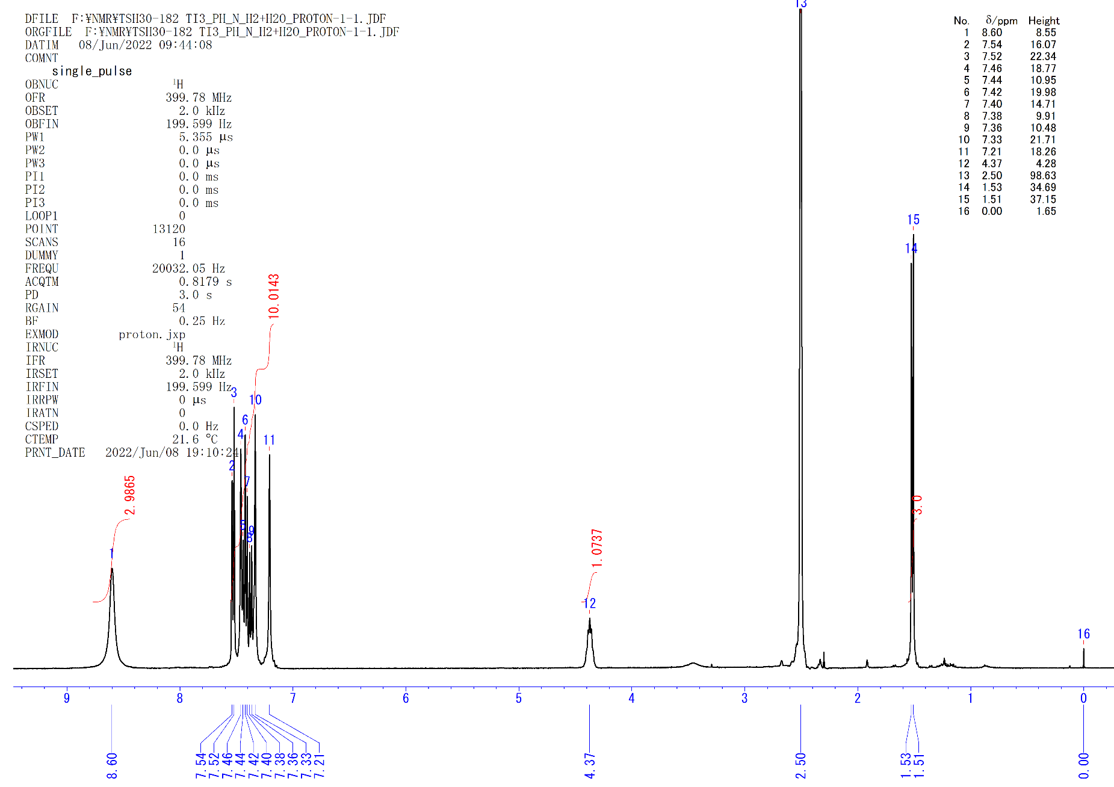
Figure S62. ¹H NMR spectrum of 7e and NH₄Cl (dmso-d₆, rt).

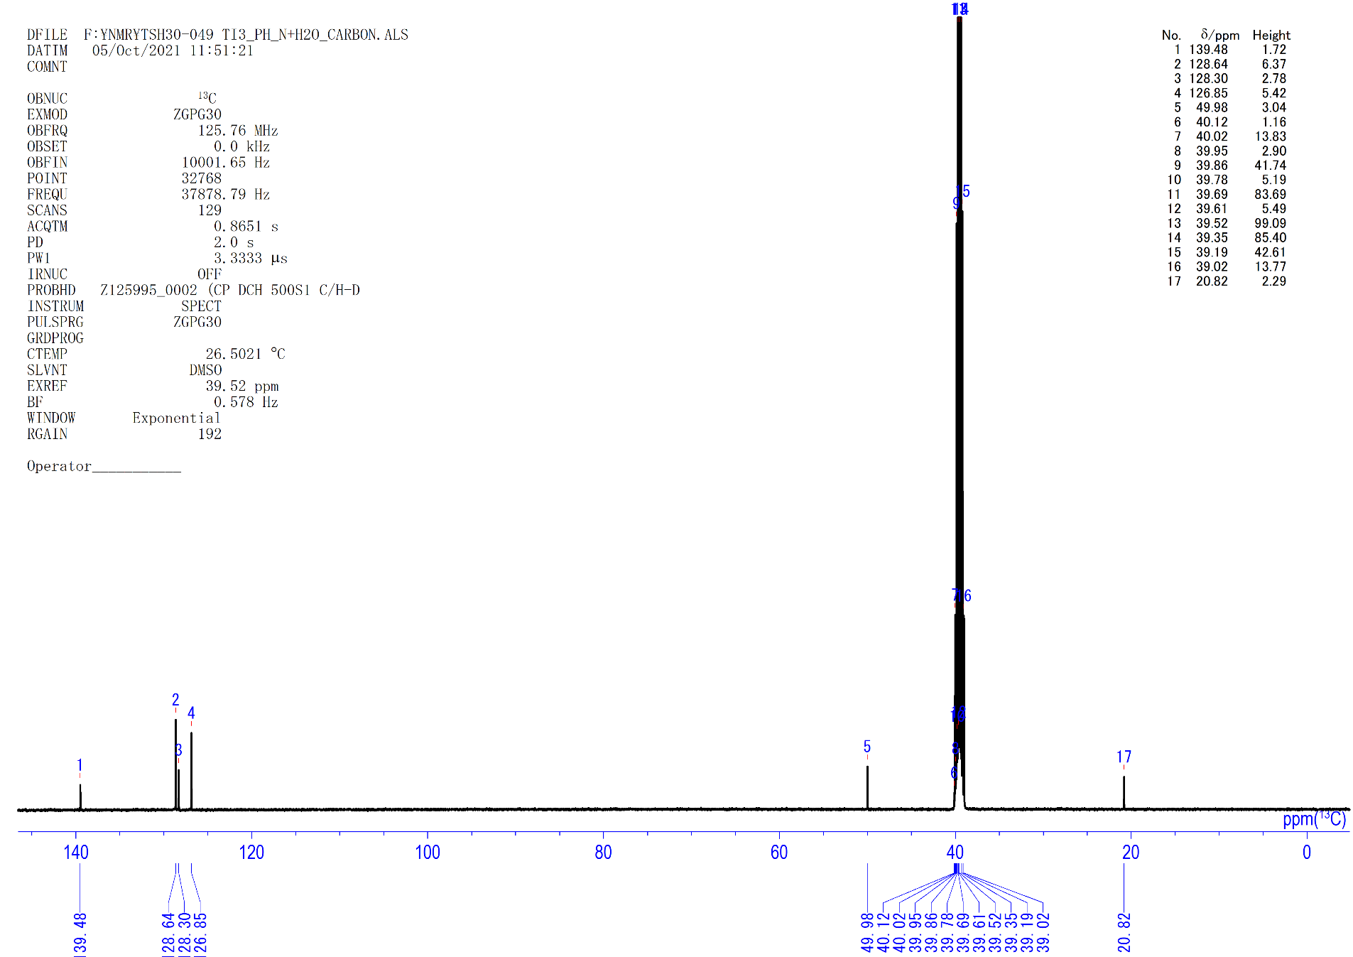
Figure S63. ¹³C{¹H} NMR spectrum of 7e (dmso-d₆, rt).

Hydrolysis of 8f with H₂O
Degassed H₂O (5.0 M in THF, 0.3 ml, 1.5 mmol) was added to a 3 ml toluene solution of complex 8f (46 mg, 0.054 mmol) under vigorously stirring at −78 ºC. After 2 h at room temperature, the resulting dark-red suspension was separated by a “trap-to-trap” technique. The solid residue was treated with an excess amount of ether solution of HCl (1.0 M in ether, 0.6 ml). The resulting orange–red solution was evaporated to give (C₅Me₄SiMe₃)TiCl₃ (50 mg, 0.14 mmol, 90%). The volatile part obtained in the above “trap-to-trap” separation was treated with HCl (1.0 M in ether, 0.5 ml), which led to immediate formation of mixture of C₅H₉CH(CH₃)NH₃Cl (7f, 61% NMR) and NH₄Cl (69% NMR) as white solid (7.0 mg).
7f: ¹H NMR (dmso-d₆, rt): δ 8.06 (brs, 3H, C₅H₉CH(CH₃)NH₃Cl), 2.95 (m, 1H, C₅H₉CH(CH₃)NH₃Cl), 1.91 (m, 1H, C₅H₉CH(CH₃)NH₃Cl), 1.71 (m, 2H, C₅H₉CH(CH₃)NH₃Cl), 1.54 (m, 2H, C₅H₉CH(CH₃)NH₃Cl), 1.48 (m, 2H, C₅H₉CH(CH₃)NH₃Cl), 1.24 (m, 2H, C₅H₉CH(CH₃)NH₃Cl), 1.17 (d, J_{HH} = 6.1 Hz, 3H, C₅H₉CH(CH₃)NH₃Cl). ¹³C{¹H} NMR (dmso-d₆, rt): δ 51.1 (s, C₅H₉CH(CH₃)NH₃Cl), 43.9 (s, C₅H₉CH(CH₃)NH₃Cl), 29.2 (s, C₅H₉CH(CH₃)NH₃Cl), 28.6 (s, C₅H₉CH(CH₃)NH₃Cl), 24.9 (s, C₅H₉CH(CH₃)NH₃Cl), 24.8 (s, C₅H₉CH(CH₃)NH₃Cl), 17.4 (s, C₅H₉CH(CH₃)NH₃Cl). EI-MS (m/z): Calculated for C₇H₁₄N ([M-H]⁺): 112.1126; Found. m/z = 112.1128 ([C₅H₉-CH(CH₃)-NH]⁺), 98.0968 ([C₅H₉-CH-NH₂]⁺), 44.04981 ([CH₃-CH-NH₂]⁺).

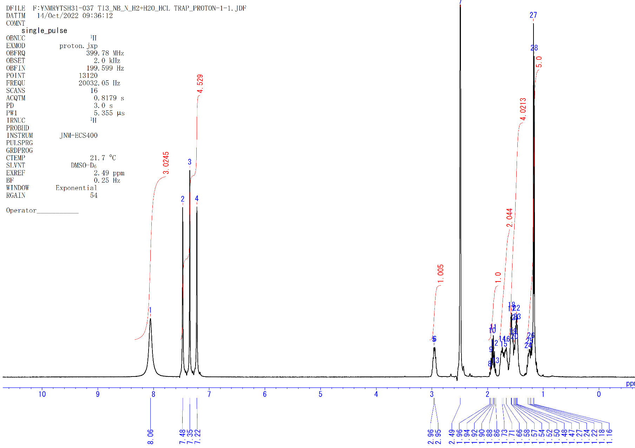
Figure S64. ¹H NMR spectrum of 7f and NH₄Cl (dmso-d₆, rt).

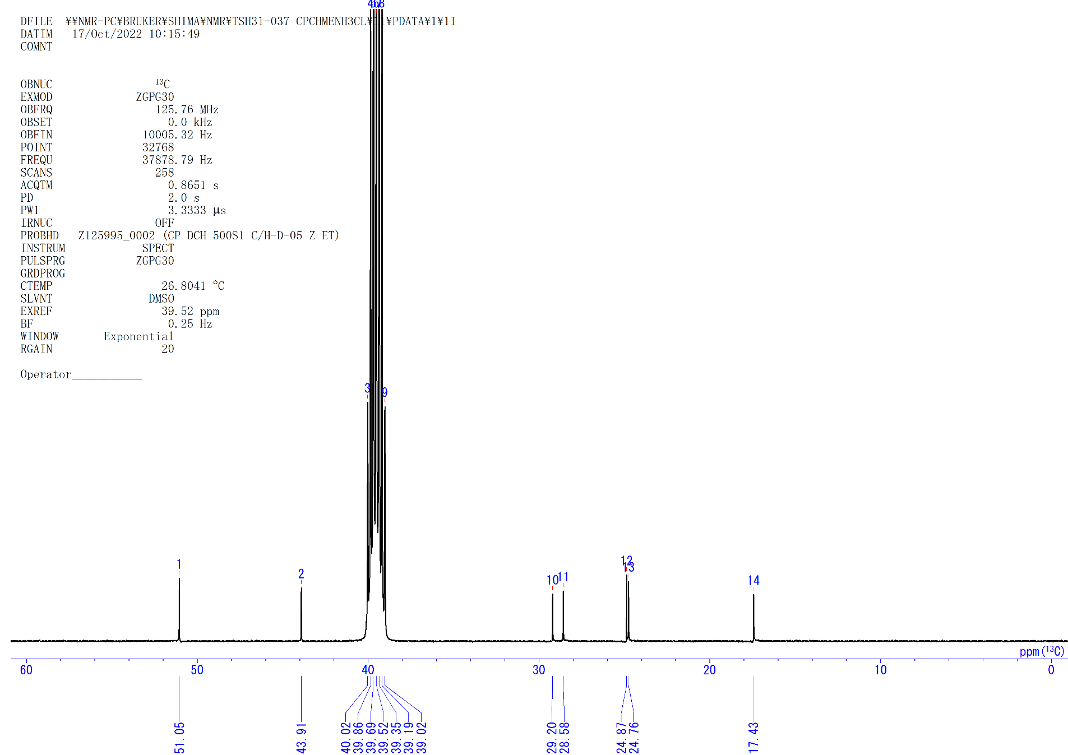
Figure S65. ¹³C{¹H} NMR spectrum of 7f (dmso-d₆, rt).

Hydrolysis of 8g with H₂O
Degassed H₂O (5.0 M in THF, 0.3 ml, 1.5 mmol) was added to a 3 ml toluene solution of complex 8g (39 mg, 0.047 mmol) under vigorously stirring at −78 ºC. After 2 h at room temperature, the resulting dark-red suspension was separated by a “trap-to-trap” technique. The solid residue was treated with an excess amount of ether solution of HCl (1.0 M in ether, 0.6 ml). The resulting orange–red solution was evaporated to give (C₅Me₄SiMe₃)TiCl₃ (45 mg, 0.13 mmol, 92%). The volatile part obtained in the above “trap-to-trap” separation was treated with HCl (1.0 M in ether, 0.5 ml), which led to immediate formation of mixture of C₆H₁₁NH₃Cl (7g, 81% NMR) and NH₄Cl (72% NMR) as white solid (7.0 mg).
7g: ¹H NMR (dmso-d₆, rt): δ 8.09 (brs, 3H, C₆H₁₁NH₃Cl), 2.91 (m, 1H, C₆H₁₁NH₃Cl), 1.90 (m, 2H, C₆H₁₁NH₃Cl), 1.71 (m, 2H, C₆H₁₁NH₃Cl), 1.56 (m, 1H, C₆H₁₁NH₃Cl), 1.25 (m, 4H, C₆H₁₁NH₃Cl), 1.09 (m, 1H, C₆H₁₁NH₃Cl). ¹³C{¹H} NMR (dmso-d₆, rt): δ 49.2 (s, C₅H₁₁NH₃Cl), 30.3 (s, C₅H₁₁NH₃Cl), 24.6 (s, C₅H₁₁NH₃Cl), 23.7 (s, C₅H₁₁NH₃Cl). EI-MS (m/z): Calculated for C₆H₁₃N ([M]⁺): 99.1048; Found. 99.1047.
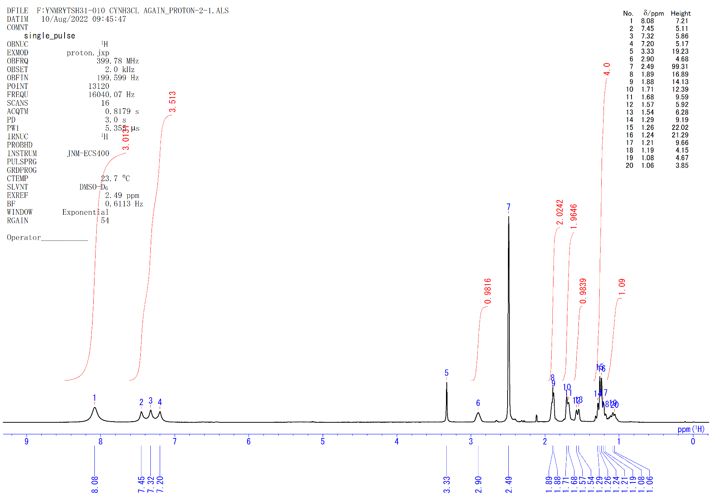
Figure S66. ¹H NMR spectrum of 7g and NH₄Cl (dmso-d₆, rt).

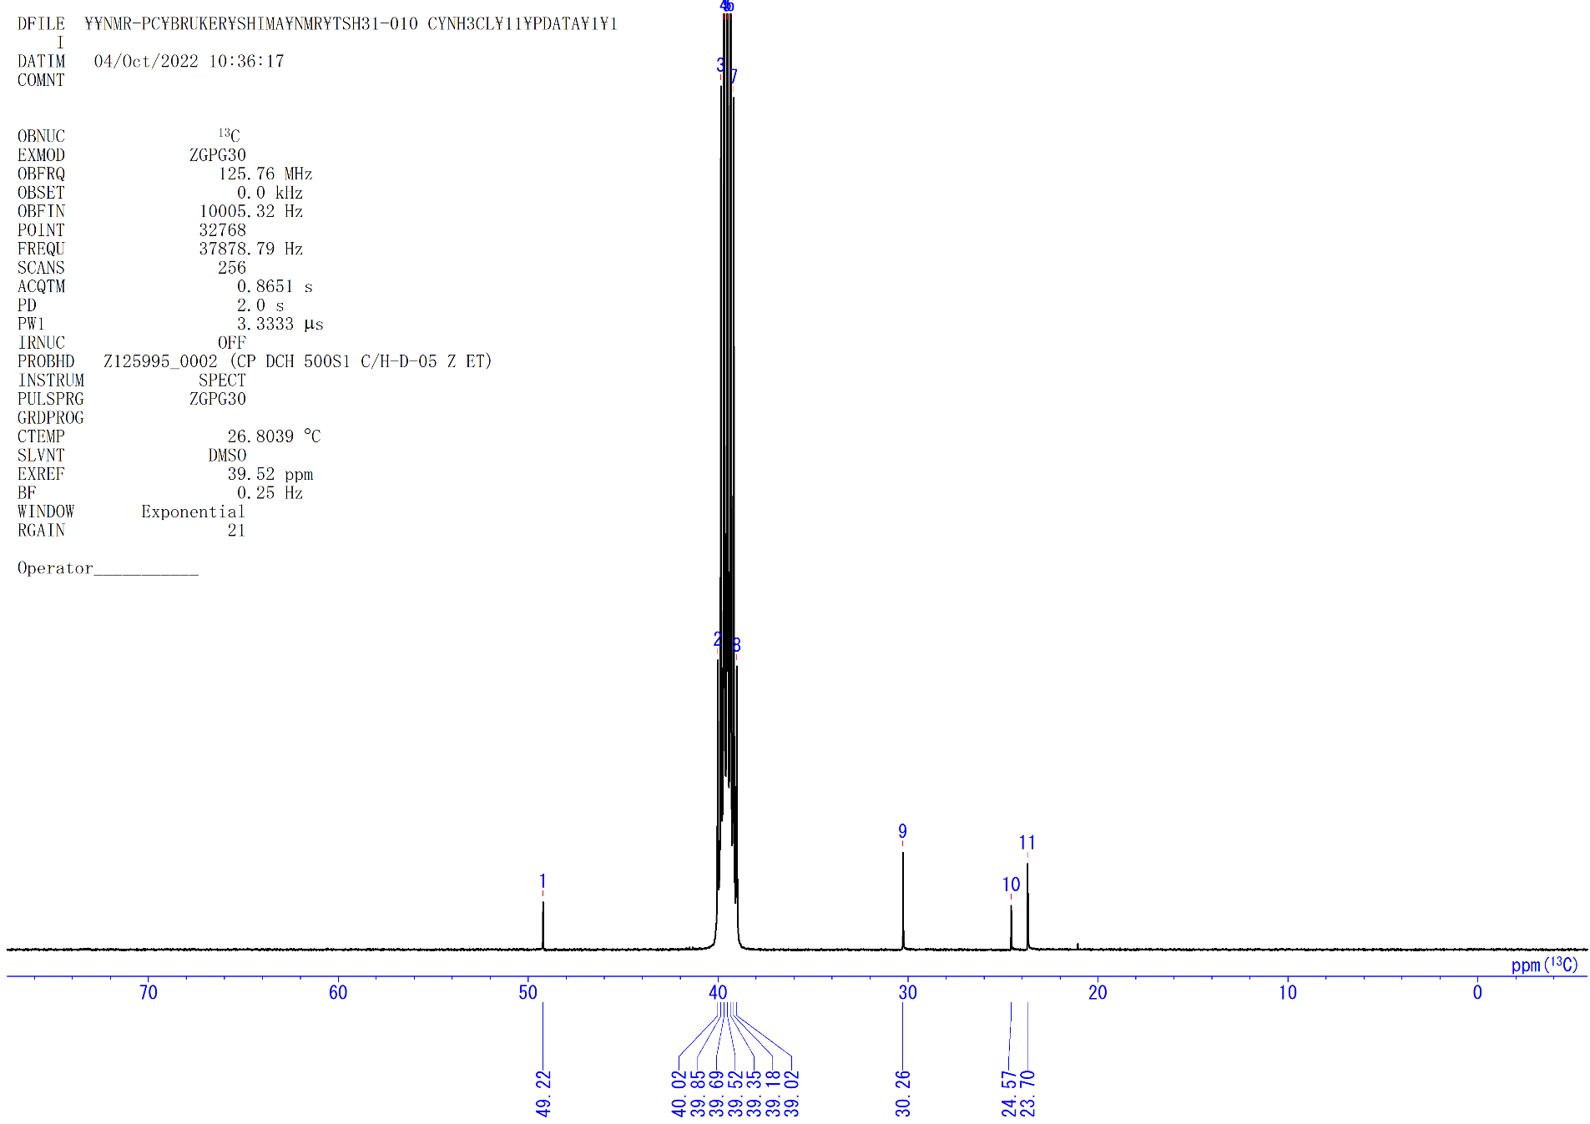
Figure S67. ¹³C{¹H} NMR spectrum of 7g (dmso-d₆, rt).

General procedure for kinetic studies of the reaction of 4a with N₂. In a typical experiment, a 5-mm pressure NMR tube (Wilmad Lab Glass) was charged with 4a (5 mg, 0.0065 mmol) and C₆D₆ (0.40 ml, 16 mM) in a glovebox. The solution was degassed under vacuum. High pressure N₂ gas (5 atm) was then introduced to the NMR tube. After vigorously shaking at room temperature, 4a was quantitatively converted to 6. The sample was heated at various temperatures and analyzed by using an NMR spectrometer. The relative concentration was calculated based on the integration of the resonances of the C₅Me₄SiMe₃ groups in the C₅Me₄SiMe₃ ligands.

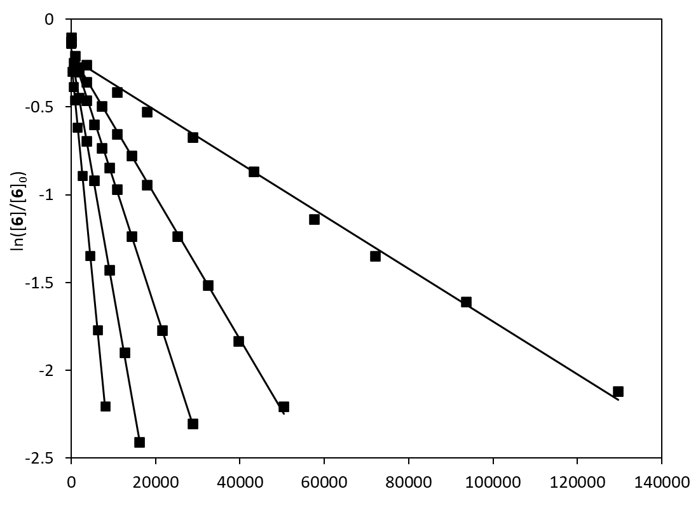
Time (s)
Figure S68. First-order plots of the disappearance of 6 as a function of time (s) at different temperature.

Table S1. Observed rate constants (k_{obs}) for the conversion of 6 to 5.
Temperature ⁰C (K) | k_{obs} (s⁻¹)
22 ⁰C (295 K) | 1.50448×10⁻⁵
30 ⁰C (303 K) | 4.07468×10⁻⁵
35 ⁰C (308K) | 7.44581×10⁻⁵
40 ⁰C (313 K) | 1.36892×10⁻⁴
45 ⁰C (318 K) | 2.47584×10⁻⁴

Figure S69. Eyring plot of the conversion of 6.

The activation parameters for the reaction of 4a with N₂ (5 atm) were determined by measuring rate constants at various temperatures (Figure S52). An Eyring plot (Figure S53) was constructed from these data (Table S1), and the activation enthalpy and entropy were extracted as follows: ΔH≠ = 22.0(2) kcal/mol, ΔS≠ = –5.9(7) eu, ΔG≠(298K) = 23.7 kcal/mol.

General procedure for kinetic studies of the conversion of 5 to 3. 5-mm J-Young NMR tube was charged with 5 (3.0 mg×5, 0.0038×5 mmol) and C₆D₆ (0.40 ml×5, 0.01 M) in a glovebox. The solution of 5 was heated at various temperatures, and analyzed by using an NMR spectrometer. The relative concentration was calculated based on the integration of the resonances of the C₅Me₄SiMe₃ groups in the C₅Me₄SiMe₃ ligands.

Table S2. Observed rate constants (k_{obs}) for the conversion of 5 to 3.
Temperature ⁰C (K) | k_{obs} (s⁻¹)
60 ⁰C (333 K) | 2.67266×10⁻⁵
65 ⁰C (338 K) | 4.57702×10⁻⁵
70 ⁰C (343 K) | 7.83415×10⁻⁵
75 ⁰C (348 K) | 1.29236×10⁻⁴
80 ⁰C (353 K) | 2.11049×10⁻⁴
65 ⁰C (338 K) | *3.40168×10⁻⁵
* conversion of 5-d to 3-d.

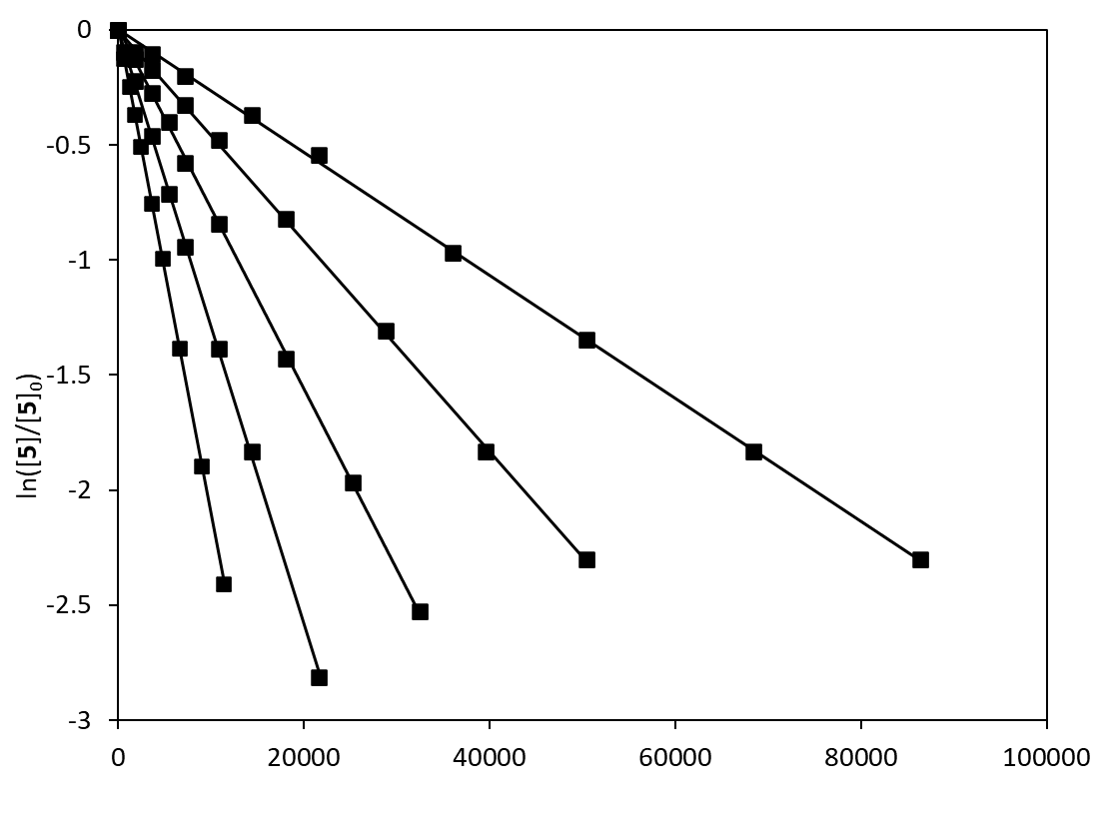
Figure S70. First-order plots of the disappearance of 5 as a function of time (s) at different temperature.
Figure S71. Eyring plot of the conversion of 5 to 3.

The activation parameters for the conversion of 5 to 3 were determined by measuring rate constants at various temperatures (Figure S54). An Eyring plot (Figure S55) was constructed from these data (Table S1), and the activation enthalpy and entropy were extracted as follows: ΔH≠ = 23.4(1) kcal/mol, ΔS≠ = –9.2(3) eu, ΔG≠(298K) = 24.1 kcal/mol.

Figure S72. Formal synthetic cycle for transformation of alkenes and N₂ into alkyl amines mediated by titanium complexes.

X-ray Crystallographic Studies. Crystals for X-ray analysis were obtained as described in the preparations. The crystals were manipulated in the glovebox under a microscope in the glovebox, and were mounted on nylon cryoloops with polybutenes (M_{n} ~920, Aldrich). Data collection were performed at –100 °C on Bruker D8 QUEST diffractrometer with CMOS area detector, using an IμS (Incoatec Microfocus Source) microfocus sealed tube with Mo-Kα radiation (λ = 0.71073 Å). The Bravais lattice and the unit cell parameters were determined by the Bruker APEX3 software package. The raw frame data were processed, and absorption corrections were done using SAINT⁴ and SADABS⁴ embedded in Bruker APEX3 to yield the reflection data (hkl) file. All of the structures were solved using SHELXL-2018. Structural refinement was performed using Olex2 systems, on F² anisotropically for all of the non-hydrogen atoms by the full matrix least-squares method. Analytical scattering factors for neutral atoms were used throughout the analysis. The hydrogen atoms of the Cp′ ligands were placed at the calculated positions, which were refined using a riding model. Other hydrogen atoms could be located on difference Fourier maps and refined isotropically. Disorder at the C1, C1A, C1B, and N1, N1A, N1B, and C13, C14, C15, C13A, C14A, C15A, and C25, C26, C27, C25A, C26A, C27A, and C37, C38, C39, C37A, C38A, C39A atoms in 3 was refined at 60(C1)%:20(C1A)%:20(C1B)%, 40(N1)%:40(N1A)%:20(N1B)%, 56(C13,C14,C15)%: 44(C13A,C14A,C15A)%, 69(C25,C26,C27)%: 31(C25A,C26A,C27A)%, 50(C37,C38,C39):50(C37A,C38A,C39A)% occupancy. Disorder at the C16, C17, C18, and C16A, C17A, C18A atoms in 4f was refined at 52(C16,C17,C18) : 48(C16A,C17A,C18A)% occupancy. Disorder at the N1, N1A, N1B, and C1, C2, C3, C4, C5, C6 atoms in 6 was refined at 50(N1) :25(N1A) :25(N1B)%, and 50(C1,C2,C3,C5) :25(C4,C6)% occupancy. The analytical scattering factors for neutral atoms were used throughout the analysis. The residual electron densities were of no chemical significance. Crystal data and analysis results are listed in Table S3.
Table S3. X-Ray crystallographic data and structure refinement for 1’, 3, 4a, 4f’, 4g, 6, 8a, and 8g’.
 | 1’ | 3 | 4a | 4f’ | 4g | 5 | 6 | 8a | 8g’
CCDC number | 2226119 | 2184614 | 2184610 | 2285950 | 2226120 | 2184611 | 2184612 | 2184613 | 2226121
formula | C₄₅H₈₈Si₃Ti₃∙C₃H₇ | C₃₉H₆₇N₂Si₃Ti₃ | C₃₉H₇₀Si₃Ti₃ | C₅₂H₉₄Si₃Ti₃ | C₄₂H₇₄Si₃Ti₃ | C₃₉H₆₈N₂Si₃Ti₃∙C₂H₅O | C₃₉H₆₈N₂Si₃Ti₃ | C₃₉H₇₂N₂Si₃Ti₃ | C₅₁H₉₄N₂Si₃Ti₃
formula weight | 900.20 | 791.91 | 766.92 | 947.24 | 806.98 | 837.98 | 792.92 | 796.95 | 963.25
crystal system | triclinic | monoclinic | triclinic | triclinic | triclinic | triclinic | monoclinic | triclinic | monoclinic
space group | P-1 | P2₁/n | P-1 | P-1 | P-1 | P-1 | P2₁/n | P-1 | P2₁/c
a, Å | 11.1673(3) | 11.5470(2) | 10.455(5) | 11.8409(7) | 10.9833(3) | 10.1274(3) | 11.4039(6) | 11.4141(5) | 11.5177(5)
b, Å | 11.5091(4) | 19.5979(4) | 11.285(5) | 16.8885(9) | 11.4834(3) | 11.6114(4) | 20.1349(11) | 11.9154(5) | 40.3561(17)
c, Å | 21.5001(7) | 19.3634(4) | 19.790(9) | 28.3739(15) | 19.7850(5) | 20.2424(6) | 19.1121(10) | 18.4622(7) | 12.1735(5)
α, deg | 90.2969(14) |  | 75.297(6) | 88.358(3) | 75.9095(14) | 105.3654(13) |  | 98.606(2)
β, deg | 96.8877(13) | 103.0488(8) | 76.669(7) | 88.355(3) | 76.2416(14) | 91.3155(12) | 90.898(3) | 101.647(2) | 94.793(2)
γ, deg | 96.1696(14) |  | 69.619(6) | 79.765(3) | 71.6674(15) | 92.6611(12) |  | 111.5620(19)
V, Å³ | 2727.02(15) | 4268.73(14) | 2091.0(16) | 5579.9(5) | 2261.96(11) | 2291.27(13) | 4387.9(4) | 2217.00(16) | 5638.6(4)
Z | 2 | 4 | 2 | 4 | 2 | 2 | 4 | 2 | 4
D_{calcd}, g/cm³ | 1.096 | 1.232 | 1.218 | 1.128 | 1.185 | 1.215 | 1.200 | 1.194 | 1.135
temp, K | 173(2) | 173(2) | 173(2) | 173(2) | 173(2) | 173(2) | 173(2) | 173(2) | 173(2)
μ, mm⁻¹(MoKα) | 0.522 | 0.660 | 0.670 | 0.514 | 0.622 | 0.620 | 0.642 | 0.635 | 0.510
2θ_{max} | 55.0 | 50.0 | 50.0 | 55.0 | 60.0 | 55.0 | 55.0 | 55.0 | 55.0
reflections collected | 12420 | 28221 | 12004 | 25351 | 16061 | 31944 | 46018 | 24279 | 12916
independent reflections (R_{int}) | 10633 (0.0465) | 7545 (0.0234) | 7995 (0.1128) | 20335 (0.0404) | 9908 (0.0568) | 12089 (0.0275) | 10048 (0.0754) | 6701 (0.0483) | 10137 (0.0491)
R1 (I > 2σ(I)) | 0.0431 | 0.0408 | 0.1076 | 0.0889 | 0.0637 | 0.0483 | 0.1113 | 0.0602 | 0.0798
wR2 (I > 2σ(I)) | 0.1132 | 0.0977 | 0.2524 | 0.2173 | 0.1289 | 0.1237 | 0.2730 | 0.1407 | 0.1974
wR2 (all data) | 0.1198 | 0.1000 | 0.2707 | 0.2288 | 0.1509 | 0.1303 | 0.2835 | 0.1527 | 0.2093
parameters | 562 | 484 | 440 | 1131 | 505 | 482 | 550 | 450 | 565
GOF | 1.016 | 1.072 | 0.929 | 1.053 | 1.016 | 1.039 | 1.139 | 1.047 | 1.088

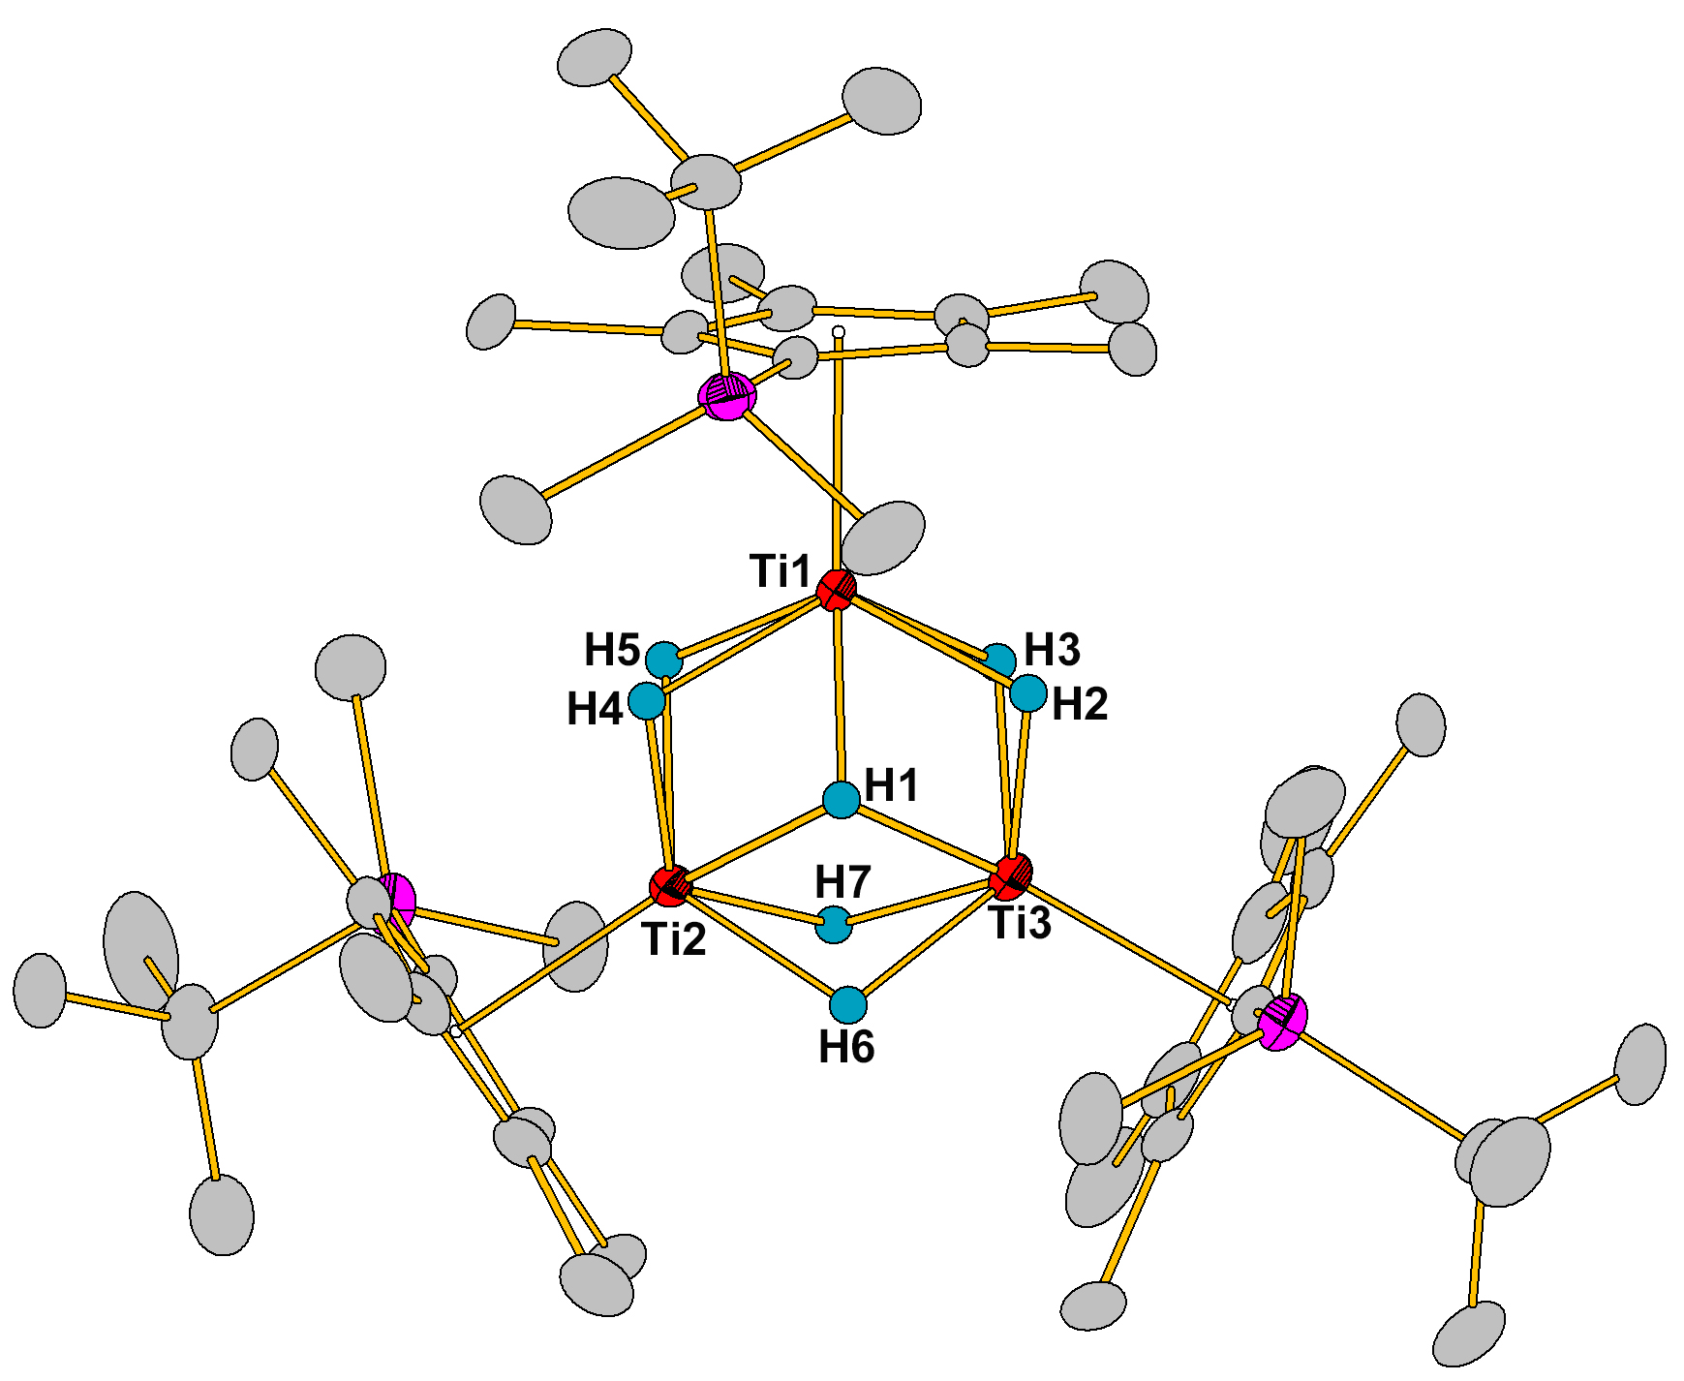
Figure S73. ORTEP drawing of the structure of 1’.

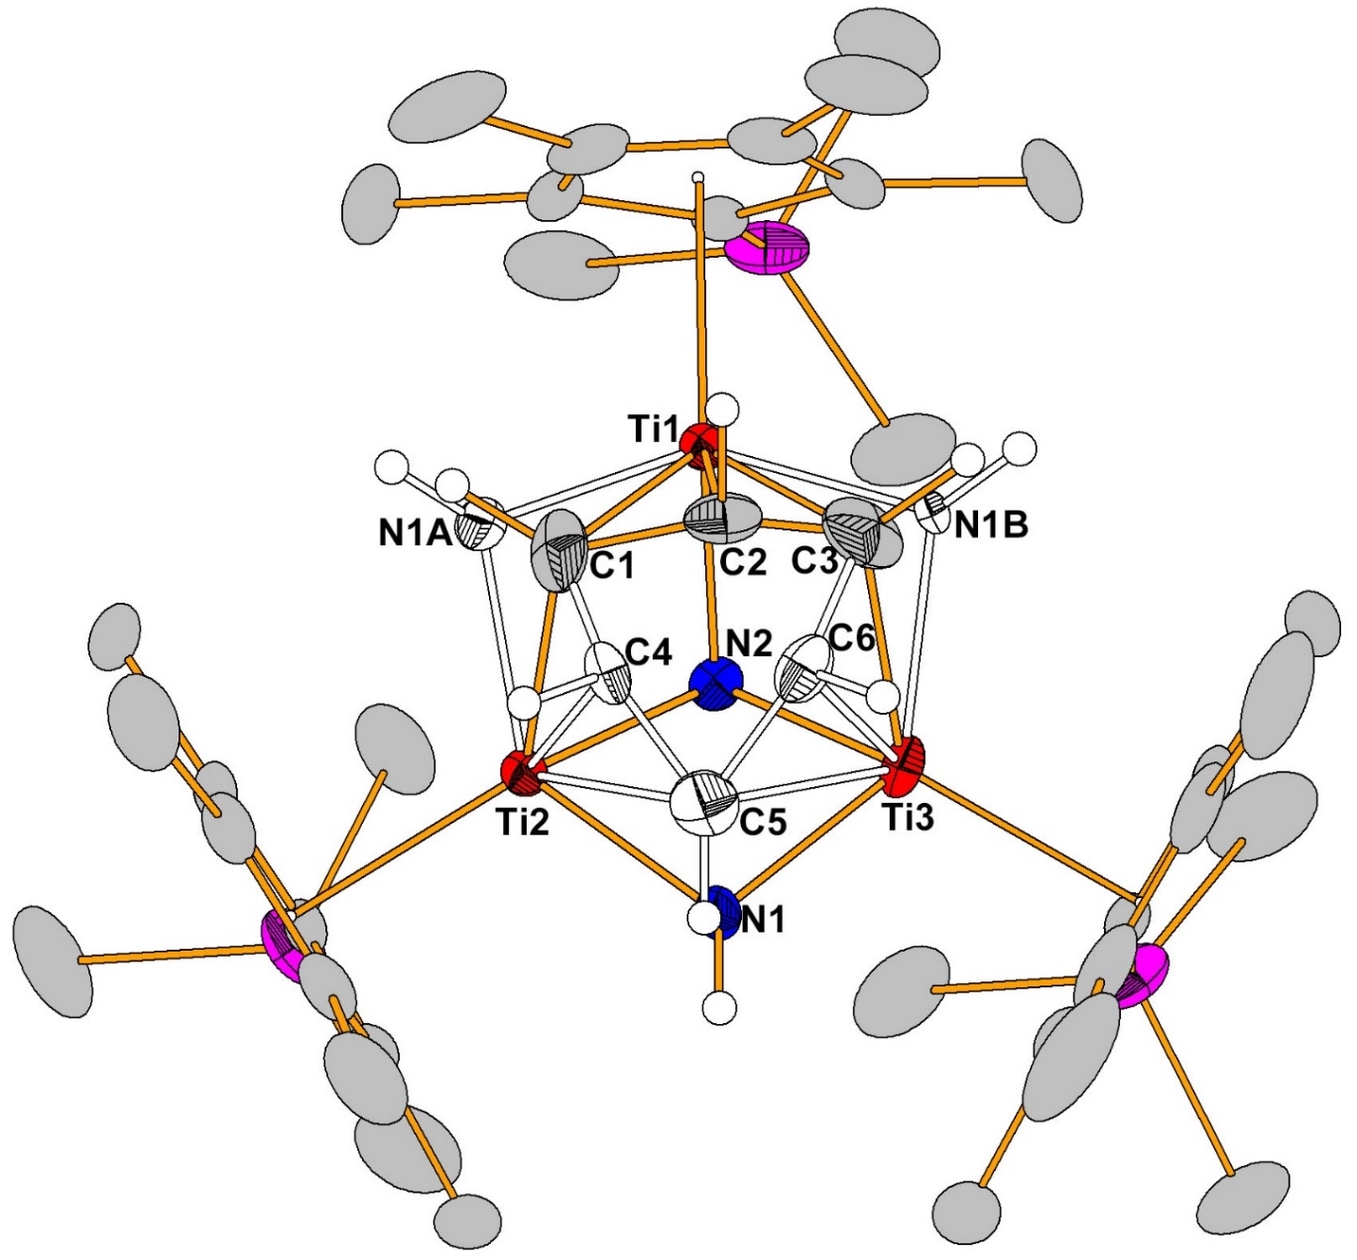
Figure S74. ORTEP drawing of the structure of 3. (N1: N1A: N1B = 50: 25: 25%; C1,C2,C3,C5 : C4,C6 = 50: 25%).

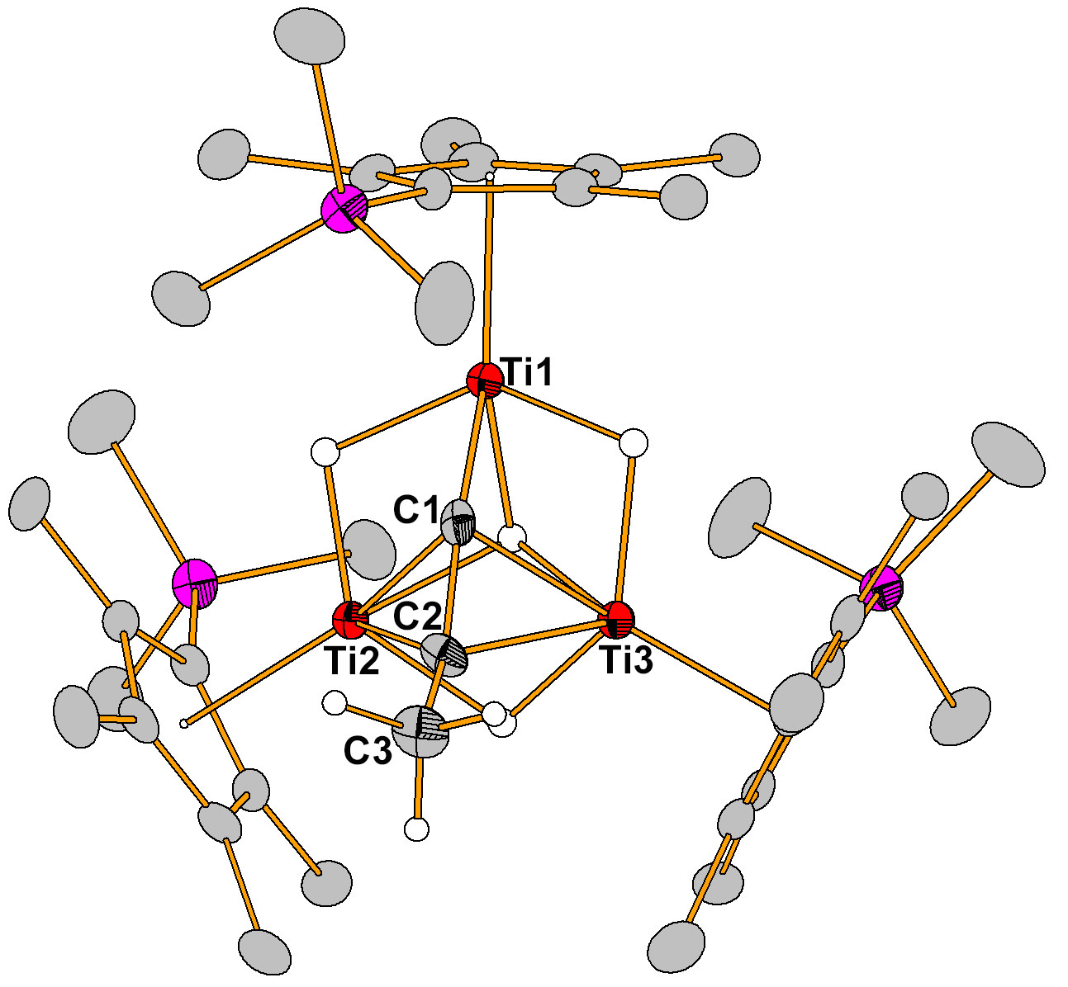
Figure S75. ORTEP drawing of the structure of 4a.

Figure S76. ORTEP drawing of the structure of 4f’.

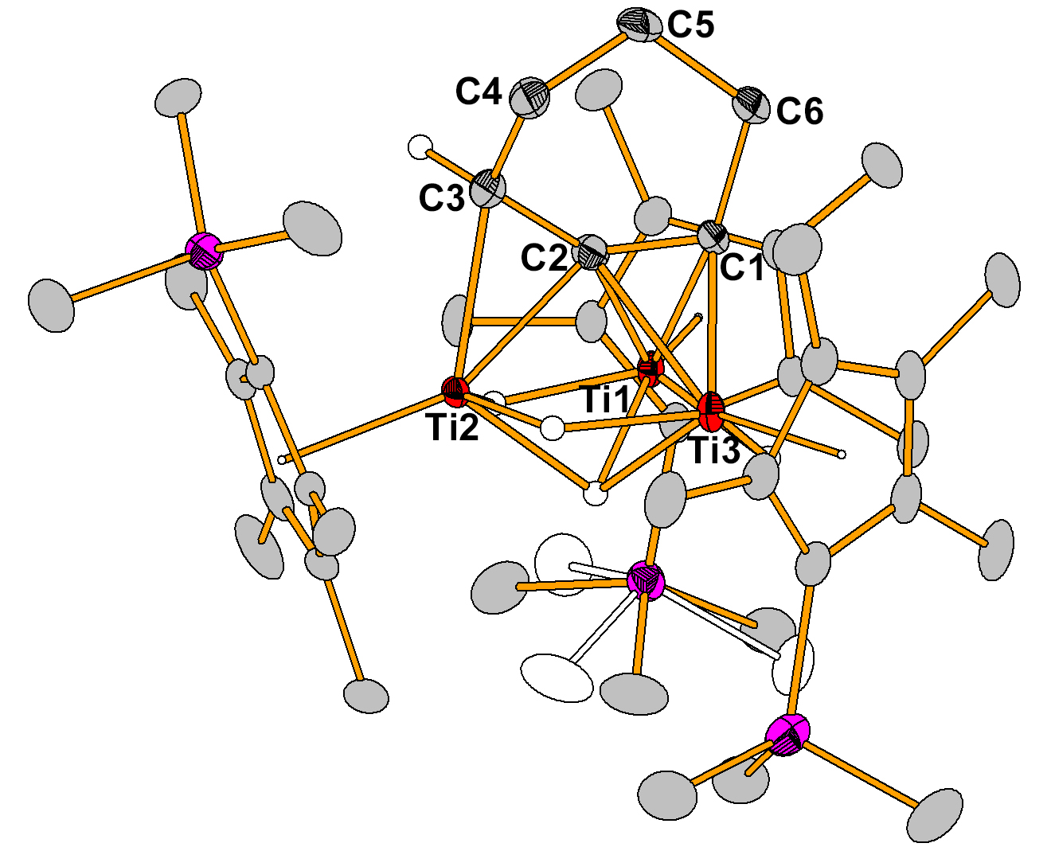
Figure S77. ORTEP drawing of the structure of 4g.

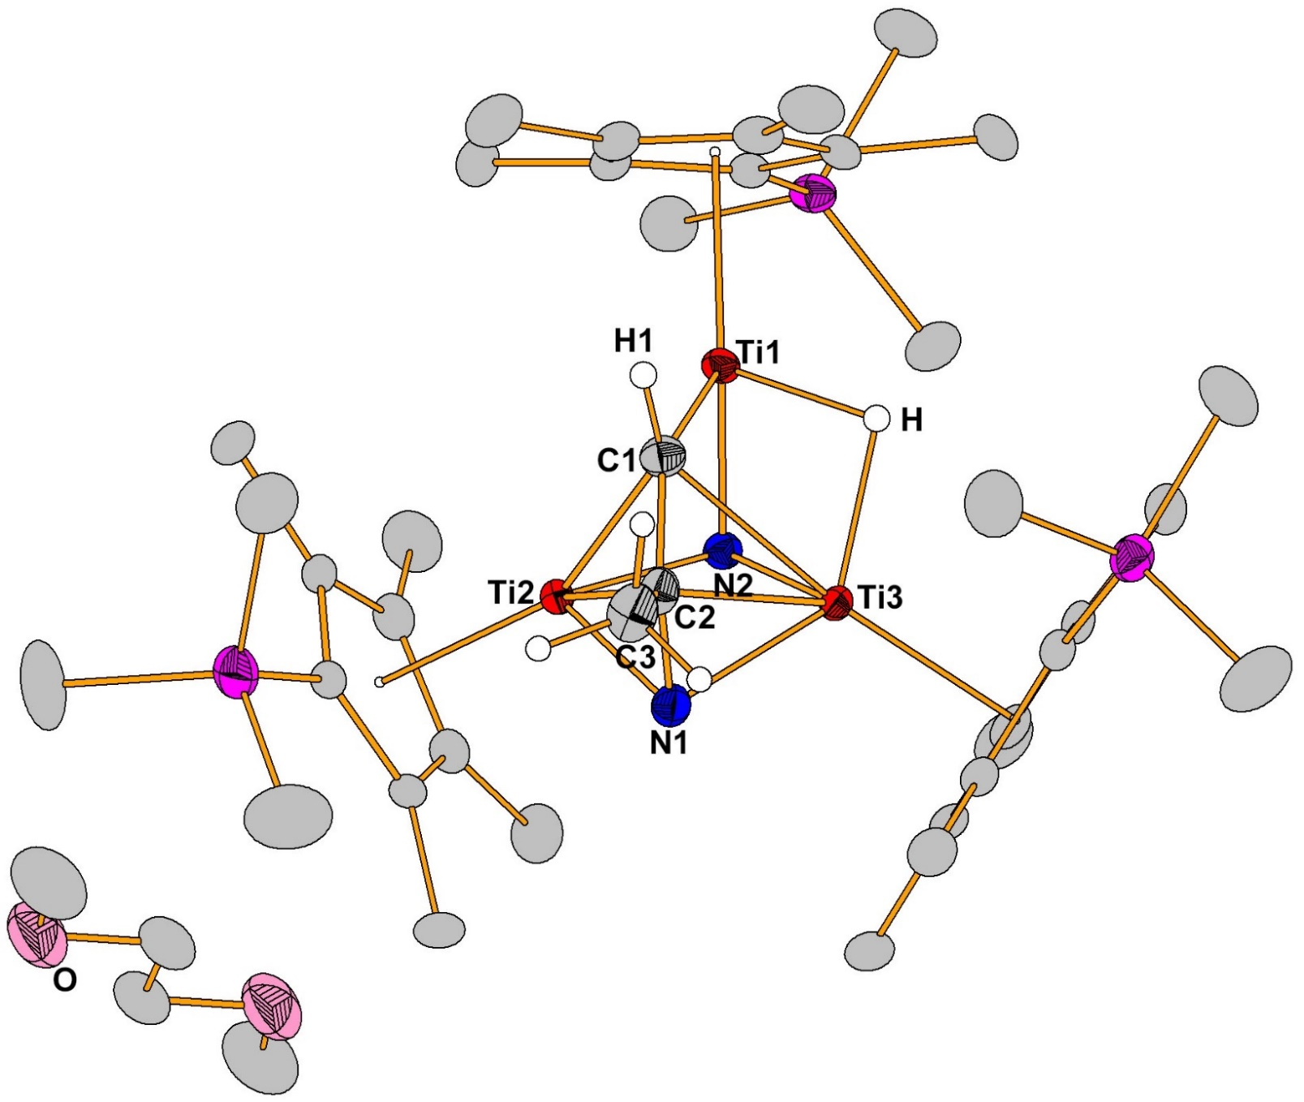
Figure S78. ORTEP drawing of the structure of 5.
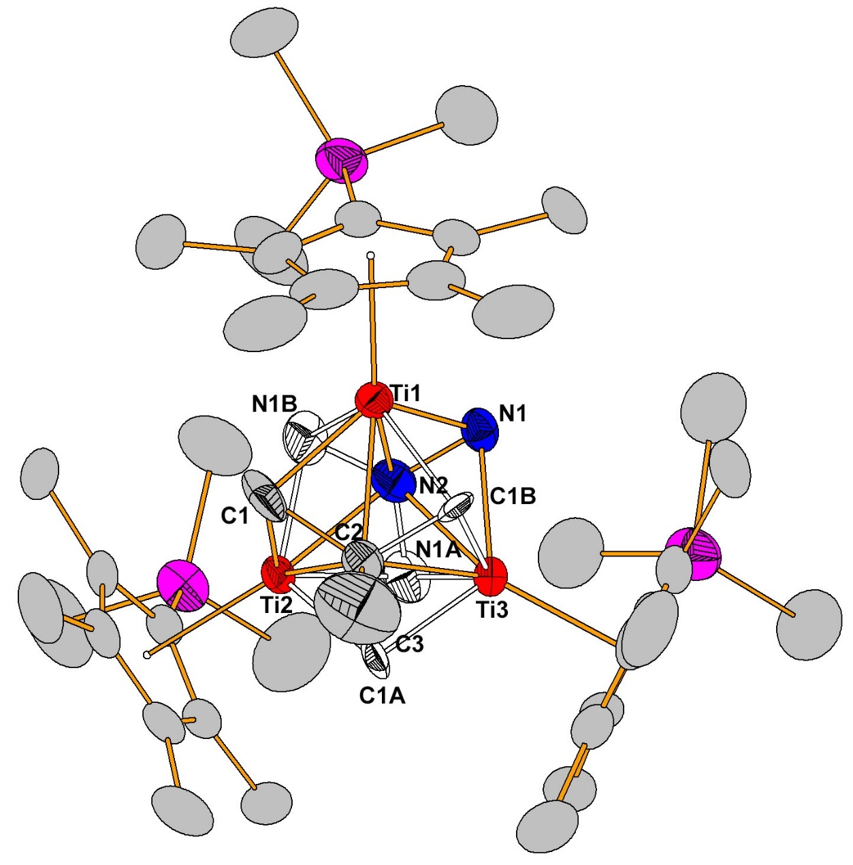
Figure S79. ORTEP drawing of the structure of 6. (C1: C1A: C1B = 60: 20: 20%; N1: N1A: N1B = 40: 40: 20%).

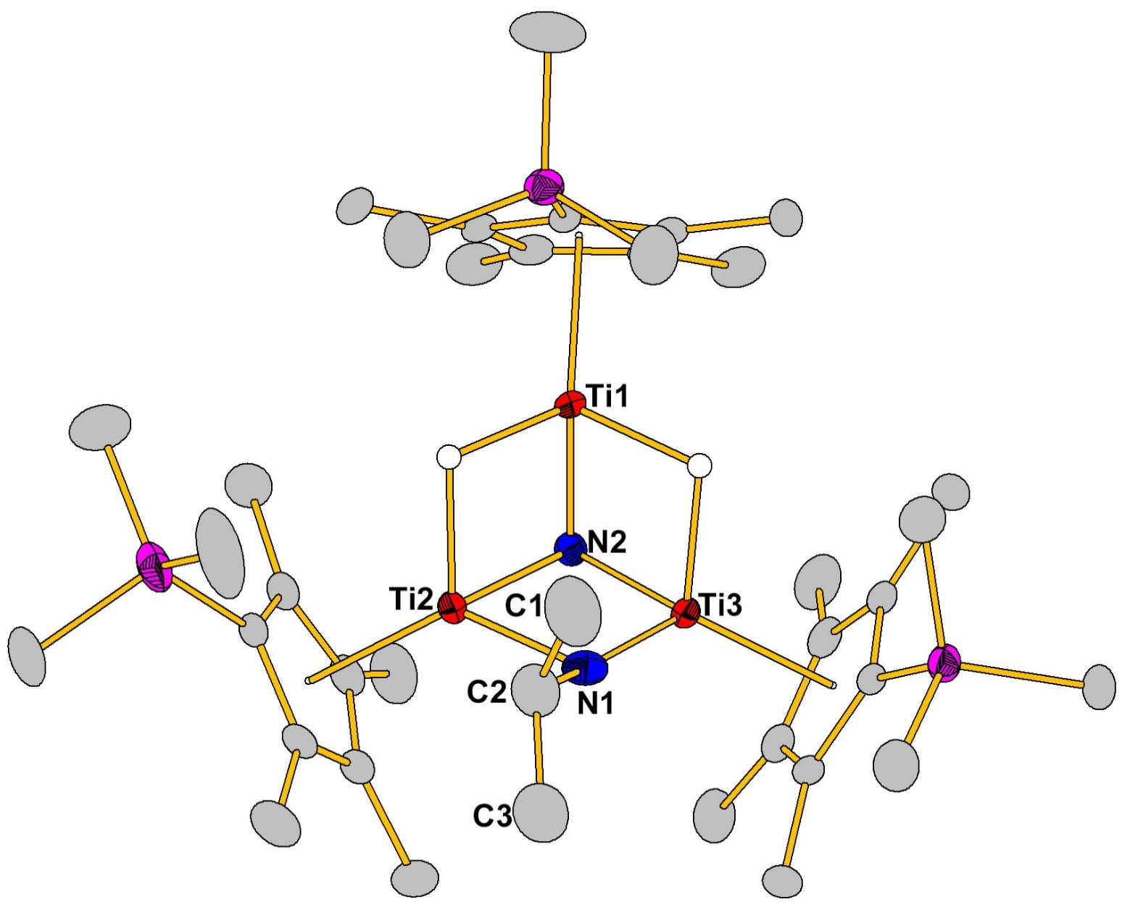
Figure S80. ORTEP drawing of the structure of 8a.
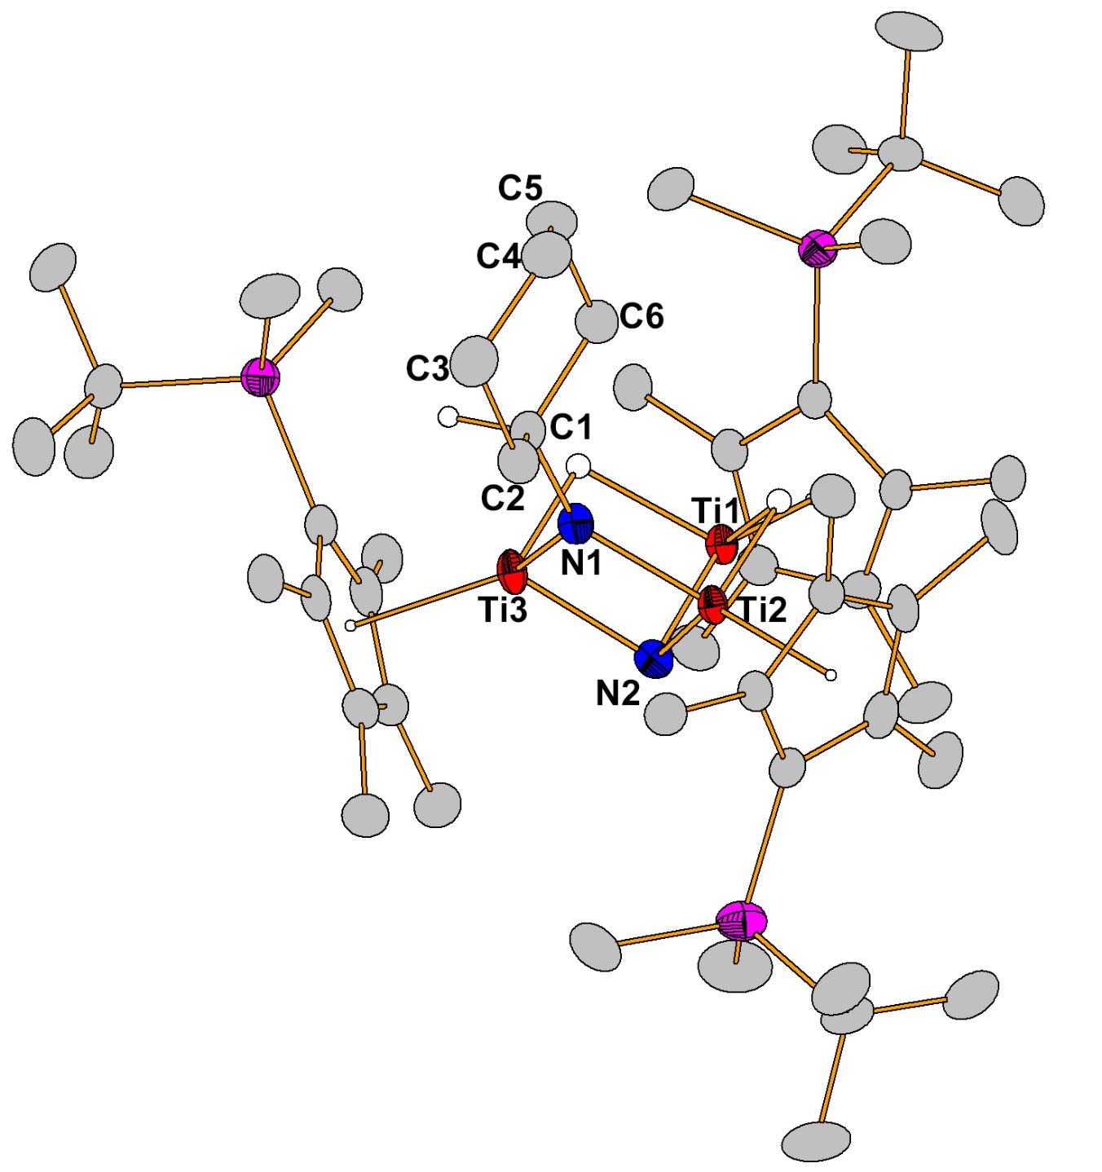
Figure S81. ORTEP drawing of the structure of 8g’.

Computational section
All the DFT calculations were performed using the Gaussian 16 program package. Due to relatively large molecular size, the ligands of C₅Me₄SiMe₃ in each structure were replaced by C₅H₄SiH₃ for the mechanism calculations. For example, [(C₅H₄SiH₃)₃Ti₃(μ-η¹:η²:η²-C=CCH₃)(μ-H)₄] (4m) was used for modelling [(C₅Me₄SiMe₃)₃Ti₃(μ-η¹:η²:η²-C=CCH₃)(μ-H)₄] (4a). Our previous studies have demonstrated that such model complexes with simplified ligands could well reproduce the core skeletons of the structures and have little inflect on relative energies., The geometries of all stationary points were optimized by unrestricted TPSSTPSS functional, which often shows the best performance for the structure and energy calculations for transition-metal-containing systems.,, In the geometrical optimizations, the 6-31G(d) basis set was considered for C, H, N, and Si atoms and the Stuttgart/Dresden, effective core potentials (ECP) as well as the associated valence basis sets were used for Ti atoms. Such basis sets are denoted as “BSI”. Considering potential antiferromagnetic coupling in some structures, the combination of the spin-unrestricted manner and the keyword of scf=nosymm was used in optimizations. All structures were optimized without any geometrical symmetry restriction. Frequency calculations of each optimized structure were subsequently analyzed to conform a stationary point as a minimum (no imaginary frequency) or a transition state (one imaginary frequency) and to obtained the thermodynamic corrections to Gibbs free energy. Based on the TPSSTPSS/BSI geometries optimized in gas-phase, single-point calculations were further performed with higher level basis sets (i.e., BSII) to obtain more accurate energies. In the BSII, the basis sets for Ti atoms are same as that in geometrical optimization, and 6-311+G(d,p) basis sets were utilized for the remaining atoms. In these single point calculations, the solvation effect of n-hexane was also considered by using the SMD model and dispersion corrections were included through GD3BJ approach. The stabilities of wave functions were tested by the keyword of stable=opt in this work. The theoretical strategy adopted here has successfully applied in previous similar multinuclear titanium systems.^{8,9,,} To reduce the overestimation of the entropy contribution derived from the gas-phase model, corrections for free energies were made by −2.6 (or +2.6) kcal/mol for two-to-one (or one-to-two) transformations, which have been used in many earlier studies.^{9,19,,,} The relative Gibbs free energies in solution were used for discussion of the mechanism in this study.

Figure S82. Computed pathways for the initial N₂ coordination and the subsequent reductive elimination of C-H bond. The Gibbs free energies are given in kcal/mol.

Figure S83. Computed pathway for the conversion of 4m to 6m. The Gibbs free energies are given in kcal/mol.

Figure S84. Computed pathways for the conversion of 6m to 5m (red line) and the conversion of 5m to 3m (green line). The Gibbs free energies are given in kcal/mol.

Figure S85. Computed pathways for the conversion of 5m to 8m. The C₅H₄SiH₃ ligands in displayed structures are omitted for clarity. The Gibbs free energies are given in kcal/mol.

Table S4. Imaginary frequency of transition state (cm⁻¹), single-point calculation energy (E_{sp,} a.u.), gas-phase thermal correction to Gibbs free energy (ΔΔG, a.u.), relative free energy (ΔG, kcal/mol), and relative free energy corrected by empirical value (ΔG_{corr.}, kcal/mol).
 | Image. Freq. | E_{sp} | ΔΔG | G | ΔG | ΔG_{corr.}
N₂ | / | -109.570655 | -0.013053 | -109.583708 | / | /
H₂ | / | -1.179258 | -0.001306 | -1.180564 | / | /
2m | / | -1746.851884 | 0.311096 | -1746.540788 | 0.0 | 0.0
A | / | -1856.443114 | 0.319001 | -1856.124113 | 0.2 | -2.4
TS1 | -562.16 | -1856.411411 | 0.315713 | -1856.095698 | 18.1 | 15.5
B | / | -1856.434085 | 0.319200 | -1856.114885 | 6.0 | 3.4
C | / | -1856.450274 | 0.323240 | -1856.127034 | -1.6 | -4.2
D | / | -1856.446610 | 0.323000 | -1856.123610 | 0.6 | -2.0
TS2 | -629.29 | -1856.446436 | 0.322053 | -1856.124383 | 0.1 | -2.5
E | / | -1855.270905 | 0.306212 | -1854.964693 | -13.0 | -13.0
TS3 | -334.09 | -1855.239692 | 0.304023 | -1854.935669 | 5.2 | 5.2
6m | / | -1855.284583 | 0.308504 | -1854.976079 | -20.2 | -20.2
TS4 | -540.38 | -1855.241960 | 0.304466 | -1854.937494 | 4.0 | 4.0
F | / | -1855.309637 | 0.303137 | -1855.006500 | -39.3 | -39.3
TS5 | -158.58 | -1855.308459 | 0.304777 | -1855.003682 | -37.5 | -37.5
G | / | -1855.314949 | 0.304568 | -1855.010381 | -41.7 | -41.7
TS6 | -197.07 | -1855.302402 | 0.304835 | -1854.997567 | -33.7 | -33.7
5m | / | -1855.324083 | 0.305266 | -1855.018817 | -47.0 | -47.0
TS7 | -587.48 | -1855.288900 | 0.308471 | -1854.980429 | -22.9 | -22.9
H | / | -1855.305887 | 0.312287 | -1854.993600 | -31.2 | -31.2
I | / | -1855.307506 | 0.308888 | -1854.998618 | -34.3 | -34.3
TS8 | -1476.56 | -1855.280001 | 0.302383 | -1854.977618 | -21.1 | -21.2
3m | / | -1855.333381 | 0.308123 | -1855.025258 | -51.0 | -51.0
TS9 | -723.24 | -1856.500310 | 0.320971 | -1856.179339 | -34.4 | -37.0
J | / | -1856.506397 | 0.322594 | -1856.183803 | -37.2 | -39.8
TS10 | -737.88 | -1856.484699 | 0.322033 | -1856.162666 | -24.0 | -26.6
K | / | -1856.516269 | 0.324707 | -1856.191562 | -42.1 | -44.7
TS11 | -1051.95 | -1857.679888 | 0.340306 | -1857.339582 | -21.7 | -26.9
L | / | -1857.715610 | 0.347245 | -1857.368365 | -39.7 | -44.9
TS12 | -859.28 | -1857.682349 | 0.344563 | -1857.337786 | -20.5 | -25.7
8m | / | -1857.733666 | 0.344242 | -1857.389424 | -52.9 | -58.1
A' | / | -1856.443120 | 0.319003 | -1856.124117 | 0.2 | -2.4
TS1' | -561.97 | -1856.411411 | 0.315719 | -1856.095692 | 18.1 | 15.5
B' | / | -1856.433260 | 0.318915 | -1856.114345 | 6.4 | 3.8
TS1'' | -550.08 | -1856.397247 | 0.313363 | -1856.083884 | 25.5 | 22.9
A'' | / | -1856.430416 | 0.316076 | -1856.114340 | 6.4 | 3.8
B'' | / | -1856.446283 | 0.321870 | -1856.124413 | 0.1 | -2.5
TS7' | -1633.98 | -1855.257856 | 0.302043 | -1854.955813 | -7.5 | -7.5
H' | / | -1855.314773 | 0.305674 | -1855.009099 | -40.9 | -40.9
TS7'' | -1226.56 | -1855.244086 | 0.303033 | -1854.941053 | 1.8 | 1.8
H'' | / | -1855.294535 | 0.304256 | -1854.990279 | -29.1 | -29.1
TS10' | -735.03 | -1856.484761 | 0.321890 | -1856.162871 | -24.1 | -26.7
K' | / | -1856.494919 | 0.325818 | -1856.169101 | -28.0 | -30.6
TS13 | -792.47 | -1857.656888 | 0.340202 | -1857.316686 | -7.3 | -12.5
M | / | -1857.703946 | 0.344455 | -1857.359491 | -34.2 | -39.4
TS14 | -1008.33 | -1856.460364 | 0.322149 | -1856.138215 | -8.6 | .-11.2
N | / | -1856.483777 | 0.323891 | -1856.159886 | -22.2 | -24.8
TS15 | -598.95 | -1856.466526 | 0.324218 | -1856.142308 | -11.2 | -13.8
O | / | -1856.497241 | 0.326541 | -1856.170700 | -29.0 | -31.6
TS11' | -1184.97 | -1857.651088 | 0.340366 | -1857.310722 | -3.6 | -8.8
L' | / | -1857.705955 | 0.341417 | -1857.364538 | -37.3 | -45.5
TS12' | -914.50 | -1857.659396 | 0.342847 | -1857.316549 | -7.2 | -12.4

Optimized Cartesian coordinates for all stationary points

4m
Ti 1.049613000 1.029091000 0.645106000
Ti -1.369702000 0.660223000 -0.481508000
Ti 0.310911000 -1.389211000 -0.339637000
Si 4.156067000 1.630870000 -1.121505000
Si -4.007930000 1.164863000 2.044014000
Si -0.083534000 -3.768514000 2.449717000
C 0.654039000 0.564440000 -1.178209000
C -0.119296000 -0.201119000 -2.036093000
C -0.197528000 -0.343358000 -3.535061000
H -0.403830000 0.624420000 -4.020025000
H -0.988697000 -1.044854000 -3.833448000
H 0.754147000 -0.716801000 -3.946581000
C 3.149749000 2.015235000 0.407461000
C 3.148326000 1.306125000 1.659631000
C 2.212570000 1.917854000 2.543352000
C 1.612892000 3.007909000 1.850860000
C 2.183562000 3.070335000 0.546759000
C -3.504162000 1.299994000 0.246531000
C -2.909435000 2.444375000 -0.388063000
C -2.681882000 2.153975000 -1.759393000
C -3.126026000 0.822050000 -2.012966000
C -3.635045000 0.301366000 -0.784419000
C 0.363787000 -3.516411000 0.649713000
C 1.674582000 -3.256101000 0.124073000
C 1.594892000 -3.128005000 -1.289001000
C 0.234500000 -3.307527000 -1.677809000
C -0.518692000 -3.549134000 -0.489906000
H -1.520050000 -1.162141000 -0.251870000
H 1.591259000 -0.710547000 0.802191000
H -0.410680000 -0.168133000 1.088974000
H -0.568835000 1.876826000 0.638207000
H -5.457479000 1.464161000 2.214064000
H -3.236869000 2.145354000 2.849122000
H -3.770539000 -0.210515000 2.551573000
H -2.634941000 3.367066000 0.113141000
H -2.194454000 2.810308000 -2.474954000
H -3.085996000 0.302630000 -2.963951000
H -4.039731000 -0.696472000 -0.646447000
H -1.590858000 -3.713990000 -0.449710000
H -0.154115000 -3.267347000 -2.689269000
H 2.418970000 -2.874717000 -1.950447000
H 2.574912000 -3.128945000 0.716718000
H -0.123221000 -5.218688000 2.789111000
H 0.938553000 -3.121782000 3.310569000
H -1.425813000 -3.202120000 2.737036000
H 3.493070000 2.204474000 -2.319071000
H 4.335708000 0.165317000 -1.285932000
H 5.517463000 2.232552000 -1.022849000
H 3.749594000 0.431471000 1.887868000
H 1.974654000 1.589044000 3.550763000
H 0.831634000 3.656224000 2.235055000
H 1.902595000 3.771845000 -0.232911000

N2
N 0.000000000 0.000000000 0.557023000
N 0.000000000 0.000000000 -0.557023000

H2
H 0.000000000 0.000000000 0.370085000
H 0.000000000 0.000000000 -0.370085000

A
Ti 0.369992000 1.286431000 -0.554788000
Ti 0.849128000 -1.352143000 -0.111360000
Ti -1.599698000 -0.366691000 0.441500000
Si 0.445380000 4.079628000 1.743276000
Si 4.492428000 -0.475070000 -0.470344000
Si -4.110359000 -0.338728000 -2.236169000
C 0.292461000 0.436332000 1.170099000
C -0.319497000 -0.441172000 2.012364000
C -0.195819000 -0.781873000 3.470063000
H 0.851001000 -0.921635000 3.780989000
H -0.762966000 -1.684053000 3.735293000
H -0.597117000 0.051578000 4.068098000
C 0.750622000 3.520671000 -0.014804000
C -0.187132000 3.492375000 -1.107366000
C 0.456722000 2.966283000 -2.264918000
C 1.799261000 2.654988000 -1.908058000
C 1.980807000 2.991522000 -0.536296000
C 3.212541000 -1.682450000 0.171026000
C 2.585701000 -1.664255000 1.454671000
C 1.674533000 -2.760232000 1.546678000
C 1.725530000 -3.473027000 0.311463000
C 2.676090000 -2.813772000 -0.526865000
C -3.769484000 -0.585144000 -0.413312000
C -3.779397000 0.430911000 0.609864000
C -3.483427000 -0.167935000 1.866435000
C -3.275002000 -1.558400000 1.649009000
C -3.456683000 -1.814125000 0.260681000
H -0.871164000 -2.007120000 -0.007304000
H -1.451978000 1.292978000 -0.377817000
H -0.530971000 -0.290863000 -1.161743000
H 1.583162000 0.011349000 -1.087821000
H 5.861993000 -1.007592000 -0.224583000
H 4.374783000 0.820681000 0.242085000
H 4.340974000 -0.275362000 -1.933413000
H 2.741016000 -0.904991000 2.213616000
H 1.048960000 -3.006665000 2.396798000
H 1.144535000 -4.353109000 0.055027000
H 2.938930000 -3.108859000 -1.537770000
H -3.337008000 -2.781164000 -0.218278000
H -2.994244000 -2.288624000 2.400989000
H -3.393101000 0.351247000 2.815802000
H -3.961634000 1.488016000 0.442051000
H -5.546967000 -0.580990000 -2.549173000
H -3.789493000 1.058333000 -2.623385000
H -3.306866000 -1.289350000 -3.046318000
H 1.459176000 3.474938000 2.643302000
H -0.922278000 3.709229000 2.190591000
H 0.558775000 5.562322000 1.858173000
H -1.225163000 3.805665000 -1.054561000
H -0.004146000 2.803804000 -3.234692000
H 2.543941000 2.202316000 -2.555396000
H 2.888250000 2.831754000 0.037811000
N 0.474254000 -2.181480000 -2.020334000
N 0.243041000 -2.629486000 -3.028979000

TS1
Ti 0.251856000 1.343242000 -0.500939000
Ti 1.071539000 -1.168114000 0.136013000
Ti -1.541566000 -0.586594000 0.420812000
Si 0.595140000 4.083165000 1.837911000
Si 4.372920000 -0.798265000 -1.404149000
Si -3.870417000 -0.771074000 -2.402214000
C -0.027846000 0.641549000 1.282565000
C -0.412028000 -0.377253000 2.105656000
C -0.329795000 -0.659619000 3.579094000
H 0.640891000 -0.371786000 4.012026000
H -0.515805000 -1.718711000 3.802001000
H -1.102399000 -0.075141000 4.104153000
C 0.484741000 3.586936000 0.037238000
C -0.713650000 3.456259000 -0.746526000
C -0.362185000 3.040802000 -2.065787000
C 1.052279000 2.913803000 -2.124629000
C 1.574873000 3.233762000 -0.838652000
C 3.349139000 -1.639795000 -0.078925000
C 3.108657000 -1.152145000 1.257713000
C 2.270097000 -2.078535000 1.940654000
C 1.978589000 -3.149567000 1.042615000
C 2.652041000 -2.890280000 -0.181642000
C -3.644887000 -0.944606000 -0.553108000
C -3.781737000 0.113727000 0.420757000
C -3.539105000 -0.417731000 1.715041000
C -3.246960000 -1.805987000 1.574773000
C -3.320216000 -2.128565000 0.191750000
H -0.513192000 -2.102099000 0.256938000
H -1.343870000 0.617868000 -0.960137000
H 1.497241000 0.101703000 -1.132031000
H 1.389041000 0.546318000 0.765811000
H 5.766532000 -1.325870000 -1.400120000
H 4.436929000 0.660209000 -1.136243000
H 3.796042000 -1.052569000 -2.747845000
H 3.514752000 -0.237111000 1.676857000
H 1.922150000 -1.994537000 2.963342000
H 1.340973000 -4.002517000 1.252508000
H 2.611261000 -3.517651000 -1.067060000
H -3.118576000 -3.107218000 -0.234888000
H -2.982997000 -2.487388000 2.377395000
H -3.537597000 0.142060000 2.645398000
H -4.007452000 1.150827000 0.191980000
H -5.212589000 -1.264574000 -2.821255000
H -3.772227000 0.662667000 -2.776059000
H -2.853676000 -1.559675000 -3.143684000
H 1.749084000 3.414367000 2.491671000
H -0.666973000 3.742846000 2.541491000
H 0.801751000 5.554554000 1.969505000
H -1.724857000 3.617483000 -0.385915000
H -1.058594000 2.824049000 -2.870013000
H 1.630168000 2.579601000 -2.981205000
H 2.624500000 3.202309000 -0.559744000
N 0.508528000 -1.830323000 -1.763224000
N 0.287212000 -2.255084000 -2.787857000

B
Ti -0.030922000 1.401363000 0.111316000
Ti 1.475176000 -0.841688000 -0.221419000
Ti -1.144262000 -1.159958000 0.283688000
Si -2.611769000 3.621190000 1.541378000
Si 4.493151000 1.320662000 0.002925000
Si -3.812987000 -1.106198000 -2.190698000
C 0.267433000 -0.029281000 1.483609000
C 0.259729000 -1.418205000 1.685184000
C 0.594409000 -2.199783000 2.929735000
H 1.603565000 -1.975698000 3.312164000
H 0.533189000 -3.283535000 2.759441000
H -0.115179000 -1.952733000 3.736774000
C -1.275151000 3.395687000 0.253554000
C -1.447417000 2.896693000 -1.084502000
C -0.193870000 2.898952000 -1.752825000
C 0.782346000 3.422525000 -0.847241000
C 0.126215000 3.722283000 0.375298000
C 3.813978000 -0.422574000 -0.018339000
C 3.398025000 -1.192354000 1.114291000
C 2.928936000 -2.461547000 0.663991000
C 3.048913000 -2.494861000 -0.757783000
C 3.592658000 -1.246047000 -1.174048000
C -3.240540000 -1.759564000 -0.535633000
C -3.455816000 -1.136753000 0.748023000
C -2.866833000 -1.943425000 1.755849000
C -2.280871000 -3.080245000 1.125707000
C -2.513244000 -2.973953000 -0.272151000
H 0.111949000 -1.990714000 -0.780507000
H -1.483878000 0.504212000 -0.412850000
H 1.622318000 0.978672000 -0.456895000
H 0.428275000 0.768805000 2.255981000
H 5.974316000 1.308496000 0.165631000
H 3.922097000 2.087105000 1.140714000
H 4.187385000 2.012459000 -1.275499000
H 3.410037000 -0.850517000 2.144739000
H 2.545467000 -3.260819000 1.288018000
H 2.760850000 -3.316458000 -1.405993000
H 3.789140000 -0.953931000 -2.201255000
H -2.165782000 -3.677923000 -1.022674000
H -1.728979000 -3.871098000 1.623237000
H -2.831485000 -1.715551000 2.817104000
H -3.955723000 -0.186268000 0.908191000
H -5.035913000 -1.816649000 -2.658456000
H -4.144019000 0.336747000 -2.061878000
H -2.765787000 -1.287109000 -3.229312000
H -2.083575000 3.306171000 2.895920000
H -3.759557000 2.730286000 1.234941000
H -3.107460000 5.025140000 1.571192000
H -2.382093000 2.537155000 -1.501930000
H -0.005415000 2.543669000 -2.761094000
H 1.841798000 3.537853000 -1.049830000
H 0.606091000 4.117833000 1.267915000
N 1.020947000 -0.529586000 -2.234614000
N 0.860496000 -0.402267000 -3.349015000

C
Ti 0.144111000 1.368463000 -0.445485000
Ti 1.398719000 -0.962895000 -0.164584000
Ti -1.332870000 -0.964347000 0.133394000
Si -1.983463000 3.090975000 2.113945000
Si 4.726849000 0.632460000 -0.263513000
Si -3.910464000 -0.808388000 -2.412278000
C 0.069829000 0.138067000 1.332976000
C 0.021339000 -1.268374000 1.555491000
C 0.209685000 -1.983215000 2.873326000
H 1.210547000 -1.811895000 3.301994000
H 0.069811000 -3.068740000 2.774305000
H -0.522446000 -1.621735000 3.613993000
C -0.736176000 3.238694000 0.727667000
C -1.032098000 3.397504000 -0.674052000
C 0.183037000 3.539886000 -1.394898000
C 1.255157000 3.433201000 -0.463382000
C 0.690464000 3.257419000 0.838458000
C 3.752867000 -0.960263000 -0.119496000
C 3.278452000 -1.567915000 1.097154000
C 2.589342000 -2.770240000 0.774188000
C 2.612151000 -2.916616000 -0.646418000
C 3.333414000 -1.816331000 -1.189452000
C -3.433634000 -1.461227000 -0.724183000
C -3.642192000 -0.791861000 0.536155000
C -3.126190000 -1.598419000 1.582713000
C -2.587106000 -2.782318000 1.001351000
C -2.779092000 -2.704374000 -0.406881000
H -0.071515000 -1.877539000 -0.883240000
H 0.298877000 0.812939000 2.166125000
H -1.499701000 0.616393000 -0.784945000
H 1.857264000 0.813738000 -0.018508000
H 6.189739000 0.350634000 -0.295513000
H 4.458301000 1.499536000 0.912070000
H 4.378153000 1.349884000 -1.516046000
H 3.409141000 -1.158927000 2.094965000
H 2.117916000 -3.449193000 1.475382000
H 2.142894000 -3.714217000 -1.213631000
H 3.492985000 -1.628898000 -2.247141000
H -2.451410000 -3.447994000 -1.127546000
H -2.091126000 -3.586270000 1.535010000
H -3.098959000 -1.337086000 2.636262000
H -4.076335000 0.196423000 0.655306000
H -5.131781000 -1.494618000 -2.919566000
H -4.203823000 0.642945000 -2.306009000
H -2.824662000 -1.038702000 -3.398982000
H -1.429785000 2.292902000 3.237937000
H -3.237347000 2.469519000 1.617923000
H -2.327739000 4.437727000 2.649664000
H -2.026754000 3.391045000 -1.109971000
H 0.277925000 3.643666000 -2.470519000
H 2.314702000 3.466262000 -0.697380000
H 1.258429000 3.133454000 1.755764000
N 0.858073000 -0.048303000 -1.875866000
N 0.467809000 0.805379000 -2.594037000

D
Ti 0.034608000 1.303227000 -0.186035000
Ti 1.746331000 -0.769528000 -0.113062000
Ti -1.034226000 -1.405732000 0.118734000
Si -3.212455000 3.060775000 0.860727000
Si 4.846713000 1.158536000 -0.670008000
Si -3.812177000 -1.573271000 -2.204295000
C -0.641178000 0.451956000 1.537658000
C 0.610389000 -0.106618000 1.673453000
C 1.222172000 -0.416423000 3.036281000
H 2.011004000 0.321258000 3.248928000
H 1.689867000 -1.408932000 3.061261000
H 0.473483000 -0.358437000 3.842514000
C -1.496895000 3.153076000 0.127236000
C -1.160897000 3.044900000 -1.260894000
C 0.234044000 3.274561000 -1.417916000
C 0.782998000 3.549609000 -0.125803000
C -0.272405000 3.465529000 0.816920000
C 4.080828000 -0.523160000 -0.363584000
C 3.868205000 -1.153192000 0.914745000
C 3.283383000 -2.430265000 0.704709000
C 3.126673000 -2.618360000 -0.701293000
C 3.620139000 -1.458179000 -1.355820000
C -3.241721000 -1.943990000 -0.455898000
C -3.309687000 -1.049182000 0.661407000
C -2.734509000 -1.686413000 1.797253000
C -2.288016000 -2.974572000 1.401495000
C -2.599569000 -3.138803000 0.019052000
H 0.635222000 -2.014995000 0.709018000
H -1.304243000 0.695319000 2.374985000
H -0.337695000 -2.837241000 -0.540269000
H 1.891056000 1.069727000 -0.153680000
H 6.320962000 1.039911000 -0.846736000
H 4.598811000 2.050824000 0.491331000
H 4.287744000 1.763034000 -1.905696000
H 4.102442000 -0.712481000 1.879113000
H 2.979061000 -3.133259000 1.473744000
H 2.658362000 -3.473276000 -1.179556000
H 3.610456000 -1.286381000 -2.428713000
H -2.396752000 -4.026944000 -0.568088000
H -1.768884000 -3.695177000 2.026013000
H -2.629584000 -1.254457000 2.787110000
H -3.711356000 -0.042329000 0.636329000
H -4.035345000 -0.115492000 -2.358542000
H -2.833579000 -2.065983000 -3.204062000
H -5.107163000 -2.265646000 -2.464142000
H -3.201171000 2.371224000 2.178408000
H -4.120453000 2.341501000 -0.067928000
H -3.763256000 4.425963000 1.080494000
H -1.847735000 2.772291000 -2.055573000
H 0.791197000 3.220333000 -2.349040000
H 1.827155000 3.745789000 0.095308000
H -0.169409000 3.594724000 1.890559000
N 0.275772000 -0.441125000 -1.162340000
N -1.003021000 -0.019381000 -1.344670000

TS2
Ti 0.015744000 1.312498000 -0.194703000
Ti 1.754843000 -0.722513000 -0.140478000
Ti -1.020198000 -1.371300000 0.154867000
Si -3.270391000 3.005245000 0.839985000
Si 4.887918000 1.172307000 -0.617693000
Si -3.726311000 -1.645020000 -2.236254000
C -0.658609000 0.416379000 1.507280000
C 0.599779000 -0.159997000 1.629188000
C 1.206457000 -0.447190000 3.003190000
H 1.933558000 0.343003000 3.246111000
H 1.741263000 -1.404692000 3.034124000
H 0.436603000 -0.450579000 3.791533000
C -1.548464000 3.131870000 0.127540000
C -1.195452000 3.050342000 -1.258420000
C 0.197373000 3.305301000 -1.395803000
C 0.726308000 3.570331000 -0.093318000
C -0.337467000 3.453765000 0.836014000
C 4.100164000 -0.503976000 -0.338618000
C 3.848135000 -1.137299000 0.930234000
C 3.253131000 -2.407085000 0.699941000
C 3.131598000 -2.586444000 -0.711120000
C 3.654383000 -1.428443000 -1.346730000
C -3.193132000 -1.978308000 -0.468422000
C -3.323836000 -1.073390000 0.636036000
C -2.764219000 -1.678195000 1.796311000
C -2.263622000 -2.954502000 1.431295000
C -2.526144000 -3.144857000 0.039875000
H 0.608072000 -2.114629000 0.575273000
H -1.308200000 0.666404000 2.352379000
H -0.160680000 -2.830750000 -0.250951000
H 1.882575000 1.106526000 -0.183832000
H 6.365648000 1.042926000 -0.753872000
H 4.614941000 2.063084000 0.539133000
H 4.368167000 1.784700000 -1.866586000
H 4.061681000 -0.703317000 1.902315000
H 2.928401000 -3.112765000 1.458310000
H 2.675699000 -3.438034000 -1.207602000
H 3.673685000 -1.251052000 -2.418664000
H -2.275941000 -4.032948000 -0.530177000
H -1.744426000 -3.652024000 2.081620000
H -2.703161000 -1.230145000 2.782584000
H -3.756841000 -0.080628000 0.586185000
H -3.988931000 -0.197572000 -2.418168000
H -2.707690000 -2.124365000 -3.202624000
H -4.992184000 -2.380626000 -2.520479000
H -3.266666000 2.292278000 2.145167000
H -4.159971000 2.293043000 -0.111836000
H -3.840119000 4.359738000 1.077827000
H -1.869372000 2.780143000 -2.064938000
H 0.765854000 3.276463000 -2.321139000
H 1.764939000 3.778217000 0.142970000
H -0.248846000 3.568321000 1.912579000
N 0.264883000 -0.441244000 -1.182126000
N -1.010879000 -0.014048000 -1.355265000

E
Ti 0.538144000 1.386232000 -0.562711000
Ti -1.807658000 0.186450000 -0.189304000
Ti 0.574390000 -1.386991000 -0.337909000
Si 2.866379000 2.669731000 1.968077000
Si -3.659348000 0.441836000 2.976933000
Si 3.131025000 -2.389260000 2.097823000
N -0.272691000 0.043020000 0.817014000
N 1.086785000 0.083820000 0.936114000
C 0.787629000 -0.140083000 -1.940141000
H 1.391061000 -0.252683000 -2.846959000
C -0.652208000 -0.213847000 -1.917193000
C -1.344817000 -0.342115000 -3.282020000
H -1.384925000 0.640673000 -3.777122000
H -2.372421000 -0.719450000 -3.216362000
H -0.777501000 -1.018079000 -3.943626000
C 2.177057000 2.890403000 0.236987000
C 2.692192000 2.307653000 -0.966537000
C 1.863620000 2.686861000 -2.062153000
C 0.815935000 3.503051000 -1.554381000
C 1.001770000 3.622444000 -0.142697000
C -3.743207000 0.033131000 1.150489000
C -4.031696000 0.933836000 0.067184000
C -4.016945000 0.204041000 -1.157994000
C -3.708312000 -1.152917000 -0.855045000
C -3.538196000 -1.259405000 0.552975000
C 2.200751000 -2.855125000 0.537293000
C 0.927226000 -3.525183000 0.455446000
C 0.565549000 -3.673027000 -0.919141000
C 1.599466000 -3.084152000 -1.701936000
C 2.595019000 -2.588752000 -0.813433000
H 0.335756000 -3.858833000 1.304999000
H -0.344574000 -4.128688000 -1.298368000
H 1.611242000 -3.002780000 -2.783804000
H 3.488140000 -2.047128000 -1.111965000
H 2.181120000 -2.086464000 3.195558000
H 3.980277000 -3.534168000 2.533926000
H 4.022143000 -1.235925000 1.828743000
H -0.004066000 3.925984000 -2.126386000
H 1.994501000 2.384200000 -3.095837000
H 3.552383000 1.647366000 -1.026693000
H 0.344970000 4.162213000 0.533517000
H 3.662272000 3.875546000 2.338095000
H 3.772289000 1.497855000 2.005326000
H 1.773637000 2.533899000 2.961730000
H -3.597260000 -1.961401000 -1.570773000
H -4.183756000 0.619411000 -2.147099000
H -3.285275000 -2.168461000 1.092223000
H -4.224946000 1.998180000 0.164465000
H -5.021690000 0.444658000 3.578153000
H -3.067993000 1.788324000 3.184662000
H -2.846252000 -0.584207000 3.677341000
H -1.282854000 1.913696000 -0.473198000

TS3
Ti -1.478941000 -0.864547000 -0.164990000
Ti 1.281313000 -1.216573000 -0.368403000
Ti 0.139975000 1.414715000 -0.427990000
Si -4.465162000 0.111691000 1.621309000
Si 2.638022000 -1.493548000 3.029310000
Si -0.109048000 4.497791000 1.516352000
N 0.786895000 0.002146000 1.003206000
N -0.599319000 0.376216000 0.986783000
C -1.174789000 0.517094000 -1.733406000
H -1.737677000 0.772774000 -2.637382000
C -0.019989000 -0.331834000 -1.744071000
C 0.569149000 -0.979555000 -3.000785000
H -0.190306000 -1.586950000 -3.514214000
H 1.424925000 -1.655292000 -2.799435000
H 0.939083000 -0.211226000 -3.696126000
C -3.699275000 -1.117711000 0.431222000
C -3.669440000 -1.040574000 -1.007162000
C -3.035561000 -2.211436000 -1.515628000
C -2.648425000 -3.016986000 -0.414192000
C -3.041070000 -2.347981000 0.781053000
C 2.973060000 -1.866767000 1.221377000
C 2.578975000 -3.028717000 0.471111000
C 2.965983000 -2.851885000 -0.888501000
C 3.574808000 -1.567712000 -1.008479000
C 3.583058000 -0.972056000 0.286057000
C 0.626851000 3.644348000 0.020069000
C 1.877678000 2.932836000 -0.037097000
C 2.087239000 2.471047000 -1.366489000
C 0.979584000 2.904599000 -2.158715000
C 0.089297000 3.615825000 -1.317789000
H 2.525356000 2.735388000 0.811728000
H 2.936858000 1.894510000 -1.718572000
H 0.823224000 2.687783000 -3.210946000
H -0.863337000 4.039473000 -1.624331000
H 0.389592000 3.859326000 2.759247000
H 0.273779000 5.936840000 1.543462000
H -1.592634000 4.425775000 1.466439000
H -2.104928000 -3.954635000 -0.467192000
H -2.841717000 -2.423932000 -2.562938000
H -4.078544000 -0.233082000 -1.605512000
H -2.860129000 -2.700587000 1.792701000
H -5.940521000 -0.078768000 1.682013000
H -4.206462000 1.505203000 1.175691000
H -3.906198000 -0.100815000 2.979026000
H 3.968152000 -1.126858000 -1.920724000
H 2.792510000 -3.557645000 -1.697212000
H 3.954125000 0.021189000 0.520623000
H 2.074155000 -3.902145000 0.872850000
H 3.587501000 -2.280885000 3.870572000
H 1.266092000 -1.893024000 3.425229000
H 2.886060000 -0.058129000 3.301235000
H -0.159773000 -2.240197000 0.025220000

6m
Ti 0.040487000 1.090629000 0.605118000
Ti 1.093850000 -1.377207000 -0.227255000
Ti -1.723609000 -0.726543000 -0.016011000
Si 1.121103000 4.088886000 -1.198075000
Si 4.022413000 -0.260529000 -2.071231000
Si -4.277073000 1.012147000 -1.986768000
N -0.251769000 -0.092069000 -1.041219000
N 1.025100000 0.469901000 -0.983570000
C -0.442562000 -2.094571000 0.887198000
H -0.624199000 -3.021126000 1.442514000
C -0.153956000 -0.847570000 1.576968000
C -0.035038000 -0.910386000 3.106543000
H -0.259539000 0.043820000 3.598241000
H 0.979661000 -1.211849000 3.411327000
H -0.733967000 -1.660729000 3.508602000
C 0.898655000 3.298949000 0.489803000
C -0.274857000 3.309078000 1.319061000
C -0.018733000 2.541543000 2.491484000
C 1.311439000 2.038232000 2.398872000
C 1.872632000 2.502280000 1.176554000
C 3.341106000 -1.520562000 -0.864287000
C 3.332060000 -1.424690000 0.566492000
C 2.699471000 -2.580716000 1.108496000
C 2.298281000 -3.414003000 0.031142000
C 2.676723000 -2.761255000 -1.180145000
C -3.886365000 -0.422537000 -0.851029000
C -3.432488000 -1.735117000 -1.230294000
C -3.270831000 -2.529346000 -0.060279000
C -3.637301000 -1.726814000 1.063793000
C -4.013932000 -0.447827000 0.583823000
H -1.783711000 0.987676000 0.640926000
H -3.592045000 -2.030757000 2.105078000
H -2.923646000 -3.556370000 -0.026066000
H -3.212981000 -2.055012000 -2.245978000
H -5.702462000 0.974921000 -2.418470000
H -3.430757000 0.944146000 -3.205048000
H -4.048916000 2.298267000 -1.280127000
H -4.307210000 0.396154000 1.200542000
H 2.860203000 2.259827000 0.797188000
H 1.803498000 1.395544000 3.121743000
H -0.727147000 2.351415000 3.291542000
H -1.213512000 3.803899000 1.085951000
H 2.428195000 3.676203000 -1.762153000
H 1.102450000 5.572235000 -1.068036000
H 0.020698000 3.706764000 -2.120142000
H 1.766997000 -4.356664000 0.114881000
H 2.512038000 -2.770141000 2.160774000
H 3.724192000 -0.593107000 1.144524000
H 2.497268000 -3.140527000 -2.184230000
H 5.413960000 -0.633734000 -2.456331000
H 3.208807000 -0.229299000 -3.311035000
H 4.076751000 1.077077000 -1.433604000

TS4
Ti -0.221866000 1.159588000 0.575875000
Ti 1.622990000 -0.817079000 0.020564000
Ti -1.242066000 -1.236097000 0.013953000
Si -1.124548000 4.099760000 -1.486354000
Si 4.161521000 0.891747000 -1.894717000
Si -4.199326000 -0.414125000 -1.961987000
N 0.068014000 -0.337507000 -0.966617000
N 1.369688000 1.039807000 -0.390436000
C 0.276800000 -1.940396000 1.235035000
H 0.437579000 -2.848462000 1.828252000
C 0.148331000 -0.654207000 1.812845000
C 0.175487000 -0.503631000 3.337473000
H 0.698363000 0.403683000 3.665498000
H 0.664016000 -1.369414000 3.811913000
H -0.852371000 -0.447151000 3.726676000
C -0.815094000 3.445769000 0.245171000
C -1.772653000 2.883756000 1.158753000
C -1.099607000 2.507868000 2.355948000
C 0.278457000 2.839167000 2.202416000
C 0.451050000 3.420124000 0.915640000
C 3.780676000 -0.656009000 -0.908985000
C 3.983847000 -0.839646000 0.497625000
C 3.507273000 -2.127552000 0.876520000
C 3.009997000 -2.769726000 -0.291726000
C 3.163108000 -1.868514000 -1.383374000
C -3.343244000 -1.676169000 -0.875545000
C -2.445176000 -2.723496000 -1.288643000
C -2.045777000 -3.469542000 -0.142818000
C -2.696417000 -2.909216000 0.994067000
C -3.486036000 -1.814480000 0.552146000
H -1.877179000 0.366367000 0.542857000
H -2.570634000 -3.232719000 2.022669000
H -1.346424000 -4.299523000 -0.131525000
H -2.102421000 -2.895564000 -2.305430000
H -5.440154000 -0.986751000 -2.554033000
H -3.312654000 0.005211000 -3.075707000
H -4.583027000 0.763897000 -1.142761000
H -4.077547000 -1.163107000 1.188378000
H 1.396313000 3.732064000 0.485036000
H 1.067024000 2.659226000 2.927078000
H -1.553288000 2.026971000 3.216471000
H -2.830910000 2.744030000 0.961818000
H 0.177539000 4.364874000 -2.144621000
H -1.898055000 5.370051000 -1.422547000
H -1.911774000 3.132394000 -2.293535000
H 2.549602000 -3.752288000 -0.331993000
H 3.504400000 -2.539378000 1.881358000
H 4.396876000 -0.096178000 1.174496000
H 2.850110000 -2.056163000 -2.407120000
H 5.513905000 0.763267000 -2.513928000
H 3.184860000 1.077275000 -2.993877000
H 4.199476000 2.072273000 -0.997179000

F
Ti 0.368381000 1.460795000 0.598313000
Ti 1.179839000 -1.082993000 0.333524000
Ti -1.617606000 -0.336036000 0.489083000
Si -0.266483000 3.105032000 -2.646948000
Si 4.501905000 -0.792706000 -1.115017000
Si -3.091118000 -1.722400000 -2.551268000
N -0.142125000 -0.029255000 -0.597718000
N 1.825967000 0.432209000 1.081149000
C -0.425376000 -1.527339000 1.743085000
H -0.430183000 -2.443333000 2.343421000
C -0.186292000 -0.250506000 2.203369000
C 0.111330000 0.184825000 3.624722000
H 0.725440000 1.092158000 3.668902000
H 0.615702000 -0.605891000 4.200003000
H -0.847826000 0.411283000 4.116844000
C 0.290977000 3.331413000 -0.873984000
C -0.527553000 3.692034000 0.245033000
C 0.286238000 3.755233000 1.413702000
C 1.631336000 3.483524000 1.027919000
C 1.636093000 3.210164000 -0.361923000
C 3.112298000 -1.965345000 -0.672770000
C 2.954796000 -2.658221000 0.574855000
C 1.775604000 -3.451374000 0.516258000
C 1.200000000 -3.289526000 -0.779564000
C 2.005727000 -2.376369000 -1.502297000
C -3.382286000 -1.201132000 -0.773927000
C -3.272624000 -2.023404000 0.403706000
C -3.627603000 -1.247159000 1.542534000
C -3.937713000 0.066030000 1.099465000
C -3.786304000 0.099360000 -0.317597000
H -1.536383000 1.430181000 0.711994000
H -4.205490000 0.909715000 1.728302000
H -3.611796000 -1.587842000 2.573387000
H -2.966923000 -3.065075000 0.421905000
H -4.328948000 -2.321110000 -3.122620000
H -2.021369000 -2.751136000 -2.616536000
H -2.720052000 -0.544941000 -3.372950000
H -3.927247000 0.973622000 -0.946178000
H 2.506054000 2.913898000 -0.940744000
H 2.487405000 3.411984000 1.690540000
H -0.060492000 3.978934000 2.419238000
H -1.601243000 3.845552000 0.217411000
H 0.602273000 2.124088000 -3.342919000
H -0.186280000 4.394337000 -3.389755000
H -1.681190000 2.653740000 -2.682120000
H 0.274958000 -3.738235000 -1.128521000
H 1.387027000 -4.077956000 1.313321000
H 3.605347000 -2.549171000 1.438191000
H 1.803451000 -2.014114000 -2.506246000
H 5.547864000 -1.493026000 -1.913108000
H 4.000878000 0.337853000 -1.939551000
H 5.136468000 -0.277260000 0.123266000

TS5
Ti -0.398279000 1.443739000 -0.584113000
Ti -1.087058000 -1.162417000 -0.278746000
Ti 1.656007000 -0.231334000 -0.467013000
Si -0.054046000 3.102693000 2.688762000
Si -4.549640000 -1.025468000 0.880439000
Si 3.351577000 -1.584099000 2.475146000
N 0.154459000 0.009481000 0.632615000
N -1.721685000 0.282156000 -1.198487000
C 0.502229000 -1.503212000 -1.626246000
H 0.606676000 -2.393573000 -2.253717000
C 0.122138000 -0.231951000 -2.109647000
C -0.165288000 0.096280000 -3.565057000
H -0.605839000 1.091067000 -3.698770000
H -0.838699000 -0.644121000 -4.020178000
H 0.790182000 0.073367000 -4.112112000
C -0.562129000 3.300178000 0.897491000
C 0.263212000 3.734837000 -0.189682000
C -0.509938000 3.736217000 -1.388490000
C -1.837473000 3.341834000 -1.054758000
C -1.869572000 3.060048000 0.333895000
C -3.044236000 -2.108425000 0.637174000
C -2.729195000 -2.873346000 -0.536643000
C -1.506200000 -3.567474000 -0.322092000
C -1.058766000 -3.269116000 0.999682000
C -1.987452000 -2.372589000 1.582389000
C 3.522911000 -1.009063000 0.698607000
C 3.415877000 -1.813266000 -0.492150000
C 3.668537000 -0.991875000 -1.625794000
C 3.913178000 0.329567000 -1.165899000
C 3.823339000 0.324340000 0.256843000
H 1.475533000 1.541978000 -0.683444000
H 4.097369000 1.201387000 -1.786231000
H 3.628148000 -1.311158000 -2.662782000
H 3.177568000 -2.871999000 -0.521555000
H 4.647050000 -2.125345000 2.970221000
H 2.342423000 -2.670304000 2.570856000
H 2.958833000 -0.445083000 3.340244000
H 3.936993000 1.192418000 0.899354000
H -2.730843000 2.684976000 0.879362000
H -2.658307000 3.198790000 -1.749620000
H -0.146835000 3.995441000 -2.379535000
H 1.317392000 3.983030000 -0.121437000
H -0.884004000 2.063980000 3.347498000
H -0.246875000 4.380029000 3.431571000
H 1.384357000 2.743868000 2.776409000
H -0.136703000 -3.617053000 1.455567000
H -1.005302000 -4.215967000 -1.034020000
H -3.308641000 -2.877160000 -1.455913000
H -1.898576000 -1.925245000 2.568446000
H -5.616119000 -1.756403000 1.621386000
H -4.208202000 0.183151000 1.676226000
H -5.099272000 -0.622918000 -0.438117000

G
Ti -0.361875000 1.451544000 -0.466763000
Ti -0.971948000 -1.217433000 0.076521000
Ti 1.685633000 -0.186383000 -0.444266000
Si -0.285437000 3.377407000 2.667671000
Si -4.655643000 -1.375617000 -0.074884000
Si 3.876040000 -1.544964000 2.141189000
N 0.240996000 0.108327000 0.781102000
N -1.501952000 0.101510000 -1.180601000
C 0.470938000 -1.589421000 -1.263305000
H 0.696714000 -2.406019000 -1.953880000
C -0.196503000 -0.336460000 -1.855084000
C -0.317767000 -0.298133000 -3.379712000
H -0.710004000 0.670993000 -3.713009000
H -1.005263000 -1.081547000 -3.735033000
H 0.663626000 -0.458039000 -3.846540000
C -0.760639000 3.378804000 0.856617000
C 0.050776000 3.795078000 -0.248555000
C -0.694037000 3.638714000 -1.456593000
C -1.986921000 3.149969000 -1.114199000
C -2.026501000 2.974955000 0.291439000
C -3.098428000 -2.195854000 0.557275000
C -2.324367000 -3.199263000 -0.115750000
C -1.210818000 -3.555469000 0.695305000
C -1.281401000 -2.786237000 1.893336000
C -2.425332000 -1.948313000 1.805520000
C 3.736661000 -0.918912000 0.378787000
C 3.475214000 -1.700683000 -0.803540000
C 3.503058000 -0.841848000 -1.935127000
C 3.768042000 0.478902000 -1.481340000
C 3.913356000 0.437182000 -0.064117000
H 1.432730000 1.594164000 -0.757730000
H 3.813704000 1.370906000 -2.098009000
H 3.306122000 -1.136458000 -2.961522000
H 3.277863000 -2.767710000 -0.824533000
H 5.245142000 -2.067725000 2.400278000
H 2.913420000 -2.652519000 2.374490000
H 3.609460000 -0.435092000 3.089461000
H 4.096992000 1.293883000 0.577589000
H -2.865677000 2.570569000 0.851125000
H -2.774269000 2.878030000 -1.809231000
H -0.331518000 3.849279000 -2.459016000
H 1.077267000 4.141875000 -0.182835000
H -1.036648000 2.321598000 3.392400000
H -0.616025000 4.685917000 3.298634000
H 1.175863000 3.159184000 2.816294000
H -0.558412000 -2.794331000 2.703584000
H -0.437635000 -4.272684000 0.439488000
H -2.533158000 -3.593810000 -1.106707000
H -2.727715000 -1.216974000 2.550781000
H -5.868826000 -2.065223000 0.448237000
H -4.719865000 0.038913000 0.377101000
H -4.698428000 -1.439708000 -1.557168000

TS6
Ti 0.059428000 1.417915000 0.510455000
Ti 1.291847000 -0.995030000 -0.181361000
Ti -1.511316000 -0.861576000 0.360829000
Si -0.653487000 3.720789000 -2.219504000
Si 4.817162000 -0.243646000 -0.795966000
Si -4.394593000 -0.521623000 -1.852434000
N -0.252576000 -0.026699000 -0.774882000
N 1.720419000 0.485793000 0.903127000
C 0.059317000 -1.411968000 1.490035000
H 0.095146000 -2.202772000 2.249332000
C 0.884169000 -0.178467000 1.881844000
C 1.382359000 -0.134680000 3.322339000
H 1.890615000 0.817897000 3.514148000
H 2.098283000 -0.950808000 3.515100000
H 0.546128000 -0.244202000 4.025577000
C -0.229878000 3.532840000 -0.405696000
C -1.149372000 3.424866000 0.692793000
C -0.405920000 3.329907000 1.910233000
C 0.975824000 3.412587000 1.585438000
C 1.091934000 3.517331000 0.178878000
C 3.459623000 -1.517361000 -0.977760000
C 3.110247000 -2.536297000 -0.028211000
C 2.012421000 -3.292020000 -0.530973000
C 1.672615000 -2.764910000 -1.810438000
C 2.542371000 -1.674893000 -2.077981000
C -3.655161000 -1.392157000 -0.368158000
C -2.880019000 -2.604991000 -0.377303000
C -2.550294000 -2.959431000 0.962036000
C -3.109539000 -1.979546000 1.823795000
C -3.778183000 -1.015320000 1.018095000
H -1.661814000 0.842160000 1.013862000
H -2.999701000 -1.943295000 2.903215000
H -1.941136000 -3.804997000 1.264992000
H -2.575675000 -3.149444000 -1.267919000
H -5.799717000 -0.961147000 -2.074439000
H -3.607898000 -0.853475000 -3.067019000
H -4.404146000 0.947534000 -1.637069000
H -4.289048000 -0.130685000 1.386355000
H 2.026434000 3.537688000 -0.375053000
H 1.802836000 3.313049000 2.280848000
H -0.825393000 3.203910000 2.903778000
H -2.231016000 3.388484000 0.610889000
H 0.423694000 3.134707000 -3.057656000
H -0.784351000 5.158715000 -2.585425000
H -1.946731000 3.054449000 -2.516288000
H 0.855803000 -3.096896000 -2.444474000
H 1.519431000 -4.116400000 -0.026001000
H 3.582603000 -2.678550000 0.940425000
H 2.504807000 -1.043154000 -2.961935000
H 6.047528000 -0.672745000 -1.519784000
H 4.393942000 1.058853000 -1.372658000
H 5.163146000 -0.081551000 0.638052000

5m
Ti -0.031428000 1.307976000 -0.176885000
H -1.771699000 0.850135000 -0.296697000
Ti 1.264000000 -0.893954000 0.681568000
Ti -1.448961000 -0.847740000 0.509995000
Si 0.190639000 4.543816000 1.502122000
Si 3.974266000 -1.404665000 -1.887455000
Si -4.426629000 -0.051519000 -1.597869000
N -0.064935000 -2.279013000 0.522324000
N -0.096507000 0.295634000 1.374907000
C 0.131742000 -0.567703000 -1.186218000
H 0.192076000 -0.374141000 -2.262231000
C -0.060499000 -1.968012000 -0.849816000
C -0.088900000 -3.092639000 -1.872184000
H -0.443487000 -2.734207000 -2.847245000
H -0.744460000 -3.898308000 -1.519223000
H 0.917351000 -3.515062000 -2.007031000
C 0.336091000 3.609870000 -0.112809000
C -0.708066000 3.370318000 -1.076653000
C -0.153676000 2.672118000 -2.188896000
C 1.228716000 2.457634000 -1.931114000
C 1.532090000 3.024162000 -0.664460000
C 3.512296000 -1.246669000 -0.084404000
C 3.200799000 -2.311536000 0.830709000
C 2.969214000 -1.759308000 2.114079000
C 3.152870000 -0.343114000 2.028964000
C 3.490927000 -0.028050000 0.685420000
C -3.786317000 -0.908018000 -0.061526000
C -3.321849000 -2.261947000 0.063410000
C -2.910234000 -2.486311000 1.405468000
C -3.120388000 -1.276392000 2.136307000
C -3.658186000 -0.314891000 1.241890000
H 3.638685000 -0.153288000 -2.616009000
H 5.433294000 -1.648666000 -2.054193000
H 3.255840000 -2.544828000 -2.515534000
H 3.099181000 -3.361196000 0.571080000
H 2.664333000 -2.311505000 2.998826000
H 3.018648000 0.366979000 2.839356000
H 3.698490000 0.963249000 0.297667000
H 1.257779000 4.101005000 2.436292000
H 0.345002000 6.009234000 1.288499000
H -1.142058000 4.312689000 2.117423000
H 2.507232000 3.021261000 -0.186453000
H 1.923940000 1.919407000 -2.567727000
H -0.703808000 2.326737000 -3.059358000
H -1.745792000 3.673229000 -0.974964000
H -3.265005000 -2.988766000 -0.741931000
H -2.467466000 -3.397351000 1.792474000
H -2.871327000 -1.108055000 3.179989000
H -3.880309000 0.719786000 1.484452000
H -4.452659000 1.415334000 -1.371773000
H -5.810823000 -0.500430000 -1.914737000
H -3.577975000 -0.361718000 -2.778653000

3m
Ti 0.339941000 1.665888000 -0.555477000
Ti 1.392237000 -0.834701000 -0.074872000
Ti -1.548132000 -0.510270000 -0.401554000
Si -1.063667000 3.014933000 2.629602000
Si 5.070829000 -0.712931000 -0.198014000
Si -2.830964000 -3.623199000 0.970628000
N -0.090055000 0.155497000 0.586766000
C -0.356440000 3.405658000 0.943718000
C -1.070993000 3.601229000 -0.285815000
C -0.142915000 3.901430000 -1.321361000
C 1.165895000 3.910474000 -0.746536000
C 1.033944000 3.604910000 0.635301000
C 3.583626000 -1.666615000 0.417223000
C 2.889919000 -2.729977000 -0.239180000
C 1.791537000 -3.142676000 0.565983000
C 1.794935000 -2.348904000 1.746757000
C 2.876921000 -1.432932000 1.647847000
C -3.226979000 -1.944341000 0.258543000
C -3.521969000 -1.635870000 -1.121379000
C -3.815882000 -0.252538000 -1.238233000
C -3.706738000 0.334751000 0.051558000
C -3.351448000 -0.695588000 0.974571000
N 1.987849000 0.702856000 -0.925133000
H 2.544028000 0.890532000 -1.778867000
C 0.069053000 -1.561480000 -1.649430000
H 0.319546000 -2.459835000 -2.227996000
C -0.708281000 -0.550970000 -2.428020000
H -1.277980000 -0.925118000 -3.289028000
C -0.814478000 0.822131000 -2.049505000
H -1.496500000 1.408225000 -2.677926000
H -0.642579000 -2.108036000 -0.819629000
H -1.375937000 4.268070000 3.372047000
H -2.328406000 2.245636000 2.499544000
H -0.083225000 2.242262000 3.433217000
H -2.144433000 3.505046000 -0.417594000
H -0.386986000 4.076491000 -2.364728000
H 2.098217000 4.086991000 -1.274883000
H 1.856917000 3.489859000 1.335789000
H -3.177207000 -0.557296000 2.037831000
H -1.926011000 -3.484212000 2.142344000
H -4.054062000 -4.339465000 1.429461000
H -2.172991000 -4.466660000 -0.062963000
H -3.487502000 -2.344482000 -1.944072000
H -4.025981000 0.276802000 -2.162018000
H -3.848738000 1.383778000 0.289971000
H 3.137212000 -3.140790000 -1.214287000
H 1.074062000 -3.919621000 0.318298000
H 1.066656000 -2.393065000 2.550414000
H 3.118825000 -0.658934000 2.371352000
H 6.329894000 -1.461283000 0.075339000
H 5.149616000 0.589711000 0.510344000
H 4.994986000 -0.488632000 -1.664806000

TS8
Ti 0.698491000 1.583991000 -0.517208000
Ti 1.127500000 -1.064640000 0.025170000
Ti -1.659527000 -0.151909000 -0.383715000
Si -0.250908000 3.363581000 2.602291000
Si 4.659391000 -1.817427000 -0.412335000
Si -3.301833000 -3.162156000 0.866322000
N -0.144462000 0.246602000 0.627784000
C 0.529828000 3.502541000 0.909470000
C -0.123992000 3.857095000 -0.315185000
C 0.828076000 3.844911000 -1.372418000
C 2.097325000 3.504280000 -0.816576000
C 1.914238000 3.283488000 0.574499000
C 3.064628000 -2.396985000 0.381044000
C 2.075675000 -3.265497000 -0.187978000
C 0.994484000 -3.415134000 0.732040000
C 1.282476000 -2.627157000 1.877401000
C 2.539664000 -1.989342000 1.656079000
C -3.491543000 -1.411709000 0.249428000
C -3.764275000 -0.991334000 -1.104331000
C -3.891628000 0.424281000 -1.137655000
C -3.697914000 0.914766000 0.181129000
C -3.454611000 -0.200760000 1.035189000
N 1.954009000 0.231653000 -0.958576000
H 1.087869000 -0.585027000 -1.707439000
C -0.174352000 -1.315261000 -1.824210000
H -0.175811000 -2.246221000 -2.396600000
C -0.874144000 -0.182713000 -2.441478000
H -1.516269000 -0.407558000 -3.299240000
C -0.770600000 1.159749000 -1.923154000
H -1.322999000 1.907916000 -2.500058000
H -0.768776000 -1.759978000 -0.758625000
H -0.182755000 4.661909000 3.329875000
H -1.686324000 2.997752000 2.477168000
H 0.457293000 2.348315000 3.422564000
H -1.186591000 4.051244000 -0.429033000
H 0.621856000 4.044320000 -2.419370000
H 3.024085000 3.372976000 -1.366151000
H 2.688475000 2.968668000 1.269179000
H -3.241496000 -0.145215000 2.098890000
H -2.416785000 -3.194297000 2.059954000
H -4.609725000 -3.758574000 1.258645000
H -2.721851000 -4.019315000 -0.202683000
H -3.838789000 -1.651742000 -1.963887000
H -4.052479000 1.029329000 -2.024223000
H -3.691643000 1.958741000 0.479369000
H 2.138649000 -3.736180000 -1.165677000
H 0.096134000 -4.003744000 0.571606000
H 0.640175000 -2.491883000 2.741914000
H 3.020447000 -1.294262000 2.340145000
H 5.766508000 -2.763011000 -0.090932000
H 5.034667000 -0.483734000 0.117524000
H 4.513974000 -1.779240000 -1.888468000

I
Ti 0.696142000 1.541119000 -0.604416000
Ti 1.187469000 -1.058531000 -0.086518000
Ti -1.708445000 -0.127269000 -0.393844000
Si -0.032830000 3.073476000 2.698377000
Si 4.752393000 -1.669244000 -0.379821000
Si -3.317040000 -3.134921000 0.874375000
N -0.138788000 0.166707000 0.545604000
C 0.588147000 3.356044000 0.958729000
C -0.185985000 3.768506000 -0.175159000
C 0.667042000 3.863911000 -1.308867000
C 1.992547000 3.538706000 -0.889402000
C 1.944492000 3.221611000 0.492395000
C 3.156575000 -2.315711000 0.359078000
C 2.226351000 -3.227176000 -0.237090000
C 1.115615000 -3.416024000 0.646483000
C 1.328080000 -2.606096000 1.790466000
C 2.562155000 -1.910214000 1.604455000
C -3.506527000 -1.348496000 0.372140000
C -3.912005000 -0.841449000 -0.918229000
C -3.984453000 0.578034000 -0.860422000
C -3.628582000 0.982590000 0.453224000
C -3.336012000 -0.186155000 1.213785000
N 2.015439000 0.270883000 -0.906680000
H 0.578503000 -1.304859000 -2.108106000
C -0.539691000 -1.379443000 -2.102089000
H -0.829125000 -2.260819000 -2.682453000
C -1.187246000 -0.114229000 -2.525236000
H -1.974773000 -0.235029000 -3.274597000
C -0.875169000 1.166827000 -1.963173000
H -1.411801000 1.992676000 -2.442554000
H -0.850190000 -1.775001000 -0.979683000
H 0.092718000 4.311871000 3.517856000
H -1.471674000 2.700538000 2.676372000
H 0.751549000 2.008325000 3.373489000
H -1.260584000 3.926386000 -0.180498000
H 0.362769000 4.127687000 -2.317127000
H 2.870999000 3.481688000 -1.524714000
H 2.787966000 2.888804000 1.090429000
H -3.001515000 -0.198708000 2.246668000
H -2.364365000 -3.247281000 2.009173000
H -4.609874000 -3.738382000 1.302898000
H -2.811349000 -3.938680000 -0.272887000
H -4.116595000 -1.447599000 -1.796593000
H -4.216990000 1.239244000 -1.689126000
H -3.544446000 2.006605000 0.804048000
H 2.351962000 -3.712203000 -1.202604000
H 0.254261000 -4.052485000 0.464124000
H 0.648589000 -2.486668000 2.628224000
H 2.988278000 -1.189583000 2.297901000
H 5.880583000 -2.579959000 -0.030419000
H 5.062384000 -0.329743000 0.175021000
H 4.655184000 -1.624734000 -1.859779000

H
Ti 0.921013000 -1.667312000 -0.275661000
Ti -1.505698000 -0.656874000 -0.568922000
Ti 0.546275000 1.066991000 0.617183000
Si 3.793256000 0.079548000 0.797429000
Si -4.726080000 -0.567054000 1.372668000
Si 1.906301000 3.399465000 -1.864264000
N 0.327940000 0.063816000 -0.927947000
N -0.725489000 -2.298074000 -0.499354000
C -1.022367000 0.000620000 1.386699000
H -1.663718000 0.382768000 2.194260000
C 0.251135000 -0.737804000 1.773179000
C 0.095936000 -1.938659000 2.718172000
H -0.477750000 -2.727055000 2.213312000
H -0.458904000 -1.650977000 3.626819000
H 1.066215000 -2.350824000 3.029509000
C 3.357795000 -1.502815000 -0.033960000
C 2.932175000 -2.702503000 0.642884000
C 2.397067000 -3.599493000 -0.313108000
C 2.456534000 -2.963722000 -1.591824000
C 3.056037000 -1.686570000 -1.423031000
C -3.889774000 -0.311795000 -0.277949000
C -3.375681000 0.929216000 -0.792660000
C -2.839850000 0.708937000 -2.085775000
C -3.017983000 -0.673750000 -2.401254000
C -3.676168000 -1.292458000 -1.305406000
C 0.954505000 3.231755000 -0.260589000
C -0.463539000 3.032771000 -0.148995000
C -0.814597000 2.926053000 1.227362000
C 0.378951000 3.071915000 1.991890000
C 1.456375000 3.260771000 1.084360000
H 0.982054000 -0.017687000 2.314670000
H 0.455148000 3.020328000 3.074383000
H -1.810310000 2.768608000 1.624449000
H -1.146896000 2.941223000 -0.986113000
H 2.329932000 4.810910000 -2.078289000
H 1.035020000 2.990982000 -2.992423000
H 3.137570000 2.566536000 -1.847795000
H 2.497534000 3.391237000 1.366210000
H 3.206779000 -0.951215000 -2.207622000
H 2.107087000 -3.388046000 -2.528246000
H 1.984146000 -4.583052000 -0.111930000
H 3.012770000 -2.885465000 1.710479000
H 4.755795000 0.925013000 0.052269000
H 4.233345000 -0.121708000 2.198901000
H 2.572088000 0.983883000 0.925166000
H -2.686716000 -1.170643000 -3.308498000
H -2.351112000 1.444345000 -2.717976000
H -3.374616000 1.873212000 -0.255990000
H -3.916947000 -2.348768000 -1.232982000
H -6.209514000 -0.508220000 1.242946000
H -4.379466000 -1.890107000 1.952616000
H -4.319658000 0.510572000 2.314147000

TS7
Ti 0.261850000 1.859844000 0.302924000
Ti -1.591229000 0.005442000 0.170031000
Ti 1.169979000 -0.900272000 -0.451531000
Si 3.718301000 1.009573000 0.533889000
Si -4.990831000 1.062379000 -0.578391000
Si 1.145739000 -3.826526000 1.824232000
N 0.256465000 0.017574000 0.904142000
N -1.529558000 1.808285000 0.236419000
C -0.443733000 -0.368301000 -1.663139000
H -0.761507000 -0.863933000 -2.592699000
C 0.291993000 0.848968000 -1.702722000
C 0.434080000 1.615726000 -3.011276000
H -0.434269000 2.284866000 -3.104319000
H 0.433739000 0.944161000 -3.884579000
H 1.337650000 2.236408000 -3.043630000
C 2.591107000 2.464974000 0.695721000
C 2.105495000 3.294254000 -0.374200000
C 1.081906000 4.138275000 0.128729000
C 0.902851000 3.835958000 1.512257000
C 1.826719000 2.813323000 1.859670000
C -3.943438000 -0.303869000 0.159663000
C -3.407804000 -1.463430000 -0.498336000
C -2.655366000 -2.221614000 0.440492000
C -2.684193000 -1.534857000 1.684642000
C -3.474577000 -0.361759000 1.516557000
C 1.537706000 -3.162031000 0.116657000
C 0.697924000 -3.148481000 -1.048434000
C 1.430351000 -2.619521000 -2.145436000
C 2.732820000 -2.279308000 -1.684602000
C 2.799464000 -2.617717000 -0.300757000
H 1.890209000 0.329799000 -1.498219000
H 3.528445000 -1.839795000 -2.276895000
H 1.048472000 -2.462509000 -3.148557000
H -0.336452000 -3.471172000 -1.088487000
H 1.570766000 -5.249117000 1.931640000
H -0.313722000 -3.767341000 2.084652000
H 1.877972000 -3.047949000 2.854107000
H 3.667778000 -2.491583000 0.338521000
H 1.913333000 2.345724000 2.836444000
H 0.177366000 4.296174000 2.176113000
H 0.513692000 4.868577000 -0.439875000
H 2.470066000 3.275697000 -1.396351000
H 4.568812000 0.823519000 1.739851000
H 4.567772000 1.068287000 -0.678709000
H 2.933122000 -0.285121000 0.481865000
H -2.172884000 -1.836071000 2.593699000
H -2.128980000 -3.148249000 0.240116000
H -3.552565000 -1.719574000 -1.544383000
H -3.663507000 0.390799000 2.276398000
H -6.399598000 0.603194000 -0.743192000
H -4.987239000 2.236161000 0.327441000
H -4.494785000 1.448215000 -1.925321000

TS9
Ti -0.183032000 1.495155000 0.363934000
H 1.649959000 1.366139000 0.208603000
Ti -1.177961000 -1.048319000 -0.096029000
Ti 1.527048000 -0.382550000 -0.446353000
Si -1.778740000 4.159829000 -1.549595000
Si -4.241730000 -2.554353000 1.239578000
Si 4.900060000 -0.447030000 1.230097000
N 0.530095000 -2.038406000 0.066379000
N -0.073449000 0.373730000 -1.080739000
C 0.431724000 -0.178887000 1.568762000
H 0.560714000 0.163250000 2.603332000
C 0.639276000 -1.570114000 1.370996000
C 1.043062000 -2.540802000 2.472022000
H 1.123480000 -2.036874000 3.442940000
H 2.006383000 -3.009051000 2.229414000
H 0.296217000 -3.342307000 2.546175000
C -1.189008000 3.586388000 0.132204000
C 0.111283000 3.801140000 0.711931000
C 0.124210000 3.256155000 2.028615000
C -1.151289000 2.685883000 2.281866000
C -1.957477000 2.877037000 1.124381000
C -3.238003000 -2.168906000 -0.286994000
C -2.229878000 -2.985600000 -0.900359000
C -1.711857000 -2.311926000 -2.041383000
C -2.394074000 -1.070616000 -2.162050000
C -3.317564000 -0.969130000 -1.091245000
C 3.924741000 -0.568480000 -0.362144000
C 3.425905000 -1.762864000 -0.984000000
C 2.775537000 -1.415879000 -2.195355000
C 2.878393000 -0.000330000 -2.364699000
C 3.585743000 0.517880000 -1.249253000
H -4.734240000 -1.293711000 1.852933000
H -5.434128000 -3.390338000 0.912913000
H -3.430716000 -3.315232000 2.226404000
H -1.873687000 -3.939794000 -0.522945000
H -0.897127000 -2.659175000 -2.668022000
H -2.182818000 -0.298667000 -2.893915000
H -3.963156000 -0.119526000 -0.889397000
H -2.822790000 3.238234000 -2.066721000
H -2.369426000 5.523912000 -1.469625000
H -0.636976000 4.209820000 -2.498898000
H -2.988366000 2.554894000 1.014637000
H -1.450222000 2.155808000 3.181224000
H 0.979339000 3.238451000 2.698191000
H 0.947111000 4.296950000 0.226427000
H 3.471000000 -2.762398000 -0.563052000
H 2.248615000 -2.101544000 -2.852068000
H 2.452774000 0.578559000 -3.177897000
H 3.809697000 1.564954000 -1.074267000
H 4.628043000 0.849190000 1.903127000
H 6.363465000 -0.534068000 0.973897000
H 4.528363000 -1.564469000 2.137187000
H -1.811558000 0.251136000 0.993869000
H -2.138282000 -0.689646000 1.351013000

J
Ti -0.031068000 1.473427000 0.449054000
H 1.756656000 1.012868000 0.361813000
Ti -1.416034000 -0.893298000 -0.052407000
Ti 1.390388000 -0.611435000 -0.431338000
Si -0.579063000 4.453009000 -1.590431000
Si -4.740949000 -1.820305000 1.126259000
Si 4.691752000 -1.290944000 1.251780000
N 0.161442000 -2.113339000 0.002634000
N -0.051437000 0.421359000 -1.040448000
C 0.307964000 -0.340207000 1.598073000
H 0.476672000 -0.063366000 2.645668000
C 0.363975000 -1.725685000 1.324114000
C 0.622672000 -2.793342000 2.375457000
H 1.037849000 -2.363124000 3.295061000
H 1.308489000 -3.554571000 1.983549000
H -0.326783000 -3.290350000 2.618906000
C -0.335981000 3.772753000 0.138946000
C 0.911794000 3.595451000 0.830340000
C 0.648717000 3.098327000 2.143279000
C -0.753400000 2.944123000 2.280227000
C -1.360197000 3.340787000 1.052746000
C -3.638695000 -1.633022000 -0.372794000
C -2.754484000 -2.614574000 -0.929037000
C -2.051238000 -2.045525000 -2.026938000
C -2.487672000 -0.701631000 -2.170855000
C -3.446459000 -0.439432000 -1.154619000
C 3.731365000 -1.150629000 -0.348639000
C 3.072997000 -2.209630000 -1.061344000
C 2.499543000 -1.682497000 -2.245758000
C 2.812246000 -0.288579000 -2.308295000
C 3.570696000 0.036021000 -1.154580000
H -4.949914000 -0.507749000 1.786192000
H -6.086658000 -2.332710000 0.725326000
H -4.168067000 -2.805754000 2.077937000
H -2.596749000 -3.615437000 -0.536927000
H -1.275169000 -2.534498000 -2.605747000
H -2.098661000 0.021654000 -2.878795000
H -3.934746000 0.513690000 -0.976548000
H -1.792589000 3.859599000 -2.206365000
H -0.753810000 5.930562000 -1.553544000
H 0.612701000 4.151101000 -2.423921000
H -2.425375000 3.317884000 0.844440000
H -1.275554000 2.535659000 3.139971000
H 1.399886000 2.841587000 2.884545000
H 1.896386000 3.807838000 0.423994000
H 2.964142000 -3.232776000 -0.715672000
H 1.888514000 -2.232100000 -2.955476000
H 2.488977000 0.404404000 -3.078215000
H 3.946493000 1.022165000 -0.902128000
H 4.589759000 -0.025320000 2.023614000
H 6.132834000 -1.555911000 0.992477000
H 4.157158000 -2.413468000 2.065406000
H -1.702644000 0.755930000 0.704040000
H -2.279545000 -0.876120000 1.439839000

TS10
Ti -0.318289000 1.392657000 0.395228000
H 1.470050000 1.062038000 0.682830000
Ti -1.135675000 -1.138185000 -0.184319000
Ti 1.596355000 -0.367470000 -0.513511000
Si -1.890259000 4.055685000 -1.540504000
Si -4.296129000 -2.144831000 1.360116000
Si 4.779684000 -0.472799000 1.491767000
N 0.656935000 -2.015428000 -0.312493000
N 0.003533000 0.471751000 -1.123283000
C -0.065049000 -0.588813000 1.543640000
H 0.014781000 -0.371734000 2.612129000
C 0.735418000 -1.716042000 1.075364000
C 1.172252000 -2.819731000 2.025735000
H 1.522424000 -2.403776000 2.980264000
H 1.978229000 -3.410877000 1.574742000
H 0.331511000 -3.500154000 2.238813000
C -1.234692000 3.528391000 0.133668000
C 0.105520000 3.696330000 0.622080000
C 0.182266000 3.194464000 1.953028000
C -1.104513000 2.707110000 2.313243000
C -1.972669000 2.902118000 1.202203000
C -3.289672000 -2.095937000 -0.214859000
C -2.350253000 -3.080738000 -0.675350000
C -1.777389000 -2.649519000 -1.904207000
C -2.341798000 -1.384668000 -2.222981000
C -3.266870000 -1.043354000 -1.194097000
C 3.981818000 -0.379154000 -0.196810000
C 3.654071000 -1.476432000 -1.064679000
C 3.090835000 -0.965333000 -2.260077000
C 3.087100000 0.463625000 -2.175189000
C 3.637278000 0.821342000 -0.919162000
H -4.491345000 -0.772973000 1.895578000
H -5.647093000 -2.728833000 1.118521000
H -3.615648000 -2.994888000 2.371031000
H -2.080822000 -3.989834000 -0.143824000
H -0.999266000 -3.163218000 -2.457377000
H -2.072052000 -0.757467000 -3.066208000
H -3.842033000 -0.124423000 -1.145474000
H -2.918369000 3.098060000 -2.021855000
H -2.524173000 5.400171000 -1.455573000
H -0.770598000 4.131587000 -2.512422000
H -3.021714000 2.626283000 1.167673000
H -1.371984000 2.235608000 3.254246000
H 1.077044000 3.158844000 2.566845000
H 0.935327000 4.112873000 0.057398000
H 3.747902000 -2.528969000 -0.816151000
H 2.692130000 -1.556515000 -3.079425000
H 2.691713000 1.146003000 -2.920755000
H 3.742543000 1.832984000 -0.539857000
H 4.305749000 0.642395000 2.352292000
H 6.262229000 -0.370396000 1.393988000
H 4.456902000 -1.771189000 2.137983000
H -1.872716000 0.502313000 0.306097000
H -1.524631000 -1.026951000 1.547586000

K
Ti 0.103746000 1.304742000 0.461058000
H 1.803747000 0.896865000 0.015588000
Ti -1.465527000 -1.048581000 -0.248044000
Ti 1.340013000 -0.910987000 -0.144840000
Si -0.680596000 3.911087000 -1.928784000
Si -4.748002000 -0.506915000 1.348612000
Si 4.728142000 0.483382000 -0.100038000
N -0.256431000 -1.985937000 0.777170000
N -0.193915000 0.143485000 -0.945385000
C 0.847999000 -0.290332000 2.034122000
H 1.695722000 -0.012285000 2.671951000
C 0.704878000 -1.743925000 1.721554000
C 1.290992000 -2.841791000 2.587075000
H 2.251997000 -2.538152000 3.025610000
H 1.437358000 -3.765120000 2.011391000
H 0.606538000 -3.071327000 3.420458000
C -0.200417000 3.510048000 -0.161889000
C 1.133692000 3.399353000 0.360889000
C 1.066067000 3.113097000 1.757983000
C -0.304482000 3.038838000 2.121923000
C -1.084218000 3.267709000 0.952474000
C -3.854689000 -1.086985000 -0.188763000
C -3.368816000 -2.405308000 -0.485105000
C -2.710913000 -2.373630000 -1.749355000
C -2.824763000 -1.046065000 -2.272198000
C -3.519593000 -0.263950000 -1.324636000
C 3.624199000 -0.923092000 -0.648982000
C 3.364844000 -2.143763000 0.056505000
C 2.475572000 -2.946221000 -0.701382000
C 2.181150000 -2.243593000 -1.911722000
C 2.873845000 -1.000197000 -1.884347000
H -4.769799000 0.979023000 1.366729000
H -6.156534000 -0.990654000 1.374360000
H -4.085244000 -1.005771000 2.582424000
H -3.442384000 -3.271831000 0.165185000
H -2.225031000 -3.214551000 -2.236138000
H -2.394698000 -0.689525000 -3.203794000
H -3.715689000 0.801216000 -1.406003000
H -1.977982000 3.274137000 -2.262772000
H -0.833434000 5.382890000 -2.096343000
H 0.379735000 3.445175000 -2.855913000
H -2.168404000 3.241952000 0.903164000
H -0.695005000 2.797769000 3.107235000
H 1.915058000 2.938810000 2.411898000
H 2.047415000 3.503770000 -0.214317000
H 3.757407000 -2.402195000 1.035925000
H 2.054427000 -3.896431000 -0.390266000
H 1.493267000 -2.570480000 -2.685407000
H 2.825997000 -0.227208000 -2.644705000
H 4.408261000 1.709436000 -0.873588000
H 6.164323000 0.157679000 -0.327733000
H 4.564161000 0.751761000 1.354715000
H -1.574335000 0.403149000 0.929607000
H -0.101246000 0.128318000 2.436481000

TS11
Ti 1.061463000 -1.306702000 0.628550000
H -0.811296000 -1.746807000 0.820481000
Ti 0.598324000 1.379281000 -0.009215000
Ti -1.523232000 -0.384260000 -0.192407000
Si 2.429766000 -3.290357000 -2.053559000
Si 3.377799000 3.769187000 -0.387230000
Si -4.987537000 0.213756000 0.854211000
N -1.179126000 0.960624000 1.026589000
N 0.241021000 -0.445884000 -0.808343000
C 0.488362000 -0.143408000 2.437491000
H -0.192341000 -0.851408000 2.944881000
C -0.270619000 1.141289000 2.080047000
C -0.687763000 2.103086000 3.200328000
H -1.466267000 1.622185000 3.810991000
H -1.098526000 3.032428000 2.785460000
H 0.160677000 2.344987000 3.854544000
C 2.373390000 -3.019489000 -0.201265000
C 1.456926000 -3.617879000 0.733574000
C 1.771819000 -3.166289000 2.047033000
C 2.871565000 -2.275306000 1.952180000
C 3.239874000 -2.174550000 0.579526000
C 1.653768000 3.277674000 -0.925772000
C 0.408858000 3.718723000 -0.339093000
C -0.671815000 3.143740000 -1.055696000
C -0.130838000 2.308892000 -2.069245000
C 1.292218000 2.392225000 -1.992540000
C -3.869465000 -0.610768000 -0.398126000
C -3.358005000 -0.023711000 -1.611420000
C -2.584928000 -0.999124000 -2.310851000
C -2.576506000 -2.185040000 -1.537212000
C -3.345954000 -1.946984000 -0.361152000
H 4.317097000 2.628711000 -0.533318000
H 3.892908000 4.889753000 -1.224718000
H 3.345969000 4.231690000 1.023479000
H 0.320710000 4.375735000 0.521534000
H -1.722980000 3.256789000 -0.814077000
H -0.690419000 1.694916000 -2.766551000
H 1.986615000 1.832274000 -2.612769000
H 2.940299000 -2.076240000 -2.737430000
H 3.338259000 -4.421964000 -2.389594000
H 1.075296000 -3.632807000 -2.558145000
H 4.039521000 -1.554420000 0.186618000
H 3.319860000 -1.722796000 2.771647000
H 1.227062000 -3.415602000 2.952692000
H 0.644173000 -4.291476000 0.477395000
H -3.555149000 0.990951000 -1.949045000
H -2.049906000 -0.842461000 -3.242523000
H -2.026649000 -3.092395000 -1.766131000
H -3.504696000 -2.663807000 0.439708000
H -4.837032000 1.688545000 0.766994000
H -4.664112000 -0.248716000 2.228871000
H -6.415645000 -0.118156000 0.591620000
H 1.343981000 0.071123000 3.098552000
H 2.031304000 0.234961000 0.499034000
H 0.906727000 1.863378000 1.668125000
H 1.861380000 1.939748000 1.076780000

L
Ti -0.101867000 1.359991000 0.265582000
H 1.416319000 0.633207000 -0.589505000
Ti -1.498767000 -0.839002000 -0.739069000
Ti 1.183659000 -1.218323000 -0.586350000
Si 2.204387000 3.024527000 -2.073300000
Si -4.502737000 0.484477000 1.199299000
Si 4.191326000 -0.250565000 1.671965000
N -0.153222000 -0.829212000 0.747749000
N -0.140721000 -1.525823000 -1.734990000
C -0.183145000 0.924477000 2.343427000
H 0.890717000 1.105599000 2.574689000
C -0.455087000 -0.568722000 2.191516000
C 0.324917000 -1.509111000 3.120177000
H 1.404990000 -1.330213000 3.039234000
H 0.124425000 -2.563664000 2.877449000
H 0.025496000 -1.327917000 4.162516000
C 0.801545000 3.223164000 -0.847455000
C 0.914809000 3.449599000 0.567031000
C -0.384302000 3.538316000 1.134309000
C -1.330595000 3.354643000 0.085117000
C -0.603863000 3.173930000 -1.128884000
C -3.833571000 -0.777722000 -0.008359000
C -3.273735000 -2.063473000 0.290582000
C -2.942962000 -2.721244000 -0.932676000
C -3.273091000 -1.847637000 -2.001471000
C -3.794423000 -0.647344000 -1.439916000
C 3.462557000 -1.386903000 0.377829000
C 2.755311000 -2.611077000 0.608096000
C 2.436268000 -3.208340000 -0.647794000
C 2.955854000 -2.367726000 -1.676077000
C 3.558879000 -1.244613000 -1.051238000
H -4.452201000 1.843289000 0.602324000
H -5.929457000 0.188032000 1.513402000
H -3.752496000 0.457432000 2.480162000
H -3.132684000 -2.476484000 1.285822000
H -2.470645000 -3.693712000 -1.028793000
H -3.083972000 -2.033262000 -3.054004000
H -4.119817000 0.225147000 -2.000158000
H 1.839535000 2.060503000 -3.139839000
H 2.511048000 4.330817000 -2.721453000
H 3.429698000 2.571401000 -1.366891000
H -1.043940000 3.003023000 -2.105135000
H -2.409363000 3.346359000 0.189657000
H -0.614404000 3.691939000 2.181964000
H 1.849025000 3.492817000 1.121504000
H 2.499925000 -3.019266000 1.580852000
H 1.889700000 -4.134556000 -0.797813000
H 2.847674000 -2.528344000 -2.744053000
H 4.017421000 -0.407086000 -1.569836000
H 5.669099000 -0.168195000 1.521768000
H 3.884223000 -0.793074000 3.020493000
H 3.657350000 1.134812000 1.581857000
H -0.803923000 1.434472000 3.087547000
H -0.892145000 0.791364000 -1.298906000
H -1.531524000 -0.744034000 2.337369000
H -1.802885000 0.856733000 0.408109000

TS12
Ti -0.102570000 1.366727000 0.520908000
H 1.703076000 0.682493000 0.338859000
Ti -1.486673000 -0.574747000 -0.711807000
Ti 1.267265000 -0.844073000 -0.472437000
Si 1.258871000 3.158504000 -2.376450000
Si -4.702247000 -0.185924000 1.243480000
Si 4.555360000 -0.633078000 1.326514000
N -0.218666000 -0.930888000 0.770266000
N 0.033967000 -0.143515000 -1.617672000
C -0.063965000 0.468547000 2.656229000
H 1.022542000 0.572693000 2.806925000
C -0.423350000 -0.965030000 2.247417000
C 0.384392000 -2.062959000 2.947892000
H 1.461791000 -1.882033000 2.836095000
H 0.148994000 -3.053770000 2.531153000
H 0.149416000 -2.073160000 4.021892000
C 0.560677000 3.281541000 -0.642398000
C 1.293313000 3.247061000 0.591081000
C 0.383847000 3.334015000 1.678981000
C -0.940600000 3.427368000 1.139199000
C -0.823895000 3.407928000 -0.284743000
C -3.809481000 -1.036622000 -0.165968000
C -3.088467000 -2.271249000 -0.125233000
C -2.576951000 -2.552373000 -1.428049000
C -2.992518000 -1.505217000 -2.301253000
C -3.724701000 -0.564804000 -1.526749000
C 3.538485000 -1.520959000 0.030317000
C 2.695316000 -2.667031000 0.200112000
C 2.106514000 -2.996268000 -1.056131000
C 2.603336000 -2.080784000 -2.031451000
C 3.462495000 -1.170100000 -1.366859000
H -4.760986000 1.277209000 1.003411000
H -6.100298000 -0.689371000 1.353329000
H -4.023768000 -0.466135000 2.535061000
H -2.926127000 -2.882427000 0.758005000
H -1.970160000 -3.410411000 -1.703755000
H -2.737515000 -1.411007000 -3.352368000
H -4.149013000 0.364721000 -1.895928000
H 0.218176000 2.679845000 -3.317322000
H 1.709786000 4.503399000 -2.836049000
H 2.441666000 2.260637000 -2.403995000
H -1.651628000 3.446589000 -0.984764000
H -1.859665000 3.524884000 1.705455000
H 0.643058000 3.307409000 2.731977000
H 2.367881000 3.117884000 0.678171000
H 2.513178000 -3.190789000 1.132663000
H 1.405777000 -3.806153000 -1.239468000
H 2.317658000 -2.044377000 -3.077818000
H 3.957070000 -0.318708000 -1.826845000
H 5.832536000 -1.351991000 1.589802000
H 3.817831000 -0.548206000 2.614319000
H 4.883080000 0.733160000 0.846030000
H -0.584743000 0.825455000 3.552857000
H -1.793658000 1.091219000 -0.154241000
H -1.495725000 -1.135452000 2.435797000
H -1.238286000 1.151866000 1.762003000

8m
Ti -0.653996000 1.723755000 -0.400690000
H -1.475391000 0.244978000 0.434540000
H 0.977354000 1.535699000 0.587883000
Ti 1.751880000 0.174877000 -0.413084000
Ti -0.700626000 -1.107498000 -0.570687000
Si -3.139710000 2.199607000 2.388492000
Si 4.761362000 -0.386032000 1.766633000
Si -3.667070000 -2.899663000 0.804194000
N 0.247661000 0.459810000 -1.465072000
N 1.030558000 -1.303195000 0.408561000
C 0.515744000 -2.239458000 1.380756000
C 1.165103000 -3.631673000 1.247021000
H 0.693735000 -4.350076000 1.932003000
H 2.232491000 -3.557646000 1.493338000
H 1.073725000 -4.005982000 0.219793000
C 0.608168000 -1.680729000 2.816140000
H 1.663022000 -1.557922000 3.094681000
H 0.132483000 -2.367584000 3.530389000
H 0.113754000 -0.704223000 2.872528000
C -2.254620000 2.950431000 0.919612000
C -1.032472000 3.695846000 0.935656000
C -0.700356000 4.080004000 -0.392898000
C -1.721396000 3.581088000 -1.262879000
C -2.675037000 2.885223000 -0.456788000
C 4.090930000 0.246125000 0.142216000
C 3.684847000 1.590475000 -0.170526000
C 3.306897000 1.658840000 -1.539067000
C 3.441282000 0.356738000 -2.093848000
C 3.921786000 -0.509445000 -1.067695000
C -2.671518000 -2.393351000 -0.692390000
C -2.912510000 -1.245313000 -1.533377000
C -2.003811000 -1.262835000 -2.616375000
C -1.169845000 -2.410631000 -2.473814000
C -1.587712000 -3.119903000 -1.310114000
H -0.599257000 -2.378446000 1.184507000
H 4.571400000 -1.857749000 1.852146000
H 6.218739000 -0.107416000 1.894528000
H 4.078382000 0.269039000 2.912981000
H 4.112642000 -1.573370000 -1.176925000
H 3.186776000 0.065894000 -3.108497000
H 2.919678000 2.532676000 -2.053455000
H 3.661141000 2.419621000 0.530391000
H -1.161799000 -4.051739000 -0.948431000
H -4.767329000 -3.834372000 0.435991000
H -4.271297000 -1.707059000 1.448796000
H -2.798836000 -3.606853000 1.785038000
H -3.649014000 -0.472546000 -1.336628000
H -1.894440000 -0.493905000 -3.373229000
H -0.346614000 -2.682843000 -3.128323000
H -2.168865000 1.650505000 3.369489000
H -4.059568000 1.130209000 1.928001000
H -3.952877000 3.231605000 3.091967000
H -0.424991000 3.892211000 1.814424000
H 0.184232000 4.633994000 -0.694759000
H -1.762148000 3.709260000 -2.341202000
H -3.571348000 2.389446000 -0.818492000

A'
Ti -0.369079000 1.286355000 -0.555517000
Ti 1.599070000 -0.368283000 0.441423000
Ti -0.850608000 -1.351612000 -0.111634000
Si -0.439377000 4.078925000 1.743728000
Si 4.109759000 -0.340812000 -2.236236000
Si -4.492676000 -0.470782000 -0.470421000
C -0.292411000 0.436717000 1.169581000
C 0.318927000 -0.440603000 2.012449000
C 0.194890000 -0.780509000 3.470289000
H 0.595943000 0.053322000 4.067962000
H 0.762027000 -1.682500000 3.736172000
H -0.852002000 -0.920163000 3.781028000
C -0.746294000 3.520933000 -0.014353000
C -1.977486000 2.993733000 -0.535438000
C -1.797087000 2.657517000 -1.907415000
C -0.454308000 2.967098000 -2.264843000
C 0.190850000 3.491820000 -1.107405000
C 3.768655000 -0.588053000 -0.413528000
C 3.779338000 0.427313000 0.610343000
C 3.482887000 -0.172160000 1.866508000
C 3.273303000 -1.562293000 1.648104000
C 3.454845000 -1.817219000 0.259605000
C -3.214241000 -1.679483000 0.171390000
C -2.587161000 -1.661461000 1.454912000
C -1.677067000 -2.758302000 1.547153000
C -1.728974000 -3.471453000 0.312187000
C -2.679018000 -2.811537000 -0.526224000
H 0.868897000 -2.008227000 -0.006950000
H -1.583547000 0.012276000 -1.088498000
H 0.530332000 -0.292243000 -1.161808000
H 1.452997000 1.291189000 -0.378738000
H 5.546477000 -0.582619000 -2.549087000
H 3.788645000 1.056291000 -2.623084000
H 3.306586000 -1.291390000 -3.046749000
H 3.962379000 1.484396000 0.443250000
H 3.392967000 0.346417000 2.816241000
H 2.991850000 -2.292771000 2.399582000
H 3.334326000 -2.783807000 -0.220057000
H -2.942346000 -3.106752000 -1.536963000
H -1.148886000 -4.352182000 0.055921000
H -1.051483000 -3.004949000 2.397203000
H -2.741592000 -0.901772000 2.213607000
H -5.862919000 -1.001103000 -0.223648000
H -4.372894000 0.825422000 0.240816000
H -4.341499000 -0.272604000 -1.933725000
H 0.928228000 3.707013000 2.189961000
H -1.453119000 3.474910000 2.644267000
H -0.551244000 5.561685000 1.859235000
H -2.884850000 2.834953000 0.039062000
H -2.542727000 2.206157000 -2.554570000
H 0.005834000 2.804383000 -3.234923000
H 1.229344000 3.803626000 -1.054956000
N -0.476758000 -2.181881000 -2.020259000
N -0.246087000 -2.630412000 -3.028798000

TS1'
Ti -0.252023000 1.343209000 -0.501005000
Ti 1.541756000 -0.586222000 0.420873000
Ti -1.071269000 -1.168231000 0.136144000
Si -0.597552000 4.083053000 1.837538000
Si 3.870625000 -0.771095000 -2.402066000
Si -4.372446000 -0.799845000 -1.404748000
C 0.027818000 0.641721000 1.282560000
C 0.412113000 -0.376988000 2.105687000
C 0.329965000 -0.659329000 3.579135000
H 1.102705000 -0.074976000 4.104133000
H 0.515835000 -1.718449000 3.802028000
H -0.640645000 -0.371355000 4.012142000
C -0.485946000 3.586821000 0.036940000
C -1.575432000 3.233251000 -0.839593000
C -1.051953000 2.913428000 -2.125260000
C 0.362431000 3.040923000 -2.065562000
C 0.712962000 3.456535000 -0.746107000
C 3.645155000 -0.943989000 -0.552894000
C 3.781733000 0.114794000 0.420528000
C 3.539272000 -0.416193000 1.715028000
C 3.247515000 -1.804595000 1.575359000
C 3.320826000 -2.127743000 0.192472000
C -3.348674000 -1.640635000 -0.079049000
C -3.108595000 -1.152448000 1.257467000
C -2.269902000 -2.078361000 1.940898000
C -1.977912000 -3.149630000 1.043296000
C -2.651194000 -2.890963000 -0.181179000
H 0.513640000 -2.101921000 0.257157000
H -1.389162000 0.546115000 0.765694000
H -1.497203000 0.101378000 -1.132001000
H 1.343777000 0.618009000 -0.960219000
H 5.212773000 -1.264767000 -2.820974000
H 3.772450000 0.662532000 -2.776357000
H 2.853856000 -1.559897000 -3.143284000
H 4.007144000 1.151862000 0.191313000
H 3.537594000 0.143996000 2.645146000
H 2.983777000 -2.485733000 2.378278000
H 3.119468000 -3.106638000 -0.233746000
H -2.610060000 -3.518643000 -1.066361000
H -1.340088000 -4.002320000 1.253611000
H -1.922185000 -1.993895000 2.963626000
H -3.515025000 -0.237381000 1.676211000
H -5.765836000 -1.328036000 -1.400989000
H -4.437134000 0.658660000 -1.137174000
H -3.795100000 -1.054195000 -2.748236000
H 0.664435000 3.743529000 2.541727000
H -1.751395000 3.413570000 2.490776000
H -0.805142000 5.554318000 1.968977000
H -2.625223000 3.201459000 -0.561338000
H -1.629205000 2.579002000 -2.982178000
H 1.059398000 2.824376000 -2.869359000
H 1.723895000 3.618102000 -0.384879000
N -0.508086000 -1.830497000 -1.763018000
N -0.286688000 -2.255287000 -2.787620000

B'
Ti -0.507031000 1.281182000 0.186042000
Ti 1.796857000 -0.297220000 0.408582000
Ti -0.536667000 -1.391111000 -0.340543000
Si -3.345472000 3.170273000 1.646229000
Si 4.173162000 1.395977000 -1.768378000
Si -4.266820000 -1.311988000 -0.482063000
C -0.079206000 -0.180100000 1.495013000
C 0.662555000 -1.361782000 1.660756000
C 0.712975000 -2.282237000 2.853604000
H 1.105619000 -1.744672000 3.732654000
H 1.369405000 -3.145487000 2.676478000
H -0.281493000 -2.666934000 3.132861000
C -1.992679000 3.095354000 0.353301000
C -2.108449000 2.579470000 -0.982133000
C -0.868627000 2.758035000 -1.659780000
C 0.026179000 3.416545000 -0.761729000
C -0.650259000 3.616571000 0.469627000
C 3.935421000 0.390644000 -0.211185000
C 3.693306000 0.912336000 1.112477000
C 3.568528000 -0.171751000 2.019584000
C 3.733493000 -1.382547000 1.285527000
C 3.963868000 -1.042143000 -0.074631000
C -2.715404000 -2.356047000 -0.418981000
C -2.054589000 -2.830529000 0.760044000
C -0.915047000 -3.595961000 0.373764000
C -0.854536000 -3.604019000 -1.052377000
C -1.959587000 -2.848100000 -1.535872000
H 1.261579000 -1.581152000 -0.801161000
H -1.642009000 0.073038000 -0.516543000
H 1.233151000 1.334875000 -0.210787000
H -0.688104000 0.344877000 2.276520000
H 5.614159000 1.499275000 -2.131877000
H 3.660296000 2.773296000 -1.546298000
H 3.464345000 0.779232000 -2.919416000
H 3.590844000 1.963909000 1.363137000
H 3.346254000 -0.095833000 3.079834000
H 3.663285000 -2.387304000 1.689468000
H 4.101755000 -1.751343000 -0.885578000
H -2.183127000 -2.655223000 -2.580817000
H -0.092622000 -4.084294000 -1.658152000
H -0.215790000 -4.086612000 1.040888000
H -2.360026000 -2.617785000 1.780040000
H -5.476070000 -2.177296000 -0.578694000
H -4.386320000 -0.501635000 0.755866000
H -4.255153000 -0.423901000 -1.672781000
H -2.858547000 2.655165000 2.955498000
H -4.501633000 2.355715000 1.199100000
H -3.794773000 4.572402000 1.857824000
H -2.988597000 2.096387000 -1.393895000
H -0.638242000 2.436929000 -2.670690000
H 1.055609000 3.683576000 -0.973985000
H -0.225851000 4.081385000 1.355972000
N -0.201416000 -0.714395000 -2.284573000
N -0.068193000 -0.430665000 -3.373760000

A''
C -0.180642000 0.460466000 1.264531000
H -1.622934000 -0.044131000 -0.663641000
Ti -0.666777000 -1.368427000 0.272007000
Si -2.716076000 2.401617000 2.087820000
Si 4.196703000 -0.574811000 -2.220325000
Si -3.794284000 -1.837803000 -1.680280000
Ti -0.403779000 1.372753000 -0.480651000
C -0.012673000 -0.653880000 2.047901000
C 0.113644000 -0.859881000 3.534715000
H 0.737126000 -0.085365000 4.007963000
H 0.541662000 -1.843594000 3.771789000
H -0.881350000 -0.812321000 4.006227000
C -1.709639000 2.946640000 0.609819000
C -2.102377000 2.954279000 -0.774648000
C -1.024260000 3.467049000 -1.557047000
C 0.060892000 3.737872000 -0.683053000
C -0.353459000 3.430008000 0.641274000
C 3.850884000 -0.329326000 -0.398279000
C 3.784760000 0.927197000 0.299801000
C 3.504784000 0.688843000 1.672273000
C 3.384585000 -0.721018000 1.860476000
C 3.603309000 -1.343283000 0.595037000
C -2.481824000 -2.622509000 -0.597497000
C -2.493337000 -2.717417000 0.838240000
C -1.322160000 -3.393668000 1.277521000
C -0.559316000 -3.717472000 0.116015000
C -1.267426000 -3.246744000 -1.029675000
H 1.118513000 -1.800480000 0.161468000
Ti 1.662510000 -0.086699000 0.413542000
H 0.455933000 -0.398651000 -1.054473000
H 1.415281000 1.430592000 -0.571096000
H 5.643233000 -0.839093000 -2.461189000
H 3.822852000 0.651968000 -2.968222000
H 3.435626000 -1.740004000 -2.739776000
H 3.894931000 1.904672000 -0.158633000
H 3.353893000 1.449626000 2.432711000
H 3.159734000 -1.226614000 2.793674000
H 3.569266000 -2.411988000 0.408528000
H -0.926726000 -3.322986000 -2.058220000
H 0.402012000 -4.220573000 0.105442000
H -1.054067000 -3.612137000 2.305256000
H -3.259134000 -2.299301000 1.487197000
H -4.810514000 -2.853660000 -2.075846000
H -4.497100000 -0.761050000 -0.938775000
H -3.187078000 -1.299056000 -2.922391000
H -1.819930000 2.203098000 3.254216000
H -3.476409000 1.157210000 1.806522000
H -3.711945000 3.450569000 2.454545000
H -3.066634000 2.635154000 -1.159735000
H -1.020367000 3.591276000 -2.634877000
H 1.044128000 4.090262000 -0.977788000
H 0.263364000 3.503272000 1.530231000
N -0.662437000 0.692957000 -3.731434000
N -0.613225000 0.939411000 -2.636323000

TS1''
C 0.282395000 -0.264553000 0.954780000
H 1.445481000 -0.565493000 0.258799000
Ti 1.277275000 1.246295000 -0.208294000
Si 0.609111000 -3.026477000 2.536884000
Si -4.157584000 1.499678000 -1.982986000
Si 4.654831000 -0.163784000 -0.116370000
Ti -0.088184000 -1.413152000 -0.612952000
C 0.293575000 0.969139000 1.631116000
C 0.497935000 1.314410000 3.089468000
H -0.215988000 0.780841000 3.737347000
H 0.373454000 2.391930000 3.262706000
H 1.509174000 1.037695000 3.427765000
C -0.189405000 -3.181018000 0.854179000
C 0.393393000 -3.690613000 -0.363592000
C -0.601852000 -3.675853000 -1.383288000
C -1.786029000 -3.114591000 -0.842870000
C -1.544655000 -2.815444000 0.529349000
C -3.563421000 1.478184000 -0.206202000
C -3.624825000 0.353219000 0.691437000
C -3.062294000 0.725968000 1.938369000
C -2.640519000 2.086358000 1.845160000
C -2.954760000 2.550316000 0.535996000
C 3.585252000 1.358336000 -0.336781000
C 3.172288000 2.291941000 0.683403000
C 2.408647000 3.324094000 0.082183000
C 2.336414000 3.056867000 -1.318481000
C 3.058487000 1.861387000 -1.581458000
H -0.309564000 2.034160000 -0.720428000
Ti -1.350801000 0.880235000 0.281143000
H 0.923050000 0.182461000 -1.534765000
H -1.513404000 -0.360705000 -1.052527000
H -5.450732000 2.230170000 -2.093457000
H -4.369305000 0.103047000 -2.439381000
H -3.177816000 2.181354000 -2.866477000
H -4.007190000 -0.629813000 0.435053000
H -2.925933000 0.076672000 2.798540000
H -2.155180000 2.658503000 2.628630000
H -2.738328000 3.542699000 0.151093000
H 3.177464000 1.391628000 -2.552049000
H 1.784812000 3.641865000 -2.048410000
H 1.922603000 4.144771000 0.600837000
H 3.385467000 2.201624000 1.744706000
H 6.100200000 0.195241000 -0.172821000
H 4.398566000 -0.787764000 1.206961000
H 4.380486000 -1.138060000 -1.201754000
H -0.205133000 -2.130757000 3.396070000
H 2.004437000 -2.527730000 2.439152000
H 0.667512000 -4.358712000 3.207214000
H 1.408144000 -4.061812000 -0.476120000
H -0.462073000 -3.991543000 -2.411778000
H -2.703956000 -2.918471000 -1.388072000
H -2.261178000 -2.386725000 1.220550000
N 0.947260000 -1.665993000 -3.719375000
N 0.584135000 -1.581454000 -2.654496000

B''
C -0.381990000 0.044859000 1.171138000
H -0.817361000 0.568549000 2.033818000
Ti -0.889974000 -1.034824000 -0.718997000
Si -2.967643000 2.861242000 1.428450000
Si 4.873985000 0.158761000 -0.863389000
Si -4.366057000 -1.372664000 0.747039000
Ti 0.047260000 1.459567000 -0.350738000
C -0.230507000 -1.372867000 1.215501000
C -0.577800000 -2.298292000 2.360878000
H -0.051453000 -2.012694000 3.286130000
H -0.314481000 -3.341818000 2.138092000
H -1.656053000 -2.267039000 2.583803000
C -1.328169000 3.149883000 0.580284000
C -1.140730000 3.435277000 -0.820633000
C 0.229361000 3.726161000 -1.057461000
C 0.920664000 3.601186000 0.182014000
C -0.030710000 3.255779000 1.184460000
C 3.868853000 -0.758415000 0.421709000
C 3.447702000 -0.230140000 1.695925000
C 2.709436000 -1.221032000 2.385308000
C 2.653866000 -2.384563000 1.560759000
C 3.372200000 -2.108200000 0.362990000
C -3.108304000 -1.895543000 -0.535299000
C -2.167110000 -2.983033000 -0.464659000
C -1.477724000 -3.080222000 -1.708364000
C -1.973586000 -2.051237000 -2.562813000
C -2.967174000 -1.330927000 -1.848400000
H 0.845650000 -1.593346000 -1.119145000
Ti 1.541918000 -0.673732000 0.354568000
H -1.374752000 0.669587000 -1.187487000
H 1.788583000 1.104868000 0.025052000
H 6.277625000 -0.336614000 -0.894011000
H 4.892552000 1.603504000 -0.520496000
H 4.303174000 -0.025908000 -2.222910000
H 3.630473000 0.781441000 2.044902000
H 2.228396000 -1.100578000 3.350940000
H 2.142769000 -3.311321000 1.798969000
H 3.501414000 -2.796380000 -0.467383000
H -3.512440000 -0.469621000 -2.221354000
H -1.620216000 -1.827634000 -3.565844000
H -0.694837000 -3.791095000 -1.952124000
H -2.022840000 -3.640172000 0.386114000
H -5.351392000 -2.465678000 0.975523000
H -3.747047000 -1.056291000 2.060004000
H -5.091240000 -0.180404000 0.242964000
H -2.834470000 1.886263000 2.541621000
H -3.963868000 2.377715000 0.441117000
H -3.482363000 4.131032000 2.014423000
H -1.924204000 3.421879000 -1.572819000
H 0.677845000 3.959982000 -2.018278000
H 1.988161000 3.725731000 0.332427000
H 0.197162000 3.079165000 2.231451000
N 1.214396000 0.776576000 -3.242884000
N 0.804041000 0.984831000 -2.203006000

TS7'
Ti -0.077557000 1.384895000 -0.753642000
Ti -1.426022000 -0.787872000 0.136471000
Ti 1.423747000 -0.897876000 -0.400117000
Si 0.370243000 2.925274000 2.527938000
Si -5.053981000 -0.376890000 -0.043259000
Si 4.184527000 -0.637413000 2.039496000
N 0.190373000 0.012425000 0.685441000
N -1.801256000 0.696180000 -0.908381000
C -0.317284000 -1.801405000 -1.441647000
H -0.786485000 -2.690868000 -1.874845000
C 0.191083000 -0.720916000 -2.099174000
C -0.176377000 0.267374000 -3.069167000
H -1.230271000 0.750514000 -2.178970000
H -0.896098000 0.021394000 -3.864517000
H 0.609628000 0.953732000 -3.402399000
C 0.273831000 3.218479000 0.678443000
C 1.369634000 3.261469000 -0.247975000
C 0.860213000 3.495289000 -1.552664000
C -0.556426000 3.645603000 -1.452119000
C -0.917286000 3.478765000 -0.093742000
C -3.660792000 -1.384228000 0.695838000
C -3.058476000 -2.564848000 0.147695000
C -2.017022000 -3.004486000 1.016925000
C -1.951147000 -2.104005000 2.113616000
C -2.942271000 -1.101581000 1.910297000
C 3.571227000 -1.367762000 0.428149000
C 2.901104000 -2.630837000 0.245773000
C 2.667235000 -2.838930000 -1.137168000
C 3.181229000 -1.711135000 -1.844063000
C 3.739716000 -0.815268000 -0.888826000
H 1.749449000 0.781950000 -0.916696000
H 3.136377000 -1.554488000 -2.916922000
H 2.150937000 -3.686428000 -1.575432000
H 2.595710000 -3.301759000 1.045280000
H 5.562946000 -1.113171000 2.339939000
H 3.302297000 -1.052535000 3.159545000
H 4.221794000 0.843797000 1.943504000
H 4.209899000 0.135963000 -1.115509000
H -1.931066000 3.482990000 0.292534000
H -1.244402000 3.798933000 -2.278352000
H 1.445145000 3.539235000 -2.467091000
H 2.409524000 3.075845000 -0.000367000
H -0.854801000 2.236690000 3.004792000
H 0.462955000 4.228689000 3.244875000
H 1.578389000 2.134332000 2.862778000
H -1.236475000 -2.135580000 2.930167000
H -1.366946000 -3.857923000 0.849757000
H -3.343680000 -3.041169000 -0.786343000
H -3.117973000 -0.248278000 2.560804000
H -6.373552000 -0.897741000 0.415952000
H -4.951781000 1.037840000 0.393948000
H -5.029236000 -0.466487000 -1.525103000

H'
Ti -0.041510000 1.600846000 -0.476903000
Ti -1.412252000 -0.686617000 0.278887000
Ti 1.383156000 -0.768735000 -0.527954000
Si 1.459274000 2.891227000 2.558701000
Si -5.079700000 -0.751915000 -0.441686000
Si 3.664124000 -2.262113000 1.892800000
N 0.260457000 -0.001730000 0.747985000
N -1.894732000 1.050753000 -0.305253000
C -0.561059000 -1.328663000 -1.549103000
H -0.902687000 -2.170203000 -2.160249000
C 0.039387000 -0.197596000 -2.068477000
C -0.044396000 0.949772000 -2.833794000
H -2.750538000 1.601464000 -0.406511000
H -0.896722000 1.170302000 -3.485769000
H 0.876859000 1.502501000 -3.035866000
C 0.713304000 3.321178000 0.893578000
C 1.407854000 3.464700000 -0.360509000
C 0.469192000 3.792753000 -1.374426000
C -0.819249000 3.865688000 -0.773475000
C -0.670476000 3.588485000 0.611908000
C -3.668922000 -1.506298000 0.522460000
C -2.852496000 -2.616717000 0.121130000
C -1.893568000 -2.878459000 1.138420000
C -2.094685000 -1.932796000 2.184836000
C -3.176939000 -1.090006000 1.806966000
C 3.256679000 -1.989919000 0.086618000
C 2.473332000 -2.852837000 -0.766569000
C 2.476866000 -2.322507000 -2.083536000
C 3.230886000 -1.119233000 -2.075969000
C 3.712937000 -0.911467000 -0.749374000
H 1.742525000 0.974966000 -0.804277000
H 3.382886000 -0.454751000 -2.920474000
H 1.938672000 -2.729507000 -2.933464000
H 1.963576000 -3.759383000 -0.452166000
H 4.865390000 -3.128871000 2.042393000
H 2.531438000 -2.937485000 2.579118000
H 3.946957000 -0.962678000 2.553115000
H 4.316086000 -0.070202000 -0.421391000
H -1.478394000 3.529357000 1.334372000
H -1.753098000 4.062254000 -1.290958000
H 0.689886000 3.939895000 -2.426559000
H 2.472354000 3.318994000 -0.508897000
H 0.443795000 2.229504000 3.414165000
H 1.905624000 4.131211000 3.255071000
H 2.645596000 2.018510000 2.382919000
H -1.498523000 -1.840437000 3.087668000
H -1.120877000 -3.640663000 1.106518000
H -2.942859000 -3.158110000 -0.815262000
H -3.550233000 -0.247641000 2.382897000
H -6.389400000 -1.330987000 -0.033476000
H -5.149488000 0.714745000 -0.197826000
H -4.899211000 -1.004074000 -1.894372000

TS7''
Ti 0.035437000 1.411778000 -0.602168000
Ti -1.516548000 -0.524875000 0.398720000
Ti 1.221193000 -1.088027000 -0.363595000
Si 1.136398000 3.269587000 2.389695000
Si -5.023977000 -0.266439000 -0.518965000
Si 3.937777000 -1.734243000 1.992636000
N 0.269380000 -0.001541000 0.949833000
N -1.728077000 0.963394000 -0.658830000
C -0.579810000 -1.808210000 -1.105308000
H -1.096567000 -2.683771000 -1.512462000
C -0.369482000 -0.617317000 -1.787148000
C -0.796527000 -0.291756000 -3.207561000
H -1.826757000 -0.619708000 -3.402736000
H -0.122892000 -0.833336000 -3.890874000
H -0.723725000 0.775849000 -3.450689000
C 0.950880000 3.269277000 0.526922000
C 1.945723000 2.883236000 -0.439644000
C 1.406717000 3.052610000 -1.746026000
C 0.085032000 3.576943000 -1.612559000
C -0.200370000 3.703773000 -0.229372000
C -3.812690000 -1.020080000 0.690563000
C -3.150928000 -2.290010000 0.596169000
C -2.284315000 -2.453384000 1.714475000
C -2.374077000 -1.281380000 2.510824000
C -3.304246000 -0.398402000 1.883632000
C 3.322598000 -1.842962000 0.228620000
C 2.634306000 -2.957137000 -0.383153000
C 2.414014000 -2.665908000 -1.752761000
C 2.937552000 -1.365451000 -2.018215000
C 3.503263000 -0.861112000 -0.813740000
H 1.314191000 0.519607000 0.464628000
H 2.895337000 -0.842689000 -2.968924000
H 1.889001000 -3.298202000 -2.461667000
H 2.325264000 -3.866126000 0.125949000
H 5.293045000 -2.336421000 2.123018000
H 3.021222000 -2.474217000 2.898688000
H 4.022262000 -0.312237000 2.411936000
H 4.000302000 0.096852000 -0.702017000
H -1.144342000 4.037717000 0.189704000
H -0.605322000 3.786396000 -2.424649000
H 1.912025000 2.820156000 -2.679572000
H 2.940855000 2.516584000 -0.210235000
H -0.175607000 3.023622000 3.039721000
H 1.641700000 4.586713000 2.869071000
H 2.114955000 2.231403000 2.801233000
H -1.804391000 -1.073325000 3.411269000
H -1.630788000 -3.301510000 1.895262000
H -3.288430000 -3.013429000 -0.202342000
H -3.571491000 0.593766000 2.237002000
H -6.399679000 -0.789778000 -0.278342000
H -5.059096000 1.206443000 -0.350114000
H -4.660602000 -0.619680000 -1.916355000

H''
Ti 0.129676000 1.678113000 -0.290575000
Ti -1.641806000 -0.305146000 -0.001886000
Ti 1.179732000 -0.926933000 -0.641116000
Si 1.994689000 2.887726000 2.735288000
Si -5.090552000 0.743444000 -0.217856000
Si 1.943284000 -3.314183000 2.050128000
N 0.211325000 0.013303000 0.858113000
N -1.609426000 1.472325000 -0.516408000
C -0.668553000 -1.306295000 -1.533229000
H -1.048751000 -2.103898000 -2.184722000
C 0.069999000 -0.183940000 -2.078127000
C -0.216751000 0.449164000 -3.418059000
H -0.452796000 -0.326050000 -4.165097000
H 0.625549000 1.047960000 -3.792812000
H -1.095030000 1.110219000 -3.342234000
C 1.791112000 2.980372000 0.879514000
C 2.531201000 2.236644000 -0.102783000
C 2.094342000 2.620699000 -1.400725000
C 1.083414000 3.616039000 -1.249595000
C 0.894680000 3.837678000 0.146456000
C -3.913927000 -0.517292000 0.513435000
C -3.520928000 -1.783580000 -0.047402000
C -2.591435000 -2.407645000 0.824507000
C -2.378397000 -1.537508000 1.932415000
C -3.192153000 -0.384355000 1.748259000
C 2.377732000 -2.683510000 0.349053000
C 1.842800000 -3.138865000 -0.914450000
C 2.482715000 -2.429493000 -1.974357000
C 3.400613000 -1.515816000 -1.390562000
C 3.337149000 -1.662297000 0.023706000
H 0.446593000 -0.118020000 1.848575000
H 4.013117000 -0.797814000 -1.930291000
H 2.277878000 -2.540483000 -3.033992000
H 1.086476000 -3.907137000 -1.037654000
H 2.875193000 -4.382125000 2.505501000
H 0.569324000 -3.881139000 2.044895000
H 2.011943000 -2.207147000 3.042725000
H 3.911461000 -1.086340000 0.745269000
H 0.191023000 4.541381000 0.582455000
H 0.535804000 4.101753000 -2.051951000
H 2.458943000 2.219204000 -2.341701000
H 3.304615000 1.504384000 0.113041000
H 0.695701000 3.149257000 3.408557000
H 2.979108000 3.886908000 3.232085000
H 2.483121000 1.536628000 3.120484000
H -1.703297000 -1.718067000 2.763511000
H -2.087697000 -3.352932000 0.649733000
H -3.863276000 -2.187096000 -0.996238000
H -3.230898000 0.478355000 2.407303000
H -6.503142000 0.350457000 0.055235000
H -4.855148000 2.069732000 0.402523000
H -4.931945000 0.822032000 -1.692603000

TS10'
Ti 0.304282000 1.464925000 0.298056000
H 1.953387000 0.888903000 -0.207587000
Ti -1.521414000 -0.663583000 -0.358633000
Ti 1.288393000 -0.824076000 -0.620216000
Si -0.179573000 4.670964000 -1.397269000
Si -4.553218000 -1.494531000 1.585072000
Si 4.290227000 -1.632963000 1.408711000
N -0.202795000 -2.031805000 -0.050438000
N -0.114652000 0.406117000 -1.171422000
C 0.717148000 -0.326432000 1.406995000
H 1.226747000 -0.187090000 2.367111000
C -0.108723000 -1.526339000 1.279448000
C -0.210666000 -2.550554000 2.405537000
H -0.437870000 -2.058757000 3.359437000
H 0.754512000 -3.068520000 2.499217000
H -0.985436000 -3.290234000 2.176271000
C 0.259195000 3.799219000 0.201102000
C 1.573638000 3.424203000 0.646395000
C 1.473411000 2.831356000 1.938562000
C 0.104708000 2.818033000 2.312584000
C -0.643493000 3.400853000 1.250071000
C -3.831342000 -1.171912000 -0.111038000
C -3.249500000 -2.134536000 -1.002954000
C -2.791738000 -1.463776000 -2.168999000
C -3.108788000 -0.077204000 -2.036942000
C -3.739724000 0.102837000 -0.780323000
C 3.491483000 -1.683290000 -0.280993000
C 2.707273000 -2.751366000 -0.838246000
C 2.284754000 -2.386409000 -2.140070000
C 2.812921000 -1.090009000 -2.430012000
C 3.562969000 -0.665698000 -1.301612000
H -4.392426000 -0.299882000 2.451496000
H -6.011323000 -1.793436000 1.493449000
H -3.895401000 -2.672256000 2.206957000
H -3.112864000 -3.190423000 -0.790893000
H -2.260776000 -1.918942000 -3.000147000
H -2.850793000 0.705232000 -2.742885000
H -4.062042000 1.052473000 -0.364526000
H -1.540109000 4.271580000 -1.840680000
H -0.171389000 6.148246000 -1.215402000
H 0.812741000 4.330337000 -2.448622000
H -1.723042000 3.515277000 1.231504000
H -0.309117000 2.390351000 3.220006000
H 2.297789000 2.411523000 2.506958000
H 2.494019000 3.562276000 0.087012000
H 2.415412000 -3.658296000 -0.317971000
H 1.629000000 -2.967674000 -2.781863000
H 2.647906000 -0.519867000 -3.339392000
H 4.082785000 0.281926000 -1.209568000
H 4.331229000 -0.239889000 1.923185000
H 5.691463000 -2.136337000 1.357172000
H 3.535087000 -2.496170000 2.353396000
H -1.462045000 0.849330000 0.711301000
H -1.628316000 -0.932151000 1.397312000

K'
Ti 0.312583000 1.445727000 0.265324000
H 1.908599000 0.888925000 -0.363557000
Ti -1.524533000 -0.671892000 -0.402172000
Ti 1.253651000 -0.881170000 -0.640803000
Si -0.277415000 4.649093000 -1.395779000
Si -4.570771000 -1.387278000 1.698782000
Si 4.329352000 -1.416169000 1.383439000
N -0.250334000 -2.030464000 -0.058498000
N -0.188845000 0.375147000 -1.201561000
C 0.820284000 -0.316407000 1.355634000
H 1.472333000 -0.247732000 2.233460000
C -0.181607000 -1.462183000 1.337920000
C -0.023852000 -2.571511000 2.388467000
H -0.109057000 -2.152153000 3.400527000
H 0.966472000 -3.030263000 2.278723000
H -0.789658000 -3.344266000 2.248219000
C 0.274513000 3.776815000 0.166177000
C 1.616767000 3.397941000 0.513526000
C 1.610435000 2.801599000 1.807066000
C 0.273160000 2.792185000 2.282034000
C -0.549741000 3.380439000 1.279325000
C -3.855718000 -1.126185000 -0.011859000
C -3.335612000 -2.130650000 -0.895806000
C -2.915507000 -1.504471000 -2.100122000
C -3.208915000 -0.106542000 -2.002925000
C -3.780154000 0.124358000 -0.728798000
C 3.497700000 -1.631792000 -0.274124000
C 2.740250000 -2.768808000 -0.722092000
C 2.286084000 -2.534521000 -2.041712000
C 2.762646000 -1.250627000 -2.451964000
C 3.518821000 -0.707043000 -1.380345000
H -4.392498000 -0.160981000 2.517927000
H -6.026600000 -1.690246000 1.631954000
H -3.897063000 -2.532917000 2.364208000
H -3.213797000 -3.182794000 -0.658330000
H -2.435380000 -1.997309000 -2.940810000
H -2.975040000 0.646527000 -2.747983000
H -4.071468000 1.091652000 -0.331184000
H -1.661157000 4.238894000 -1.749715000
H -0.272745000 6.126085000 -1.209997000
H 0.645481000 4.321131000 -2.512088000
H -1.627338000 3.499762000 1.340505000
H -0.070990000 2.366032000 3.218577000
H 2.471626000 2.372917000 2.310005000
H 2.493039000 3.531387000 -0.113490000
H 2.487977000 -3.635581000 -0.118988000
H 1.638109000 -3.189550000 -2.616731000
H 2.566312000 -0.768296000 -3.405105000
H 4.008023000 0.261202000 -1.381843000
H 4.290993000 0.006123000 1.813108000
H 5.761589000 -1.825357000 1.328316000
H 3.659165000 -2.264824000 2.402656000
H -1.458113000 0.820064000 0.708241000
H -1.245616000 -1.014461000 1.549511000

TS13
Ti 0.104669000 1.298922000 -0.858613000
H -1.529057000 1.264012000 -0.172359000
Ti 1.354549000 -1.029845000 0.419748000
Ti -1.392922000 -0.561857000 0.348731000
Si 0.823023000 3.292184000 2.061816000
Si 4.417508000 -1.235288000 -1.695461000
Si -4.875848000 -0.559777000 -1.007754000
N -0.122320000 -2.013771000 -0.147969000
N 0.307006000 0.421857000 0.857988000
C -1.267754000 -0.495305000 -1.676913000
H -2.018184000 -0.346073000 -2.461391000
C -0.583996000 -1.886197000 -1.599391000
C -1.464131000 -3.064641000 -2.042860000
H -1.686730000 -2.983106000 -3.116793000
H -2.414375000 -3.078312000 -1.495527000
H -0.942953000 -4.014311000 -1.861983000
C 0.539525000 3.333756000 0.210280000
C -0.720394000 3.468975000 -0.460097000
C -0.512701000 3.389357000 -1.870601000
C 0.878791000 3.210694000 -2.096238000
C 1.522483000 3.151700000 -0.826289000
C 3.709658000 -1.407756000 0.027518000
C 3.153197000 -2.584033000 0.633977000
C 2.708424000 -2.252293000 1.943779000
C 3.039516000 -0.879058000 2.189327000
C 3.649082000 -0.367190000 1.026088000
C -3.785210000 -0.705769000 0.500086000
C -3.238420000 -1.903276000 1.077846000
C -2.490661000 -1.563823000 2.234051000
C -2.564508000 -0.149289000 2.406346000
C -3.362098000 0.373683000 1.355970000
H 4.513158000 0.204421000 -2.048256000
H 5.782872000 -1.824434000 -1.782624000
H 3.566368000 -1.937089000 -2.692727000
H 3.030209000 -3.550929000 0.154149000
H 2.221001000 -2.928078000 2.641637000
H 2.808893000 -0.320350000 3.091074000
H 3.964336000 0.661191000 0.876995000
H 2.020178000 2.480087000 2.387606000
H 1.079512000 4.677173000 2.554439000
H -0.381807000 2.789617000 2.764290000
H 2.584432000 2.985382000 -0.669133000
H 1.364597000 3.105482000 -3.060583000
H -1.286351000 3.427129000 -2.632069000
H -1.678468000 3.617166000 0.026026000
H -3.340296000 -2.905364000 0.672163000
H -1.921078000 -2.254817000 2.848485000
H -2.061017000 0.429812000 3.173827000
H -3.593567000 1.423127000 1.204131000
H -4.603864000 0.713194000 -1.725428000
H -6.318783000 -0.563020000 -0.634722000
H -4.646841000 -1.706827000 -1.923782000
H 1.577727000 0.005910000 -1.056130000
H 0.337261000 -1.900568000 -2.210516000
H 0.578399000 0.844142000 -2.621989000
H -0.127264000 0.293113000 -2.433678000

M
Ti 0.417592000 1.415433000 -0.344048000
H -1.373722000 1.363075000 -0.171980000
Ti 1.254043000 -1.236961000 0.312690000
Ti -1.464983000 -0.533965000 -0.019810000
Si 0.532482000 4.460813000 1.694245000
Si 4.638515000 -0.636829000 -1.167289000
Si -4.932452000 0.606320000 -0.785595000
N -0.189628000 -2.094725000 -0.370137000
N 0.289438000 0.190090000 1.008624000
C -1.958582000 -1.602920000 -1.871696000
H -2.986794000 -1.957712000 -2.007412000
C -0.953062000 -2.710958000 -1.485930000
C -1.559204000 -4.068225000 -1.096889000
H -2.069609000 -4.510695000 -1.964300000
H -2.288327000 -3.961651000 -0.283907000
H -0.773610000 -4.759884000 -0.761697000
C 0.726230000 3.703229000 -0.008135000
C -0.291723000 3.559179000 -1.016659000
C 0.286533000 2.968491000 -2.177971000
C 1.668944000 2.745769000 -1.912404000
C 1.939204000 3.190847000 -0.590125000
C 3.639391000 -1.511830000 0.151353000
C 3.042581000 -2.819222000 0.064532000
C 2.386434000 -3.106338000 1.288264000
C 2.573091000 -1.986398000 2.159172000
C 3.355096000 -1.022135000 1.471621000
C -3.809288000 -0.186616000 0.483429000
C -3.542591000 -1.590244000 0.619227000
C -2.609163000 -1.787097000 1.667475000
C -2.289684000 -0.505446000 2.210454000
C -3.037135000 0.468135000 1.499389000
H 4.634376000 0.827194000 -0.913631000
H 6.055138000 -1.096861000 -1.153110000
H 4.087969000 -0.914039000 -2.518801000
H 3.053711000 -3.463189000 -0.810585000
H 1.815275000 -4.001745000 1.512276000
H 2.170582000 -1.884295000 3.162840000
H 3.636504000 -0.047157000 1.858057000
H 1.579672000 3.924827000 2.601021000
H 0.680630000 5.940464000 1.635858000
H -0.813347000 4.156004000 2.244485000
H 2.900064000 3.121652000 -0.086565000
H 2.380621000 2.274218000 -2.582180000
H -0.239435000 2.709764000 -3.090836000
H -1.333815000 3.841401000 -0.906955000
H -3.971581000 -2.367924000 -0.002054000
H -2.185222000 -2.735167000 1.981060000
H -1.571305000 -0.304163000 2.996460000
H -2.985978000 1.539180000 1.665575000
H -4.283188000 1.790351000 -1.407824000
H -6.200232000 1.068548000 -0.155869000
H -5.269090000 -0.387818000 -1.835797000
H 1.650582000 0.127559000 -0.927869000
H -0.227773000 -2.887878000 -2.298475000
H -0.424940000 0.355641000 -1.465002000
H -1.634213000 -1.059995000 -2.766193000

TS14
Ti -0.153075000 1.412920000 0.264464000
H 1.470378000 1.397122000 -0.457345000
Ti -1.114174000 -1.463660000 -0.173492000
Ti 1.505911000 -0.505679000 -0.520316000
Si -1.705964000 3.956351000 -1.832244000
Si -4.581029000 -0.576926000 0.981396000
Si 4.700856000 0.070267000 1.244282000
N 0.628906000 -2.140250000 0.116748000
N -0.440546000 0.066633000 -0.981332000
C 0.880140000 -0.075886000 1.498462000
H 1.407249000 0.285599000 2.388569000
C 0.509064000 -1.561133000 1.506736000
C 1.149416000 -2.460495000 2.569623000
H 0.886721000 -2.111091000 3.577847000
H 2.240375000 -2.433988000 2.459995000
H 0.810623000 -3.495725000 2.442468000
C -1.009887000 3.535134000 -0.145965000
C 0.351676000 3.706363000 0.294647000
C 0.446237000 3.311657000 1.661064000
C -0.840085000 2.880487000 2.083042000
C -1.733010000 3.010342000 0.983407000
C -3.496139000 -1.725924000 -0.019409000
C -2.902500000 -2.960885000 0.438215000
C -2.191841000 -3.562469000 -0.628968000
C -2.305169000 -2.701852000 -1.762798000
C -3.130419000 -1.595499000 -1.400089000
C 3.870732000 -0.421785000 -0.353723000
C 3.527932000 -1.751498000 -0.784139000
C 2.926884000 -1.686000000 -2.064301000
C 2.889718000 -0.316632000 -2.465456000
C 3.486693000 0.454937000 -1.433206000
H -4.470465000 0.813983000 0.472917000
H -6.012800000 -0.978727000 0.884294000
H -4.194669000 -0.623103000 2.415075000
H -2.975332000 -3.351856000 1.449935000
H -1.602561000 -4.472126000 -0.576204000
H -1.842932000 -2.859671000 -2.733106000
H -3.378615000 -0.758466000 -2.045120000
H -2.880161000 3.096339000 -2.128859000
H -2.152706000 5.375944000 -1.882275000
H -0.667183000 3.768288000 -2.877378000
H -2.784662000 2.739476000 0.990993000
H -1.093066000 2.480054000 3.059619000
H 1.354649000 3.294983000 2.255834000
H 1.169835000 4.079652000 -0.313123000
H 3.639355000 -2.654399000 -0.192062000
H 2.505245000 -2.524141000 -2.611210000
H 2.461743000 0.070003000 -3.385659000
H 3.606382000 1.532702000 -1.441297000
H 4.217958000 1.399904000 1.699605000
H 6.180419000 0.161420000 1.088457000
H 4.425127000 -0.945608000 2.294290000
H -0.607696000 0.285061000 1.540827000
H -0.653005000 -1.583957000 1.749662000

N
Ti -0.178713000 1.580511000 0.369281000
H 1.617882000 1.715597000 0.013359000
Ti -0.787909000 -1.443872000 -0.345286000
Ti 1.682295000 -0.155452000 -0.231516000
Si -2.405656000 3.336508000 -1.936680000
Si -4.116815000 -1.801043000 1.353111000
Si 5.206432000 0.060156000 0.965424000
N 0.878966000 -1.799122000 0.520759000
N -0.135644000 0.230907000 -0.928567000
C 0.792850000 0.164047000 1.920132000
H 1.883651000 0.160182000 2.157414000
C 0.312086000 -1.296655000 1.775222000
C 0.529868000 -2.244363000 2.966471000
H 0.014897000 -1.868982000 3.862136000
H 1.605218000 -2.310133000 3.178936000
H 0.159519000 -3.251223000 2.732516000
C -1.735046000 3.237034000 -0.192619000
C -0.567915000 3.905433000 0.321905000
C -0.438763000 3.595696000 1.705663000
C -1.510551000 2.730888000 2.067148000
C -2.305558000 2.507051000 0.911480000
C -3.044525000 -2.167652000 -0.133178000
C -2.203293000 -3.324050000 -0.335899000
C -1.613173000 -3.239473000 -1.626564000
C -2.105721000 -2.051082000 -2.257843000
C -2.985631000 -1.407540000 -1.355125000
C 4.043030000 -0.240097000 -0.466751000
C 3.515144000 -1.504187000 -0.907851000
C 2.710016000 -1.292497000 -2.057285000
C 2.733593000 0.103886000 -2.360486000
C 3.556483000 0.744952000 -1.401707000
H -4.426199000 -0.348192000 1.405971000
H -5.406643000 -2.542190000 1.296684000
H -3.425063000 -2.199049000 2.608313000
H -2.018459000 -4.109103000 0.392238000
H -0.911796000 -3.949096000 -2.056025000
H -1.820053000 -1.683603000 -3.238771000
H -3.477703000 -0.455275000 -1.528376000
H -3.217925000 2.129584000 -2.238424000
H -3.285925000 4.526784000 -2.100723000
H -1.296654000 3.454551000 -2.917700000
H -3.197504000 1.889042000 0.868522000
H -1.681914000 2.300202000 3.049509000
H 0.363481000 3.927616000 2.358948000
H 0.102430000 4.540855000 -0.249486000
H 3.651302000 -2.455383000 -0.403883000
H 2.145220000 -2.051864000 -2.588967000
H 2.174299000 0.594069000 -3.150554000
H 3.749921000 1.811100000 -1.347474000
H 5.061010000 1.458031000 1.448589000
H 6.626579000 -0.146208000 0.569992000
H 4.905595000 -0.878099000 2.079711000
H 0.329393000 0.687675000 2.771279000
H -0.845418000 -1.222549000 1.664113000

TS15
Ti -0.275759000 1.326503000 0.401886000
H 1.455065000 0.726531000 0.593299000
Ti -1.293384000 -1.293773000 -0.100764000
Ti 1.415285000 -0.762547000 -0.486463000
Si -0.708825000 4.008145000 -1.953724000
Si -4.752822000 -0.067999000 0.638843000
Si 4.701496000 -0.292417000 1.185933000
N 0.353760000 -2.210546000 0.226519000
N -0.331699000 0.083093000 -0.973473000
C 1.057423000 -0.112678000 1.535464000
H 1.718816000 0.116992000 2.370885000
C 0.392411000 -1.514202000 1.565461000
C 0.937085000 -2.450878000 2.658044000
H 0.830195000 -1.988679000 3.649057000
H 1.999014000 -2.648358000 2.468399000
H 0.392817000 -3.402825000 2.640095000
C -0.443762000 3.526585000 -0.165988000
C 0.823197000 3.368584000 0.512385000
C 0.569228000 3.050679000 1.879378000
C -0.838501000 3.011540000 2.072231000
C -1.464753000 3.294596000 0.830245000
C -3.698518000 -1.393489000 -0.158044000
C -3.234208000 -2.610112000 0.461365000
C -2.470538000 -3.350575000 -0.476363000
C -2.418900000 -2.591468000 -1.683459000
C -3.188075000 -1.403066000 -1.496282000
C 3.783165000 -0.663316000 -0.394874000
C 3.419987000 -1.960961000 -0.903261000
C 2.760282000 -1.800321000 -2.145994000
C 2.713657000 -0.402104000 -2.447458000
C 3.349519000 0.293272000 -1.388093000
H -4.453656000 1.260175000 0.046188000
H -6.200087000 -0.345394000 0.417297000
H -4.517968000 -0.037381000 2.104950000
H -3.427900000 -2.901269000 1.490810000
H -1.952042000 -4.284723000 -0.289085000
H -1.875451000 -2.862467000 -2.584280000
H -3.316930000 -0.613824000 -2.230319000
H -1.988321000 3.441695000 -2.452607000
H -0.776266000 5.488559000 -2.105687000
H 0.419030000 3.519180000 -2.788260000
H -2.536129000 3.311771000 0.652017000
H -1.347473000 2.744838000 2.993854000
H 1.321238000 2.847000000 2.634937000
H 1.802816000 3.502475000 0.064792000
H 3.566706000 -2.905430000 -0.387832000
H 2.321880000 -2.595210000 -2.742839000
H 2.239336000 0.048036000 -3.314181000
H 3.464426000 1.370453000 -1.319860000
H 4.276551000 1.022240000 1.736687000
H 6.173720000 -0.226988000 0.965722000
H 4.444801000 -1.356915000 2.191435000
H -1.737899000 0.212438000 0.931483000
H -0.715917000 -1.315487000 1.845966000

O
Ti 0.348285000 1.354832000 0.672725000
H 1.369799000 -1.362807000 1.939348000
Ti -1.667020000 -0.273698000 -0.504004000
Ti 1.039961000 -0.881531000 -0.496667000
Si 1.267560000 4.195553000 -1.287814000
Si -4.935015000 -0.555507000 1.395242000
Si 3.450303000 -3.452317000 0.838206000
N -0.638041000 -1.880314000 -0.309682000
N -0.100582000 0.641030000 -0.996982000
C 0.478546000 -0.774613000 1.647902000
H 0.175954000 -0.218078000 2.552787000
C -0.707547000 -1.667656000 1.162842000
C -0.960892000 -2.977525000 1.926696000
H -1.117084000 -2.778647000 2.996181000
H -0.091096000 -3.636616000 1.811488000
H -1.840798000 -3.491926000 1.520710000
C 1.367461000 3.361009000 0.381018000
C 2.406391000 2.463489000 0.836420000
C 2.125279000 2.087966000 2.176303000
C 0.928589000 2.742555000 2.584475000
C 0.449171000 3.515994000 1.491989000
C -4.069003000 -0.341368000 -0.250910000
C -3.684152000 -1.373007000 -1.172677000
C -3.084245000 -0.766167000 -2.307634000
C -3.130399000 0.656219000 -2.132666000
C -3.731826000 0.913450000 -0.878441000
C 3.048127000 -2.165106000 -0.452920000
C 2.356285000 -2.381971000 -1.698527000
C 2.366714000 -1.162671000 -2.437450000
C 3.061519000 -0.182543000 -1.671606000
C 3.473055000 -0.787928000 -0.458269000
H -4.636844000 0.599230000 2.280210000
H -6.410502000 -0.638595000 1.219517000
H -4.486526000 -1.811676000 2.052852000
H -3.767187000 -2.441856000 -1.002737000
H -2.647443000 -1.290672000 -3.152881000
H -2.726839000 1.396745000 -2.815333000
H -3.864294000 1.892537000 -0.428819000
H -0.147989000 4.349766000 -1.712983000
H 1.872391000 5.557177000 -1.246223000
H 2.014956000 3.400438000 -2.295788000
H -0.445739000 4.131275000 1.495091000
H 0.436462000 2.629007000 3.546928000
H 2.703313000 1.389706000 2.774821000
H 3.268725000 2.150482000 0.258407000
H 1.894573000 -3.312876000 -2.013310000
H 1.889991000 -0.993572000 -3.398941000
H 3.191844000 0.858612000 -1.948067000
H 4.009000000 -0.294386000 0.347177000
H 3.580368000 -2.811231000 2.175240000
H 4.735732000 -4.141511000 0.541422000
H 2.382831000 -4.485091000 0.897952000
H -1.535003000 1.049774000 0.862202000
H -1.623522000 -1.000472000 1.386083000

TS11'
Ti 0.433559000 1.369860000 0.714059000
H 1.779135000 0.093061000 0.857065000
Ti -1.707164000 -0.260429000 0.047680000
Ti 0.968451000 -1.266155000 -0.239082000
Si 0.734878000 3.656705000 -2.074787000
Si -5.327521000 -0.463575000 0.810680000
Si 4.641702000 -0.720830000 0.137170000
N -0.773471000 -1.916711000 0.433641000
N 0.066148000 0.349899000 -0.732668000
C -0.398366000 -0.347701000 2.270698000
H 0.472130000 0.332362000 2.525230000
C 0.001732000 -1.661358000 1.611626000
C 0.261703000 -2.835406000 2.547370000
H 1.102853000 -2.619640000 3.223439000
H 0.489714000 -3.749701000 1.985271000
H -0.626070000 -3.040053000 3.173955000
C 0.997159000 3.413118000 -0.234423000
C 2.177976000 2.899047000 0.399625000
C 1.980606000 2.880994000 1.810841000
C 0.676440000 3.381501000 2.076508000
C 0.066589000 3.695746000 0.828778000
C -4.003680000 -0.450393000 -0.512129000
C -3.320692000 -1.581401000 -1.072986000
C -2.404545000 -1.125193000 -2.056177000
C -2.514742000 0.294454000 -2.136863000
C -3.486547000 0.710588000 -1.195602000
C 3.274204000 -1.796158000 -0.543668000
C 2.657005000 -2.916163000 0.123493000
C 1.710265000 -3.507425000 -0.756226000
C 1.707609000 -2.755866000 -1.964207000
C 2.671375000 -1.714669000 -1.843169000
H -5.390266000 0.866398000 1.469041000
H -6.665717000 -0.746608000 0.219359000
H -5.049423000 -1.516188000 1.821344000
H -3.430849000 -2.610780000 -0.747861000
H -1.705133000 -1.743193000 -2.609567000
H -1.904562000 0.945132000 -2.753146000
H -3.762569000 1.738751000 -0.981669000
H -0.688071000 3.428138000 -2.429485000
H 1.081487000 5.051409000 -2.464707000
H 1.612922000 2.731882000 -2.832412000
H -0.938643000 4.083554000 0.700620000
H 0.207773000 3.467186000 3.052767000
H 2.691875000 2.515784000 2.545737000
H 3.066676000 2.544499000 -0.113174000
H 2.882576000 -3.249990000 1.131212000
H 1.051377000 -4.337864000 -0.525465000
H 1.060364000 -2.927923000 -2.820298000
H 2.885048000 -0.960417000 -2.595435000
H 4.585651000 0.637027000 -0.466232000
H 5.979357000 -1.290840000 -0.188571000
H 4.544529000 -0.615796000 1.615473000
H -0.858059000 -0.477931000 3.270832000
H -1.401118000 1.533564000 0.678219000
H -1.752908000 0.070126000 1.934815000
H -2.666808000 0.149180000 1.574547000

L'
Ti 0.288528000 1.506962000 0.673665000
H 1.393325000 0.076997000 1.222781000
Ti -1.719077000 -0.375604000 -0.125630000
Ti 1.009999000 -1.152875000 -0.209749000
Si 1.602391000 3.883622000 -1.749671000
Si -5.055507000 -0.600603000 1.321673000
Si 4.344242000 -1.424441000 1.415018000
N -0.789138000 -1.955666000 0.159360000
N 0.059873000 0.486027000 -0.740688000
C 0.315556000 -3.058340000 2.062382000
H 1.114823000 -3.780954000 2.276774000
C 0.038165000 -2.967052000 0.560963000
C -0.035461000 -4.292741000 -0.188150000
H 0.850878000 -4.916428000 -0.004490000
H -0.139965000 -4.131222000 -1.268671000
H -0.916567000 -4.866234000 0.148041000
C 1.017156000 3.612647000 0.008203000
C 1.812235000 3.261767000 1.158078000
C 0.974822000 3.209216000 2.305658000
C -0.355501000 3.509358000 1.892527000
C -0.329635000 3.759590000 0.491755000
C -4.084756000 -0.290293000 -0.246713000
C -3.598086000 -1.274102000 -1.167973000
C -2.826962000 -0.622355000 -2.176679000
C -2.841580000 0.774784000 -1.905200000
C -3.598388000 0.979242000 -0.721932000
C 3.358012000 -1.495575000 -0.177973000
C 2.733205000 -2.637551000 -0.780231000
C 2.093343000 -2.215142000 -1.986272000
C 2.353526000 -0.822286000 -2.162342000
C 3.122301000 -0.381653000 -1.062726000
H -4.763464000 0.445425000 2.333340000
H -6.524231000 -0.540980000 1.045448000
H -4.770064000 -1.954636000 1.857165000
H -3.748277000 -2.346000000 -1.083991000
H -2.301485000 -1.107732000 -2.993706000
H -2.307488000 1.535743000 -2.464892000
H -3.758207000 1.934104000 -0.229526000
H 0.486890000 3.634332000 -2.695883000
H 2.073063000 5.282917000 -1.940032000
H 2.741361000 2.980180000 -2.057883000
H -1.196112000 3.988383000 -0.122503000
H -1.237375000 3.517001000 2.524714000
H 1.288118000 2.942419000 3.310988000
H 2.879398000 3.055066000 1.148354000
H 2.749595000 -3.650825000 -0.394888000
H 1.511606000 -2.843363000 -2.654320000
H 1.961974000 -0.197879000 -2.958062000
H 3.438663000 0.641101000 -0.883368000
H 4.540119000 -0.002757000 1.796387000
H 5.680587000 -2.053050000 1.231986000
H 3.651141000 -2.144880000 2.513411000
H -0.594476000 -3.367629000 2.605006000
H -1.344243000 0.995256000 1.195435000
H 0.602988000 -2.077378000 2.475450000
H -2.369083000 -0.603320000 1.455417000

TS12'
Ti 1.700862000 0.120322000 0.678095000
H 0.677629000 -1.380404000 1.261615000
Ti -0.355476000 1.432460000 -0.116369000
Ti -0.627348000 -1.367241000 -0.010926000
Si 3.560231000 -0.766054000 -2.310154000
Si -1.458506000 4.876102000 0.449502000
Si -4.082179000 -2.549104000 -0.644250000
N -1.474254000 -0.040659000 0.911159000
N 0.635592000 -0.223192000 -0.824999000
C 0.103189000 1.254380000 2.124239000
H 0.870130000 0.403861000 2.403148000
C -1.326588000 0.627192000 2.208037000
C -1.528784000 -0.323822000 3.401893000
H -0.809618000 -1.151999000 3.343882000
H -2.545536000 -0.738497000 3.383068000
H -1.385210000 0.212949000 4.351049000
C 3.661574000 -0.516141000 -0.457134000
C 3.422437000 -1.501372000 0.555499000
C 3.556599000 -0.899523000 1.843355000
C 3.882879000 0.469147000 1.647716000
C 3.927916000 0.712460000 0.244984000
C -1.399666000 3.445093000 -0.747690000
C -2.362470000 2.389654000 -0.905530000
C -1.933641000 1.509561000 -1.939538000
C -0.697218000 1.997505000 -2.437191000
C -0.358855000 3.168652000 -1.706636000
C -2.279963000 -3.027846000 -0.482409000
C -1.288477000 -3.097763000 -1.527446000
C -0.058168000 -3.536781000 -0.973106000
C -0.254554000 -3.719398000 0.426852000
C -1.616681000 -3.425599000 0.724435000
H -0.082147000 5.350125000 0.745368000
H -2.228181000 6.029876000 -0.099416000
H -2.128918000 4.464527000 1.713094000
H -3.259141000 2.259188000 -0.305320000
H -2.447734000 0.609220000 -2.261501000
H -0.074968000 1.515505000 -3.183855000
H 0.549556000 3.750456000 -1.830761000
H 3.028523000 0.444784000 -2.981171000
H 4.919352000 -1.026403000 -2.866363000
H 2.721422000 -1.951779000 -2.614192000
H 4.129072000 1.672545000 -0.219716000
H 4.021077000 1.213285000 2.427422000
H 3.420007000 -1.397872000 2.798467000
H 3.148040000 -2.536312000 0.373722000
H -1.452983000 -2.841975000 -2.571308000
H 0.878664000 -3.645815000 -1.510039000
H 0.499300000 -4.032005000 1.142164000
H -2.070979000 -3.456364000 1.710492000
H -4.244468000 -1.431611000 -1.611635000
H -4.614465000 -2.148451000 0.682085000
H -4.891853000 -3.693948000 -1.145594000
H 0.312976000 1.968669000 2.937543000
H 1.477520000 1.869863000 0.077163000
H -2.049520000 1.458062000 2.308900000
H -0.015501000 2.419332000 1.273783000

References

Shima, T., Hu, S., Luo, G., Kang, X., Luo, Y. & Hou, Z. Dinitrogen cleavage and hydrogenation by a trinuclear titanium polyhydride complex. Science 340, 1549–1552 (2013).
Jones, N. A., Liddle, S. T., Wilson, C., Arnold, P. L. Titanium(III) alkoxy-N-heterocyclic carbenes and a safe, low-cost route to TiCl₃(THF)₃. Organometallics 26, 755-757 (2007).
Constantine, S. P., Hitchcock, P. B., Lawless, G. A. Lima, G. M. D. Synthesis, characterization, and molecular structure of bis{(tert-butyldimethylsilyl)- tetramethylcyclopentadienyl}lead. Chem. Commun. 1101-1102 (1996).
. APEX3 v2016.1-0, Bruker AXS Inc., Madison, 2016.
. Sheldrick, G. M. SHELXT-Integrated space-group and crystal-structure determination. Acta Cryst. C71, 3-8 (2015).
. Dolomanov, O. V., Bourhis, L. J., Gildea, R. J., Howard, J. A. K. & Puschmann, H. OLEX2: a complete structure solution, refinement and analysis program. J. Appl. Cryst. 42, 339-341 (2009).
. Frisch, M. J., Trucks, G. W., Schlegel, H. B., Scuseria, G. E., Robb, M. A., Cheeseman, J. R., Scalmani, G., Barone, V., Petersson, G. A., Nakatsuji, H., Li, X., Caricato, M., Marenich, A. V., Bloino, J., Janesko, B. G., Gomperts, R., Mennucci, B., Hratchian, H. P., Ortiz, J. V., Izmaylov, A. F., Sonnenberg, J. L., Williams-Young, D., Ding, F., Lipparini, F., Egidi, F., Goings, J., Peng, B., Petrone, A., Henderson, T., Ranasinghe, D., Zakrzewski, V. G., Gao, J., Rega, N., Zheng, G., Liang, W., Hada, M., Ehara, M., Toyota, K., Fukuda, R., Hasegawa, J., Ishida, M., Nakajima, T., Honda, Y., Kitao, O., Nakai, H., Vreven, T., Throssell, K., Montgomery, J. A., Jr., Peralta, J. E., Ogliaro, F., Bearpark, M. J., Heyd, J. J., Brothers, E. N., Kudin, K. N., Staroverov, V. N., Keith, T. A., Kobayashi, R., Normand, J., Raghavachari, K., Rendell, A. P., Burant, J. C., Iyengar, S. S., Tomasi, J., Cossi, M., Millam, J. M., Klene, M., Adamo, C., Cammi, R., Ochterski, J. W., Martin, R. L., Morokuma, K., Farkas, O., Foresman, J. B. & Fox, D. J. Gaussian 16, Revision B.01; Gaussian, Inc., Wallingford CT, 2016.
. Hu, S., Luo, G., Shima, T., Luo, Y. & Hou, Z. Hydrodenitrogenation of pyridines and quinolines at a multinuclear titanium hydride framework. Nat. Commun. 8, 1866 (2017).
. Kang, X., Luo, G., Luo, L., Hu, S., Luo, Y. & Hou, Z. Mechanistic insights into ring cleavage and contraction of benzene over a titanium hydride cluster. J. Am. Chem. Soc. 138, 11550-11559 (2016).
. Tao, J., Perdew, J., Staroverov, V. & Scuseria, G. Climbing the density functional ladder: Nonemprical meta-generalized gradient approximation designed for molecules and solids. Phys. Rev. Lett. 91, 146401 (2003).
. Bühl, M. & Kabrede, H. Geometries of transition-metal complexes from density-functional theory. J. Chem. Theory Comput. 2, 1282−1290 (2006).
. Zhao, Y. & Truhlar, D. G. Comparative assessment of density functional methods for 3d transition-metal chemistry. J. Chem. Phys. 124, 224105 (2006).
. Furche, F. & Perdew, J. P. The Performance of semilocal and hybrid density functionals in 3d transition-metal chemistry. J. Chem. Phys. 124, 044103 (2006).
. Dolg, M., Wedig, U., Stoll, H. & Preuss, H. Energy-adjusted ab initio pseudopotentials for the first row transition elements. J. Chem. Phys. 86, 866−872 (1987).
. Bergner, A., Dolg, M., Küchle, W., Stoll, H. & Preuss, H. Ab initio energy-adjusted pseudopotentials for elements of groups 13–17. Mol. Phys. 80, 1431−1441 (1993).
. Marenich, A. V., Cramer, C. J. & Truhlar, D. G. Universal solvation model based on solute electron density and on a continuum model of the solvent defined by the bulk dielectric constant and atomic surface tensions. J. Phys. Chem. B 113, 6378– 6396 (2009).
. Grimme, S., Ehrlich, S. & Goerigk, L. Effect of the damping function in dispersion corrected density functional theory. J. Comput. Chem. 32, 1456−1465 (2011).
. Shima, T., Luo, G., Hu, S., Luo, Y. & Hou, Z. Experimental and computational studies of dinitrogen activation and hydrogenation at a tetranuclear titanium imide/hydride framework. J. Am. Chem. Soc. 141, 2713–2720 (2019).
. Wang, B., Luo, G., Nishiura, M., Hu, S., Shima, T., Luo, Y. & Hou, Z. Dinitrogen activation by dihydrogen and a PNP-ligated titanium complex. J. Am. Chem. Soc. 139, 1818–1821 (2017).
. Benson, S. W. The Foundations of Chemical Kinetics; Krieger: Malabar, FL, 1982.
. Bai, W., Wei, W., Sung, H. H. Y., Williams, I. D., Lin, Z. & Jia, G. Syntheses of Re(V) alkylidyne complexes and ligand effect on the reactivity of Re(V) alkylidyne complexes toward alkynes. Organometallics 37, 559−569 (2018).
. Liu, Q., Lan, Y.; Liu, J., Li, G., Wu, Y.-D. & Lei, A. Revealing a second transmetalation step in the Negishi coupling and its competition with reductive elimination: Improvement in the interpretation of the mechanism of biaryl syntheses. J. Am. Chem. Soc. 131, 10201–10210 (2009).

