Supporting Information

In Vitro Antibacterial Activities, DPPH Radical Scavenging, and Molecular Modeling of Isolated Compounds from the Bark of Grewia ferruginea

Tolessa Duguma¹, Yadessa Melaku¹, Daniel Rentsch², Urgessa Ensermu³, Milkyas Endale¹, Aman Dekebo¹, Lemi Guta⁴, Hunduma Dinka³

¹Department of Applied Chemistry, Adama Science and Technology University, Adama, Ethiopia
² Laboratory for Functional Polymers, Empa, Swiss Federal Laboratories for Materials Science and Technology, Switzerland
³Department of Applied Biology, Adama Science and Technology University, Adama, Ethiopia
⁴Department of Applied Mathematics, Adama Science and Technology University, Adama, Ethiopia

The total ion chromatogram and the NMR spectral data used to characterize the structure of isolated compounds are shown as Figure S1-S32 and the table contains the essential oil components, the summary of NMR spectral data of compound 36 and 39, and molecular docking results are given as Table S-1 to S-5

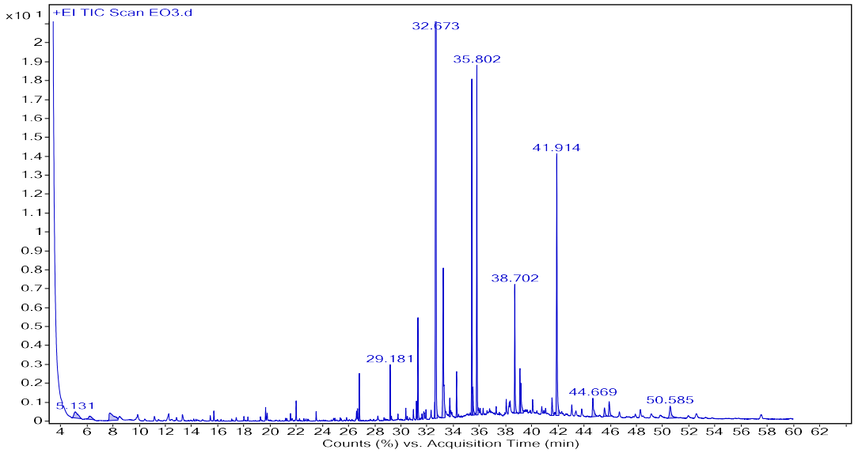
Figure S1: Total ion chromatogram (TIC) of essential oil from dried G. ferruginea bark

Table S-1. List of 48 essential oil components from dried G. ferruginea bark analyzed using GC-MS (Only numbered compounds were characterized)
Comp. | Name | Formula | RT | RI |  | Area | Peak Area (%)
 |  |  |  | Calculated | Reported | Area | Peak Area (%)
 | toluene | C₇H₈ | 5.131 | 758.1 | 758 | 468399 | 1.08
 | hexanol-4-D2 | C₆H₁₂D₂O | 6.221 | 799.7 |  | 196606 | 0.45
1 | sulfinylbis(methane) | C₂H₆OS | 7.772 | 844.7 | 829.2 | 690476 | 1.59
 | m - xylene and p - xylene | C₈H₁₀ | 8.478 | 865.2 | 865 | 111646 | 0.26
 | hexanol-6-D3 | C₆H₁₁D₃O | 9.884 | 906.4 |  | 157460 | 0.36
2 | pentanoic acid | C₅H₁₀O₂ | 12.261 | 980.8 | 938 | 167203 | 0.38
3 | 2(5H)-furanone, 3-methyl-5-methylene- | C₆H₆O₂ | 13.304 | 1015 |  | 122367 | 0.28
4 | nonanal | C₉H₁₈O | 15.706 | 1099.6 | 1099 | 103555 | 0.24
5 | (2E)-2-decenal | C₁₀H₁₈O | 19.66 | 1256.2 | 1256 | 118264 | 0.27
6 | 1-undecen-10-al | C₁₁H₂₀O | 21.995 | 1357.4 | 1313 | 192705 | 0.44
7 | 1-dodecanol | C₁₂H₂₆O | 26.691 | 1582.4 | 1487 | 104900 | 0.24
8 | 1,2-benzenedicarboxylic acid, diethyl ester | C₁₂H₁₄O₄ | 26.825 | 1589.5 | 1589.2 | 415251 | 0.95
9 | myristic acid, methyl ester | C₁₅H₃₀O₂ | 29.181 | 1714.4 | 1714 | 464009 | 1.07
10 | (E)-2-nonadecene | C₁₉H₃₈ | 30.375 | 1781.1 | 1906 | 101333 | 0.23
11 | methyl 13-methyltetradecanoate | C₁₆H₃₂O₂ | 30.956 | 1814.1 | 1779.1 | 116412 | 0.27
12 | neophytadiene | C₂₀H₃₈ | 31.189 | 1827.5 | 1827 | 164888 | 0.38
13 | 6,10,14-trimethyl-2-pentadecanone | C₁₈H₃₆O | 31.303 | 1834 | 1835 | 929497 | 2.14
14 | phthalic acid, butyl undecyl ester | C₂₃H₃₆O₄ | 31.75 | 1860.3 |  | 127938 | 0.29
15 | methyl palmitate | C₁₇H₃₄O₂ | 32.673 | 1914.7 | 1915 | 19658935 | 45.17
16 | palmitic acid | C₁₆H₃₂O₂ | 33.239 | 1949.7 | 1950 | 2222527 | 5.11
17 | ethyl palmitate | C₁₈H₃₆O₂ | 33.737 | 1980.4 | 1980 | 226847 | 0.52
18 | methyl heptadecanoate | C₁₈H₃₆O₂ | 34.256 | 2012.9 | 2013 | 423655 | 0.97
19 | methyl 13-octadecenoate | C₁₉H₃₆O₂ | 35.418 | 2087.7 | 2098 | 3072885 | 7.06
Table S-1. Continued

20 | methyl (Z)-9-octadecenoate | C₁₉H₃₆O₂ | 35.501 | 2092.8 | 2095 | 400352 | 0.92
21 | methyl stearate | C₁₉H₃₈O₂ | 35.802 | 2112.7 | 2113 | 3283989 | 7.55
22 | methyl 16-acetylhydroxypalmitate | C₁₉H₃₆O₄ | 35.942 | 2122.1 |  | 112366 | 0.26
 | linoleic acid | C₁₈H₃₂O₂ | 38.054 |  |  | 195288 | 0.45
23 | (E)-9-octadecenoic acid | C₁₈H₃₄O₂ | 38.287 | 2283.3 |  | 166743 | 0.38
 | linoleic acid | C18H32O2 | 38.35 |  |  | 192359 | 0.44
24 | methyl eicosanoate | C₂₁H₄₂O₂ | 38.702 | 2312.9 | 2313 | 1311757 | 3.01
25 | 4,8,12,16-tetramethylheptadecan-4-olide | C₂₁H₄₀O₂ | 39.097 | 2341 | 2364.2 | 477525 | 1.10
26 | (Z)-9-pentadecenol | C₁₅H₃₀O | 39.169 | 2346.7 |  | 515161 | 1.18
27 | methyl 18-methylicosanoate | C₂₂H₄₄O₂ | 40.067 | 2411.6 | 2401.1 | 158363 | 0.36
28 | methyl docosanoate | C₂₃H₄₆O₂ | 41.551 | 2511 | 2511 | 291599 | 0.67
29 | diisooctylphthalate | C₂₄H₃₈O₄ | 41.914 | 2532.4 | 2525 | 3325247 | 7.64
 | 11,13-dimethyl-12-tetradecen-1-ol acetate | C₁₈H₃₄O₂ | 43.061 |  |  | 169443 | 0.39
 | 1,3-dioxolane, 4-ethyl-5-octyl-2,2-bis(trifluoromethyl)-, trans- | C₁₅H₂₄F₆O₂ | 43.372 |  |  | 119854 | 0.28
 | 11,13-dimethyl-12-tetradecen-1-ol acetate | C₁₈H₃₄O₂ | 43.818 |  |  | 129369 | 0.30
 | stearyl alcohol | C₁₈H₃₈O | 44.669 |  |  | 469285 | 1.08
30 | methyl tetracosanoate | C₂₅H₅₀O₂ | 45.557 | 2712.3 | 2712 | 197657 | 0.45
 | stearyl alcohol | C₁₈H₃₈O | 45.92 |  |  | 318451 | 0.73
 | tridecanal | C₁₃H₂₆O | 46.703 |  |  | 126066 | 0.29
31 | 5,9,13,17-tetramethyl 4,8,12,16-octadecatetraenoic acid | C₂₂H₃₆O₂ | 48.296 | 2811.1 |  | 189473 | 0.44
 | 1,3-dioxolane, 4-ethyl-5-octyl-2,2-bis(trifluoromethyl)-, trans- | C₁₅H₂₄F₆O₂ | 49.127 |  |  | 126913 | 0.29
32 | ginsenol | C₁₅H₂₆O | 49.832 | 2855.9 |  | 113101 | 0.26
 | 1,3-dioxolane, 4-ethyl-5-octyl-2,2-bis(trifluoromethyl)-, trans | C₁₅H₂₄F₆O₂ | 50.585 |  |  | 453782 | 1.04
 | 1,3-dioxolane, 4-ethyl-5-octyl-2,2-bis(trifluoromethyl)-, trans- | C₁₅H₂₄F₆O₂ | 52.577 |  |  | 140392 | 0.32
 | arsenous acid, tris(trimethylsilyl) ester | C₉H₂₇AsO₃Si₃ | 57.532 |  |  | 182182 | 0.42

Figure S2: ¹H NMR spectra of compound 33

Figure S3. ¹³C NMR spectrum of compound 33

Figure S4. ¹³C DEPT-135 NMR spectrum of compound 33

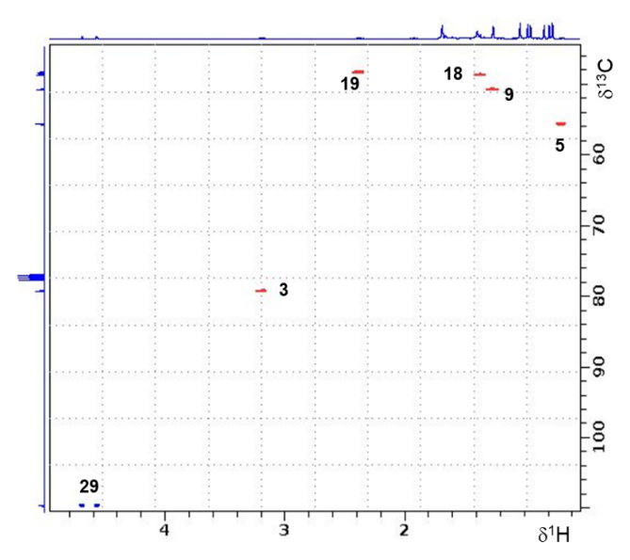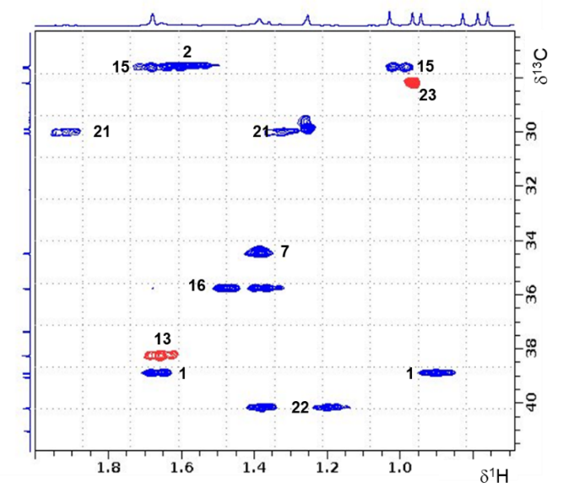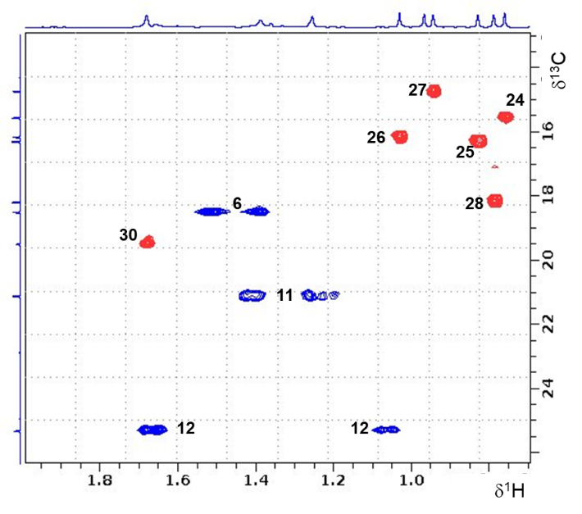
Figure S5. Expanded regions of ¹H-¹³C HSQC NMR spectrum with assignments of resonances of compound 33

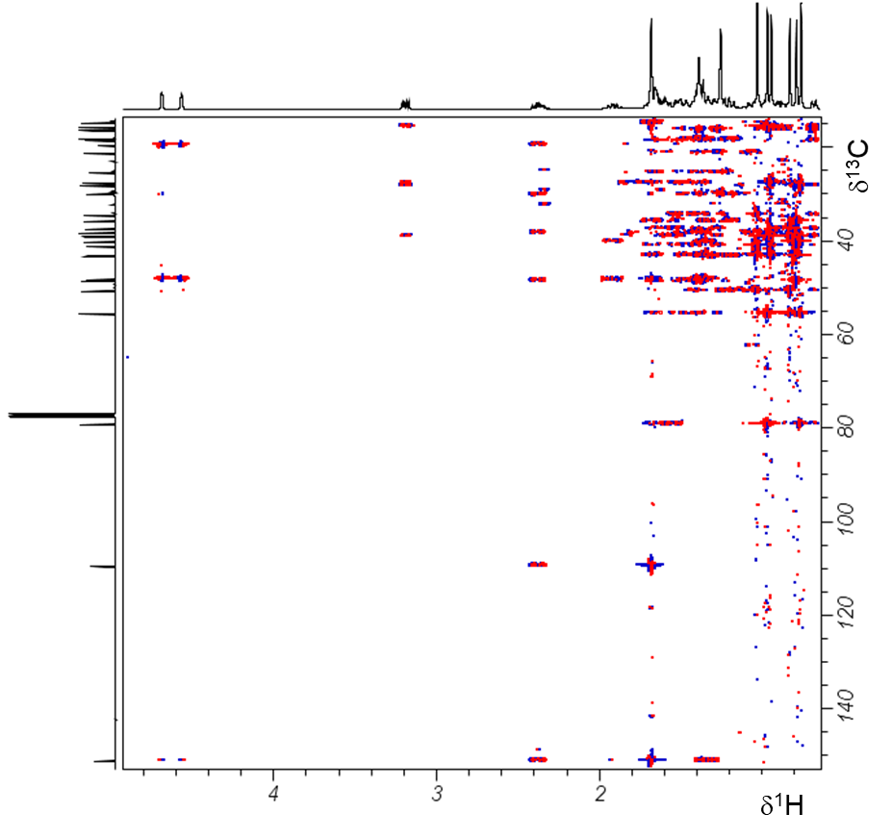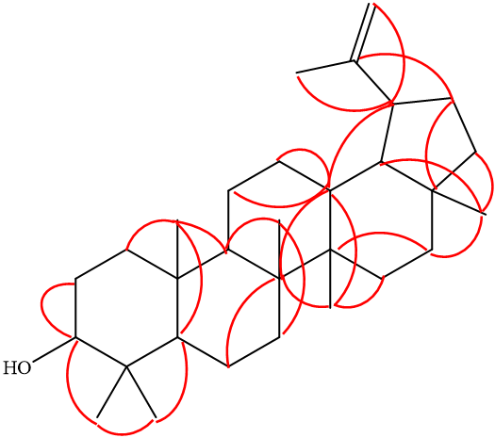
Figure S6. ¹H-¹³C HMBC NMR spectrum and crucial correlations identified for assignment of chemical structure of compound 33

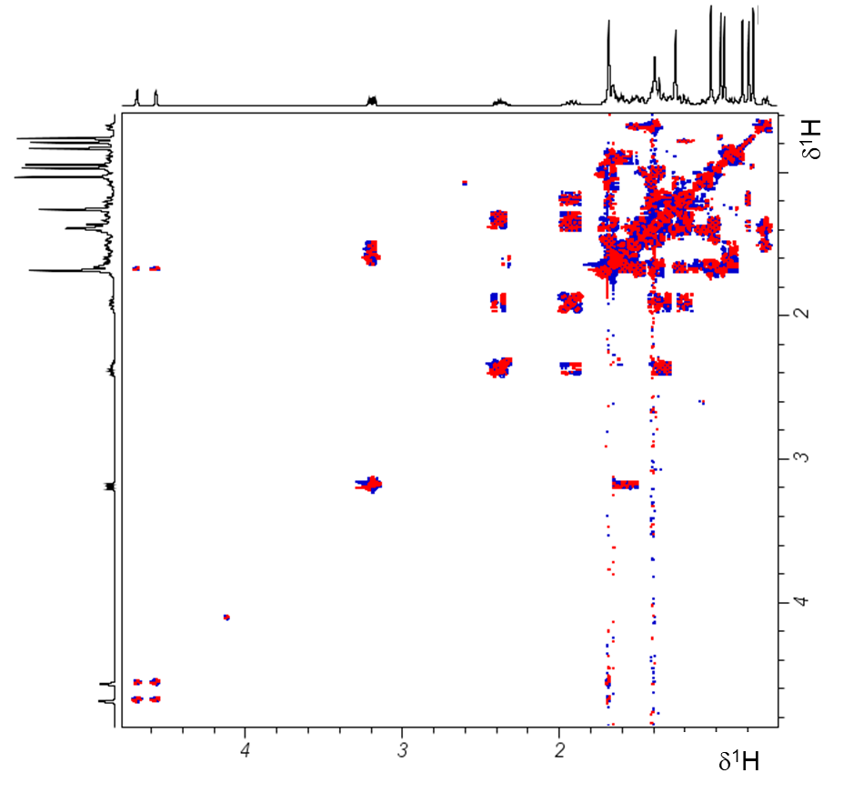
Figure S7. ¹H-¹H DQF-COSY NMR spectrum of compound 33

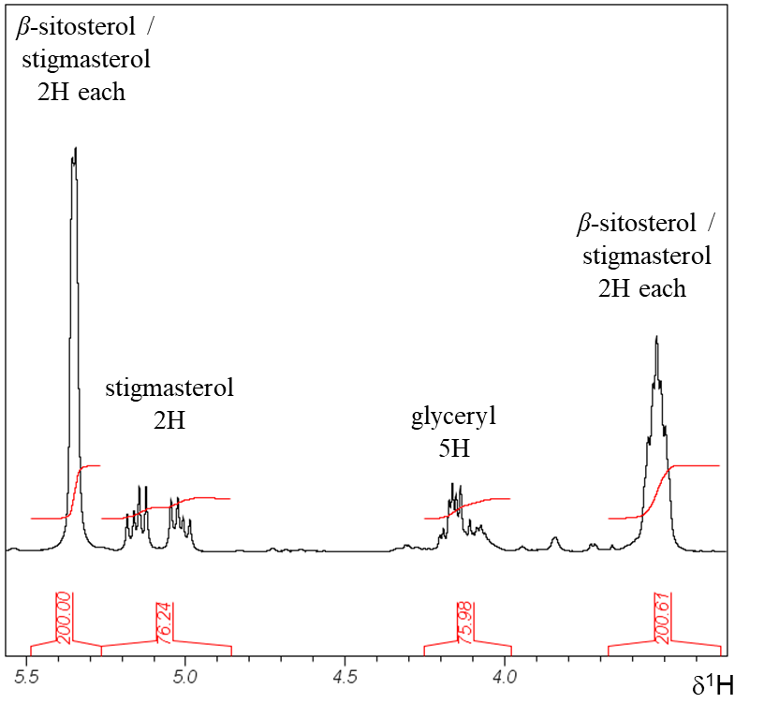

Figure S8. ¹H NMR spectrum and enlarged region with integrals to determine relative amounts of compound 34, 35, and glyceryl tristearate

Figure S9. ¹³C NMR spectrum of compound 34, 35, and glyceryl tristearate)

Figure S10. ¹³C DEPT-135 NMR spectrum of compound 34, 35, and glyceryl tristearate

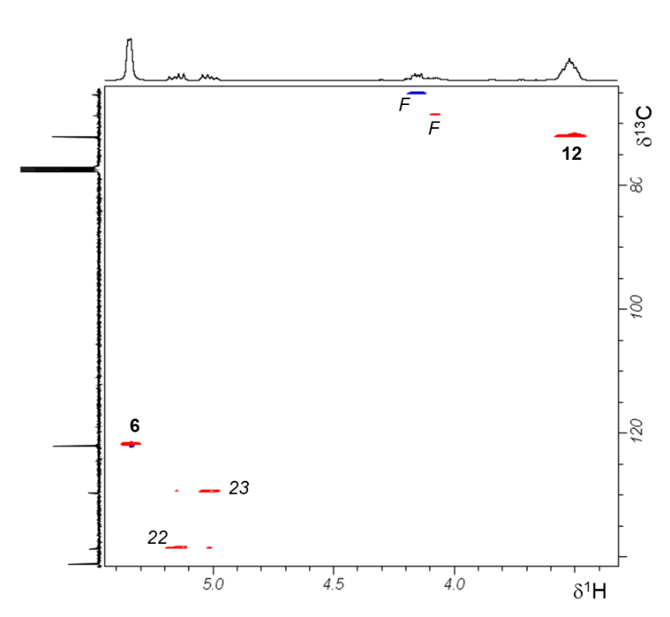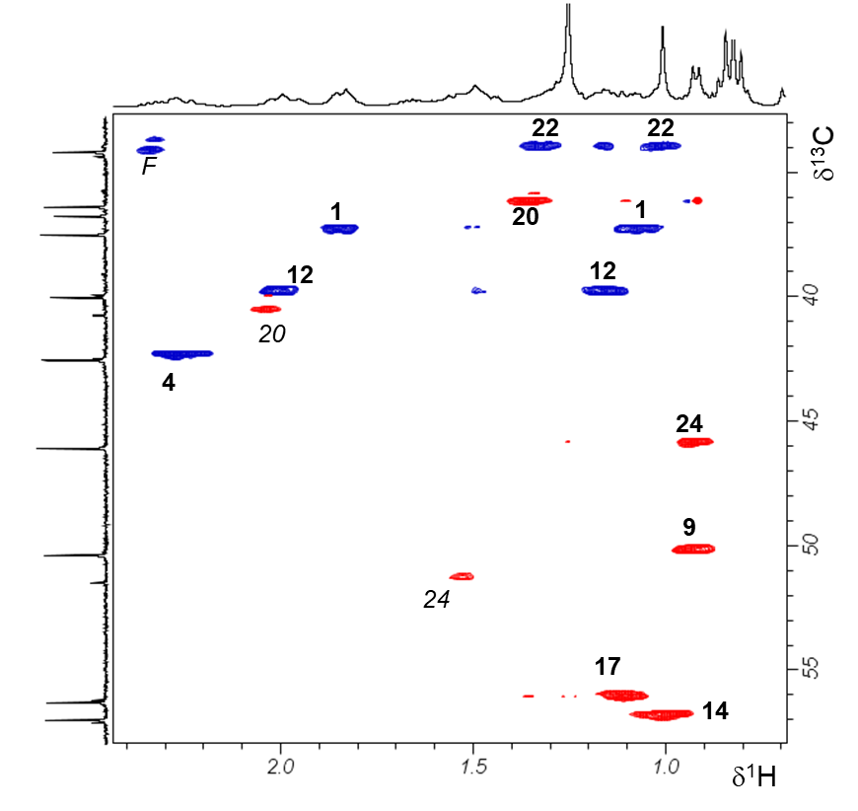
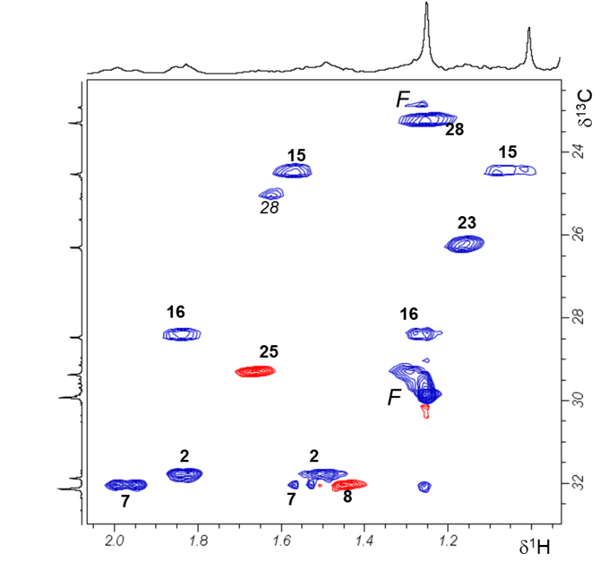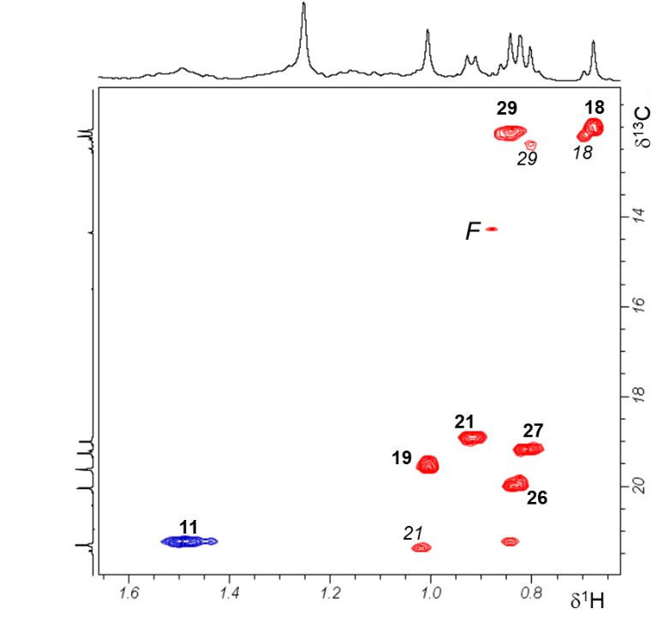
Figure S11. Expanded regions of ¹H-¹³C HSQC NMR spectrum with assignments of resonances of compound 34 (in bold), compound 35 (in italic), and glyceryl tristearate = F)

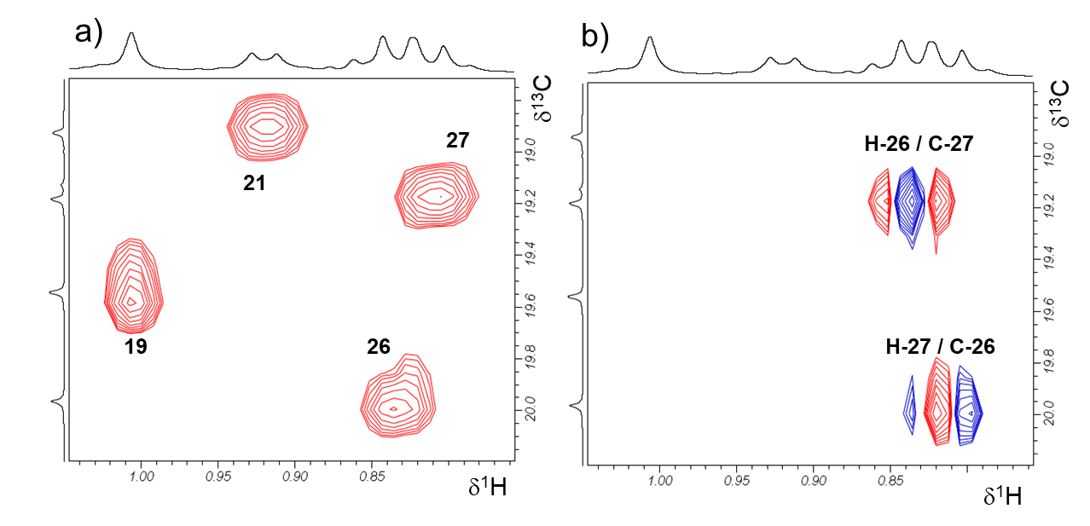 Figure S12. Expanded regions of ¹H-¹³C HSQC (a) and HMBC (b) NMR spectra with assignments of resonances of compound 34 with crucial HMBC correlations of H-26 to C-27 and H-27 to C-26 used for unambiguous assignment of resonances

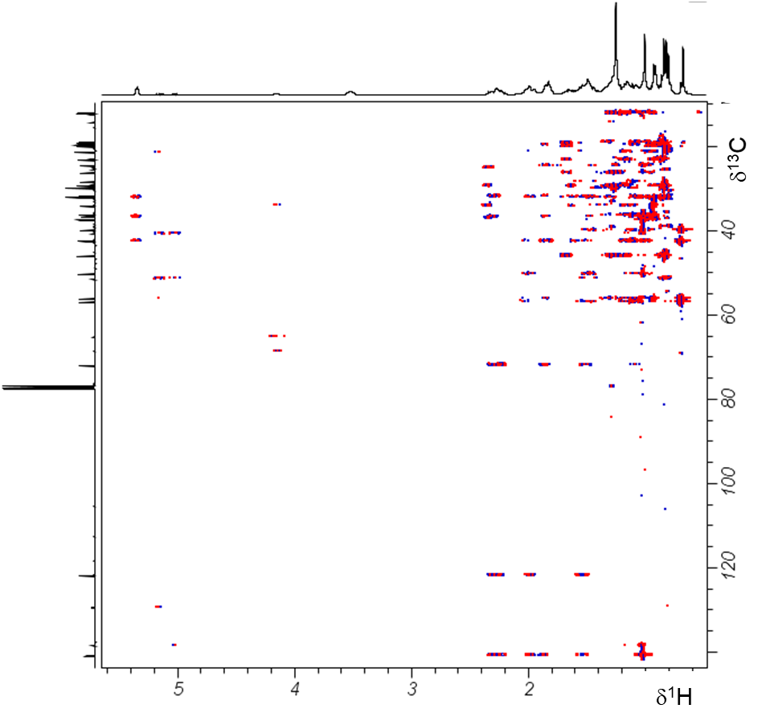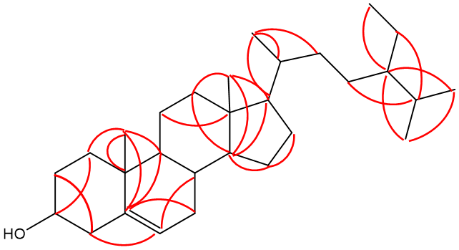
Figure 13. ¹H-¹³C HMBC NMR spectrum and crucial correlations identified for assignment of chemical structure of compound 34

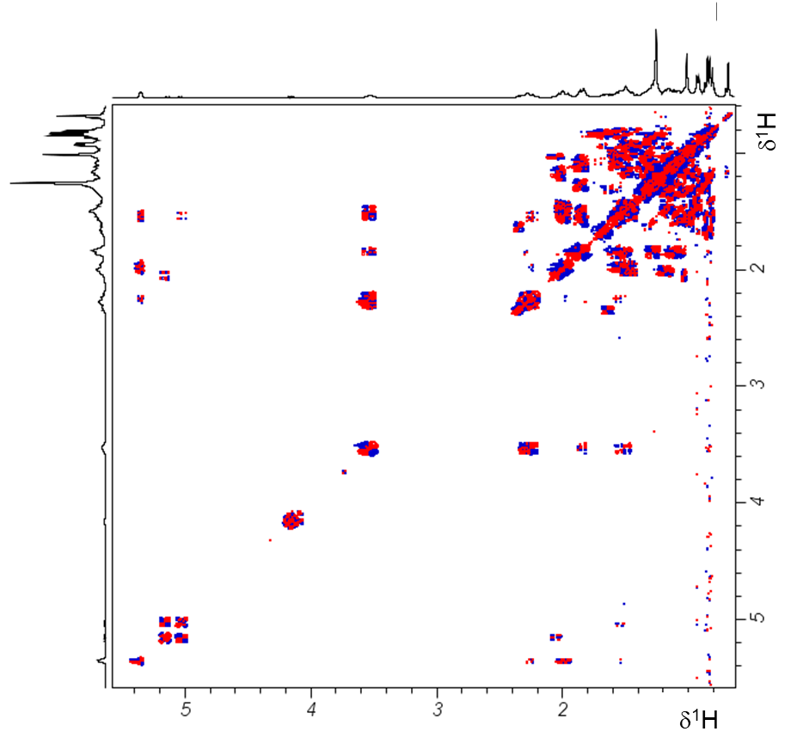
Figure S14. ¹H-¹H DQF-COSY NMR spectrum of compound 34, 35, and glyceryl tristearate

Table S-2. ¹H-NMR (400.2 MHz) and ¹³C-NMR (100.6 MHz) spectral data of compound 35 and NMR data reported for stigmasterol
C-$№$ | Compound 35 (in CDCl₃) |  |  | δ¹³C of stigmasterol
C-$№$ | δ¹H | δ¹³C | HMBC | [30] | [31]
1 |  | 37.4 |  | 37.2 | 37.6
2 |  | 31,8 |  | 31.6 | 32.1
3 |  | 72.0 |  | 71.8 | 72.1
4 |  | 42.4 |  | 42.2 | 42.4
5 |  | 140.9 |  | 140.7 | 141.1
6 |  | 121.9 |  | 121.7 | 121.8
7 |  | 32.0 |  | 31.9 | 31.8
8 |  | 32.0 |  | 31.9 | 31.8
9 |  | 50.3 |  | 50.1 | 50.2
10 |  | 36.6 |  | 36.5 | 36.6
11 |  | 21.2 |  | 21.0 | 21.5
12 | 2.01 & 1.16 (m, 2H) | 39.8 |  | 39.7 | 39.9
13 |  | 42.4 |  | 42.3 | 42.4
14 | 1.00 (m, 1H) | 57.0 |  | 56.8 | 56.8
15 | 1.57 &1.04 (m, 2H) | 24.5 |  | 24.4 | 24.4
16 |  | 29.1 |  | 28.9 | 29.3
17 | 1.10 (m, 1H) | 56.1 |  | 56.0 | 56.2
18 | 0.69 (s, 3H) | 12.2 |  | 11.8 | 12.0
19 | 0.80 (s, 3H) | 19.1 |  | 19.1 | 18.9
20 | 2.03 (m, 1H) | 40.6 |  | 40.5 | 40.6
21 | 1.01 (3H) | 21.4 | H-17, 20, 22 | 21.5 | 21.7
22 | 5.15 (dd, 2H) | 138.3 |  | 138.3 | 138.7
23 | 5.01 (dd, 2H) | 129.4 |  | 129.3 | 129.6
24 | 1.53 (m, 1H) | 51.4 |  | 51.2 | 46.1
25 |  | 36.3 |  | 36.1 | 29.6
26 |  | 20.0 |  | 19.8 | 20.2
27 |  | 19.1 |  | 18.9 | 19.8
28 |  | 25.5 |  | 25.4 | 25.4
29 | 0.80 (3H) | 12.4 |  | 12.0 | 12.1

Figure S15. ¹H NMR spectrum of compound 36

Figure S16. ¹³C NMR spectrum of compound 36

Figure S17. ¹³C DEPT-135 NMR spectrum of compound 36

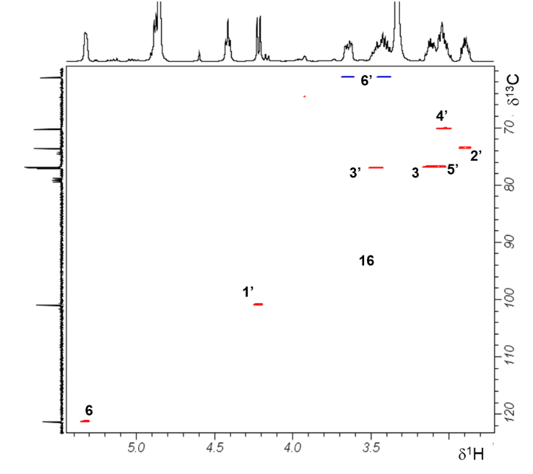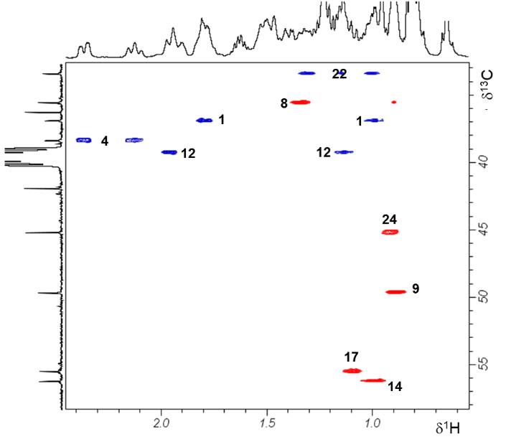
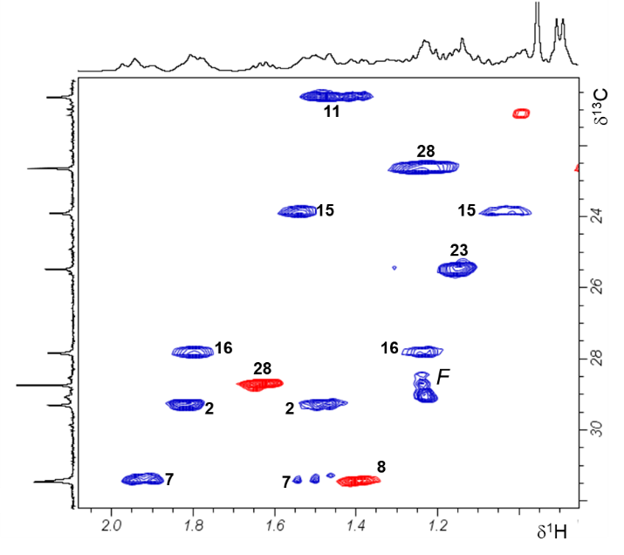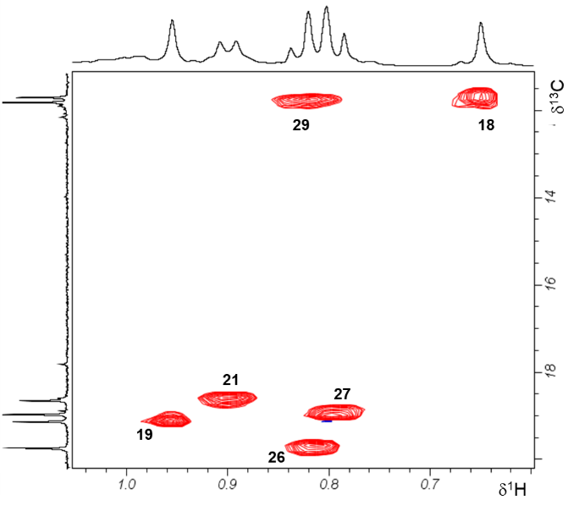
Figure S18. Expanded regions of ¹H-¹³C HSQC NMR spectrum with assignments of resonances of compound 36

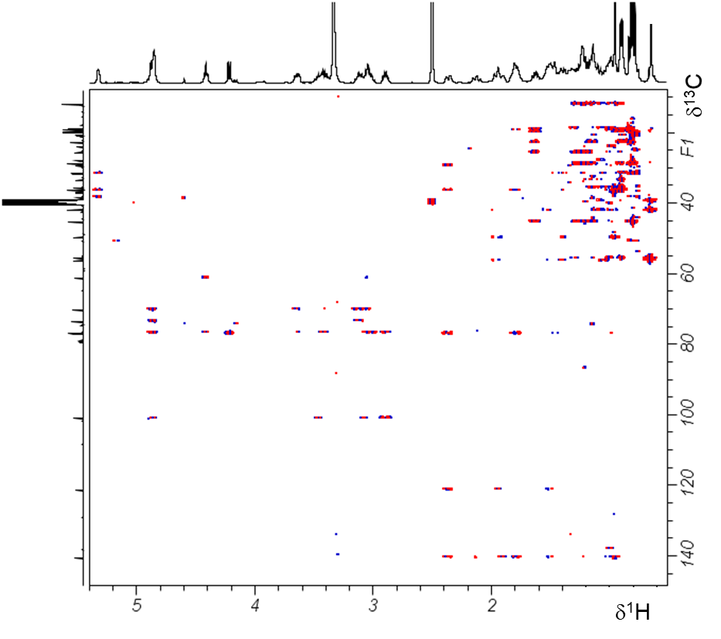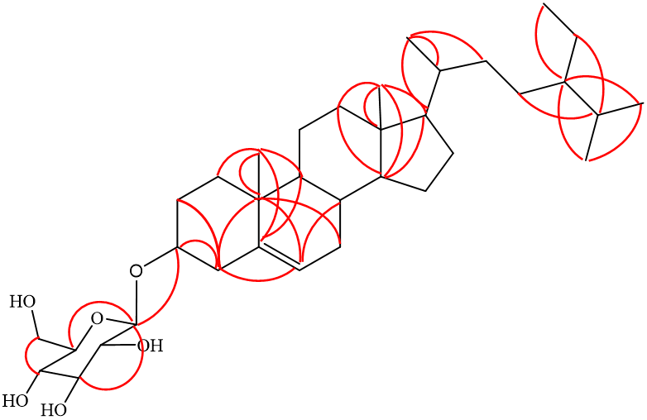

Figure S19. ¹H-¹³C HMBC NMR spectrum and crucial correlations identified for assignment of chemical structure of compound 36

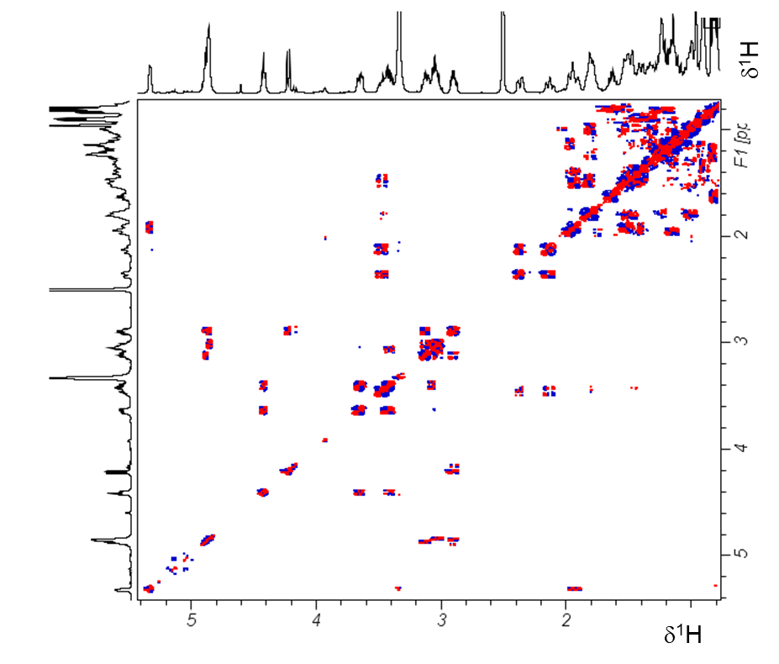
Figure S20. ¹H-¹H DQF-COSY NMR spectrum of compound 36

Figure S21. ¹H NMR spectrum of compound 37 and 38 and expanded region used to calculate their percentage.

Figure S22. ¹³C NMR spectrum of compound 37 and 38

Figure S23. ¹³C DEPT-135 NMR spectrum of compound 37 and 38

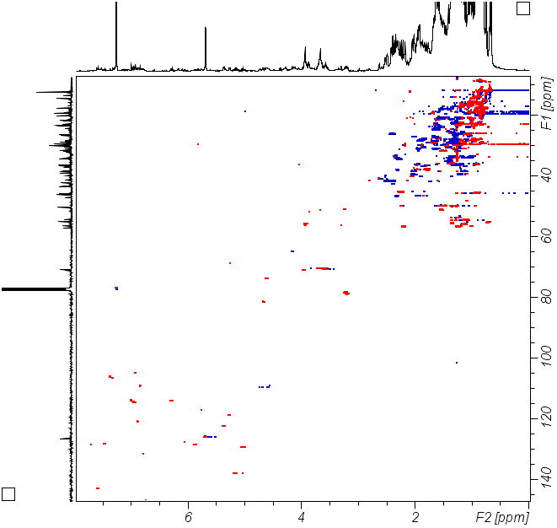

Figure S24. Expanded regions of ¹H-¹³C HSQC NMR spectrum with assignments of resonances of compound 37 and 38
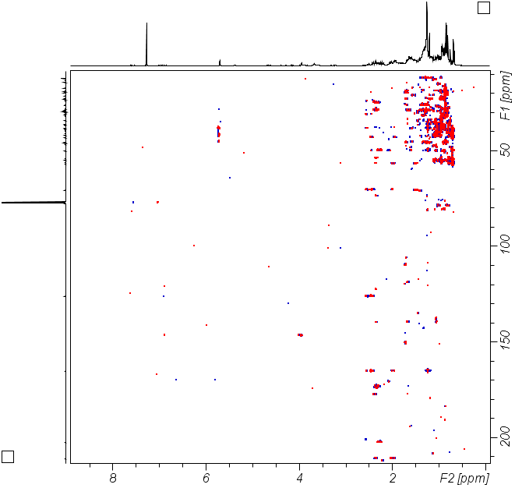

Figure S25. ¹H-¹³C HMBC NMR spectrum of 37 and 38

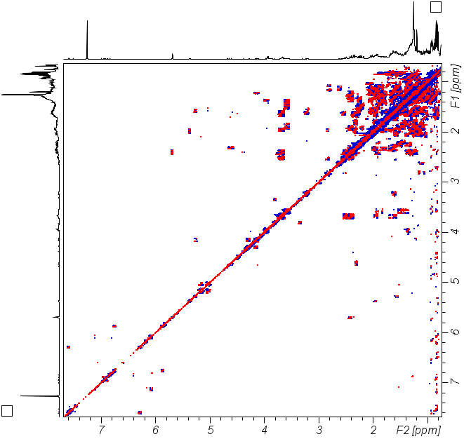

Figure S26. ¹H-¹H DQF-COSY NMR spectrum of 37 and 38

Table S-3. ¹H-NMR (400.2 MHz, DMSO-d₆) and ¹³C-NMR (100.6 MHz) spectral data of compound 39 and NMR data reported for catechin
C $№$ | Compound 39 |  |  |  | Catechin [42]  δ¹³C/ DMSO-d₆
C $№$ | δ¹H | δ¹³C | ¹H-¹H COSY | ¹H-¹³C HMBC | Catechin [42]  δ¹³C/ DMSO-d₆
1 |  | - |  |  | -
2 | 4.46 (d, J=7.6 Hz, 1H) | 81.3 | H-3 | H-4, 2’ | 81.1
3 | 3.81 (m, 1H) | 66.6 | H-4 | H-2, 4 | 66.5
4 | 2.34 (dd, J= 15.9, 5.1 Hz, 1H)  2.64 (dd, J= 16.0, 8.0 Hz, 1H) | 28.2 | H-3 | H-2 | 28.0
5 | - | 155.6 |  | H-4, 8 | 155.5
6 | 5.68 (d, J= 2.2 Hz, 1H) | 94.0 |  | H-8 | 94.1
7 | - | 156.6 |  |  | 156.6
8 | 5.91 (d, 2.2 Hz, 1H) | 95.5 |  |  | 95.4
9 | - | 156.8 |  |  | 156.4
10 | - | 99.2 |  | H-4, 6, 8 | 99.3
1’ | - | 130.7 |  | H-5’, H-2 | 130.8
2’ | 6.69 (d, 2.0 Hz, 1H) | 115.4 |  | H-6’, 2 | 114.7
3’ | - | 145.6 |  | H-2’ | 145.0
4' | - | 145.6 |  | H-5’ | 145.0
5’ | 6.67 (d, J= 8.0 Hz, 1H) | 115.9 | H-6’ |  | 115.3
6’ | 6.56 (dd, J= 8.0, 2.0 Hz, 1H) | 118.5 | H-5’ | H-2’ | 118.7

Figure S27. ¹H NMR spectrum of compound 39

Figure S28. ¹³C NMR spectrum of compound 39
Figure S29. ¹³C DEPT-135 NMR spectrum of compound 39
Figure S30. ¹H-¹³C HSQC NMR spectrum with assignments of resonances of compound 39
Figure S31. ¹H-¹³C HMBC NMR spectrum of 39

Figure S32. ¹H-¹H DQF-COSY NMR spectrum of 39

Target | Ligand | Binding affinity (Kcal/mol) | H-bonding | Hydrophobic and Electrostatic | Vaan der Waals
7P2M | 33 | -6.9 | - | - | Ile-140, Arg-206, His-64, Gln-72, Ser-70, Met-166, Glu-131, Val-133, Arg-142, Thr-157
7P2M | 34 | -6.8 | - | Pi-sigma: Phe-196; Alkyl and Pi-alkyl: Arg-192, Leu-197, Phe-196 | Glu-193, Ser-195, His-217, Phe-216, Tyr-218
7P2M | 35 | -7.8 | Thr-165 | Alkyl: Ile-78, Ile-94 | Leu-98, Val-93, Val-97, Gly-119, Val-120, Asn-46, Asp-73, Glu-50, Gly-75, Arg-76, Gly-77, Pro-79
7P2M | 36 | -7.7 | Glu-85 | Alkyl and Pi-alkyl: Tyr-26, Leu-98, Lys-11, Val-97 | Val-118, Ser-8, Glu-86, Val-12, Gly-15
7P2M | 37 | -7.8 | Asp-73 | Alkyl: Ile-78, Ile-94; Pi-sigma: His-83 | Ala-90, Val-93, Pro-79, Arg-76, Arg-136, Gly-77, Thr-165, Glu-50, Ala-47, Asn-46
7P2M | 38 | -8.0 | Asp-73 | Alkyl: Ala-90, Ile-78, Val-93, Ile-94;Pi-sigma: His- 83 | Pro-79, Gly-77, Glu-50, Thr-165, Ala-47, Asn-46, Asp-49
7P2M | 39 | -7.8 | Asp-73, Arg-76 | Carbon hydrogen bond: Asn-46; Pi-anion: Glu-50; Pi-sigma: THr-165; Pi-alkyl:Ala-47 | Val-71, 43, 167, 120, Ile-78, 94, Asp-49
7P2M | Ciprofloxacin | -7.4 | Arg-76 | Carbon hydrogen bond: Asp-73; Halogen: Asp-73; Amide pi-stacked: Gly-77; Alkyl and pi-alkyl:Pro-79, Ile-94, Ile-78 | Arg-136, Glu-50, Thr-165, Val-120, Val-167, Val-43, Asn-46, Ala-47,
5OE4 | 33 | -9.1 | - | Pi-sigma: Trp-233 | Ala-256, Pro-234, Asn-84, Phe-208, Lys-86, Phe-209, Lys-206, Pro-205, Ile-204, Val-254, Ile-257
5OE4 | 34 | -8.8 | - | Pi-sigma: Phe-209, Trp-233; Alkyl and Pi-alkyl: Pro-205, Phe-209, Trp-233 | Val-254, Pro-234, Phe-208, Lys-206, Ile-204
5OE4 | 35 | -9.0 | - | Pi-sigma: Phe-209, Trp-233, Alkyl and Pi-alkyl: Pro-205, Trp-233 | Val-254, Ile-204, Pro-234, Pro-236, Ser-235, Phe-208
5OE4 | 36 | -8.4 | Arg-200, Ala-245 | - | Gly-198, Thr-20, Ala-21, Gly-27, Thr-29, Gln-28, Gly-27, Phe-246, His-24, Thr-29, His-24, Ala-21, Asp-19
5OE4 | 37 | -8.0 | Lys-86 | Alkyl: Pro-205, Pro-234; Pi-sigma: Phe-209, Trp-234 | Ser-235, Ile-204, Ile-257, Lys-206, Phe-208
5OE4 | 38 | -8.3 | - | Alkyl and Pi-alkyl: Lys-206, Pro-234, TRp-233 | Phe-209, Phe-208, Ser-235, Pro-236, Pro-205, Val-254, Ile-204, Ile-257
5OE4 | 39 | -8.0 | Gly-279, 300, Tyr-378, Glu-305, Thr-305, 164 | Carbon hydrogen and Pi-donor hydrogen bond: Pro-281, His-394; Pi-sigma and Amide pi-stacked:Ile-301, Ala-303, Gly-279 | Ala-278, Ser-280, Asp-382, Arg-397, Gly-302
5OE4 | Ciprofloxacin | -7.2 | Arg-200 | Halogen: Asp-19, Arg-200; Alkyl: Ala-21; Carbon hydrogen bond: Gly-198, Asp-17 | His-24, Ser-226, Thr-29, Arg-249, Thr-20, Gly-198
Table S-4. Molecular docking results of isolated compounds against E. coli DNA Gyrase B (PDB ID: 7P2M) and PqsA (PDB ID: 5OE4)

Table S-5. Molecular docking results of isolated compounds against Pyruvate kinase (PDB ID: 4G1N) and human topoisomerase IIβ (PDB ID: 3QX3)
Target | Ligand | Binding affinity | H-bonding | Hydrophobic and Electrostatic | Vaan der Waals
4G1N | 33 | -7.4 | - | - | Arg-376, 339, Leu-380, Lys-173, Pro-212, 302, 338, Glu-300, 304, 373, Ile-299, 301, Tyr-175, Ala-303, Met-377
4G1N | 34 | -7.5 | Tyr-390 | Pi-alkyl: Tyr-390 | Gln-393, 393, Arg-400, 400, 400, Thr-25, 25, Asp-24, 24, Glu-397, 396, 396, 396, Leu-392
4G1N | 35 | -7.1 | - | Alkyl: Pro-403, Met-22, Leu-392 | Leu-401, Ala-402, 21, Ile-404, Lys-422, Phe-421, 395, Arg-399, Glu-418
4G1N | 36 | -7.1 | Arg-106, 43 | - | Ser-67, Lys-66, Arg-383, 500, 376, Gly-68, His-464, 379, Asn-70, Phe-470, 502, Ala-42, Thr-41, Leu-380
4G1N | 37 | -6.9 | Glu-198 | Alkyl: Pro-212, Arg-339, Tyr-175;Pi-sigma: Tyr-175 | Ile-299, Gly-298, Ala-303, Pro-302,338, Glu-304, 373, Leu-380, Met-377, Lys-136, 173, Asn-199, Ser-182
4G1N | 38 | -7.1 | Glu-418, Arg-399 | Alkyl: Met-22 | Asp-24, Leu-401, 392, Arg-400, 447, Phe-421, 395, Lys-422, Ile-404, Ala-402, Pro-403
4G1N | 39 | -9.9 | Tyr-390, Lys-311, Asp-354, Ala-388 | Pi-sigma: Leu-353; Pi-pi T-shaped: Phe-26; Alkyl-353 | Ile-389, His-29, Leu-33, Met-30
4G1N | PKM2-IN-1 | -9.5 | Tyr-390 | Pi-pi T-shaped: Phe-26; Alkyl and Pi-alkyl: Leu-353, Phe-26 | Asp-354, Lys-311, Tyr-390, His-29, Ala-388, Ile-389, Asp-354, Met-30, Ala-388, His-29, Ile-389, Tyr-390
3QX3 | 33 | -8.8 | Asp-847 | Pi-sigma: Phe-1019 | Met-1022, Gly-1023, Ser-733, Glu-855, 728, 853, Arg-743, Pro-740, Val-852, Lys-744, Tyr-846, Leu-845
3QX3 | 34 | -8.4 | His- 775 | Pi-sigma:Phe-1019; Alkyl and Pi-alkyl: Leu-394, 353, Phe-26 | Glu-397, Gln-393, Ile-389, Met-30, Leu-353, Lys-311, Asn-350,
3QX3 | 35 | -7.9 | - | Alkyl and Pi-alkyl: Glu-853, Leu-845, Arg-743 | Glu-855, 728, Trp-856, His-1021, Asp-1020, Ser-733, Phe-1019, Lys-744, Tyr-773, Ala-772
3QX3 | 36 | -8.2 | Gln-1197, Ser-827, Glu-1198 | Alkyl: Pro-802 | Asn-790, 798, Gly-804, 807, Phe-806, 791, Thr-808, 980, 828, Gln-805, 801, Asp-979, Ala-637, Lys-638, 1193, Leu-829, 826, Val-1194
3QX3 | 37 | -7.6 | Leu-829, Ser-827, Thr-828, Asn-890 | Alkyl: Ile-803, Val-1194; Carbon hydrogen bond: Pro-802 | Asp-1201, Asn-798, Gln-801, 1197, Glu-1198, Gly-804
3QX3 | 38 | -7.7 | Thr-828, Ser-827, Asn-798 | Alkyl: Ile-803, Val-1194 | Asp-1201, Asn-790, Gln-801, 1197, Leu-829, Pro-802, Glu-1198, Gly-804
3QX3 | 39 | -8.3 | Gln-850, His-774, Lys-759, Gly-765 | Carbon hydrogen bond and Pi-anion: Glu-769;Pi-Pi T-shaped and Amide Pi-stacked: Ala-768, Phe-823 | Val-758, Gln-762
3QX3 | Etoposide | -9.7 | Arg-494, Gln-949, Lys-952, His-811 | Carbon hydrogen bond: Val-486, Asp-815; Alkyl and Pi-Alkyl:Val-491, Leu-484 | Gly-490, Thr-808, Ser-487, 483, Lys-638, 482, Gln-805, Ala-817, Leu-810

