Additional file 2: Figure S2. The input map of the MHb^{vGlut2} neurons.
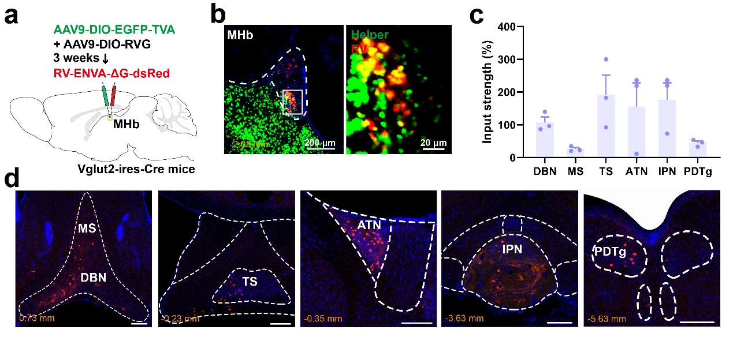
(a) Virus strategy for retrograde labeling vGlut2 positive neurons in the MHb. (b) Representative image of the injection site. Starter cells were highly limited to the MHb. Scale bar (left) = 200 μm; scale bar (right) = 20 μm. (c) The percentage of input strength of the MHb. n = 3 in total. (d) Representative image showing input brain regions to the MHb vGlut2 neurons. scale bar = 200 μm.

