
CARE Checklist of information to include when writing a case report
Topic Item Checklist item description Reported on Line
Title 1 The diagnosis or intervention of primary focus followed by the words “case report”
Imerslund-Gräsbeck Syndrome in a child with a novel compound heterozygous mutations in the AMN gene: A Case Report
Key Words 2 2 to 5 key words that identify diagnoses or interventions in this case report, including "case report"
Imerslund-Gräsbeck syndrome;AMN gene;anemia;oral;case report

Abstract
(no references)
3a Introduction: What is unique about this case and what does it add to the scientific literature?
Imerslund-Gräsbeck syndrome (IGS) is an autosomal recessive disorder characterized by selective vitamin B12 malabsorption, resulting in vitamin B12 deficiency and impaired reabsorption of proximal tubular proteins.This case highlights a previously unidentified compound heterozygous variant in the AMN gene that causes IGS syndrome and underscores the importance of long-term oral vitamin B12 replacement therapy in managing the condition.
3b Main symptoms and/or important clinical findings
The child was admitted to the hospital due to persistent anemia for over a month.The admission examination revealed megaloblastic anemia with proteinuria. Serum vitamin B12 levels were decreased, while folic acid and renal function were normal
3c The main diagnoses, therapeutic interventions, and outcomes
After the initial diagnosis of macrocytic anemia, the child received oral treatment with vitamin B12 at a dosage of 100 μg/day. After 3 months of treatment, the outpatient follow-up revealed that the hemoglobin levels had returned to normal. However, due to the persistent proteinuria, a whole exon gene test was conducted in November 2019, which led to the diagnosis of IGS.The child continued to receive oral vitamin B12 therapy as an alternative treatment during follow-up. Fortunately, the oral vitamin B12 therapy demonstrated good efficacy for the child. As a result, the decision was made to maintain the adherence to oral vitamin B12 therapy even after the diagnosis of IGS.During the follow-up period,the hemoglobin, vitamin B12, folic acid and renal function were normal, while proteinuria persisted.
3d Conclusion—What is the main “take-away” lesson(s) from this case?
In this case, oral vitamin B12 treatment also demonstrated positive clinical effects for the child, offering a new option for patients who are unable to undergo intramuscular vitamin B12 replacement therapy.

Introduction 4 One or two paragraphs summarizing why this case is unique (may include references)
An earlier trial of vitamin B12 absorption in 30 IGS patients demonstrated a greater heterogeneity in the absorption impairment of vitamin B12 in different IGS patients^{[19]}.This heterogeneity may be attributed to differences in the number and activity of vitamin B12-internal factor complex receptors among individuals with IGS. Additionally, molecular changes in the AMN genes of IGS patients can result in varying degrees of functional impairment of the vitamin B12-internal factor complex receptor.The AMN protein is a transmembrane protein with signal sequence and transmembrane domain located between amino acids 1 and 19 and between amino acids 361 and 381, respectively.^{[20]} The compound heterozygous mutation of AMN in this child is located at amino acid 308 (c.922C> T) and intron 3 (c.162 + 1G> A) of the coding region, which does not affect the key functional domains of the protein.Therefore, the degree of receptor defect caused by AMN mutation in this child may be mild, and oral administration of vitamin B12 can still effectively improve vitamin B12 deficiency.
Patient Information 5a De-identified patient specific information
Tongji Hospital, Tongji Medical College, Huazhong University of Science and Technology PatientID :100849050
5b Primary concerns and symptoms of the patient
The child was admitted to the hospital due to a history of anemia persisting for over a month. The admission examination revealed that she suffered from megaloblastic anemia with proteinuria.
5c Medical, family, and psycho-social history including relevant genetic information
There were no significant past medical or family history, and the living environment was considered favorable.
5d Relevant past interventions with outcomes
The patient had not been treated in the past

Clinical Findings

Timeline

- Describe significant physical examination (PE) and important clinical findings
Physical examination reveals a pale complexion and lips.The admission examination revealed that she suffered from megaloblastic anemia with proteinuria.

- Historical and current information from this episode of care organized as a timeline
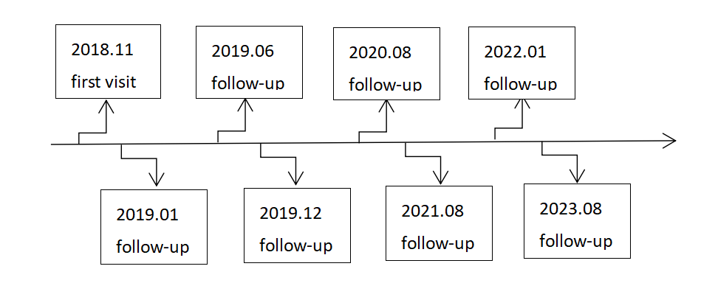

Diagnostic Assessment

Therapeutic Intervention

8a Diagnostic testing (such as PE, laboratory testing, imaging, surveys).
Hemoglobin content: 61 g/L.Mean corpuscular volume:112.7 fL.Mean hemoglobin content: 38.6 pg.Urinary protein: ++.Folic acid: 20.54 ng/mL.Vitamin B12: <50 pg/mL.α1-microglobulin:9.20mg/L.Urinary microprotein:534mg/L.24-hour urinary microalbuminuria total protein: 366.1 mg/24 h.24-hour urinary microalbuminuria: 234.1 mg/24 h.Genetic test:a compound heterozygous variant in the AMN gene: c.162+1G>A and c.922C>T (p.Q308X).

8b Diagnostic challenges (such as access to testing, financial, or cultural)
This patient did not receive a genetic test at the first visit for economic reasons. Therefore she was diagnosised of megaloblastic anemia with proteinuria at tne first visit.However, due to the persistent proteinuria, a whole exon gene test was conducted in November 2019, which led to the diagnosis of IGS

8c Diagnosis (including other diagnoses considered)
The admission examination revealed megaloblastic anemia with proteinuria.However, due to the persistent proteinuria, a whole exon gene test was conducted in November 2019, which led to the diagnosis of IGS

8d Prognosis (such as staging in oncology) where applicable
The disease has a good prognosis after long-term vitamin B12 replacement therapy

9a Types of therapeutic intervention (such as pharmacologic, surgical, preventive, self-care)
After the initial diagnosis of macrocytic anemia, the child received oral treatment with vitamin B12 at a dosage of 100 μg/day.

9b Administration of therapeutic intervention (such as dosage, strength, duration)
The patient received oral treatment with vitamin B12 at a dosage of 100 μg/day for a long time.

9c Changes in therapeutic intervention (with rationale)
The drug dose of this child has not been adjusted yet

Follow-up and Outcomes

10a Clinician and patient-assessed outcomes (if available)
Throughout the follow-up period, blood tests of serum vitamin B12 levels、folic acid levels and renal function consistently showed normal results, while proteinuria persisted.

10b Important follow-up diagnostic and other test results
In November 2019, the child underwent a whole-exon gene test, which revealed a novel compound heterozygous variant in the AMN gene: c.162 + 1G> A and c.922C> T (p.Q308X).

10c Intervention adherence and tolerability (How was this assessed?)
The children has good treatment adherence and can take medicine following the doctor's advice
10d Adverse and unanticipated events
No adverse events occurred during the treatment period.

Discussion 11a A scientific discussion of the strengths AND limitations associated with this case report
This case highlights a previously unidentified compound heterozygous variant in the AMN gene that causes IGS syndrome and underscores the importance of long-term oral vitamin B12 replacement therapy in managing the condition.However, the mechanism of effective oral vitamin B12 replacement therapy in this child is still unclear.An earlier trial of vitamin B12 absorption in 30 IGS patients demonstrated a greater heterogeneity in the absorption impairment of vitamin B12 in different IGS patients.This heterogeneity may be attributed to differences in the number and activity of vitamin B12-internal factor complex receptors among individuals with IGS. Additionally, molecular changes in the AMN genes of IGS patients can result in varying degrees of functional impairment of the vitamin B12-internal factor complex receptor.The AMN protein is a transmembrane protein with signal sequence and transmembrane domain located between amino acids 1 and 19 and between amino acids 361 and 381, respectively. The compound heterozygous mutation of AMN in this child is located at amino acid 308 (c.922C> T) and intron 3 (c.162 + 1G> A) of the coding region, which does not affect the key functional domains of the protein.Therefore, the degree of receptor defect caused by AMN mutation in this child may be mild, and oral administration of vitamin B12 can still effectively improve vitamin B12 deficiency.
11b Discussion of the relevant medical literature with references
Altay C, Cetin M, Gümrük F, Irken G, Yetgin S, Laleli Y. Familial selective vitamin B12 malabsorption (Imerslund-Gräsbeck syndrome) in a pool of Turkish patients. Pediatr Hematol Oncol. 1995 Jan-Feb; 12(1):19-28. doi: 10.3109/08880019509029524. PMID: 7703038.
Kalantry S, Manning S, Haub O, Tomihara-Newberger C, Lee HG, Fangman J, Disteche CM, Manova K, Lacy E. The amnionless gene, essential for mouse gastrulation, encodes a visceral-endoderm-specific protein with an extracellular cysteine-rich domain. Nat Genet. 2001 Apr; 27(4):412-6. doi: 10.1038/86912. PMID: 11279523.

11c The scientific rationale for any conclusions (including assessment of possible causes)
An earlier trial of vitamin B12 absorption in 30 IGS patients demonstrated a greater heterogeneity in the absorption impairment of vitamin B12 in different IGS patients.The AMN protein is a transmembrane protein with signal sequence and transmembrane domain located between amino acids 1 and 19 and between amino acids 361 and 381, respectively. The compound heterozygous mutation of AMN in this child is located at amino acid 308 (c.922C> T) and intron 3 (c.162 + 1G> A) of the coding region, which does not affect the key functional domains of the protein.
11d The primary “take-away” lessons of this case report (without references) in a one paragraph conclusion
In this case, we report the identification of two novel mutations in the AMN gene: c.162+1G>A and c.922C>T (p.Q308X). It is noteworthy that during regular vitamin B12 replacement therapy, oral administration of vitamin B12 has shown significant efficacy in improving anemia and related symptoms caused by vitamin B12 deficiency in patients with IGS.
Patient Perspective 12 The patient should share their perspective in one to two paragraphs on the treatment(s) they received
The patient and her families were very satisfied with the treatment plan and the treatment effect.
Informed Consent 13 Did the patient give informed consent? Please provide if requested . . . . . . . . . . . . . . . . . . . . . . . . . . . . . . . . . . . . . . Yes √ No

