Supplementary Materials

Mechanistic Understanding of Speciated Oxide Growth in High Entropy Alloys
Bharat Gwalani^{1,2}*, Andrew Martin², Elizabeth Kautz^{3,4} S.V. Lambeets¹, Matthew Olszta³, Anil Krishna Battu⁵, Aniruddha Malakar¹ Feipeng Yang⁶ Jinghua Gua⁶, Thevuthasan Suntharampillai¹, Martin Thuo², Arun Devaraj¹*
¹Physical & Computational Sciences Directorate, Pacific Northwest National Laboratory, Richland, WA 99352 USA
²North Carolina State University, Department of Materials Science and Engineering. Raleigh, NC 27695. USA
³Energy and Environment Directorate, Pacific Northwest National Laboratory, Richland, WA 99352 USA
⁴North Carolina State University, Department of Nuclear Engineering. Raleigh, NC 27695. USA
⁵Earth and Biological Sciences Directorate, Pacific Northwest National Laboratory, Richland, WA 99352 USA
⁶Advanced Light Source, Lawrence Berkeley National Laboratory, Berkeley, CA, USA
*Corresponding author emails: bgwalan@ncsu.edu, arun.devaraj@pnnl.gov

Table of Contents

Appendix 1: Preferential Interactivity Parameter…………………………………………..……… …….………….S2
Appendix 2: APT Sample Preparation and Analysis…………………………………….… ………………….………S3
Appendix 3: Solid State Diffusion and Oxide Film Formation……………….……………………… ..…………S4
Appendix 4: APT element distribution maps and contour plots for the CoCrFeNiMi HEA……… …S5
Appendix 5: APT element distribution maps, contour plots, and concentration profiles for the CoCrFeNiMn_{0.6}Al_{0.4} HEA……………………………………………………………….………… ……….……………………. S8
References……………………………………………………………………………………………………………...……………S11

Appendix 1: Preferential Interactivity Parameter

The Preferential Interactivity Parameter (PIP) utilizes elements' intrinsic properties to determine their favorability to either diffuse towards the surface (segregate) or stay within the bulk (mix). Parameters such as atomic radius (r, pm), cohesive energy density (CED, Pa)^{1,2}, and standard reduction potential (E⁰, V) are chosen specifically for oxidation processes, whereas atomic radius determines mobility, CED determines the strength of interatomic bonds within the bulk hence the energy cost to escape from the native state, and E⁰ (or electronegativity) determines favorability to oxidize. Convergence of these parameters into a 3D plot, the so-called PIP, predicts preference to dominate the surface in core-shell particles hence oxidation behavior in general.³ In general, coupled lower values in each of these parameters results in a preference to diffuse towards the surface in an oxidizing environment, as a small radius means higher mobility, low CED (low vapor pressure) indicates weaker bonds hence low energy cost to leave the native state and lower diffusion energy barrier en route. Low E⁰ gives the propensity of an element to oxidize (i.e. lose electrons) hence a higher chemical potential towards an oxidizing front.

Shifting from thermodynamics (prediction) to kinetics, in a multi-element system, a gradient in diffusion towards the surface is expected based on species ranking on the PIP. Surface speciation has previously been demonstrated in metal alloys through spectroscopy, theory, or composition inversion.⁴⁻⁸ Thermodynamically, speciation within the surface oxide (Guggenheim interface) is critical in developing pseudo-equilibrium conditions between a system and its surroundings as it serves as an energy and mass interface barrier. Consequently, the system needs to accommodate the associated energy gradient due to Coulombic effects (e.g. dipoles) associated with compositional gradients. PIP helps predict which elements are more favorable to surface segregation and the likely distribution in the sub-oxide layers and/or interface-enriched components between the oxide and the bulk alloy. The combination of this energetic and composition gradient is the building block for the surface tensor that is developed within the surface oxide, $<\hat{T}>=∇Γ_{i}μ_{i}$ (where $Γ$ is interfacial excess and $μ$ is chemical potential).

Appendix 2: Sample Preparation for Atom Probe Tomography (APT) and Analysis
APT samples were made via the focused ion beam (FIB) lift-out procedure, using a dual beam focused ion beam-scanning electron microscope (FIB-SEM). Final APT specimens (an example of which is shown in Figure S1(a)) were shaped into needles with an apex diameter of < 50 nm using 2 kV Ga to minimize Ga ion beam damage and implantation. For in situ experiments, a pre-sharpened tungsten TEM-APT grid,⁹ shown in Figure S1(b) was used.
The APT system used for in situ experiments and data collection is shown in Figure S1(c). A CAMECA local electrode atom probe (LEAP) 4000X HR system equipped with a 355 nm wavelength ultraviolet (UV) laser was used for APT data collection with the following analysis parameters: 60–200 pJ/pulse laser energy, 125 kHz pulse repetition rate, 45 K specimen base temperature, and 0.003 detected ions/pulse detection rate. The analysis chamber pressure was kept at less than 2×10⁻¹¹ Torr. The detector efficiency of the LEAP used in this work is approximately 36%. The custom-built environmental transfer system was used for all oxygen gas exposures.
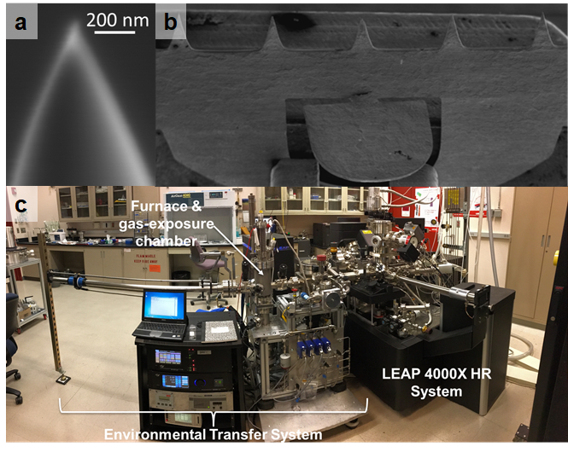
Figure S1. The needle shaped specimens were deposited on a TEM-APT custom-made conical TEM grid. An image of the polished APT need and the grid is provided in (a) and (b) respectively. (c) The state-of-the-art customized APT instrument which has a reaction chamber attached to the atom probe. More details on the modified equipment can be found in the literature by Lambeets, et. al.¹⁰

Appendix 3: Solid-State Diffusion and Formation of Oxide Film
Figure S2 displays significant dislocation and cracks within the interface between the oxide and base alloy (enriched zone) due to the oxidation occurring exclusively within the solid state of this alloy (400°C). As captured by the Shuttleworth equation,¹¹ unlike oxidation in the liquid state—where surface atoms can plastically deform and reorganize, solid-state oxidation induces elastic deformation causing surface defects, especially within the enriched zone. Another consequence of solid-state diffusion leads to speciation and the creation of defined oxide zones such as the visible Cr₂O₃ in lieu of more diffuse (statistical) layers (Figure 2c). The defects that are created lead to a new diffusion pathway for metal atoms toward the surface, this can be seen from the formation of metallic lattice towards the surface (hypothetically diffused Co as shown from STEM-EDS and APT results) above the developed Cr₂O₃ and spinel.
Figure S2. TEM results from the oxidized CoCrFeNiMn HEA (120 mins) (a) A TEM BF image showing the cross-section of the alloy where the base, enriched interface (brightened layer) and oxide film can be seen. The top layer is Pt deposited during the FIB-liftout process. (b) A closer look at the oxide-alloy interface, the swelling, and bubble-like formation depict oozing out of Fe/Co/Mn metal/ions from the Cr-oxide layer to form the top-layer oxides. (c) A higher magnification view of the FCC (HEA) and Cr₂O₃ interface shows the nano-crystalline nature of the chromia layer. (d) A region magnified from the interface of Cr₂O₃ and the topmost multi-oxide (Fe/Co/Mn) region. This region shows the presence of chromia with a corundum structure, a spinel structure and a Co-rich metallic lattice structure indicating pure Co diffusing outwards.

Appendix 4: APT element distribution maps and contour plots for the CoCrFeNiMi HEA
Three-dimensional (3D) element distribution maps and two-dimensional (2D) contour plots for APT reconstructed volumes for 2-minute 30 minute, and 2-hour oxidation exposure are provided in Figures S4 - S6. The 3D element distribution maps all show a 10 nm section from the center of the reconstructed volume to easily visualize the oxide/metal interfaces. Iso-concentration surfaces in both 3D element distribution maps and 2D contour plots provide an estimate of the location of the oxide/metal interfaces. This iso-concentration surface composition varies with oxidation exposure time and varies from 20 - 35 at. % oxygen (O).
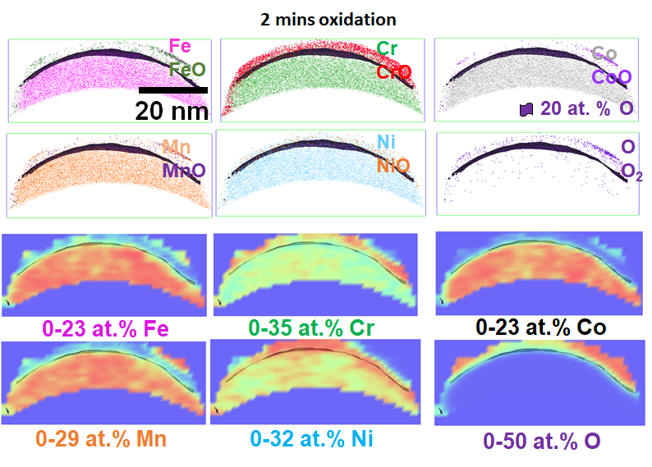
Figure S3. APT results from the 2 mins oxidation treatment. In the top panel, the ion maps of Fe/FeO, Cr/CrO, Co/CoO, Mn/MnO, Ni/NiO and O/O₂ show the distribution of pure metal and oxides species of that metal in each image. Below them are the thermal maps showing the density of each in the 2D map.
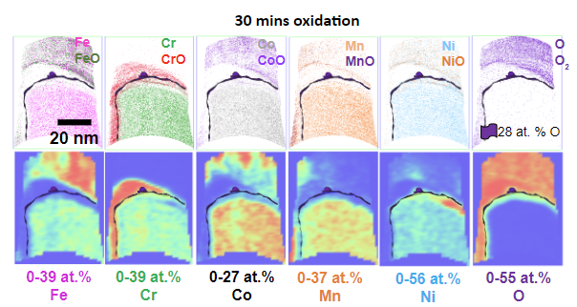

Figure S4. APT results from the 30 mins oxidation treatment. In the top panel, the ions maps of Fe/FeO, Cr/CrO, Co/CoO, Mn/MnO, Ni/NiO and O/O₂ show the distribution of pure metal and oxides species of that metal in each image. Below them are the thermal maps showing the density of each in the 2-D map.
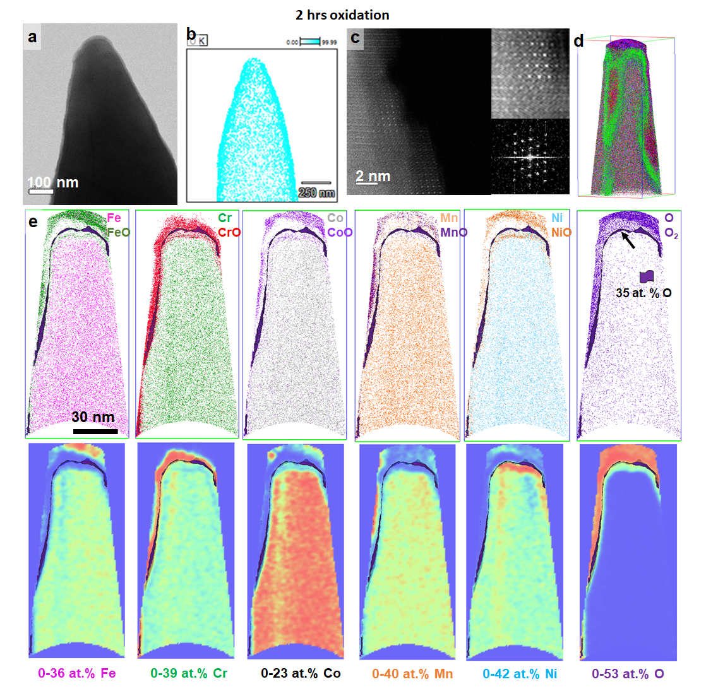
Figure S5. (a-c) have the TEM results showing the needle after 120 mins of oxidation. The needle was transported from the APT chamber to TEM under a controlled environment. The high-resolution imaging of the needle was not possible at most locations due to the high thickness of the needle, however, at few locations the atomic structure of the out region was captured using atomic column STEM images as seen in figure (c). The region captured in (c) depicted a corundum structure indicating a chromia layer.

Appendix 5: APT element distribution maps, contour plots, and concentration profiles for the CoCrFeNiMn_{0.6}Al_{0.4} HEA
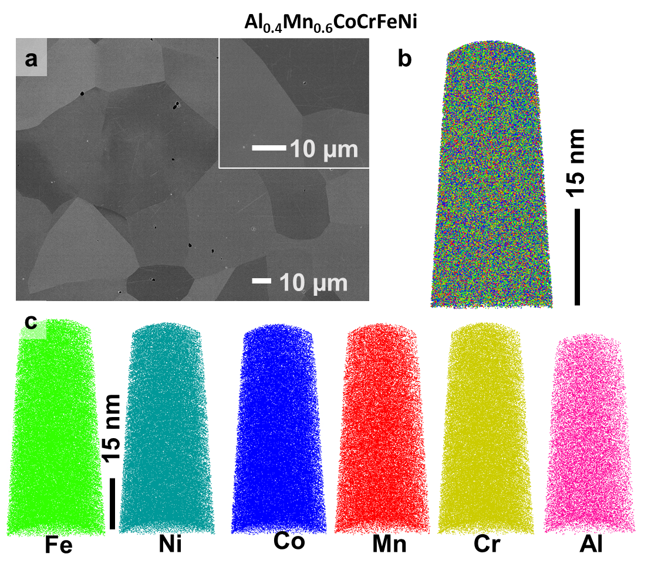
Figure S6. SEM and APT results from the modified alloy where Al substituted Mn partially. The melting, cold rolling (50%), annealing at 1100 C for 30 mins and water quenching resulted in a recrystallized equiatomic grain structure as seen in Figure (a). The APT structure in (b-c) show a single phase random alloy no perceivable compositional partitioning.

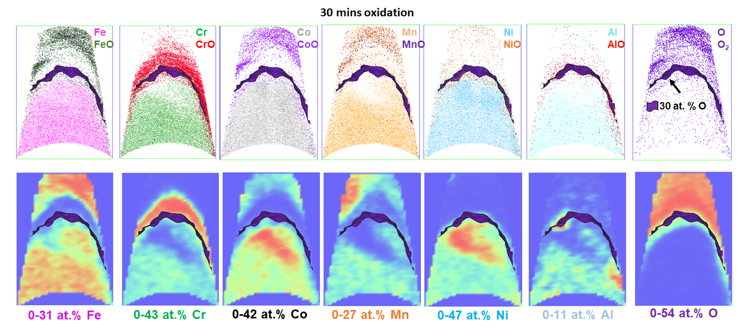
Figure S7. APT results from the 30 mins oxidation treatment of AlMnCoCrFeNi alloy. In the top panel the ions maps of Fe/FeO, Cr/CrO, Co/CoO, Mn/MnO, Ni/NiO, and O/O2 show the distribution of pure metal and oxides species of that metal in each image. Below them are the thermal maps showing the density of each in the 2-D map.

From the 3D element distribution maps and 2D contour plots shown in Figure S8, we see that the inner oxide is Cr-rich, and the outer oxide includes Fe, Co, and Mn signals. To further investigate the composition of the outer oxide, concentration profiles were generated across Fe and Mn iso-concentration surfaces, with results reported in Figure S9. From the concentration profile across the 33 at. % iso-concentration surface, we see that the Fe-rich regions of the outer oxide also have approximately 10 at. % Co, but other elements, including Mn, Cr, Ni, and Al are less than a few at. % (Figure S9(b)). We also find there is a pile-up of Mn at the outer region of the Fe-rich outer oxide (up to approximately 10 at. % Mn). In the Mn-rich region of the outer oxide (shown in Figure S9(c) - (d)), we also observe signals from Fe, Co, and Ni. From Figure S9, we see that the outer oxide of the CoCrFeNiMn_{0.6}Al_{0.4} HEA has non-uniform composition, with Fe and Mn-enriched regions, suggesting non-uniform mobility of these elements through the Cr-rich inner oxide.
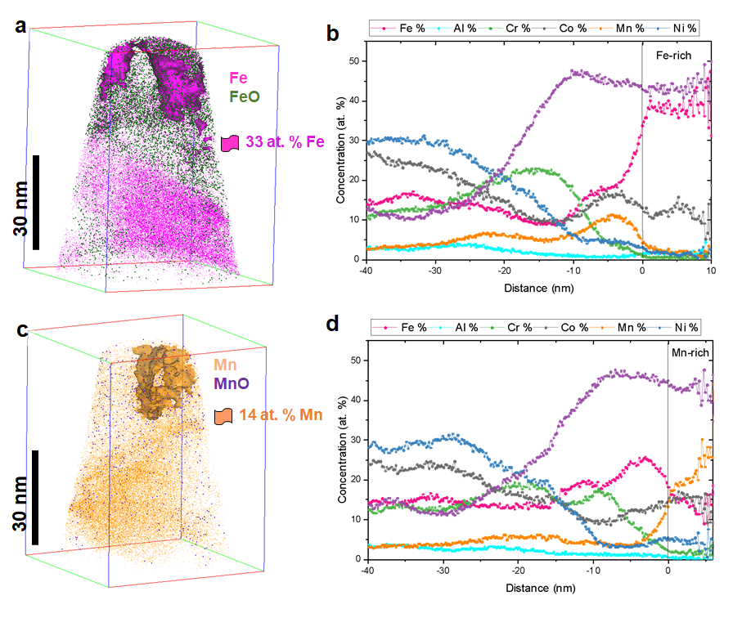
Figure S8. APT results from the 30 mins oxidation treatment of AlMnCoCrFeNi alloy. (a) shows the Fe and FeO ions to depict the oxide layer. The compositional partitioning across the

References

1 Wang, L.-L. & Johnson, D. D. Predicted Trends of Core−Shell Preferences for 132 Late Transition-Metal Binary-Alloy Nanoparticles. J. Am. Chem. Soc. 131, 14023-14029 (2009). https://doi.org:10.1021/ja903247x
2 Mizutani, U., Inukai, M., Sato, H. & Zijlstra, E. S. in Physical Metallurgy (Fifth Edition) (eds David E. Laughlin & Kazuhiro Hono) 103-202 (Elsevier, 2014).
3 Martin, A., Chang, B. S. & Thuo, M. Effect of Surface Nanostructures and Speciation on Undercooling for Low-Temperature Solder Alloys. ACS Appl. Nano Mater. 5, 3325-3332 (2022). https://doi.org:10.1021/acsanm.1c03865
4 Cutinho, J. et al. Autonomous Thermal-Oxidative Composition Inversion and Texture Tuning of Liquid Metal Surfaces. ACS Nano 12, 4744-4753 (2018). https://doi.org:10.1021/acsnano.8b01438
5 Martin, A. et al. Passivation-driven speciation, dealloying and purification. Mater. Horiz. 8, 925-931 (2021). https://doi.org:10.1039/D0MH01832E
6 Martin, A., Kiarie, W., Chang, B. & Thuo, M. Chameleon Metals: Autonomous Nano-Texturing and Composition Inversion on Liquid Metals Surfaces. Angew. Chem. Int. Ed. 59, 352-357 (2020). https://doi.org:https://doi.org/10.1002/anie.201912639
7 Cademartiri, L. et al. Electrical Resistance of Ag^{TS}–S(CH₂)_{n−1}CH₃//Ga₂O₃/EGaIn Tunneling Junctions. J. Phys. Chem. C 116, 10848-10860 (2012). https://doi.org:10.1021/jp212501s
8 Sodhi, R. N. S., Brodersen, P., Cademartiri, L., Thuo, M. M. & Nijhuis, C. A. Surface and buried interface layer studies on challenging structures as studied by ARXPS. Surf. Interface Anal. 49, 1309-1315 (2017). https://doi.org:https://doi.org/10.1002/sia.6270
9 Felfer, P. J., Alam, T., Ringer, S. P. & Cairney, J. M. A reproducible method for damage-free site-specific preparation of atom probe tips from interfaces. Microsc. Res. Tech. 75, 484-491 (2012). https://doi.org:https://doi.org/10.1002/jemt.21081
10 Lambeets, S. V. et al. Nanoscale Perspectives of Metal Degradation via In Situ Atom Probe Tomography. Top. Catal. 63, 1606-1622 (2020). https://doi.org:10.1007/s11244-020-01367-z
11 Shuttleworth, R. The Surface Tension of Solids. Proc. Phys. Soc. A 63, 444 (1950). https://doi.org:10.1088/0370-1298/63/5/302

