Methods
Mechanistic Understanding of Speciated Oxide Growth in High Entropy Alloys
Bharat Gwalani^{1,2}*, Andrew Martin², Elizabeth Kautz^{3,4} S.V. Lambeets¹, Matthew Olszta³, Anil Krishna Battu⁵, Aniruddha Malakar¹ Feipeng Yang⁶ Jinghua Gua⁶, Thevuthasan Suntharampillai¹, Martin Thuo², Arun Devaraj¹*

1Physical & Computational Sciences Directorate, Pacific Northwest National Laboratory, Richland, WA 99352 USA
2North Carolina State University, Department of Materials Science and Engineering. Raleigh, NC 27695. USA
3Energy and Environment Directorate, Pacific Northwest National Laboratory, Richland, WA 99352 USA
4North Carolina State University, Department of Nuclear Engineering. Raleigh, NC 27695. USA
5Earth and Biological Sciences Directorate, Pacific Northwest National Laboratory, Richland, WA 99352 USA
6Advanced Light Source, Lawrence Berkeley National Laboratory, Berkeley, CA, USA
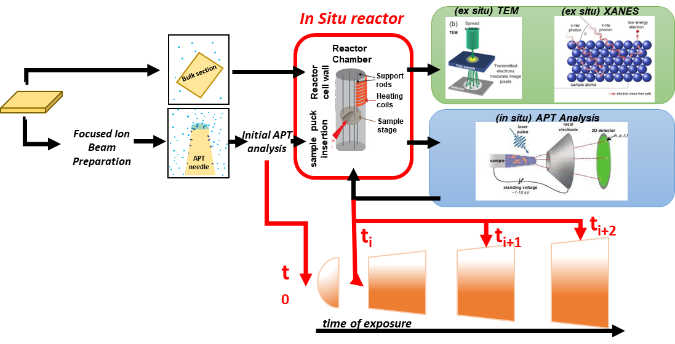
*Corresponding author emails: bgwalan@ncsu.edu, arun.devaraj@pnnl.gov

Figure M1: Coupled Ex Situ and In Situ Characterization of Oxide Film Formation on HEA Surfaces: Illustrative Procedure. The process involves the oxidation of a bulk sample in the form of a flat specimen for ex situ TEM and XANES analyses, as well as preparing APT needles for in situ investigations. All oxidation experiments were conducted within the same chemical reactor chamber environment.
Materials and Experimental Approach
The two alloy compositions (CoCrFeNiMn and CoCrFeNiMn+Al) (measured in atomic ratios) were synthesized using arc melting and casting techniques. Afterward, a homogenization annealing process was carried out at 1200°C for a duration of 10 hours. The alloys were then cold rolled to a 50% reduction in the cross-sectional area. Subsequently, recrystallization was induced via annealing at 1100°C for 10 minutes, resulting in the formation of 3 mm thick sheets with refined microstructures. The alloy sheets were then precisely sectioned, mounted, and subjected to metallographic polishing.

Microstructural Characterization of the Alloy Before Oxidation
For the initial microstructural analysis of the alloys, an Oxford Symmetry electron backscatter diffraction (EBSD) detector was employed. This EBSD system was integrated into a ThermoFisher Scientific plasma-focused ion beam (PFIB). The obtained EBSD data were subsequently analyzed using the integrated AZtecHKL software.

Ex-situ Oxidation and Characterization
Mirror-polished samples of the two alloys underwent oxidation within the chemical reactor chamber attached to the atom probe instrument. The flat specimens were securely held in place by a custom-made clip situated within the reactor chamber. In order to validate the oxide layer structures formed within the bulk samples, a metallographically polished bulk sample was subjected to an oxidation process at 10 mbar O₂ for a duration of 120 minutes at 400 °C. This procedure ensured consistency with the oxidation conditions applied to the in-situ samples. Subsequently, cross-sectional TEM samples were extracted from the oxidized surfaces using a site-specific focused ion beam (FIB) lift-out technique. The manuscript contains scanning transmission electron microscopy - energy dispersive spectroscopy (STEM-EDS) maps derived from the cross-sectional TEM sample of the bulk alloy oxidized for 120 minutes.

Cross-Sectional STEM-EDS
TEM specimens were prepared using a Thermo Fisher Scientific Helios 5 Hydra DualBeam PFIB/SEM and an FEI Helios Nanolab FIB/SEM. STEM imaging and spectroscopy were performed using a Thermo Fisher Scientific Themis Z 60-300 S/TEM with an accelerating voltage of 300 kV and a convergence angle of 25 mrad. The high-resolution HAADF STEM images were collected with an annular detection range of 51–200 mrad. 25 frames of the image with a dwell time of 4 µs per pixel were post-processed using a drift-corrected frame integration method in Velox software to optimize the signal-to-noise ratio and contrast. EDS was collected to show the compositional map using Super-X G2 detector with a dwell time of 3 µs per pixel and 540 frames. EDS line profile was plotted perpendicular to metal–oxide interfaces and integrated over 50 pixels (3.5 nm). A part of STEM work was also performed using an aberration (CS) corrected, JEOL ARM200CF operated at 200 keV equipped with a JEOL Centurio energy dispersive spectrometer (EDS) with a 0.9 sR collection angle. Annular dark-field (ADF) data were collected with a convergence angle of 20 mrad and a collection angle ranging from 79–294 mrad. Digital imaging data collection was performed using Gatan Microscopy Suite (GMS) version 3.

Atom probe tomography
APT sample preparation was executed using an FEI Helios dual-beam focused ion beam-scanning electron microscope (FIB-SEM). The process began with the deposition of a protective Pt capping layer, serving to shield the material from Ga ion-induced damage during FIB milling. A cantilever was extracted from the base alloy, and segments of it were affixed onto a commercial Si micropost array. These segments were then shaped into APT needle specimens.
The in situ APT experimental methodology encompasses several steps¹. Initially, native oxide layers are analyzed and removed via APT field evaporation. Subsequently, the specimens are transferred under ultra-high vacuum (UHV) conditions ranging from 10⁻⁷ to 10⁻⁸ mbar to a gas-phase chemical reactor chamber preheated to the designated temperature of 400 °C. Within this chamber, the specimens are exposed to O₂ gas (99.993% purity) at 10 mbar for select time steps. Following the oxidation exposure, the APT specimens are transferred back to the analysis chamber under UHV conditions. The newly formed oxide and underlying base metal are then analyzed via APT. The oxidation process for the needle specimens is carried out at 400°C for varying durations of 2, 5, 30, and 120 minutes. These parameters are chosen to induce the development of nanoscale oxide layers with thicknesses ranging from approximately 5 to 50 nm.
For APT data collection, a CAMECA Local Electrode Atom Probe (LEAP) 4000X HR system equipped with a 355 nm wavelength ultraviolet (UV) laser was employed. The user-defined settings included a laser energy of 200 pJ/pulse, a pulse repetition rate of 200 kHz, a specimen base temperature of 45 K, and a detection rate of 0.003 ions/pulse. The analysis chamber was maintained at a pressure below 2×10⁻¹¹ Torr. The detector efficiency of the LEAP utilized in this study is estimated to be around 36 %. The collected data underwent reconstruction and analysis using IVAS version 3.8.2 by CAMECA.

STEM of needle specimen after in situ oxidation
Crystallographic and compositional examination of oxidized needle samples was done with a probe-corrected FEI Titan 80–300 STEM instrument operated at 300 kV. The observations were performed using STEM with a high-angle annular dark-field (HAADF) detector. The probe convergence angle was 18 mrad, and the inner detection angle on the HAADF detector was three times larger than the probe convergence angle. AZtec energy dispersive spectroscopy (EDS) software was used to analyze the composition captured by EDS in the STEM instrument.

X-ray absorption near edge spectroscopy (XANES)
The electronic structure changes of unoxidized CoCrFeNiMn and CoCrFeNiMn+Al alloys, and samples of each alloy oxidized at 400 °C for 2 min, 30 min, and 120 min and Co metal, Cr₂O₃, Fe metal, Fe₂O₃, Fe₃O₄, and MnO₂ standards were analyzed using synchrotron based XANES. XANES was performed at the Advanced Light Source (ALS) synchrotron beamline 7.3.1 at Lawrence Berkeley National Laboratory (LBNL). Experiments were conducted in an Ultra High Vacuum chamber with a background pressure of 5.0 × 10⁻⁸ Torr with a ring current of 500 mA. XANES data were collected at room temperature using Total Electron Yield (TEY) mode which measures the sample drain current resulting from photo and Auger electrons leaving the sample surface. The incident beam intensity was monitored (I_{o}) via the gold grid to normalize the total electron yield signal (I_{I}). Each final spectrum was an average of four scans. For comparison, asymmetric least squares smoothing baseline was performed and then normalized. The Co, Cr, Fe, Ni, and Mn L-edge TEY signals were utilized in this work to characterize the top 10 nm of all samples to complement APT and TEM studies.

References:
1 Kautz, E. J. et al. Rapid assessment of structural and compositional changes during early stages of zirconium alloy oxidation. npj Materials Degradation 4, 29 (2020).

