Additional file 2
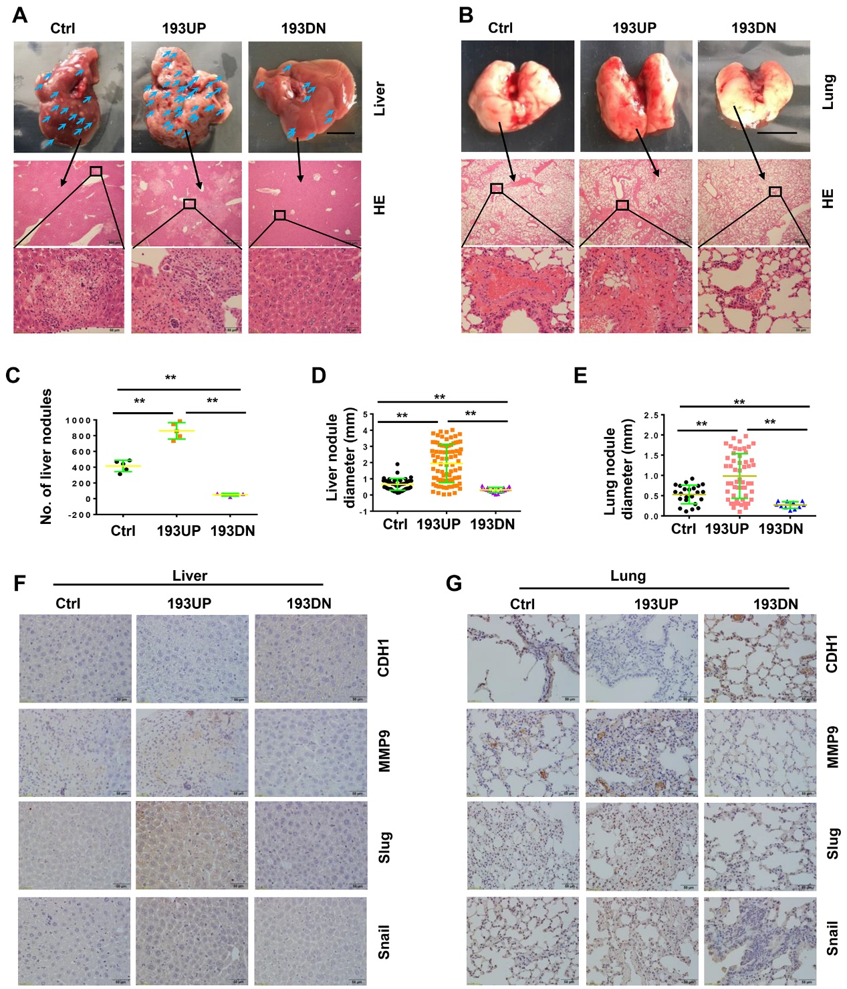

Fig. S1 miR-193a-5p promotes osteosarcoma metastasis to both liver and lung in xenograft mice. About 1×10⁶ of the SaOS-2 cells stably over-expressing pre-miR-193a-5p (193UP), ant-miR-193a-5p (193DN) or non-target sequence (Ctrl) were implanted into nude mice (n = 6 per group) by tail-vein injection. At 60 days after injection, the mice were sacrificed. a, b Gross appearance (upper panel, bar length: 1cm) and HE staining (middle panel, bar length: 500 μm; lower panel, bar length: 50 μm) of liver and lung, the arrows indicate the metastatic nodules on the surface of livers. c The number of nodules on liver surface. d, e The diameter of nodules in liver and lung. f, g The expressions of EMT-related markers in liver and lung were determined by IHC. Bar length in the picture of liver and lung: 1cm, bar length in the picture of HE and IHC: 50 μm.

Fig. S2 MiR-193a-5p promotes colony formation, migration, invasion and EMT by targeting NCX2. The SaOS-2 cells stably expressing pre-miR-193a (193UP), anti-miR-193a-5p (193DN) or non-target sequence (Ctrl) were infected with the adenovirus expressing NCX2, empty vector (Vec), NCX shRNA (shNCX2), or scramble shRNA (shNC). a Representative images of colony (left panel) and the colony numbers (right panel). b Representative images of wound area at the indicated time. c Representative images of invade cells. d, e Data (mean+SD) represent the result of three independent wound healing assay (d) and Transwell invasion assay (e). f Western blotting of EMT-related markers. Bar length: 50 μm.

