Supplementary Materials
Supplementary Tables………………………………………………………………………2
Supplementary Table S1: Group differences in Iso-Distance Average Correlation (IDAC) functional connectivity measures across the three distances (F contrast Effect of Group).….2
Supplementary Table S2: Group differences in functional connectivity measures based on Iso-Distance Average Correlations (IDAC) for the 5-10mm distance………..……………...4
Supplementary Table S3: Group differences in functional connectivity measures based on Iso-Distance Average Correlations (IDAC) for the 15-20mm distance………..…………….5
Supplementary Table S4: Group differences in functional connectivity measures based on Iso-Distance Average Correlations (IDAC) for the 25-30mm distance………..…………….7
Supplementary Table S5: Correlation between ERQ suppression scores and functional connectivity measures based on Iso-Distance Average Correlations (IDAC) for the 5-10mm distance………..……………………………………………………………………………...9
Supplementary Table S6: Correlation between ERQ suppression scores and functional connectivity measures based on Iso-Distance Average Correlations (IDAC) for the 15-20mm distance………..……………………………………………………………………………...10
Supplementary Table S7: Correlation between ERQ suppression scores and functional connectivity measures based on Iso-Distance Average Correlations (IDAC) for the 25-30mm distance………..……………………………………………………………………………...12
Supplementary Figures……………………………………………………………………..15
Supplementary Figure S1: Distribution of (A) Montgomery-Åsberg Depression Rating Scale scores, (B) Emotion Regulation Questionnaire Suppression Subscale scores and (C) Emotion Regulation Questionnaire Reappraisal Subscale scores by diagnostic group. Healthy controls are shown in blue, MDD participants in green.………..…………………..………………...15
Supplementary Figure S2: Red, green, and blue overlays illustrating associations between ERQ Suppression scores and local functional connectivity for MDD participants………….16

Supplementary Tables
Supplementary Table S1
Group differences in Iso-Distance Average Correlation (IDAC) functional connectivity measures across the three distances (F contrast Effect of Group)
Brain region | Hemisphere | BA | Coordinates |  |  | Cluster size (3mm³ voxels) | F-value
Brain region |  | BA | X | Y | Z | Cluster size (3mm³ voxels)
MDD > Controls
Hippocampus | R | - | 31 | -39 | 0 | 882 | 46.57
Retrosplenial cortex | R | 30 | 22 | -42 | 3 |  | 41.60
Hippocampus | R | - | 28 | -30 | -3 |  | 41.29
Fusiform gyrus | L | 37 | -35 | -57 | -6 | 883 | 45.54
Hippocampus | L | - | -26 | -36 | 9 |  | 38.50
 |  | - | -32 | -39 | 0 |  | 37.95
Insula | L | 13 | 34 | -3 | 18 | 78 | 32.62
 |  | 13 | 31 | -15 | 18 |  | 27.63
Supramarginal gyrus | L | 40 | 37 | -30 | 24 |  | 26.55
Primary motor cortex | L | 4 | -38 | -9 | 21 | 237 | 32.21
Insula | L | 13 | -35 | 0 | 18 |  | 28.56
Supramarginal gyrus | L | 40 | -44 | -30 | 27 |  | 24.80
Supplementary motor cortex | L | 6 | -14 | -15 | 63 | 15 | 28.44
Primary motor cortex | L | 4 | -11 | -21 | 57 |  | 24.12
Sensory association cortex | R | 5 | -17 | -30 | 48 | 32 | 27.40
 | L | 5 | -17 | -36 | 42 |  | 26.13
Precuneus | L | 7 | -14 | -45 | 60 |  | 15.80
Angular gyrus | R | 39 | 37 | -51 | 18 | 10 | 26.83
 | R |  | 40 | -57 | 12 |  | 15.85
Supplementary motor cortex | R | 6 | 16 | -21 | 42 | 121 | 25.54
Ventral anterior cingulate | R | 24 | 13 | -9 | 42 |  | 23.50
Supplementary motor cortex | R | 6 | 1 | -12 | 69 |  | 23.15

Supplementary Table S2
Group differences in functional connectivity measures based on Iso-Distance Average Correlations (IDAC) for the 5-10mm distance
Brain region | Hemisphere | BA | Coordinates |  |  | Cluster size (3mm³ voxels) | t-value
Brain region | Hemisphere | BA | X | Y | Z | Cluster size (3mm³ voxels) | t-value
MDD > Controls
Hippocampus | R | - | 31 | -39 | 0 | 219 | 5.96
Visual association cortex | R | 19 | 40 | -60 | -3 |  | 5.53
Caudate tail | R | - | 34 | -30 | -3 |  | 5.50
Fusiform gyrus | L | 37 | -35 | -57 | -6 | 205 | 5.89
Caudate tail | L | - | -26 | -36 | 9 |  | 5.34
 | L | - | -35 | -33 | 0 |  | 5.28
Insula | R | 13 | 34 | -3 | 18 | 24 | 5.43
Primary motor cortex | L | 4 | -38 | -6 | 24 | 18 | 5.91
Supplementary motor area | L | 6 | -35 | 0 | 18 |  | 4.36
Insula | L | 13 | -29 | 9 | 12 | 13 | 4.85
Pars opercularis | L | 44 | -38 | 12 | 12 |  | 3.89

Supplementary Table S3
Group differences in functional connectivity measures based on Iso-Distance Average Correlations (IDAC) for the 15-20mm distance
Brain region | Hemisphere | BA | Coordinates |  |  | Cluster size (3mm³ voxels) | t-value
Brain region | Hemisphere | BA | X | Y | Z | Cluster size (3mm³ voxels) | t-value
MDD > Controls
Retrosplenial cortex | R | 30 | 22 | -45 | 6 | 1228 | 6.96
Hippocampus | R | - | 28 | -30 | -3 |  | 6.91
 | R | - | 28 | -39 | 0 |  | 6.58
Visual association cortex | L | 19 | -32 | -54 | -6 | 1239 | 6.74
Hippocampus | L | - | -29 | -30 | -3 |  | 6.52
Retrosplenial cortex | L | 30 | -17 | -45 | 3 |  | 6.52
Primary motor cortex | L | 6 | -38 | -9 | 24 | 406 | 5.57
Insula | L | 13 | -35 | 0 | 18 |  | 5.38
Premotor cortex | L | 6 | -44 | -3 | 18 |  | 5.28
Insula | R | 13 | 31 | -15 | 18 | 196 | 5.34
 | R | 13 | 31 | -6 | 12 |  | 5.11
Supramarginal gyrus | R | 40 | 37 | -30 | 24 |  | 5.04
Mid cingulate cortex | R | 24 | 16 | -18 | 42 | 347 | 5.23
 | R | 24 | 13 | -9 | 42 |  | 4.88
Supplementary motor cortex | L | 40 | -14 | -12 | 48 |  | 4.75
Sensory association cortex | L | 5 | -17 | -30 | 48 | 67 | 4.88
 | L | 5 | -14 | -36 | 54 |  | 4.80
 | L | 5 | -17 | -36 | 42 |  | 4.33
Primary motor | L | 24 | -11 | -21 | 57 | 16 | 4.71
Supplementary motor cortex | L | 5 | -14 | -15 | 63 |  | 4.71
Premotor cortex | L | 6 | -29 | -12 | 48 | 12 | 4.38
Mid cingulate cortex | L | 24 | -8 | 3 | 36 | 22 | 4.35
Subgenual anterior cingulate cortex | L | 25 | -5 | 24 | -3 | 15 | 4.33
Rostral anterior cingulate | R | 24 | 1 | 18 | 0 |  | 3.84
Ventral posterior cingulate | L | 23 | -8 | -18 | 33 | 11 | 4.26
Sensory association cortex | L | 5 | -26 | -36 | 45 | 14 | 4.03
Dorsal anterior cingulate | R | 32 | 13 | 3 | 39 | 11 | 3.95
 | R | 32 | 13 | 12 | 39 |  | 3.73
Subgenual anterior cingulate cortex | R | 25 | 4 | 24 | -12 | 10 | 3.93
Supplementary motor cortex | L | 6 | -20 | -6 | 66 | 12 | 3.53
 | L | 6 | -11 | -6 | 69 |  | 3.53

Supplementary Table S4
Group differences in functional connectivity measures based on Iso-Distance Average Correlations (IDAC) for the 25-30mm distance
Brain region | Hemisphere | BA | Coordinates |  |  | Cluster size (3mm³ voxels) | t-value
Brain region | Hemisphere | BA | X | Y | Z | Cluster size (3mm³ voxels) | t-value
MDD > Controls
Retrosplenial cortex | L | 30 | -5 | -39 | 12 | 1530 | 6.68
 | L | 30 | -17 | -45 | 0 |  | 6.46
Fusiform gyrus | L | 37 | -38 | -51 | -9 |  | 6.31
Retrosplenial cortex | R | 30 | 22 | -42 | 3 | 1937 | 6.46
Visual association cortex | R | 19 | 25 | -54 | -9 |  | 5.97
Parahippocampal cortex | R | 36 | 37 | -39 | -9 |  | 5.95
Primary motor cortex | L | 4 | -35 | -12 | 21 | 485 | 5.53
Premotor cortex | L | 5 | -47 | -3 | 18 |  | 5.26
Insula | L | 13 | -35 | 0 | 18 |  | 4.81
Ventral posterior cingulate cortex | R | 23 | 10 | -18 | 36 | 808 | 5.20
Mid cingulate cortex | R | 24 | 16 | -21 | 42 |  | 5.12
Premotor cortex | R | 6 | 34 | -6 | 45 |  | 4.82
Primary sensory cortex | R | 1 | 52 | -21 | 57 | 63 | 4.67
 | R | 1 | 34 | -27 | 42 |  | 3.59
 | R | 1 | 40 | -21 | 36 |  | 3.55
Subgenual anterior cingulate cortex | R | 25 | 10 | 12 | -18 | 54 | 4.54
Putamen | R | - | 25 | 12 | -12 |  | 4.19
Insula | R | 13 | 37 | 12 | -12 |  | 3.61
Superior temporal gyrus | L | 22 | -47 | -21 | -6 | 29 | 4.53
Angular gyrus | L | 39 | -44 | -45 | 30 | 13 | 4.04
Temporal pole | R | 38 | 40 | 18 | -36 | 11 | 3.89
Dorsal posterior cingulate cortex | R | 31 | 25 | -63 | 27 | 18 | 3.84
Dorsal posterior cingulate cortex | L | 31 | -17 | -36 | 42 | 20 | 3.81
Sensory association cortex | L | 5 | -17 | -30 | 48 |  | 3.79
 | L | 5 | -11 | -27 | 54 |  | 3.51
Primary visual cortex | L | 17 | -17 | -87 | 6 | 11 | 3.68
Primary motor cortex | R | 4 | 10 | -24 | 66 | 10 | 3.60
 | R | 4 | 4 | -33 | 63 | 14 | 3.60

Supplementary Table S5
Correlation between ERQ suppression scores and functional connectivity measures based on Iso-Distance Average Correlations (IDAC) for the 5-10mm distance
Brain region | Hemisphere | BA | Coordinates |  |  | Cluster size (3mm³ voxels) | t-value
Brain region | Hemisphere | BA | X | Y | Z | Cluster size (3mm³ voxels) | t-value
Insula | L | 13 | -38 | 0 | 12 | 136 | 5.00
 | L | 13 | -34 | -6 | 21 |  | 4.54
Primary sensory | L | 1 | -41 | -18 | 21 |  | 4.35
Insula | R | 13 | 37 | 3 | 12 | 17 | 4.60
 | R | 13 | 34 | -6 | 12 |  | 3.65
Fusiform gyrus | R | 37 | 37 | -60 | -9 | 23 | 4.20
Visual association area | R | 18 | 34 | -57 | 0 |  | 4.11
Insula | R | 13 | 34 | -12 | 21 | 37 | 4.07
Primary sensory | R | 1 | 34 | -24 | 18 |  | 4.05
Primary sensory | R | 1 | 40 | -18 | 21 |  | 4.04
Visual association area | R | 18 | 25 | -72 | 0 | 16 | 3.94
 | R | 18 | 22 | -66 | 12 |  | 3.76

Supplementary Table S6
Correlation between ERQ suppression scores and functional connectivity measures based on Iso-Distance Average Correlations (IDAC) for the 15-20mm distance
Brain region | Hemisphere | BA | Coordinates |  |  | Cluster size (3mm³ voxels) | t-value
Brain region | Hemisphere | BA | X | Y | Z | Cluster size (3mm³ voxels) | t-value
Insula | L | 13 | -38 | 3 | 9 | 838 | 5.50
Thalamus | L | 13 | -17 | -33 | 9 |  | 4.45
Insula | L | 13 | -32 | -9 | 18 |  | 4.30
Pars opercularis | R | 44 | 43 | 12 | 21 | 282 | 4.96
Insula | R | 13 | 34 | -9 | 18 |  | 4.34
Pars opercularis | R | 44 | 64 | 12 | 24 |  | 4.25
Visual association cortex | R | 19 | 40 | -66 | 0 | 547 | 4.78
Fusiform gyrus | R | 37 | 37 | -57 | -12 |  | 4.57
Visual association cortex | R | 19 | 28 | -72 | 0 |  | 4.31
Posterior cingulate cortex | R | 23 | 7 | -21 | 30 | 22 | 3.96
Amygdala | R | - | 25 | -6 | -15 | 15 | 3.93
Hippocampus | R |  | 31 | -12 | -12 |  | 3.25
Subgenual anterior cingulate cortex | R | 24 | 1 | 36 | -3 | 11 | 3.80
Premotor cortex | R | 6 | 37 | 0 | 30 | 21 | 3.66
 | R | 6 | 49 | -3 | 33 |  | 3.30
Supplementary motor cortex | L | 6 | -17 | 3 | 66 | 13 | 3.63
Posterior cingulate cortex | L | 31 | -23 | -60 | 24 | 12 | 3.60
Visual motor cortex | L | 7 | -20 | -69 | 36 |  | 3.15
Superior temporal gyrus | L | 22 | -44 | -12 | -12 | 10 | 3.50
Insula | L | 13 | -41 | -12 | -3 |  | 3.32

Supplementary Table S7
Correlation between ERQ suppression scores and functional connectivity measures based on Iso-Distance Average Correlations (IDAC) for the 25-30mm distance
Brain region | Hemisphere | BA | Coordinates |  |  | Cluster size (3mm³ voxels) | t-value
Brain region | Hemisphere | BA | X | Y | Z | Cluster size (3mm³ voxels) | t-value
Pars opercularis | R | 44 | 43 | 12 | 21 | 1038 | 4.86
Superior temporal gyrus | R | 22 | 43 | 0 | -21 |  | 4.35
Pars opercularis | R | 44 | 64 | 12 | 24 |  | 4.25
Insula | L | 13 | -35 | 0 | 0 | 4214 | 4.66
Thalamus | L |  | -17 | -33 | 9 |  | 4.63
Pars opercularis | L | 44 | -50 | 6 | 24 |  | 4.46
Supplementary motor area | L | 6 | -17 | 3 | 66 | 463 | 4.29
 | L | 6 | -17 | -15 | 48 |  | 4.24
Sensory association cortex | R | 5 | 19 | -33 | 45 |  | 3.99
Cerebellum | R |  | 7 | -36 | -9 | 15 | 4.14
 | R |  | 13 | -42 | -12 |  | 3.48
Parahippocampus | R |  | 10 | -30 | -3 |  | 2.62
Primary sensory cortex | R | 1 | 37 | -21 | 39 | 16 | 3.80
Primary motor cortex | R | 4 | 46 | -15 | 36 |  | 2.73
Supramarginal gyrus | R | 40 | 46 | -24 | 33 |  | 2.69
Frontal eye fields | L | 8 | -8 | 30 | 54 | 25 | 3.64
Supplementary motor area | R | 6 | 4 | 12 | 72 | 68 | 3.62
 | R | 6 | 16 | 15 | 69 |  | 3.22
 | R | 6 | 16 | 3 | 66 |  | 2.67
Inferior temporal gyrus | L | 20 | 31 | -3 | -42 | 24 | 3.51
Temporal gyrus | R | 38 | 37 | 9 | -33 |  | 3.01
Supplementary motor area | L | 6 | -32 | -3 | 42 | 59 | 3.42
 | L | 6 | -32 | 9 | 48 |  | 2.91
Frontal eye fields | L | 8 | -35 | 18 | 51 |  | 2.76
Pars orbitalis | R | 47 | 37 | 42 | -12 | 16 | 3.23
Pars opercularis | R | 44 | 61 | 21 | 6 | 11 | 3.15
dlPFC | R | 9 | 61 | 27 | 12 |  | 2.71
Visual motor cortex | L | 7 | -23 | -81 | 48 | 10 | 3.13
dlPFC | L | 46 | -47 | 45 | 15 | 21 | 3.13
Supramarginal gyrus | L | 40 | -59 | -33 | 24 | 32 | 3.10
 | L | 40 | -65 | -39 | 30 |  | 3.09
Supplementary motor area | R | 6 | 7 | -21 | 69 | 52 | 3.04
Primary motor cortex | L | 4 | -8 | -24 | 69 |  | 3.01
Supplementary motor area | R | 6 | 10 | -15 | 63 |  | 2.86
Angular gyrus | L | 39 | -41 | -48 | 33 | 11 | 2.98
 | L | 39 | -47 | -45 | 24 |  | 2,67
Frontal eye fields | L | 8 | -14 | 21 | 39 | 11 | 2.95
 | L | 8 | -14 | 27 | 33 |  | 2.89
Supplementary motor area | R | 6 | 10 | 9 | 48 | 19 | 2.92
 | R | 6 | 13 | 3 | 54 |  | 2.69
Fusiform gyrus | L | 37 | -44 | -51 | 6 | 17 | 2.88
dlPFC | L | 9 | -26 | 33 | 27 | 10 | 2.81

Supplementary Figures
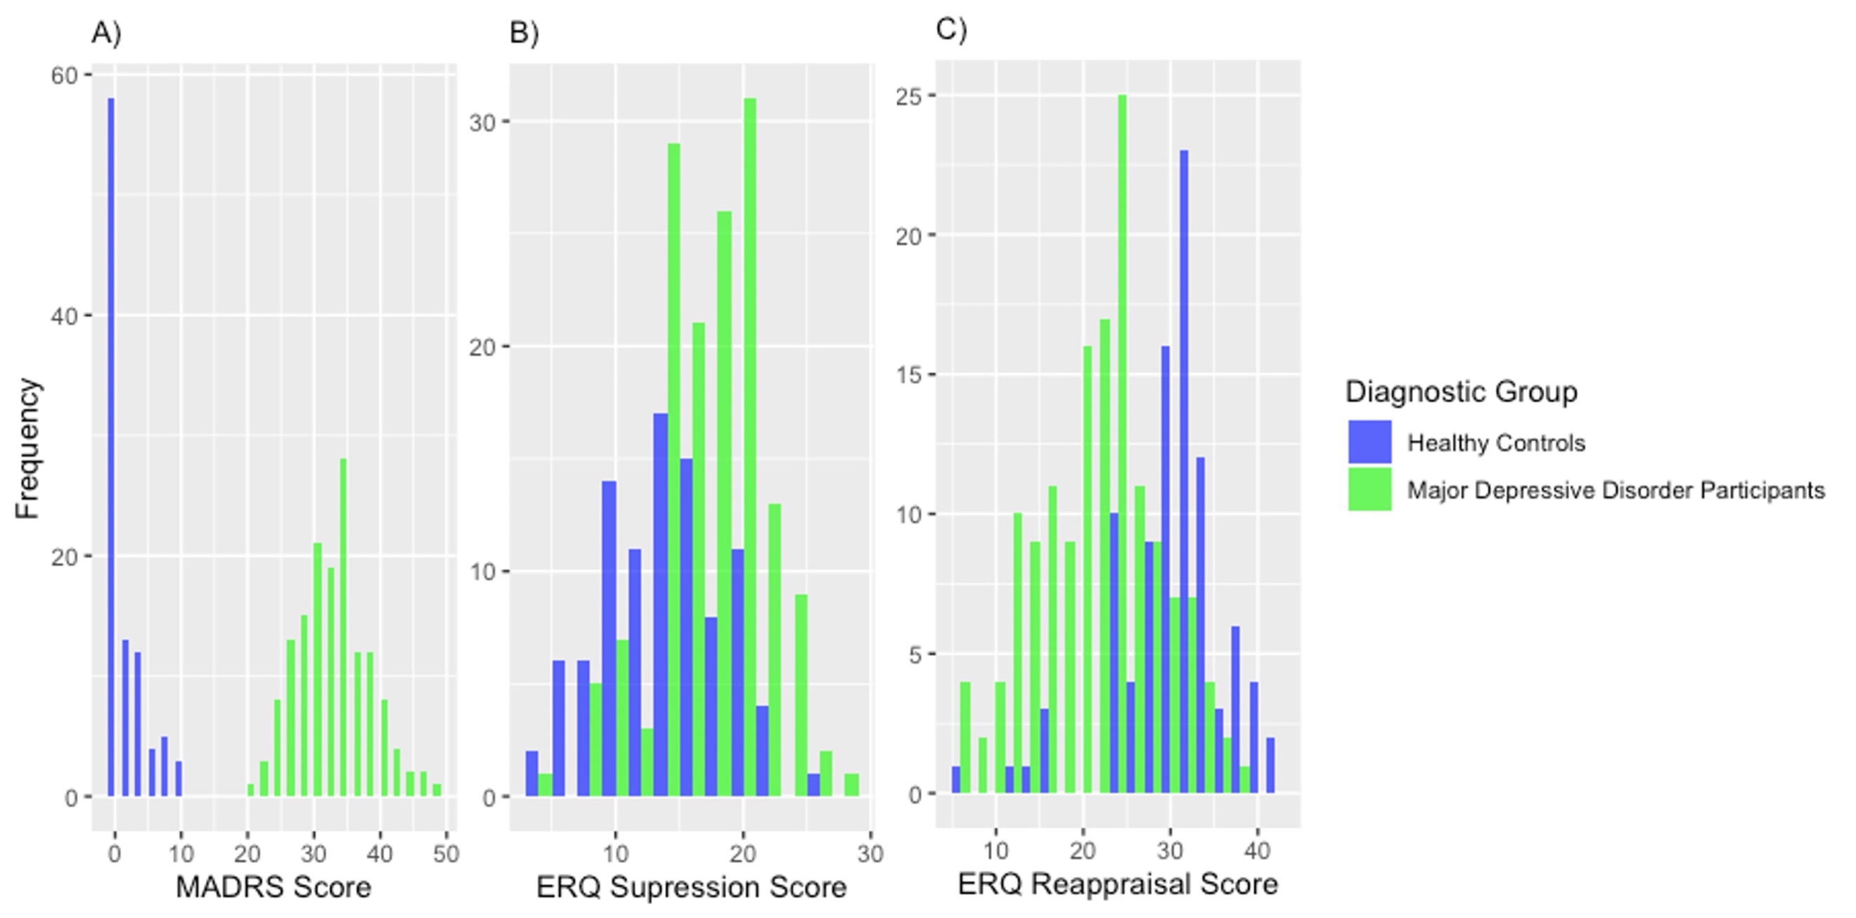
Supplementary Figure S1. Distribution of (A) Montgomery-Åsberg Depression Rating Scale scores, (B) Emotion Regulation Questionnaire Suppression Subscale scores and (C) Emotion Regulation Questionnaire Reappraisal Subscale scores by diagnostic group. Healthy controls are shown in blue, MDD participants in green.

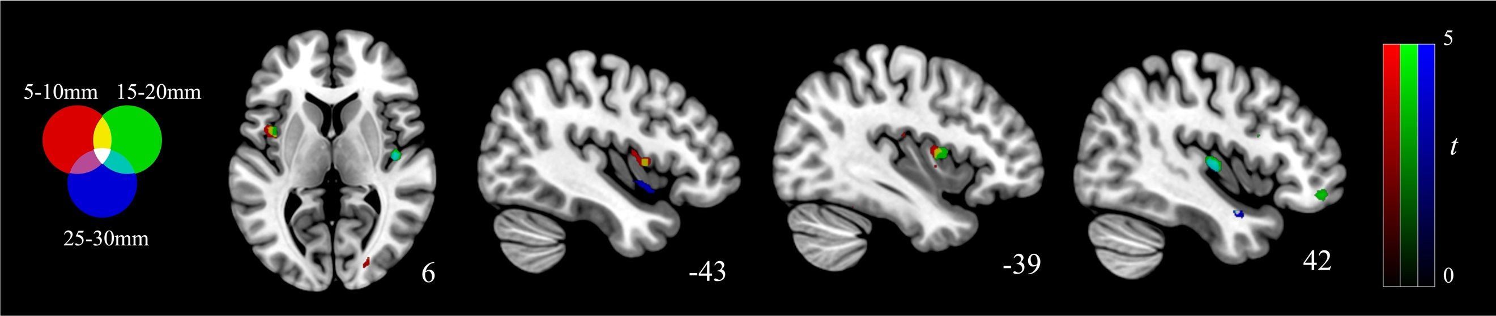
Supplementary Figure S2. Red, green, and blue overlays illustrating associations between ERQ Suppression scores and local functional connectivity for MDD participants.

