Additional File 3.
Axenic Whiteflies - Alternative Host - Data Sheet
Plant | Picture  (top) | Picture  (side) | Plant  picture | Observations(#) | Optimal Seed #
Cabbage | 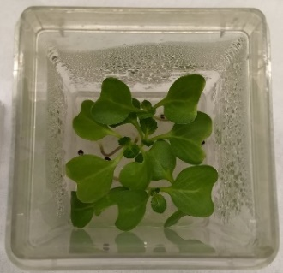 | 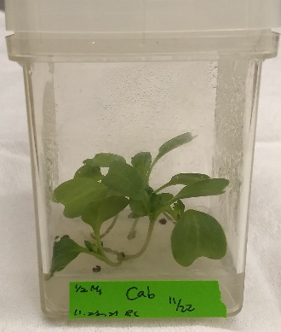 | 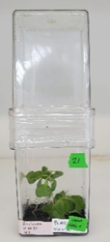 | Great size for growth in tissue vessel. Leaf senescence happens very slowly. | 4-6
Broccoli | 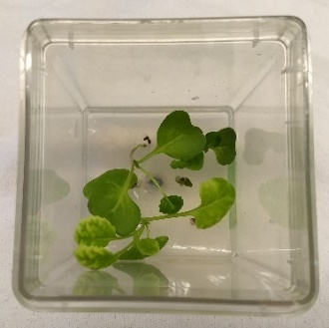 | 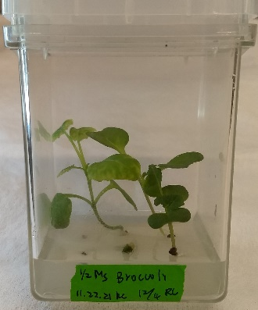 | 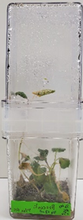 | Great size for growth in tissue vessel. Leaf senescence happens very slowly. | 4-6
Cotton | 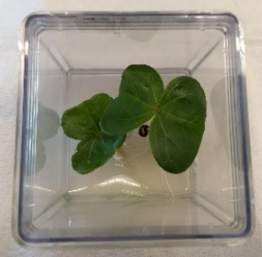 | 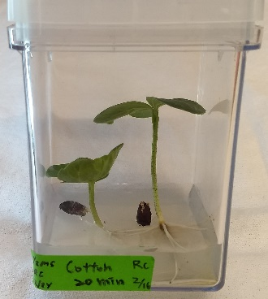 | 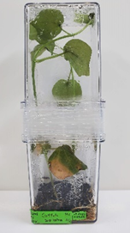 | Very large leaves which were initially good for whiteflies but it quickly outgrew the two GA7 combined height | 2
Corn | 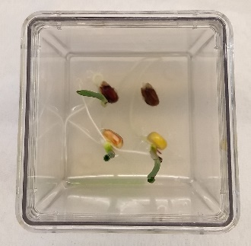 | 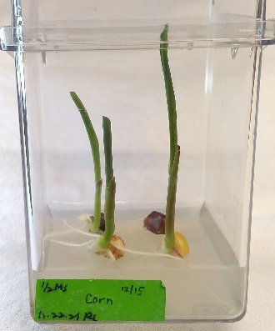 | 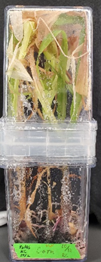 | Quickly outgrew the height of the two GA7’s. Monocot. | 2-4
Cucumber | 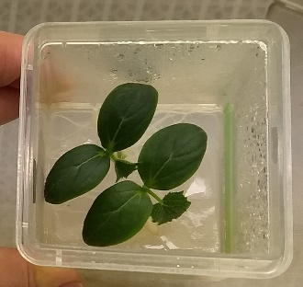 | 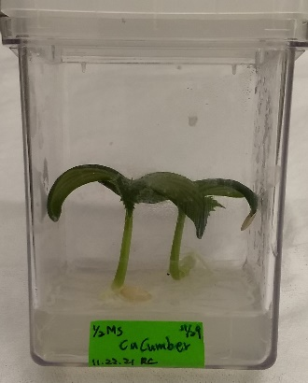 | 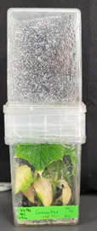 | Nice compact, large cotyledon growth | 2
Leopard Melon | 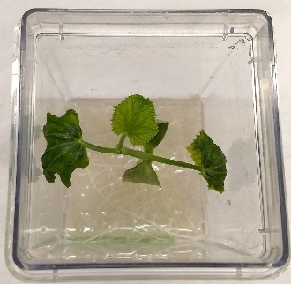 | 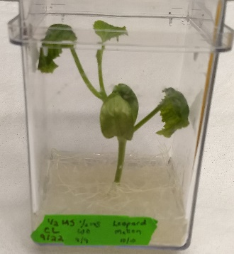 |  | Compact, nice leaf size. | 1
Acorn Squash | 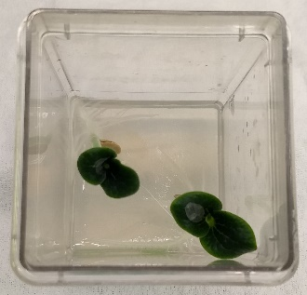 | 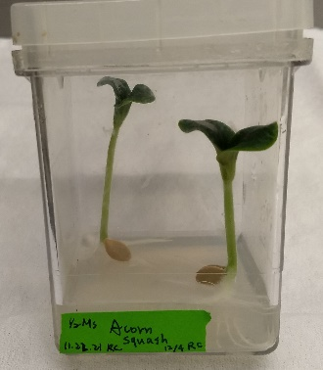 | 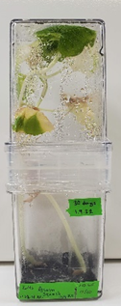 | Vine, outgrew GA7’s quickly | 2
Kabocha | 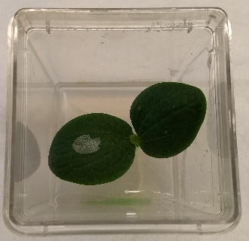 | 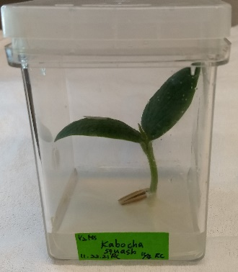 | 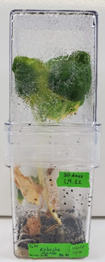 | Great cotyledon size and leaf area. | 1
Pea | 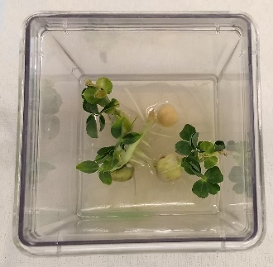 | 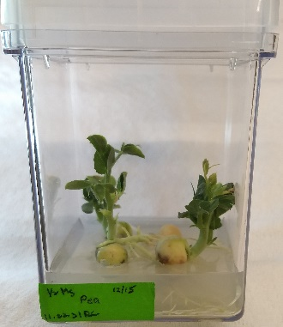 | 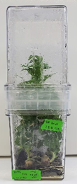 | Small leaves, worked well as a whitefly host. | 3-4
CowPea | 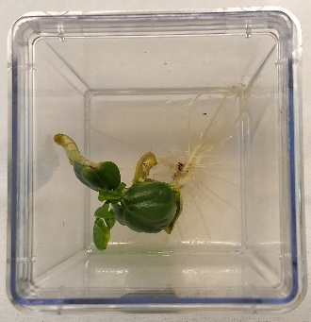 | 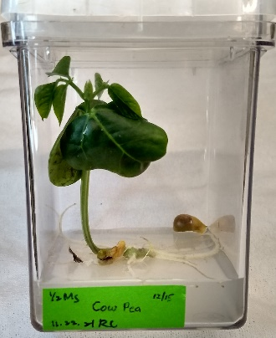 | 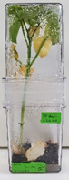 | Grew far to quickly and too tall but the leaves were a great size. | 1
Soy | 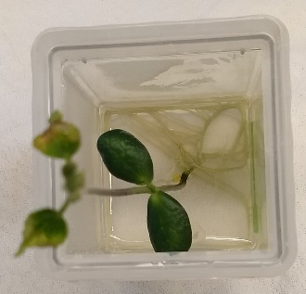 | 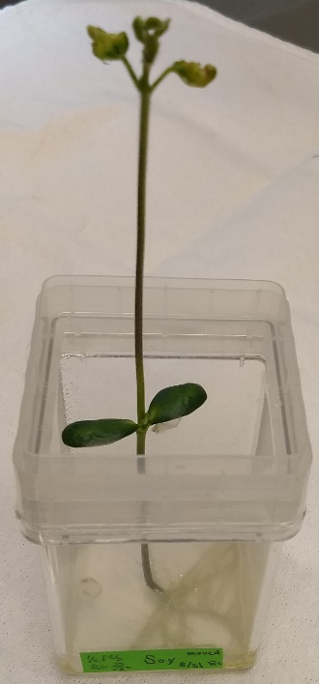 |  | Grew very high very quickly. Small leaves | 1
String Bean | 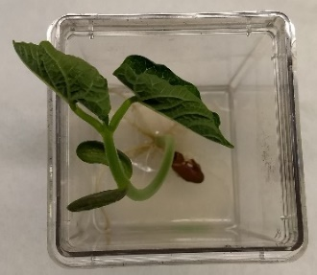 | 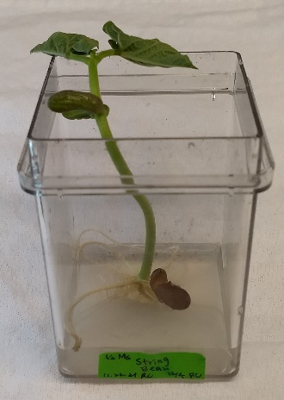 | 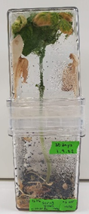 | Grew far to quickly and too tall but the leaves were a great size. | 1
Bell Pepper | 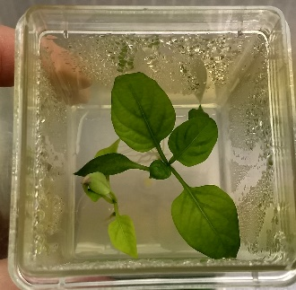 |  | 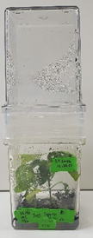 | Slow grower. Great final plant size | 2-3
Jalapeno | 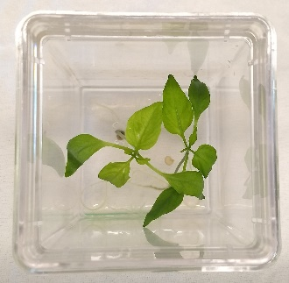 | 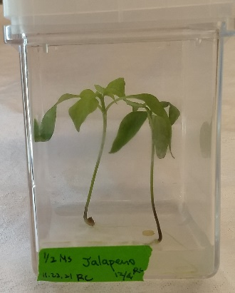 | 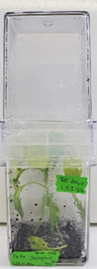 | Narrow leaves but good final plant size. | 2-4
Tomato | 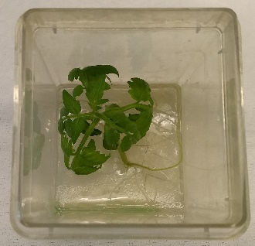 | 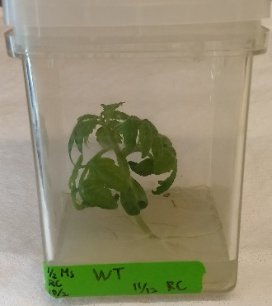 | 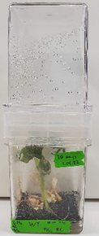 | One plant per GA7 minimized the leaves curling and allowed larger expansion. Trichomes were hard for the whiteflies to feed through. | 1
Nicotiana tabacum | 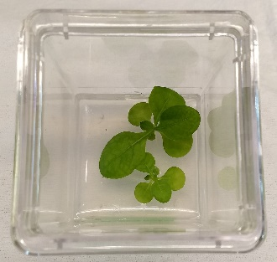 | 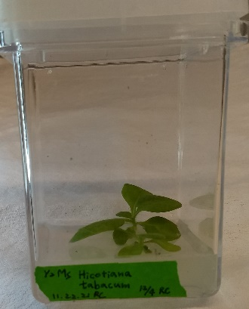 | 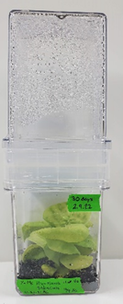 | Great leaf and final plant size | 2-5
Nicotiana benthamiana | 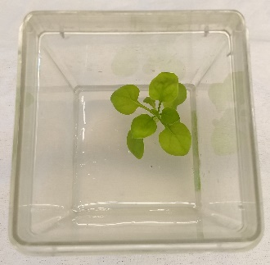 | 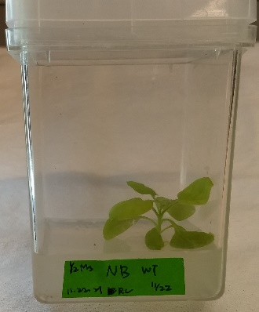 | 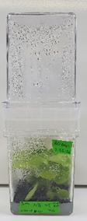 | Great leaf and final plant size | 2-5
Acyl-sugar knockout Nicotiana benthamiana | 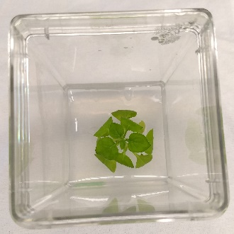 | 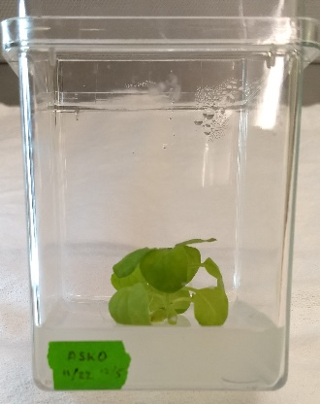 | 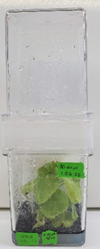 | Great leaf and final plant size. The acyl-sugar knockout variety had much larger fecundity of the whiteflies. | 2-5
Okra | 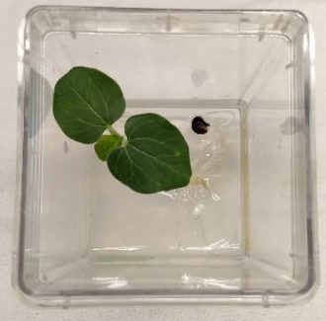 | 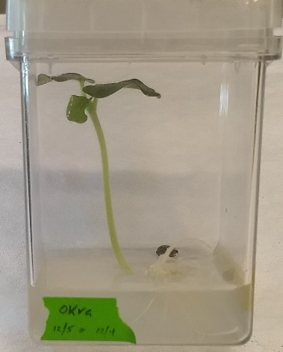 | 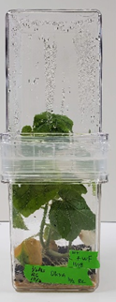 | Roots pushed the seed out of the media but the final plant size was good. | 1
Radish | 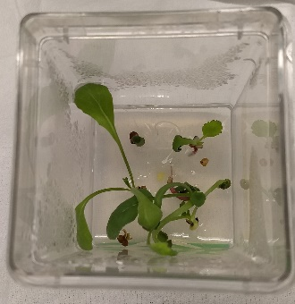 | 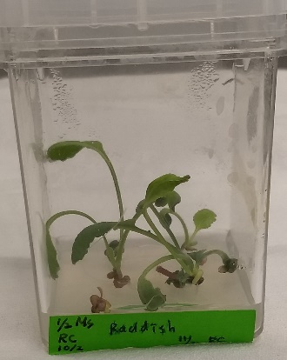 | 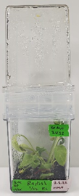 | Narrow leaves but height of the plant was good. | 2-5
Sweet Potato | 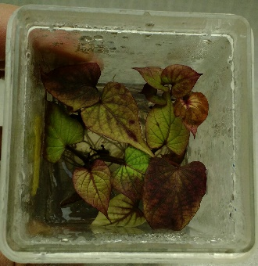 | 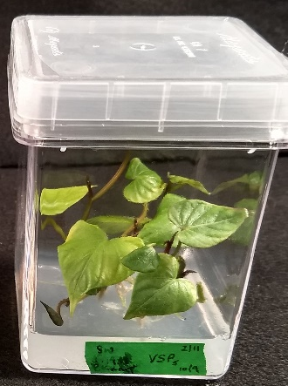 |  | Great in tissue culture. Needs to be subcultured once every couple of months. | 3-4
Yam (Ro) | 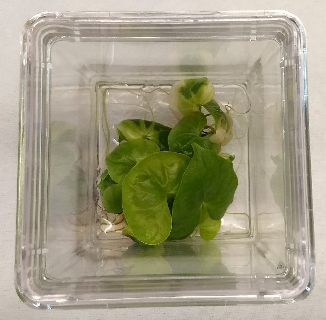 | 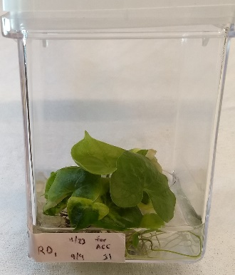 | 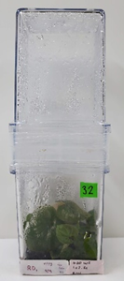 | Monocot (Dioscorea); Great in tissue culture. Needs to be subcultured once every couple of months. | 3-4
Yam (Ca) | 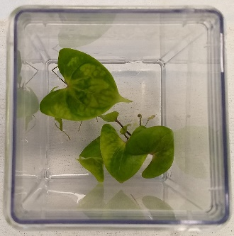 | 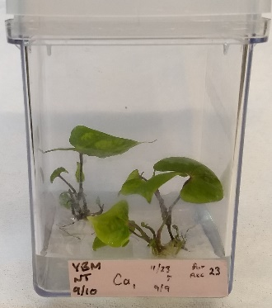 | 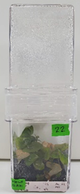 | Monocot (Dioscorea); Great in tissue culture. Needs to be subcultured once every couple of months. | 3-4
Greenbriar | 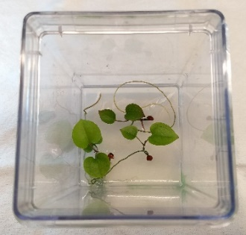 | 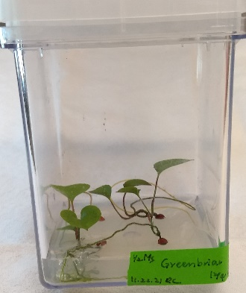 |  | Struggled with germination. It grew very slowly and leaf size was very small; Monocot | 4
Orange | 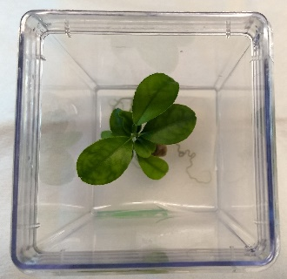 | 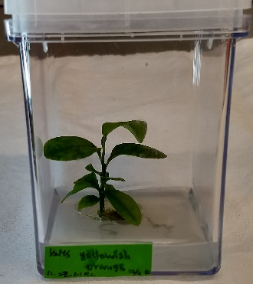 | 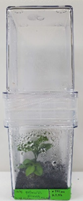 | Great leaf size and height. | 1-2
Lemon | 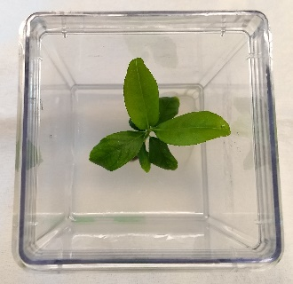 | 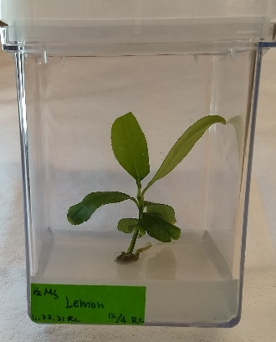 | 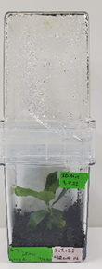 | Great leaf size and height. | 1-2
Grapefruit | 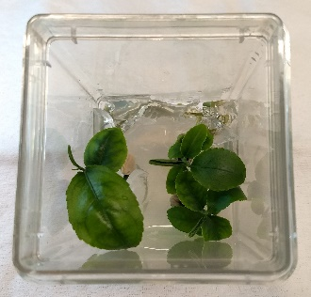 | 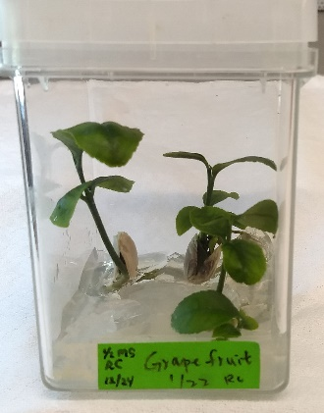 | 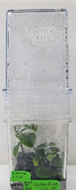 | Great leaf size and height. | 1-2
Arabidopsis | 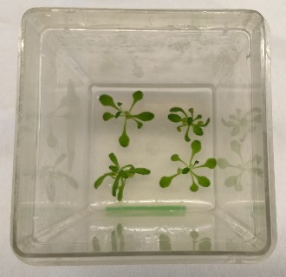 | 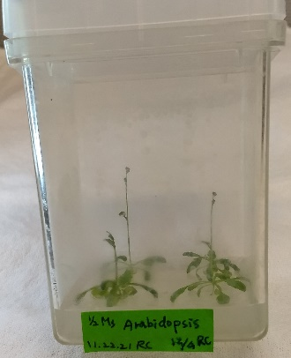 | 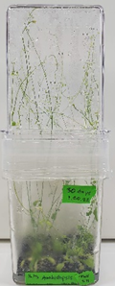 | Very small leaves did not work for whiteflies in tissue culture and it bolted quickly which was too high for the GA7 combo. | 4
Pomegranate | 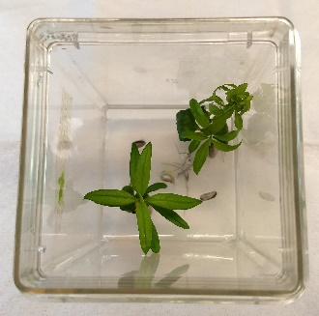 | 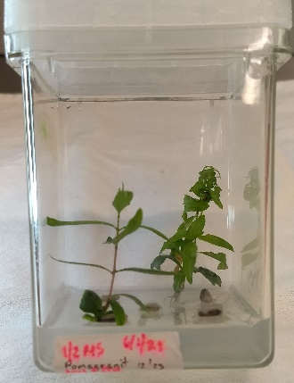 | 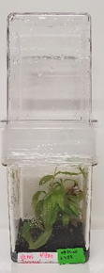 | Great height but leaves were very narrow. | 1-2

