Table S1. Questionnaires from the World Trade Center Health Program General Responder Cohort used in this study.
Instrument | Description | Visit | Number of Items
Exposure assessment questionnaire (EAQ) | Interviewer-administered questionnaire that assesses exposures (before 9/11, during WTC recovery efforts and current work) to hazardous and noxious substances, high noise levels, ergonomic risk factors, specific WTC-related tasks, work in confined spaces and use of PPE and hygiene. | Collected at the first monitoring visit only. | 660
Self-administered medical questionnaire (SAMQ)* | Self-report on illnesses and injuries while involved in WTC effort, claims filed for any injuries or illnesses resulting from WTC work (e.g., Workers’ Compensation, Unemployment Insurance), demographics, and reproductive and sexual health. Also collects demographic information. | Collected at first monitoring visit only. | 260
Interviewer-administered medical questionnaire (IAMQ) | Administered by a medical professional, collecting information on medical conditions (e.g., self-reported symptoms, diagnosed medical conditions), family medical history and alcohol and tobacco histories. Also collects demographic information. | Collected at each monitoring visit. | 1600
Mental health screening questionnaire (MHSQ) | Administered by WHOM. Addresses PTSD, generalized anxiety disorder, major depression, panic disorder, daily activities in the last month, alcohol use and distressing events experienced other than 9/11. A life impact survey collects information on life events and stressors. | Collected at the first monitoring visit only. | 370
Self-administered mental health questionnaire (SAMHQ) | Similar to MHSQ. Address mental health symptoms of general health, PTSD, generalized anxiety disorder, major depression, and panic disorder, and alcohol use, daily activities in the last month and distressing events experienced other than 9/11. A life impact survey collects information on life events and stressors. | Collection starts at the second monitoring visit and continues at subsequent visits. | 260
*Instrument was discontinued in 2010.

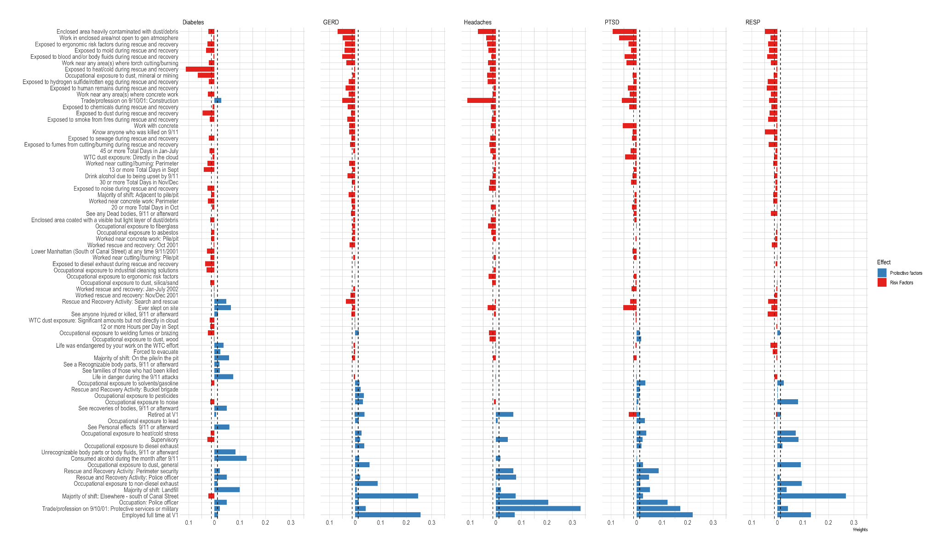
Figure S1. Weights from gWQS analyses among 34,096 responders included in this study. Bar plots represent estimated weights for each mixture component in the WQS regressions. Weights are color-coded to indicate models constrained to the positive direction (risk) and the negative direction (protective).

