Article title: PM_{2.5} decadal changes in Brazil: influence of vehicular fleet growth and policy to control vehicular emissions
Journal name: Clean Technologies and Environmental Policy

Authors: Camilo Bastos Ribeiroª, Leonardo Hoinaski^{b}

ªGraduate Program in Environmental Engineering, Federal University of Santa Catarina, Campus Trindade, Florianópolis, Santa Catarina, Brazil. cb_ambiental@hotmail.com

^{b}Department of Sanitary and Environmental Engineering - Technological Center. Federal University of Santa Catarina, Campus Trindade, Florianópolis, Santa Catarina, Brazil. leonadro.hoinaski@ufsc.br

*Corresponding author
E-mail address: leonardo.hoinaski@ufsc.br (L. Hoinaski).

SUPPLEMENTARY MATERIAL 1 – Study area

Figure SM1. Study area. Brazilian boundary cities are colored in grey; Brazilian mesoregions are colored in black; Brazilian urban spots are colored in magenta.
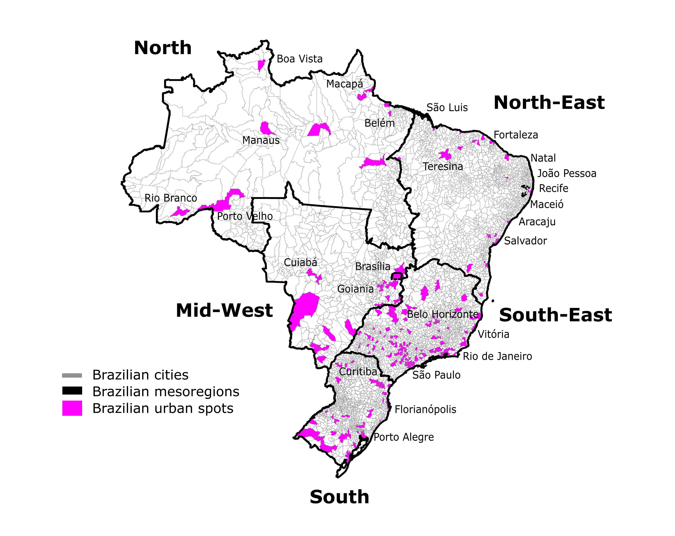

SUPPLEMENTARY MATERIAL 2 – Details of meteorological datasets

Table SM2. Primary source and details of meteorological dataset adopted in this study.
Dataset | Variables | Temporal resolution | Spatial resolution | Citation | Source
CHIRPS | Precipitation | Monthly | 0.05x0.05 | Funk et al., (2015) | https://chc.ucsb.edu/data
FLDAS Noah Land Surface Model | Surface air temperature (K), humidity (kg/kg), wind speed (m/s) | Monthly | 0.1x0.1 | McNally, (2018) | https://disc.gsfc.nasa.gov/

SUPPLEMENTARY MATERIAL 3 – Vehicle categories

Table SM3. Details about the vehicle categories adopted in this study (DENATRAN, 2023).
Main group | Categories | Motorization | Fuel | Definition
Heavy-Duty Vehicles (HDV) | Truck, tractor, platform chassis, crawler tractor, wheeled tractor, bus, and minibus. | Diesel cycle | Diesel | Cargo vehicle and public transport with total gross weight exceeding 3856kg.
Light-Duty Vehicles (LDV) | Automobiles, Pickup truck, utility vehicles, and others. | Otto or diesel cycleª | Gasoline C (~27% of anhydrous ethanol), hydrous ethanol, flex fuel | Self-propelled vehicle for passenger and vehicle designed for people or cargo transport with total gross weight up to 3856kg.
ª Some categories such as utility vehicles can adopted diesel cycle engines.

SUPPLEMENTARY MATERIAL 4 – Stages implemented by Brazilian PCVE

Table SM4. Stages implemented by Brazilian PCVE for light-duty and heavy-duty vehicles (TransportPolicy, 2023).
Year^{(a)} | Stage implemented ^{(b)} | Policy
1988 | L-1 | CONAMA 18/1986
1989 | P-1 | CONAMA 18/1986
1992 | L-2 | CONAMA 18/1986
1996 | P-2 | CONAMA 18/1986
1997 | L-3 | CONAMA 8/1993
2000 | P-3 | CONAMA 8/1993
2002 | P-4 | CONAMA 8/1993
2006 | P-5 | CONAMA 315/2002
2007 | L-4 | CONAMA 315/2002
2009 | L-5 | CONAMA 315/2002
2012 | P-7 | CONAMA 403/2018
2015 | L-6 | CONAMA 415/2009
2022 | L-7, P-8 | CONAMA 492/2018
2025 | L-8 | CONAMA 492/2018
^{(a)} Year of implementation for 100% of the vehicles.
^{(b)} P and L indicates the stages implemented for heavy-duty and light-duty vehicles, respectively.

SUPPLEMENTARY MATERIAL 5 – Percentual of fleet density and emissions contribution to PM_{2.5} changes
Figure SM5. Spatial distribution of fleet density and emissions contribution (%) to PM_{2.5} changes in Brazilian urban spots.
