Supplementary Table 1. Clinical, demographic and biochemical parameters of non-obese subjects and obese individuals negative and positive for Ad-36 antibodies.

Supplementary Table 2. Set of specific primers for lncRNAs.

Supplementary Figure 1. Influence of obesity and Ad-36 serology on the expression of PPARG. Values are presented as box plot and represent gene expression in non-obese and obese subjects (A) and according to Ad3-6 serology in the obese group (B). Data were compared by Mann-Whitney test. Seronegative individuals [Ad36 (-)]; seropositive individuals [Ad36 (+)].

Supplementary Table 1. Clinical, demographic and biochemical parameters of non-obese subjects and obese individuals negative and positive for Ad-36 antibodies.
Variable | Non-obese (n=17) | Obese (n=57) | P-value |  | Ad-36 (-)  (n=28) | Ad-36 (+)  (n=29) | P-value
Demographic and anthropometric data
Age, y | 50 ± 11 | 41 ± 12 | 0.004 |  | 42 ± 12 | 39 ± 10 | 0.264
Sex [women], % | 71 (12) | 74 (42) | 0.948 |  | 71 (28) | 76 (22) | 0.541
SBP, mmHg | 117 ± 13 | 121 ± 15 | 0.438 |  | 120 ± 12 | 123 ± 17 | 0.507
DBP, mmHg | 76 ± 9 | 78 ± 7 | 0.532 |  | 77 ± 13 | 78 ± 8 | 0.903
Weight, Kg | 66.1 ± 7.0 | 104.1 ± 17.5 | <0.001 |  | 100.7 ± 15.1 | 108.7 ± 22.0 | 0.115
Body mass index, Kg/m² | 23.7 ± 3.4 | 39.5 ± 5.6 | <0.001 |  | 39.4 ± 5.2 | 40.4 ± 7.2 | 0.549
Waist circumference, cm | 85.6 ± 8.7 | 108.4 ± 13.3 | <0.001 |  | 106.3 ± 14.7 | 109.4 ± 15.5 | 0.442
Fat Mass, % | 31.2 ± 7.6 | 40.2 ± 9.6 | 0.021 |  | 37.3 ± 10.9 | 42.9 ± 9.6 | 0.045
Biochemical parameters
Total cholesterol, mg/dL | 182 ± 31 | 185 ± 34 | 0.841 |  | 184 ± 38 | 186 ± 29 | 0.828
LDL cholesterol, mg/dL | 110 ± 31 | 116 ± 53 | 0.835 |  | 115 ± 39 | 118 ± 25 | 0.633
HDL cholesterol, mg/dL | 62 ± 17 | 48 ± 11 | <0.001 |  | 49 ± 14 | 48 ± 11 | 0.956
VLDL cholesterol, mg/dL | 25 ± 22 | 37 ± 29 | <0.001 |  | 30 ± 18 | 28 ± 11 | 0.587
Triglycerides, mg/dL | 125 ± 66 | 146 ± 84 | <0.001 |  | 152 ± 91 | 141 ± 56 | 0.587
Glucose, mg/dL | 92 ± 7 | 100 ± 31 | 0.046 |  | 103 ± 15 | 99 ± 49 | 0.677
HOMA-IR, a.u. | 1.71 ± 1.26 | 6.58 ± 7.9 | <0.001 |  | 7.12 ± 8.39 | 6.10 ± 10.9 | 0.693
Adiponectin, μg/mL | 9.27 ± 4.69 | 7.47 ± 5.15 | 0.146 |  | 7.92 ± 4.10 | 7.41 ± 5.65 | 0.656
Leptin, ng/mL | 19.0 ± 12.2 | 34.3 ± 30.4 | 0.013 |  | 40.6 ± 32.8 | 25.2 ± 21.3 | 0.032
Number of individuals is in parenthesis. Continuous variables are presented as mean and standard deviation and compared by t test or Mann Whitney U test. Categorical variables are presented as percentage and compared by chi-square test. Ad-36(-): Adenovirus 36 seronegative individuals; Ad-36(+): Adenovirus 36 seropositive individuals; SBP: systolic blood pressure; DBP: diastolic blood pressure. LDL: low density lipoprotein; HDL: high density lipoprotein; VLDL: very low density lipoprotein; HOMA-IR: Homeostasis model assessment of insulin resistance; a.u.: Arbitrary units. This data was previously published (Manriquez et al. Int J of Obes 2020; doi: 10.1038/s41366-020-00654-9)

Supplementary Table 2. Set of specific primers for lncRNAs.
lncRNA | Primer nucleotide sequence
ADINR | FW: 5’- AAGGAGGAGACAGAAGGAGTAG-3’
ADINR | REV: 5’- CTCTTCATCACAGCACATCCA -3’
MEG3 | FW: 5’- CTGGATCCCACCAACATACAA -3’
MEG3 | REV: 5’- CCTCACTAGGGCATTGGTTT -3’
GAS5 | FW: 5’- AGTCCTAAAGAGCAAGCCTAAC -3’
GAS5 | REV: 5’- GTTACCAGGAGCAGAACCATTA -3’
FW: primer forward; REV: primer reverse.

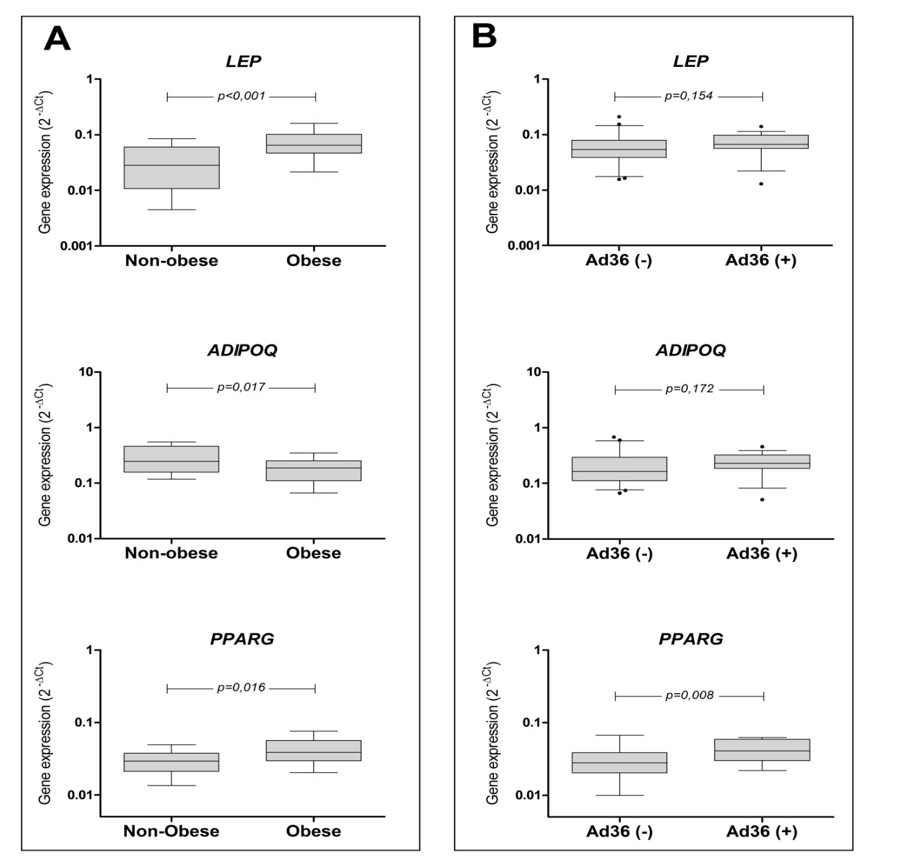
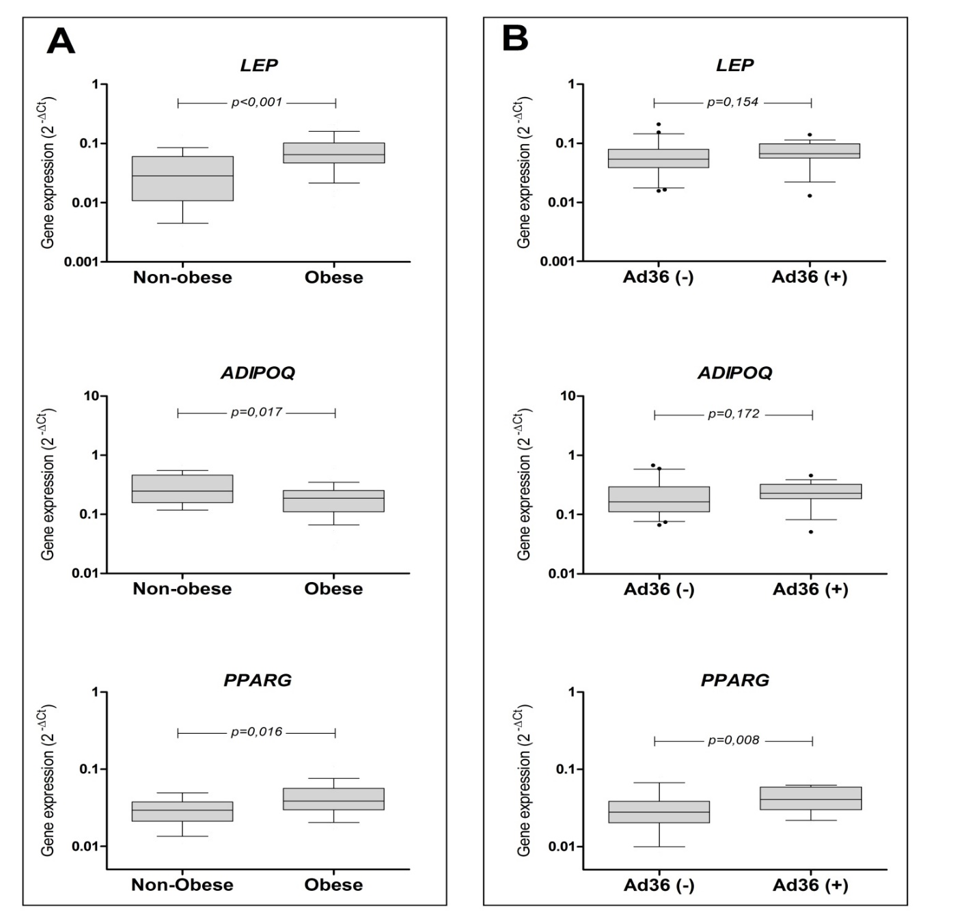
A) B)

Supplementary Figure 1. Influence of obesity and Ad-36 serology on the expression of PPARG. Values are presented as box plot and represent gene expression in non-obese and obese subjects (A) and according to Ad-36 serology in the obese group (B). Data were compared between groups by Mann-Whitney test. Seronegative individuals [Ad36 (-); n=28]; seropositive individuals [Ad36 (+); n=29].

