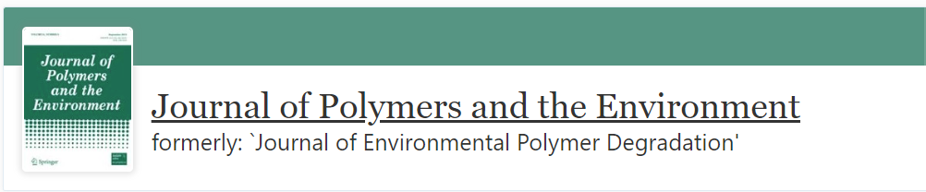

From recycled PVC and its blends to eco-friendly materials for the footwear industry in Brazil: Insight into the process and evaluation of the mechanical properties

Giovanna Marsura¹, Juliana Otavia Bahú², Laura Plazas Tovar^{1,*}, Romilda Fernandez-Felisbino¹, Eliezer Ladeia Gomes¹

¹Department of Chemical Engineering, Federal University of São Paulo, ZIP code 09913-030, Diadema–SP, Brazil.
²Center for Energy and Petroleum Studies, University of Campinas, ZIP code 13083-896, Campinas–SP, Brazil.

_____________________________________________________________________________
*Corresponding author
Laura P. Tovar, laura.tovar@unifesp.br
Department of Chemical Engineering, Federal University of São Paulo, ZIP code 09913-030, Diadema–SP, Brazil.

Supplementary Material

Table S1 - Tensile test results of blends prepared from pure TPU, pure PVC, and recycled PVC.
Properties | Rupture Strength | Yield Strength | Elongation at Break | Young’s Module | Tensile Stress (10%) | Tensile Stress (100%) | Tensile Stress (300%)
Units | MPa | N | % |  | MPa | MPa | MPa
PVC | 9.1 ± 0.7 | 82.0 ± 5.9 | 185.0 ± 20.8 | 1.1 ± 0.0 | 1.1 ± 0.1 | 5.8 ± 0.0 | 0.0
rPVC | 14.7 ± 0.7 | 132.5 ± 6.1 | 131.9 ± 9.3 | 1.8 ± 0.0 | 1.6 ± 0.1 | 12.1 ± 0.8 | 0.0
TPU | 18.5 ± 3.2 | 168.4 ± 29.2 | 620.4 ± 22.1 | 0.9 ± 0.0 | 1.7 ± 0.4 | 4.9 ± 0.3 | 11.5 ± 1.0
TPU/PVC (33/67 wt.%) | 10.3 ± 0.6 | 92.6 ± 5.4 | 200.2 ± 18.6 | 1.1 ± 0.0 | 1.3 ± 0.1 | 6.8 ± 0.4 | 0.0
TPU/PVC (50/50 wt.%) | 12.6 ± 0.7 | 113.2 ± 6.5 | 275.3 ± 5.4 | 1.2 ± 0.0 | 1.4 ± 0.1 | 6.6 ± 0.4 | 0.0
TPU/rPVC (50/50 wt.%) | 25.6 ± 1.3 | 230.0 ± 5.11 | 384.1 ± 17.8 | 1.9 ± 0.0 | 1.8 ± 0.2 | 9.2 ± 0.2 | 20.2 ± 0.3
TPU/PVC (67/33 wt.%) | 15.7 ± 4.0 | 141.0 ± 35.6 | 405.1 ± 14.0 | 1.2 ± 0.0 | 1.4 ± 0.1 | 6.0 ± 0.4 | 13.4 ± 0.4
TPU/rPVC (67/33 wt.%) | 33.9 ± 1.6 | 305.0 ± 4.8 | 490.1 ± 14.2 | 1.8 ± 0.0 | 1.7 ± 0.1 | 8.6 ± 0.2 | 18.5 ± 0.2

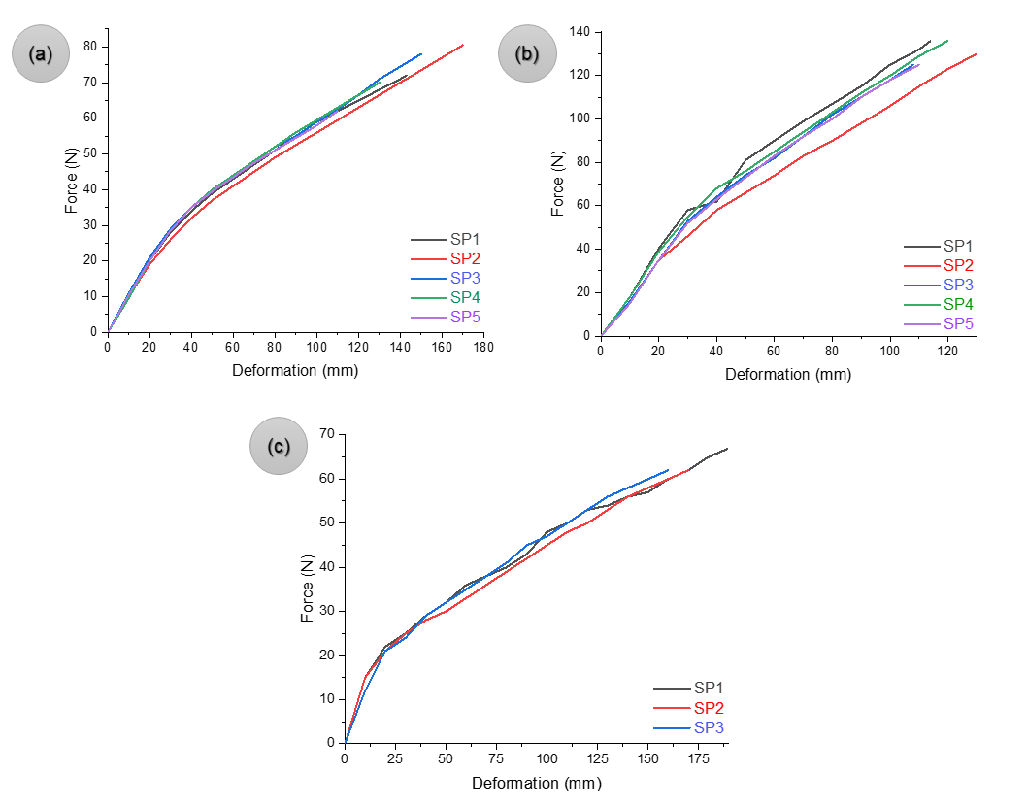
Figure S1 - Tensile testing results for the pure polymers: a) PVC, b) rPVC, and c) TPU.
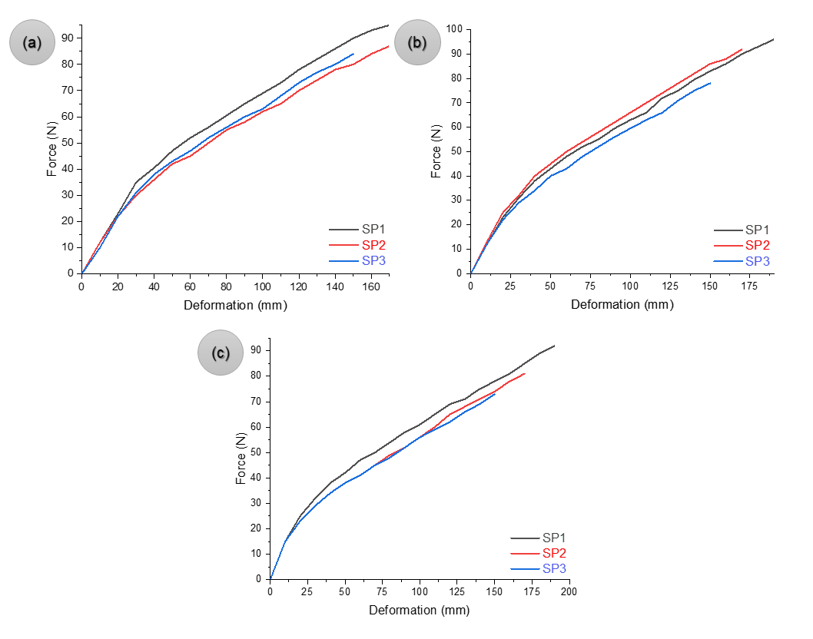
Figure S2 - Tensile testing results for the blends: a) TPU/PVC (33/67 wt.%), b) TPU/PVC (50/50 wt.%), and c) TPU/PVC (67/33 wt.%).

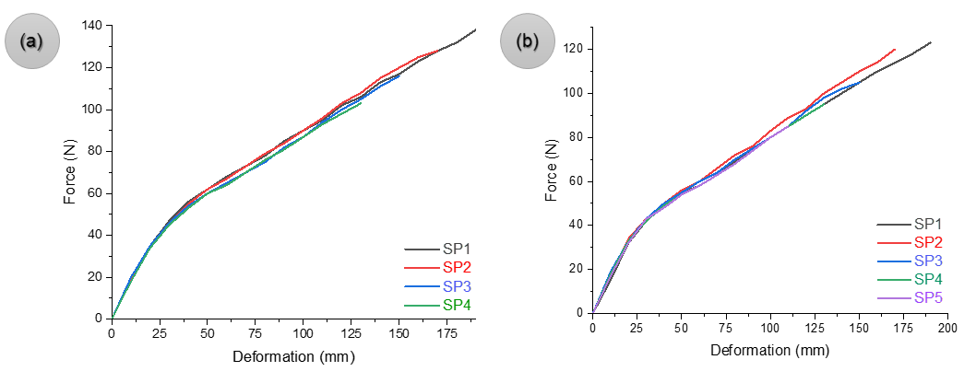
Figure S3 - Tensile testing results for the recycled blends: a) TPU/rPVC (50/50 wt.%), and b) TPU/PVC (67/33 wt.%).

