Supplemental information
The dominant role of bacterial community and network characteristics drive the humification process and greenhouse gas emissions during plant residues composting under different aeration rates

Junyu Gu ^{a,b}, Yun Cao^{a,b,c,d}, Qian Sun ^{a,c,d}, Jing Zhang ^{a,d}, Yueding Xu^{a,d}, Hongmei Jin^{a,b,c,d}, Huang Hongying^{a,d}

Contact information: a. Institute of Agricultural Resources and Environment, Jiangsu Academy of Agricultural Sciences, Nanjing, 210014, China; b.College of Resources and Environmental Sciences, Nanjing, 210095, China; c. Key Laboratory of Crop and Livestock Integrated Farming, Ministry of Agriculture, Nanjing, 210014, China; d. Jiangsu Collaborative Innovation Center for Solid Organic Waste Resource Utilization, Nanjing, 210014, China.

*Corresponding author: yun.cao@jaas.ac.cn

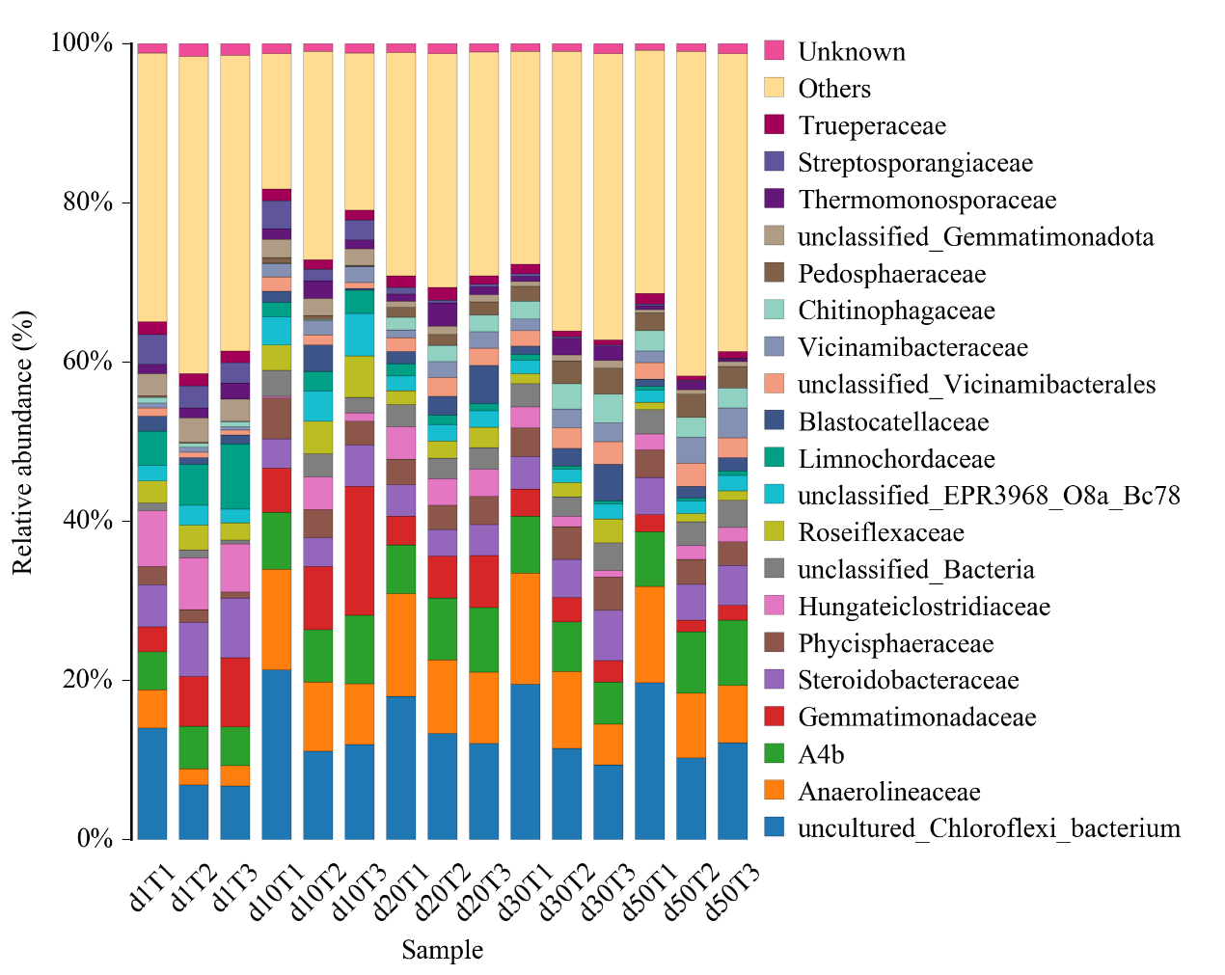
Fig. S1 Relative abundance of predominant bacterial community at family level during composting
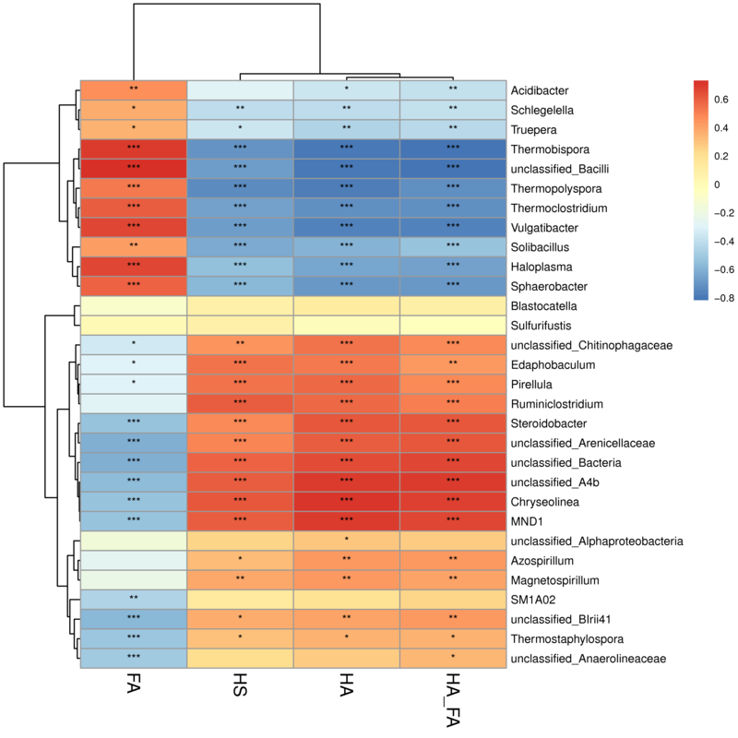
Fig. S2 Correlation analysis between bacterial abundance at genus level and humificaiton index. * p<0.05, ** p<0.01, *** p<0.001.

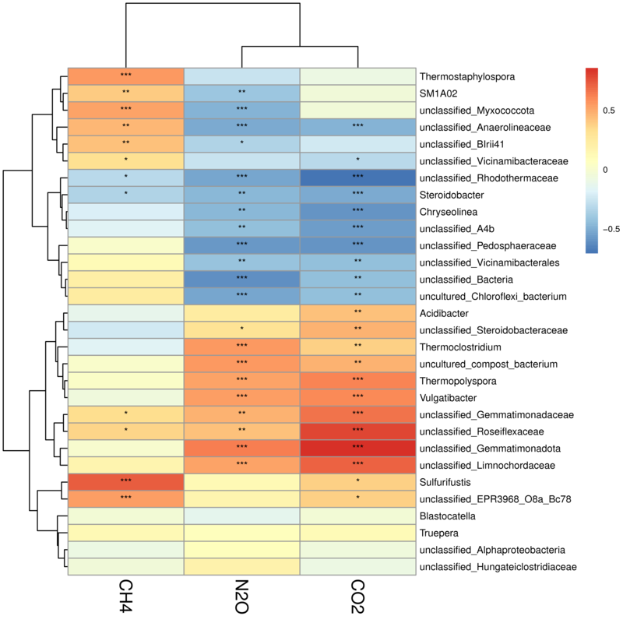
Fig.S3 Correlation analysis between bacterial abundance at genus level and gaseous emiison. * p<0.05, ** p<0.01, *** p<0.001.

Table S1 The basic characteristics of raw materials used in composting experiment
Feedstocks | Moisture content % | TOC content % | TN content %
Spent mushroom substrate (SMS) | 7.29 | 425.21 | 26.81
Rice straw | 7.35 | 493.93 | 13.05
Rice husk | 10.38 | 502.18 | 7.45
Sawdust | 22.80 | 738.36 | 2.29

Table S2 Topological indices of each network in Fig. 3
Network specificity | Treatments
Network specificity | T1 | T2 | T3
Number of nodes | 194 | 229 | 278
Number of edges | 218 | 372 | 576
Average degree | 9.132 | 15.73 | 17.28
Closeness centrality | 0.303 | 0.322 | 0.356
Network density | 0.0116 | 0.0142 | 0.0149
Modularity_class | 1.952 | 1.516 | 1.618

