Extended data figures:

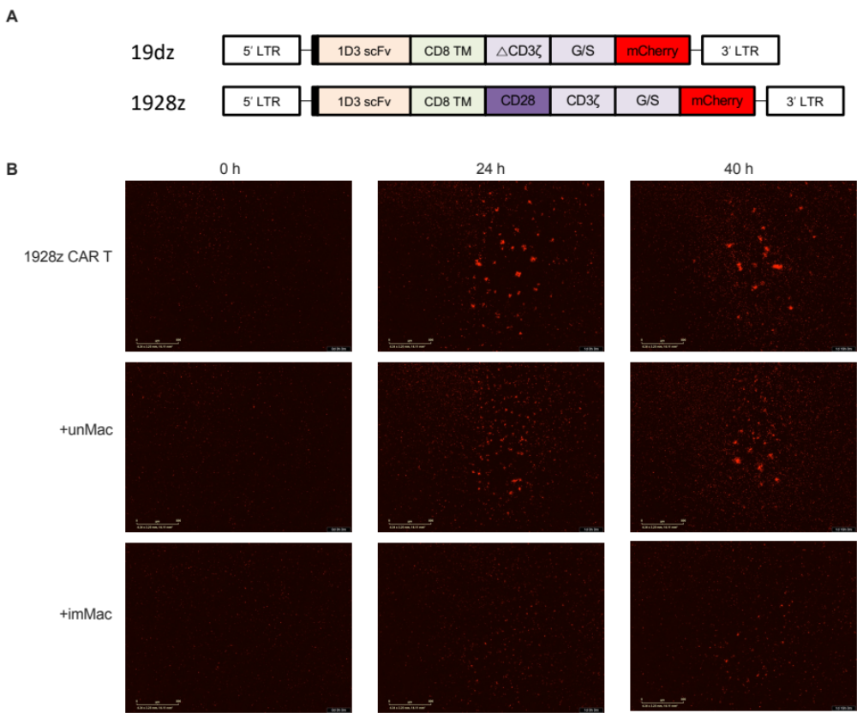
Extended Data Fig. 1. Exposure of imMac suppresses CAR T cell expansion. (A) Construct maps encoding anti-CD19 CARs. All included a 5’ long terminal repeat (LTR), anti-murine CD19 single-chain variable fragment (scFv), CD8 transmembrane and hinge domain (CD8 TM), glycine-serine linker (G/S), mCherry, and 3’ LTR. 19dz CAR is 1st generation CAR containing truncated CD3ς chain (ΔCD3ς). 1928z CAR is 2nd generation CAR containing CD28 costimulatory domain and CD3ς chain. (B) Representative IncuCyte images taken at 0, 24, and 40 h during cocultures of CAR T cells and Eμ-myc cells with unMac or imMac or without macrophages.
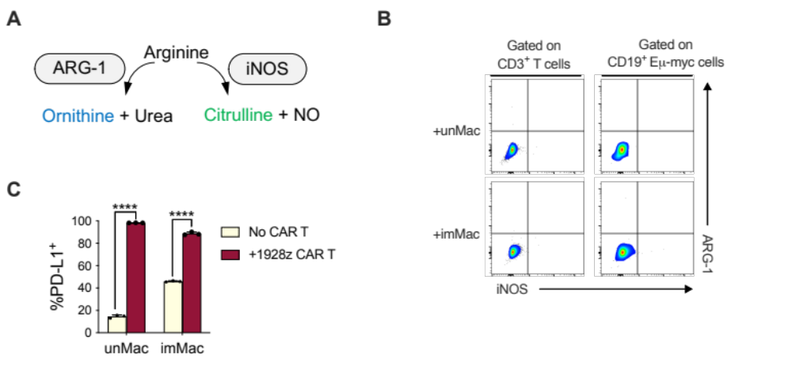
Extended Data Fig. 2. Exposure to CAR T cells induces phenotypic changes in macrophages. (A) Arginine metabolic pathways. (B) CAR T cells and Eμ-myc cells were cocultured with unMac or imMac for 24 h. Expression of ARG-1 and iNOS in CD3⁺ T cells or CD19⁺ Eμ-myc cells were analyzed by flow cytometry. (C) Flow cytometry analysis of expression of PD-L1 in unMac or imMac cocultured with Eμ-myc cells in the presence or absence of CAR T cells at 24 h (n=3). Data in (C) are presented in mean ± SD. Statistical significance was determined by unpaired two-tailed Student’s t tests. ****, P < 0.0001. ARG-1, arginase-1; iNOS, inducible nitric oxide synthase; NO, nitric oxide.

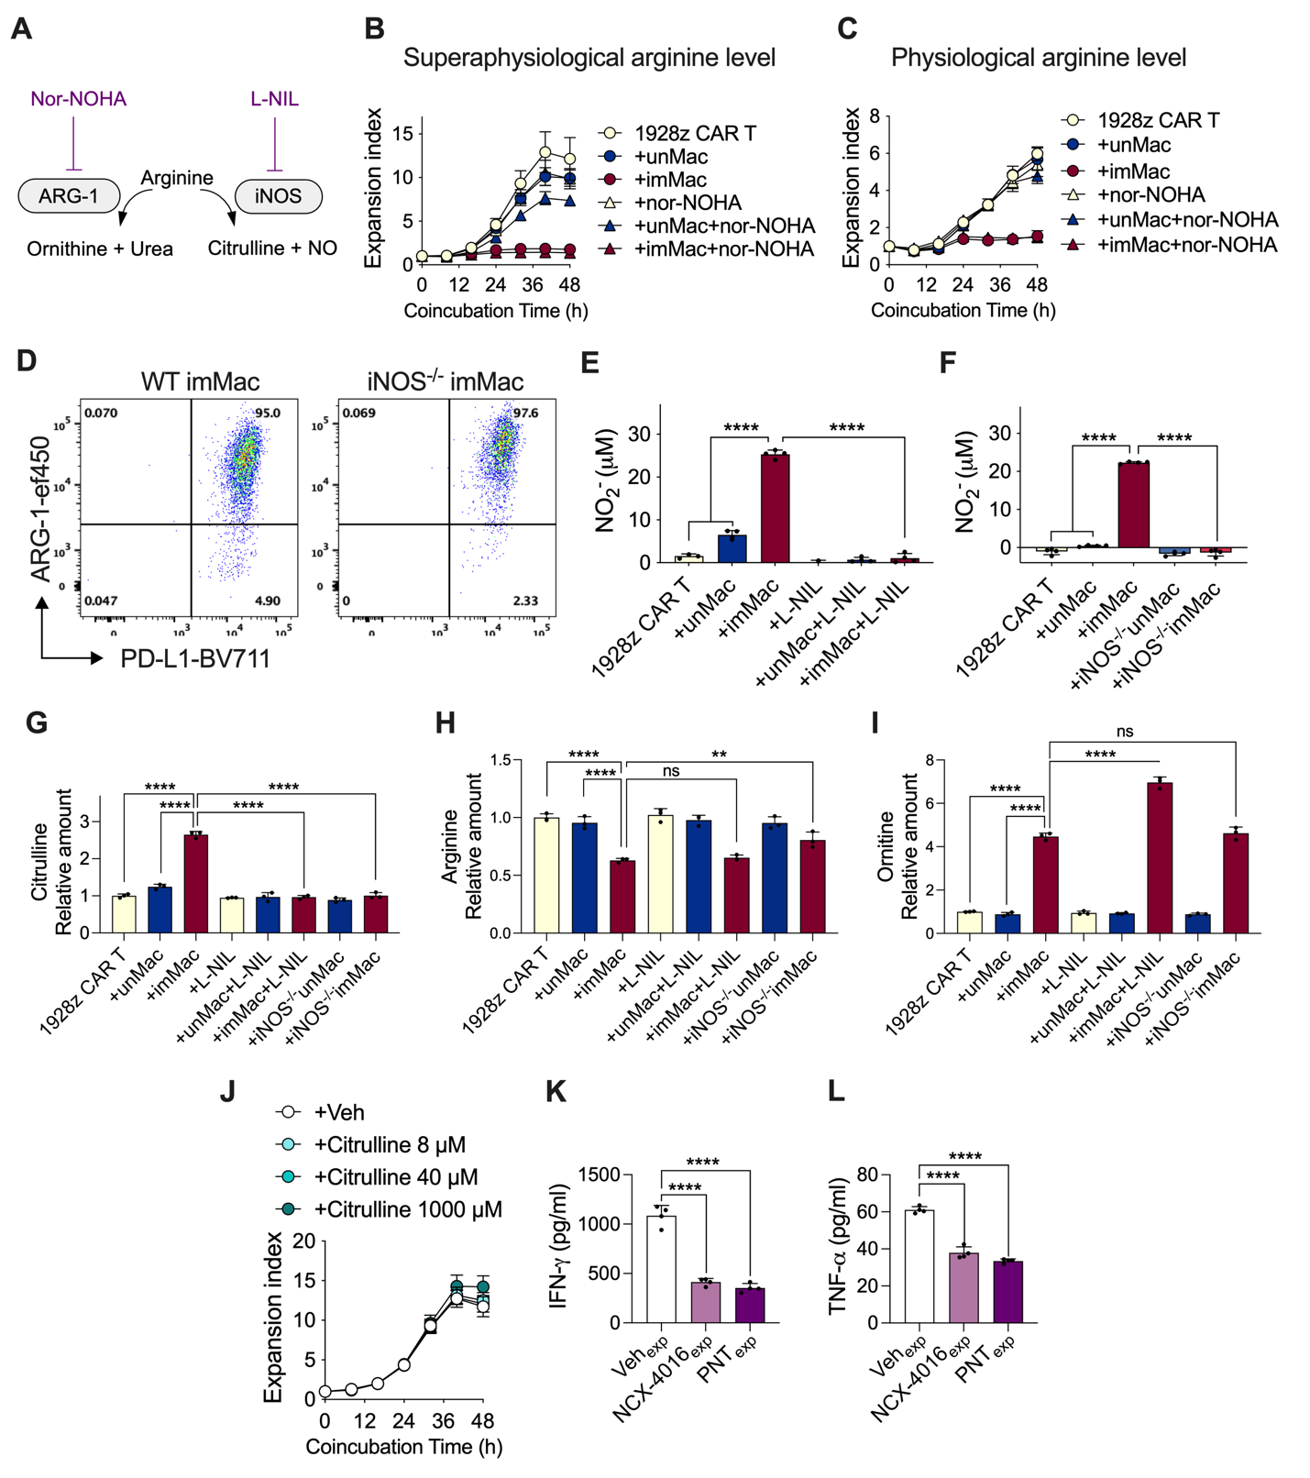
Extended Data Fig. 3. Arginine metabolism by imMac mediates impairment of CAR T cell function. (A) Arginine metabolic pathway and the inhibitors of respective enzymes. (B and C) CAR T cells and Eμ-myc cells were cocultured with unMac or imMac or without macrophages in the culture media containing supraphysiological (1.15 mM) (B) or physiological (150 μM) (C) concentration of arginine in the presence or absence of nor-NOHA (50 μM). CAR T cell expansion was measured over 48 h by a live cell analysis system (n=4). Data are representative of n = 2 independent experiments. (D) Flow cytometry analysis of expression of ARG-1 and PD-L1 in WT or iNOS^{-/-} imMac cocultured with CAR T cells and Eμ-myc cells at 24 h. (E) Analysis of NO levels in coculture supernatants of CAR T cells and Eμ-myc cells with or without WT unMac or imMac in the presence or absence of L-NIL (50 μM) at 48 h using Griess assay (n=4). Data are representative of n = 2 independent experiments. (F) Analysis of NO levels in coculture supernatants of CAR T cells and Eμ-myc cells with or without WT or iNOS^{-/-} unMac or imMac at 48 h using Griess assay (n=4). (G-I) Citrulline, arginine, and ornithine levels in coculture supernatants of CAR T cells and Eμ-myc cells with or without WT or iNOS^{-/-} unMac or imMac in the presence or absence of L-NIL (50 μM) (n=3). Graphs contain control data also used in Fig.3 D-F. (J) CAR T cells and Eμ-myc cells were cocultured in the increasing concentrations of citrulline. CAR T cell expansion was measured over 48 h by a live cell analysis system (n=4). (K and L) After initial coculture of CAR T cells and Eμ-myc cells in the presence of NCX-4016 (100 μM) or PNT (50 μM) or 0.01% DMSO (Veh) for 48 h, isolated CAR T cells were cocultured with fresh Eμ-myc cells. Levels of IFN-γ and TNF-α in coculture supernatants at 24 h were measured by ELISA (n=4). All data are presented in mean ± SD. Data in (E, F, G-I, K, L), statistical significance was determined by one-way ANOVA with Bonferroni correction for multiple comparisons. **, P < 0.01; ****, P < 0.0001; ns, not significant; NO, nitric oxide; PNT, peroxynitrite; exposed, isolated CAR T cells from prior coculture.
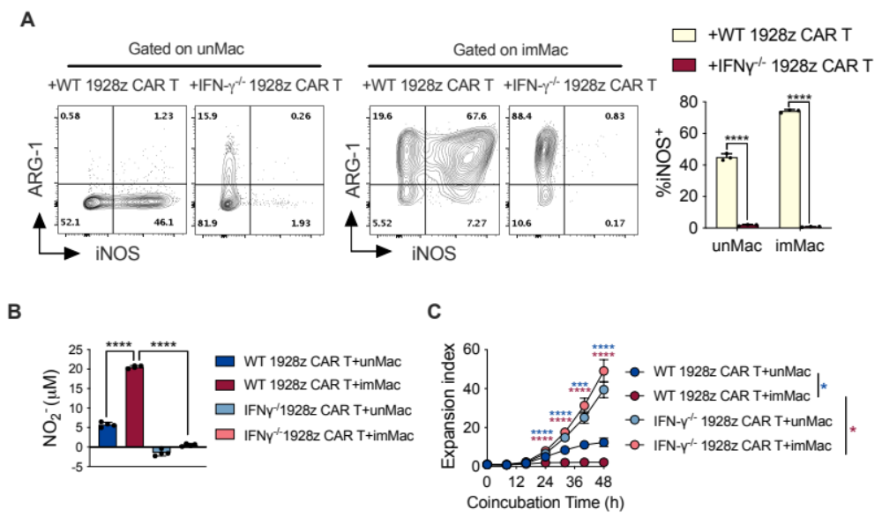
Extended Data Fig. 4. IFN-γ^{-/-} CAR T cells do not trigger iNOS in macrophages. WT or IFN-γ^{-/-} CAR T cells were cocultured with Eμ-myc cells in the presence of unMac or imMac. (A) Expression of ARG-1 and iNOS in unMac or imMac at 24 h was analyzed by flow cytometry (n=3). (B) NO levels in coculture supernatants at 48 h were analyzed by Griess assay (n=4). (C) CAR T cell expansion was measured over 48 h by a live cell analysis system (n=4). All data are presented in mean ± SD. Statistical significance was determined by unpaired two-tailed Student’s t tests (A, C) or one-way ANOVA with Bonferroni correction for multiple comparisons (B). ***, P < 0.001; ****, P < 0.0001; WT, wildtype; NO, nitric oxide.

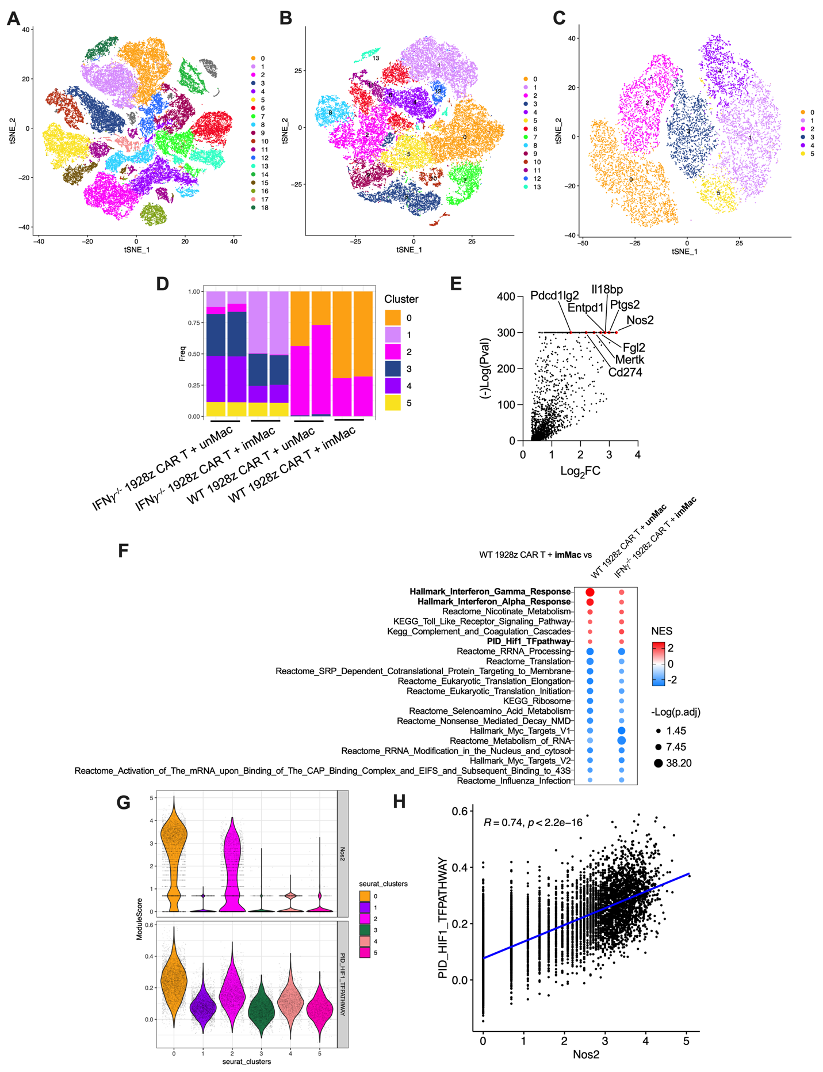
Extended Data Fig. 5. scRNA-seq reveals imMac complexity. WT or IFN-γ^{-/-} CAR T cells were cocultured with Eμ-myc cells in the presence of unMac or imMac. After coculture for 48 h, scRNA-seq was performed on T cells and macrophages. (A) Unsupervised clustering of cells derived from the cocultures. (B) t-SNE plot showing T cell subclusters. (C) t-SNE plot showing macrophage subclusters. (D) The composition of macrophage clusters (Cluster 0–5) in coculture groups. (E) Key differentially expressed genes (DEGs) in Cluster 0. (F) Pathway enrichment analysis of DEGs in imMac cocultured with WT CAR T cells compared with imMac cocultured with IFN-γ^{-/-} CAR T cells or unMac cocultured with WT CAR T cells. (G) Violin plots depicting the expression of Nos2 (iNOS) and HIF-1α transcription factor pathway in macrophage subclusters. (H) Pearson correlation analysis between Nos2 expression and the HIF-1α transcription factor pathway in macrophage subclusters.
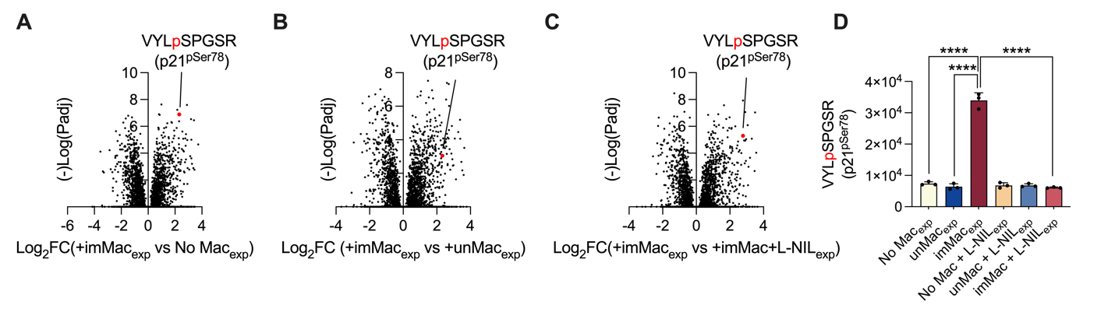
Extended Data Fig. 6. Phospho-proteomics reveals increased phosphorylation at serine 78 in Cdkn1/p21. CAR T cells and Eμ-myc cells were cocultured with unMac, imMac or without macrophages (No Mac) in the presence or absence of L-NIL (50 μM). After coculture for 48 h, phospho-proteomics analyses were performed on T cells. (A-C) Quantification of relative abundance of phospho-Cdkn1/p21 in CAR T cells exposed to imMac versus No Mac (A) or unMac (B) or imMac with L-NIL treatment (C). (D) Levels of phospho-Cdkn1a/p21 in different coculture groups (n=3). Statistical significance was determined by one-way ANOVA with Bonferroni correction for multiple comparisons (D).

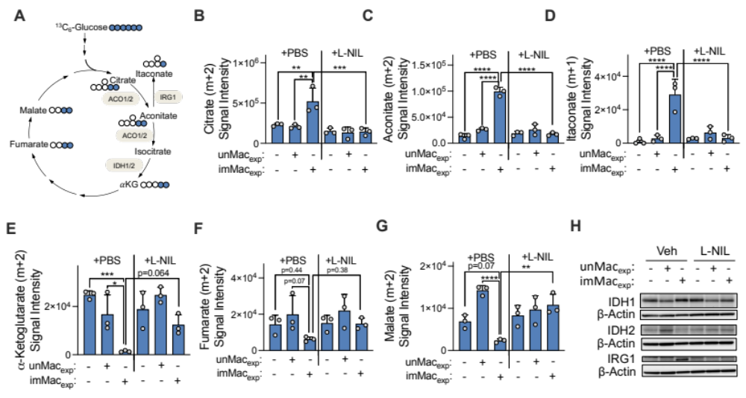
Extended Data Fig. 7. Itaconate is endogenously produced in imMac-exposed CAR T cells. CAR T cells and Eμ-myc cells were cocultured with unMac or imMac or without macrophages in the presence or absence of L-NIL (50 μM) for 48 h. (A-G) ¹³C₆-glucose tracing was performed on isolated CAR T cells. (A) Schematic showing ¹³C-labeled TCA cycle-related metabolites generated from ¹³C₆-glucose. Colored circles represent ¹³C-labeled carbons. (B-G) Levels of ¹³C-labeled citrate, aconitate, itaconate, α-ketoglutarate, fumarate, and malate (n=3). (H) Immunoblotting was performed on isolated CAR T cells. The β-actin was used as a loading control. Data in (B-G) are presented in mean ± SD. Statistical significance was determined by one-way ANOVA with Bonferroni correction for multiple comparisons. *, P < 0.05; **, P < 0.01; ***, P < 0.001; ****, P < 0.0001; IDH, isocitrate dehygrogenase; IRG1, immune response gene 1; exp: exposed, isolated CAR T cells from prior coculture.
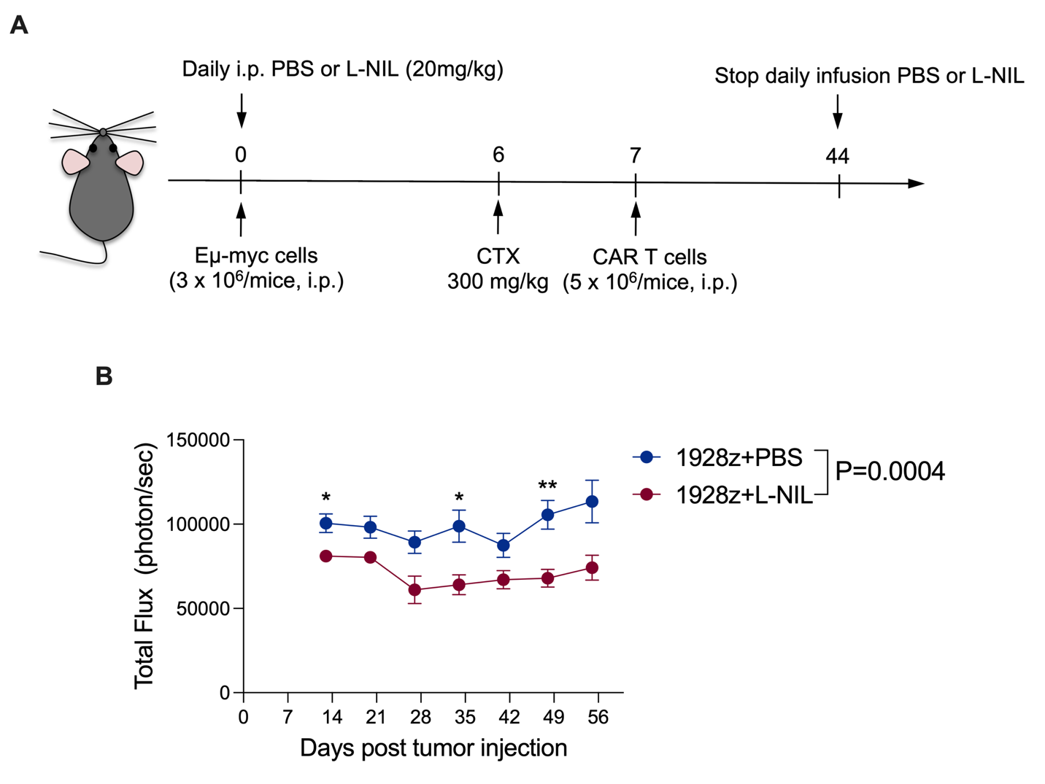
Extended Data Fig. 8. Enhanced tumor eradication of B cell malignancies in immune competent mice. (A) Schematic of experimental settings for (B) where Eμ-myc cells were intraperitoneally injected into WT C57BL/6J mice. Six days later, mice were lymphodepleted using 300 mg/kg cyclophosphamide, and one day later (Day 7) 1928z CAR T cells were transferred intraperitoneally into mice. Mice received daily injections of L-NIL (20 mg/kg) or PBS. (B) Kinetics of tumor bioluminescence for Eμ-myc tumor-bearing mice treated with 1928z CAR T cells in combination with daily L-NIL injections or PBS. 1928z + PBS, n= 19; 1928z + L-NIL, n= 19. Error bars indicate the mean ± SEM. Statistical significance was determined by two-way ANOVA with Sidak’s correction for multiple comparisons. *, P < 0.05; **, P < 0.01.

