Supplementary Table S1 Infectious profile in a sample of patients with AT in Latin America.
Infection | n (%)
Pneumonia | 213
Up to 1 episode | 94 (44.1)
2-4 episodes | 50 (23.5)
5 or more episodes | 69 (32.4)
Missing information | 5
Pneumonia – Isolated Pathogen | 131
Yes | 16 (12.2)
No | 115 (87.8)
Missing information | 18
Pneumonia – Type of isolated pathogen | 16
Bacteria | 11 (68.8)
Pneumocystis jirovecii | 2 (12.5)
Mycobacteria | 1 (6.3)
Fungi | 1 (6.3)
Virus | 1 (6.3)
Sequels | 45
Bronchiectasis | 32 (71.1)
Other | 13 (28.9)
Missing information | 104
Recurrent Otitis | 199
Up to 4 episodes | 172 (86.4)
5 or more episodes | 27 (13.6)
Recurrent Sinusitis | 198
Up to 4 episodes | 142 (71.7)
5 or more episodes | 56 (28.3)
Relevant Viral Infection^{a,b} | 21
Severe varicella | 7 (36.8)
Systemic CMV and EBV infection | 3 (15.8)
HPV (extensive/refractory to treatment) | 3 (15.8)
Meningoencephalitis | 3 (15.8)
Severe molluscum contagiosum | 3 (15.8)
Pneumonia by Parainfluenza 3 | 1 (5.3)
Severe cutaneous herpes | 1 (5.3)
Missing information | 11
Opportunistic Infection | 218
Pneumonia by Pneumocystis jirovecii | 2 (0.9)
Pneumonia by Candida albicans | 1 (0.5)
Abdominal tumor by Histoplasmosis | 1 (0.5)
Without opportunistic infection | 214 (98.2)
ª Just for infections with isolated pathogen (n = 30).
^{b} n = 30 for multiple answers

Supplementary Table S2 Vaccines received by a sample of patients with AT in Latin America
Vaccine | Yes  n (%) | No  n (%) | Missing information | Total  n
BCG | 161 (99.4) | 1 (0.6) | 56 | 162
Diphtheria | 162 (99.4) | 1 (0.6) | 55 | 163
Tetanus | 161 (99.4) | 1 (0.6) | 56 | 162
Measles | 159 (99.4) | 1 (0.6) | 75 | 160
Bordetella pertussis | 160 (99.4) | 1 (0.6) | 57 | 161
Rubella | 156 (97.5) | 4 (2.5) | 58 | 160
Mumps | 153 (96.2) | 6 (3.8) | 59 | 159
Oral Poliovirus (attenuated) | 146 (92.4) | 12 (7.6) | 60 | 158
Haemophillus influenza | 110 (89.4) | 13 (10.6) | 95 | 123
Hepatitis B | 134 (85.9) | 22 (14.1) | 62 | 156
Influenza | 124 (84.4) | 23 (15.6) | 71 | 147
Inactivated Poliovirus | 56 (38.6) | 89 (61.4) | 73 | 145
Pneumococcal | 129 (80.6) | 31 (19.4) | 58 | 160
Rotavirus | 62 (45.9) | 73 (54.1) | 83 | 135
Meningococcus C | 58 (41.7) | 81 (58.3) | 79 | 139
Hepatitis A | 54 (39.7) | 82 (60.3) | 82 | 136
Varicella | 53 (37.6) | 88 (62.4) | 77 | 141
Yellow Fever | 32 (20.8) | 122 (79.2) | 64 | 154
Meningococcus ACWY | 8 (6.2) | 121 (93.8) | 89 | 129
Human papilloma virus | 5 (3.5) | 138 (96.5) | 75 | 143
Meningococcus B | 3 (2.3) | 121 (93.8) | 89 | 129

Supplementary Table S3 Immunoglobulin levels in a sample of patients with AT in Latin America
Immunoglobulin | < 2 SD  n (%) | Normal  n (%) | > 2 SD  n (%) | Total | Missing information
First Dosage
IgGª | 55 (28.6) | 115 (59.9) | 22 (11.5) | 192 | 8
IgA | 121 (60.8) | 74 (37.2) | 4 (2.0) | 199 | 19
IgM | 4 (2.0) | 85 (42.9) | 109 (55.1) | 198 | 20
Last Dosage
IgG^{b} | 8 (12.9) | 44 (71.0) | 10 (16.1) | 62 | -
IgA | 80 (67.2) | 36 (30.3) | 3 (2.5) | 119 | 99
IgM | 12 (10.3) | 43 (36.8) | 62 (53.0) | 117 | 101

ª Just for cases that had measurement before IgG replacement therapy
^{b} Just for cases that were not in IgG replacement therapy

Supplementary Table S4 Vaccine antibody responses in a sample of patients with AT in Latin America
Vaccine | Reagent  n (%) | Total
Rubella | 56 (93.3) | 60
Measles | 20 (87.0) | 23
Tetanus | 26 (76.5) | 34
Diphteria | 4 (57.1) | 7
Hepatitis B | 15 (39.5) | 38
Pneumococcal | 15 (20.5) | 73
Haemophilus influenzae | 2 (40.0) | 5

Supplementary Table S5 Patients with 2 dosages of immunoglobulin levels: first and recent dosage
 | First Dosage |  | Recent Dosage |  | p^{c}
 | n | % | n | % | p^{c}
IgG^{a,b} | 58 | 100.0 | 58 | 100.0
< 2 SD | 12 | 20.7 | 7 | 12.1 | 0.402
Normal | 39 | 67.2 | 41 | 70.7 | 0.402
> 2 SD | 7 | 12.1 | 10 | 17.2 | 0.402
IgA | 114 | 100.0 | 114 | 100.0
< 2 SD | 63 | 55.3 | 76 | 66.7 | 0.001
Normal | 50 | 43.9 | 35 | 30.7 | 0.001
> 2 SD | 1 | 0.9 | 3 | 2.6 | 0.001
IgA | 118 | 100.0 | 118 | 100.0
IgA ≤ 7^{d} | 50 | 42.4 | 50 | 42.4 | 0.100
IgA > 7^{d} | 68 | 57.6 | 68 | 57.6 | 0.100
IgM | 112 | 100.0 | 112 | 100.0
< 2 SD | 2 | 1.8 | 11 | 9.8 | 0.047
Normal | 43 | 38.4 | 41 | 36.6 | 0.047
> 2 SD | 67 | 59.8 | 60 | 53.6 | 0.047
ª Just for cases that had measurement before IgG replacement therapy
^{b} Just for cases that were not in IgG replacement therapy
^{c} p descriptive level of McNemar test
^{d} mg/dL

Supplementary Table S6 Lymphocyte subsets in a sample of patients with AT in Latin America
Lymphocyte subset | < 2 SD  n (%) | Normal  n (%) | > 2 SD  n (%) | Total  n | Missing information
First Dosage
CD3+ | 114 (76.5) | 17 (11.4) | 18 (12.1) | 149 | 69
CD3+CD4+ | 120 (79.5) | 29 (19.2) | 2 (1.3) | 151 | 67
CD3+CD8+ | 83 (55.0) | 55 (36.4) | 13 (8.6) | 151 | 67
CD16+56+ | 14 (12.6) | 54 (48.6) | 43 (38.7) | 111 | 107
CD19+ | 115 (92.0) | 7 (5.6) | 3 (2.4) | 125 | 93
Last Dosage
CD3+ | 38 (77.6) | 8 (16.3) | 3 (6.1) | 49 | 169
CD3+CD4+ | 44 (86.3) | 5 (9.8) | 2 (3.9) | 51 | 167
CD3+CD8+ | 22 (43.1) | 26 (51.0) | 3 (5.9) | 51 | 167
CD16+56+ | 4 (13.8) | 16 (55.2) | 9 (31.0) | 29 | 189
CD19+ | 30 (93.8) | 2 (6.3) | 0 (0.0) | 32 | 186

Supplementary Table S7 Patients with CD3+CD4+ (cell/mm3), CD16+56+ (cell/mm3) e CD19+ (cell/mm3) - All evaluations in a sample of patients with AT in Latin America
Lymphocyte subset | n (%)
CD3+CD4+ | 151
< 200 cells/mm³ | 22 (14.6)
≥ 200 cells/mm³ | 129 (85.4)
CD16+56+ | 101
≤ 2% | 4 (4.0)
> 2% | 97 (96.0)
CD19+ | 114
≤ 2% | 105 (92.1)
> 2% | 9 (7.9)

Supplementary Table S8 Survival analysis by variables in a sample of patients with AT in Latin America, Kaplan-Meier method

 | % Cumulate Survivalª |  |  |  |  |  | p-value^{b}
 | 1 year | 3 years | 5 years | 10 years | 15 years | 20 years | p-value^{b}
Total | 100,00 | 99,46 ± 0,54 | 98,37 ± 0,93 | 95,03 ± 1,73 | 81,3 ± 3,65 | 52,62 ± 6,18 | -
Gender |  |  |  |  |  |  | 0,036
Female | 100,00 | 98,94 ± 1,06 | 97,84 ± 1,51 | 95,36 ± 2,27 | 75,04 ± 5,84 | 48,48 ± 8,70
Male | 100,00 | 100,00 | 98,91 ± 1,08 | 94,71 ± 2,59 | 87,23 ± 4,35 | 57,01 ± 8,50
Beginning of symptoms’ age |  |  |  |  |  |  | 0,738
< 2 years | 100,00 | 99,18 ± 0,82 | 97,5 ± 1,43 | 94,34 ± 2,27 | 79,68 ± 4,97 | 52,63 ± 8,55
2 years and more | 100,00 | 100,00 | 100,00 | 98,11 ± 1,87 | 83,95 ± 5,6 | 52,77 ± 9,60
IgA – 1st evaluation |  |  |  |  |  |  | 0,156
Normal/Over percentile 97 | 100,00 | 100,00 | 97,10 ± 2,02 | 93,22 ± 3,33 | 93,22 ± 3,33 | 75,20 ± 10,21
Below percentile 3 | 100,00 | 98,99 ± 1,00 | 98,99 ± 1,00 | 95,43 ± 2,24 | 73,21 ± 5,57 | 44,79 ± 7,47
IgG – 1st evaluation |  |  |  |  |  |  | 0,009
Normal/Over percentile 97 | 100,00 | 100,00 | 98,25 ± 1,23 | 96,23 ± 1,86 | 84,27 ± 4,34 | 59,00 ± 7,98
Below percentile 3 | 100,00 | 97,96 ± 2,02 | 97,96 ± 2,02 | 89,99 ± 4,79 | 68,30 ± 8,79 | 35,03 ± 10,96
IgM – 1st evaluation |  |  |  |  |  |  | 0,882
Normal/Below percentile 3 | 100,00 | 100,00 | 100,00 | 95,13 ± 2,74 | 77,14 ± 6,29 | 61,07 ± 8,93
Over percentile 97 | 100,00 | 98,90 ± 1,09 | 96,68 ± 1,89 | 93,92 ± 2,66 | 81,05 ± 5,11 | 48,54 ± 8,56
CD4 – 1st evaluation) |  |  |  |  |  |  | 0,388
Normal/Over percentile 90 | 100,00 | 100,00 | 100,00 | 91,27 ± 5,91 | 67,56 ± 11,46 | 48,26 ± 14,15
Below percentile 10 | 100,00 | 100,00 | 100,00 | 97,54 ± 1,72 | 84,99 ± 4,43 | 57,27 ± 7,88
ª Probability of survival estimate ± standard error
^{b} p descriptive levels of Log Rank’s test (Mantel-Cox)

Supplementary Figure S1 Kaplan-Meyer curves of survival rate in a sample of patients with AT in Latin America

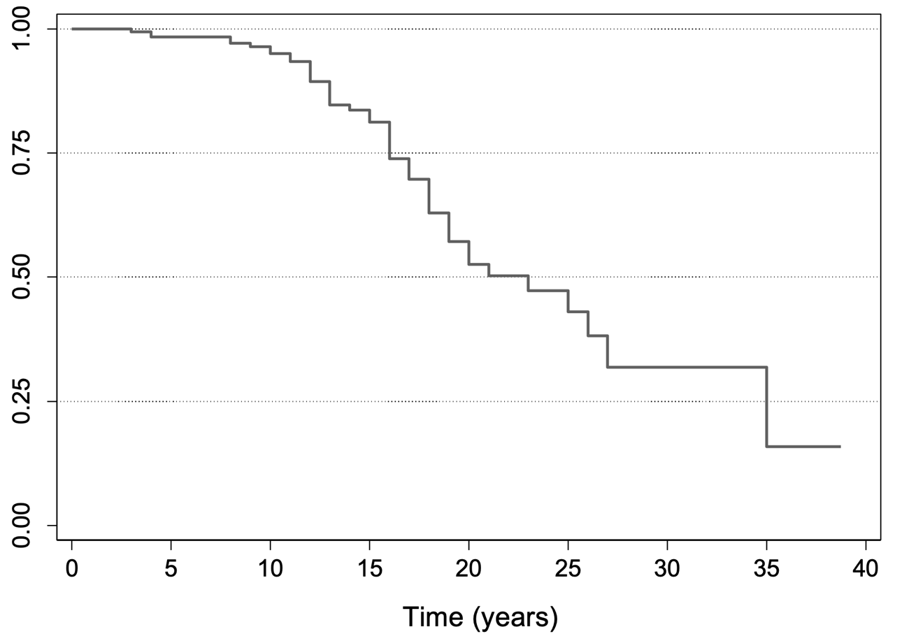Supplementary Figure S1A Overall survival rate. Mean time of survival was 24.21 years (95% CI 21.47 – 26.95).

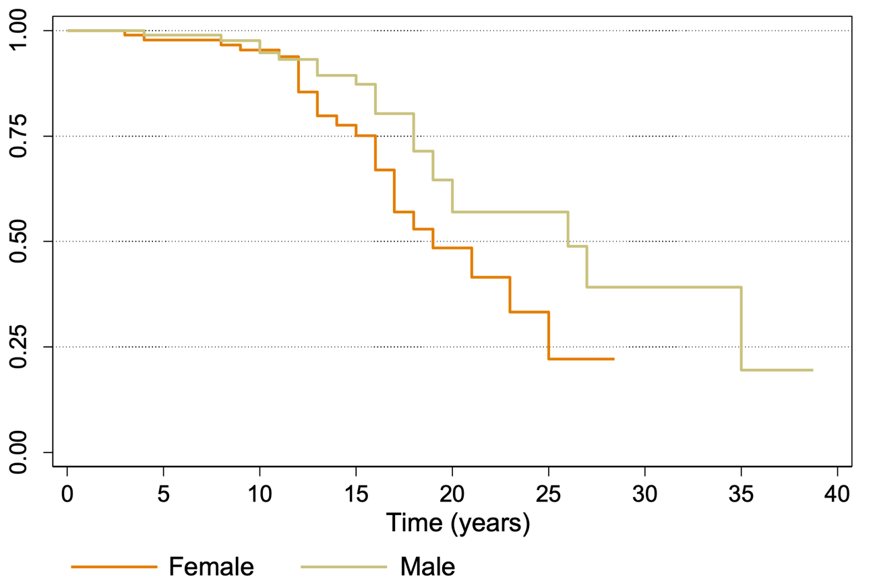
Supplementary Figure S1B Survival rate by gender. Hazard ratio 2.1; 95% CI 1.11 – 3.93; p = 0.049.

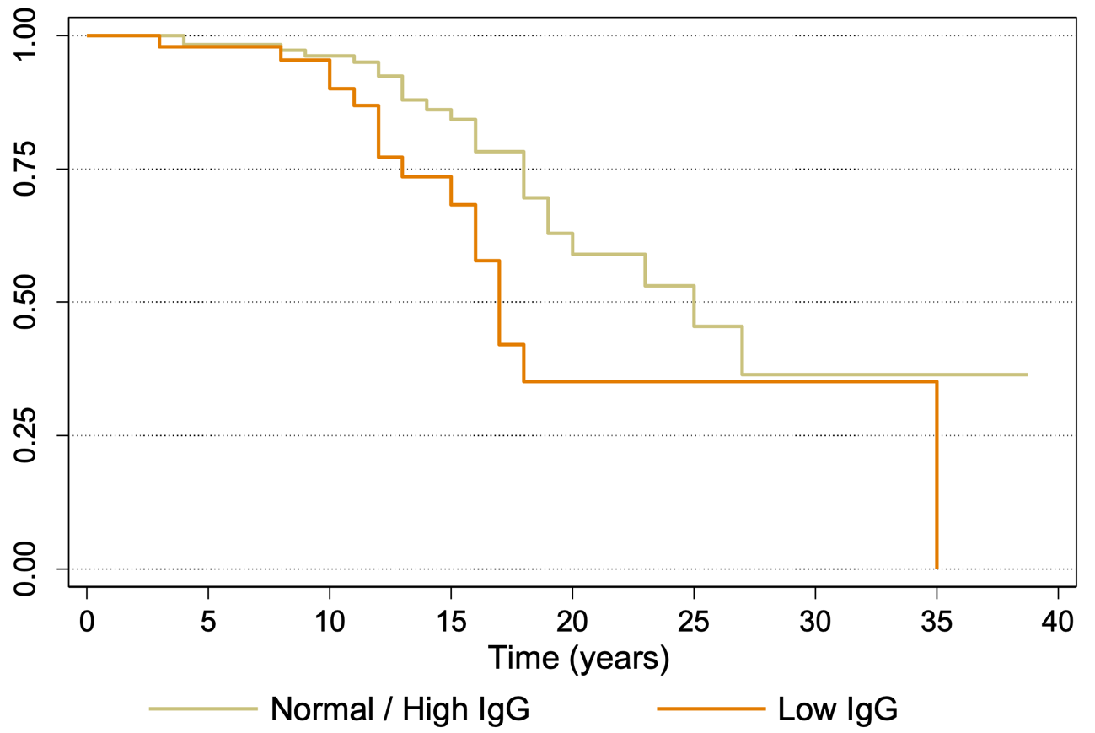

Supplementary Figure S1C Survival rate by IgG levels. Hazard ratio 0.52; 95% CI 0.27 – 0.99; p = 0.022).

