Supplementary Materials for
ACD856, a Novel Positive Allosteric Modulator of Trk-receptors, Single Ascending Doses in Healthy Subjects: Safety and Pharmacokinetics
By
Boel Nilsson¹ MSc, Johan Bylund² PhD, Magnus M. Halldin¹ PhD, Matthias Rother¹ MD, PhD, Erik Rein-Hedin^{2,3} MD, PhD, Kristin Önnestam¹ MSc, Märta Segerdahl^{1,4} MD, PhD
1. AlzeCure Pharma AB, Hälsovägen 7, SE-141 57 Huddinge, Sweden
2. CTC Clinical Trial Consultants AB, Dag Hammarskjölds väg 10B, SE-752 37 Uppsala, Sweden
3. Department of Surgical Sciences, Plastic Surgery, Uppsala University, SE-751 85 Uppsala, Sweden
4. Karolinska Institute, Department of Neurobiology, Care Sciences and Society, Alfred Nobels allé 23, SE-141 52 Huddinge, Sweden
Corresponding Author:
Märta Segerdahl
AlzeCure Pharma AB
Hälsovägen 7
SE-141 57 Huddinge
Sweden
Phone: +46 736 808 898
E-mail: marta.segerdahl@alzecurepharma.com

Table S1: Reported adverse events by system organ class and preferred term for the microdose study
Total
N=6
System organ class  Preferred term | n(%) | m
Respiratory, thoracic and mediastinal disorders | 2(33%) | 2
Epistaxis | 1(17%) | 1
Nasal congestion | 1(17%) | 1
Investigations | 1(17%) | 4
Alanine aminotransferase increased | 1(17%) | 1
Aspartate aminotransferase increased | 1(17%) | 1
Blood creatine phosphokinase increased | 1(17%) | 1
Blood lactate dehydrogenase increased | 1(17%) | 1
Musculoskeletal and connective tissue disorders | 1(17%) | 1
Flank pain | 1(17%) | 1
Nervous system disorders | 1(17%) | 1
Tremor | 1(17%) | 1
n, number of subjects; m, number of events
Percentages are based on the number of subjects in the treatment period included in the Full analysis set.

Table S2: Reported adverse events by system organ class and preferred term for the single ascending dose study
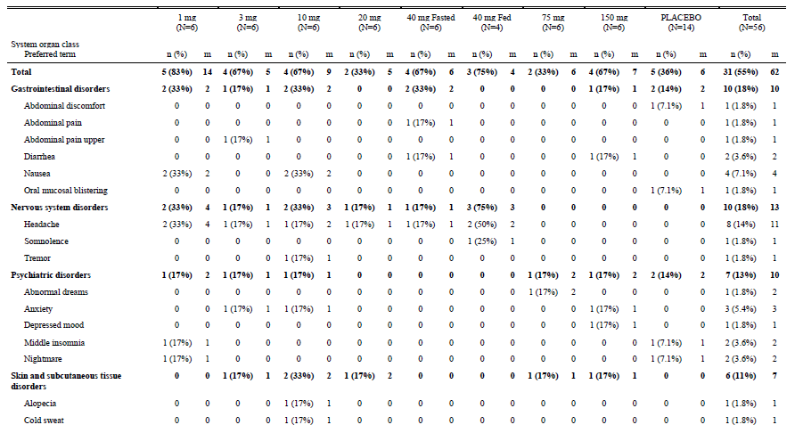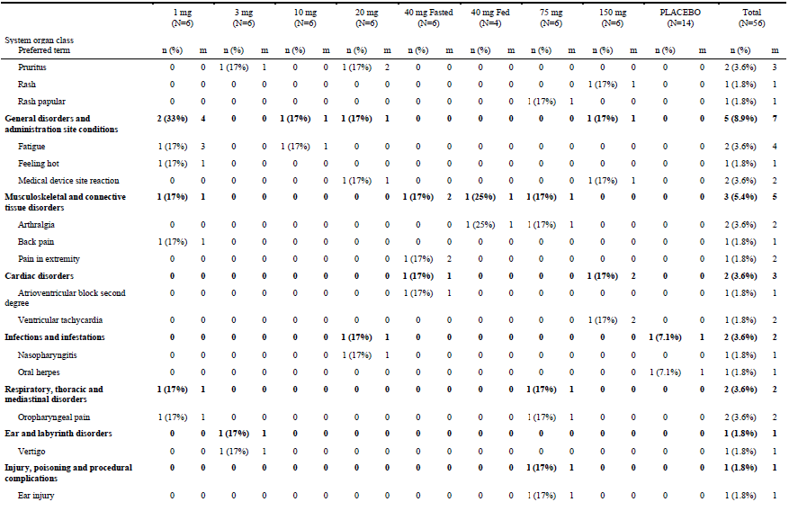
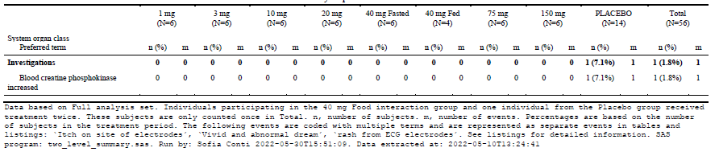

Figure S1
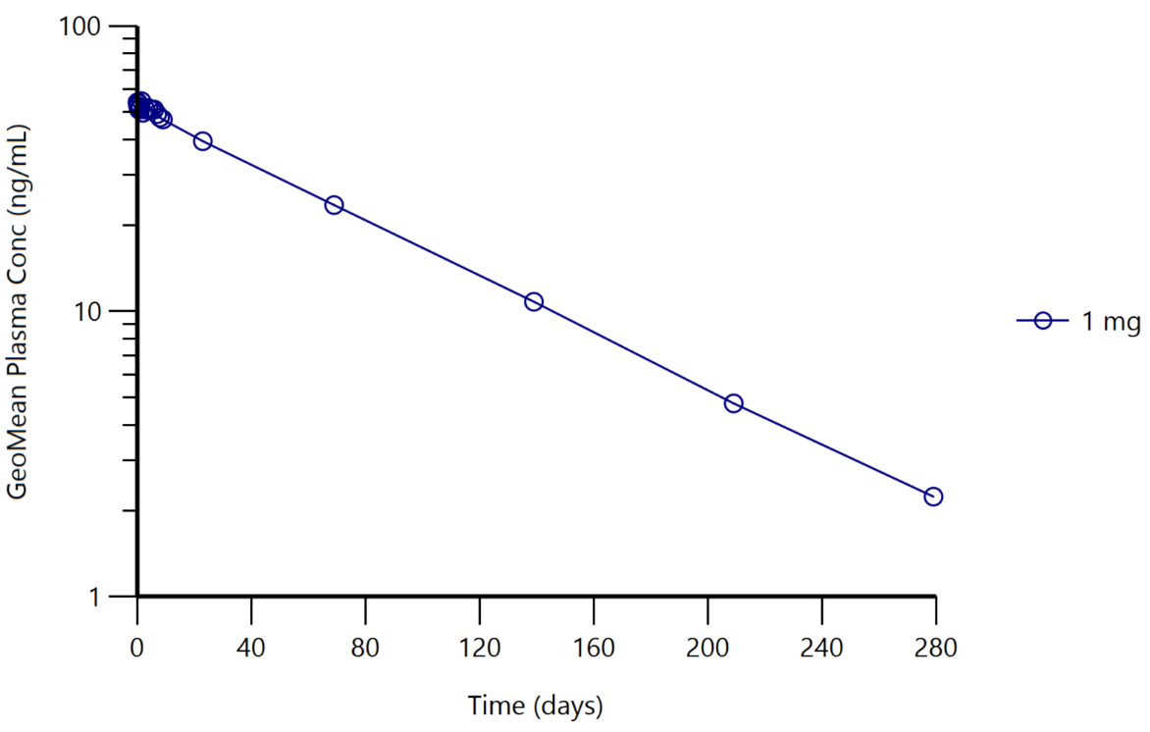
Figure S1: Mean plasma concentration curve for predecessor compound ACD855 following a single ascending oral dose of 1 mg.

