Supplementary Materials

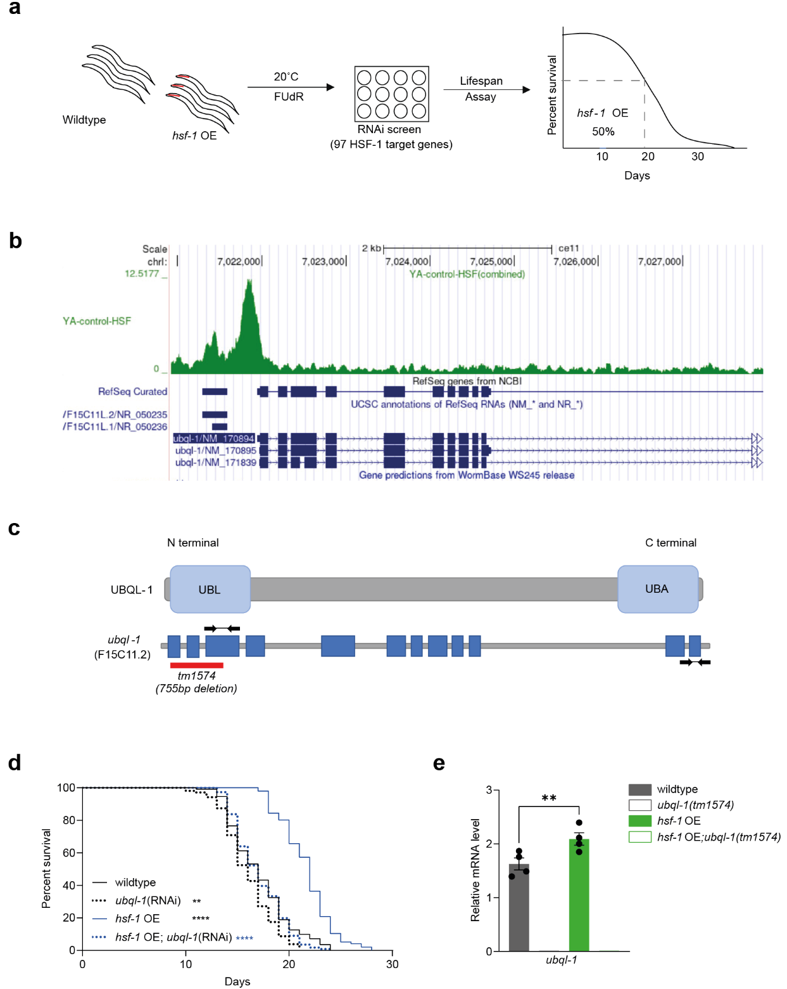

Supplementary Figure 1: Ubiquilin is essential for hsf-1 OE lifespan
(a) Schematic representation of RNAi screen to find modifiers of hsf-1 OE extended survival (b) UCSC genome browser view of HSF-1 showing ubql-1 site from ChIP-seq data ¹⁴ (c) Schematic diagram of C. elegans ubql-1 protein and gene structures, arrows to the left atop exon 3 indicate set of primers used in Supplementary Fig.1e and arrows to the far right atop exon 12 indicate primers used in Fig. 1b (d) Lifespan of wildtype and hsf-1 OE (AM583) animals on empty vector and ubql-1(RNAi) (e) Relative expression of ubql-1 mRNA on day 1 of adulthood (YA) in wildtype,ubql-1(tm1574), hsf-1 OE, hsf-1 OE;ubql-1(tm1574) animals grown on OP50. Data are the mean of 4 biological replicates. All error bars denote SD. Statistical significance was calculated using One-way ANOVA with post-analysis pairwise comparison of groups (e) and the Mantel-Cox log rank test (d). **p < 0.01, ***p < 0.001. Full statistics for lifespan trials (including n values) can be found in Supplementary Table 2.

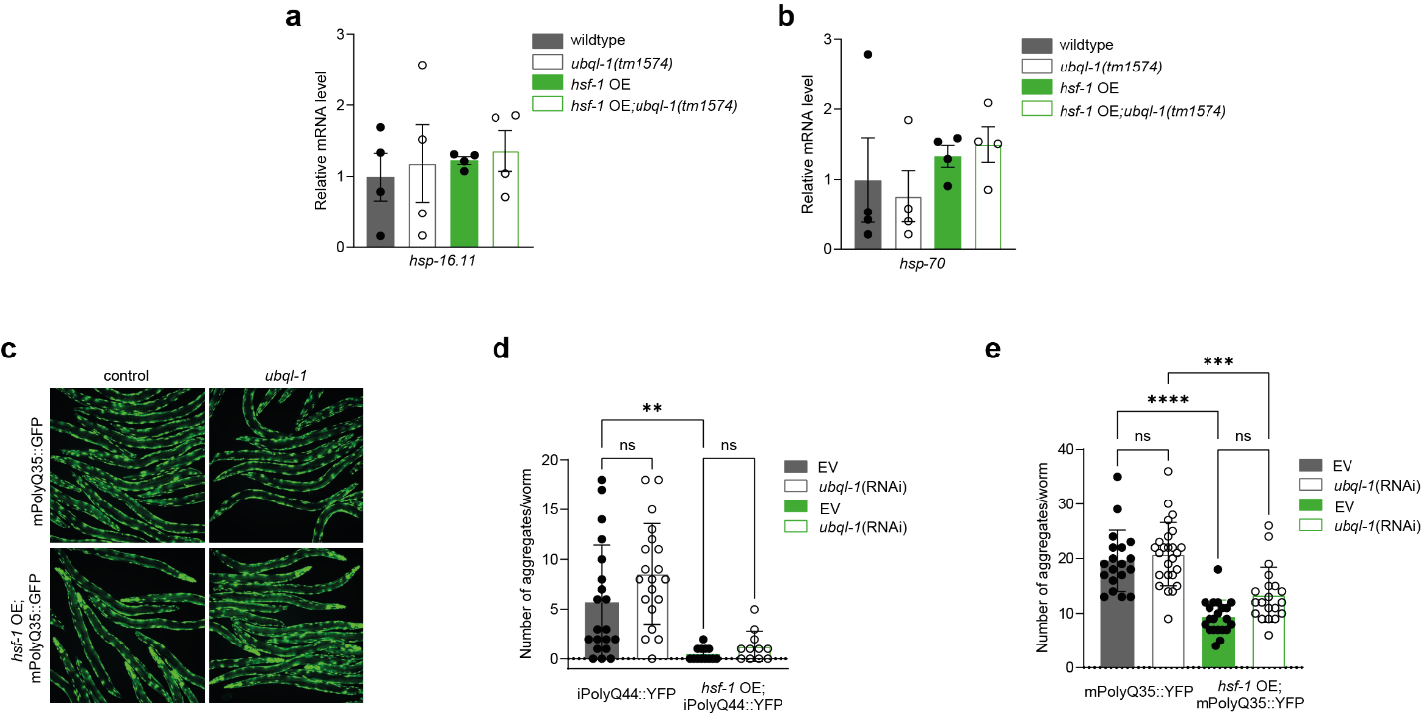

Supplementary Figure 2: Ubiquilin-1 is not necessary for hsf-1 OE to suppress polyglutamine aggregation
(A-B) Relative expression of hsp-16.11 and hsp-70 mRNA on day 1 of adulthood in wildtype, ubql-1(tm1574), hsf-1 OE or hsf-1 OE;ubql-1(tm1574) animals grown on OP50. Data are the mean of 4 biological replicates (c) Representative images of wildtype and hsf-1 OE worms expressing body wall muscle polyQ35::YFP grown on empty vector or ubql-1(RNAi) at day 5 of adulthood. (d-e) Number of polyglutamine::YFP aggregates present in the (d) intestine (Q44::YFP) and (e) body wall muscle (Q35::YFP) on D3 of adulthood in wildtype and hsf-1 OE animals grown on empty vector and ubql-1(RNAi). One of two independent experiments has been shown for intestinal and muscle PolyQ sensors. Between 11-25 worms were mounted to assess PolyQ::YFP aggregates in intestine and muscle.All error bars denote SD. Statistical significance was calculated using One-way ANOVA with post-analysis pairwise comparison of groups (a, b, d, e) ns, not significant (p>0.05), **p < 0.01, ***p < 0.001, ****p<0.0001.

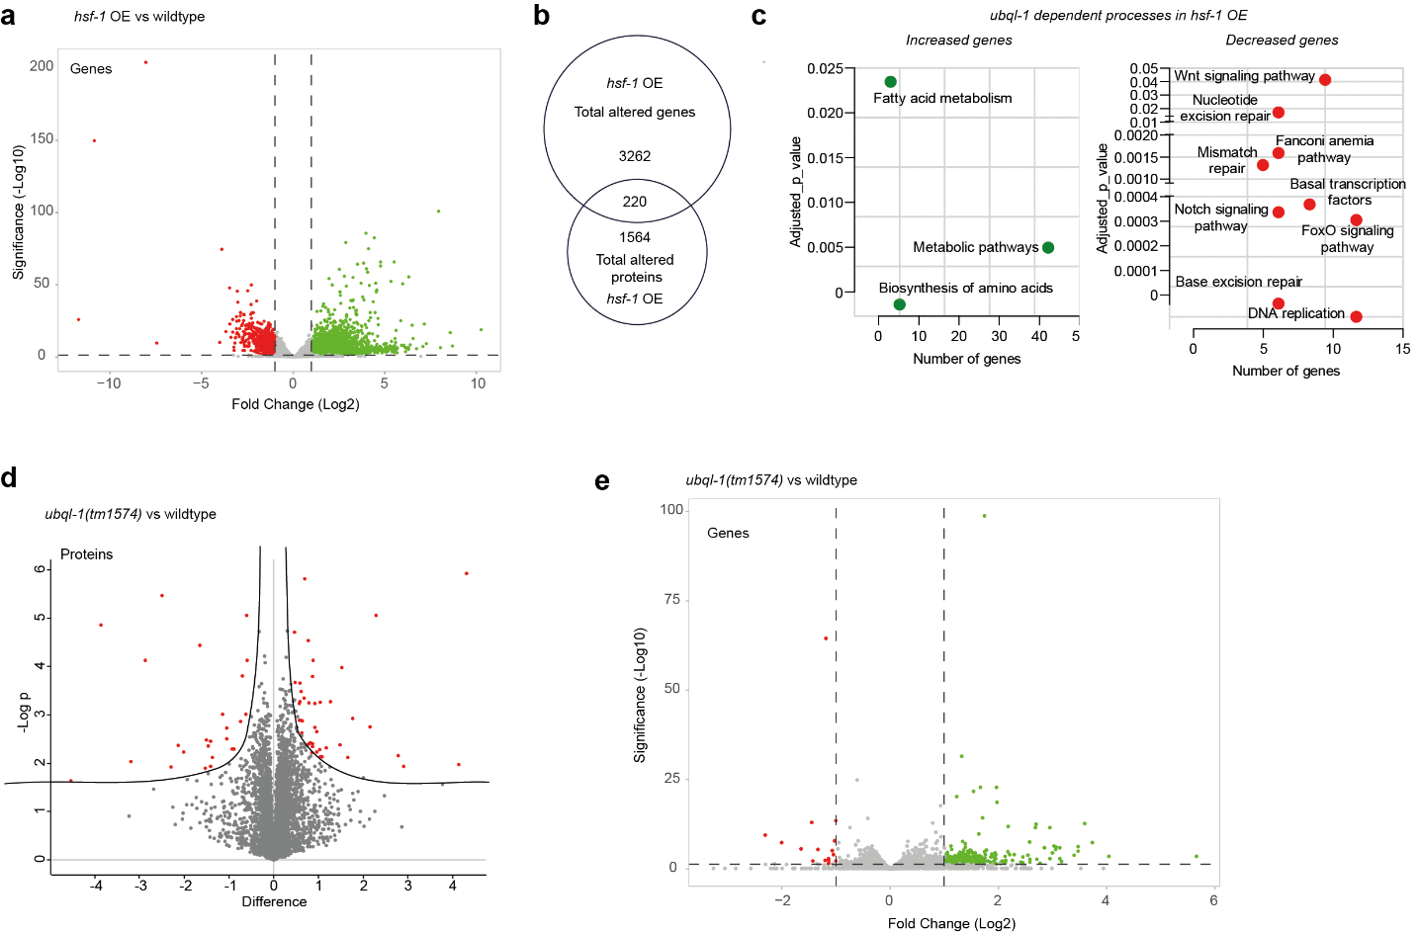
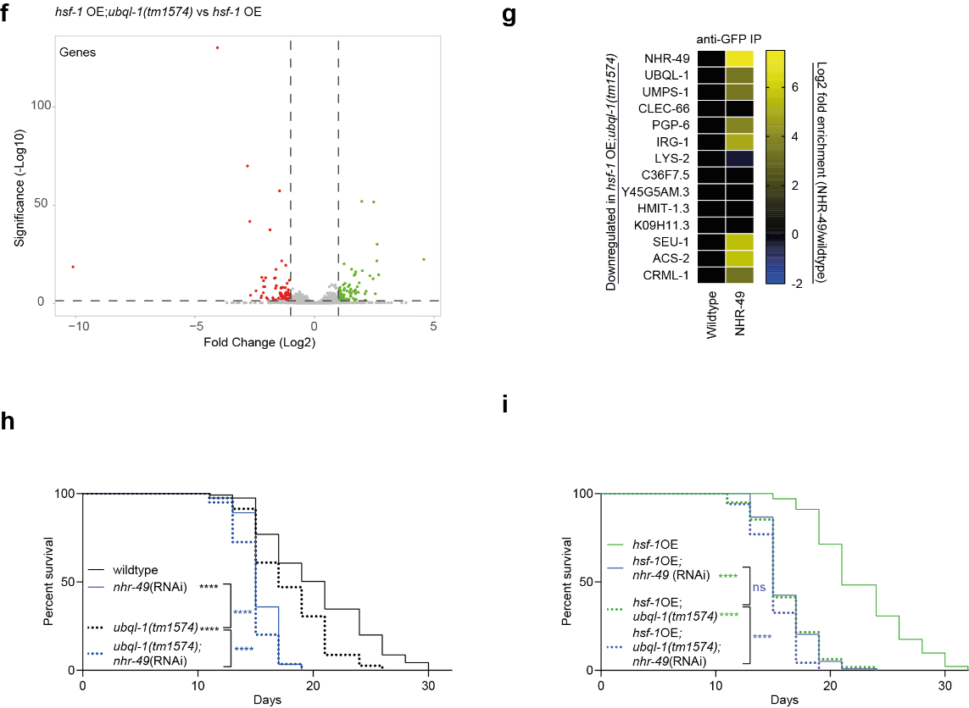
Supplementary Figure 3: ubql-1 promotes metabolic remodelling in hsf-1 OE animals
(a, e and f) Volcano plots showing log2 (fold change, FC) against −log10 (q-value) of genes identified from RNASeq analysis of (a) hsf-1 OE vs wildtype worms, (e) ubql-1(tm1574) vs wildtype worms, and (f) hsf-1 OE;ubql-1(tm1574) vs hsf-1 OE collected at Day1 of adulthood. Transcripts significantly up-regulated (green) and down-regulated (red) are displayed. (b) Venn diagram depicting overlap of significantly altered proteins and genes in hsf-1 OE worms. (c) KEGG pathway enrichment analysis of the significantly up-regulated (left) and downregulated (right) genes upon hsf-1 overexpression. (d) Perseus volcano plot representing differentially expressed proteins (red dots) between ubql-1(tm1574) vs wildtype worms on Day1 of adulthood. 4 biological replicates per genetic background were assessed during Proteomics analyses. (g) Heatmap depicting overlap of proteins altered in a ubql-1 dependent manner in hsf-1 OE worms with proteins found to be enriched in NHR-49::GFP immunoprecipitates relative to non-transgenic controls (adapted from Watterson et al.2022 ¹⁸) (h-i) Lifespan analysis of (h) wildtype and ubql-1 (tm1574) mutants and (i) hsf-1 OE and hsf-1 OE;ubql-1(tm1574) animals subjected to nhr-49 RNAi. Statistical significance was calculated by the Mantel-Cox log rank test (h-i) ns, not significant (p>0.05), ****p<0.0001. Full statistics for lifespan trials (including n values) can be found in Supplementary Table 2.

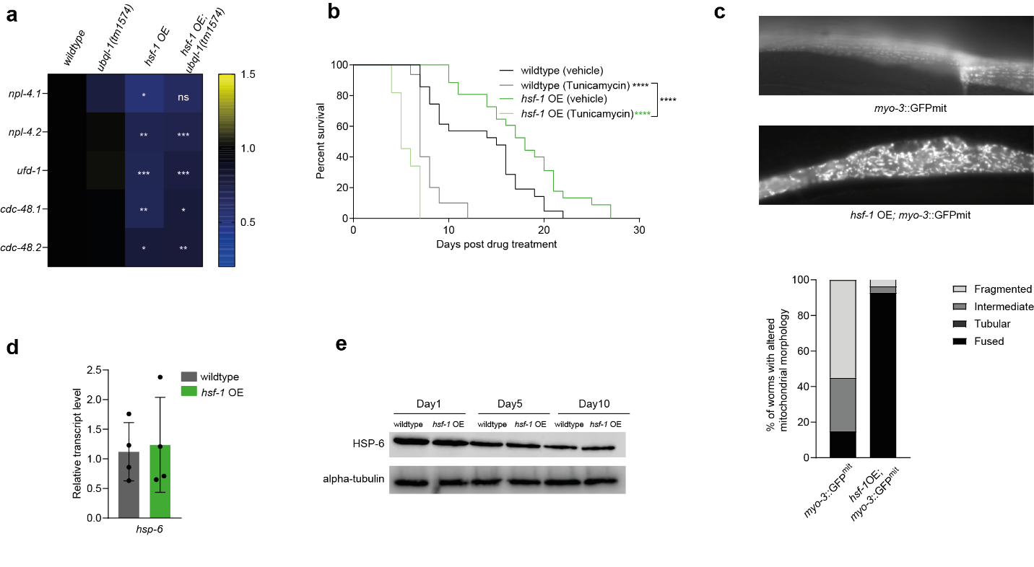
Supplementary Figure 4: HSF-1 overexpression sensitizes animals to ER and mitochondrial stress
(a) Relative expression (FPKM) of CDC-48-NPL-4-UFD-1 complex subunits in wildtype, ubql-1(tm1574), hsf-1 OE and hsf-1 OE;ubql-1(tm1574) worms on day 1 of adulthood. Values (n = 4 per group) were extracted from RNA-seq data. Mean FPKM is plotted, and bars represent standard deviation. Statistical comparisons to relative wild type groups were performed by one-way ANOVA with post-analysis pairwise comparison of means. ns, not significant (p>0.05), *p<0.05,**p<0.01,***p<0.001,****p<0.0001. (b) Survival of wildtype and hsf-1 OE worms grown on vehicle (DMSO) and upon treatment with Tunicamycin. Statistical significance was calculated by the Mantel-Cox log rank test ****p<0.0001. Full statistics for lifespan trials (including n values) can be found in Supplementary Table 2. (c) Representative fluorescence images and quantification of mitochondrial morphology in wildtype and hsf-1 OE worms carrying the p_{myo-3}::GFP(mit) transgene. (d) Relative expression of hsp-6 (a heat shock protein that is an established indicator of mito^{UPR}) in wildtype and hsf-1OE worms. Data are the mean of 4 biological replicates. (e) Representative western blot of HSP-6 and alpha-tubulin from wildtype and hsf-1 OE animals on Day 1, 5, 10 of adulthood. One of two independent blots has been shown.

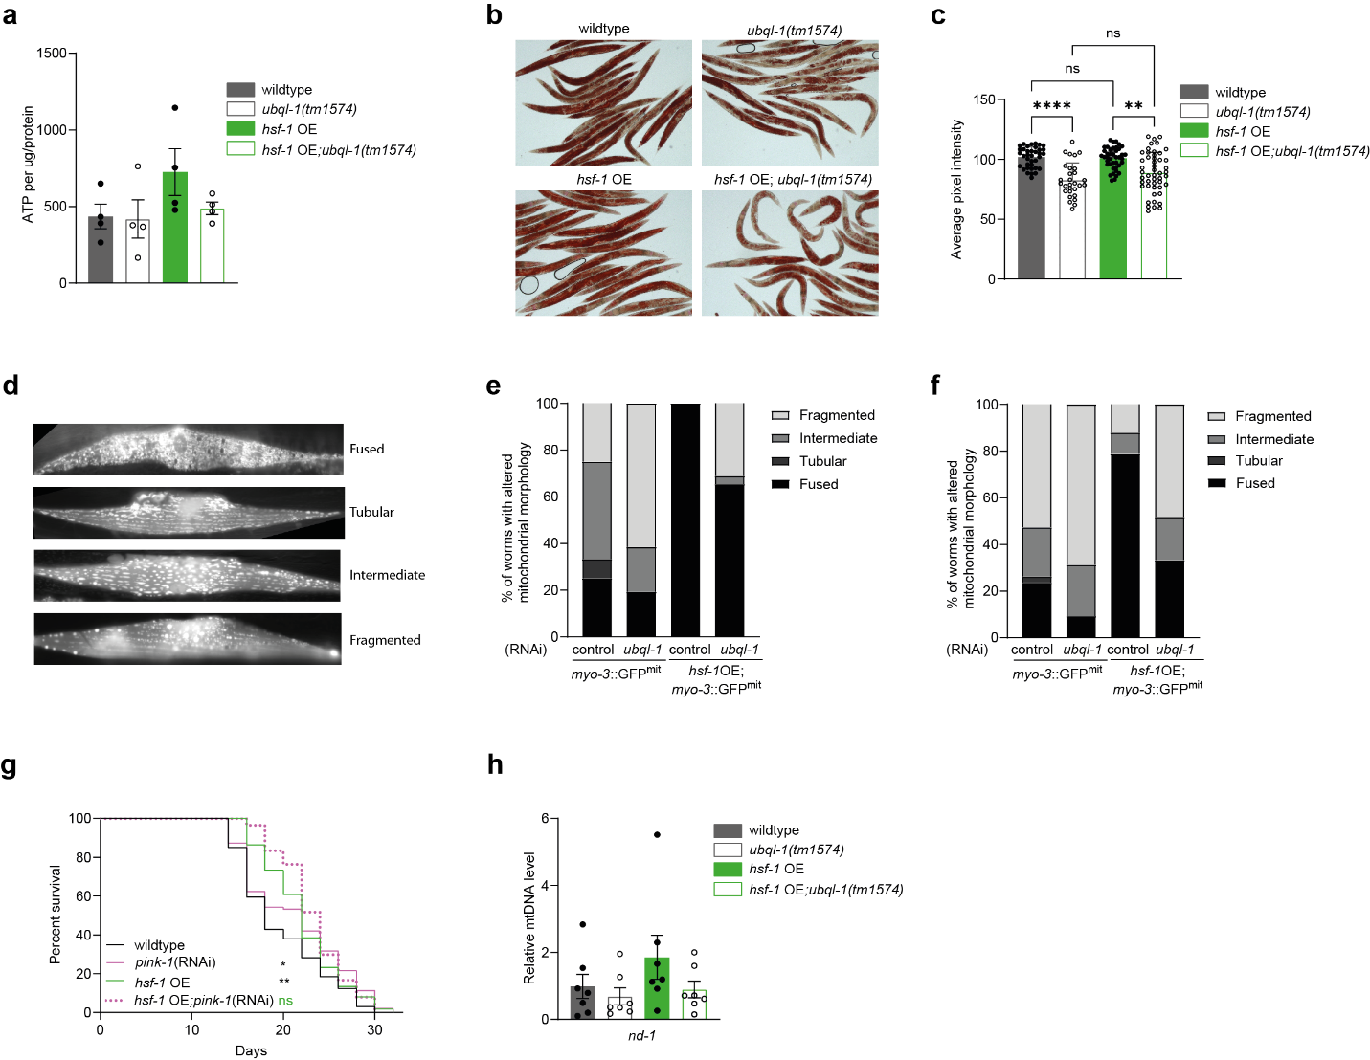
Supplementary Figure 5: Ubiquilin-1 is necessary for mitochondrial fusion and global fat regulation, but hsf-1 OE survival is independent of mitochondrial copy number or mitophagy
(a) ATP levels in wildtype, ubql-1(tm1574), hsf-1 OE and hsf-1 OE; ubql-1(tm1574) animals at Day 1 of adulthood. Data are the mean of 4 biological replicates. (b and c) Triglyceride levels in day 5 wildtype, ubql-1(tm1574), hsf-1 OE and hsf-1 OE;ubql-1(tm1574) adult animals. Representative images (b) and quantification (c) representing the relative lipid content in whole body of worms. One of two independent experiments has been shown. Between 29-49 worms were assessed for triglyceride levels. All error bars denote SD. Statistical significance was calculated by One-Way ANOVA with post-analysis pairwise comparison of groups. ns, not significant (p>0.05), **p < 0.01, ****p<0.0001. (d-f) Representative fluorescence images (d) and quantification of mitochondrial morphologies in p_{myo-3}::GFP(mit) worms and hsf-1 OE; p_{myo-3}::GFP(mit) worms grown on control, ubql-1(RNAi) on (e) Day 2 and (f) Day3 adulthood. (g) Lifespan of wildtype and hsf-1 OE animals subjected to empty vector control and RNAi against mitophagy component, pink-1. Statistical significance was calculated by Mantel-Cox Log-rank test. ns, not significant (p>0.05), *p<0.05, **p < 0.01. Full statistics for lifespan trials (including n values) can be found in Supplementary Table 2. (h) Copy number of mtDNA (ND-1) relative to genomic DNA (CDC-42) in wildtype, ubql-1 (tm1574), hsf-1 OE and hsf-1 OE; ubql-1(tm1574) animals grown on OP50 at Day 1 of adulthood. Data are the mean of 4 biological replicates. All error bars represent SD.

