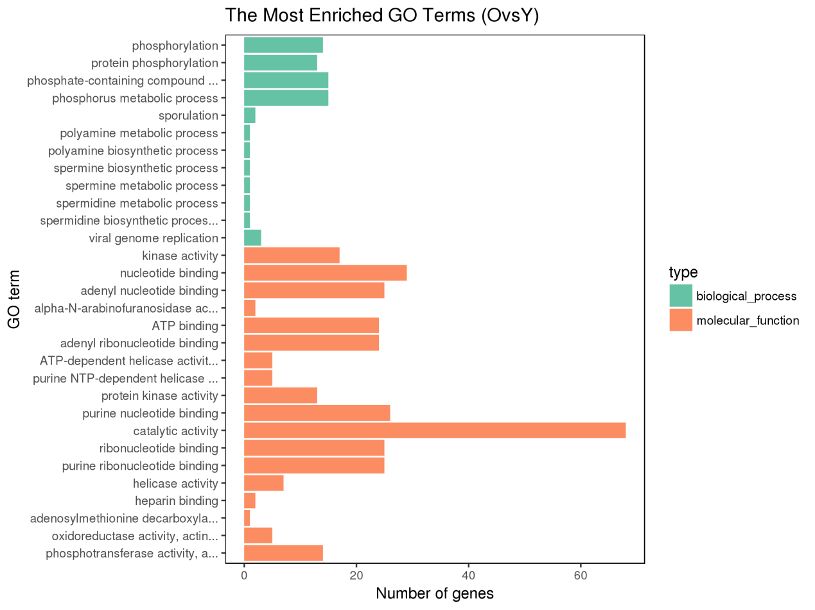
Fig.S1 GO enrichment analysis of differentially expressed protein-coding genes targeted by cis-acting (<10 kb) lncRNAs

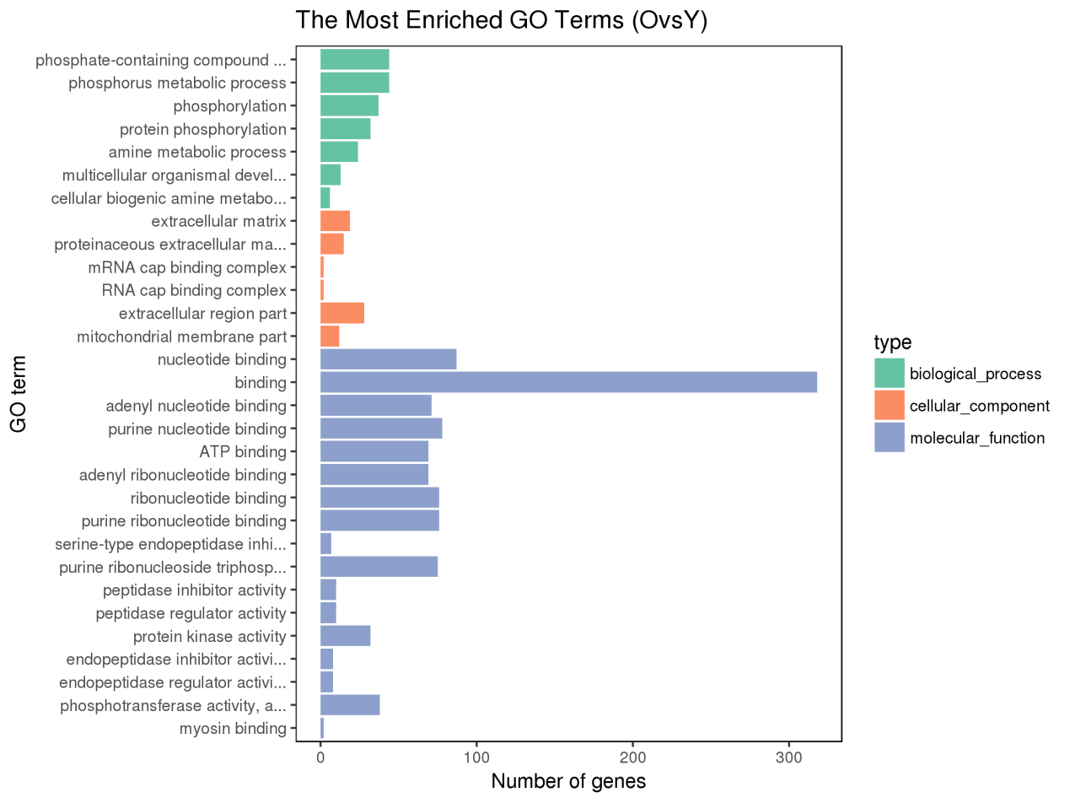
Fig.S2 Gene Ontology (GO) enrichment analysis of differentially expressed protein-coding genes targeted by cis-acting (<100 kb) lncRNAs

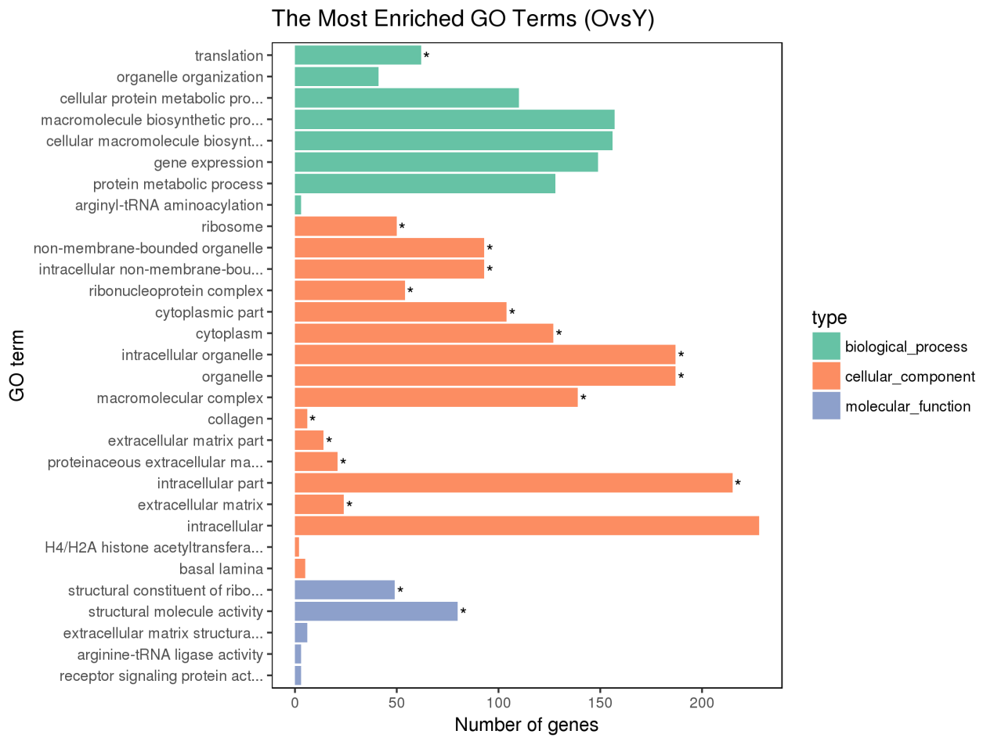
Fig.S3 GO enrichment analysis of differentially expressed protein-coding genes targeted by trans-acting lncRNAs

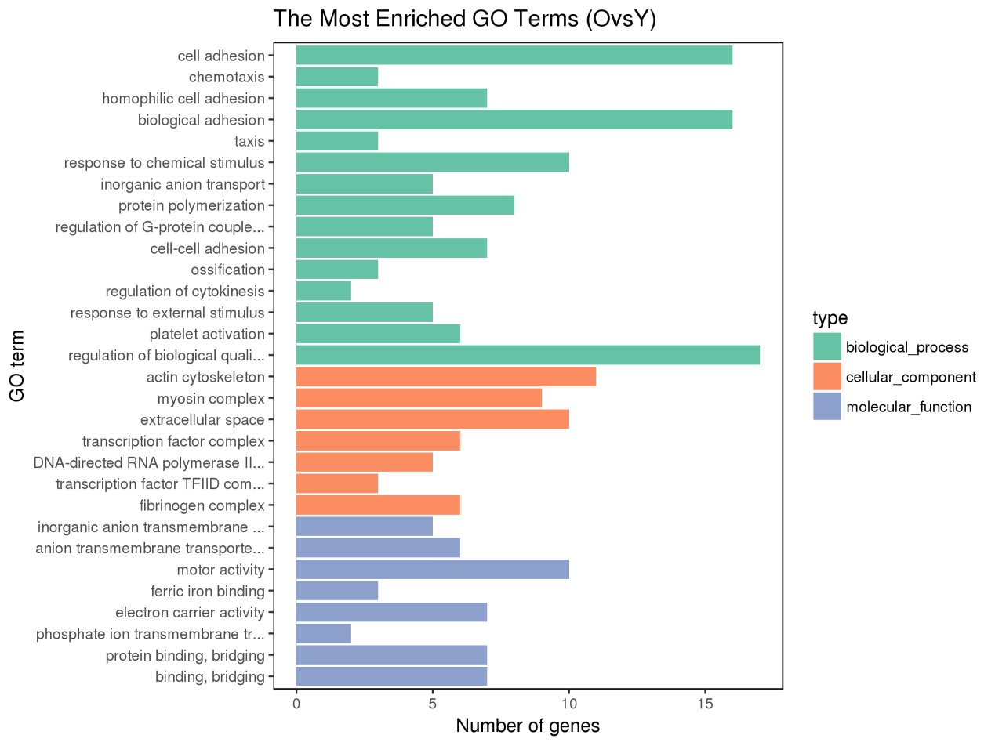
Fig.S4 GO enrichment analysis of differentially expressed protein-coding genes

