Supplementary Figure
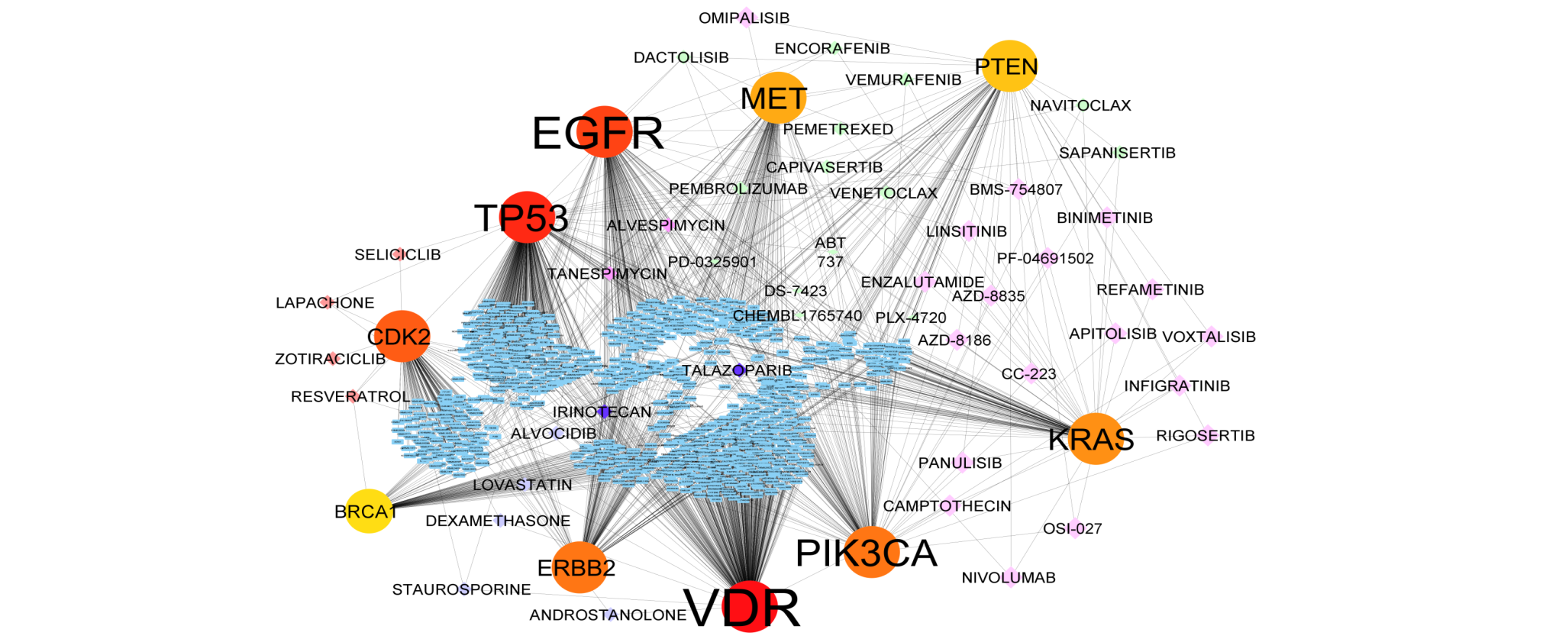
Breast Cancer
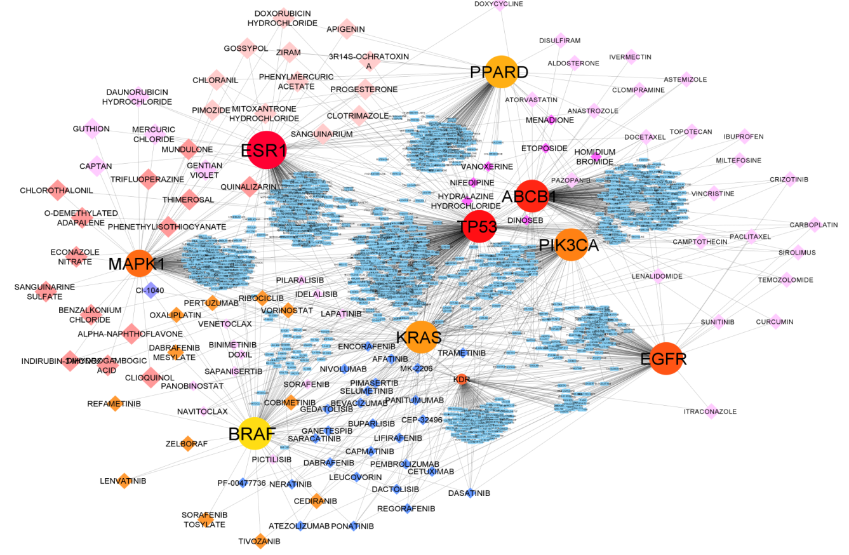
Cervical Cancer

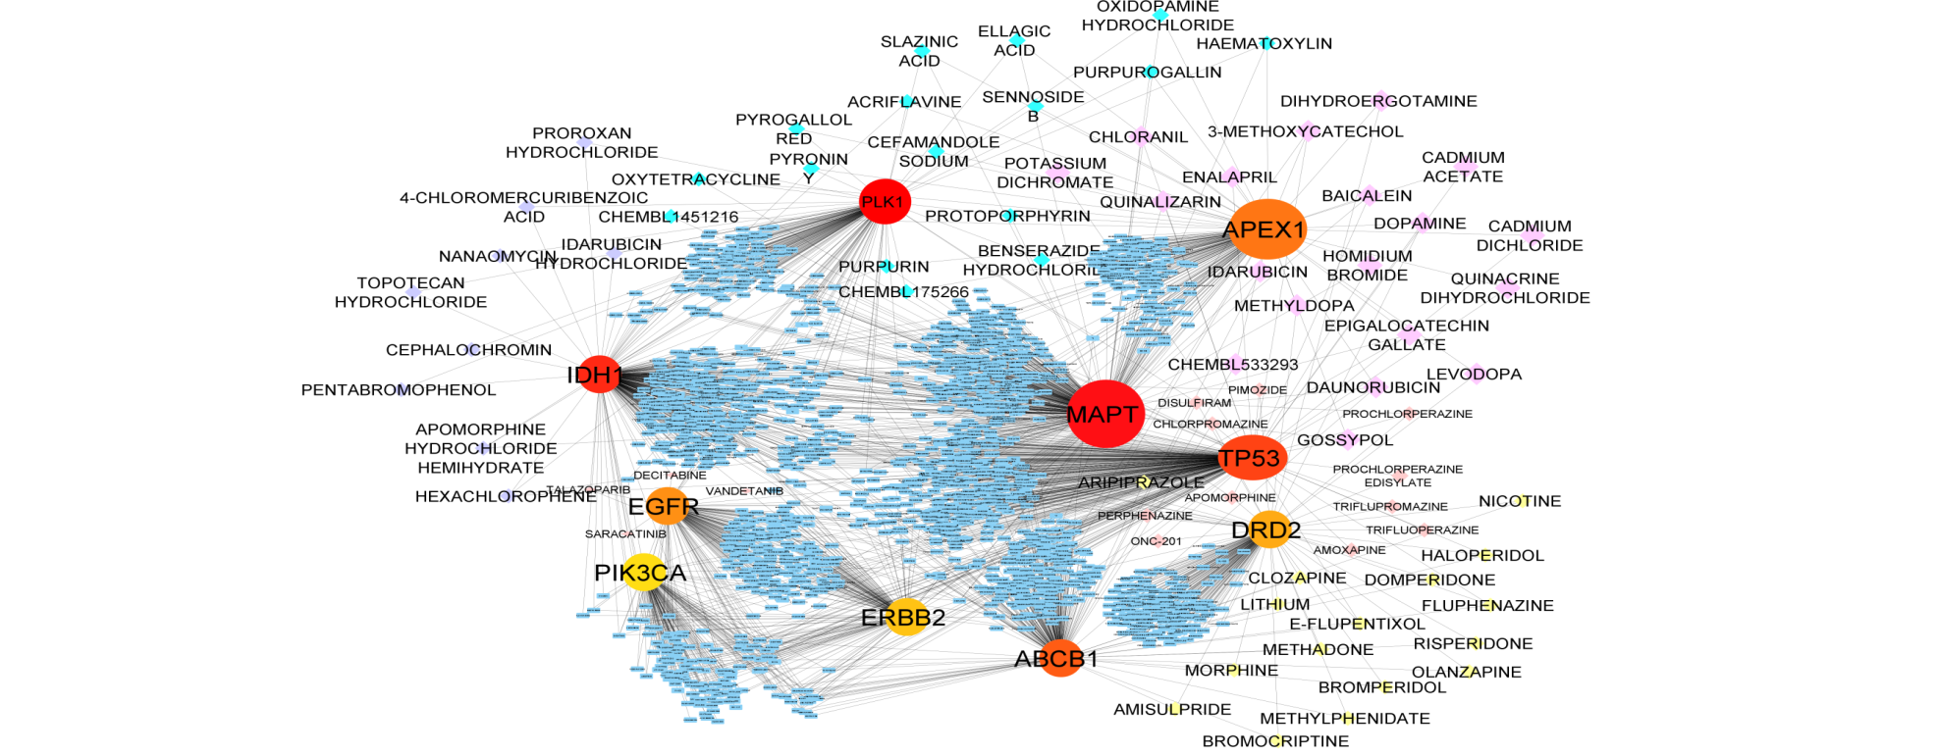
CNS Cancer

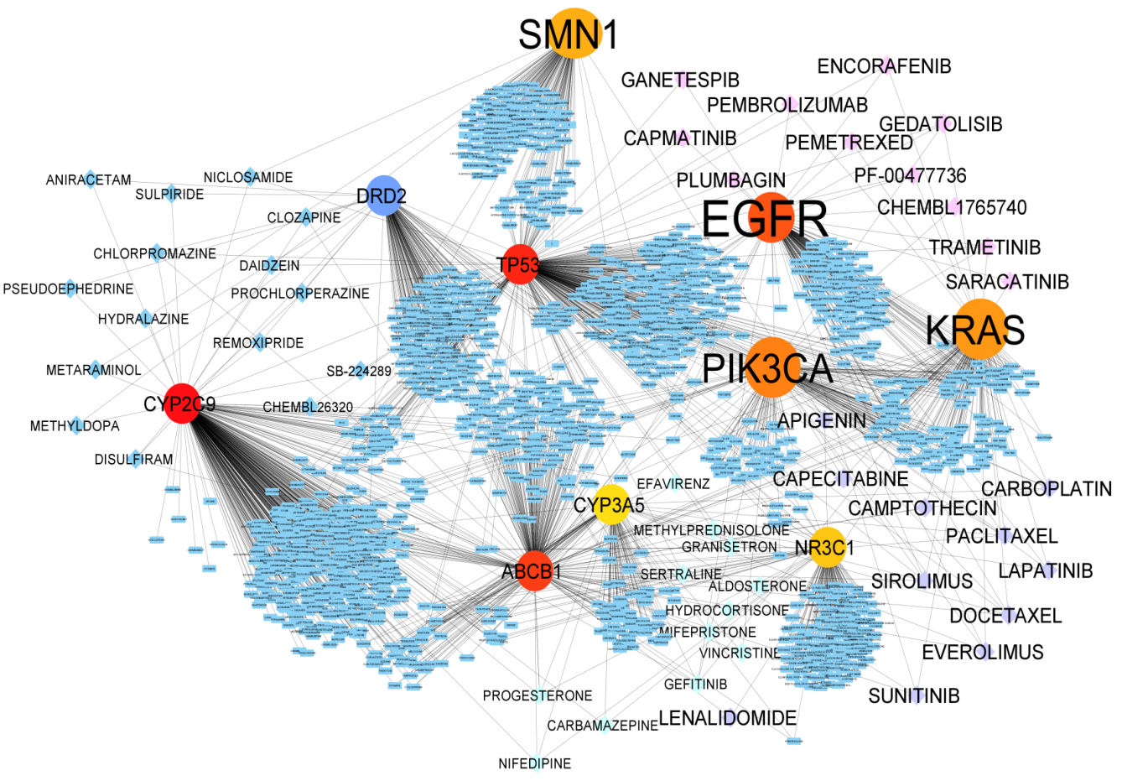
Colon Cancer

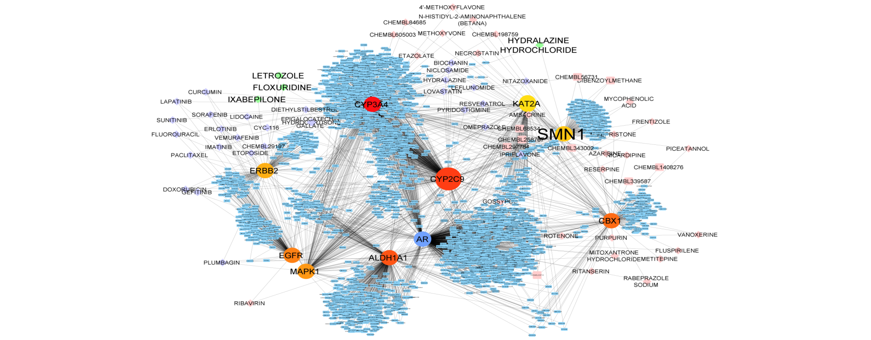
Kidney Cancer

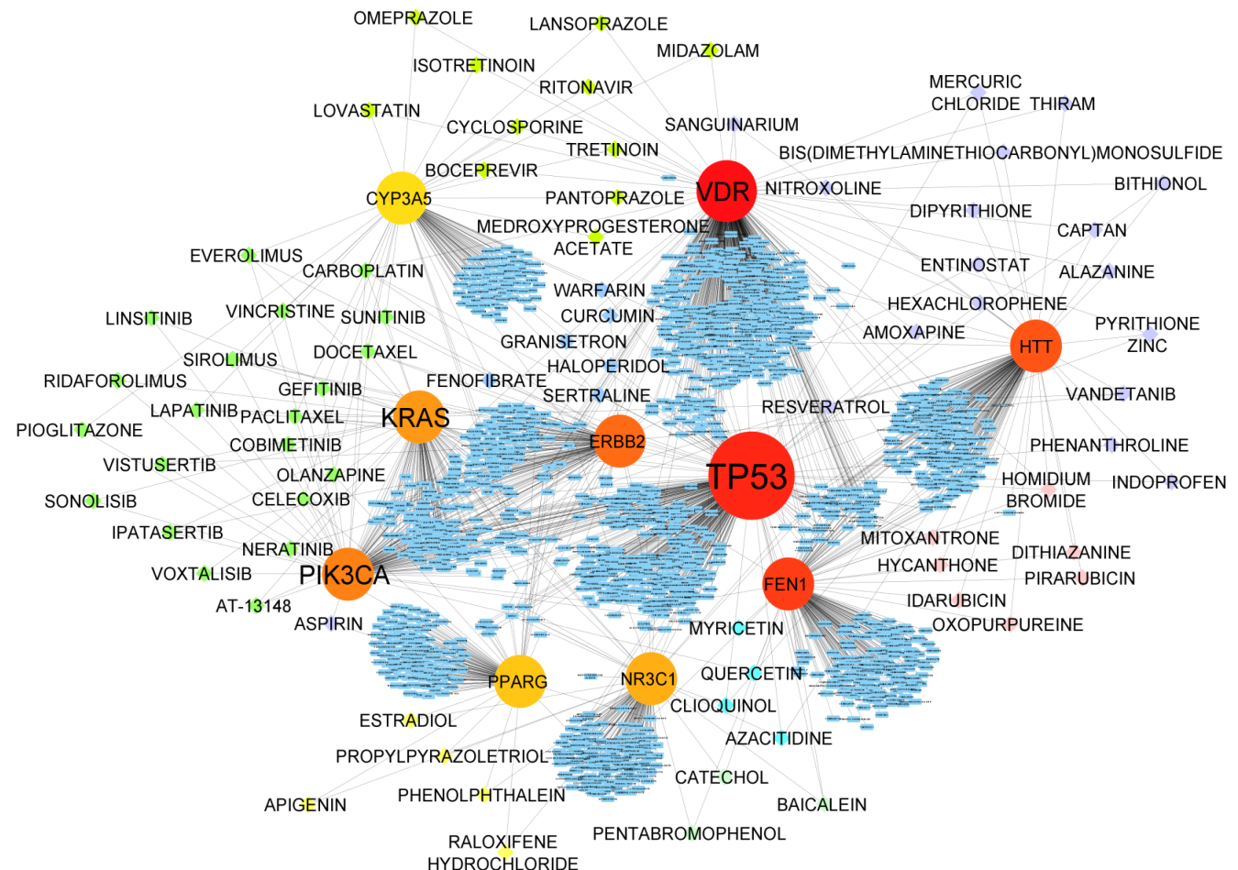
Leukemia Cancer

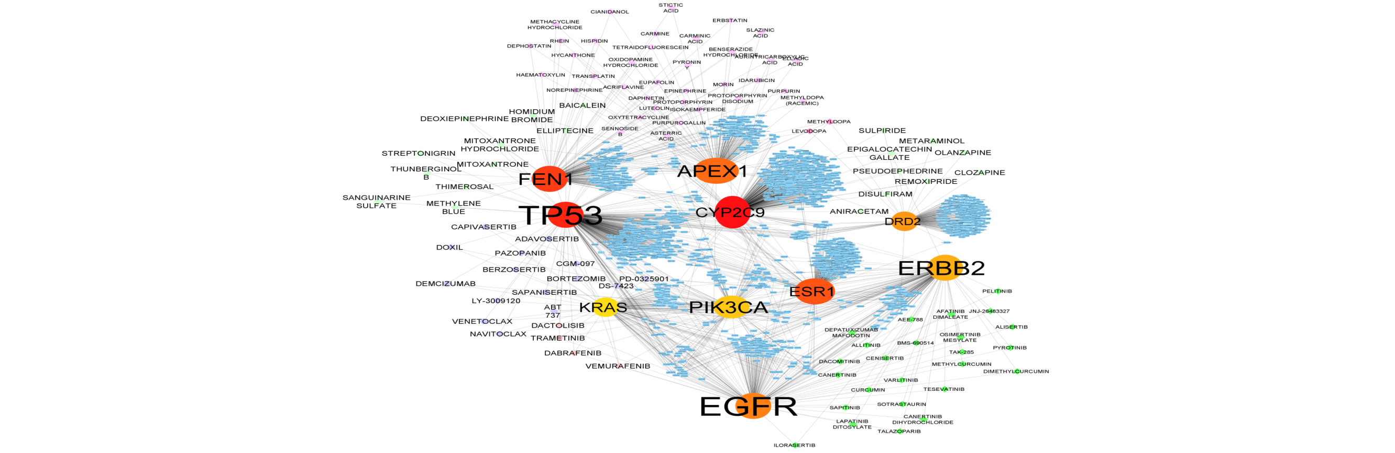
Lung Cancer

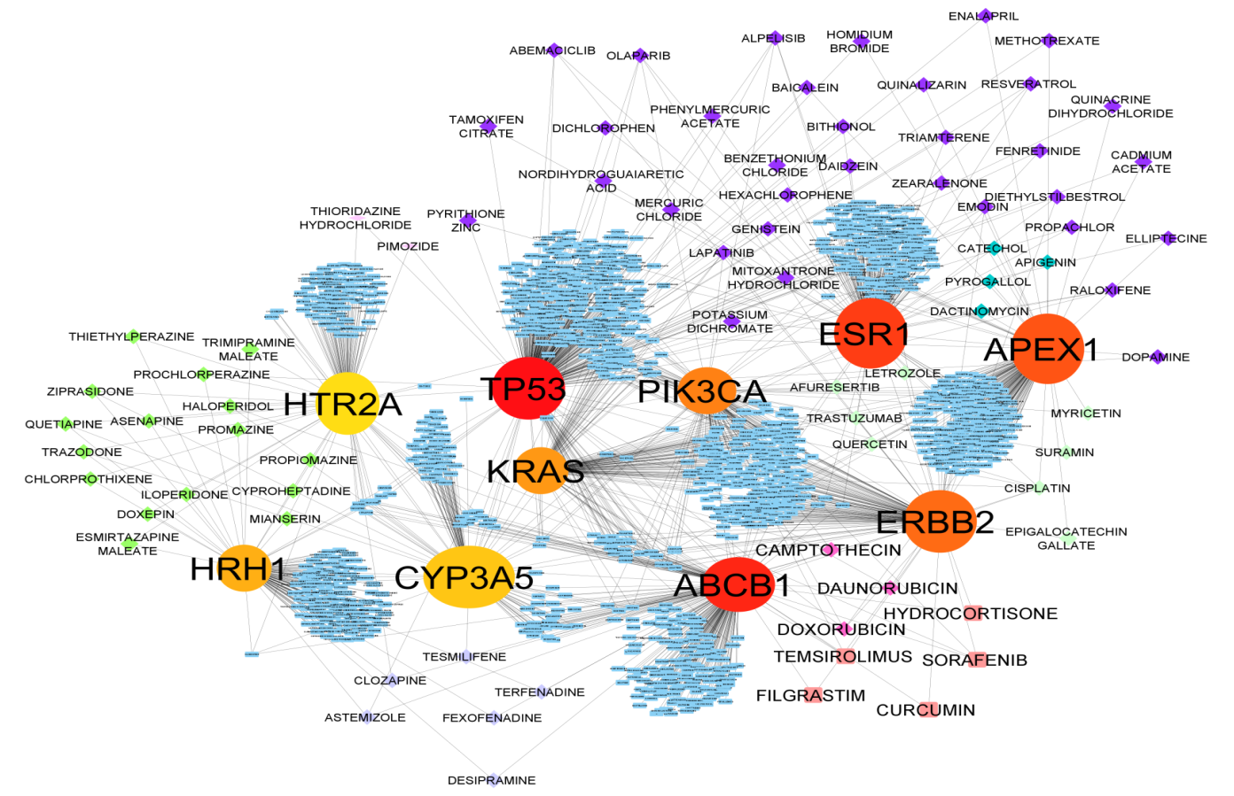
Melanoma Cancer
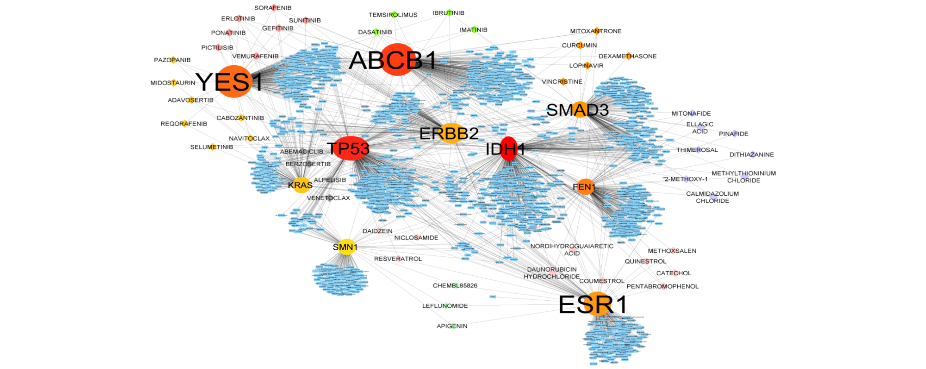
Ovarian Cancer

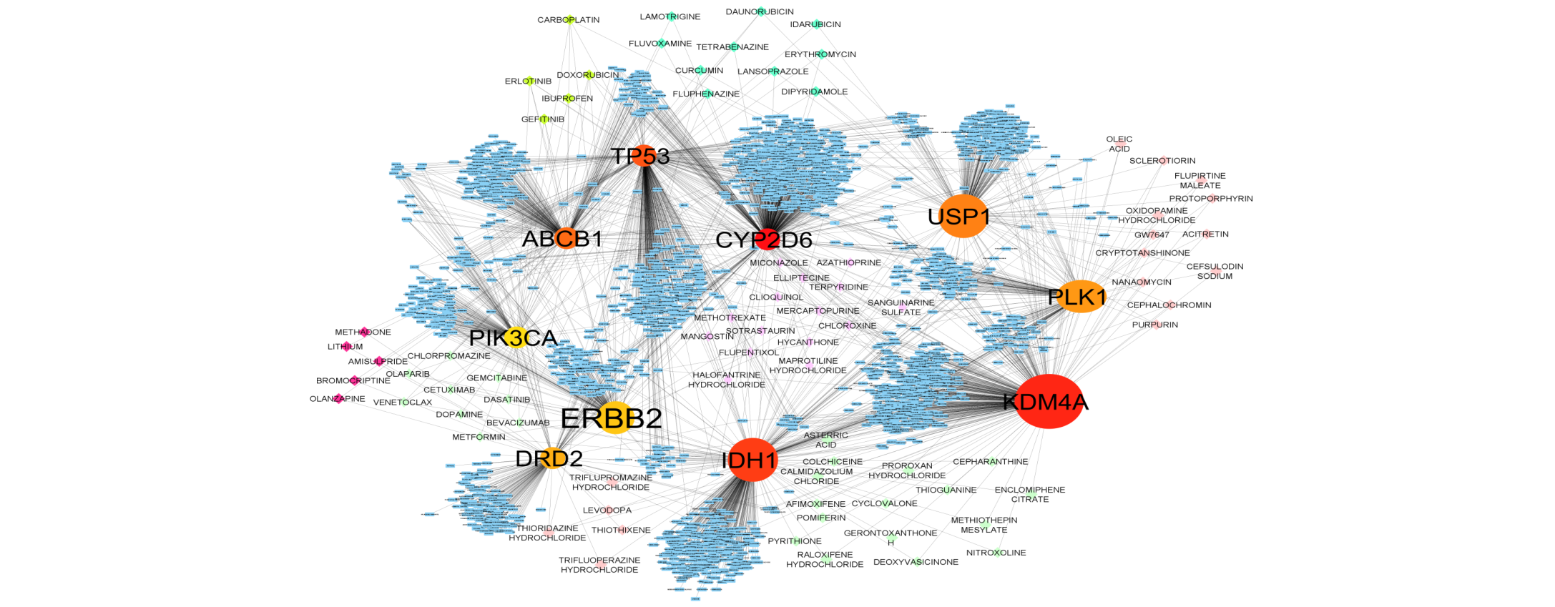
Prostate Cancer
Figure S1: Individual gene-drug interaction (GDI) network representing top 10 hub genes for breast cancer (nodes=1382 and edges=1947), cervical cancer (nodes=1268 and edges=1762), cns cancer (nodes=1757 and edges=2404), colon cancer (nodes=1502 and edges=2007), kidney cancer (nodes=2527 and edges=3486), leukemia cancer (nodes=1573 and edges=2004), lung cancer (nodes=1576 and edges=2119), melanoma cancer (nodes=1304 and edges=1734), ovarian cancer (nodes=1680 and edges=2237) and prostate cancer (nodes=2123 and edges=2864)

